Supplementary Material for
Persistent venular dysfunction despite structural convergence in post-COVID-19 syndrome: a prospective six-month retinal vessel analysis follow-up
Michael Basta-Wunderle¹*, Andrea Ribeiro¹, Isabelle Lethen¹, Roman Günthner¹, Emily Feneberg², Maciej Lech³, Christoph Schmaderer^{1,4,5}, Timon Wallraven¹*
1 TUM School of Medicine and Health, Department of Nephrology, TUM University Hospital, Technical University of Munich, Munich, Germany.
2 TUM School of Medicine and Health, Department of Neurology, TUM University Hospital, Technical University of Munich, Munich, Germany.
3 LMU Hospital, Medizinische Klinik und Poliklinik IV, Ludwig-Maximilians-Universität, Munich, Germany.
4 German Centre for Infection Research (DZIF), Munich Partner Site, Munich, Germany
5 Site Lead, VADYS-ME Research Program, TUM University Hospital, Munich, Germany

Supplementary Table S1. Outlier and plausibility flagging of RVA parameters.
Values outside pre-specified physiological ranges or exceeding IQR/MAD-based outlier thresholds were flagged but retained in the primary analysis; see Supplementary Table S3 for a winsorized sensitivity analysis. CRAE = central retinal arteriolar equivalent; CRVE = central retinal venular equivalent; AVR = arteriolar-to-venular ratio; aFID/vFID = arteriolar/venular flicker-induced dilation. BL = baseline; FU = follow-up; IQR = interquartile range; MAD = median absolute deviation.
Parameter | Plausible range | Time point | n available | n flagged
CRAE | 100–220 µm | Baseline | 201 | 1
CRAE | 100–220 µm | Follow-up | 82 | 2
CRVE | 130–280 µm | Baseline | 201 | 0
CRVE | 130–280 µm | Follow-up | 82 | 0
AVR | 0.5–1.0 | Baseline | 201 | 4
AVR | 0.5–1.0 | Follow-up | 82 | 1
Arteriolar FID | -3 to 14% | Baseline | 196 | 2
Arteriolar FID | -3 to 14% | Follow-up | 82 | 2
Venular FID | -3 to 12% | Baseline | 194 | 1
Venular FID | -3 to 12% | Follow-up | 82 | 5

Supplementary Table S2. Completer vs. non-completer comparison of baseline characteristics.
Variable | Completer (n = 81) | Non-completer (n = 21) | p
Age, years | 42.1 ± 11.4 | 40.8 ± 12.5 | 0.663
Female sex, n (%) | 60 (74.1%) | 17 (81.0%) | 0.713
BMI, kg/m² | 24.9 ± 4.9 | 23.1 ± 4.3 | 0.121
Hypertension, n (%) | 14 (17.3%) | 2 (9.5%) | 0.593
Hypercholesterolemia, n (%) | 37 (45.7%) | 9 (50.0%) | 0.943
ME/CFS, n (%) | 48 (59.3%) | 14 (70.0%) | 0.531
PCS Severity Score | 37.2 ± 10.6 | 35.6 ± 10.4 | 0.556
Fatigue Severity Scale | 5.6 ± 1.3 | 5.9 ± 1.3 | 0.394
CRAE (µm), baseline | 177.82 ± 15.79 | 179.90 ± 14.42 | 0.567
CRVE (µm), baseline | 213.46 ± 16.17 | 215.37 ± 16.30 | 0.635
AVR, baseline | 0.83 ± 0.06 | 0.84 ± 0.06 | 0.863
Arteriolar FID (%), baseline | 3.02 ± 2.48 | 2.24 ± 1.34 | 0.069
Venular FID (%), baseline | 3.64 ± 2.26 | 3.91 ± 1.76 | 0.589
Comparison of PCS patients who did ("completer") and did not ("non-completer") complete six-month RVA follow-up. Welch’s t-test (continuous) or χ² test (categorical). Completers are defined as patients with complete follow-up data for all five RVA parameters. Percentages are based on the number of participants with available data for each variable. No variable differed significantly between groups. CRAE = central retinal arteriolar equivalent; CRVE = central retinal venular equivalent; AVR = arteriolar-to-venular ratio; aFID/vFID = arteriolar/venular flicker-induced dilation. BMI = body-mass index; ME/CFS = myalgic encephalomyelitis/chronic fatigue syndrome.

Supplementary Table S3. Sensitivity analyses for the primary longitudinal and between-group findings.
Parameter | Winsorized BL→FU change, pᵃ | 1:1 matching w/o replacement, β (PCS FU vs. Recovered BL) | p
CRAE | <0.001 | -0.76 | 0.794
CRVE | 0.213 | -2.65 | 0.341
AVR | <0.001 | 0.006 | 0.562
Arteriolar FID | 0.744 | -0.38 | 0.408
Venular FID | 0.796 | -1.13 | 0.029
ᵃWilcoxon signed-rank test on within-PCS paired values winsorized at the 1st/99th percentile. CRAE = central retinal arteriolar equivalent; CRVE = central retinal venular equivalent; AVR = arteriolar-to-venular ratio; aFID/vFID = arteriolar/venular flicker-induced dilation. BL = baseline; FU = follow-up.
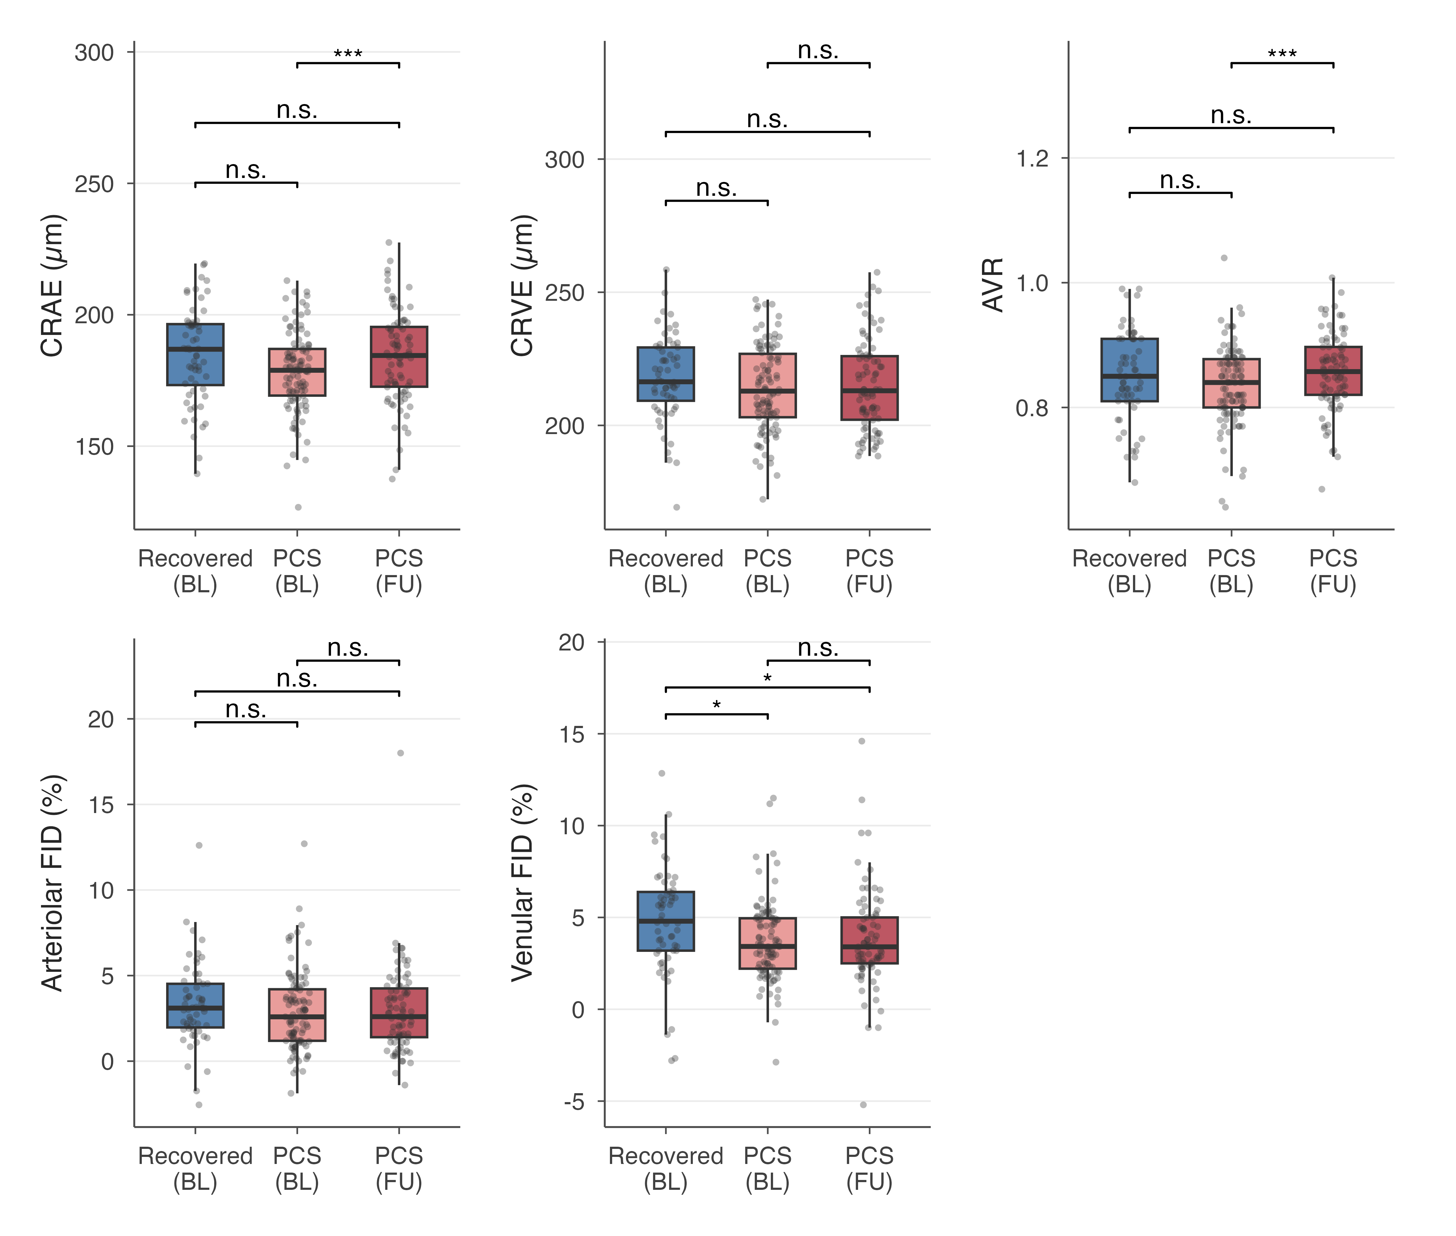
Supplementary Figure S1. Between-group comparison using the propensity score–matched, weighted analysis (2:1 nearest-neighbor matching with replacement, average treatment effect on the treated; HC3 robust standard errors), shown here as a sensitivity check for the covariate-adjusted, full-cohort comparison presented as Figure 2 in the main text. Boxplots indicate median, interquartile range and individual data points; the Recovered (BL) group is displayed with propensity-score weights applied. Results are consistent in direction and significance pattern with the main-text figure. CRAE = central retinal arteriolar equivalent; CRVE = central retinal venular equivalent; AVR = arteriolar-to-venular ratio; aFID/vFID = arteriolar/venular flicker-induced dilation. BL = baseline; FU = follow-up; HC3 = heteroskedasticity-consistent robust standard errors. n.s. = not significant, * p < 0.05, ** p < 0.01, *** p < 0.001.

Supplementary Table S4. Covariate balance before and after propensity score matching.
Covariate | Type | SMD before matching | SMD after matching (weighted)
Propensity score (distance) | Continuous | 0.757 | -0.0004
Age | Continuous | 0.742 | 0.0008
Sex | Binary | -0.039 | 0.0049
All standardized mean differences (SMD) after matching were below the pre-specified threshold of 0.1, indicating adequate covariate balance (2:1 nearest-neighbor propensity score matching with replacement, average treatment effect on the treated). Age and sex were the matching covariates.

Supplementary Table S5. Structural–functional dissociation: correlations between six-month change scores across RVA parameters.
ΔParameter 1 | ΔParameter 2 | n | ρ | p | q (FDR)
ΔCRAE | ΔCRVE | 82 | 0.38 | <0.001 | 0.003
ΔCRAE | ΔAVR | 82 | 0.74 | <0.001 | <0.001
ΔCRAE | ΔArteriolar FID | 81 | -0.19 | 0.091 | 0.182
ΔCRAE | ΔVenular FID | 81 | -0.12 | 0.305 | 0.408
ΔCRVE | ΔAVR | 82 | -0.27 | 0.015 | 0.036
ΔCRVE | ΔArteriolar FID | 81 | -0.09 | 0.445 | 0.495
ΔCRVE | ΔVenular FID | 81 | -0.13 | 0.236 | 0.393
ΔAVR | ΔArteriolar FID | 81 | -0.11 | 0.327 | 0.408
ΔAVR | ΔVenular FID | 81 | 0.01 | 0.961 | 0.961
ΔArteriolar FID | ΔVenular FID | 82 | 0.38 | <0.001 | 0.003
Spearman correlations between six-month change scores (follow-up minus baseline) among RVA parameters within the PCS cohort. ΔCRAE is correlated with both ΔCRVE and ΔAVR, consistent with AVR being calculated as CRAE/CRVE; neither ΔCRAE nor ΔAVR is correlated with Δvenular FID, supporting an independent structural and functional trajectory. CRAE = central retinal arteriolar equivalent; CRVE = central retinal venular equivalent; AVR = arteriolar-to-venular ratio; aFID/vFID = arteriolar/venular flicker-induced dilation. Δ = six-month change (follow-up minus baseline); FDR = false discovery rate (Benjamini-Hochberg).
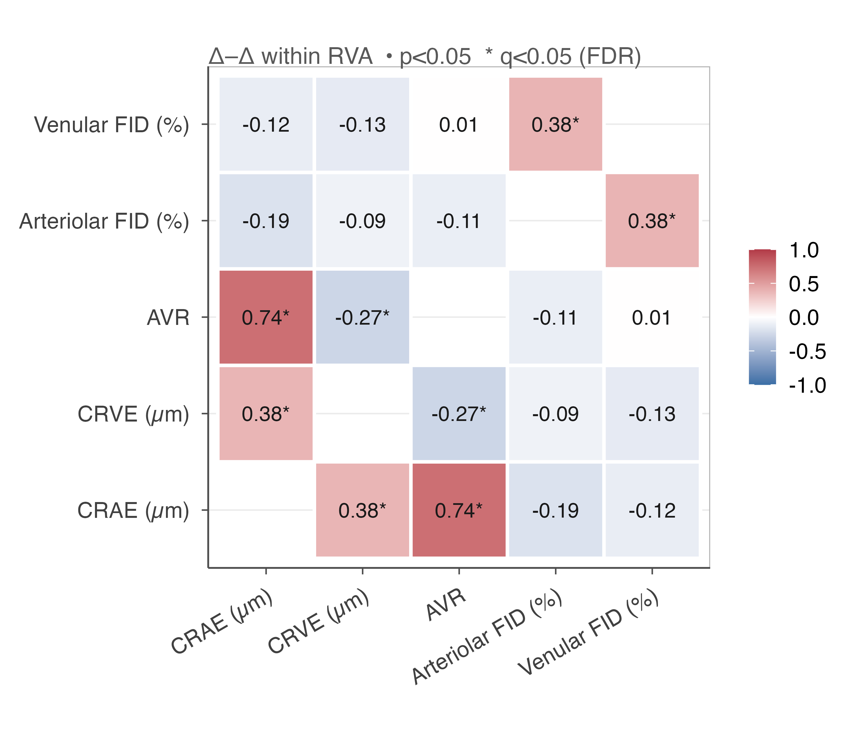
Supplementary Figure S2. Visual representation of the correlations reported in Supplementary Table S5 (symmetric matrix; diagonal omitted). • p < 0.05, * q < 0.05 (FDR, Benjamini-Hochberg). CRAE = central retinal arteriolar equivalent; CRVE = central retinal venular equivalent; AVR = arteriolar-to-venular ratio; aFID/vFID = arteriolar/venular flicker-induced dilation; Δ = six-month change (follow-up minus baseline); FDR = false discovery rate.

Supplementary Table S6. Association between six-month change in RVA parameters and change in patient-reported outcome measures.
ΔRVA | ΔPROM | n | ρ | p | q (FDR)
ΔCRAE | ΔPCS Score | 82 | 0.08 | 0.469 | 0.950
ΔCRAE | ΔC19-YRS | 61 | 0.21 | 0.112 | 0.665
ΔCRAE | ΔGAD-7 | 80 | 0.04 | 0.736 | 0.950
ΔCRAE | ΔPHQ-9 | 80 | -0.07 | 0.538 | 0.950
ΔCRAE | ΔFSS | 81 | 0.02 | 0.866 | 0.950
ΔCRVE | ΔPCS Score | 82 | -0.06 | 0.611 | 0.950
ΔCRVE | ΔC19-YRS | 61 | 0.20 | 0.119 | 0.665
ΔCRVE | ΔGAD-7 | 80 | -0.17 | 0.133 | 0.665
ΔCRVE | ΔPHQ-9 | 80 | 0.03 | 0.802 | 0.950
ΔCRVE | ΔFSS | 81 | -0.09 | 0.403 | 0.950
ΔAVR | ΔPCS Score | 82 | 0.15 | 0.176 | 0.734
ΔAVR | ΔC19-YRS | 61 | 0.11 | 0.416 | 0.950
ΔAVR | ΔGAD-7 | 80 | 0.19 | 0.097 | 0.665
ΔAVR | ΔPHQ-9 | 80 | -0.09 | 0.451 | 0.950
ΔAVR | ΔFSS | 81 | 0.07 | 0.523 | 0.950
ΔArteriolar FID | ΔPCS Score | 82 | -0.02 | 0.829 | 0.950
ΔArteriolar FID | ΔC19-YRS | 60 | -0.06 | 0.626 | 0.950
ΔArteriolar FID | ΔGAD-7 | 80 | 0.13 | 0.262 | 0.818
ΔArteriolar FID | ΔPHQ-9 | 80 | -0.02 | 0.879 | 0.950
ΔArteriolar FID | ΔFSS | 81 | -0.05 | 0.653 | 0.950
ΔVenular FID | ΔPCS Score | 82 | 0.01 | 0.912 | 0.950
ΔVenular FID | ΔC19-YRS | 60 | 0.15 | 0.251 | 0.818
ΔVenular FID | ΔGAD-7 | 80 | 0.19 | 0.098 | 0.665
ΔVenular FID | ΔPHQ-9 | 80 | -0.02 | 0.871 | 0.950
ΔVenular FID | ΔFSS | 81 | 0.01 | 0.963 | 0.963
Spearman correlations between six-month change scores (follow-up minus baseline) in RVA parameters and patient-reported outcome measures within the PCS cohort. PCS Score = Post-COVID-19 Syndrome Severity Score; C19-YRS = COVID-19 Yorkshire Rehabilitation Scale; GAD-7 = Generalized Anxiety Disorder-7; PHQ-9 = Patient Health Questionnaire-9; FSS = Fatigue Severity Scale. No association reached significance after FDR correction (all q ≥ 0.66). CRAE = central retinal arteriolar equivalent; CRVE = central retinal venular equivalent; AVR = arteriolar-to-venular ratio; aFID/vFID = arteriolar/venular flicker-induced dilation. FDR = false discovery rate.

Supplementary Table S7. Prediction of follow-up PROM scores from baseline RVA parameters (univariable and adjusted models).
Predictor (BL) | Outcome (FU) | Univariable β | Univariable p | Adjusted βᵃ | Adjusted 95% CI | Adjusted p | q (FDR)
CRAE | PCS Score | 0.064 | 0.425 | 0.013 | -0.116 to 0.141 | 0.846 | 0.963
CRAE | C19-YRS | 0.019 | 0.866 | 0.068 | -0.083 to 0.219 | 0.374 | 0.811
CRAE | GAD-7 | 0.019 | 0.487 | 0.001 | -0.041 to 0.043 | 0.961 | 0.964
CRAE | PHQ-9 | 0.026 | 0.405 | 0.024 | -0.020 to 0.069 | 0.282 | 0.811
CRAE | FSS | 0.003 | 0.756 | <0.001 | -0.015 to 0.015 | 0.964 | 0.964
CRVE | PCS Score | 0.211 | 0.007 | 0.079 | -0.052 to 0.209 | 0.235 | 0.811
CRVE | C19-YRS | 0.245 | 0.019 | 0.133 | -0.015 to 0.281 | 0.078 | 0.811
CRVE | GAD-7 | 0.031 | 0.255 | 0.019 | -0.023 to 0.060 | 0.371 | 0.811
CRVE | PHQ-9 | 0.041 | 0.180 | 0.009 | -0.035 to 0.054 | 0.677 | 0.956
CRVE | FSS | 0.013 | 0.185 | 0.004 | -0.011 to 0.019 | 0.620 | 0.956
AVR | PCS Score | -34.85 | 0.078 | -13.83 | -45.49 to 17.83 | 0.387 | 0.811
AVR | C19-YRS | -59.22 | 0.035 | -12.93 | -52.94 to 27.07 | 0.520 | 0.928
AVR | GAD-7 | -1.14 | 0.868 | -4.32 | -14.77 to 6.14 | 0.414 | 0.811
AVR | PHQ-9 | -2.03 | 0.790 | 4.40 | -6.44 to 15.25 | 0.422 | 0.811
AVR | FSS | -2.11 | 0.377 | -0.79 | -4.48 to 2.90 | 0.671 | 0.956
aFID | PCS Score | -0.695 | 0.193 | -0.129 | -0.987 to 0.728 | 0.765 | 0.956
aFID | C19-YRS | 0.201 | 0.799 | 0.654 | -0.384 to 1.692 | 0.212 | 0.811
aFID | GAD-7 | 0.140 | 0.448 | -0.024 | -0.304 to 0.256 | 0.864 | 0.963
aFID | PHQ-9 | 0.183 | 0.373 | 0.169 | -0.119 to 0.457 | 0.245 | 0.811
aFID | FSS | -0.030 | 0.644 | -0.007 | -0.106 to 0.092 | 0.886 | 0.963
vFID | PCS Score | -0.627 | 0.275 | -0.430 | -1.338 to 0.479 | 0.350 | 0.811
vFID | C19-YRS | -0.887 | 0.234 | -0.456 | -1.485 to 0.572 | 0.378 | 0.811
vFID | GAD-7 | 0.162 | 0.413 | -0.052 | -0.347 to 0.243 | 0.726 | 0.956
vFID | PHQ-9 | <0.001 | 0.999 | -0.049 | -0.360 to 0.262 | 0.755 | 0.956
vFID | FSS | -0.131 | 0.056 | -0.120 | -0.223 to -0.017 | 0.023 | 0.565
PCS Score = Post-COVID-19 Syndrome Severity Score; C19-YRS = COVID-19 Yorkshire Rehabilitation Scale; GAD-7 = Generalized Anxiety Disorder-7; PHQ-9 = Patient Health Questionnaire-9; FSS = Fatigue Severity Scale. ᵃAdjusted for age, sex and the corresponding baseline PROM value. p-values were FDR-corrected (Benjamini-Hochberg) across all 25 adjusted models. CRAE = central retinal arteriolar equivalent; CRVE = central retinal venular equivalent; AVR = arteriolar-to-venular ratio; aFID/vFID = arteriolar/venular flicker-induced dilation. FDR = false discovery rate.

Supplementary Table S8. Interaction between baseline RVA parameters and ME/CFS status on follow-up PROM scores.
Predictor (BL) | Outcome (FU) | Interaction β | p | q (FDR)
CRAE | PCS Score | 0.137 | 0.324 | 0.464
CRAE | C19-YRS | -0.020 | 0.903 | 0.903
CRAE | GAD-7 | -0.126 | 0.003 | 0.085
CRAE | PHQ-9 | -0.058 | 0.218 | 0.418
CRAE | FSS | -0.023 | 0.144 | 0.312
CRVE | PCS Score | -0.092 | 0.503 | 0.599
CRVE | C19-YRS | -0.265 | 0.072 | 0.226
CRVE | GAD-7 | -0.102 | 0.017 | 0.143
CRVE | PHQ-9 | -0.113 | 0.013 | 0.143
CRVE | FSS | -0.031 | 0.046 | 0.190
AVR | PCS Score | 59.98 | 0.070 | 0.226
AVR | C19-YRS | 65.88 | 0.100 | 0.278
AVR | GAD-7 | -10.57 | 0.334 | 0.464
AVR | PHQ-9 | 11.39 | 0.323 | 0.464
AVR | FSS | 1.18 | 0.766 | 0.833
aFID | PCS Score | 1.304 | 0.132 | 0.312
aFID | C19-YRS | 2.231 | 0.042 | 0.190
aFID | GAD-7 | 0.311 | 0.289 | 0.464
aFID | PHQ-9 | 0.652 | 0.032 | 0.190
aFID | FSS | 0.085 | 0.410 | 0.540
vFID | PCS Score | 1.300 | 0.150 | 0.312
vFID | C19-YRS | -1.025 | 0.331 | 0.464
vFID | GAD-7 | 0.160 | 0.592 | 0.673
vFID | PHQ-9 | 0.230 | 0.470 | 0.587
vFID | FSS | -0.014 | 0.899 | 0.903
Interaction term (baseline RVA parameter × ME/CFS status) from linear models predicting follow-up PROM scores, adjusted for the corresponding baseline PROM, age and sex. No interaction survived FDR correction; results are exploratory. CRAE = central retinal arteriolar equivalent; CRVE = central retinal venular equivalent; AVR = arteriolar-to-venular ratio; aFID/vFID = arteriolar/venular flicker-induced dilation. PCS Score = Post-COVID-19 Syndrome Severity Score; C19-YRS = COVID-19 Yorkshire Rehabilitation Scale; GAD-7 = Generalized Anxiety Disorder-7; PHQ-9 = Patient Health Questionnaire-9; FSS = Fatigue Severity Scale. ME/CFS = myalgic encephalomyelitis/chronic fatigue syndrome; FDR = false discovery rate.

Supplementary Table S9. Nominally significant associations between circulating biomarkers and RVA parameters or PROMs.
Biomarker | RVA / PROM | n | ρ | p | Time point | q (FDR) | Comparison
VCAM-1 | CRAE | 82 | -0.38 | <0.001 | Follow-up | 0.040 | Biomarker × RVA
VCAM-1 | CRAE | 102 | -0.33 | <0.001 | Baseline | 0.061 | Biomarker × RVA
VCAM-1 | PHQ-9 | 84 | -0.31 | 0.004 | Follow-up | 0.381 | Biomarker × PROM
IL-6 | AVR | 102 | -0.27 | 0.006 | Baseline | 0.263 | Biomarker × RVA
IgG4 | PCS Score | 83 | -0.29 | 0.008 | Follow-up | 0.381 | Biomarker × PROM
VCAM-1 | FSS | 84 | -0.26 | 0.018 | Follow-up | 0.568 | Biomarker × PROM
IgG3 | AVR | 99 | 0.23 | 0.020 | Baseline | 0.628 | Biomarker × RVA
vWF | C19-YRS | 63 | -0.28 | 0.024 | Follow-up | 0.573 | Biomarker × PROM
IL-8 | vFID | 81 | -0.25 | 0.027 | Follow-up | 0.510 | Biomarker × RVA
NfL | AVR | 91 | 0.23 | 0.027 | Baseline | 0.651 | Biomarker × RVA
VEGF | aFID | 82 | 0.24 | 0.029 | Follow-up | 0.510 | Biomarker × RVA
VCAM-1 | C19-YRS | 63 | -0.27 | 0.030 | Follow-up | 0.573 | Biomarker × PROM
IL-6 | CRAE | 82 | -0.24 | 0.031 | Follow-up | 0.510 | Biomarker × RVA
VCAM-1 | AVR | 82 | -0.23 | 0.034 | Follow-up | 0.510 | Biomarker × RVA
D-Dimer | AVR | 73 | -0.24 | 0.037 | Follow-up | 0.510 | Biomarker × RVA
VCAM-1 | GAD-7 | 84 | -0.22 | 0.042 | Follow-up | 0.664 | Biomarker × PROM
GFAP | AVR | 93 | 0.21 | 0.045 | Baseline | 0.653 | Biomarker × RVA
IgG3 | aFID | 81 | -0.22 | 0.046 | Follow-up | 0.510 | Biomarker × RVA
IL-6 | C19-YRS | 92 | 0.21 | 0.046 | Baseline | 0.996 | Biomarker × PROM
VCAM-1 | CRVE | 102 | -0.20 | 0.047 | Baseline | 0.653 | Biomarker × RVA
IgG3 | CRAE | 80 | 0.22 | 0.049 | Follow-up | 0.510 | Biomarker × RVA
VCAM-1 | CRVE | 82 | -0.22 | 0.049 | Follow-up | 0.510 | Biomarker × RVA
Uncorrected Spearman correlations with p < 0.05 between circulating biomarkers and RVA parameters (Biomarker × RVA) or PROMs (Biomarker × PROM) in the PCS cohort. VCAM-1–CRAE was the only association to reach FDR significance (at follow-up, q = 0.040) and showed a consistent direction and magnitude at baseline. IL-6/IL-8 = interleukin-6/8; MCP-1 = monocyte chemoattractant protein-1; IP-10 = interferon gamma-induced protein-10; ICAM-1/VCAM-1 = intercellular/vascular cell adhesion molecule-1; VEGF = vascular endothelial growth factor; vWF = von Willebrand factor; NfL = neurofilament light chain; GFAP = glial fibrillary acidic protein; IgG = immunoglobulin G. CRAE = central retinal arteriolar equivalent; CRVE = central retinal venular equivalent; AVR = arteriolar-to-venular ratio; aFID/vFID = arteriolar/venular flicker-induced dilation. FDR = false discovery rate.
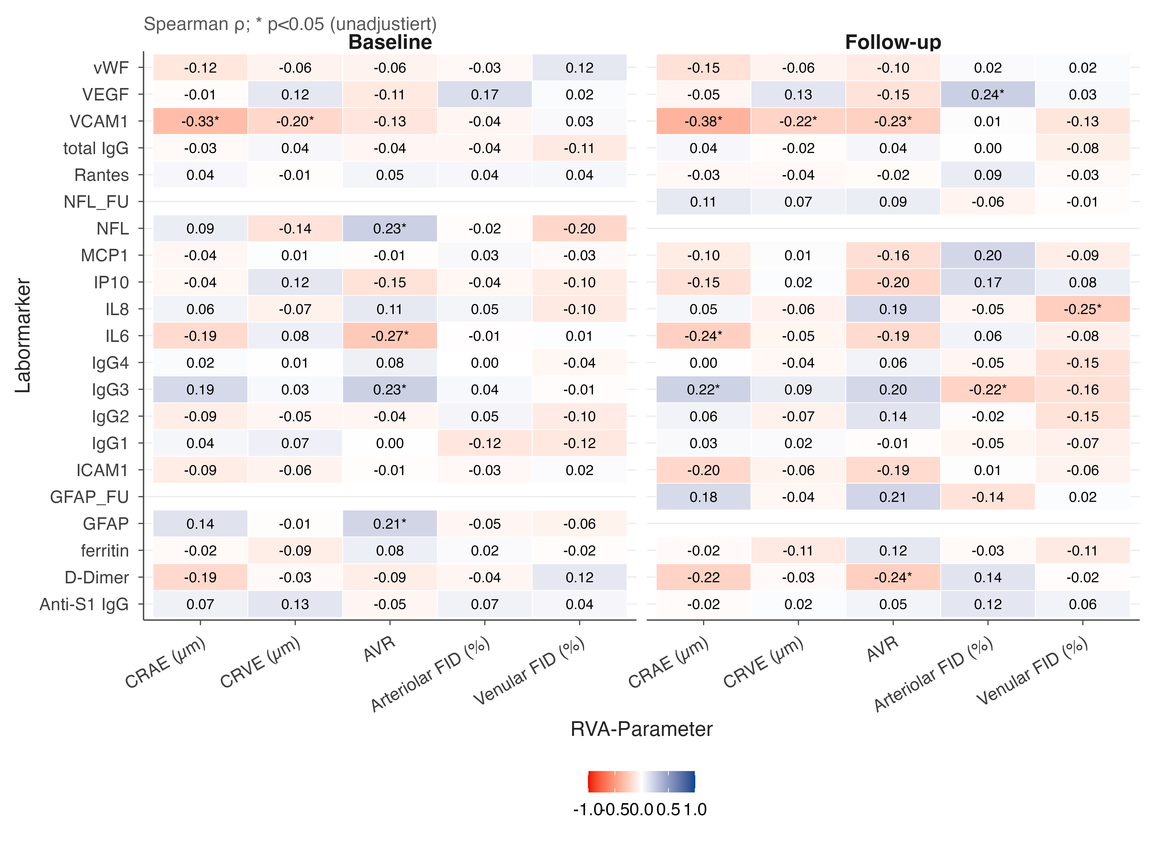
Supplementary Figure S3. Full correlation matrix (Spearman ρ) between circulating biomarkers and RVA parameters at baseline and follow-up in the PCS cohort. * p < 0.05, unadjusted. Underlying values are reported in full in Supplementary Table S9 (nominally significant associations). Biomarker abbreviations as in Supplementary Table S9; CRAE = central retinal arteriolar equivalent; CRVE = central retinal venular equivalent; AVR = arteriolar-to-venular ratio; aFID/vFID = arteriolar/venular flicker-induced dilation.

Supplementary Table S10. Sex-stratified associations between circulating biomarkers and RVA parameters.
Biomarker | RVA parameter | Sex | n | ρ | p
VEGF | Arteriolar FID (BL) | Female | 76 | 0.29 | 0.012
VCAM-1 | CRAE (BL) | Female | 77 | -0.31 | 0.007
IL-6 | AVR (BL) | Female | 77 | -0.26 | 0.021
NfL | Venular FID (BL) | Female | 67 | -0.24 | 0.048
IP-10 | CRVE (BL) | Male | 25 | 0.40 | 0.047
IP-10 | Venular FID (BL) | Male | 23 | -0.49 | 0.018
IgG4 | CRAE (BL) | Male | 25 | -0.44 | 0.028
GFAP | CRVE (BL) | Male | 25 | -0.43 | 0.030
Exploratory sex-stratified Spearman correlations (uncorrected p < 0.05 only); male subgroup n = 21–25. Given the small male subgroup size and absence of correction for multiple testing across sexes, these associations are hypothesis-generating only. Biomarker and RVA abbreviations as in Supplementary Table S9.

ME/CFS Subgroup Analysis

Supplementary Table S11. Longitudinal course of RVA parameters by ME/CFS status (descriptive, within-group).
Parameter | Group | n | Baseline | Follow-up | Δ (FU-BL) | Test | p
CRAE | non-ME/CFS | 33 | 177.40 ± 15.68 | 182.59 ± 14.32 | 5.19 ± 8.39 | paired t | 0.001
CRAE | ME/CFS | 49 | 178.66 ± 16.30 | 185.11 ± 19.61 | 6.45 ± 11.45 | paired t | <0.001
CRVE | non-ME/CFS | 33 | 208.96 ± 16.89 | 211.64 ± 17.88 | 2.67 ± 8.26 | paired t | 0.072
CRVE | ME/CFS | 49 | 217.14 ± 15.46 | 217.60 ± 16.39 | 0.46 ± 7.42 | Wilcoxon | 1.000
AVR | non-ME/CFS | 33 | 0.85 ± 0.07 | 0.87 ± 0.06 | 0.01 ± 0.04 | paired t | 0.041
AVR | ME/CFS | 49 | 0.82 ± 0.06 | 0.85 ± 0.06 | 0.03 ± 0.05 | paired t | <0.001
Arteriolar FID | non-ME/CFS | 33 | 3.30 ± 2.90 | 3.53 ± 3.25 | 0.23 ± 2.53 | paired t | 0.605
Arteriolar FID | ME/CFS | 49 | 2.82 ± 2.13 | 2.61 ± 1.89 | -0.21 ± 2.31 | Wilcoxon | 0.917
Venular FID | non-ME/CFS | 33 | 3.56 ± 2.66 | 3.82 ± 2.72 | 0.26 ± 2.99 | Wilcoxon | 0.238
Venular FID | ME/CFS | 49 | 3.73 ± 1.96 | 3.78 ± 2.72 | 0.05 ± 2.81 | Wilcoxon | 0.441
Within-group paired comparisons by ME/CFS status (Canadian Consensus Criteria) in the PCS cohort (total n = 101 with known ME/CFS status: 39 non-ME/CFS, 62 ME/CFS at baseline; subgroup n per parameter reflects available follow-up data). Neither FID parameter changed significantly within either subgroup; see Supplementary Table S12 for the formal time × ME/CFS interaction test. CRAE = central retinal arteriolar equivalent; CRVE = central retinal venular equivalent; AVR = arteriolar-to-venular ratio; aFID/vFID = arteriolar/venular flicker-induced dilation.

Supplementary Table S12. Full model: linear mixed-effects time × ME/CFS interaction.
Parameter | Time β | Time p | ME/CFS β | ME/CFS p | Interaction β | Interaction p | Interaction q
CRAE | 5.02 | 0.005 | -0.85 | 0.804 | 1.54 | 0.499 | 0.624
CRVE | 2.59 | 0.055 | 6.07 | 0.075 | -2.03 | 0.242 | 0.403
AVR | 0.014 | 0.062 | -0.028 | 0.031 | 0.012 | 0.215 | 0.403
Arteriolar FID | 0.30 | 0.460 | -0.56 | 0.267 | -0.45 | 0.390 | 0.651
Venular FID | 0.23 | 0.623 | 0.08 | 0.878 | -0.18 | 0.766 | 0.766
Linear mixed-effects model (parameter ~ time × ME/CFS + age + sex + (1|id)) within the PCS cohort. Time β reflects the follow-up vs. baseline effect in the non-ME/CFS reference group; ME/CFS β reflects the baseline difference between groups; Interaction β tests whether the time effect differs by ME/CFS status. No interaction term reached significance after FDR correction (Benjamini-Hochberg across the 5 parameters). CRAE = central retinal arteriolar equivalent; CRVE = central retinal venular equivalent; AVR = arteriolar-to-venular ratio; aFID/vFID = arteriolar/venular flicker-induced dilation. FDR = false discovery rate.

Supplementary Table S13. Cross-sectional comparison of RVA parameters between ME/CFS and non-ME/CFS PCS patients.
Parameter | Time point | Adjusted βᵃ | 95% CI | p | q (FDR)
CRAE | Baseline | 0.33 | -6.40 to 7.05 | 0.923 | 0.923
CRAE | Follow-up | 4.50 | -3.92 to 12.91 | 0.290 | 0.414
CRVE | Baseline | 5.69 | -1.50 to 12.87 | 0.119 | 0.397
CRVE | Follow-up | 6.95 | -1.48 to 15.38 | 0.105 | 0.397
AVR | Baseline | -0.021 | -0.047 to 0.005 | 0.109 | 0.397
AVR | Follow-up | -0.009 | -0.038 to 0.020 | 0.527 | 0.659
Arteriolar FID | Baseline | -0.55 | -1.54 to 0.44 | 0.274 | 0.456
Arteriolar FID | Follow-up | -1.03 | -2.21 to 0.16 | 0.089 | 0.298
Venular FID | Baseline | 0.08 | -0.85 to 1.00 | 0.699 | 0.923
Venular FID | Follow-up | -0.13 | -1.39 to 1.14 | 0.844 | 0.923
ᵃAdjusted linear models comparing ME/CFS vs. non-ME/CFS PCS patients (reference: non-ME/CFS) at each time point, adjusted for age, sex, mean arterial pressure and body-mass index (CRAE, CRVE, AVR) or age, sex and body-mass index (arteriolar/venular FID). No comparison reached significance after FDR correction. CRAE = central retinal arteriolar equivalent; CRVE = central retinal venular equivalent; AVR = arteriolar-to-venular ratio; aFID/vFID = arteriolar/venular flicker-induced dilation. FDR = false discovery rate.

