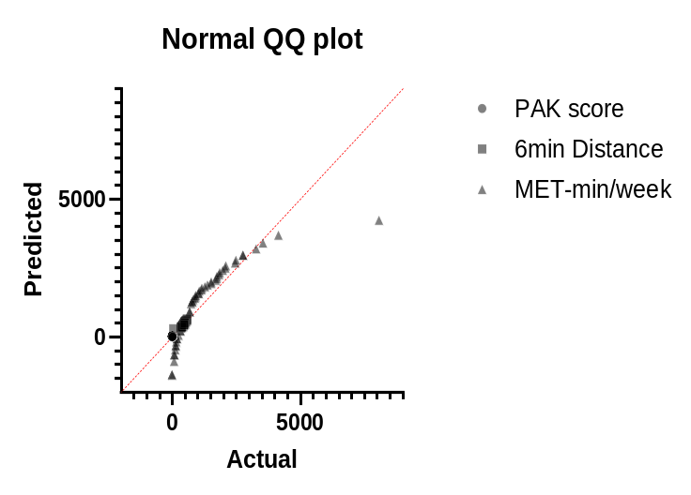
Graph 1. : Distribution of the study variables.
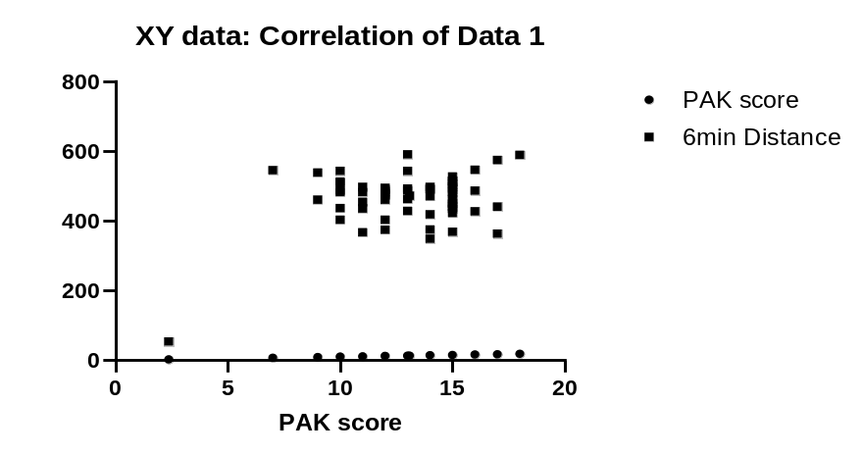
Graph 2. : Correlation between PAK score and 6MWT distance
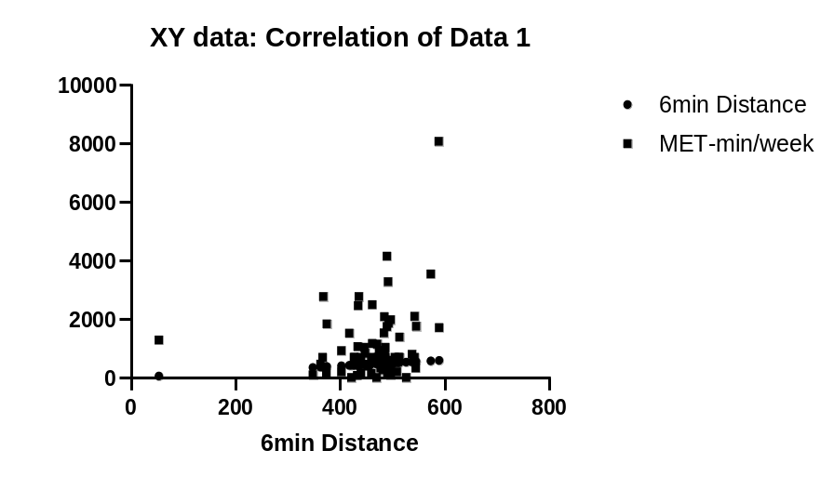
Graph 3. : Correlation between PAK scores and six-minute walk distance

