Supplementary Materials

Table of Contents

Supplementary Table S1. Keyword search string 4
Supplementary Figure S1. PRISMA Selection chart 5
Supplementary Figure S2. ROBINS-E Risk of bias summary 6
Supplementary Figure S3. Forest plot meta-analysis of metastasis risk 7
Supplementary Figure S4. Forest plot meta-analysis of age in EOPC compared to nEOPC 7
Supplementary Figure S5. Forest plot meta-analysis of male gender proportion in EOPC compared to nEOPC 8
Supplementary Figure S6. Forest plot meta-analysis of BMI in EOPC compared to nEOPC 8
Supplementary Figure S7. Forest plot meta-analysis of obesity proportion in EOPC compared to nEOPC 8
Supplementary Figure S8. Forest plot meta-analysis of alcohol history proportion in EOPC compared to nEOPC 9
Supplementary Figure S9. Forest plot meta-analysis of chronic pancreatitis history proportion in EOPC compared to nEOPC 9
Supplementary Figure S10. Forest plot meta-analysis of diabetes mellitus history proportion in EOPC compared to nEOPC 9
Supplementary Figure S11. Forest plot meta-analysis of smoking history proportion in EOPC compared to nEOPC 10
Supplementary Figure S12. Forest plot meta-analysis of family history of any cancer proportion in EOPC compared to nEOPC 10
Supplementary Figure S13. Forest plot meta-analysis of family history of pancreatic cancer proportion in EOPC compared to nEOPC 10
Supplementary Figure S14. Forest plot meta-analysis of jaundice proportion in EOPC compared to nEOPC 11
Supplementary Figure S15. Forest plot meta-analysis of new onset diabetes mellitus proportion in EOPC compared to nEOPC 11
Supplementary Figure S16. Forest plot meta-analysis of pain proportion in EOPC compared to nEOPC 11
Supplementary Figure S17. Forest plot meta-analysis of weight loss proportion in EOPC compared to nEOPC 12
Supplementary Figure S18. Forest plot meta-analysis of Stage T3/T4 proportion in EOPC compared to nEOPC 12
Supplementary Figure S19. Forest plot meta-analysis of N+ proportion in EOPC compared to nEOPC 12
Supplementary Figure S20. Forest plot meta-analysis of Stage III/IV proportion in EOPC compared to nEOPC 13
Supplementary Figure S21. Forest plot meta-analysis of locally advanced/metastasis NCCN stage proportion in EOPC compared to nEOPC 13
Supplementary Figure S22. Forest plot meta-analysis of body/tail location proportion in EOPC compared to nEOPC 14
Supplementary Figure S23. Forest plot meta-analysis of well differentiation proportion in EOPC compared to nEOPC 14
Supplementary Figure S24. Forest plot meta-analysis of moderate differentiation proportion in EOPC compared to nEOPC 15
Supplementary Figure S25. Forest plot meta-analysis of poor differentiation proportion in EOPC compared to nEOPC 15
Supplementary Figure S26. Forest plot meta-analysis of tumor size in EOPC compared to nEOPC 15
Supplementary Figure S27. Forest plot meta-analysis of lymphovascular involvement proportion in EOPC compared to nEOPC 16
Supplementary Figure S28. Forest plot meta-analysis of perineural involvement proportion in EOPC compared to nEOPC 16

Supplementary Table S1. Keyword search string
Science Direct
("Early-onset" OR "Young-onset") AND "Pancreatic Cancer" AND (Prognosis OR Survival OR Clinicopathological)
Pubmed and Scopus
(("Pancreatic Neoplasms" OR "Pancreas Adenocarcinoma" OR "Pancreatic Cancer")
AND
("Early Onset" OR "Young Adult" OR "Younger Patients" OR "Young-Onset" OR "Younger Population")
AND
("Prognosis" OR "Survival Rate" OR "Overall Survival" OR "Progression-Free Survival")
AND
("Risk factors" OR Risk)
AND
(“Clinical” OR “Pathological” OR “Clinicopathologic”))

Supplementary Figure S1. PRISMA Selection chart
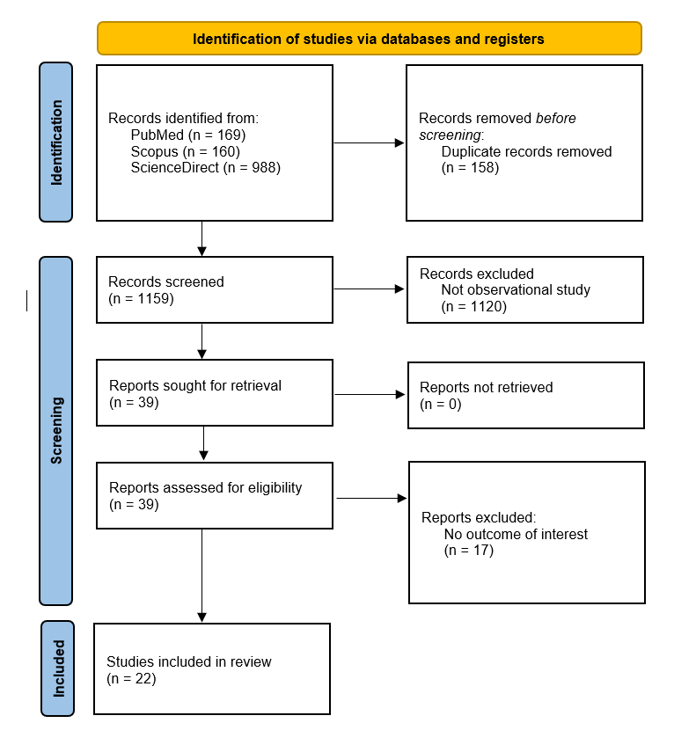

Supplementary Figure S2. ROBINS-E Risk of bias summary
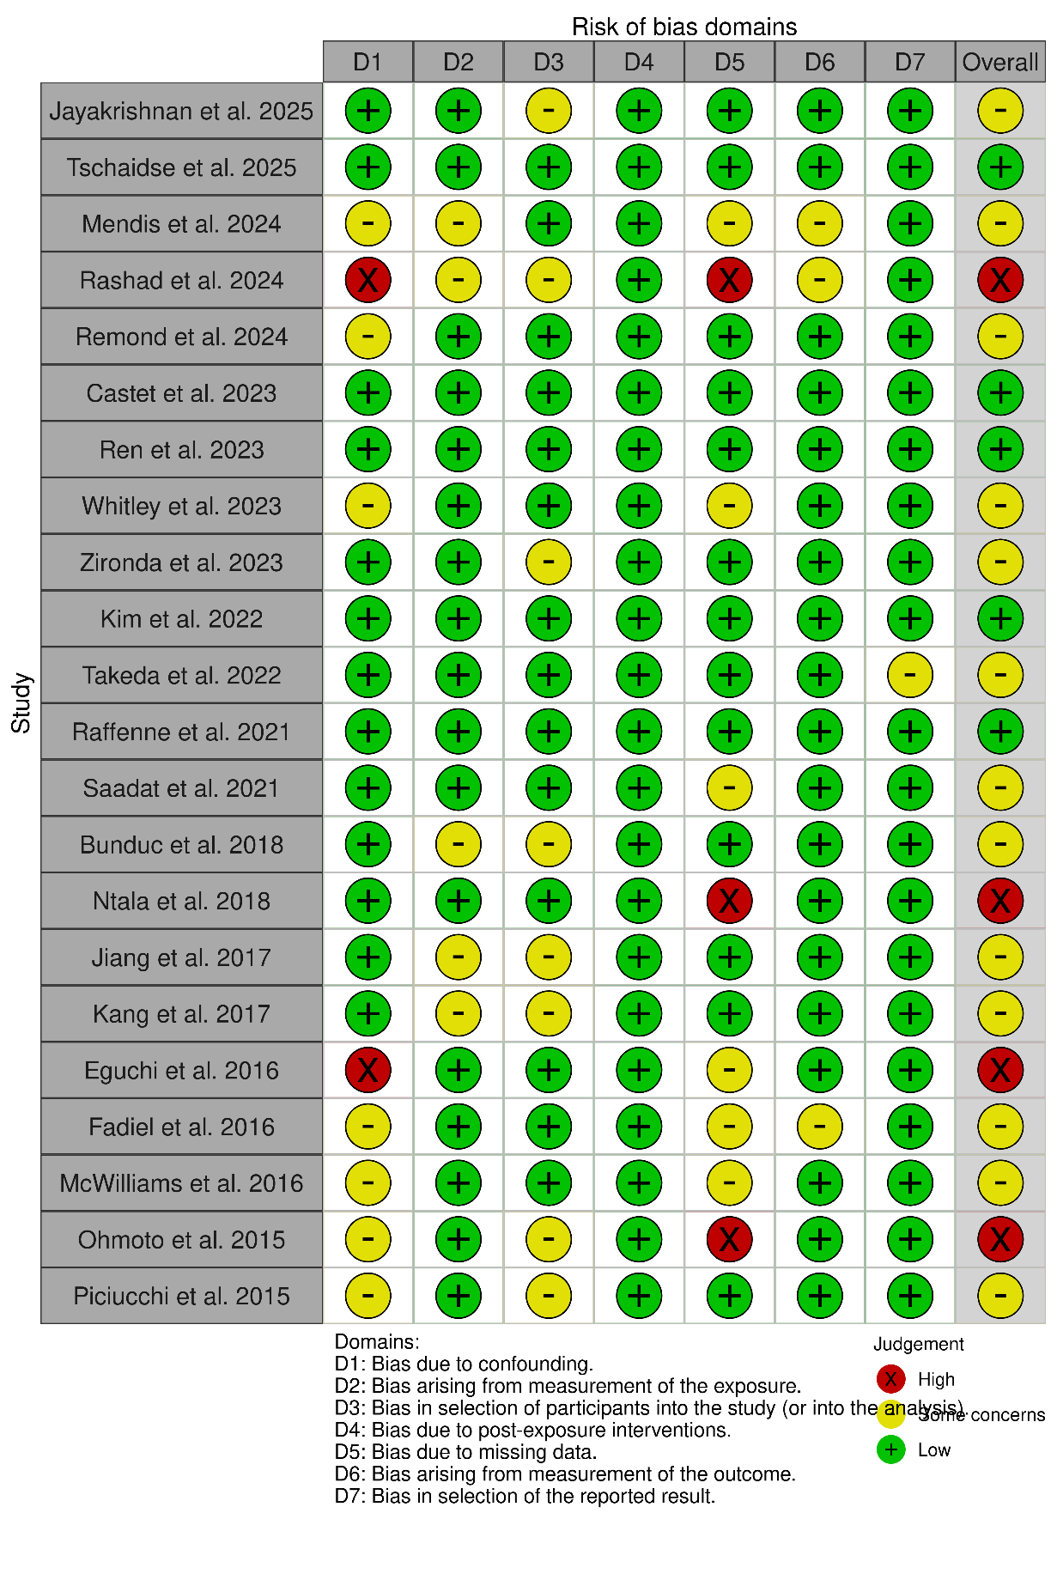

Supplementary Figure S3. Forest plot meta-analysis of metastasis risk
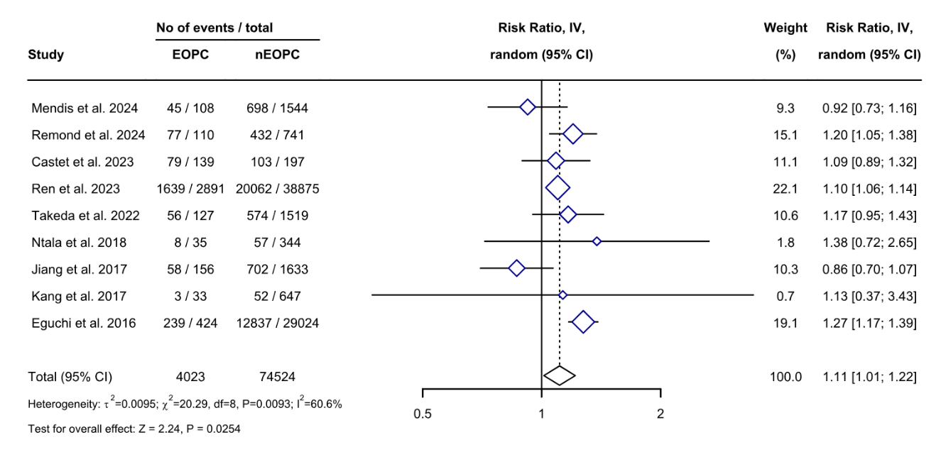

Supplementary Figure S4. Forest plot meta-analysis of age in EOPC compared to nEOPC
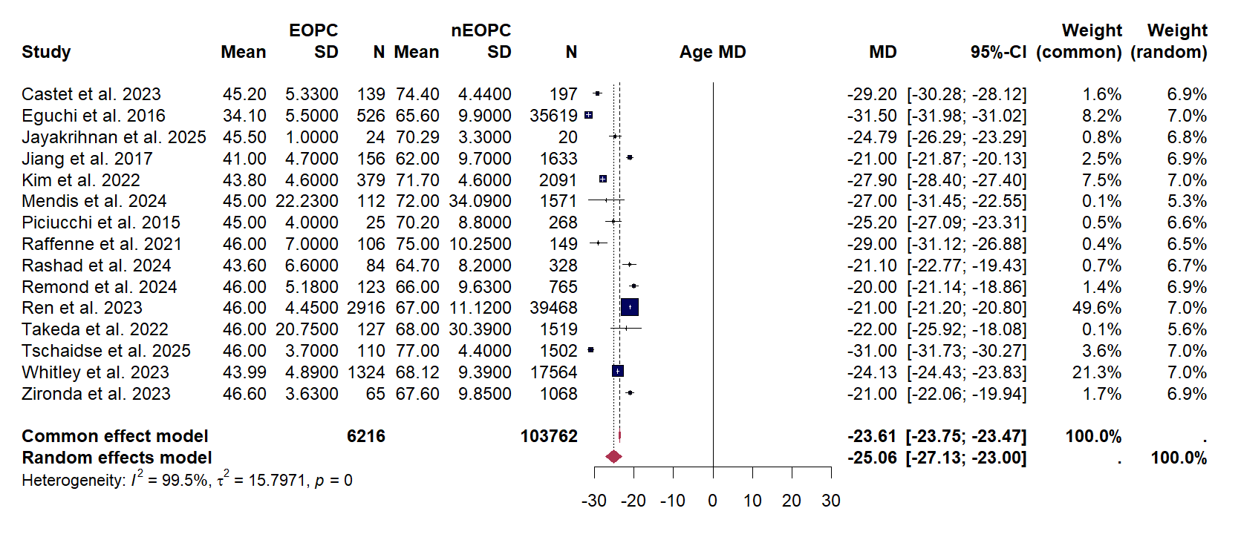

Supplementary Figure S5. Forest plot meta-analysis of male gender proportion in EOPC compared to nEOPC
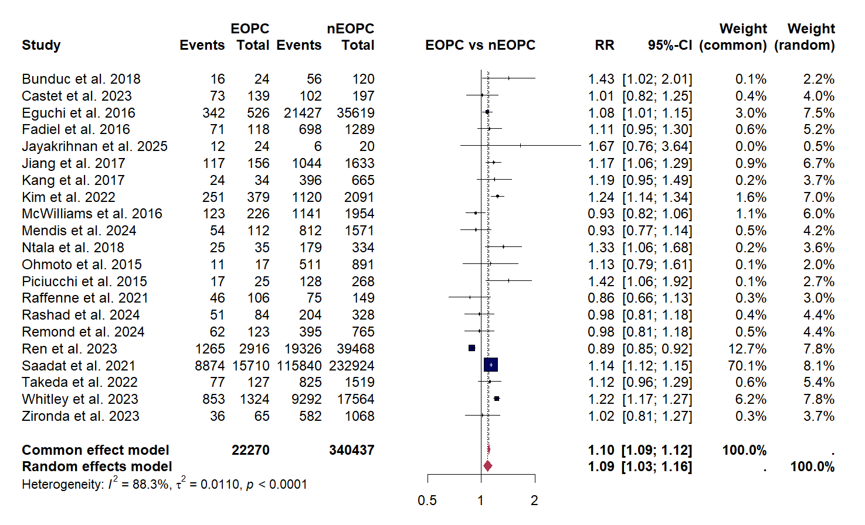

Supplementary Figure S6. Forest plot meta-analysis of BMI in EOPC compared to nEOPC
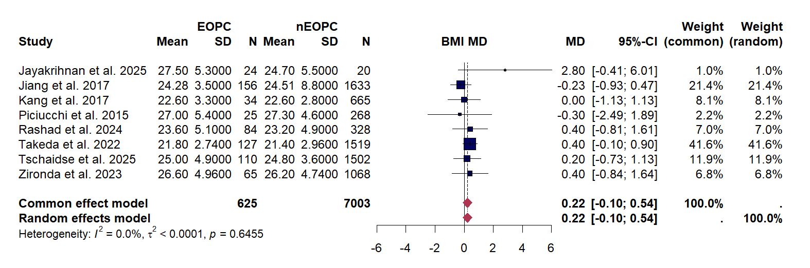
Supplementary Figure S7. Forest plot meta-analysis of obesity proportion in EOPC compared to nEOPC
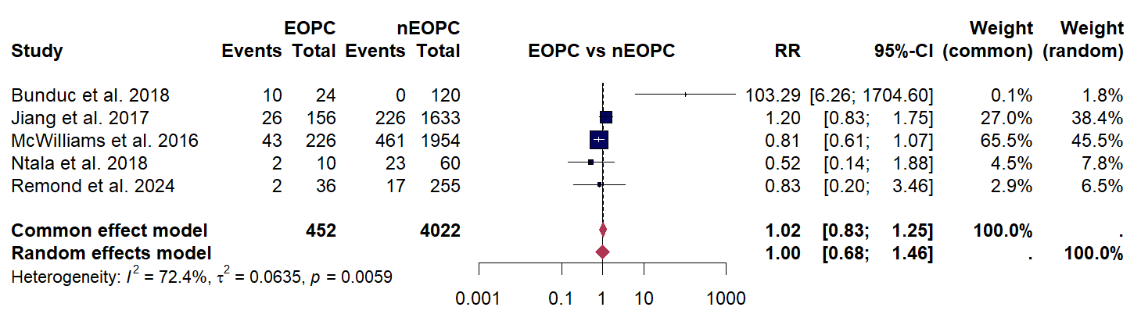

Supplementary Figure S8. Forest plot meta-analysis of alcohol history proportion in EOPC compared to nEOPC
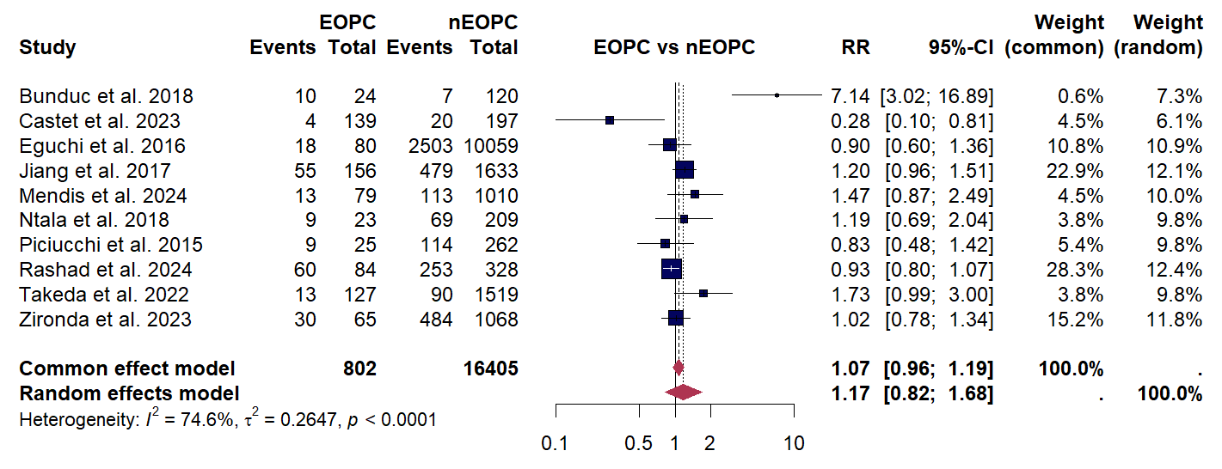

Supplementary Figure S9. Forest plot meta-analysis of chronic pancreatitis history proportion in EOPC compared to nEOPC
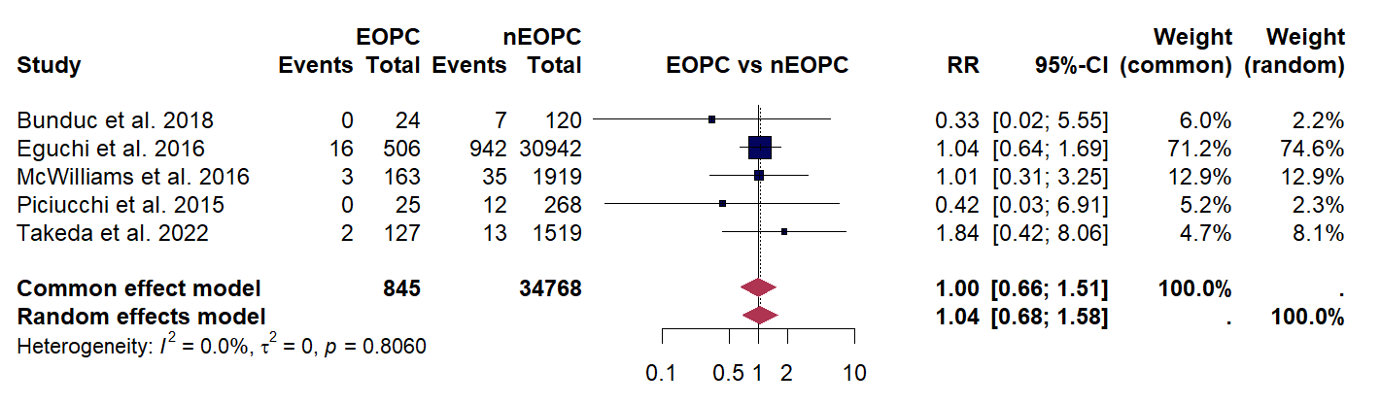

Supplementary Figure S10. Forest plot meta-analysis of diabetes mellitus history proportion in EOPC compared to nEOPC
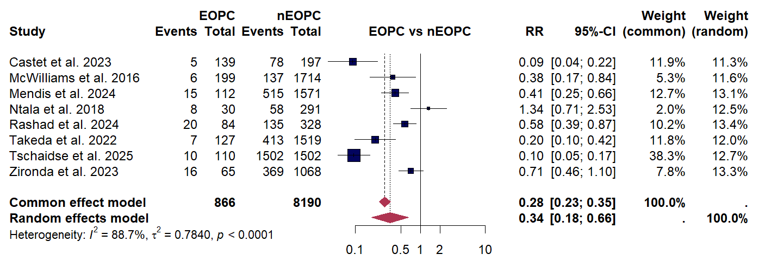

Supplementary Figure S11. Forest plot meta-analysis of smoking history proportion in EOPC compared to nEOPC
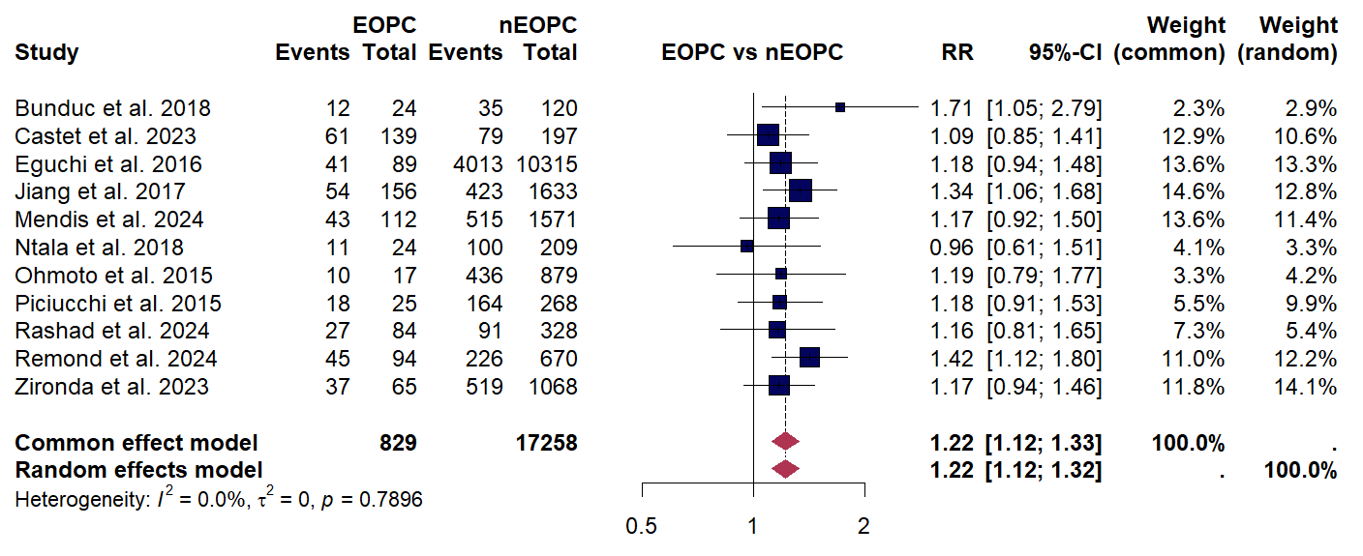

Supplementary Figure S12. Forest plot meta-analysis of family history of any cancer proportion in EOPC compared to nEOPC
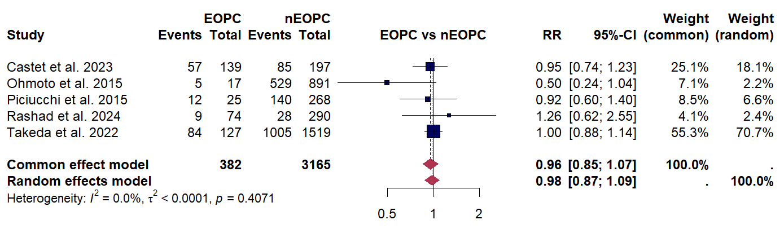

Supplementary Figure S13. Forest plot meta-analysis of family history of pancreatic cancer proportion in EOPC compared to nEOPC
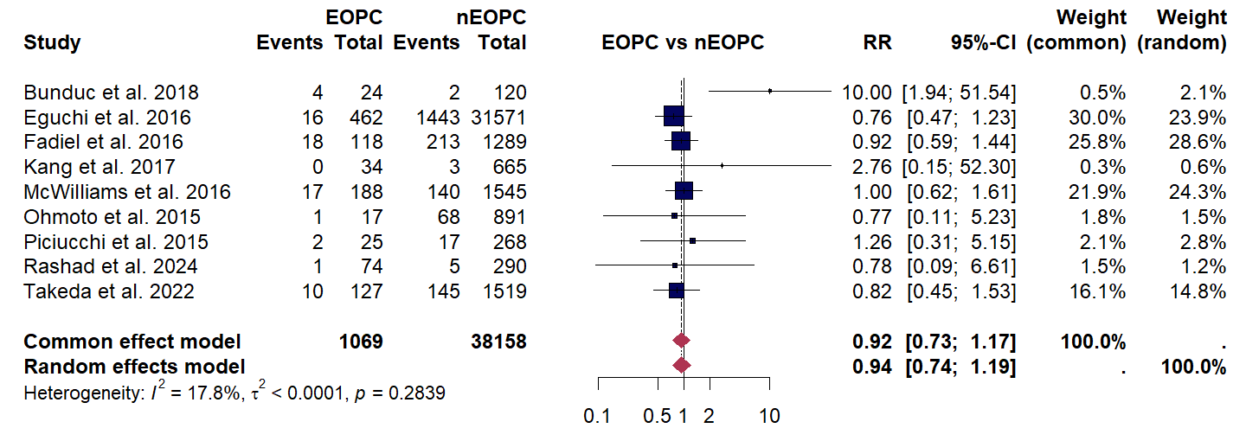

Supplementary Figure S14. Forest plot meta-analysis of jaundice proportion in EOPC compared to nEOPC
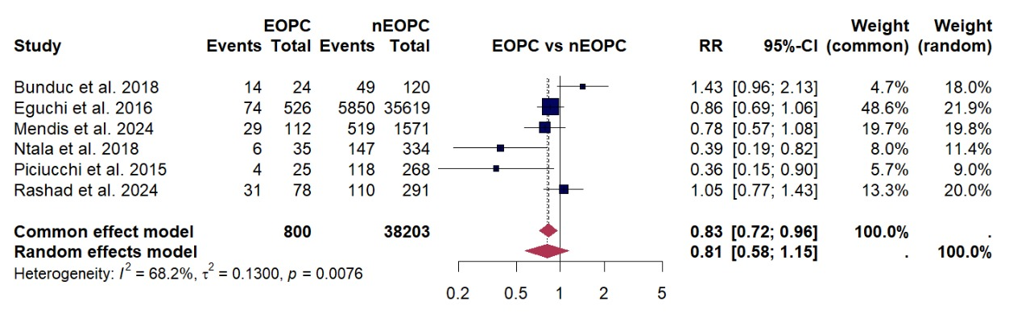

Supplementary Figure S15. Forest plot meta-analysis of new onset diabetes mellitus proportion in EOPC compared to nEOPC
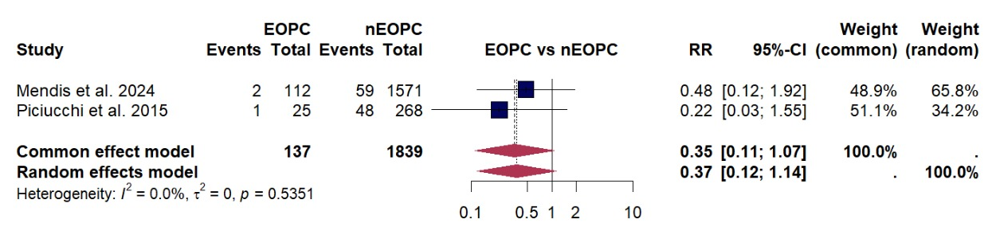

Supplementary Figure S16. Forest plot meta-analysis of pain proportion in EOPC compared to nEOPC
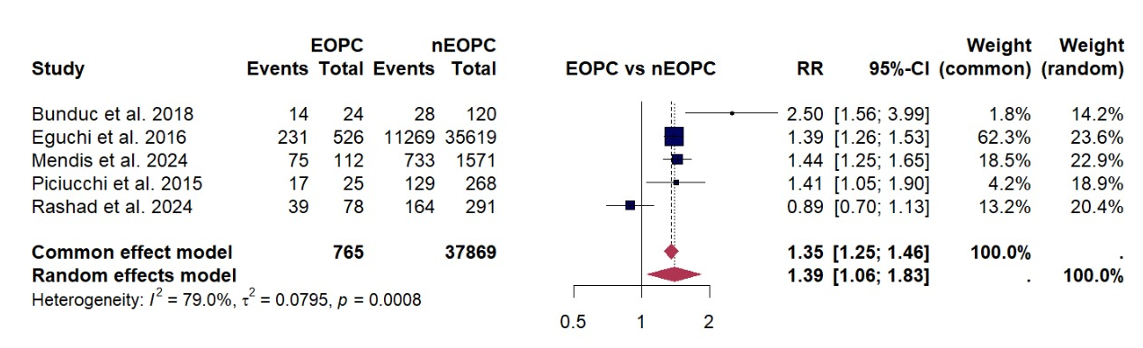

Supplementary Figure S17. Forest plot meta-analysis of weight loss proportion in EOPC compared to nEOPC
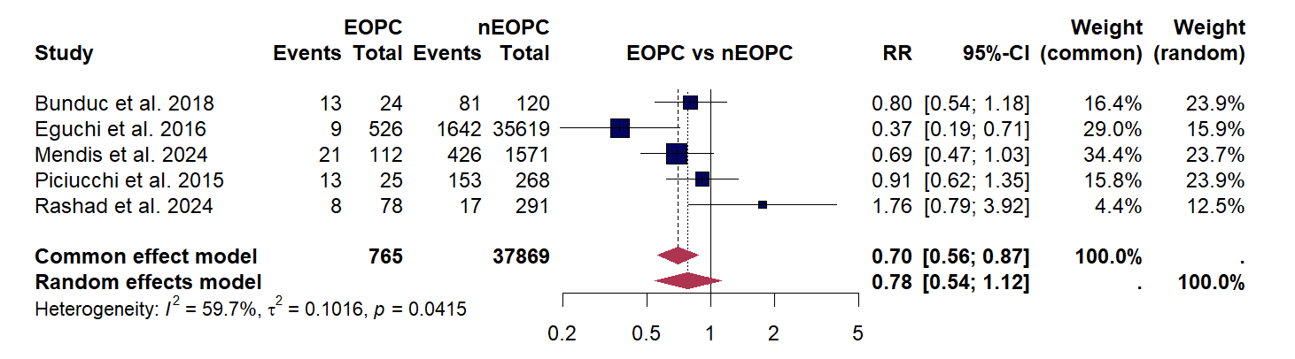

Supplementary Figure S18. Forest plot meta-analysis of Stage T3/T4 proportion in EOPC compared to nEOPC
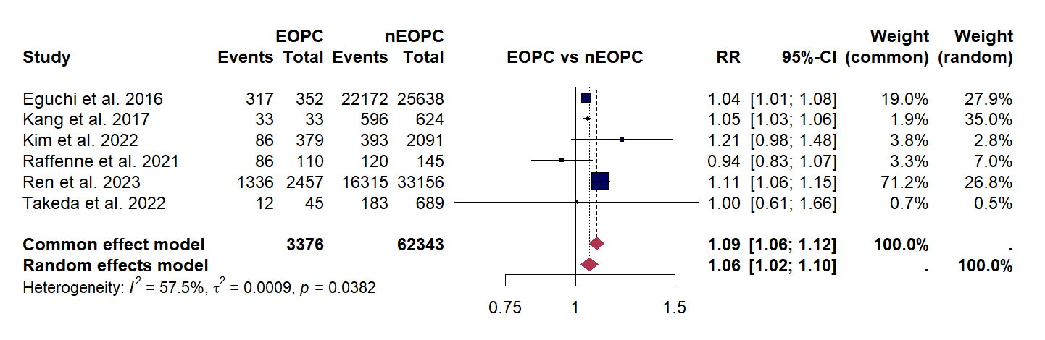

Supplementary Figure S19. Forest plot meta-analysis of N+ proportion in EOPC compared to nEOPC
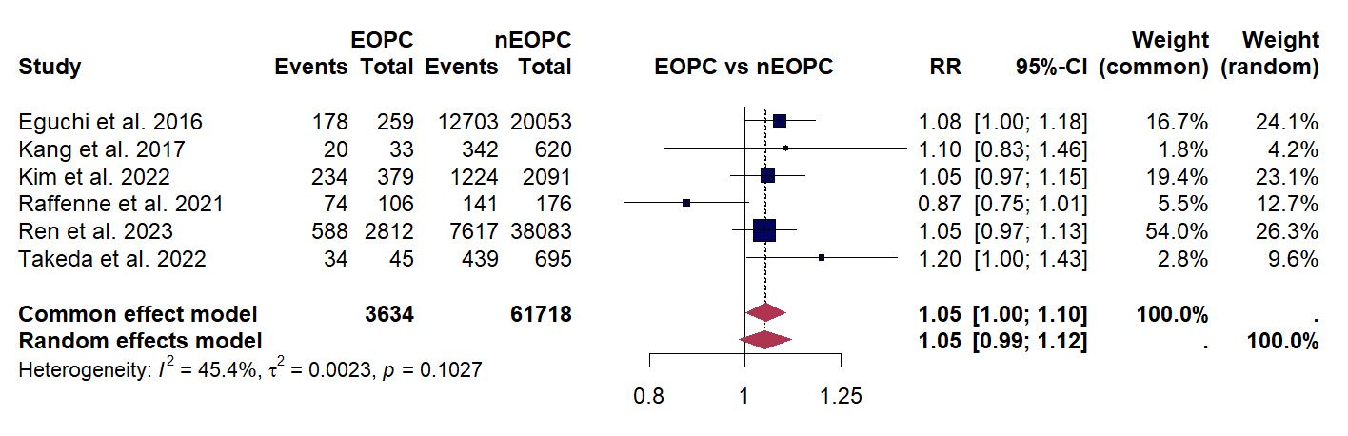

Supplementary Figure S20. Forest plot meta-analysis of Stage III/IV proportion in EOPC compared to nEOPC
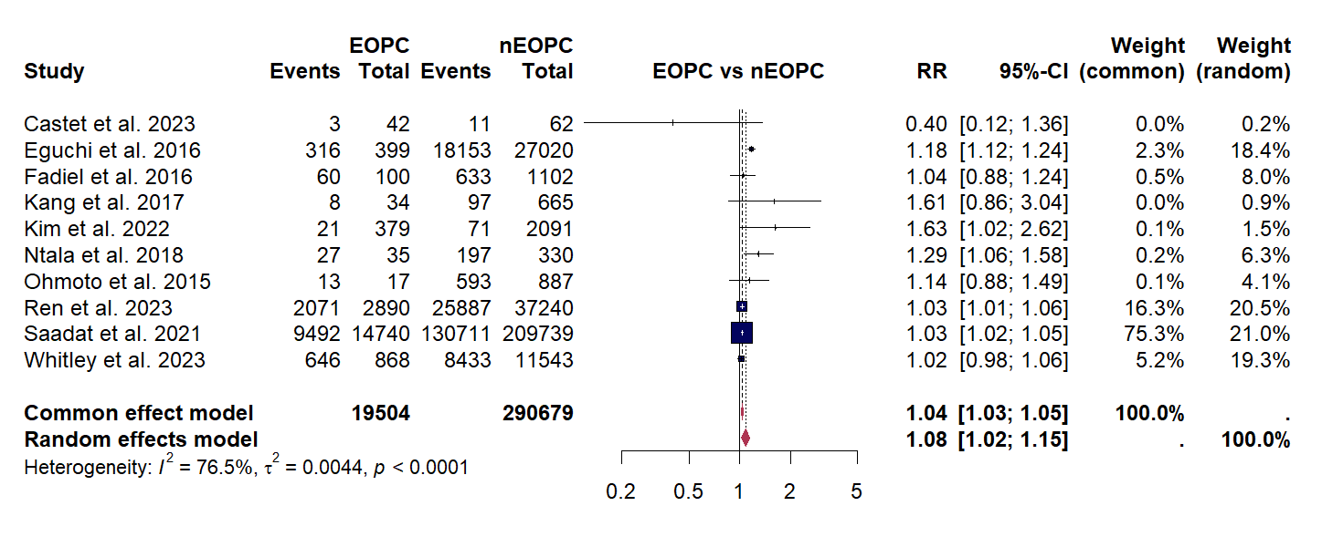

Supplementary Figure S21. Forest plot meta-analysis of locally advanced/metastasis NCCN stage proportion in EOPC compared to nEOPC
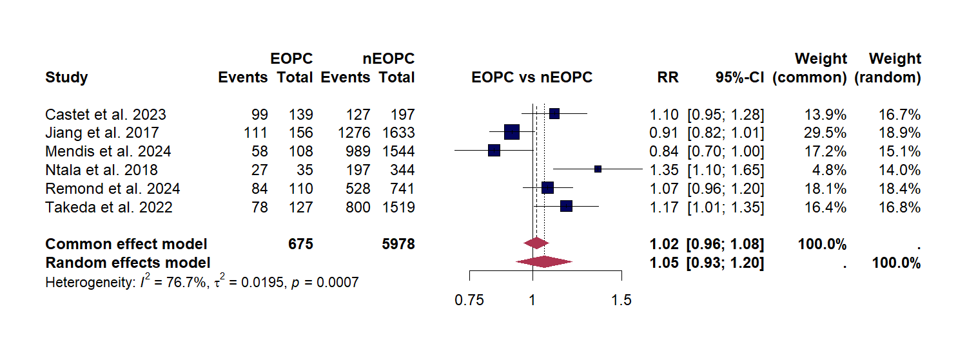

Supplementary Figure S22. Forest plot meta-analysis of body/tail location proportion in EOPC compared to nEOPC
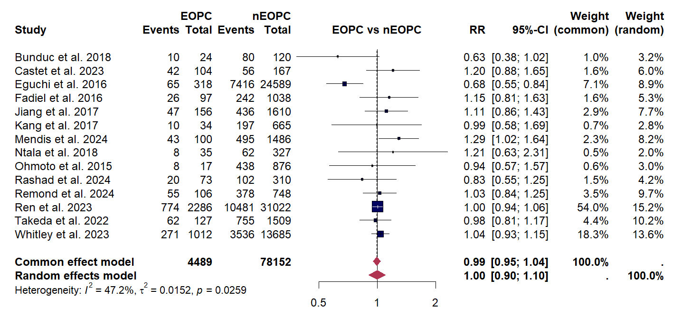

Supplementary Figure S23. Forest plot meta-analysis of well differentiation proportion in EOPC compared to nEOPC
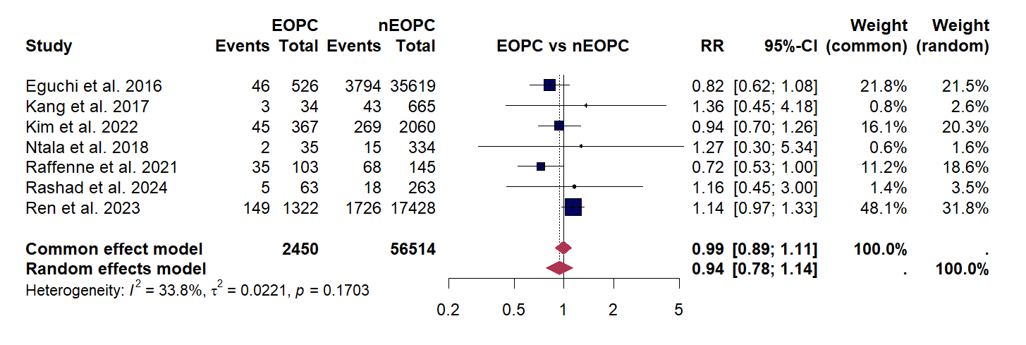

Supplementary Figure S24. Forest plot meta-analysis of moderate differentiation proportion in EOPC compared to nEOPC
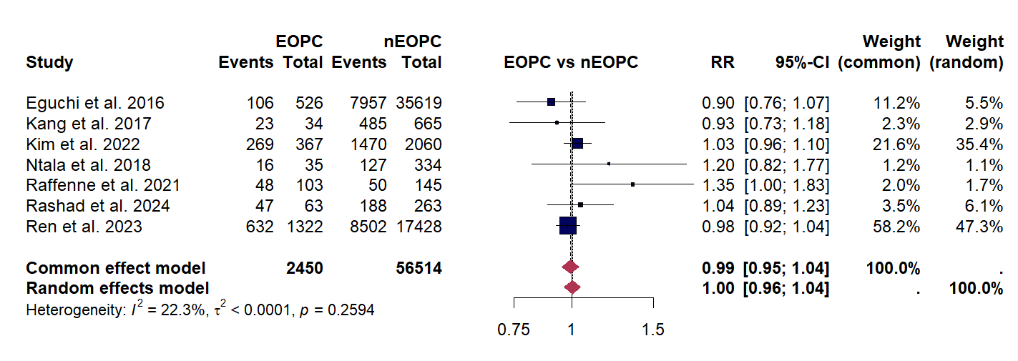

Supplementary Figure S25. Forest plot meta-analysis of poor differentiation proportion in EOPC compared to nEOPC
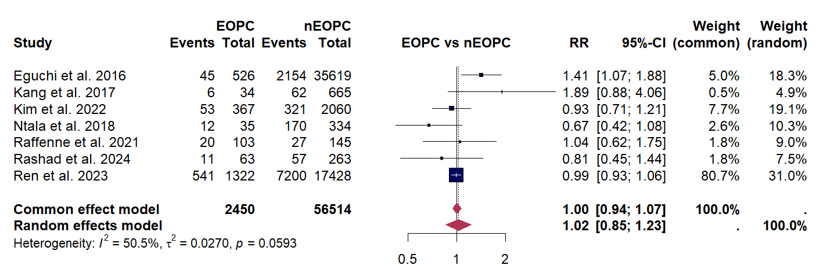

Supplementary Figure S26. Forest plot meta-analysis of tumor size in EOPC compared to nEOPC
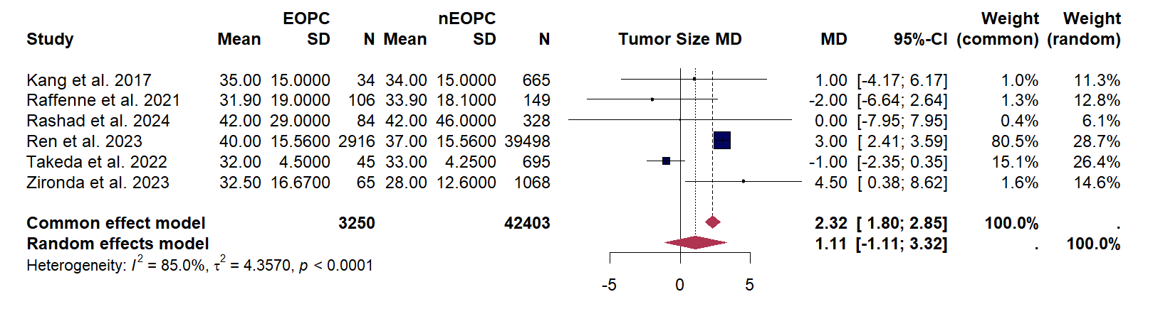

Supplementary Figure S27. Forest plot meta-analysis of lymphovascular involvement proportion in EOPC compared to nEOPC
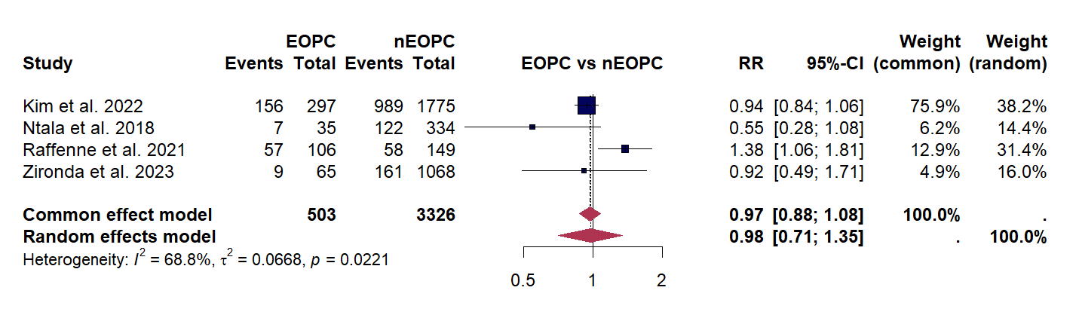

Supplementary Figure S28. Forest plot meta-analysis of perineural involvement proportion in EOPC compared to nEOPC
