Supporting Information
Self-oscillating chemoelectrical interface of solution-gated ion-sensitive field-effect transistor based on Belousov–Zhabotinsky reaction
Toshiya Sakata,^{*1} Shoichi Nishitani,¹ Yusuke Yasuoka,¹ Shogo Himori,¹ Kenta Homma,¹ Tsukuru Masuda,² Aya Mizutani Akimoto,¹ Kazuaki Sawada,³ and Ryo Yoshida¹
¹ Department of Materials Engineering, School of Engineering, The University of Tokyo, 7-3-1 Hongo, Bunkyo-ku, Tokyo 113-8656, Japan
² Department of Bioengineering, School of Engineering, The University of Tokyo, 7-3-1 Hongo, Bunkyo-ku, Tokyo 113-8656, Japan
³ Department of Electrical and Electronic Information Engineering, Toyohashi University of Technology, Tempaku-cho, Toyohashi 441-8580, Japan
*Corresponding author. E-mail: sakata@biofet.t.u-tokyo.ac.jp
CORRESPONDING AUTHOR FOOTNOTE: Affiliation; Department of Materials Engineering, School of Engineering, The University of Tokyo, 7-3-1 Hongo, Bunkyo-ku, Tokyo 113-8656, Japan, TEL; +81-3-5841-1842, FAX; +81-3-5841-1842

Sensor performance parameters of arrayed-gate ISFET sensor

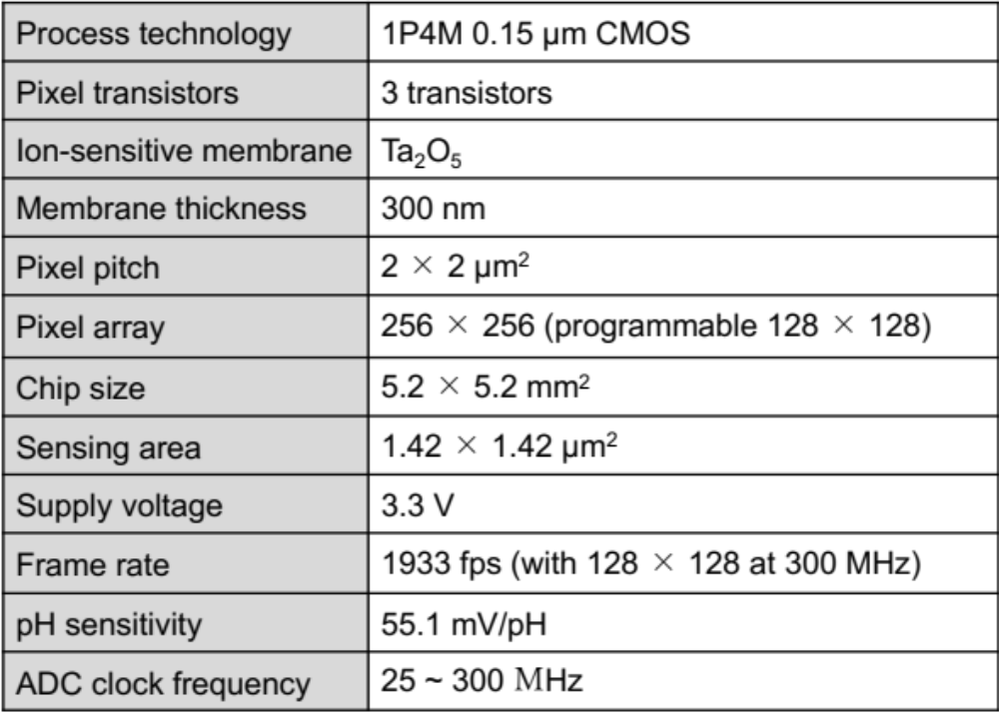
Table S1. Summary of sensor performance parameters.

Fundamental electrical properties of single-gate ISFET sensor
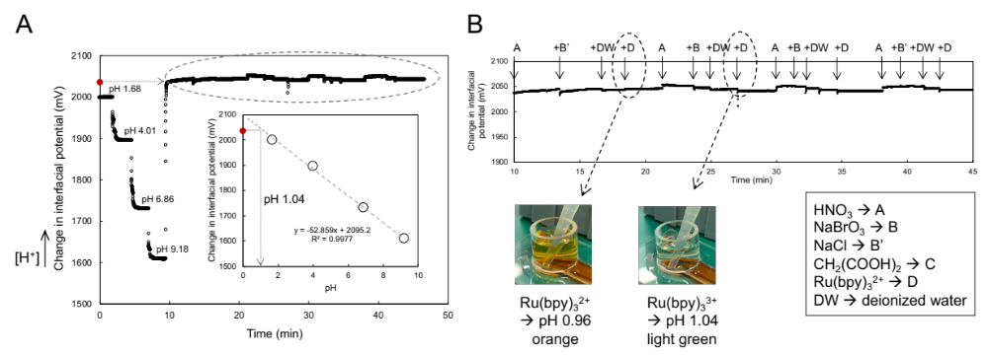
Figure S1. (A) pH response of nonmodified single-gate ISFET sensor. From the calibration line (inset), the single-gate ISFET sensor used in this study was approximately 53 mV/pH. The change in the interfacial potential surrounded by the dotted line was also caused by the addition of each component for the BZ presolution without malonic acid, the pH of which was approximately 1. (B) Change in interfacial potential upon adding each component of BZ solution obtained from (A). At 10 min, the measurement solution was totally exchanged to HNO₃ (1 M, 150 μL), subsequently NaCl (1 M, 75 μL) was added instead of NaBrO₃ and then deionized water (125 μL) was added. After that, Ru(bpy)₃²⁺ 2Cl⁻ (1 mM, 50 μL) was added [see the dotted circle and arrow (left)]. The color of the mixed solution was orange for Ru(bpy)₃²⁺ added to it. On the other hand, when NaBrO₃ was included in the BZ presolution, the mixed solution was light-green for Ru(bpy)₃³⁺ owing to the oxidation reaction [see the dotted circle and arrow (right)]. The pH of the BZ presolution was almost 1.

pH oscillation at 1/2 × χ and 2 × χ using single-gate ISFET sensor
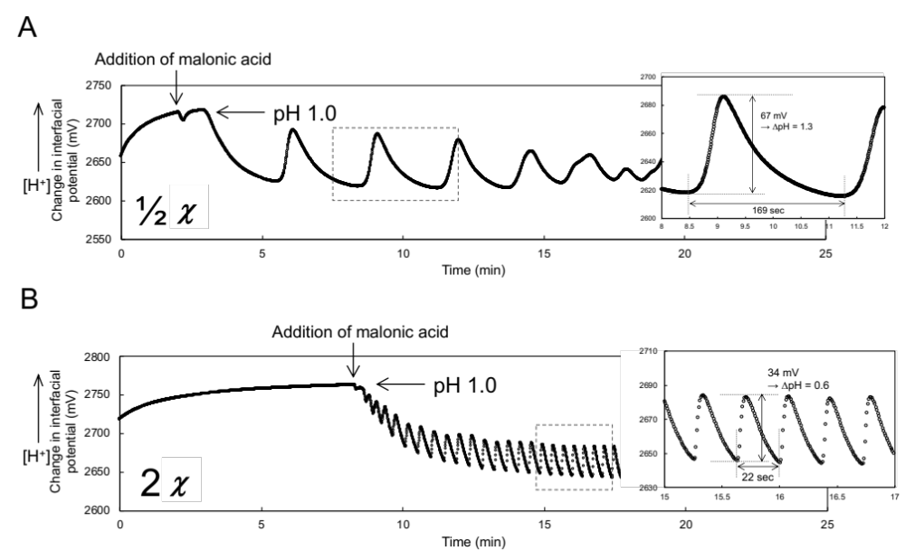
Figure S2. Change in interfacial potential (ΔV_{out}) oscillation based on BZ reaction at 1/2 $×$ χ (A) and 2 $×$ χ (B). ΔV_{out} was regarded as the change in [H⁺] (pH), considering the pH responsivity of single-gate ISFET sensor used in this study.

Change in color of BZ solution based on redox reaction of ruthenium bipyridine complex Ru(bpy)₃^{2+/3+}
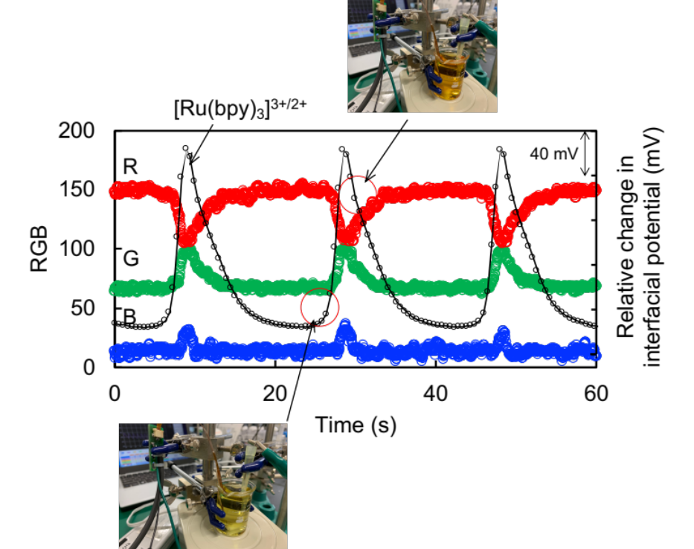
Figure S3. Change in color of BZ reaction at a concentration χ. The cyclic redox reaction was observed from the change in the color of the BZ solution [Ru(bpy)₃²⁺ (orange) $⇄$ Ru(bpy)₃³⁺ (light green) + e⁻]. This analysis was based on Red-Green-Blue (RGB) color model. Corresponding to the RGB analysis, the redox reaction of the ruthenium ion complex on the Pt electrode was measured in accordance with equations 4 and 5 (see “3. Results and Discussion”).

Field, Koros, and Noyes (FKN) mechanism for BZ reaction

Table S2. FKN mechanism
Reaction number Reaction
Process A ${5Br}^{-}+BrO_{3}^{-}+{6H}^{+}⇄{3Br}_{2}+{3H}_{2}O$
- ${Br}^{-}+HOBr+H^{+}⇄{Br}_{2}+H_{2}O$
- ${Br}^{-}+HBrO_{2}+H^{+}⇄2HOBr$
- ${Br}^{-}+BrO_{3}^{-}+{2H}^{+}⇄HOBr+HBrO_{2}$
Process B 4$Ru{\left(bpy\right)}_{3}^{2+}+BrO_{3}^{-}+5H^{+}⇄4Ru{\left(bpy\right)}_{3}^{3+}+HOBr+{2H}_{2}O$
- $2HBrO_{2}⇄HOBr+BrO_{3}^{-}+H^{+}$
- $HBrO_{2}+BrO_{3}^{-}+H^{+}⇄2BrO_{2}^{∙}+H_{2}O$
- $BrO_{2}^{∙}+Ru{\left(bpy\right)}_{3}^{2+}+H^{+}⇄HBrO_{2}+Ru{\left(bpy\right)}_{3}^{3+}$
Process C $10Ru{\left(bpy\right)}_{3}^{3+}+CH_{2}{\left(COOH\right)}_{2}+BrCH{\left(COOH\right)}_{2}+4H_{2}O$
$$⇄10Ru{\left(bpy\right)}_{3}^{2+}+{Br}^{-}+2HCOOH+4CO_{2}+11H^{+}$$
- ${Br}_{2}+CH_{2}{\left(COOH\right)}_{2}⇄BrCH{\left(COOH\right)}_{2}+{Br}^{-}+H^{+}$
- $6Ru{\left(bpy\right)}_{3}^{3+}+CH_{2}{\left(COOH\right)}_{2}+2H_{2}O⇄6Ru{\left(bpy\right)}_{3}^{2+}+HCOOH+2CO_{2}+ 6H^{+}$
- $4Ru{(bpy)}_{3}^{3+}+BrCH{(COOH)}_{2}+2H_{2}O⇄4Ru{(bpy)}_{3}^{2+}+HCOOH+{Br}^{-}+ 2CO_{2}+5H^{+}$

Fundamental electrical properties of arrayed-gate ISFET sensor
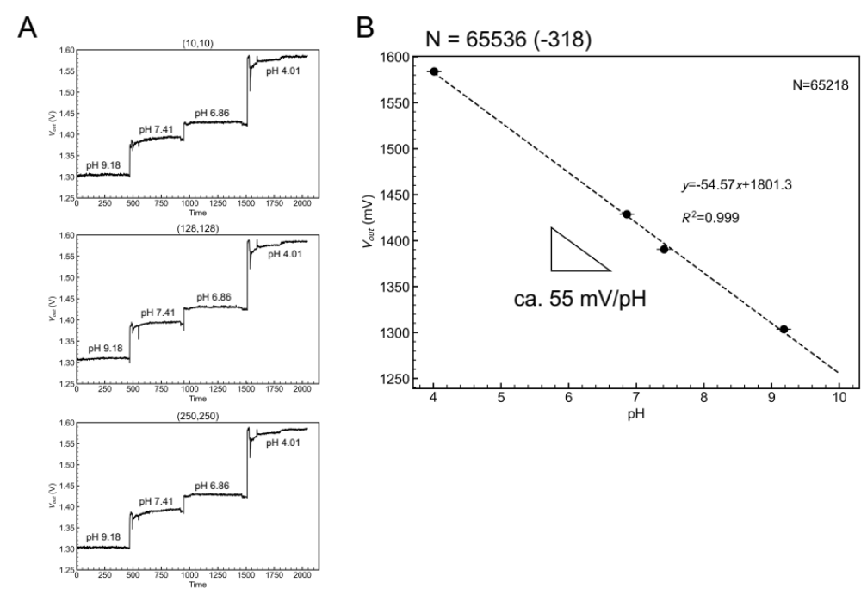
Figure S4. pH responsivity of arrayed-gate ISFET sensor. (A) Real-time monitoring of ΔV_{out} with changing in pH (pH 9.187.416.864.01). Three ISFETs were randomly chosen from among the 256 × 256 ISFETs [(x, y): (10, 10), (128, 128), and (250, 250) for the positions]. (B) Calibration curve of ΔV_{out} with changing in pH for arrayed-gate ISFET sensor (256 $×$ 256). This was based on (A). The standard errors ($±0.02 mV)$ were evaluated for the 256 $×$ 256 ISFETs except for 0.5% electrical failures.

Visualized pH oscillation with arrayed-gate ISFET sensor (see another file for the movie in SI)
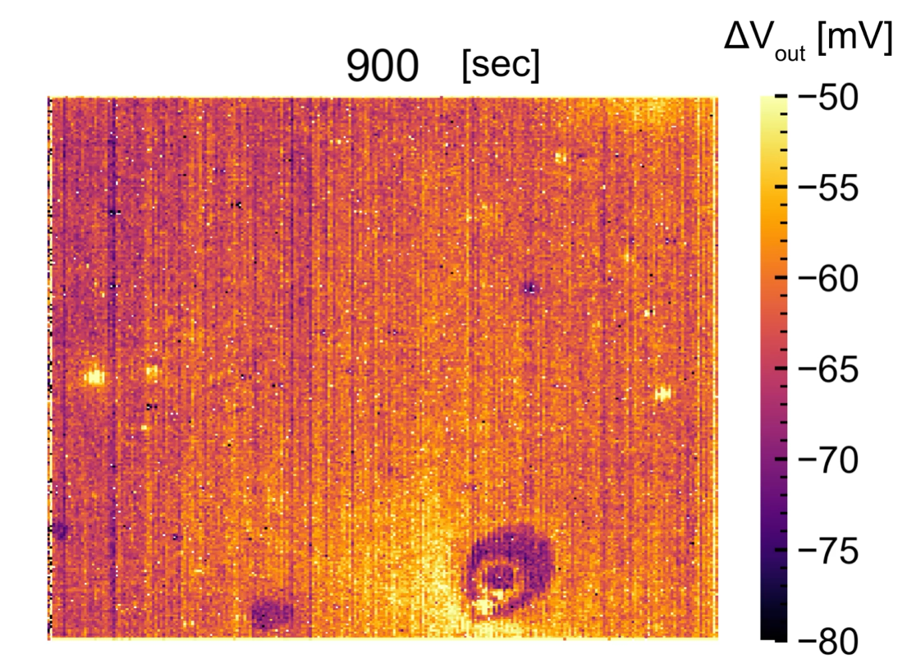

Figure S5. Movie of pH oscillation based on BZ reaction using arrayed-gate ISFET sensor with 256 $×$ 256 pixels. ΔV_{out} corresponds to that shown in Figure 4 [15–25 min (900–1500 s)]. Also, ΔV_{out} indicates the change in [H⁺] (pH). (see another file for the movie in SI)

Thickness of poly(NIPAAm-r-NAPMAm) brush grafted on the Ta₂O₅ gate insulator
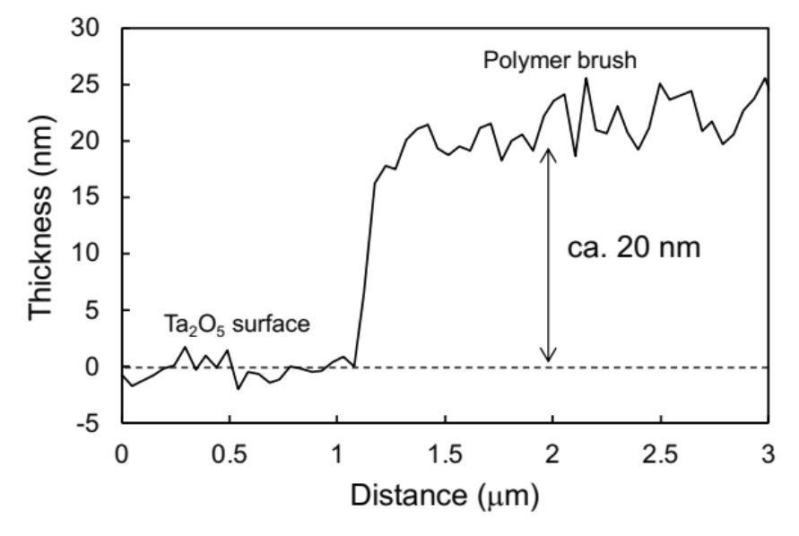
Figure S6. Thickness profile of poly(NIPAAm-r-NAPMAm) brush measured by AFM. The poly(NIPAAm-r-NAPMAm) brush was grafted on Ta₂O₅ surface by SI-ARGET ATRP. The thickness of the polymer film was analyzed to be approximately 20 nm against the unmodified Ta₂O₅ surface. The polymer film on the Ta₂O₅ surface was obtained by covering a part of the Ta₂O₅ surface with a polydimethylsiloxane (PDMS) sheet. The covered part was not modified in the subsequent modification processes, and the PDMS sheet was peeled off from the substrate after the polymerization.

Measurement setup for self-oscillating polymer grafted on Ta₂O₅ gate surface
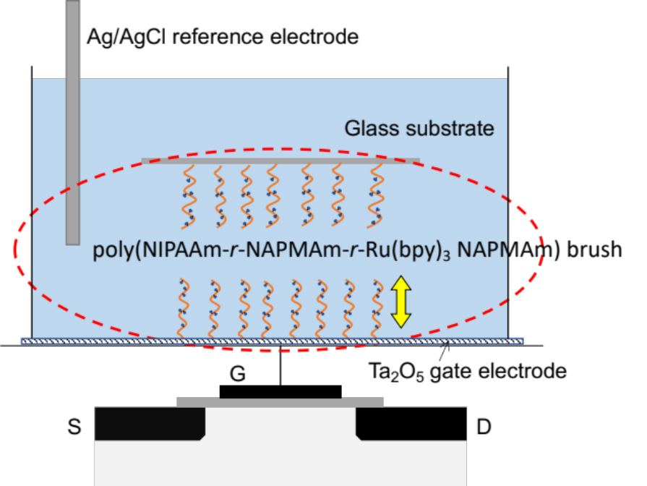
Figure S7. Measurement setup for self-oscillating polymer grafted on Ta₂O₅ gate surface. The glass substrate grafted with the same polymer brush was used to cover over the modified Ta₂O₅ gate surface to prevent the BZ components such as Br⁻ from diffusing away from the active surface, that is, to maintain the BZ reaction at the surface.

