Table S1. The sequences of primers for Coro1a knockdown in Raw264.7
Primer name | Sequence (5'-3')
Coro1a-shNC-F | GATCCCAACAAGATGAAGAGCACCAACTCGAGTTGGTGCTCTTCATCTTGTTGTTTTTG
Coro1a-shNC-R | AATTCAAAAACAACAAGATGAAGAGCACCAACTCGAGTTGGTGCTCTTCATCTTGTTG
Coro1a-sh1-F | GATCCTGACAGCTCTATCCGGTATTTCTCGAGAAATACCGGATAGAGCTGTCATTTTTG
Coro1a-sh1-R | AATTCAAAAATGACAGCTCTATCCGGTATTTCTCGAGAAATACCGGATAGAGCTGTCAG
Coro1a-sh2-F | GATCCGAAGATTCTAACCACGGGTTTCTCGAGAAACCCGTGGTTAGAATCTTCTTTTTG
Coro1a-sh2-R | AATTCAAAAAGAAGATTCTAACCACGGGTTTCTCGAGAAACCCGTGGTTAGAATCTTC
Coro1a-sh3-F | GATCCCCTGCATTATCTTTCCATGTTCTCGAGAACATGGAAAGATAATGCAGGTTTTTG
Coro1a-sh3-R | AATTCAAAAACCTGCATTATCTTTCCATGTTCTCGAGAACATGGAAAGATAATGCAGGG
Table S2. The sequences of primers for Coro1a-mut expression plasmid
Primer name | Sequence (5'-3')
D183A-F | CGGACACAATCTACAGCGTGGCTTGGAGCCGGGACGGTGCTCT
D183A-R | AGAGCACCGTCCCGGCTCCAAGCCACGCTGTAGATTGTGTCCG
D183G-F | CGGACACAATCTACAGCGTGGGCTGGAGCCGGGACGGTGCTCT
D183G-R | AGAGCACCGTCCCGGCTCCAGCCCACGCTGTAGATTGTGTCCG

Table S3. The serum-absorbed components
Number | Time（min） | m/z actual value | Formula | Name
1 | 0.8 | 180.0635 | C₆H₁₂O₆ | 3′-Methoxydaidzin-C16H10O4(cleavage)
2 | 37.79 | 468.1108 | C₁₇H₂₄O₁₅ | 4',6,7-Trihydroxyisoflavone-6-methylether-7-O-beta-D-xylopyranosyl-(1->6)-beta-D-glucopyranoside-C16H10O5(cleavage)+2x(-H2) +C6H8O6
3 | 33.95 | 148.0161 | C8H4O3 | 5-Hydroxymethylfurfural-O(cleavage)+2x(-H2) +C2H2O
4 | 8.8 | 430.0904 | C21H18O10 | Daidzin+O-H2
5 | 43.17 | 709.2197 | C31H39N3O14S | Daidzin-O(cleavage)+2x(+H2)+C10H15N3O6S
6 | 32.79 | 500.0996 | C21H24O12S | Puerarin+2x(+H2)+SO3
7 | 31.96 | 1041.2596 | C43H51N3O25S | Robinin+2x(-H2)+C10H15N3O6S
8 | 0.81 | 382.1089 | C14H22O12 | Robinin-C21H18O9(cleavage)+O-H2+C2H2O
9 | 37.67 | 500.1367 | C18H28O16 | Robinin-C21H18O9(cleavage)-H2+C6H8O6
Table S4. Changes in protein stability after amino acid mutation predicted by DUET and DDMut
Amino acid name | DUET（kcal/mol） | DDMut（kcal/mol）
D183A | -1.022 | -0.95
D183R | -0.518 | 0.22
D183N | -0.921 | -0.15
D183G | -1.394 | -1.12
D183L | -0.012 | 0.2
D183K | -0.601 | -0.02
D183W | -0.559 | -0.03
D183E | -0.698 | -0.11

Figure S1
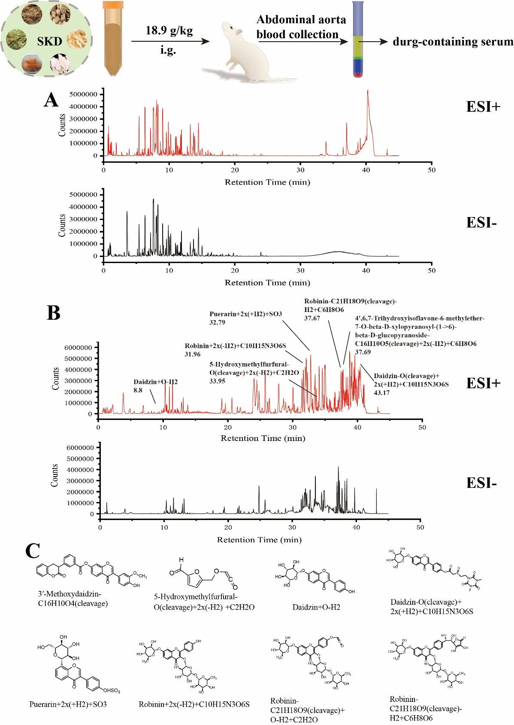
Fig. S1. UPLC-Q-TOF/MS analysis for SKD components and serum components. (A) Comparison of BPI graphs of SKD with ESI⁺ and ESI⁻. (B) Comparison of BPI graphs of SKD serum with ESI⁺ and ESI⁻. (C) The chemical structures of key constituents detected in both modes.

Figure S2
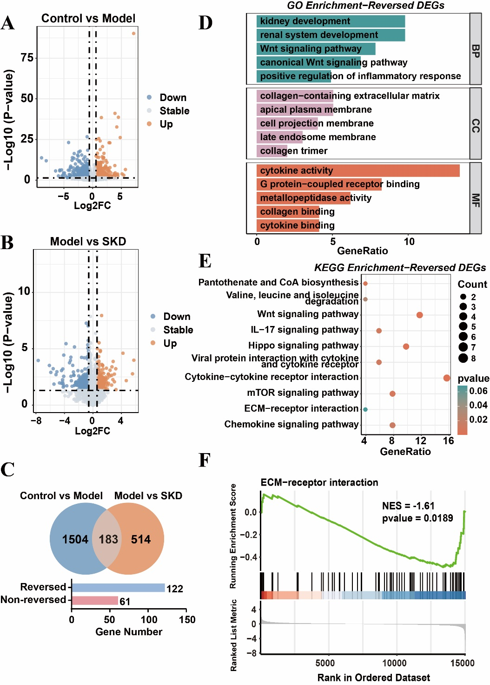
Fig. S2. Effects of SKD treatment on the kidney transcriptome. (A) Volcano plot of DEGs between control and model group. (B) Volcano plot of DEGs between SKD and model group. (C) Venn diagram of DEGs between (model vs. control) and (SKD vs. model). (D) GO enrichment of reversed DEGs. (E) KEGG enrichment of reversed DEGs. (F) GSEA analysis of ECM-receptor interaction.

Figure S3
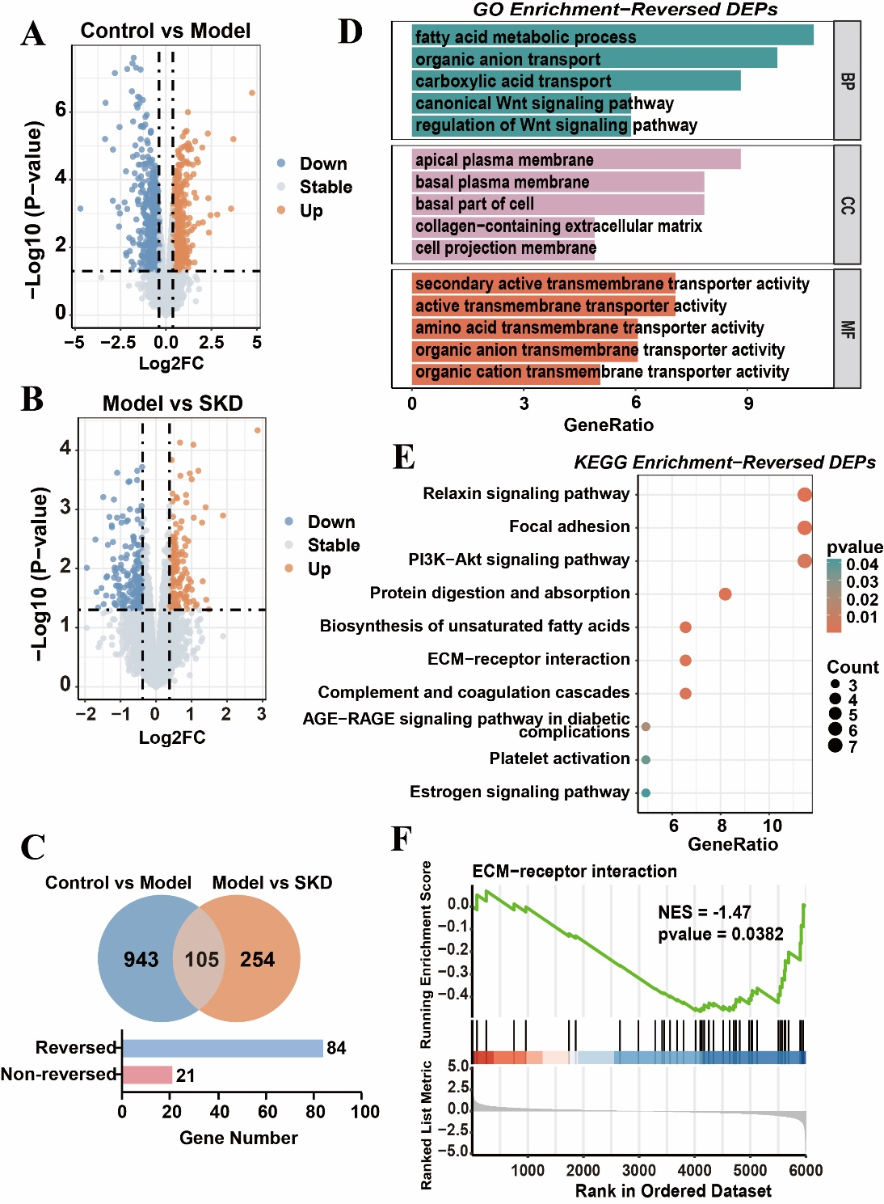
Fig. S3. Effects of SKD treatment on the kidney proteomics. (A) Volcano plot of DEPs between control and model group. (B) Volcano plot of DEPs between SKD and model group. (C) Venn diagram of DEPs between (model vs. control) and (SKD vs. model). (D) GO enrichment of reversed DEPs. (E) KEGG enrichment of reversed DEPs. (F) GSEA analysis of ECM-receptor interaction.

Figure S4
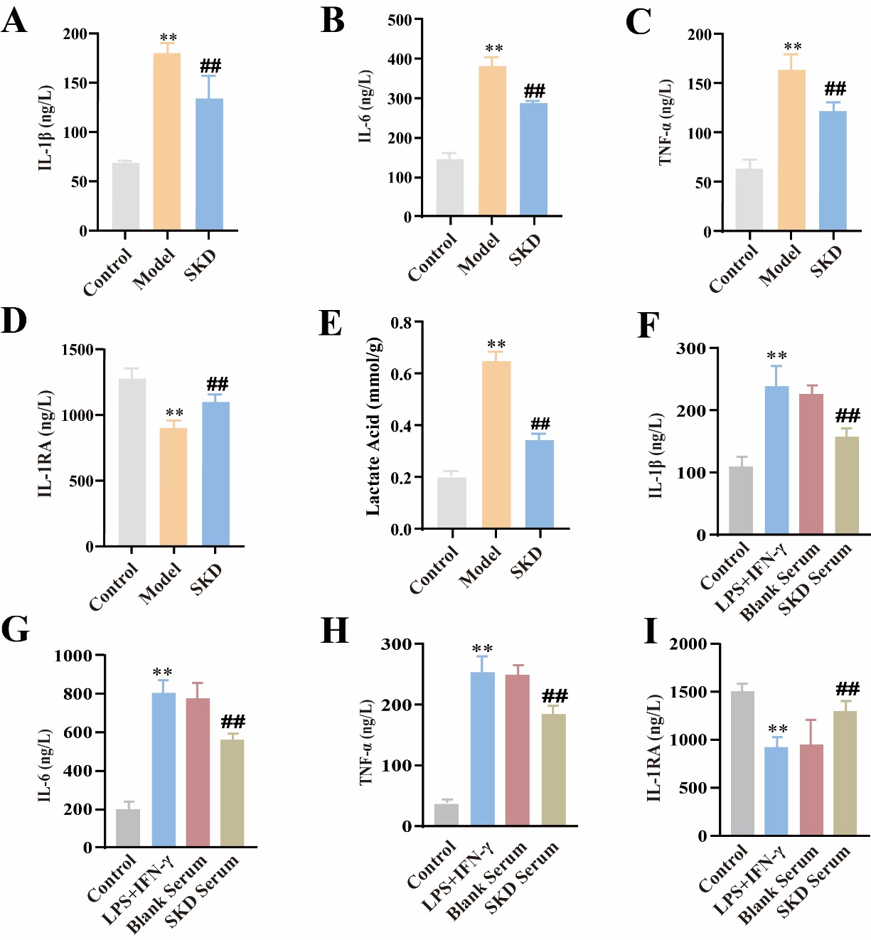
Fig. S4. Effects of SKD treatment on cytokines, and lactate acid in db/db mice and macrophage supernatant. (A-E) The concentrations of IL-1β, TNF-α, IL-6, IL-1RA, and lactate acid in renal tissue homogenate. (F-I) The concentrations of IL-1β, TNF-α, IL-6, IL-10, and IL-1RA in cell supernatant. Data were shown as the mean ± SEM. N=3, *p<0.05, **p<0.01 vs control group; #p<0.05, ##p<0.01 vs model group.

Figure S5
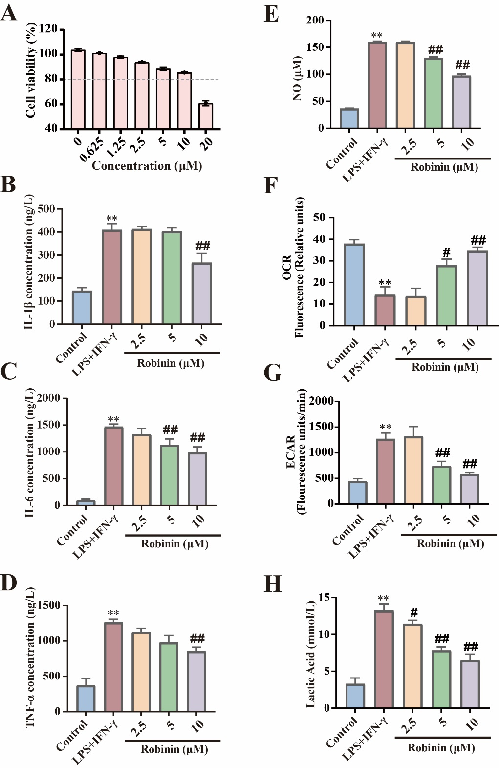
Fig. S5. Evaluation of the anti-inflammatory efficacy of Robinin. (A) CCK-8 analysis results. (B-E) The concentrations of IL-1β, TNF-α, IL-6, and NO in cell supernatant. (F-H) The OCR, ECAR, and lactate acid level in RAW264.7 cells. Data were shown as the mean ± SEM. N=3, *p<0.05, **p<0.01 vs control group; #p<0.05, ##p<0.01 vs LPS+IFN-γ group.

Figure S6
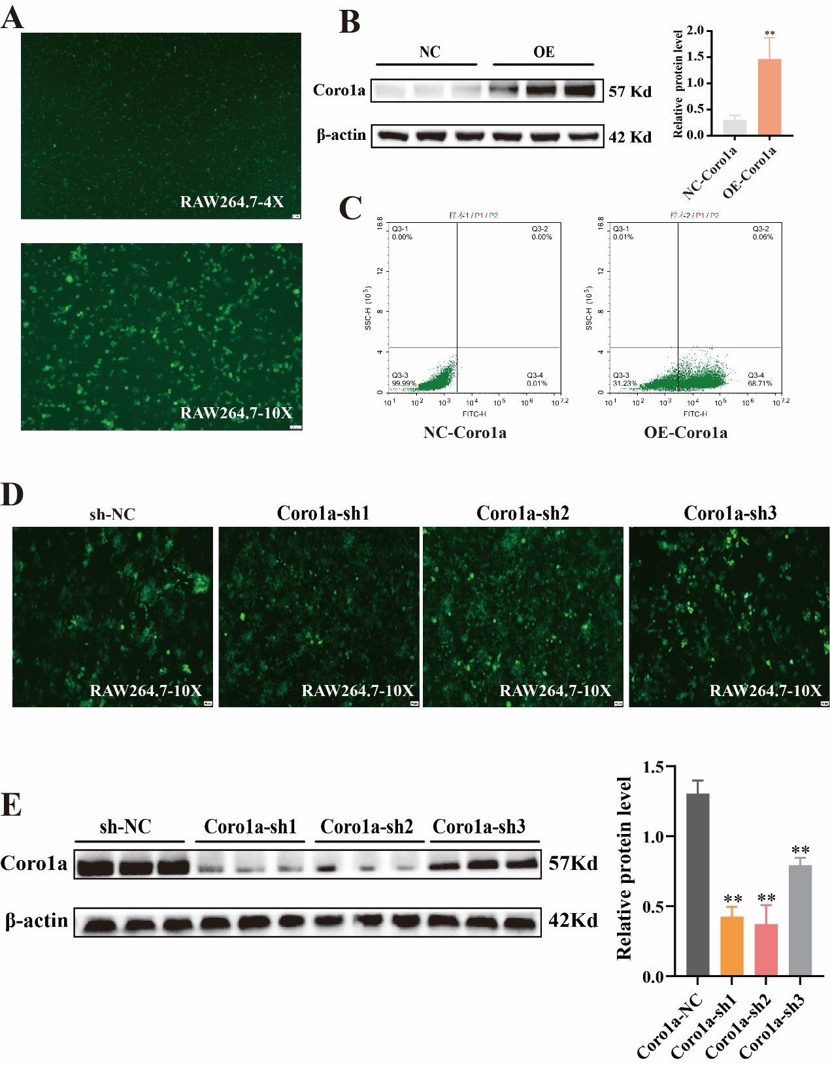
Fig. S6. Construction of macrophage stable cell lines with overexpression and knockdown. (A) Fluorescence intensity of macrophages with Coro1a overexpression. (B, C) WB validation of overexpression and flow cytometry detection of transfection efficiency. (D, E) Fluorescence intensity of macrophages with Coro1a knockdown and WB validation.
Figure S7
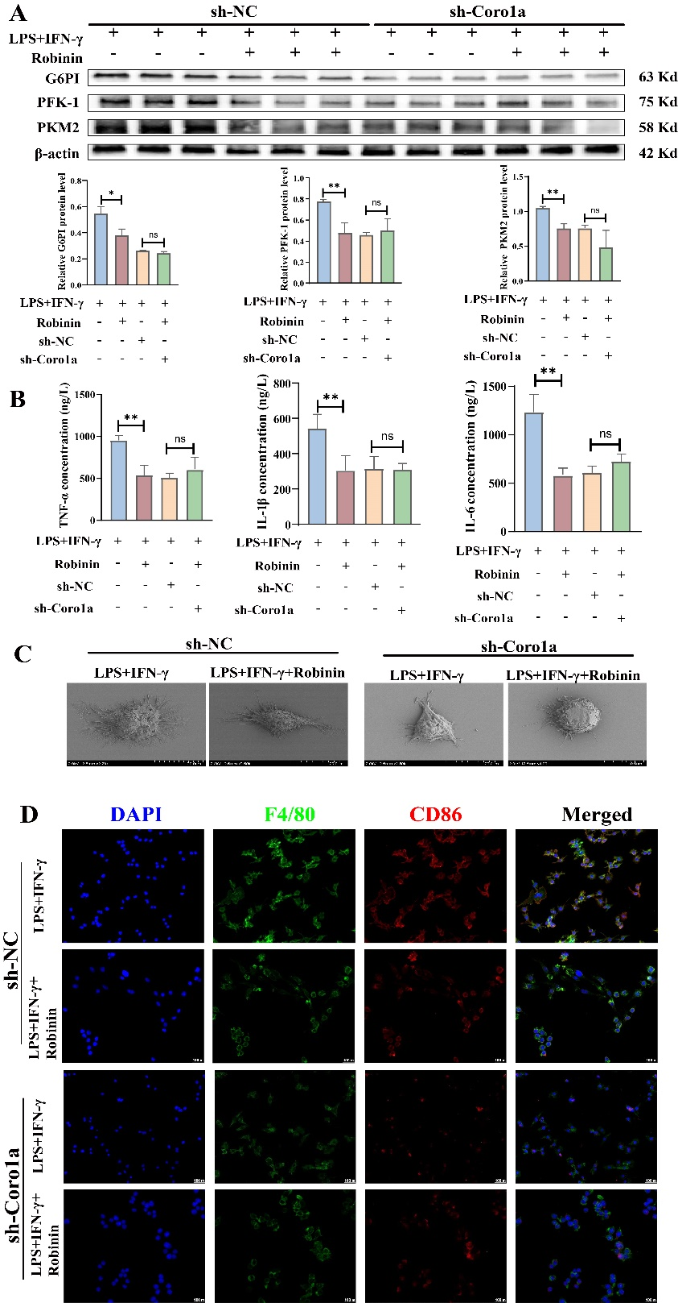
Fig. S7. The anti-inflammatory efficacy of Robinin is abolished upon Coro1a knockdown in macrophages. (A) Protein expression levels of G6PI, PFK-1, and PKM2 in cells. (B) SEM results of morphological changes in macrophages. (C) The concentrations of IL-1β, TNF-α, IL-6 in cell supernatant. (D) Immunoﬂuorescence staining of F4/80 and CD86 in RAW264.7 cells. Data were shown as the mean ± SEM. N=3, *p<0.05, **p<0.01 vs LPS+IFN-γ group.

