Table 1: Patient demographic and clinical parameters by COVID-19 severity groups for patients with first sample at DPSO≤11.
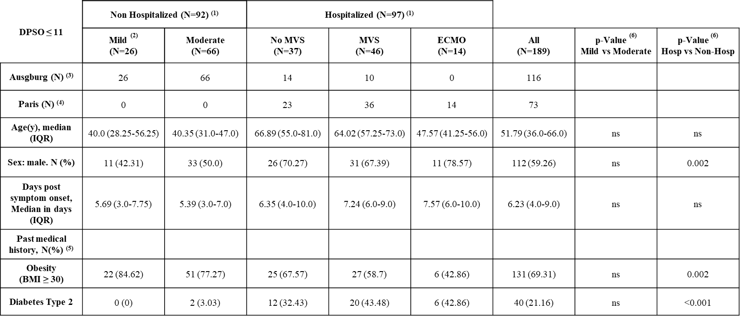
(1) Hospitalized patients are patients being hospitalized due to their SARS-CoV-2 infection while non-hospitalized patients were recovering at home,
(2) N=5 asymptomatic patients included here within the Mild group.
(3) Patients included in Augsburg from the Early-Opt (n=83), CoVaKo-Augsburg (n=9)³⁵ and University Hospital Augsburg (n=23) cohorts.
(4) Patients included in Paris from our Dorgham et al³² study.
(5) Past medical history given here concisely only for the 2 most prevalent conditions, more details in Supplementary Methods section.
(6) Hospitalized versus non-hospitalized and mild versus moderate patients were compared using Mann-Whitney or Fisher Exact tests as mentioned in methods.

Table 2: Biomarkers and biomarker combinations allowing early accurate prediction of COVID-19 hospitalization risk (A, DPSO≤11) and moderate versus mild disease in non-hospitalized patients (B, DPSO≤6).
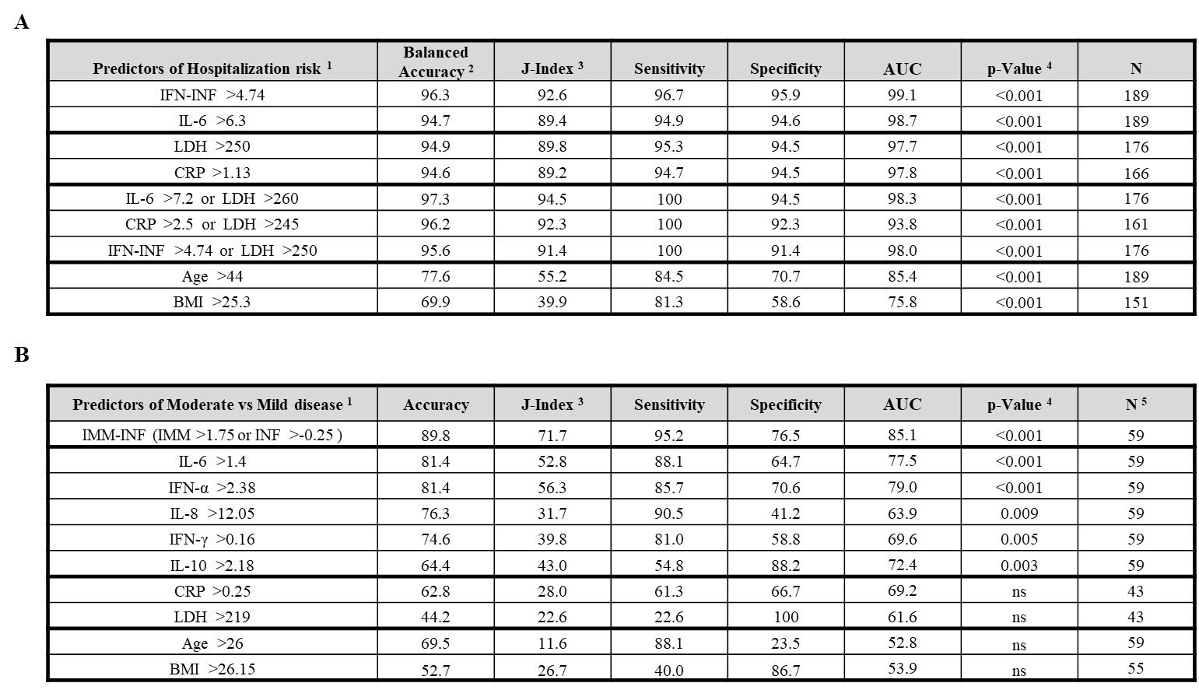
(1) The threshold used for prediction was selected as the point with highest J-index on the corresponding ROC curve.
(2) For prediction of Hospitalization risk, Balanced Accuracy ((Sensitivity+Specificity)/2) is used instead of Accuracy, since the ratio of hospitalized to non-hospitalized patient numbers in this study does not represent real world ratios. For the same reason, Odds Ratio, Positive Predictive Value and Negative Predictive Value were not given.
(3) Youden J- Index (Informedness, defined by Specificity + Sensitivity -1) was used to assess predictive value.
(4) Statistical significance of the prediction was assessed by Fisher-Exact Test on the confluence table.
(5) For the prediction of moderate disease course only patients with first sample at DPSO≤6 were used.
LDH [log U/l]; CRP [log mg/dl]; All cytokines [log pg/ml].
IFN-INF function is defined by: log(2*IL-6*IL-10*TNF-α/IFN-α)
IMM-INF function is defined by: (log(IL-6)+ log(IL-8) >1.75) OR (log(IFN-α)+ log(IFN-γ) >-0.25)

