Supplementary Materials

Limiting internal short-circuit damage by self-fusing tabs for high-safety lithium-ion batteries

Yang Li¹, Zhining Zhang¹, Xinyu Liu¹, Yubai Li^{1*}, Hao Cui², Zhifu Zhou³,
Wei-Tao Wu⁴, Lei Wei⁵, Chengzhi Hu¹, Linsong Gao⁶, Yongchen Song^{1*}

1. Key Laboratory of Ocean Energy Utilization and Energy Conservation of Ministry of Education, Dalian University of Technology, Dalian 116024, China
2. State Key Laboratory of Fine Chemicals, Department of Chemical Machinery and Safety Engineering, Dalian University of Technology, Dalian, Liaoning 116024, China
3. State Key Laboratory of Multiphase Flow in Power Engineering, Xi'an Jiaotong University, Xi'an 710049, China
4. School of Mechanical Engineering, Nanjing University of Science and Technology, Nanjing 210094, China
5. Department of Mechanical and Energy Engineering, Southern University of Science and Technology, Shenzhen 518055, China
6. School of Mechanical Engineering and Mechanics, Xiangtan University, Xiangtan 411105, China
*Corresponding author: liyubai2021@126.com, songyc@dlut.edu.cn

This supplementary material includes:
Supplementary Figure 1 to 35
Supplementary Note 1
Supplementary Table 1
Captions for Supplementary Video 1 to 3

Other supplementary materials for this manuscript include the following:
Supplementary video 1. Suppression of thermal runaway in NCM811 cells by self-fusing tabs under electrical abuse.
Supplementary video 2. Suppression of thermal runaway across different battery chemistries by self-fusing tabs under electrical abuse.
Supplementary video 3. Suppression of thermal runaway in NCM811 cells by self-fusing tabs under mechanical abuse.
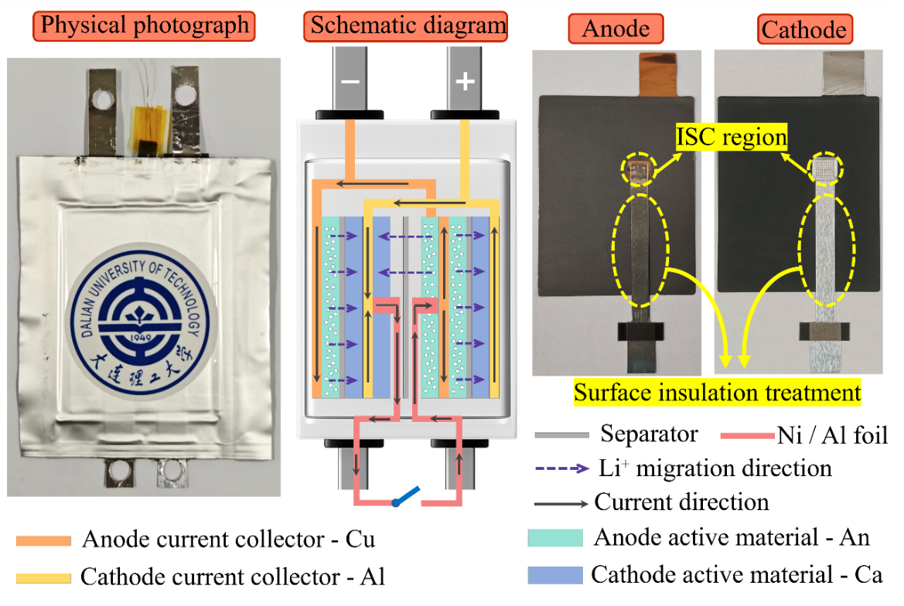
Supplementary Figure 1. Design of the pouch cell with controllable ISC triggering. The photograph on the left shows the pouch cell used for ISC triggering experiments. The central schematic illustrates the internal cell architecture coupled to an external switch. Ni and Al foils were introduced at predefined interfaces and connected to the external switch, enabling precise control over the location and timing of ISC initiation. Photographs of the anode and cathode sheets are shown on the right, with the yellow dashed outlines marking the predefined ISC regions. Purple dashed arrows denote the direction of Li⁺ migration, whereas black arrows indicate the direction of the short-circuit current. Cu, Al, An and Ca denote the anode current collector, cathode current collector, anode active material and cathode active material, respectively.

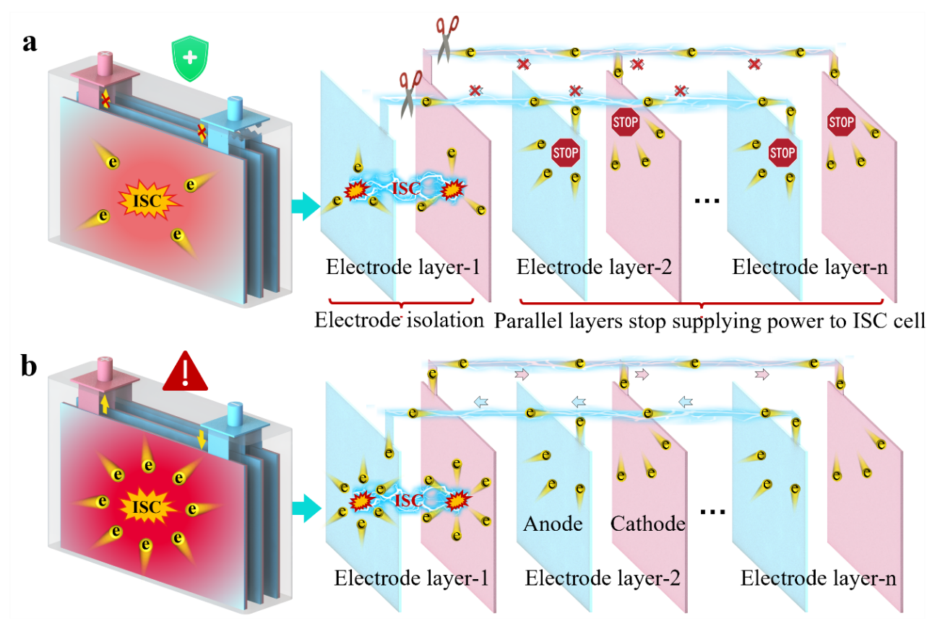
Supplementary Figure 2. Effect of the electrical connection between the faulted layer and the intact parallel-connected layers on energy input to the short-circuit site. a, Schematic of the ISC process under electrical-isolation conditions. The short circuit is confined within a single electrode layer, and the electronic pathway between the faulted layer and the neighbouring parallel-connected layers is interrupted. The intact layers are therefore prevented from supplying energy to the short-circuit site, thereby limiting localized heat generation. b, Schematic of the ISC process without electrical isolation. When the faulted layer remains connected in parallel with the neighbouring intact layers, electrons from the surrounding layers continuously flow towards the short-circuit site, driving progressive Joule heat accumulation and markedly increasing the risk of thermal runaway. This comparison identifies sustained energy input from the intact parallel-connected layers as the key driver transforming a localized ISC into cell-wide thermal runaway.

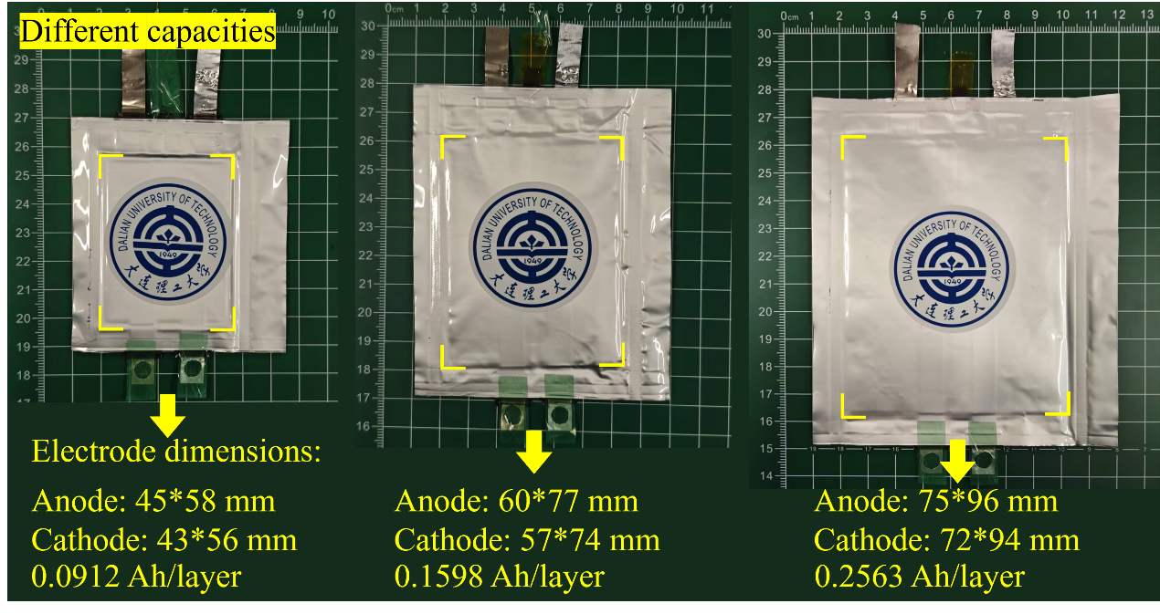
Supplementary Figure 3. Photographs and electrode dimensions of pouch cells with different single-layer capacities. Three pouch cells of different sizes were used to evaluate the effect of increasing single-layer capacity on heat generation during ISC. The yellow dashed boxes indicate the active electrode areas. From left to right, the single-layer capacities are 0.0912, 0.1598 and 0.2563 Ah per layer. The corresponding anode dimensions are 45×58, 60×77 and 75×96 mm², respectively, and the cathode dimensions are 43×56, 57×74 and 72×94 mm², respectively. This comparison demonstrates that, without energy input from the parallel-connected layers, increasing the capacity of the shorted layer alone is insufficient to trigger cell-level thermal runaway.

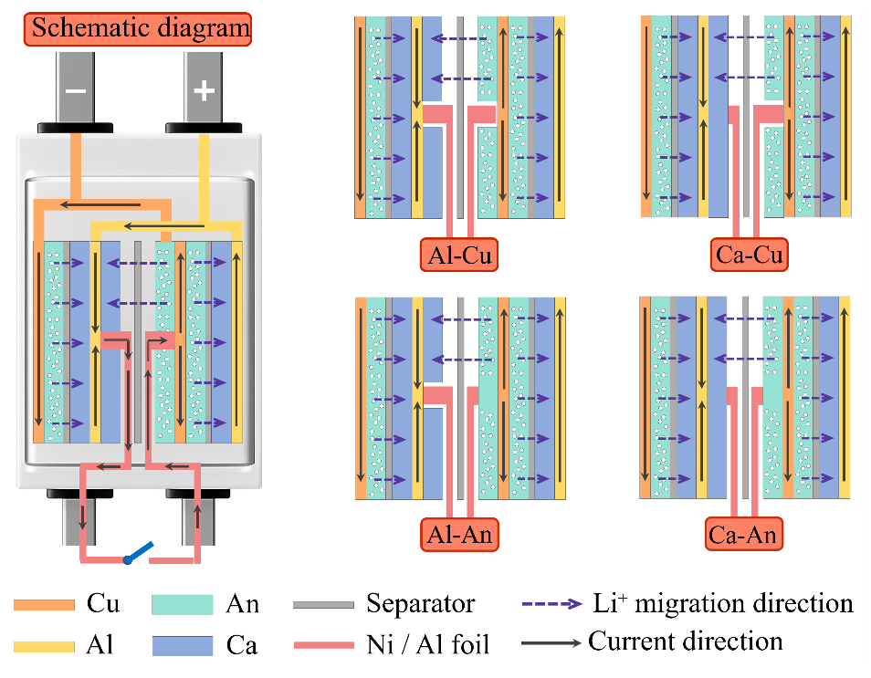
Supplementary Figure 4. Schematics of different ISC configurations used in the controlled ISC experiments. The schematic on the left shows the short-circuit triggering architecture within the pouch cell. Ni and Al foils were introduced at selected electrode interfaces and connected to an external switch, enabling controlled initiation of ISC at prescribed locations. The schematics on the right illustrate four representative ISC configurations: cathode current collector-anode current collector shorting (Al-Cu), cathode active material-anode current collector shorting (Ca-Cu), cathode current collector-anode active material shorting (Al-An), and cathode active material-anode active material shorting (Ca-An). This design enables systematic comparison of the effects of ISC configuration on short-circuit current, Joule heat accumulation and thermal-runaway initiation.

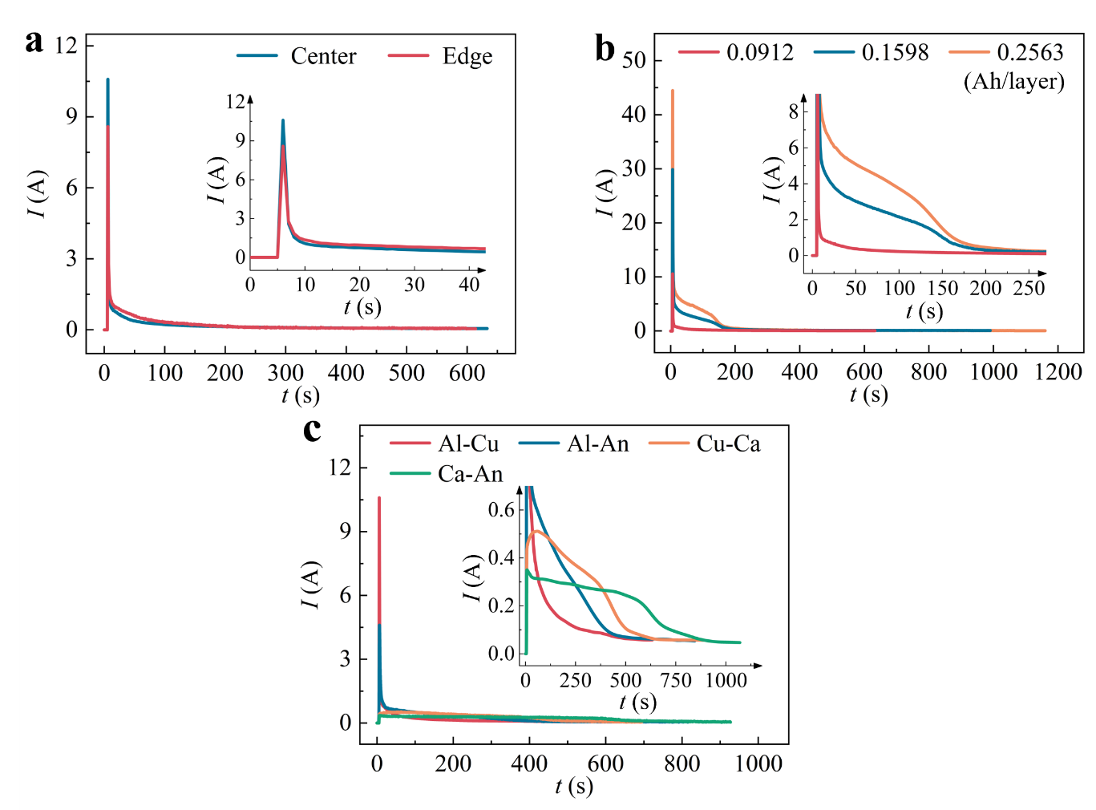
Supplementary Figure 5. Transient short-circuit current responses of isolated single electrode layers under different ISC conditions. a, Transient current responses for ISC initiated at the centre and edge of the cell. The inset shows an expanded view of the current evolution immediately after ISC initiation. b, Transient current responses for ISC initiated in electrode layers with single-layer capacities of 0.0912, 0.1598 and 0.2563 Ah. The inset shows an expanded view of the low-current region. c, Transient current responses for four ISC configurations: Al-Cu, Al-An, Cu-Ca and Ca-An. The inset shows an expanded view of the low-current region. Although the low-contact-resistance Al-Cu configuration produces the largest transient short-circuit current, the current rapidly decays in the absence of sustained energy input from the parallel-connected layers, preventing the sustained Joule heating required to initiate thermal runaway.

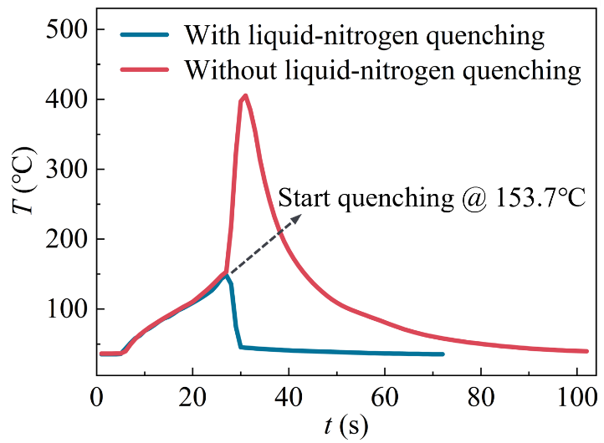
Supplementary Figure 6. Temperature response during liquid-nitrogen quenching immediately before thermal runaway. The red trace shows the temperature evolution of an unquenched control cell, which exhibited a rapid temperature rise following ISC initiation and ultimately underwent thermal runaway. The blue trace shows the response of a cell quenched in liquid nitrogen at the critical pre-runaway stage. Quenching was initiated when the cell temperature reached 153.7℃, after which the temperature decreased sharply, demonstrating that quenching in liquid nitrogen effectively arrested the sustained temperature rise induced by the ISC. This rapid-quenching protocol preserved the electrode structure immediately before thermal runaway, enabling further elucidation of the evolution of cathode phase transitions under critical thermal conditions.

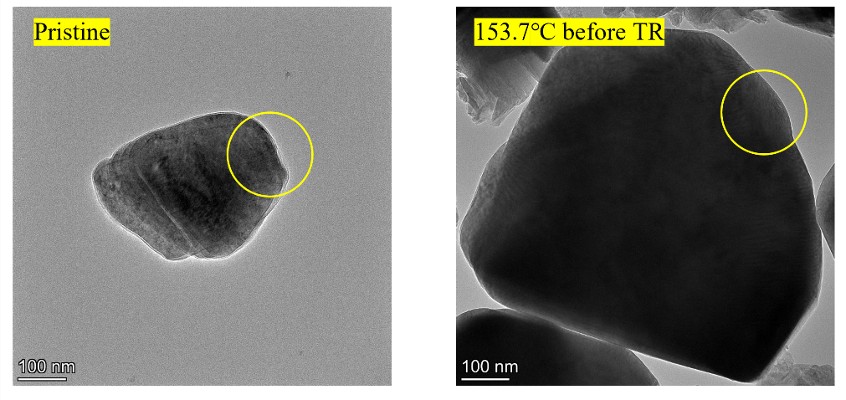
Supplementary Figure 7. TEM images of pristine NCM811 cathode particles (left) and particles quenched in liquid nitrogen at 153.7 ℃ immediately before thermal runaway (right). The yellow circles indicate the regions selected for SAED analysis.

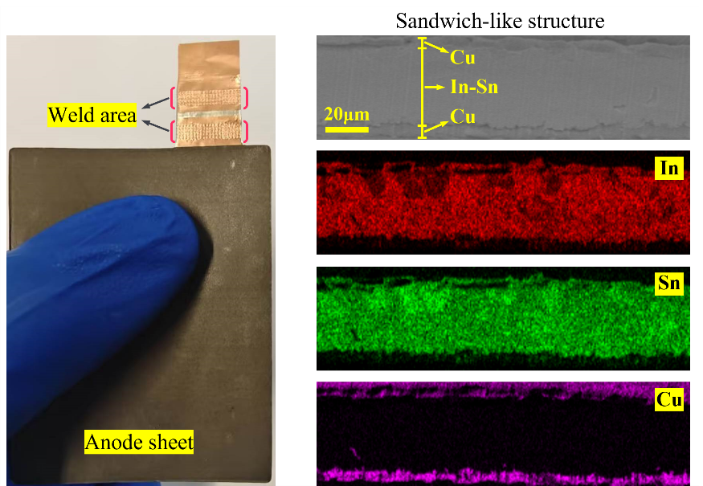
Supplementary Figure 8. Interfacial morphology and elemental distribution in the welded region of the self-fusing tab. The photograph on the left shows an anode sheet incorporating a self-fusing tab, in which the In-Sn alloy is integrated into the anode tab region by ultrasonic welding to form a localized thermally responsive current-interruption unit. The cross-sectional SEM image of the welded region (upper right) reveals a well-defined Cu/In-Sn/Cu sandwich structure with continuous interfaces between the In-Sn alloy and the Cu layers. The corresponding EDS elemental maps (lower right) show that In and Sn are homogeneously distributed within the central alloy layer, whereas Cu is concentrated primarily in the two outer layers. These results confirm that ultrasonic welding provides robust interfacial bonding and a continuous conductive pathway, thereby ensuring reliable electron transport through the self-fusing tab under normal charge-discharge conditions.

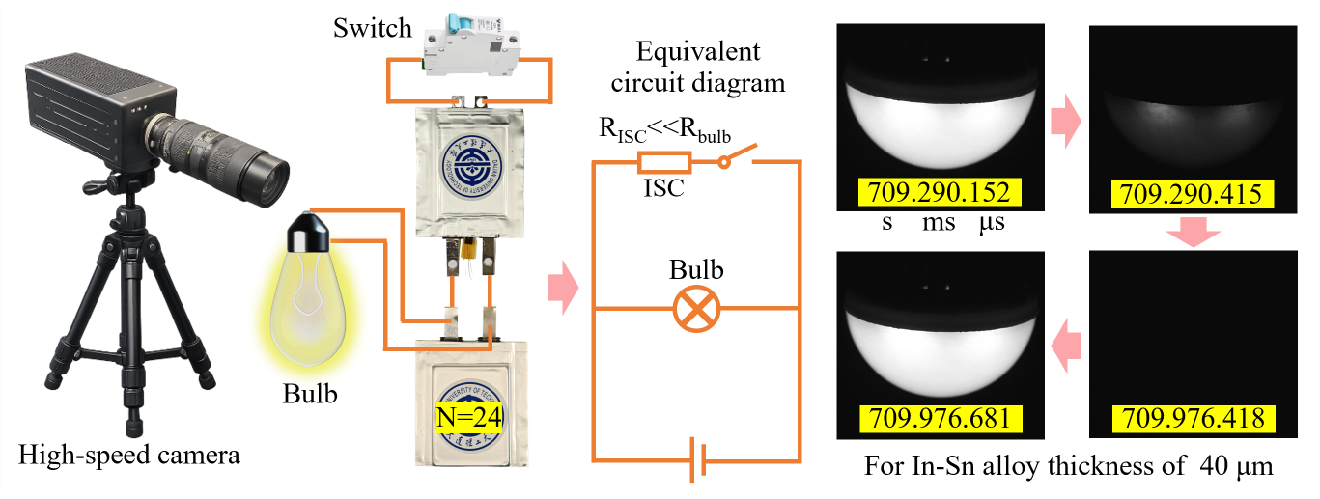
Supplementary Figure 9. High-speed imaging method for determining the fusing isolation of the self-fusing tab. The image on the left shows the experimental setup used to capture the rapid fusing of the In-Sn alloy. A controllable ISC single-layer cell incorporating a self-fusing tab is positioned above a 24-layer power-supplying cell connected in parallel. The layer number, N=24, corresponds to the critical threshold for thermal-runaway initiation under the present ISC conditions. The schematic in the centre shows the equivalent circuit of the measurement system. With the switch open, the ISC has not yet been triggered, and current flows through the bulb branch, keeping the bulb illuminated. When the switch is subsequently closed, the ISC is triggered. Because R_{ISC} < R_{bulb}, current is diverted through the low-resistance short-circuit branch and the bulb turns off. Once the In-Sn alloy fuses under the short-circuit current surge, the short-circuit pathway is interrupted, redirecting the current through the bulb branch and relighting the bulb. The time interval between bulb extinction and relighting is therefore defined as the fusing time. The high-speed image sequence on the right shows the bulb switching from illuminated to extinguished and then back to illuminated for a 40-μm-thick In-Sn alloy under ISC conditions. The alloy fuses within 1 s, rapidly interrupting the short-circuit pathway and demonstrating the rapid response of the self-fusing tab to hazardous short-circuit currents.

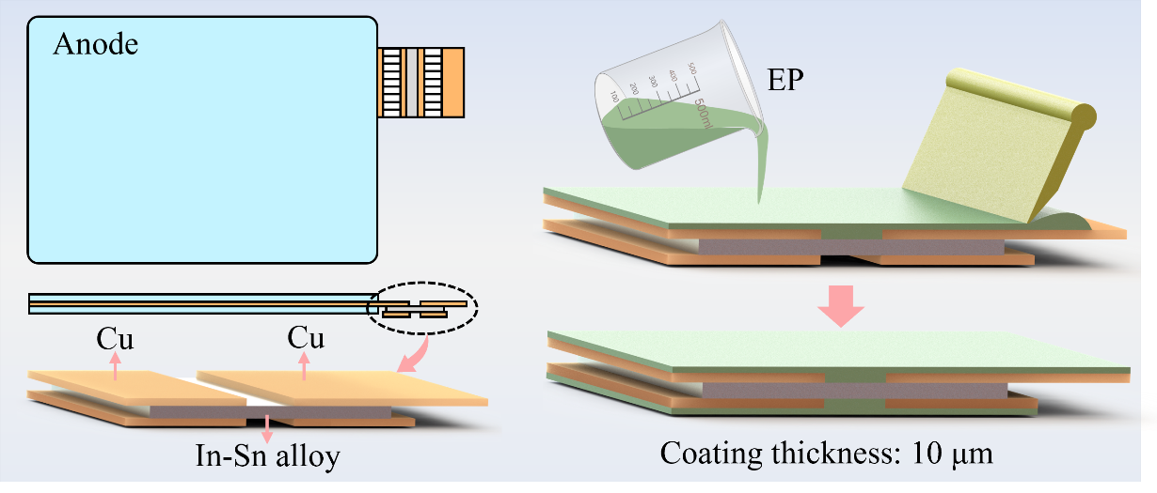
Supplementary Figure 10. Schematic of the surface coating of the self-fusing tab. The schematic on the left shows an anode sheet incorporating a self-fusing tab, in which the In-Sn alloy forms the central layer of the Cu/In-Sn/Cu sandwich structure and serves as a thermally responsive current-interruption layer. The schematic on the right illustrates the application of the epoxy (EP) passivation layer. The exposed In-Sn alloy is conformally coated with an ultrathin epoxy layer (~10 μm), forming a polymer barrier that prevents direct contact with the electrolyte and Li⁺ and suppresses parasitic alloying reactions at low anode potentials. The coating also reinforces the tab structure and improves its long-term reliability during cell assembly and throughout service.

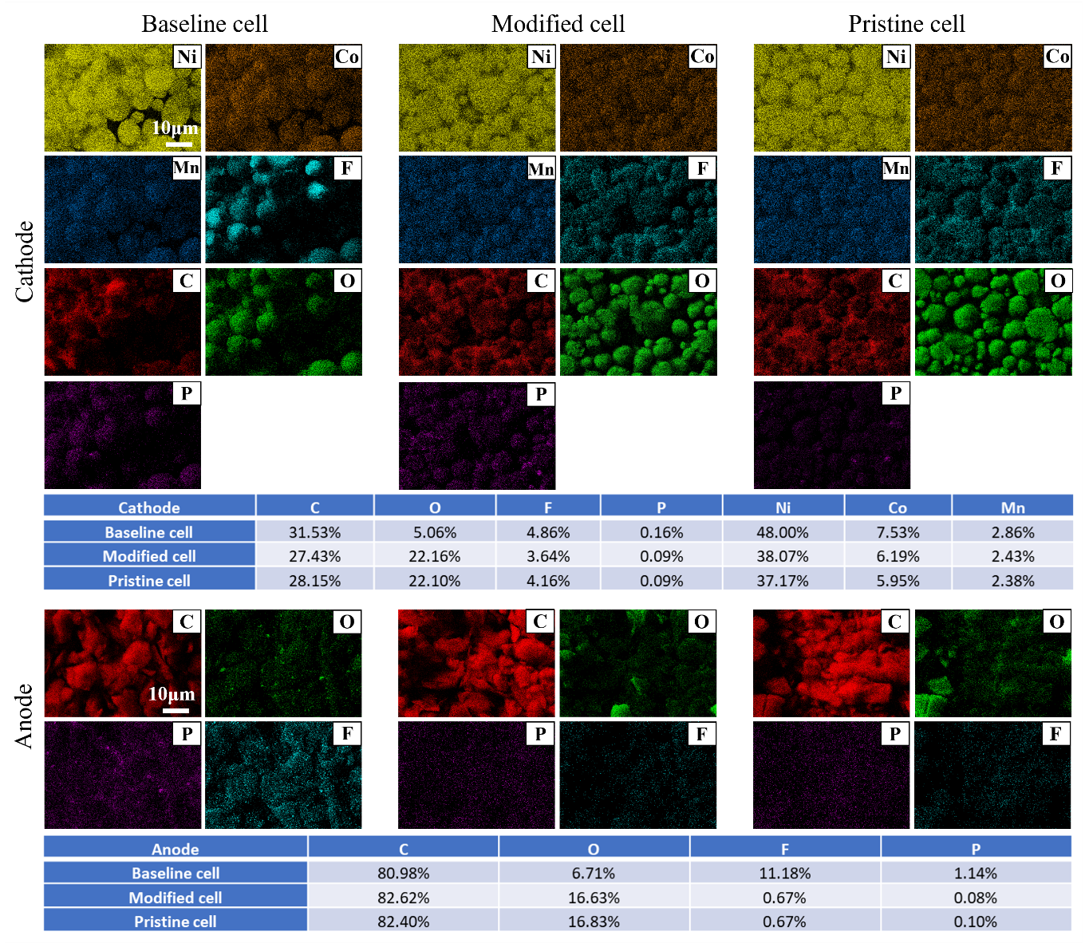
Supplementary Figure 11. Elemental distributions of the cathodes and anodes after ISC testing. EDS elemental maps and corresponding compositions of cathodes (top; C, O, F, P, Ni, Co and Mn) and anodes (bottom; C, O, F and P) recovered from baseline and modified cells after ISC testing, alongside those from a pristine cell. The baseline cell, which underwent thermal runaway, shows pronounced oxygen depletion in the cathode and substantial enrichment of F and P in the anode, consistent with severe cathode degradation and extensive electrolyte and SEI decomposition. By contrast, the elemental distributions and relative compositions of both electrodes from the modified cell closely resemble those of the pristine cell, indicating that rapid interruption of the short-circuit current suppresses interfacial side reactions and preserves electrode integrity.

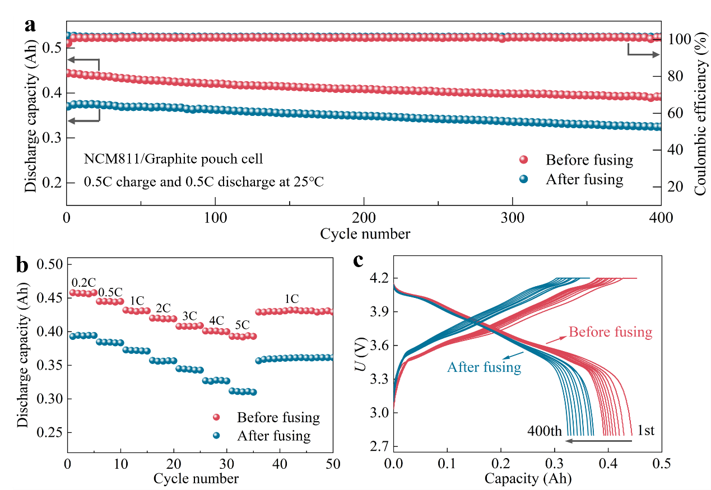
Supplementary Figure 12. Residual electrochemical performance of modified cells after localized ISC-induced fusing. a, Cycling performance and Coulombic efficiency of an NCM811/graphite modified pouch cell before and after fusing at 25 ℃ under 0.5 C charge-discharge cycling. After fusing, the cell maintains stable long-term capacity output and a Coulombic efficiency approaching 100%, with only a modest decrease in total capacity arising from the electrical isolation of the faulted electrode layer. b, Discharge capacities at different rates before and after fusing. Over the range of 0.2-5 C, the cell retains a rate response similar to that before fusing and exhibits good capacity recovery when the rate is returned to 1 C. c, Charge-discharge voltage profiles at different stages of cycling before and after fusing. The nearly identical voltage plateaus and polarization behaviour indicate that self-fusing precisely isolates the faulted electrode layer without perturbing the electrochemical reactions in the remaining parallel-connected layers. Collectively, these results demonstrate that the self-fusing tab confines the ISC to the faulted layer, allowing the cell to sustain stable and safe electrochemical output with only a minor capacity penalty.

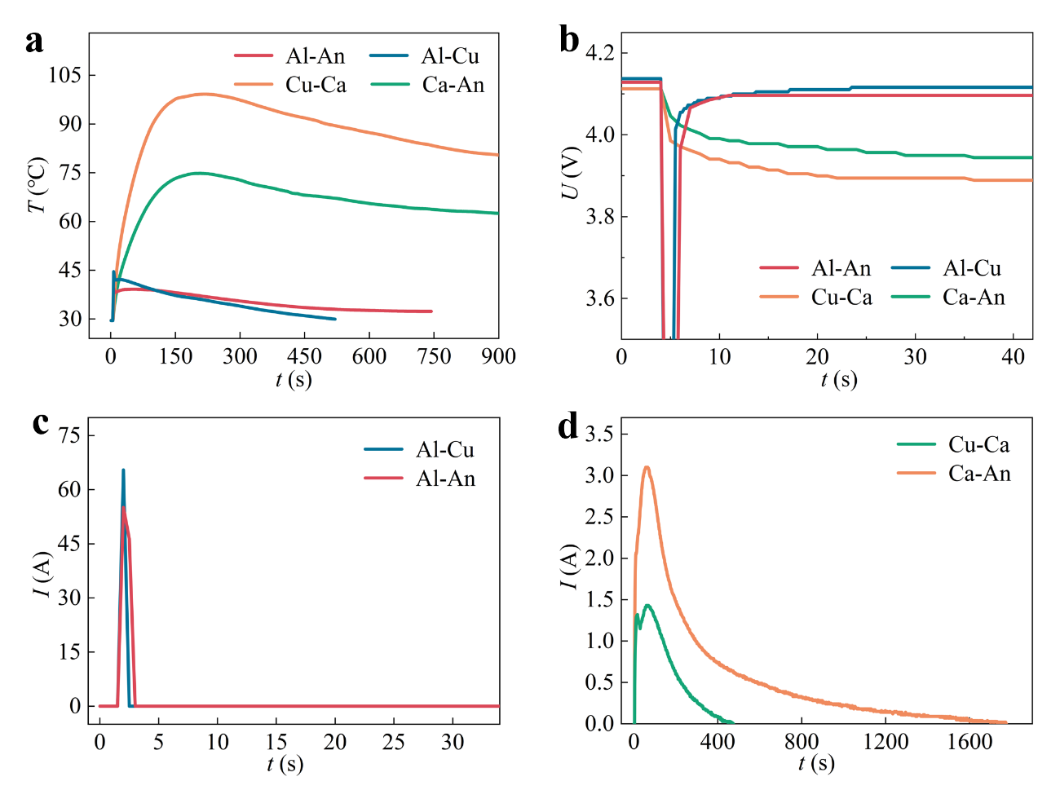
Supplementary Figure 13. Electrothermal responses of modified cells under different ISC configurations. a,b, Temperature and voltage responses of modified cells under four representative ISC configurations. For the low-resistance Al-Cu and Al-An short circuits, the large transient current rapidly melts the In-Sn alloy segment, resulting in only a slight temperature rise and rapid voltage recovery to a stable plateau after a brief perturbation. By contrast, the high-resistance Cu-Ca and Ca-An short circuits generate lower currents that are insufficient to trigger fusing, leading to a limited temperature rise and gradual voltage decay. c,d, Current responses under the different ISC configurations. The Al-Cu and Al-An short circuits produce sharp transient current peaks that rapidly fall to zero after fusing, whereas the lower current peaks generated by the Cu-Ca and Ca-An short circuits decay progressively owing to local active-material depletion, electrolyte depletion and increasing interfacial contact resistance. Together, these results show that the self-fusing tabs rapidly electrically isolate the faulted electrode layer under hazardous low-resistance ISC conditions, whereas high-resistance short circuits self-attenuate without progressing to thermal runaway.

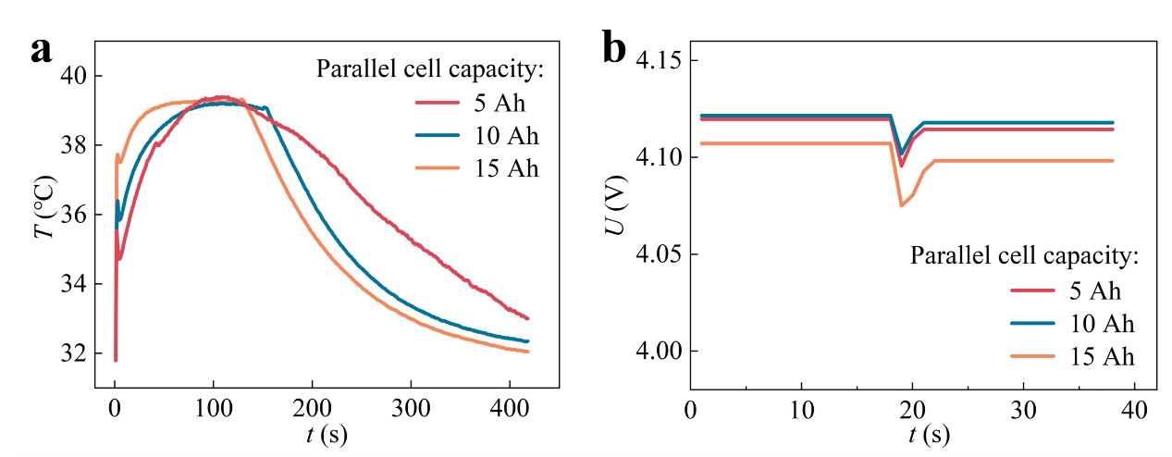
Supplementary Figure 14. Electrothermal responses of modified cells at different equivalent capacities. a, Temperature responses of modified cells after ISC initiation with external cells of 5, 10 and 15 Ah connected in parallel. Despite the greater potential energy input associated with increasing parallel-connected capacity, the cell temperature rose only marginally under all three conditions, with peak temperatures remaining below 40 ℃. b, Voltage responses of the modified cells at different equivalent capacities. Upon ISC initiation, the cell voltage exhibits a transient perturbation before rapidly returning to a stable operating plateau, indicating that the In-Sn alloy segment within the tab reliably fuses to interrupt the fault current even under high-capacity parallel-connected conditions. Together, these results demonstrate that the self-fusing tab remains effective at large equivalent capacities by terminating sustained energy transfer from the parallel-connected cells to the short-circuit site, thereby preventing a localized ISC from developing into cell-wide thermal runaway.

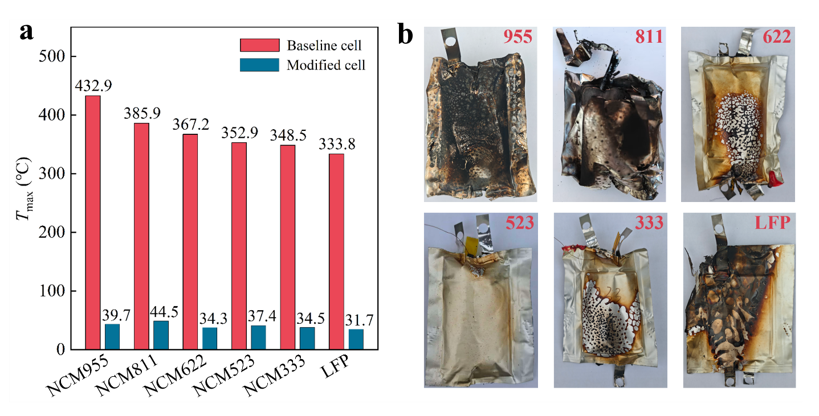
Supplementary Figure 15. Suppression of thermal runaway by self-fusing tabs across commercial lithium-ion cells with different cathode chemistries. a, Peak temperatures of cells with different cathode chemistries during ISC testing. Baseline cells with NCM955, NCM811, NCM622, NCM523, NCM333 and LFP cathodes underwent severe heating under sustained short-circuit currents, reaching peak temperatures of 333.8-432.9 ℃. By contrast, modified cells incorporating self-fusing tabs exhibited only minor temperature rises, with peak temperatures limited to 31.7-44.5℃. b, Post-test photographs of baseline cells with different cathode chemistries. The cells exhibited varying degrees of swelling, rupture, ablation or carbonization, indicating severe thermal runaway and structural damage driven by sustained Joule heating. Together, these results demonstrate that self-fusing tabs rapidly electrically isolate the faulted electrode layer across diverse cathode chemistries, thereby preventing the progression of ISC into thermal runaway and highlighting the broad applicability and practical potential of this strategy.

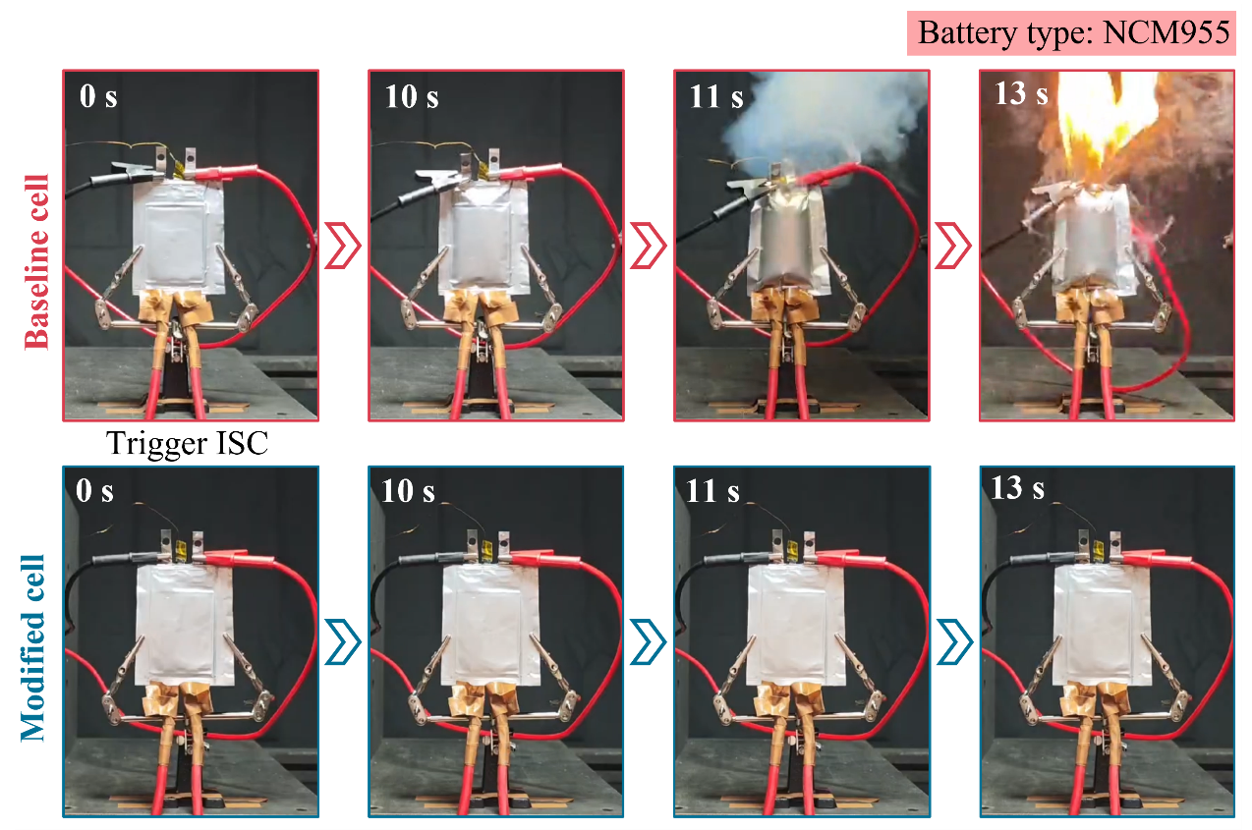
Supplementary Figure 16. Time-resolved images of NCM955 pouch cells following ISC initiation. The upper row shows the baseline cell, and the lower row shows the modified cell incorporating self-fusing tabs. Following ISC initiation, the baseline cell exhibited pronounced swelling at 10 s, followed by substantial smoke release at 11 s and violent combustion at 13 s, demonstrating that sustained short-circuit current rapidly drives thermal runaway in the Ni-rich NCM955 cell. By contrast, the modified cell maintained its structural integrity throughout the test, with no observable swelling, smoke evolution or ignition after the same ISC trigger. This comparison demonstrates that the self-fusing tabs rapidly interrupt the fault circuit in the Ni-rich NCM955 system, thereby effectively suppressing the evolution of ISC-induced thermal runaway.

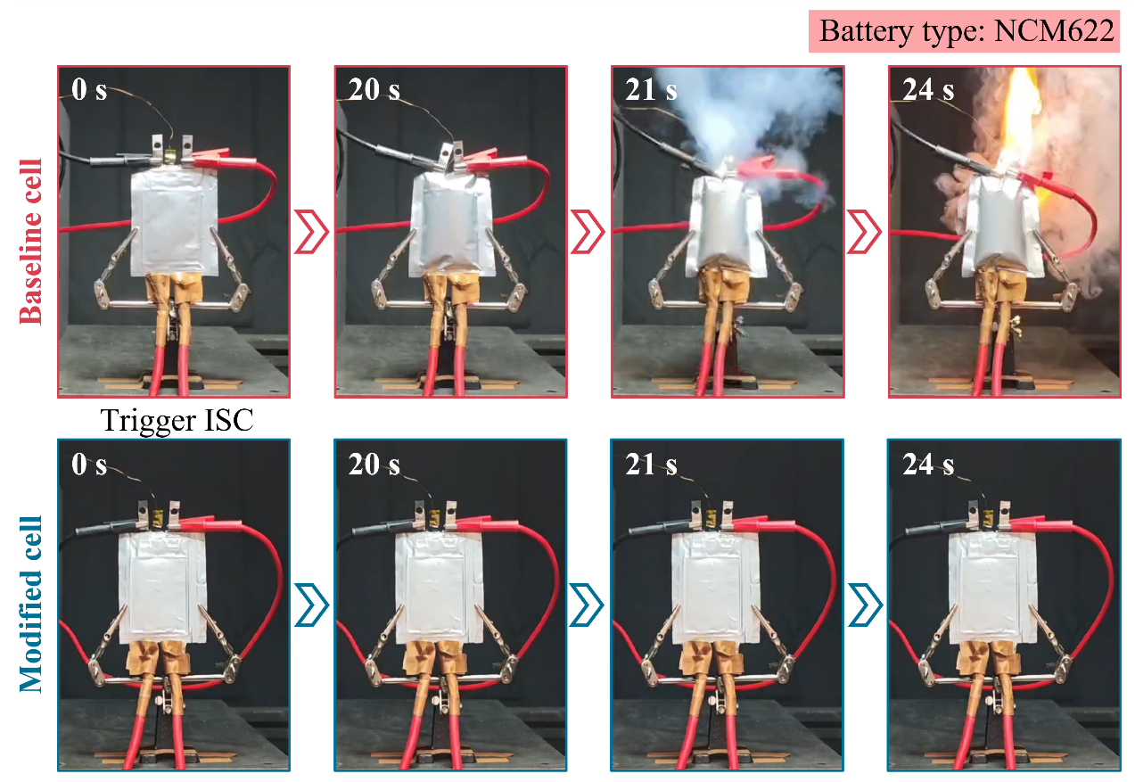
Supplementary Figure 17. Time-resolved images of NCM622 pouch cells following ISC initiation. Following ISC initiation, the baseline cell exhibited pronounced swelling at 20 s, followed by substantial smoke release at 21 s and ignition at 24 s, indicating that sustained short-circuit current drives the rapid evolution of a localized ISC into thermal runaway in the NCM622 cell. By contrast, the modified cell maintained its structural integrity throughout the test, with no observable swelling, smoke evolution or combustion under the same ISC conditions. These observations demonstrate that the self-fusing tabs rapidly interrupt the fault circuit in the NCM622 cell, effectively eliminating sustained energy input from the parallel-connected layers to the short-circuit site and thereby suppressing the evolution of ISC-induced thermal runaway.

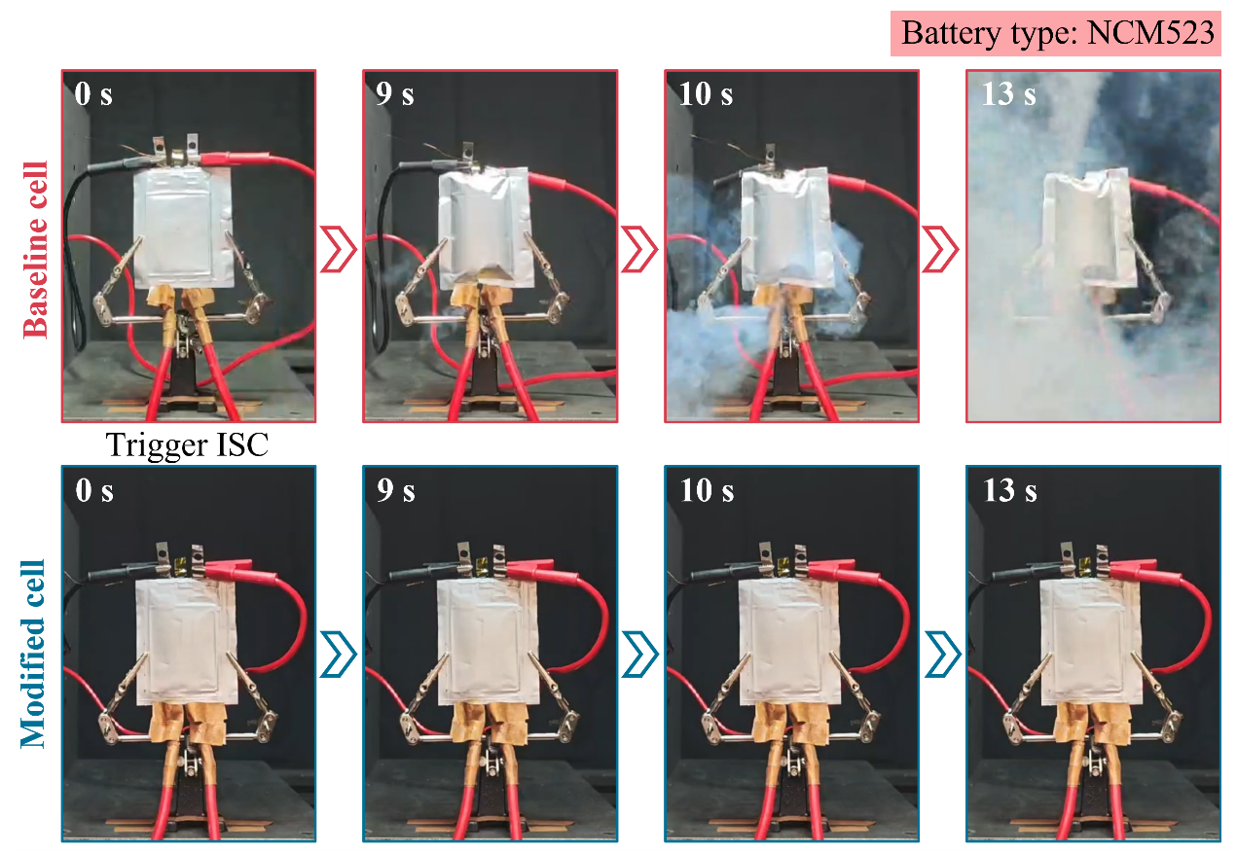
Supplementary Figure 18. Time-resolved images of NCM523 pouch cells following ISC initiation. Following ISC initiation, the baseline cell exhibited pronounced swelling at 9 s, followed by smoke release at 10 s and dense smoke evolution at 13 s, indicating that sustained short-circuit current induces severe parasitic reactions within the NCM523 cell and promotes the progression of thermal runaway. By contrast, the modified cell maintained its structural integrity throughout the test, with no observable swelling, smoke evolution or combustion under the same ISC conditions. These observations demonstrate that the self-fusing tabs rapidly isolate the faulted electrode layer, thereby eliminating sustained energy input from the parallel-connected layers to the short-circuit site and effectively suppressing the evolution of ISC-induced thermal runaway.

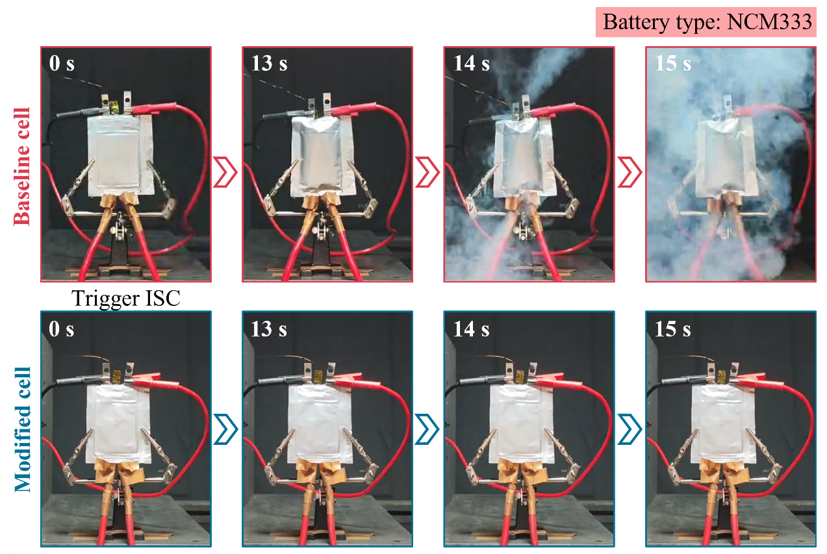
Supplementary Figure 19. Time-resolved images of NCM333 pouch cells following ISC initiation. Following ISC initiation, the baseline cell exhibited pronounced swelling at 13 s, followed by smoke release at 14 s and dense smoke evolution at 15 s, indicating that sustained short-circuit current rapidly aggravates parasitic reactions within the NCM333 cell and triggers thermal runaway. By contrast, the modified cell maintained its structural integrity throughout the test, with no observable swelling, smoke evolution or combustion under the same ISC conditions. These observations demonstrate that the self-fusing tabs rapidly isolate the faulted electrode layer, thereby eliminating sustained energy input from the parallel-connected layers to the short-circuit site and effectively suppressing the evolution of ISC-induced thermal runaway.

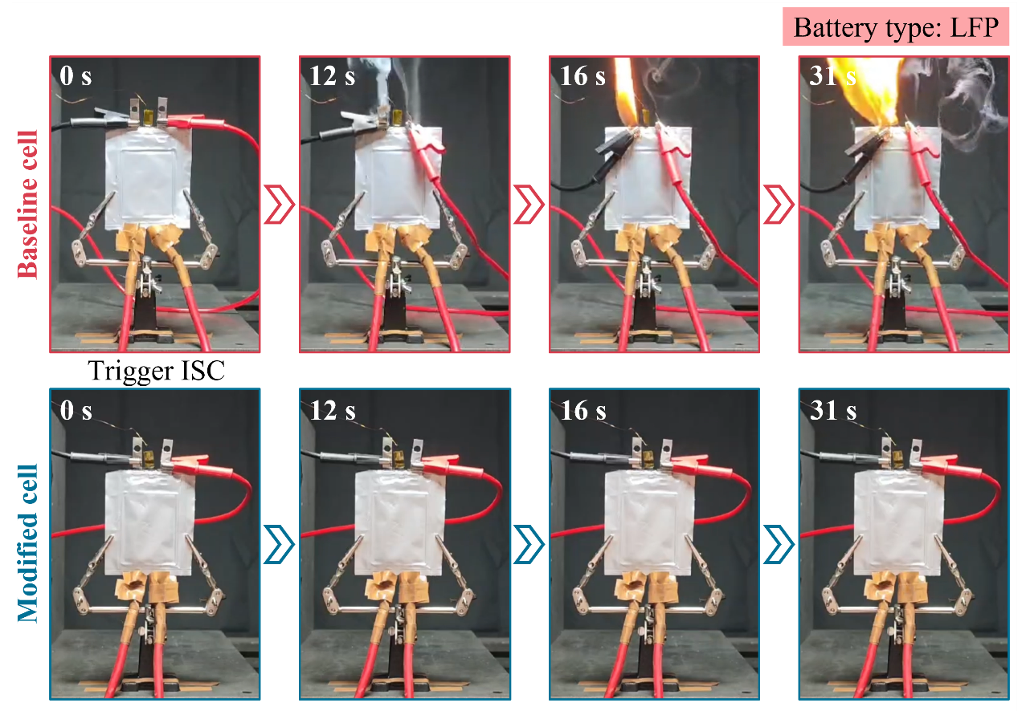
Supplementary Figure 20. Time-resolved images of LFP pouch cells following ISC initiation. Following ISC initiation, the baseline cell exhibited pronounced smoke evolution at 12 s, followed by localized ignition at 16 s, with intensified flaming at 31 s, indicating that even the intrinsically thermally stable LFP chemistry undergoes severe thermal runaway under sustained short-circuit current as a result of continuous Joule heat accumulation and aggravated parasitic reactions. By contrast, the modified cell maintained its structural integrity throughout the test, with no observable swelling, smoke evolution or ignition under the same ISC conditions. These observations demonstrate that the self-fusing tabs rapidly isolate the faulted electrode layer, thereby eliminating sustained energy input from the parallel-connected layers to the short-circuit site and effectively suppressing the evolution of ISC-induced thermal runaway.

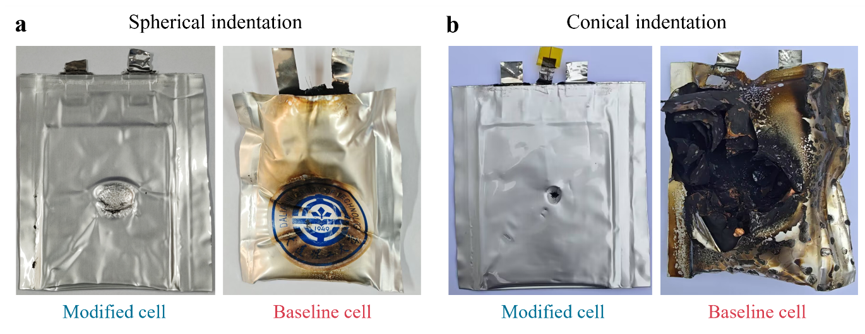
Supplementary Figure 21. Post-mortem appearance of the baseline and modified cells after mechanical abuse. a, Comparison of the modified and baseline cells after hemispherical indentation. The modified cell exhibited only localized indentation and slight deformation within the compressed region while preserving its structural integrity. By contrast, the baseline cell showed extensive burn marks, indicating that the mechanically induced severe ISC rapidly evolved into violent thermal runaway. b, Comparison of the modified and baseline cells after conical indentation. The modified cell exhibited only a localized perforation and plastic deformation near the penetration site, with no visible evidence of thermal damage. In contrast, the baseline cell underwent severe carbonization, burn damage and structural destruction, indicative of much more severe thermal runaway. These post-mortem observations demonstrate that the self-fusing tabs rapidly interrupt sustained short-circuit current under representative mechanical abuse conditions, including hemispherical and conical indentation, thereby effectively preventing the propagation of localized mechanical damage into cell-level thermal runaway.

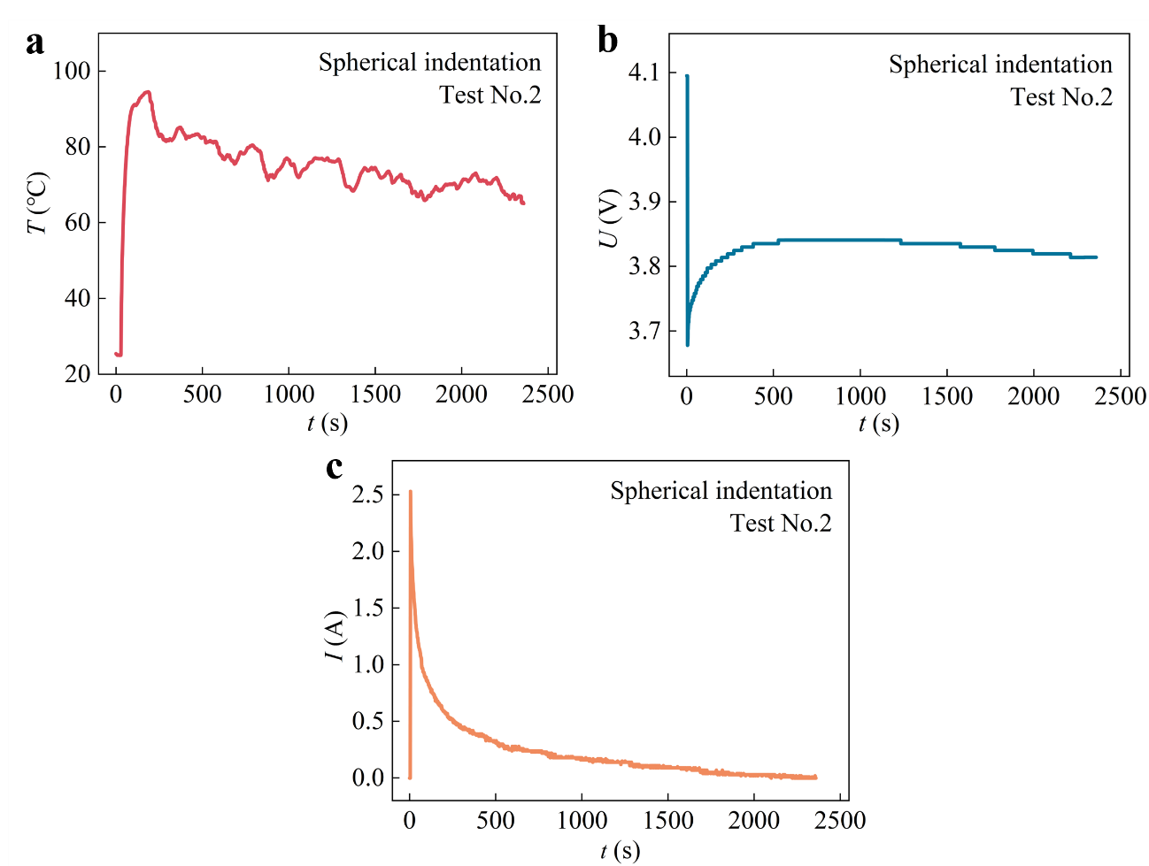
Supplementary Figure 22. Electrothermal response of the modified cell during the second hemispherical indentation test. a, Temperature evolution under a mechanically induced weak ISC. Following ISC initiation, the cell temperature rapidly increased to approximately 94.5℃ and then gradually decreased, without sustained temperature rise or thermal runaway. b, Corresponding voltage profile. the cell voltage dropped instantaneously at the onset of indentation and then gradually recovered to a stable plateau. This response suggests that weakening of the short-circuit contact, increased contact resistance and current decay collectively alleviated cell polarization. c, Corresponding short-circuit current profile. The short-circuit current reached a peak of only ~2.53 A and then gradually decayed to nearly 0 A, without triggering self-fusing of the In-Sn alloy. These results indicate that, under a mechanically induced weak ISC, the limited short-circuit current was insufficient to activate the self-fusing tab, while the associated Joule heat generation was likewise insufficient to drive the cell into thermal runaway.

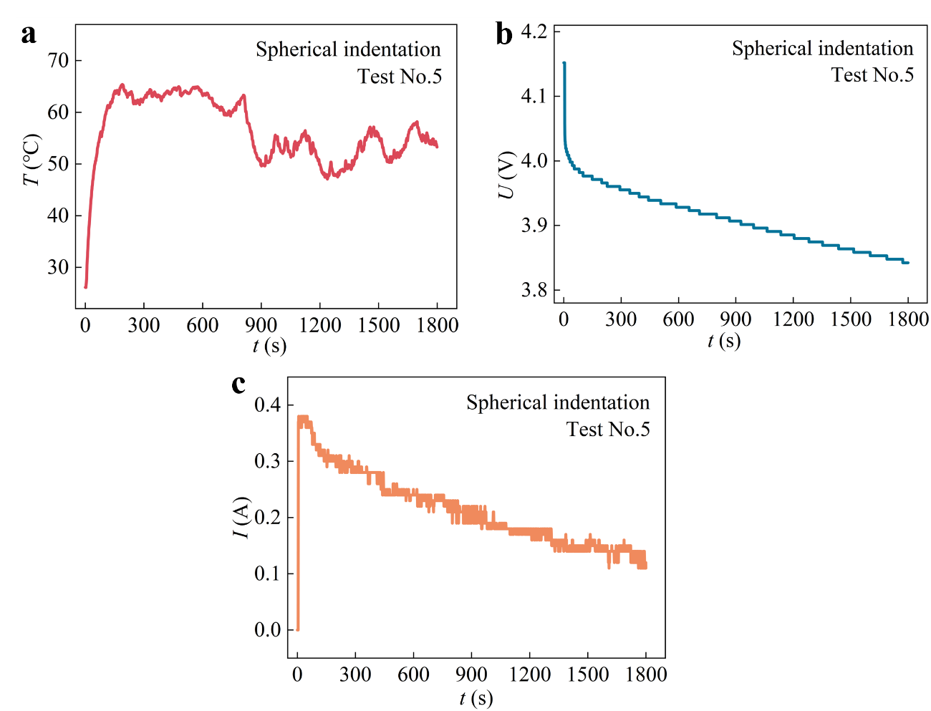
Supplementary Figure 23. Electrothermal response of the modified cell during the fifth hemispherical indentation test. a, Temperature evolution under a mechanically induced weak ISC. Following ISC initiation, the cell temperature rapidly increased to 65.4℃, after which it fluctuated slightly within a relatively low temperature range and gradually decreased, with no sustained temperature rise or thermal runaway. b, Corresponding voltage profile. The cell exhibited an instantaneous voltage drop at the onset of indentation, followed by a gradual decline. This behavior indicates that a weak short-circuit pathway persisted over an extended period but was insufficient to cause rapid voltage collapse. c, Corresponding short-circuit current profile. The short-circuit current reached a peak of only 0.38 A and gradually decayed during the test, confirming that hemispherical indentation induced only a weak ISC and did not trigger self-fusing of the In-Sn alloy. These results demonstrate that, under a sustained weak ISC, the limited short-circuit current caused only a modest temperature rise and gradual voltage decay, while the associated Joule heat input remained insufficient to drive the cell into thermal runaway. This finding further confirms that the onset of thermal runaway requires a sufficiently large short-circuit current and sustained energy input.

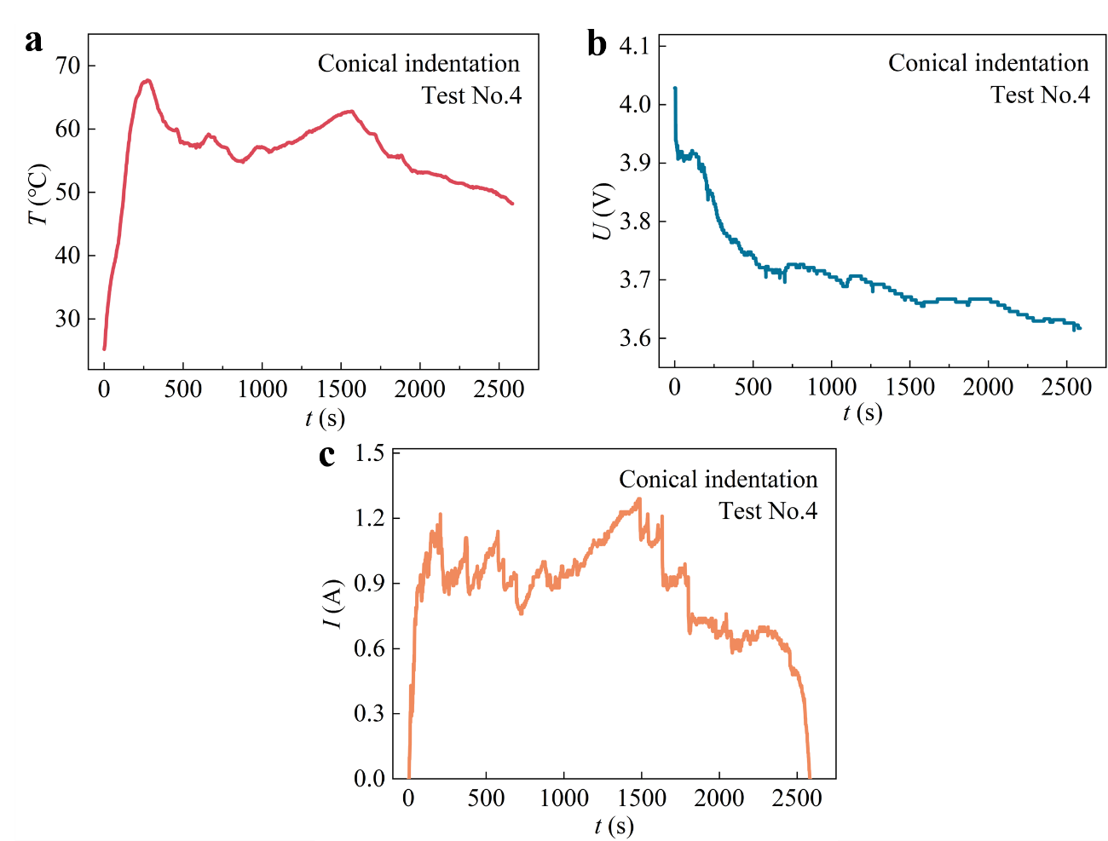
Supplementary Figure 24. Electrothermal response of the modified cell during the fourth conical indentation test. a, Temperature evolution under a mechanically induced weak ISC. Following ISC initiation, the cell temperature rapidly increased to approximately 67.7℃, after which it fluctuated slightly within a relatively low temperature range and gradually decreased, with no sustained temperature rise or thermal runaway. b, Corresponding voltage profile. The cell exhibited an instantaneous voltage drop at the onset of indentation, followed by a gradual decline. This behavior indicates that a weak short-circuit pathway persisted over an extended period but was insufficient to cause rapid voltage collapse. c, Corresponding short-circuit current profile. The short-circuit current reached a peak of approximately 1.29 A and subsequently exhibited a fluctuating decay, gradually approaching 0 A by the end of the test. This behavior suggests that the short-circuit contact progressively weakened owing to the combined effects of localized mechanical deformation, electrode-interface degradation and increasing contact resistance. These results demonstrate that, even under the more concentrated loading imposed by conical indentation, the limited current generated by the weak ISC remained below the threshold for tab self-fusing. The associated Joule heating was likewise insufficient to initiate thermal runaway, allowing the cell to remain thermally stable.

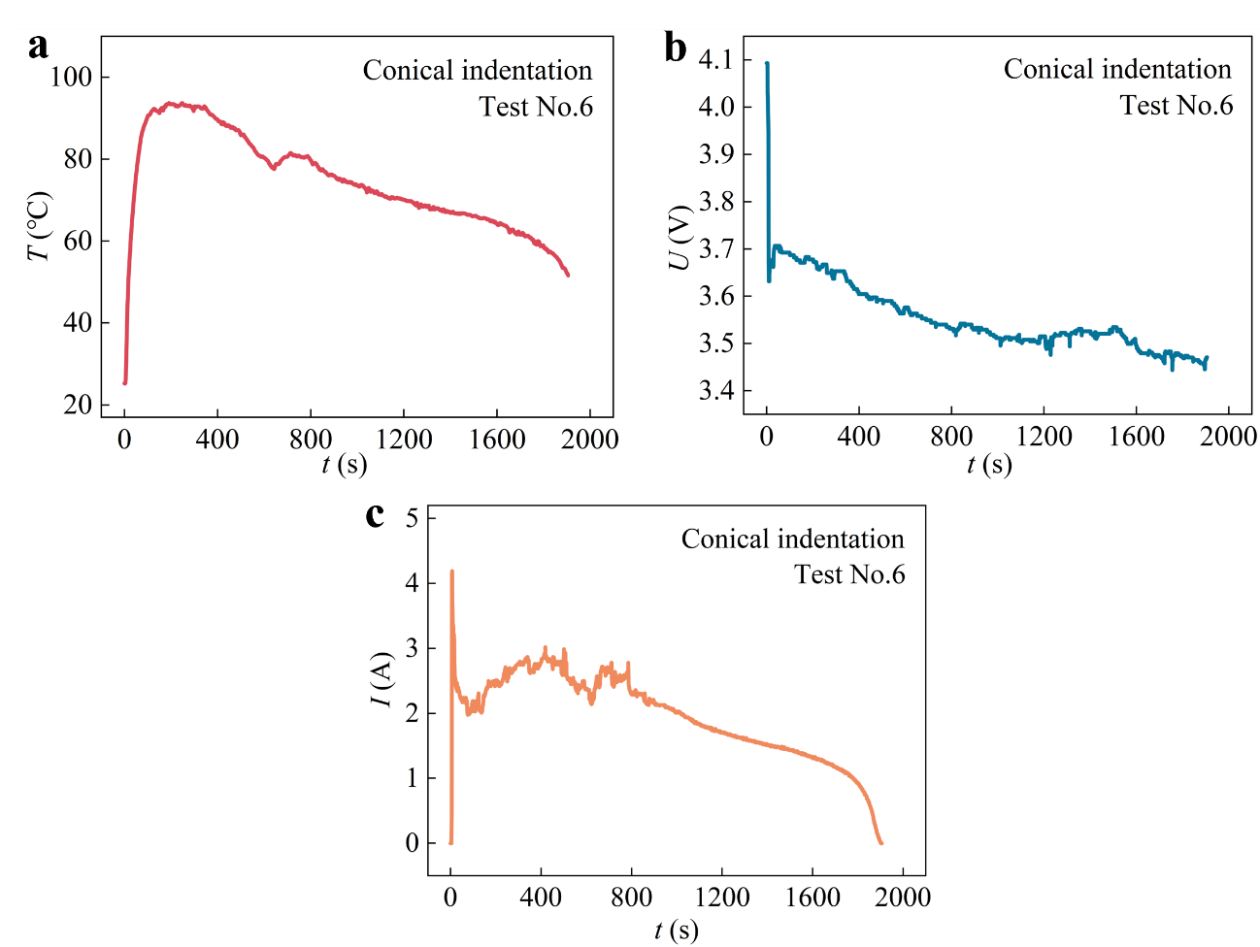
Supplementary Figure 25. Electrothermal response of the modified cell during the sixth conical indentation test. a, Temperature evolution under a mechanically induced weak ISC. Following ISC initiation, the cell temperature rapidly increased to approximately 92.9℃ and then declined continuously, with no sustained temperature rise or thermal runaway. b, Corresponding voltage profile. The voltage dropped instantaneously at the onset of indentation and subsequently decayed slowly, indicating that a weak short-circuit pathway persisted over an extended period but remained insufficient to cause rapid voltage collapse. c, Corresponding short-circuit current profile. The short-circuit current reached a peak of approximately 4.19 A, subsequently fluctuated within a low-current range and gradually decayed to nearly 0 A. This behavior indicates that the localized short-circuit contact progressively weakened owing to the combined effects of mechanical deformation, interfacial degradation and dynamic changes in contact resistance. These results indicate that conical indentation can induce a comparatively stronger ISC. Although the resulting short-circuit current remained below the threshold required to fuse the In-Sn alloy segment in the tab, the associated Joule heating was still insufficient to drive the modified cell into thermal runaway.

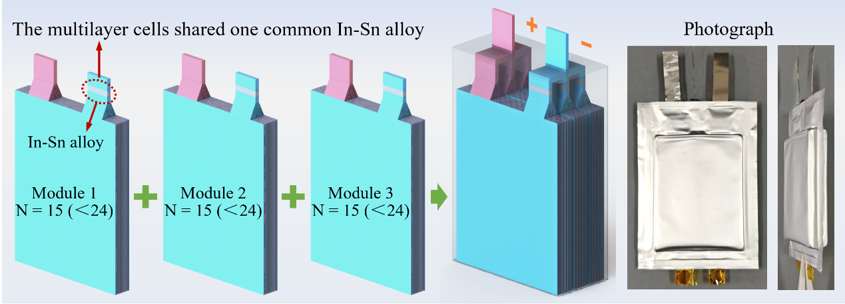
Supplementary Figure 26. Modular self-fusing-tab architecture. The multilayer cell is partitioned into parallel-connected safety modules, with the electrode layers within each module sharing a single In-Sn segment that functions as a thermally responsive current-interruption layer. A representative three-module configuration is shown, in which each module comprises 15 electrode layers—below the critical threshold for ISC-induced thermal runaway (N=24). This modular architecture reduces the complexity of integrating In-Sn segments on a layer-by-layer basis while confining the energy available to a fault within an individual module. Upon a localized ISC, the resulting current surge rapidly melts the In-Sn segment at the top of the faulted module, interrupting sustained energy transfer from the intact modules and electrically isolating the fault at the module level. Front and side photographs of the modular self-fusing-tab pouch cell are shown on the right, demonstrating the assembly feasibility and engineering potential of the design. Overall, the modular architecture simplifies cell manufacturing while preserving rapid responsiveness to hazardous short-circuit currents and effective fault-isolation capability.

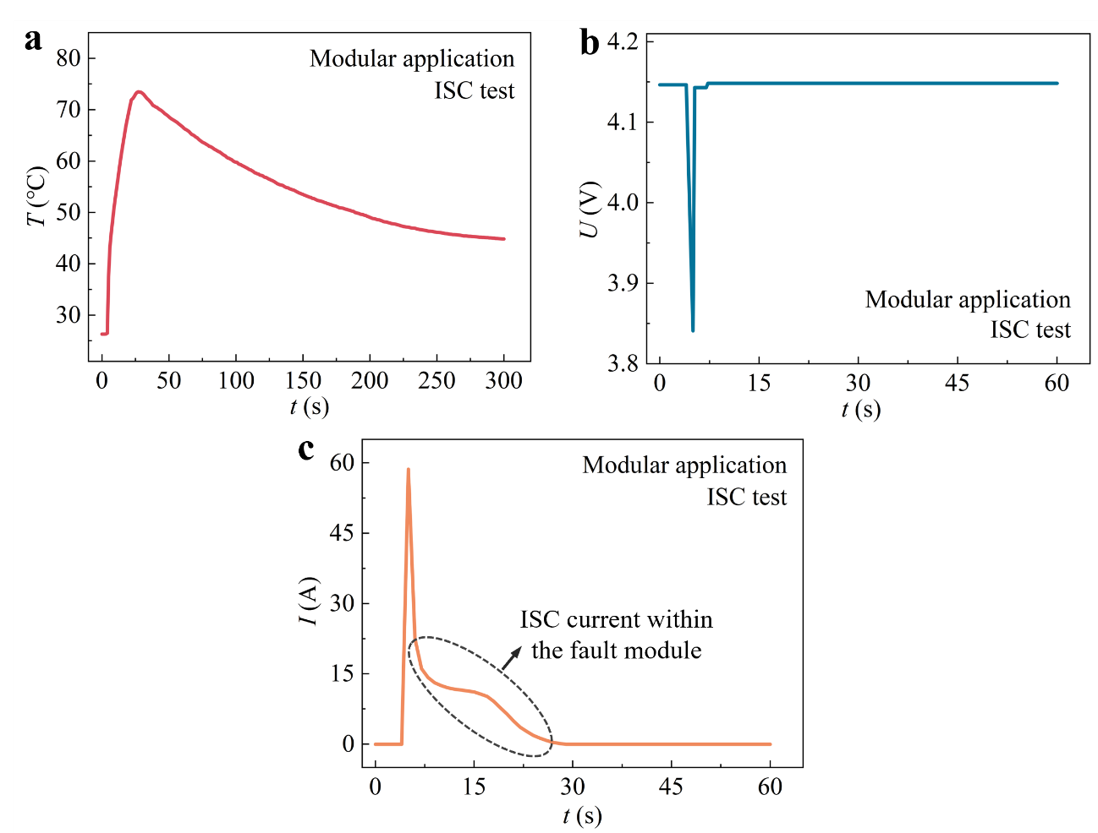
Supplementary Figure 27. Electrothermal response of the modular self-fusing-tab cell under ISC conditions. a, Temperature response after a Cu-Al current-collector short circuit was triggered within module 3. The cell exhibited only a limited temperature rise followed by gradual cooling, with no sustained heating or thermal runaway. b, Corresponding voltage profile. The voltage briefly dropped to 3.84 V upon short-circuit initiation before rapidly recovering and remaining stable, indicating timely interruption of sustained energy transfer between the faulted module and the intact modules. c, Corresponding short-circuit current profile. The current initially surged to 58.6 A and then rapidly decreased to 22.6 A as the In-Sn segment at the top of module 3 fused. The residual current subsequently decayed slowly, indicating that the local short circuit was not eliminated but instead confined within the faulted module. Together, these results demonstrate that the modular self-fusing-tab architecture enables rapid module-level fault isolation under severe high-current short-circuit conditions, thereby suppressing the progression to thermal runaway driven by sustained energy transfer from the intact parallel-connected modules.

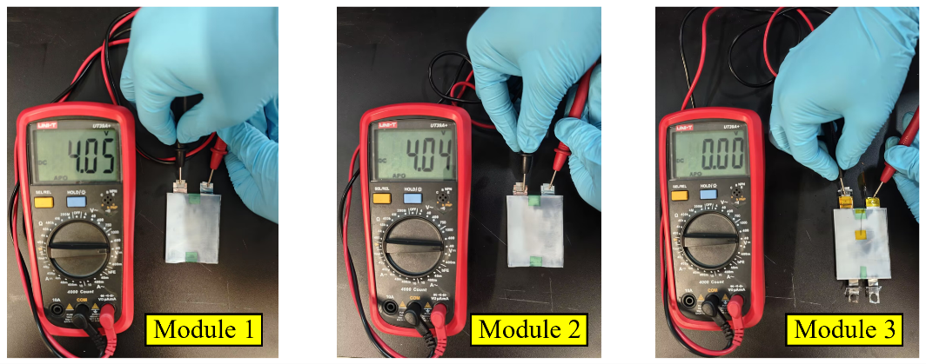
Supplementary Figure 28. Module-level voltage distribution following ISC testing. After the ISC test, the modular cell was disassembled and the voltage of each module was measured independently. Modules 1 and 2 retained voltages of approximately 4.05 and 4.04 V, respectively, indicating that the intact modules remained in a normal electrochemical state. The voltage of the faulted module 3 decreased to 0.00 V, confirming that the In-Sn alloy at the top of module 3 opened under the severe short-circuit current surge and interrupted sustained energy transfer between the faulted module and the intact modules. These results demonstrate that the modular self-fusing-tab architecture confines ISC-induced damage to the faulted module and prevents continued discharge of the neighbouring intact modules, thereby enabling effective module-level fault isolation and protection.

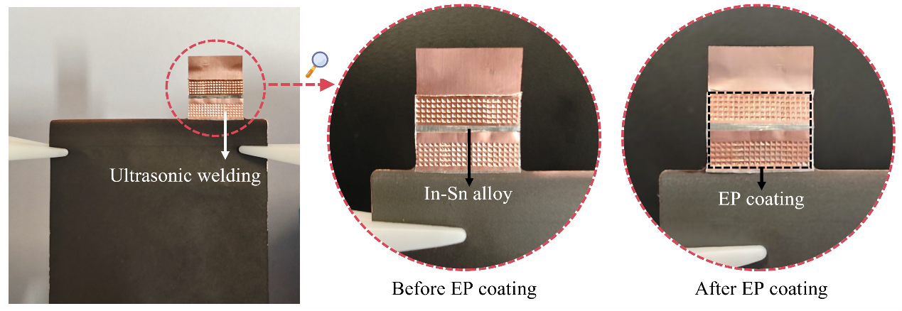
Supplementary Figure 29. Photographs of the self-fusing anode tab. Left, photograph of the ultrasonically welded self-fusing anode tab, in which an In-Sn alloy segment is integrated into the central region of the tab to form a thermally responsive current-interruption layer. Centre, magnified view of the tab before epoxy coating, showing the exposed In-Sn segment, approximately 2 mm in length. Right, magnified view after epoxy coating, showing the In-Sn segment conformally covered by an ultrathin epoxy (EP) passivation layer. The coating suppresses parasitic reactions between the In-Sn alloy and the electrolyte or Li⁺ while enhancing the mechanical robustness of the tab, thereby ensuring its structural stability during cell assembly and long-term operation.

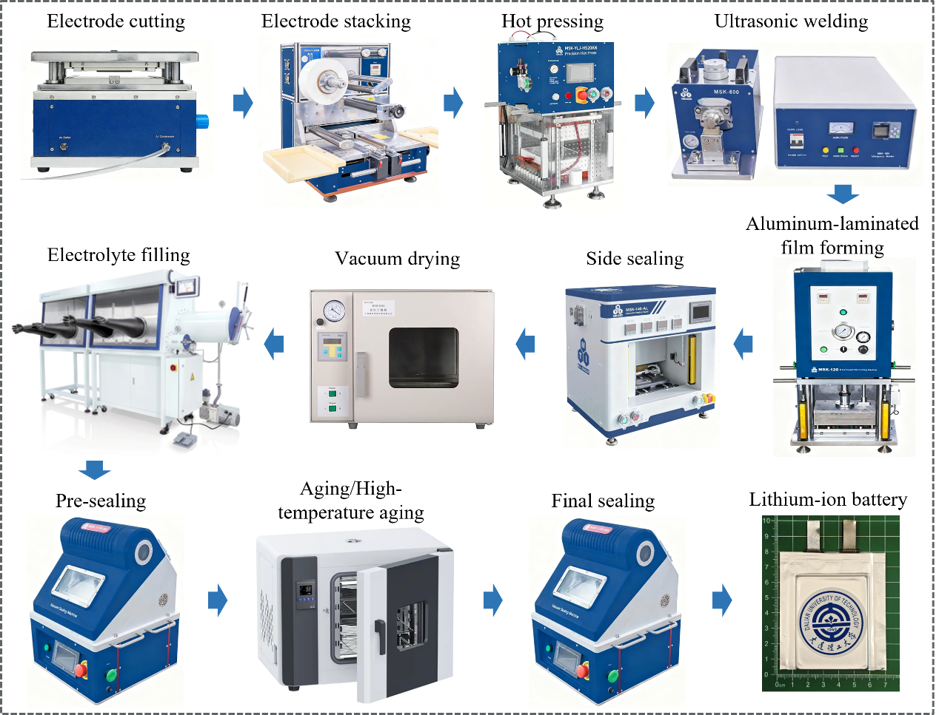
Supplementary Figure 30. Semi-automated assembly workflow for lithium-ion pouch cells. The sequential process comprises electrode cutting, stacking, hot pressing, tab welding, aluminium-laminate forming, side sealing, vacuum drying, electrolyte filling, pre-sealing, ageing, formation, high-temperature ageing, final sealing and capacity grading. Standardized control over key processing parameters during electrode cutting, stacking, welding, electrolyte filling and cell sealing minimizes operator-dependent variability and improves the structural uniformity and manufacturing reproducibility of the pouch cells, thereby providing reliable samples for subsequent electrochemical testing and safety evaluation.

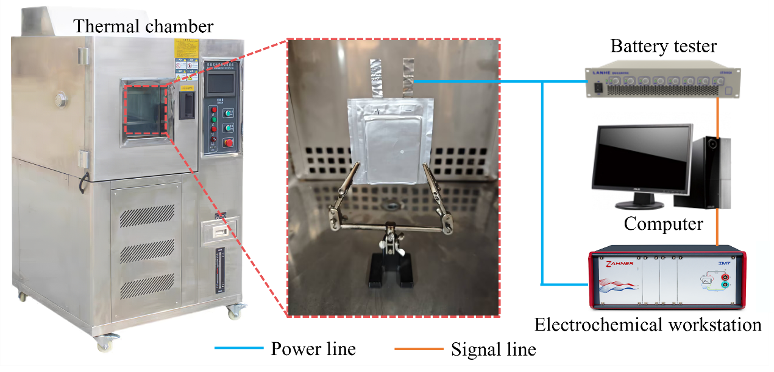
Supplementary Figure 31. Electrochemical testing platform for lithium-ion pouch cells. Cycling and rate-performance measurements were conducted at 25 ℃ in a thermal chamber to minimize temperature-induced variations in cell capacity, Coulombic efficiency and rate response. The pouch cells were connected to a multichannel battery tester and tested under predefined galvanostatic charge-discharge protocols. Electrochemical impedance spectroscopy was performed on a ZAHNER electrochemical workstation over a frequency range of 0.01 Hz to 100 kHz.

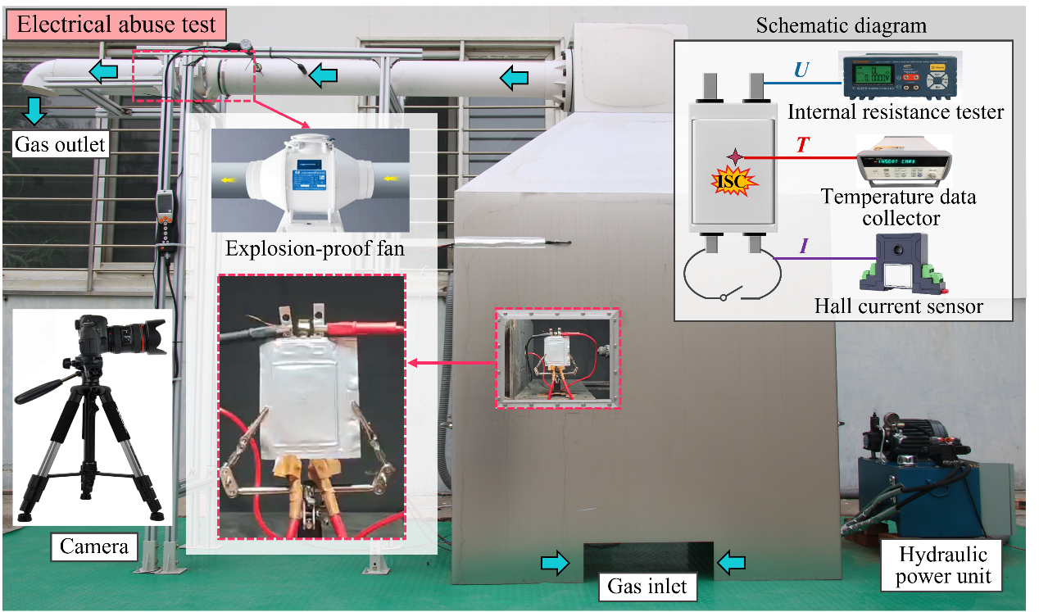
Supplementary Figure 32. Electrical abuse testing system for lithium-ion pouch cells. Electrical abuse tests were conducted using four-terminal pouch cells, in which a predefined ISC was triggered by an external switch. The cells were tested inside a collecting hood designed to contain any flames, smoke and high-temperature gases generated during thermal runaway. A central observation window enabled real-time visualization and recording of cell morphological evolution following ISC initiation, while an air inlet at the base ensured a continuous air supply throughout the test. Gases released during thermal runaway were discharged through a top-mounted exhaust duct connected to an explosion-proof fan. Cell voltage, short-circuit current and temperature were recorded simultaneously using an internal resistance tester, a Hall current sensor and a temperature data collector, respectively, enabling characterization of the coupled electrothermal response under electrical abuse conditions.

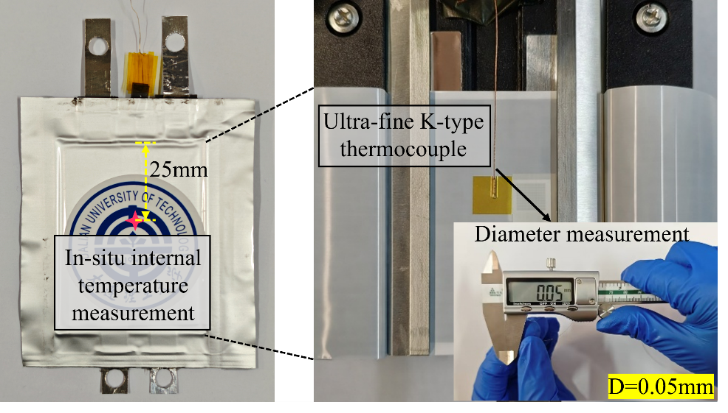
Supplementary Figure 33. Internal temperature monitoring in pouch cells. To enable rapid and accurate tracking of temperature evolution following ISC initiation, an ultrafine K-type thermocouple (~50 μm in diameter) was pre-positioned inside each pouch cell. Its small size and rapid thermal response enabled real-time measurement of the cell interior while minimizing perturbations to the internal structure and local thermal field. As shown on the left, the temperature-measurement point was located at the cell centre, approximately 25 mm below the upper edge of the electrodes. This configuration provided the temperature signal required to resolve internal heating and the progression of thermal runaway under electrical abuse conditions.

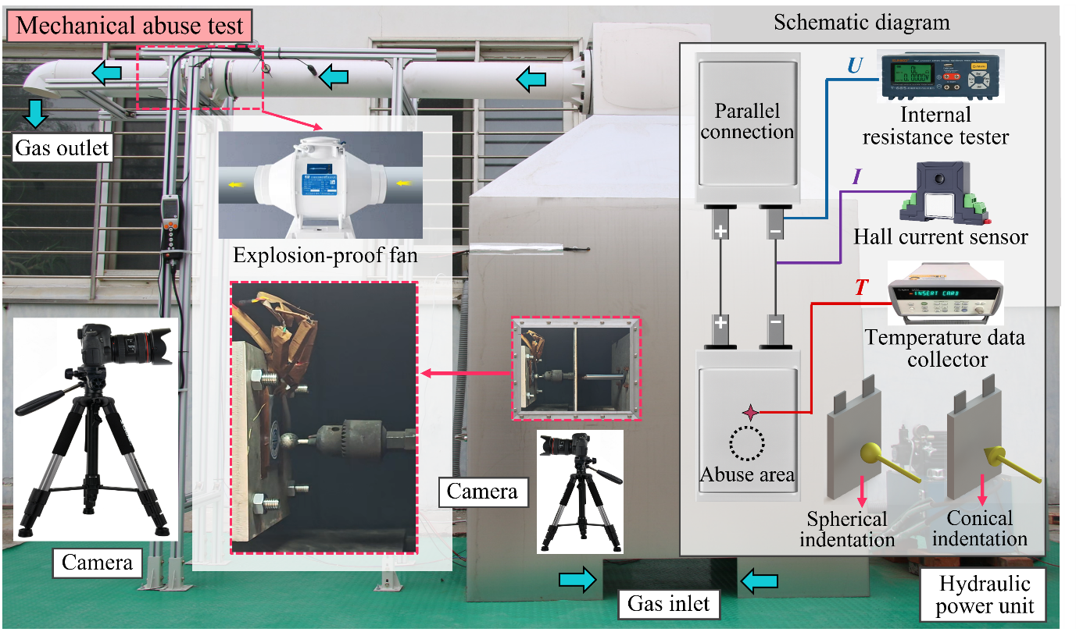
Supplementary Figure 34. Mechanical abuse testing system for lithium-ion pouch cells. Mechanical abuse tests were conducted using conventional two-tab pouch cells, with failure induced by external indentation. The tests were performed in the same collecting hood. A hydraulic loading system drove either a spherical or conical indenter into fully charged pouch cells to reproduce mechanically induced ISCs. The spherical indenter was 20 mm in diameter, whereas the conical indenter had a base diameter of 20 mm and an apex angle of 90°. Indentation was applied directly beneath the internal temperature-measurement point. An auxiliary cell identical to the test cell in model, rated capacity and initial SOC was connected in parallel, and the resulting circulating current was used as a proxy for the ISC current generated during indentation. Cell voltage, circulating current and internal temperature were recorded synchronously to resolve the coupled electrothermal response and the progression of thermal runaway under mechanical abuse conditions.

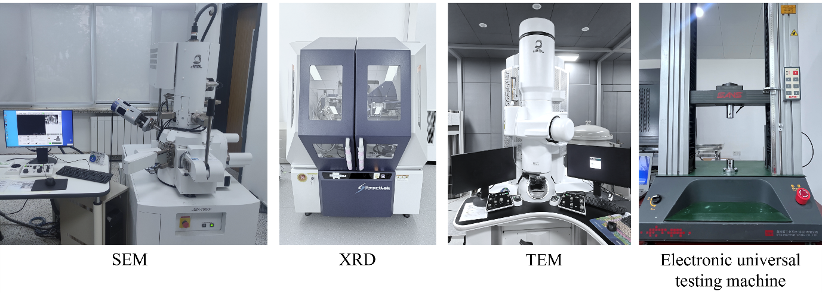
Supplementary Figure 35. Physicochemical characterization platform for battery materials. SEM was used to examine the morphologies of cathodes and anodes recovered after ISC or abuse testing, and EDS to analyse the elemental composition of the electrode surfaces. TEM was used for high-resolution imaging and SAED analysis of cathode materials quenched immediately before thermal runaway, revealing phase transformations within the cathode structure. XRD was used to analyse crystal-structure evolution in the cathode and anode materials, as well as the formation of side-reaction products. The mechanical properties of the tabs were measured using an electronic universal testing machine at a crosshead speed of 1 mm/min.

Supplementary Note 1. Design and Verification of the modular self-fusing-tab architecture
Integrating an In-Sn segment into the anode tab of every electrode layer would increase the complexity of electrode processing, tab welding and cell assembly, potentially limiting large-scale implementation. We therefore developed a modular self-fusing-tab architecture to reduce this integration burden. In this design, the multilayer cell was partitioned into parallel-connected safety modules, with multiple electrode layers within each module sharing a single In-Sn segment to enable module-level fault isolation. As illustrated in Supplementary Fig. 26, a representative three-module configuration was constructed, with each module comprising 15 electrode layers—below the experimentally identified critical threshold for ISC-induced thermal runaway (N=24). In this configuration, activation of the shared self-fusing tab disconnects the entire faulted module from the remaining intact modules, rather than isolating an individual electrode layer.
The protective response of this architecture was evaluated by triggering a Cu-Al short circuit in module 3 while monitoring the coupled electrothermal response of the cell. Upon ISC initiation, the current surged to 58.6 A, accompanied by a transient decrease in the voltage to 3.84 V (Supplementary Fig. 27). This current surge activated the shared self-fusing tab, after which the voltage rapidly recovered and the current decreased to 22.6 A. The rapid voltage recovery indicates that activation of the In-Sn segment interrupted energy transfer from modules 1 and 2 to the faulted module. The current did not immediately decrease to zero, however, consistent with continued current circulation among the parallel-connected electrode layers within the electrically isolated module 3. The modular architecture therefore confines the fault to the disconnected module rather than completely eliminating the ISC pathway within that module.
Post-test voltage measurements further confirmed module-level fault isolation (Supplementary Fig. 28). Modules 1 and 2 retained their normal voltages after activation of the self-fusing tab, whereas the voltage of module 3 decreased to 0 V, confirming that the faulted module was selectively disconnected while the two intact modules remained electrically functional. Compared with the layer-resolved architecture, the modular configuration reduces the number of required In-Sn segments and associated welding sites by allowing multiple electrode layers to share a single self-fusing tab. This reduction in integration complexity, however, comes at the cost of lowering the fault-isolation resolution from the individual electrode layer to the module level.
The number of electrode layers assigned to each module therefore represents a key design parameter. After activation of the self-fusing tab, the energy stored within the faulted module remains available to sustain the ISC and must be insufficient to independently initiate thermal runaway. In the present proof-of-concept configuration, limiting each module to 15 electrode layers maintained the isolated module below the experimentally identified critical threshold. These results demonstrate the feasibility of balancing integration complexity against fault-isolation resolution and suggest a potential route towards scalable module-level protection.

Supplementary Table 1. Details of the other NCM and LFP cells
Electrode type | Active material | Conductive agent | Binder | Thickener | Solvent
955 | 95.5%  M8-S  NCM955 | 2.5%  SUPER P LI  conductive carbon black | 2%  HSV900  PVDF | / | NMP
622 | 97.5%  T61R  NCM622 | 1.3%  SUPER P LI  conductive carbon black | 1.2%  HSV900  PVDF | / | NMP
523 | 95.5%  T52S  NCM523 | 2.5%  SUPER P LI  conductive carbon black | 2%  HSV900  PVDF | / | NMP
333 | 95.5%  T11R  NCM333 | 2.5%  SUPER P LI  conductive carbon black | 2%  HSV900  PVDF | / | NMP
LFP | 95.4%  P198-DF5  lithium iron phosphate | 2.5%  SUPER P LI  conductive carbon black | 2%  HSV900  PVDF | 0.1%  LD1128  dispersant | NMP

