SeqVOI supplementary methods and analyses
Michael Doane
Additional file 1 for Choosing protein design models with limited experimental measurements
This supplement specifies the certification calculations, acquisition rules, numerical qualifications, and secondary analyses used in the manuscript. It distinguishes results retained from the experiments from later descriptive calculations. The corresponding tables and reconstruction ledger are provided in Additional file 2.

Exact bounds and decision feasibility
The population contains fixed binary recorded outcomes $G_{i}$ and known candidate probabilities $q_{k}(i)$, which are nonnegative and sum to one for each candidate. For any set $O$ of observed identities, the yield separates into an observed contribution and an unknown remainder:
$θ_{k}=∑_{i∈O}q_{k}(i)G_{i}+∑_{i∉O}q_{k}(i)G_{i}.$ (S1)
The second term lies between zero and $∑_{i∉O}q_{k}(i)$ because each outcome lies in $[0,1]$. This proves the lower and upper bounds in the main text for every possible observation set. It therefore holds simultaneously for arbitrary adaptive acquisition and stopping. Switching between SeqVOI and greedy changes the observation set while preserving the same bound. Repeated identities leave the set unchanged.
With threshold $τ=0.20$ and margin $ϵ={10}^{−10}$, the implementation certifies a positive decision when $L_{k}≥τ+ϵ$ and eliminates a candidate when $U_{k}<τ−ϵ$. Eliminating every candidate gives a null certificate. Equality satisfies neither decision. Even a complete census can remain unresolved when no candidate clears the positive threshold and at least one yield lies in $[τ−ϵ,τ+ϵ)$.
For a uniform proposed set of size $m$, with $h$ measured hits and $f$ measured failures within that set, the bounds are $L=h/m$ and $U=1−f/m$. A positive certificate needs at least $⌈m(τ+ϵ)⌉$ observed hits. Eliminating that candidate needs at least $⌊m(1−τ+ϵ)⌋+1$ observed failures. These necessary conditions supply a budget check before acquisition.
PHOT_CHLRE_Chen_2023 has 167529 variants and a proposed set of 16753, requiring at least 3351 hits for positive certification. Historical HIS7_YEAST_Pokusaeva_2019 has 496137 variants and a set of 49614, requiring at least 9923 hits. Both allow at most 3128 observations, including the initial sample. Their required failure counts for eliminating each candidate are 13403 and 39692, respectively. Neither a positive nor a null exact certificate is attainable within budget under these settings. This diagnostic preserves the original evaluation cohort and does not resolve HIS7’s preparation history.
The exact-method export checks final-state interval containment with tolerance $2×{10}^{−8}$. Its positive-error flag tests whether the certified candidate has $θ_{k}<τ−ϵ$. That is weaker than testing the formal false-positive condition $θ_{k}≤τ$. The field certificate_sound complements this flag; correct null decisions are recorded separately in correct_decision. Zero exported flags therefore do not establish a numerical audit of every state or threshold boundary. The deterministic proof assumes exact arithmetic, correct identities, normalized probabilities, and correct observation bookkeeping.

Anytime evidence for a positive certificate

Conditional mean of each observation
Condition on the complete recorded population and the initial observations. Before draw $t$, the history includes public model scores, candidate probabilities, the threshold, and identities and outcomes already observed. Predictions $m_{t}(i)∈[0,1]$ and proposal probabilities $p_{t}(i)$ use that history only. Every unobserved identity with positive probability under any fixed candidate has positive sampling probability, including identities supported only by previously resolved candidates.
The prediction baseline and residual-corrected observation are
$B_{k,t}=∑_{i∈O_{t−1}}q_{k}(i)G_{i}+∑_{i∉O_{t−1}}q_{k}(i)m_{t}(i),$ (S2)
$Z_{k,t}=B_{k,t}+\frac{q_{k}(X_{t})\{G_{X_{t}}−m_{t}(X_{t})\}}{p_{t}(X_{t})}.$ (S3)
Taking the conditional expectation over the next sampled identity cancels the prediction error and gives $E[Z_{k,t}∣F_{t−1}]=θ_{k}$. Prediction accuracy affects variance, rather than this identity [1–3]. Individual observations can fall outside $[0,1]$ and are left unclipped.
At the start of batch $ℓ$, let $S_{ℓ}$ be the unobserved union of candidate sets, $π_{ℓ}$ its normalized proposal, and $m_{ℓ}$ the predictions frozen for that batch. The residual extents are
$d_{k,ℓ}^{−}=\max_{i∈S_{ℓ}}\frac{q_{k}(i)m_{ℓ}(i)}{π_{ℓ}(i)},$ (S4)
$d_{k,ℓ}^{+}=\max_{i∈S_{ℓ}}\frac{q_{k}(i)\{1−m_{ℓ}(i)\}}{π_{ℓ}(i)}.$ (S5)
Before a draw, the surviving proposal renormalizes to $p_{t}(i)=π_{ℓ}(i)/∑_{j∈S_{t}}π_{ℓ}(j)≥π_{ℓ}(i)$. Thus $a_{k,t}=B_{k,t}−d_{k,ℓ}^{−}$ and $b_{k,t}=B_{k,t}+d_{k,ℓ}^{+}$ bound $Z_{k,t}$ using quantities known before the draw. After revealing $X_{t}$, the baseline updates by adding $q_{k}(X_{t})\{G_{X_{t}}−m_{ℓ}(X_{t})\}$. Residual extents stay fixed within the batch; both endpoints move with the baseline. Predictions and extents are recalculated at the next batch boundary.

Repeated checks across the candidate menu
Let $c_{k,t}=max(|a_{k,t}−τ|,|b_{k,t}−τ|)$ and set $Y_{k,t}=(Z_{k,t}−τ)/c_{k,t}$ when $c_{k,t}>0$. Then $Y_{k,t}∈[−1,1]$. When $c_{k,t}=0$, set $Y_{k,t}=0$. Using $Γ=\{0.003,0.01,0.03,0.10,0.30,0.60\}$, define
$E_{k,t}^{(γ)}=∏_{s=1}^{t}(1+γY_{k,s}),$ (S6)
${\overline{E}}_{k,t}=\frac{1}{6}∑_{γ∈Γ}E_{k,t}^{(γ)}.$ (S7)
Under the null $θ_{k}≤τ$, each nonnegative factor has conditional mean at most one. Each product and their fixed mixture are consequently nonnegative supermartingales starting at one. Ville’s inequality and a union bound across the $K$ candidates give
$Pr(∃k:θ_{k}≤τ, \sup_{t≥0}{\overline{E}}_{k,t}≥K/α)≤α.$ (S8)
Dependence between candidates is allowed. The crossing threshold applies to the mixture rather than separately to each of its six components. This construction uses established betting and time-uniform inference arguments [4–7]. ProteinGym sets $α=0.025$. Initial observations enter the baseline and predictions; betting starts with the subsequent randomized draws. Historical crossings remain recorded. After the budget or query support is exhausted, the process is held constant. No noncrossing process is replaced with an exact certificate. The result concerns false positive certification within a trial, conditional on the stated sampling assumptions, and provides no guarantee for recommendation regret or biological measurement error.

Numerical error flags
The anytime export flags a trial when a candidate in its first-crossing set has yield at most $τ+{10}^{−12}$, a conservative enlargement of the formal null. It checks residual bounds after each draw with tolerance ${10}^{−10}$. These checks supplement the exact-arithmetic argument.
For independent trial randomizations with flag probabilities $p_{j}$, the probability of zero flags is at most ${(1−\overline{p})}^{n}$, where $\overline{p}$ is the arithmetic mean of the $p_{j}$. This follows by applying the arithmetic–geometric mean inequality to $∏_{j}(1−p_{j})$. With zero flags in 2944 trials, the one-sided 97.5% upper bound for that average is $1−{0.025}^{1/2944}=0.0012522$, or 0.1252%. It bounds the mean over the tested settings under independence, without requiring identical error probabilities. It is not a bound for the worst assay or a future assay.

Acquisition and recommendation details

Initial sample and budgets
For an assay of size $N$, the initial sample size is $w=min\{N−1,128,max(32,round(0.02N))\}$. The subsequent budget is $B=min\{3000,⌈0.5N⌉,N−w\}$. Recommendation counts use ceiling-rounded fractions 0.05, 0.10, 0.20, 0.40, and 1.00 of $B$. Batches contain at most 16 distinct queries, except reference replay, which samples with replacement and charges repetitions.

Working predictions and candidate weights
For each model, a finite prediction score receives its ascending average-tie rank divided by the number of finite scores. Missing scores receive zero. Averaging these percentiles across models gives the public consensus score, which is divided into ten fixed-width bins. If the observed sample contains $n$ variants and $s$ hits, its smoothed rate is $r=(1+s)/(2+n)$. A bin with counts $n_{b},s_{b}$ predicts $(2r+s_{b})/(2+n_{b})$, clipped to $[{10}^{−4},1−{10}^{−4}]$.
Candidate $k$ has working mean $(1+s_{k})/(2+n_{k})$ for observed hits and labels within its proposed set. Softmax weights use the median standard deviation of the corresponding beta distributions, floored at ${10}^{−3}$, as temperature. Logits are clipped below at −50. These are working weights for acquisition and recommendation, without established joint posterior calibration. For acquisition, 5% of the total weight is spread uniformly over the currently eligible candidates and 95% follows their working weights. The legacy gap_temperature setting is unused.

Exact SeqVOI and randomized SeqVOI
For unresolved candidate $k$, define the positive distance $d_{k}^{+}=τ−L_{k}$, the elimination distance $d_{k}^{−}=U_{k}−τ$, and width $W_{k}=U_{k}−L_{k}$. Measuring a new identity with probability mass $q_{k}(i)$ produces a nominal hit gain of $W_{k}$ when $q_{k}(i)≥d_{k}^{+}$ and $q_{k}(i)$ otherwise. The nominal failure gain is $W_{k}$ when $q_{k}(i)>d_{k}^{−}$ and $q_{k}(i)$ otherwise. Exact SeqVOI combines these gains using the current hit prediction and candidate weights, held fixed while scoring a batch. The nominal score uses $τ$ while actual stopping uses the numerical margin; the score approximates decision progress.
Anytime SeqVOI scores a remaining identity in proportion to
$\sqrt{m(i)\{1−m(i)\}∑_{k}ω_{k}q_{k}{(i)}^{2}}.$ (S9)
Here $ω_{k}$ denotes the current acquisition weights. Ten percent of the final proposal is proportional to the mean probability assigned by all fixed candidates over unobserved identities. It preserves positive support for the residual estimator even after individual candidates are resolved.
The policy identifiers in the code are mass_active_q_greedy, seqvoi_exact, seqvoi_anytime, guarded_seqvoi, p_lab_exact_replay, passive_random, prediction_disagreement, active_testing_lure, ase_xwed, and online_active_model_selection. The last two denote the adaptations described in the main text.

Features and controller training
Normalized entropy is calculated from the all-candidate working weights before masking or adding the uniform acquisition floor. The leading gap uses the largest two working means. Disagreement is mean variance in binary proposed-set membership among unobserved identities in the union of candidate sets. The measured-fraction feature averages the fraction of each candidate’s proposed set already observed. Legacy fields posterior_best_entropy, estimated_hit_prevalence, and effective_sample_size thus describe working-weight spread, the queried-sample hit rate, and design-set coverage, respectively.
For the two proposed next batches, let $V$ be summed unresolved widths after a batch and $T$ indicate a positive or null certificate. Training utility is
$u=V_{greedy}−V_{VOI}+2(T_{VOI}−T_{greedy}).$ (S10)
The label is one when $u>0$. During inner validation, choosing SeqVOI earns $u$ and choosing greedy earns zero. Utility is averaged within then across validation protein groups. The selected logistic score must strictly exceed its tuned threshold to choose SeqVOI. This score predicts positive local utility, not the probability of reducing full campaign cost. The code uses a greedy fallback with insufficient training groups and a constant predictor when training labels contain one class. Unexpected fitting exceptions can abort a run. All 159 outer fits are present in the retained record.

Continued acquisition after a certificate
A state is terminal after a positive certificate or elimination of every candidate. The current batch finishes. At the next batch boundary after termination, the default acquisition mask returns to all candidates; otherwise it uses unresolved candidates. Certification cost stays fixed at the first decision. Most checkpoint recommendations select the highest working mean among exact-certified candidates, or among all candidates if none is certified. Anytime SeqVOI uses this checkpoint rule too; its run-summary field instead selects among first-crossing candidates when a crossing occurred. The plotted outcomes use checkpoints consistently. Guard diagnostics evaluate both full proposals using the recorded labels after the action has been chosen. They would be omitted from an acquisition service supplying new laboratory measurements.

Corrected LURE estimates
Condition on the initial observed set $W$. Let $N_{R}=N−|W|$, and apply LURE to the remaining finite population with item value $h_{k}(i)=N_{R}q_{k}(i)G_{i}$. For a post-initial checkpoint $1≤M<N_{R}$ fixed before its outcomes are observed, the weights are
$v_{j,M}=1+\frac{N_{R}−M}{N_{R}−j}\left(\frac{1}{(N_{R}−j+1)p_{j}(i_{j})}−1\right).$ (S11)
The corrected yield estimate is
${\hat{θ}}_{k,M}=∑_{i∈W}q_{k}(i)G_{i}+\frac{N_{R}}{M}∑_{j=1}^{M}v_{j,M}q_{k}(i_{j})G_{i_{j}}.$ (S12)
The sampling probability $p_{j}(i_{j})$ is the actual conditional probability at draw $j$. The 10% uniform component ensures positive support throughout the remaining population. Weights depend on both draw and checkpoint and are recalculated at each checkpoint. When $M=1$, the added term equals $q_{k}(i_{1})G_{i_{1}}/p_{1}(i_{1})$. At a complete census, $M=N_{R}$, weights are defined separately as one; the potentially zero denominator is not evaluated. Estimates remain unclipped. The known initial contribution is added exactly [8, 9].
The repair replaced the full-population size in post-initial weights and restored the initial sample’s contribution. The archived replay covers 2944 trials and 14720 checkpoints, with all trial records reporting reproduction of historical outcomes and unchanged certification cost. The present revision inspected those records rather than rerunning acquisition. Original query traces were not exported, so bitwise agreement with them is unavailable. HIS7’s input discrepancy also remains. The proposal uses surrogate classification loss and differs from Hara et al.’s pairwise-loss-difference acquisition [10].

Secondary analyses and their interpretation

A common cohort for recommendation curves
DNJA1_HUMAN, NKX31_HUMAN, PITX2_HUMAN, and YNZC_BACSU lack 64 final anytime checkpoints because their remaining sampling support was exhausted. The all-method comparison excludes these four groups from every method and budget, leaving 180 assays in 155 groups. Missing outcomes are not imputed. Cost and certificate summaries and the primary guard–greedy analysis retain 184 assays and 159 groups. Additional file 2 separates these populations explicitly.
The revised curves reproduce all 50 archived common-cohort method-by-budget points from retained trial rows using the corrected LURE recommendations. This arithmetic check does not independently reproduce original acquisition, prepared assay inputs, or controller fits. Full-cohort LURE–guard comparisons use their complete 159-group records; their nominal paired intervals apply separately to individual budgets and outcomes without multiplicity adjustment.

Charging complete batches
For a first recorded correct certificate at post-initial count $T$, the descriptive whole-batch cost is $w+min\{B,16⌈T/16⌉\}$. Other runs retain cost $w+B$. Query paths, initial costs, and the original efficacy test are unchanged. Relative reductions are calculated within assays, averaged within protein groups, then equally across 159 groups. No new confidence bounds or controller fits were calculated. This sensitivity represents payment for the committed batch, without modelling laboratory prices, failed synthesis, repeat measurements, or latency.
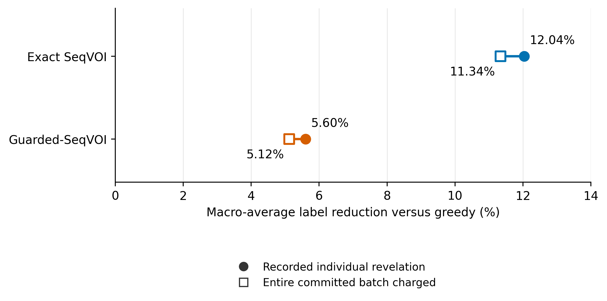
Figure S1. Descriptive sensitivity to charging complete laboratory batches. Filled circles use recorded individual-label stopping costs. Open squares charge all members of each committed batch of up to 16 labels. Query paths and warm-screen costs are unchanged. Cost reduction is calculated relative to greedy within each assay, then averaged within and across 159 UniProt groups. No new experiments or uncertainty intervals are used. This cost-only sensitivity leaves the original prespecified efficacy assessment unchanged and does not estimate actual laboratory expenditure.
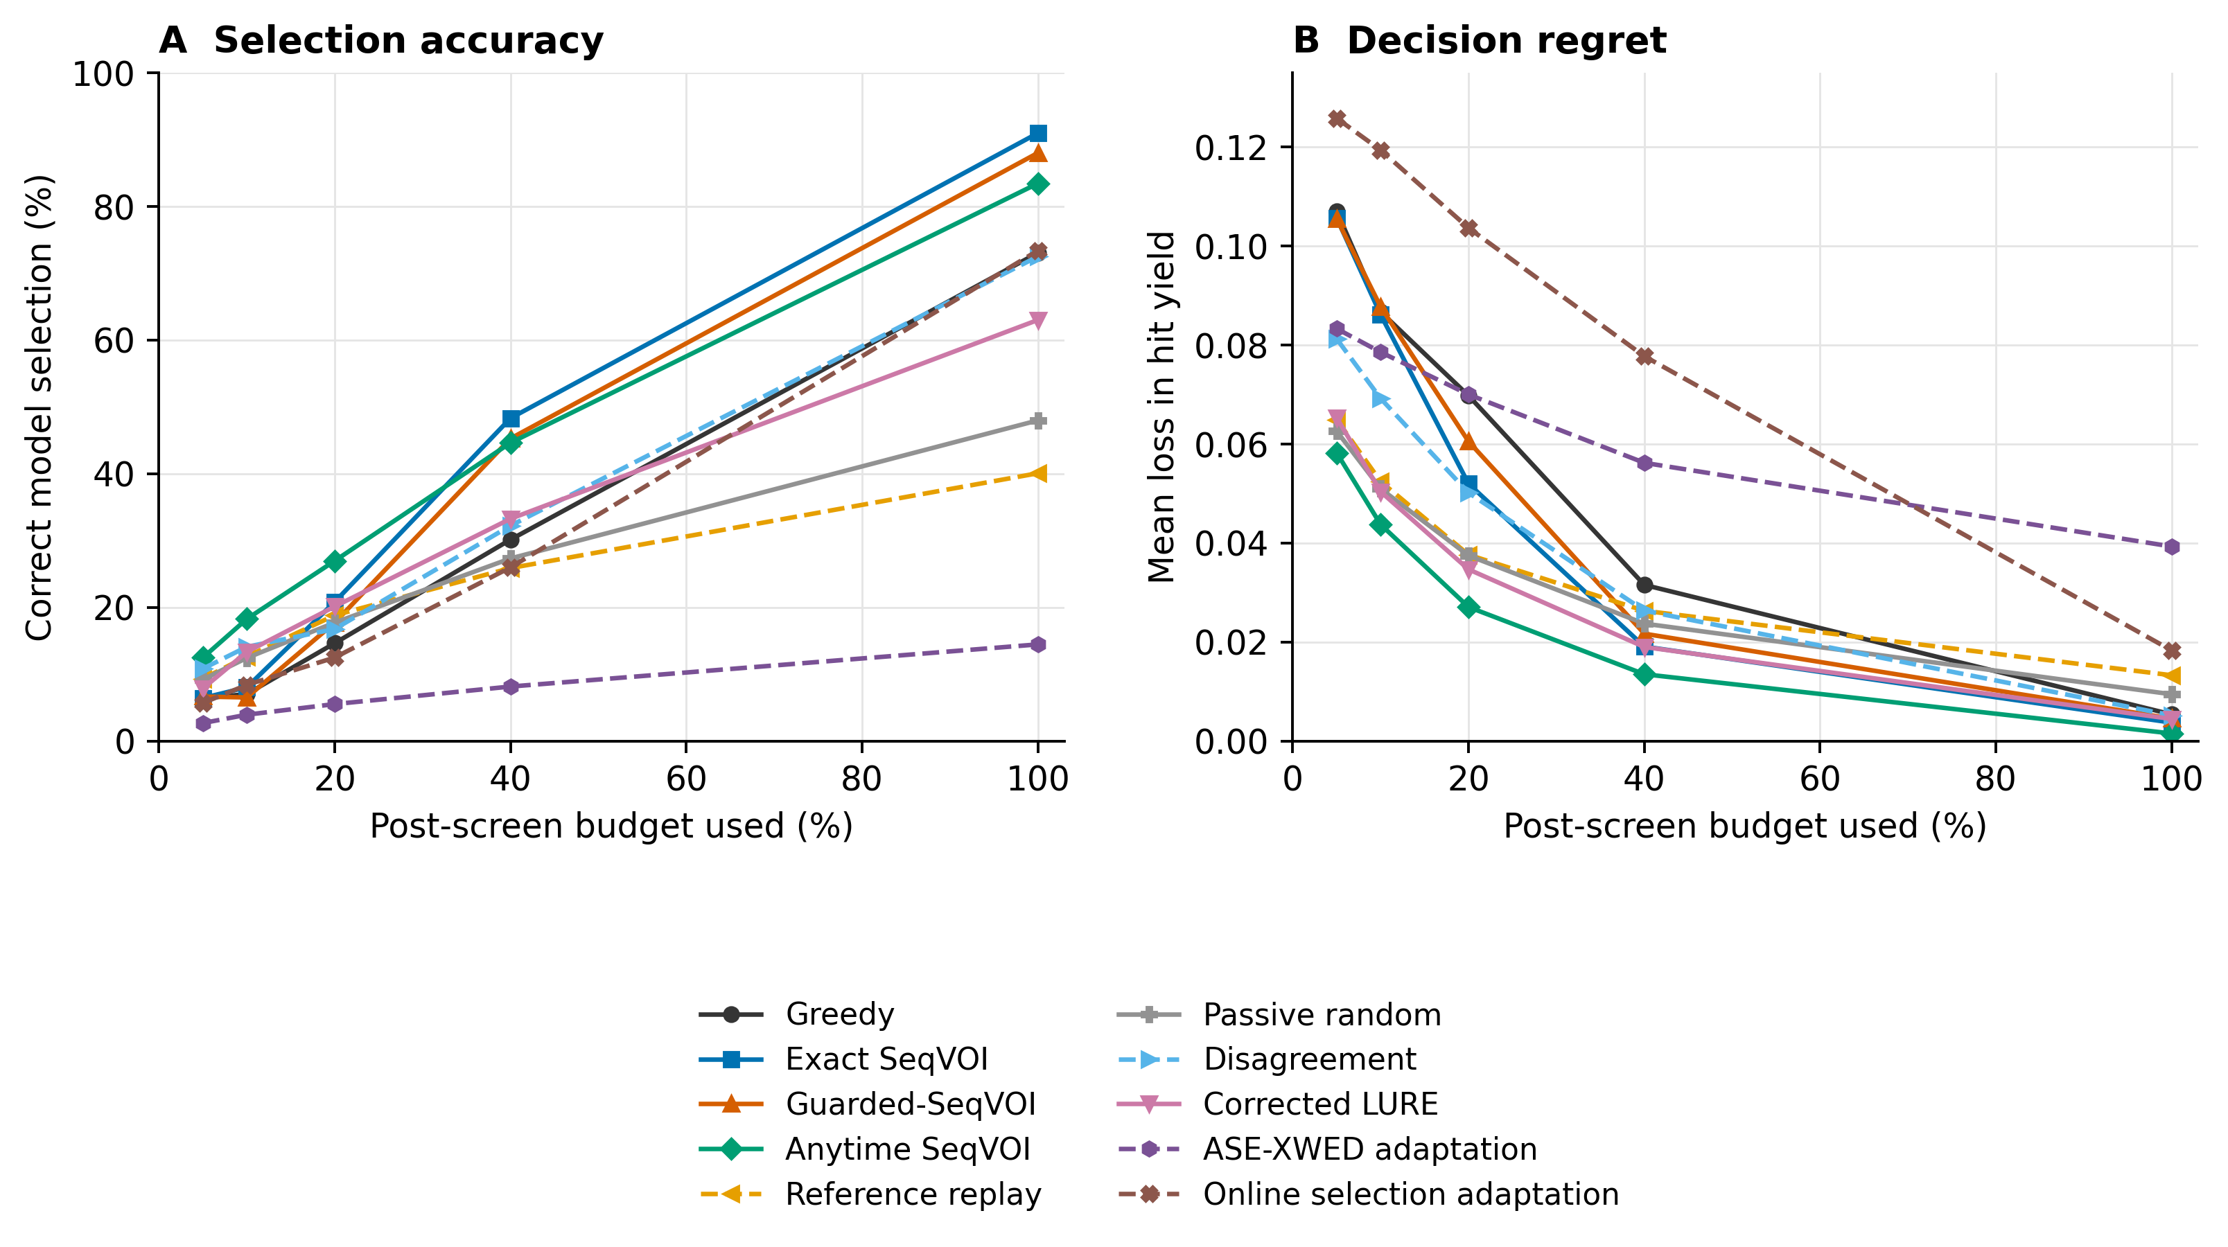
Figure S2. Recommendation accuracy and regret for all 10 acquisition policies. The complete policy comparison uses the same 180 assays and 155 UniProt groups as Figure 2, with equal group weighting. All curves use recorded checkpoints and corrected LURE recommendations. Dashed lines distinguish additional comparator adaptations and do not indicate uncertainty. ASE-XWED and online active model selection are the implemented adaptations described in Methods.

Local acquisition states
The retained map contains 150012 states observed before certification during held-out guard evaluation. Both next batches are evaluated retrospectively using recorded outcomes. The diagnostic is the summed unresolved width after the greedy batch minus that after the SeqVOI batch. A positive value favors SeqVOI for that immediate width reduction. The diagnostic omits the training utility’s termination bonus and differs from total labels to certification.
Each of the six features is divided into four groups using quartiles of the evaluation collection, giving 24 overlapping summaries. Every state appears in one bin for each feature. Repeated states within a trial are dependent, and long trajectories contribute more states. One bin, the highest observed-hit-rate quartile, had positive mean reduction for SeqVOI, approximately 0.032 width units; the other 23 means favored greedy. These bins describe states reached by the fitted switch. They do not identify causes or validate a future switching rule.
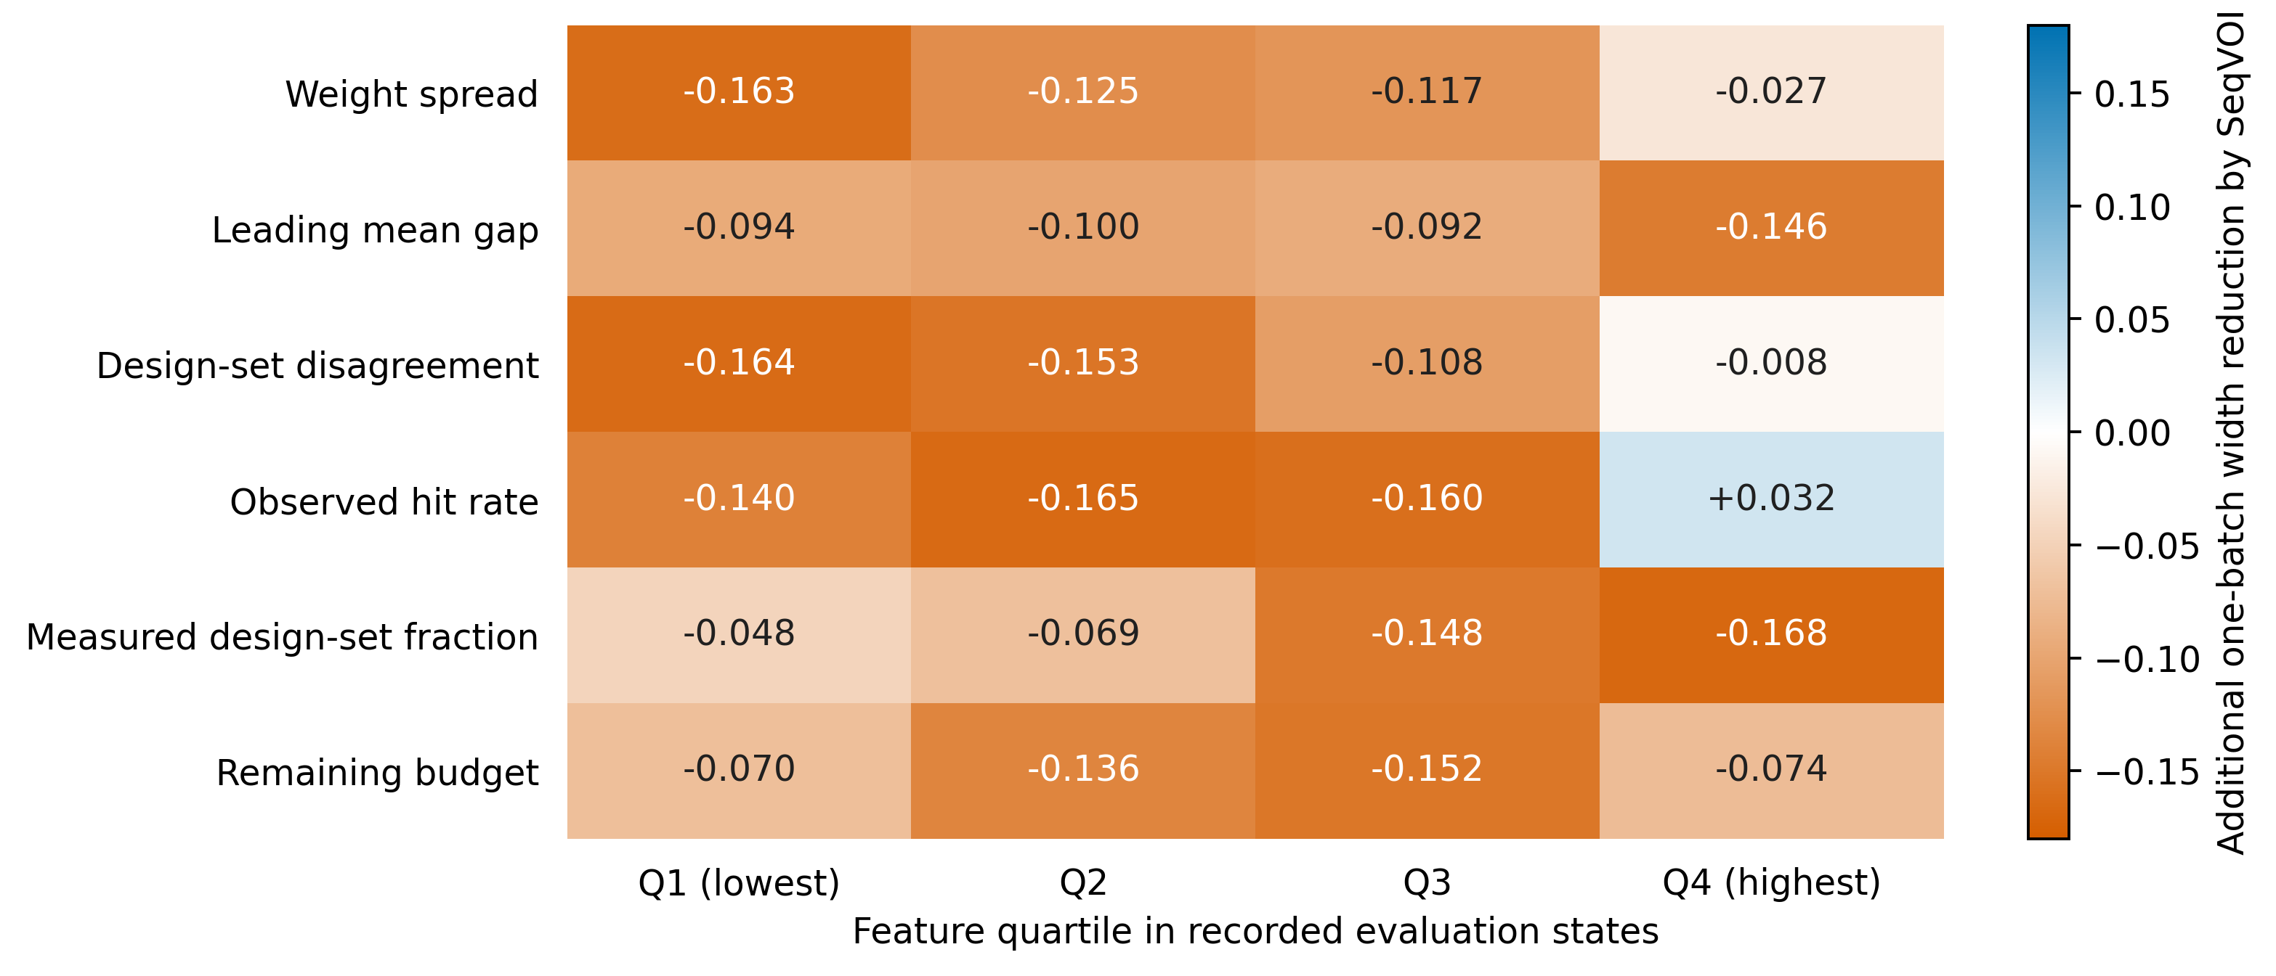
Figure S3. Local width reduction across recorded controller states. Values reproduce the existing 24-bin summary of 150012 repeated states visited by Guarded-SeqVOI before a terminal decision. Positive values mean that the SeqVOI batch reduced summed unresolved interval widths more than the greedy batch from the same state. Only the highest observed-hit-rate quartile has a positive mean. Quartiles were defined from the evaluation states and retain their original boundaries in the accompanying CSV. Every state contributes once for each feature, so rows describe overlapping observations. This local width difference omits the terminal-decision bonus used in controller training and is not the final certification cost. No confidence intervals or independent deployment recommendation are supplied.

Reconstructed input records
The reconstructed 217-entry ledger reproduces the 184 recorded assay identities. It is explicitly labelled as a later reconstruction, with 29 exclusions for too few usable variants, three development-related exclusions, and one degenerate target. It does not reproduce the absent original preparation export. Historical HIS7 uses the experimental DMS_score column of the pinned merged-score table to recover 496137 variants; the standalone label archive supplies 407055. Both reconstructions select the same assay identities. The existing HIS7 exclusion removes its evaluation contribution and keeps the fitted controllers unchanged.
The GB1/AAV retained package includes 7900 trial audits, benchmark and run manifests, and result summaries. The present audit verified all 7913 internally manifested result files. It did not regenerate upstream model assets or experimental inputs. ProteinGym v1.3, upstream revisions, and the distinction between original and reconstructed artifacts are documented in the inherited release [11, 12]. The revised tables, batch calculation, figures, and reconstructed-cohort ledger accompany this manuscript as additional files; they are not described as already deposited under the older release DOI.

Supplementary references
1. Horvitz DG, Thompson DJ. A generalization of sampling without replacement from a finite universe. Journal of the American Statistical Association. 1952;47(260):663–685. https://doi.org/10.1080/01621459.1952.10483446.
2. Angelopoulos AN, Bates S, Fannjiang C, Jordan MI, Zrnic T. Prediction-powered inference. Science. 2023;382(6671):669–674. https://doi.org/10.1126/science.adi6000.
3. Zrnic T, Candès E. Active statistical inference. Proceedings of the 41st international conference on machine learning. 2024;235:62993–63010. https://proceedings.mlr.press/v235/zrnic24a.html.
4. Howard SR, Ramdas A, McAuliffe J, Sekhon J. Time-uniform, nonparametric, nonasymptotic confidence sequences. The Annals of Statistics. 2021;49(2):1055–1080. https://doi.org/10.1214/20-AOS1991.
5. Waudby-Smith I, Ramdas A. Confidence sequences for sampling without replacement. Advances in neural information processing systems. 2020;33:20204–20214. https://arxiv.org/abs/2006.04347.
6. Ramdas A, Grünwald P, Vovk V, Shafer G. Game-theoretic statistics and safe anytime-valid inference. Statistical Science. 2023;38(4):576–601. https://doi.org/10.1214/23-STS894.
7. Waudby-Smith I, Ramdas A. Estimating means of bounded random variables by betting. Journal of the Royal Statistical Society Series B: Statistical Methodology. 2024;86(1):1–27. https://doi.org/10.1093/jrsssb/qkad009.
8. Farquhar S, Gal Y, Rainforth T. On statistical bias in active learning: How and when to fix it. International conference on learning representations. 2021. https://arxiv.org/abs/2101.11665.
9. Kossen J, Farquhar S, Gal Y, Rainforth T. Active testing: Sample-efficient model evaluation. Proceedings of the 38th international conference on machine learning. 2021;139:5753–5763. https://proceedings.mlr.press/v139/kossen21a.html.
10. Hara S, Matsuura M, Honda J, Ito S. Active model selection: A variance minimization approach. Machine Learning. 2024;113:8327–8345. https://doi.org/10.1007/s10994-024-06603-1.
11. ProteinGym contributors. ProteinGym release v1.3. Zenodo. 2025. Dataset and published model scores. Accessed 10 September 2026. https://doi.org/10.5281/zenodo.15293562.
12. Doane M. SeqVOI: Sequential finite-population certification for biomolecular design. Zenodo. 2026. Software and retained results, version 0.4.3. Accessed 10 September 2026. https://doi.org/10.5281/zenodo.22420027.

