How does the visual complexity of architectural signage affect wayfinding search efficiency? Nonlinear evidence from a semantic-computational dual-channel experiment
Zonghui Wang a,*, Huadi Liu b,*
a Department of Architecture, Restoration and Design, Engineering Academy, RUDN University, Moscow 117198, Russia.
b Department of Visual Communication, School of Art and Design, Nanchang Hangkong University, Nanchang 330063, China.
*Corresponding author.
E-mail address: zonghui1128@outlook.com (Z. Wang); 531882202@qq.com (H. Liu)

Supplementary Figure S1
Research framework.
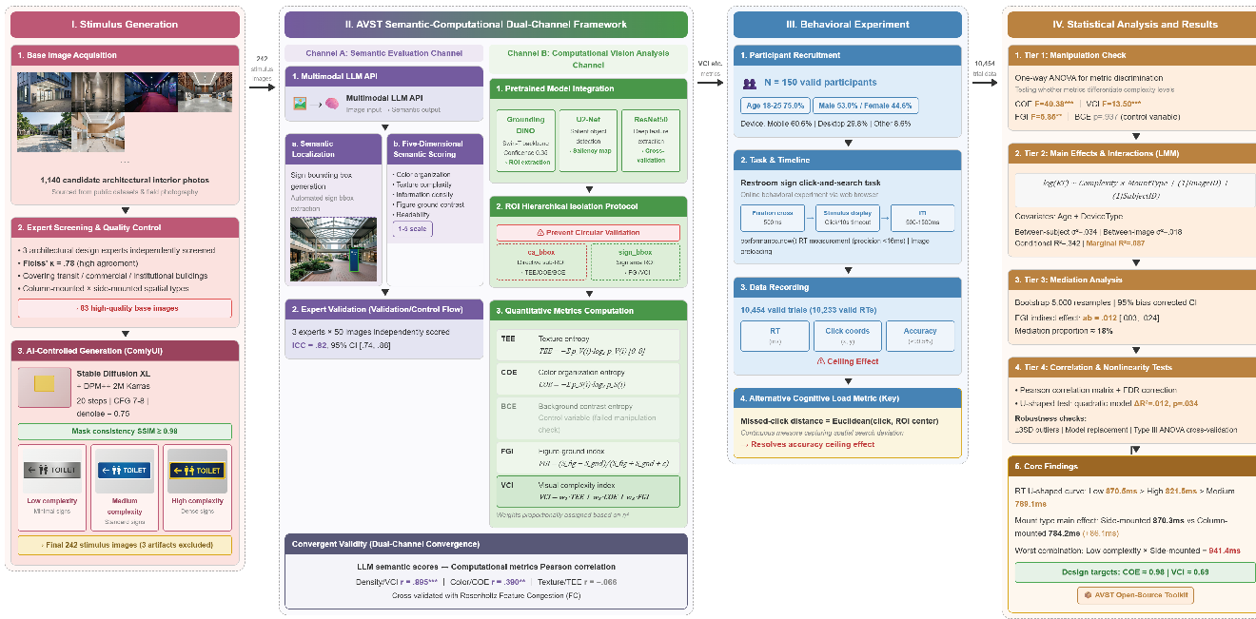
Supplementary Note 1. Abbreviations and metric formulas
This supplementary note summarizes all abbreviations used in this paper and provides calculation formulas for key metrics.
Supplementary Table S1. Abbreviation reference table.
Metric calculation formulas
Texture Entropy (TEE): Shannon entropy of the V channel within the signage ROI, range [0, 8]:
TEE = −Σ p_V(i) · log₂ p_V(i)
where p_V(i) is the probability of the i-th gray level in the V channel histogram (Laplacian smoothed).
Color Organization Entropy (COE): This metric is structurally identical to TEE but is based on the S (saturation) channel, capturing color distribution diversity:
COE = −Σ p_S(i) · log₂ p_S(i)
Background contrast entropy (BCE): The same formula is computed for the background region outside the ROI, which serves as a control variable to verify ROI isolation.
Figure-Ground Index (FGI): Ratio of the mean saliency inside and outside the ROI from the U2-Net saliency map, range [−1, 1]:
FGI = (S_figure − S_ground)/(S_figure + S_ground + ε)
where S_figure and S_ground are the mean saliency within and outside the ROI, respectively, and ε = 10⁻⁸ prevents division by zero.
Visual complexity index (VCI): Weighted fusion after min–max normalization:
VCI = w₁ · TEE_norm + w₂ · COE_norm + w₃ · FGI_norm
Abbreviation | Full name | Description
AVST | Architectural Visual Search Toolkit | The architectural visual search toolkit developed in this study, containing the semantic-computational dual-channel evaluation framework
TEE | Texture Entropy | Shannon entropy of the V (luminance) channel within the signage ROI
COE | Color Organization Entropy | Shannon entropy of the S (saturation) channel within the signage ROI
BCE | Background Contrast Entropy | Shannon entropy of the background region outside the ROI, serving as a control variable
FGI | Figure-Ground Index | Index measuring the saliency contrast between signage and background
VCI | Visual Complexity Index | Weighted fusion metric of TEE, COE, and FGI
FC | Feature Congestion | Visual clutter quantification metric proposed by Rosenholtz
ROI | Region of Interest | The image region where signage is located
LLM | Large Language Model | This study employs a multimodal LLM for semantic scoring
RT | Reaction Time | Time interval from stimulus presentation to user click (ms)
SD | Standard Deviation | Statistical measure of data dispersion
LMM | Linear Mixed Model | Regression analysis handling nested random effects
ANOVA | Analysis of Variance | Statistical method testing between-group mean differences
ICC | Intraclass Correlation Coefficient | Coefficient assessing interr-rater reliability
CI | Confidence Interval | Confidence interval
R² | Coefficient of Determination | Conditional R² includes fixed + random effects; marginal R² includes only fixed effects
η² | Eta-squared | Effect size measuring the proportion of dependent variable variance explained by independent variables

