SUPPLEMENTARY DATA FOR:

DIFFERENTIAL IMMUNE DYNAMICS IN LARGE B-CELL LYMPHOMA PATIENTS TREATED WITH AXI-CEL AND TISA-CEL CAR-T CELL PRODUCTS
Giulia Radice,^{1*} Nadia Peragine,^{1*} Michela Ansuinelli,^{1*} Alice Di Rocco,¹ Livia Donzelli,¹ Arianna Di Rocco,² Anna Guarini,¹ and Robin Foà¹
* Equal contribution
¹Hematology, Department of Translational and Precision Medicine, Sapienza University, Rome, Italy
²Sandro Pertini Hospital, ASL Roma 2, Rome, Italy

Corresponding author: Robin Foà, MD, Emeritus Professor of Hematology
Department of Translational and Precision Medicine, Sapienza University of Rome, Via Benevento 6, 00161 Rome, Italy.
E-mail: rfoa@bce.uniroma1.it

This file includes:
Supplemental methods
Supplemental Tables S1-5
Supplemental Figures S1, 2

Supplementary methods

Immunophenotyping and intracellular cytokine production
Peripheral blood (PB) lymphocytes were obtained from whole blood samples collected before CAR-T-cell infusion and at different timepoints after the infusion, as detailed in the main text. After excluding doublets and dead cells, multiparametric flow cytometry was performed on fresh blood samples to assess the absolute counts and monitor the relative proportion of T, B and NK lymphocyte subsets using a combination of labelled monoclonal antibodies (moAbs) against the CD3, CD4, CD8, CD16 and CD56 antigens (all antibodies from Becton Dickinson, BD, San Jose, CA) (Supplemental Table S1A). CAR⁺ cells were detected using the CAR target protein CD19 fused with a biotin-labeled mutated Fc backbone and identified using a fluorochrome-labeled biotin antibody (Miltenyi Biotec, Bergisch Gladbach, Germany). Absolute cell counts were determined by correlating the percentage of positive populations to the total lymphocyte numbers and were reported as cells x10⁹/L.
Analysis of maturational states and of exhaustion and senescence phenotypes of lymphocytes was performed on infusion bag leftovers and on PB samples, using a 12-color panel of moAbs against CD3, CD4, CD8, CD25, CD28, CD45RA, CD57, CD62L, CD127, PD1, Tim3 in association with CAR staining (Supplemental Table S1B). T lymphocyte subsets were defined as naïve (CD62L+CD45RA+), central memory (TCM: CD62L+CD45RA−), effector memory (TEM: CD62L−CD45RA−) and effector memory re-expressing CD45RA (TEMRA) cells.
The assessment of fresh PB mononuclear cells (PBMCs) cytokine production was performed by intracellular staining as previously described.¹ For T- and NK-cell cytokine production, PBMCs were stained with FITC-, PE-, PerCP-, PECy7-, and APC-labeled moAbs against CD3, CD4, CD16, CD56, interferon-gamma (IFNγ), and tumor necrosis factor-alpha (TNFα). The samples were acquired using a FACS Celesta flow cytometer and analyzed using the FACSDIVA software.
Samples were acquired with the FACS Celesta ﬂow cytometer (BD) collecting at least 30,000 events and analyzed using the FACSDIVA software (BD).

Statistical analysis
Baseline characteristics were summarized using descriptive statistics. Continuous variables were reported as mean ± standard deviation (SD), and categorical variables as counts and percentages. Associations between baseline clinical-biological parameters (ferritin, LDH, CAR-Hematotox score) and response and hematologic reconstitution, as well as the relationship between lymphocyte dynamics and CRS/ICANS occurrence, were analyzed using mixed-effects logistic regression models with a patient-specific random intercept and time as a covariate. Comparisons between groups for immunophenotypic features, longitudinal lymphocytes monitoring, cytokine production, differentiation profiles and plasma cytokine levels were performed using the two-sided Student t test. Analyses were performed using software R (version 4.4.2) and GraphPad Prism Software (version 5.0). Statistical significance was assessed using two-sided p-values, with p < 0.05 considered significant.

Additional References

- Guarini A, Radice G, Peragine N, et al (2023) Long-Term Host Immune Modulation Following Tisagenlecleucel Administration in Patients with Diffuse Large B-Cell Lymphoma and B-Lineage Acute Lymphoblastic Leukemia. Cancers 15(9):2411

Supplemental Table S1. Antibody panels for peripheral blood immune cell monitoring (A) and for analysis of maturational state, exhaustion and senescence phenotypes (B).
A.

Antibody | Fluorochrome | Vendor | Catalog N.
CD45 | FITC | BD Biosciences | 345808
CD56 | APC | BD Biosciences | 341027
CD19 CAR | Biotin-PE | Mylteni | 130-129-550
CD3 | BV786 | BD Biosciences | 563799
CD4 | BV711 | BD Biosciences | 563028
CD16 | BV510 | BD Biosciences | 563830
CD8 | BV786 | BD Biosciences | 563823

B.
Antibody | Fluorochrome | Vendor | Catalog N.
TIM3 | BB700 | BD Biosciences | 746178
CD19 CAR | Biotin-PE | Mylteni | 130-129-550
CD25 | APC-R700 | BD Biosciences | 565106
CD62L | BV605 | BD Biosciences | 562719
CD3 | BV786 | BD Biosciences | 563799
CD57 | FITC | BD Biosciences | 561906
PD1 | APC | BD Biosciences | 558694
CD127 | BV421 | BD Biosciences | 562436
CD4 | BV510 | BD Biosciences | 562970
CD8 | BV650 | BD Biosciences | 563821
CD45RA | APC-H7 | BD Biosciences | 560674
CD45RA | APC-H7 | BD Biosciences | 560674

Supplementary Table S2. Baseline characteristics of patients at the time of selection for CAR-T (A); characteristic of patients evaluated for lymphocytes longitudinal monitoring with available flow-cytometric analysis of T-cell maturation and senescence (B) and with available cytokine analysis (C).
A.
OVERALL BASELINE PATIENTS’ CHARACTERISTICS
 | All patients (n=67) | Axi-cel (n=39) | Tisa-cel (n=28)
Median age (range) | 51.7 (20-71) | 49.2 (20-70) | 59.4 (34-71)
Gender (%)  F  M | 26 (38.8)  41 (61.2) | 15 (38.5)  24 (61.5) | 11 (39.3)  17 (60.7)
Previous lines of treatment (%)  1 line  ≥2 lines | 10 (14.9)  57 (85.1) | 10 (25.6)  29 (74.4) | 0  28 (100)
IPI (%)  <2  ≥2 | 37 (55.2)  30 (44.8) | 26 (66.7)  13 (33.3) | 11 (39.2)  17 (60.7)
Stage at selection  I-II  III-IV | 36 (53.7)  31 (46.3) | 26 (66.7)  13 (33.3) | 10 (35.7)  18 (64.3)
Extranodal  Yes  No | 23 (34.3)  44 (65.7) | 8 (20.5)  31 (79.5) | 15 (53.6)  13 (46.4)
Elevated LDH (≥2.5 ULN)  Yes  No | 26 (38.8)  41 (61.2) | 12 (30.8)  27 (69.2) | 14 (50)  14 (50)
Elevated Ferritin (≥650 ng/ml)  Yes  No | 26 (38.8)  41 (61.2) | 14 (35.9)  25 (64.1) | 12 (42.9)  16 (57.1)
CAR HematoTOX  Low  High | 47 (70.1)  20 (29.9) | 28 (71.8)  11 (28.2) | 19 (67.9)  9 (32.1)

B.
BASELINE PATIENTS’ CHARACTERISTICS with available flow-cytometric analysis of T-cell maturation and senescence
 | All patients (n=28) | Axi-cel (n=18) | Tisa-cel (n=10)
Median age (range) | 54 (20-71) | 52,5 (25-68) | 62 (44-71)
Gender (%)  F  M | 10 (35.7)  18 (64.3) | 7 (38.9)  11 (61.1) | 3 (30)  7 (70)
Previous lines of treatment (%)  1 line  ≥2 lines | 10 (35.7)  18 (64.3) | 10 (55.6)  8 (44.4) | 0  10 (100)
IPI (%)  <2  ≥2 | 17 (60.7)  11 (39.3) | 14 (77,8)  4 (22.2) | 3 (30)  7 (70)
Stage at selection  I-II  III-IV | 14 (50)  14 (50) | 11 (61.1)  7 (38.9) | 3 (30)  7 (70)
Extranodal  Yes  No | 6 (21.4)  22 (65.7) | 4 (22.2)  14 (77,8) | 2 (20)  8 (80)
Elevated LDH (≥ 2.5 ULN)  Yes  No | 8 (28.6)  20 (71.4) | 5 (27.8)  13 (72.2) | 3 (30)  7 (70)
Elevated Ferritin (≥650 ng/ml)  Yes  No | 9 (32.1)  19 (67.9) | 7 (38.9)  11 (61.1) | 2 (20)  8 (80)
CAR HematoTOX  Low  High | 20 (71.4)  8 (28.6) | 13 (72.2)  5 (27.8) | 7 (70)  3 (30)

C.
BASELINE PATIENTS’ CHARACTERISTICS with available plasma cytokine analysis
 | All patients (n=38) | Axi-cel (n=19) | Tisa-cel (n=19)
Median age (range) | 54.6 (25-71) | 51 (25-70) | 56.3 (34-70)
Gender (%)  F  M | 15 (39.5)  23 (60.5) | 7 (36.8)  12 (36.2) | 8 (42.1)  11 (57.9)
Previous lines of treatment (%)  1 line  ≥2 lines | 0  38 (100) | 0  19 (100) | 0  19 (100)
IPI (%)  <2  ≥2 | 23 (60.5)  15 (39.5) | 15 (78.9)  4 (21.1) | 8 (42.1)  11 (57.9)
Stage at selection  I-II  III-IV | 17 (44.3)  21 (55.3) | 11 (27.9)  8 (42.1) | 6 (31.6)  13 (68.4)
Extranodal  Yes  No | 13 (34.2)  25 (65.8) | 4 (21.1)  15 (78.9) | 9 (47.4)  10 (52.6)
Elevated LDH (≥2.5 ULN)  Yes  No | 13 (32.4)  25 (65.8) | 7 (36.8)  12 (63.2) | 6 (31.6)  13 (68.4)
Elevated Ferritin (≥650 ng/ml)  Yes  No | 12 (31.6)  26 (68.4) | 5 (26.3)  14 (73.7) | 7 (36.8)  12 (63.2)
CAR HematoTOX  Low  High | 28 (73.7)  10 (26.3) | 15 (78.9)  4 (21.1) | 13 (68.4)  6 (31.6)

Supplemental Table S3. Relative post-infusion toxicities and clinical responses in the two cohorts of treatment. The overall response value is calculated including patients who obtained a complete and a partial response. Relapse rate was calculated as the proportion of patients who experienced disease progression or relapse within 6 months after CAR-T-cell infusion among patients who achieved a complete or partial response at any on-treatment PET evaluation. Patients with primary refractory disease were excluded from this analysis.

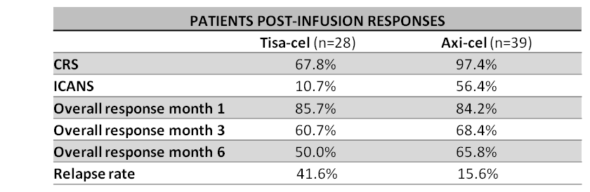

Supplementary Table S4. In vivo longitudinal monitoring of CD3, CD4 (CD3⁺CD4⁺), CD8 (CD3⁺CD8⁺) and NK (CD3⁻CD56⁺) cells, and IFNγ/TNFα producing lymphocytes populations at different timepoints before and after CAR-T-cell infusion. Data are reported as means ± SD of the absolute number of the different lymphocyte populations studied. Significant differences were calculated compared with T0.

 | Pre-LD | T0 | T3d |  | T7d |  | T14d |  | T28d |  | T3M |  | T6M
 | Mean±SD | Mean±SD | Mean±SD | p-value | Mean±SD | p-value | Mean±SD | p-value | Mean±SD | p-value | Mean±SD | p-value | Mean±SD | p-value
CD3 | 0.65±0.05 | 0.09±0.08 | 0.20±0.01 | 0.002 | 0.59±0.73 | 0.002 | 0.57±0.16 | <0.001 | 0.70±0.03 | <0.001 | 0.75±0.02 | <0.001 | 0.87±.0.07 | <0.001
CD4 | 0.33±0.02 | 0.05±0.0004 | 0.08±0.04 | 0.010 | 0.25±0.21 | <0.001 | 0.33±0.12 | <0.001 | 0.37±0.20 | <0.001 | 0.35±0.07 | <0.001 | 0.45±0.11 | <0.001
CD8 | 0.46±0.06 | 0.06±0.09 | 0.15±0.03 | 0.006 | 0.40±0.62 | 0.007 | 0.34±0.06 | <0.001 | 0.48±0.15 | <0.001 | 0.55±0.02 | <0.001 | 0.67±0.15 | <0.001
NK | 0.03±0.04 | 0.001±0.0004 | 0.004±0.004 | 0.011 | 0.01±0.01 | 0.001 | 0.02±0.01 | <0.001 | 0.04±0.01 | <0.001 | 0.05±0.02 | <0.001 | 0.06±0.02 | <0.001
IFNγ CD3 | 0.32±0.10 | 0.04±0.07 | 0.07±0.06 | 0.080 | 0.26±0.27 | 0.001 | 0.31±0.08 | <0.001 | 0.37±0.17 | <0.001 | 0.45±0.10 | <0.001 | 0.54±0.07 | <0.001
IFNγ CD4 | 0.11±0.002 | 0.01±0.004 | 0.02±0.02 | 0.146 | 0.09±0.10 | 0.001 | 0.14±0.05 | <0.001 | 0.16±0.07 | <0.001 | 0.15±0.01 | <0.001 | 0.19±0.06 | <0.001
IFNγ CD8 | 0.28±0.09 | 0.03±0.07 | 0.06±0.05 | 0.094 | 0.20±0.24 | 0.002 | 0.23±0.04 | <0.001 | 0.30±0.13 | <0.001 | 0.39±0.08 | <0.001 | 0.50±0.11 | <0.001
IFNγ NK | 0.01±0.03 | 0.001±0.001 | 0.002±0.004 | 0.003 | 0.01±0.02 | 0.010 | 0.02±0.07 | <0.001 | 0.03±0.07 | <0.001 | 0.01±0.02 | <0.001 | 0.02±0.02 | <0.001
TNFα CD3 | 0.38±0.02 | 0.04±0.002 | 0.08±0.07 | 0.012 | 0.25±0.26 | <0.001 | 0.36±0.17 | <0.001 | 0.41±0.29 | <0.001 | 0.48±0.15 | <0.001 | 0.61±0.01 | <0.001
TNFα CD4 | 0.23±0.004 | 0.03±0.004 | 0.05±0.05 | 0.054 | 0.15±0.19 | 0.003 | 0.25±0.14 | <0.001 | 0.29±0.21 | <0.001 | 0.25±0.11 | <0.001 | 0.35±0.09 | <0.001
TNFα CD8 | 0.24±0.06 | 0.03±0.07 | 0.04±0.03 | 0.365 | 0.13±0.16 | 0.007 | 0.16±0.06 | <0.001 | 0.21±0.16 | <0.001 | 0.31±0.08 | <0.001 | 0.44±0.06 | <0.001
TNFα NK | 0.01±0.04 | 0.001±0.001 | 0.002±0.003 | 0.015 | 0.01±0.01 | 0.012 | 0.01±0.05 | 0.001 | 0.03±0.08 | <0.001 | 0.01±0.02 | <0.001 | 0.02±0.02 | <0.001

Supplementary Table S5. Ferritin and LDH values before CAR-T-cell infusion. Mean Ferritin (ng/ml) (A) and LDH (U/l) (B) values were evaluated before CAR-T-cell infusion in patients who obtained a complete response (CR) and in patients who achieved partial response (PR), progressive disease (PD) or relapsed (R). Data are reported as means ± SD and significant differences were calculated compared with the CR group.

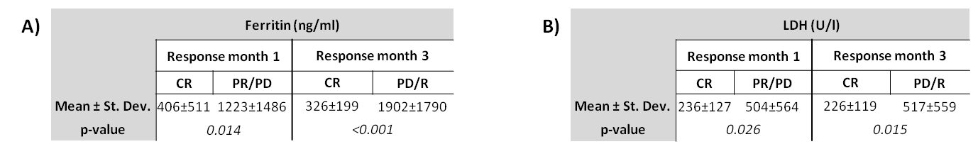

Supplementary Fig. S1 In vivo longitudinal monitoring of peripheral IFNγ/TNFα producing CD3, CD4 and CD8 T-cells at different timepoints before and after CAR-T-cell infusion (A) Absolute counts (×10⁹/L) of IFNγ-producing CD3⁺ T-cells measured after in vitro stimulation at the post-lymphodepletion pre-infusion baseline (T0), days 3, 7, 14 and 28, and months 3 and 6 after infusion (B) Absolute counts (×10⁹/L) of IFNγ-producing CD4⁺ T-cells (C) Absolute counts (×10⁹/L) of IFNγ-producing CD8⁺ T-cells (D) Absolute counts (×10⁹/L) of TNFα-producing CD3⁺ T-cells (E) Absolute counts (×10⁹/L) of TNFα-producing CD4⁺ T-cells (F) Absolute counts (×10⁹/L) of TNFα-producing CD8⁺ T-cells. Data are presented as mean ± SD. Significant differences are indicated as ***p < 0.001, **p < 0.01, *p < 0.05.

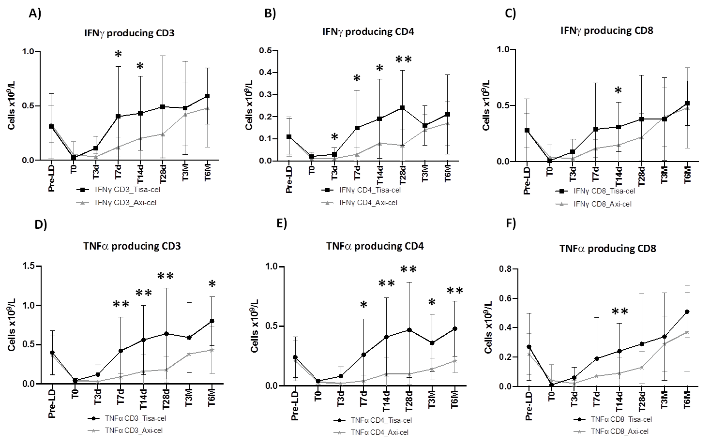

Supplementary Fig. S2 Phenotypic profiling of CAR-T products tisa-cel and axi-cel (A) Pie charts show the percentage of CAR⁻ and CAR⁺ cells and their relative CD4 and CD8 composition (B) Proportion of CD4 and CD8 CAR-T cells across different differentiation states — naïve, central memory (CM), effector memory (EM), and terminal effector memory (TEMRA) — (C) percentage of CAR-T cells displaying exhaustion and senescence phenotypes.

