Supplementary Information For

Development and validation of polygenic risk scores for prediction of breast cancer and breast cancer subtypes in Chinese women

Table of contents
Table S1 Basic information of the first set of SNPs along with the SNP selection results 2
Table S2 Basic information of the second set of SNPs along with SNP selection results 6
Table S3 Basic information of the 24 SNPs included for PRSs construction 7
Table S4 Characteristics of the participants in the SGWAS 9
Table S5 Comparison between the participants in the SBCCS who were included in the current study with the participants excluded due to unavailability of DNA samples or number of failed SNPs ≥ 3 10
Table S6 Predictive performance of the primary PRSs for overall and ER+/ER- breast cancer 11
Table S7 Sensitivity analysis 1 - predictive performance of the primary PRSs for overall and ER+/ER- breast cancer when samples with missing genotypes were all excluded 12
Table S8 Sensitivity analysis 2 - predictive performance of the SNP-17 PRS_{RLR} for overall and ER+/ER- breast cancer 14
Table S9 Indirect comparison with previous PRSs for Chinese women 15
Figure S1 Flowchart of the quality control process of the SGWAS dataset using PLINK 1.90 and IMPUTE2 17
Figure S2 Linkage disequilibrium matrix of the first set of SNPs 18
Figure S3 Linkage disequilibrium matrix of the second set of SNPs 19
Figure S4 Hyperparameters tuning results of the logistic ridge regression model 20
Figure S5 Hyperparameters tuning (A: number of iterations, B: number of hidden layers and dropout rate) results of the Artificial Neural Network model 21
Figure S6 The structure of the ANN model used in the current study 22
Figure S7 Spearman’s rank correlation coefficient matrix for breast cancer risk factors, PRSs and Gail-2 model 5-year risk 23

Table S1 Basic information of the first set of SNPs along with the SNP selection results
SNP | Position (GRCh37) | Proxy | Position for proxy (GRCh37) | Included for genotype in the SBCCS (reason for exclusion) | N_Missing  (N=807) | HWE-P (case) | HWE-P  (control) | Included in PRS  (reason for exclusion)
rs1801133¹ | chr1:11856378 | - | - | No (no proxy found) | - | - | - | -
rs1137100² | chr1:66036441 | - | - | Yes | 3 | 0.40 | 0.90 | Yes
rs1137101³ | chr1:66058513 | rs10789190 | chr1:66063580 | Yes | 3 | 0.79 | 0.87 | Yes
rs763110^{4,5} | chr1:172627498 | - | - | Yes | 3 | 0.99 | 1.00 | Yes
rs4973768⁶ | chr3:27416013 | - | - | No (no proxy found) | - | - | - | -
rs10941679⁷ | chr5:44706498 | rs4479849 | chr5:44644006 | Yes | 3 | 0.71 | 0.09 | Yes
rs9485372⁸ | chr6:149608874 | - | - | Yes | 5 | 0.81 | 1.00 | Yes
rs2046210⁹ | chr6:151948366 | - | - | Yes | 0 | 0.75 | 0.10 | Yes
rs9397437^{9,10} | chr6:151952332 | - | - | Yes | 2 | 0.06 | 0.23 | Yes
rs662^{11,12} | chr7:94937446 | rs2057681 | chr7:94938257 | Yes | 4 | 0.74 | 0.53 | Yes
rs854560¹¹ | chr7:94946084 | - | - | No (no proxy found) | - | - | - | -
rs7799039³ | chr7:127878783 | - | - | Yes | 13 | 0.99 | 0.64 | Yes
rs2234767^{13,14} | chr10:90749256 | rs7097467 | chr10:90753244 | Yes | 3 | 0.67 | 0.98 | Yes
rs2981578^{15,16} | chr10:123340311 | rs10736303 | chr10:123334457 | Yes | 2 | 0.99 | 0.98 | Yes
rs2981575¹⁶ | chr10:123346116 | - | - | Yes | 16 | 0.82 | 0.89 | Yes
rs1219648^{16,17} | chr10:123346190 | - | - | No (in LD with rs2162540 and rs2981575) | - | - | - | -
rs2420946^{16,17} | chr10:123351324 | rs2162540 | chr10:123352136 | Yes | 5 | 0.97 | 0.67 | Yes
rs2981582^{15,16} | chr10:123352317 | - | - | Yes | 1 | 0.99 | 0.98 | Yes
rs3817198¹⁸ | chr11:1909006 | - | - | Yes | 5 | 0.73 | 0.62 | Yes
rs1695¹⁹ | chr11:67352689 | - | - | No (no proxy found) | - | - | - | -
rs730154²⁰ | chr15:51591204 | rs8031463 | chr15:51596539 | Yes | 0 | 1.00 | 0.67 | Yes
rs9282861²¹ | chr16:28617514 | - | - | No (no proxy found) | - | - | - | -
rs8051542²² | chr16:52534167 | - | - | Yes | 0 | 0.98 | 0.99 | Yes
rs3803662^{22,23} | chr16:52586341 | - | - | Yes | 4 | 0.85 | 0.20 | Yes
rs4784227²⁴ | chr16:52599188 | - | - | Yes | 0 | 0.85 | 0.92 | Yes
rs12922061²³ | chr16:52635000 | - | - | Yes | 3 | 0.88 | 0.56 | Yes
rs11655505²⁵ | chr17:41278377 | rs9646413 | chr17:41426157 | Yes | 0 | 0.18 | 0.70 | Yes
rs4680²⁶ | chr22:19951271 | - | - | Yes | 0 | 1.00 | 0.83 | Yes
Eligible proxy needs to be in tight LD (R² > 0.9) with the original SNP; 22 SNPs from the first set of SNPs were genotyped in the SBCCS samples (N = 807); HWE-P: P-value for Hardy Weinberg equilibrium test.

References:
1. Yu L, Chen J. Association of MHTFR Ala222Val (rs1801133) polymorphism and breast cancer susceptibility: An update meta-analysis based on 51 research studies. Diagnostic pathology. 2012;7(1):171.
2. Wang L-q, Shen W, Xu L, et al. The association between polymorphisms in the leptin receptor gene and risk of breast cancer: a systematic review and pooled analysis. Breast cancer research and treatment. 2012;136(1):231-239.
3. Luan H, Zhang H, Li Y, et al. Association of two obesity-related gene polymorphisms LEPG2548A rs7799039 and LEPRQ223R rs1137101 with the risk of breast cancer. Oncotarget. 2017;8(35):59333.
4. Wang M, Wang Z, Wang X-J, et al. Distinct role of the Fas rs1800682 and FasL rs763110 polymorphisms in determining the risk of breast cancer among Han Chinese females. Drug design, development and therapy. 2016;10:2359.
5. Wang Z, Gu J, Nie W, Xu J, Huang G, Guan X. Quantitative assessment of the association between three polymorphisms in FAS and FASL gene and breast cancer risk. Tumor Biology. 2014;35(4):3035-3039.
6. Chen W, Zhong R, Ming J, et al. The SLC4A7 variant rs4973768 is associated with breast cancer risk: evidence from a case–control study and a meta-analysis. Breast cancer research and treatment. 2012;136(3):847-857.
7. Wang X, Zhang L, Chen Z, et al. Association between 5p12 genomic markers and breast cancer susceptibility: evidence from 19 case-control studies. PloS one. 2013;8(9):e73611.
8. Long J, Cai Q, Sung H, et al. Genome-wide association study in east Asians identifies novel susceptibility loci for breast cancer. PLoS genetics. 2012;8(2):e1002532.
9. Zheng W, Long J, Gao Y-T, et al. Genome-wide association study identifies a new breast cancer susceptibility locus at 6q25. 1. Nature genetics. 2009;41(3):324-328.
10. Hirata T, Koga K, Johnson TA, et al. Japanese GWAS identifies variants for bust-size, dysmenorrhea, and menstrual fever that are eQTLs for relevant protein-coding or long non-coding RNAs. Scientific reports. 2018;8(1):1-17.
11. Liu P, Wang Q, Cui Y, Wang J. A meta-analysis of the relationship between paraoxonase 1 polymorphisms and cancer. Free Radical Research. 2019;53(11-12):1045-1050.
12. Saadat M. Paraoxonase 1 genetic polymorphisms and susceptibility to breast cancer: a meta-analysis. Cancer Epidemiology. 2012;36(2):e101-e103.
13. Wang W, Zheng Z, Yu W, Lin H, Cui B, Cao F. Polymorphisms of the FAS and FASL genes and risk of breast cancer. Oncology letters. 2012;3(3):625-628.
14. Chen Y, Wang H, Yan Y, Ren M, Yan C, Wang B. Correlation between FAS single nucleotide polymorphisms and breast carcinoma susceptibility in Asia. Medicine. 2019;98(49).
15. Zhang Y, Zeng X, Liu P, et al. Association between FGFR2 (rs2981582, rs2420946 and rs2981578) polymorphism and breast cancer susceptibility: a meta-analysis. Oncotarget. 2017;8(2):3454.
16. Cui F, Wu D, Wang W, He X, Wang M. Variants of FGFR2 and their associations with breast cancer risk: a HUGE systematic review and meta-analysis. Breast cancer research and treatment. 2016;155(2):313-335.
17. Zhang Y, Lu H, Ji H, et al. Association between rs11200014, rs2981579, and rs1219648 polymorphism and breast cancer susceptibility: A meta-analysis. Medicine. 2017;96(50).
18. Tang J, Li H, Luo J, Mei H, Peng L, Li X. The LSP1 rs3817198 T> C polymorphism contributes to increased breast cancer risk: a meta-analysis of twelve studies. Oncotarget. 2016;7(39):63960.
19. Kuang M, Xu W, Cao C, et al. Glutathione S-transferase P1 rs1695 A> G polymorphism and breast cancer risk: evidence from a meta-analysis. Genet Mol Res. 2016;15(2).
20. Wang Q, Li H, Tao P, et al. Soy isoflavones, CYP1A1, CYP1B1, and COMT polymorphisms, and breast cancer: a case–control study in southwestern China. DNA and cell biology. 2011;30(8):585-595.
21. Forat-Yazdi M, Jafari M, Kargar S, et al. Association between SULT1A1 Arg213His (Rs9282861) polymorphism and risk of breast cancer: A systematic review and meta-analysis. Journal of Research in Health Sciences. 2017;17(4):396.
22. Zhang L, Long X. Association of three SNPs in TOX3 and breast cancer risk: Evidence from 97275 cases and 128686 controls. Scientific reports. 2015;5:12773.
23. Liao J, Chen Y, Zhu J, Wang Q, Mo Z. Polymorphisms in the TOX3/LOC643714 and risk of breast cancer in south China. The International Journal of Biological Markers. 2018;33(4):492-499.
24. Sun Y, Chen P, Wu J, et al. Association of polymorphisms in LOC105377871 and CASC16 with breast cancer in the northwest Chinese Han population. The Journal of Gene Medicine. 2020;22(3):e3131.
25. Chan KY, Liu W, Long J-R, et al. Functional polymorphisms in the BRCA1 promoter influence transcription and are associated with decreased risk for breast cancer in Chinese women. Journal of medical genetics. 2009;46(1):32-39.
26. Qiu J, Du Z, Liu J, Zhou Y, Liang F, Lü Q. Association between polymorphisms in estrogen metabolism genes and breast cancer development in Chinese women: A prospective case–control study. Medicine. 2018;97(47).

Table S2 Basic information of the second set of SNPs along with SNP selection results
SNP | Position (GRCh37) | Effect allele | Training set (SGWAS) |  |  | Test set (SBCCS)
SNP | Position (GRCh37) | Effect allele | OR | P-value | Included for genotype | OR | P-value | HWE-P  (case) | HWE-P  (control) | N_Missing  (N=807) | Included in PRS
rs6730484 | chr2:79157621 | A | 0.60 | 3.60E-08 | Yes | 1.86 | 0.01 | <0.001 | <0.001 | 5 | No
rs1440625 | chr3:74159454 | C | 0.62 | 5.25E-09 | Yes | 1.04 | 0.90 | 0.85 | 0.86 | 3 | No
rs1583563 | chr3:161556214 | G | 0.52 | 1.64E-15 | Yes | 3.59 | 0.05 | 0.96 | 1.00 | 3 | No
rs13113498 | chr4:125011101 | A | 0.61 | 1.31E-08 | Yes | 1.26 | 0.51 | 0.89 | 0.93 | 1 | No
rs9477834 | chr6:18713337 | A | 0.47 | 1.55E-15 | Yes | - | 1.00 | - | 1.00 | 3 | No
rs11773166 | chr7:86040733 | C | 0.76 | 1.28E-08 | Yes | 1.38 | 0.01 | 0.98 | 0.96 | 1 | No
rs7863754 | chr9:20168739 | T | 0.62 | 1.58E-08 | Yes | 0.78 | 0.25 | 0.60 | 0.90 | 3 | Yes
rs292433 | chr11:30736383 | A | 0.57 | 5.66E-10 | Yes | 1.33 | 0.42 | 0.87 | 0.93 | 2 | No
rs7120385 | chr11:106507197 | T | 0.64 | 6.54E-09 | Yes | 1.09 | 0.75 | 0.17 | 0.79 | 5 | No
rs41464146 | chr13:47764748 | C | 1.34 | 9.20E-10 | Yes | 0.96 | 0.82 | 1.00 | 0.47 | 3 | No
rs1417216 | chr13:66304003 | A | 0.51 | 8.08E-13 | Yes | 0.68 | 0.45 | 0.99 | 0.97 | 3 | Yes
rs9323935 | chr14:27717045 | A | 0.59 | 1.22E-10 | Yes | 1.93 | 0.19 | 0.95 | 0.99 | 3 | No
These SNPs were selected to be genotyped in the SBCCS samples because they achieved genome-wide significance (P < 5×10⁻⁸) for overall breast cancer on the SGWAS dataset; ten SNPs were excluded from further analysis because they had opposite effects on breast cancer in the SGWAS and SBCCS; HWE-P: P-value for Hardy Weinberg equilibrium test.

Table S3 Basic information of the 24 SNPs included for PRSs construction
SNP | Position  (GRCh37) | Effect allele | Gene | Training set (SGWAS) |  | Test set (SBCCS, N=801)
 |  |  |  | MAF | OR | N_Missing | MAF | OR
rs1137100 | chr1:66036441 | A | LEPR | 0.16 | 1.08 | 0 | 0.17 | 1.23
rs10789190 | chr1:66063580 | G | LEPR | 0.12 | 1.15 | 0 | 0.12 | 1.08
rs763110 | chr1:172627498 | T | FASLG | 0.25 | 1.07 | 0 | 0.26 | 1.12
rs4479849 | chr5:44644006 | G | Unknow | 0.49 | 0.98 | 2 | 0.50 | 1.01
rs9485372 | chr6:149608874 | A | TAB2 | 0.41 | 0.88 | 2 | 0.41 | 0.83
rs2046210 | chr6:151948366 | A | ESR1 | 0.39 | 1.24 | 0 | 0.40 | 1.28
rs9397437 | chr6:151952332 | A | ESR1 | 0.34 | 1.26 | 1 | 0.34 | 1.44
rs2057681 | chr7:94938257 | A | PON1 | 0.37 | 1.03 | 2 | 0.35 | 1.03
rs7799039 | chr7:127878783 | G | LEP | 0.25 | 1.07 | 11 | 0.23 | 1.15
rs7863754 | chr9:20168739 | T | Unknow | 0.07 | 0.62 | 0 | 0.06 | 0.78
rs7097467 | chr10:90753244 | C | FAS | 0.36 | 0.94 | 2 | 0.39 | 1.06
rs10736303 | chr10:123334457 | A | FGFR2 | 0.42 | 0.83 | 0 | 0.44 | 0.80
rs2981575 | chr10:123346116 | G | FGFR2 | 0.45 | 1.15 | 14 | 0.46 | 1.18
rs2162540 | chr10:123352136 | C | FGFR2 | 0.41 | 1.12 | 3 | 0.41 | 1.17
rs2981582 | chr10:123352317 | A | FGFR2 | 0.34 | 1.15 | 0 | 0.35 | 1.11
rs3817198 | chr11:1909006 | C | LSP1 | 0.13 | 1.06 | 2 | 0.10 | 1.19
rs1417216 | chr13:66304003 | A | Unknow | 0.05 | 0.51 | 0 | 0.01 | 0.68
rs8031463 | chr15:51596539 | C | CYP19 | 0.34 | 0.94 | 0 | 0.32 | 0.93
rs8051542 | chr16:52534167 | T | TOX3 | 0.19 | 1.07 | 0 | 0.19 | 1.03
rs3803662 | chr16:52586341 | G | TOX3 | 0.34 | 0.93 | 1 | 0.37 | 1.11
rs4784227 | chr16:52599188 | T | TOX3 | 0.27 | 1.20 | 0 | 0.26 | 1.09
rs12922061 | chr16:52635000 | T | CASC16 | 0.27 | 1.16 | 0 | 0.26 | 1.06
rs9646413 | chr17:41426157 | G | BRCA1 | 0.37 | 1.06 | 0 | 0.37 | 1.09
rs4680 | chr22:19951271 | A | COMT | 0.27 | 0.97 | 0 | 0.26 | 0.95
Gene: gene that the SNP is located or its nearby gene; MAF: minor allele frequency;

Table S4 Characteristics of the participants in the SGWAS
Characteristics | Controls  (N=2,139) | Cases  (N=2,722) | P-value*
Age
20-35 | 44（2.1%） | 47（1.7%） | <0.001
36-50 | 1,150（53.8%） | 1,381（50.7%） | <0.001
51-65 | 824（38.5%） | 1,032（37.9%） | <0.001
66-80 | 121（56.6%） | 262（9.6%） | <0.001
ER status
Positive | NA | 985（65.9%） | NA
Negative | NA | 510（34.1%） | NA
Missing | NA | 1227 | NA
*P-value from Pearson chi-squared test

Table S5 Comparison between the participants in the SBCCS who were included in the current study with the participants excluded due to unavailability of DNA samples or number of failed SNPs ≥ 3
Characteristics | Controls excluded  (N=367) | Controls included  (N=427) | P-value* | Cases excluded  (N=431) | Cases included  (N=374) | P-value*
Continuous variables (median, IQR)
Age (years) | 50.00 (43.00-57.00) | 50.00 (44.00-57.00) | 0.32 | 48.00 (43.00-55.00) | 48.00 (42.00-53.00) | 0.26
BMI (kg/m2) | 22.67 (20.83-24.95) | 22.94 (21.23-25.24) | 0.12 | 22.89 (21.09-25.21) | 23.37 (21.46-25.10) | 0.11
Age at menarche (years) | 14.00 (13.00-15.00) | 14.00 (13.00-15.00) | 0.32 | 14.00 (13.00-15.00) | 14.00 (13.00-15.00) | 0.36
Number of live births (N) | 1.00 (1.00-2.00) | 1.00 (1.00-2.00) | 0.15 | 1.00 (1.00-1.00) | 1.00 (1.00-1.00) | 0.09
Gail-2 model 5-year risk (%) | 0.57 (0.46-0.68) | 0.54 (0.46-0.67) | 0.49 | 0.50 (0.46-0.67) | 0.54 (0.42-0.67) | 0.29
Categorical variables (N, %)
Menopausal status |  |  | 0.84 |  |  | 0.29
Premenopausal | 209 (56.95%) | 239 (55.97%) | 0.84 | 240 (55.68%) | 223 (59.63%) | 0.29
Postmenopausal | 158 (43.05%) | 188 (44.03%) | 0.84 | 191 (44.32%) | 151 (40.37%) | 0.29
Family history of breast cancer |  |  | 0.90 |  |  | 0.84
Yes | 9 (2.45%) | 10 (2.34%) | 0.90 | 10 (2.32%) | 7 (1.87%) | 0.84
No | 358 (97.55%) | 417 (97.66%) | 0.90 | 421 (97.68%) | 367 (98.13%) | 0.84
*P-value from Mann-Whitney U test (continuous variables) or chi-squared test (categorical variables)

Table S6 Predictive performance of the primary PRSs for overall and ER+/ER- breast cancer
PRS | N  (Controls/Cases) | Cases  (Median, IQR) | Controls  (Median, IQR) | Q_{4th} vs Q_{1st} OR  (95% CI) | IQ-OR  (95% CI) | O/E OR  (95% CI) | AUC  (95% CI) | Adjustment*
All breast cancer cases
PRS_{RLR} | 374/427 | 0.62 (0.23-1.05) | 0.44 (0.05-0.84) | 2.09 (1.40-3.11) | 1.49 (1.23-1.81) | 1.10 (0.71-1.48) | 0.586 (0.547-0.625) | None
PRS_{RLR} | 374/427 | 0.17 (-0.22-0.6) | -0.01 (-0.41-0.39) | 2.18 (1.46-3.26) | 1.49 (1.23-1.82) | 1.07 (0.63-1.51) | 0.586 (0.547-0.625) | A
PRS_{LRR} | 374/427 | 0.14 (-0.06-0.32) | 0.02 (-0.18-0.23) | 2.59 (1.71-3.91) | 1.58 (1.29-1.92) | 1.08 (0.62-1.55) | 0.598 (0.559-0.637) | None
PRS_{LRR} | 374/427 | 0.11 (-0.09-0.29) | -0.01 (-0.21-0.2) | 2.40 (1.60-3.61) | 1.57 (1.29-1.91) | 1.08 (0.58-1.58) | 0.598 (0.559-0.637) | A
PRS_{ANN} | 374/427 | 0.01 (-0.24-0.13) | -0.17 (-0.33-0.09) | 2.61 (1.72-3.95) | 1.76 (1.39-2.24) | 1.09 (0.77-1.41) | 0.601 (0.562-0.640) | None
PRS_{ANN} | 374/427 | 0.15 (-0.1-0.27) | -0.02 (-0.19-0.23) | 2.81 (1.85-4.28) | 1.75 (1.38-2.21) | 1.13 (0.83-1.42) | 0.600 (0.561-0.639) | A
ER+ breast cancer cases
PRS_{RLR} | 374/290 | 0.65 (0.24-1.06) | 0.44 (0.05-0.84) | 2.24 (1.44-3.48) | 1.56 (1.26-1.93) | 1.09 (0.61-1.57) | 0.597 (0.553-0.641) | None
PRS_{RLR} | 374/290 | 0.19 (-0.21-0.62) | -0.01 (-0.41-0.39) | 2.37 (1.51-3.72) | 1.56 (1.26-1.94) | 1.05 (0.56-1.53) | 0.596 (0.552-0.640) | A
PRS_{LRR} | 374/290 | 0.15 (-0.05-0.33) | 0.02 (-0.18-0.23) | 2.94 (1.85-4.69) | 1.67 (1.34-2.08) | 1.12 (0.74-1.51) | 0.613 (0.570-0.656) | None
PRS_{LRR} | 374/290 | 0.12 (-0.07-0.3) | -0.01 (-0.21-0.2) | 2.69 (1.70-4.26) | 1.66 (1.34-2.07) | 1.10 (0.61-1.59) | 0.612 (0.569-0.655) | A
PRS_{ANN} | 374/290 | 0.04 (-0.22-0.15) | -0.17 (-0.33-0.09) | 3.00 (1.87-4.78) | 1.96 (1.50-2.55) | 1.09 (0.80-1.38) | 0.620 (0.577-0.663) | None
PRS_{ANN} | 374/290 | 0.18 (-0.09-0.29) | -0.02 (-0.19-0.23) | 3.25 (2.03-5.23) | 1.93 (1.48-2.52) | 1.11 (0.74-1.48) | 0.619 (0.576-0.662) | A
ER- breast cancer cases
PRS_{RLR} | 374/124 | 0.57 (0.19-0.92) | 0.44 (0.05-0.84) | 1.63 (0.91-2.95) | 1.27 (0.96-1.69) | 1.08 (0.42-1.74) | 0.554 (0.495-0.613) | None
PRS_{RLR} | 374/124 | 0.13 (-0.27-0.46) | -0.01 (-0.41-0.39) | 1.63 (0.91-2.95) | 1.28 (0.96-1.70) | 1.00 (0.26-1.75) | 0.553 (0.494-0.612) | A
PRS_{LRR} | 374/124 | 0.08 (-0.11-0.28) | 0.02 (-0.18-0.23) | 1.79 (0.98-3.28) | 1.29 (0.97-1.72) | 1.23 (0.18-2.28) | 0.555 (0.496-0.614) | None
PRS_{LRR} | 374/124 | 0.05 (-0.15-0.25) | -0.01 (-0.21-0.2) | 1.72 (0.95-3.11) | 1.29 (0.97-1.71) | 1.11 (0.00-2.22) | 0.556 (0.497-0.615) | A
PRS_{ANN} | 374/124 | -0.13 (-0.25-0.11) | -0.17 (-0.33-0.09) | 1.78 (0.96-3.30) | 1.32 (0.93-1.87) | 1.37 (-0.62-3.35) | 0.550 (0.491-0.609) | None
PRS_{ANN} | 374/124 | 0.01 (-0.12-0.24) | -0.02 (-0.19-0.23) | 1.90 (1.02-3.52) | 1.32 (0.93-1.86) | 1.40 (-0.42-3.23) | 0.550 (0.491-0.609) | A
*Adjustment A: adjusted for Gail-2 model 5-year absolute risk; Q_{4th} vs Q_{1st} OR: participants in the fourth quartile of the PRS vs those in the first quartile; IQ-OR: OR per IQR increase of the PRS in controls; O/E OR: observed to expected OR; AUC: area under the receiver operator characteristic curves
Table S7 Sensitivity analysis 1 - predictive performance of the primary PRSs for overall and ER+/ER- breast cancer when samples with missing genotypes were all excluded
PRS | N  (Controls/Cases) | Cases  (Median, IQR) | Controls  (Median, IQR) | Q_{4th} vs Q_{1st} OR  (95% CI) | IQ-OR  (95% CI) | O/E OR  (95% CI) | AUC  (95% CI) | Adjustment*
All breast cancer cases
PRS_{RLR} | 358/405 | 0.62 (0.23-1.06) | 0.45 (0.05-0.85) | 2.2 (1.46-3.31) | 1.49 (1.22-1.82) | 1.1 (0.67-1.54) | 0.586 (0.546-0.626) | None
PRS_{RLR} | 358/405 | 0.17 (-0.23-0.59) | -0.01 (-0.41-0.39) | 2.28 (1.51-3.45) | 1.49 (1.22-1.82) | 1.08 (0.59-1.57) | 0.586 (0.546-0.626) | A
PRS_{RLR} | 358/405 | 0.16 (-0.24-0.58) | -0.01 (-0.4-0.38) | 2.0 (1.33-3.0) | 1.44 (1.19-1.75) | 1.09 (0.55-1.64) | 0.582 (0.542-0.622) | B
PRS_{LRR} | 358/405 | 0.14 (-0.05-0.32) | 0.02 (-0.18-0.23) | 2.54 (1.66-3.88) | 1.57 (1.28-1.92) | 1.09 (0.61-1.57) | 0.598 (0.558-0.638) | None
PRS_{LRR} | 358/405 | 0.1 (-0.09-0.29) | -0.01 (-0.21-0.2) | 2.52 (1.65-3.85) | 1.57 (1.28-1.93) | 1.07 (0.61-1.53) | 0.598 (0.558-0.638) | A
PRS_{LRR} | 358/405 | 0.1 (-0.1-0.29) | -0.0 (-0.21-0.22) | 2.24 (1.47-3.4) | 1.57 (1.27-1.94) | 1.06 (0.72-1.41) | 0.594 (0.554-0.634) | B
PRS_{ANN} | 358/405 | 0.01 (-0.24-0.13) | -0.16 (-0.33-0.09) | 2.52 (1.65-3.86) | 1.76 (1.38-2.24) | 1.06 (0.74-1.38) | 0.601 (0.561-0.641) | None
PRS_{ANN} | 358/405 | 0.15 (-0.1-0.27) | -0.02 (-0.19-0.23) | 2.59 (1.69-3.97) | 1.76 (1.38-2.24) | 1.06 (0.8-1.32) | 0.6 (0.56-0.64) | A
PRS_{ANN} | 358/405 | 0.15 (-0.1-0.27) | -0.02 (-0.19-0.22) | 2.42 (1.6-3.66) | 1.69 (1.33-2.14) | 1.14 (0.59-1.69) | 0.596 (0.556-0.636) | B
ER+ breast cancer cases
PRS_{RLR} | 358/274 | 0.64 (0.24-1.06) | 0.45 (0.05-0.85) | 2.42 (1.53-3.83) | 1.56 (1.25-1.95) | 1.12 (0.6-1.64) | 0.596 (0.551-0.641) | None
PRS_{RLR} | 358/274 | 0.18 (-0.22-0.6) | -0.01 (-0.41-0.39) | 2.56 (1.61-4.07) | 1.57 (1.25-1.95) | 1.11 (0.48-1.74) | 0.596 (0.551-0.641) | A
PRS_{RLR} | 358/274 | 0.18 (-0.21-0.6) | -0.01 (-0.4-0.38) | 2.23 (1.42-3.51) | 1.52 (1.22-1.88) | 1.12 (0.37-1.86) | 0.593 (0.548-0.638) | B
PRS_{LRR} | 358/274 | 0.15 (-0.05-0.33) | 0.02 (-0.18-0.23) | 2.96 (1.83-4.79) | 1.67 (1.34-2.1) | 1.1 (0.71-1.49) | 0.612 (0.568-0.656) | None
PRS_{LRR} | 358/274 | 0.12 (-0.07-0.3) | -0.01 (-0.21-0.2) | 2.93 (1.81-4.75) | 1.68 (1.34-2.1) | 1.11 (0.76-1.47) | 0.612 (0.568-0.656) | A
PRS_{LRR} | 358/274 | 0.13 (-0.08-0.3) | -0.0 (-0.21-0.22) | 2.57 (1.6-4.13) | 1.68 (1.33-2.13) | 1.08 (0.75-1.4) | 0.608 (0.563-0.653) | B
PRS_{ANN} | 358/274 | 0.04 (-0.22-0.15) | -0.16 (-0.33-0.09) | 2.93 (1.81-4.74) | 1.96 (1.49-2.58) | 1.07 (0.75-1.38) | 0.62 (0.576-0.664) | None
PRS_{ANN} | 358/274 | 0.18 (-0.08-0.29) | -0.02 (-0.19-0.23) | 2.97 (1.83-4.82) | 1.96 (1.49-2.57) | 1.08 (0.78-1.38) | 0.62 (0.576-0.664) | A
PRS_{ANN} | 358/274 | 0.17 (-0.09-0.28) | -0.02 (-0.19-0.22) | 2.82 (1.77-4.5) | 1.87 (1.43-2.44) | 1.11 (0.59-1.64) | 0.615 (0.571-0.659) | B
ER- breast cancer cases
PRS_{RLR} | 358/118 | 0.59 (0.18-0.92) | 0.45 (0.05-0.85) | 1.65 (0.91-2.99) | 1.28 (0.95-1.71) | 1.11 (0.48-1.74) | 0.553 (0.492-0.614) | None
PRS_{RLR} | 358/118 | 0.13 (-0.27-0.46) | -0.01 (-0.41-0.39) | 1.65 (0.9-2.99) | 1.28 (0.95-1.71) | 1.15 (0.72-1.58) | 0.553 (0.492-0.614) | A
PRS_{RLR} | 358/118 | 0.1 (-0.29-0.5) | -0.01 (-0.4-0.38) | 1.4 (0.77-2.53) | 1.24 (0.93-1.64) | 1.11 (0.15-2.07) | 0.548 (0.487-0.609) | B
PRS_{LRR} | 358/118 | 0.09 (-0.12-0.28) | 0.02 (-0.18-0.23) | 1.68 (0.91-3.09) | 1.29 (0.96-1.73) | 1.15 (0.16-2.15) | 0.555 (0.494-0.616) | None
PRS_{LRR} | 358/118 | 0.06 (-0.15-0.25) | -0.01 (-0.21-0.2) | 1.68 (0.91-3.09) | 1.29 (0.96-1.73) | 1.18 (0.34-2.02) | 0.555 (0.494-0.616) | A
PRS_{LRR} | 358/118 | 0.06 (-0.13-0.25) | -0.0 (-0.21-0.22) | 1.57 (0.85-2.9) | 1.28 (0.94-1.75) | 1.11 (0.21-2.01) | 0.552 (0.491-0.613) | B
PRS_{ANN} | 358/118 | -0.11 (-0.27-0.11) | -0.16 (-0.33-0.09) | 1.69 (0.91-3.15) | 1.32 (0.93-1.88) | 1.33 (-0.5-3.15) | 0.549 (0.488-0.61) | None
PRS_{ANN} | 358/118 | 0.03 (-0.13-0.25) | -0.02 (-0.19-0.23) | 1.8 (0.97-3.35) | 1.32 (0.93-1.88) | 1.47 (-0.43-3.37) | 0.549 (0.488-0.61) | A
PRS_{ANN} | 358/118 | 0.0 (-0.11-0.23) | -0.02 (-0.19-0.22) | 1.67 (0.9-3.08) | 1.29 (0.91-1.82) | 1.04 (-0.29-2.37) | 0.546 (0.485-0.607) | B
*Adjustment A: adjusted for Gail-2 model 5-year absolute risk, adjustment B: adjusted for classical breast cancer risk factors; Q_{4th} vs Q_{1st} OR: participants in the fourth quartile of the PRS vs those in the first quartile; IQ-OR: OR per IQR increase of the PRS in controls; O/E OR: observed to expected OR; AUC: area under the receiver operator characteristic curves

Table S8 Sensitivity analysis 2 - predictive performance of the SNP-17 PRS_{RLR} for overall and ER+/ER- breast cancer
PRS | N  (Controls/Cases) | Cases  (Median, IQR) | Controls  (Median, IQR) | Q_{4th} vs Q_{1st} OR  (95% CI) | IQ-OR  (95% CI) | O/E OR  (95% CI) | AUC  (95% CI) | Adjustment*
All breast cancer cases
PRS_{RLR} | 374/427 | 0.02 (-0.24-0.21) | -0.14 (-0.36-0.1) | 2.34 (1.56-3.51) | 1.53 (1.26-1.85) | 1.07 (0.69-1.45) | 0.596 (0.557-0.635) | None
PRS_{RLR} | 374/427 | 0.14 (-0.11-0.34) | 0.0 (-0.22-0.23) | 2.26 (1.52-3.38) | 1.5 (1.25-1.82) | 1.12 (0.64-1.6) | 0.595 (0.556-0.634) | A
PRS_{RLR} | 374/427 | 0.13 (-0.11-0.32) | 0.01 (-0.23-0.23) | 2.29 (1.53-3.43) | 1.48 (1.22-1.79) | 1.12 (0.8-1.43) | 0.59 (0.551-0.629) | B
ER+ breast cancer cases
PRS_{RLR} | 374/290 | 0.04 (-0.21-0.23) | -0.14 (-0.36-0.1) | 2.63 (1.68-4.12) | 1.64 (1.32-2.03) | 1.09 (0.72-1.46) | 0.612 (0.569-0.655) | None
PRS_{RLR} | 374/290 | 0.17 (-0.09-0.36) | 0.0 (-0.22-0.23) | 2.45 (1.58-3.81) | 1.61 (1.3-1.98) | 1.09 (0.6-1.57) | 0.611 (0.568-0.654) | A
PRS_{RLR} | 374/290 | 0.17 (-0.1-0.34) | 0.01 (-0.23-0.23) | 2.62 (1.68-4.09) | 1.58 (1.27-1.95) | 1.09 (0.57-1.6) | 0.605 (0.562-0.648) | B
ER- breast cancer cases
PRS_{RLR} | 374/124 | -0.07 (-0.27-0.11) | -0.14 (-0.36-0.1) | 1.66 (0.89-3.1) | 1.27 (0.96-1.68) | 1.2 (0.01-2.39) | 0.552 (0.493-0.611) | None
PRS_{RLR} | 374/124 | 0.05 (-0.15-0.25) | 0.0 (-0.22-0.23) | 1.77 (0.95-3.29) | 1.26 (0.96-1.66) | 1.31 (-0.18-2.8) | 0.552 (0.493-0.611) | A
PRS_{RLR} | 374/124 | 0.04 (-0.13-0.25) | 0.01 (-0.23-0.23) | 1.58 (0.86-2.9) | 1.25 (0.94-1.65) | 1.04 (-0.24-2.32) | 0.548 (0.489-0.607) | B
*Adjustment A: adjusted for Gail-2 model 5-year absolute risk, adjustment B: adjusted for classical breast cancer risk factors; Q_{4th} vs Q_{1st} OR: participants in the fourth quartile of the PRS vs those in the first quartile; IQ-OR: OR per IQR increase of the PRS in controls; O/E OR: observed to expected OR; AUC: area under the receiver operator characteristic curves

Table S9 Indirect comparison with previous PRSs for Chinese women
Study | SNPs | Predictive ability
Zheng et al. | rs2046210, rs1219648, rs3817198, rs8051542, rs3803662, rs889312, rs10941679, rs13281615 | Q_{5th} vs Q_{1st} OR: 1.83
Dai et al. | rs13387042, rs2307032, rs2180341, rs2046210, rs2981582 | Q_{4th} vs Q_{1st} OR: 1.91  AUC: 0.573
Lee et al. | rs616488, rs11552449, rs11249433, rs4849887, rs2016394, rs13387042, rs16857609, rs6762644, rs4973768, rs12493607, rs9790517, rs6828523, rs4415084, rs10941679, rs889312, rs10472076, rs1432679, rs11242675, rs2180341, rs204247, rs17529111, rs3757318, rs2046210, rs720475, rs9693444, rs13281615, rs1562430, rs1011970, rs10759243, rs865686, rs10822013, rs10995190, rs704010, rs1219648, rs2981582, rs3817198, rs3903072, rs11820646, rs12422552, rs10771399, rs17356907, rs2236007, rs941764, rs4784227, rs3112612, rs13329835, rs17817449, rs527616, rs1436904, rs3760982, rs2823093 | Q_{4th} vs Q_{1st} OR: 1.75
Hsieh et al. | rs2981582, rs981782, rs889312, rs3803662, rs10822013, rs3784099 | Q_{4th} vs Q_{1st} OR: 2.26  AUC: 0.598
Chan et al. | rs16886165, rs3757318, rs11155804, rs12662670, rs2046210, rs10816625, rs704010, rs909116, rs7297051, rs4784227, rs745570 | Q_{4th} vs Q_{1st} OR: 2.01  AUC: 0.565
Current study (PRS_{LRR} and PRS_{ANN}) | See Supplementary Table S3 | Q_{4th} vs Q_{1st} OR: 2.47-2.51  AUC: 0.595-0.596
SNPs that were also included in the current SNP-24 were shown in red

Figure S1 Flowchart of the quality control process of the SGWAS dataset using PLINK 1.90 and IMPUTE2
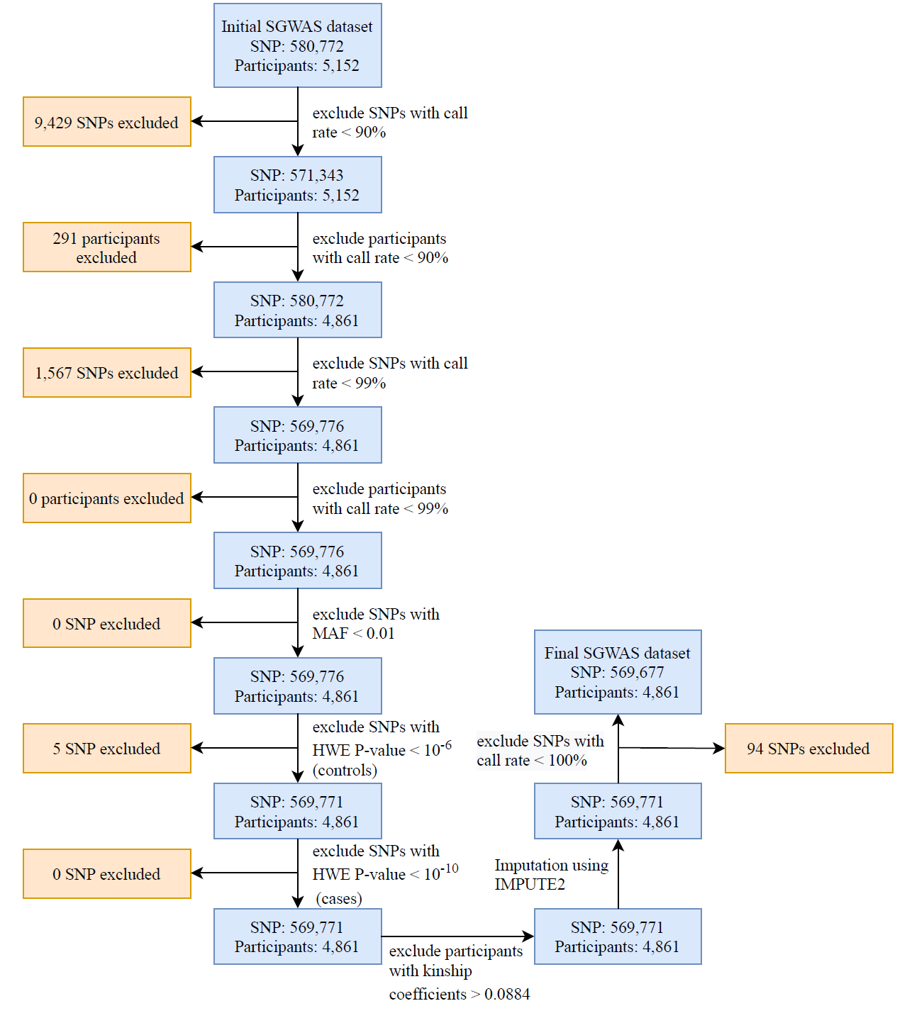

Figure S2 Linkage disequilibrium matrix of the first set of SNPs
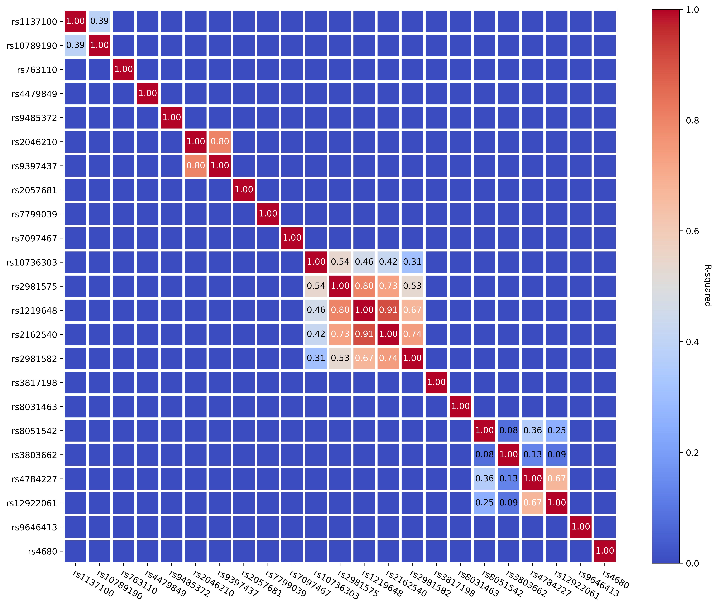
Pairwise R² were calculated based on the SGWAS dataset.

Figure S3 Linkage disequilibrium matrix of the second set of SNPs
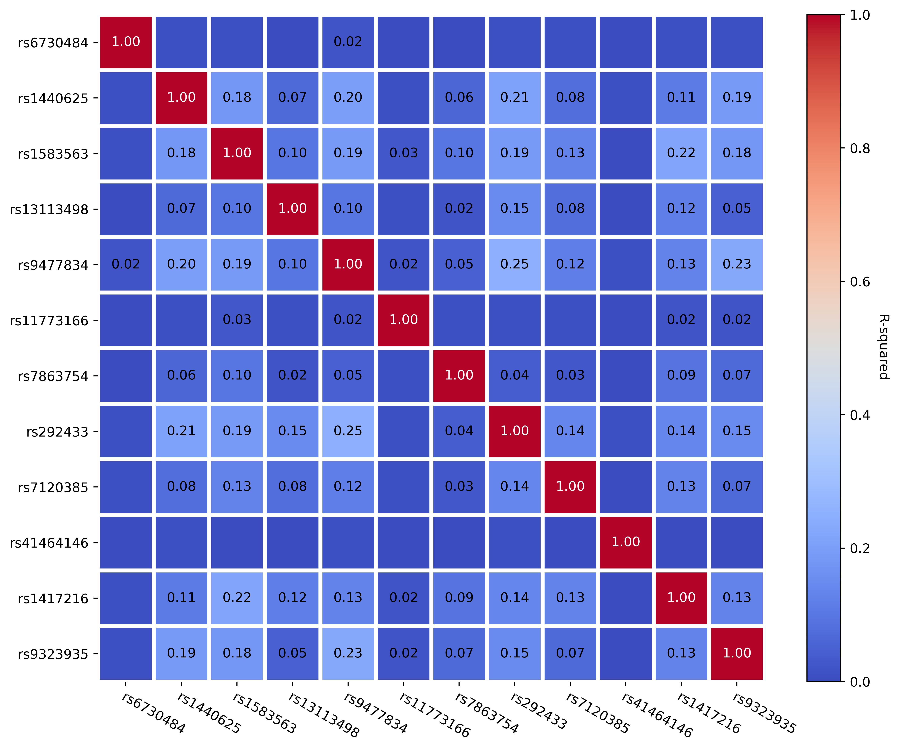
Pairwise R² were calculated based on the SGWAS dataset.

Figure S4 Hyperparameters tuning results of the logistic ridge regression model
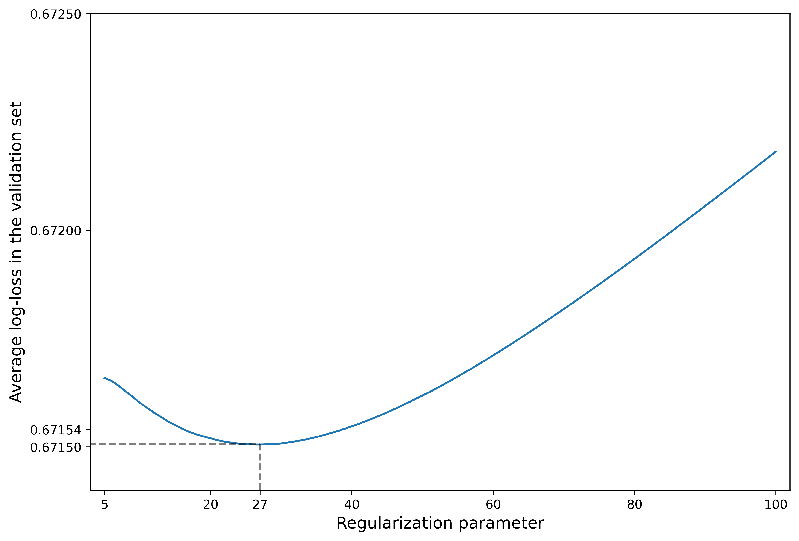
Hyperparameters tuning was conducted by applying 10-fold cross validation on the SGWAS dataset and using average log-loss as the main outcome; the optimal regularization parameter was 27.

Figure S5 Hyperparameters tuning (A: number of iterations, B: number of hidden layers and dropout rate) results of the Artificial Neural Network model
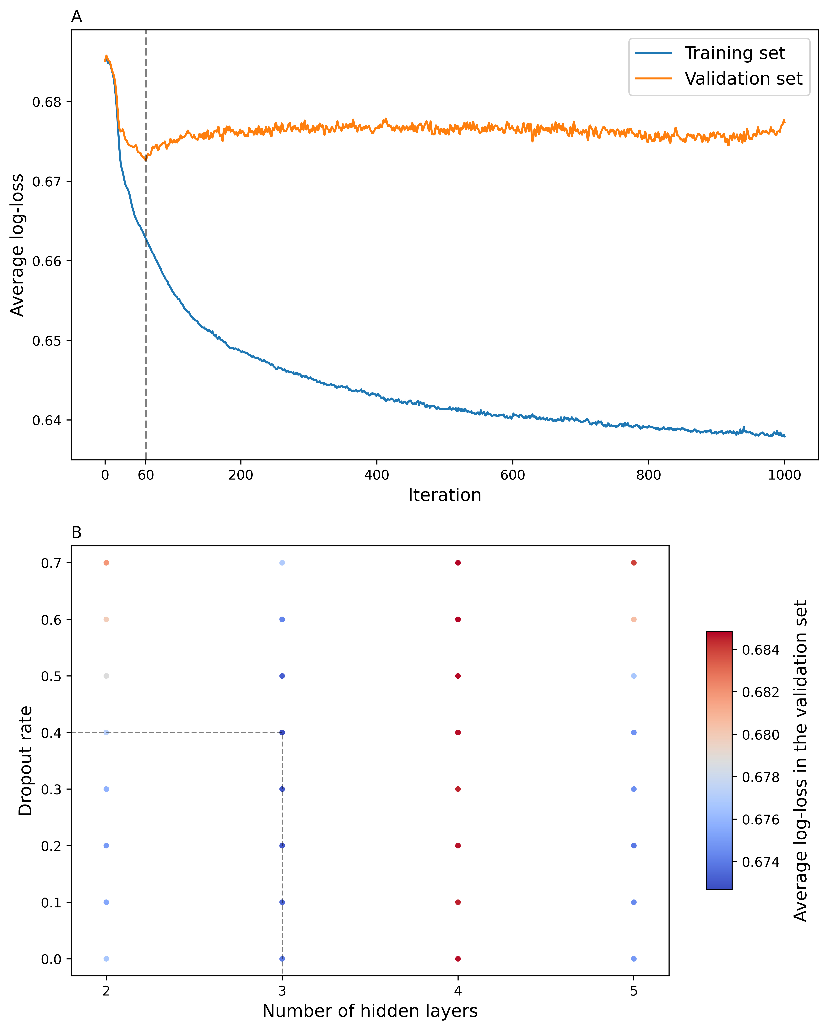
Hyperparameters tuning was conducted by applying 10-fold cross validation on the SGWAS dataset and using average log-loss as the main outcome; the optimal number of iterations, hidden layers and dropout rate were 60, 3 and 0.4 respectively; other hyperparameters that were not tuned: number of hidden neurons in each hidden layer = 2 plus square root of number of SNPs; learning rate = 0.01, activation function in the hidden layers was Leaky ReLU; activation function in the output layer was sigmoid; loss function was sigmoid cross entropy and optimizer was Adam optimizer

Figure S6 The structure of the ANN model used in the current study
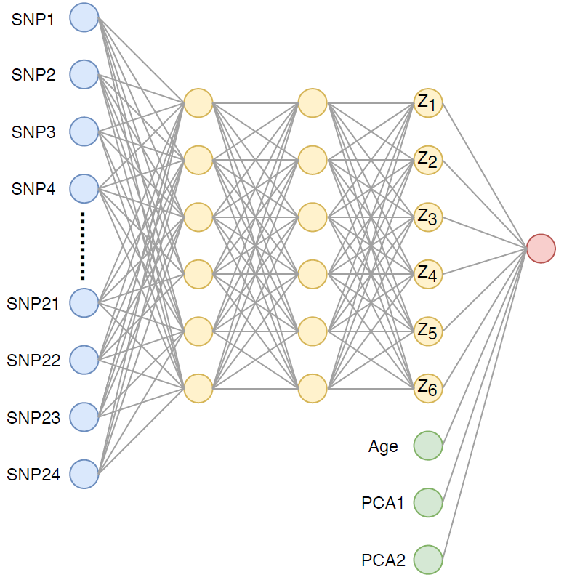
Bias neurons are not plotted on the graph; the blue dots represent the values of the 24-SNPs inputted into the model, the yellow dots represent the hidden neurons in the hidden layers, the green dots represent the covariates adjusted in the model, and the red dot represents the outcome variable; values of the hidden neurons in the third hidden layers ($Z_{1}-Z_{6}$) and their corresponding weighting parameters were used to calculate the PRS_{ANN}: ${PRS}_{ANN}=\sum_{i=1}^{6}{{β_{i}Z}_{i}}$

Figure S7 Spearman’s rank correlation coefficient matrix for breast cancer risk factors, PRSs and Gail-2 model 5-year risk
