Figure S1: Temperature and Energy Fluctuation profiles
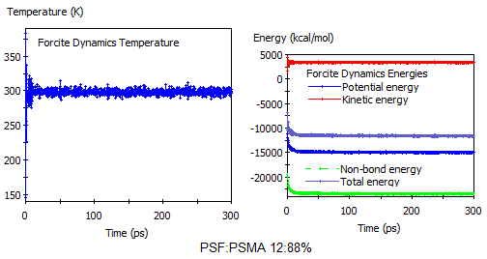
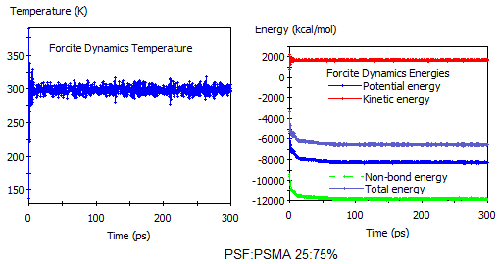
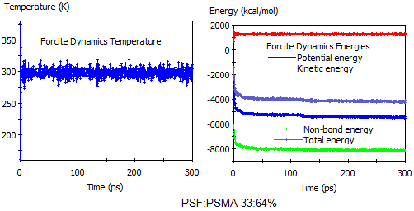

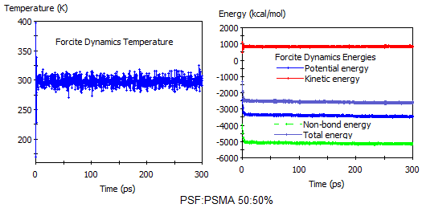
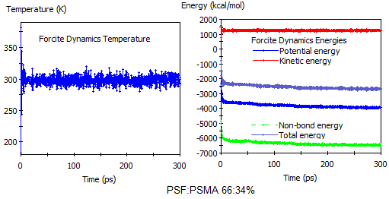
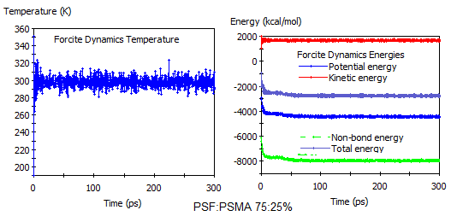
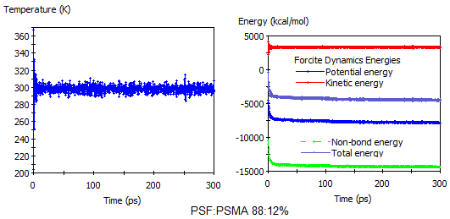

Figure S2: Blending Analysis Mixing Energy:
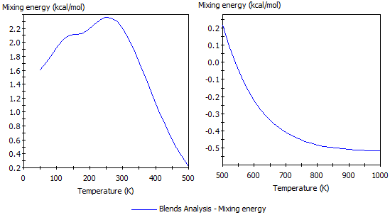

Figure S3: Mesodyne mesoscopic simulated cell for miscible and immiscible polymer composition for as per density distribution
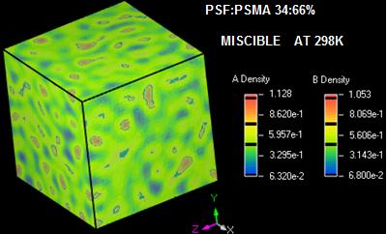
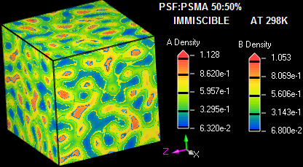

Table S1:
Computed Florry Huggins Interaction parameter at 298K temperature for various polymer compositions and simulated densities
Simulations  Run case. | Polymer-chain  Composition in cell | SMA %  wt.wt | Density  g/cm³ | Chi Parameter  X_{i} at 298K | Compatibility
1 | 1PSMA chain | 100 | 1.086 | N/A | N/A
2 | 12:88 (PSF:PSMA) | 88 | 1.079 | 11.146 | Incompatible
3 | 25:75 (PSF:PSMA) | 75 | 1.086 | 12.203 | Incompatible
4 | 34:66 (PSF:PSMA) | 66 | 1.095 | -4.460 | Compatible
5 | 50:50 (PSF:PSMA) | 50 | 1.185 | 5.014 | Incompatible
6 | 66:34 (PSF:PSMA) | 34 | 1.204 | 13.874 | Incompatible
7 | 75:25 (PSF:PSMA) | 25 | 1.210 | 49.945 | Incompatible
8 | 88:12 (PSF:PSMA) | 12 | 1.22 | 29.740 | Incompatible
9 | 1 PSF chain | 0 | 1.25 | N/A | N/A

Using Schneier Equation; - Polymers compatibility prediction
Table and figures are showing in summary for other polymers compatibility state with SMA and PMMA additives respectively using Schneier Enthalpy of mixing theory at 298K
Table S2: Compatibility of other polymers with SMA and PMMA by theories
POLYMER | POLYMER PROPERTIES |  |  | SMA | PMMA
POLYMER | Density (g/ml) | Mol. Weight (g/mol) | Sol. Param.(cal/cm³) | COMPATIBILITY | COMPATIBILITY
PMMA | 1.18 | 100.12 | 9.29 | Compatible | -
SMA | 1.08 | 202.212 | 9.4 | - | Compatible
PSF | 1.24 | 442.52 | 9.63 | Compatible | Compatible
SPSF | 1.1 | 462 | 10.1219 | Compatible < 20% | Incompatible
PVDF | 1.78 | 64.034 | 9.02 | Partially Compatible | Compatible
PVDF-2* | 1.78 | 64.034 | 11.4 | Incompatible | Incompatible
PVA | 1.26 | 44.053 | 12.64 | Incompatible | Incompatible
PVA-2* | 1.3 | 44.053 | 15.2 | Incompatible | Incompatible
PES | 1.37 | 232.25 | 11.306 | Compatible <10% | Compatible <18%
PVC | 1.38 | 62.5 | 9.5 | Compatible | Compatible
PEEK | 1.26 | 288.31 | 10.71 | Compatible < 20% | Incompatible
NYLON 6,6 | 1.14 | 226.3 | 13.7 | Incompatible | Incompatible
EVOH 27 | 1.2 | 46.87 | 11.29 | Compatible < 15% | Incompatible
EVOH32 | 1.19 | 72.107 | 11.052 | Compatible < 9% | Incompatible
EVOH38 | 1.17 | 72.107 | 10.759 | Compatible < 20% | Incompatible
EVOH 44 | 1.14 | 60.09 | 10.46 | Compatible < 30% | Incompatible
-2* - Change in solubility parameter of the polymer depend on manufacturer set

SPSF/SMA SPSF/PMMA
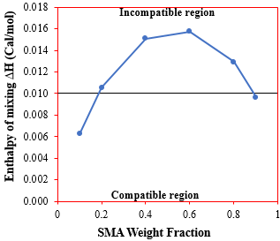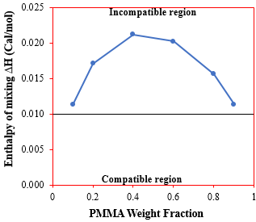

PVDF / SMA PVDF / PMMA
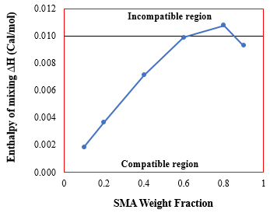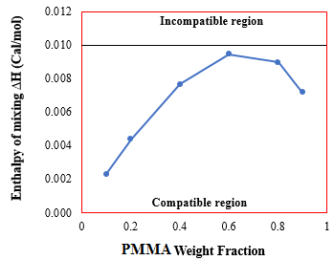

PVDF-2*/SMA PVDF-2*/PMMA
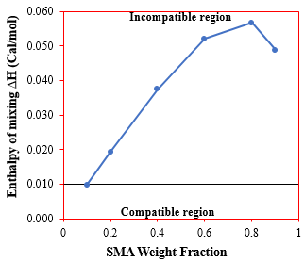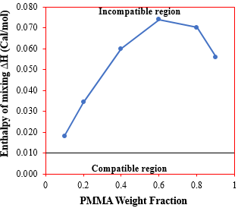

PVA / SMA PVA / PMMA
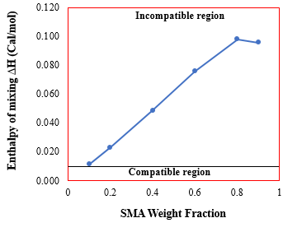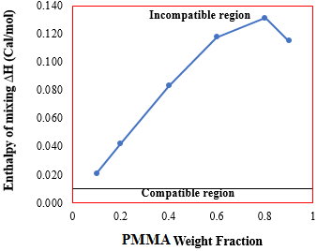

PVA-2*/SMA PVA-2*/PMMA
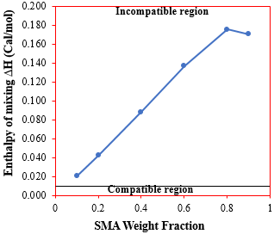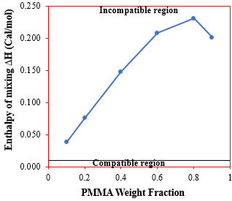

PES / SMA PES / PMMA
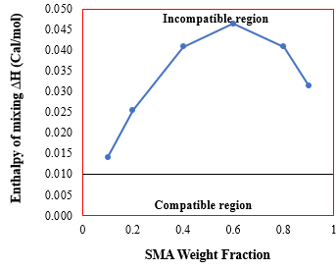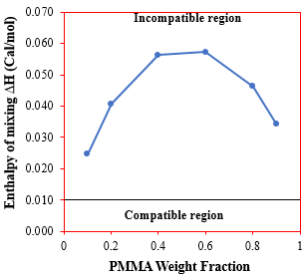

PVC / SMA PVC / PMMA
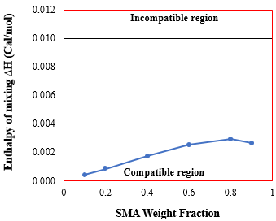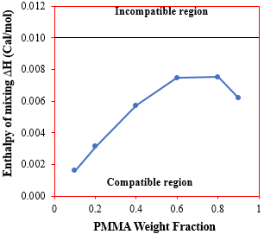

PEEK / SMA PEEK / PMMA
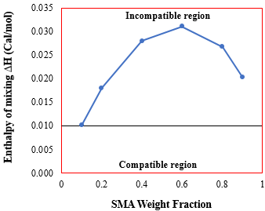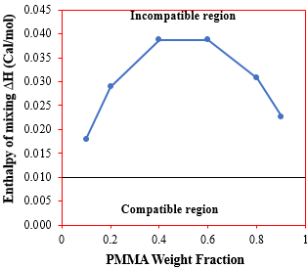

Nylon 6,6 / SMA Nylon 6,6 / PMMA
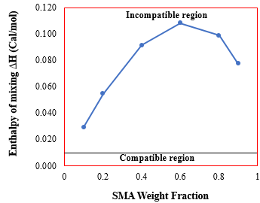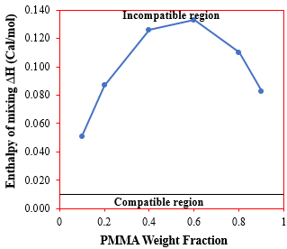

EVOH 27/SMA EVOH 27/PMMA
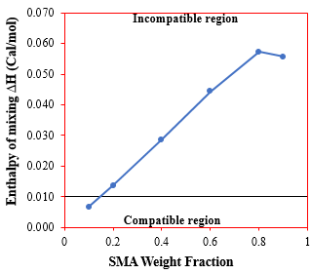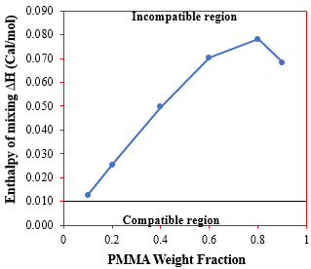

EVOH 32/ SMA EVOH 32/ PMMA
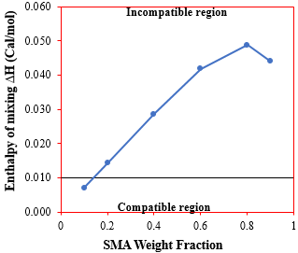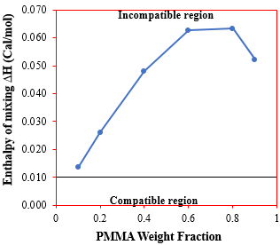

EVOH 38/ SMA EVOH 38/ PMMA
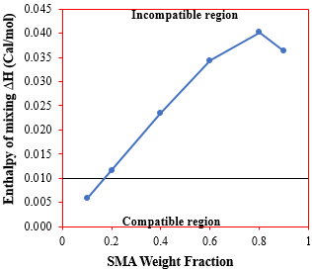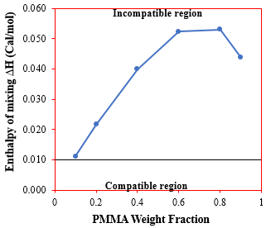
EVOH 44/ SMA EVOH 44/ PMMA
