Table 1. Characteristics of research participants
 | Characteristic | Original PD cohort (n=82) | Month 36  (n=43) | Month 36 Not Taking PD Medication  (n=12) | Month 36 Taking PD Medication  (n=31)
Demographic  Characteristics | Age, y | 63.3 (9.4) | 66.7 (8.3) | 67.1 (10.8) | 66.6 (7.3)
Demographic  Characteristics | Female, n (%) | 36 (44) | 18 (42) | 6 (50) | 12 (39)
Demographic  Characteristics | Race, n (%)
Demographic  Characteristics | White | 78 (95) | 41 (95) | 11 (92) | 30 (97)
Demographic  Characteristics | Asian | 3 (4) | 2 (5) | 1 (8) | 1 (3)
Demographic  Characteristics | Not specified | 1 (1) | 0 (0) | 0 (0) | 0 (0)
Demographic  Characteristics | Hispanic or Latino, n (%) | 3 (4) | 1 (2) | 1 (8) | 0 (0)
Demographic  Characteristics | Education > 12 Years, n (%) | 78 (95) | 42 (98) | 12 (100) | 30 (97)
Clinical  Characteristics | Right or mixed handedness, n (%) | 74 (90) | 40 (93) | 12 (100) | 28 (90)
Clinical  Characteristics | Parkinson’s disease duration, y | 0.8 (0.6) | 3.9 (0.7) | 3.9 (0.6) | 3.9 (0.7)
Clinical  Characteristics | On medication for treating the symptoms of Parkinson’s disease, n (%) | 0 (0) | 31 (72) | 0 (0) | 31 (100)
Clinical  Characteristics | Hoehn & Yahr, n (%)
Clinical  Characteristics | Stage 1 | 19 (23) | 6 (14) | 2 (17) | 4 (13)
Clinical  Characteristics | Stage 2 | 62 (76) | 36 (84) | 10 (83) | 26 (84)
Clinical  Characteristics | Stage 3 | 1 (1) | 1 (2) | 0 (0) | 1 (3)
Clinical  Characteristics | MDS-UPDRS
Clinical  Characteristics | Part I | 5.5 (3.6) | 7.5 (4.9) | 7.1 (5.5) | 7.6 (4.7)
Clinical  Characteristics | Part II | 5.6 (3.8) | 7.6 (5.2) | 7.8 (6.0) | 7.6 (5.0)
Clinical  Characteristics | Part III (modified) | 20.0 (8.8) | 24.4 (10.8) | 26.1 (11.4) | 23.7 (10.7)
Clinical  Characteristics | Montreal Cognitive Assessment | 27.6 (1.4) | 27.2 (2.7) | 26.3 (3.8) | 27.6 (2.1)
Clinical  Characteristics | Parkinson's Disease Quality of Life Questionnaire | 7.7 (6.7) | 11.6 (3.3) | 11.9 (4.7) | 11.5 (2.7)
Clinical  Characteristics | Geriatric Depression Scale (Short Version) | 1.6 (1.9) | 2.0 (2.0) | 1.9 (1.6) | 2.1 (2.2)
Clinical  Characteristics | REM Sleep Behavior Disorder Questionnaire | 4.4 (3.1) | 5.4 (3.3) | 6.2 (2.9) | 5.1 (3.4)
Clinical  Characteristics | Epworth Sleepiness Scale | 4.9 (3.2) | 5.3 (3.0) | 4.5 (3.1) | 5.6 (3.0)
Clinical  Characteristics | Scale for Outcomes in Parkinson’s Disease for Autonomic Symptoms | 9.1 (5.1) | 13.8 (7.3) | 13.1 (6.0) | 14.1 (7.9)
Results are mean (standard deviation) for continuous measures and n (%) for categorical measures.
MDS-UPDRS = Movement Disorder Society-Unified Parkinson's Disease Rating Scale
Modified MDS-UPDRS Part III scores exclude rigidity and postural stability assessments.

Table 2A. Changes in selected endpoints measured over 36 months for all participants
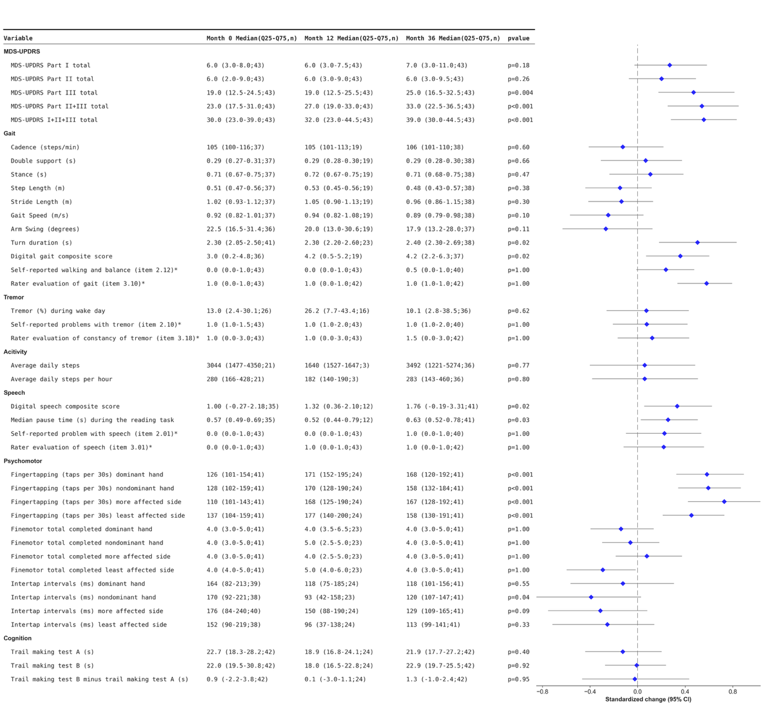
MDS-UPDRS = Movement Disorder Society-Unified Parkinson's Disease Rating Scale
Modified MDS-UPDRS Part III scores exclude rigidity and postural stability assessments.

Table 2B. Changes in selected endpoints measured over 36 months for medication-naïve participants
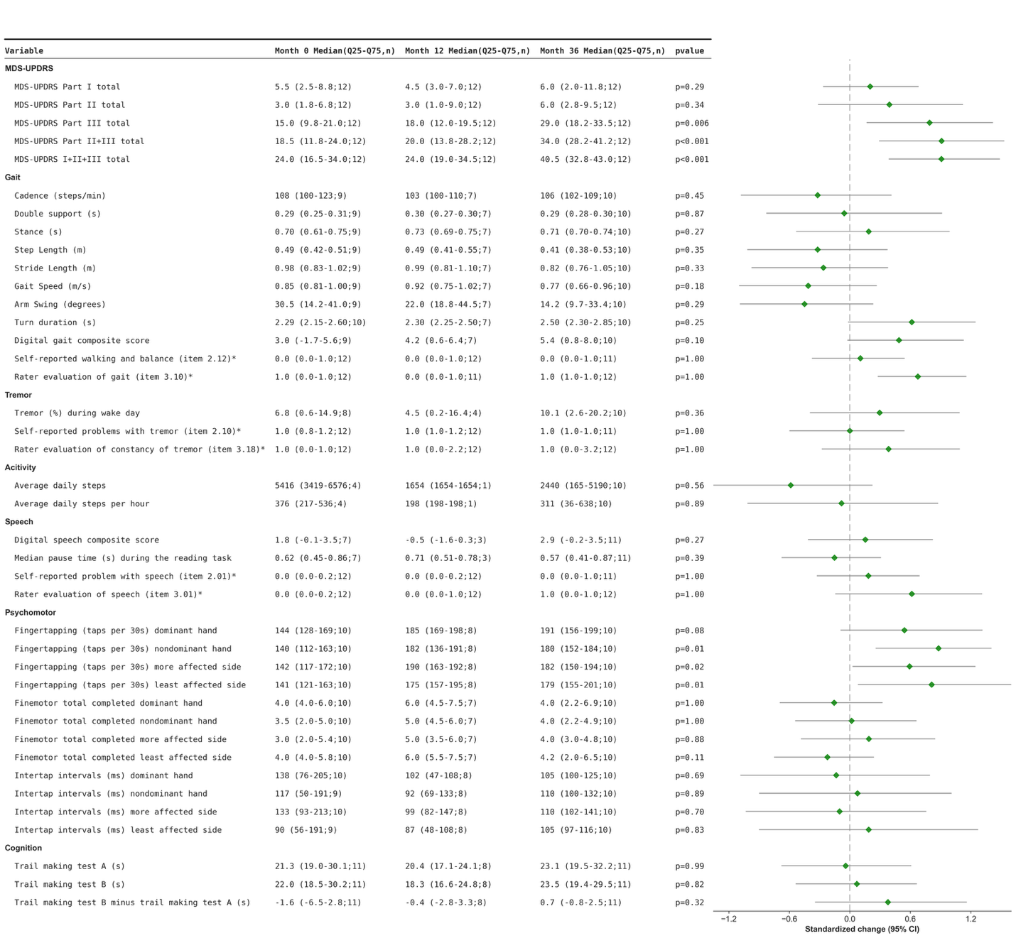
MDS-UPDRS = Movement Disorder Society-Unified Parkinson's Disease Rating Scale
Modified MDS-UPDRS Part III scores exclude rigidity and postural stability assessments.

Table 2C. Changes in selected endpoints measured over 36 months for participants on dopaminergic medications
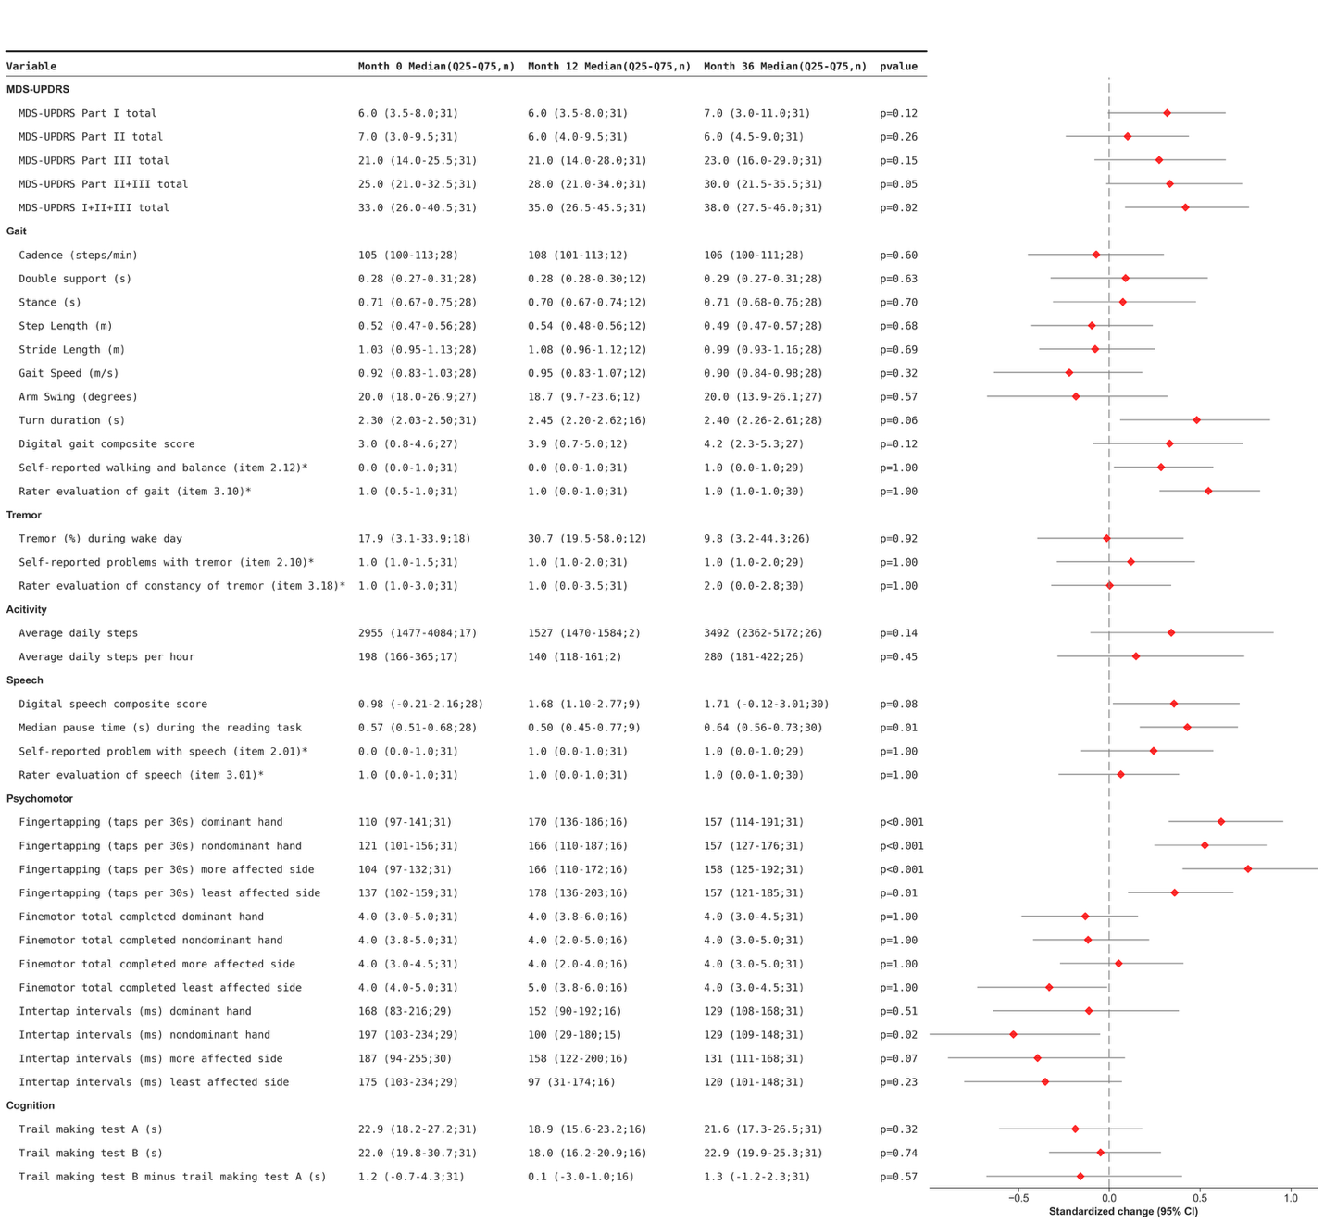
MDS-UPDRS = Movement Disorder Society-Unified Parkinson's Disease Rating Scale
Modified MDS-UPDRS Part III scores exclude rigidity and postural stability assessments.

Table 2D. Modelled changes in selected endpoints measured over 36 months for all participants
