Legends to supplemental Figures

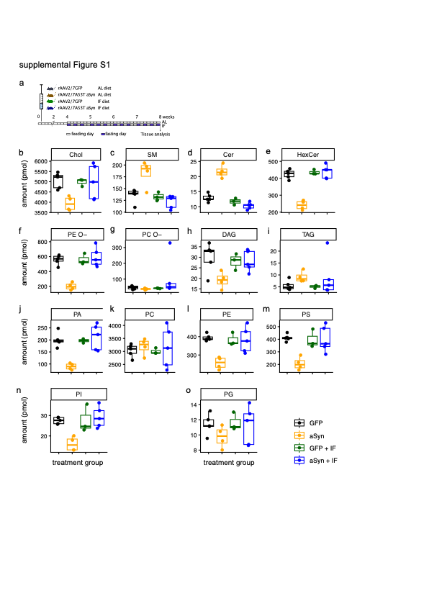
Supplemental Figure S1: Response of mice with aSyn transduction to intermittent fasting. (a) Experimental paradigm. AL, ad libitum diet; IF, intermittent fasting, for 24 h on three days per week. (b) Absolute amounts of lipid classes in pmol. Each marker represents one experiment. Abbreviations as in Figure 2.

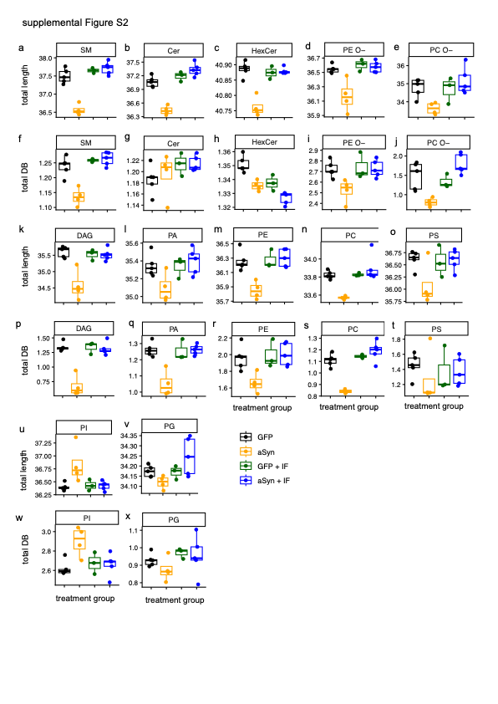
Supplemental Figure S2: Acyl chain remodeling with intermittent fasting. (a) Experimental paradigm. AL, ad libitum diet; IF, intermittent fasting, for 24 h on three days per week. (b-e, k-o, u-v) Weighed average length of acyl chains. (f-j, p-t, w-x) Weighed average number of double bonds. Each marker represents one experiment. Abbreviations as in Figure 2; AL, ad libitum diet; IF, intermittent fasting.

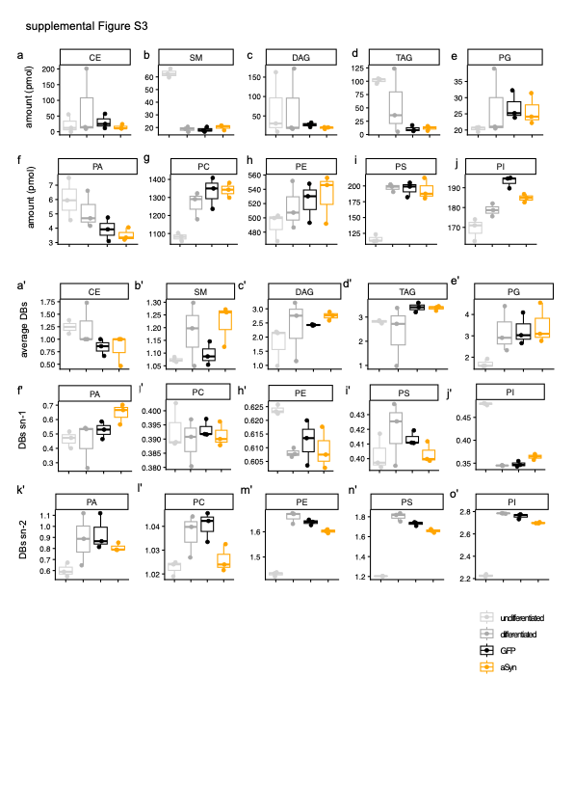
Supplemental Figure S3: Lipid profile during differentiation of LUHMES cells. (a-j) Absolute amounts of lipid classes in pmol. (a’-e’) Weighed total number of double bonds. (f’-j’) Weighed number of double bonds at the sn-1 position. (k’-o’) Weighed average number of double bonds at the sn-2 position.

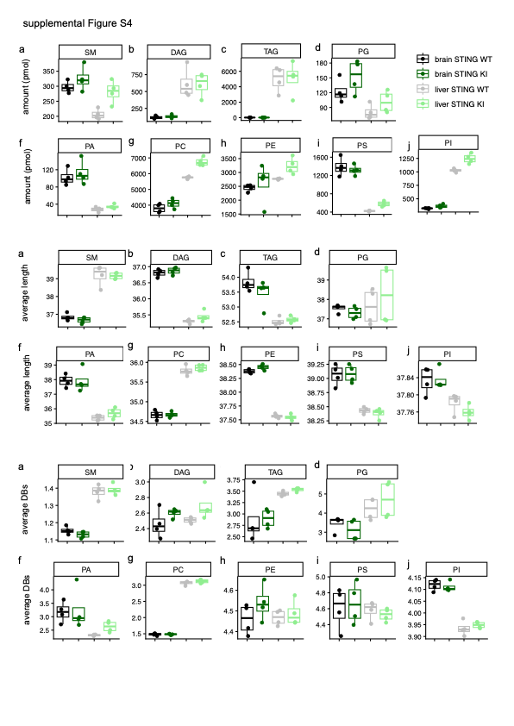
Supplemental Figure S4: Lipid profile in brain and liver of STING WT and KI mice. (a-i) Absolute amounts of lipid classes in pmol. (a’-i’) Weighed average length of acyl chains. (a’’-i’’) Weighed average number of double bonds. Each marker represents one animal. Abbreviations as in Figure 2.

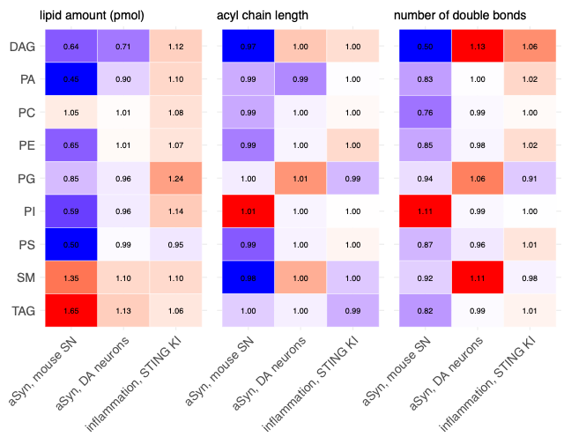Supplemental Figure S5: Summary of median changes with aSyn transduction per lipid class and property (amount in pmol, acyl chain length and double bonds).

