Moment estimators of relatedness from low-depth whole-genome sequencing data
Herzig AF¹, Ciullo M^{2,3}, FranceGenRef Consortium⁴, Leutenegger A-L⁵, Perdry H⁶

1. Inserm, Univ Brest, EFS, UMR 1078, GGB, F-29200 Brest, France
2. Institute of Genetics and Biophysics A. Buzzati-Traverso - CNR, Naples, Italy
3. IRCCS Neuromed, Pozzilli, Isernia, Italy
4. LABEX GENMED, Centre National de Recherche en Génomique Humaine, Evry, Paris
5. Inserm, Université de Paris, UMR 1141, NeuroDiderot, F-75019 Paris, France
6. CESP Inserm U1018, Université Paris-Saclay, Villejuif, France

Corresponding Author:
Anthony Francis Herzig
anthony.herzig@inserm.fr
+33298017361
Inserm UMR 1078, 22 Avenue Camille Desmoulins, 29238 Brest, France

Supplementary Figures

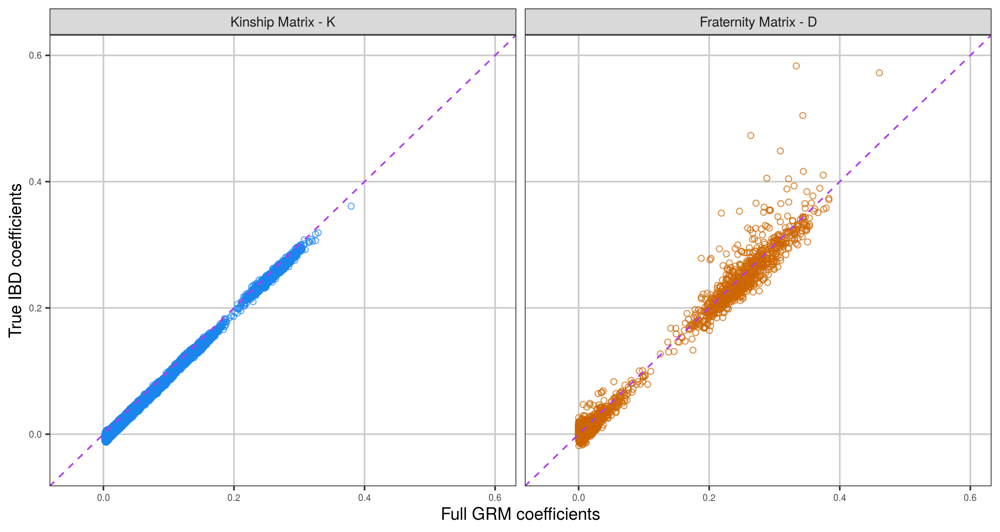
Supplementary Figure 1
Full GRM off-diagonal elements against simulated IBD-sharing proportions in the CilentoSim population for the kinship and fraternity matrices, $K$and $D$.

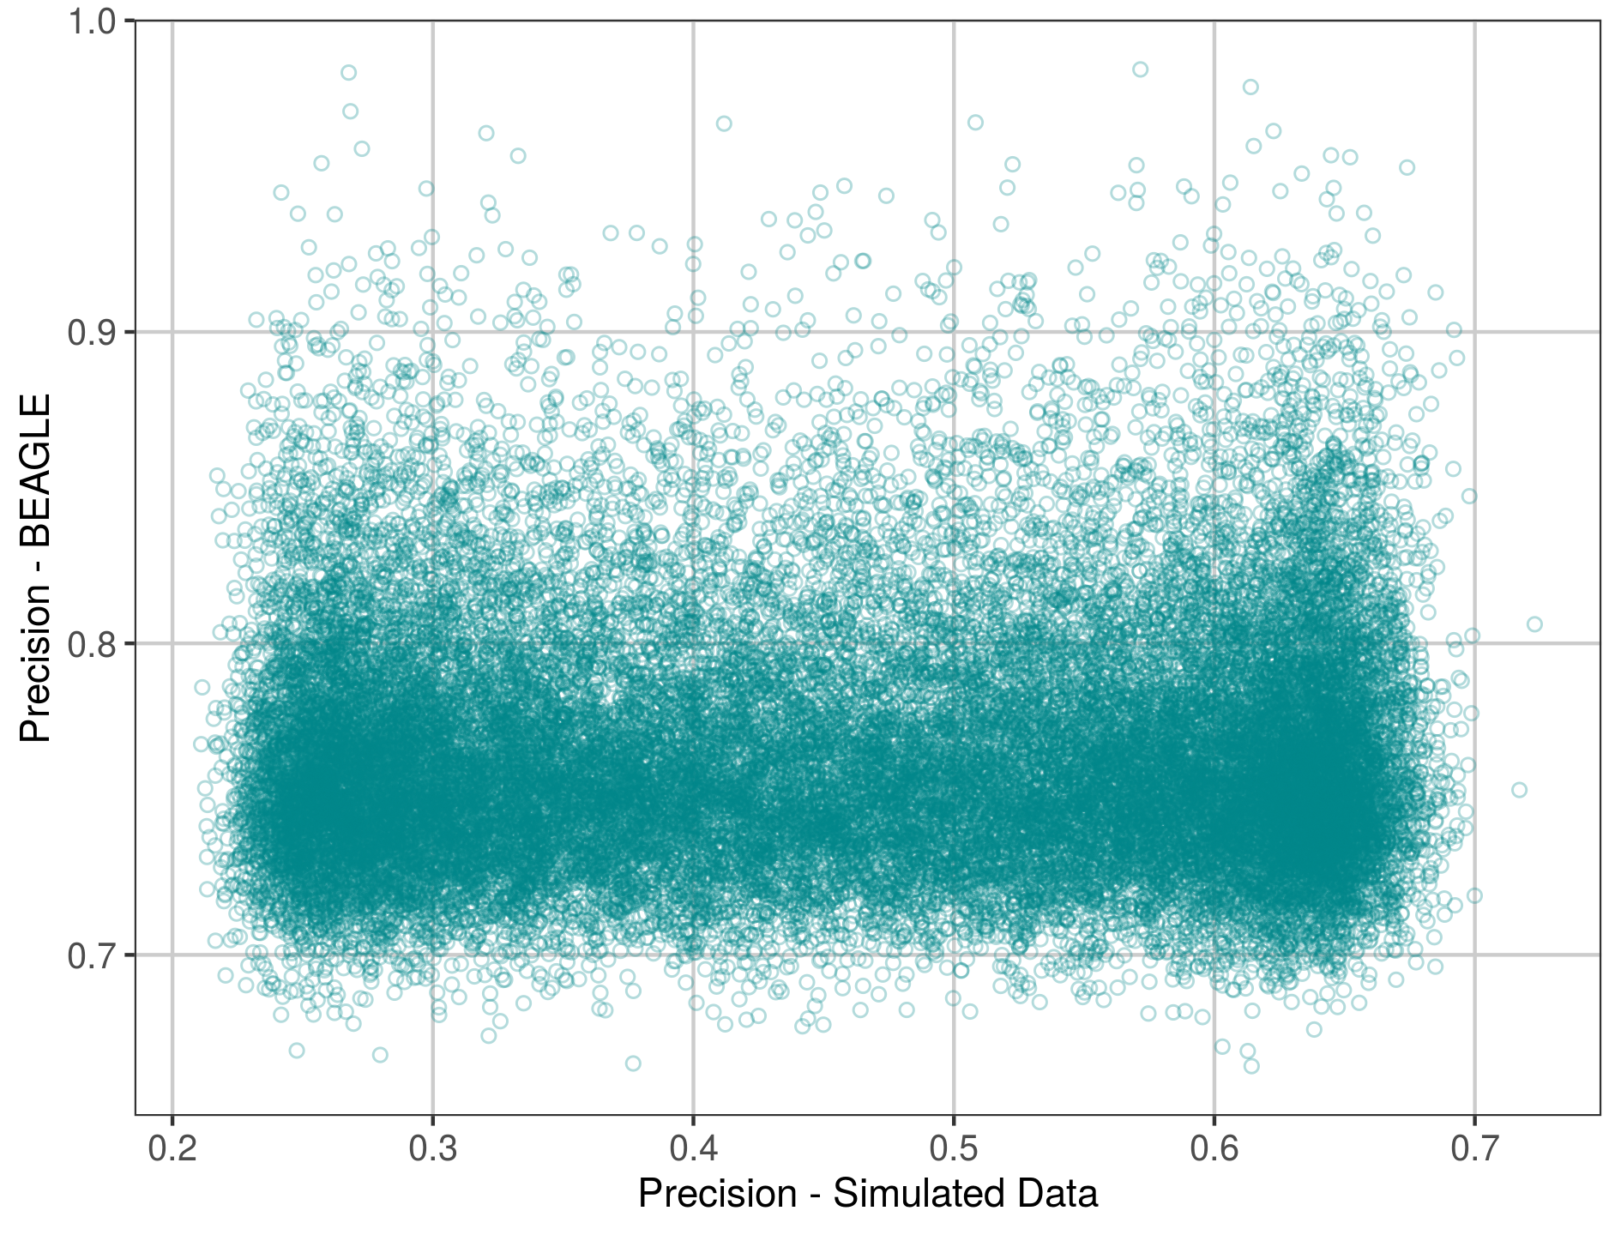
Supplementary Figure 2
Comparison of observed precision of three genotype probabilities for 32,876 variants. A values of precision of 1 indicates a set of probabilities such as (1,0,0) whereas a precision of 0 indicates probabilities $(\frac{1}{3},\frac{1}{3},\frac{1}{3})$. Precision was first calculated on the simulated genotypes likelihoods of CilentoSim at a depth of 2.5$×$ (x-axis). Almost all precision statistics lie between 0.2 and 0.7. On the y-axis, the precision is given after BEAGLE has been applied, now all statistics are roughly between 0.7 and 1.0. Demonstrating how SEEKIN benefits greatly from the improvements that BEAGLE makes to the raw data.

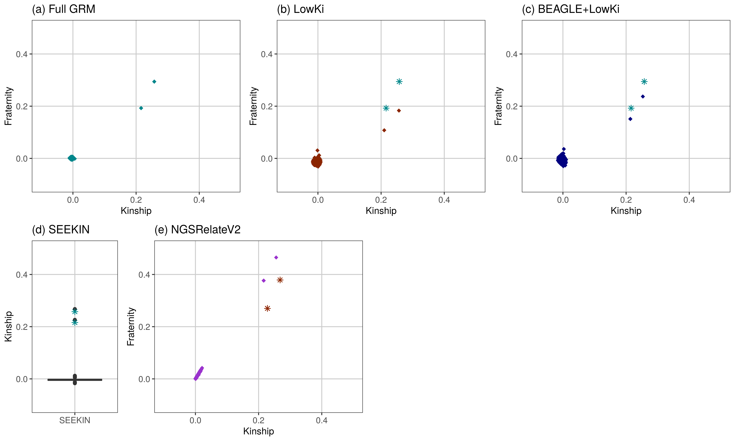
Supplementary Figure 3
Analysis of 150 individuals from the FranceGenRef panel including two sibling pairs, all methods could identify the two sibling pairs as clear outliers successfully.
Panel (a) - Kinship and Fraternity coefficients estimated by LowKi on genotypes (Full GRM) from the original 30-40$×$ data, the two sibling pairs are visible.
Panel (b) - In dark red, the estimates of kinship and fraternity from down-sampled (2.5$×$) data using our proposed moment estimators. The two stars represent the benchmark for these estimates coming from panel (a).
Panel (c) - Similar to panel (b) but here BEAGLE was used before applying our moment estimators in Gaston - a slight improvement in the estimation of fraternity was observed.
Panel (d) - Kinship estimates only from SEEKIN are given in a boxplot as SEEKIN does not estimate fraternity. Again, blue stars give the benchmark from the estimates of panel (a).
Panel (e) - In purple, the estimates of kinship and fraternity by NGSRelateV2 are given. Here the benchmark (dark red stars) are the estimated from NGSRelateV2 applied to the original 30-40$×$ data.

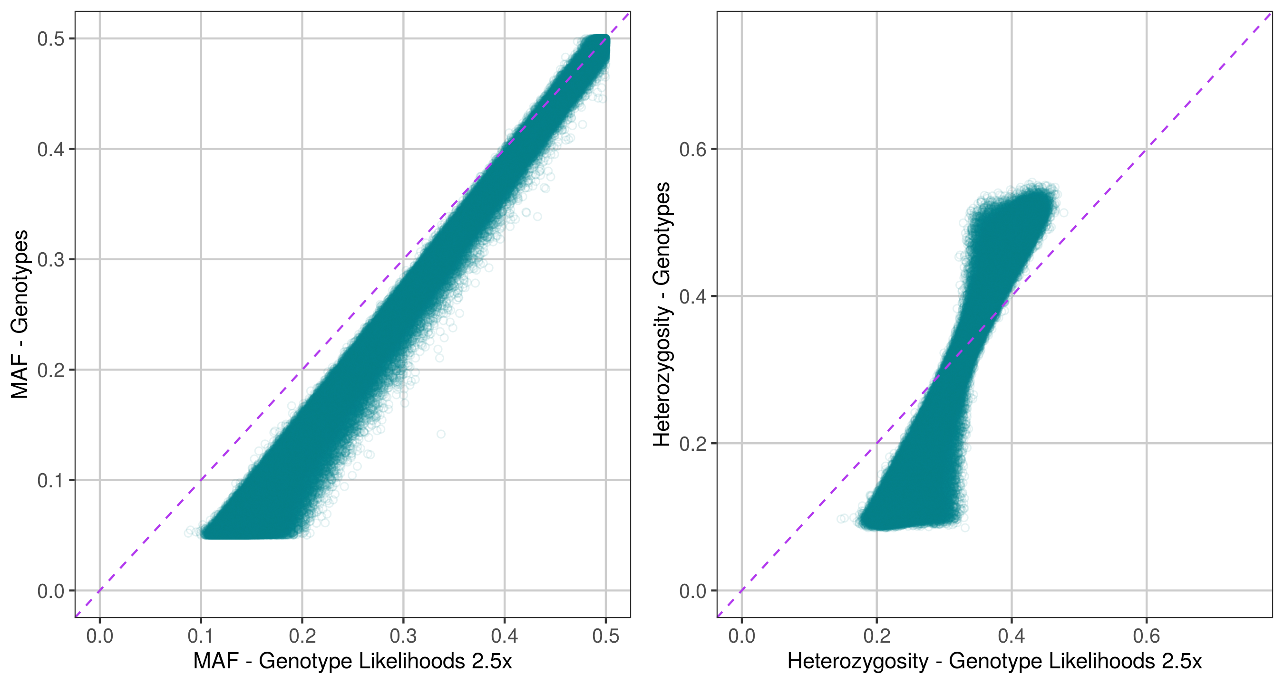
Supplementary Figure 4
View of how our genotype likelihood simulation affects the observed MAF and heterozygosity in the sample, going some way to explaining why correlations between individuals become biased compared to what they should be if full genotypes are observed.

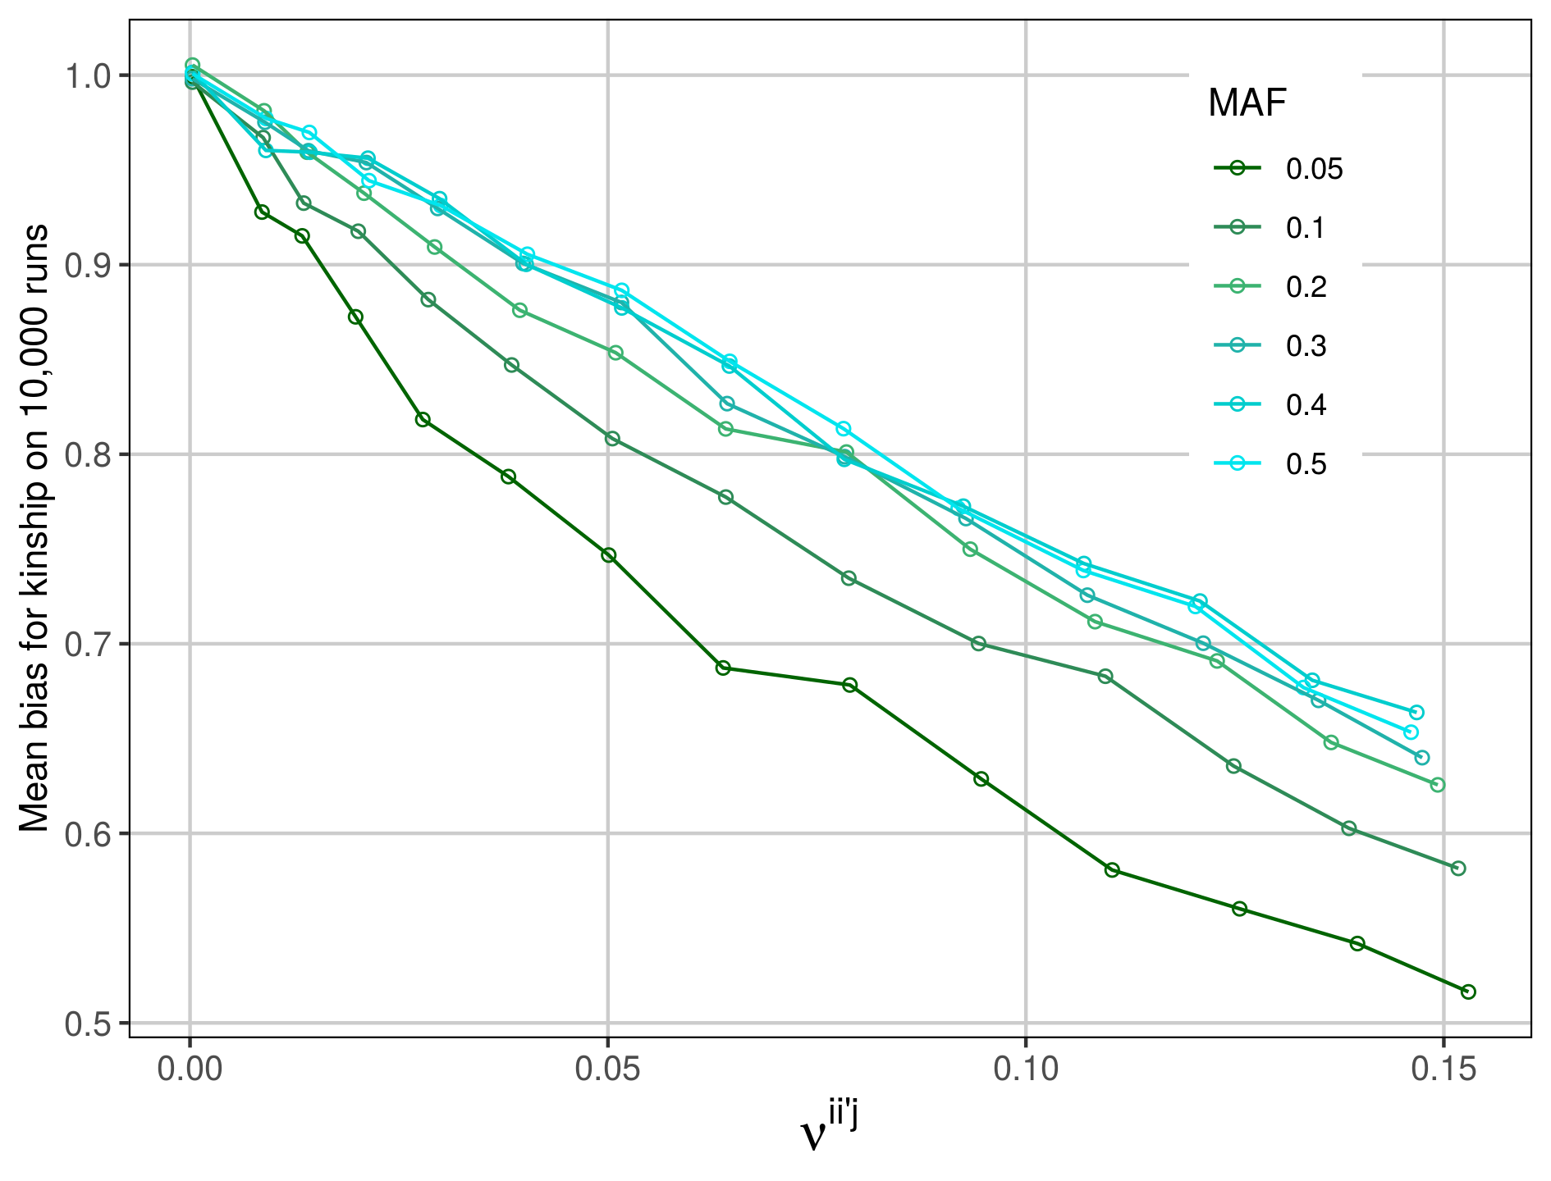
Supplementary Figure 5
Demonstration of the relationship between bias of kinship estimate for a sibling pair against the mean precision of genotype likelihoods ($ν^{ii^{'}j}$ defined in main text) involved in the estimate.
Linear relationships are observed, changing the Minor Allele Frequency (MAF) gives slightly different slopes.

