Supporting Information

GOx-Assisted Synthesis of Pillar[5]arene Based Supramolecular Polymeric Nanoparticles for Targeted/Synergistic Chemo-Chemodynamic Cancer Therapy

Jin Wang,† Di Wang,† Moupan Cen, Danni Jing, Jiali Bei, Youyou Huang, Jianan Zhang, Bing Lu, Yang Wang,* and Yong Yao*

- Materials…………………………………………………………………………………S2
- Characterization………………………………………………………………………...S4
- Synthesis of AP5…………………………………………………………………………S6
- Construction of FA-Py/SP/GOx/Dox NPs……………………………………………..S8
- Cell viability analysis…………………………………………………………………..S10
- Animal experiments……………………………………………………………………S12

- Materials
All chemical reagents are of analytical grade and are not further purified. Specifically, BF₃•Et₂O, ClCH₂COOCH₃, NH₂CH₂CH₂NH₂, CH₃CH₂OH, (CH₂O)n, hydroquinone, ferrocene dicarbaldehyde were purchased from Shanghai Aladdin Industrial Corporation. Doxorubicin (DOX) and folic acid (FA) were purchased from Sinoreagent Co. Ltd. All the solutions were prepared in deionized water or phosphate buffer saline (PBS, Gibco). The Cell Counting Kit (CCK)-8 was bought from MedChemExpress Co. Ltd.

2. Characterization
The morphology and microstructure were obtained by field emission scanning electron microscopy (SEM) and transmission electron microscopy (TEM). SEM was performed by using a HITACHI S-4800 microscope at an accelerating voltage of 5 kV. TEM observations were performed by a Philips CM20. The N₂ adsorption desorption curves were recorded on a Quad-resorb-SI instrument and the specific surface area was examined by the Brunauer-Emmett-Teller (BET) process. ¹H and ¹³C NMR spectra were recorded on a Brucker AV400 spectrometer. UV/Vis spectra and the optical transmittance were recorded in a quartz cell (light path 10 mm) on a Shimadzu UV-3600 spectrophotometer equipped with a PTC-348WI temperature controller. Electrospray ionization mass spectra (ESI-MS) were measured by Agilent 6520 Q-TOF-MS.

3. Synthesis of AP5

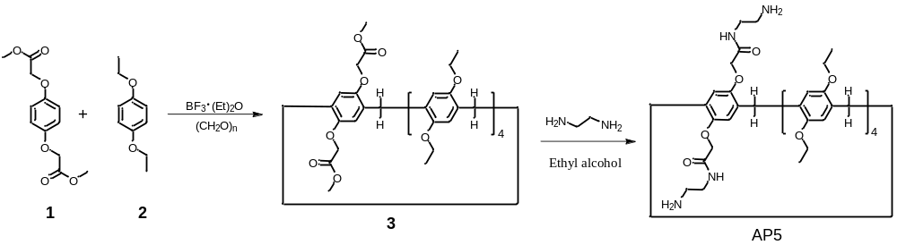
Scheme S1. Synthetic route to compound AP5.
A solution of 1 (2.54 g, 10.0 mmol), 2 (6.64g, 40.0 mmol) and triformol (1.50 g, 50.0 mmol) in 1,2-dichloroethane (50 mL) was cooled with ice bath. Boron trifluoride etherate (16.0 g, 50.0 mmol) was added to the solution and the mixture was stirred at room temperature for 1 hour. The reaction mixture was then washed by water (50 mL × 2) and dried with Na₂SO₄. The solvent was evaporated to provide a crude product, which was purified by column chromatography (eluent: petroleum ether/ethyl acetate, 5:1) to give a white solid 3 (4.58 g, 47%). ¹H NMR (400 MHz, CDCl₃) was shown in Figure S1, δ : 6.83 – 6.76 (m, 8H), 4.51 (s, 4H), 3.88 (ddd, J = 13.5, 11.4, 6.7 Hz, 16H), 3.80 – 3.73 (m, 10H), 3.13 (s, 6H), 1.37 (ddt, J = 13.9, 10.6, 5.4 Hz, 24H). ¹³C NMR (101 MHz, CDCl₃) was shown in Figure S2, δ: 169.8, 149.7, 149.6, 149.6, 149.4, 128.8, 128.6, 128.4, 128.3, 127.7, 115.1, 114.6, 114.5, 114.4, 77.4, 77.0, 76.7, 65.8, 63.8, 63.6, 63.5, 51.6, 29.7, 29.5, 29.4, 15.3, 15.2. HRESIMS: m/z calcd for [1 + Na]⁺ 1001.4605; found 1001.4605.

A mixture of 3 (0.98 g, 1.00 mmol) and ethanediamine (5 mL) in ethanol (25 mL) was stirred in a 100 mL round-bottom flask at 90 ºC for 24 hours. After cooling, the solvent was removed and the residue was poured into saturated brine (50 mL) to give AP5 as a white solid (0.78 g, 75%). ¹H NMR (400 MHz, CDCl₃) was shown in Figure S3, δ 6.97 (s, 2H), 6.94 (s, 2H), 6.89 (s, 2H), 6.87 (s, 2H), 6.73 (s, 2H), 4.52 (s, 4H), 3.92 (dq, J = 19.7, 6.9 Hz, 16H), 3.77 (d, J = 7.6 Hz, 10H), 2.39 (s, 2H), 1.99 (d, J = 17.6 Hz, 2H), 1.48 (dt, J = 24.6, 6.9 Hz, 28H). ¹³C NMR (101 MHz, CDCl₃) was shown in Figure S4, δ: 167.0, 148.9, 148.7, 148.2, 147.4, 128.5, 128.0, 127.0, 126.0, 123.8, 113.9, 113.6, 113.4, 113.3, 112.6, 76.3, 76.0, 75.7, 66.8, 63.1, 62.9, 62.4, 40.2, 38.7, 37.8, 28.4, 27.5, 14.5, 14.4, 14.3. HRESIMS: m/z calcd for [1 + Na]⁺ 1057.5465; found 1057.5465 (Figure S5).
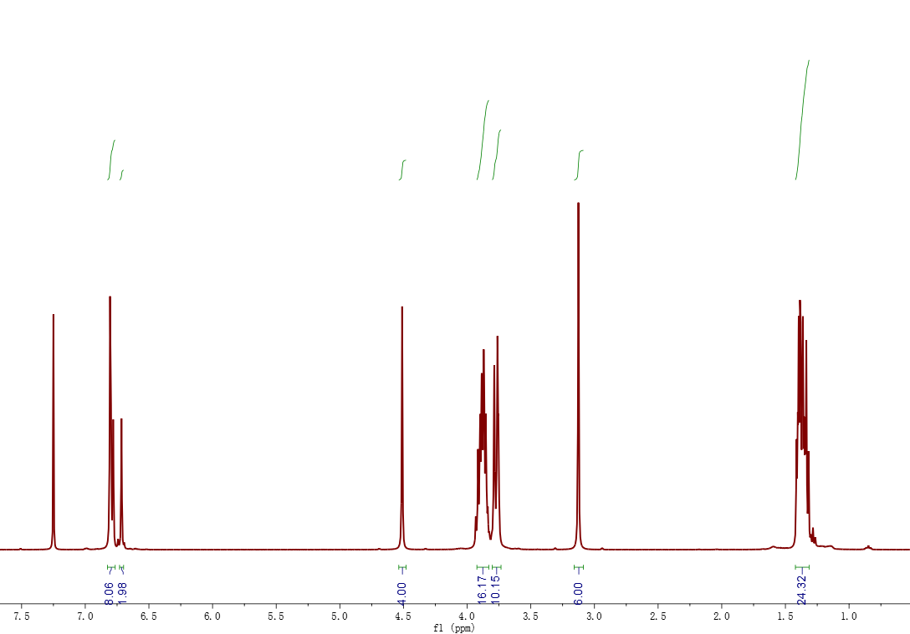
Figure S1. ¹H NMR spectrum (400 MHz, CDCl₃, 293 K) of 3.
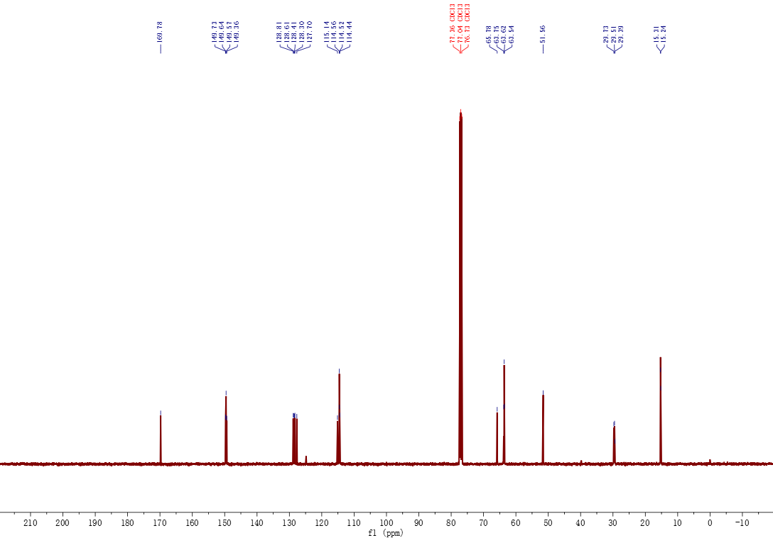
Figure S2. ¹³C NMR spectrum (100 MHz, CDCl₃, 293 K) of 3.

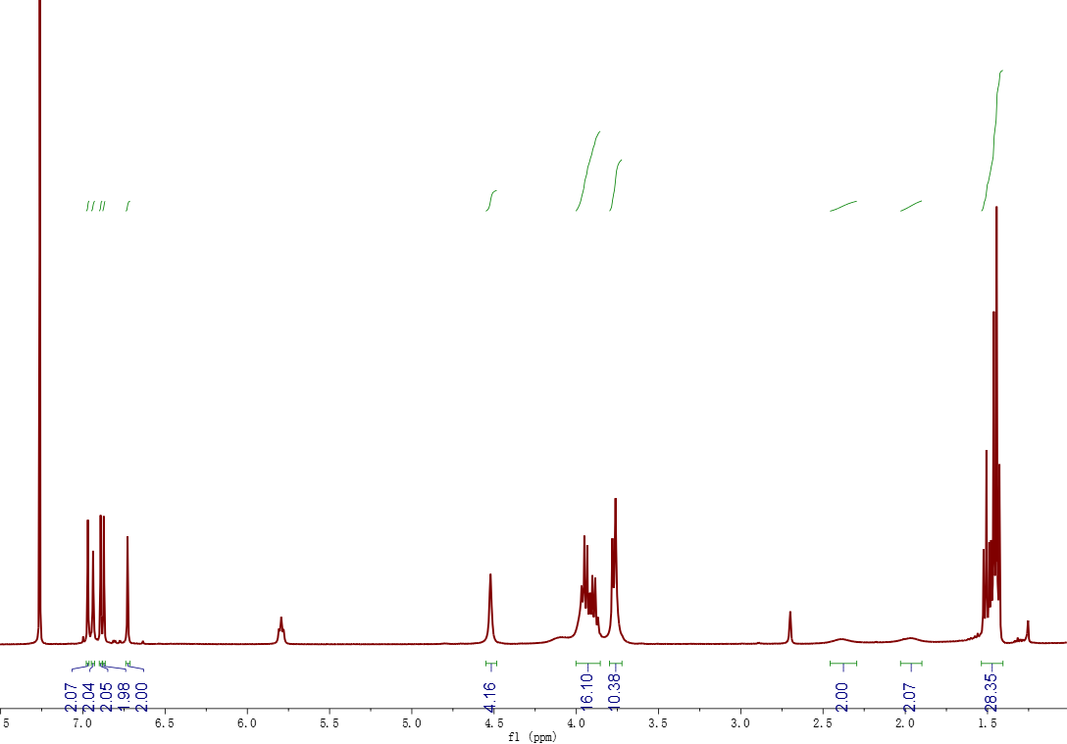
Figure S3. ¹H NMR spectrum (400 MHz, CDCl₃, 293 K) of AP5.

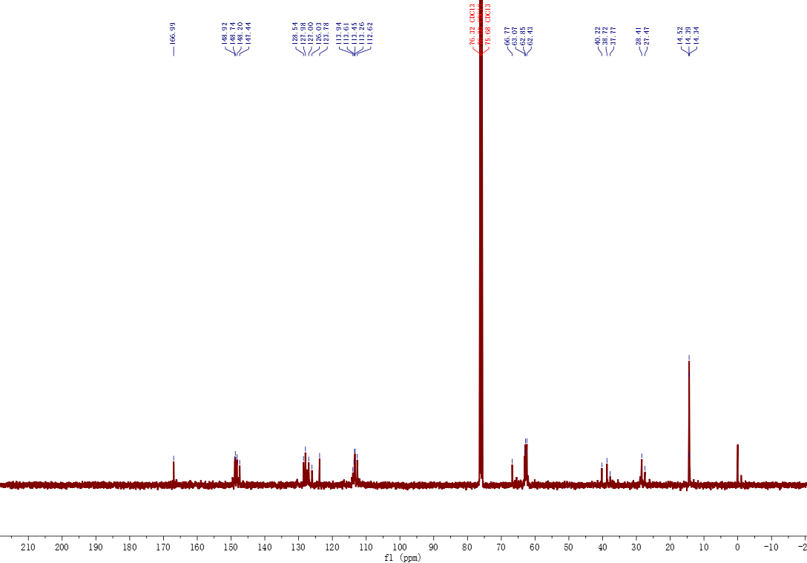
Figure S4. ¹³C NMR spectrum (100 MHz, CDCl₃, 293 K) of AP5.

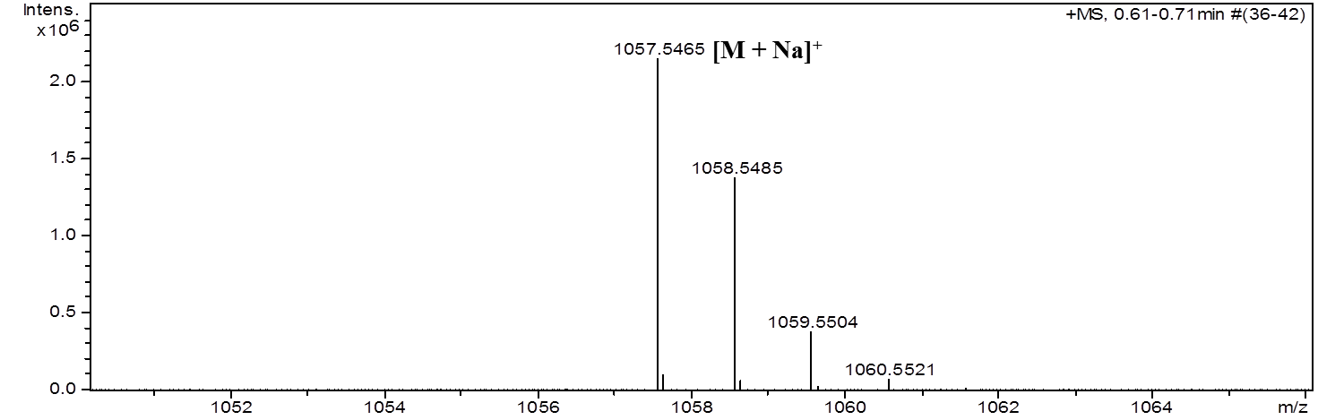
Figure S5. Electrospray ionization mass spectrum of AP5. Assignment of main peaks: m/z 1057.5465 [AP5 + Na]⁺ (100%).

4. Construction of FA-Py/SP/GOx/Dox NPs
For the synthesis of SP/GOx NPs, AP5 (13.5 mg, 0.02 mmol), FeE (5.6 mg, 0.027 mmol), GOx (20 mg, 34 wt% feed ratio), as well as mixed solvent of methanol (20 mL) and acetone (20 mL) were added to a flask (100 mL). The mixture was stirred at 40 °C for 24 h under nitrogen. Then, the product was obtained after washing with N,N-dimethylformamide, acetone and water for several times via centrifugation (10,000 rpm × 10 min). Then SP/GOx NPs was added to the aqueous solution of Dox and stirred overnight to obtain Dox loaded materials (SP/GOx/Dox NPs). At last, SP/GOx/Dox NPs was added to the solution of FA-Py overnight to get resultant materials FA-Py/SP/GOx/Dox NPs.

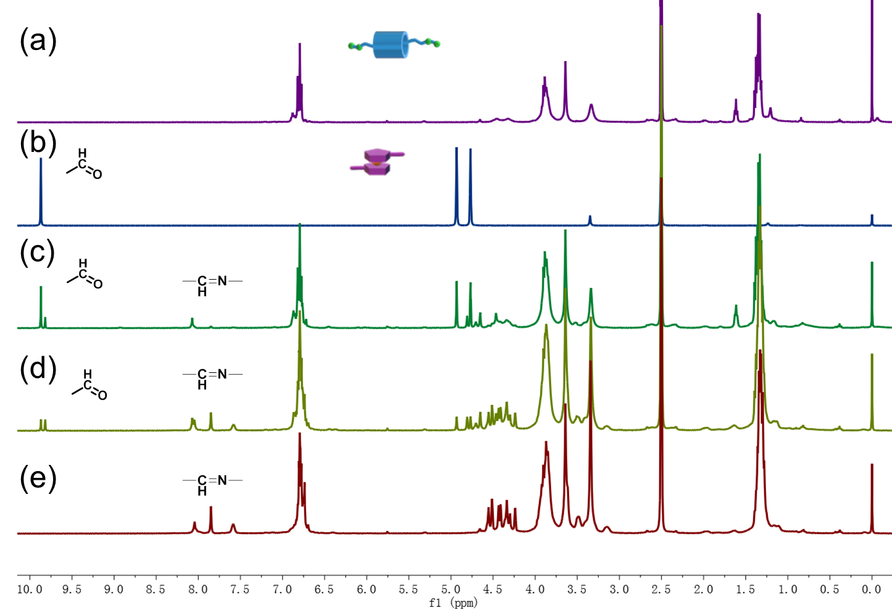
Figure S6. ¹H NMR spectrum (400 MHz, DMSO-d₆, 293 K) of (a) AP5, (b) FeE, (c) fresh (AP5 + FeE), (d) (AP5 + FeE) reacted 4 h, (e) (AP5 + FeE) reacted 24 h.

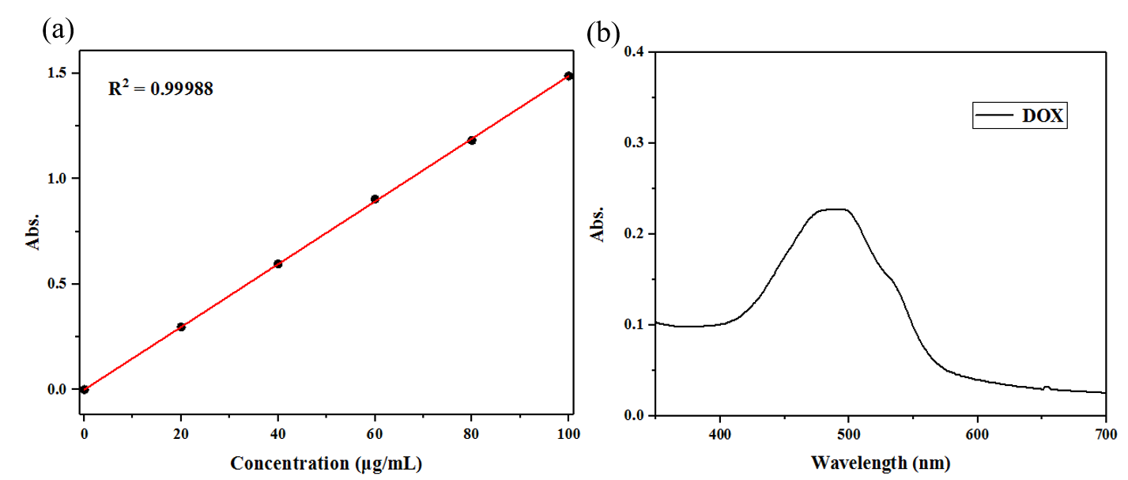
Figure S7. (a) Absorbance intensity at 480 nm as a function of the concentration of Dox in solution. (b) The UV-vis absorbance of the supernatant after DOX loading.
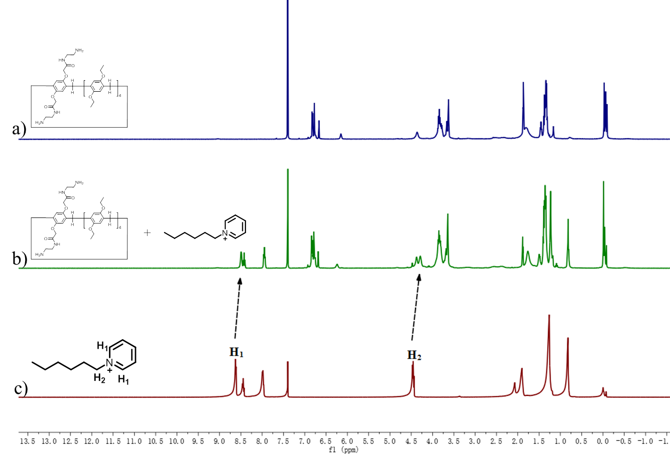
Figure S8. ¹H NMR spectra (400 MHz, CDCl₃/Acetonitrile-D₃, 298 K) of (a) AP5 (10.0 mM), (b) AP5 + G ([AP5] = 10.0 mM, [G]=10.0 mM), and (c) G (10.0 mM).

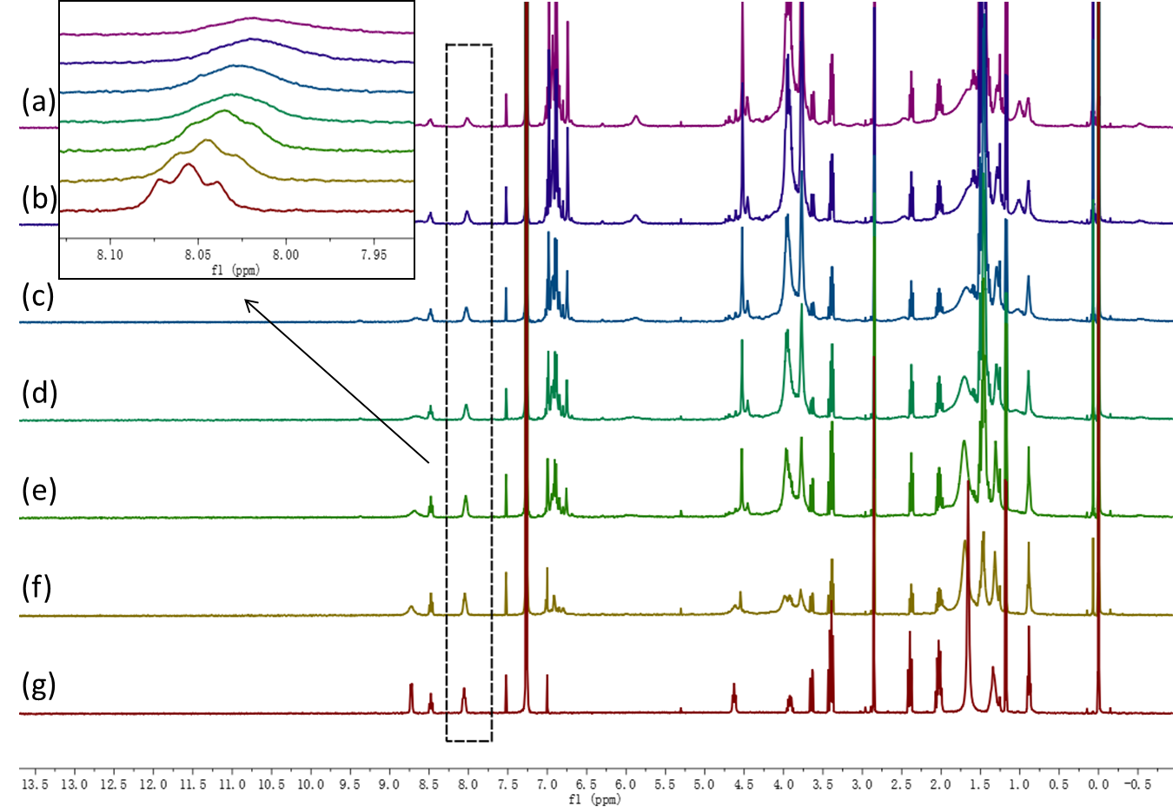
Figure S9 ¹H NMR spectra (CDCl₃, 293 K, 400Hz) of G at a concentration of 4.0 mM upon different concentration of AP5:(a) 0 mM, (b) 1 mM, (c) 2 mM, (d) 3 mM, (e) 4 mM, (f) 5 mM, (g) 6 mM.
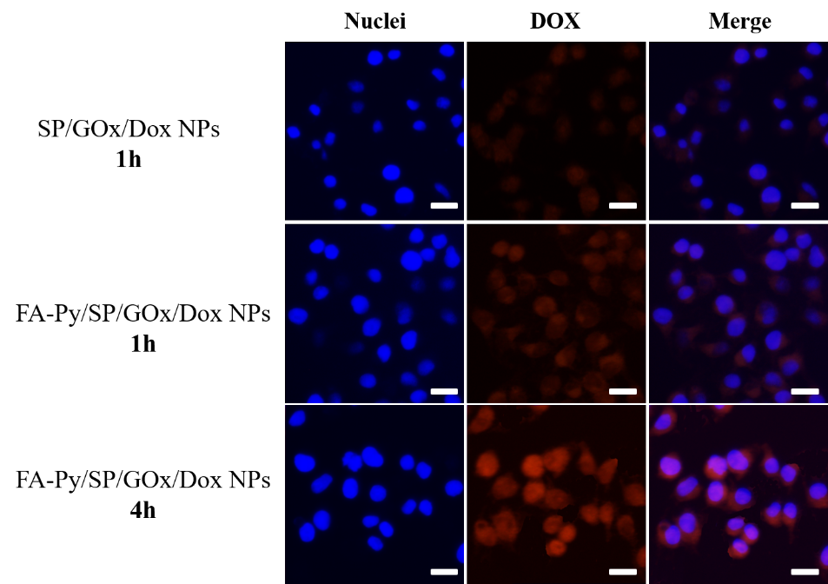
Figure S10 CLSM images of Hela cells incubated with SP/GOx/Dox NPs or FA-Py/SP/GOx/Dox NPs (100 μg/mL). The blue fluorescence of DAPI shows the location of the nuclei and the red fluorescence represents Dox. Scale bar: 50 µm.

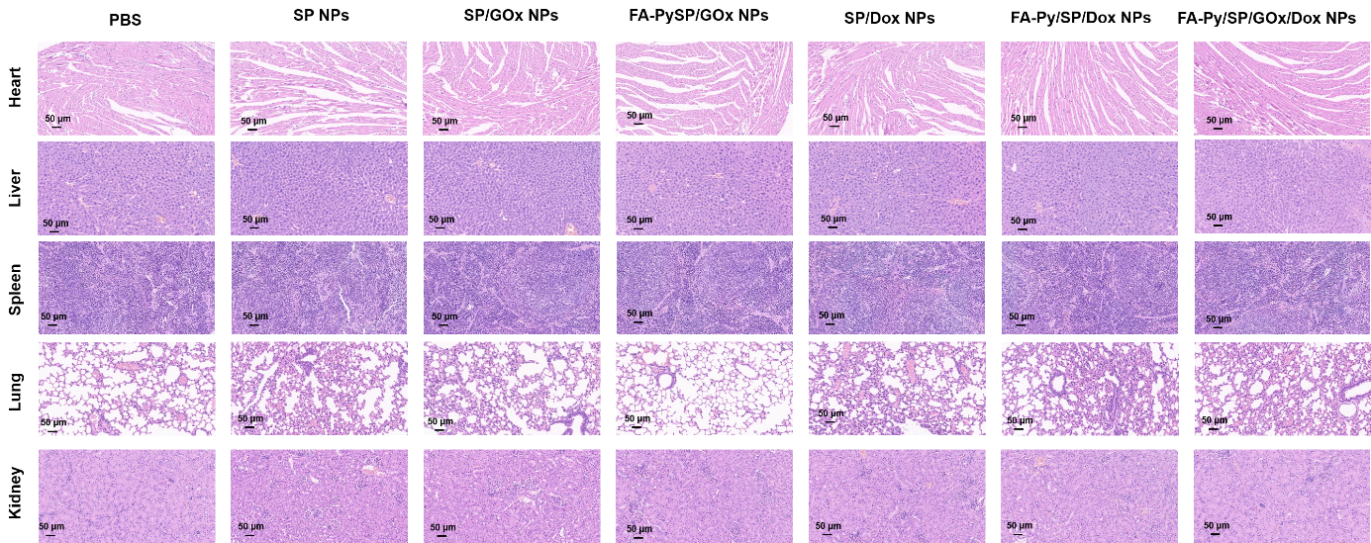
Figure S11. Representative H&E stained images of major organs collected from a untreated mouse (PBS), a SP NPs injected mouse, a SP/GOx NPs injected mouse, a FA-Py/SP/Gox NPs injected mouse, a SP/Dox NPs injected mouse, a FA-Py/SP/Dox NPs injected mouse and a FA-Py/SP/GOx/Dox injected mouse.

