Supporting Information

Optimization of carotenoid production by Rhodotorula mucilaginosa using sugarcane bagasse hydrolysate as carbon source and mutagen ethyl methanesulfonate for biosynthesis of antioxidant

Riahna Kembaren¹, Alicia Cherie Chandra², Florence Gianni², Matthew Edward Chandra², Franklin Setiadarma², Owen Jovanco Hariyanto², Ita Margaretha Nainggolan¹, Riksfardini Annisa Ermawar³, Indra Kurniawan Saputra^{4,5*}

¹Eijkman Research Center for Molecular Biology, National Research and Innovation Agency (BRIN), Cibinong, 16911, Indonesia
²Department of Biotechnology, School of Health and Life Sciences, i3L University, Jakarta, 13210, Indonesia
³Research Center for Applied Botany, National Research and Innovation Agency (BRIN), Cibinong, 16911, Indonesia
⁴Department of Chemistry, University of Warwick, Coventry, CV4 7AL, United Kingdom
⁵Department of Applied Science, Faculty of Mathematics and Natural Sciences, Universitas Negeri Malang, Malang, 65145, Indonesia

*Correspondent author: Indra Kurniawan Saputra (indra.k.saputra@warwick.ac.uk, +62 852-8968-3715)

S1. Standard curve for sugar analysis in sugarcane bagasse hydrolysate (SBH)
A.
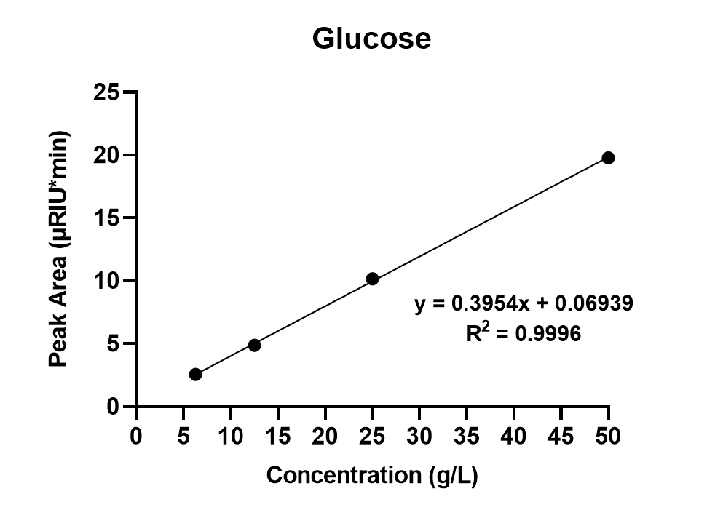
B.
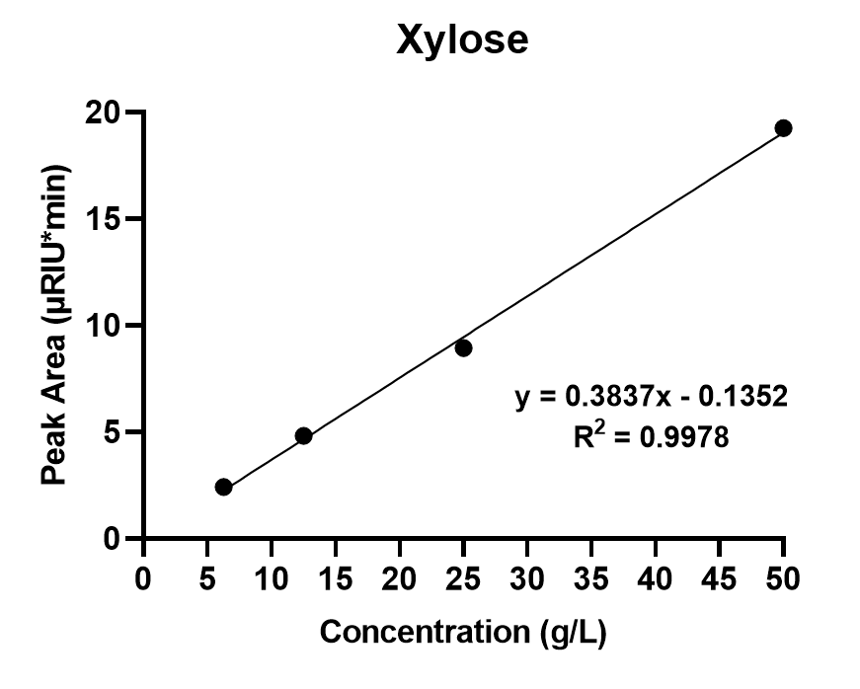
Fig. S1. Standard curve for sugar analysis in sugarcane bagasse hydrolysate (SBH). A. Glucose. and B. Xylose.

S2. The results of cell viability following EMS treatment
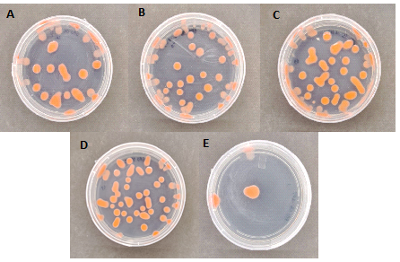
Fig. S2. Comparison of the colony growth of R. mucilaginosa after exposure to EMS with varying concentrations of (A) 0% (control), (B) 1%, (C) 2%, (D) 3%, and (E) 4% (v/v).

