Supporting Information

Metabolic profiling of neocortical tissue discriminates Alzheimer’s disease from mild cognitive impairment, high pathology controls, and normal controls

Paniz Jasbi¹⁺, Xiaojian Shi^{1,2+}, Ping Chu³, Natalie Elliott³, Haley Hudson³, Douglas Jones⁴, Geidy Serrano⁵, Thomas Beach⁵, Li Liu^{6,7}, Garilyn Jentarra^{3,8}*, Haiwei Gu¹*

¹Arizona Metabolomics Laboratory, College of Health Solutions, Arizona State University, Scottsdale, AZ 85259, USA
²Systems Biology Institute, Cellular and Molecular Physiology, Yale School of Medicine, West Haven, CT 06516, USA
³Department of Biochemistry and Molecular Genetics, ⁴Department of Pharmacology, Midwestern University, Glendale, AZ 85308, USA
⁵Banner Sun Health Research Institute, Sun City, AZ 85351, USA
⁶College of Health Solutions, Biodesign Institute, Arizona State University, Tempe, Arizona 85259, USA
⁷Department of Neurology, Mayo Clinic, Scottsdale, Arizona 85259, USA
⁸Precision Medicine Program, Midwestern University, Glendale, AZ 85308, USA
⁺Authors contributed equally
*Corresponding authors
Separate Excel File S1: All data underlying reported findings.
Page S-3: Table S1. Matrix of correlation analysis between candidate markers and clinical characteristics showing r and (p).
Page S-5: Table S2. Full list of significantly enriched enzymes in response to Alzheimer’s progression. For analysis, subjects were dichotomously grouped as case (MCI and AD) and control (NC and HPC).
Page S-6: Figure S1. Significant metabolites between case (AD and MCI) and control (HPC and NC) as determined by independent samples t-test. Data were log₁₀-transformed and Pareto scaled prior to plotting.
Page S-7: Figure S2. ROC analysis of PLS-DA model constructed using levels of lauric acid, myristic acid, stearic acid, and palmitic acid (all p < 0.05): (A) classification of NC vs. HPC/MCI/AD, (B) classification of HPC vs. NC/MCI/AD, (C) classification of MCI vs. NC/HPC/AD, and (D) classification of AD vs. NC/HPC/MCI.

Page S-8: Figure S3. Univariate ROC analysis and t-testing between NC and MCI groups shows lauric acid to be highly predictive (AUC = 0.993) and significant (FDR q < 0.001).
Page S-9: Figure S4. Univariate ROC analysis and t-testing between NC and AD groups shows lauric acid to be highly predictive (AUC = 1.0) and significant (FDR q < 0.001).
Page S-10: Figure S5. Univariate ROC analysis and t-testing of between HPC and AD groups shows high predictive performance (AUC > 0.90) and significance (FDR q < 0.01) of myristic acid, lauric acid, palmitic acid, and stearic acid.
Table S1. Matrix of correlation analysis between candidate markers and clinical characteristics showing r and (p).
Clinical Characteristic | 272.2@20.932005 | 147.1@14.3080015 | 147.1@20.774895 | 73.1@27.868113 | Lauric acid | Myristic acid | Palmitoleic acid | Palmitic acid | Stearic acid
Age | -0.079 | 0.048 | -0.036 | -0.103 | -0.043 | 0.150 | 0.210 | 0.168 | 0.168
Age | (0.598) | (0.748) | (0.810) | (0.490) | (0.775) | (0.313) | (0.157) | (0.259) | (0.259)
Sex | 0.116 | -0.246 | -0.012 | -0.100 | -0.071 | 0.104 | 0.234 | 0.181 | 0.136
Sex | (0.437) | (0.095) | (0.936) | (0.505) | (0.638) | (0.488) | (0.114) | (0.222) | (0.360)
PMI | 0.219 | 0.019 | 0.183 | -0.078 | -0.269 | -0.221 | -0.222 | -0.149 | -0.154
PMI | (0.139) | (0.897) | (0.217) | (0.604) | (0.067) | (0.135) | (0.134) | (0.318) | (0.302)
APOE alleles | -0.045 | 0.048 | -0.047 | -0.084 | 0.092 | 0.051 | 0.058 | 0.031 | 0.043
APOE alleles | (0.762) | (0.751) | (0.755) | (0.574) | (0.538) | (0.733) | (0.699) | (0.839) | (0.777)
MMSE | -0.097 | 0.114 | -0.064 | 0.362 | 0.363 | 0.398 | 0.202 | 0.278 | 0.294
MMSE | (0.515) | (0.445) | (0.669) | (0.012) | (0.012) | (0.006) | (0.172) | (0.059) | (0.045)
Frontal plaque | 0.198 | -0.036 | 0.130 | -0.160 | -0.598 | -0.085 | 0.118 | 0.003 | -0.004
Frontal plaque | (0.182) | (0.810) | (0.382) | (0.283) | (0.000) | (0.569) | (0.428) | (0.982) | (0.981)
Total Plaque | 0.296 | -0.092 | 0.157 | -0.153 | -0.579 | -0.100 | 0.108 | -0.001 | -0.002
Total Plaque | (0.043) | (0.539) | (0.293) | (0.305) | (0.000) | (0.503) | (0.469) | (0.993) | (0.988)
Frontal Tangle | 0.203 | -0.129 | 0.070 | -0.141 | -0.410 | -0.399 | -0.109 | -0.289 | -0.276
Frontal Tangle | (0.172) | (0.387) | (0.639) | (0.345) | (0.004) | (0.005) | (0.467) | (0.048) | (0.061)
Total Tangle | 0.111 | -0.200 | 0.148 | -0.246 | -0.507 | -0.350 | -0.011 | -0.219 | -0.229
Total Tangle | (0.457) | (0.177) | (0.322) | (0.096) | (0.000) | (0.016) | (0.941) | (0.138) | (0.122)
Braak score | 0.063 | -0.157 | 0.198 | -0.252 | -0.539 | -0.353 | -0.046 | -0.234 | -0.250
Braak score | (0.672) | (0.293) | (0.182) | (0.087) | (0.000) | (0.015) | (0.757) | (0.113) | (0.091)
Frontal CAA | 0.105 | 0.036 | 0.179 | -0.165 | -0.169 | 0.094 | 0.274 | 0.209 | 0.196
Frontal CAA | (0.481) | (0.811) | (0.228) | (0.267) | (0.257) | (0.529) | (0.063) | (0.159) | (0.187)
Total CAA | 0.100 | 0.005 | 0.083 | -0.164 | -0.211 | 0.091 | 0.295 | 0.219 | 0.194
Total CAA | (0.502) | (0.972) | (0.579) | (0.269) | (0.155) | (0.543) | (0.044) | (0.139) | (0.191)

Table S2. Full list of significantly enriched enzymes in response to Alzheimer’s progression. For analysis, subjects were dichotomously grouped as case (MCI and AD) and control (NC and HPC).
Enzyme | p value
Mitochondrial 2-oxovalerate dehydrogenase | 0.025
3-amino-isobutyrate transport | 0.025
Mitochondrial 3-amino-isobutyrate transport | 0.025
3-hydroxyacyl-CoA dehydratase | 0.025
Mitochondrial 3-hydroxyisobutyrate dehydrogenase | 0.025
Mitochondrial 3-hydroxyisobutyryl-CoA hydrolase | 0.025
Mitochondrial acyl-CoA dehydrogenase | 0.025
L-3-amino-isobutanoate exchange | 0.025
Mitochondrial L-3-aminoisobutyrate transaminase | 0.025
Mitochondrial malonate-semialdehyde dehydrogenase | 0.025
Methylmalonate-semialdehyde dehydrogenase | 0.025

Figure S1. Significant metabolites between case (MCI and AD) and control (NC and HPC) as determined by independent samples t-test. Data were log₁₀-transformed and Pareto scaled prior to plotting.

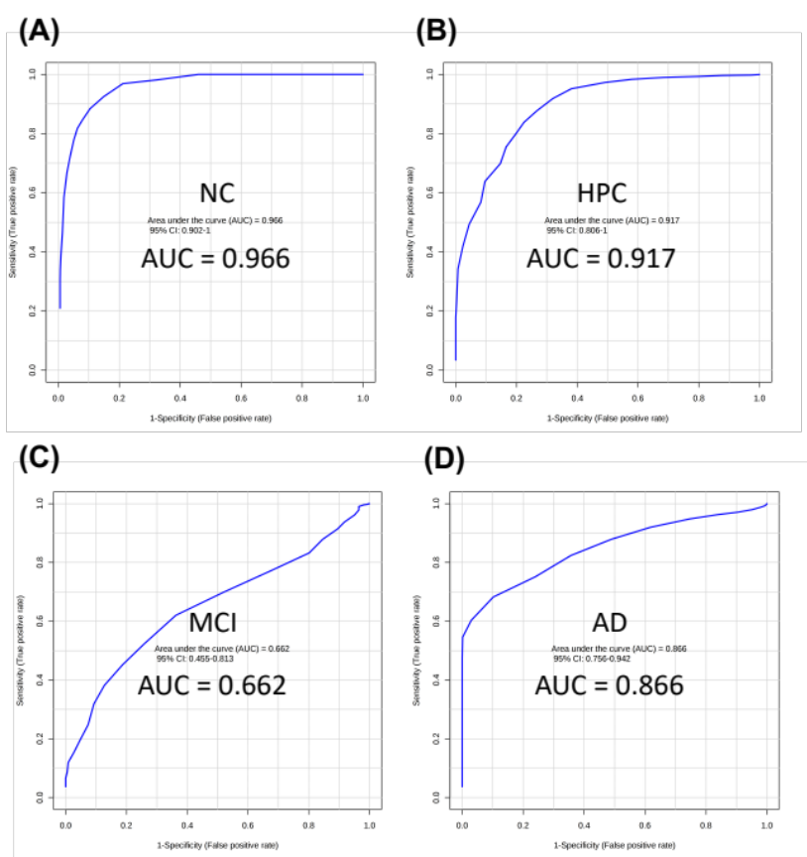

Figure S2. ROC analysis of PLS-DA model constructed using levels of lauric acid, myristic acid, stearic acid, and palmitic acid (all p < 0.05): (A) classification of NC vs. HPC/MCI/AD, (B) classification of HPC vs. NC/MCI/AD, (C) classification of MCI vs. NC/HPC/AD, and (D) classification of AD vs. NC/HPC/MCI.

Figure S3. Univariate ROC analysis and t-testing between NC and MCI groups shows lauric acid to be highly predictive (AUC = 0.993) and significant (FDR q < 0.001).

Figure S4. Univariate ROC analysis and t-testing between NC and AD groups shows lauric acid to be highly predictive (AUC = 1.0) and significant (FDR q < 0.001).

Figure S5. Univariate ROC analysis and t-testing of between HPC and AD groups shows high predictive performance (AUC > 0.90) and significance (FDR q < 0.01) of myristic acid, lauric acid, palmitic acid, and stearic acid.

