Supplementary

Can Video Laryngoscopy Enhance Direct Laryngoscopy Skills in Novice Medical Students?
A Randomized Crossover Trial (ViDiLa)

Table of Contents
Additional Information on Statistical Analysis 2
R-Packages 2
Additional information on the study population 2
Table S1: Secondary outcomes by intubation method cumulated for all timepoints 2
Table S2: Self-assessed competence before training and after follow-up 2
Figure S1: First-Pass Success Rate by Method Across Timepoints 5
Figure S2: Time to intubation at first intubation attempt 6
Figure S3: Time to Intubation at Follow-Up between VL and DL 7
Figure S4: Individual time to intubation at follow-up by method 8
Figure S5: Time to intubation between first attempt and follow-up by method 9
Figure S6: Exploratory Analysis of Predictors of Time to Successful Intubation 10
Figure S7: Self-Assessed Competence Before Training 11
Figure S8: Self-Assessed Competence After Training 12
Figure S9: Self-Assessed Confidence and Time to Intubation by Method 13
Figure S10: Time to successful intubation by Group after covariate adjustment 14
Figure S11: Time to successful intubation by method after covariate adjustment 15
Study Workflow 16
Experimental Setup 17
Participant Self-Assessment Questionnaire 18
References 21

Additional Information on Statistical Analysis

R-Packages
The following R packages were used in the analysis workflow:
”tidyverse“(1), "ggplot2"(2), "gtsummary"(3), "forester"(4), “lme4” (5), “lmerTest”(6), “coxme”(7), “survival”(8), “survminer”(9).

Additional information on the study population

Table S1: Secondary outcomes by intubation method cumulated for all timepoints

Outcome | VL  N = 99¹ | DL  N = 99¹ | p-value²
TTI (s) | 28 (23, 43) | 27 (23, 37) | 0.5
TTV (s) | 25 (16, 36) | 22 (17, 29) | 0.2
TTTP (s) | 21 (16, 31) | 19 (16, 24) | 0.2
First-pass success | 63 (64%) | 86 (89%) | <0.001
Esophageal intubation | 0 (0%) | 9 (9.2%) | 0.002
Tooth contact | 48 (49%) | 48 (49%) | >0.9
Stylet use | 91 (92%) | 90 (91%) | >0.9
Cormack-Lehane grade |  |  | <0.001
I | 48 (51%) | 19 (20%)
II | 41 (43%) | 54 (56%)
II–III | 5 (5.3%) | 12 (13%)
III | 0 (0%) | 8 (8.3%)
III–IV | 0 (0%) | 1 (1.0%)
IV | 1 (1.1%) | 2 (2.1%)
¹Median (Q1, Q3); n (%)
²Wilcoxon rank sum test; Fisher's exact test
Continuous: median (IQR); categorical: n (%). TTI = time-to-intubation; TTV = time-to-view; TTTP = time-to-tube-passage; FPS = first-pass success; VL = video laryngoscopy; DL = direct laryngoscopy.

Table S2: Self-assessed competence before training and after follow-up

Characteristic¹ | Pre Training  N = 64¹ | Post Follow-Up  N = 31¹
Bag-mask ventilation on manikin
Not confident | 7 (12%) | 0 (0%)
Rather unsure | 12 (21%) | 0 (0%)
Rather confident | 29 (50%) | 13 (42%)
Very confident | 10 (17%) | 18 (58%)
Oropharyngeal airway on manikin
Not confident | 34 (60%) | 0 (0%)
Rather unsure | 5 (8.8%) | 2 (6.5%)
Rather confident | 7 (12%) | 12 (39%)
Very confident | 11 (19%) | 17 (55%)
Nasopharyngeal airway on manikin
Not confident | 36 (63%) | 0 (0%)
Rather unsure | 4 (7.0%) | 5 (16%)
Rather confident | 9 (16%) | 13 (42%)
Very confident | 8 (14%) | 13 (42%)
Laryngeal mask airway on manikin
Not confident | 35 (61%) | 0 (0%)
Rather unsure | 5 (8.8%) | 3 (10%)
Rather confident | 12 (21%) | 16 (53%)
Very confident | 5 (8.8%) | 11 (37%)
Laryngeal tube on manikin
Not confident | 38 (68%) | 0 (0%)
Rather unsure | 6 (11%) | 5 (17%)
Rather confident | 7 (13%) | 16 (53%)
Very confident | 5 (8.9%) | 9 (30%)
Direct laryngoscopy on manikin
Not confident | 42 (74%) | 0 (0%)
Rather unsure | 11 (19%) | 4 (13%)
Rather confident | 1 (1.8%) | 20 (65%)
Very confident | 3 (5.3%) | 7 (23%)
Video laryngoscopy on manikin
Not confident | 40 (70%) | 0 (0%)
Rather unsure | 9 (16%) | 1 (3.2%)
Rather confident | 6 (11%) | 19 (61%)
Very confident | 2 (3.5%) | 11 (35%)
ET intubation via DL on manikin
Not confident | 42 (75%) | 0 (0%)
Rather unsure | 10 (18%) | 3 (9.7%)
Rather confident | 3 (5.4%) | 19 (61%)
Very confident | 1 (1.8%) | 9 (29%)
ET intubation via VL on manikin
Not confident | 41 (72%) | 0 (0%)
Rather unsure | 7 (12%) | 4 (13%)
Rather confident | 9 (16%) | 15 (50%)
Very confident | 0 (0%) | 11 (37%)
Tube position verification on manikin
Not confident | 40 (70%) | 0 (0%)
Rather unsure | 3 (5.3%) | 3 (9.7%)
Rather confident | 6 (11%) | 13 (42%)
Very confident | 8 (14%) | 15 (48%)
Intubation overall on manikin
Not confident | 41 (72%) | 0 (0%)
Rather unsure | 12 (21%) | 2 (6.7%)
Rather confident | 3 (5.3%) | 24 (80%)
Very confident | 1 (1.8%) | 4 (13%)
Bag-mask ventilation on patient
Not confident | 21 (41%) | 3 (10%)
Rather unsure | 16 (31%) | 7 (24%)
Rather confident | 9 (18%) | 14 (48%)
Very confident | 5 (9.8%) | 5 (17%)
Oropharyngeal airway on patient
Not confident | 35 (69%) | 4 (14%)
Rather unsure | 3 (5.9%) | 7 (25%)
Rather confident | 5 (9.8%) | 12 (43%)
Very confident | 8 (16%) | 5 (18%)
Nasopharyngeal airway on patient
Not confident | 36 (71%) | 6 (21%)
Rather unsure | 5 (9.8%) | 8 (28%)
Rather confident | 4 (7.8%) | 12 (41%)
Very confident | 6 (12%) | 3 (10%)
Laryngeal mask airway on patient
Not confident | 36 (71%) | 6 (22%)
Rather unsure | 8 (16%) | 13 (48%)
Rather confident | 4 (7.8%) | 8 (30%)
Very confident | 3 (5.9%) | 0 (0%)
Laryngeal tube on patient
Not confident | 40 (80%) | 11 (41%)
Rather unsure | 4 (8.0%) | 11 (41%)
Rather confident | 1 (2.0%) | 4 (15%)
Very confident | 5 (10%) | 1 (3.7%)
Direct laryngoscopy on patient
Not confident | 46 (90%) | 11 (39%)
Rather unsure | 3 (5.9%) | 12 (43%)
Rather confident | 2 (3.9%) | 4 (14%)
Very confident | 0 (0%) | 1 (3.6%)
Video laryngoscopy on patient
Not confident | 44 (86%) | 8 (29%)
Rather unsure | 7 (14%) | 14 (50%)
Rather confident | 0 (0%) | 3 (11%)
Very confident | 0 (0%) | 3 (11%)
ET intubation via DL on patient
Not confident | 46 (90%) | 11 (39%)
Rather unsure | 4 (7.8%) | 15 (54%)
Rather confident | 1 (2.0%) | 2 (7.1%)
Very confident | 0 (0%) | 0 (0%)
ET intubation via VL on patient
Not confident | 45 (87%) | 10 (36%)
Rather unsure | 6 (12%) | 14 (50%)
Rather confident | 1 (1.9%) | 4 (14%)
Very confident | 0 (0%) | 0 (0%)
Tube position verification on patient
Not confident | 38 (75%) | 7 (24%)
Rather unsure | 4 (7.8%) | 9 (31%)
Rather confident | 4 (7.8%) | 6 (21%)
Very confident | 5 (9.8%) | 7 (24%)
Intubation overall on patient
Not confident | 44 (86%) | 9 (32%)
Rather unsure | 6 (12%) | 15 (54%)
Rather confident | 1 (2.0%) | 4 (14%)
Very confident | 0 (0%) | 0 (0%)
¹Missing values at follow-up: Laryngeal mask airway on manikin (n=1); Laryngeal tube on manikin (n=1); ET intubation via VL on manikin (n=1); Intubation overall on manikin (n=1); Bag-mask ventilation on patient (n=2); Oropharyngeal airway on patient (n=3); Nasopharyngeal airway on patient (n=2); Laryngeal mask airway on patient (n=4); Laryngeal tube on patient (n=4); Direct laryngoscopy on patient (n=3); Video laryngoscopy on patient (n=3); ET intubation via DL on patient (n=3); ET intubation via VL on patient (n=3); Tube position verification on patient (n=2); Intubation overall on patient (n=3).

Figure S1: First-Pass Success Rate by Method Across Timepoints

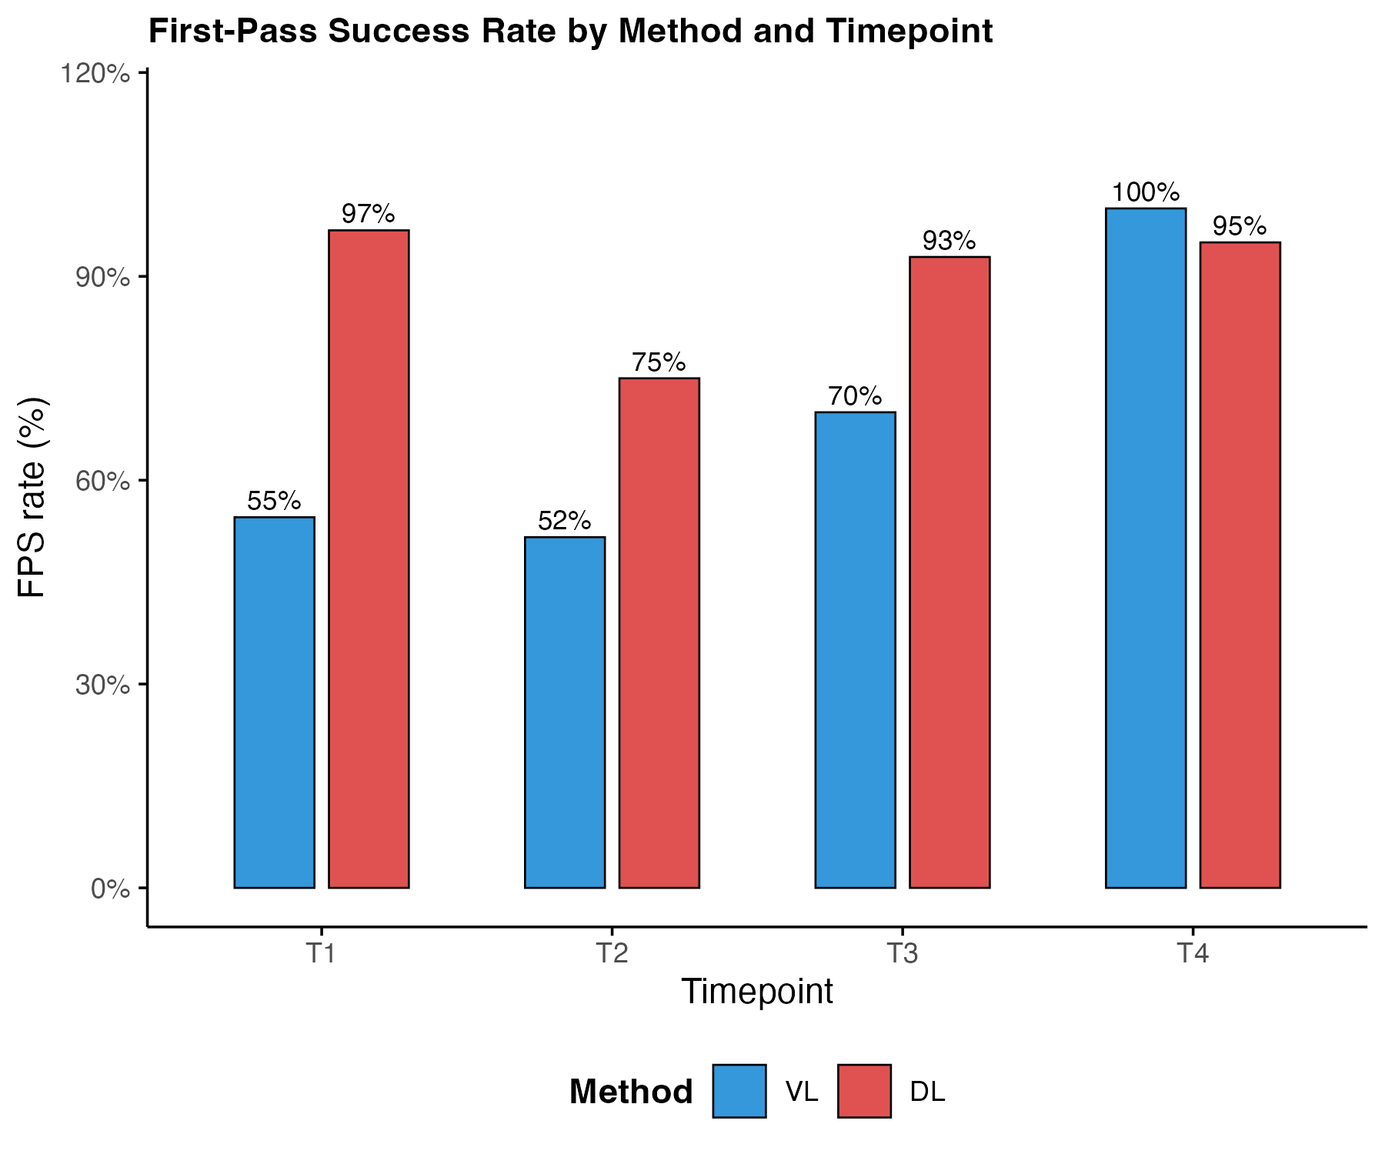
Bars show the proportion of successful first-pass intubations at each timepoint for video laryngoscopy (blue) and direct laryngoscopy (red). At T1 and T2, each method is performed by a different group. At T3 and T4, both groups performed both methods.

Figure S2: Time to intubation at first intubation attempt

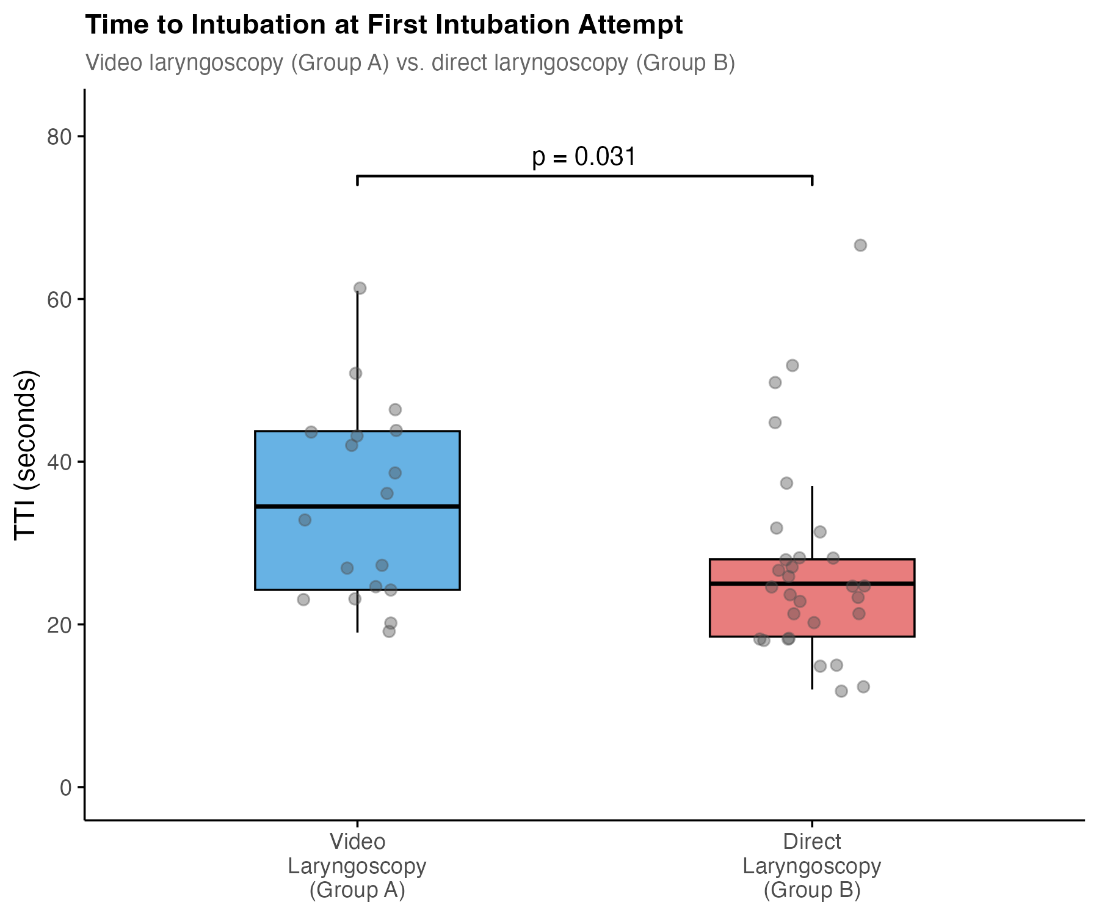

Box plots show median (IQR) with individual TTI data points. Group A performed video laryngoscopy (n=18), Group B performed direct laryngoscopy (n=30). Among participants with first-pass success, median TTI was significantly shorter with direct laryngoscopy compared to video laryngoscopy (25s, (19-28s) vs. 35s, (24-44s); p=0.031).

Figure S3: Time to Intubation at Follow-Up between VL and DL

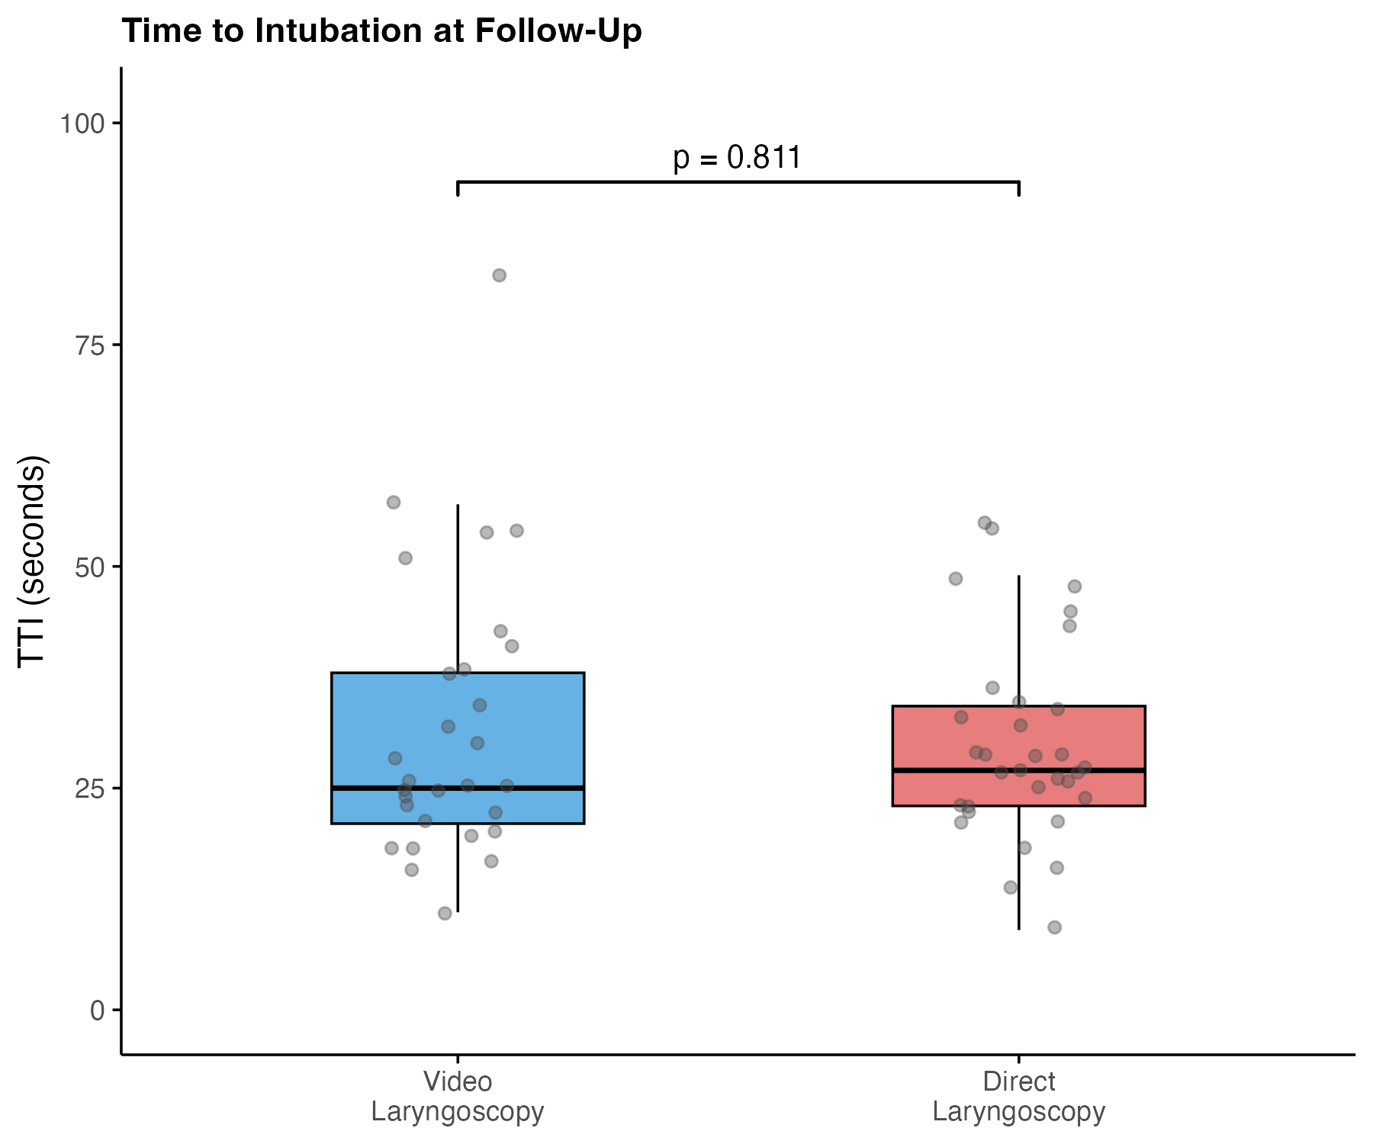
Box plots show median (IQR) with individual TTI data points. Both groups performed video laryngoscopy and direct laryngoscopy at follow-up; analysis is restricted to participants with first-pass success (VL n=29, DL n=32). No significant difference in TTI was observed between methods (median 25s (21-38s) vs. 27s (23-34s); p=0.81).

Figure S4: Individual time to intubation at follow-up by method

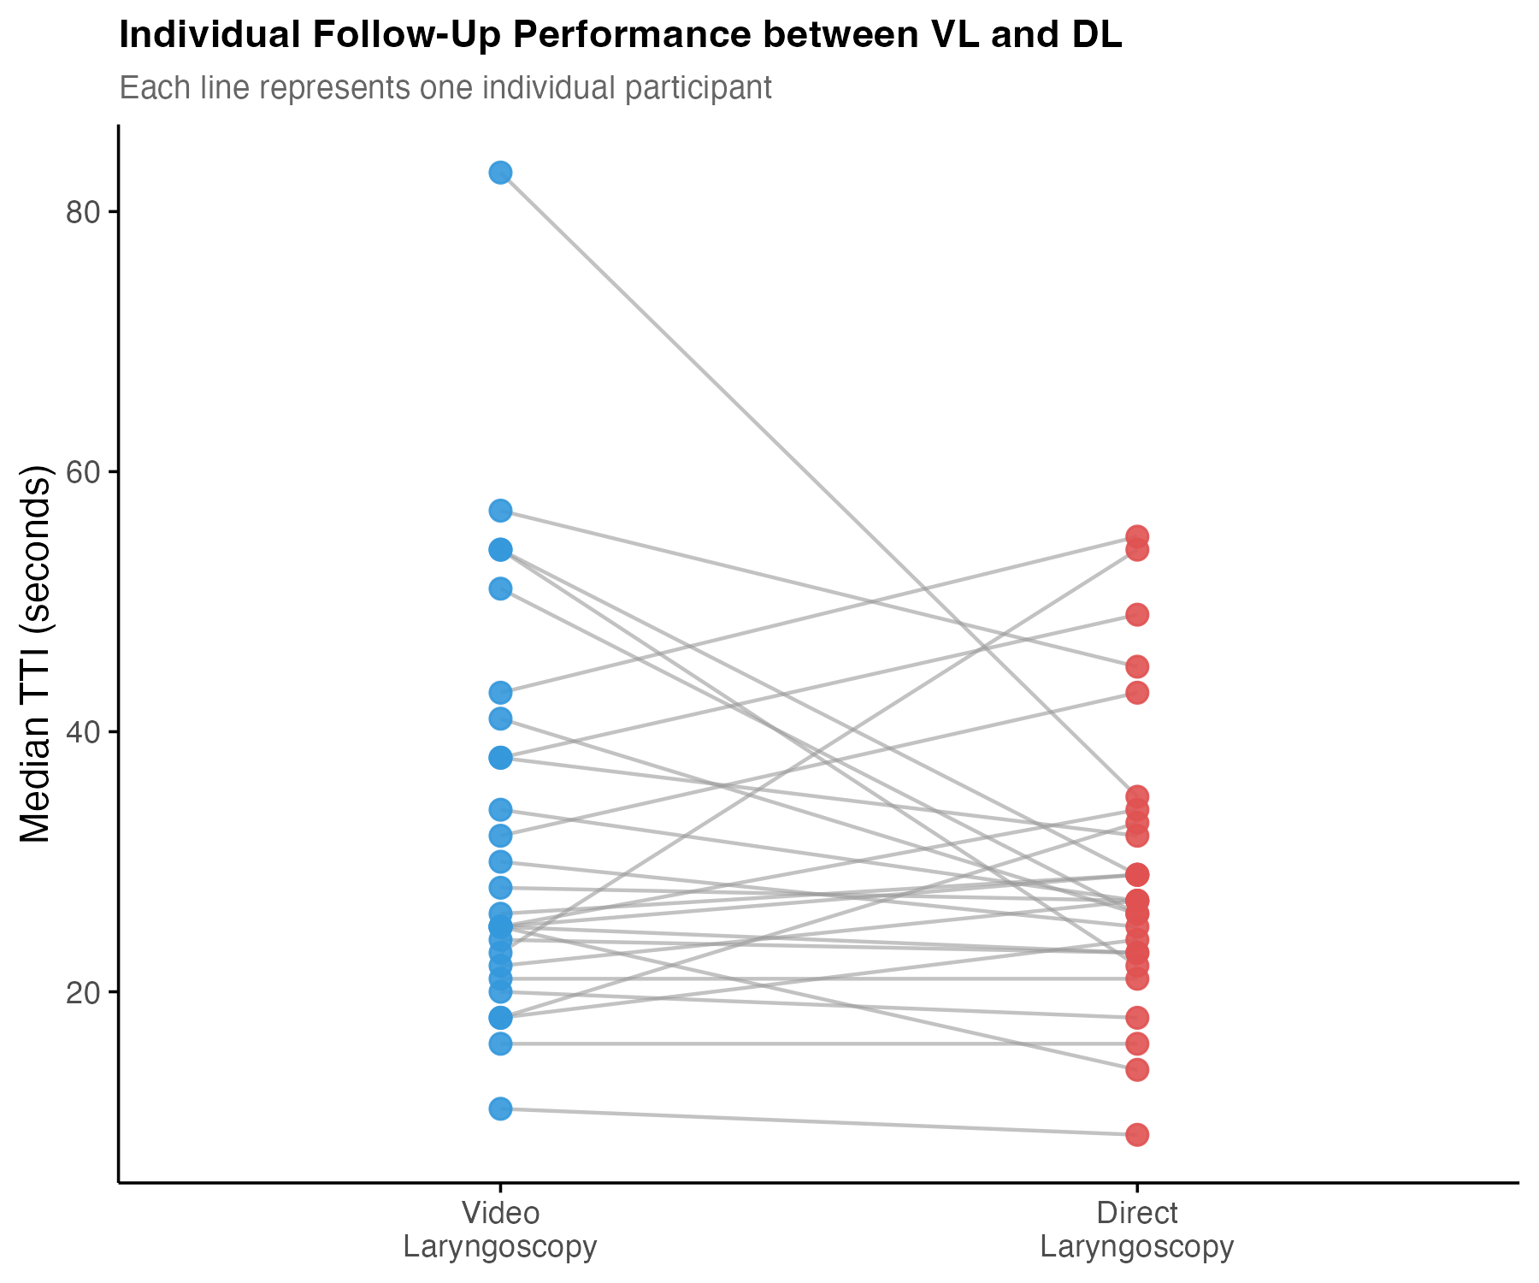
Each line represents one participant (n=27) who completed both video and direct laryngoscopy at follow-up. Dots indicate individual TTI values for video laryngoscopy (blue) and direct laryngoscopy (red). Of 27 participants with paired data, 15 were faster with direct laryngoscopy, 10 with video laryngoscopy and 2 showed identical times with both techniques.

Figure S5: Time to intubation between first attempt and follow-up by method

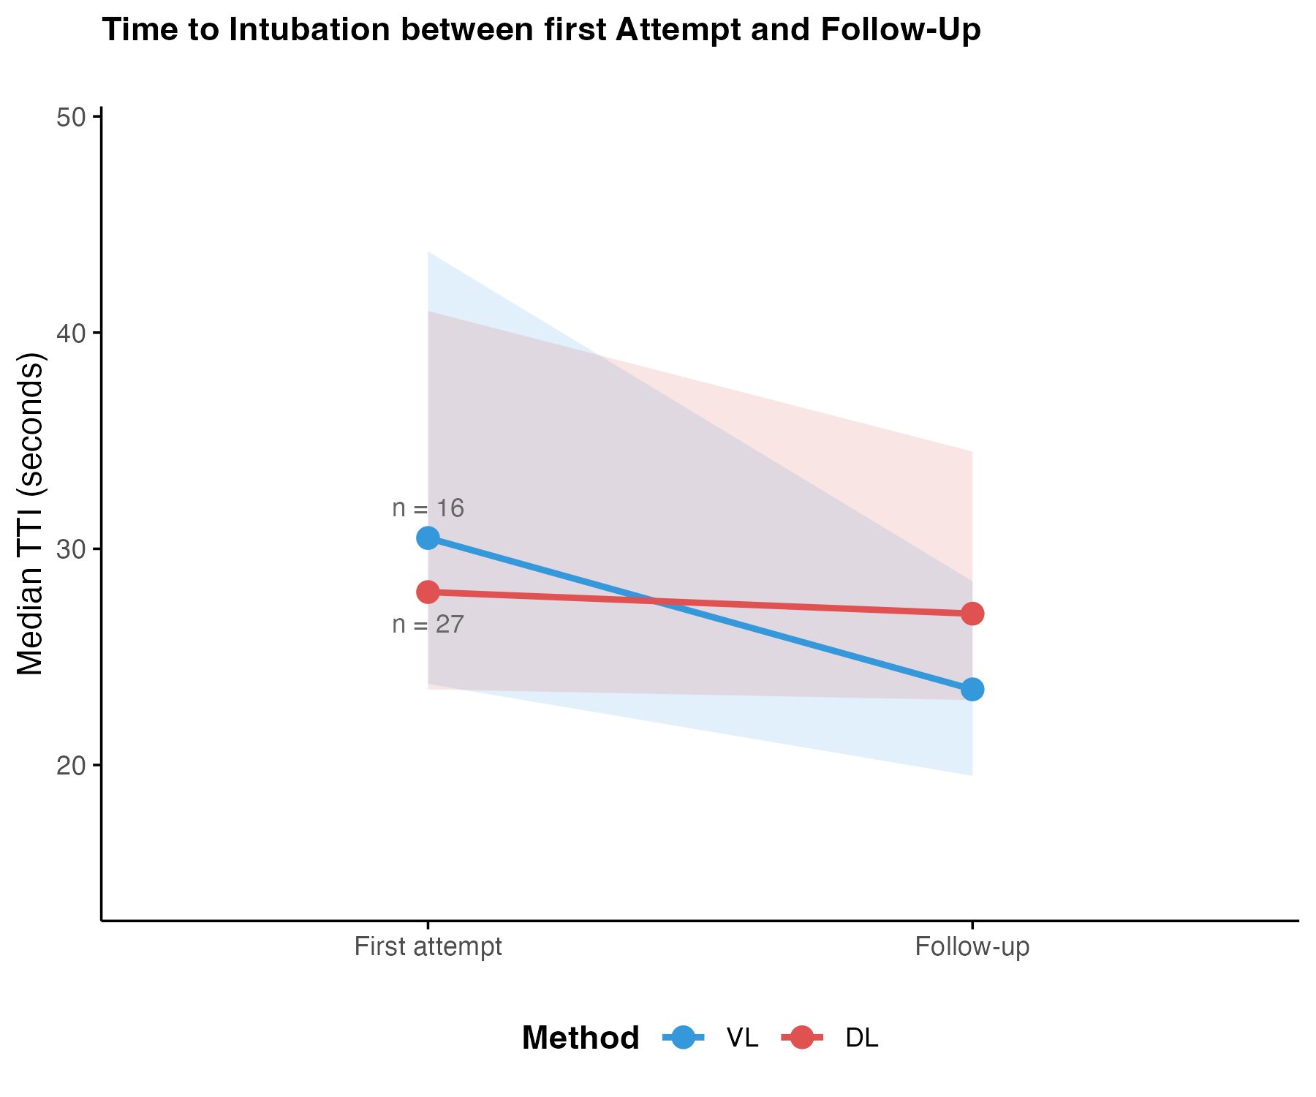
Lines show median TTI with shaded areas representing IQR for video laryngoscopy (blue) and direct laryngoscopy (red). Only participants with successful intubations at both the first attempt and follow-up are included (VL n=16, DL n=27). "First attempt" represents each participant's first exposure (T1 or T2) to the respective method, "Follow-up" combines T3 and T4. Among participants with data at both timepoints, VL showed a significant reduction in TTI (p=0.01), whereas no significant change was observed for DL (p=0.61).

Figure S6: Exploratory Analysis of Predictors of Time to Successful Intubation

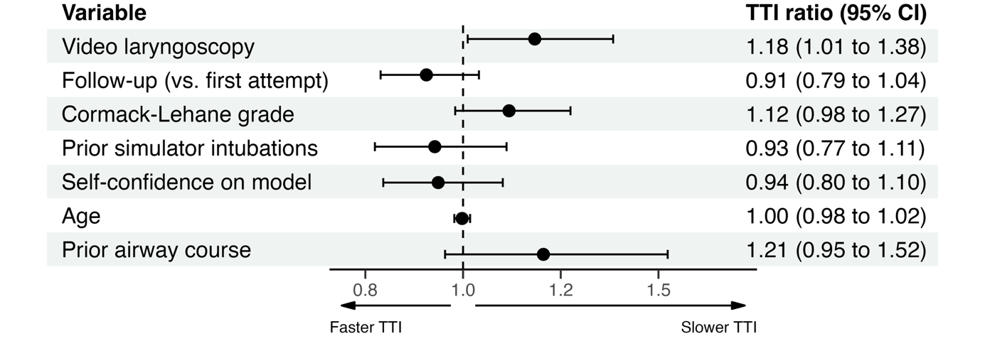
Forest plot showing adjusted TTI ratios from a linear mixed-effects model with log-transformed TTI as the outcome and participant-specific random intercepts. Only successful intubations were included. A TTI ratio greater than 1 indicates longer time to intubation (slower); a ratio below 1 indicates shorter time to intubation (faster). Horizontal bars represent 95% confidence intervals.
Video laryngoscopy was compared to direct laryngoscopy as reference. Follow-up refers to timepoints T3 and T4 combined, compared to the first attempt at the respective technique (T1 or T2 depending on group assignment). Cormack-Lehane grade reflects glottic view quality scored 1-4Cormack-Lehane grade was self-reported by participants using a printed reference chart and was entered into the model as an ordinal score; higher grades indicate a more difficult view and were associated with longer TTI. Prior simulator intubations and self-confidence on model are participant-reported values at baseline; estimates represent the change in TTI ratio per one-unit increase. Prior airway course was compared to no prior airway course as reference.

Figure S7: Self-Assessed Competence Before Training

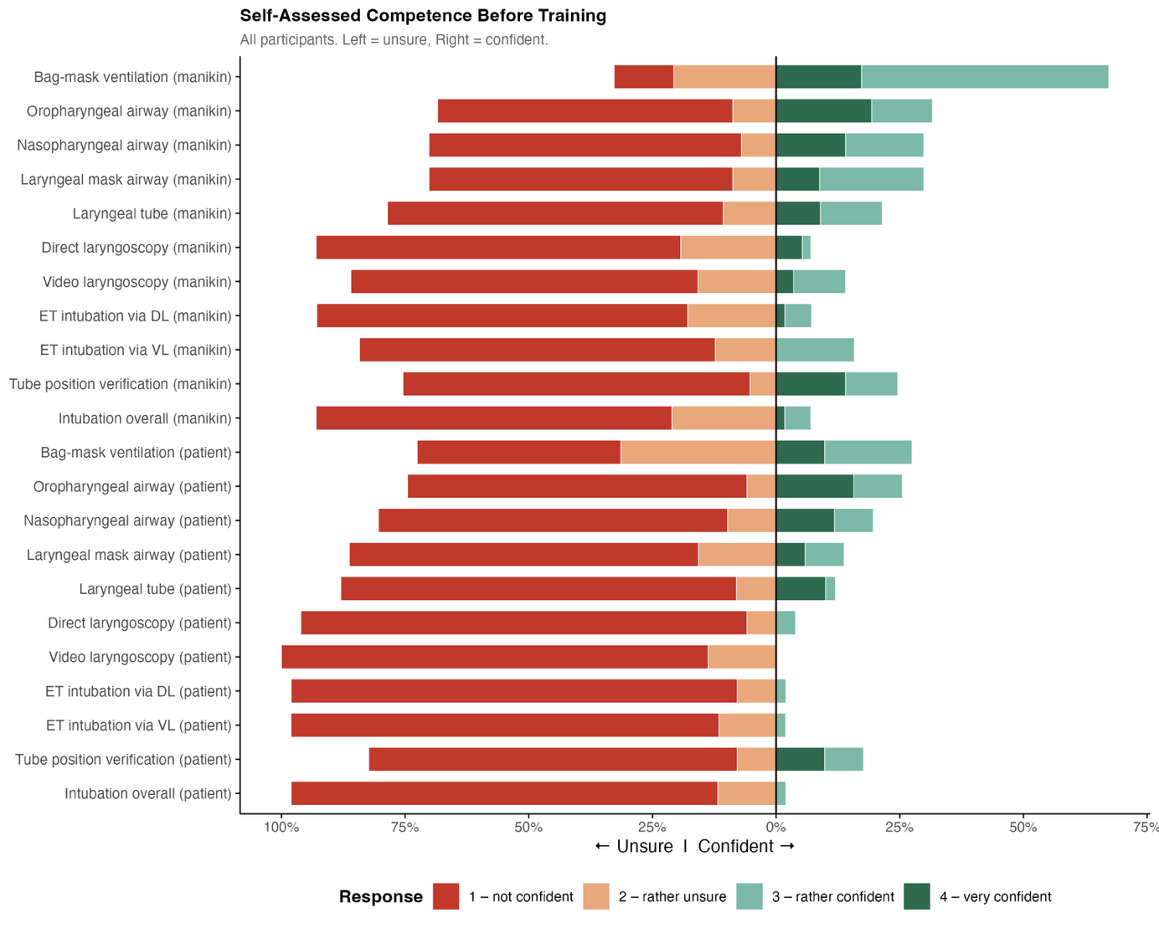
Distribution of self-assessed competence across all airway management skills before training (n=64). Responses are displayed as a diverging bar chart, bars extending left represent unsure ratings (not confident, rather unsure), bars extending right represent confident ratings (rather confident, very confident). Items are grouped by setting (manikin vs. patient). Exact response frequencies are provided in Table S2. The complete questionnaire wording is provided at the end of this Supplementary Material.

Figure S8: Self-Assessed Competence After Training

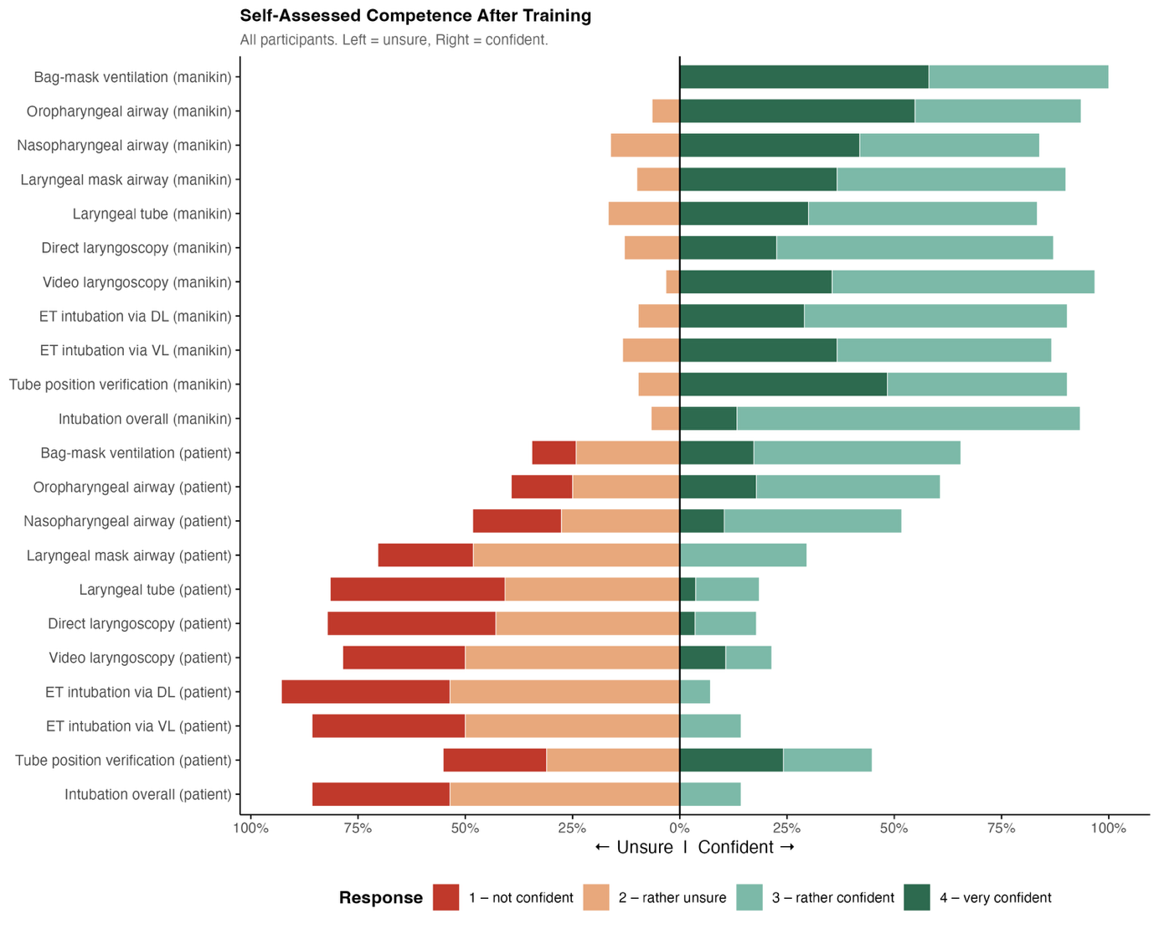
Distribution of self-assessed competence across all airway management skills after follow-up (n = 31). Responses are displayed as a diverging bar chart, bars extending left represent unsure ratings (not confident, rather unsure), bars extending right represent confident ratings (rather confident, very confident). Items are grouped by setting (manikin vs. patient). Exact response frequencies are provided in Table S2. The complete questionnaire wording is provided at the end of this Supplementary Material.

Figure S9: Self-Assessed Confidence and Time to Intubation by Method

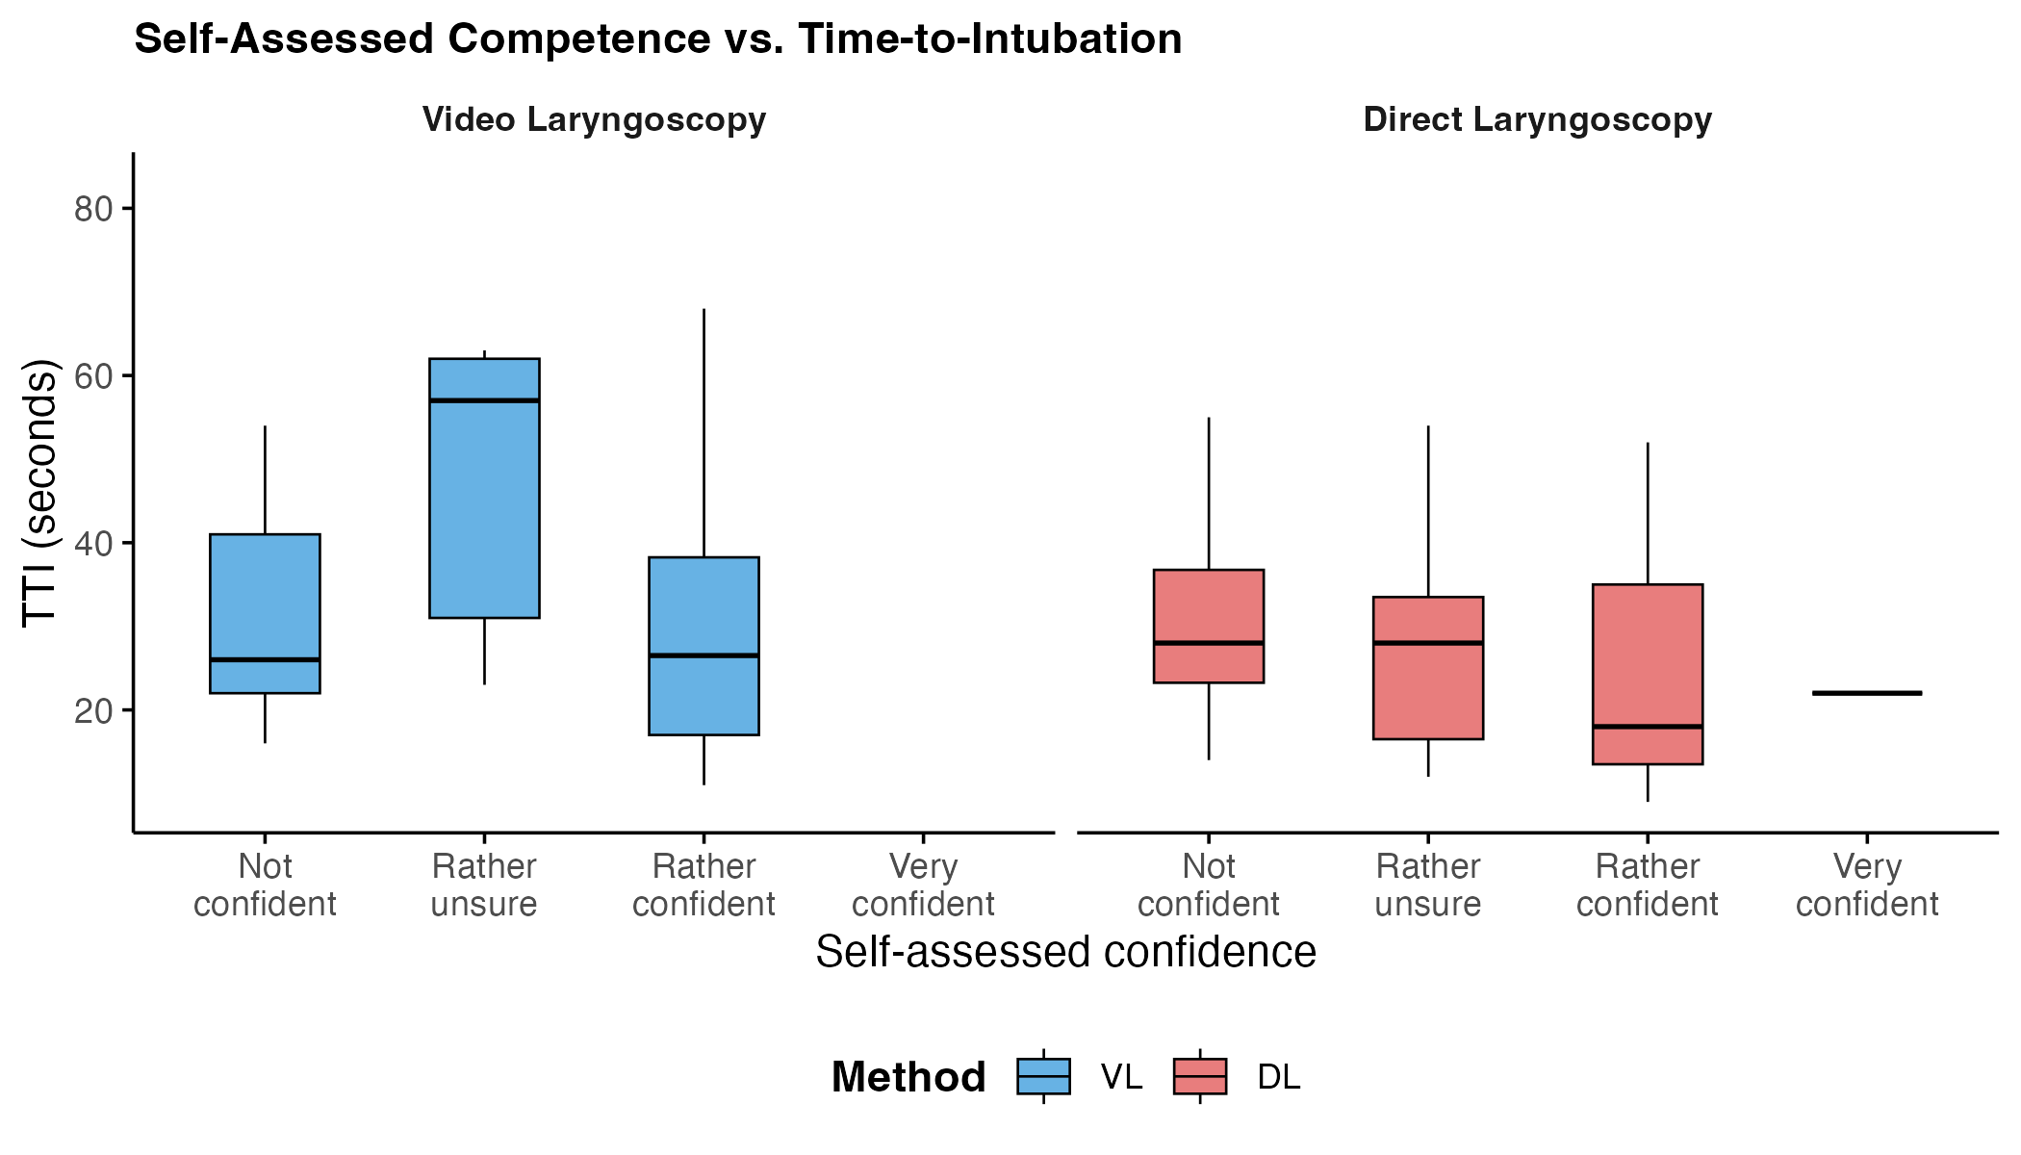
Time to intubation by self-assessed confidence level and intubation method. Boxes show median and interquartile range. Self-assessed confidence was rated on a four-point scale prior to intubation simulation. Only successful intubations are shown.

Figure S10: Time to successful intubation by Group after covariate adjustment

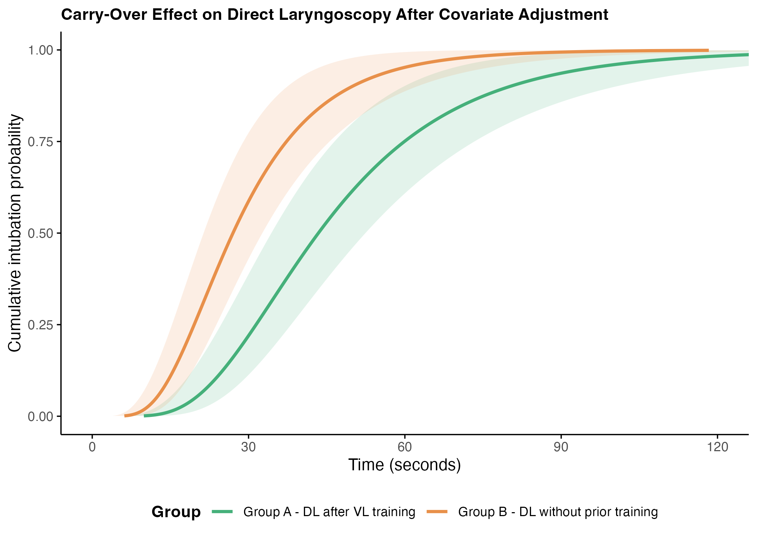
Cumulative probability of successful direct laryngoscopy over time by group, adjusted for covariates. The green curve represents Group A (DL after prior VL training, T2) and the orange curve represents Group B (DL without prior VL training, T1). Curves are model-predicted for a participant with mean values of the continuous covariates (Cormack-Lehane grade, number of prior simulator intubations, pre-training self-assessed DL competence, age) and the most frequent category for prior airway course attendance.Failed intubations were censored at 120 seconds. Shaded areas represent 95% confidence intervals. Estimates are derived from an accelerated failure time model with a lognormal distribution.

Figure S11: Time to successful intubation by method after covariate adjustment

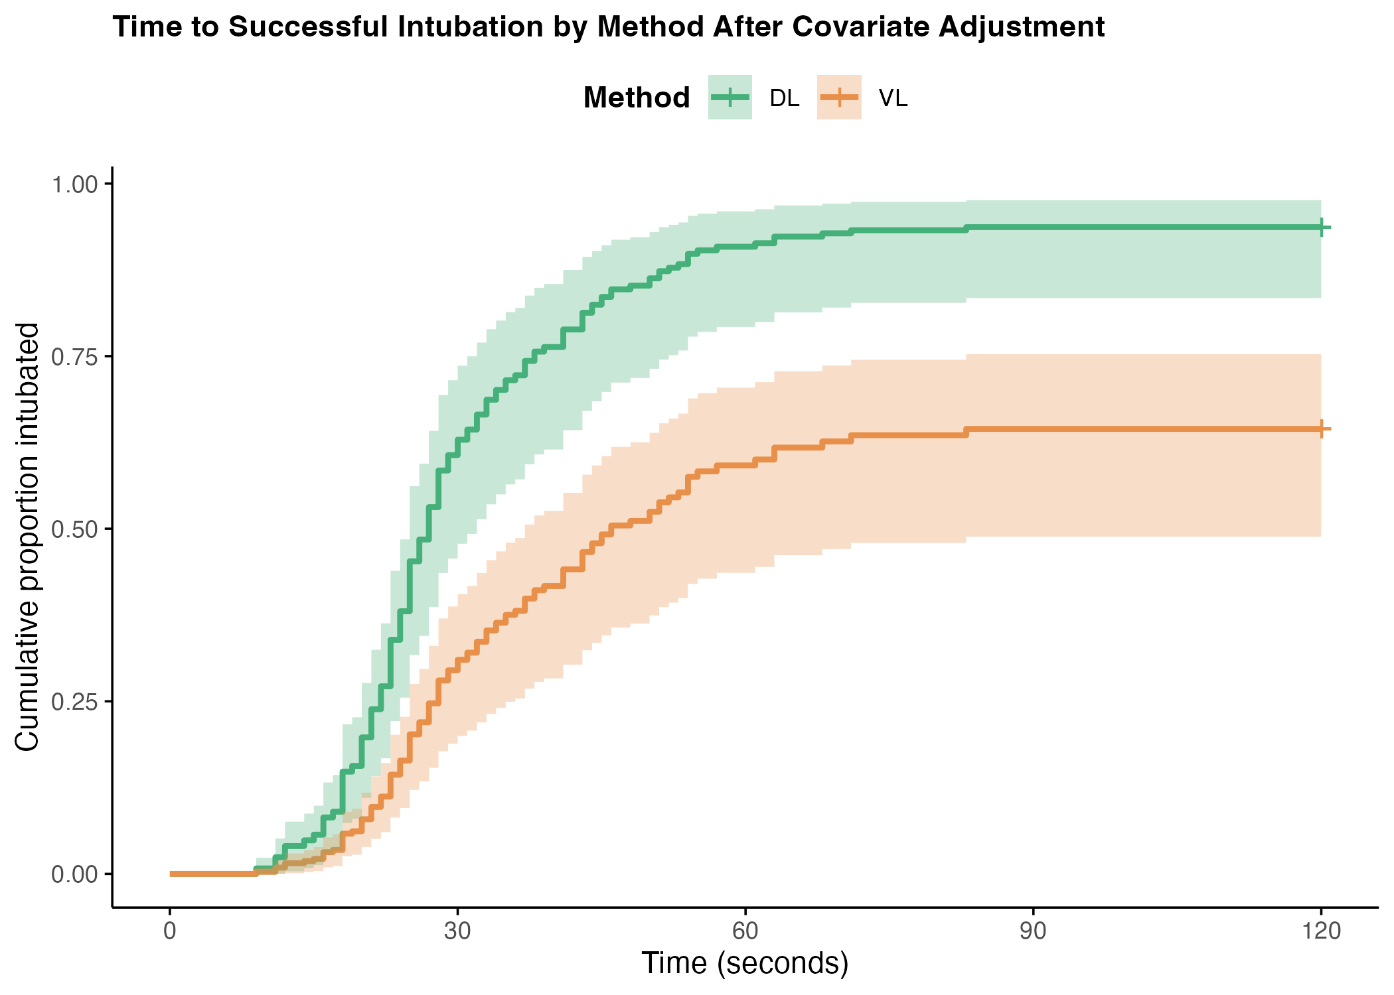
Cumulative proportion of successful intubations over time by method, adjusted for covariates. The green curve represents direct laryngoscopy (DL) and the orange curve represents video laryngoscopy (VL). Curves show model-predicted intubation rates for a participant with mean values of all covariates at first attempt. Failed intubations were censored at 120 seconds. Shaded areas represent 95% confidence intervals.
Estimates are derived from a Cox proportional hazards model adjusting for training phase (first attempt vs. follow-up), glottic view quality (Cormack-Lehane grade 1-4), number of prior simulator intubations and pre-training self-assessed competence in endotracheal intubation (4-point Likert scale), age, and prior airway course attendance.

Study Workflow

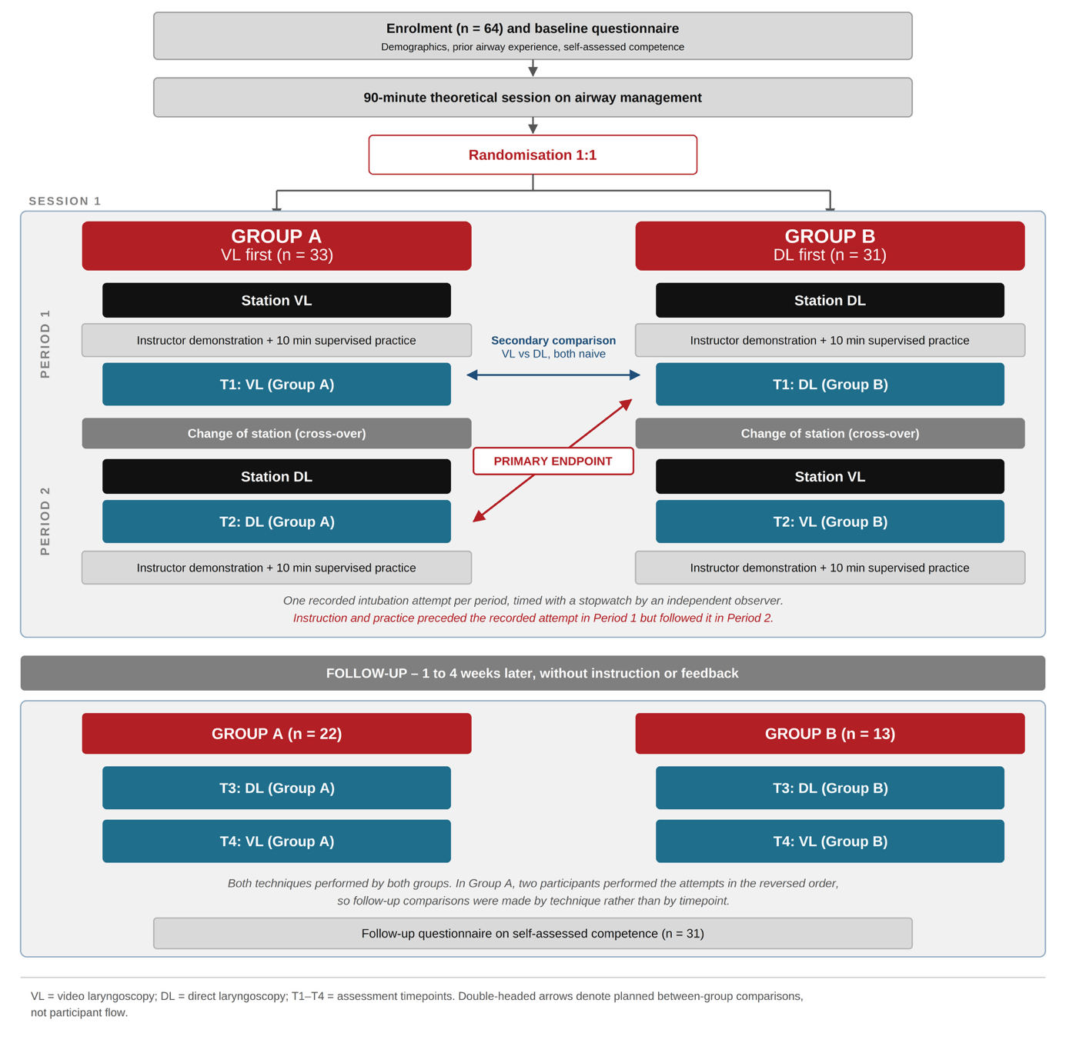
Study workflow. Sixty-four fifth-semester medical students completed a baseline questionnaire and a 90-minute theoretical session on airway management before being randomised 1:1 to one of two training sequences. In Session 1, Group A (n = 33) started at the video laryngoscopy (VL) station and Group B (n = 31) at the direct laryngoscopy (DL) station. In the first period, participants received an instructor demonstration and 10 minutes of supervised practice with the allocated technique before performing one recorded intubation attempt (T1). After crossing over to the alternative station, participants received an instructor demonstration of the second technique and then performed the recorded attempt of the second period (T2) without any hands-on practice or feedback; the corresponding 10 minutes of supervised practice with feedback followed the recorded attempt. A demonstration therefore preceded the recorded attempt in both periods, whereas the supervised practice preceded it in Period 1 and followed it in Period 2. The primary endpoint compared time to intubation at the first DL attempt of each sequence, that is T2 in Group A with T1 in Group B (red). This comparison is confounded both with study period and with the amount of technique-specific hands-on practice preceding the attempt. The secondary comparison of VL and DL under naive conditions (blue) contrasts T1 in Group A with T1 in Group B and is free of both confounders. Follow-up took place 1 to 4 weeks later without instruction or feedback, with 22 participants from Group A and 13 from Group B performing both techniques (T3, T4); 31 participants completed the follow-up questionnaire. Double-headed arrows denote planned between-group comparisons and not participant flow. VL, video laryngoscopy; DL, direct laryngoscopy.

Experimental Setup

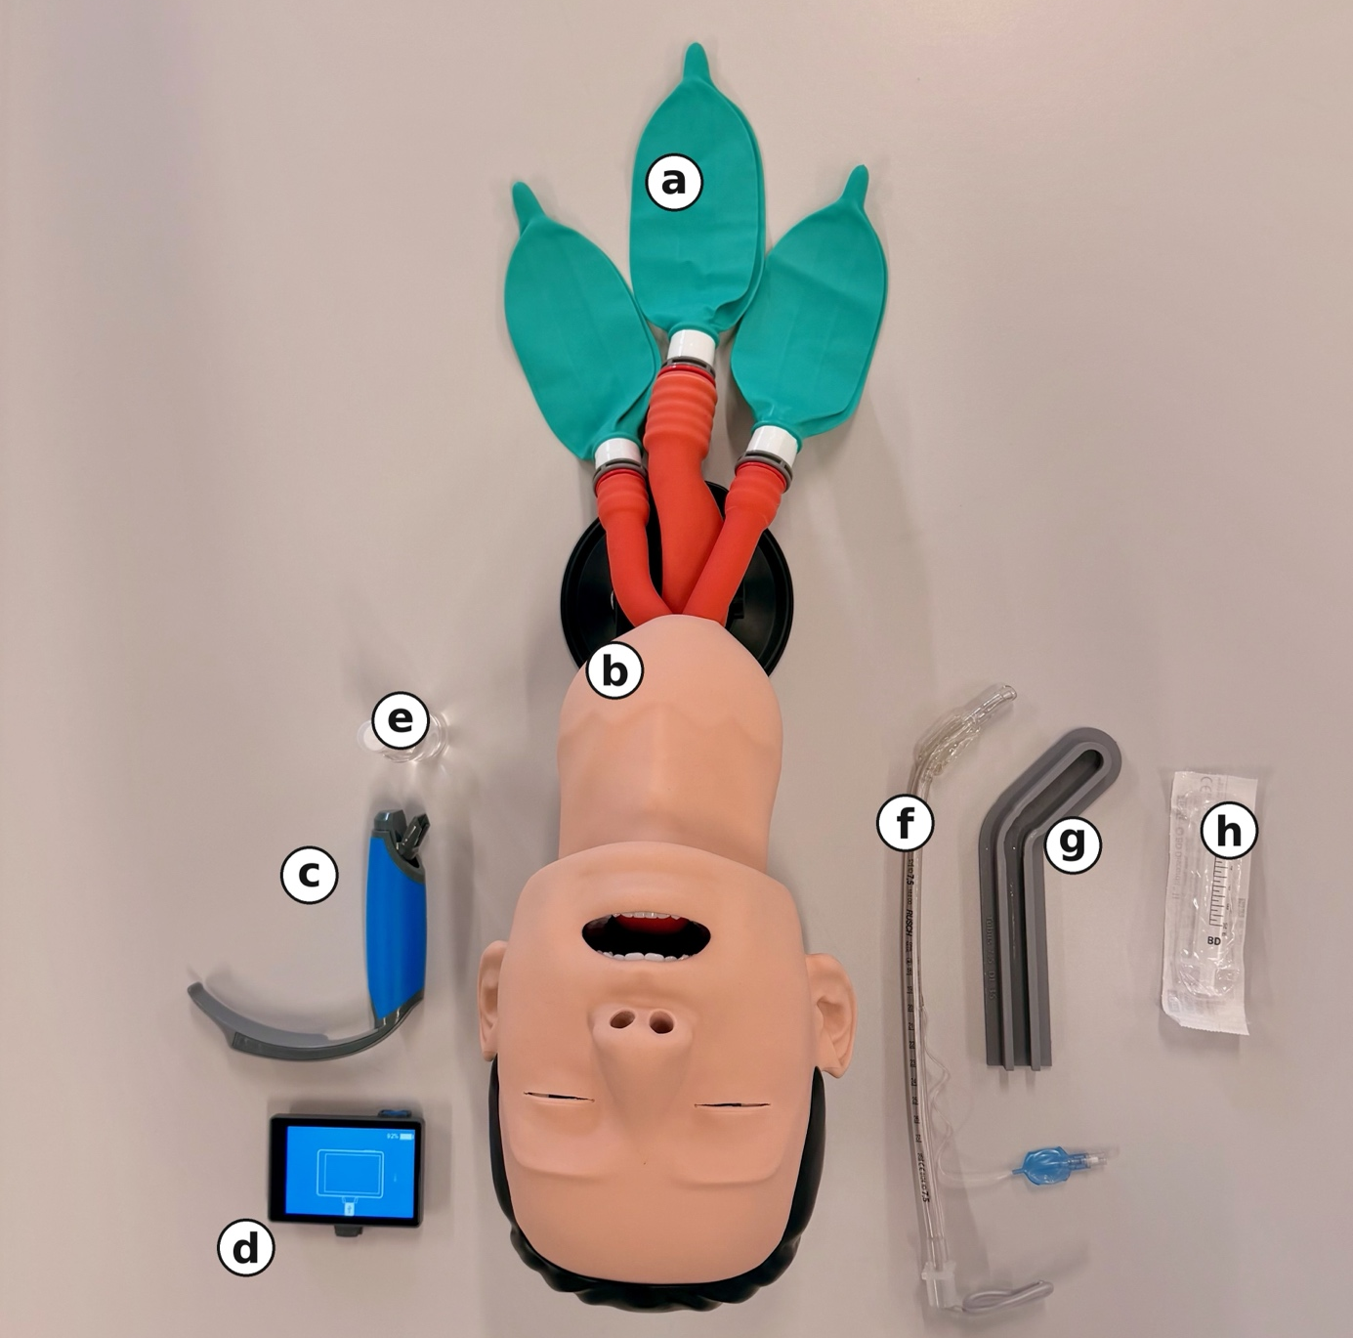

Experimental setup. Photograph of the standardised setup at the video laryngoscopy station, taken from the operator's position at the head of the manikin. (a) Reservoir bags of the airway management trainer representing both lungs and the stomach. Oesophageal intubation was identified by inflation of the gastric bag. (b) Head and upper airway of the airway management trainer P73 (3B Scientific, Hamburg, Germany) used in the neutral position throughout. (c) Video laryngoscope (ProVu, Flexicare Medical, Mountain Ash, United Kingdom) with a reusable handle and a single-use size 3 Macintosh-style blade. (d) Detachable monitor of the video laryngoscope, shown here separated from the handle; during all attempts it was attached to the handle and positioned identically. (e) Lubricant. (f) Cuffed endotracheal tube with an internal diameter of 7.5 mm (RÜSCH, Kernen, Germany) with the pilot balloon and the malleable stylet in situ. (g) Reusable templates used to shape every tube and stylet to an identical, predefined curvature before each attempt. (h) 10 mL syringe (BD Discardit II, Becton Dickinson, Franklin Lakes, NJ, USA) for cuff inflation. The direct laryngoscope with a size 3 Macintosh blade (KaWe, Asperg, Germany) used at the direct laryngoscopy station is not shown.

Participant Self-Assessment Questionnaire
The original questionnaire was administered in German; an English translation is provided here for reference.
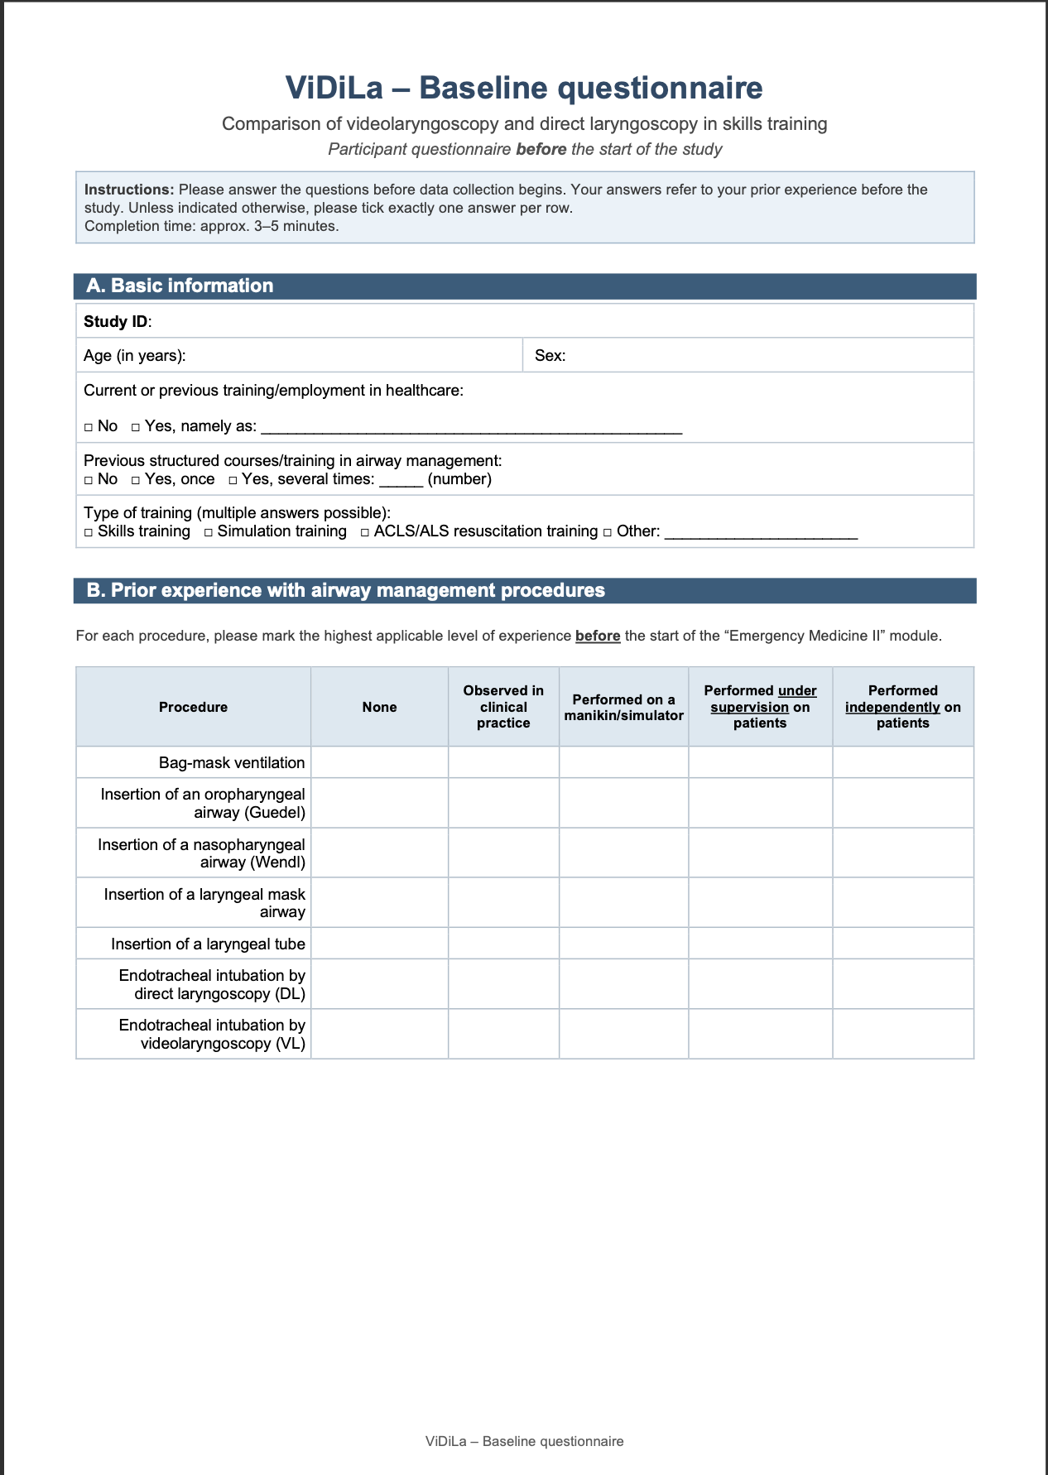
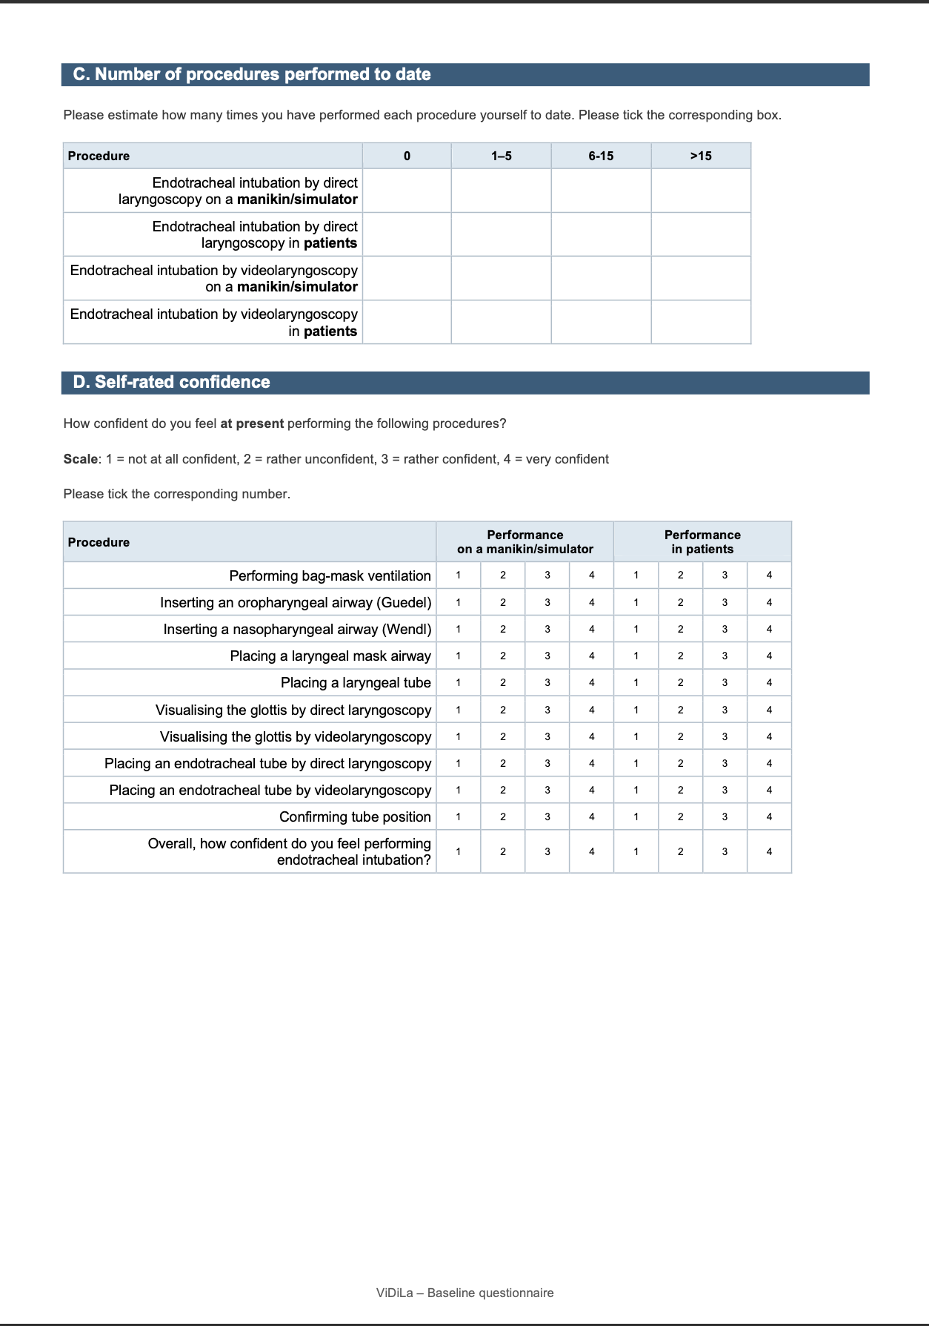

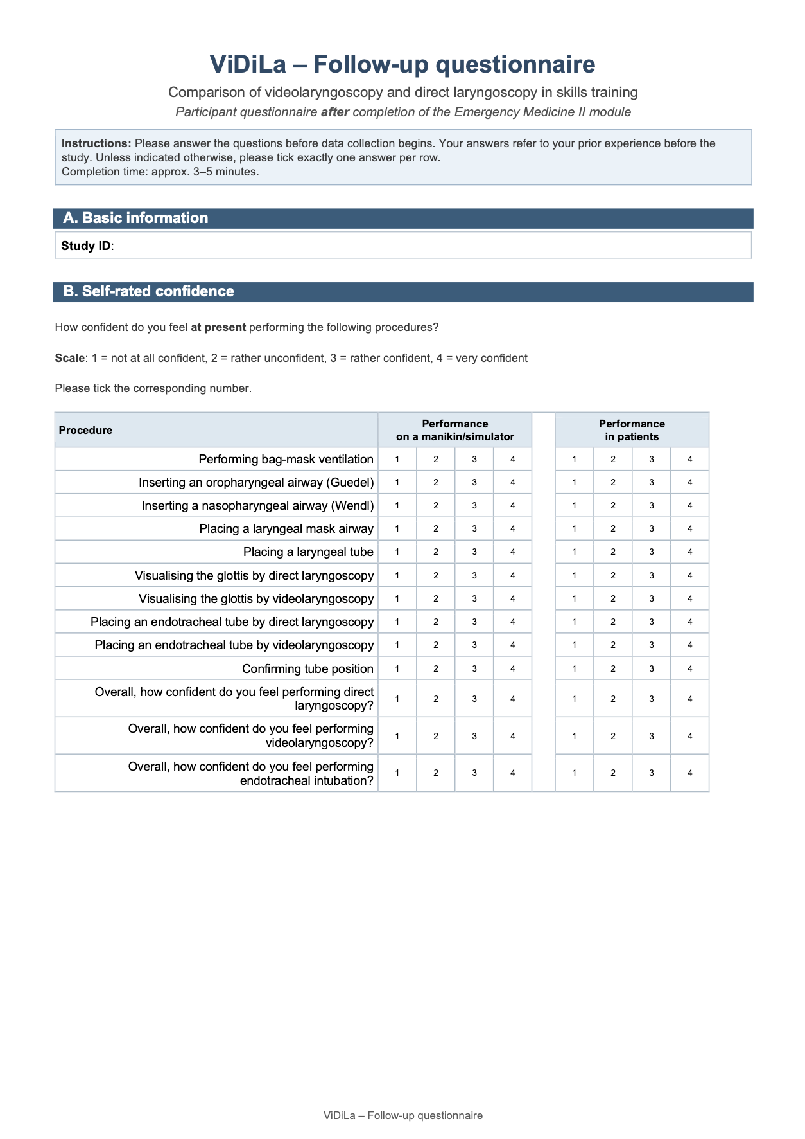

References

1. Wickham H, Averick M, Bryan J, Chang W, McGowan L, François R, et al. Welcome to the Tidyverse. JOSS. 2019 Nov 21;4(43):1686. doi:10.21105/joss.01686
2. Wickham H, Chang W, Henry L, Pedersen TL, Takahashi K, Wilke C, et al. ggplot2: Create Elegant Data Visualisations Using the Grammar of Graphics [Internet]. 2007 [cited 2025 Aug 13]. p. 3.5.2. Available from: https://CRAN.R-project.org/package=ggplot2 doi:10.32614/CRAN.package.ggplot2
3. Sjoberg D D, Whiting K, Curry M, Lavery J A, Larmarange J. Reproducible Summary Tables with the gtsummary Package. The R Journal. 2021;13(1):570. doi:10.32614/RJ-2021-053
4. Randy Boyes. Forester: An R package for creating publication-ready forest plots. [Internet]. 2021. Available from: https://github.com/rdboyes/forester
5. Bates D, Mächler M, Bolker B, Walker S. Fitting Linear Mixed-Effects Models Using lme4. J Stat Soft. 2015;67(1). doi:10.18637/jss.v067.i01
6. Kuznetsova A, Brockhoff PB, Christensen RHB. lmerTest Package: Tests in Linear Mixed Effects Models. J Stat Soft. 2017;82(13). doi:10.18637/jss.v082.i13
7. Therneau TM. coxme: Mixed Effects Cox Models [Internet]. 2009 [cited 2026 Jul 13]. p. 2.2-22. Available from: https://CRAN.R-project.org/package=coxme doi:10.32614/CRAN.package.coxme
8. Therneau TM. survival: Survival Analysis [Internet]. 2001 [cited 2025 Sep 17]. p. 3.8-3. Available from: https://CRAN.R-project.org/package=survival doi:10.32614/CRAN.package.survival
9. Kassambara A, Kosinski M, Biecek P. survminer: Drawing Survival Curves using ‘ggplot2’ [Internet]. 2016 [cited 2026 Jul 13]. p. 0.5.2. Available from: https://CRAN.R-project.org/package=survminer doi:10.32614/CRAN.package.survminer

