Supplementary information
Table S1: Simple linear regressions between Forest specialist Species richness and forest cover (%) by decade and buffer size
Response Variable | Predictor | Intercept | Slope | R² | p value
Forest specialist Species richness | Forest cover 1970s 100m | 1.144 | 0.017 | 0.109 | 0.017
Forest specialist Species richness | Forest cover 1980s 100m | 0.89 | 0.02 | 0.11 | 0.016
Forest specialist Species richness | Forest cover 1990s 100m | 0.864 | 0.02 | 0.109 | 0.017
Forest specialist Species richness | Forest cover 2000s 100m | 0.883 | 0.02 | 0.129 | 0.009
Forest specialist Species richness | Forest cover 2010s 100m | 0.795 | 0.021 | 0.124 | 0.01
Forest specialist Species richness | Forest cover 2020s 100m | 0.863 | 0.02 | 0.125 | 0.01
Forest specialist Species richness | Forest cover 1970s 250m | 1.932 | 0.01 | 0.053 | 0.102
Forest specialist Species richness | Forest cover 1980s 250m | 1.982 | 0.009 | 0.039 | 0.158
Forest specialist Species richness | Forest cover 1990s 250m | 1.985 | 0.009 | 0.039 | 0.163
Forest specialist Species richness | Forest cover 2000s 250m | 2.015 | 0.008 | 0.037 | 0.174
Forest specialist Species richness | Forest cover 2010s 250m | 1.972 | 0.009 | 0.04 | 0.155
Forest specialist Species richness | Forest cover 2020s 250m | 1.962 | 0.009 | 0.042 | 0.144
Forest specialist Species richness | Forest cover 1970s 500m | 2.345 | 0.004 | 0.01 | 0.48
Forest specialist Species richness | Forest cover 1980s 500m | 2.447 | 0.002 | 0.003 | 0.689
Forest specialist Species richness | Forest cover 1990s 500m | 2.436 | 0.003 | 0.004 | 0.666
Forest specialist Species richness | Forest cover 2000s 500m | 2.468 | 0.002 | 0.002 | 0.736
Forest specialist Species richness | Forest cover 2010s 500m | 2.438 | 0.002 | 0.004 | 0.672
Forest specialist Species richness | Forest cover 2020s 500m | 2.425 | 0.003 | 0.004 | 0.645
Forest specialist Species richness | Forest cover 1970s 1km | 2.71 | -0.003 | 0.004 | 0.655
Forest specialist Species richness | Forest cover 1980s 1km | 2.798 | -0.005 | 0.013 | 0.414
Forest specialist Species richness | Forest cover 1990s 1km | 2.796 | -0.005 | 0.013 | 0.419
Forest specialist Species richness | Forest cover 2000s 1km | 2.807 | -0.005 | 0.015 | 0.391
Forest specialist Species richness | Forest cover 2010s 1km | 2.797 | -0.005 | 0.013 | 0.42
Forest specialist Species richness | Forest cover 2020s 1km | 2.783 | -0.004 | 0.011 | 0.453

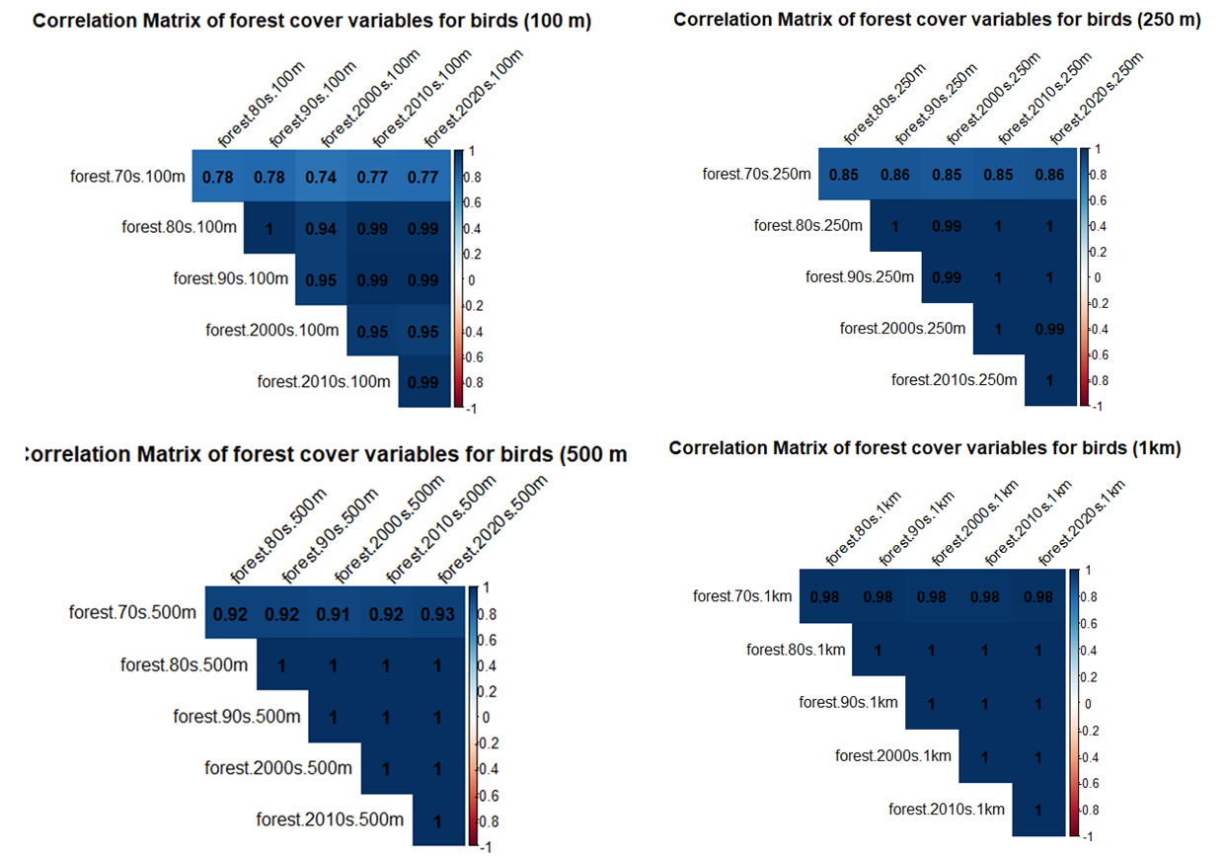
Figure S2: Correlation matrices of forest cover variables

