Extended Data Table 1. Factors and events that determine the state of the ITS (according to [27])
Factor/event | Characteristics
1. Internal failures and malfunctions of the ITS | Ageing, wear, and other internal processes that lead to failure or malfunction of ITS components
2. Human and automated factors
2.1. Correct operator actions | Positive human influence resulting from actions or inaction that contribute to the prevention, detection, and elimination of failures of ITS components
2.2. Automation of operator actions | Increased reliability and reduced likelihood of operator errors through automation of operator functions, including the use of artificial intelligence technologies
2.3. Operator errors | Negative human influence resulting from actions or inaction that lead to failure of ITS components
2.4. Erroneous actions of an automated system | Failure or occurrence of an emergency situation resulting from erroneous actions of an automated system while performing operator functions, when such actions fail to prevent or eliminate the emergency situation or cause it directly
3. External natural events | Damage associated with hazardous geophysical, geological, meteorological, or hydrological phenomena; degradation of soils or subsoil; fires in natural ecosystems; changes in the state of the air basin; infectious morbidity and poisoning of people; infectious diseases of domestic animals; mass mortality of wild animals; damage to agricultural crops caused by diseases and pests; and other natural hazards
4. External anthropogenic events
4.1. Technogenic events | Damage caused by transport accidents (catastrophes), fires, explosions, accidents involving the release or threat of release of hazardous chemical, radioactive, or biological substances, sudden structural failures, accidents in power systems, life-support systems, and telecommunications systems, accidents at treatment facilities and in oil and gas industry systems, hydrodynamic accidents, and other technogenic events
4.2. Social events | Damage caused by illegal acts of a terrorist or anti-constitutional nature, as well as acts related to the loss or theft of weapons and hazardous substances, accidents involving people, and other social hazards
4.3. Military events | Damage caused by the use of conventional weapons or weapons of mass destruction, as well as by secondary damaging factors

Extended Data Table 2. Main protection measures aimed at preventing hazardous events, reducing associated risks, and ensuring network resilience
Event | Example
1. Short-term hazard forecasting, based on operational data and carried out for: (a) timely notification of the hazard; and (b) collection of additional data on its characteristics, spatial distribution, and expected intensity | Operational forecasting of hazardous hydrometeorological phenomena uses current data from ground-based meteorological and hydrological stations, remote sensing, and numerical models to detect the development of a hazardous process, assess its spatial distribution, and forecast its intensity over the coming hours. On this basis, a warning is issued when a hazardous phenomenon is expected, while additional operational observations are used to refine its location, trajectory, and intensity. This approach is a component of modern multi-hazard early warning systems, in which the sequence of “observation–analysis–forecast–warning” provides timely information and decision-making support [28]
2. Long-term forecasting and risk assessment. Data obtained through operational monitoring are used for long-term forecasting, risk assessment, determination of acceptable risk levels, assessment of the safety of power-grid facilities, decision-making on their location and operation, and development of measures to prevent and prepare for accidents | Assessment of power-system stability before the heating season, determination of generation-capacity deficits, and assessment of the need for distributed generation, energy storage, and backup equipment. The IEA notes that, following large-scale damage, Ukraine increased its capacity for restoration, distributed generation, and energy-storage systems [29]
3. Resilient design and construction. This stage involves: (a) the use of materials, structures, and technical systems designed to withstand anticipated hazards; (b) redundancy of critical infrastructure elements; and (c), for information systems, the use of measures to prevent unauthorised access and other information-security threats | Construction of protective structures around electrical substations and autotransformers. The state programme of Ukraine provides for the protection of 22 substations in 14 regions against UAV and missile strikes [30]. The IEA also notes the use of reinforced-concrete structures, gabions, sandbags, and anti-drone nets [31]. For the power grid and operational communication network, identification and access-control measures include user authentication, segregation of access rights to IT and OT systems, remote-access control, and protection of information resources against unauthorised actions. NIST demonstrates this approach for electric utilities as a means of increasing the security of electricity generation, transmission, and distribution systems [32]
4. Interception and containment of hazardous effects | Passive and/or active countermeasures against hazardous effects
4.1. Passive countermeasures. Measures include: (a) protecting the facility or its most vulnerable and critical elements from the hazard; and (b) shielding the facility from the hazard or containing its effects within a defined area | Physical shielding of transformers, substations, and other critical equipment using reinforced-concrete structures, gabions, sand, and mesh [31]
4.2. Active countermeasures. These involve the use of appropriate technical and organisational means. For the operational communication network, such countermeasures may include information-protection tools, backup communication channels, filtering and blocking of unwanted traffic, and other means of counteracting unauthorised access, malicious activity, and other cyber threats to information systems and information flows | Multi-level protection of energy facilities, combining air and missile defence to intercept airborne threats with physical protection of substations. Such a combination is directly considered an element of multi-level protection of Ukraine’s energy infrastructure [31]. For the operational communication network, active measures include cyber protection, detection and blocking of malicious activity, traffic filtering, and response to cyber incidents. In 2025, CERT-UA processed 5,927 cyber incidents, with the energy and telecommunications sectors among the main targets of attacks [7]
5. Decommissioning of individual systems or elements under hazardous conditions | (a) Replacement or dismantling of systems supporting operability; (b) reconfiguration of networks and rerouting of information flows
5.1. Replacement, duplication, or dismantling of systems supporting operability. It is envisaged to replace, duplicate, or, if necessary, dismantle or temporarily decommission power-supply systems, ventilation and air-conditioning systems, fire-alarm systems, fire-extinguishing systems, notification systems, and other auxiliary systems whose functioning may be disrupted by a hazardous impact or failure of the main equipment | In 2024, the NCU established phased requirements for providing mobile communication base stations with backup power. For critical nodes, operation for up to 72 hours from generators or batteries was planned [6]
5.2. Reconfiguration of networks and rerouting of information flows. This measure involves changing electricity-transmission routes in the power grid, reconfiguring the information-transmission network, rerouting information flows, and redirecting calls in the communication network in order to preserve or restore the functioning of critical services | Reconfiguration of the power grid after damage to an individual line can be achieved by switching sectional and backup lines and forming a new network topology, thereby enabling electricity supply to be restored to the maximum possible number of consumers [10]. The Ministry of Digital Transformation of Ukraine notes that, in the event of signal loss caused by damage to a station, users can switch to another operator’s network through national roaming. The state has also provided for the use of mobile base stations to rapidly restore communications in areas where communication infrastructure has been damaged [33]. The resilience of interdependent networks can also be enhanced through their decentralisation, which reduces dependence on individual critical nodes [34]. |

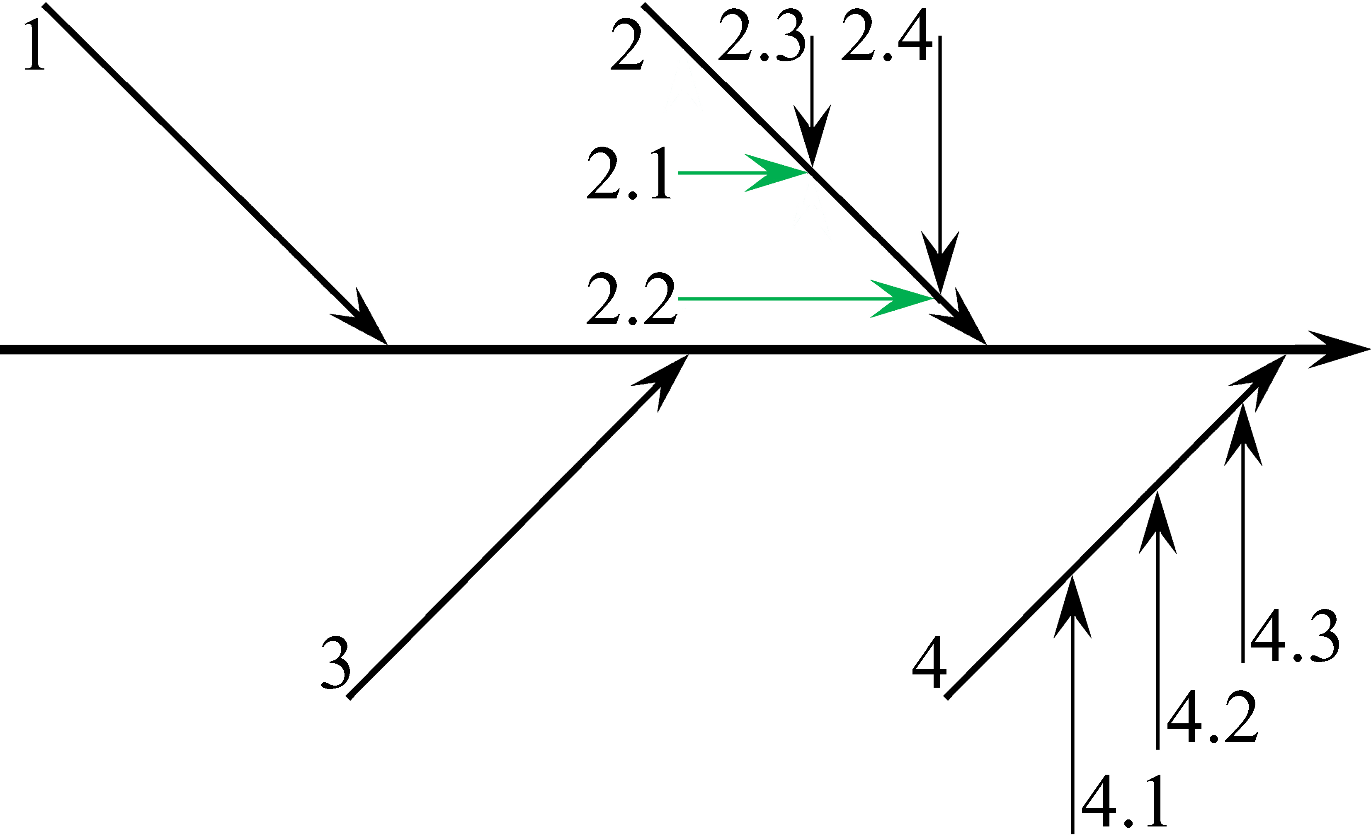
Extended Data Fig. 1. Diagram of factors and events that determine the state of the ITS [27]

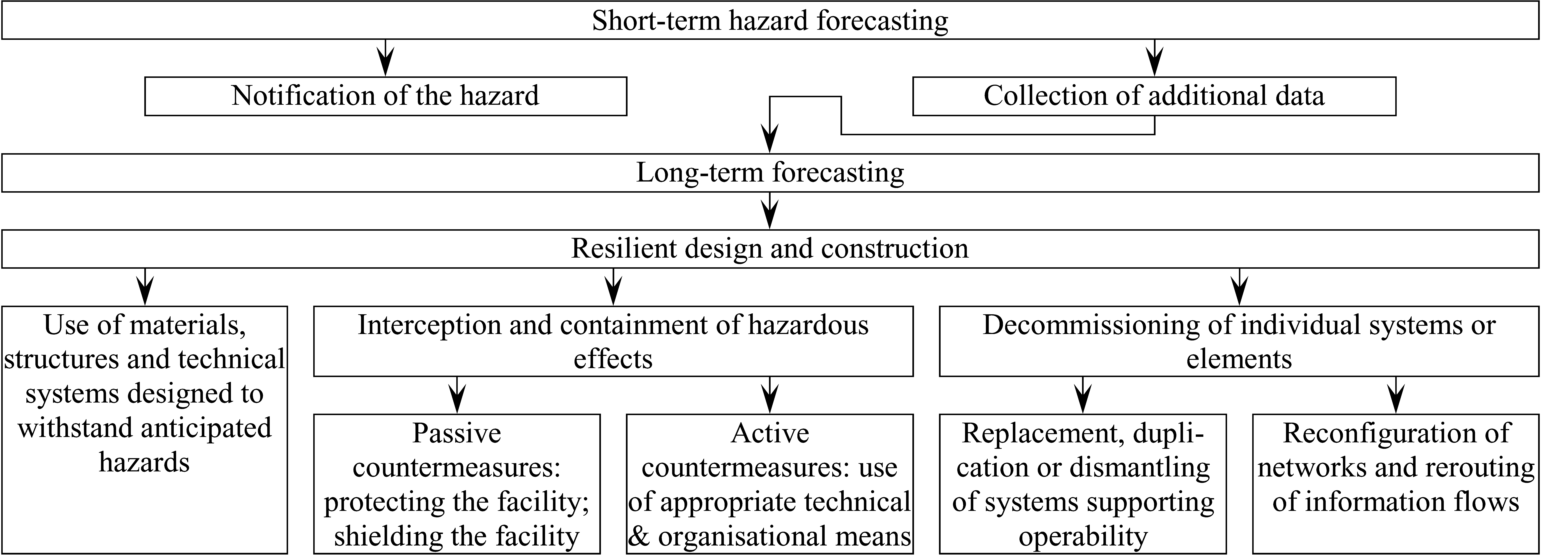
Extended Data Fig. 2. Scheme for applying risk reduction measures and ensuring the resilience of interdependent power and operational communication networks in response to hazardous impacts (modified from [35])

