This Supplementary Information has not been peer reviewed

Supplementary Information for:
Potential for wolf-based conflicts – A transdisciplinary mapping approach for hotspots using socio-economic and ecological factors

Supplementary material S1
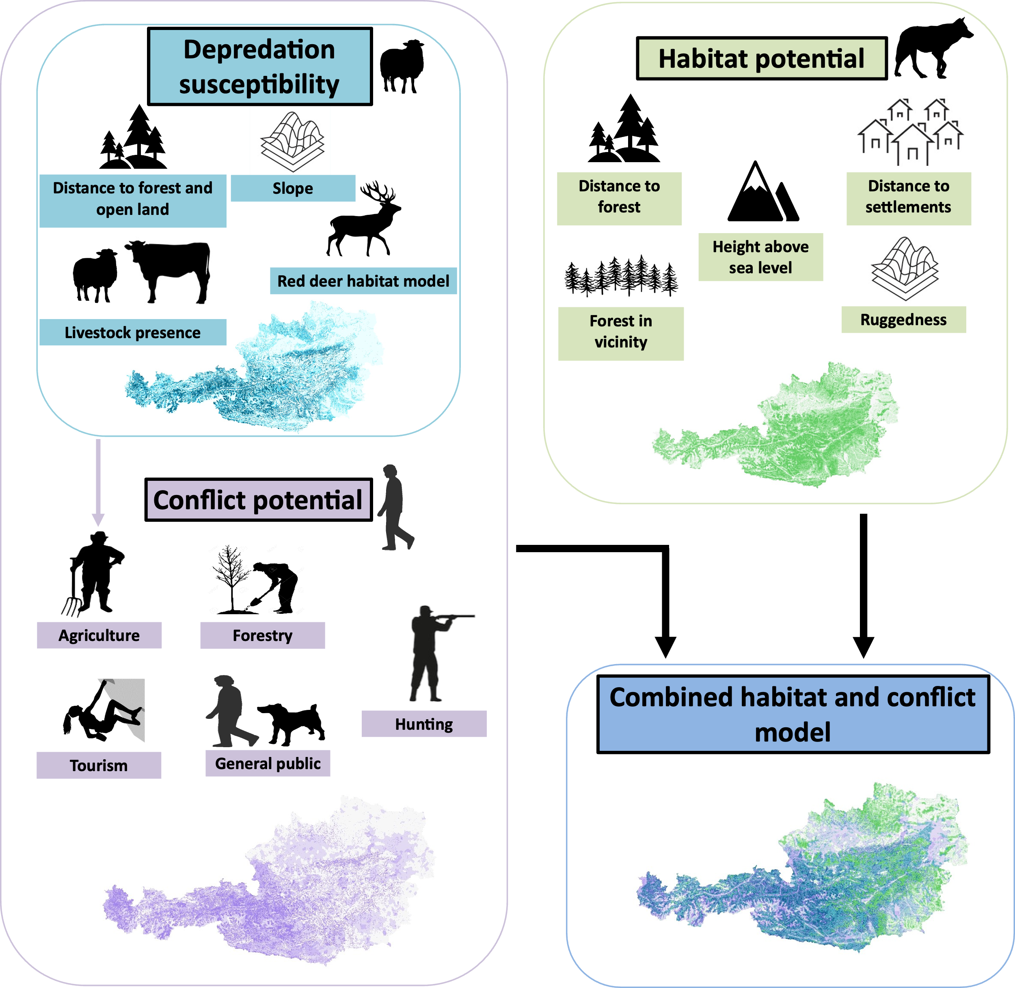
Figure 1: Concept and graphical representation of the models used and produced. The icons represent the variables included for the depredation susceptibility and habitat potential. COPO is calculated by integrating variables for each given stakeholder group. The depredation risk map was also used as a variable in the COPO model. The combined habitat and conflict model is a bivariate representation of its input models.

Supplementary material S2
The supplementary includes a list and short categorization of the institutions which were represented by the delegates (n = 15) which were consulted in the variable weighting process.

Name of institution | National / Federal | Number of people
Bundesministeriums für Land- und Forstwirtschaft, Klima und Umweltschutz, Regionen und Wasserwirtschaft: BMLUK: Abteilung Agrarumwelt (ÖPUL) | National | 1
BMLUK: Bergbauern und Benachteiligte Gebiete, Biologische Landwirtschaft (Abteilung II/3) | National | 1
BMLUK: Abteilung Tierische Produkte (Abteilung II/6) | National | 1
BMLUK: Abteilung Recht 4 | National | 1
Kärnten (Abteilung 10 - Land- und Forstwirtschaft, Ländlicher Raum, Abteilung 1 – Landesamtsdirektion) | Federal | 2
Niederösterreich (NÖ Landesforstdirektion (LF4)) | Federal | 1
Oberösterreich (Direktion für Landesplanung, wirtschaftliche und ländliche Entwicklung - Abteilung Land- und Forstwirtschaft) | Federal | 2
Salzburg (Abt. 4, Lebensgrundlagen und Energie) | Federal | 2
Steiermark (Landesforstdirektion, Agrarrecht) | Federal | 1
Tirol (Gruppe Agrar) | Federal | 2
Vorarlberg (Abteilung Landwirtschaft und ländlicher Raum (Va) | Federal | 1

Supplementary material S3
This supplementary includes the template of the questionnaire used for the variable assessment.
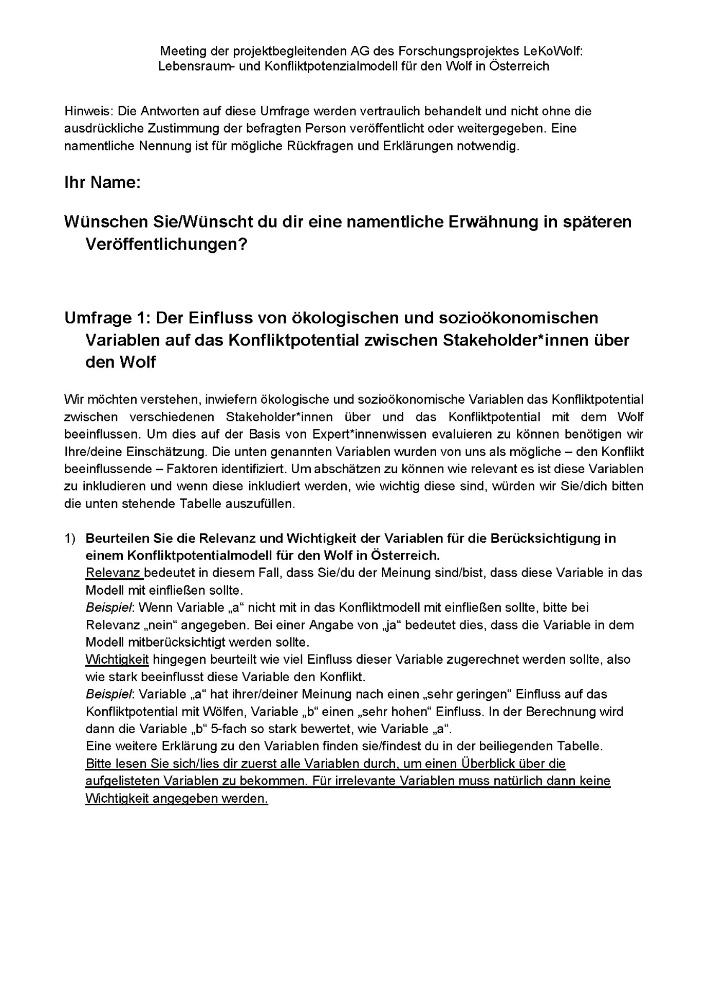
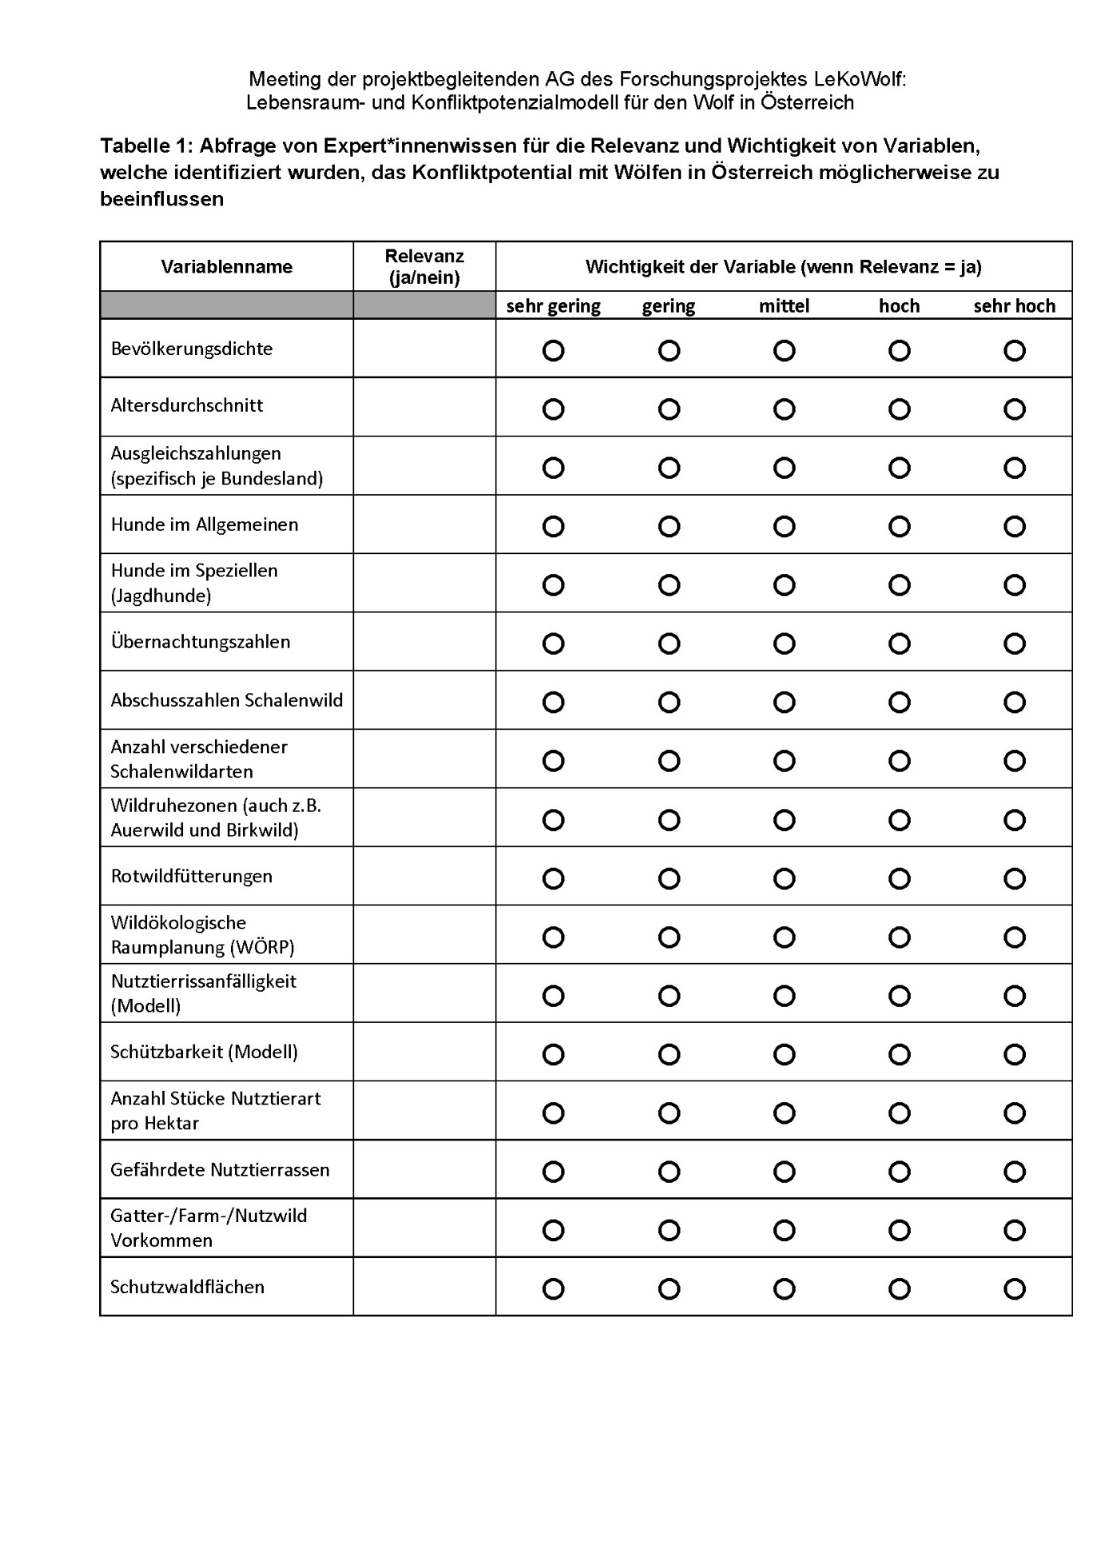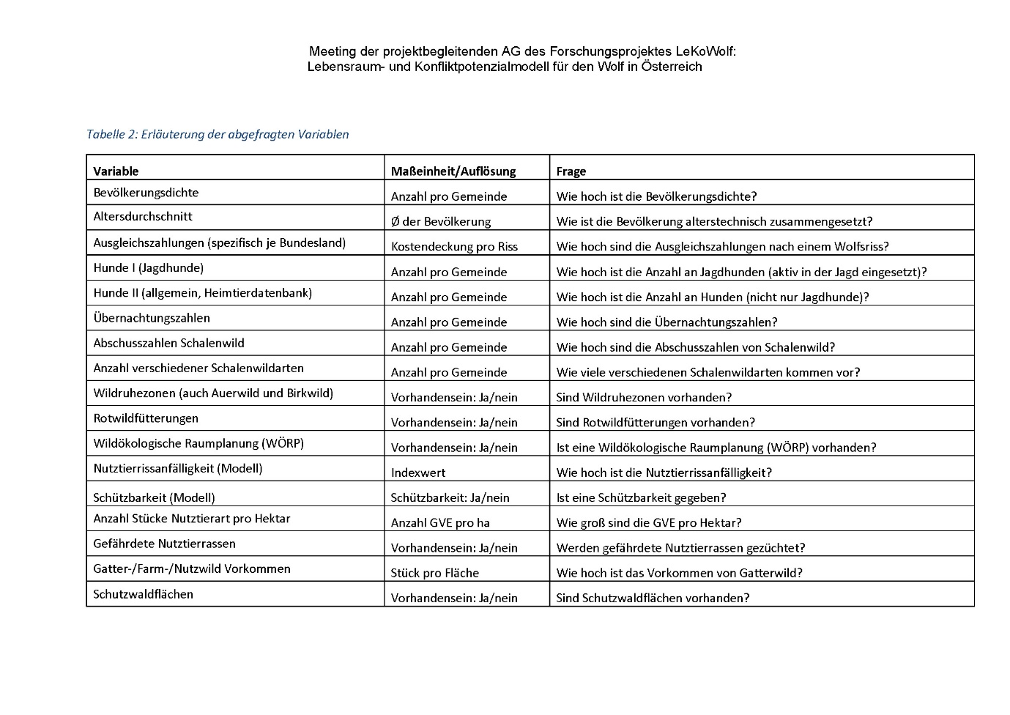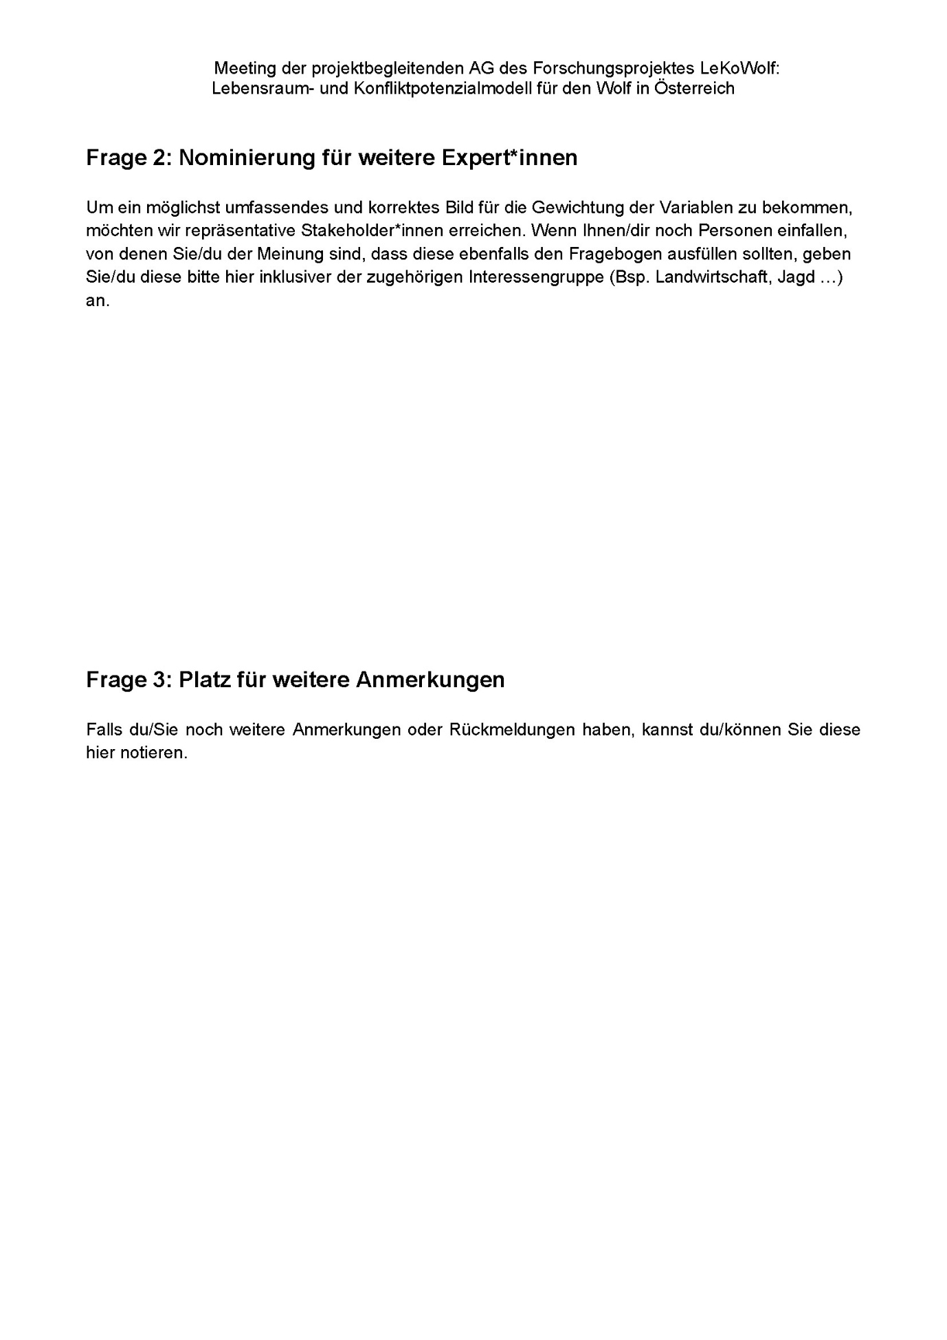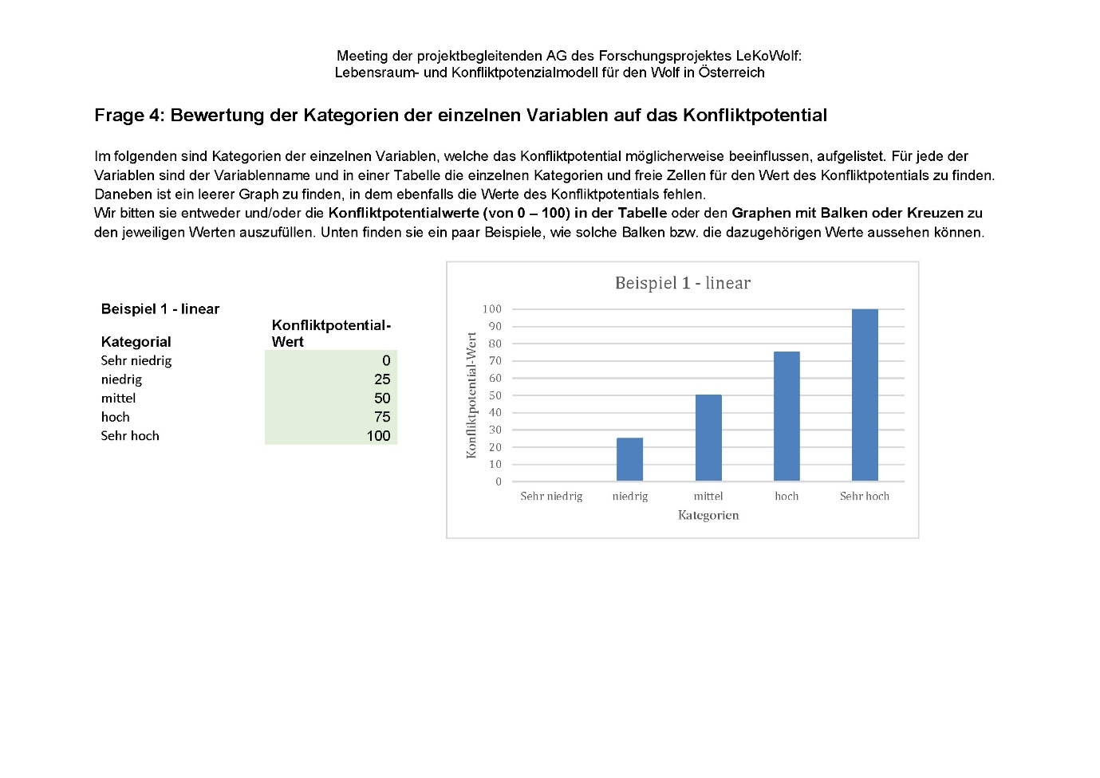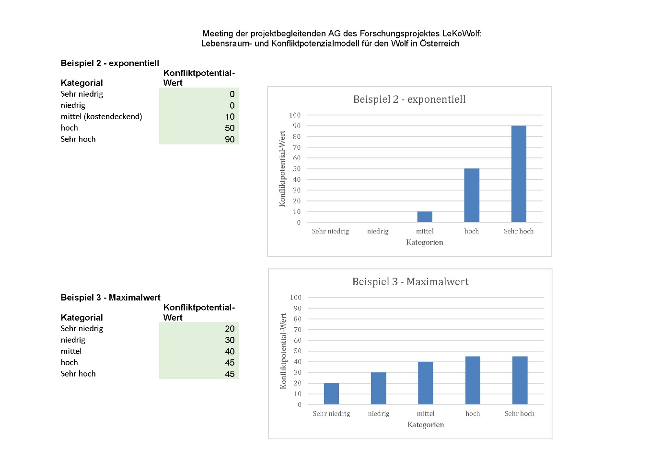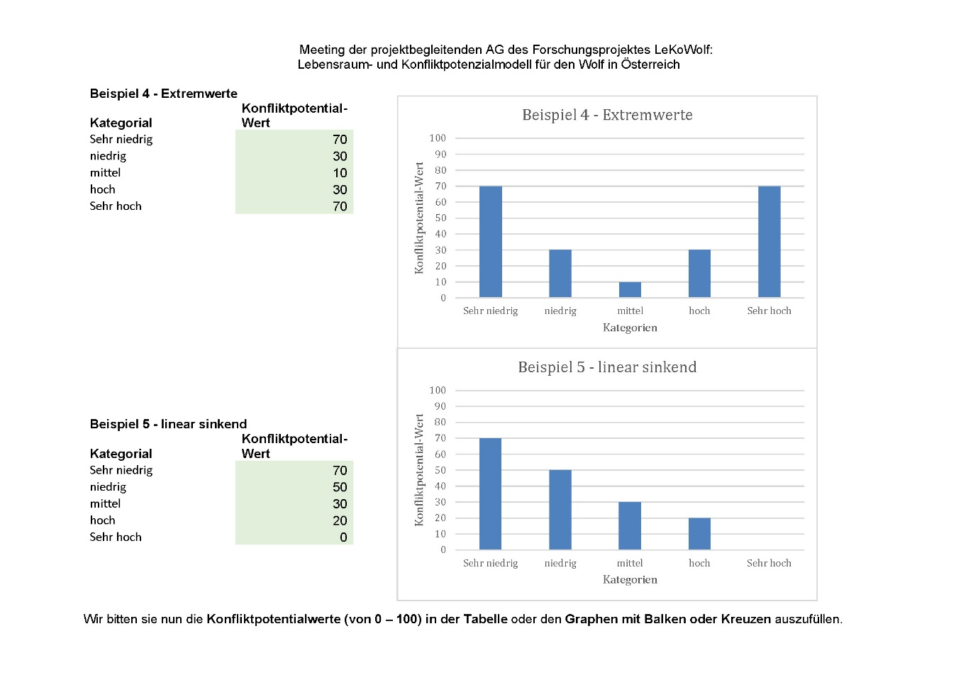
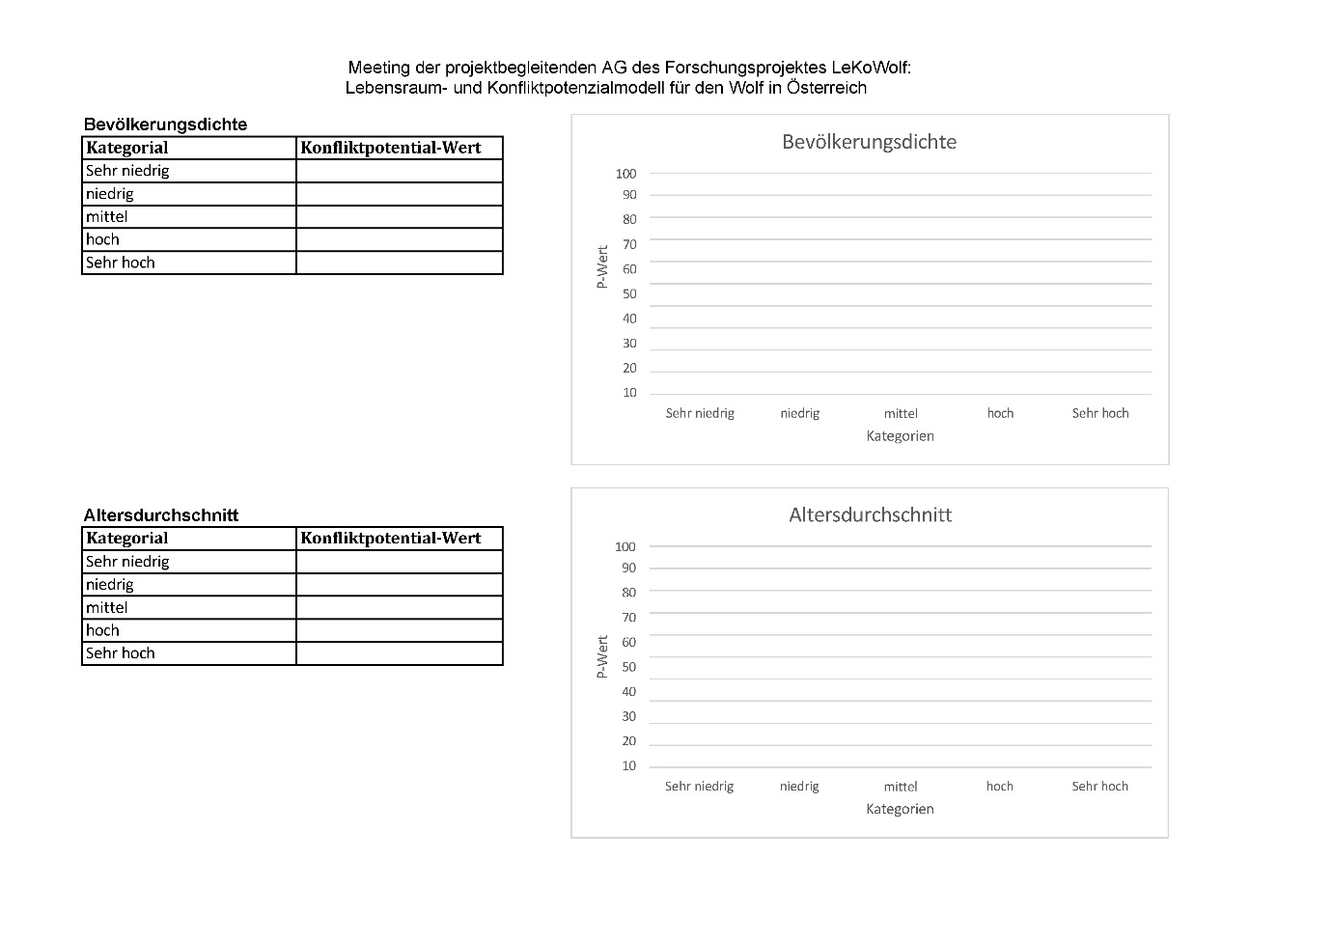
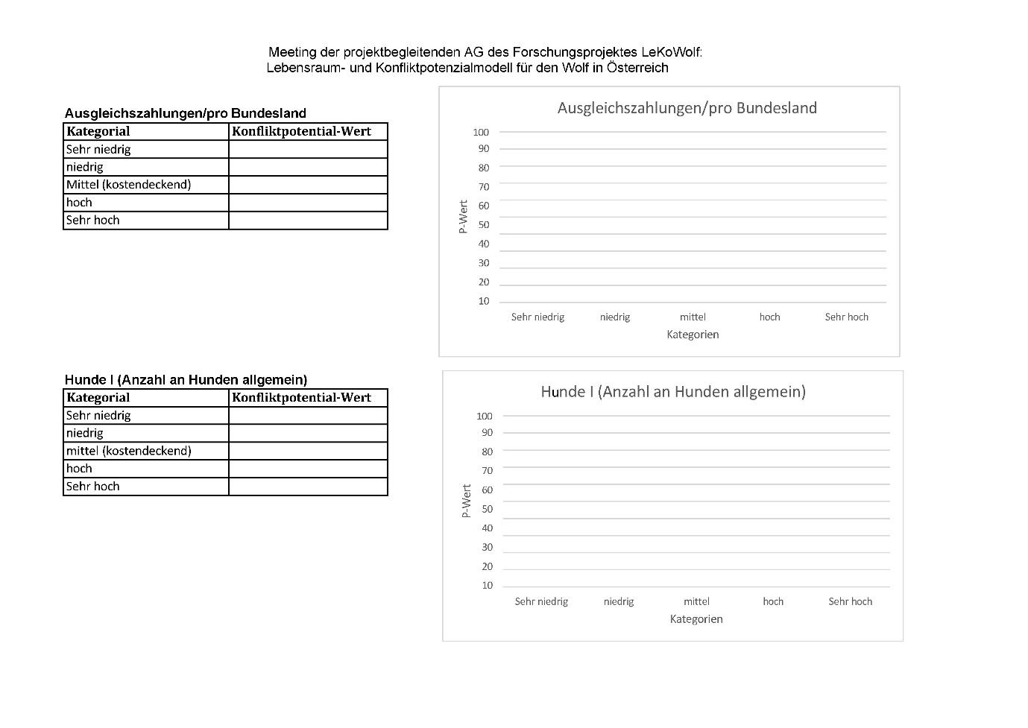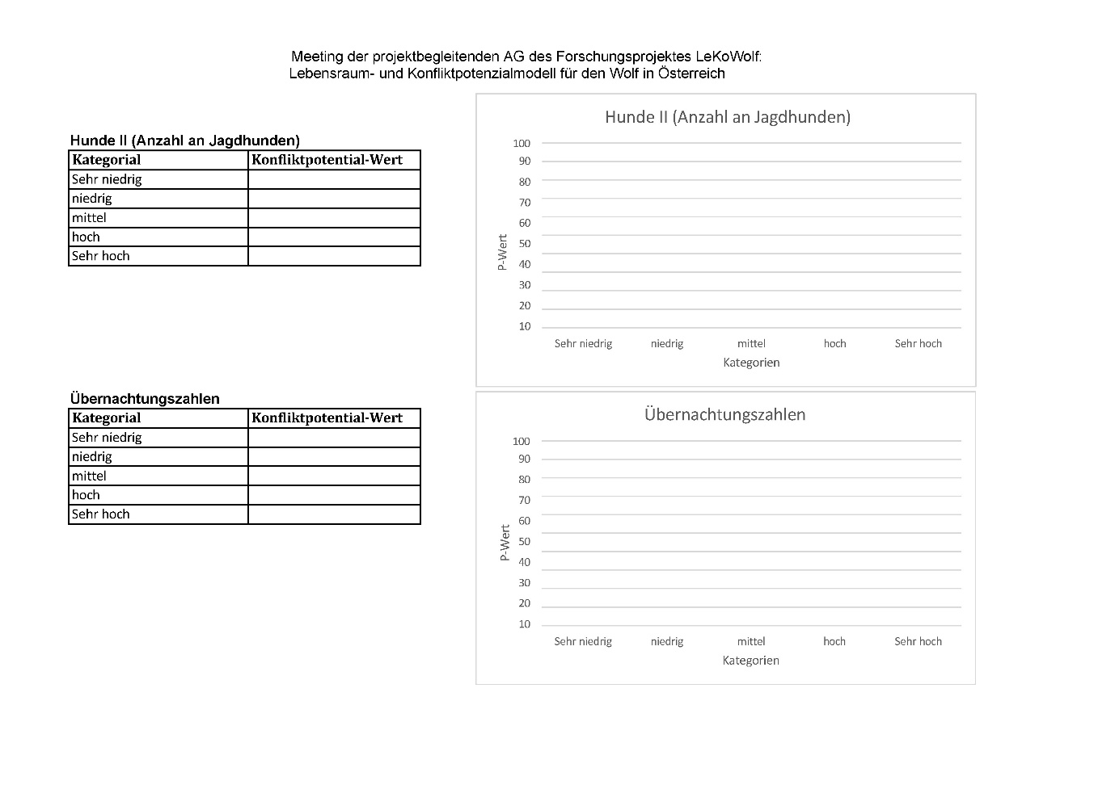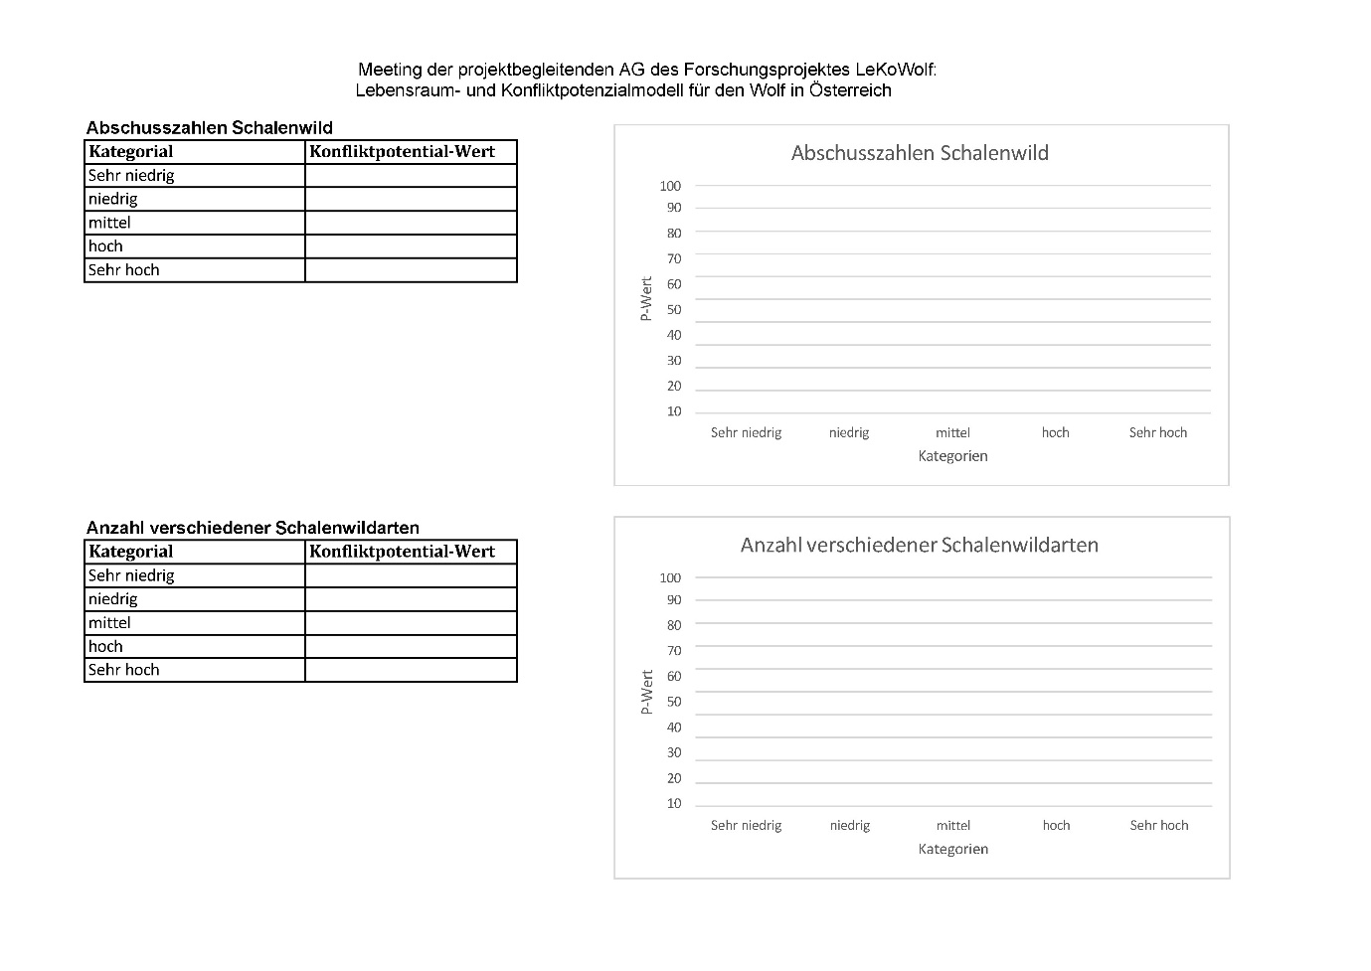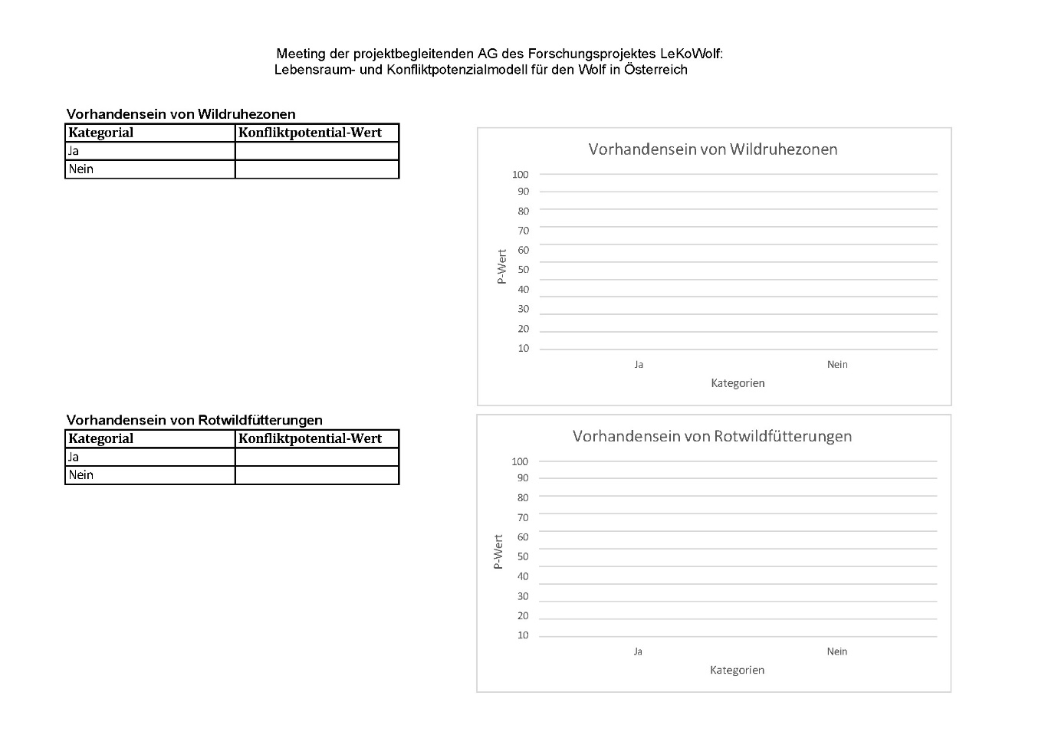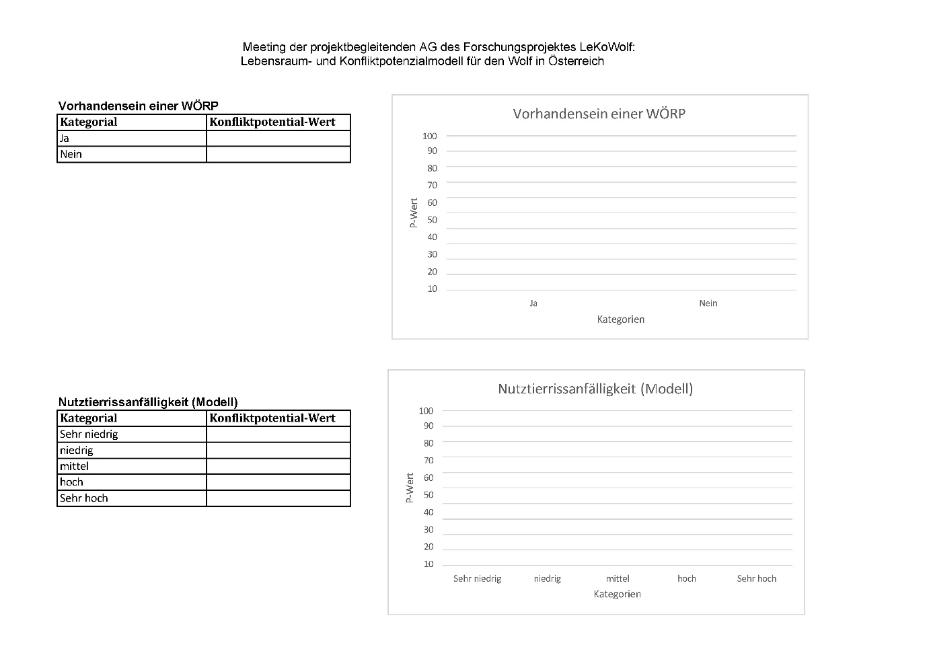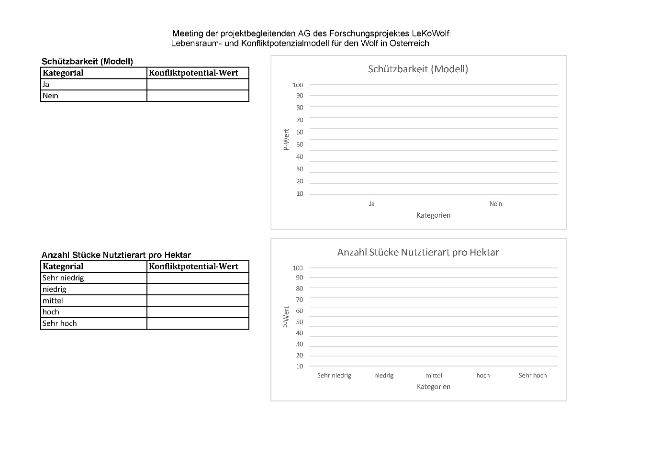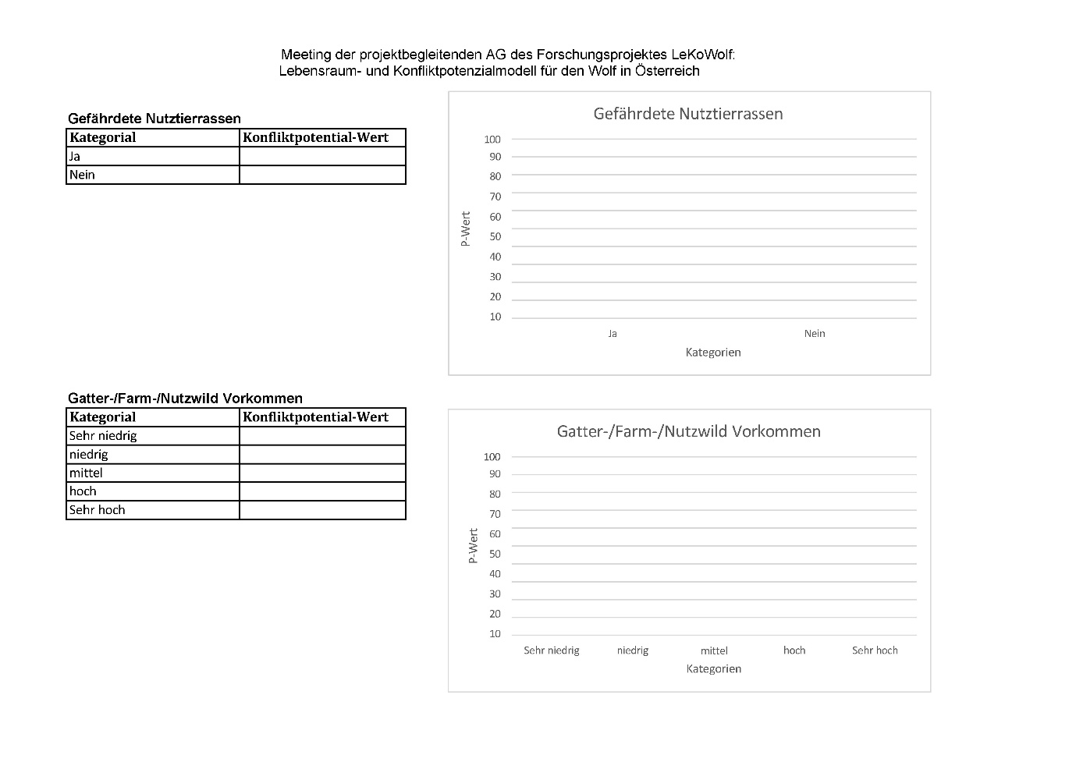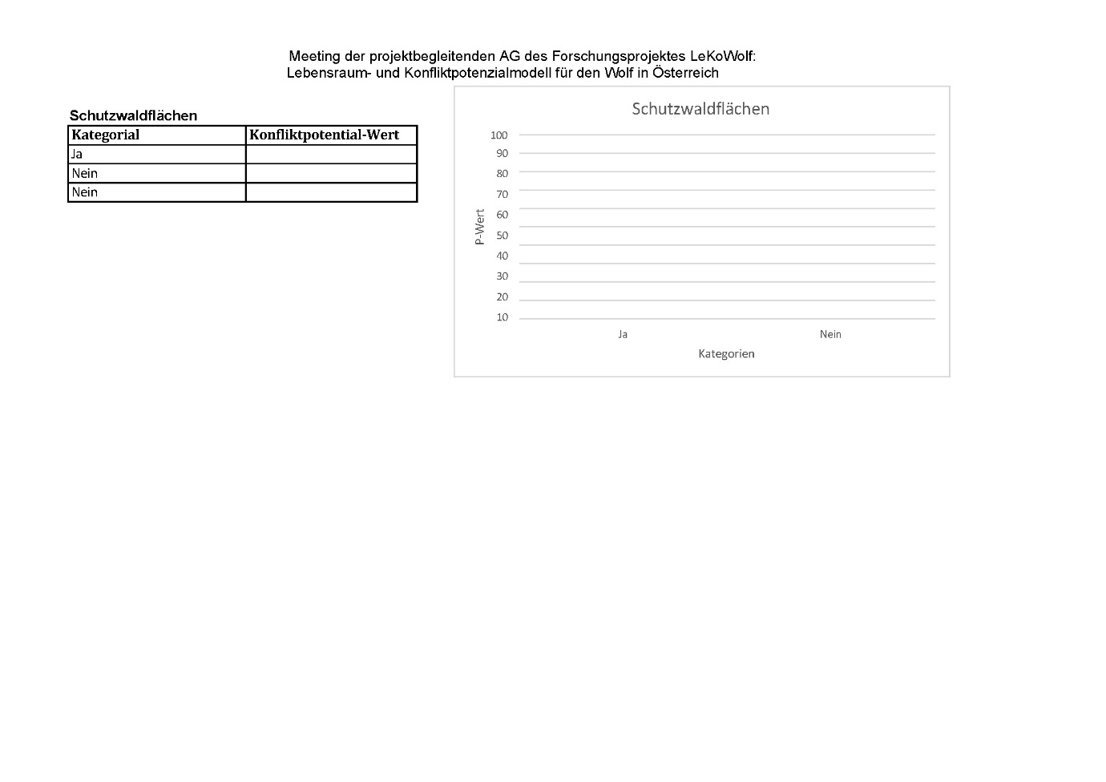

Supplementary material S4

This supplementary includes a detailed description of the reasoning behind the inclusion and the processing of the variables included in the conflict potential model.

Human population density
The human population size was extracted from the Austrian municipality database “Gemeindedatenbank (GeDaBa)” (Bundesanstalt für Agrarwirtschaft und Bergbauernfragen, BAB 2024). The census year used was the most recent available, 2023.

Human demography (age)
Naughton-Treves et al. (2003) describe human demography (sex and age) as relevant for wolf acceptance in the US, Wisconsin. We therefore included the variable “average age” in our set of potential variables. However, during the rating of the relevance for this variable 33% (n=5) of the participants indicated that they consider the variable as non-contributing to the conflict potential with wolves. Therefore, it was excluded from further analyses.

Dogs
The amount of registered dogs were assessed through the Austrian pet database “Heimtierdatenbank” (Federal Ministry of Health and Social Affairs 2025). The dataset included the number of dogs for each municipality and was transformed to density of dogs per square kilometre.

Livestock predation compensation payments
Compensation for predation on livestock is a commonly used strategy to improve coexistence between humans and carnivores (Dickman et al. 2011). In Austria the compensation schemes are always effective for whole federal states. The schemes were downloaded from official sources or requested if they were not publicly available. The schemes for the compensations did however change between the years and during the analysis and therefore the different federal states had unmatching periods of the schemes. To reduce inconsistencies, we therefore excluded the compensation payments from the modelling.

Livestock protectability
The variable protectability was planned to be included through a modelling approach of the EU project Livestock protect. However, the project results were not published in time to be included in the model. Following the relevance of this variable was assessed by the stakeholders, but it was not included in the conflict model.

Funding for livestock protection measures
No dataset exists which includes the exact geographical location of implemented livestock protection measures for Austria. We aimed at covering the implementation of livestock protection measures by a proxy, the funding for those measures. The categorization of the funding for different livestock protection measures was based on the published guidelines for the different federal states and extended by personal information from the delegates in the project consortium. As the funding schemes for several federal states changed during the analyses, we did not include this variable in the conflict model.

Depredation susceptibility
The livestock depredation susceptibility model from Kunz et al. (2025) was included as a measure for the vulnerability of livestock on the given spatial pastures. This model predicts exposure and vulnerability of livestock being predated by wolves, independent of wolf abundance, following the risk concepts discussed in (Zingaro and Boitani 2017).

Livestock presence
The variable livestock presence is only describing the presence of sheep and cattle, because they are occurring in the highest numbers and making up the biggest proportion of livestock being predated on by wolves in Austria (Österreichzentrum Bär, Wolf, Luchs 2025). It was originally planned to use the livestock density rather than the livestock presence as this variable. In the adapted DELPHI process the participants indicated that in their opinion the variable should be adapted to represent presence rather than density of livestock. Following this recommendation, the variable was adapted. The variable was processed as described in Kunz et al. (2025).

Threatened livestock breeds
The presence of threatened livestock breeds was extracted from the GeDaBa by filtering for the aids from the Austrian agricultural environmental program (ÖPUL) for the protection of threatened livestock breeds. The presence of threatened livestock breeds was extrapolated from those aids. However, this dataset did not hold specific spatial information and was not comparable with the other agricultural variables. The variable was only available on a municipality scale and therefore not assignable to specific pastures. Due to insufficient spatial resolution the variable endangered livestock breeds was excluded.

Farmed game
The data for farmed game species was extracted from AMA for the year 2022. We filtered the Integrated Administration and Control System (IACS) vector data set for pastures and merged those with the animal owner lists. By that we were able to compute a density of farmed game on those pastures.

Hunting dogs
Attacks on hunting dogs are a major driver of conflicts between hunters and wolves and attacks are often fatal (Tikkunen & Kojola 2019, Bassi et al. 2021). The Austrian federal hunting laws are defining the minimum number of hunting dogs for either the federal state, district or hunting ground. Those numbers vary between federal states and between the specifics of the hunting ground. Since the real number of hunting dogs in use is not known we identified the minimum number that is legally required as the best estimate for each federal state. We did not distinguish between the type and/or breed of hunting dogs which is required, even though it seems to influence the probability of being predated by wolves (Bassi et al. 2021). However, due to the inaccurate spatial resolution and the unclear difference between legal requirements and reality we excluded this variable in the modelling process.

Ungulate hunting bags
To assess the size of the hunting bags for ungulate species, we all species data from the Austrian statistics information manager “Statistik Austria” (Statistics Austria 2025a), summed up for all species and averaged over the years 2017-2023 for each district. We used data for all occurring ungulate species (Red deer Cervus elaphus, Sika deer Cervus nippon, Fallow deer Dama dama, Roe deer Capreolus capreolus, Chamois Rupicapra rupicapra, Ibex Capra ibex, Mouflon Ovis gmelini and Wild boar Sus scrofa).

Ungulate number of species
Likewise, to the hunting bag data, the number of ungulate species was extracted from the same dataset. The occurring species were extracted from the species that were shot or found dead.

Wildlife protection areas
Wildlife protection areas are established to support areas in which wildlife can retract and be undisturbed by human activities. Those areas are either focused on grouse species or on ungulates. The corresponding variable existence of wildlife protection areas is describing if the particular cell is part of a wildlife protection area (yes / no). The spatial extent and coordinates of the protection areas were provided for only three of the nine federal states (Lower Austria, Styria, Tyrol) and extractable for a fourth (Vorarlberg) from the WESP dataset. Due to the bad coverage of the variable, it was excluded from the modelling.

Red deer feeding sites
Red deer feeding sites are commonly used in Austria, especially in the alpine regions to direct red deer and prevent over-browsing of protective forests (Arnold et al. 2018). The functionality and effectiveness of red deer feeding sites with wolf presence is however still unclear and might vary from case to case. Non-functioning feeding sites can pose a nuisance due to a need for adaptations, the need for deer culls, lower deer population size or alternative overwintering concepts. Additionally, it might increase the conflict between forestry and hunting, if the distraction of deer from vulnerable forest stands and protective forests is not given. The locations of red deer feeding sites were provided from the federal states lower Austria, Carinthia, Salzburg, Styria, Tyrol and Vorarlberg. The variable red deer feeding sites was excluded from the modelling because it was not available for all federal states.

Wildlife ecological spatial planning (WESP)
Wildlife ecological spatial planning (WESP) is an interdisciplinary spatial concept of wildlife integration into a human-dominated landscape while balancing interests of different stakeholder groups (e.g. forestry, hunting, agriculture, tourism, administrative bodies) (Reimoser et al. 2025). WESP results in spatial maps of areas with different levels of wildlife integration (wildlife core zone, wildlife peripheral zone, wildlife exclusion zone), usually enrolled over a whole federal state, and implemented within the federal state hunting laws. As only three of Austria's nine federal states currently have WESP implemented, we chose the variable to be included in a binary manner for the whole federal state. The single wildlife management areas classifications (core zone, peripheral zone, exclusion zone and corridor) were not included specifically.

Protective forests
Protective forests are established in Austria to buffer and prevent the impacts of natural hazards such as soil erosion, avalanches, mud slides, rockfall and flooding. 42% of the Austrian forest is designated as having a protective function (Pichler et al. 2024). We extracted all areas with a protective function designated as protecting the site and its soil and/ or human infrastructure from the information map for protective forests (Bundesministerium für Land- und Forstwirtschaft 2023). This binary variable is describing if the raster cell is including a patch of forest with protective function.

Number of overnight stays (summer & winter)
The number of overnight stays was extracted from “Statistik Austria” (Statistics Austria 2025b). The dataset was divided into stays during summer and during winter period (May to October and November to April respectively). We used the overnight stays from the winter period 2022/2023 and summer period 2023. In order to receive a relative measure for the importance of tourism, we created a density of overnight stays per square kilometer by dividing the number of stays by the size of the municipality. For the municipalities which submitted their number of stays as confidential, we assumed the area corrected mean of the district the municipality is located in. To prevent over-accountancy of the overnight stays in the model, the weighted values of both were divided by two.

References Supplementary material S4
Arnold, J.M., Gerhardt, P., Steyaert, S.M., Hochbichler, E. & Hackländer, K. (2018) Diversionary feeding can reduce red deer habitat selection pressure on vulnerable forest stands, but is not a panacea for red deer damage. Forest Ecology and Management, 407, 166–173. Available from: https://doi.org/10.1016/j.foreco.2017.10.050.
Bassi, E., Pervan, I., Ugarković, D., Kavčić, K., Maksan, M.T. & Krofel, M. et al. (2021) Attacks on hunting dogs: the case of wolf–dog interactions in Croatia. European Journal of Wildlife Research, 67(1). Available from: https://doi.org/10.1007/s10344-020-01451-5.
BAB (2025) Gemeindedatenbank. Available from: https://gedaba.agrarforschung.at/home.
Bundesministerium für Land- und Forstwirtschaft (2023) Datensatz Hinweiskarte Schutzwald. Available from: https://geoportal.inspire.gv.at/metadatensuche/inspire/ger/catalog.search#/metadata/d3505963-3cda-4aba-b107-d3cbca0b3d07.
Dickman, A.J., Macdonald, E.A. & Macdonald, D.W. (2011) A review of financial instruments to pay for predator conservation and encourage human-carnivore coexistence. Proceedings of the National Academy of Sciences of the United States of America, 108(34), 13937–13944. Available from: https://doi.org/10.1073/pnas.1012972108.
Federal Ministry of Health and Social Affairs (2024) Heimtierdatenbank. Available from: https://heimtierdatenbank.ehealth.gv.at/.
Kunz, F., Fuchs, L., Amon, M., Hackländer, K., Knufinke, J.F. & Hatlauf, J. (2025 - under review) Prioritizing areas for wolf management in Austria by modelling potential habitat and depredation risk. Wildlife Biology.
Naughton-Treves, L., Grossberg, R. & Treves, A. (2003) Paying for Tolerance: Rural Citizens' Attitudes toward Wolf Depredation and Compensation. Conservation Biology, 17(6), 1500–1511. Available from: https://doi.org/10.1111/j.1523-1739.2003.00060.x.
Österreichzentrum Bär, Wolf, Luchs (2021) Wolfsmanagement in Österreich: Grundlagen und Empfehlungen. Available from: https://baer-wolf-luchs.at/wp-content/uploads/2022/05/OeZ_Wolfsmanagement_Empfehlungen_2021.pdf.
Pichler, A., Starsich, A. & Oswald, V. (2024) Protective Forest in Austria. Available from: www.protective-forest.at.
Reimoser, F., Schatz, H., Erber, J., Duscher, A. & Kunz, F. (2025) Wildökologische Raumplanung – Möglichkeiten und Grenzen. Beiträge zur Jagd- und Wildforschung: 50.
Statistics Austria (2024) Annual average population. Available from: https://www.statistik.at/statistiken/bevoelkerung-und-soziales/bevoelkerung/bevoelkerungsstand/bevoelkerung-im-jahresdurchschnitt.
Statistics Austria (2025) Hunting statistics. Available from: https://statcube.at/statistik.at/ext/statcube/openinfopage?tableId=defaulttable_deviejagd001.
Statistics Austria (2025) Overnight stays. Available from: https://statcube.at/statistik.at/ext/statcube/openinfopage?tableId=defaulttable_detouextsai.
Tikkunen, M. & Kojola, I. (2019) Hunting dogs are at biggest risk to get attacked by wolves near wolves’ territory boundaries. Mammal Research, 64(4), 581–586. Available from: https://doi.org/10.1007/s13364-019-00444-3.
Zingaro, M. & Boitani, L. (2017) Assessing wild canid depredation risk using a new three steps method: the case of Grosseto province (Tuscany, Italy). Hystrix the Italian Journal of Mammalogy, 28(1), 21–27. Available from: https://doi.org/10.4404/hystrix-28.1-11941.

Supplementary material S5
This supplementary includes a detailed discussion of the variables that are not discussed in much detail in the main text.

The contribution of overnight stays was defined as medium to low. The delegates mentioned possible negative influences based on fear of wolves and avoidance of certain areas. The resulting change in tourism is, however, probably rather low as 89,4% of the hikers and mountain bikers would not change their behaviour except in the case of extreme and media-effective events (Pröbstl-Haider et al. 2019).

Interactions between wolves and dogs, as well as attacks on dogs, are a common source of conflict between dog owners and wolves. Some factors like the size, age, breed and utilization of the dog (hunting, shepherding, pet), wolf pack size, or the individual wolf behaviour have strong effects on the outcome of a possible interaction with wolves (Kojola et al. 2004, Mugnari et al. 2025) and cannot be influenced by the dog owners. However simple measures like the timing of the interaction can reduce the number of negative interactions. Some measures to foster cohabitation, such as the confinement of the dogs overnight, keeping dogs in a short distance to the holder, or not walking the dog at night in wolf territory, are more easily implemented than others (Petolta & Heikkilä 2015). For Austria, no spatially explicit measure of the existence and actual usage of hunting dogs exists, and therefore the variable could not be included in the model. Nevertheless, the high potential for interaction with wolves makes (hunting) dog owners a key stakeholder group in wolf management and coexistence.

The influence on space use of game species was also underlined for the variables WESP and wildlife protection areas. If concepts are functioning in the status quo, every external influence is seen as a disruption. The delegates articulated that every change of the status quo is seen as a dispute, which might be explained by the highly conservative ideology – and therefore resistance to change - which prevails in Austria and in particular in rural and natural resource related sectors (forestry, hunting, agriculture) and is driving conflict between those sectors and nature conservation (Geitzenauer et al. 2016).
In contrast to higher conflict values for red deer feeding sites, the ungulate harvest bags were only scored medium and the ungulate species diversity was scored the lowest. Although the occurrence of Mouflon (Ovis gmelini) was communicated by single delegates as an important factor in conflict. Due to a comparably low total amount of regularly occurring Mouflon (between 0.008% and 11% of the of the single species hunting bags for red deer, roe deer, Chamois and wild boar) (Statistics Austria 2025a) and a rather local and patchy distribution, we did not include the occurrence of Mouflon as a standalone variable. Although rarity can induce a higher economic value, leasing hunting grounds can be a very important income stream for many landowners in Austria and forest enterprises (Reimoser 2000).
The even distribution of the weighting of the harvest bag may be reflected in differing assumptions about the effect of wolves on their prey species and in the administration. Hunters tend to have a negative association with large carnivores (Newson et al 2025). Some delegates saw wolves as an impediment to meet hunting quotas, while others saw their potential to reduce the high densities of ungulates and therefore be helping human hunters (Kuijper et al. 2024).

The importance of the livestock presence was assessed and medium to high, which is also confirmed by studies from other countries, such as Portugal where the density of livestock correlated with an increasing number of livestock depredations (Pimenta et al. 2018). The conflict is probably also highly influenced by the economic value of the different livestock species, races, age, and sex classes, and usages. Similarly, are threatened livestock races of particular value due to their rarity or genetics (Agrarmarkt Austria 2023). Despite the potential high economic and idealistic value, it was assessed as rather unimportant on the scale of the whole of Austria based on a rather local importance. The existence of threatened livestock species was however not available in a high spatial resolution and was excluded. As with fenced livestock, farmed game is kept in enclosures, which prevents flight and might result in surplus killings by wolves, if they can overcome the protective measures which are often not wolf repellent (Bundesamt für Naturschutz 2019). This can result in high economic damages, especially in areas with a higher density of farmed game enclosures, like the eastern alpine foothills.

References supplementary S5
Agrarmarkt Austria (2023) Informationsblatt „ÖPUL 2023 – Erhaltung gefährdeter Nutztierrassen“. STAND Oktober 2024. Available from: https://www.google.com/url?sa=t&source=web&rct=j&opi=89978449&url=https://www.ama.at/media/hxclchhn/o6_5_erhaltung_gefaehrdeter_nutztierrassen_2024_10.pdf&ved=2ahUKEwiuha2DsdGQAxUqgf0HHamQGBIQFnoECAwQAQ&usg=AOvVaw3PVaLGY58NVEixKijROvm-.
Bundesamt für Naturschutz (2019) Empfehlungen zum Schutz von Weidetieren und Gehegewild vor dem Wolf: Konkrete Anforderungen an die empfohlenen Präventionsmaßnahmen. BfN-Skripten 530. Available from: https://doi.org/10.19217/skr530.
Geitzenauer, M., Hogl, K. & Weiss, G. (2016) The implementation of Natura 2000 in Austria—A European policy in a federal system. Land Use Policy, 52, 120–135. Available from: https://doi.org/10.1016/j.landusepol.2015.11.026.
Kojola, I., Ronkainen, S., Hakala, A., Heikkinen, S. & Kokko, S. (2004) Interactions between wolves Canis lupus and dogs C. familiaris in Finland. Wildlife Biology, 10(2), 101–105. Available from: https://doi.org/10.2981/wlb.2004.014.
Kuijper, D.P.J., Diserens, T.A., Say‐Sallaz, E., Kasper, K., Szafrańska, P.A. & Szewczyk, M. et al. (2024) Wolves recolonize novel ecosystems leading to novel interactions. Journal of Applied Ecology, 61(5), 906–921. Available from: https://doi.org/10.1111/1365-2664.14602.
Mugnari A., Álvares F., Bartol M., Dietz S., Frank J., Frýbová Š., Iliopoulos Y., Karthun-Strijbos S. (2025) Identification of hotspots and variables associated with lethal wolf-dog interactions. Report for LIFE WILD WOLF project LIFE21-NAT-IT 101074417.
Newsom, A., Lozano, J. & Martín-López, B. Social perceptions of carnivores across the globe – a literature review. Human Dimensions of Wildlife, 1–24. Available from: https://doi.org/10.1080/10871209.2025.2459733.
Peltola, T. & Heikkilä, J. (2015) Response-ability in wolf–dog conflicts. European Journal of Wildlife Research, 61(5), 711–721. Available from: https://doi.org/10.1007/s10344-015-0946-0.
Pimenta, V., Barroso, I., Boitani, L. & Beja, P. (2018) Risks a la carte: Modelling the occurrence and intensity of wolf predation on multiple livestock species. Biological Conservation, 228, 331–342. Available from: https://doi.org/10.1016/j.biocon.2018.11.008.
Pröbstl-Haider U, Mostegl N, Schlegel A (2019) Touristische Bedeutung des Wolfes. In: Hackländer, K. (Ed.) Der Wolf: Im Spannungsfeld von Land- & Forstwirtschaft, Jagd, Tourismus und Artenschutz. Leopold Stocker Verlag: Graz, Stuttgart.
Reimoser, F. (2000) Income from hunting in mountain forests of the Alps. In: Price, M.F., Butt, N. & Price, M.F. (Eds.) Forests in sustainable mountain development: A state of knowledge report for 2000 ; task force on forests in sutainable mountain development. CABI Publ: Wallingford, pp. 346–353.

