Additional file 3. Subgroup analyses of 28-day mortality.
This file accompanies the manuscript: Propofol-referenced comparison of midazolam and dexmedetomidine for 28-day mortality in critically ill patients with hepatic failure: a retrospective cohort study of MIMIC-IV and eICU-CRD.
Subgroup analyses of 28-day mortality (reference: propofol)
Subgroup | n | Midazolam vs propofol, HR (95% CI) | Dexmedetomidine vs propofol, HR (95% CI) | P for interaction (midazolam / dexmedetomidine)
Age | 1494 | 1.57 (1.32-1.87) | 0.56 (0.43-0.74) | 0.268 / 0.761
 | 764 | 1.38 (1.13-1.69) | 0.50 (0.35-0.72)
MELD score | 1017 | 1.50 (1.21-1.85) | 0.39 (0.27-0.59) | 0.896 / 0.051
 | 1241 | 1.41 (1.19-1.67) | 0.65 (0.50-0.85)
SOFA score | 1075 | 1.26 (1.01-1.57) | 0.53 (0.37-0.74) | 0.001 / 0.660
 | 1183 | 1.76 (1.49-2.09) | 0.55 (0.42-0.73)
APACHE II score | 1055 | 1.21 (0.94-1.55) | 0.59 (0.43-0.81) | <0.001 / 0.681
 | 1203 | 1.91 (1.62-2.26) | 0.51 (0.38-0.70)
Charlson index | 873 | 1.26 (1.03-1.53) | 0.36 (0.22-0.59) | 0.117 / 0.102
 | 1385 | 1.55 (1.28-1.87) | 0.63 (0.49-0.81)
Sepsis | 1054 | 1.53 (1.23-1.91) | 0.61 (0.40-0.94) | 0.687 / 0.666
 | 1204 | 1.44 (1.22-1.71) | 0.53 (0.41-0.68)
Vasopressor use | 391 | 1.65 (0.93-2.93) | 0.88 (0.40-1.93) | 0.379 / 0.275
 | 1867 | 1.49 (1.30-1.71) | 0.53 (0.42-0.66)
CRRT | 1550 | 1.47 (1.24-1.76) | 0.56 (0.42-0.75) | 0.863 / 0.840
 | 708 | 1.46 (1.19-1.80) | 0.53 (0.38-0.73)
Mechanical ventilation | 187 | 0.72 (0.41-1.26) | 0.35 (0.17-0.74) | 0.007 / 0.376
 | 2071 | 1.60 (1.39-1.83) | 0.57 (0.46-0.73)
Etiology (alcoholic) | 1546 | 1.45 (1.24-1.68) | 0.54 (0.40-0.73) | 0.881 / 0.912
 | 712 | 1.63 (1.21-2.19) | 0.57 (0.41-0.80)
Hepatic encephalopathy | 619 | 1.47 (1.17-1.86) | n/a | 0.784 / 0.839
 | 1639 | 1.56 (1.30-1.86) | 0.55 (0.43-0.68)
Hazard ratios are from Cox proportional-hazards models fitted within each stratum and adjusted for the same covariates as the primary model, with the stratifying variable omitted; propofol is the reference. P values are two-sided for the multiplicative drug x subgroup interaction term and were not adjusted for multiplicity. MELD model for end-stage liver disease, SOFA Sequential Organ Failure Assessment, APACHE II Acute Physiology and Chronic Health Evaluation II, CRRT continuous renal replacement therapy, HE hepatic encephalopathy, HR hazard ratio.

Figure. Subgroup analyses of 28-day mortality, with propofol as the reference
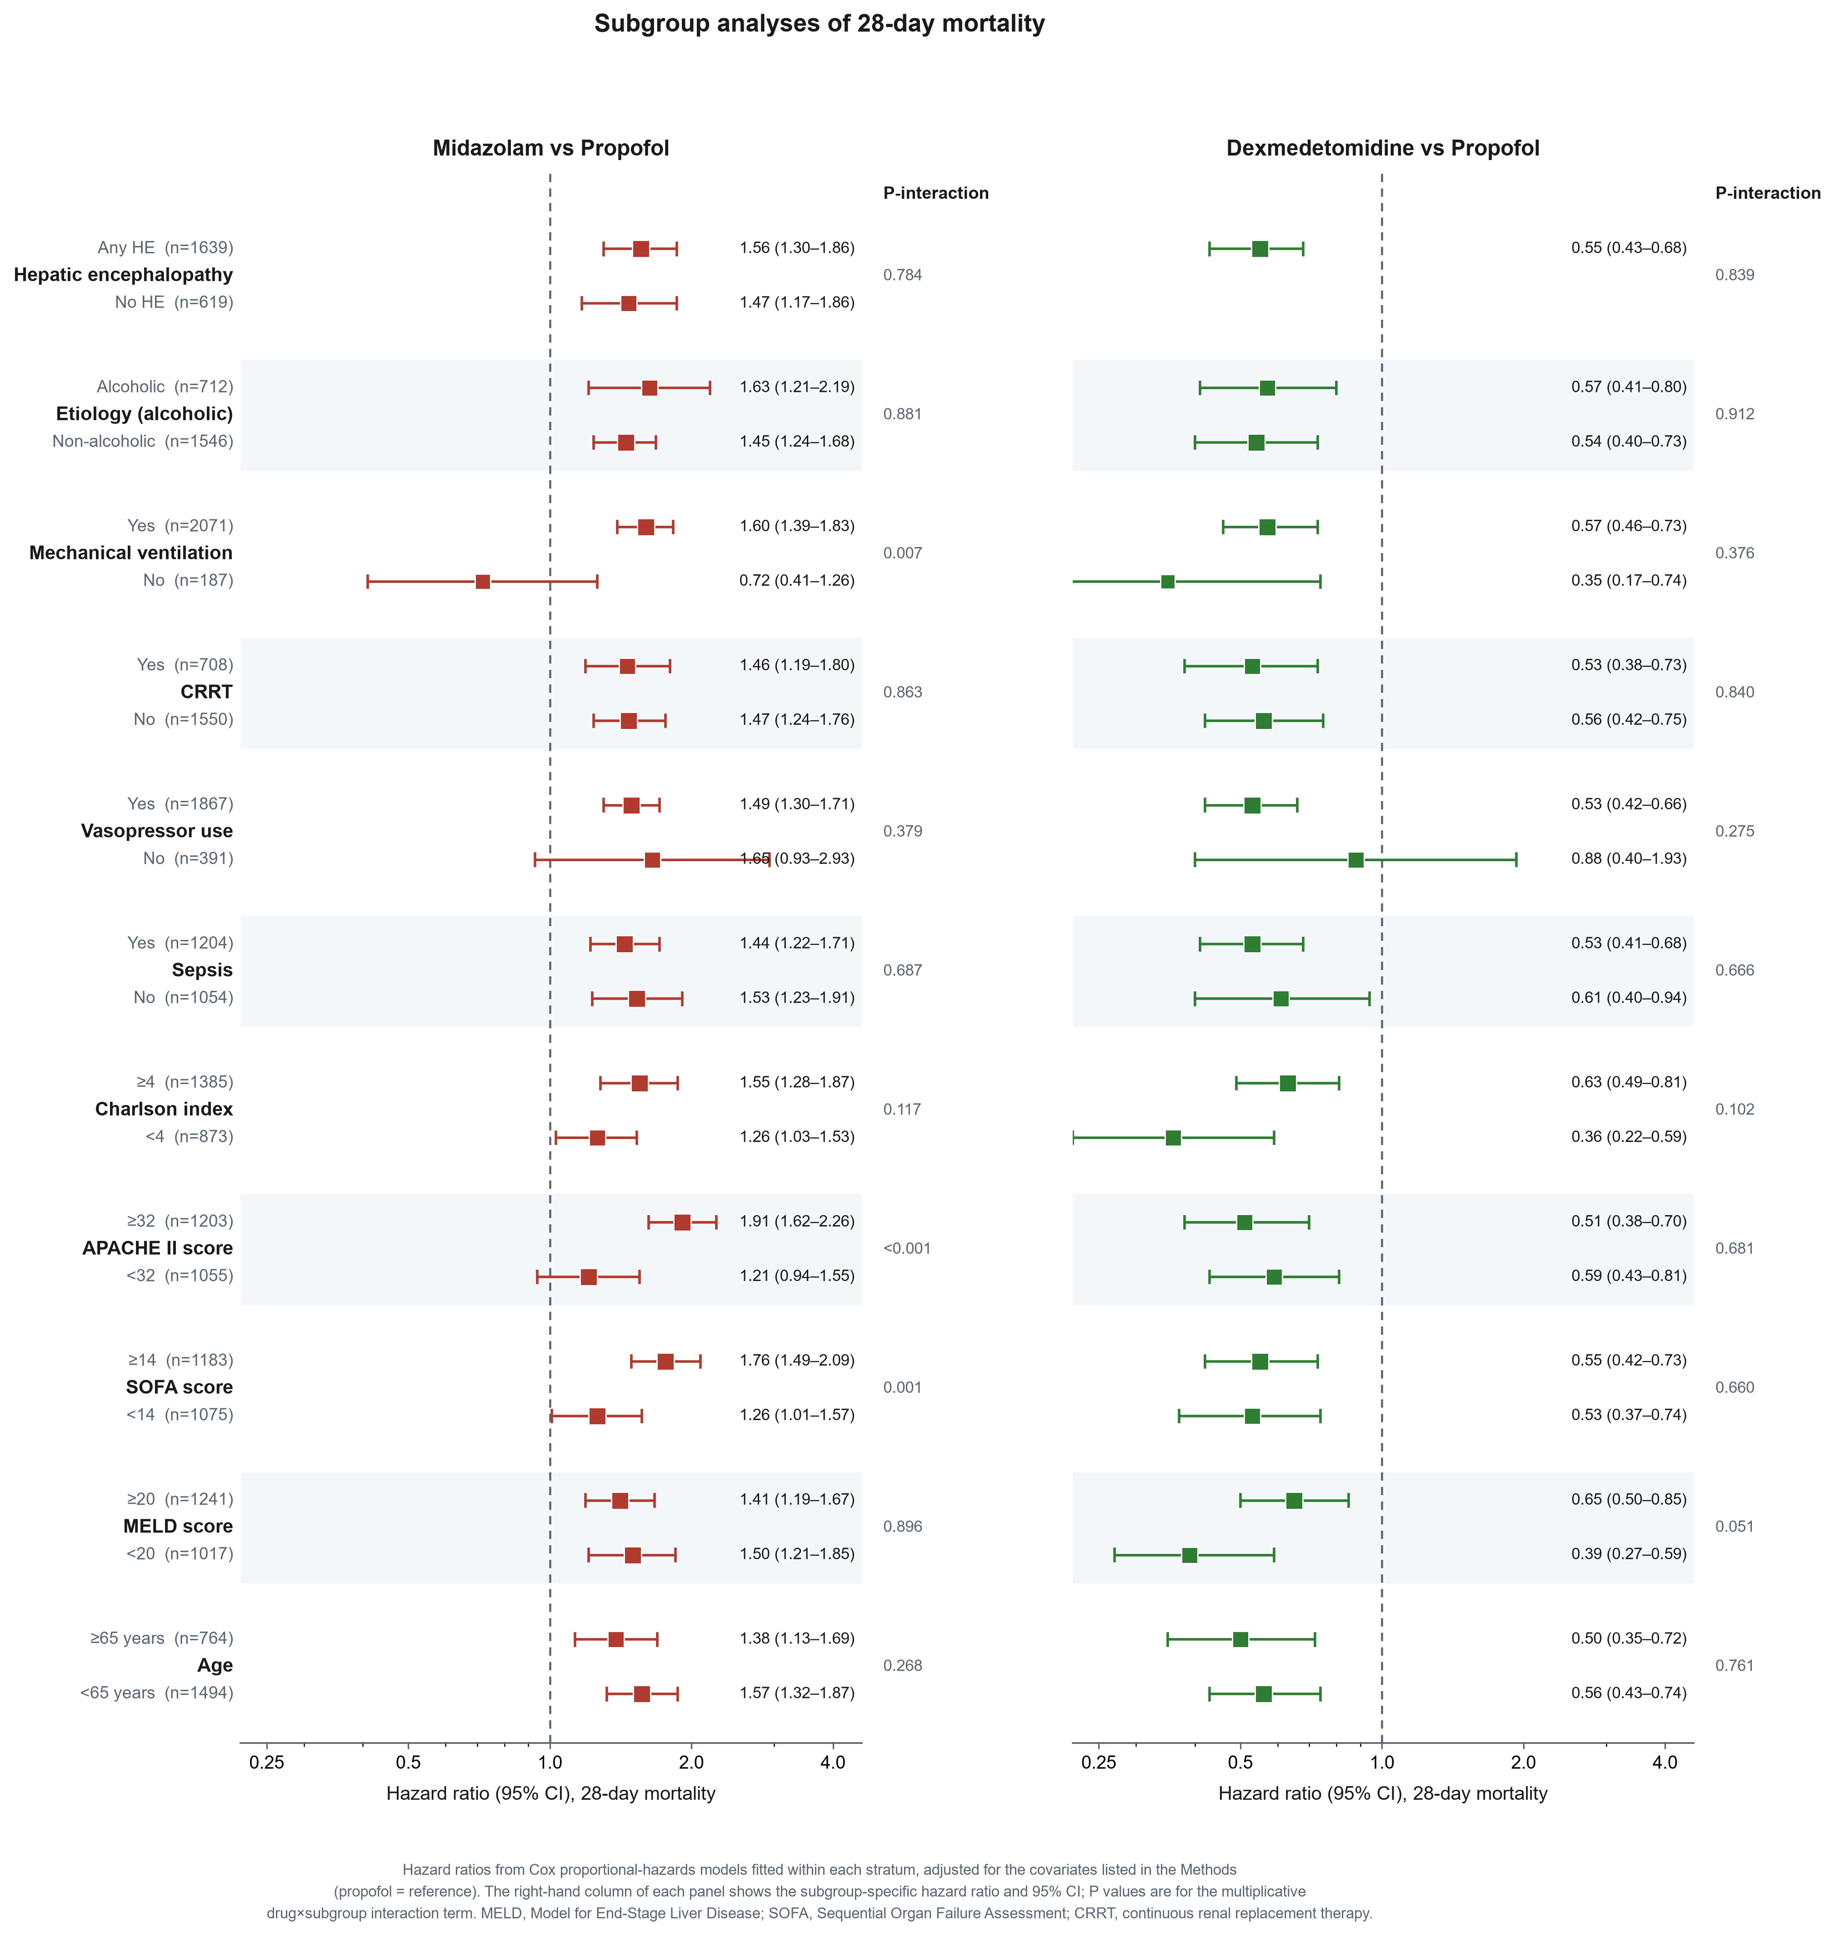
Subgroup analyses of 28-day mortality, with propofol as the reference. Hazard ratios were estimated within each stratum from Cox proportional-hazards models adjusted as in the primary model, with the stratifying variable omitted; P values are for the multiplicative drug x subgroup interaction term. HR hazard ratio, CI confidence interval, MELD model for end-stage liver disease, SOFA Sequential Organ Failure Assessment, APACHE II Acute Physiology and Chronic Health Evaluation II, CRRT continuous renal replacement therapy, HE hepatic encephalopathy.

