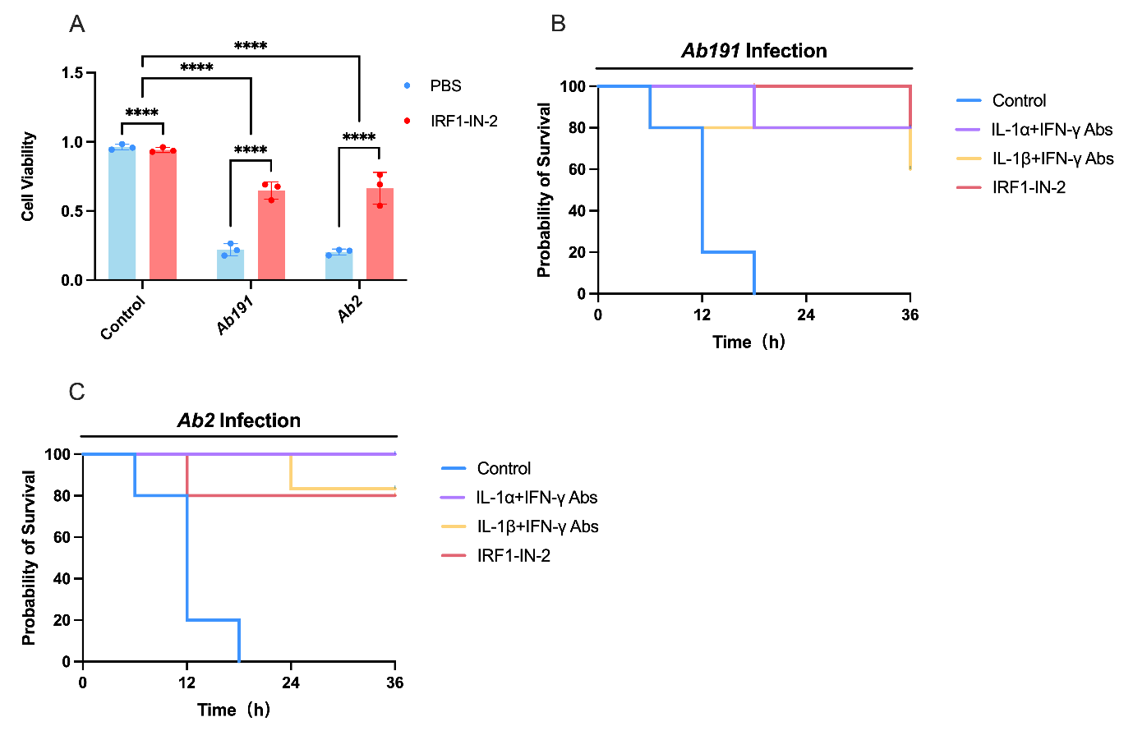
Figure S1. IRF1 inhibition and cytokine neutralization protect against infection with clinical Ab isolates. (A) Cell viability of macrophages infected with the clinical Ab isolates Ab191 or Ab2 in the presence or absence of IRF1-IN-2. (B, C) Survival of mice infected with Ab191 (B) or Ab2 (C) and treated with PBS (control), IL-1α plus IFN-γ neutralizing antibodies, IL-1β plus IFN-γ neutralizing antibodies, or IRF1-IN-2. Data are shown as mean ± SD. Statistical significance was determined by one-way ANOVA for cell viability and log-rank test for survival analysis.*p < 0.05; **p < 0.01; ***p < 0.001; ****p < 0.0001; ns, not significant.

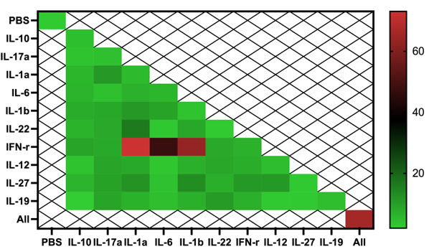
Figure S2. Complete cytokine pairwise screen in iBMDMs. Heatmap showing cell death (%) of iBMDMs after 48 h stimulation with all pairwise combinations of the 13 cytokines. Values represent mean ± SEM from n = 3 independent experiments. IL-1α+IFN-γ, IL-1β+IFN-γ, and IL-6+IFN-γ were identified as the dominant cytotoxic pairs. Single-cytokine treatments produced minimal cytotoxicity, consistent with the THP-1 validation shown in the main figures. Statistical significance assessed by one-way ANOVA with Tukey’s multiple comparisons (*p<0.05, **p<0.01, ***p<0.001, ****p<0.0001).

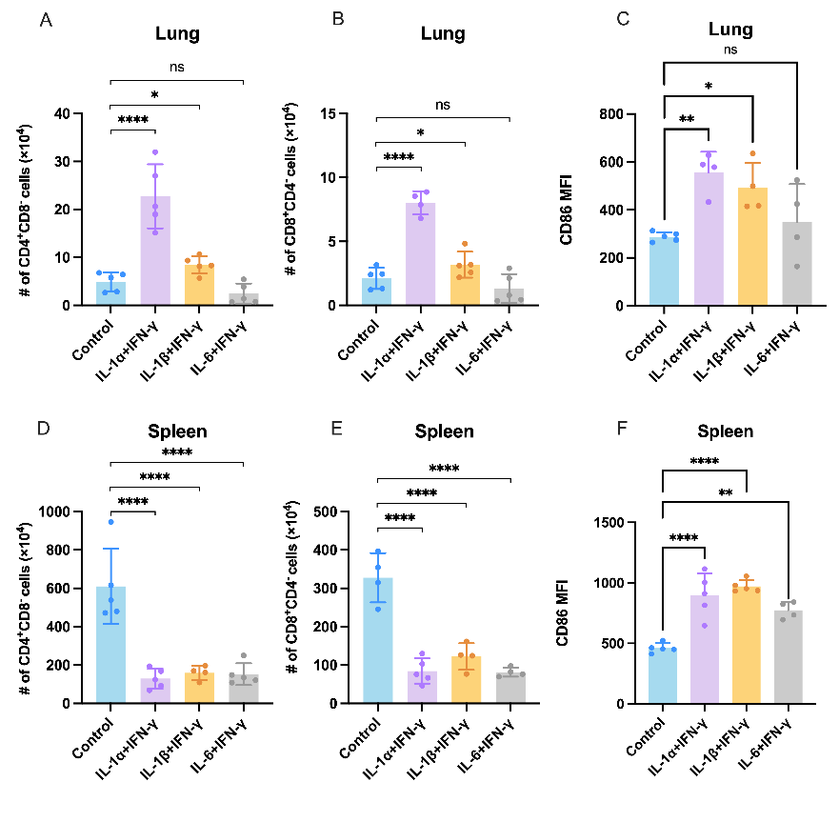
Figure S3. Lymphocyte and macrophage activation in lung and spleen after IL-1α/β + IFN-γ treatment. (A) Percentage of CD4⁺CD8⁻ T cells in lung tissue of mice treated with PBS or IL-1α/β + IFN-γ. n = 5 mice per group; mean ± SEM. (B) Percentage of CD4⁻CD8⁺ T cells in lung tissue. n = 5; mean ± SEM. (C) Mean fluorescence intensity (MFI) of CD86 on lung macrophages (F4/80⁺ cells). n = 5; mean ± SEM. (D) Percentage of CD4⁺CD8⁻ T cells in spleen. n = 5; mean ± SEM. (E) Percentage of CD4⁻CD8⁺ T cells in spleen. n = 5; mean ± SEM. (F) Mean fluorescence intensity (MFI) of CD86 on spleen macrophages. n = 5; mean ± SEM. Statistical analysis: unpaired t-test; *p < 0.05, **p < 0.01, ***p < 0.001, ****p < 0.0001; ns = not significant.

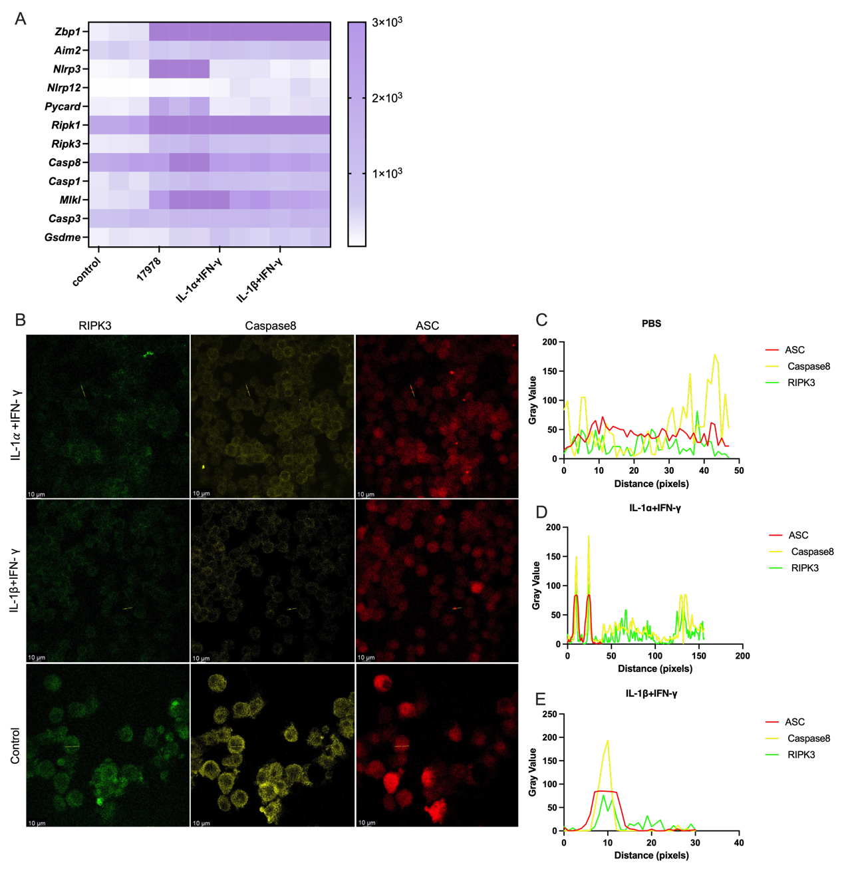
Figure S4. PANoptosome assembly and PANoptosis activation. A. PANoptosis-related gene expression. B. iBMDMs treated with IL-1α/β + IFN-γ for 4 h were analyzed by confocal microscopy. Data represent n = 3 independent experiments. Scale bars: 10 μm. C, D, E. Colocation analysis was performed as shown in the right panels.

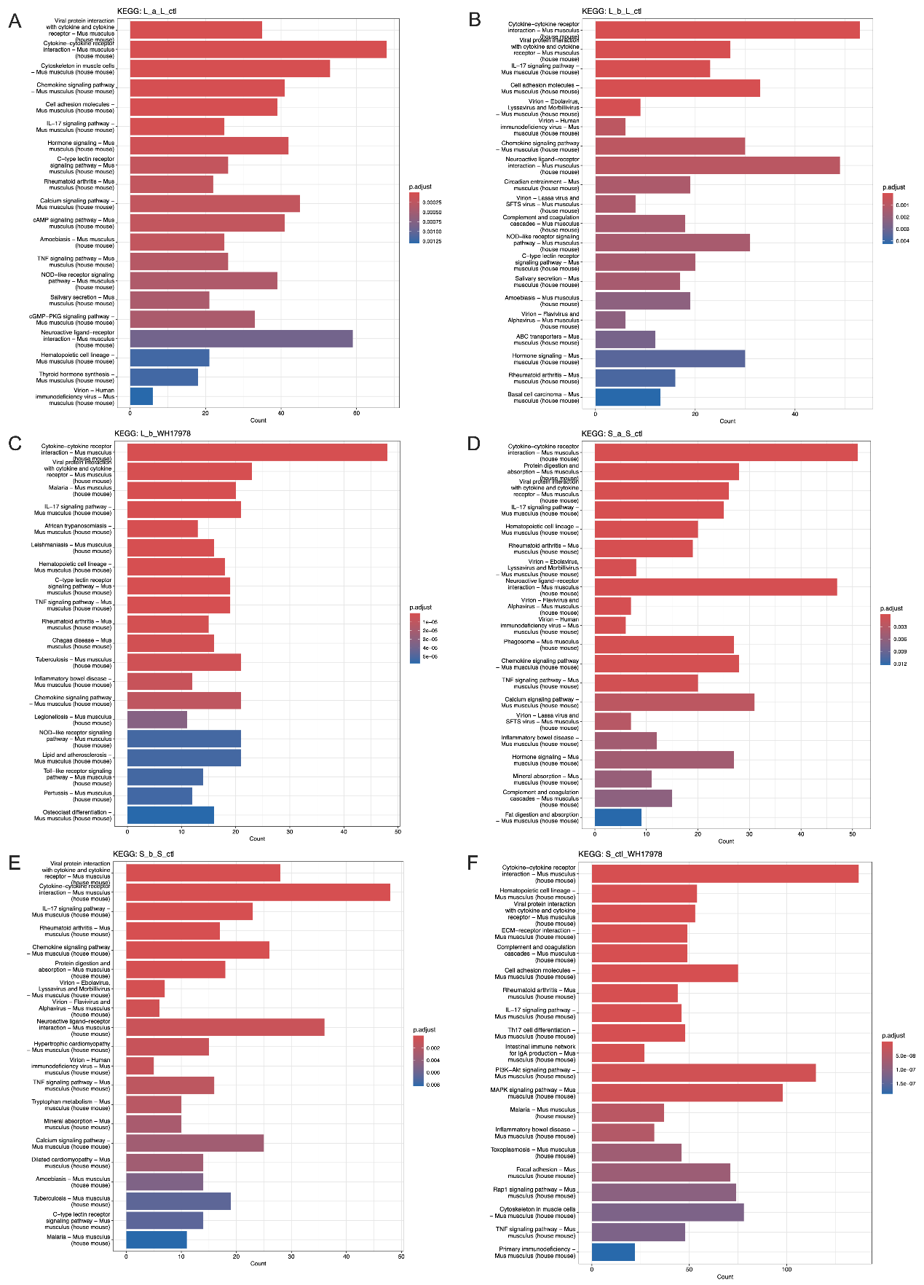
Figure S5. Kyoto Encyclopedia of Genes and Genomes (KEGG) pathway enrichment analysis from mice co-administered with (A) IL-1α and IFN-γ, (B) IL-1β and IFN-γ, (C) ATCC17978 infection on lung tissues. Kyoto Encyclopedia of Genes and Genomes (KEGG) pathway enrichment analysis from mice co-administered with (D) IL-1α and IFN-γ, (E) IL-1β and IFN-γ, (F) ATCC17978 infection on spleen tissues.

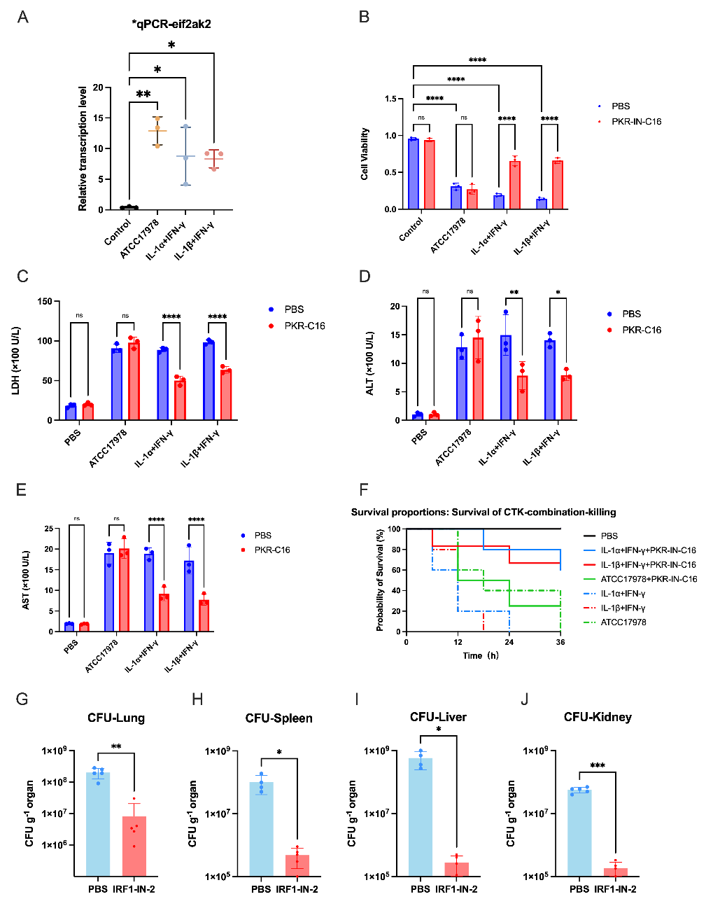
Figure S6. (A) Quantitative PCR analysis of PKR mRNA expression in iBMDM cells 6 h after infected with Ab (Ab, ATCC17978, 5 × 10^7 CFU) or treated with IL-1α/β+ IFN-γ, compared to uninfected PBS controls. (B) Cell death in iBMDMs pretreated with PKR-IN-C16（0.05%）or vehicle (PBS) for 1 h, followed by stimulation with IL-1α/β+ IFN-γ for 48 h or infection with Ab (MOI 10) for 6 h. Cell death was assessed by LDH release assay (percentage of maximum release). Data are mean ± SEM from three independent experiments (****P < 0.0001 by two-way ANOVA). (C-E) Serum levels of lactate dehydrogenase (LDH), aspartate aminotransferase (AST), and alanine aminotransferase (ALT) in mice treated as in (Fig. S5B) (n =5 per group; **P < 0.01, ***P < 0.001, ****P < 0.0001 by one-way ANOVA with Tukey's post-test). (F) Kaplan–Meier survival curves of 6–8-week-old C57BL/6 mice (n = 5 per group) prophylactically treated with PKR-IN-C16 (100 μg/d, i.p.) or vehicle (PBS) 24 h, 2 h before challenge with IL-1α/β + IFN-γ or Ab infection (7.5 × 10^7 CFU) and 24 h after injection. (G-J) Bacterial burden (CFU) in lung (D), spleen (E), liver (F), and kidney (G) of mice infected with Ab and treated with IRF1-IN-2 or vehicle. n = 5 mice per group; mean ± SEM.
Statistical analyses were conducted by one-way ANOVA. Data are representative of at least three independent experiments. *p < 0.05; **p < 0.01; ***p < 0.001; ****p < 0.0001; ns, not significant.

