Supplementary Figures
Population-scale catalogue of clinically actionable pharmacogenomic variation in the Middle Eastern Levant
a
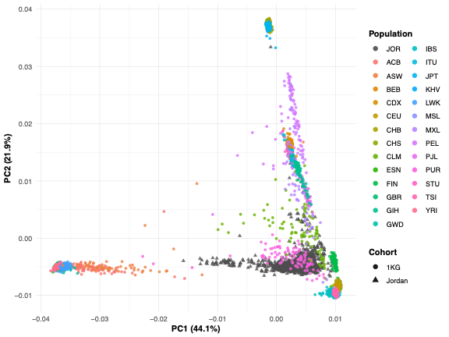
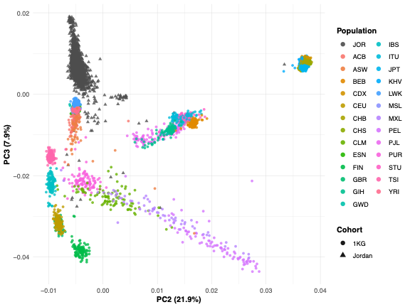
c
b
d
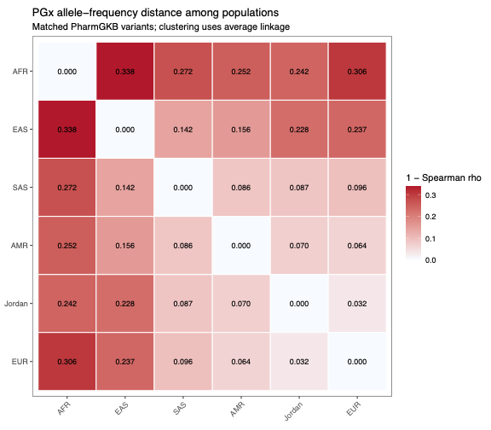
e
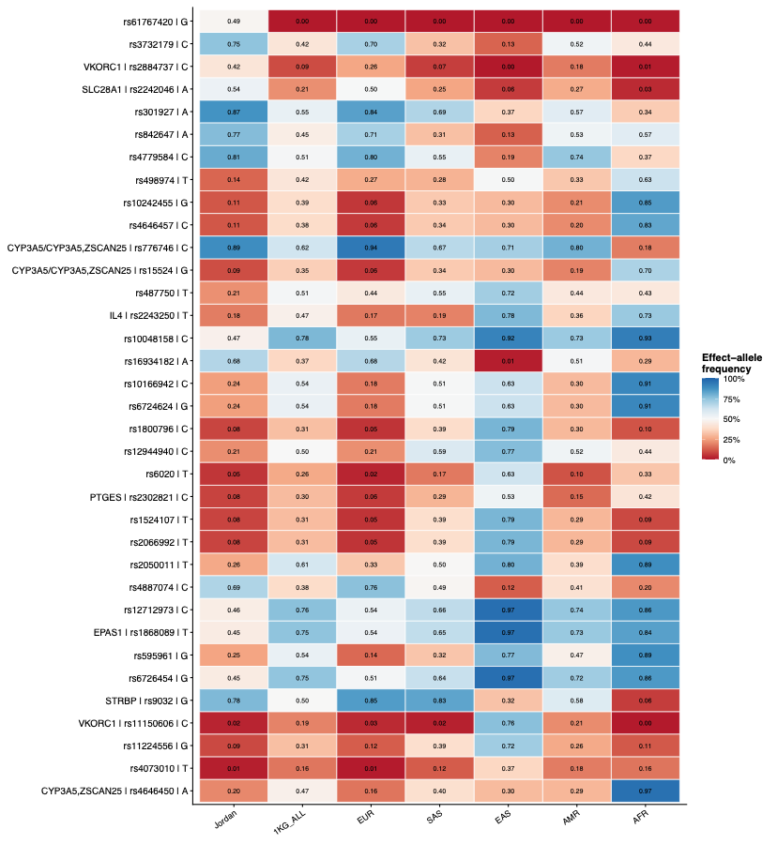
f
g
Supplementary Figure 1. Population structure and pharmacogenomic frequency relationships.
Principal component (PC) analysis of Jordanian and 1000 Genomes Project (1KGP) participants (a, PC1–PC2 and b, PC2–PC3), with samples coloured by population. c, Eigenvalues for the first 20 PCs from the combined Jordanian and 1KGP cohort. Points represent individual components. d, Median absolute PharmGKB allele-frequency differences between Jordanians and 1KGP superpopulation. Labels indicate the number of variants significant after FDR correction (FDR < 0.05). e, Pairwise pharmacogenomic allele-frequency distance between Jordanians and 1KGP superpopulations, calculated as 1−Spearman's correlation across matched variants; lower values indicate greater similarity. f, Heatmap of effect-allele frequencies for selected highly differentiated PharmGKB variants across Jordanians, the overall 1KGP cohort and superpopulations. g, PharmGKB-annotated variants with the largest absolute allele-frequency differences between Jordanians and the overall 1KGP cohort. AFR, African; AMR, Admixed American; EAS, East Asian; EUR, European; JOR, Jordanian; SAS, South Asian.
a

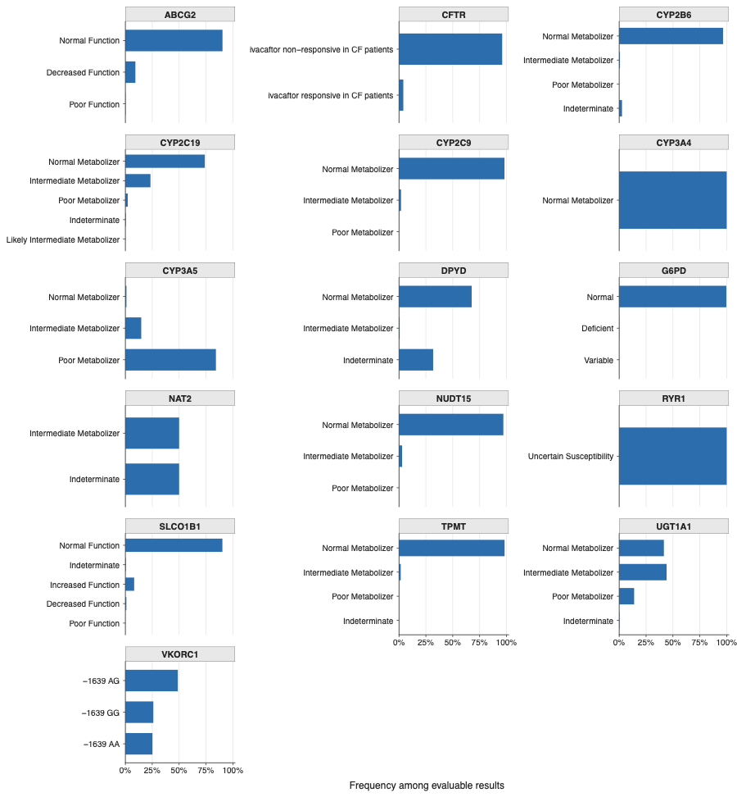
b
d
c
Supplementary Figure 2. Clinical interpretability and burden of pharmacogenomic results.
a, PharmCAT result status across pharmacogenes in 4,322 participants. Horizontal stacked bars show complete-position calls, usable calls with missing-position warnings, ambiguous calls, absent calls, and loci requiring specialized typing. b, Gene-specific distributions of predicted phenotypes among participants with an evaluable result; corresponding counts and frequencies are provided in Supplementary Table 3. c, Distribution of actionable medication burden. Bars show participant counts for each number of actionable medications, and the dashed line denotes the cohort median. d, Participants with actionable results supported by CPIC, DPWG, an FDA labels, or an FDA pharmacogenomic association. Labels show participant counts and percentages; evidence-source categories are not mutually exclusive.
Supplementary Figure 3. Selected pharmacogenomic allele frequencies across global reference populations.
Effect-allele frequencies of selected clinically relevant pharmacogenomic variants in the Jordanian cohort and the Genome Aggregation Database (gnomAD) Middle Eastern, non-Finnish European, and global genome populations. Alleles were harmonized by GRCh38 chromosome, position, reference allele and alternate allele before conversion to the displayed clinical effect allele. Cell colour and printed values indicate effect-allele frequency; unavailable population estimates are shown as NA.

