Supplementary Information

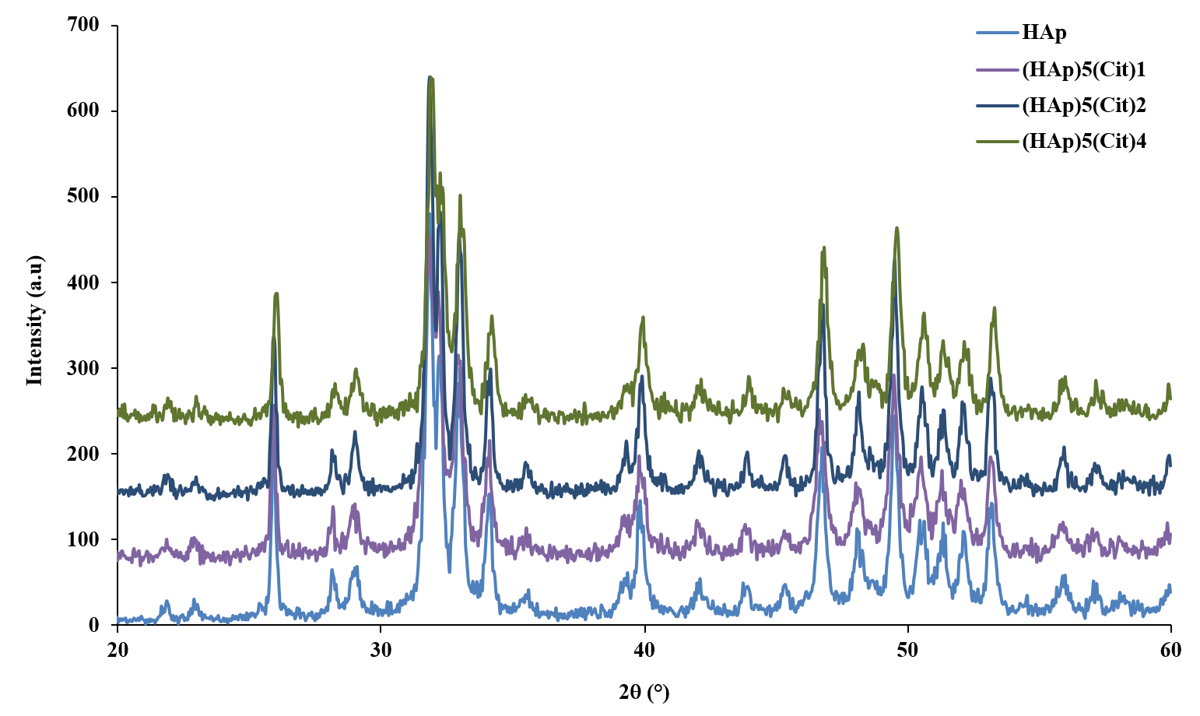
Figure S1: XRD diffractogramms of differents supports (HAp)₅(Cit)_{x}

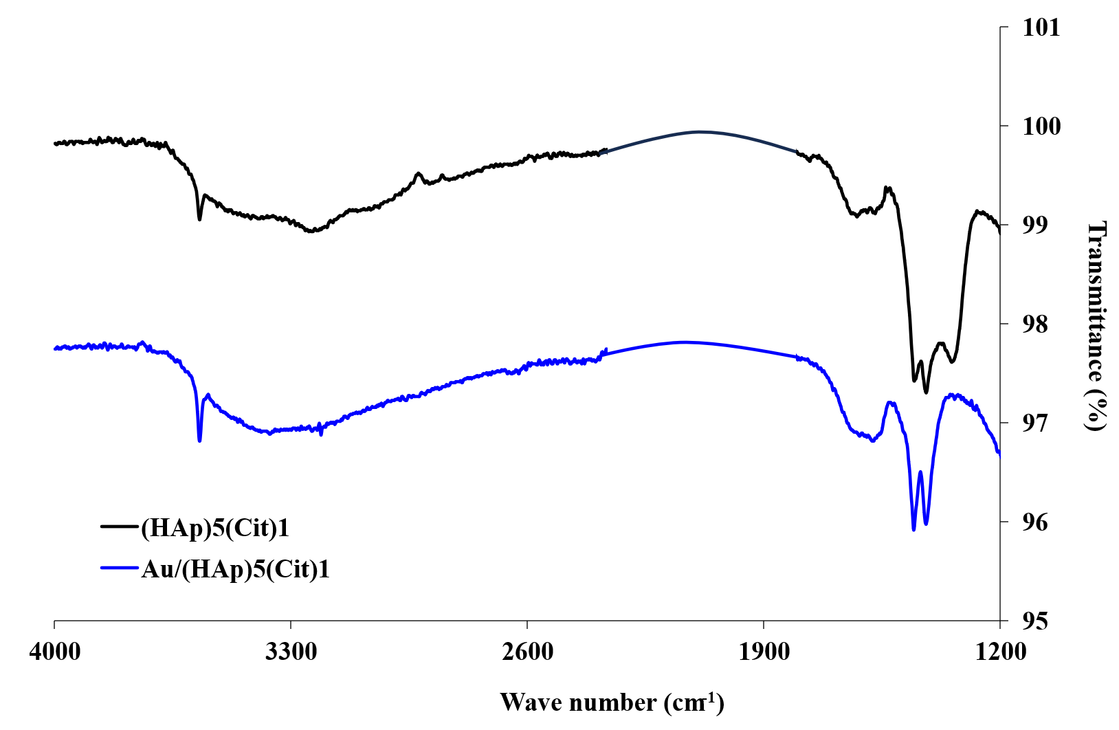
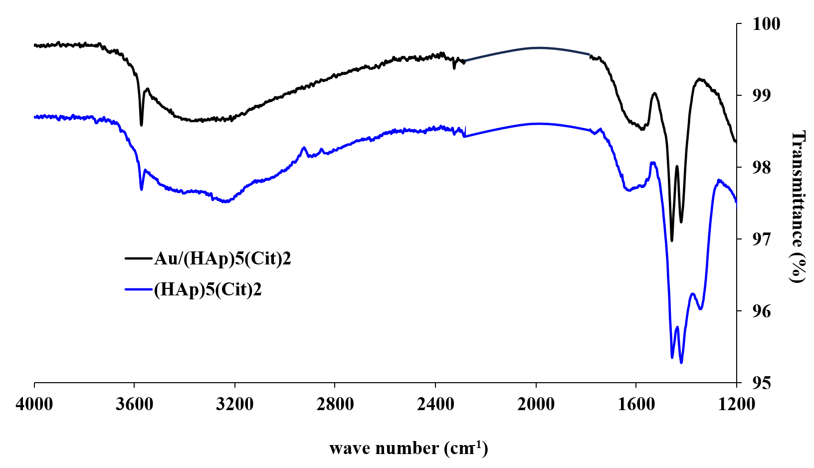
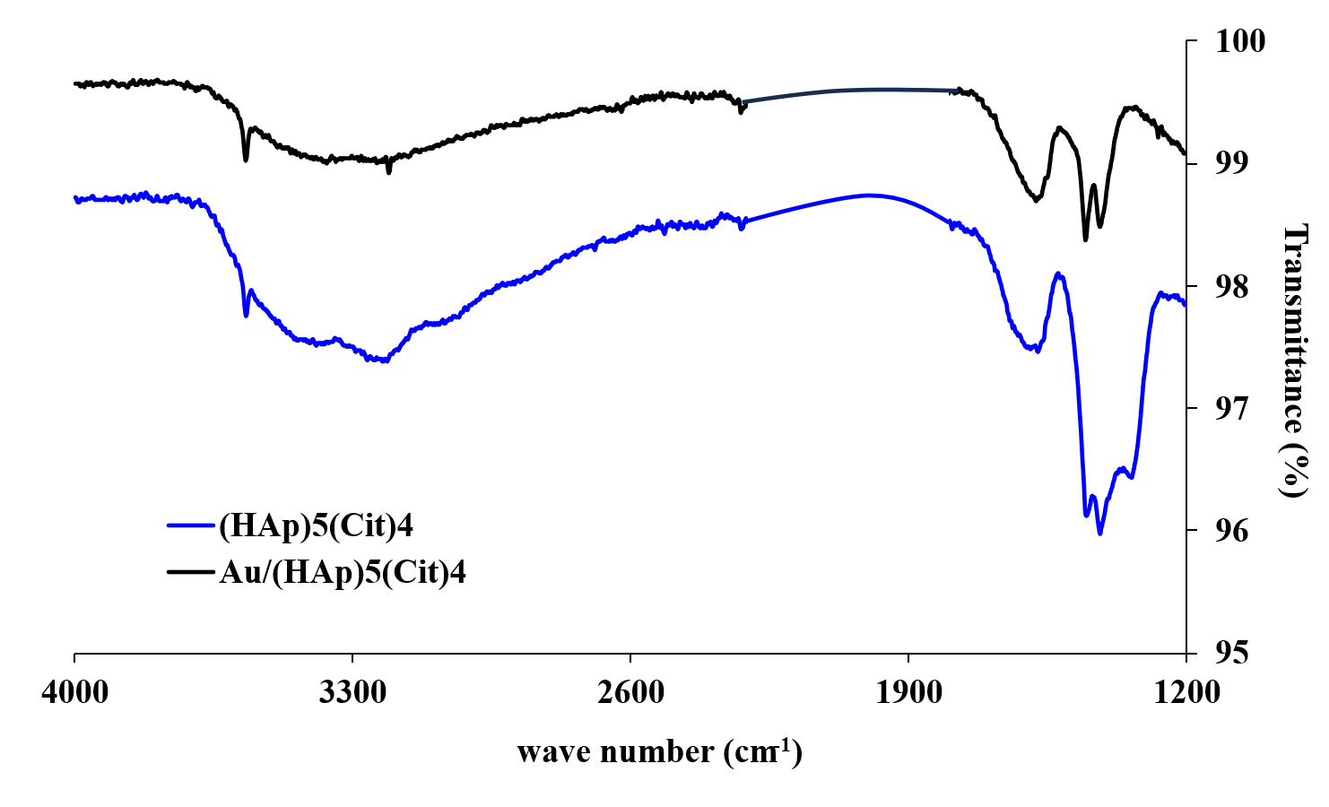
Figure S2: Compared IR-ATR spectra for Au/(HAp)₅(Cit)_{x} and (HAp)₅(Cit)_{x}

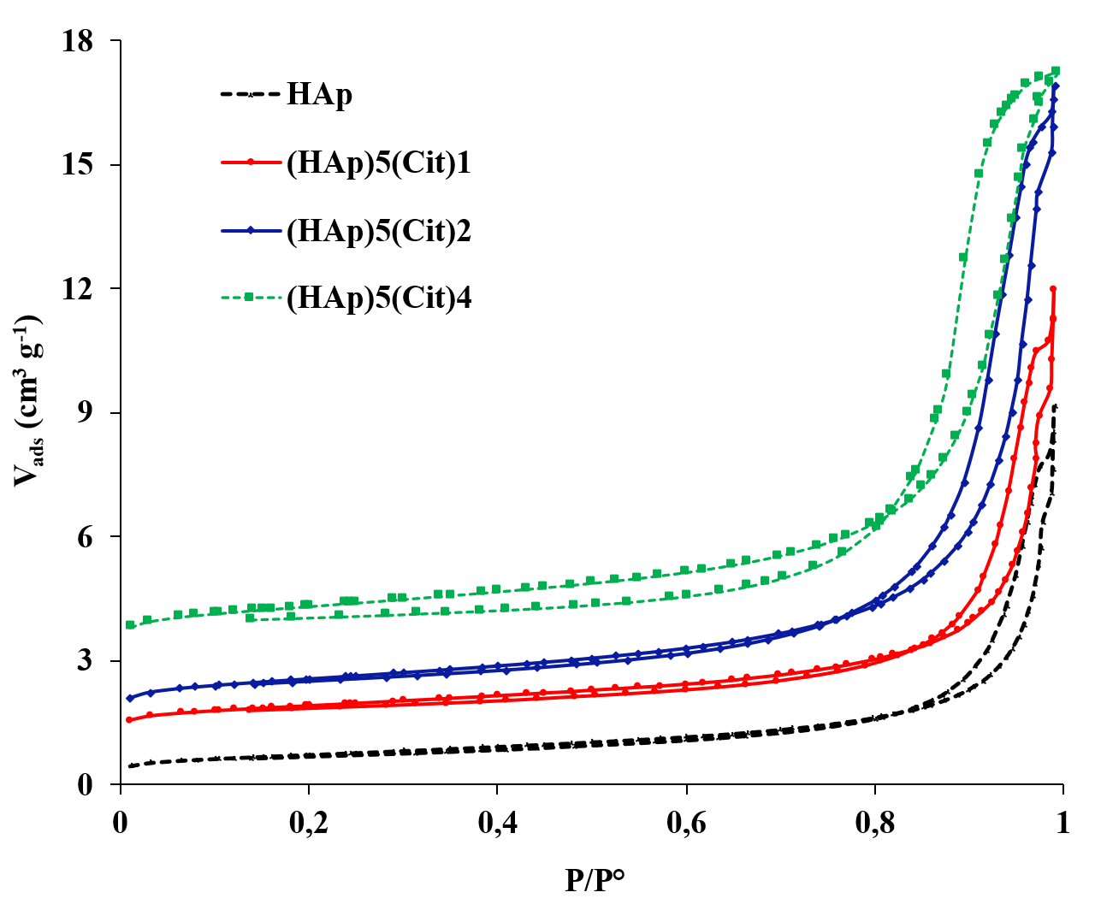
Figure S3: N₂ adsorption-desorption isotherms for (HAp)₅(Cit)_{x}

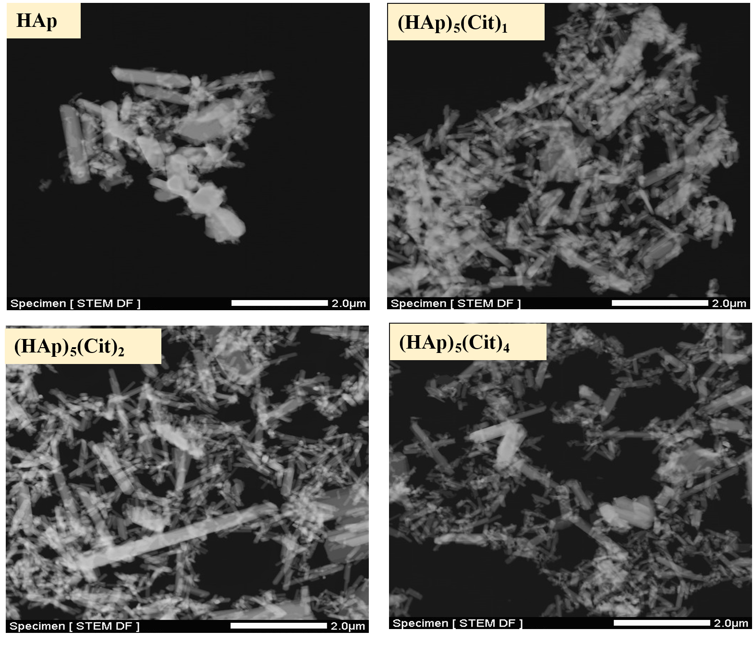
Figure S4: SEM micrographs for (HAp)₅(Cit)_{x} supports

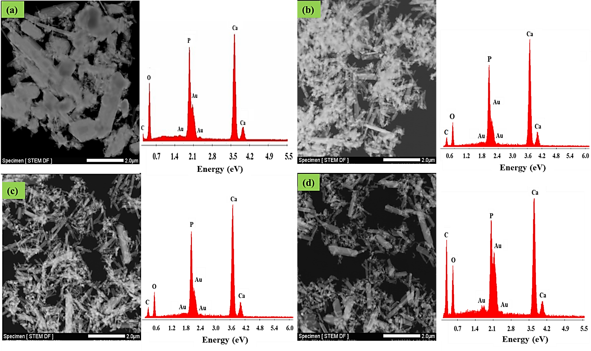
Figure S5: SEM-EDX micrographs of different gold catalysts Au/(HAp)₅(Cit)_{x}: (a) x=0, (b) x=1, (c) x=2 and (d) x=4

Figure S6:

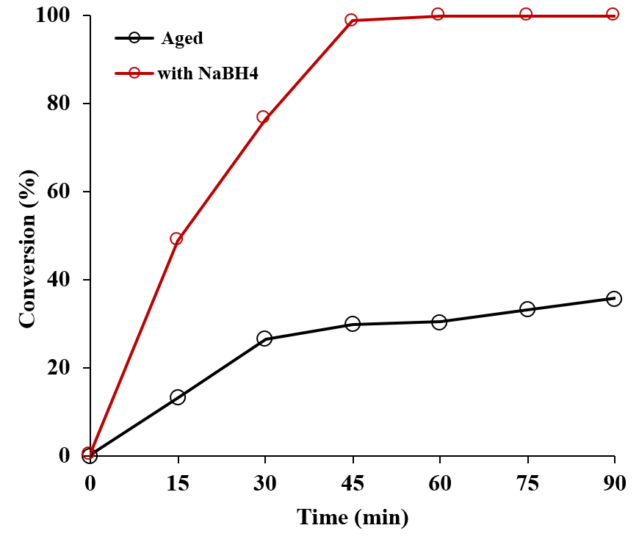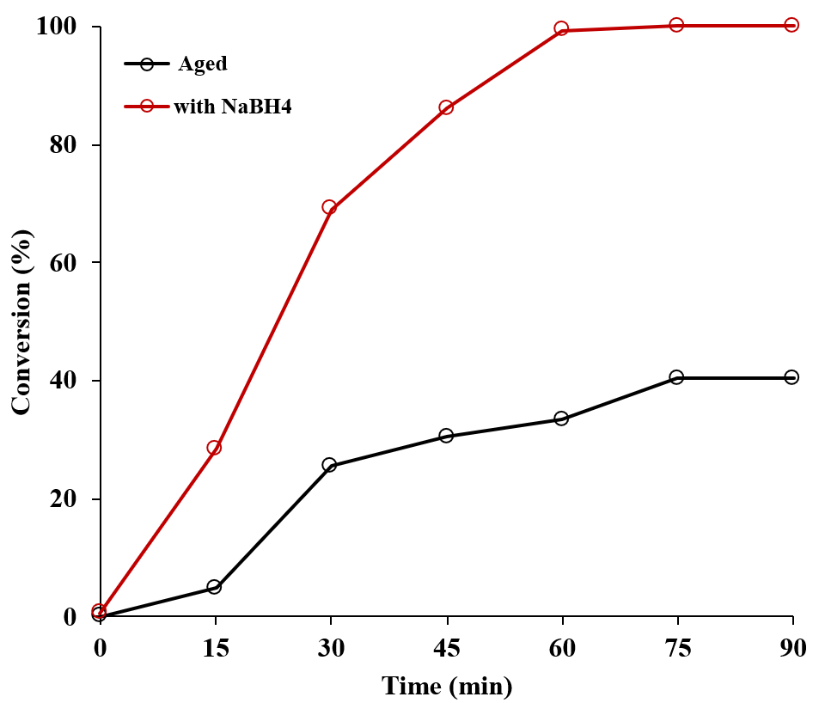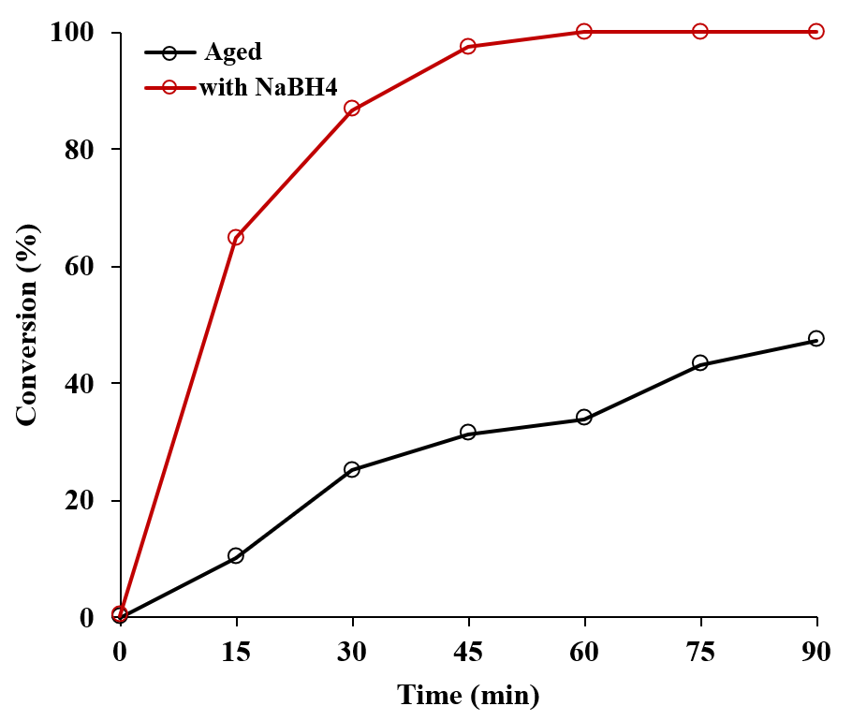
(A)
(c)
(b)
(a)
(B)
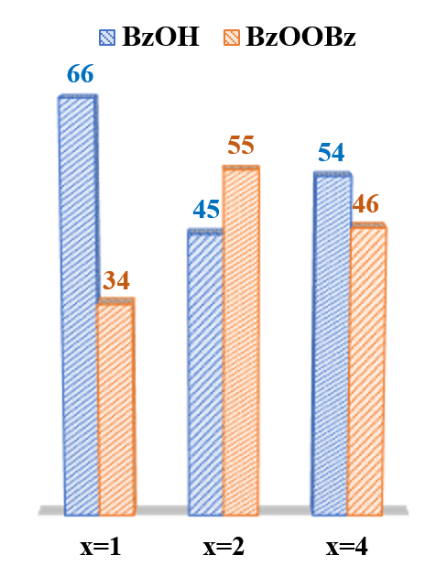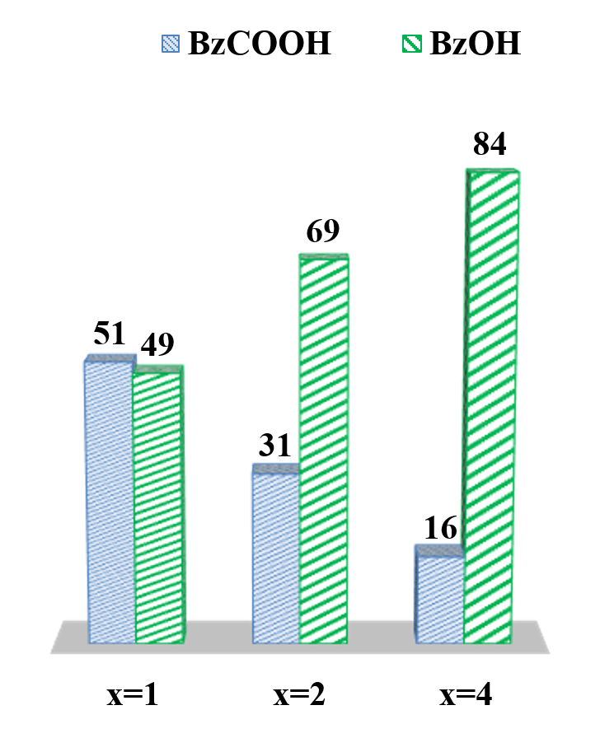
Figure S7: (A) Effect of time storage and NaBH₄ reduction of BzOH conversion using Au/(HAp)₅(Cit)_{x}: (a)x=1, (b)x=2 and (c)x=4 (B) Effect of storage time on the selectivity properties for different catalysts Au/(HAp)₅(Cit)_{x}

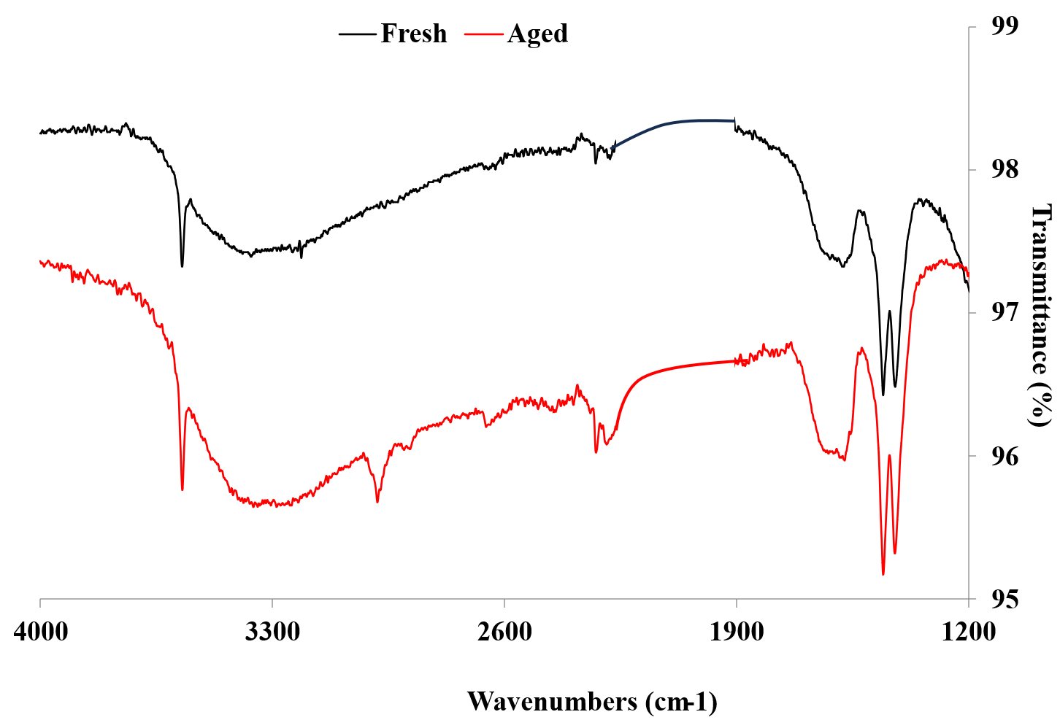

Figure S8: Effect of storage time on surface Au/(HAp)₅(Cit)₁

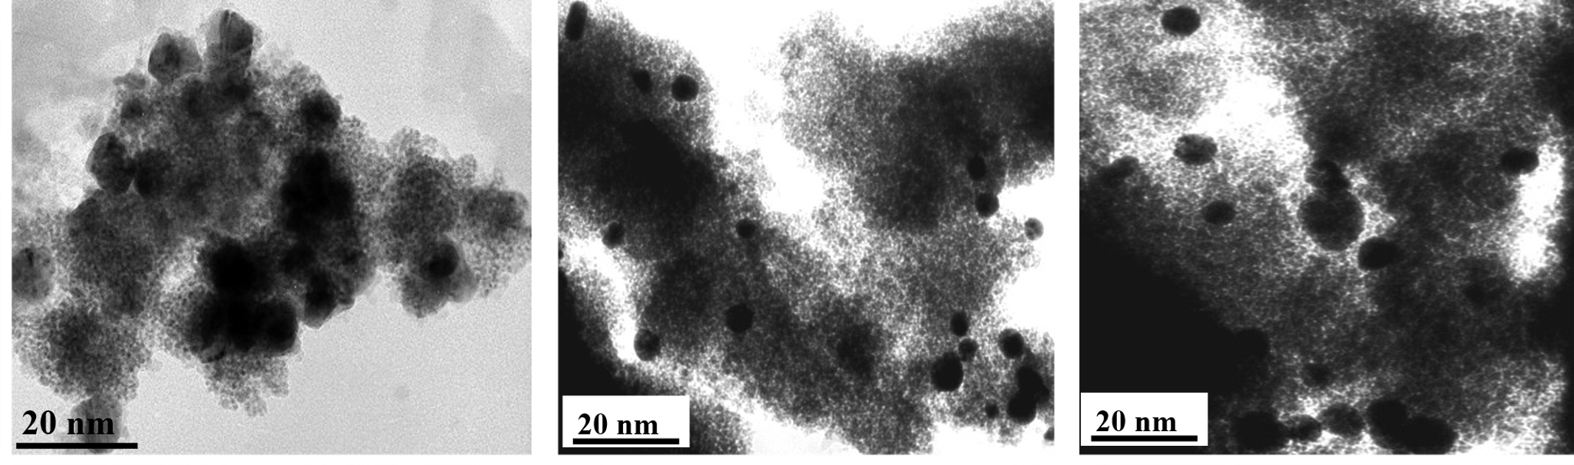
Figure S9: Effect of storage time on Au NPs morphology

