Electrochemical Post-Treatment of Constructed Wetland effluent for Enhanced Ketoprofen Removal and Toxicity Reduction

Isabel Maximo Corrêa de Alcantaraª, Thalita Ferreira da Silva^{b}, Priscila Sabioni Cavalheri^{c,} Emmanuel Da Silva Côgo Miguel^{c}, Antonio Kaique Canattoª, Lucas de Melo da Silva^{d}, Fernando Jorge Correa Magalhães Filho^{e}, Osvaldo Chiavone Filho^{f}, Marcos Roberto de Vasconcelos Lanza^{b}, Anderson Rodrigues Lima Caires^{c}, Amilcar Machulek Junior^{f*}

ª Faculty of Engineering, Architecture and Urbanism, and Geography, Federal University of Mato Grosso do Sul, Costa e Silva Avenue, s/n, Campo Grande, MS, Brazil.
^{b} São Carlos Institute of Chemistry, University of São Paulo, Trab. São Carlense Avenue, 400, São Carlos, SP, Brazil.
^{c} Institute of Physics, Federal University of Mato Grosso do Sul, UFMS St, s/n, Campo Grande, MS, Brazil.
^{d} Unigran Capital University Center, Abrão Júlio Rahe St, 325, Campo Grande, MS, Brazil.
^{e} Institute of Hydraulic Research, Federal University of Rio Grande do Sul, Bento Gonçalves Avenue, 9500, Porto Alegre, RS, Brazil.
^{f} Institute of Chemistry, Federal University of Rio Grande do Norte, Senador Salgado Filho Avenue, s/n, Natal, RN, Brazil.

*Corresponding author:
E-mail addresses: amilcar.machulek@ufrn.br, machulekjr@gmail.com.

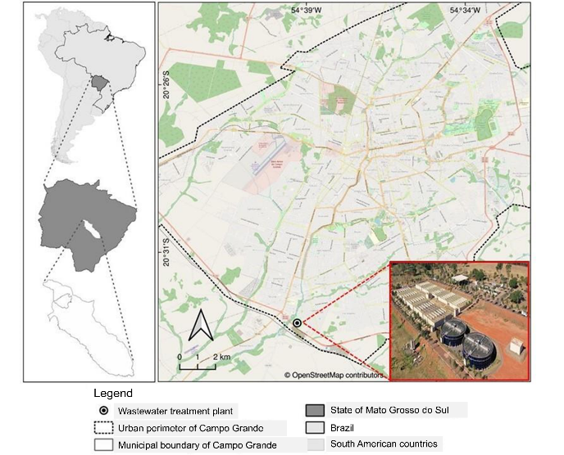
Figure S1. Location map of the Los Angeles WWTP.

S1. Analytical Determinations
A calibration curve for KET was constructed in the range of 2.5 - 35.0 mg L⁻¹, showing a linear regression (R²) of 0.9984, with a detection limit (LOD) of 1.9495 mg L⁻¹ and a quantification limit (LOQ) of 6.4984 mg L⁻¹. Aliquots of 15 μL were injected into a C18 column (Zorbax ODS Agilent, 5 μm, 4.6 × 150 mm), maintained at 35 °C, using a mixture of water and acetonitrile (25:75 v/v) as the eluent, at a flow rate of 0.8 mL min⁻¹. The degradation percentage was calculated according to Equation S1, and the pseudo-first-order rate constant (k_{ap}) according to Equation S2.

%DEG = $\left(\frac{ {\text{[KET]}}_{\text{i}} - {\text{[KET]}}_{\text{f}}}{{\text{[KET]}}_{\text{i}}}\right)\text{×100}$ (S1)
ln$\left(\frac{\text{[}{\text{KET]}}_{\text{f}}}{{\text{[KET]}}_{\text{i}}}\right)\text{= }{\text{-}\text{k}}_{\text{ap}}\text{t}$ (S2)

Mineralization was assessed by measuring the non-purgeable organic carbon using a TOC–TV analyzer (Shimadzu, model SSM–5000), calibrated with standard solutions of potassium hydrogen phthalate and equipped with a non-dispersive infrared (NDIR) absorption detector. The mineralization percentage was calculated according to Equation S3.

%MIN = $\left(1 -\frac{{{\text{TOC}}_{\text{i}} - \text{TOC}}_{\text{f}}}{{\text{TOC}}_{\text{i}}}\right)\text{×100}$ (S3)

Based on the total organic carbon (TOC) analysis, the energy consumption (EC, in kWh g⁻¹ TOC) per unit mass of TOC removed over a given time in each test was calculated ^{2,3}, according to Equation S4:

${\text{EC}}_{\text{TOC}} \text{=} \frac{{\text{E}}_{\text{cel} }\text{×} \text{I} \text{×} \text{t}}{{\text{V}}_{\text{s}} \text{×} {\text{∆(TOC)}}_{\text{exp}}}$ (S4)

In this equation, E_{cel} is the average cell voltage (V), I is the applied current (A), t is the electrolysis time (h), V_{s} is the volume of treated solution (L), and Δ(TOC)_{exp} represents the variation in TOC (mg L⁻¹).

Table S1. Physicochemical characteristics of the constructed wetland system effluent.
*Parameters | Inlet of VFCW | Outlet of VFCW | Efficiency (%)
Chloride (mg L⁻¹) | 170.44 ± 6.38 | 74.39 ± 0.83 | 56.35
Conductivity (mS cm⁻¹) | 1015 ± 7.94 | 528.33 ± 5.51 | -
COD (mg L⁻¹) | 408.07 ± 32.20 | 105.77 ± 15.20 | 74.08
BOD_{5,20} (mg L⁻¹) | 194.39 ± 9.35 | 26.63 ± 0.71 | 86.30
Phosphorus (mg L⁻¹) | 5.64 ± 0.66 | 4.50 ± 0.35 | 20.28
Nitrate (mg L⁻¹) | 5.50 ± 0.42 | 2.65 ± 0.21 | 51.82
Nitrite (mg L⁻¹) | 0.16 ± 0.02 | 0.05 ± 0.01 | 66.67
TKN (mg L⁻¹) | 64.00 ± 1.41 | 16.50 ± 0.71 | 74.22
N-NH₃ (mg L⁻¹) | 60.00 ± 2.83 | 13.00 ± 2.83 | 78.33
Oils and grease (mg L⁻¹) | 21.80 ± 3.96 | 3.10 ± 0.42 | 85.78
pH | 7.12 ± 0.08 | 6.99 ± 0.78 | -
Settleable solids (ml L⁻¹) | 4.50 ± 0.71 | ND | 100.00
Total solids (mg L⁻¹) | 602.50 ± 21.92 | 286.00 ± 96.17 | 52.53
Suspended solids (mg L⁻¹) | 285.50 ± 60.10 | 53.00 ± 7.07 | 81.44
Dissolved solids (mg L⁻¹) | 296.00 ± 21.21 | 206.50 ± 13.44 | 30.24
Turbidity (NTU) | 241.33 ± 4.93 | 22.83 ± 3.84 | 90.54
TOC (mg L⁻¹) | 186.48 ± 3.31 | 70.00 ± 0.21 | 62.19
COD = chemical oxygen demand; BOD = biochemical oxygen demand; TKN = total Kjeldahl nitrogen; N-NH₃ = ammoniacal nitrogen; TOC = total organic carbon; ND = not detectable
*The effluent characterization was performed according to the methods and techniques described in the Standard Methods for the Examination of Water and Wastewater. The parameters analyzed included conductivity, BOD_{5,20}, COD, pH, and turbidity in the effluent before and after treatment by the integrated system.

S2. Acute Toxicity Assays
S2.1. Artemia sp.
Cysts of the microcrustacean were incubated for hatching in synthetic saline solution at 36.00 g L⁻¹, pH 8.0-9.0, under constant light irradiation and aeration for 48 h. After hatching, five organisms were placed in each culture well containing 3.00 mL of untreated and electrochemically treated solutions, which were diluted to the following concentrations: 75.00%, 50.00%, 25.00%, 12.50%, and 6.25% (v/v). The temperature was maintained at 25 ± 2 °C, with a photoperiod of 16 h light and 8 h dark, under static conditions. Saline solution was used as a negative control and for sample dilution. A 1% potassium dichromate solution was used as the positive control.
Dead or immobilized larvae were counted, and the median lethal concentration (LC₅₀) was calculated using PROBIT analysis with Statistica Statsoft version 12 software (StatSoft, Tulsa, USA). LC₅₀ values were converted into Toxic Units (TU) (Equation S5), and the samples were classified according to the toxicity scoring system.

$\text{TU=}\frac{\text{1}}{{\text{LC}}_{\text{50}}}\text{×100}$ (S5)

S2.2. Lactuca sativa
Commercial seeds of Lactuca sativa (Topseed brand), without chemical treatment, were used for phytotoxicity assays. For each sample, 20 seeds were placed in 90 mm diameter Petri dishes with germination paper as support at the bottom. Four milliliters of the samples were diluted in mineral water (75%, 50%, 25%, 12.5%, and 6.25% (v/v)). The plates were sealed and kept in the dark for 72 h at a temperature of 24 ± 1 °C. Mineral water and a 1% Zn(NO₃)₂ solution were used as negative and positive controls, respectively.
After the exposure period, the radicle length of the germinated seeds was measured using a digital caliper. The number of germinated seeds in the sample (GSS) and the sample radicle length (RLS) were used to calculate the germination index (GI%), according to Equations S6 and S7:

$\text{RGR=}\frac{\text{RLS}}{\text{RLC}}$ (S6)
$\text{\%}\text{GI=RGR×}\frac{\text{GSS}}{\text{GSC}}\text{×100}$ (S7)

In this equation, RGR represents the relative root growth; RLS is the total root length of the sample; RLC corresponds to the total root length in the negative control; GSS is the number of germinated seeds in the sample, and GSC refers to the number of germinated seeds in the negative control. %GI values below 50% indicate high toxicity, values between 50% and 80% indicate moderate toxicity, and values above 80% suggest no significant toxic effect.
Residual H₂O₂ was removed from all samples prior to analysis with Artemia sp. and Lactuca sativa, using a bovine catalase solution at 0.1 g L⁻¹.

¹¹
Table S2. Ketoprofen concentration recovery by solid-phase extraction (SPE)
Samples | Concentration (mg L⁻¹) |  |  | RSD (%)
UASB-KETª | 23.71 ± 2.636 |  |  | 1.33
VFCW-KET^{b} | 5.47 ± 0.294 |  |  | 5.29
Ketoprofen standard (1.0 mg L⁻¹) | 0.87 ± 0.004 |  |  | 13.5
ᵃEffluent after the UASB reactor with the addition of 25 mg L⁻¹ of KET.
ᵇOutlet effluent from the CW at peak time.

Table S3. Results of the 2³ Central Composite Design with the degradation and mineralization percentage responses for the Electro-Fenton Process.
Experiments | j  (mA cm⁻²) | [Fe³⁺]  (mg L⁻¹) | [Fe³⁺:Citrate] | %DEG | %MIN
12 | 60.000 | 13.727 | 1:2 | 48.4 | 20.4
14 | 60.000 | 7.000 | 1:3.68 | 54.5 | 13.0
3 | 35.000 | 11.000 | 1:1 | 28.5 | 12.0
6 | 85.000 | 3.000 | 1:3 | 76.7 | 29.4
16 (C) | 60.000 | 7.000 | 1:2 | 67.4 | 12.7
8 | 85.000 | 11.000 | 1:3 | 82.4 | 41.4
5 | 85.000 | 3.000 | 1:1 | 53.7 | 25.1
17 (C) | 60.000 | 7.000 | 1:2 | 67.2 | 12.7
10 | 102.044 | 7.000 | 1:2 | 92.7 | 43.2
2 | 35.000 | 3.000 | 1:3 | 32.9 | 9.8
15 (C) | 60.000 | 7.000 | 1:2 | 67.7 | 12.7
1 | 35.000 | 3.000 | 1:1 | 27.8 | 9.5
11 | 60.000 | 0.273 | 1:2 | 46.1 | 9.2
13 | 60.000 | 7.000 | 1:0.32 | 33.7 | 12.0
9 | 17.955 | 7.000 | 1:2 | 15.9 | 8.2
7 | 85.000 | 11.000 | 1:1 | 62.5 | 35.4
4 | 35.000 | 11.000 | 1:3 | 31.2 | 11.6
* Highlighted in red in the table is the experiment that presented results considered optimal.

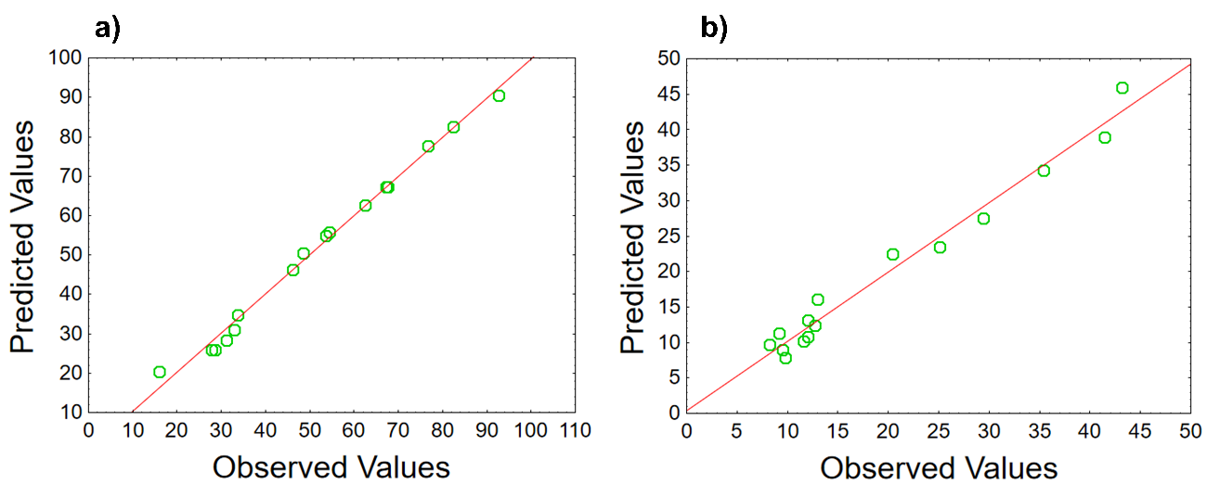
Figure S2. Plot of experimentally observed versus model-predicted values for the response of (a) %DEG and (b) %MIN in the EF process.

Table S4. Results of the 2³ Central Composite Design with the degradation and mineralization percentage responses for the Photoelectro-Fenton Process.
Experiments | j  (mA cm⁻²) | [Fe³⁺]  (mg L⁻¹) | [Fe³⁺:Citrate] | %DEG | %MIN
12 | 60.000 | 13.727 | 1:2 | 50.6 | 25.1
14 | 60.000 | 7.000 | 1:3.68 | 61.2 | 25.9
3 | 35.000 | 11.000 | 1:1 | 38.1 | 15.0
6 | 85.000 | 3.000 | 1:3 | 97.0 | 40.2
16 (C) | 60.000 | 7.000 | 1:2 | 70.1 | 34.2
8 | 85.000 | 11.000 | 1:3 | 75.6 | 36.2
5 | 85.000 | 3.000 | 1:1 | 99.3 | 45.0
17 (C) | 60.000 | 7.000 | 1:2 | 70.6 | 34.7
10 | 102.044 | 7.000 | 1:2 | 97.7 | 44.0
2 | 35.000 | 3.000 | 1:3 | 45.1 | 11.0
15 (C) | 60.000 | 7.000 | 1:2 | 70.5 | 34.6
1 | 35.000 | 3.000 | 1:1 | 48.5 | 12.1
11 | 60.000 | 0.273 | 1:2 | 77.1 | 26.2
13 | 60.000 | 7.000 | 1:0.32 | 81.9 | 27.0
9 | 17.955 | 7.000 | 1:2 | 15.6 | 5.7
7 | 85.000 | 11.000 | 1:1 | 86.8 | 38.2
4 | 35.000 | 11.000 | 1:3 | 25.4 | 16.2
* Highlighted in red in the table is the experiment that presented results considered optimal.

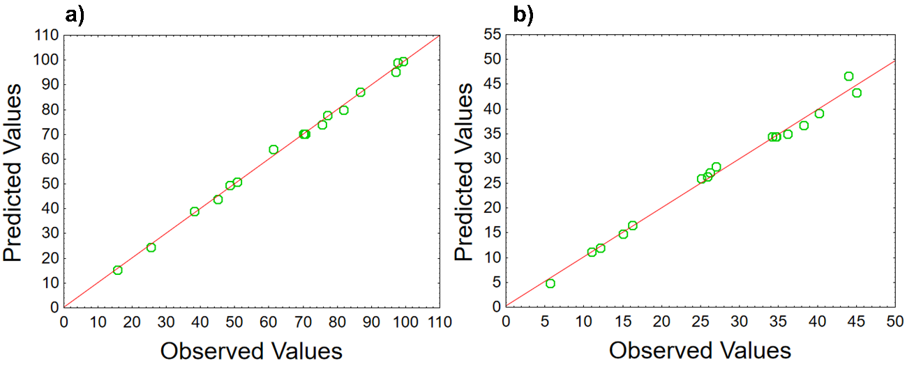
Figure S3. Plot of experimentally observed versus model-predicted values for the response of (a) %DEG and (b) %MIN in the PEF process.

