Additional file 1
Sustained-attention slowing and trial-level P3-reaction time coupling in university students with generalized anxiety disorder and self-reported habitual short sleep: a secondary cross-sectional study

Supplementary Methods S1. Age- and sex-adjusted sensitivity analyses
Participant-level age and sex data were available for all 69 participants. Original unadjusted analyses remained primary. Sensitivity models included centered age and sex. Continuous participant-level outcomes used HC3 inference with Huber sensitivity analyses. The lapse outcome was also assessed using an NB2 count model with log(valid trials) as an offset. EEG contrasts preserved their original endpoint-family membership, and a separate global sensitivity correction covered 42 adjusted EEG contrasts. Trial-level models preserved the original task covariates and added age and sex.

Supplementary Methods S2. PVT parameter reconstruction
The PVT used E-Prime 3.0 as one continuous run. The recorded event stream contained S11 target, S1 response, and S3 feedback markers, a 10-s timeout, 79–81 target events, and a run duration of 577.5–603.6 s. Participants responded with the right hand using the ‘1’ key on a Lenovo keyboard. The exact programmed foreperiod and feedback duration could not be recovered from the available task files and were not inferred.

Supplementary Table S1. Complete primary behavioral analyses
Endpoint | HC mean | GAD-HSS mean | Difference | Hedges’ g | p | p_{FDR}
median RT (ms) | 320.000 | 353.000 | 33.000 | 0.745 | 0.0022 | 0.0087
RT coefficient of variation | 0.429 | 0.386 | −0.043 | −0.112 | 0.6479 | 0.6479
lapse proportion | 0.056 | 0.100 | 0.044 | 0.474 | 0.0455 | 0.0606
omission proportion | 0.001 | 0.003 | 0.002 | 0.174 | 0.4397 | 0.513
mean RT (ms) | 351.958 | 390.455 | 38.497 | 0.512 | 0.0295 | 0.0516
RT SD (ms) | 164.142 | 172.995 | 8.853 | 0.043 | 0.8559 | 0.8559
median response speed | 3.160 | 2.886 | −0.275 | −0.747 | 0.0023 | 0.0054
severe attention-failure proportion | 0.057 | 0.103 | 0.046 | 0.488 | 0.0395 | 0.0553
early median RT (ms) | 311.688 | 343.757 | 32.069 | 0.764 | 0.0015 | 0.0054
late median RT (ms) | 328.031 | 368.324 | 40.293 | 0.741 | 0.0023 | 0.0054
RT progress slope (ms) | −43.735 | 57.519 | 101.254 | 0.588 | 0.0187 | 0.0373

Supplementary Table S2. Age- and sex-adjusted behavioral models
Endpoint | Family | n | Adjusted effect | 95% CI | p | p_{FDR} | Scale
median RT (ms) | primary behavioral endpoint | 69 | 31.4755 | 3.4559 to 59.4951 | 0.0283 | 0.0449 | ms; Anxiety minus Healthy
RT coefficient of variation | primary behavioral endpoint | 69 | 0.0182 | −0.2198 to 0.2563 | 0.879 | 0.879 | coefficient of variation; Anxiety minus Healthy
lapse proportion | primary behavioral endpoint | 69 | 0.7424 | 0.0572 to 1.4276 | 0.0337 | 0.0449 | log odds (Anxiety vs Healthy); odds ratio also reported
RT progress slope (ms) | primary behavioral endpoint | 69 | 100.2556 | 16.5581 to 183.9531 | 0.0196 | 0.0449 | ms across normalized task progress; Anxiety minus Healthy
mean RT (ms) | secondary behavioral endpoint | 69 | 44.2699 | −3.8139 to 92.3536 | 0.0705 | 0.0705 | ms; Anxiety minus Healthy
median response speed | secondary behavioral endpoint | 69 | −0.2520 | −0.4787 to −0.0253 | 0.0299 | 0.0598 | responses/s; Anxiety minus Healthy

Supplementary Table S3. Lapse overdispersion sensitivity models
Model | Measure | Effect | 95% CI | p | Dispersion | AIC | FDR handling
Participant-aggregate binomial with HC3 sandwich | OR | 2.101 | 1.059–4.169 | 0.0337 | 8.997 |  | Member of the original four-endpoint adjusted behavioral family
Negative-binomial NB2 lapse-count sensitivity with log(valid trials) offset | IRR | 1.887 | 1.110–3.205 | 0.0189 | 0.986 | 407.975 | Additional sensitivity model; did not redefine the original adjusted family

Supplementary Table S4. Complete ERP analyses
Component | Analysis | Contrast | n HC/GAD-HSS | Difference (µV) | 95% CI | p | p_{FDR}
P1 | all valid × group | all valid | 25/33 | −0.480 | −1.222 to 0.262 | 0.1975 | 0.4168
P1 | speed interaction | slow versus fast | 19/17 | 0.169 | −1.391 to 1.728 | 0.827 | 0.8532
P1 | time interaction | late versus early | 18/20 | −0.789 | −2.500 to 0.922 | 0.3559 | 0.5338
N1 | all valid × group | all valid | 25/33 | −0.899 | −2.142 to 0.344 | 0.153 | 0.4168
N1 | speed interaction | slow versus fast | 19/17 | 0.194 | −1.943 to 2.332 | 0.8532 | 0.8532
N1 | time interaction | late versus early | 18/20 | 1.239 | −0.723 to 3.202 | 0.2084 | 0.4168
N2 | all valid × group | all valid | 25/33 | 0.733 | −1.371 to 2.836 | 0.487 | 0.487
N2 | speed interaction | slow versus fast | 19/17 | 3.518 | −0.083 to 7.119 | 0.0552 | 0.2997
N2 | time interaction | late versus early | 18/20 | 1.388 | −1.424 to 4.199 | 0.3218 | 0.3861
P3/LPC | all valid × group | all valid | 25/33 | −2.249 | −5.436 to 0.938 | 0.1623 | 0.3246
P3/LPC | speed interaction | slow versus fast | 19/17 | 2.070 | −1.557 to 5.697 | 0.2498 | 0.3747
P3/LPC | time interaction | late versus early | 18/20 | 2.063 | −0.415 to 4.540 | 0.0999 | 0.2997
readiness | all valid × group | all valid | 24/29 | −0.197 | −1.207 to 0.814 | 0.6971 | 0.8963
readiness | speed interaction | slow versus fast | 16/13 | 0.974 | −1.653 to 3.602 | 0.4514 | 0.8963
readiness | time interaction | late versus early | 15/15 | −0.849 | −3.810 to 2.113 | 0.5601 | 0.8963
motor | all valid × group | all valid | 24/29 | −0.632 | −3.249 to 1.984 | 0.6296 | 0.8963
motor | speed interaction | slow versus fast | 16/13 | −0.110 | −4.308 to 4.087 | 0.9564 | 0.9564
motor | time interaction | late versus early | 15/15 | −0.217 | −3.118 to 2.683 | 0.8791 | 0.9564
post-response | all valid × group | all valid | 24/29 | −2.538 | −5.857 to 0.781 | 0.1307 | 0.8963
post-response | speed interaction | slow versus fast | 16/13 | −1.190 | −5.470 to 3.090 | 0.5691 | 0.8963
post-response | time interaction | late versus early | 15/15 | −1.138 | −4.646 to 2.371 | 0.5111 | 0.8963

Supplementary Table S5. Age- and sex-adjusted ERP analyses
Endpoint | Analysis | Contrast | n HC/GAD-HSS | Adjusted effect | 95% CI | p | Family p_{FDR} | Global p_{FDR}
P1 | all valid × group | all valid | 25/33 | −0.570 | −1.377 to 0.237 | 0.1627 | 0.3254 | 0.541
P1 | speed interaction | slow versus fast | 19/17 | −0.213 | −2.343 to 1.917 | 0.8398 | 0.945 | 0.9803
P1 | time interaction | late versus early | 18/20 | 0.121 | −1.864 to 2.105 | 0.9025 | 0.945 | 0.9803
N1 | all valid × group | all valid | 25/33 | −1.316 | −2.775 to 0.142 | 0.076 | 0.3254 | 0.4593
N1 | speed interaction | slow versus fast | 19/17 | −0.131 | −3.980 to 3.717 | 0.945 | 0.945 | 0.9803
N1 | time interaction | late versus early | 18/20 | 2.117 | −0.716 to 4.951 | 0.1382 | 0.3254 | 0.5275
N2 | all valid × group | all valid | 25/33 | 0.020 | −2.444 to 2.484 | 0.9873 | 0.9873 | 0.9873
N2 | speed interaction | slow versus fast | 19/17 | 3.493 | −0.670 to 7.657 | 0.0971 | 0.1289 | 0.5011
N2 | time interaction | late versus early | 18/20 | 2.498 | −0.572 to 5.568 | 0.1074 | 0.1289 | 0.5011
P3/LPC | all valid × group | all valid | 25/33 | −3.408 | −6.805 to −0.011 | 0.0493 | 0.1289 | 0.4141
P3/LPC | speed interaction | slow versus fast | 19/17 | 3.189 | −0.360 to 6.739 | 0.0765 | 0.1289 | 0.4593
P3/LPC | time interaction | late versus early | 18/20 | 3.158 | 0.092 to 6.225 | 0.0439 | 0.1289 | 0.4141
readiness | all valid × group | all valid | 24/29 | −0.471 | −1.601 to 0.660 | 0.4069 | 0.9569 | 0.7947
readiness | speed interaction | slow versus fast | 16/13 | 1.137 | −1.816 to 4.091 | 0.4352 | 0.9569 | 0.7947
readiness | time interaction | late versus early | 15/15 | 0.959 | −4.510 to 6.428 | 0.7214 | 0.9569 | 0.9803
motor | all valid × group | all valid | 24/29 | −1.466 | −4.137 to 1.206 | 0.2755 | 0.9569 | 0.6807
motor | speed interaction | slow versus fast | 16/13 | 0.580 | −4.080 to 5.240 | 0.7997 | 0.9569 | 0.9803
motor | time interaction | late versus early | 15/15 | 1.006 | −6.764 to 8.776 | 0.7922 | 0.9569 | 0.9803
post-response | all valid × group | all valid | 24/29 | −4.171 | −7.408 to −0.933 | 0.0126 | 0.1137 | 0.363
post-response | speed interaction | slow versus fast | 16/13 | −0.415 | −5.902 to 5.071 | 0.8774 | 0.9569 | 0.9803
post-response | time interaction | late versus early | 15/15 | 0.197 | −7.244 to 7.639 | 0.9569 | 0.9569 | 0.9803

Supplementary Table S6. Complete time-frequency and response-beta analyses
Metric | Analysis | Contrast | n HC/GAD-HSS | Difference | 95% CI | p | p_{FDR}
poststimulus theta (dB) | all valid × group | all valid | 24/31 | −0.222 | −0.690 to 0.245 | 0.3441 | 0.6452
poststimulus theta (dB) | speed interaction | slow versus fast | 15/13 | 0.100 | −1.079 to 1.279 | 0.8626 | 0.906
poststimulus theta (dB) | time interaction | late versus early | 17/15 | 0.835 | −0.184 to 1.855 | 0.1045 | 0.6452
alpha suppression (dB) | all valid × group | all valid | 24/31 | 0.193 | −0.884 to 1.270 | 0.7195 | 0.906
alpha suppression (dB) | speed interaction | slow versus fast | 15/13 | −0.084 | −1.336 to 1.168 | 0.8911 | 0.906
alpha suppression (dB) | time interaction | late versus early | 17/15 | −0.159 | −1.542 to 1.223 | 0.8157 | 0.906
prestimulus alpha log power | all valid × group | all valid | 24/31 | 0.144 | −0.104 to 0.392 | 0.2453 | 0.6452
prestimulus alpha log power | speed interaction | slow versus fast | 15/13 | 0.052 | −0.024 to 0.128 | 0.1724 | 0.6452
prestimulus alpha log power | time interaction | late versus early | 17/15 | −0.006 | −0.118 to 0.105 | 0.906 | 0.906
delta ITPC | all valid × group | all valid | 24/31 | −0.034 | −0.103 to 0.034 | 0.3213 | 0.6452
delta ITPC | speed interaction | slow versus fast | 15/13 | 0.023 | −0.142 to 0.189 | 0.7741 | 0.906
delta ITPC | time interaction | late versus early | 17/15 | 0.065 | −0.049 to 0.179 | 0.2548 | 0.6452
theta ITPC | all valid × group | all valid | 24/31 | −0.046 | −0.094 to 0.001 | 0.0568 | 0.6452
theta ITPC | speed interaction | slow versus fast | 15/13 | 0.045 | −0.072 to 0.163 | 0.429 | 0.715
theta ITPC | time interaction | late versus early | 17/15 | 0.047 | −0.046 to 0.139 | 0.3097 | 0.6452
pre-response beta (dB) | all valid × group | all valid | 24/33 | 0.225 | −0.004 to 0.454 | 0.0538 | 0.1614
pre-response beta (dB) | speed interaction | slow versus fast | 19/17 | 0.188 | −0.382 to 0.757 | 0.506 | 0.506
pre-response beta (dB) | time interaction | late versus early | 20/19 | −0.436 | −1.073 to 0.201 | 0.1725 | 0.3072
post-response beta (dB) | all valid × group | all valid | 24/33 | 0.207 | −0.252 to 0.666 | 0.3689 | 0.4427
post-response beta (dB) | speed interaction | slow versus fast | 19/17 | −0.345 | −0.891 to 0.200 | 0.2048 | 0.3072
post-response beta (dB) | time interaction | late versus early | 20/19 | −0.833 | −1.426 to −0.240 | 0.0072 | 0.0431

Supplementary Table S7. Adjusted time-frequency and response-beta analyses
Endpoint | Analysis | Contrast | n HC/GAD-HSS | Adjusted effect | 95% CI | p | Family p_{FDR} | Global p_{FDR}
poststimulus theta (dB) | all valid × group | all valid | 24/31 | −0.235 | −0.898 to 0.429 | 0.4809 | 0.9016 | 0.8415
poststimulus theta (dB) | speed interaction | slow versus fast | 15/13 | 0.090 | −1.583 to 1.764 | 0.9123 | 0.9123 | 0.9803
poststimulus theta (dB) | time interaction | late versus early | 17/15 | 0.632 | −0.462 to 1.725 | 0.2469 | 0.9016 | 0.6672
alpha suppression (dB) | all valid × group | all valid | 24/31 | 0.363 | −0.849 to 1.575 | 0.5502 | 0.9123 | 0.8888
alpha suppression (dB) | speed interaction | slow versus fast | 15/13 | −0.131 | −1.542 to 1.279 | 0.8491 | 0.9123 | 0.9803
alpha suppression (dB) | time interaction | late versus early | 17/15 | 0.163 | −1.404 to 1.730 | 0.8326 | 0.9123 | 0.9803
prestimulus alpha log power | all valid × group | all valid | 24/31 | 0.112 | −0.135 to 0.358 | 0.3666 | 0.9016 | 0.7698
prestimulus alpha log power | speed interaction | slow versus fast | 15/13 | 0.059 | −0.045 to 0.163 | 0.2542 | 0.9016 | 0.6672
prestimulus alpha log power | time interaction | late versus early | 17/15 | −0.031 | −0.201 to 0.139 | 0.7144 | 0.9123 | 0.9803
delta ITPC | all valid × group | all valid | 24/31 | −0.037 | −0.114 to 0.041 | 0.3452 | 0.9016 | 0.7631
delta ITPC | speed interaction | slow versus fast | 15/13 | 0.013 | −0.175 to 0.201 | 0.8871 | 0.9123 | 0.9803
delta ITPC | time interaction | late versus early | 17/15 | 0.050 | −0.078 to 0.179 | 0.4307 | 0.9016 | 0.7947
theta ITPC | all valid × group | all valid | 24/31 | −0.039 | −0.088 to 0.011 | 0.1202 | 0.9016 | 0.5048
theta ITPC | speed interaction | slow versus fast | 15/13 | 0.013 | −0.114 to 0.139 | 0.8378 | 0.9123 | 0.9803
theta ITPC | time interaction | late versus early | 17/15 | 0.052 | −0.039 to 0.144 | 0.2515 | 0.9016 | 0.6672
pre-response beta (dB) | all valid × group | all valid | 24/33 | 0.303 | 0.038 to 0.569 | 0.0259 | 0.0778 | 0.363
pre-response beta (dB) | speed interaction | slow versus fast | 19/17 | 0.316 | −0.676 to 1.308 | 0.5211 | 0.6253 | 0.8754
pre-response beta (dB) | time interaction | late versus early | 20/19 | −0.385 | −1.168 to 0.398 | 0.3249 | 0.4874 | 0.7581
post-response beta (dB) | all valid × group | all valid | 24/33 | 0.389 | −0.168 to 0.946 | 0.1675 | 0.3349 | 0.541
post-response beta (dB) | speed interaction | slow versus fast | 19/17 | −0.160 | −1.302 to 0.981 | 0.7766 | 0.7766 | 0.9803
post-response beta (dB) | time interaction | late versus early | 20/19 | −0.931 | −1.741 to −0.122 | 0.0254 | 0.0778 | 0.363

Supplementary Table S8. Single-trial models and trial-count reconciliation
Model/data stage | Participants | Trials | P3 result | Reconciliation note
Source analysis table | 60 | 3,266 | Not a fitted model | Contains 35 rows missing foreperiod and/or previous-trial RT derivatives
Primary P3 random-intercept model | 60 | 3,231 | β = −0.02384; SE = 0.00593; p = 5.89 × 10⁻⁵ | Residual df = 3,224 plus seven fixed effects confirms n = 3,231
Adjusted correlated P3 random-slope model | 60 | 3,231 | β = −0.02332; 95% CI −0.03929 to −0.00736; p = 0.00420 | P3 × group p = 0.144

Supplementary Table S9. Primary and adjusted FDR-family definitions
Family | m | Membership | Adjusted-analysis handling
Behavior primary | 4 | Median RT; RT CV; lapse proportion; participant reaction-time progress slope | Same endpoints after age/sex adjustment
Behavior secondary | 2 | Mean RT; median response speed | Same endpoints after age/sex adjustment
Early ERP | 6 | P1 and N1 × three contrasts | Same family
Late ERP | 6 | N2 and P3/LPC × three contrasts | Same family
Response ERP | 9 | Readiness, motor, post-response × three contrasts | Same family
Time-frequency | 15 | Five measures × three contrasts | Same family
Response beta | 6 | Pre- and post-response beta × three contrasts | Same family
Global adjusted EEG | 42 | All adjusted EEG contrasts | Sensitivity correction distinct from family p_{FDR}
Adjusted P3 reporting | 2 focal terms | P3 association and P3 × group interaction | Raw p reported; no new BH family defined

Supplementary Table S10. Beta robustness analyses
Analysis | Effect (dB) | 95% CI | p | n HC/GAD-HSS | Conclusion
Primary Welch | −0.833 | −1.426 to −0.240 | 0.0072 | 20/19 | Replicates locked primary result
Wilcoxon rank-sum | −0.833 |  | 0.0237 | 20/19 | Distribution-free sensitivity
10,000-label permutation | −0.833 |  | 0.0059 | 20/19 | Participant-label permutation sensitivity
10,000-resample bootstrap | −0.833 | −1.395 to −0.286 | 0.0024 | 20/19 | Percentile confidence interval and two-sided sign-based bootstrap p value
Huber robust regression | −0.724 | −1.319 to −0.130 | 0.017 | 20/19 | Robust to vertical outliers
Average-reference sensitivity | −0.442 | −0.968 to 0.084 | 0.0972 | 20/24 | Reference sensitivity
Exclude either period with 15-17 clean trials | −1.100 | −1.834 to −0.367 | 0.0058 | 11/8 | Near-threshold trial-retention sensitivity
Leave-one-participant-out range | −0.833 | −0.918 to −0.716 | 0.0136 | 20/19 | All 39 omitted-record estimates retained the primary direction; p range 0.003022-0.01365

Supplementary Table S11. Endpoint-specific participant flow
Stage/endpoint | Healthy | GAD-HSS | Total
Completed baseline records | 32 | 37 | 69
Behavior | 32 | 37 | 69
Primary-reference ERP | 25 | 33 | 58
Stimulus-locked time-frequency | 24 | 31 | 55
All valid post-response beta | 24 | 33 | 57
Paired beta | 20 | 19 | 39
Single-trial P3 | 26 | 34 | 60

Supplementary Table S12. Relationship to the published parent-study protocol
Feature | Clarification
Publication type | Published protocol for the parent study; no participant-level outcomes
Present report | Secondary cross-sectional analysis of baseline data
Registration | ChiCTR2400082221; registered 25 March 2024
Included PVT-EEG acquisition | 28 September to 28 November 2024; all after registration
Previously published present outcomes | None of the current behavior, ERP, time-frequency, response-beta, or single-trial results
Inference boundary | Combined GAD plus self-reported habitual short-sleep group; no GAD-only attribution

Supplementary Figures

Supplementary Figure S1. Endpoint-specific participant flow.
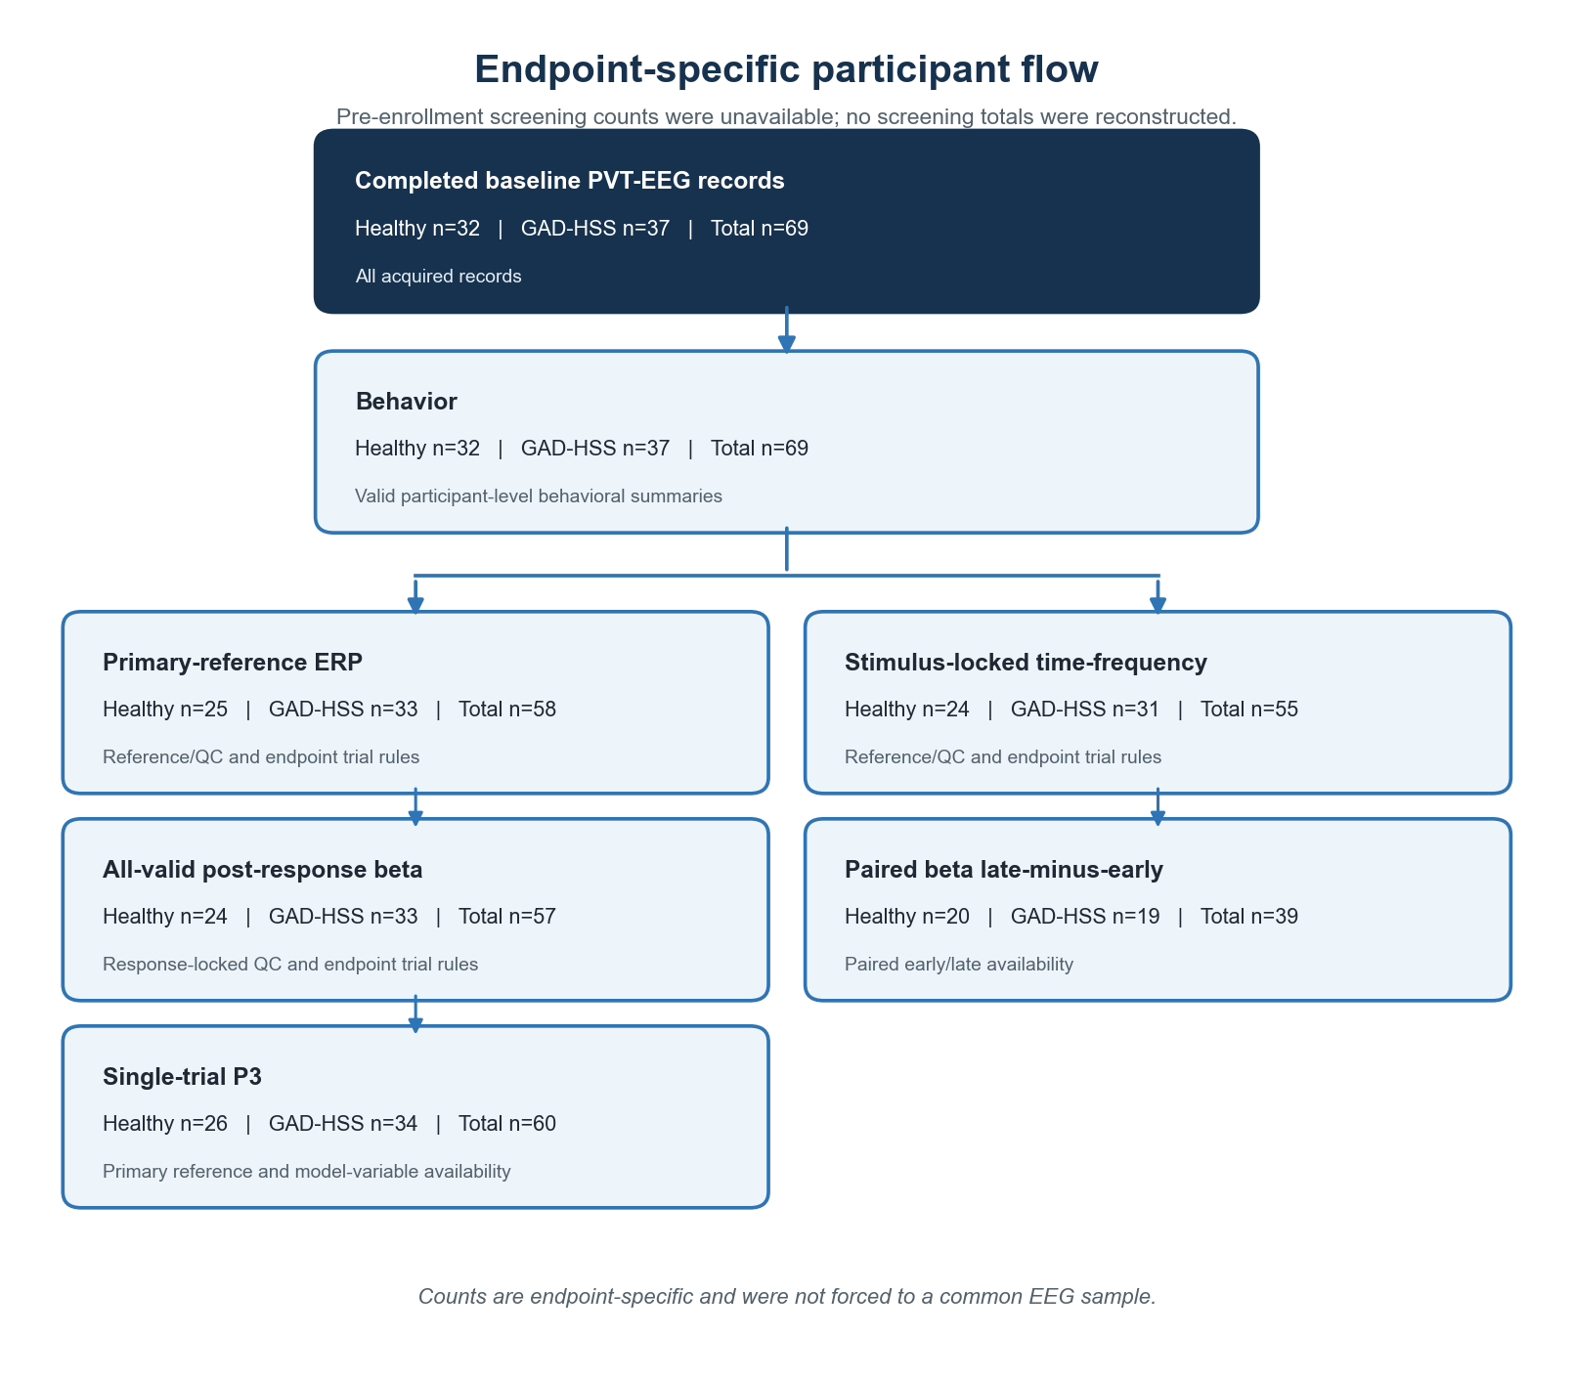
Counts are endpoint-specific. Pre-enrollment screening totals were unavailable and were not reconstructed.

Supplementary Figure S2. Reference sensitivity for key electrophysiological outcomes.
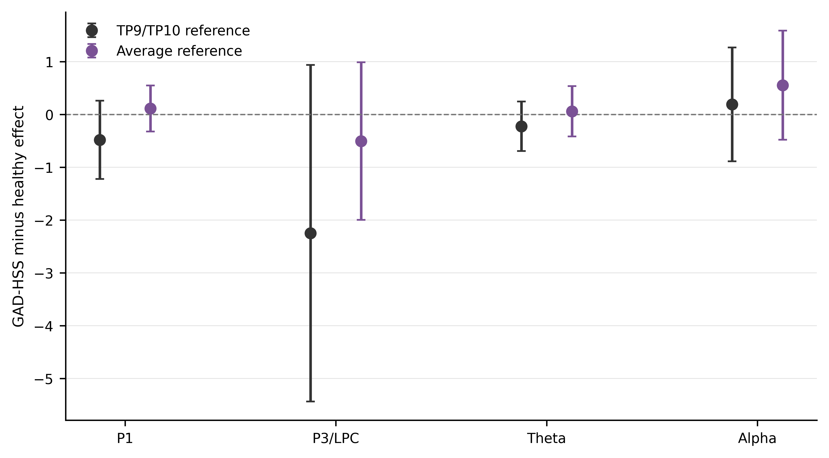
Reference-dependent shifts were visible across the displayed P1, P3/LPC, theta, and alpha estimates; uncertainty remained substantial.

Supplementary Figure S3. Time-on-task influence diagnostics.
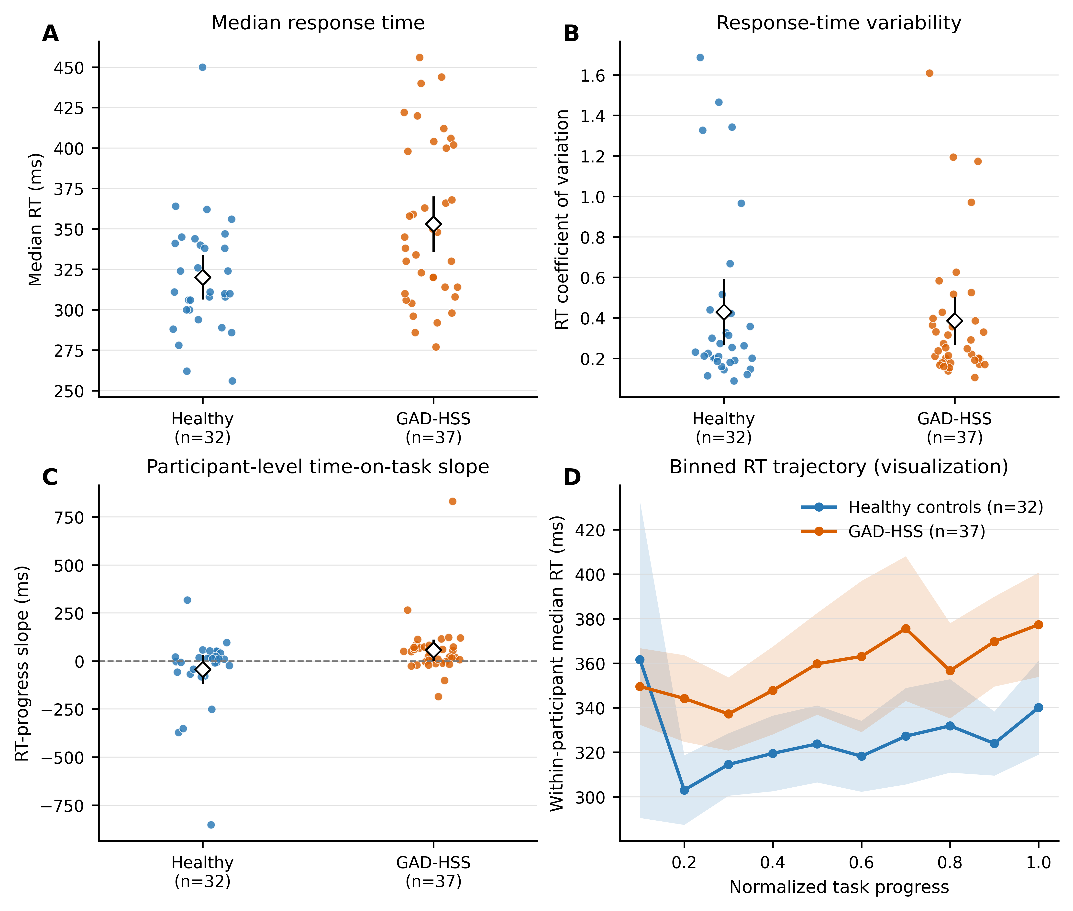
Participant-level slope estimates were influenced by extreme values, while the trial-level interaction remained nonsignificant.

Supplementary Figure S4. Beta leave-one-participant-out analysis.
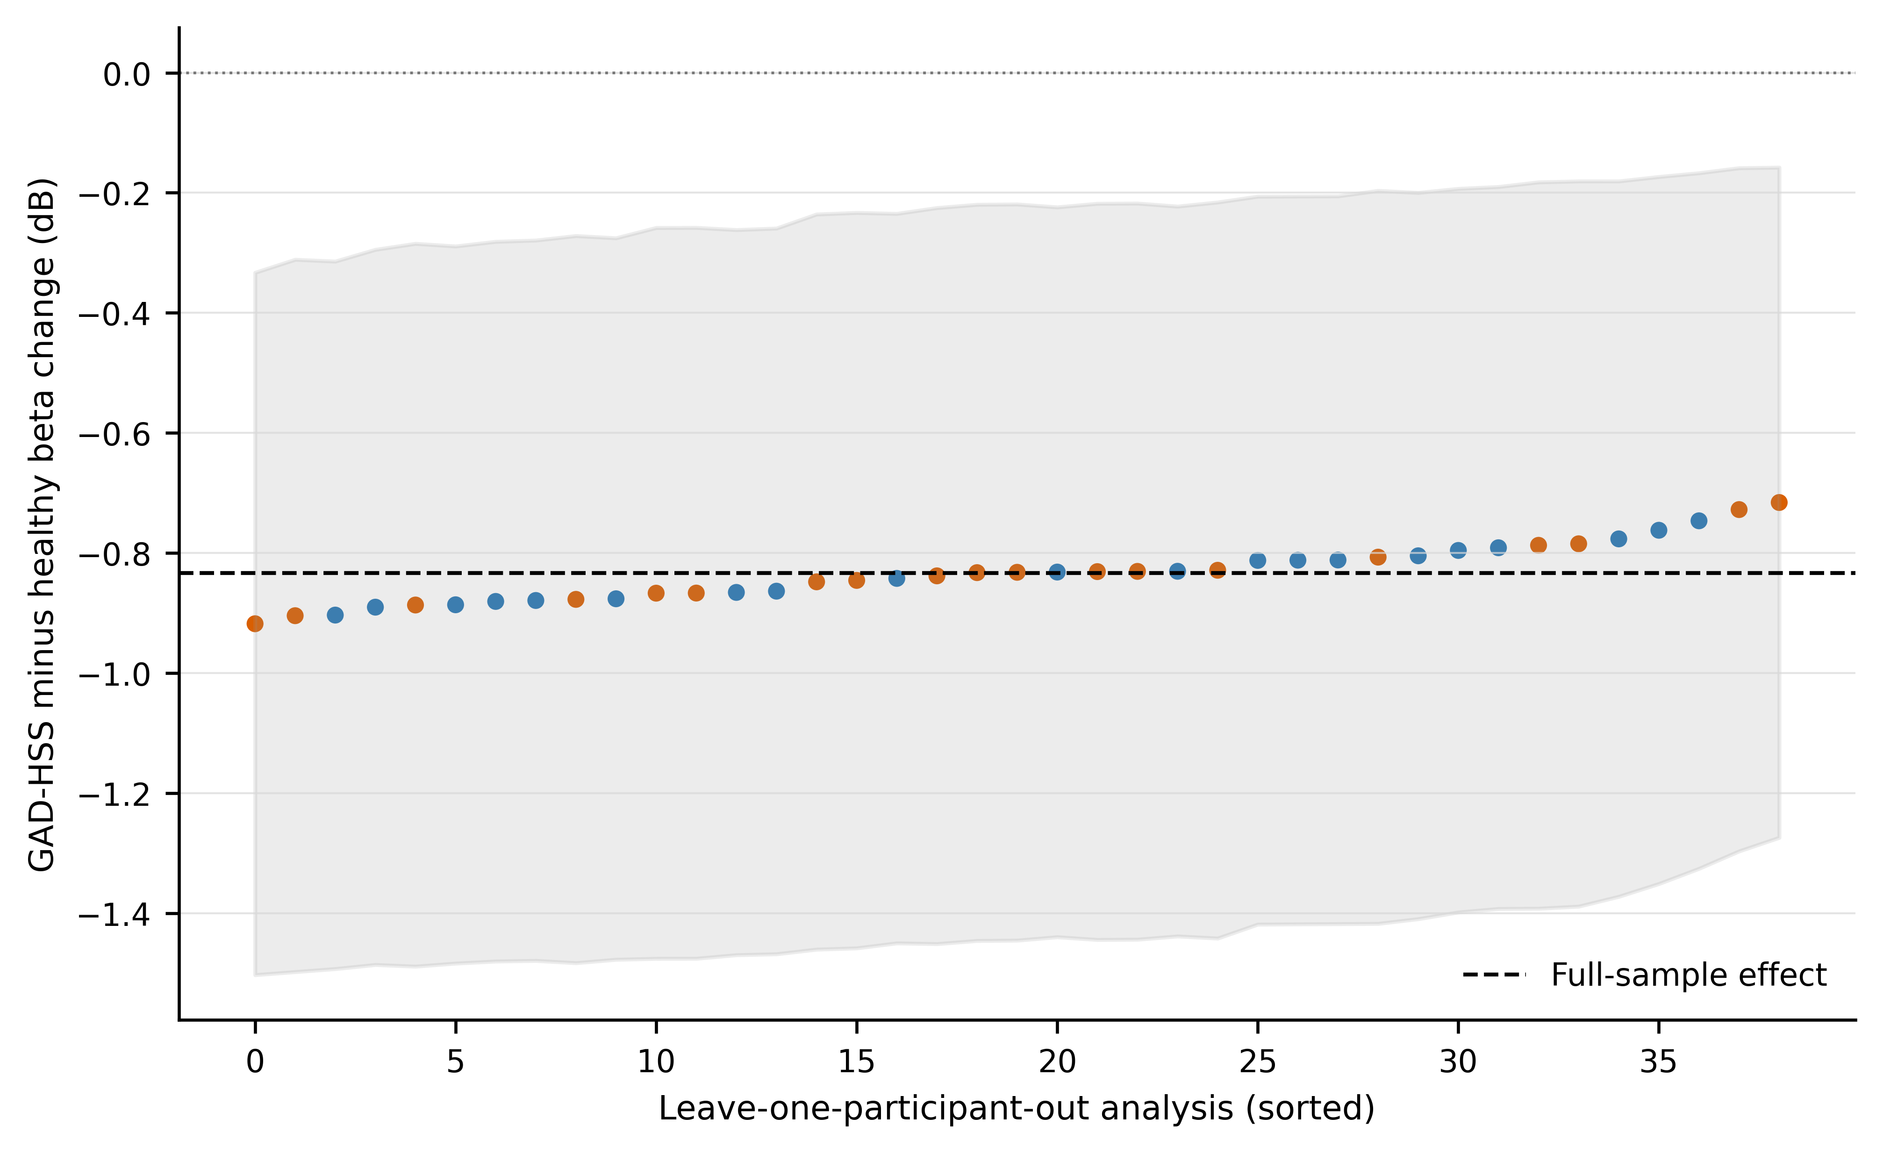
All leave-one-participant-out estimates retained the primary negative direction; this does not resolve reference or multiplicity sensitivity.

