Appendix 1: Co-design process and outcomes
The co-design process involved a series of three online workshops (1.5h each) with a group of seven autistic adults. The first workshop focused on introducing the original paper-based guide and identifying preferences and priorities for digital adaptation. Based on co-design input, Google Sites was used for free and rapid website development, in combination with Google Docs for hosting worksheets, balancing co-designers’ wishes for save-and-return functionality and privacy. The draft prototype was presented at the second workshop for review, refined based on initial feedback, then presented again at the third workshop for further feedback and refinement. Figure A1 depicts this iterative process. Table A1 shows the co-designed adaptations combined from all three workshops and organised according to three dimensions of accessibility.
Figure A1. Process of adapting paper-based guide into digital format
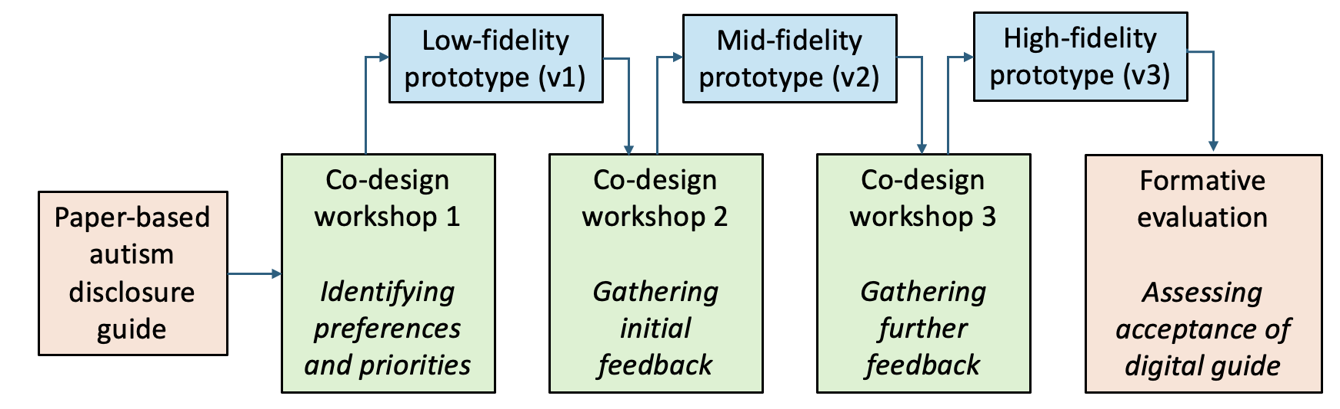
Table A1. Co-designed adaptations to optimise accessibility of the digital guide
Accessibility dimension | Co-designed adaptations
Physical accessibility | Enabling flexible engagement  - Added videos with accompanying transcripts  - Highlighted different ways of engaging with worksheets (e.g., audio/speech options)  - Checked compatibility and functionality across devices (e.g., laptop, tablet, mobile)  Improving visual presentation  - Used a warm, pastel colour scheme  - Increased font size and spacing to improve readability  - Used different colours to distinguish between content sections  - Used icons to signal different activity types (e.g., watch, read, do)
Intellectual accessibility | Supporting understanding  - Added a flowchart illustrating key decision-making steps to supplement textual bullet-point summary  - Added instructions for using worksheets on Google Docs/Drive  - Added examples of completed worksheets  Reducing cognitive load  - Divided content into separate sub-pages  - Reordered or highlighted content to make important points more visible (e.g., accessibility help, legal rights, wellbeing)  - Used collapsible sections to “hide” more detailed information  Facilitating navigation and flow  - Used buttons instead of hyperlinks for key navigation points  - Changed from horizontal to vertical navigation menu  - Added worksheets to the table of contents on each page  - Added links from flowchart to worksheets  - Added links from worksheets back to relevant website sections  - Placed transcript links directly beneath each video  - Improved connectivity between different parts of the website
Social accessibility | Refining terminology  - Replaced "Setting the Tone" with “Our Language and Approach”  - Replaced "secrecy" with "privacy"  - Replaced "testing" someone with "gauging" their reactions  - Used both "disclosure" and "sharing", "story" and "identity"  - Explicitly acknowledged differing language preferences  Increasing inclusivity  - Added information on autism, acknowledging that users will have different levels of self-understanding  - Added acknowledgement of intersectionality and resources on common co-occurring conditions  - Replaced stock photos with illustrations  - Ensured diverse representation of gender and race across illustrations and videos  - Updated national support organisations and removed local support groups to avoid geographical bias/exclusion (replaced with general tips on finding local support)  Enhancing credibility  - Created a custom domain  - Added researcher's contact details  - Created and added logo to website and worksheets

