Appendix 2: Prototype screenshots
Screenshot 1. Website section – home page
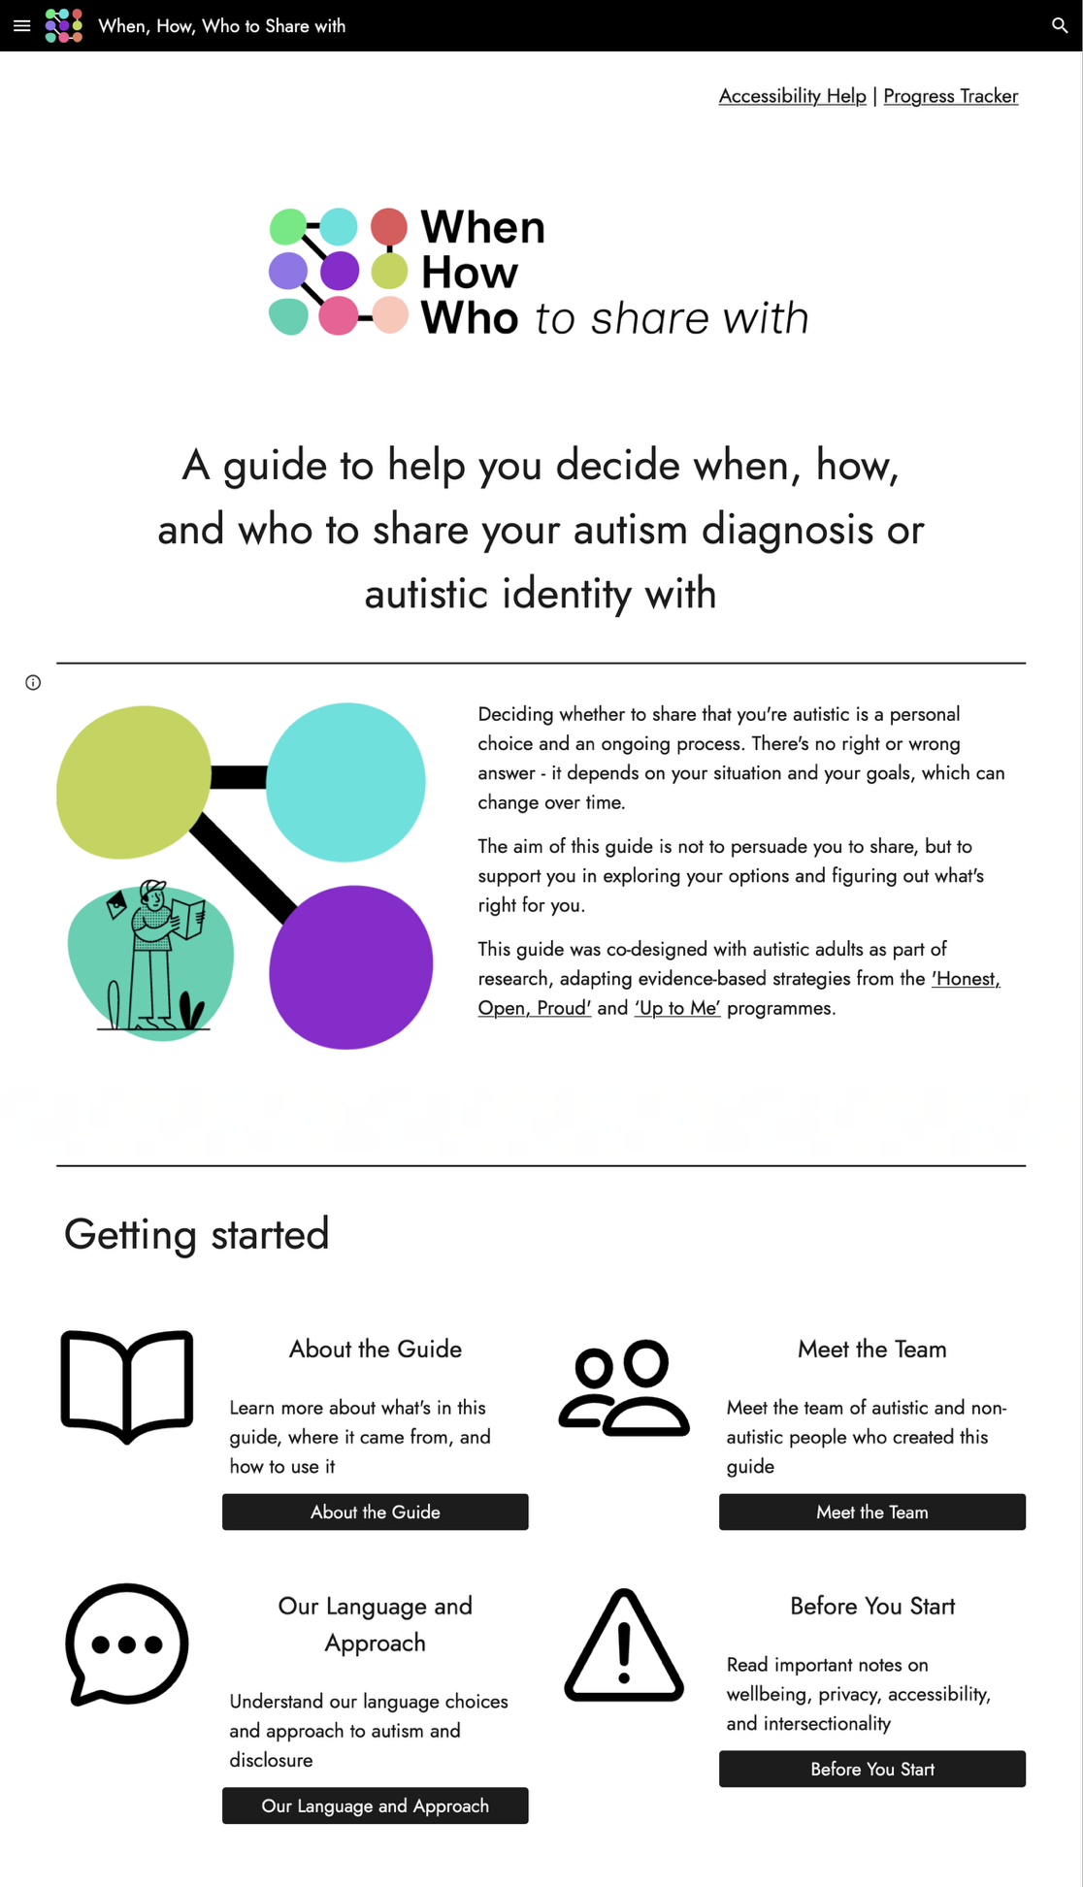
Screenshot 2. Website section – weighing pros and cons of sharing in different settings
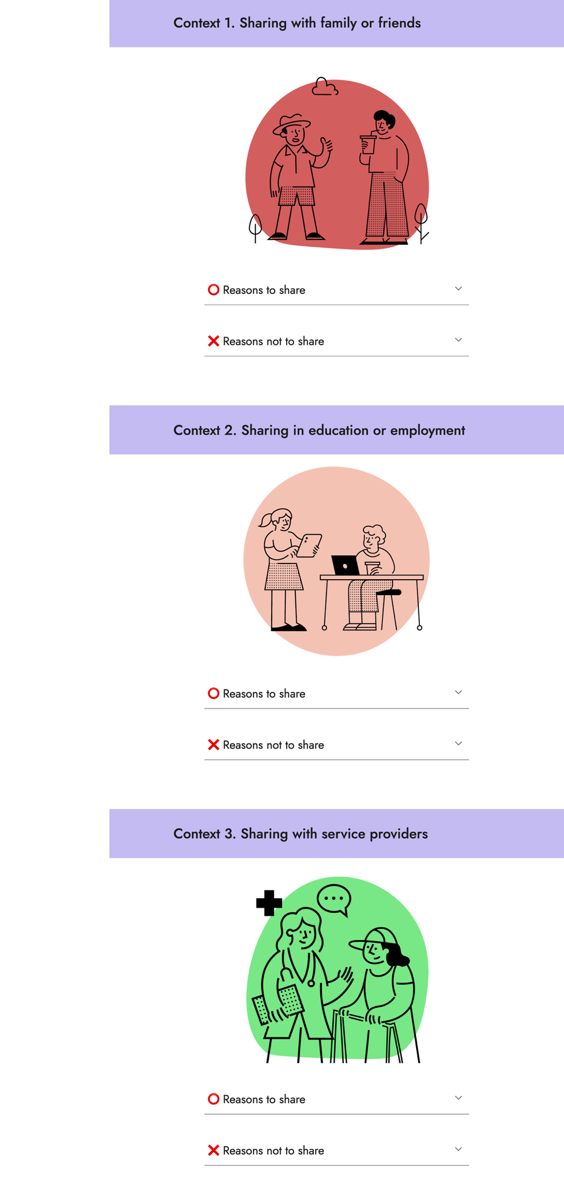
Screenshot 3. Website section – considering different levels of disclosure
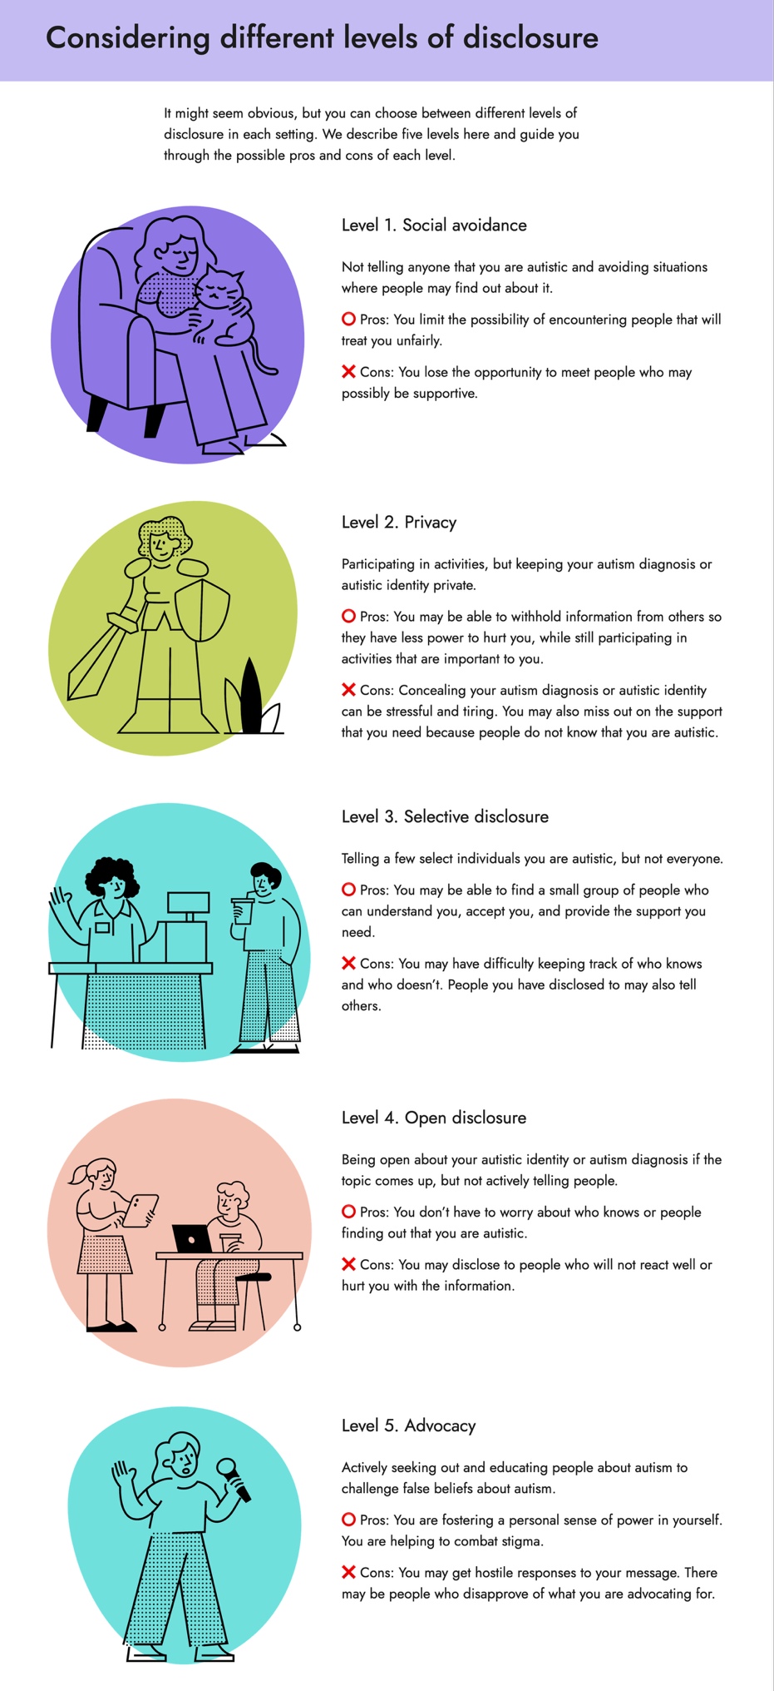
Screenshot 4. Website section – reframing unhelpful beliefs
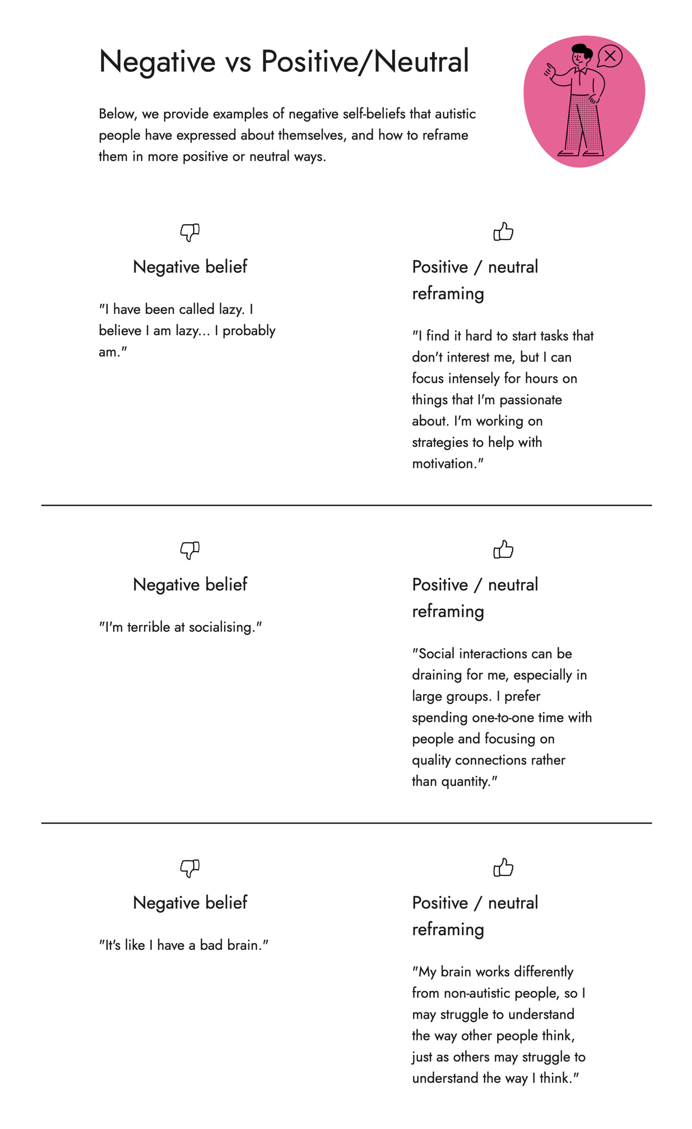
Screenshot 5. Website section – decision-making flowchart
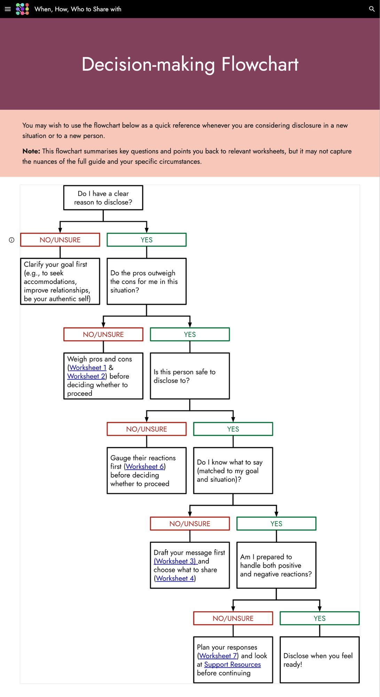
Screenshot 6. Website section – accessibility help
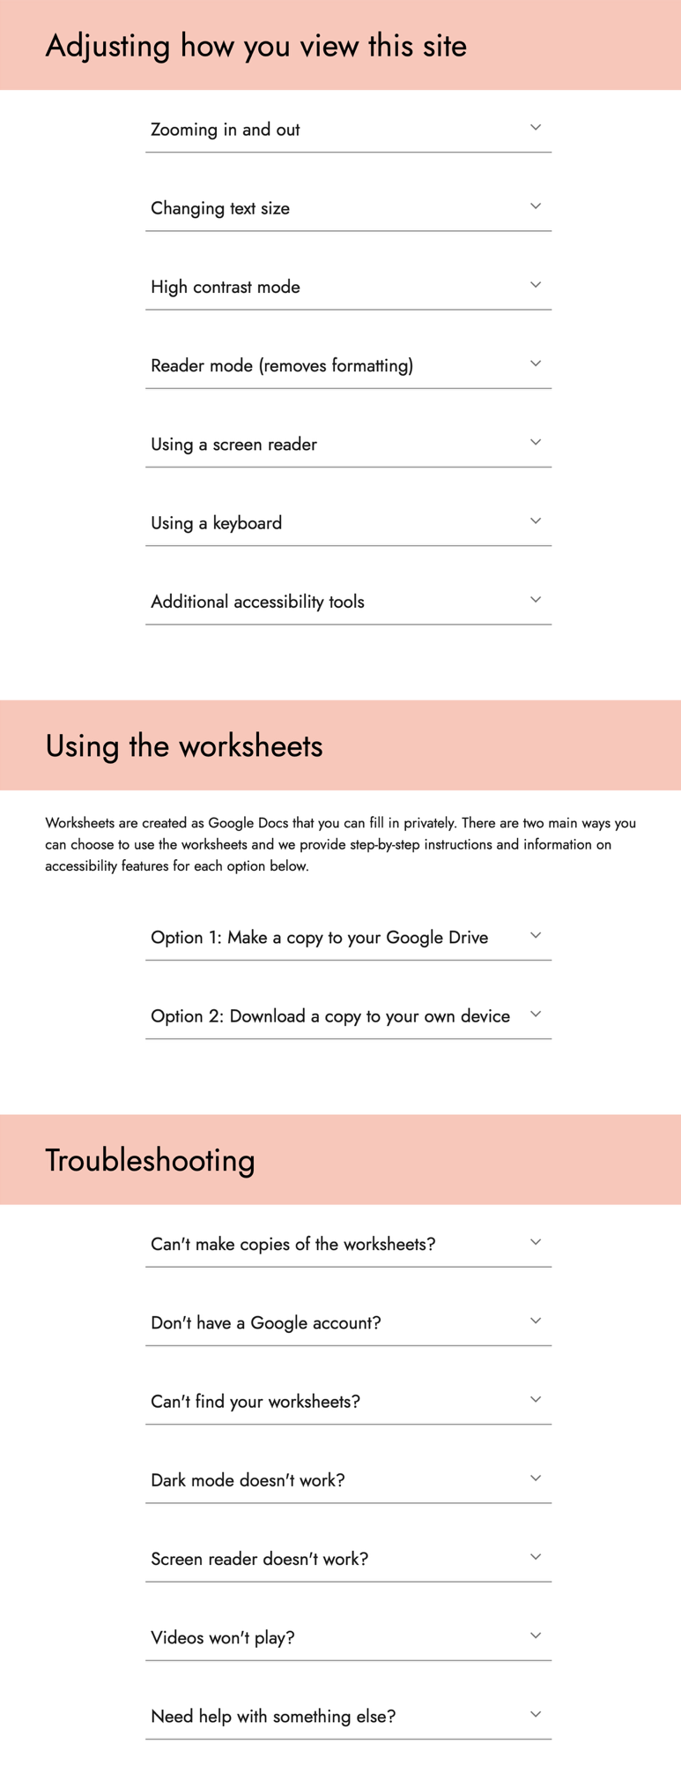
Screenshot 7. Website section – support resources
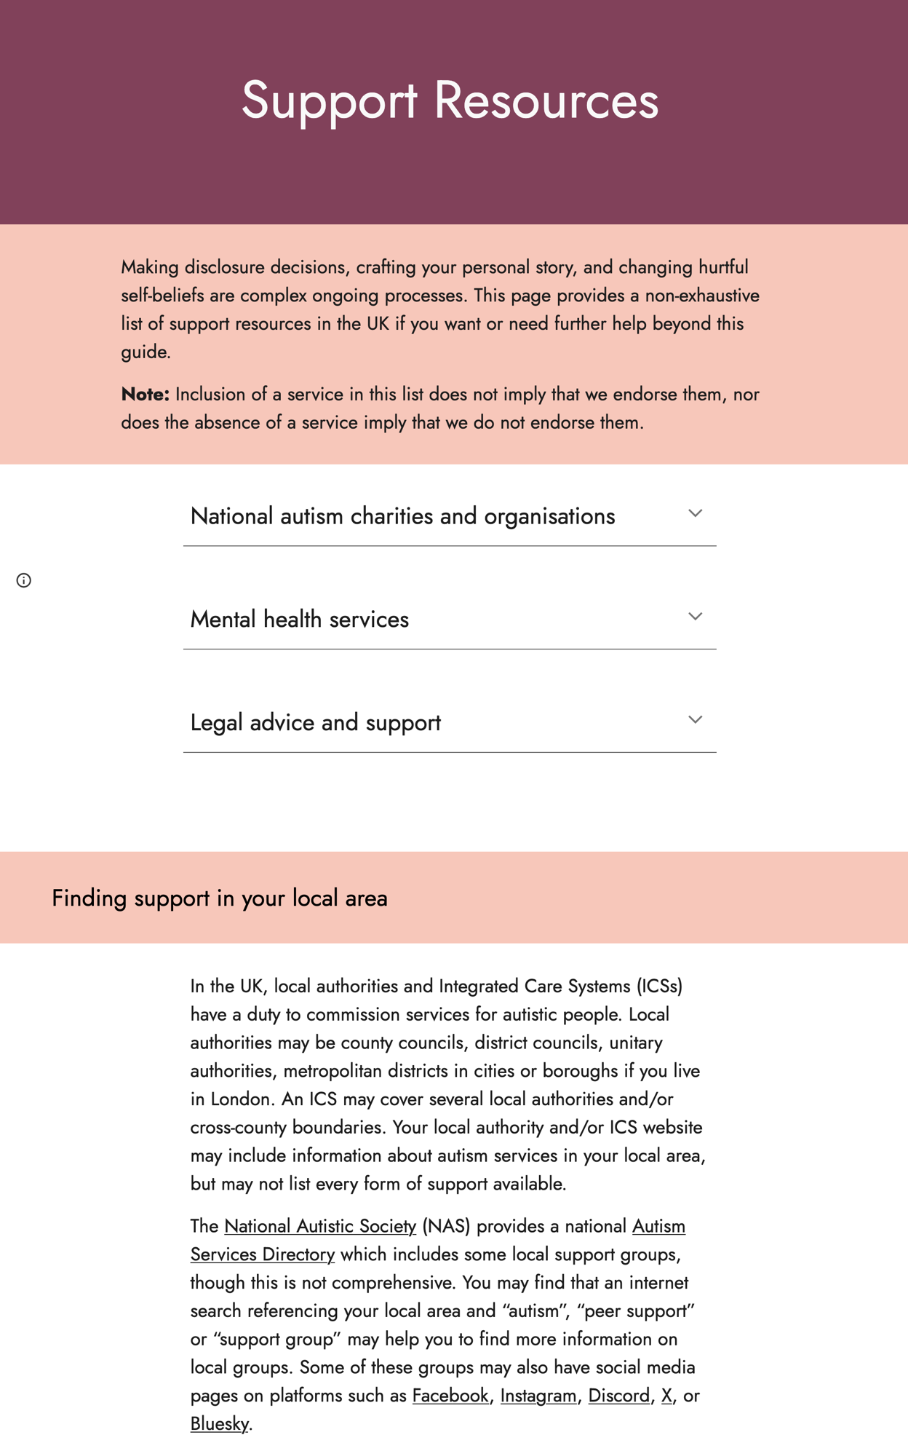
Screenshot 8. Copy of blank worksheet
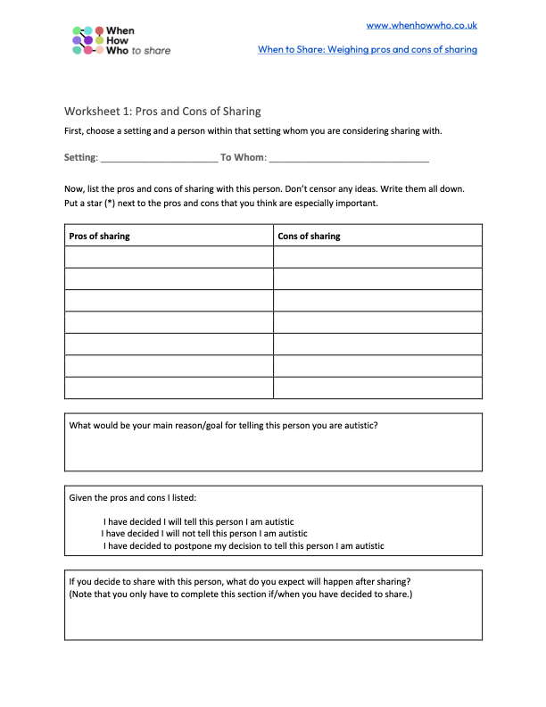
Screenshot 9. Example of completed worksheet
