Supplementary information
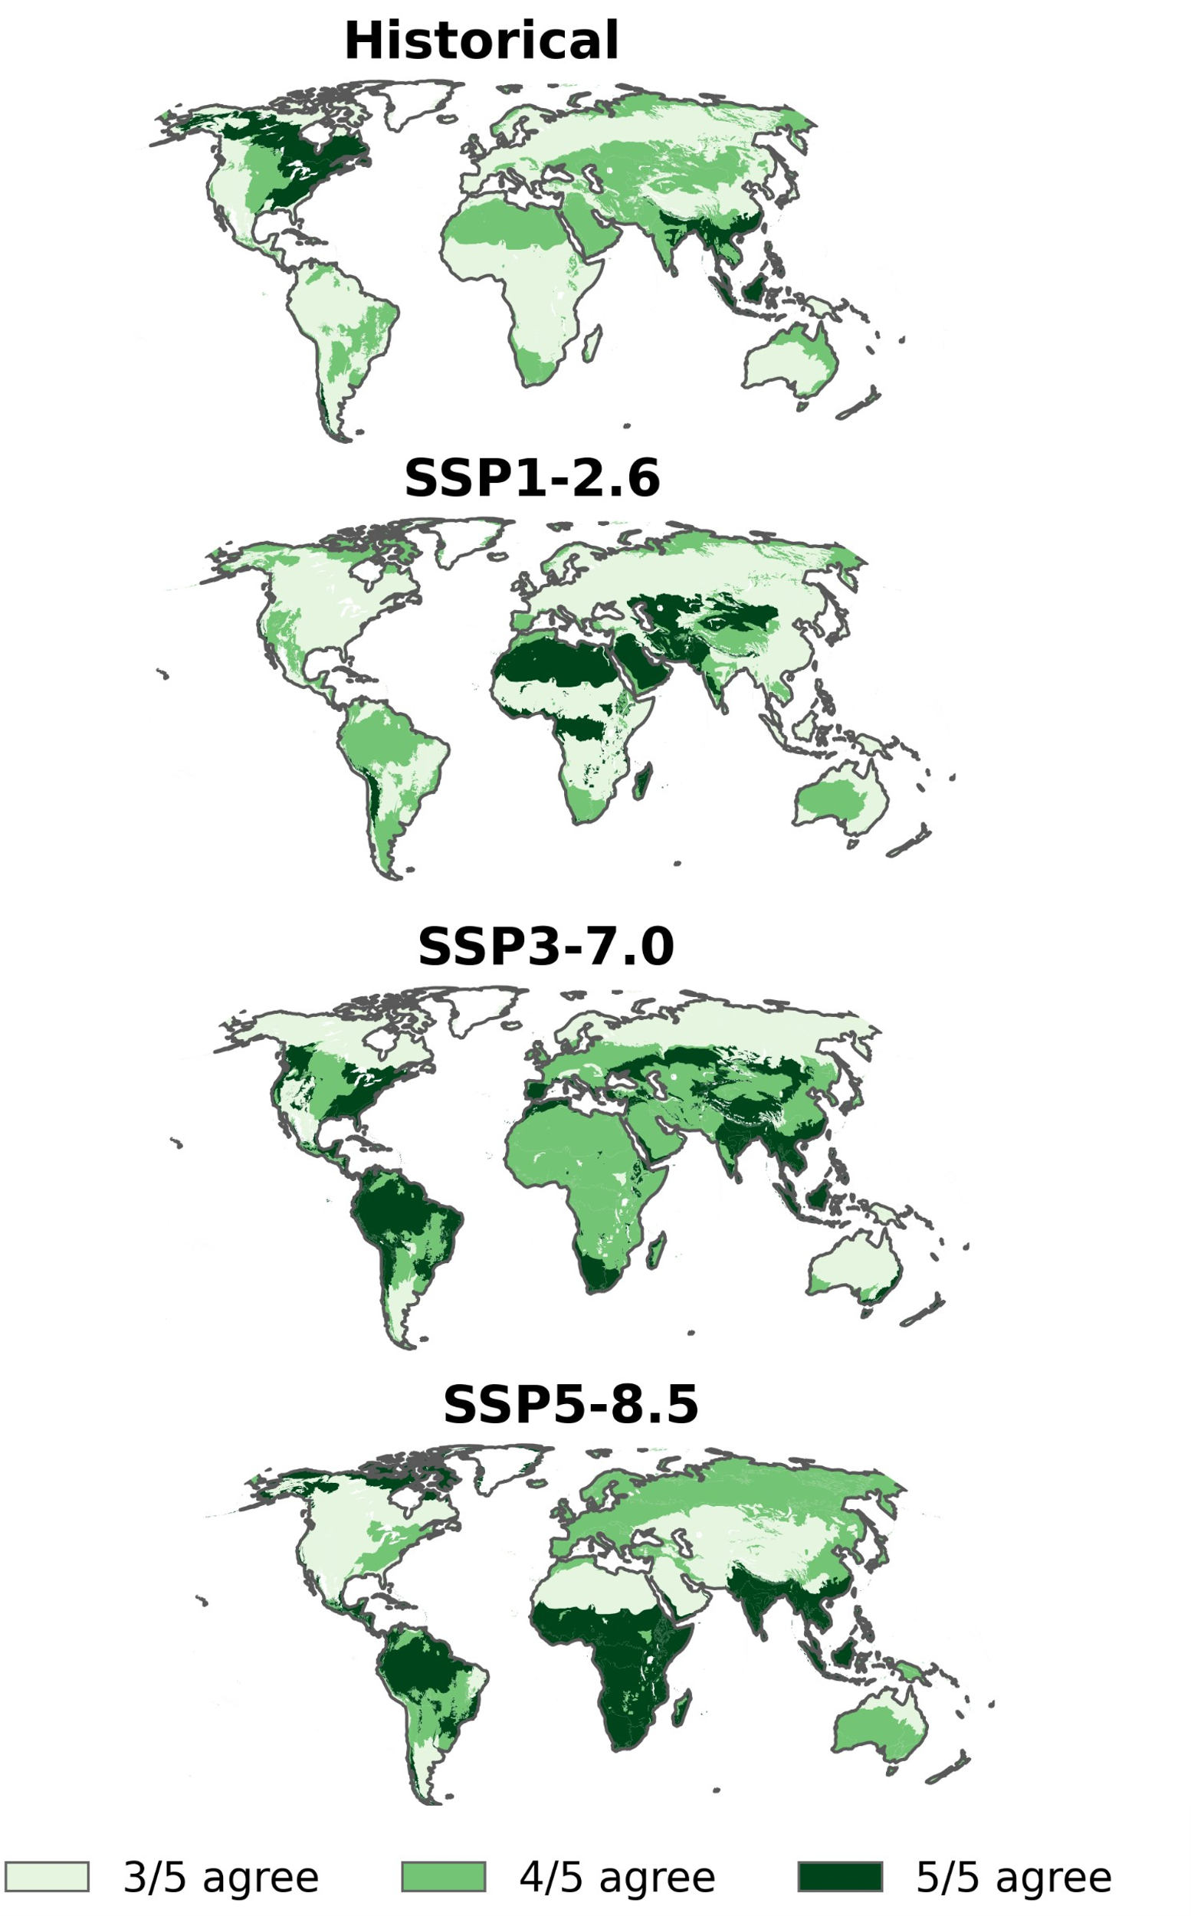
Figure S1| Agreement among the five global climate models (GCMs) in simulated groundwater-dependent wetland (GDW) area. Agreement is shown for the historical simulation (2005–2014) and the SSP1-RCP2.6, SSP3- RCP 7.0 and SSP5- RCP 8.5 scenarios (2041–2050). Colours indicate areas where three, four or all five GCMs simulate the presence of groundwater-dependent wetlands.

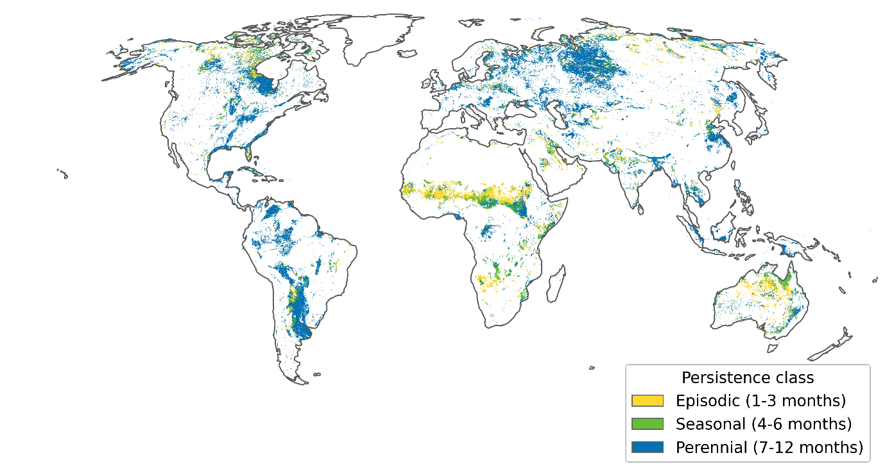

Figure S2| Persistence class of GDWs: episodic (1-3 months), seasonal (4-6 months) and perennial (7-12 months).

Supplementary Note S1| Sub-grid characterisation of the water table depth threshold and sensitivity
The water table depth threshold was applied at 5 arc-minute model resolution. To characterize the corresponding sub-grid distribution of water table depth, mean simulated water table depths within grid cells where saturation supports GDW presence were disaggregated to 90 m resolution using relative-elevation percentiles from MERIT DEM ⁴⁹. The distribution of the sub-grid water table depths was summarised by the cumulative proportion of 90 m sub-cells within specified depth intervals (Supplementary Figure S4).
The sensitivity of GDW identification to the water table depth and saturated area fraction thresholds was evaluated using 27 threshold combinations. Water table depth thresholds of 0.1, 1, 2, 3, 4, 5, 6, 7 and 8 m were combined with saturated area fraction thresholds of 0.25, 0.5 and 0.75. For each combination, the simulated GDW distribution was evaluated against the independent validation dataset using precision, recall and F1 score. The evaluation was performed at 5 arc-minute resolution using the same dryland mask and a 1 km spatial tolerance as in the main validation analysis (Supplementary Figure S3.3).

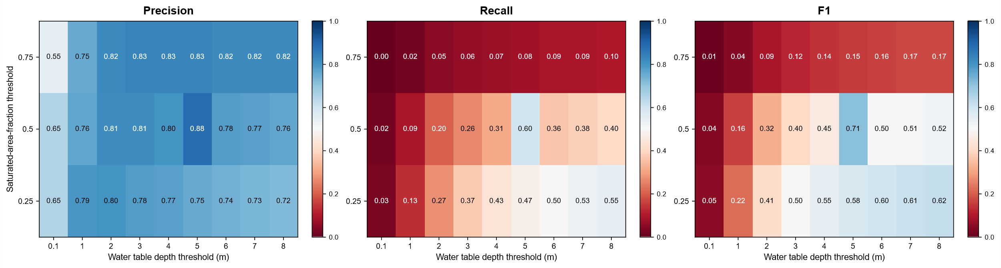
Figure S3| Sensitivity of GDW identification skill to water table depth and saturated area fraction thresholds. Precision, recall and F1 score of the simulated GDW distribution evaluated against the validation dataset constructed by intersecting GLWD v2 with the dryland groundwater-dependent ecosystem map of Rohde et al. (2024). Water table depth thresholds ranged from 0.1 to 8 m and saturated area fraction thresholds ranged from 0.25 to 0.75. All threshold combinations were evaluated at 5 arc-minute resolution using a 1 km spatial tolerance and restricted to dryland regions.

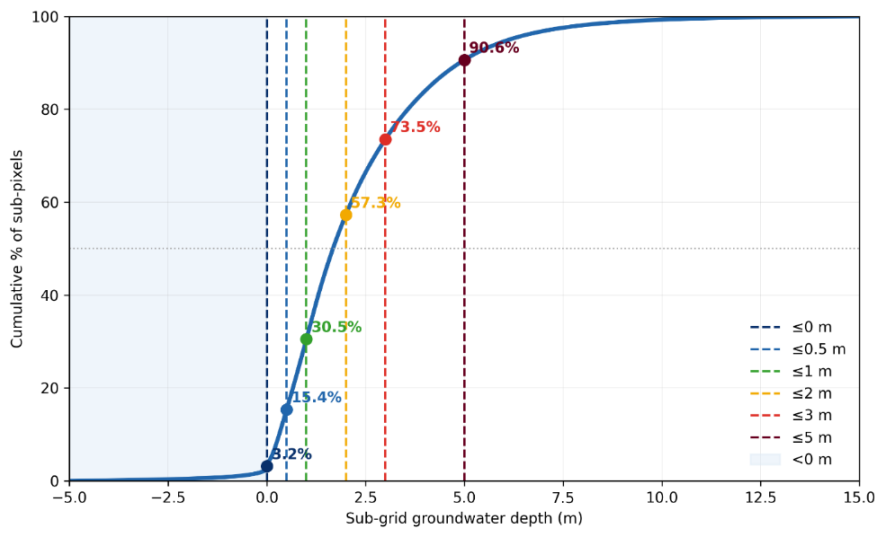
Figure S4| Sub-grid distribution of water table depth within grid cells classified as groundwater-dependent wetlands. Cumulative distribution of simulated water table depth disaggregated to 90 m resolutions within 5 arc-minute grid cells satisfying GDW criteria during the historical period (1979–2014). Water table depths were disaggregated using relative elevation percentiles derived from the MERIT DEM (Yamazaki et al., 2017). Dashed lines indicate water table depths of 0, 0.5,1,2,3 and 5, and shading represents sub-pixels with a water table at or above the land surface

Table S1| Model input data for historical and future simulations
Description | Symbol | Unit | References/Sources
Upper and lower soil store parameters (~1 km, 30 arcsec) |  |  | ⁵⁰, van Beek and Bierkens (2009)
- Soil thickness | Z₁ and Z₂ | m
- Residual soil moisture content | θr₁ and θr₂ | m³/m³
- Soil moisture at saturation | θs₁ and θs₂ | m³/m³
- Soil water storage capacity per soil layer: SC = Z/ (θs − θr) | SC₁ and SC₂ | m
- Soil matric suction at saturation | ψs₁ and ψs₂ | m
- Exponent in the soil water retention curve | β₁ and β₂ | –
- Saturated hydraulic conductivities (upper and lower soil stores) | K₁ and K₂ | m/day
- Total soil water storage capacity (SCupp + SClow) | $$W_{max}$$ | m
Land cover fraction (~1 km resampled): Landcover areas (including extent of irrigated areas) over cell areas  Future landuse fractions per SSP (2015–2050), including irrigated area extent | $$fl_{cov}$$  $$f_{conv}$$ | m²/m²  m²/m² | GLCC v2.0 (USGS, 1997); Olson (1994a, b); MIRCA2000 (Portmann et al., 2010); FAOSTAT (2012); IMAGE 3.2 ³⁰  IMAGE 3.2 ³⁰
Topographical parameters (30 arcsec, ~1 km) |  |  | HydroSHEDS (Lehner et al., 2008); MERIT DEM (Yamazaki et al., 2017)
- Cell-average DEM | $$DEM_{avg}$$ | m
- Floodplain elevation | $$DEM_{fpl}$$ | m
Root fractions per soil layer (~1 km) | $Rf_{upp} and$ $Rf_{low}$ | – | Canadell et al. (1996); van Beek and Bierkens (2009)
Arno scheme parameters (~10 km, model scale) | $$βarno$$ | – | Todini (1996); Hagemann and Gates (2003); van Beek (2008)
Ratio of minimum soil storage to Wmax (~10 km) | $${fw}_{min}$$ | m/m | van Beek (2008); van Beek and Bierkens (2009)
Ratio of maximum soil storage to Wmax (~10 km) | $${fw}_{max}$$ | m/m | van Beek (2008); van Beek and Bierkens (2009)
Vegetation and phenology parameters (~10 km) |  |  | Hagemann et al. (1999, 2002); van Beek (2008); van Beek and Bierkens (2009); MIRCA2000 (Portmann et al., 2010)
Crop coefficient | $$K_{c}$$ | –
Interception capacity | $$S_{int-max}$$ | m
Vegetation cover fraction | $$C_{v}$$ | m²/m²
Groundwater parameters (30 arcsec, ~1 km) |  |  | GLHYMPS (Gleeson et al., 2014); van Beek (2008); van Beek and Bierkens (2009)
- Aquifer transmissivity | KD | m²/day
- Aquifer specific yield | Sy | m³/m³
- Groundwater recession coefficient | J⁻¹ | day⁻¹
Meteorological forcing (~10 km, daily) |  |  | CRU (Harris et al., 2014); W5E5 (Cucchi et al., 2020; Lange et al., 2021)
- Total precipitation | P | m/day
- Atmospheric air temperature | $$T_{air}$$ | °C or K
- Reference potential evapotranspiration  - Bias-adjusted future climate forcing (2015-2050), SSP1-RCP2.6, SSP3-RCP7.0, SSP5-RCP8.5) | $$E_{ref,pot}$$  P, $T_{air}, E_{ref,pot}$ | m/day  m/day, °C, m/day | SIMIP3b (Lange and Büchner, 2021); CMIP6 GCMs: GFDL-ESM4, IPSL-CM6A-LR, MPI-ESM1-2-HR, MRI-ESM2-0, UKESM1-0-LL (Sutanudjaja et al., 2023)
Wetland identification variables (1 km, monthly) |  |  | PCR-GLOBWB (van Beek, 2008) and GLOBGM
- Saturated area fraction | $$satAreaFrac$$ | –
- Groundwater table depth | $$Gwt$$ | m
Groundwater head | h | m
Validation datasets
- Groundwater monitoring wells (point data, monthly) | – | m | GGMN (IGRAC, 2024)
- Global wetland extent (15 arcsec) | – | – | GLWD v2 (Lehner et al., 2025)
- Groundwater-dependent ecosystems (~1 km) | – | – | Rohde et al. (2024)
- Reference dataset (constructed in this study, 30 arcsec) |  |  | This study
- Intersection of GLWD v2 and Rohde et al. (2024) | – | –
Ecological classification (~10 km, resampled) |  |  | Olson et al. (2001)
- Biomes / ecoregions | – | –
Climate variability indices (monthly) |  |  | KNMI Climate Explorer (2025)
- ENSO (Niño 3.4 index) | – | –
Other inputs (~30 arcsec)
- Non-irrigation water demand (livestock, domestic, industrial) | – | m/day | Wada et al. (2014)
- Desalinated water  - Future non-irrigation water demand per SSP (livestock, domestic, industrial, 2015-2050) | –  – | m/day  m/day | Wada et al. (2011a); FAO (2016)  Wada et al. (2016); Graham et al. (2018)

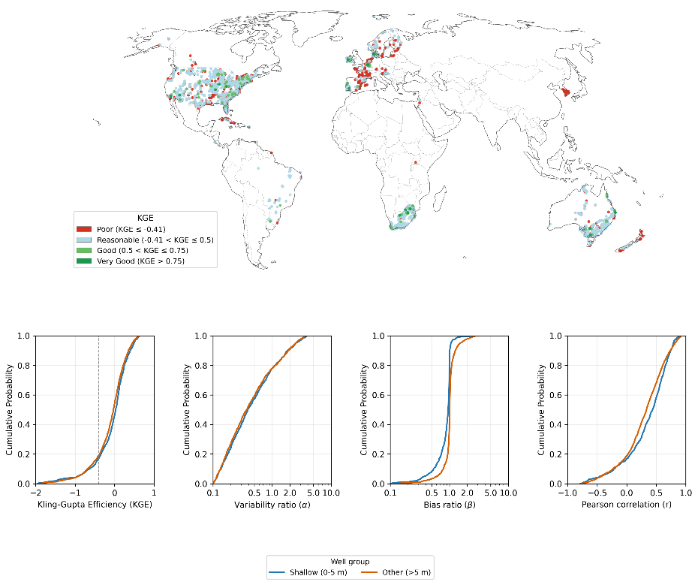

Figure S5| GLOBGM evaluation; KGE, variability ratio, bias ratio and Pearson correlation across 15,846 monitoring wells.

Table S2| Proportions of wells meeting commonly used performance thresholds for KGE and its components including Pearson correlation (r), variability ratio (α) and bias (β).
 | All Wells | Shallow Wells (0-5 m)
Reasonable$(-0.41 <KGE≤0.5)$ | 70.2% | 71.9%
Good $\left(0.5<KGE≤0.75\right),$ | 2.8% | 3.0%
Very good$(KGE> 0.75)$ | 0.5% | 0.51%
Reasonable ($ρ ≥ 0)$ | 78.9% | 80.4%
Good ($ρ ≥ 0.5)$ | 31.7% | 36.7%
Reasonable ratio 0.5 ≤ α ≤ 2.0 | 17.6% | 20.2%
Reasonable 0.5 ≤ β ≤ 2.0 | 87.7% | 85.9%

Table S3| Gross gains, gross losses and net changes in global GDW area (thousand km²) between 2005-2014 baseline and 2041 and 2050, for each GCM and scenario.
Scenario | GCM | Gross gain | Gross loss | Net change
SSP1-RCP2.6 | GFDL-ESM4 | 15.4 | 191.4 | −176.0
 | IPSL-CM6A-LR | 12.8 | 131.7 | −118.8
 | MPI-ESM1-2-HR | 141.3 | 25.0 | +116.2
 | MRI-ESM2-0 | 111.0 | 31.4 | +79.6
 | UKESM1-0-LL | 77.8 | 141.9 | −64.1
SSP3-RCP7.0 | GFDL-ESM4 | 0.4 | 337.6 | −337.1
 | IPSL-CM6A-LR | 7.6 | 178.8 | −173.3
 | MPI-ESM1-2-HR | 34.6 | 175.6 | −141.0
 | MRI-ESM2-0 | 103.5 | 115.2 | −11.7
 | UKESM1-0-LL | 78.3 | 284.3 | −206.0
SSP5-RCP8.5 | GFDL-ESM4 | 64.2 | 301.3 | −237.1
 | IPSL-CM6A-LR | 79.6 | 139.7 | −60.1
 | MPI-ESM1-2-HR | 113.7 | 96.3 | +17.4
 | MRI-ESM2-0 | 202.5 | 55.1 | +147.4
 | UKESM1-0-LL | 142.2 | 170.5 | −28.3

