Supplementary Information for
Elemental sulfur enables a thione-mediated, non-radical polycondensation toward poly(benzodifurandione)
Yi-Dan Luan,^{1,3} Jia-Qiang Liao,^{1,3} Xin-Yu Wang,³ Tian-Yi Dai,¹ Si-Jing Wang,^{1,3} Xin-Yi Liu,³ Shuo Chen,^{1,3} Feng Ye,¹ Rong-Sheng Zhang,^{1,3} Ri-Qing Ding,¹ Jun-Tong Li,¹ Shao-Hua Tong,² Meng-Ming Sun,² Lei Fang,^{1*} Yu-Guang Ma,² Qing-Lin Jiang,2* and Zi-Hao Guo^{1,2,3*}
1UCenter for Functional Organic Materials, Yongjiang Laboratory, Ningbo 315202, Zhejiang, China.
2Institute of Polymer Optoelectronic Materials and Devices, Guangdong Basic Research Center of Excellence for Energy and Information Polymer Materials, State Key Laboratory of Luminescent Materials and Devices, South China University of Technology, Guangzhou 510640, Guangdong, China.
³Guangdong Provincial Key Laboratory of Functional and Intelligent Hybrid Materials and Devices, South China Advanced Institute for Soft Matter Science and Technology, School of Emergent Soft Matter, South China University of Technology, Guangzhou 510640, Guangdong, China.
*Corresponding Author(s): Lei Fang: lei-fang@ylab.ac.cn; Qing-Lin Jiang: jiangql@scut.edu.cn; Zi-Hao Guo: zihao-guo@ylab.ac.cn

Table of Contents
- Materials and Methods
- Base-catalyzed S₈-mediated oxidative polymerization of PBFDO
- Optimization of conditions for S₈-mediated polymerization
- Mechanistic understanding of S₈-mediated polymerization
- Dynamic light scattering (DLS) measurements of PBFDO polymers
- General characterization of polymers
- Thermoelectric and OECT measurements
- Scale-up synthesis of PBFDO
- Additional device characterization
- References

- Materials and Methods
Materials
Unless otherwise stated, all reagents and solvents were purchased from commercial suppliers such as Adamas, Aladdin, Sigma-Aldrich, Bidepharm, Energy Chemistry and Jk Chemical and used as received. All reactions were carried out under nitrogen atmosphere. The 3,7-dihydrobenzo[1,2-b:4,5-b′]difuran-2,6-dione (BFDO) was purchased from Bidepharm and processed through a dichloromethane column to yield white crystals. Sulfur (AR, 99.5%) was purchased from Aladdin. Dimethyl sulfoxide (Water≤50 ppm (by K.F.), 99.7%, SafeDry, Safeseal) was purchased from Adamas.
General procedure for PBFDO polymerization
BFDO monomer (5–10 mg mL⁻¹) and sulfur (0.1–2 eq. S) were dissolved in DMSO under nitrogen atmosphere at different temperatures (100 °C–150 °C). Sulfur loadings are expressed as equivalents of sulfur atoms relative to the organic substrate (BFDO or the BF model compound), i.e. n(S)/n(substrate), where n(S) is the molar amount of sulfur atoms irrespective of speciation. Elemental sulfur is supplied as the S₈ ring; therefore 1 eq. S corresponds to 0.125 eq. of S₈ molecules, and the standard BFDO condition uses 8.4 mg of S₈ per 50 mg of BFDO (0.26 mmol S per 0.26 mmol BFDO). The mixture was stirred for several hours until a gel was formed or the monomer conversion was complete (as checked by ¹H NMR). After cooling the solution to room temperature, the polymer solutions were filtered through a 0.22 μm polytetrafluoroethylene (PTFE) filter head (used solely to remove system aggregates and insoluble impurity particles) without dialysis. The electrical conductivity of the polymer solution was measured using the four-probe method. The polymerization conditions and conductivity results are summarized in Table 1 of the main text.
Detailed examples of reactions are below: In a nitrogen atmosphere, BFDO (50 mg, 0.26 mmol, 1 eq.) and S₈ (8.4 mg, 0.26 mmol S, 1 eq. S) were dissolved in DMSO (10 mL) (5 mg mL⁻¹). Then, the reaction mixture was heated to 120 °C for 5 h, and the solution gradually changed from light blue to dark black. The reaction mixture is cooled to room temperature and filtered with a 0.22 μm PTFE filter using a syringe to obtain polymer inks.
Characterizations
¹H NMR and ¹³C NMR spectra were recorded on JNM-ECZ500R (500 MHz). ¹H NMR chemical shifts were referenced to DMSO-d₆ at 2.50 ppm and CDCl₃ at 7.26 ppm. ¹³C NMR chemical shifts were referenced to CDCl₃ at 77.16 ppm. UV-Vis-NIR absorption spectroscopy was recorded on Shimadzu UV-3600 Plus. The infrared spectrum was measured using the INVENIO S spectrometer equipped with an attenuated total reflection accessory. Cyclic voltammograms (CV) were measured on an electrochemical workstation SP-200 (BioLogic Science Instruments) in acetonitrile solution containing 0.1 M anhydrous tetrabutylammonium hexafluorophosphate (n-Bu₄NPF₆) as a supporting electrolyte. A standard three-electrode setup was established by employing a glassy carbon electrode as the working electrode (WE), a platinum wire acted as the counter electrode (CE), and an Ag/AgCl electrode as the reference electrode (RE), further calibrated against ferrocene (Fc/Fc⁺). The HOMO and LUMO energy levels were calculated according to the equation of and . Here the Fc/Fc⁺ redox couple was referenced to −4.8 eV versus vacuum, a value widely adopted for organic semiconductors. High-resolution mass spectra (HR-MS) were recorded on a Bruker Impact II and TIMS-TOF SCP. The gas chromatography was performed on SHIMADZU. Thermogravimetric analysis (TGA) was carried out on a TA Instruments TGA5500. Dynamic Light Scattering (DLS) was measured on a Wyatt Omni. Two-dimensional GIWAXS measurements were performed on a Rigaku HomeLab. The Cypher VRS atomic force microscope (AFM) was used for morphological testing in the tapping mode. X-ray photoelectron spectroscopy (XPS) and ultraviolet photoelectron spectroscopy (UPS) were performed using the PHI GENESIS 500 instrument.$E_{HOMO} = - \left[4.8 + \left(E_{ox}-E_{Fc/Fc+}\right)\right]\left(eV\right)E_{LUMO} = - \left[4.8 + \left(E_{re}-E_{Fc/Fc+}\right)\right]\left(eV\right)$

Substrate and Film Preparation
The glass and silicon substrate was cleaned by continuous ultrasonication in deionized water, acetone, and isopropanol for 5 minutes each, followed by 1 minute of plasma treatment. Finally, the polymer solution was applied to the substrate, preheated at 60 °C for 5 min, spin coated at 2000 rpm, and dried in nitrogen atmosphere to remove residual solvent.
Thermoelectric performance measurement
The conductivity was measured using the four-probe method on a Keithley 4200 SCS semiconductor analyzer. The aspect ratio (W/L) of the four parallel electrodes is 1000 μm/200 μm. The Seebeck coefficient (S) was determined through the equation , where ΔV_{therm} represents the thermoelectric voltage between the hot and cold junctions under a temperature gradient of ΔT. ΔT was varied over 5–20 K, and S was obtained from the slope of ΔVtherm versus ΔT (linear fit, R² > 0.99); the reported uncertainty is the standard deviation of two parallel runs on independently prepared films (n = 2). The thermoelectric voltage ΔVtherm was collected via the Keithley 4200 SCS system. The power factor and its uncertainty were propagated from the standard deviations of σ and S via δPF/PF = √((2δS/S)² + (δσ/σ)²). The power factor (PF) is calculated using the formula .$S = \frac{{ΔV}_{therm}}{ΔT}PF = σS^{2}$
OECT devices fabrication and characterization
The OECT device with a W/L ratio of 100 μm/10 μm was fabricated through photolithography, vapor deposition of gold, parylene sacrificial layer deposition, etching, and spin-coating of channel material. The PBFDO solution was first applied as a droplet onto the substrate and preheated at 60 °C for 5 minutes. Subsequently, spin-coating was performed at 2000 rpm onto the substrate, followed by drying in nitrogen at 60 °C to form the channel. After completing the exfoliation of the second sacrificial parylene layer, measurements were conducted. OECT performance characterization was performed using the FSA Pro semiconductor analyzer (PDA). All measurements were carried out in air with 0.1 M sodium chloride solution as the electrolyte and an Ag/AgCl electrode as the gate electrode. The μC* product was extracted using the equation (where W, L, and d represent the width, length, and depth of the organic channel, and V_{th} is the threshold voltage). The film thickness was determined in the dry state using a DEKTAK profiler (Bruker).$g_{m} = \frac{∂I_{D}}{∂V_{G}} = \frac{Wd}{L}×μC^{*}×\left(V_{G}-V_{Th}\right)$
Spectroelectrochemical measurements
The electrochemical measurements of polymer films were performed using a Shimadzu UV-3600 UV-Vis-NIR spectrophotometer at the voltage applied by the CHI660 constant potential/current electrochemical workstation. The polymer was coated onto an ITO glass substrate. A three-electrode system was established in a quartz domed cell, with the polymer-coated ITO serving as the working electrode, an Ag/AgCl electrode as the reference electrode, and Pt wire as the counter electrode. A 0.1 M sodium chloride solution was used as the supporting electrolyte. The applied bias voltage ranged from −0.6 to 0.6 V. The doping states at different working voltages were analyzed through the absorption spectrum of the UV-Vis-NIR spectrophotometer.
Electrochemical impedance spectroscopy (EIS) measurements
EIS tests were performed using the SP-300 electrochemical workstation (BioLogic Scientific Instruments). The polymer film deposited on gold electrodes via photolithography was patterned into square shapes of specified areas. EIS measurements were conducted using polymer-modified gold electrodes as working electrodes, Ag/silver chloride particles as reference electrodes, and platinum wires as counter electrodes in 0.1 M sodium chloride solution. The polymer coating was applied to the top of poly(p-xylylene-C) patterned devices, followed by a stripping step to expose gold electrodes with varying active areas. Capacitance measurements of the polymer on gold electrodes of different sizes were obtained through potential-EIS methods, with the DC bias voltage set at the maximum doping level achievable for each polymer. A sine wave voltage with an AC amplitude of 10 mV (RMS) was applied to the WE, and the frequency was scanned from 1 Hz to 100 kHz. The resulting Bode plots or Nyquist plots were fitted to equivalent circuits (i.e., Randle circuits Rs (Rp||Rc)) using EC-Lab software. The film thickness was measured in a dry state using a DEKTAK profiler (Bruker). Three independent measurements (sample size n ≥ 3) were performed for each material, with averages and standard deviations (SD) calculated to summarize the results.

- Base-catalyzed S₈-mediated oxidative polymerization of PBFDO
Supplementary Table 1 | Self-condensation of BFDO catalyzed by organic amines in the presence of S₈.
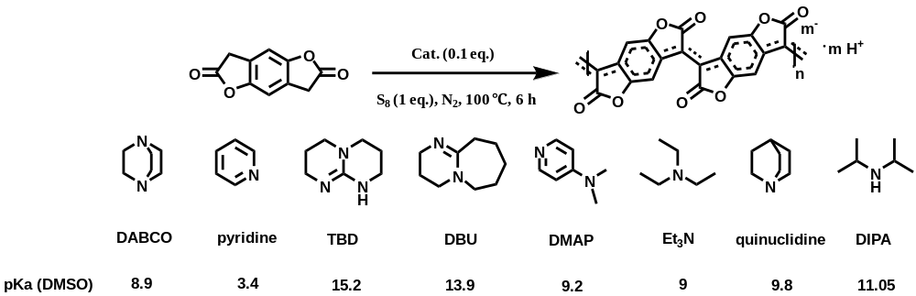
Entry | Cat. | Conductivity (S cm⁻¹)
1 | None | 1305.13 ± 45.79
2 | DABCO | 738.59 ± 71.43
3 | pyridine | 525.62 ± 35.89
4 | TBD | 186.42 ± 59.89
5 | DBU | 156.11 ± 29.04
6 | Et₃N | 316.95 ± 4.94
7 | DMAP | 350.13 ± 16.79
8 | quinuclidine | 344.27 ± 27.50
9 | DIPA | 406.09 ± 22.21
[a] All reactions were carried out at a BFDO:S:amine molar ratio of 1:1:0.1, with a monomer concentration of 10 mg mL⁻¹ and a reaction time of 6 h at 100 °C.
[b] The resulting polymer solutions were dialyzed in DMSO for 3 days to remove low-molecular-weight residues prior to measurement; conductivities were determined using the four-probe method. This purification step applies only to the screening experiments in Supplementary Table 1; the standard protocol requires no dialysis (see Table 1). Note that the conditions in Supplementary Table 1 (10 mg mL−1, 100 °C, 6 h, with dialysis) differ from the optimized conditions in Table 1 of the main text (5–10 mg mL−1, 100–150 °C, no dialysis); the two data sets are therefore not directly comparable.
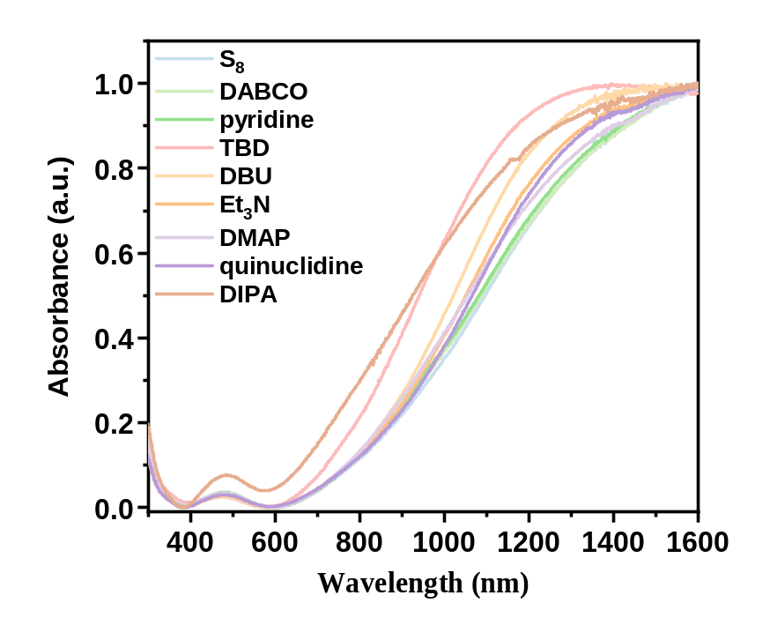
Supplementary Fig. 1 | UV-Vis-NIR absorption spectrum of organic amine catalyzing BFDO in the presence of S₈ (polymerization conditions: 10 mg mL⁻¹, BFDO:S:amine = 1:1:0.1, 100 °C heated for 6 h).
Supplementary Table 2 | The conversion rates of BFD and CCD, along with the residual rate of BF, were obtained through the GC-MS internal standard method.
Formation of the chromeno[4,3-c]chromene-5,11-dione (CCD) isomer. The primary oxidative coupling product of the BF model substrate is the isoxindigo-type dimer BFD. Under basic conditions, deprotonation at the acidic bridgehead C–H opens the α,β-unsaturated lactone, and a 6π-electrocyclic ring closure followed by re-aromatisation fuses the two benzofuranone units into the planar dibenzonaphthyrone core of CCD. The controls in Supplementary Table 2 reveal two contrasting effects of DABCO. First, DABCO accelerates monomer consumption: the residual BF after 24 h at 60 °C drops from 70.8% without base to 7.5% with DABCO, and at 100 °C from 39.4% to 0.4%. Second, the same additive diverts the reaction towards the undesired isomer: with DABCO the CCD fraction rises from 29.4% (24 h, 60 °C) to 88.6% (24 h, 100 °C), whereas without base it stays below 1.5% even after 24 h. Because a CCD unit replaces the alternating single/double-bond pattern of the BFD-type repeat unit with a fused, bond-delocalised aromatic core, it interrupts the quinoidal conjugation path and acts as a charge-transport defect. Base-catalysed routes therefore convert the monomer faster but accumulate CCD defects, whereas the base-free, sulfur-only protocol keeps the backbone dominated by BFD-type units and delivers the highest conductivity (2059 S cm−1; Table 1).
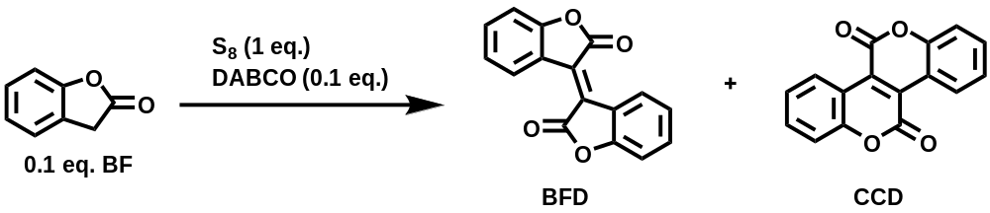
Time | Temperature | S₈ (eq. S) | DABCO | BFD Yield (%) | CCD Yield (%) | BF Remaining (%)
24 h | 60 °C | 1 | With DABCO | 63.10 | 29.43 | 7.47
24 h | 60 °C | 1 | Without DABCO | 29.21 | 0.02 | 70.77
5 h | 100 °C | 1 | With DABCO | 33.80 | 56.15 | 10.06
5 h | 100 °C | 1 | Without DABCO | 41.08 | 1.47 | 57.46
24 h | 100 °C | 1 | With DABCO | 10.99 | 88.57 | 0.44
24 h | 100 °C | 1 | Without DABCO | 59.72 | 0.88 | 39.40

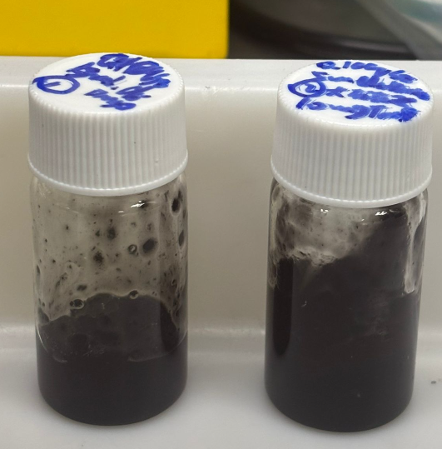
- Optimization of conditions for S₈-mediated polymerization
To optimize polymerization conditions and monitor the process, ¹H-NMR spectra were recorded over time during polymerization. TMB (1,3,5-trimethoxybenzene), an inert compound that does not affect polymerization, was used as a standard to quantitatively determine monomer conversion rates. The BFDO monomer conversion rate was calculated using NMR integrals with TMB as the reference.
General procedure for ¹H NMR characterization of polymerization reactions: BFDO monomer (50 mg, 5 mg mL⁻¹–10 mg mL⁻¹), S₈ (0.1–2 eq. S), and 1,3,5-trimethoxybenzene (TMB, 10 mg) were thoroughly dissolved in DMSO-d₆ under 100–150 °C and nitrogen atmosphere. The mixture was stirred continuously for several hours until gel formation or complete monomer conversion was achieved. During this period, 500 μL of the mixture was loaded into NMR tubes and ¹H-NMR spectra were recorded at different polymerization intervals. The BFDO monomer conversion rate was calculated using NMR integrals in the aromatic region with TMB as the reference^{[1]}. Results are shown in Supplementary Figs. 2–11.

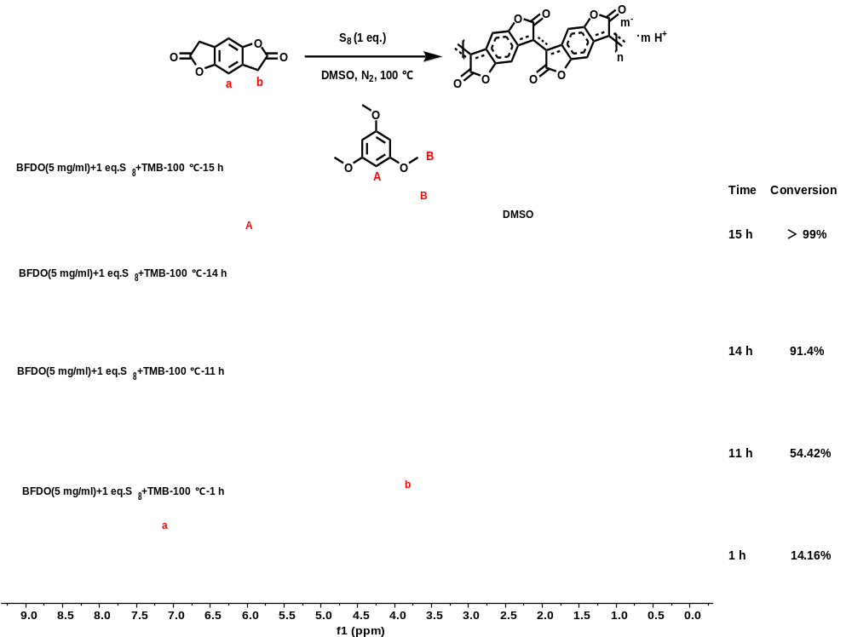
Supplementary Fig. 2 | ¹H NMR spectrum of polymerization of BFDO (5 mg mL⁻¹) with S₈ (1 eq. S) in DMSO-d₆ at 100 °C for different time under nitrogen. TMB was used as a reference.

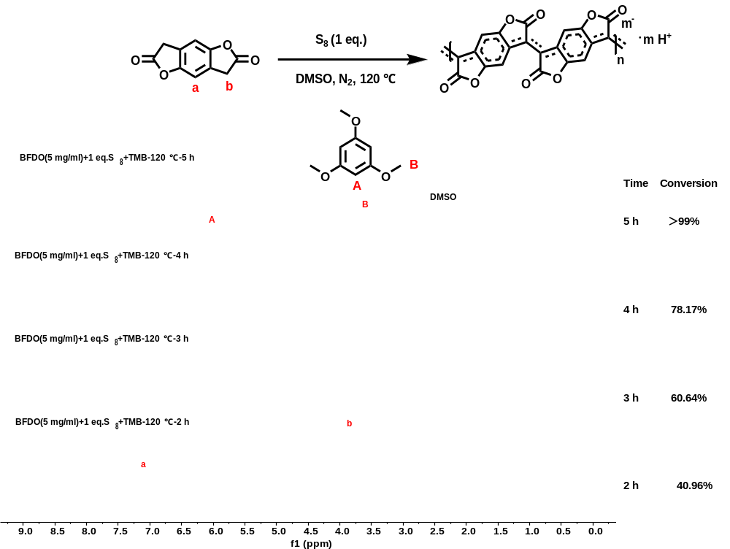
Supplementary Fig. 3 | ¹H NMR spectrum of polymerization of BFDO (5 mg mL⁻¹) with S₈ (1 eq. S) in DMSO-d₆ at 120 °C for different time under nitrogen. TMB was used as a reference.

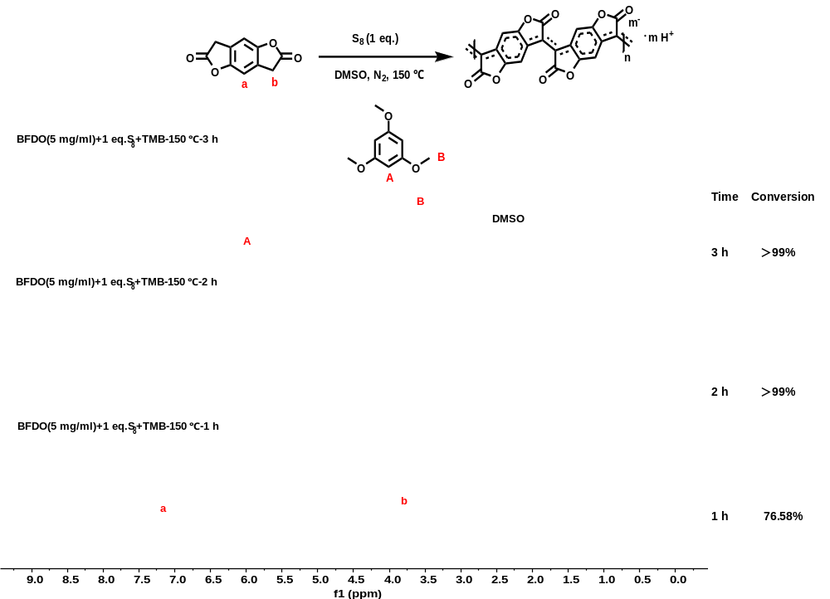
Supplementary Fig. 4 | ¹H NMR spectrum of polymerization of BFDO (5 mg mL⁻¹) with S₈ (1 eq. S) in DMSO-d₆ at 150 °C for different time under nitrogen. TMB was used as a reference.

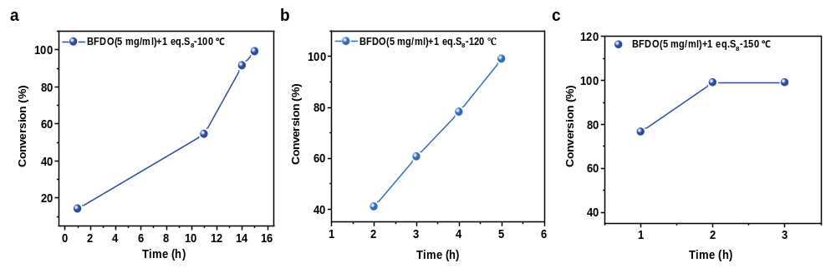
Supplementary Fig. 5 | Plots of monomer conversions with times under different temperature. (a) 100 °C (b) 120 °C (c) 150 °C (Polymerization conditions: 5 mg mL⁻¹, 1 eq. S)

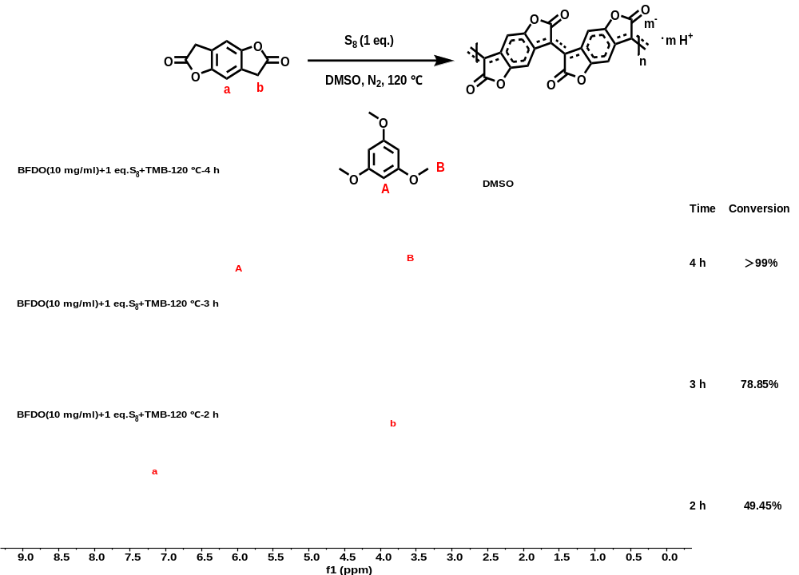
Supplementary Fig. 6 | ¹H NMR spectrum of polymerization of BFDO (10 mg mL⁻¹) with S₈ (1 eq. S) in DMSO-d₆ at 120 °C for different time under nitrogen. TMB was used as a reference. The reaction mixture formed gel after 5 hours.

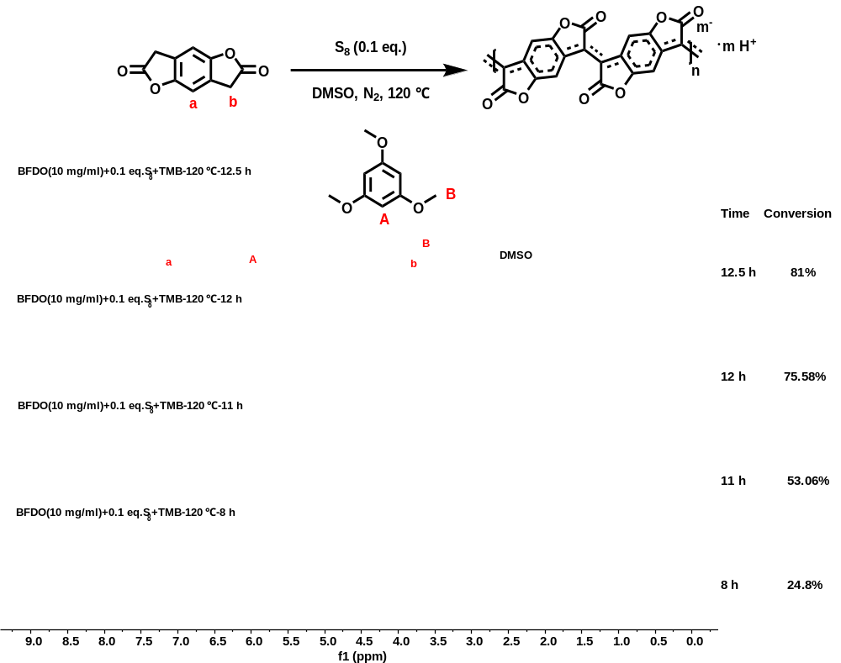
Supplementary Fig. 7 | ¹H NMR spectrum of polymerization of BFDO (10 mg mL⁻¹) with S₈ (0.1 eq. S) in DMSO-d₆ at 120 °C for different time under nitrogen. TMB was used as a reference. The reaction mixture formed gel after 12 hours.

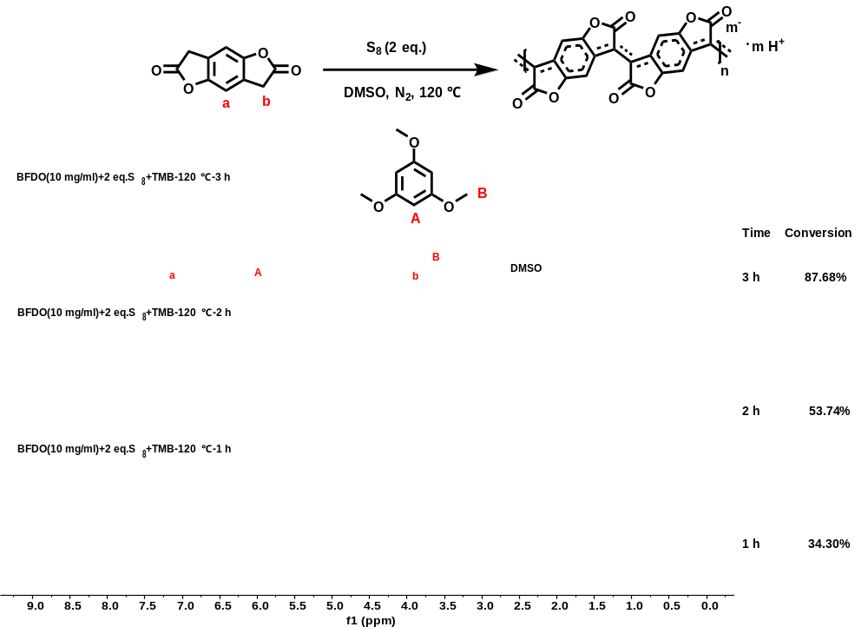
Supplementary Fig. 8 | ¹H NMR spectrum of polymerization of BFDO (10 mg mL⁻¹) with S₈ (2 eq. S) in DMSO-d₆ at 120 °C for different time under nitrogen. TMB was used as a reference. The reaction mixture formed gel after 3 hours.

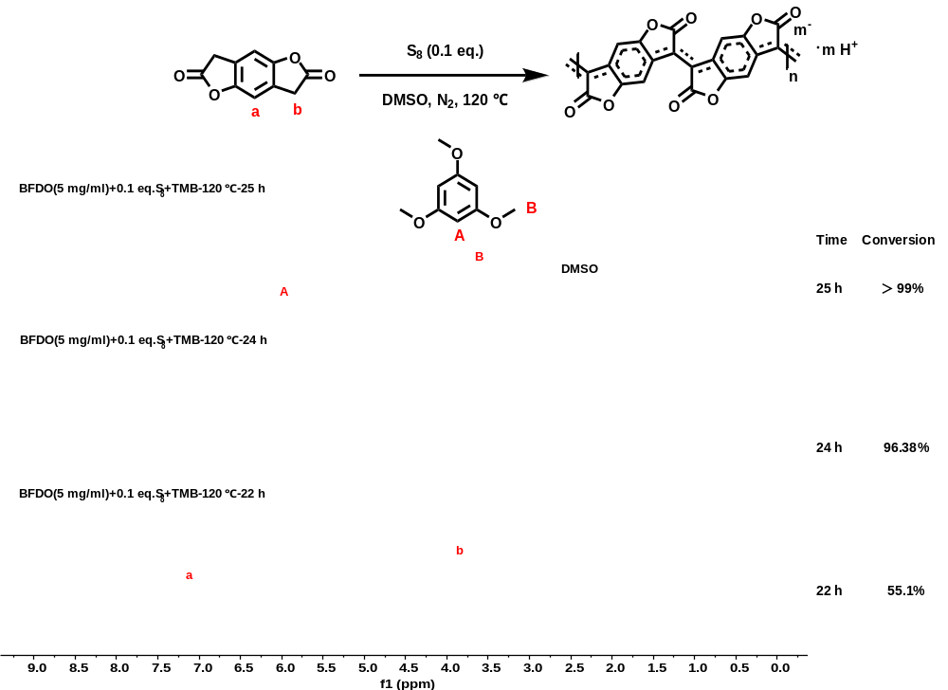
Supplementary Fig. 9 | ¹H NMR spectrum of polymerization of BFDO (5 mg mL⁻¹) with S₈ (0.1 eq. S) in DMSO-d₆ at 120 °C for different time under nitrogen. TMB was used as a reference.

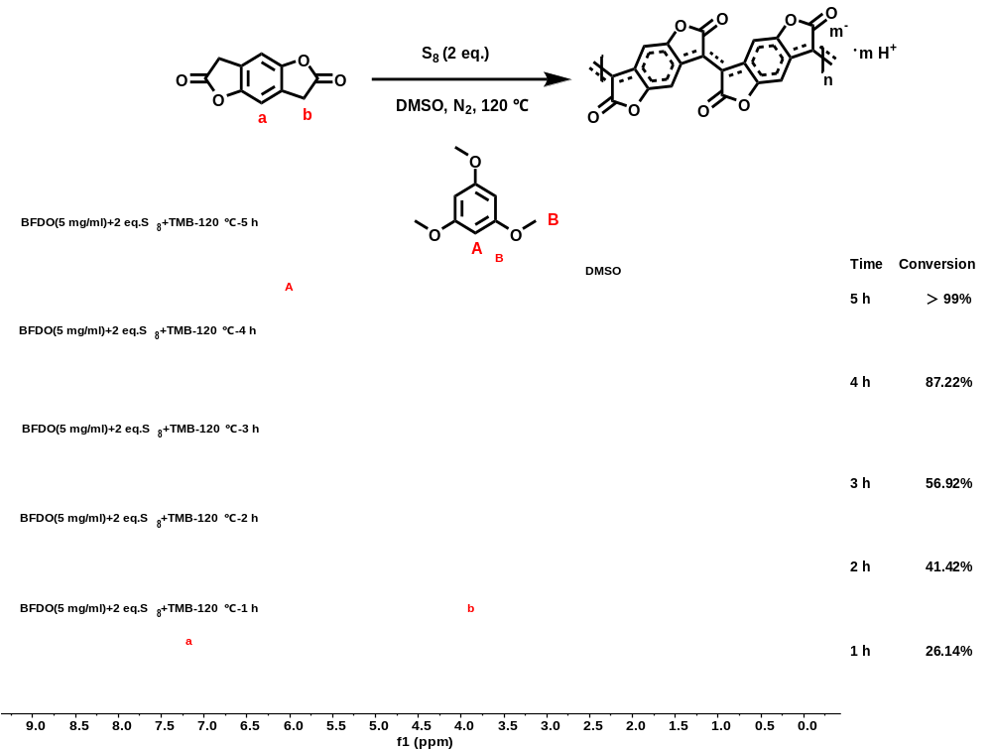
Supplementary Fig. 10 | ¹H NMR spectrum of polymerization of BFDO (5 mg mL⁻¹) with S₈ (2 eq. S) in DMSO-d₆ at 120 °C for different time under nitrogen. TMB was used as a reference.

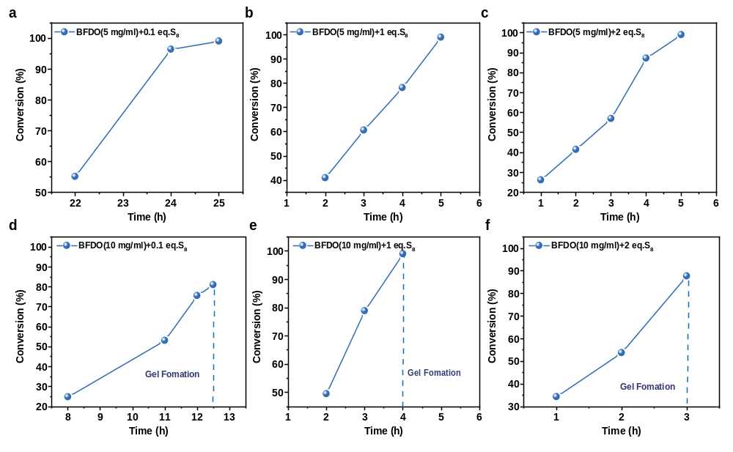
Supplementary Fig. 11 | Plots of monomer conversions with times under different monomer concentrations and different S₈ loadings. (a-c) 5 mg mL⁻¹ (d-f) 10 mg mL⁻¹ (Polymerization conditions: 120 °C)

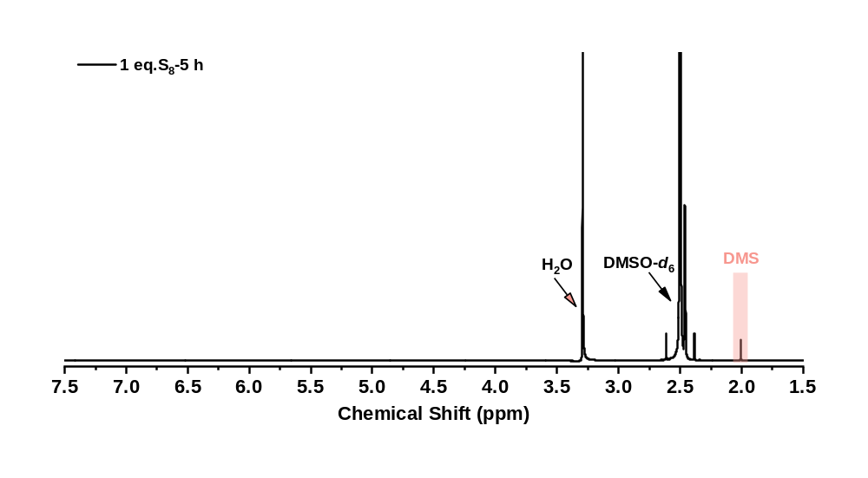
Supplementary Fig. 12 | ¹H NMR spectra of the crude mixture after 5 h (1 eq. S). Complete monomer conversion is reached within 5 h; the peak at 2.01 ppm is assigned to DMS^{[2]}.

Supplementary Table 3 | Elemental analysis (wt%) of polymer synthesized with 1 eq. S (as S₈) (dried by filtration after precipitation into isopropanol)
Product | C | H | N | S | O
PBFDO-(S) | 60.64 | 2.93 | 0 | 3.01 | 33.42
theoretical | 64.30 | 1.44 | 0 | 0 | 34.26
[a] All values are reported in wt%. The theoretical row is calculated for the sulfur-free PBFDO repeat unit. The measured sulfur content of 3.01 wt% — versus 0 wt% expected for the ideal polymer — provides direct quantitative evidence that sulfur-containing species are retained in the isolated material. S 2p XPS (Supplementary Fig. 13) identifies this sulfur as predominantly elemental sulfur, with a minor S=O contribution from residual DMSO.

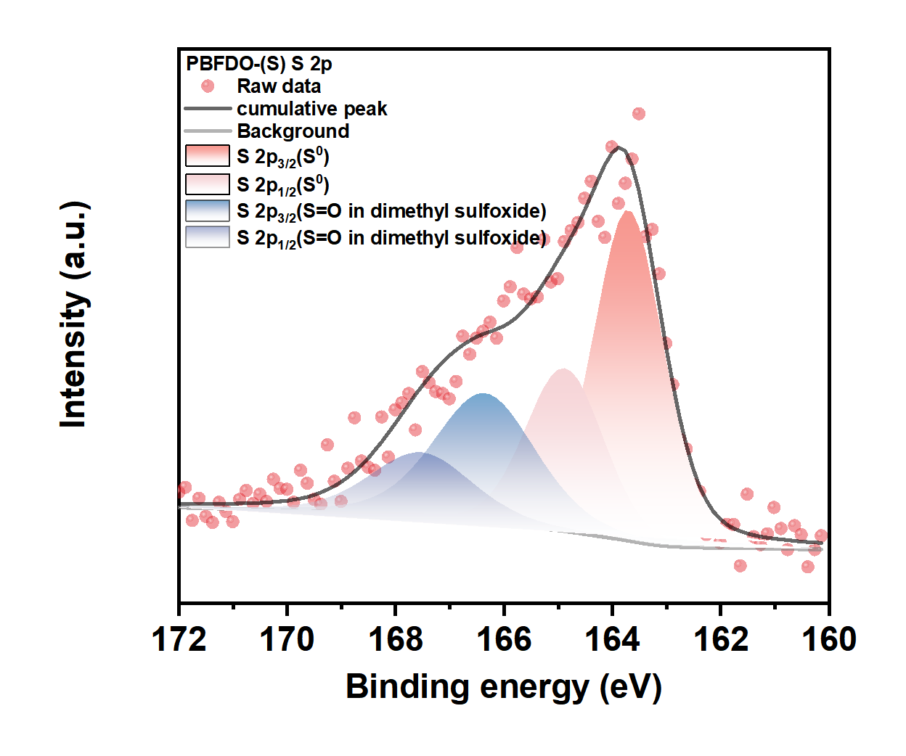
Supplementary Fig. 13 | XPS Spectrum of Sulfur 2p. After the reaction, the sulfur mainly exists in the form of elemental sulfur^{[3]}, and there is also S=O in dimethyl sulfoxide^{[4]}.
- Mechanistic understanding of S₈-mediated polymerization
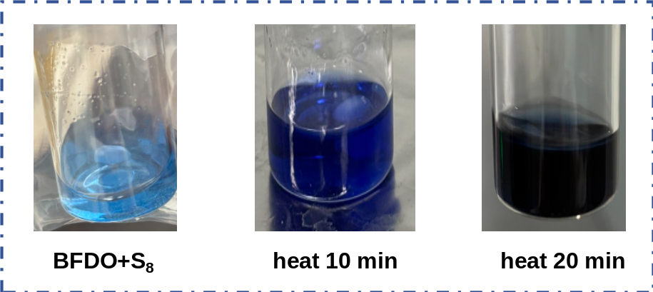
Supplementary Fig. 14 | The color change of BFDO monomer and S₈ reaction.

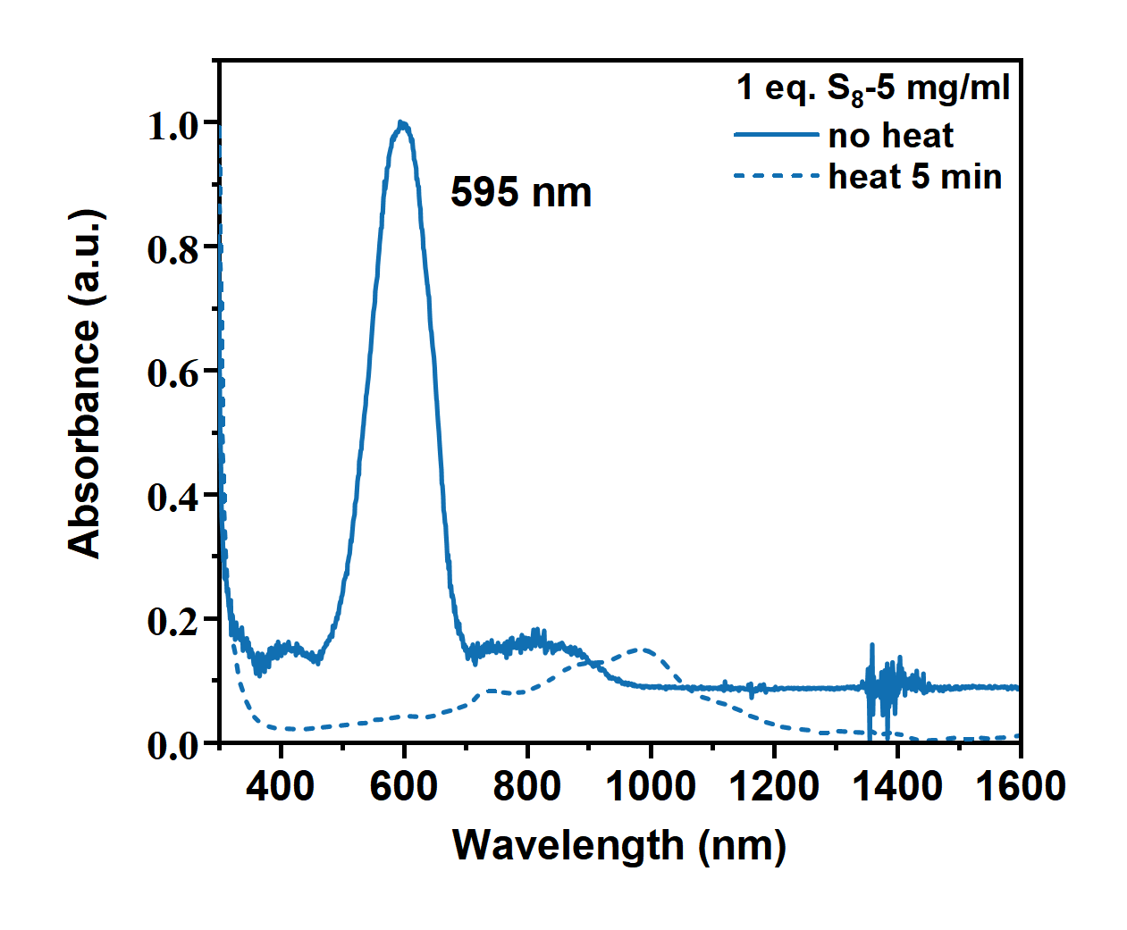
Supplementary Fig. 15 | The UV-Vis-NIR absorption spectrum of BFDO monomer and S₈ Reaction.

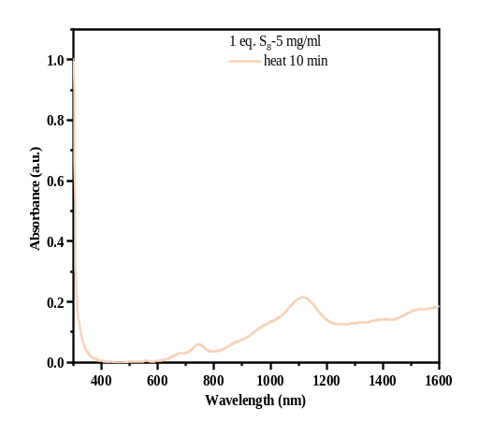
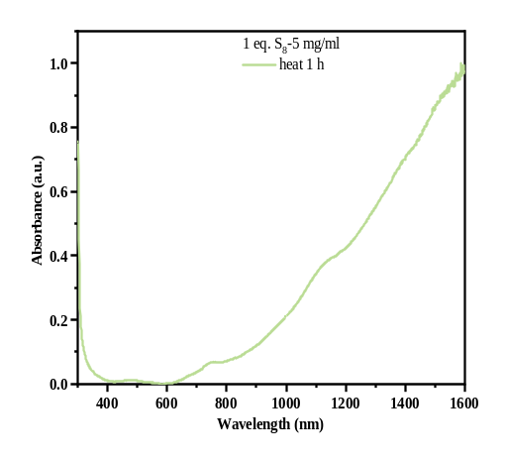
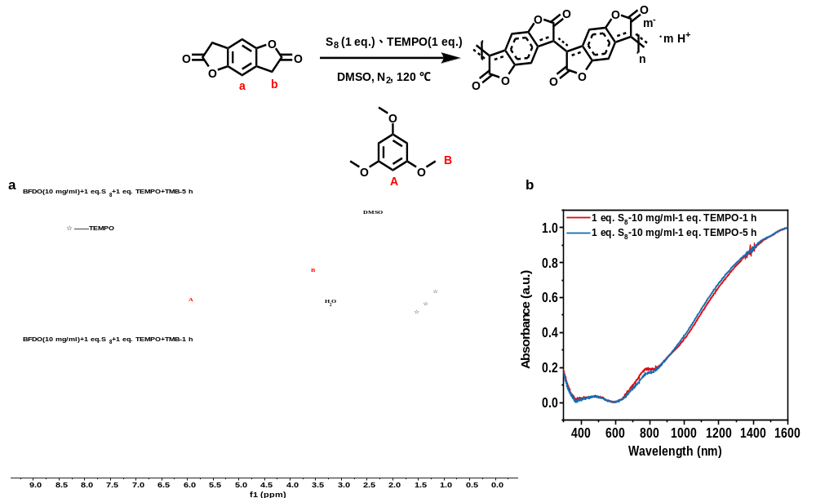
Supplementary Fig. 16 | (a) 1H NMR, (b) UV-Vis-NIR absorption spectra of n-PBFDO (10 mg mL−1) with added TEMPO after 1 h and 5 h of reaction. At 1 h, the monomers had been consumed, and the polymer solution with TEMPO exhibited absorption profiles similar to PBFDO, showing strong polarons and bipolarons in the near-infrared region. This indicates that the addition of a free radical scavenger did not hinder the reaction progression.

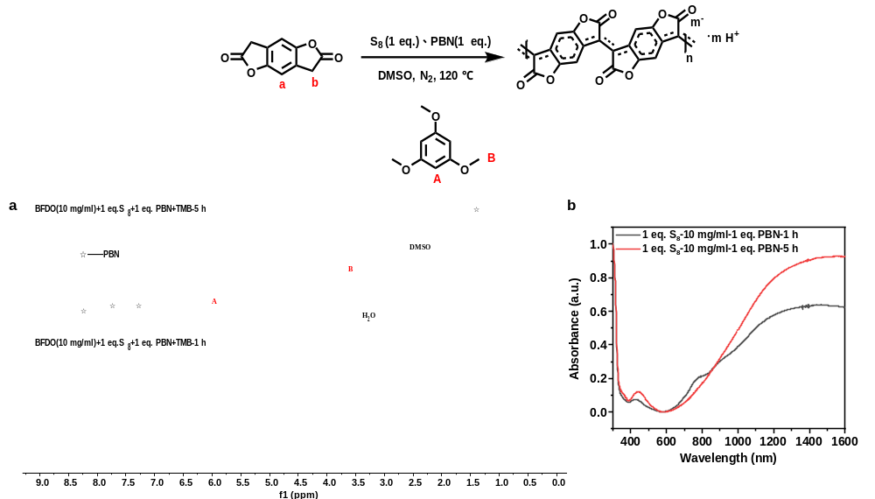
Supplementary Fig. 17 | (a) 1H NMR, (b) UV-Vis-NIR absorption spectra of n-PBFDO (10 mg mL−1) prepared with PBN for 1h and 5 h. At 1h reaction time, the monomers had been consumed, while the polymer solution containing PBN exhibited absorption profiles similar to n-PBFDO. Strong polarons and bipolarons absorption bands were observed in the near-infrared region, indicating that the addition of a free radical scavenger did not hinder the reaction progression.

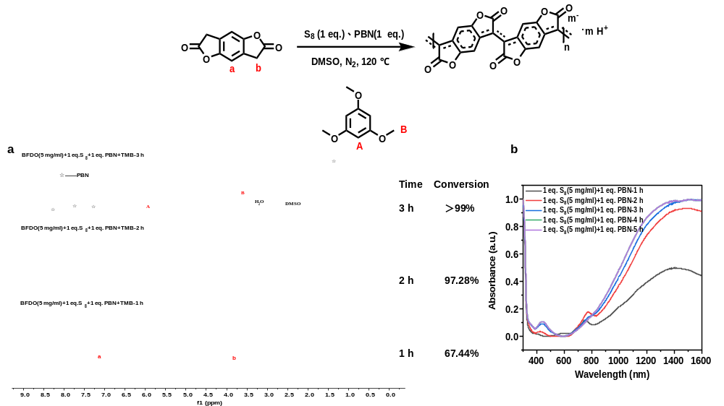
Supplementary Fig. 18 | (a) 1H NMR, (b) UV-Vis-NIR absorption spectrum of n-PBFDO (5 mg mL−1) after 1–5 h of PBN addition. At 3 h, the monomer was completely consumed, and the polymer solution exhibited absorption profiles similar to n-PBFDO. Strong polarons and bipolarons absorption bands were observed in the near-infrared region, indicating that the reaction is not affected by free radicals.
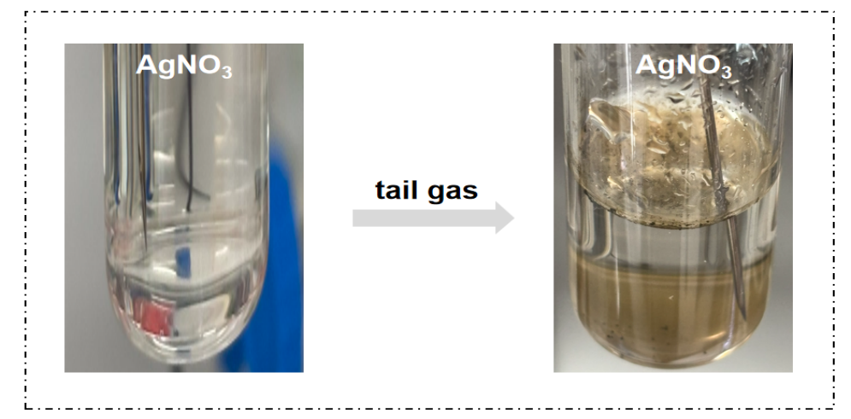
Supplementary Fig. 19 | Tail gas detection using AgNO3 aqueous solution (25 mg mL−1). Reaction conditions: BFDO (500 mg, 2.63 mmol), S8 (84 mg, 2.63 mmol S), DMSO (50 mL), stirred under nitrogen at 120 °C. When the reaction exhaust gas was directed into the AgNO3 solution, a black solid formed, indicating the release of H₂S.

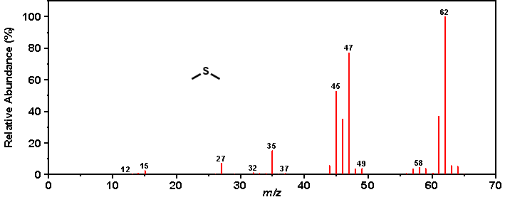
Supplementary Fig. 20 | GC-MS analysis of the polymerization: m/z 62 is the characteristic ion of DMS.

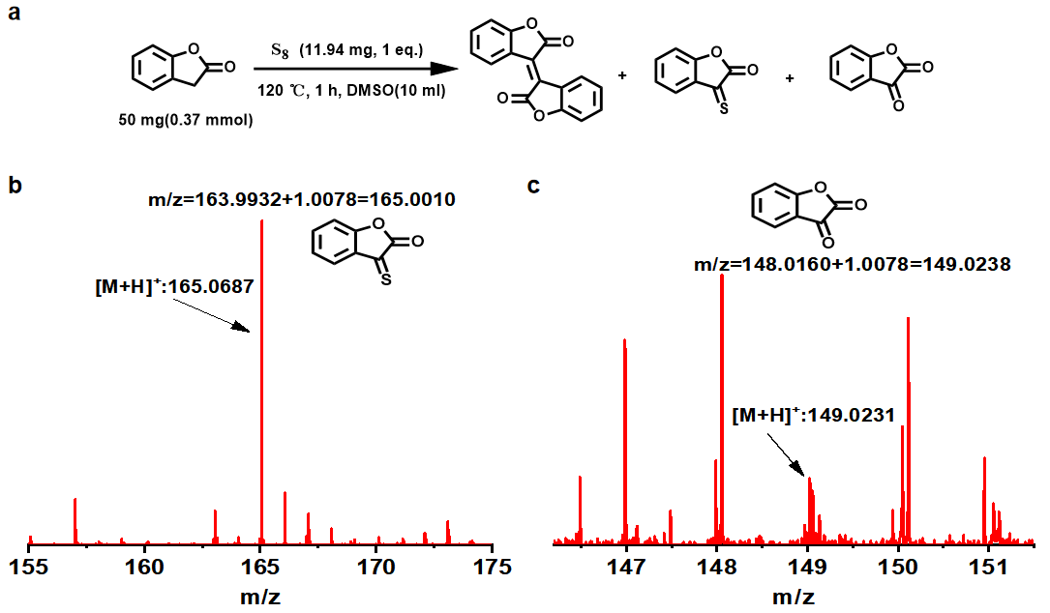
Supplementary Fig. 21 | The reaction of small-molecule BF with S8 was monitored by HR-MS, and the C=S and C=O intermediates were captured.

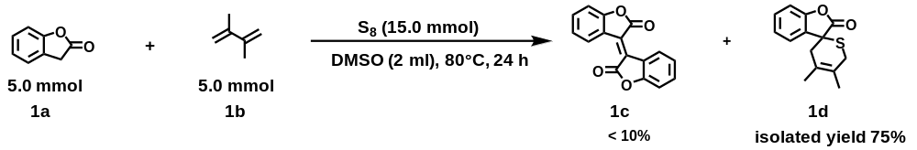
Supplementary Fig. 22 | Detection of intermediate using 2,3-dimethyl-1,3-butadiene by BFO model compound.

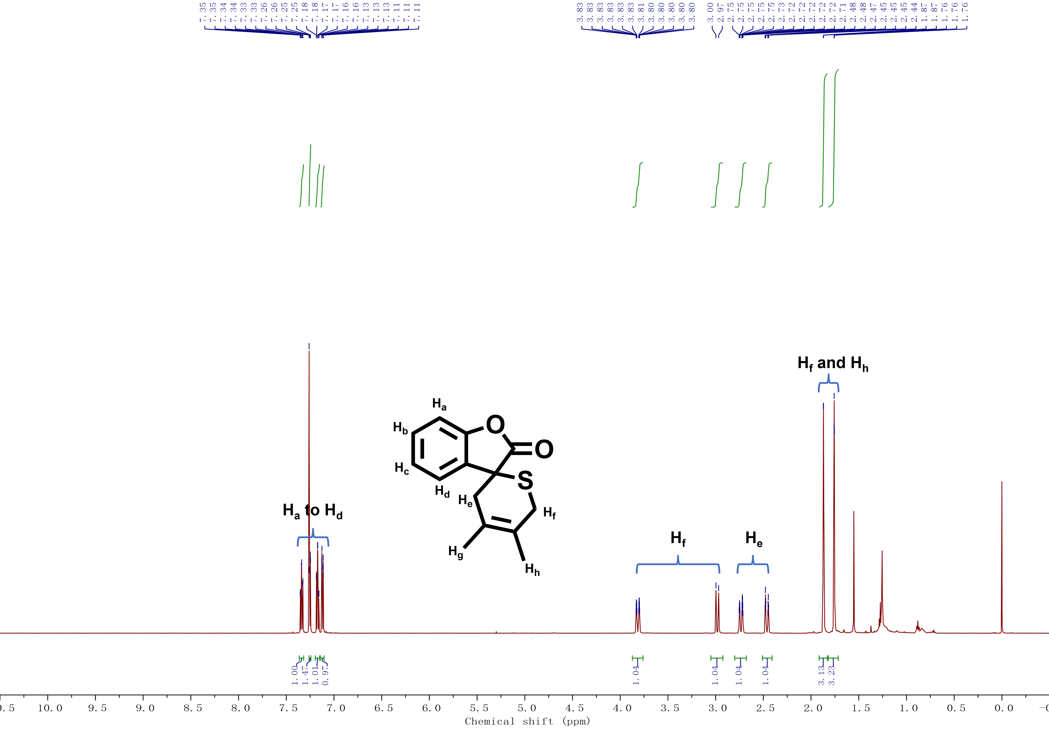
Supplementary Fig. 23 | ¹H NMR spectra of the Cyclic D-A Intermediate Product (1d).
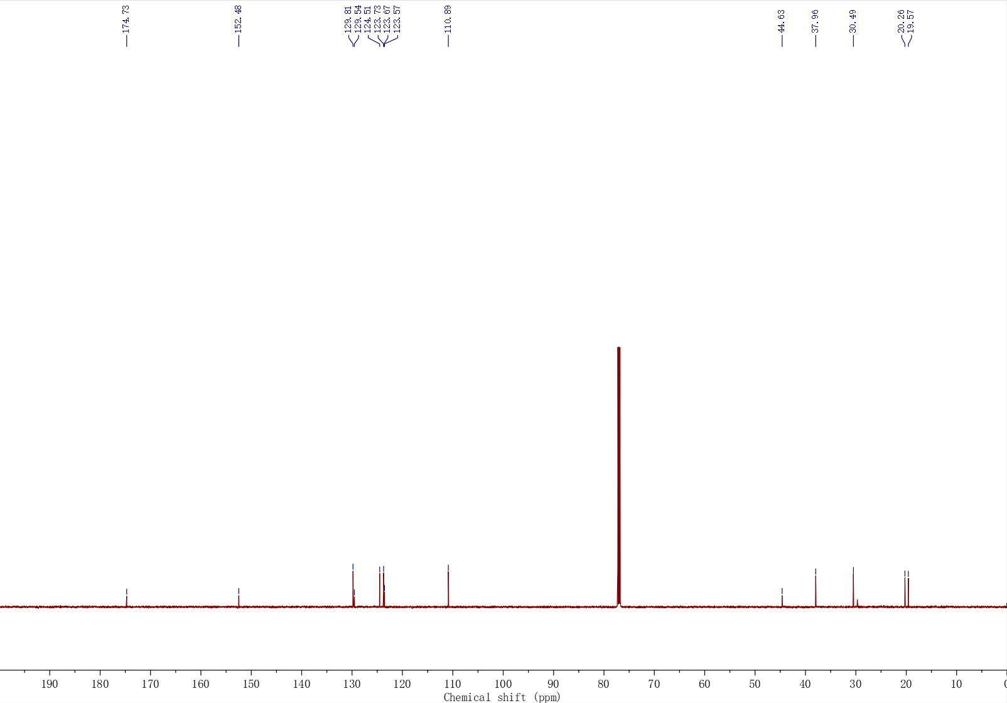
Supplementary Fig. 24 | ¹³C NMR spectra of the Cyclic D-A Intermediate Product (1d).

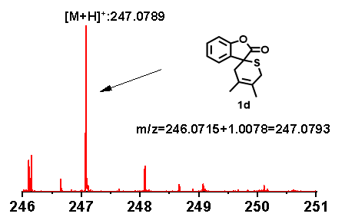
Supplementary Fig. 25 | HR-MS of the Cyclic D-A Intermediate Product (1d).

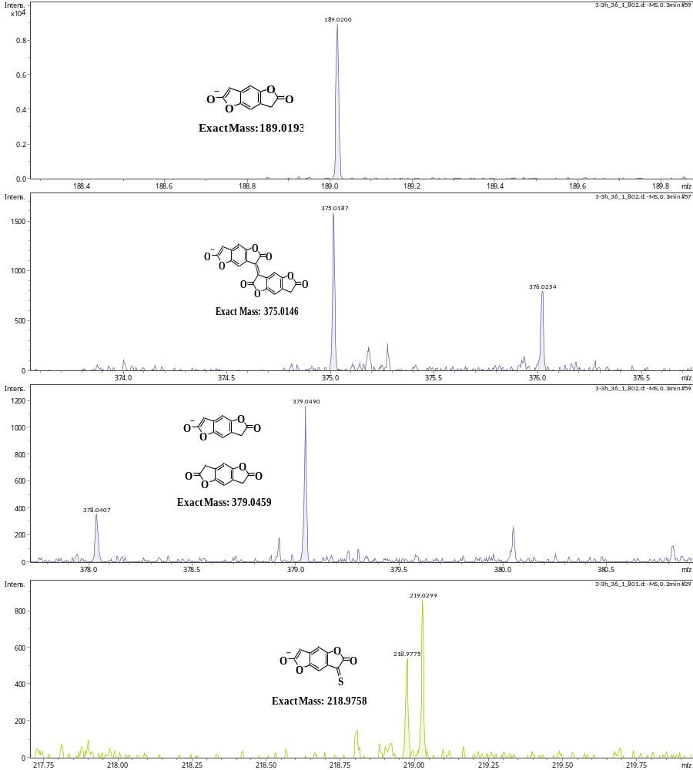
Supplementary Fig. 26 | HR-ESI-MS of the early-stage reaction mixture (30 min) from the polymerization with 1 eq. S. In the initial stage of polymerization, the BFDO monomer ([M−H]⁻ calcd. for C₁₀H₅O₄⁻, m/z 189.0193; found 189.0200), the dimer ([M−H]⁻ calcd. for C₂₀H₇O₈⁻, m/z 375.0146; found 375.0187) and the thione intermediate A ([M−H]⁻ calcd. for C₁₀H₃O₄S⁻, m/z 218.9758; found 218.9775) were detected, supporting the proposed mechanism.
- Dynamic light scattering (DLS) measurements of PBFDO polymers
Since PBFDO polymers are almost exclusively soluble in DMSO, conventional GPC mobile phases are not suitable for their molecular weight measurements. Therefore, we used DLS measurements to characterize the hydrodynamic diameter of polymer chains and understand polymer dynamics.
General method for DLS characterization: In a nitrogen atmosphere, BFDO monomer (50 mg, 5 mg mL−1) and S₈ (1–2 eq. S) were dissolved in DMSO at 120 °C. The mixture was stirred for several hours until the monomer conversion was complete (as checked by 1H NMR). At different reaction times, 200 μL of the mixture was taken from the reaction solution and diluted to 3 mL with DMSO. These diluted solutions were used for time-dependent UV-Vis-NIR absorption measurements and DLS studies. The summary of DLS results is presented in Supplementary Tables 4–5 and Supplementary Figs. 27–28.
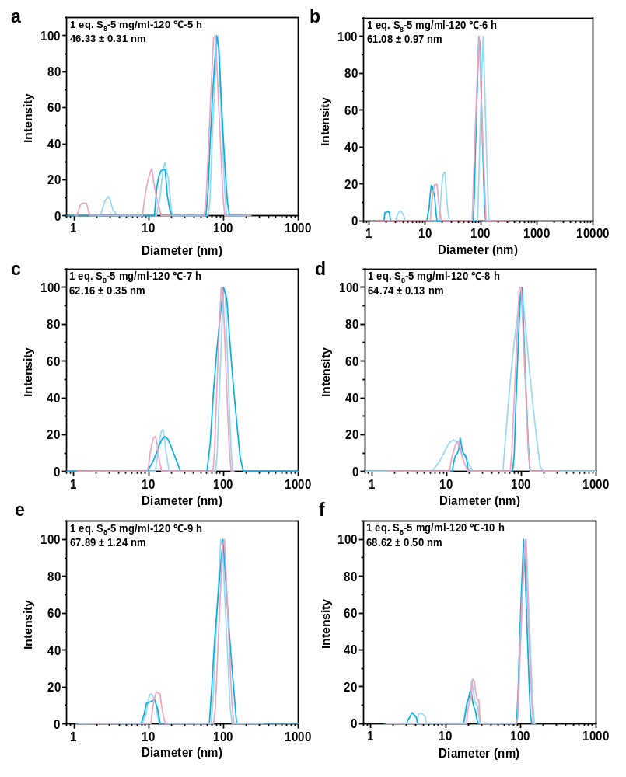
Supplementary Fig. 27 | DLS analysis of hydrodynamic diameter distribution of n-PBFDO particles at different polymerization time (polymerization condition: 5 mg mL−1 BFDO with 1 eq. S at 120 °C).

Supplementary Table 4 | Hydrodynamic diameters of n-PBFDO particles at different polymerization time (polymerization condition: 5 mg mL⁻¹ BFDO with 1 eq. S at 120 °C).
Time | Monomer conversion (%) | Hydrodynamic diameter (nm)
2 h | 40.96 | –
3 h | 60.64 | –
4 h | 78.17 | –
5 h | > 99 | 46.33 ± 0.31
6 h | > 99 | 61.08 ± 0.97
7 h | > 99 | 62.16 ± 0.35
8 h | > 99 | 64.74 ± 0.13
9 h | > 99 | 67.89 ± 1.24
10 h | > 99 | 68.62 ± 0.50
[a] Due to the weak scattering intensity of the sample, the hydrodynamic diameter data could not be measured for the polymer solution with short polymerization time. It can be seen that the particle size remained basically unchanged after the conversion rate reached 99%.
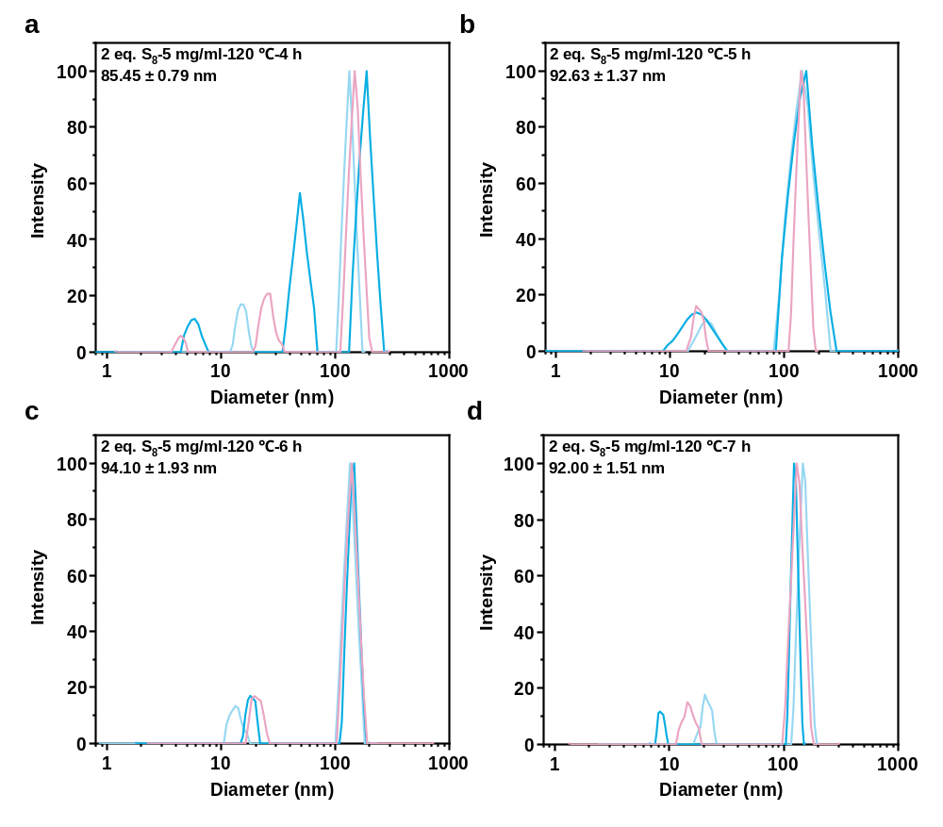
Supplementary Fig. 28 | DLS analysis of hydrodynamic diameter distribution of n-PBFDO particles at different polymerization time (polymerization condition: 5 mg mL−1 BFDO with 2 eq. S at 120 °C).

Supplementary Table 5 | Hydrodynamic diameters of n-PBFDO particles at different polymerization time (polymerization condition: 5 mg mL⁻¹ BFDO with 2 eq. S at 120 °C).
Time | Monomer conversion (%) | Hydrodynamic diameter (nm)
1 h | 26.14 | –
2 h | 41.42 | –
3 h | 56.92 | –
4 h | 87.22 | 85.45 ± 0.79
5 h | > 99 | 92.63 ± 1.37
6 h | > 99 | 94.10 ± 1.93
7 h | > 99 | 92.00 ± 1.51
[a] Due to the weak scattering intensity of the sample, the hydrodynamic diameter data could not be measured for the polymer solution with short polymerization time.
- General characterization of polymers
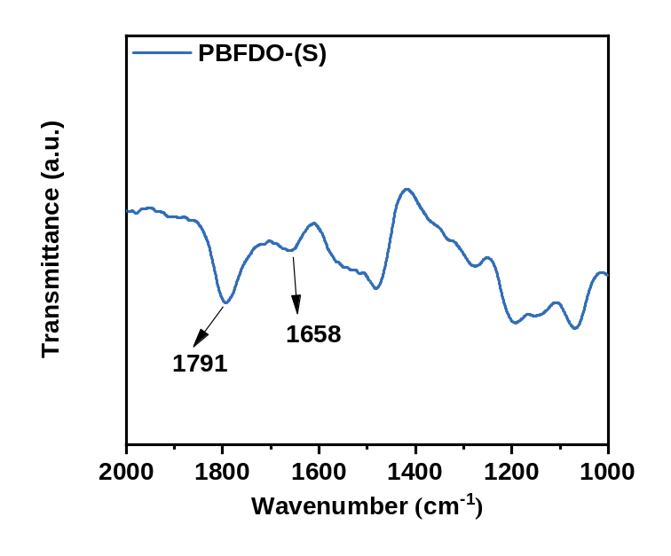
Supplementary Fig. 29 | FTIR spectrum of PBFDO-(S).

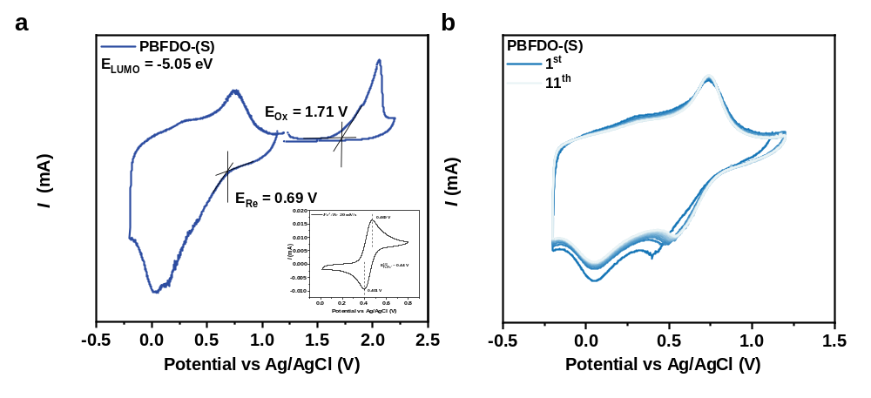
Supplementary Fig. 30 | (a) Cyclic voltametric curves of the polymer films. (b) Cyclic voltammetry scan of the polymer films in 0.1 M n-Bu₄NPF₆ acetonitrile solution.

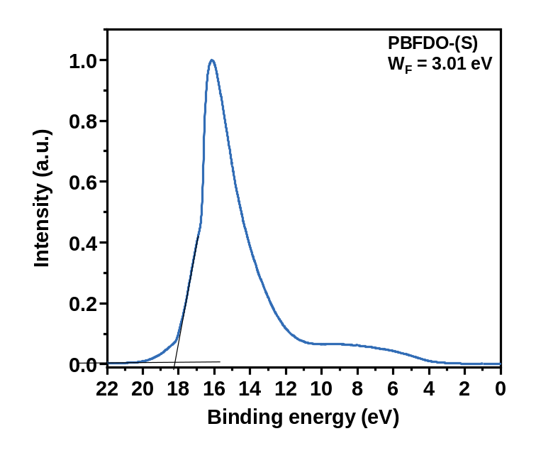
Supplementary Fig. 31 | Ultraviolet photoelectron spectrum (UPS) of PBFDO deposited on Si substrate.

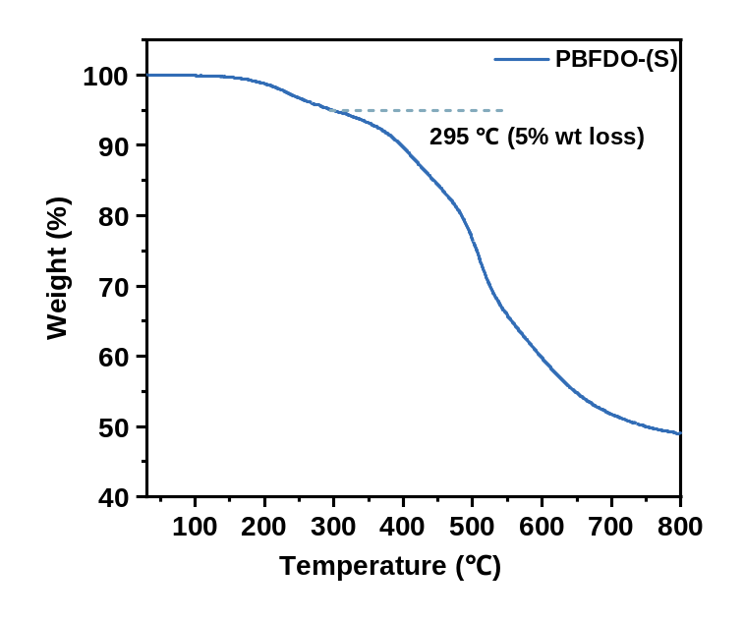
Supplementary Fig. 32 | Thermogravimetric (TGA) curves of the polymers. (N₂, 10 °C min−1, 30 °C–800 °C)

- Thermoelectric and OECT measurements
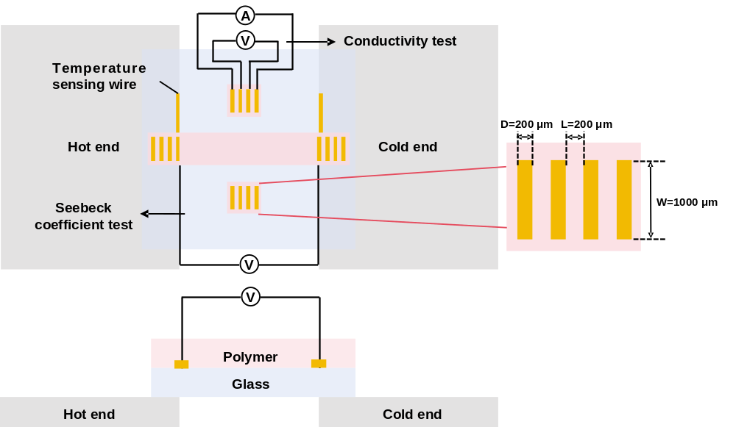
Supplementary Fig. 33 | Device architecture for conductivity and Seebeck measurements.
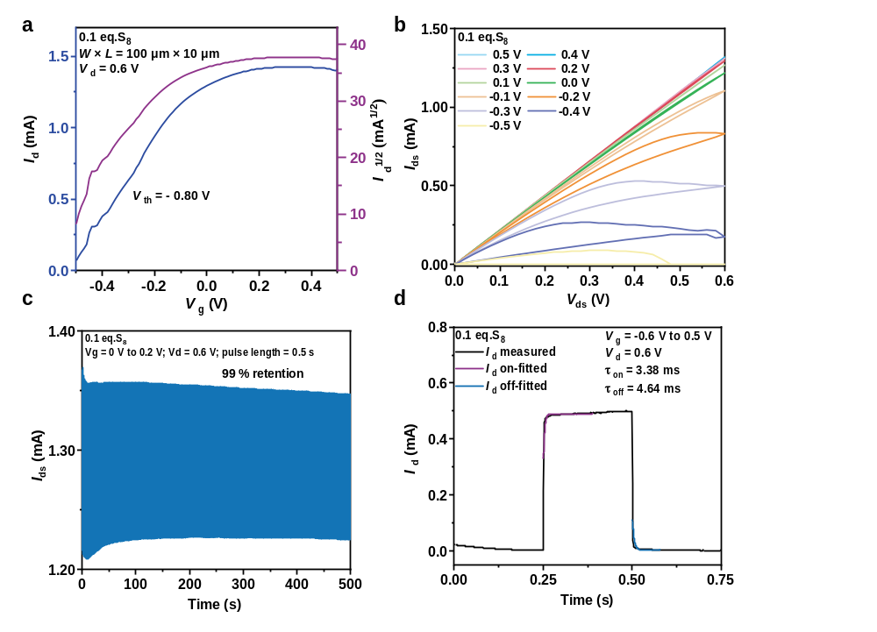
Supplementary Fig. 34 | OECT performance of PBFDO synthesized by 0.1 eq. S.
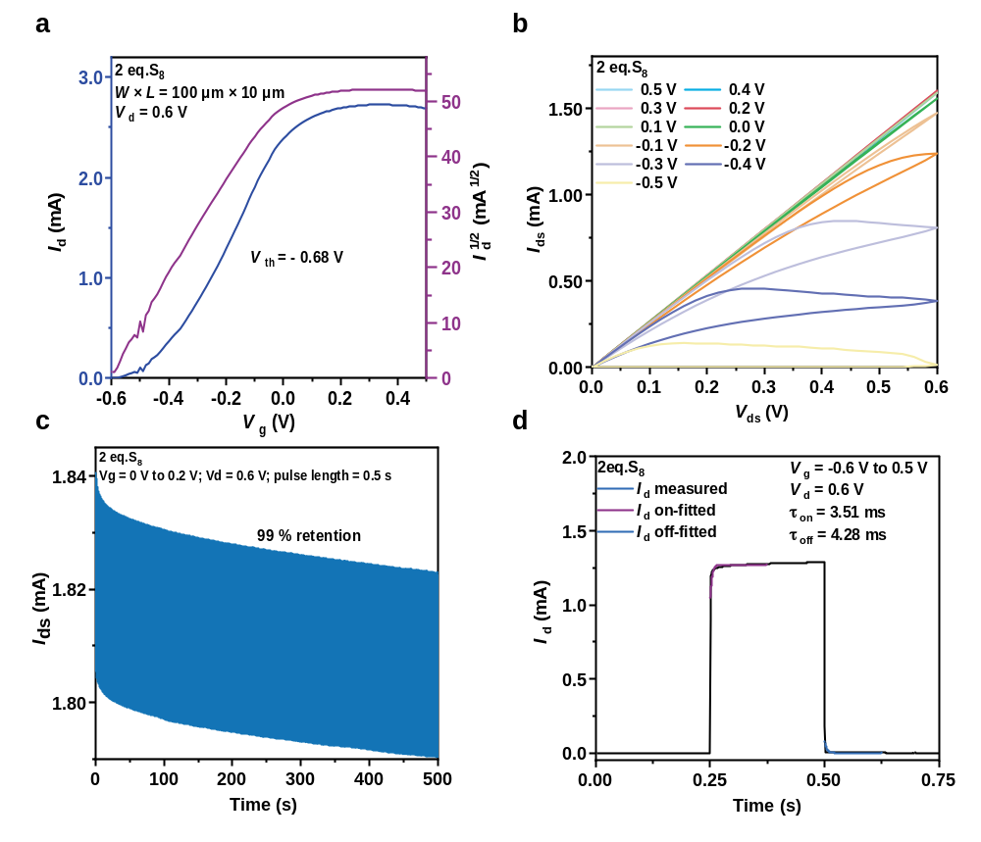
Supplementary Fig. 35 | OECT performance of PBFDO synthesized by 2 eq. S.

Supplementary Table 6 | OECT performance summary of PBFDO synthesized with different S loadings.
S₈ (eq. S) | g_{m,norm} (S cm⁻¹) | Wd/L | V_{th} (V) | μC* (F cm⁻¹ V⁻¹ s⁻¹) | μ_{OECT} (cm² V⁻¹ s⁻¹) | C* (F cm⁻³) | τ_{on}/τ_{off}
0.1 | 137 (120) | 275 | −0.80 | 253 (217) | 1.00 (0.86) | 253 | 3.38/4.64 ms
1 | 248 (208) | 270 | −0.69 | 460 (394) | 1.53 (1.31) | 300 | 3.09/3.82 ms
2 | 217 (184) | 308 | −0.68 | 396 (345) | 1.36 (1.19) | 291 | 3.51/4.28 ms
[a] The values in parentheses are the average of the measurements of the six devices, and the values outside the parentheses are the maximum of the six devices.

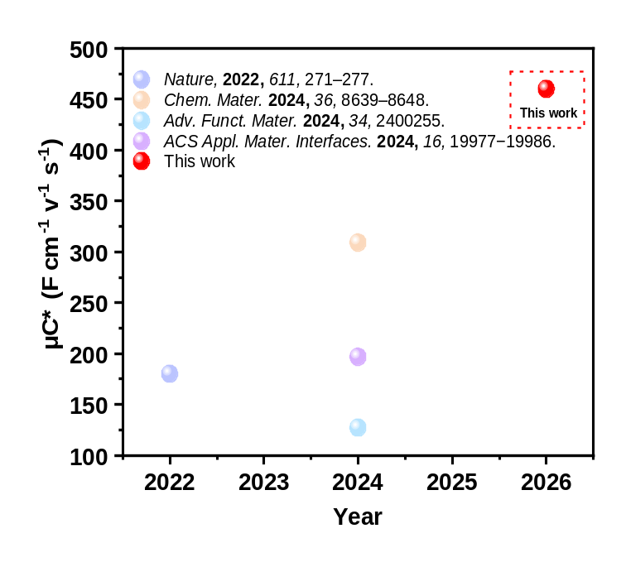
Supplementary Fig. 36 | Comparison of the μC* of PBFDO-based OECT devices in this work with that reported in the literature.

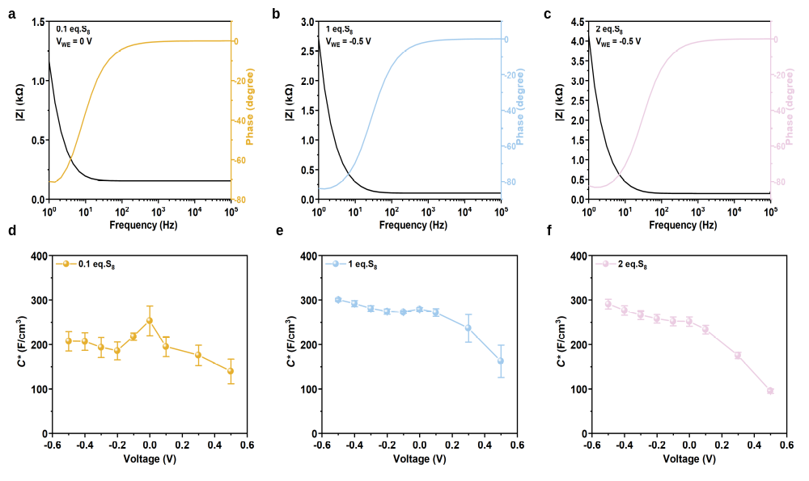
Supplementary Fig. 37 | (a-c) capacitance behavior (d-f) Bode and phase plots of samples synthesized with different S loadings, measured by electrochemical impedance spectroscopy during electrochemical oxidation and reduction. The sample size n = 3, and the error bar indicates the mean ± standard deviation.
- Scale-up synthesis of PBFDO
BFDO monomer (2.5 g, 1 eq.) and S8 (0.42 g, 1 eq. S) were added to 500 mL of dimethyl sulfoxide under nitrogen atmosphere. The mixture was stirred at 120 °C. During polymerization, monomer conversion was monitored by thin-layer chromatography (TLC) and 1H NMR until complete polymerization (Supplementary Fig. 39). The total reaction time was 7 h. After cooling to room temperature, the solution was filtered through a 0.22 μm PTFE membrane to obtain PBFDO ink.
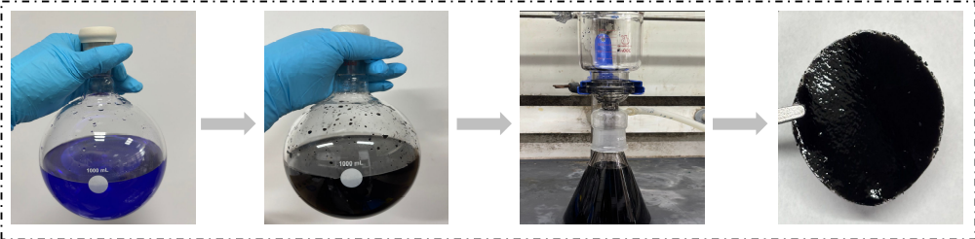
Supplementary Fig. 38 | The scaled-up synthesis of PBFDO (500 mL).

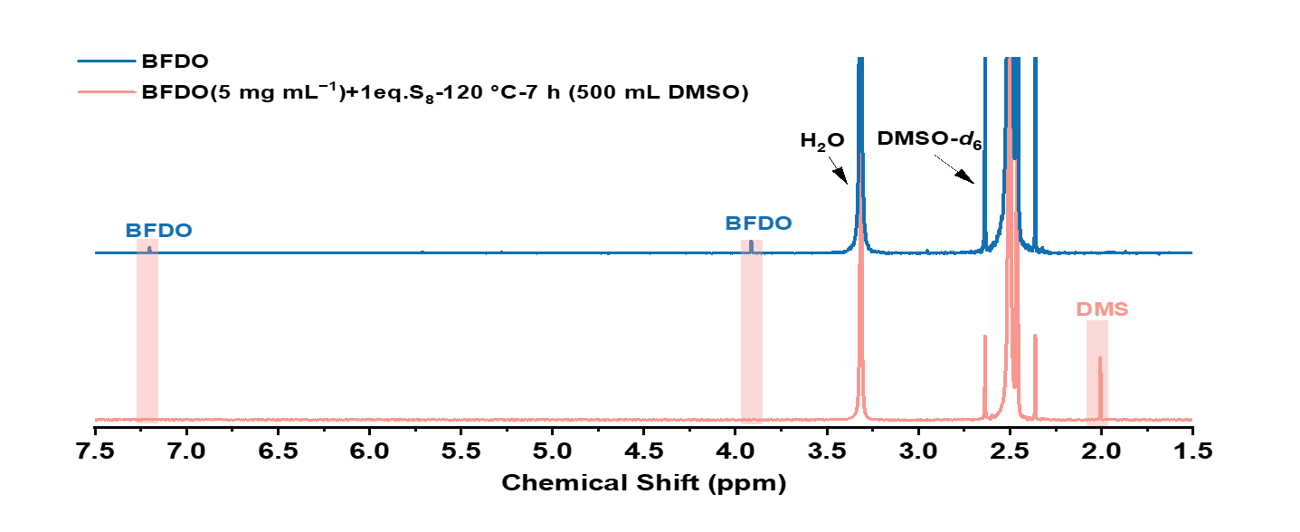
Supplementary Fig. 39 | ¹H NMR spectrum of BFDO monomer and 500 mL reaction mixture after 7 hours.
- Additional device characterization
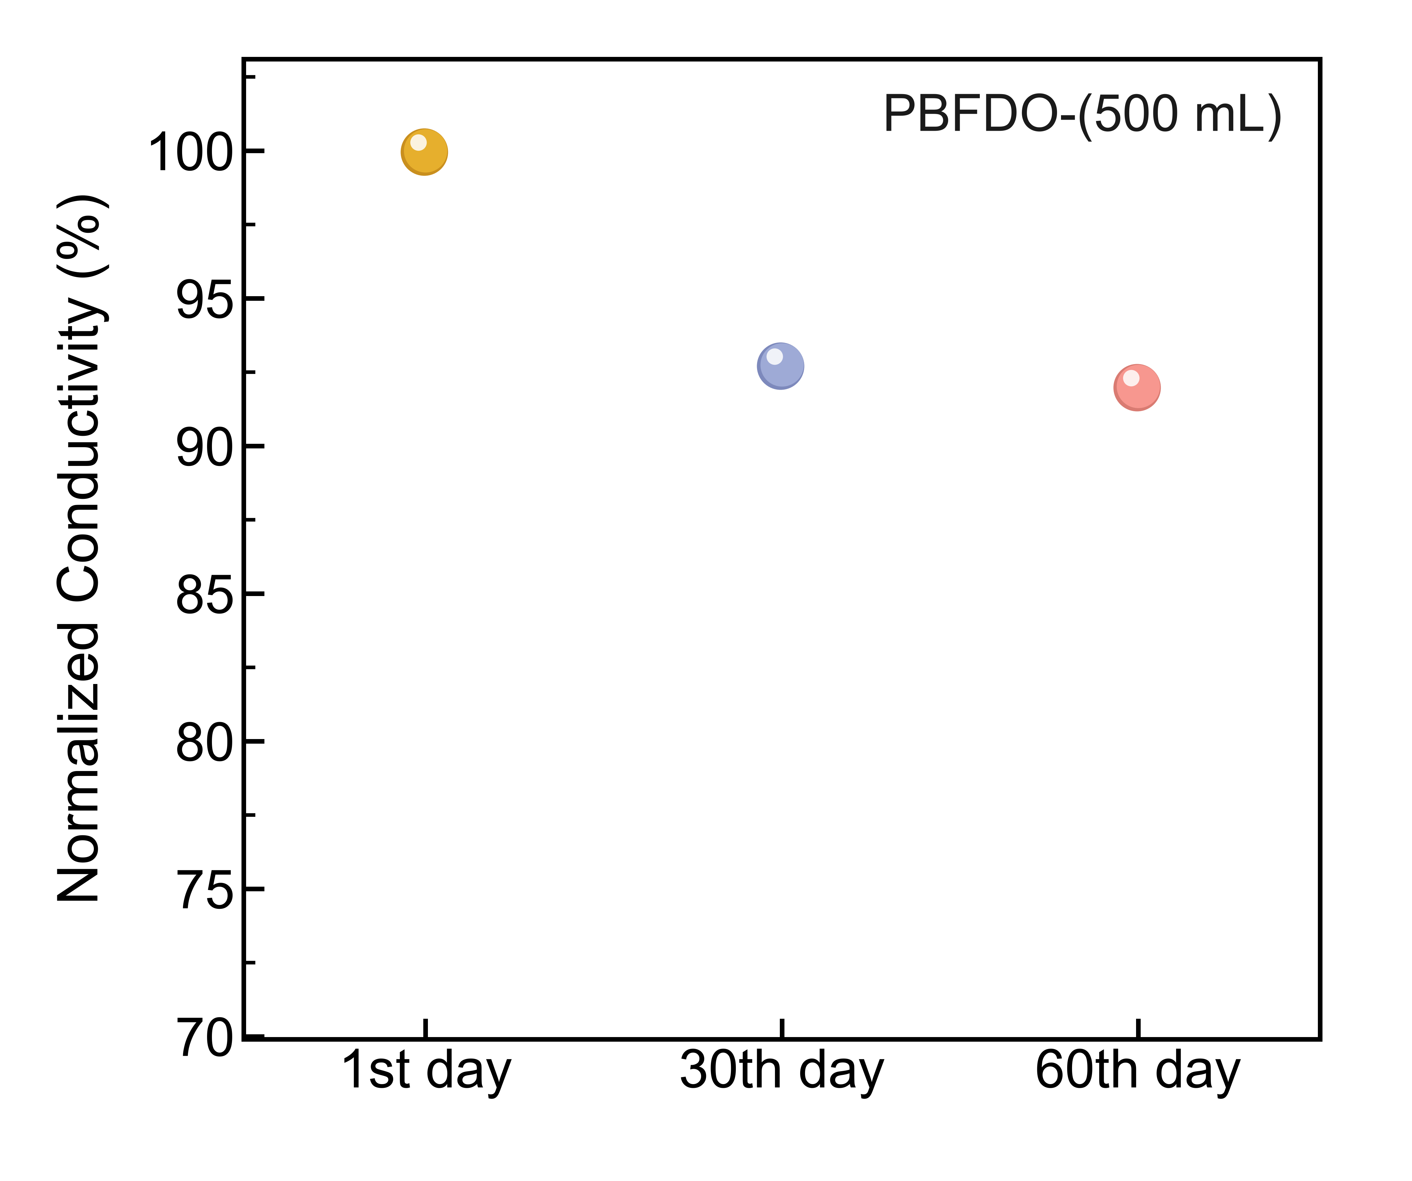
Supplementary Fig. 40 | Conductivity retention of the 500 mL scaled-up PBFDO ink stored in air over 60 days. The ink retained 92% of its initial conductivity (1257 ± 20 S cm−1) after 60 days.
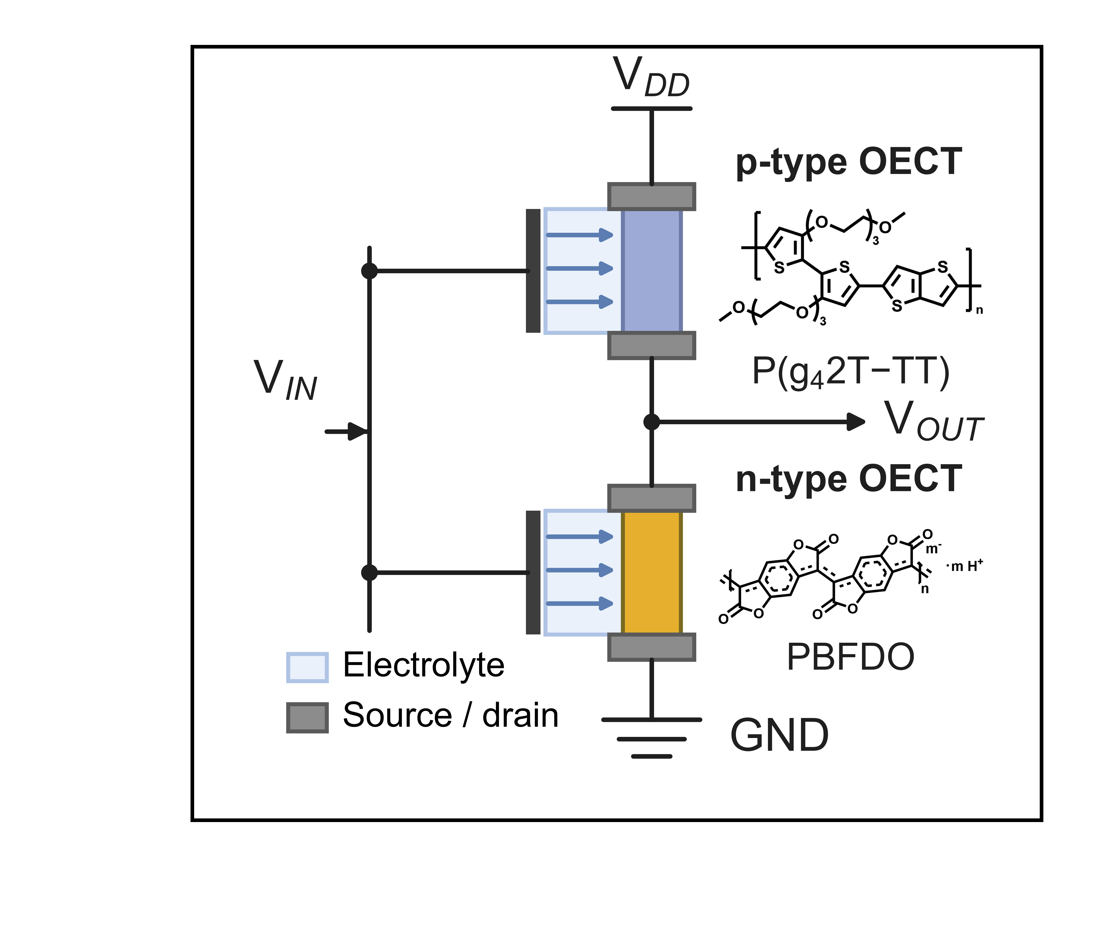
Supplementary Fig. 41 | Device architecture of the p–n complementary inverter based on n-type PBFDO and p-type P(g42T-TT).
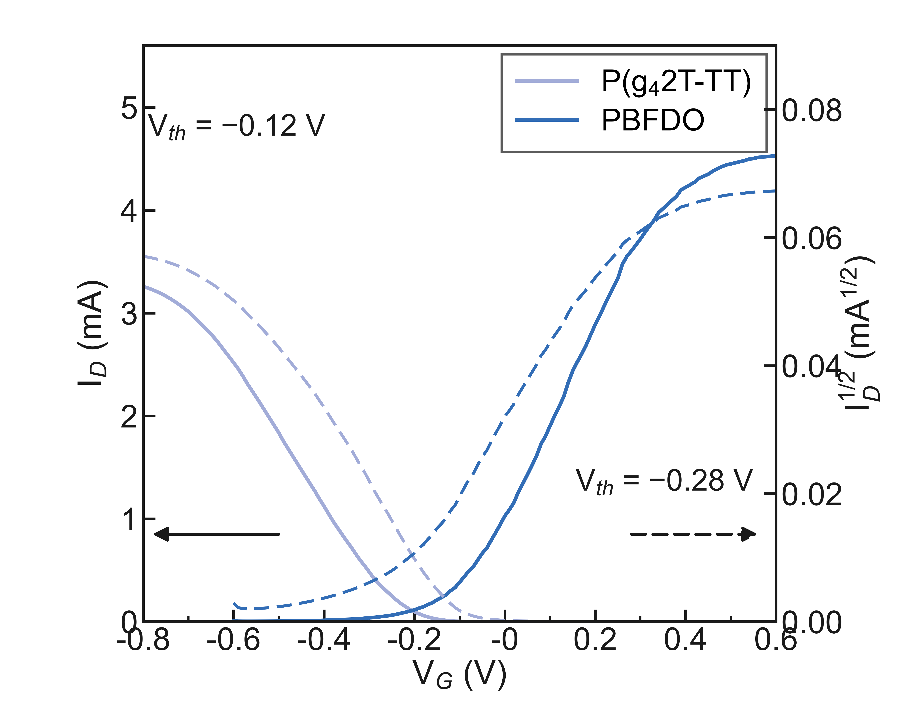
Supplementary Fig. 42 | Transfer curves of p-type P(g42T-TT) and n-type PBFDO recorded in 0.1 M NaCl.
- References
[1] Liu, G., Pal, U., Samal, S., Espenship, M. F., Li, Y. et al. Catalytic polymerization of n-doped poly(benzodifurandione) (n-PBDF) using parts per million (ppm) levels of molybdenum trioxide. Angew. Chem. Int. Ed. 64, e202510411 (2025).
[2] Huang, Y., Yu, Y., Hu, R. & Tang, B. Z. Multicomponent polymerizations of elemental sulfur, CH₂Cl₂, and aromatic amines toward chemically recyclable functional aromatic polythioureas. J. Am. Chem. Soc. 146, 14685–14696 (2024).
[3] Smart, R. S. C., Skinner, W. M. & Gerson, A. R. XPS of sulphide mineral surfaces: metal-deficient, polysulphides, defects and elemental sulphur. Surf. Interface Anal. 28, 101–105 (1999).
[4] Siow, K. S., Britcher, L., Kumar, S. & Griesser, H. J. XPS study of sulfur and phosphorus compounds with different oxidation states. Sains Malays. 47, 1913–1922 (2018).

