Supplementary material

Table S1. List of siRNAs used in the present study. The table provides information on the siRNAs used in this study, including catalog number and supplier.

siRNAs | Target Sequence (5’ -> 3’) | Cat. # | Supplier
siCTL | Allstars Negative Control siRNA, sequence not provided | SI03650318 | Qiagen, Venlo,  Netherlands
Human siJAK1 #1 | CACGGATAACATCAGCTTCAT | SI00605521 | Qiagen, Venlo,  Netherlands
Human siJAK1 #2 | CCAAAGCAATTGAAACCGATA | SI02628136 | Qiagen, Venlo,  Netherlands
Human siJAK2 #2 | CAGAATTAGCAAACCTTATAA | SI02634177 | Qiagen, Venlo,  Netherlands
Human siJAK2 #3 | AACGAGAAATATATTGGTGGA | SI00070728 | Qiagen, Venlo,  Netherlands
Human siJNK1 #1 | GGGCCUACAGAGAGCUAGUUCUUAU | HSS108547 | Invitrogen,  Pasley, UK
Human siJNK1 #2 | GCUGACUCAGAACACAACAAACUUA | HSS108549 | Invitrogen,  Pasley, UK
Human siTYK2 #1 | CACCATCTGGTAATAAACTCA | SI02223221 | Qiagen, Venlo,  Netherlands
Human siTYK2 #2 | CTGATGCTATATTTCCGCATA | SI02659559 | Qiagen, Venlo,  Netherlands

Table S2. Checklist for reporting human islet preparations used in research adapted from Hart NJ, Powers AC (2018) Progress, challenges, and suggestions for using human islets to understand islet biology and human diabetes ⁽¹⁾.

Islet preparation | 1 | 2 | 3 | 4 | 5 | 6 | 7 | 8
MANDATORY INFORMATION
Unique identifier | HIRP-23 | HIRP-24 | HIRP-29 | HI 375 | HI 376 | HIRP-37 | HIRP-36 | HIRP-38
Donor age (years) | 70 | 51 | 49 | 62 | 61 | 57 | 43 | 57
Donor sex (M/F) | M | F | M | F | M | F | M | M
Donor BMI (kg/m²) | 25 | 26 | 17 | 24.7 | 25.1 | 30 | 25 | 32
Donor HbA_{1c} or other measure of blood glucose control | HbA_{1c}: 5.2% | Glycemia: 126  HbA_{1c}: 4.4% | Glycemia: 98  HbA_{1c}: 5.2% | HbA_{1c}: 6% | HbA_{1c}: 6% | Glycemia: 185  HbA_{1c}: 5.9% | HbA_{1c}: 5.5% | Glycemia: 162  HbA_{1c}: 4.9%
Origin/source of islets | Cliniques universitaires Saint-Luc UCL, Brussels | Cliniques universitaires Saint-Luc UCL, Brussels | Cliniques universitaires Saint-Luc UCL, Brussels | Diabetes,  University of  Lille, Lille,  France | Diabetes,  University of  Lille, Lille,  France | Cliniques universitaires Saint-Luc UCL, Brussels | Cliniques universitaires Saint-Luc UCL, Brussels | Cliniques universitaires Saint-Luc UCL, Brussels
Islet isolation centre | Pole of Experimental Surgery & Transplantation, UCL | Pole of Experimental Surgery & Transplantation, UCL | Pole of Experimental Surgery & Transplantation, UCL | European  Genomic  Institute for  Diabetes,  Translational  Research for Diabetes | European  Genomic  Institute for  Diabetes,  Translational  Research for Diabetes | Pole of Experimental Surgery & Transplantation, UCL | Pole of Experimental Surgery & Transplantation, UCL | Pole of Experimental Surgery & Transplantation, UCL
Donor history of diabetes? Please select yes/no from drop down list | No | No | No | ​​No​ | ​​No​ | ​​No​ | ​​No​ | ​​No​
RECOMMENDED INFORMATION
Donor cause of death | Circulatory death | Circulatory death | Circulatory death | Ruptured aneurysm | Stroke | Brain death | Circulatory death | Brain death
Cold ischaemia time (h) | ____ | 4h7 | 4h10 | 11h30 | 7h25 | 12h | 12h30 | 10h40
Estimated purity (%) | 69 | 35 | 25 | 66 | 48 | 60 | 37 | 59
Total culture time | 8 days | 8 days | 8 days | 8 days | 8 days | 8 days | 8 days | 8 days

Table S3. Sequences of the primers used for quantitative RT-PCR analysis in the present study. The table provides information on the primers used in this study, including sequence and supplier.

Gene | Primer sequence (5’ -> 3’) | Direction | Supplier
Human ACTIN | CTGTACGCCAACACAGTGCT | Forward | Eurogentec
 | GCTCAGGAGGAGCAATGATC | Reverse
Human ATF4 | GGCCAAGCACTTCAAACCTC | Forward | Eurogentec
 | GAGAAGGCATCCTCCTTGCT | Reverse
Human BIP (HSPA5) | GeneGlobe ID: QT00096404 | Forward and Reverse | Qiagen, Venlo,  Netherlands
Human CHOP (DDIT3) | GeneGlobe ID: QT00082278 | Forward and Reverse | Qiagen, Venlo,  Netherlands
Human CXCL10 | GTGGCATTCAAGGAGTACCTC | Forward | Eurogentec
 | GCCTTCGATTCTGGATTCAG | Reverse
Human HLA-A | TGGAGCTGTGATCACTGGAG | Forward | Eurogentec
 | GGGCACTGTCACTGCTTG | Reverse
Human HLA-B | AGACACAGATCTCCAAGACCAACA | Forward | Eurogentec
 | CGTCGCAGCCGTACATCCT | Reverse
Human JAK1 | CTCACCAGGATGCGGATAAA | Forward | Eurogentec
 | AGTTTCCAAGGTAGCCAAGTAT | Reverse
Human JAK2 | ACAGGAACAAGATGTGAACTGTTTC | Forward | Eurogentec
 | TTTCAGAACATTTGCCGTCGC | Reverse
Human JNK1 | TATGGACTTGGAGGAGAGAACCA | Forward | Eurogentec
 | GGATGCTGAGAGCCATTGATCAC | Reverse
Human TYK2 | TGGCTTGGAAGATGGTGGTG | Forward | Eurogentec
 | GTTCCGGCCACACACATTACC | Reverse
Human VAPA | TACCGAAACAAGGAAACTAATGGAA | Forward | Eurogentec
 | GCCTTAAACCTTCATCTCTCAGGT | Reverse

Table S4. List of antibodies used in the present study. The table provides information on the antibodies used in this study, including protein target name, company, catalog number and dilution.

PRIMARY
Antibody | Company | Cat. # | Dilution | Application
BIP | Biorbyt | ORB1725583 | 1:500 | WB
CHOP | Boster Biological Techonology | M00311 | 1:500 | WB
GAPDH | R&D Systems | 2275-PC-100 | 1:10000 | WB
JAK1 | Cell signaling | 3332 | 1:1000 | WB
JAK2 | Cell signaling | 3230 | 1:1000 | WB
JNK1 | Cell signaling | 3708 | 1:1000 | WB
PD-L1 | Cell signaling | 13684 | 1:1000 | WB
Phospho-SAPK/JNK | Cell signaling | 9251 | 1:1000 | WB
Phospho-STAT1 (Ser727) | Cell signaling | 9177 | 1:1000 | WB
Phospho-STAT1 (Tyr701) | Cell signaling | 9167 | 1:1000 | WB
STAT1 | Cell signaling | 9172 | 1:1000 | WB
TYK2 | Cell signaling | 9312 | 1:1000 | WB
SECONDARY
Antibody | Company | Cat. # | Dilution | Application
Peroxidase AffiniPure® F(ab')₂ Fragment Donkey Anti-Mouse IgG (H+L) | Jackson ImmunoResearch | 715-036-150 | 1:5000 | WB
Peroxidase AffiniPure® F(ab')₂ Fragment Donkey Anti-Rabbit IgG (H+L) | Jackson ImmunoResearch | 711-036-152 | 1:5000 | WB

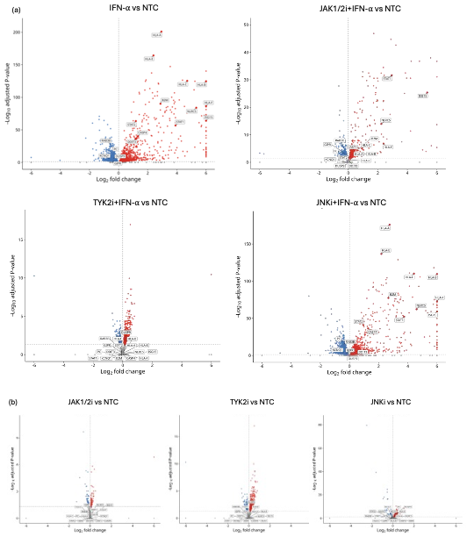

Fig. S1. Differential gene expression following IFN-α exposure and kinase inhibition in EndoC-βH1 cells. (a) Volcano plots showing differential gene expression in IFN-α-, JAK1/2i+IFN-α-, TYK2i+IFN-α- and JNKi+IFN-α-treated cells relative to non-treated control (NTC) cells. (b) Volcano plots showing differential gene expression following treatment with baricitinib (JAK1/2i; 4 µmol/L), deucravacitinib (TYK2i; 0.3 µmol/L) or SP600125 (JNKi; 20 µmol/L) relative to NTC cells. Cells were pretreated with the inhibitors for 2 h and subsequently cultured with or without IFN-α (2,000 U/mL) for 24 h. Each point represents one gene. Red and blue points indicate genes with significantly increased and decreased expression, respectively, whereas gray points indicate genes that did not meet the differential-expression criteria. Horizontal dashed lines indicate the adjusted P-value threshold (Padj < 0.05), and vertical dashed lines indicate log₂FC = 0. Selected genes are labeled. Differential-expression analyses were based on four independent biological replicates per condition (n = 4).

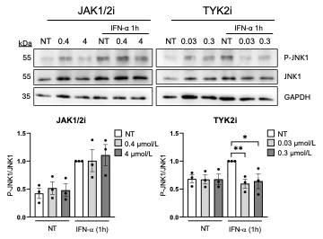

Fig. S2. Effects of JAK1/2 and TYK2 inhibition on JNK1 phosphorylation following short-term IFN-α stimulation in EndoC-βH1 cells. EndoC-βH1 cells were pretreated for 2 h with the JAK1/2 inhibitor baricitinib (0.4 or 4 μmol/L) or the selective TYK2 inhibitor deucravacitinib (0.03 or 0.3 μmol/L) and then left untreated or treated with IFN-α (2,000 U/mL) for 1 h. P-JNK1, JNK1 and GAPDH protein levels were analysed by immunoblot. Bands were quantified by densitometry and the levels of P-JNK1 were corrected by JNK, the values were normalized by the condition of IFN-α considered as 1, and representative western blots are shown. The results are mean ± SEM of 3 independent experiments. *P < 0.05, and **P < 0.01. One-way ANOVA followed by Bonferroni correction for multiple comparisons post-hoc test.

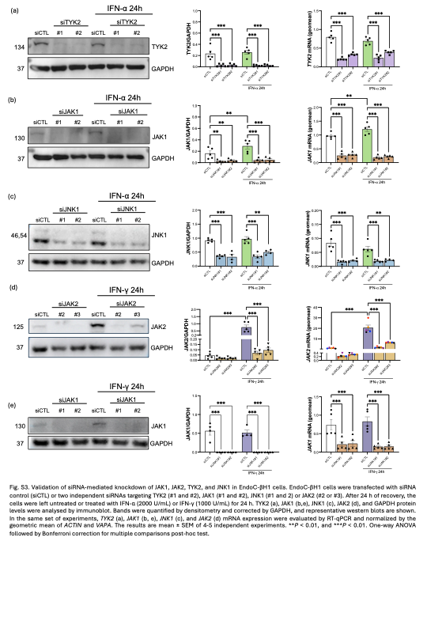

Fig. S3. Validation of siRNA-mediated knockdown of JAK1, JAK2, TYK2, and JNK1 in EndoC-βH1 cells.
EndoC-βH1 cells were transfected with siRNA control (siCTL) or two independent siRNAs targeting TYK2 (#1 and #2), JAK1 (#1 and #2), JNK1 (#1 and #2) or JAK2 (#2 or #3). After 24 h of recovery, the cells were left untreated or treated with IFN-α (2,000 U/mL) or IFN-γ (1,000 U/mL) for 24 h. TYK2 (a), JAK1 (b,e), JNK1 (c), JAK2 (d), and GAPDH protein levels were analyzed by immunoblot. Bands were quantified by densitometry and corrected by GAPDH, and representative western blots are shown. In the same set of experiments, TYK2 (a), JAK1 (b, e), JNK1 (c), and JAK2 (d) mRNA expression were evaluated by RT-qPCR and normalized by the geometric mean of ACTIN and VAPA. The results are mean ± SEM of 4-5 independent experiments. **P < 0.01, and ***P < 0.01. One-way ANOVA followed by Bonferroni correction for multiple comparisons post-hoc test.

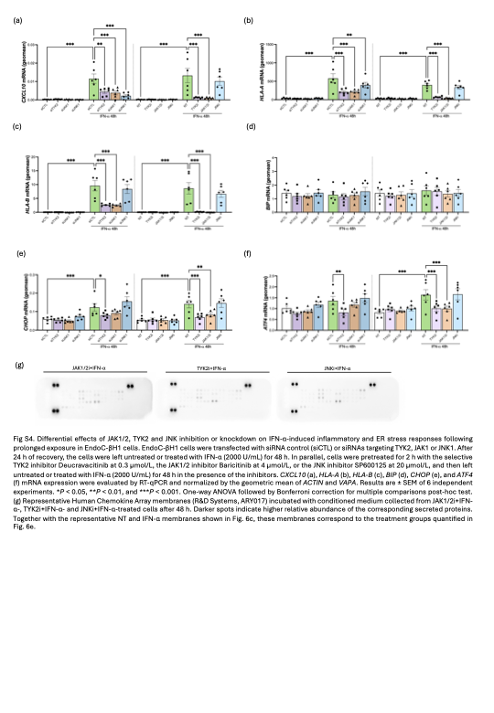

Fig. S4. Differential effects of JAK1/2, TYK2 and JNK inhibition or knockdown on IFN-α-induced inflammatory and ER stress responses following prolonged exposure in EndoC-βH1 cells. EndoC-βH1 cells were transfected with siRNA control (siCTL) or siRNAs targeting TYK2, JAK1 or JNK1. After 24 h of recovery, the cells were left untreated or treated with IFN-α (2,000 U/mL) for 48 h. In parallel, cells were pretreated for 2 h with the selective TYK2 inhibitor deucravacitinib (0.3 µmol/L), the JAK1/2 inhibitor baricitinib (4 µmol/L), or the JNK inhibitor SP600125 (20 µmol/L), and then left untreated or treated with IFN-α (2,000 U/mL) for 48 h in the presence of the inhibitors. CXCL10 (a), HLA-A (b), HLA-B (c), BIP (d), CHOP (e), and ATF4 (f) mRNA expression were evaluated by RT-qPCR and normalized by the geometric mean of ACTIN and VAPA. Results are ± SEM of 6 independent experiments. *P < 0.05, **P < 0.01, and ***P < 0.001. One-way ANOVA followed by Bonferroni correction for multiple comparisons post-hoc test. (g) Representative Human Chemokine Array membranes (R&D Systems, ARY017) incubated with conditioned medium collected from JAK1/2i+IFN-α-, TYK2i+IFN-α- and JNKi+IFN-α-treated cells after 48 h. Darker spots indicate higher relative abundance of the corresponding secreted proteins. Together with the representative NT and IFN-α membranes shown in Fig. 6c, these membranes correspond to the treatment groups quantified in Fig. 6e.

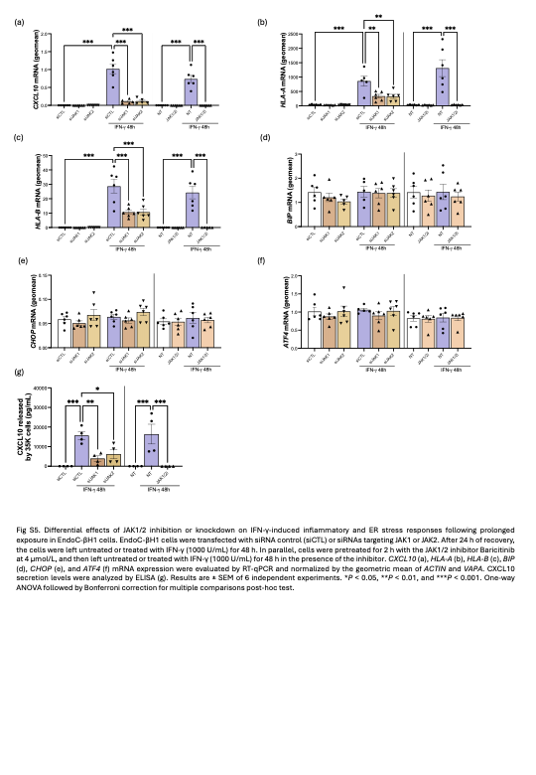

Fig. S5. Differential effects of JAK1/2 inhibition or knockdown on IFN-γ-induced inflammatory and ER stress responses following prolonged exposure in EndoC-βH1 cells.
EndoC-βH1 cells were transfected with siRNA control (siCTL) or siRNAs targeting JAK1 or JAK2. After 24 h of recovery, the cells were left untreated or treated with IFN-γ (1,000 U/mL) for 48 h. In parallel, cells were pretreated for 2 h with the JAK1/2 inhibitor baricitinib (4 µmol/L) and then left untreated or treated with IFN-γ (1,000 U/mL) for 48 h in the presence of the inhibitor. CXCL10 (a), HLA-A (b), HLA-B (c), BIP (d), CHOP (e), and ATF4 (f) mRNA expression were evaluated by RT-qPCR and normalized by the geometric mean of ACTIN and VAPA. CXCL10 secretion levels were analyzed by ELISA (g). Results are ± SEM of 6 independent experiments. *P < 0.05, **P < 0.01, and ***P < 0.001. One-way ANOVA followed by Bonferroni correction for multiple comparisons post-hoc test.

References
1. Hart NJ, Powers AC. Use of human islets to understand islet biology and diabetes: progress, challenges and suggestions. Diabetologia. 2019;62(2):212–22.

