Supplementary Information for Publication

Table S1 The sources of standardized compounds and their relative correction coefficients
No. | Compound | CAS | Relative correction factor | Supplier | Purity
1 | Dimethyl sulfide | 75-18-3 | 0.467 | Aladdin | 99%
2 | 2-Methylbutanal | 96-17-3 | 2.3 | Aladdin | >95.0% (GC)
3 | 3-Methylbutanal | 590-86-3 | 1.549 | Aladdin | >99% (GC)
4 | 3-Methyl-2-butanone | 563-80-4 | 2.135 | Aladdin | >99.5% (GC)
5 | Pentanal | 110-62-3 | 3.551 | Sigma | >97.5% (GC)
6 | 1-Penten-3-one | 1629-58-9 | 3.226 | Aladdin | 97%
7 | Hexanal | 66-25-1 | 1.981 | Sigma | 98%
8 | β-Myrcene | 123-35-3 | 11.99 | Yuanye | ≥90% (GC)
9 | (E)-2-Hexenal | 6728-26-3 | 2.823 | Yuanye | ≥99% (GC)
10 | 1-Pentanol | 71-41-0 | 1.942 | Aladdin | ≥99.8% (GC)
11 | Acetoin | 513-86-0 | 9.416 | Aladdin | 97%
12 | 1-Hexanol | 111-27-3 | 9.116 | Aladdin | 99.80%
13 | 2,6-Dimethyl-5-heptenal | 106-72-9 | 12.077 | Aladdin | 80%
14 | (Z)-3-Hexen-1-ol | 928-96-1 | 3.389 | Aladdin | >95.0% (GC)
15 | Nonanal | 124-19-6 | 22.523 | Sigma | 95%
16 | (E)-2-Hexen-1-ol | 928-95-0 | 6.349 | Aladdin | 97%
17 | 1-Octen-3-ol | 3391-86-4 | 23.866 | Aladdin | ≥98%
18 | 2-Ethyl-1-hexanol | 104-76-7 | 129.87 | Aladdin | ≥99.5% (GC)
19 | cis-3-Hexenyl isovalerate | 35154-45-1 | 526.316 | Macklin | 97%
20 | Benzaldehyde | 100-52-7 | 52.083 | Sigma | ≥99%
21 | Linalool | 78-70-6 | 78.125 | Yuanye | ≥98% (GC)
22 | 1-Octanol | 111-87-5 | 149.254 | Yuanye | ≥99.5% (GC)
23 | (E)-2-Octen-1-ol | 18409-17-1 | 178.571 | Aladdin | ≥95.0% (GC)
24 | 1-Ethyl-1H-pyrrole-2-carbaldehyde | 2167-14-8 | 181.818 | Macklin | >98% (GC)
25 | 1-Nonanol | 143-08-8 | 172.414 | Macklin | ≥99.5% (GC)
26 | Phenylacetaldehyde | 122-78-1 | 24.096 | Yuanye | ≥98% (GC)
27 | (Z)-3-Nonen-1-ol | 10340-23-5 | 133.333 | Aladdin | ≥95.0% (GC)
28 | Methyl salicylate | 119-36-8 | 181.818 | Sigma | ≥99% (GC)
29 | Nerol | 106-25-2 | 77.519 | Aladdin | ≥97%
30 | 1-Phenylethanol | 98-85-1 | 28.169 | Aladdin | ≥95%
31 | (E,E)-2,4-Decadienal | 25152-84-5 | 588.235 | Aladdin | >90.0% (GC)
32 | 2-Phenylethyl acetate | 103-45-7 | 769.231 | Yuanye | ≥99% (GC)
33 | (E)-6,10-Dimethyl-5,9-undecadien-2-one | 3796-70-1 | 243.902 | Yuanye | ≥98%
34 | Geraniol | 106-24-1 | 217.391 | Yuanye | ≥98% (GC)
35 | Benzyl alcohol | 100-51-6 | 3.975 | Aladdin | ≥99.9%
36 | 1-Ethylpyrrolidine-2,5-dione | 2314-78-5 | 0.653 | Aladdin | ≥98% (GC)
37 | 2-Phenylethanol | 60-12-8 | 22.371 | Yuanye | ≥99% (GC)
38 | Heptanoic acid | 111-14-8 | 0.071 | Yuanye | ≥98% (GC)
39 | 2-Phenylethyl butyrate | 103-52-6 | 1000 | Yuanye | ≥98%
40 | (E)-3-Hexenoic acid | 1577-18-0 | 1.133 | Aladdin | 98%
41 | cis-Jasmone | 488-10-8 | 5.238 | Aladdin | 98%
42 | β-Ionone | 14901-07-6 | 476.19 | Yuanye | ≥98% (GC)
43 | Maltol | 118-71-8 | 12.771 | Yuanye | ≥98%
44 | (E)-2-Hexenoic acid | 13419-69-7 | 15.773 | Yuanye | 99%
45 | Phenol | 108-95-2 | 10.101 | Aladdin | ≥99.5%
46 | trans-Nerolidol | 40716-66-3 | 156.25 | Yuanye | ≥95% (GC)
47 | 1H-Pyrrole-2-carbaldehyde | 1003-29-8 | 0.327 | Yuanye | 98%
48 | Nonanoic acid | 112-05-0 | 0.166 | Yuanye | ≥98%
49 | Geranic acid | 459-80-3 | 0.081 | Macklin | 90%

Table S2 Criteria for sensory evaluation and scoring
Sensory category | Attribute | Descriptor and score
Appearance | Tightness and fineness | Tight and fine, 5; relatively tight and fine, 4; moderately tight and fine, 3; moderately compact, 2; coarse and loose, 1
 | Oiliness | Oily 5; relatively oily 4; moderately oily 3; slightly dull, 2; dull, 1
 | Fiber content | Densely covered with fiber, 5; abundant, 4; present, 3; slight, 2; absent, 1
 | Completeness | Complete, 5; relatively complete, 4; moderately complete, 3; slightly broken, 2; broken, 1
 | Uniformity | Uniform, 5; relatively uniform, 4; moderately uniform, 3; slightly mixed, 2; mixed, 1
 | Evenness | Even, 5; relatively even, 4; moderately even, 3; slightly uneven, 2; uneven, 1
Liquor color | Redness | Red, 5; relatively red, 4; orange-red, 3; orange-yellow, 2; yellow, 1
 | Brightness | Bright, 5; relatively bright, 4; moderately bright, 3; less bright, 2; dark, 1
Aroma | Floral and fruity aroma | Intense, 5; relatively intense, 4; moderately intense, 3; perceptible, 2; absent, 1
 | Sweet aroma | Intense, 5; relatively intense, 4; moderately intense, 3; perceptible, 2; absent, 1
 | Grassy aroma | Absent, 5; perceptible, 4; moderately intense, 3; relatively intense, 2; intense, 1
 | Off-odor | Absent, 5; perceptible, 4; moderately intense, 3; relatively intense, 2; intense, 1
Taste | Acidity | Absent, 5; perceptible, 4; moderately intense, 3; relatively intense, 2; intense, 1
 | Bitterness | Absent, 5; perceptible, 4; moderately intense, 3; relatively intense, 2; intense, 1
 | Astringency | Absent, 5; perceptible, 4; moderately intense, 3; relatively intense, 2; intense, 1
 | Umami | Strong, 5; relatively strong, 4; moderate, 3; slight, 2; neutral, 1
 | Sweetness | Strong, 5; relatively strong, 4; moderate, 3; slight, 2–1
 | Concentration | Full-bodied, 5; relatively full-bodied, 4; moderately full-bodied, 3; mellow, 2; mild, 1
Infused leaves | Redness | Red, 5; relatively red, 4; moderately red, 3; reddish-yellow, 2; greenish-yellow, 1
 | Brightness | Bright, 5; relatively bright, 4; moderately bright, 3; less bright, 2; dark, 1
 | Uniformity | Uniform, 5; relatively uniform, 4; moderately uniform, 3; slightly mixed, 2; mixed red and green, 1

Table S3. Sensory evaluation results of Lichuan black teas produced from Lichuanhong No. 1 at different maturity levels
Tea sample | Appearance | Liquor color | Aroma | Taste | Infused leaves
LCBT-SB | Fine and slender, even, with apparent golden tips, slightly dark, glossy, and uniform | Orange-red and bright | Pronounced clear floral aroma with fruity notes | Fresh and mellow, with a sweet aftertaste | Fine and tender, fairly red, bright, and uniform
LCBT-OBOL | Tight and fine, even, dark and glossy, with abundant golden tips, and uniform | Red and bright | Relatively pronounced clear floral aroma with fruity and sweet notes | Moderately rich and mellow, and relatively fresh | Fine and tender, red and bright, and uniform
LCBT-OBTL | Moderately tight and fine, even, dark, moderately glossy, with golden tips, and uniform | Red and fairly bright | Relatively pronounced sweet aroma with fruity notes | Rich and mellow | Fairly tender, red, fairly bright, and uniform

Table S4. Relative concentrations of volatile compounds in Lichuan black teas produced from Lichuanhong No. 1 at different maturity levels (μg/L)
No. | Compound | CAS No. | RI | Identification method | LCBT-SB | LCBT-OBOL | LCBT-OBTL
 | Alcohols
1 | 1-Penten-3-ol | 616-25-1 | 1142 | SAFE/SPME | 9.86 ± 0.44ᵇ | 16.28 ± 1.49ᵃ | 18.02 ± 2.02ᵃ
2 | trans-3-Penten-2-ol | 3899-34-1 | 1153 | SAFE | 8.65 ± 1.69ᵃ | 3.44 ± 0.32ᵇ | 2.84 ± 0.74ᵇ
3 | 3-Methyl-1-butanol | 123-51-3 | 1185 | SAFE | 2.25 ± 0.08ᵃ | 2.18 ± 0.14ᵃ | 2.52 ± 0.44ᵃ
4 | 1-Pentanol | 71-41-0 | 1241 | SAFE/SPME | 2.52 ± 1.02ᵃ | 2.29 ± 0.47ᵃ | 2.36 ± 0.07ᵃ
5 | (Z)-2-Penten-1-ol | 1576-95-0 | 1308 | SAFE/SPME | 13.03 ± 0.24ᵇ | 20.84 ± 2.34ᵃ | 22.41 ± 0.26ᵃ
6 | 1-Hexanol | 111-27-3 | 1341 | SAFE/SPME | 11.80 ± 0.08ᵇ | 14.69 ± 1.25ᵃ | 15.75 ± 0.59ᵃ
7 | (E)-3-Hexen-1-ol | 928-97-2 | 1353 | SAFE | 0.51 ± 0.18ᵃ | 0.58 ± 0.03ᵃ | 0.62 ± 0.05ᵃ
8 | (Z)-3-Hexen-1-ol | 928-96-1 | 1374 | SAFE/SPME | 15.40 ± 0.17ᵇ | 18.06 ± 1.21ᵃ | 15.34 ± 0.45ᵇ
9 | 3-Octanol | 589-98-0 | 1379 | SPME | 2.51 ± 0.07ᵇ | 3.37 ± 0.54ᵃ | 2.86 ± 0.40ᵃᵇ
10 | (E)-2-Hexen-1-ol | 928-95-0 | 1392 | SAFE/SPME | 12.61 ± 2.13ᶜ | 22.67 ± 1.34ᵃ | 15.91 ± 0.19ᵇ
11 | (Z)-2-Hexen-1-ol | 928-94-9 | 1402 | SAFE | 0.44 ± 0.02ᵃ | 0.48 ± 0.03ᵃ | 0.49 ± 0.03ᵃ
12 | 1-Heptanol | 111-70-6 | 1443 | SAFE | 0.39 ± 0.11ᵇ | 0.68 ± 0.06ᵃ | 0.72 ± 0.02ᵃ
13 | Sulcatol | 1569-60-4 | 1449 | SAFE/SPME | 0.48 ± 0.17ᵃ | 0.33 ± 0.02ᵃ | 0.30 ± 0.02ᵃ
14 | 1-Octen-3-ol | 3391-86-4 | 1472 | SAFE/SPME | 0.47 ± 0.14ᵇ | 0.97 ± 0.14ᵃ | 1.01 ± 0.09ᵃ
15 | 2-Ethyl-1-hexanol | 104-76-7 | 1475 | SPME | 41.10 ± 6.67ᵃ | 17.31 ± 2.30ᵇ | 22.00 ± 1.80ᵇ
16 | 1-Octanol | 111-87-5 | 1543 | SAFE/SPME | 0.58 ± 0.19ᵇ | 0.90 ± 0.05ᵃ | 1.00 ± 0.07ᵃ
17 | 1-Methylcycloheptanol | 3761-94-2 | 1576 | SAFE | 0.42 ± 0.16ᵇ | 0.81 ± 0.07ᵃ | 0.91 ± 0.04ᵃ
18 | (E)-2-Octen-1-ol | 18409-17-1 | 1600 | SAFE/SPME | 0.11 ± 0.03ᵇ | 0.16 ± 0.02ᵃ | 0.19 ± 0.02ᵃ
19 | 2,5-Dimethylcyclohexanol | 3809-32-3 | 1601 | SAFE | 1.13 ± 0.46ᵃᵇ | 1.44 ± 0.10ᵃ | 0.74 ± 0.06ᵇ
20 | 1-Nonanol | 143-08-8 | 1644 | SAFE/SPME | 1.22 ± 0.39ᵇ | 1.60 ± 0.03ᵃᵇ | 1.85 ± 0.23ᵃ
21 | (Z)-3-Nonen-1-ol | 10340-23-5 | 1671 | SAFE/SPME | 1.07 ± 0.33ᵃ | 0.82 ± 0.06ᵃᵇ | 0.57 ± 0.03ᵇ
22 | 2-Nonen-1-ol | 22104-79-6 | 1703 | SAFE | 0.13 ± 0.05ᵃ | 0.17 ± 0.02ᵃ | 0.18 ± 0.02ᵃ
23 | (E,Z)-3,6-Nonadien-1-ol | 56805-23-3 | 1739 | SAFE/SPME | 0.86 ± 0.18ᵃ | 0.68 ± 0.02ᵃᵇ | 0.54 ± 0.03ᵇ
24 | 2-(2-Nitrophenyl)ethanol | 15121-84-3 | 1795 | SAFE | 1.42 ± 0.09ᵇ | 1.65 ± 0.13ᵃᵇ | 1.72 ± 0.13ᵃ
25 | 1-Phenylethanol | 98-85-1 | 1802 | SAFE | 1.57 ± 0.59ᵃ | 0.56 ± 0.03ᵇ | 0.68 ± 0.02ᵇ
26 | 2-Methyl-6-methylene-2,7-octadien-4-ol | 14434-41-4 | 1820 | SAFE | 0.97 ± 0.05ᵃ | – | –
27 | 3,3-Dimethyl-1,2-butanediol | 59562-82-2 | 1836 | SAFE | 1.81 ± 0.18ᵃ | 1.75 ± 0.10ᵃ | 1.73 ± 0.39ᵃ
28 | m-Cymen-8-ol | 5208-37-7 | 1840 | SAFE | 0.97 ± 0.33ᵃ | 0.55 ± 0.09ᵇ | 0.54 ± 0.02ᵇ
29 | Benzyl alcohol | 100-51-6 | 1874 | SAFE/SPME | 261.56 ± 23.22ᵃ | 266.17 ± 4.41ᵃ | 282.07 ± 50.69ᵃ
30 | 2-Phenylethanol | 60-12-8 | 1911 | SAFE/SPME | 1311.05 ± 399.90ᵃ | 729.39 ± 25.46ᵇ | 684.60 ± 34.29ᵇ
31 | 2,6-Dimethyl-3,7-octadiene-2,6-diol | 13741-21-4 | 1923 | SAFE/SPME | 15.14 ± 4.72ᵃᵇ | 17.03 ± 1.40ᵃ | 10.79 ± 0.24ᵇ
32 | p-Cymen-7-ol | 536-60-7 | 2101 | SAFE/SPME | 0.31 ± 0.12ᵃᵇ | 0.18 ± 0.01ᵇ | 0.34 ± 0.01ᵃ
33 | 2,6-Dimethyl-1,7-octadiene-3,6-diol | 51276-33-6 | 2105 | SAFE | 0.52 ± 0.17ᵃ | 0.61 ± 0.05ᵃ | 0.74 ± 0.04ᵃ
34 | Cinnamyl alcohol | 104-54-1 | 2165 | SAFE | 0.05 ± 0.01ᶜ | 0.21 ± 0.02ᵇ | 0.42 ± 0.01ᵃ
35 | 2,6-Dimethyl-2,7-octadiene-1,6-diol | 64142-78-5 | 2292 | SAFE | 1.43 ± 0.43ᵃ | 1.89 ± 0.04ᵃ | 1.44 ± 0.31ᵃ
 | Terpenes
36 | β-Myrcene | 123-35-3 | 1145 | SPME | 32.50 ± 1.92ᵃ | 29.80 ± 2.36ᵃᵇ | 25.22 ± 3.48ᵇ
37 | α-Phellandrene | 99-83-2 | 1151 | SPME | 2.75 ± 0.44ᵃ | 2.72 ± 0.30ᵃ | 2.69 ± 0.42ᵃ
38 | Limonene | 138-86-3 | 1190 | SAFE/SPME | 0.39 ± 0.16ᵇ | 1.57 ± 0.06ᵃ | 0.30 ± 0.05ᵇ
39 | β-Phellandrene | 555-10-2 | 1201 | SPME | 4.52 ± 0.04ᵃ | 4.71 ± 0.33ᵃ | 5.02 ± 0.81ᵃ
40 | (Z)-β-Ocimene | 3338-55-4 | 1234 | SPME | 4.37 ± 0.66ᵇ | 7.50 ± 0.98ᵃ | 6.46 ± 0.43ᵃ
41 | (E)-β-Ocimene | 3779-61-1 | 1237 | SPME | 14.96 ± 0.30ᵇ | 18.26 ± 1.43ᵃ | 14.59 ± 2.13ᵇ
42 | o-Cymene | 527-84-4 | 1268 | SPME | 5.77 ± 0.62ᵇ | 7.70 ± 1.06ᵃ | 8.83 ± 0.81ᵃ
43 | Terpinolene | 586-62-9 | 1278 | SPME | 1.39 ± 0.18ᵇ | 2.30 ± 0.30ᵃ | 2.62 ± 0.24ᵃ
44 | cis-Linalool oxide | 5989-33-3 | 1439 | SAFE/SPME | 34.07 ± 11.13ᵃ | 32.70 ± 0.90ᵃ | 21.97 ± 0.47ᵃ
45 | trans-Linalool oxide (furanoid) | 34995-77-2 | 1468 | SAFE/SPME | 151.98 ± 51.07ᵃ | 116.41 ± 5.63ᵃᵇ | 81.52 ± 4.22ᵇ
46 | 2,6,10,10-Tetramethyl-1-oxaspiro[4.5]dec-6-ene | 36431-72-8 | 1509 | SPME | 2.20 ± 0.34ᶜ | 9.72 ± 1.45ᵇ | 12.34 ± 1.01ᵃ
47 | 1,7,7-Trimethylbicyclo[2.2.1]hept-2-ene | 464-17-5 | 1530 | SPME | 54.18 ± 1.63ᵃ | 63.99 ± 15.32ᵃ | 66.28 ± 4.66ᵃ
48 | Linalool | 78-70-6 | 1533 | SAFE/SPME | 108.79 ± 36.50ᵃ | 63.99 ± 3.70ᵇ | 61.39 ± 0.71ᵇ
49 | Hotrienol | 29957-43-5 | 1596 | SAFE/SPME | 0.31 ± 0.11ᶜ | 0.58 ± 0.03ᵇ | 1.20 ± 0.06ᵃ
50 | α,4-Dimethyl-3-cyclohexene-1-acetaldehyde | 29548-14-9 | 1624 | SPME | 5.16 ± 0.32ᵇ | 9.36 ± 1.60ᵃ | 10.98 ± 1.08ᵃ
51 | β-Cyclocitral | 432-25-7 | 1630 | SAFE/SPME | 0.12 ± 0.03ᶜ | 0.22 ± 0.01ᵇ | 0.26 ± 0.01ᵃ
52 | β-Citral | 106-26-3 | 1679 | SAFE | 1.46 ± 0.35ᵃ | 1.41 ± 0.13ᵃ | 1.12 ± 0.07ᵃ
53 | α-Terpineol | 98-55-5 | 1691 | SAFE/SPME | 3.13 ± 1.14ᵃ | 1.58 ± 0.06ᵇ | 1.53 ± 0.10ᵇ
54 | trans-Linalool 3,7-oxide | 39028-58-5 | 1732 | SAFE/SPME | 63.70 ± 26.16ᵃ | 59.23 ± 0.76ᵃ | 40.24 ± 1.18ᵃ
55 | cis-Linalool 3,7-oxide | 14009-71-3 | 1752 | SAFE/SPME | 144.97 ± 48.39ᵃ | 100.27 ± 5.46ᵃᵇ | 73.85 ± 4.50ᵇ
56 | δ-Cadinene | 483-76-1 | 1763 | SPME | 96.56 ± 13.20ᵃ | 57.27 ± 3.54ᵇ | 44.76 ± 3.44ᵇ
57 | 7-Methyl-3-methylene-6-octen-1-ol | 13066-51-8 | 1774 | SAFE/SPME | 1.47 ± 0.55ᵇ | 1.01 ± 0.03ᵇ | 3.19 ± 0.76ᵃ
58 | Nerol | 106-25-2 | 1792 | SAFE | 6.35 ± 1.70ᵃ | 5.41 ± 0.20ᵃᵇ | 4.01 ± 0.30ᵇ
59 | Isogeraniol | 5944-20-7 | 1800 | SAFE | 0.95 ± 0.25ᵃ | 0.21 ± 0.01ᵇ | 0.15 ± 0.02ᵇ
60 | (E)-1-(2,6,6-Trimethyl-1,3-cyclohexadien-1-yl)-2-buten-1-one | 23726-93-4 | 1827 | SPME | 92.05 ± 13.92ᵇ | 139.24 ± 17.39ᵃ | 156.42 ± 10.26ᵃ
61 | Geraniol | 106-24-1 | 1832 | SAFE/SPME | 260.82 ± 66.59ᵃ | 170.00 ± 11.72ᵇ | 97.42 ± 2.55ᵇ
62 | Geranylacetone | 3796-70-1 | 1851 | SAFE/SPME | 0.38 ± 0.15ᵃ | 0.52 ± 0.03ᵃ | 0.57 ± 0.07ᵃ
63 | α-Ionone | 127-41-3 | 1857 | SPME | 3.88 ± 0.44ᶜ | 9.38 ± 0.88ᵇ | 11.51 ± 0.77ᵃ
64 | β-Ionone | 14901-07-6 | 1947 | SPME | 20.11 ± 0.59ᶜ | 57.02 ± 4.49ᵇ | 75.46 ± 4.05ᵃ
65 | cis-Jasmone | 488-10-8 | 1954 | SAFE/SPME | 1.30 ± 0.34ᵃ | 1.61 ± 0.06ᵃ | 0.74 ± 0.02ᵇ
66 | β-Ionone 5,6-epoxide | 23267-57-4 | 2003 | SAFE/SPME | 1.02 ± 0.14ᵇ | 1.98 ± 0.09ᵃ | 2.05 ± 0.05ᵃ
67 | p-Mentha-1,8-dien-7-ol | 536-59-4 | 2014 | SAFE | 0.11 ± 0.03ᵃ | – | –
68 | trans-Nerolidol | 40716-66-3 | 2026 | SPME | 93.13 ± 11.26ᵃ | 93.30 ± 12.08ᵃ | 88.98 ± 6.85ᵃ
 | Esters
69 | Hexyl 2-methylbutanoate | 10032-15-2 | 1416 | SPME | 1.62 ± 0.07ᶜ | 4.37 ± 0.57ᵇ | 9.16 ± 1.32ᵃ
70 | (E)-3-Hexenyl butanoate | 53398-84-8 | 1453 | SPME | 3.82 ± 0.51ᵇ | 4.95 ± 1.11ᵇ | 6.86 ± 0.97ᵃ
71 | cis-3-Hexenyl isovalerate | 35154-45-1 | 1481 | SPME | 4.11 ± 0.28ᵃ | 3.91 ± 0.19ᵃᵇ | 3.51 ± 0.11ᵇ
72 | Hexyl hexanoate | 6378-65-0 | 1600 | SPME | 4.00 ± 0.34ᶜ | 16.28 ± 0.40ᵇ | 25.16 ± 2.73ᵃ
73 | γ-Butyrolactone | 96-48-0 | 1637 | SAFE | 5.38 ± 0.54ᶜ | 6.19 ± 0.20ᵇ | 16.15 ± 0.10ᵃ
74 | (Z)-3-Hexenyl hexanoate | 31501-11-8 | 1648 | SPME | 12.16 ± 0.71ᶜ | 26.86 ± 0.71ᵇ | 47.38 ± 5.42ᵃ
75 | (E)-2-Hexenyl hexanoate | 53398-86-0 | 1661 | SPME | 7.43 ± 0.29ᶜ | 22.06 ± 4.67ᵇ | 28.74 ± 2.46ᵃ
76 | 5-Methyl-5-vinyldihydrofuran-2(3H)-one | 1073-11-6 | 1675 | SAFE | 0.41 ± 0.09ᶜ | 0.76 ± 0.11ᵇ | 1.19 ± 0.26ᵃ
77 | 3-Methylene-5-methyldihydrofuran-2(3H)-one | 62873-16-9 | 1695 | SAFE | 3.35 ± 0.82ᵇ | 5.18 ± 0.11ᵃ | 1.75 ± 0.19ᶜ
78 | Methyl 2-methylpentanoate | 2177-77-7 | 1700 | SPME | 28.30 ± 5.15ᵃ | 33.02 ± 1.22ᵃ | 32.94 ± 1.48ᵃ
79 | γ-Heptalactone | 695-06-7 | 1715 | SAFE/SPME | 5.16 ± 1.78ᵃ | 5.75 ± 0.09ᵃ | 7.27 ± 0.40ᵃ
80 | Methyl salicylate | 119-36-8 | 1788 | SAFE/SPME | 148.86 ± 49.92ᵃ | 89.41 ± 2.95ᵇ | 58.39 ± 2.07ᵇ
81 | 2-Phenylethyl acetate | 103-45-7 | 1817 | SPME | 21.98 ± 1.24ᵃ | 15.81 ± 2.31ᵇ | 25.32 ± 3.28ᵃ
82 | 2-Phenylethyl butyrate | 103-52-6 | 1968 | SPME | 4.82 ± 0.15ᵇ | 5.02 ± 0.75ᵇ | 8.65 ± 0.54ᵃ
83 | δ-Octalactone | 698-76-0 | 1977 | SAFE | 1.10 ± 0.29ᶜ | 1.71 ± 0.10ᵇ | 6.15 ± 0.21ᵃ
84 | Isopropyl myristate | 110-27-0 | 2019 | SAFE | 1.85 ± 0.63ᵇ | 2.05 ± 0.02ᵇ | 12.67 ± 1.36ᵃ
85 | Pantolactone | 79-50-5 | 2031 | SAFE | 1.73 ± 0.13ᵇ | 2.50 ± 0.17ᵇ | 9.06 ± 0.95ᵃ
86 | Hexyl benzoate | 6789-88-4 | 2083 | SPME | 4.15 ± 0.43ᶜ | 11.27 ± 0.67ᵇ | 19.86 ± 1.54ᵃ
87 | (Z)-3-Hexenyl benzoate | 25152-85-6 | 2138 | SAFE/SPME | – | 0.26 ± 0.01ᵇ | 0.30 ± 0.01ᵃ
88 | Methyl palmitate | 112-39-0 | 2211 | SPME | 22.39 ± 1.09ᵇ | 20.90 ± 0.44ᵇ | 46.66 ± 1.57ᵃ
89 | δ-Decalactone | 705-86-2 | 2219 | SAFE/SPME | – | 1.27 ± 0.14ᵃ | –
90 | (Z)-6-(2-Pentenyl)tetrahydro-2H-pyran-2-one | 25524-95-2 | 2271 | SAFE | 1.88 ± 0.70ᵇ | 3.79 ± 0.25ᵃ | 4.14 ± 0.49ᵃ
91 | cis-3-Hexenyl salicylate | 65405-77-8 | 2316 | SPME | 26.04 ± 20.23ᵃ | – | –
92 | (R)-5,6,7,7a-Tetrahydro-4,4,7a-trimethyl-2(4H)-benzofuranone | 17092-92-1 | 2367 | SAFE/SPME | 1.72 ± 0.49ᵇ | 3.38 ± 0.05ᵃ | 3.61 ± 0.50ᵃ
 | Aldehydes
93 | 2-Methylpropanal | 78-84-2 | 825 | SPME | 186.25 ± 21.36ᵇ | 233.44 ± 17.44ᵇ | 484.76 ± 67.22ᵃ
94 | 2-Methylbutanal | 96-17-3 | 916 | SAFE/SPME | 0.77 ± 0.12ᵇ | 1.01 ± 0.10ᵇ | 2.75 ± 0.35ᵃ
95 | 3-Methylbutanal | 590-86-3 | 918 | SAFE/SPME | 1.24 ± 0.02ᵇ | 1.49 ± 0.18ᵇ | 3.64 ± 0.33ᵃ
96 | Pentanal | 110-62-3 | 973 | SAFE/SPME | 1.99 ± 0.11ᵇ | 2.67 ± 0.04ᵃ | 2.82 ± 0.31ᵃ
97 | Hexanal | 66-25-1 | 1079 | SAFE/SPME | 12.15 ± 0.44ᵃ | 13.19 ± 1.94ᵃ | 13.99 ± 1.16ᵃ
98 | (E)-2-Pentenal | 1576-87-0 | 1125 | SAFE | 2.02 ± 0.11ᶜ | 2.67 ± 0.12ᵇ | 3.12 ± 0.29ᵃ
99 | Heptanal | 111-71-7 | 1180 | SAFE/SPME | 0.35 ± 0.04ᵇ | 0.60 ± 0.05ᵃ | 0.41 ± 0.04ᵇ
100 | (E)-2-Hexenal | 6728-26-3 | 1208 | SAFE/SPME | 17.55 ± 0.30ᵇ | 23.45 ± 1.80ᵃ | 21.85 ± 0.74ᵃ
101 | (Z)-2-Heptenal | 57266-86-1 | 1326 | SAFE/SPME | 0.26 ± 0.02ᵇ | 0.52 ± 0.05ᵃ | 0.55 ± 0.07ᵃ
102 | Nonanal | 124-19-6 | 1390 | SPME | 61.21 ± 7.85ᵃᵇ | 70.55 ± 7.96ᵃ | 50.09 ± 5.56ᵇ
103 | (E,E)-2,4-Hexadienal | 142-83-6 | 1404 | SAFE | 0.90 ± 0.29ᶜ | 1.54 ± 0.08ᵇ | 2.26 ± 0.05ᵃ
104 | (E)-2-Octenal | 2548-87-0 | 1431 | SAFE/SPME | 0.82 ± 0.27ᵃ | 0.88 ± 0.03ᵃ | 0.84 ± 0.08ᵃ
105 | Methional | 3268-49-3 | 1457 | SAFE | 1.63 ± 0.54ᵃ | 1.59 ± 0.08ᵃ | 1.70 ± 0.24ᵃ
106 | Furfural | 98-01-1 | 1463 | SAFE | 2.86 ± 0.88ᶜ | 6.22 ± 0.33ᵇ | 48.82 ± 0.72ᵃ
107 | Decanal | 112-31-2 | 1494 | SPME | 24.64 ± 5.51ᵃ | 17.57 ± 0.95ᵃ | 18.07 ± 3.27ᵃ
108 | (E,E)-2,4-Heptadienal | 4313-03-5 | 1496 | SAFE/SPME | 8.44 ± 2.63ᵇ | 13.84 ± 1.79ᵃ | 8.09 ± 0.68ᵇ
109 | Benzaldehyde | 100-52-7 | 1528 | SAFE | 28.25 ± 9.31ᵃ | 28.49 ± 2.22ᵃ | 32.58 ± 3.66ᵃ
110 | (E,Z)-2,6-Nonadienal | 557-48-2 | 1587 | SPME | 17.59 ± 0.82ᵇ | 23.16 ± 0.95ᵃ | 19.17 ± 1.83ᵇ
111 | 1-Ethyl-1H-pyrrole-2-carbaldehyde | 2167-14-8 | 1611 | SAFE | 0.94 ± 0.32ᶜ | 1.48 ± 0.06ᵇ | 10.43 ± 0.12ᵃ
112 | Phenylacetaldehyde | 122-78-1 | 1651 | SAFE/SPME | 43.74 ± 18.31ᵃ | 42.86 ± 2.36ᵃ | 61.08 ± 5.40ᵃ
113 | (E,E)-2,4-Nonadienal | 5910-87-2 | 1704 | SPME | 19.85 ± 1.71ᶜ | 43.38 ± 1.84ᵃ | 31.08 ± 3.17ᵇ
114 | (E,E)-2,4-Decadienal | 25152-84-5 | 1814 | SPME | 16.18 ± 2.51ᵇ | 37.15 ± 0.71ᵃ | 33.57 ± 2.46ᵃ
115 | α-Ethylidenephenylacetaldehyde | 4411-89-6 | 1942 | SPME | 11.24 ± 0.22ᵇ | 18.73 ± 1.57ᵇ | 84.58 ± 9.04ᵃ
 | Hydrocarbons
116 | Decane | 124-18-5 | 987 | SPME | 103.19 ± 21.05ᵃ | 42.65 ± 6.95ᵇ | 43.47 ± 8.01ᵇ
117 | 2,4,6-Trimethyloctane | 62016-37-9 | 1021 | SAFE | 0.45 ± 0.04ᵃ | 0.51 ± 0.05ᵃ | 0.53 ± 0.10ᵃ
118 | Toluene | 108-88-3 | 1034 | SAFE | 1.63 ± 0.13ᵃ | 2.13 ± 0.34ᵃ | 2.24 ± 0.40ᵃ
119 | 3-Methyldecane | 13151-34-3 | 1051 | SAFE/SPME | 0.61 ± 0.06ᵃ | 0.63 ± 0.05ᵃ | 0.66 ± 0.05ᵃ
120 | Undecane | 1120-21-4 | 1090 | SAFE | 1.09 ± 0.28ᵃ | 1.04 ± 0.12ᵃ | 0.37 ± 0.08ᵇ
121 | Dodecane | 112-40-3 | 1172 | SPME | 322.93 ± 30.34ᵃ | 284.65 ± 29.51ᵃ | 276.76 ± 45.72ᵃ
122 | Styrene | 100-42-5 | 1255 | SPME | 2.16 ± 0.31ᵇ | 2.95 ± 0.35ᵃᵇ | 3.24 ± 0.55ᵃ
123 | 2,6,11-Trimethyldodecane | 31295-56-4 | 1238 | SAFE | 1.04 ± 0.03ᵃ | 0.81 ± 0.02ᵇ | 0.79 ± 0.03ᵇ
124 | 2,2,6-Trimethylcyclohexanone | 2408-37-9 | 1321 | SAFE/SPME | 0.26 ± 0.03ᶜ | 0.51 ± 0.03ᵇ | 0.66 ± 0.01ᵃ
125 | 2,6,10-Trimethyldodecane | 3891-98-3 | 1348 | SAFE | 0.38 ± 0.06ᵃ | 0.41 ± 0.05ᵃ | 0.47 ± 0.04ᵃ
126 | 3-Methyltridecane | 6418-41-3 | 1350 | SPME | 20.93 ± 2.80ᵇ | 27.61 ± 1.06ᵃ | 23.03 ± 1.79ᵇ
127 | Tridecane | 629-50-5 | 1391 | SAFE | 1.32 ± 0.13ᵇ | 1.83 ± 0.17ᵃ | 1.95 ± 0.06ᵃ
128 | Cyclotetradecane | 295-17-0 | 1488 | SAFE | 0.71 ± 0.16ᵇ | 0.74 ± 0.11ᵃᵇ | 1.02 ± 0.17ᵃ
129 | Pentadecane | 629-62-9 | 1490 | SPME | 11.55 ± 8.51ᵃ | 4.40 ± 0.25ᵃ | 3.35 ± 0.45ᵃ
130 | Hexadecane | 544-76-3 | 1588 | SAFE/SPME | 1.00 ± 0.08ᵃ | 1.07 ± 0.06ᵃ | 1.15 ± 0.14ᵃ
131 | 1-Ethylidene-1H-indene | 2471-83-2 | 1862 | SAFE | 0.55 ± 0.21ᵃ | 0.45 ± 0.01ᵃ | 0.34 ± 0.08ᵃ
 | Acids
132 | Acetic acid | 64-19-7 | 1447 | SPME | 56.19 ± 7.44ᵃ | 40.64 ± 35.63ᵃ | 76.07 ± 6.15ᵃ
133 | 2-Methylpropanoic acid | 79-31-2 | 1557 | SAFE | 0.74 ± 0.16ᵇ | 0.78 ± 0.09ᵇ | 1.04 ± 0.08ᵃ
134 | Butanoic acid | 107-92-6 | 1615 | SAFE | 0.22 ± 0.07ᵇ | 0.28 ± 0.01ᵃᵇ | 0.34 ± 0.01ᵃ
135 | 3-Methylbutanoic acid | 503-74-2 | 1656 | SAFE | 3.81 ± 0.39ᵇ | 4.34 ± 0.10ᵇ | 4.97 ± 0.31ᵃ
136 | 2-Methylbutanoic acid | 116-53-0 | 1660 | SAFE/SPME | 12.91 ± 4.61ᵃ | 5.55 ± 0.09ᵇ | 8.52 ± 0.20ᵃᵇ
137 | Pentanoic acid | 109-52-4 | 1723 | SAFE | 1.31 ± 0.05ᵇ | 2.06 ± 0.07ᵃ | 2.14 ± 0.17ᵃ
138 | Hexanoic acid | 142-62-1 | 1829 | SAFE | 59.69 ± 1.43ᵃ | 59.57 ± 6.05ᵃ | 62.62 ± 6.02ᵃ
139 | Heptanoic acid | 111-14-8 | 1934 | SAFE | 1.87 ± 0.71ᵇ | 2.72 ± 0.16ᵃᵇ | 2.92 ± 0.32ᵃ
140 | (E)-3-Hexenoic acid | 1577-18-0 | 1945 | SAFE/SPME | 6.00 ± 1.25ᵇ | 7.26 ± 0.52ᵃᵇ | 7.90 ± 0.48ᵃ
141 | (E)-2-Hexenoic acid | 13419-69-7 | 1957 | SAFE/SPME | 111.89 ± 35.03ᵃ | 118.43 ± 6.42ᵃ | 126.96 ± 13.16ᵃ
142 | Octanoic acid | 124-07-2 | 2050 | SAFE/SPME | 1.75 ± 0.63ᵃ | 1.98 ± 0.16ᵃ | 2.26 ± 0.07ᵃ
143 | Nonanoic acid | 112-05-0 | 2154 | SAFE/SPME | 1.48 ± 0.21ᵇ | 1.95 ± 0.04ᵃ | 2.30 ± 0.34ᵃ
144 | Geranic acid | 459-80-3 | 2333 | SAFE/SPME | 2.24 ± 0.12ᶜ | 5.33 ± 0.38ᵃ | 2.72 ± 0.08ᵇ
145 | Phenylacetic acid | 103-82-2 | – | SAFE | 0.99 ± 0.22ᵇ | 2.02 ± 0.26ᵃ | 2.23 ± 0.34ᵃ
 | Heterocyclic compounds
146 | 2-Pentylfuran | 3777-69-3 | 1217 | SPME | 52.29 ± 5.31ᶜ | 105.92 ± 15.19ᵇ | 127.10 ± 8.04ᵃ
147 | Maltol | 118-71-8 | 1962 | SAFE | 2.13 ± 0.80ᵇ | 2.21 ± 0.07ᵇ | 5.22 ± 0.43ᵃ
148 | 2-Acetylpyrrole | 1072-83-9 | 1966 | SAFE | 0.54 ± 0.20ᵇ | 0.57 ± 0.02ᵇ | 39.10 ± 1.87ᵃ
149 | 1H-Pyrrole-2-carbaldehyde | 1003-29-8 | 2022 | SAFE | 0.94 ± 0.28ᵇ | 2.88 ± 0.05ᵇ | 39.95 ± 4.47ᵃ
150 | γ-Nonalactone | 104-61-0 | 2046 | SAFE/SPME | 2.81 ± 0.92ᵃ | 3.55 ± 0.25ᵃ | 4.15 ± 0.70ᵃ
151 | 1,3-Dimethyl-2,4,5-trioxoimidazolidine | 5176-82-9 | 2193 | SAFE | 0.55 ± 0.05ᶜ | 0.77 ± 0.02ᵇ | 1.16 ± 0.12ᵃ
152 | 2,3-Dihydrobenzofuran | 496-16-2 | 2382 | SAFE/SPME | 2.92 ± 0.99ᵇ | 2.84 ± 0.12ᵇ | 6.57 ± 0.71ᵃ
153 | Indole | 120-72-9 | – | SAFE/SPME | 0.43 ± 0.15ᵃ | 0.46 ± 0.06ᵃ | 0.57 ± 0.04ᵃ
154 | Coumarin | 91-64-5 | – | SAFE | 0.27 ± 0.03ᶜ | 0.62 ± 0.02ᵃ | 0.48 ± 0.05ᵇ
 | Ketones
155 | 3-Methyl-2-butanone | 563-80-4 | 927 | SAFE | 14.34 ± 0.68ᵇ | 17.05 ± 1.23ᵃᵇ | 18.86 ± 2.89ᵃ
156 | 3-Methyl-3-buten-2-one | 814-78-8 | 986 | SAFE | 19.19 ± 2.83ᵃ | – | –
157 | 1-Penten-3-one | 1629-58-9 | 1011 | SAFE | 2.74 ± 0.33ᵃ | – | –
158 | Acetoin | 513-86-0 | 1285 | SAFE | 0.12 ± 0.04ᵇ | 0.20 ± 0.01ᵃ | 0.25 ± 0.03ᵃ
159 | 2-Methyl-3-octanone | 923-28-4 | 1316 | SPME | 13.59 ± 0.60ᶜ | 16.95 ± 1.33ᵇ | 20.00 ± 2.07ᵃ
160 | 6-Methyl-5-hepten-2-one | 110-93-0 | 1335 | SAFE/SPME | 1.07 ± 0.26ᵃ | 0.67 ± 0.16ᵇ | 0.18 ± 0.03ᶜ
161 | 3-Octen-2-one | 1669-44-9 | 1406 | SPME | 16.84 ± 1.68ᶜ | 29.25 ± 3.26ᵃ | 22.30 ± 1.41ᵇ
162 | 3,5-Octadien-2-one | 38284-27-4 | 1519 | SAFE/SPME | 1.38 ± 0.38ᵇ | 2.94 ± 0.60ᵃ | 1.38 ± 0.19ᵇ
163 | (E,E)-3,5-Octadien-2-one | 30086-02-3 | 1572 | SAFE/SPME | 0.41 ± 0.10ᵃ | 0.46 ± 0.08ᵃ | 0.51 ± 0.02ᵃ
164 | 3,4-Dimethyl-3-pyrrolin-2-one | 4030-22-2 | 1844 | SAFE | 0.89 ± 0.22ᵇ | 1.85 ± 0.28ᵇ | 28.86 ± 1.44ᵃ
 | Sulfur- and nitrogen-containing compounds
165 | Dimethyl sulfide | 75-18-3 | 753 | SPME | 212.89 ± 12.31ᵇ | 190.38 ± 29.07ᵇ | 320.27 ± 50.55ᵃ
166 | N,N-Dimethylformamide | 68-12-2 | 1332 | SAFE | 1.88 ± 0.18ᵃ | 1.91 ± 0.05ᵃ | 2.51 ± 0.50ᵃ
167 | Dimethyl sulfoxide | 67-68-5 | 1573 | SAFE | 2.83 ± 0.68ᶜ | 5.49 ± 0.56ᵇ | 16.83 ± 1.42ᵃ
168 | 1-Ethylpyrrolidine-2,5-dione | 2314-78-5 | 1882 | SAFE | 7.40 ± 2.22ᵇ | 8.14 ± 0.64ᵇ | 24.41 ± 2.22ᵃ
169 | Benzyl nitrile | 140-29-4 | 1940 | SAFE/SPME | 0.75 ± 0.10ᶜ | 1.88 ± 0.12ᵃ | 1.10 ± 0.10ᵇ
 | Phenols
170 | Phenol | 108-95-2 | 2007 | SAFE | 4.72 ± 1.22ᵃ | 2.17 ± 0.10ᵇ | 2.54 ± 0.13ᵇ
171 | Eugenol | 97-53-0 | 2163 | SAFE | 0.38 ± 0.13ᵃ | 0.24 ± 0.02ᵃ | 0.26 ± 0.01ᵃ
172 | 2,4-Di-tert-butylphenol | 96-76-4 | 2302 | SAFE/SPME | 0.43 ± 0.06ᵃ | 0.46 ± 0.02ᵃ | 0.49 ± 0.11ᵃ
 | Others
173 | 2-Ethylhexyl tert-butyl ether | 83704-03-4 | 1048 | SAFE | 2.92 ± 0.41ᵃ | 2.99 ± 0.16ᵃ | 3.30 ± 0.33ᵃ
174 | 2H-Pyran-2,6(3H)-dione | 5926-95-4 | 1988 | SAFE | 0.41 ± 0.13ᶜ | 0.91 ± 0.13ᵇ | 1.93 ± 0.07ᵃ
Note: Values are expressed as mean ± SD. Different superscript lowercase letters within the same row indicate significant differences among samples at p < 0.05, whereas the same letter indicates no significant difference; RI, retention index; CAS, Chemical Abstracts Service registry number; SAFE, solvent-assisted flavor evaporation; SPME, solid-phase microextraction.“–”represents that the compound was not detected or was below the quantification level under the analytical conditions used.

Table S5. Changes in volatile compounds during the processing of Lichuan black tea produced from Lichuanhong No. 1 (μg/L)
No. | Compound | CAS No. | RI | FL | WL | RL | F1.5H | F3H | F4.5H | DT | AET
 | Terpenes
1 | β-Myrcene | 123-35-3 | 1146 | 52.60 ± 9.55ᶜ | 70.73 ± 19.35ᶜ | 134.67 ± 29.31ᵇ | 155.67 ± 2.12ᵇ | 160.14 ± 5.65ᵇ | 164.05 ± 11.64ᵇ | 165.16 ± 9.99ᵇ | 214.62 ± 40.52ᵃ
2 | α-Phellandrene | 99-83-2 | 1154 | 1.29 ± 0.21ᶜ | 2.24 ± 0.57ᶜ | 3.70 ± 0.13ᵇ | 3.79 ± 0.21ᵇ | 3.89 ± 0.27ᵇ | 4.10 ± 1.16ᵃᵇ | 4.18 ± 0.90ᵃᵇ | 5.17 ± 0.99ᵃ
3 | α-Terpinene | 99-86-5 | 1169 | 2.45 ± 0.42ᵉ | 3.39 ± 0.65ᵈ | 6.94 ± 0.22ᶜ | 6.96 ± 0.26ᶜ | 7.70 ± 0.69ᵇᶜ | 7.92 ± 0.35ᵇ | 8.17 ± 0.82ᵇ | 10.59 ± 0.17ᵃ
4 | Limonene | 138-86-3 | 1188 | 15.02 ± 2.41ᶜ | 18.83 ± 4.91ᶜ | 27.28 ± 5.42ᵇ | 30.66 ± 2.51ᵃᵇ | 33.07 ± 0.81ᵃᵇ | 35.48 ± 3.45ᵃ | 34.64 ± 2.09ᵃ | 34.52 ± 3.28ᵃ
5 | β-Phellandrene | 555-10-2 | 1199 | 6.41 ± 0.83ᶜ | 7.89 ± 2.03ᶜ | 13.77 ± 2.72ᵇ | 14.71 ± 0.33ᵇ | 14.89 ± 0.43ᵇ | 15.12 ± 1.32ᵃᵇ | 15.65 ± 1.89ᵃᵇ | 18.21 ± 2.70ᵃ
6 | (Z)-β-Ocimene | 3338-55-4 | 1239 | 38.68 ± 5.58ᶜ | 48.97 ± 13.26ᶜ | 98.04 ± 25.13ᵃᵇ | 103.91 ± 2.25ᵃᵇ | 109.52 ± 17.08ᵃᵇ | 116.88 ± 21.01ᵃᵇ | 87.88 ± 15.10ᵇ | 122.15 ± 20.79ᵃ
7 | o-Cymene | 527-84-4 | 1266 | 5.50 ± 0.55ᶜ | 4.99 ± 0.35ᶜ | 4.99 ± 0.48ᶜ | 7.79 ± 1.18ᵇ | 9.15 ± 1.11ᵃᵇ | 10.01 ± 1.00ᵃ | 7.93 ± 0.58ᵇ | 7.39 ± 1.81ᵇ
8 | Terpinolene | 586-62-9 | 1278 | 3.73 ± 0.72ᶜ | 4.80 ± 0.84ᶜ | 9.43 ± 0.83ᵇ | 9.81 ± 0.74ᵇ | 10.32 ± 1.95ᵃᵇ | 10.88 ± 1.32ᵃᵇ | 11.18 ± 1.41ᵃᵇ | 12.61 ± 2.20ᵃ
9 | cis-Linalool oxide | 5989-33-3 | 1450 | 324.12 ± 34.53ᶜ | 500.45 ± 28.73ᵇ | 865.12 ± 74.11ᵃ | 814.29 ± 61.22ᵃ | 799.77 ± 108.33ᵃ | 751.65 ± 90.49ᵃ | 743.99 ± 95.14ᵃ | 878.70 ± 22.44ᵃ
10 | trans-Linalool oxide (furanoid) | 34995-77-2 | 1479 | 980.01 ± 93.10ᵉ | 1387.49 ± 120.63ᵈ | 1813.50 ± 122.54ᶜ | 2200.44 ± 220.02ᵇ | 2258.78 ± 185.05ᵇ | 2426.08 ± 266.98ᵇ | 2530.91 ± 324.80ᵇ | 2886.80 ± 44.22ᵃ
11 | 2,6,10,10-Tetramethyl-1-oxaspiro[4.5]dec-6-ene | 36431-72-8 | 1511 | 0.79 ± 0.02ᵈ | 1.07 ± 0.32ᵈ | 3.27 ± 0.61ᵇ | 2.79 ± 0.36ᵇᶜ | 2.14 ± 0.36ᶜ | 2.00 ± 0.29ᶜ | 3.05 ± 0.46ᵇ | 5.22 ± 0.94ᵃ
12 | Linalool | 78-70-6 | 1540 | 1670.14 ± 184.72ᶜ | 2098.59 ± 342.40ᵇᶜ | 3143.24 ± 370.50ᵃ | 2720.27 ± 279.58ᵃᵇ | 2867.40 ± 281.07ᵃ | 2961.83 ± 540.58ᵃ | 3112.57 ± 558.21ᵃ | 3251.13 ± 99.12ᵃ
13 | Hotrienol | 29957-43-5 | 1599 | 10.15 ± 1.53ᵉ | 16.28 ± 2.53ᵉ | 40.43 ± 2.54ᶜᵈ | 32.56 ± 2.16ᵈ | 42.91 ± 2.28ᶜ | 48.56 ± 10.71ᶜ | 101.66 ± 7.29ᵇ | 196.56 ± 5.67ᵃ
14 | β-Cyclocitral | 432-25-7 | 1637 | 1.40 ± 0.21ᵈ | 1.93 ± 0.29ᵈ | 3.84 ± 0.40ᶜ | 3.89 ± 0.52ᶜ | 5.41 ± 0.93ᵇ | 6.10 ± 1.42ᵇ | 6.14 ± 0.78ᵇ | 10.83 ± 1.13ᵃ
15 | β-Citral | 106-26-3 | 1688 | 22.42 ± 3.15ᶜ | 62.02 ± 10.38ᶜ | 294.53 ± 43.69ᵃᵇ | 287.09 ± 59.62ᵃᵇ | 277.36 ± 31.00ᵇ | 277.73 ± 16.67ᵇ | 317.32 ± 57.49ᵃᵇ | 352.73 ± 26.85ᵃ
16 | α-Terpineol | 98-55-5 | 1700 | 38.29 ± 6.68ᵈ | 69.57 ± 9.57ᵈ | 177.85 ± 39.07ᶜ | 200.60 ± 22.57ᵇᶜ | 235.68 ± 26.75ᵃᵇ | 209.90 ± 34.07ᵇᶜ | 230.79 ± 50.48ᵃᵇᶜ | 267.41 ± 18.42ᵃ
17 | Citral | 5392-40-5 | 1737 | 125.63 ± 12.93ᵇ | 312.04 ± 66.58ᵇ | 1052.47 ± 123.07ᵃ | 1099.36 ± 251.41ᵃ | 1124.43 ± 211.20ᵃ | 1223.44 ± 275.94ᵃ | 1081.44 ± 255.32ᵃ | 1328.62 ± 374.76ᵃ
18 | trans-Linalool 3,7-oxide | 39028-58-5 | 1741 | 23.53 ± 5.57ᵈ | 110.35 ± 17.00ᵈ | 374.44 ± 27.05ᶜ | 420.55 ± 32.74ᶜ | 698.90 ± 84.63ᵃ | 731.49 ± 112.05ᵃ | 551.29 ± 55.37ᵇ | 663.93 ± 123.59ᵃᵇ
19 | cis-Linalool 3,7-oxide | 14009-71-3 | 1760 | 101.55 ± 15.35ᶜ | 274.07 ± 38.99ᶜ | 795.34 ± 52.32ᵇ | 874.22 ± 31.56ᵇ | 1116.16 ± 180.10ᵃ | 1209.06 ± 158.50ᵃ | 1229.52 ± 106.26ᵃ | 1288.31 ± 167.42ᵃ
20 | δ-Cadinene | 483-76-1 | 1769 | 67.24 ± 12.27ᵈ | 161.67 ± 27.25ᶜ | 201.57 ± 20.93ᶜ | 170.52 ± 20.61ᶜ | 167.11 ± 21.34ᶜ | 156.53 ± 30.95ᶜ | 283.61 ± 55.94ᵇ | 416.06 ± 38.38ᵃ
21 | cis-Isogeraniol | 13066-51-8 | 1781 | 62.83 ± 11.42ᶜ | 71.08 ± 13.19ᶜ | 121.00 ± 11.02ᵃ | 102.16 ± 15.18ᵃᵇ | 97.03 ± 7.93ᵇ | 71.92 ± 9.40ᶜ | 83.80 ± 12.36ᵇᶜ | 95.88 ± 8.77ᵇ
22 | Nerol | 106-25-2 | 1795 | 225.84 ± 48.66ᶜ | 332.10 ± 59.22ᶜ | 951.37 ± 118.35ᵃ | 749.16 ± 77.81ᵃᵇ | 718.85 ± 85.71ᵃᵇ | 682.73 ± 99.69ᵇ | 737.48 ± 160.41ᵃᵇ | 975.87 ± 294.77ᵃ
23 | Geraniol | 106-24-1 | 1844 | 3471.48 ± 445.90ᶜ | 4324.53 ± 778.73ᶜ | 10548.41 ± 728.40ᵃᵇ | 9592.57 ± 1315.23ᵇ | 9957.78 ± 634.51ᵃᵇ | 9596.34 ± 1713.75ᵇ | 9634.57 ± 2236.93ᵇ | 11954.78 ± 401.05ᵃ
24 | β-Ionone | 14901-07-6 | 1957 | 18.91 ± 2.49ᵈ | 24.58 ± 3.52ᵈ | 31.10 ± 4.49ᵈ | 32.53 ± 6.85ᵈ | 58.47 ± 8.16ᶜ | 65.14 ± 4.87ᶜ | 87.81 ± 18.30ᵇ | 102.72 ± 7.62ᵃ
25 | cis-Jasmone | 488-10-8 | 1965 | 58.99 ± 9.21ᵇᶜᵈ | 45.88 ± 7.39ᶜᵈᵉ | 31.67 ± 5.35ᵉ | 44.15 ± 7.15ᵈᵉ | 57.48 ± 4.45ᵇᶜᵈ | 60.25 ± 12.09ᵇᶜ | 64.67 ± 10.98ᵃᵇ | 76.63 ± 3.12ᵃ
26 | β-Ionone 5,6-epoxide | 23267-57-4 | 2012 | 3.11 ± 0.48ᵈ | 4.27 ± 0.83ᵈ | 7.83 ± 1.07ᶜ | 8.48 ± 0.67ᶜ | 14.49 ± 1.59ᵇ | 15.62 ± 2.43ᵇ | 17.07 ± 2.67ᵇ | 21.14 ± 2.00ᵃ
27 | trans-Nerolidol | 40716-66-3 | 2031 | 14.11 ± 2.58ᵇ | 7.39 ± 1.45ᶜ | 14.01 ± 1.19ᵇ | 16.06 ± 2.48ᵇ | 17.19 ± 2.58ᵇ | 17.61 ± 1.66ᵇ | 17.95 ± 2.04ᵇ | 24.59 ± 2.12ᵃ
 | Aldehydes
28 | 2-Methylpropanal | 78-84-2 | 833 | 6.42 ± 1.16ᶠ | 16.39 ± 2.73ᵉ | 17.43 ± 1.27ᵉ | 23.84 ± 2.26ᵈᵉ | 29.46 ± 0.81ᶜᵈ | 38.24 ± 11.12ᶜ | 106.74 ± 7.10ᵇ | 172.44 ± 5.81ᵃ
29 | 2-Methylbutanal | 96-17-3 | 938 | 32.42 ± 3.48ᵉ | 43.38 ± 6.59ᵉ | 140.06 ± 13.40ᵈ | 246.23 ± 22.48ᶜ | 322.73 ± 22.26ᶜ | 285.33 ± 62.05ᶜ | 564.80 ± 102.18ᵇ | 896.09 ± 49.02ᵃ
30 | 3-Methylbutanal | 590-86-3 | 939 | 3.43 ± 0.12ᵉ | 6.09 ± 1.19ᵈᵉ | 19.60 ± 1.20ᵈ | 39.79 ± 4.49ᶜ | 48.61 ± 4.68ᵇᶜ | 48.70 ± 9.35ᵇᶜ | 56.32 ± 11.82ᵇ | 119.22 ± 16.45ᵃ
31 | Pentanal | 110-62-3 | 949 | 8.49 ± 1.13ᵈ | 7.79 ± 0.90ᵈ | 15.95 ± 2.34ᶜᵈ | 20.28 ± 1.58ᶜᵈ | 22.30 ± 1.56ᶜᵈ | 31.13 ± 8.47ᵇᶜ | 44.68 ± 10.05ᵇ | 76.04 ± 19.56ᵃ
32 | Hexanal | 66-25-1 | 1073 | 76.49 ± 4.12ᶜ | 66.35 ± 13.79ᶜ | 63.70 ± 6.02ᶜ | 112.12 ± 7.39ᵇ | 126.69 ± 5.90ᵃᵇ | 140.75 ± 20.80ᵃ | 65.00 ± 12.07ᶜ | 42.91 ± 4.78ᵈ
33 | Heptanal | 111-71-7 | 1178 | 16.91 ± 1.97ᵇᶜ | 13.89 ± 1.56ᶜ | 13.34 ± 2.17ᶜ | 15.89 ± 0.68ᶜ | 19.53 ± 2.49ᵇ | 20.20 ± 2.58ᵇ | 25.86 ± 2.42ᵃ | 27.09 ± 0.88ᵃ
34 | (E)-2-Hexenal | 6728-26-3 | 1218 | 366.87 ± 42.05ᵇ | 414.34 ± 110.65ᵇ | 533.64 ± 56.74ᵃ | 549.34 ± 28.23ᵃ | 566.53 ± 62.15ᵃ | 598.19 ± 81.72ᵃ | 205.46 ± 29.26ᶜ | 191.84 ± 27.96ᶜ
35 | Octanal | 124-13-0 | 1284 | 3.13 ± 0.22ᵇ | 2.41 ± 0.10ᶜ | 2.01 ± 0.03ᵈ | 2.19 ± 0.32ᶜᵈ | 2.29 ± 0.17ᶜᵈ | 2.55 ± 0.40ᶜ | 3.38 ± 0.05ᵇ | 4.65 ± 0.06ᵃ
36 | 2,6-Dimethyl-5-heptenal | 106-72-9 | 1360 | 3.55 ± 0.18ᵉ | 8.16 ± 1.28ᶜᵈ | 15.39 ± 2.71ᵃ | 10.69 ± 0.51ᵇᶜ | 11.46 ± 2.90ᵇ | 10.61 ± 1.60ᵇᶜ | 7.93 ± 1.01ᶜᵈ | 7.26 ± 0.16ᵈ
37 | Nonanal | 124-19-6 | 1391 | 24.68 ± 3.06ᵃᵇᶜ | 22.47 ± 3.63ᵇᶜ | 21.60 ± 4.52ᶜ | 24.87 ± 3.12ᵃᵇᶜ | 27.67 ± 4.02ᵃᵇᶜ | 28.29 ± 2.63ᵃᵇ | 30.11 ± 3.73ᵃ | 30.83 ± 1.02ᵃ
38 | (E,E)-2,4-Hexadienal | 142-83-6 | 1407 | 3.38 ± 0.31ᵈ | 4.25 ± 0.49ᵈ | 12.68 ± 1.79ᶜ | 19.71 ± 2.02ᵇ | 45.34 ± 5.25ᵃ | 48.08 ± 7.09ᵃ | 25.67 ± 0.19ᵇ | 24.84 ± 1.54ᵇ
39 | (E)-2-Octenal | 2548-87-0 | 1431 | 0.80 ± 0.05ᵈ | 1.15 ± 0.30ᶜᵈ | 2.38 ± 0.41ᵇᶜ | 2.48 ± 0.21ᵇ | 3.27 ± 0.24ᵇ | 3.58 ± 0.65ᵇ | 7.11 ± 1.73ᵃ | 7.52 ± 0.57ᵃ
40 | Decanal | 112-31-2 | 1496 | 5.14 ± 0.68ᵉ | 5.64 ± 1.42ᵈᵉ | 6.00 ± 0.63ᵈᵉ | 7.12 ± 1.37ᶜᵈᵉ | 7.69 ± 0.78ᶜᵈ | 8.58 ± 1.49ᵇᶜ | 10.19 ± 1.96ᵃᵇ | 11.62 ± 0.82ᵃ
41 | (E,E)-2,4-Heptadienal | 4313/3/5 | 1499 | 13.76 ± 0.18ᵉ | 36.00 ± 4.22ᵈ | 58.96 ± 1.29ᶜ | 47.78 ± 6.96ᶜᵈ | 54.09 ± 3.01ᶜᵈ | 63.68 ± 10.77ᶜ | 107.02 ± 26.73ᵇ | 166.48 ± 10.20ᵃ
42 | Benzaldehyde | 100-52-7 | 1535 | 18.82 ± 1.03ᶜ | 56.10 ± 3.70ᶜ | 178.80 ± 11.25ᵇ | 186.59 ± 5.87ᵇ | 254.72 ± 15.87ᵃ | 293.80 ± 57.70ᵃ | 261.93 ± 36.50ᵃ | 254.74 ± 9.01ᵃ
43 | (E,Z)-2,6-Nonadienal | 557-48-2 | 1588 | 2.10 ± 0.25ᵉ | 6.77 ± 1.59ᵉ | 16.31 ± 2.24ᶜᵈ | 12.71 ± 1.16ᵈ | 18.86 ± 3.78ᵇᶜ | 20.24 ± 4.55ᵇᶜ | 23.81 ± 3.67ᵃᵇ | 25.36 ± 1.95ᵃ
44 | Phenylacetaldehyde | 122-78-1 | 1653 | – | – | 314.31 ± 44.20ᶜ | 334.87 ± 14.67ᶜ | 352.48 ± 12.91ᶜ | 365.93 ± 44.84ᶜ | 485.57 ± 100.95ᵇ | 776.28 ± 28.18ᵃ
45 | α-Ethylidenephenylacetaldehyde | 4411-89-6 | 1946 | – | – | – | 1.70 ± 0.18ᵈ | 6.29 ± 0.47ᶜ | 7.28 ± 1.51ᶜ | 22.94 ± 4.61ᵇ | 43.92 ± 3.15ᵃ
 | Alcohols
46 | 1-Penten-3-ol | 616-25-1 | 1160 | 29.09 ± 3.53ᵈ | 29.04 ± 0.38ᵈ | 55.09 ± 4.95ᶜ | 63.79 ± 11.47ᵇᶜ | 111.13 ± 13.98ᵃ | 122.56 ± 23.05ᵃ | 73.00 ± 2.27ᵇᶜ | 81.26 ± 10.51ᵇ
47 | 3-Methyl-1-butanol | 123-51-3 | 1204 | 0.00 ± 0.00ᵈ | 5.27 ± 1.01ᵈ | 23.09 ± 3.12ᶜ | 30.94 ± 2.58ᵇ | 36.93 ± 4.74ᵇ | 47.68 ± 9.81ᵃ | 33.35 ± 2.69ᵇ | 37.86 ± 1.59ᵇ
48 | 1-Pentanol | 71-41-0 | 1251 | 2.90 ± 0.19ᵈ | 3.34 ± 0.38ᶜᵈ | 3.50 ± 0.39ᶜᵈ | 3.53 ± 0.53ᶜᵈ | 3.66 ± 0.58ᵇᶜᵈ | 4.06 ± 0.81ᵃᵇᶜ | 4.54 ± 0.27ᵃᵇ | 4.66 ± 0.74ᵃ
49 | (E)-2-Penten-1-ol | 1576-96-1 | 1315 | 25.88 ± 1.99ᵈ | 30.93 ± 0.99ᵈ | 97.60 ± 21.08ᵇᶜ | 98.98 ± 10.86ᵇᶜ | 117.61 ± 12.96ᵃᵇ | 124.14 ± 12.84ᵃ | 88.63 ± 7.77ᶜ | 102.46 ± 7.86ᵇᶜ
50 | 1-Hexanol | 111-27-3 | 1349 | 133.77 ± 12.79ᵉ | 435.34 ± 22.72ᵇᶜᵈ | 501.12 ± 40.69ᵃᵇᶜ | 535.97 ± 17.98ᵃᵇ | 559.22 ± 29.23ᵃᵇ | 602.19 ± 143.88ᵃ | 400.06 ± 78.89ᶜᵈ | 330.11 ± 92.36ᵈ
51 | (E)-3-Hexen-1-ol | 928-97-2 | 1382 | 322.53 ± 9.38ᵈ | 398.95 ± 48.53ᵇᶜᵈ | 622.47 ± 81.81ᵃ | 477.29 ± 64.35ᵇ | 472.07 ± 32.05ᵇ | 429.19 ± 35.96ᵇᶜ | 355.93 ± 44.87ᶜᵈ | 337.50 ± 60.62ᶜᵈ
52 | (Z)-3-Hexen-1-ol | 928-96-1 | 1384 | 482.32 ± 29.48ᶜ | 613.49 ± 31.77ᵇᶜ | 813.04 ± 90.67ᵃ | 706.75 ± 86.04ᵃᵇ | 650.71 ± 86.00ᵇ | 610.65 ± 52.72ᵇᶜ | 594.89 ± 109.93ᵇᶜ | 575.73 ± 22.99ᵇᶜ
53 | (E)-2-Hexen-1-ol | 928-95-0 | 1400 | 131.04 ± 10.41ᵉ | 453.65 ± 35.98ᶜ | 745.77 ± 89.18ᵃ | 552.69 ± 38.98ᵇ | 521.93 ± 39.82ᵇᶜ | 456.65 ± 44.33ᶜ | 362.07 ± 65.88ᵈ | 342.05 ± 9.46ᵈ
54 | 1-Octen-3-ol | 3391-86-4 | 1443 | 10.78 ± 1.15ᵈ | 18.81 ± 1.40ᶜ | 34.57 ± 3.77ᵃ | 27.63 ± 5.74ᵇ | 25.74 ± 3.22ᵇᶜ | 22.14 ± 5.16ᵇᶜ | 19.50 ± 5.01ᶜ | 21.07 ± 0.92ᵇᶜ
55 | 6-Methyl-5-hepten-2-ol | 1569-60-4 | 1457 | 15.99 ± 1.91ᶜ | 30.52 ± 1.94ᵇ | 50.12 ± 2.80ᵃ | 37.34 ± 5.83ᵇ | 35.53 ± 2.30ᵇ | 31.54 ± 5.88ᵇ | 34.58 ± 7.91ᵇ | 38.51 ± 6.52ᵇ
56 | 1-Octanol | 111-87-5 | 1552 | 15.45 ± 2.79ᵈ | 19.93 ± 4.89ᶜᵈ | 29.59 ± 5.34ᵃᵇ | 23.35 ± 3.42ᵃᵇᶜᵈ | 28.01 ± 3.63ᵃᵇ | 30.09 ± 5.63ᵃ | 21.62 ± 4.87ᵇᶜᵈ | 27.08 ± 1.66ᵃᵇᶜ
57 | (Z)-3-Nonen-1-ol | 10340-23-5 | 1679 | 5.87 ± 0.80ᵇ | 14.43 ± 2.92ᵇ | 36.70 ± 6.76ᵃ | 35.03 ± 4.36ᵃ | 31.40 ± 5.83ᵃ | 29.71 ± 6.83ᵃ | 31.11 ± 6.04ᵃ | 38.48 ± 4.61ᵃ
58 | (E,Z)-3,6-Nonadien-1-ol | 56805-23-3 | 1747 | 8.40 ± 1.69ᵈ | 32.21 ± 4.04ᶜ | 87.95 ± 11.51ᵃ | 79.25 ± 12.50ᵃ | 77.64 ± 10.41ᵃ | 61.54 ± 11.73ᵇ | 35.26 ± 6.33ᶜ | 51.08 ± 2.76ᵇ
59 | Benzyl alcohol | 100-51-6 | 1881 | 301.53 ± 58.19ᵉ | 633.45 ± 137.26ᵉ | 1681.89 ± 123.76ᵈ | 1782.20 ± 227.84ᶜᵈ | 2141.47 ± 204.81ᵇᶜ | 2303.07 ± 309.93ᵇ | 2365.89 ± 305.57ᵃᵇ | 2747.48 ± 325.41ᵃ
60 | 2-Phenylethanol | 1960/12/8 | 1920 | 1705.92 ± 303.85ᵉ | 2592.53 ± 394.70ᵉ | 5747.50 ± 209.71ᶜᵈ | 4923.02 ± 113.18ᵈ | 6146.29 ± 1197.18ᵇᶜ | 6493.60 ± 884.42ᵇᶜ | 7228.15 ± 556.00ᵃᵇ | 7747.95 ± 877.65ᵃ
61 | 2,6-Dimethyl-3,7-octadiene-2,6-diol | 13741-21-4 | 1932 | 1.67 ± 1.46ᵉ | 6.18 ± 1.07ᵈ | 9.55 ± 1.27ᵈ | 13.79 ± 1.34ᶜ | 15.25 ± 2.33ᶜ | 20.00 ± 2.22ᵇ | 22.94 ± 2.28ᵇ | 31.70 ± 3.63ᵃ
 | Esters
62 | Hexyl 2-methylbutanoate | 10032-15-2 | 1422 | – | 2.28 ± 0.38ᶜᵈ | 3.26 ± 0.41ᵃᵇ | 2.29 ± 0.50ᶜᵈ | 2.26 ± 0.59ᶜᵈ | 2.17 ± 0.44ᵈ | 2.95 ± 0.36ᵇᶜ | 3.89 ± 0.24ᵃ
63 | (E)-2-Hexenyl butanoate | 53398-83-7 | 1465 | 7.89 ± 1.58ᶜ | 22.19 ± 3.35ᵃ | 16.74 ± 1.30ᵇ | 8.23 ± 1.00ᶜ | 7.49 ± 1.30ᶜ | 4.51 ± 1.14ᵈ | 4.02 ± 0.31ᵈ | 6.05 ± 0.69ᶜᵈ
64 | Hexyl hexanoate | 6378-65-0 | 1604 | 2.16 ± 0.07ᵈ | 12.02 ± 1.85ᶜ | 17.06 ± 0.66ᵇ | 11.20 ± 1.98ᶜ | 17.51 ± 1.68ᵇ | 17.95 ± 2.04ᵇ | 26.97 ± 5.78ᵃ | 27.50 ± 1.94ᵃ
65 | (Z)-3-Hexenyl hexanoate | 31501-11-8 | 1651 | 65.85 ± 9.69ᵃᵇ | 72.88 ± 10.25ᵃ | 72.09 ± 11.00ᵃ | 51.82 ± 5.38ᵇᶜ | 50.72 ± 2.86ᵇᶜ | 49.28 ± 5.83ᶜ | 57.37 ± 8.98ᵃᵇᶜ | 67.82 ± 10.51ᵃ
66 | Methyl geranate | 2349-14-6 | 1694 | 1.18 ± 0.23ᵉ | 8.00 ± 1.28ᵉ | 28.09 ± 1.82ᵈ | 23.31 ± 4.54ᵈ | 41.05 ± 8.91ᶜ | 43.12 ± 3.93ᵇᶜ | 51.35 ± 6.96ᵃᵇ | 59.38 ± 7.53ᵃ
67 | Methyl 2-methylpentanoate | 2177-77-7 | 1704 | 6.27 ± 1.17ᵈ | 6.73 ± 1.85ᵈ | 10.04 ± 0.88ᶜᵈ | 10.53 ± 2.37ᶜᵈ | 15.39 ± 1.86ᵇᶜ | 16.18 ± 2.56ᵇᶜ | 38.24 ± 7.96ᵃ | 19.95 ± 1.91ᵇ
68 | Methyl salicylate | 119-36-8 | 1792 | 832.93 ± 139.89ᶜ | 1437.90 ± 205.56ᶜ | 4663.62 ± 489.41ᵃᵇ | 4320.42 ± 566.69ᵃᵇ | 4125.93 ± 742.12ᵇ | 3933.37 ± 404.60ᵇ | 4395.17 ± 1019.28ᵃᵇ | 5311.49 ± 257.40ᵃ
69 | 2-Phenylethyl acetate | 103-45-7 | 1822 | 17.68 ± 3.04ᶜ | 20.11 ± 2.85ᶜ | 61.64 ± 6.12ᵃ | 43.94 ± 5.58ᵇ | 55.45 ± 6.54ᵃᵇ | 58.62 ± 13.01ᵃ | 58.40 ± 8.55ᵃ | 66.04 ± 3.92ᵃ
70 | 2-Phenylethyl butyrate | 103-52-6 | 1974 | 1.52 ± 0.33ᶜ | 3.69 ± 0.75ᶜ | 12.58 ± 1.73ᵃ | 9.08 ± 1.95ᵇ | 12.62 ± 2.24ᵃ | 9.16 ± 1.56ᵇ | 10.30 ± 2.19ᵃᵇ | 12.43 ± 0.54ᵃ
71 | (Z)-3-Hexenyl benzoate | 25152-85-6 | 2144 | 5.29 ± 0.34ᵉ | 10.98 ± 1.37ᵈ | 15.86 ± 1.74ᶜ | 9.65 ± 1.68ᵈ | 18.49 ± 2.66ᵇᶜ | 19.81 ± 0.99ᵇ | 21.35 ± 3.56ᵇ | 33.88 ± 2.60ᵃ
72 | Methyl palmitate | 112-39-0 | 2216 | – | 5.59 ± 1.40ᵉ | 25.24 ± 4.90ᵈ | 26.69 ± 1.43ᵈ | 30.11 ± 5.04ᶜᵈ | 40.13 ± 6.23ᶜ | 54.03 ± 7.49ᵇ | 71.86 ± 16.35ᵃ
73 | δ-Decalactone | 705-86-2 | 2226 | – | 1.86 ± 0.46ᶜ | 3.21 ± 0.45ᵇ | 3.50 ± 0.69ᵇ | 4.27 ± 0.55ᵃᵇ | 4.46 ± 1.14ᵃᵇ | 4.46 ± 0.43ᵃᵇ | 5.06 ± 0.95ᵃ
74 | cis-3-Hexenyl salicylate | 65405-77-8 | 2321 | 9.65 ± 0.66ᶜ | 5.41 ± 0.69ᵈ | 5.17 ± 0.10ᵈ | 72.18 ± 2.59ᵃ | 11.35 ± 2.27ᵇᶜ | 12.84 ± 0.65ᵇ | 6.24 ± 0.51ᵈ | 5.22 ± 0.50ᵈ
75 | Methyl jasmonate | 1211-29-6 | 2356 | 4.07 ± 3.54ᵈ | 6.52 ± 1.36ᶜᵈ | 10.75 ± 1.30ᵃᵇ | 6.78 ± 0.97ᶜᵈ | 8.80 ± 0.20ᵇᶜ | 10.39 ± 1.92ᵇ | 11.15 ± 1.07ᵃᵇ | 14.27 ± 2.96ᵃ
 | Acids
76 | Acetic acid | 64-19-7 | 1447 | 59.13 ± 3.58ᶜᵈ | 76.84 ± 17.14ᶜ | 100.51 ± 18.04ᵇ | 59.04 ± 1.93ᶜᵈ | 55.26 ± 10.37ᵈ | 45.54 ± 13.07ᵈ | 55.82 ± 10.24ᶜᵈ | 136.44 ± 1.47ᵃ
77 | 2-Methylbutanoic acid | 116-53-0 | 1663 | 15.62 ± 0.52ᶜ | 22.16 ± 3.12ᶜ | 70.64 ± 8.55ᵇ | 49.39 ± 1.36ᵇᶜ | 70.88 ± 11.29ᵇ | 80.09 ± 20.43ᵇ | 93.13 ± 16.73ᵇ | 224.88 ± 62.97ᵃ
78 | Hexanoic acid | 142-62-1 | 1836 | 18.99 ± 1.22ᶠ | 31.90 ± 5.23ᶠ | 163.18 ± 23.42ᶜ | 113.77 ± 6.80ᵉ | 130.01 ± 10.14ᵈᵉ | 151.30 ± 30.45ᶜᵈ | 212.51 ± 14.16ᵇ | 390.19 ± 10.19ᵃ
79 | (E)-3-Hexenoic acid | 1577-18-0 | 1949 | 0.32 ± 0.28ᵉ | 0.67 ± 0.08ᵉ | 2.71 ± 0.34ᵈ | 2.97 ± 0.28ᵈ | 4.50 ± 1.05ᶜ | 5.14 ± 1.16ᵇᶜ | 5.70 ± 0.45ᵇ | 9.70 ± 0.21ᵃ
80 | Heptanoic acid | 111-14-8 | 1944 | 1.28 ± 0.12ᵉ | 1.66 ± 0.36ᵉ | 4.93 ± 0.50ᶜ | 3.57 ± 0.37ᵈ | 4.52 ± 0.98ᶜᵈ | 5.04 ± 0.77ᶜ | 7.34 ± 0.52ᵇ | 10.43 ± 0.89ᵃ
81 | (E)-2-Hexenoic acid | 13419-69-7 | 1961 | 12.20 ± 1.06ᵉ | 13.64 ± 3.10ᵉ | 39.61 ± 4.23ᵈ | 41.99 ± 5.34ᵈ | 50.99 ± 7.48ᶜ | 59.23 ± 8.85ᶜ | 89.14 ± 2.19ᵇ | 205.18 ± 2.33ᵃ
82 | Octanoic acid | 124-07-2 | 2052 | 1.10 ± 0.95ᵉ | 1.96 ± 0.40ᵉ | 8.08 ± 0.80ᵇᶜ | 5.68 ± 1.10ᵈ | 7.02 ± 0.74ᶜᵈ | 7.78 ± 2.08ᵇᶜ | 9.37 ± 0.71ᵇ | 12.71 ± 0.52ᵃ
83 | Nonanoic acid | 112-05-0 | 2161 | 3.19 ± 0.24ᵈ | 4.85 ± 0.73ᵈ | 7.83 ± 0.85ᵈ | 8.78 ± 0.93ᵈ | 15.65 ± 3.12ᶜ | 32.37 ± 8.02ᵃ | 23.26 ± 0.66ᵇ | 24.59 ± 2.31ᵇ
84 | Geranic acid | 459-80-3 | 2338 | 5.05 ± 4.38ᵈ | 6.93 ± 0.56ᵈ | 65.16 ± 10.06ᶜ | 67.29 ± 8.94ᶜ | 72.19 ± 4.61ᶜ | 92.15 ± 18.68ᵇ | 105.72 ± 17.27ᵇ | 167.69 ± 5.39ᵃ
 | Hydrocarbons
85 | Decane | 124-18-5 | 986 | 7.45 ± 0.26ᵃᵇ | 7.59 ± 1.96ᵃ | 6.73 ± 0.68ᵃᵇᶜ | 6.29 ± 0.83ᵃᵇᶜ | 6.18 ± 0.32ᵃᵇᶜ | 5.66 ± 1.40ᵇᶜᵈ | 4.93 ± 0.82ᶜᵈ | 4.19 ± 0.34ᵈ
86 | 2-Methyldecane | 6975-98-0 | 1038 | 3.30 ± 0.19ᵃ | 3.23 ± 0.45ᵃᵇ | 3.15 ± 0.52ᵃᵇ | 3.01 ± 0.17ᵃᵇᶜ | 2.81 ± 0.16ᵃᵇᶜ | 2.66 ± 0.41ᵇᶜᵈ | 2.50 ± 0.33ᶜᵈ | 2.17 ± 0.22ᵈ
87 | 3-Methyldecane | 13151-34-3 | 1048 | 1.28 ± 0.03ᵃ | 1.25 ± 0.23ᵃ | 1.22 ± 0.18ᵃ | 1.13 ± 0.11ᵃ | 1.07 ± 0.03ᵃᵇ | 0.85 ± 0.17ᵇᶜ | 0.68 ± 0.15ᶜᵈ | 0.49 ± 0.02ᵈ
88 | Dodecane | 112-40-3 | 1175 | 17.26 ± 0.99ᶜ | 31.14 ± 3.84ᵇ | 31.63 ± 1.08ᵇ | 33.01 ± 5.86ᵇ | 35.89 ± 1.85ᵇ | 38.00 ± 3.59ᵇ | 48.99 ± 8.25ᵃ | 52.67 ± 4.17ᵃ
89 | Styrene | 100-42-5 | 1255 | 1.75 ± 0.18ᶜ | 1.84 ± 0.25ᵇᶜ | 2.85 ± 0.59ᵃᵇ | 3.05 ± 0.50ᵃ | 3.26 ± 0.40ᵃ | 3.75 ± 1.11ᵃ | 3.08 ± 0.73ᵃ | 2.74 ± 0.18ᵃᵇᶜ
90 | Tridecane | 629-50-5 | 1282 | 11.98 ± 1.23ᶜ | 16.11 ± 3.31ᵇ | 15.84 ± 0.55ᵇ | 16.49 ± 1.34ᵇ | 17.91 ± 0.46ᵇ | 18.92 ± 4.23ᵇ | 19.53 ± 1.60ᵇ | 36.23 ± 1.21ᵃ
91 | (E,E)-2,6-Dimethyl-2,4,6-octatriene | 3016-19-1 | 1359 | 2.88 ± 0.38ᶜᵈ | 4.49 ± 0.89ᶜᵈ | 7.53 ± 0.87ᶜ | 9.05 ± 0.39ᵇᶜ | 10.47 ± 1.42ᵃᵇ | 11.00 ± 1.82ᵃᵇ | 11.50 ± 2.41ᵃᵇ | 12.91 ± 2.29ᵃ
 | Ketones
 | Ketones
92 | 2-Methyl-3-octanone | 923-28-4 | 1313 | 5.20 ± 0.31ᶜ | 8.40 ± 1.17ᵃᵇ | 8.73 ± 0.05ᵃ | 6.48 ± 0.92ᵇᶜ | 6.46 ± 0.77ᵇᶜ | 6.20 ± 1.14ᶜ | 9.06 ± 2.35ᵇ | 10.12 ± 0.81ᵃ
93 | 6-Methyl-5-hepten-2-one | 110-93-0 | 1336 | 4.78 ± 0.06ᵉ | 9.29 ± 1.25ᵉ | 20.58 ± 1.81ᵈ | 27.89 ± 0.74ᶜᵈ | 31.91 ± 3.88ᶜ | 33.68 ± 2.63ᶜ | 54.78 ± 13.16ᵇ | 84.11 ± 5.65ᵃ
94 | 3-Octen-2-one | 1669-44-9 | 1410 | 1.34 ± 0.10ᵈ | 2.21 ± 0.20ᶜᵈ | 2.86 ± 0.26ᶜ | 3.00 ± 0.17ᶜ | 4.76 ± 0.70ᵇ | 5.01 ± 0.85ᵇ | 5.12 ± 0.86ᵇ | 6.66 ± 0.37ᵃ
95 | 3,5-Octadien-2-one | 38284-27-4 | 1524 | 4.79 ± 0.27ᵈ | 6.24 ± 0.77ᵈ | 6.56 ± 0.28ᵈ | 6.69 ± 0.38ᵈ | 9.76 ± 0.65ᶜ | 11.03 ± 2.63ᵇᶜ | 12.08 ± 1.17ᵇ | 14.60 ± 0.87ᵃ
96 | (E,E)-3,5-Octadien-2-one | 30086-02-3 | 1576 | 5.09 ± 0.88ᵉ | 7.75 ± 1.49ᶜᵈ | 8.42 ± 0.91ᶜᵈ | 6.70 ± 0.87ᵈᵉ | 8.40 ± 0.66ᶜᵈ | 9.03 ± 1.19ᵇᶜ | 10.79 ± 1.89ᵇ | 13.78 ± 1.21ᵃ
97 | (E)-Geranylacetone | 689-67-8 | 1856 | 5.93 ± 0.48ᵈ | 6.73 ± 1.01ᶜᵈ | 7.72 ± 0.10ᶜᵈ | 6.96 ± 1.25ᶜᵈ | 8.57 ± 1.05ᶜᵈ | 9.00 ± 0.91ᶜ | 13.16 ± 1.68ᵇ | 17.14 ± 3.14ᵃ
 | Heterocyclic compounds
98 | 1-Ethyl-1H-pyrrole-2-carbaldehyde | 2167-14-8 | 1622 | – | – | – | – | – | – | 20.22 ± 3.69ᵇ | 81.15 ± 2.96ᵃ
99 | γ-Nonalactone | 104-61-0 | 2051 | 2.28 ± 0.30ᵉ | 9.91 ± 1.58ᵈ | 27.84 ± 3.08ᵇᶜ | 25.10 ± 3.40ᶜ | 32.99 ± 5.09ᵃᵇ | 34.77 ± 6.49ᵃᵇ | 36.88 ± 0.50ᵃ | 37.94 ± 5.45ᵃ
100 | 2,3-Dihydrobenzofuran | 496-16-2 | 2400 | 79.77 ± 4.10ᵈ | 95.44 ± 14.64ᵈ | 169.37 ± 11.72ᶜ | 172.86 ± 23.40ᶜ | 214.28 ± 37.95ᵇᶜ | 221.38 ± 10.54ᵇᶜ | 234.91 ± 54.90ᵇ | 323.30 ± 37.75ᵃ
 | Sulfur- and nitrogen-containing compounds
101 | Dimethyl sulfide | 75-18-3 | 725 | 22.35 ± 1.76ᵉ | 31.07 ± 3.67ᵈᵉ | 62.50 ± 6.59ᶜᵈ | 80.36 ± 0.48ᶜ | 89.53 ± 6.99ᶜ | 50.85 ± 11.04ᶜᵈᵉ | 209.82 ± 46.47ᵇ | 443.92 ± 33.61ᵃ
102 | Benzyl nitrile | 140-29-4 | 1942 | 1.46 ± 0.27ᵈ | 4.73 ± 0.55ᵇᶜ | 5.71 ± 0.14ᵃᵇ | 5.09 ± 0.76ᵃᵇᶜ | 5.04 ± 1.10ᵃᵇᶜ | 4.34 ± 0.48ᶜ | 5.57 ± 1.14ᵃᵇᶜ | 6.32 ± 0.43ᵃ
 | Phenols
103 | Thymol | 89-83-8 | 2181 | – | – | 4.03 ± 0.41ᵇ | 4.11 ± 0.58ᵇ | 5.31 ± 0.30ᵃ | 5.61 ± 0.95ᵃ | 5.67 ± 1.09ᵃ | 5.68 ± 0.53ᵃ
104 | 2,4-Di-tert-butylphenol | 96-76-4 | 2302 | 8.33 ± 0.46ᶜ | 14.01 ± 3.04ᵇ | 15.58 ± 0.45ᵇ | 12.87 ± 0.40ᵇᶜ | 22.51 ± 4.09ᵃ | 18.51 ± 4.89ᵃᵇ | 14.67 ± 3.23ᵇ | 22.47 ± 3.61ᵃ
Note: Values are expressed as mean ± SD. Different superscript lowercase letters within the same row indicate significant differences among processing stages at p < 0.05, whereas the same letter indicates no significant difference. FL, fresh leaves; WL, completion of withering; RL, completion of rolling; F1.5H, fermentation for 1.5 h; F3H, fermentation for 3 h; F4.5H, fermentation for 4.5 h; DT, completion of drying; AET, completion of aroma-enhancing treatment. RI, retention index; CAS, Chemical Abstracts Service registry number.“–”represents that the compound was not detected or was below the quantification level under the analytical conditions used.
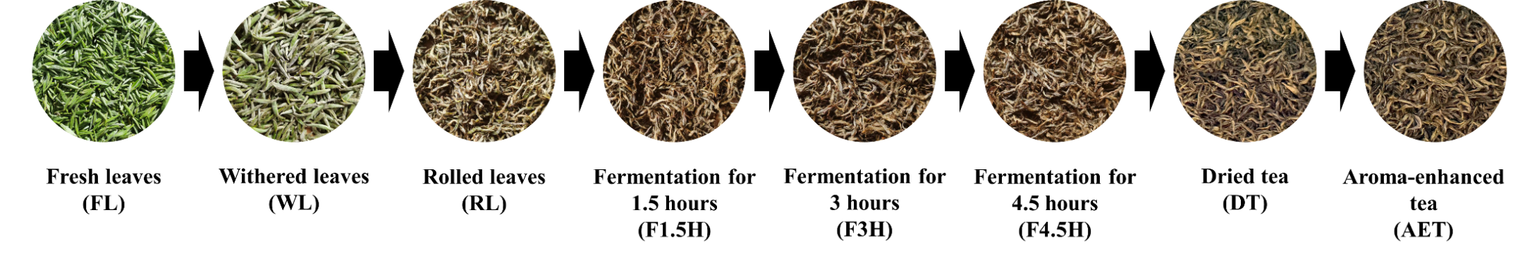 Fig. S1. Changes in leaf color during Lichuan black tea processing.

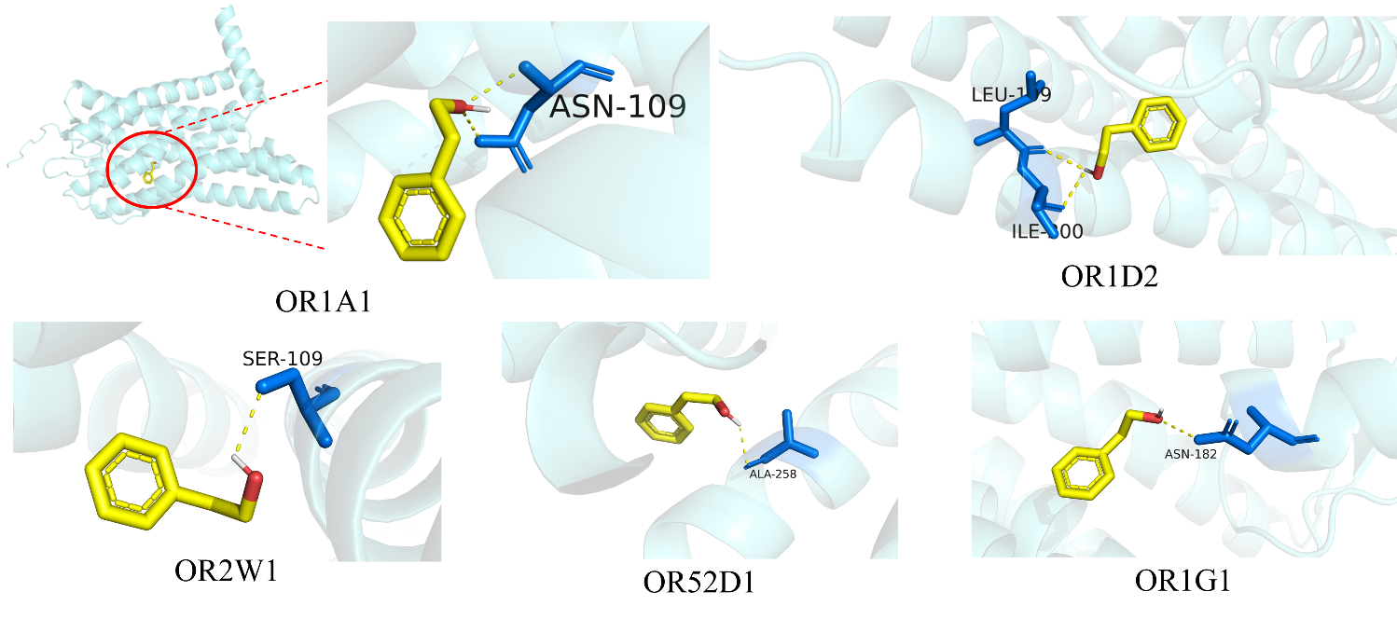
Fig.S2 Molecular docking simulations of phenylethyl alcohol with OR1A1, OR1D2, OR2W1, OR52D1 and OR1G1

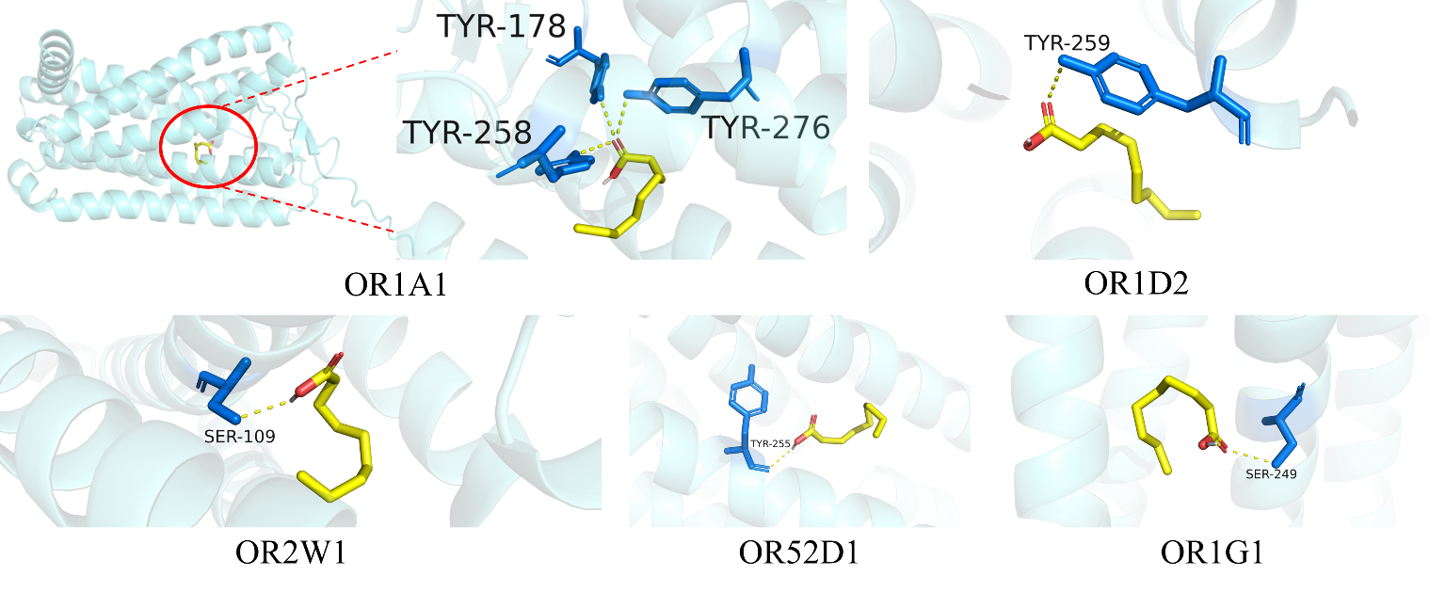
Fig.S3 Molecular docking simulations of nonanoic acid with OR1A1, OR1D2, OR2W1, OR52D1 and OR1G1

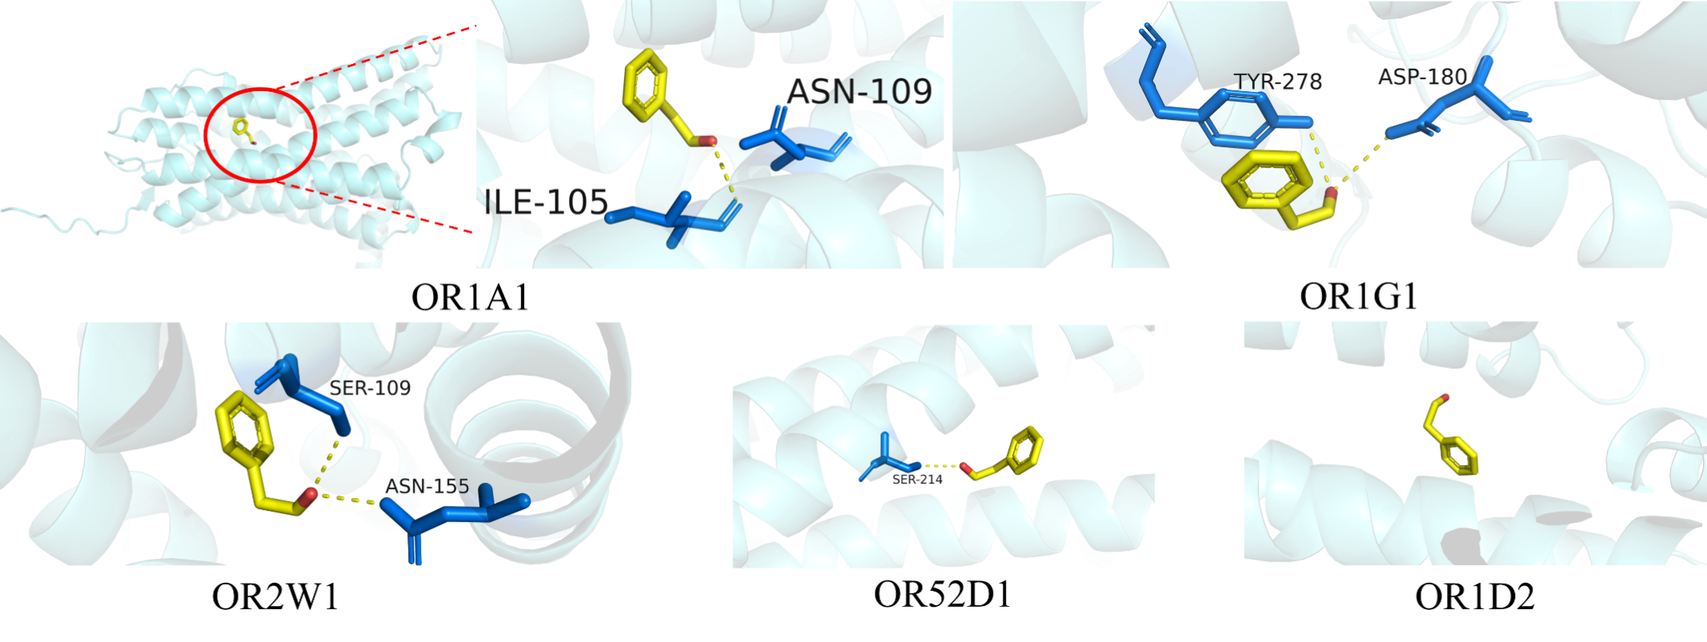Fig.S4 Molecular docking simulations of phenylacetaldehyde with OR1A1, OR1D2, OR2W1, OR52D1 and OR1G1

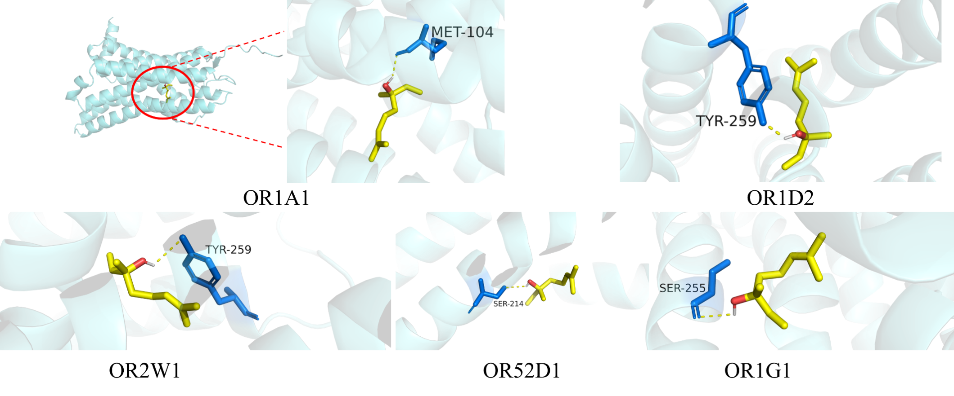Fig.S5 Molecular docking simulations of linalool with OR1A1, OR1D2, OR2W1, OR52D1 and OR1G1

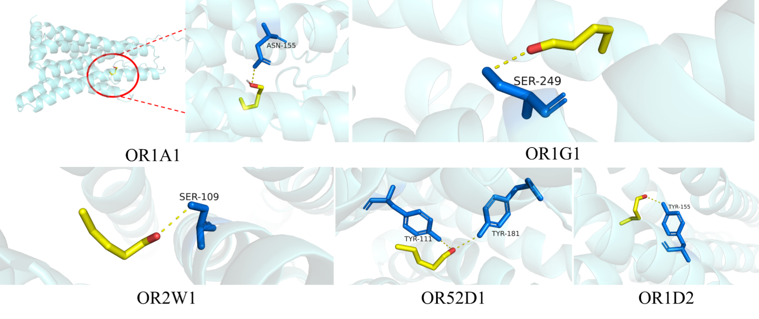Fig.S6 Molecular docking simulations of pentanal with OR1A1, OR1D2, OR2W1, OR52D1 and OR1G1

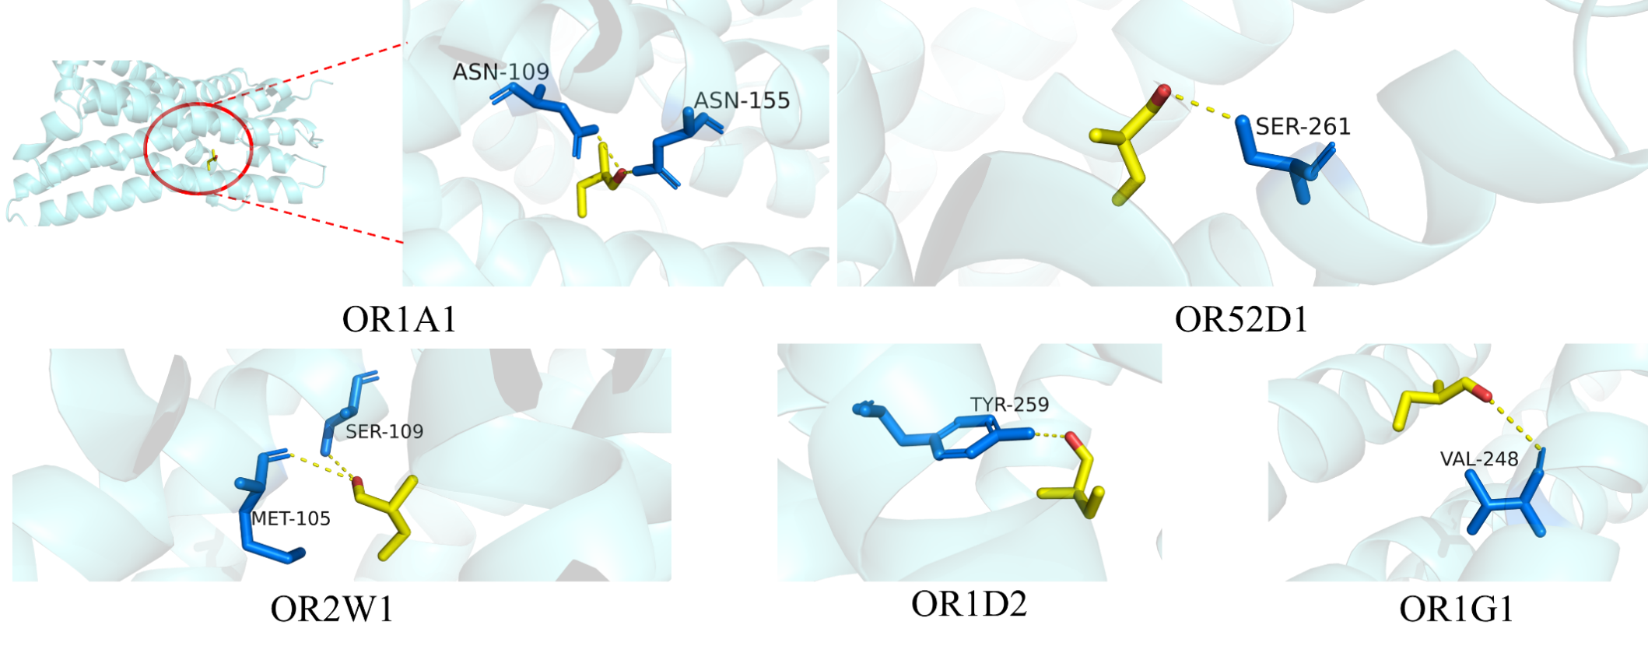Fig.S7 Molecular docking simulations of 2-methylbutanal with OR1A1, OR1D2, OR2W1, OR52D1 and OR1G1

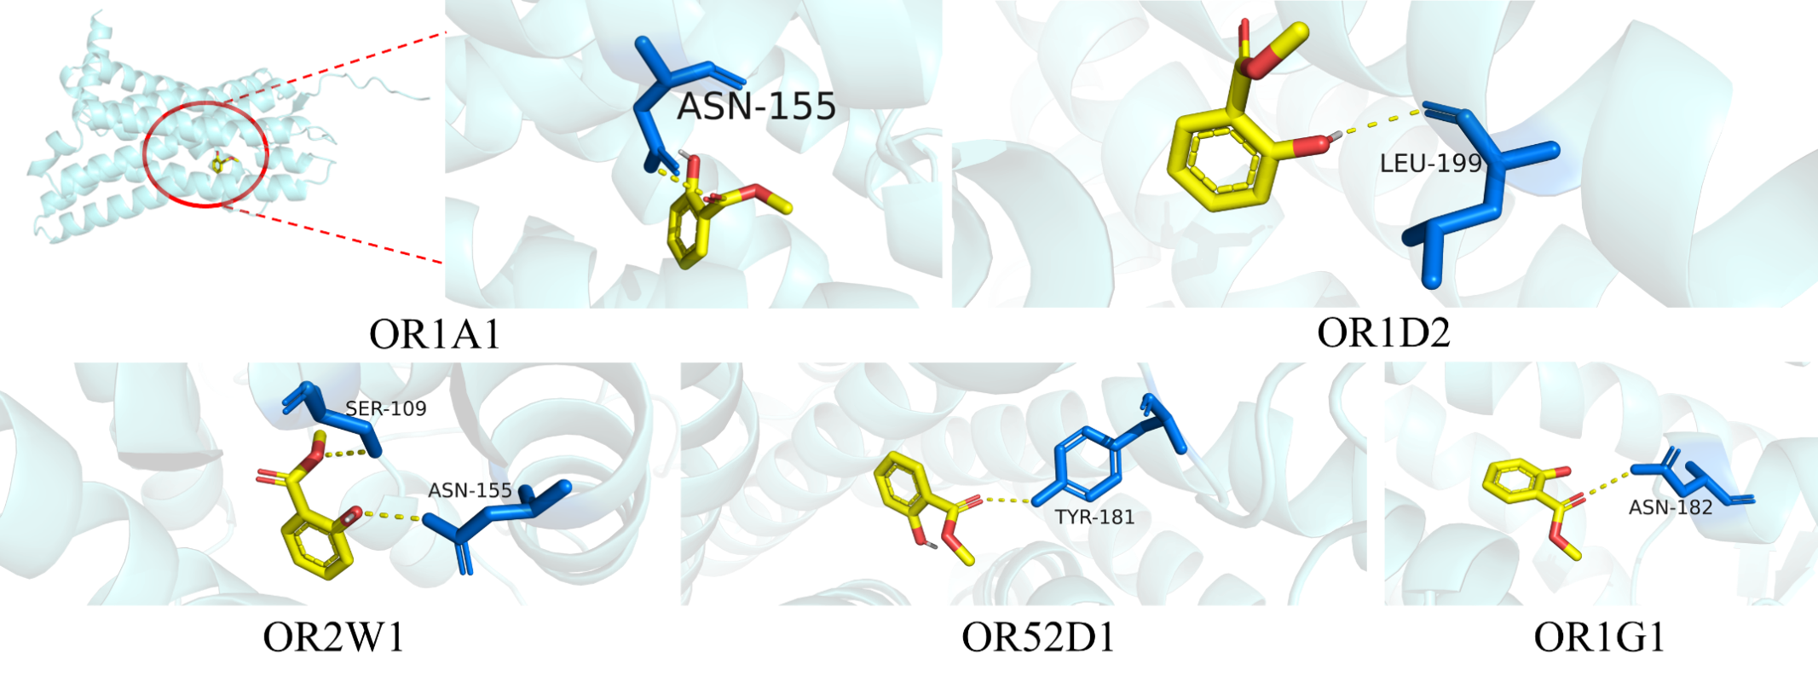Fig.S8 Molecular docking simulations of methyl salicylate with OR1A1, OR1D2, OR2W1, OR52D1 and OR1G1

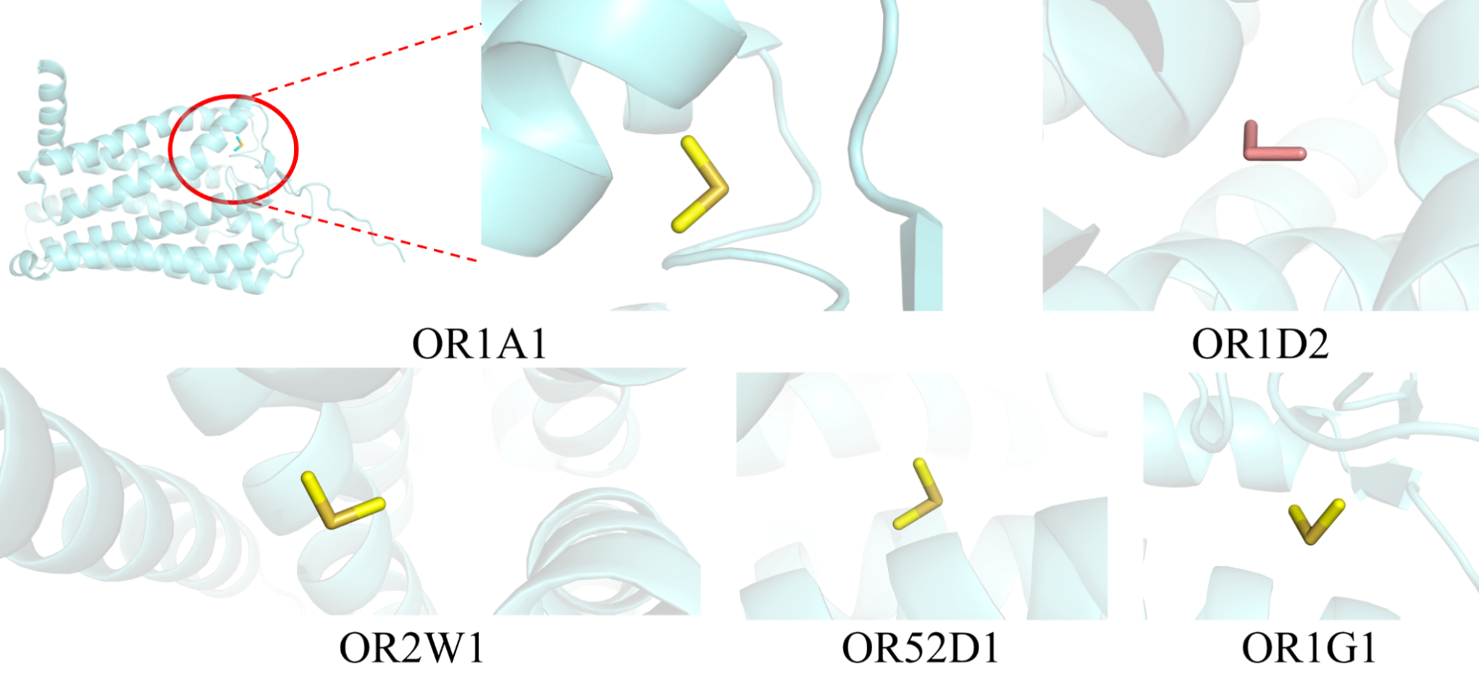
Fig.S9 Molecular docking simulations of dimethyl sulfide with OR1A1, OR1D2, OR2W1, OR52D1 and OR1G1

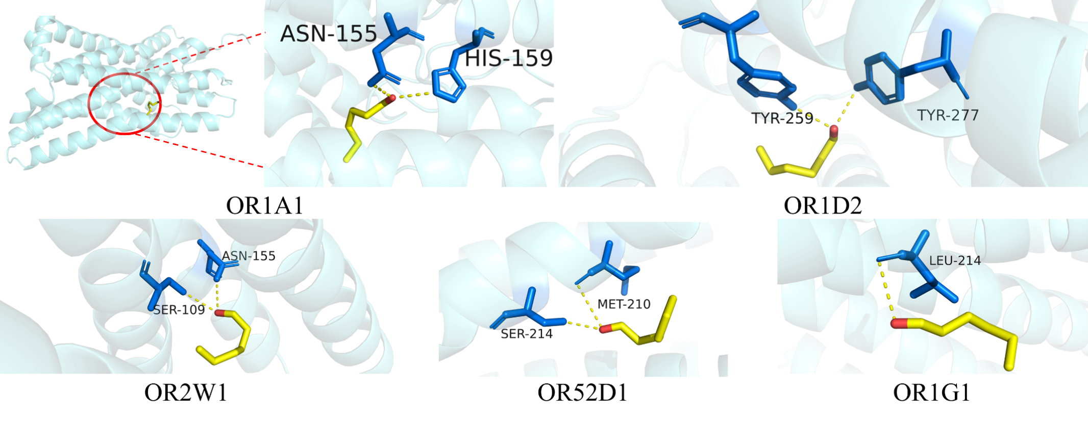
Fig.S10 Molecular docking simulations of hexanal with OR1A1, OR1D2, OR2W1, OR52D1 and OR1G1

