Supplementary Information

Supplementary figure 1. Sequencing of LeGO-GpINV. The sequenced fragments were amplified with the LEGO-R primer. (A) Scheme of the LeGO-GpINV construction and the transcription factors binding sites and restriction enzyme sites in pINVf identified by sequencing. (B) The transcription factor binding sites AP1-1, AP1-5 and SP1, C/EBP, TATA box and the restriction enzyme sites XhoI, BamHI and AscI of pINVf were identified. (C) The result in FASTA format of the amplified and sequenced fragment (Query) was analyzed in comparison to the expected vector sequence (Sbjct).

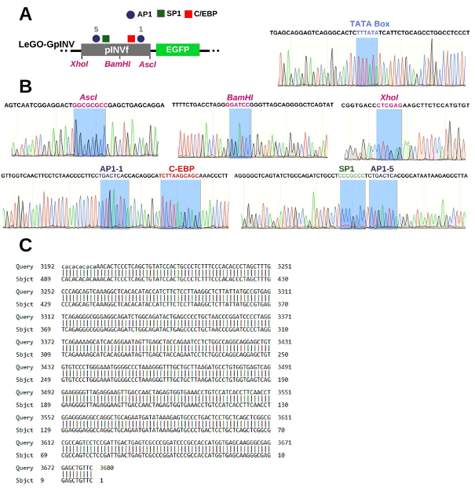
Supplementary figure 2. Full-lanes of electrophoresis on 1% agarose gel analyses depicted in Figure 1. Analysis of products by: (A) PCR products of RRP (242 bp, arrow), RRD (404 bp, arrow), water (CT); (B) pINVf amplified after ligation of the functional regions forming the segment with 659 bp; (C) PCR products of the vector templates using two primer sets: LEGO-F and R and INV-F and R; the lanes correspond to: 1. pSFFV (726 bp) in LeGO-G/NeoOpt, 2. pINVf (850 bp) in LeGO-CpINV, 3. pINVf (850 bp) in LeGO-GpINV, 4. no pINVf amplification in LeGO-G/NeoOpt, 5. pINVf (659 bp) in LeGO-CpINV, 6. pINVf (659 bp) in LeGO-GpINV; (D) Vector digestion with NheI and EcoRI: 1. LeGO-G/NeoOpt containing pSFFV (1960 bp, arrow), 2. linearized LeGO-CpINV and absence of pSFFV, 2. linearized LeGO-GpINV and absence of pSFFV. M1: GeneRuler molecular mass standard 1 kb DNA Ladder; M1’: Molecular mass standard 1 kb (Amresco Inc, Solon, OH); MM: Fastruler Middle Range DNA Ladder mass standard.
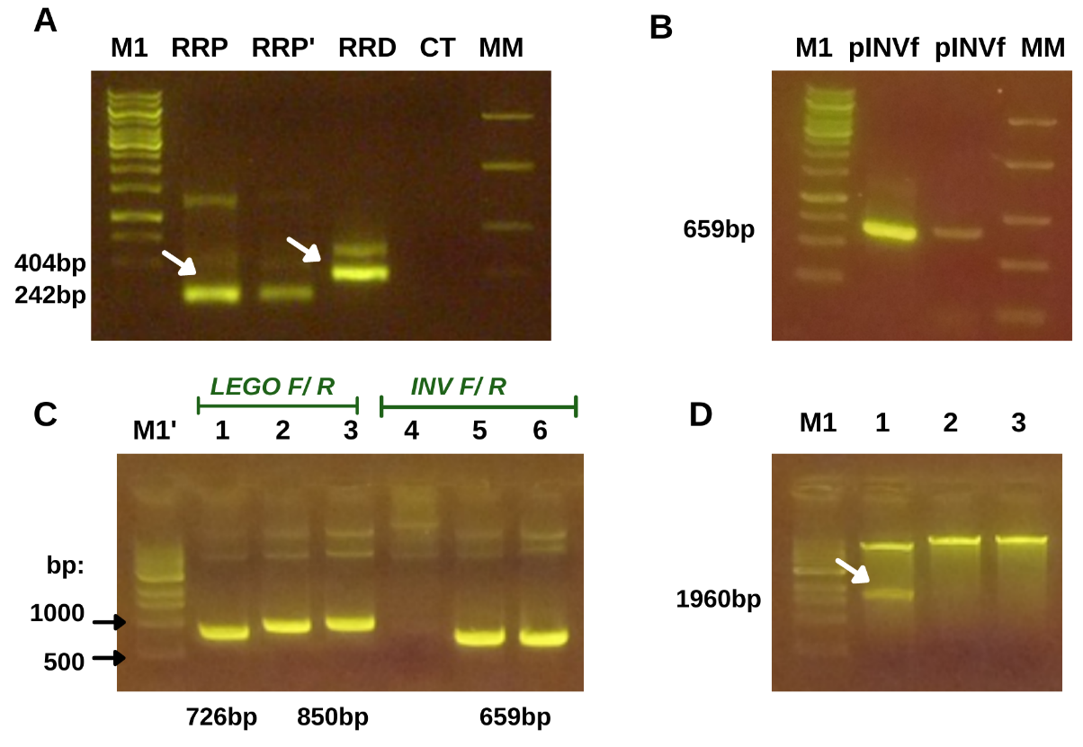

Supplementary figure 3. Full-lanes of Western blot analyses depicted in Figure 6B. Relative expression of involucrin by western blot in MSC, HaCaT, primary keratinocytes (Ker) and dermal fibroblasts (FP) cultured by 7 and 14 days in DMEM (D) and in KSFM (K) on the same days. 14' corresponds to cell lysates from MSC transduced with the recombinant vector. Marker: SeeBlue Plus 2 (Thermo Fisher Scientific, Waltham, MA).
