Extended Data
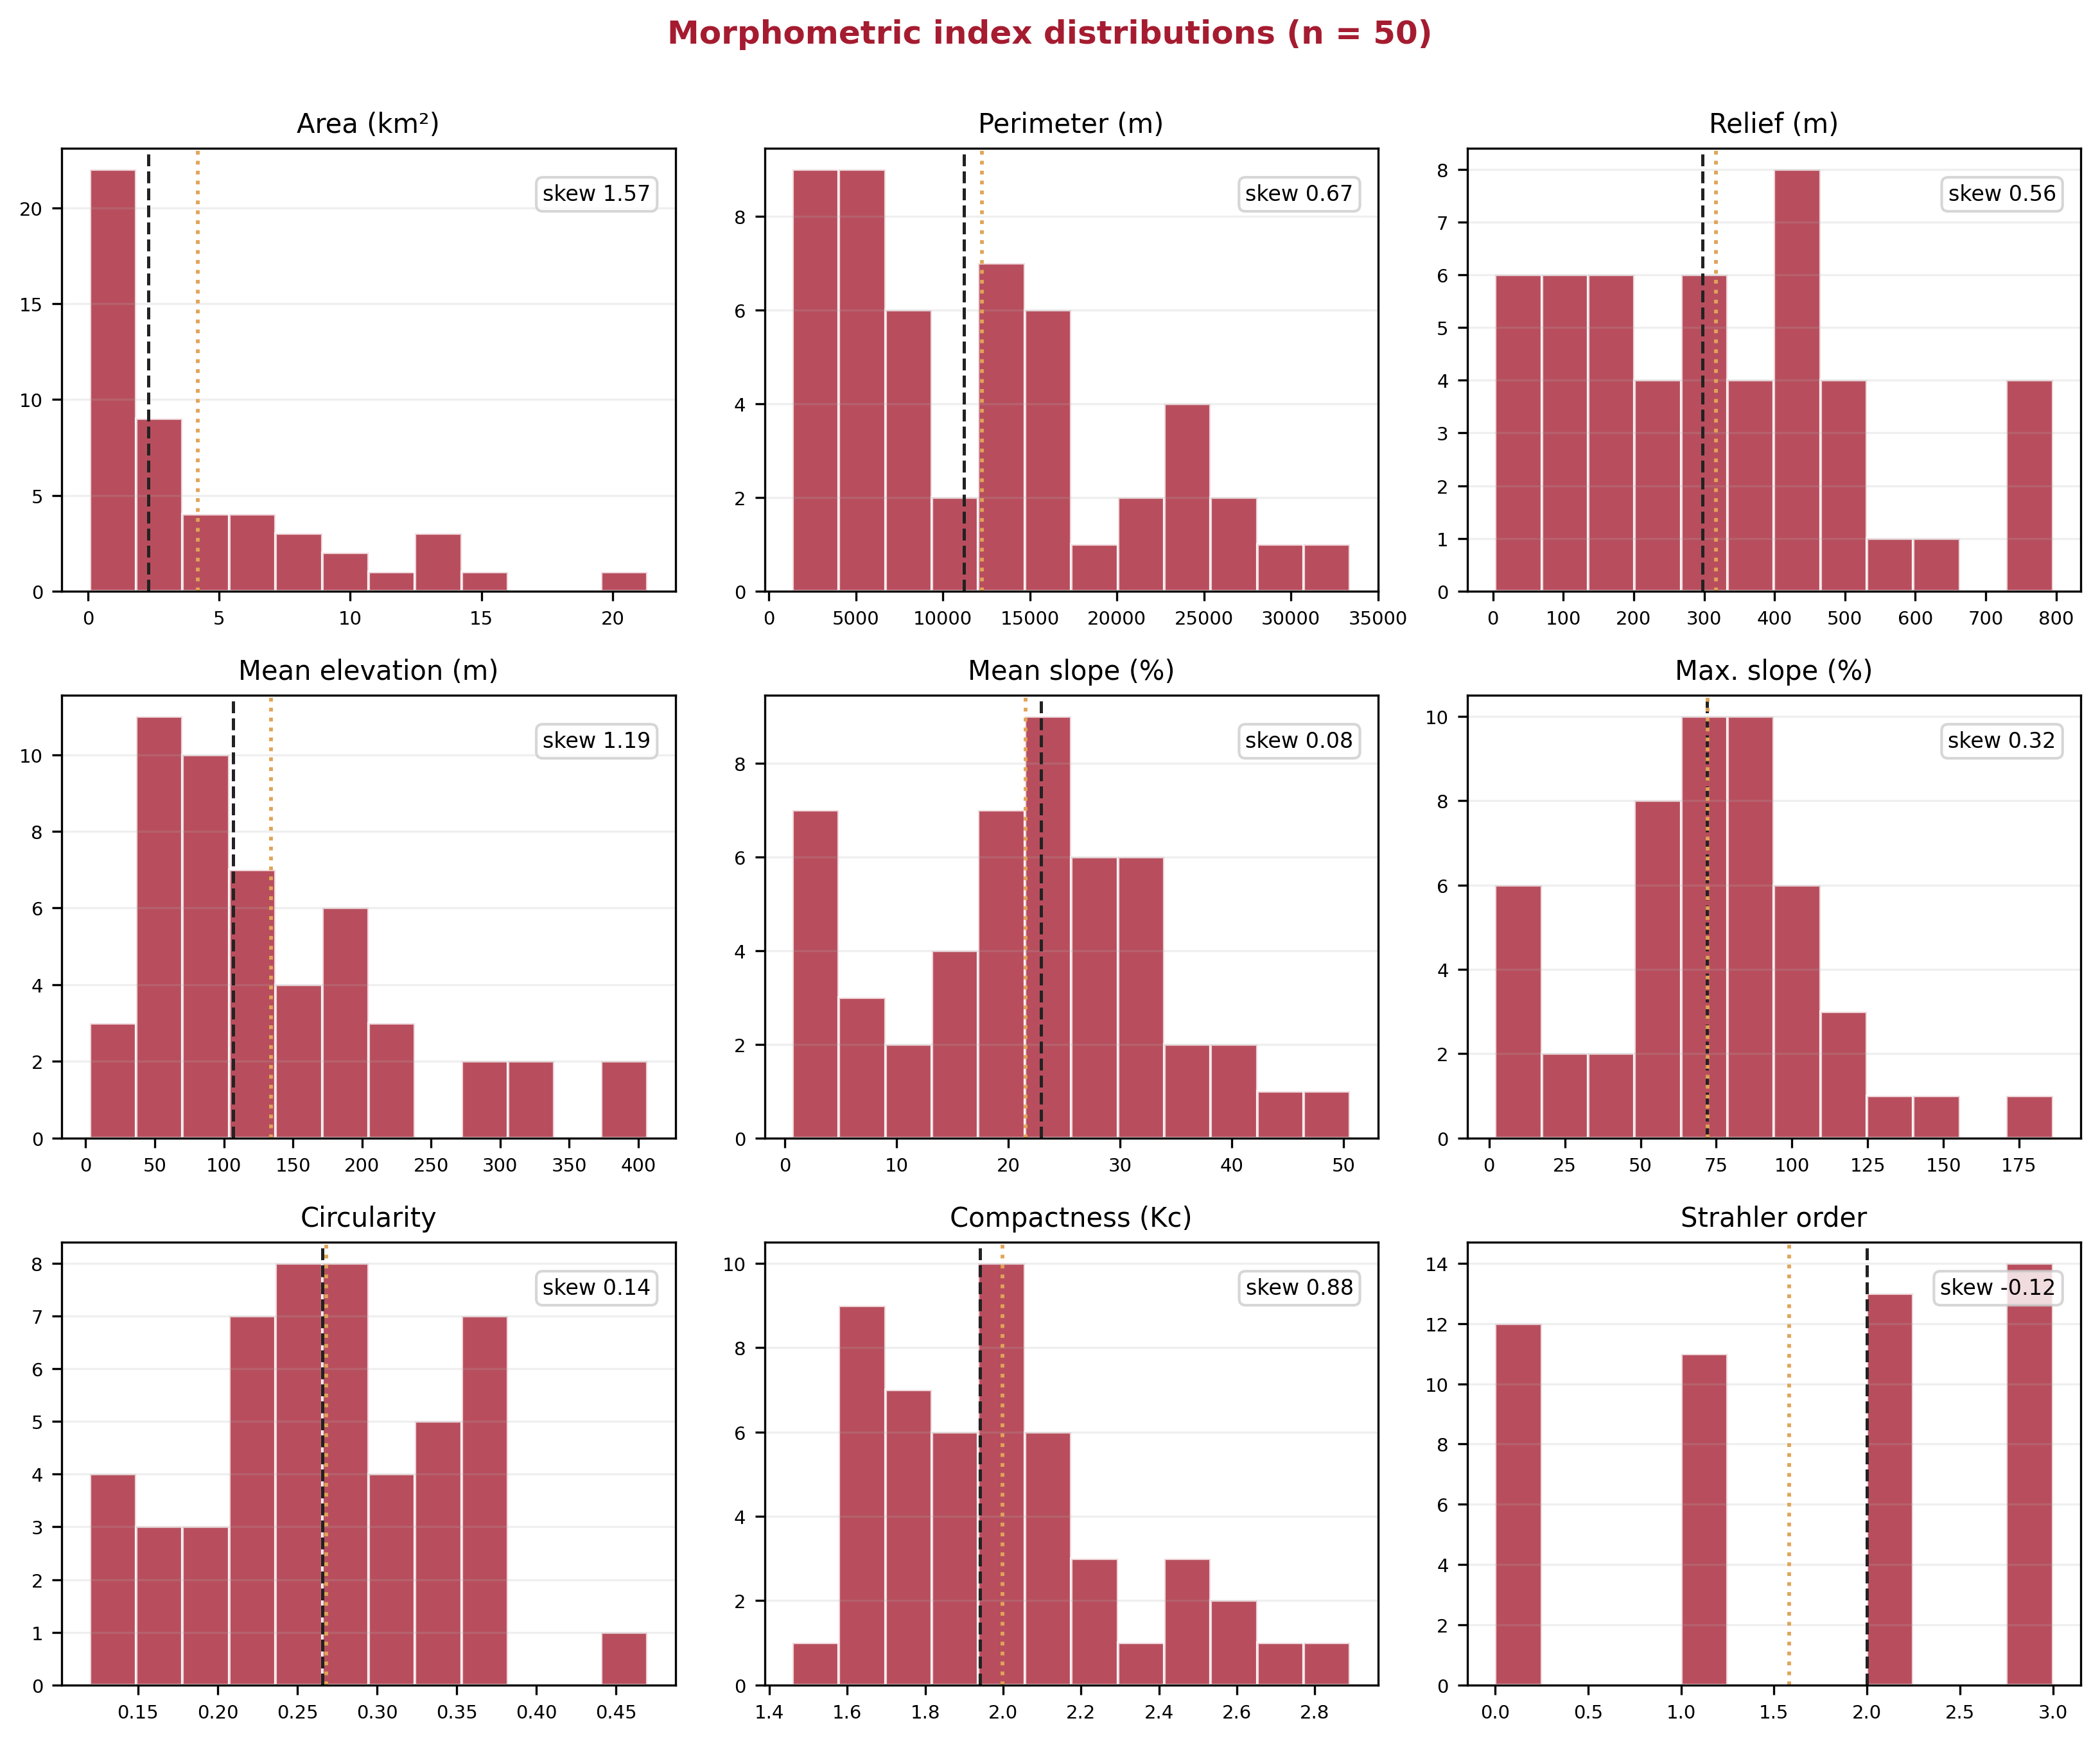
Extended Data Fig. 1. Frequency distributions of the morphometric indices for the 50 studied catchments. Dashed lines, median; dotted lines, mean; skewness shown in each panel.
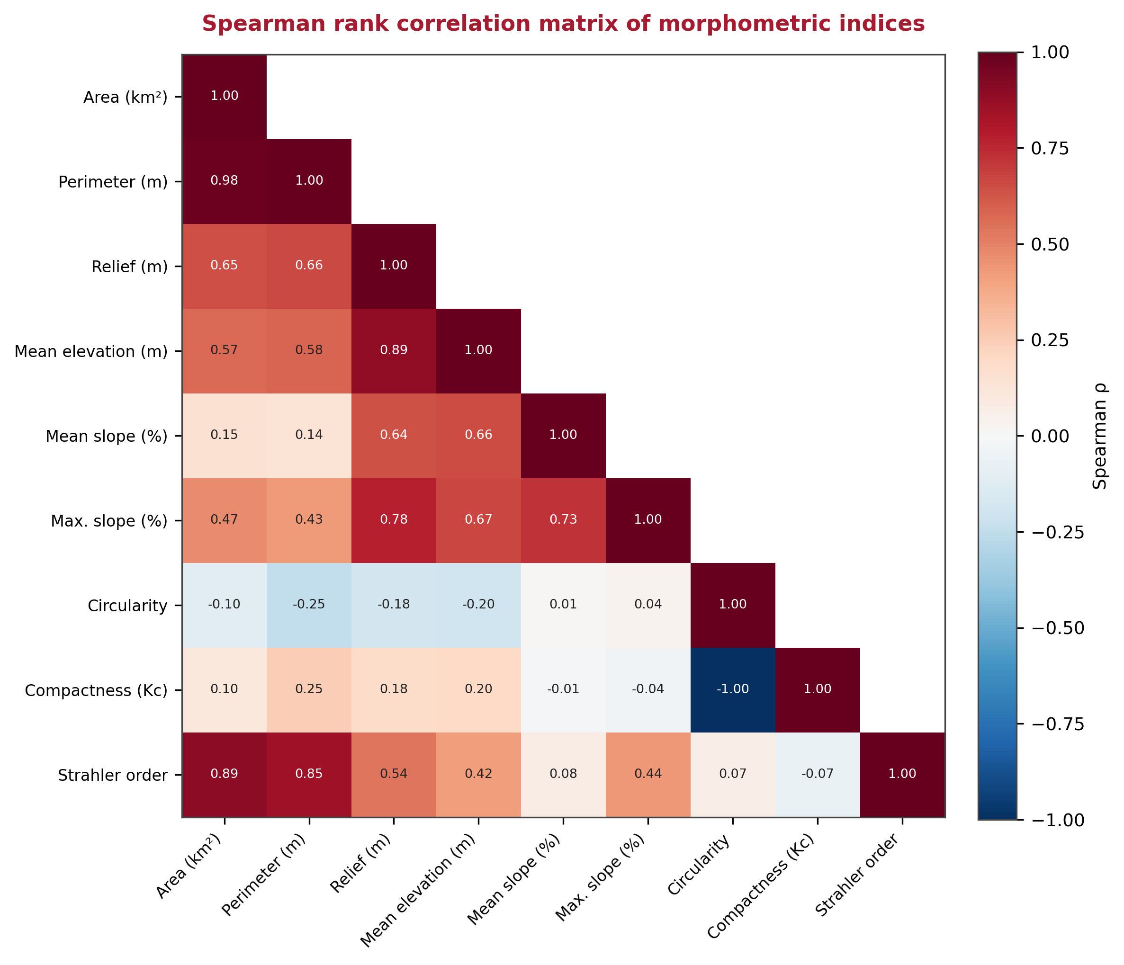
Extended Data Fig. 2. Spearman rank correlation matrix of the morphometric indices (n = 50). Colour intensity and printed values give the correlation coefficient ρ.
Extended Data Fig. 3. Morphometric comparison between urban (n = 37) and agricultural (n = 13) ghost-river catchments. Boxes show the interquartile range and median; whiskers, 1.5× IQR; two-sided Mann-Whitney U test P values are printed for each variable.
Extended Data Fig. 4. Choice of the number of catchment clusters. (A) Ward hierarchical dendrogram of the 50 catchments on seven standardised morphometric variables; the dashed line marks the four-cluster cut and colours denote the four types shown in Fig. 2. The only strongly separated division is the primary two-cluster split (large mountain catchments versus small coastal basins); the merges producing three, four and five clusters occur at closely spaced linkage heights. (B) Internal validation indices versus the number of clusters k: average silhouette width (left axis) and total within-cluster sum of squares (right axis, elbow criterion). No index identifies k = 4 as optimal, the silhouette width is a local minimum there and the elbow is gradual, so the four-cluster solution was adopted for geomorphological interpretability and parsimony rather than internal-index optimality.
Extended Data Fig. 5. Hydrological screening of flood hazard (Témez modified rational method, 100-year design storm). (A) Peak discharge, (B) specific discharge and (C) runoff coefficient for recognised (mapped, n = 18) versus unrecognised (unmapped, n = 32) catchments. Peak discharges are statistically comparable (P = 0.86); unmapped catchments generate significantly higher specific discharges (P = 0.010) and runoff coefficients (P = 0.008), indicating a persistent — indeed, per unit area, more torrential — flood hazard. Boxes, interquartile range and median; whiskers, 1.5× IQR; points, outliers.
Extended Data Table 1. Morphometric comparison between urban and agricultural ghost-river catchments (median values; two-sided Mann-Whitney U test).
Variable | Urban (n=37) | Agric. (n=13) | P | Sig.
Area (km²) | 2.55 | 1.38 | 0.122 | n.s.
Mean slope (%) | 24.14 | 12.80 | 0.070 | n.s.
Max. slope (%) | 80.61 | 56.04 | 0.002 | **
Relief (m) | 332.2 | 165.9 | 0.138 | n.s.
Circularity | 0.266 | 0.235 | 0.413 | n.s.
Compactness (Kc) | 1.937 | 2.065 | 0.413 | n.s.
Strahler order | 2.0 | 1.0 | 0.069 | n.s.
Extended Data Table 2. Coverage of the modelled flood extents (percentage of catchment area) across the 50 catchments.
Return period | Catchments affected | Median coverage (%) | Max. coverage (%)
T50 | 11 (22.0%) | 2.38 | 6.15
T100 | 25 (50.0%) | 2.34 | 100.0
T500 | 25 (50.0%) | 3.43 | 100.0
Extended Data Table 3. Comparison between catchments inside (mapped) and outside (unmapped) the APSFR register (median values; two-sided Mann-Whitney U test).
Variable | Mapped (n=18) | Unmapped (n=32) | P | Sig.
Area (km²) | 4.86 | 2.17 | 0.298 | n.s.
Mean slope (%) | 24.69 | 19.67 | 0.390 | n.s.
Max. slope (%) | 75.50 | 70.23 | 0.911 | n.s.
Relief (m) | 363.3 | 239.5 | 0.192 | n.s.
Circularity | 0.250 | 0.266 | 0.679 | n.s.
Compactness (Kc) | 2.002 | 1.938 | 0.679 | n.s.
Strahler order | 2.0 | 1.0 | 0.504 | n.s.
Hazard proxy | 0.400 | 0.339 | 0.084 | n.s.
Flood cover T500 (%) | 0.88 | 0.00 | 0.046 | *
Extended Data Table 4. Ghost-river catchments with the lowest population-weighted net income per person.
Catchment | APSFR | Pop. | Income (€) | % ≥65
Bco. del Caballar | Mapped | 7,943 | 5,797 | 11.1
Bco. de las Cabreras | Unmapped | 2,318 | 8,191 | 16.2
Rambla de Villanueva | Mapped | 2,878 | 8,766 | 17.2
Rambla de Villalobos | Unmapped | 3,967 | 9,071 | 10.0
Bco. de la Mula | Mapped | 3,934 | 9,113 | 12.6
Rambla del Castellar (Crevillent) | Mapped | 18,563 | 9,528 | 17.8
Bco. de la Higuera | Mapped | 3,129 | 9,692 | 22.2
Bco. de Amorós (Vega Baja) | Mapped | 6,163 | 9,769 | 23.7
Extended Data Table 5. Descriptive statistics of the morphometric indices for the 50 ghost-river catchments.
Variable | Min | Q25 | Median | Mean | Q75 | Max | Skew.
Area (km²) | 0.07 | 0.55 | 2.30 | 4.18 | 6.65 | 21.32 | 1.57
Perimeter (m) | 1,348 | 5,491 | 11,203 | 12,220 | 16,532 | 33,400 | 0.67
Mean slope (%) | 0.69 | 14.24 | 22.93 | 21.53 | 28.89 | 50.57 | 0.08
Max. slope (%) | 1.99 | 54.63 | 71.90 | 72.20 | 90.37 | 186.13 | 0.32
Relief (m) | 3.22 | 141.5 | 297.3 | 317.3 | 442.5 | 795.4 | 0.56
Mean elevation (m) | 2.89 | 66.6 | 106.8 | 134.1 | 180.0 | 406.6 | 1.19
Circularity | 0.120 | 0.220 | 0.266 | 0.268 | 0.326 | 0.470 | 0.14
Compactness (Kc) | 1.46 | 1.75 | 1.94 | 2.00 | 2.13 | 2.89 | 0.88
Strahler order | 0 | 1.0 | 2.0 | 1.58 | 3.0 | 3.0 | −0.12

