Supplementary Material
Determining the Presence of a Stress-Free State in Panel Paintings Through Numerical Modelling and Experimental Tests on Historical Artworks
Lorenzo Riparbelli, Łukasz Bratasz, Michał Łukomski, Paola Mazzanti, Luciano Ricciardi, Sandra Rossi, Ciro Castelli, Andrea Santacesaria, Marco Fioravanti
The following photographs document the condition of the six panel paintings (WPP1–WPP6) examined at the Opificio delle Pietre Dure (OPD), Florence. Conservators recorded raking-light views and Dino-Lite micrographs, with magnifications given on the images. The front and back views show the Deformometric Kit (DK) position and the microscopy areas, marked by stars; numbers identify the corresponding micrographs.

General Observations
All six paintings have quadrangular surface craquelure. WPP1, WPP3 and WPP6 also exhibit deep cracks parallel to the wood grain and perpendicular to the cupping direction. As defined in Section 2.2 of the main text, deep cracks include discontinuities associated with lifting (tenting) of the paint layers and losses, mostly filled during earlier treatments. Visible as light lines in raking light and microscopy, they are densest in the central, tangentially cut regions. WPP2, WPP4 and WPP5 show no lifting, and their ground remains continuous beneath the craquelure and at minor paint losses.
Raking light best revealed cracks, lifting and fills; microscopy helped assess their depth and the condition of the ground. Examination areas lay near the DK column positions projected onto the painted face and midway between them, allowing comparison with measured deformation and the identified distributions of stiffness reduction (Figures 6(d), 7(d) and 8(d) of the main text).
Conservators identified lifting along the grain, often treated with fills, as the principal feature in WPP1, WPP3 and WPP6. These discontinuities predate OPD storage and were unchanged by the 53–60% RH test cycles. They reflect each painting’s combined history of rigid restraint, previous interventions, climatic variation, handling, transport and relocation, together with board orientation and ground quality. An unfilled loss remains open in tension and compression and contributes no stiffness to the decorative layer; a filled loss can transmit compression but not tension. This is the type of mechanical discontinuity detected by the method. WPP1 and WPP3, the two paintings with a canvas interlayer beneath the ground, both show an asymmetric response, consistent with the greater susceptibility of thicker, stiffer decorative layers to deep cracking. WPP6 has no canvas interlayer but also exhibits deep cracks, suggesting that restraint and treatment history, board orientation, ground quality and interface defects may outweigh stratigraphy alone.

Specific Observations

WPP1
The surface combines quadrangular craquelure with ridges of lifted paint along the grain. As Japanese tissue facing secures the paint over the central examination point, the area immediately below it was examined, where the ridges are widest.

WPP2
Craquelure is confined to the surface, with continuous ground beneath the cracks and at minor paint losses.

WPP3
Lines of lifted and filled paint follow the grain and are much wider than the superficial craquelure.

WPP4
Craquelure affects the surface without extending into the ground.

WPP5
Only surface craquelure was observed.

WPP6
Lines of lifted and filled paint run along the grain, as in WPP3, separated by areas of superficial craquelure.

Summary
The deep cracks in WPP1, WPP3 and WPP6 coincide with the modelled stiffness asymmetry between adsorption and desorption, with the greatest stiffness reduction in the central panel regions (Section 3.5 of the main text). The other three paintings have continuous ground and symmetric responses. Surface craquelure, common to all six, does not account for this asymmetry.

WPP1
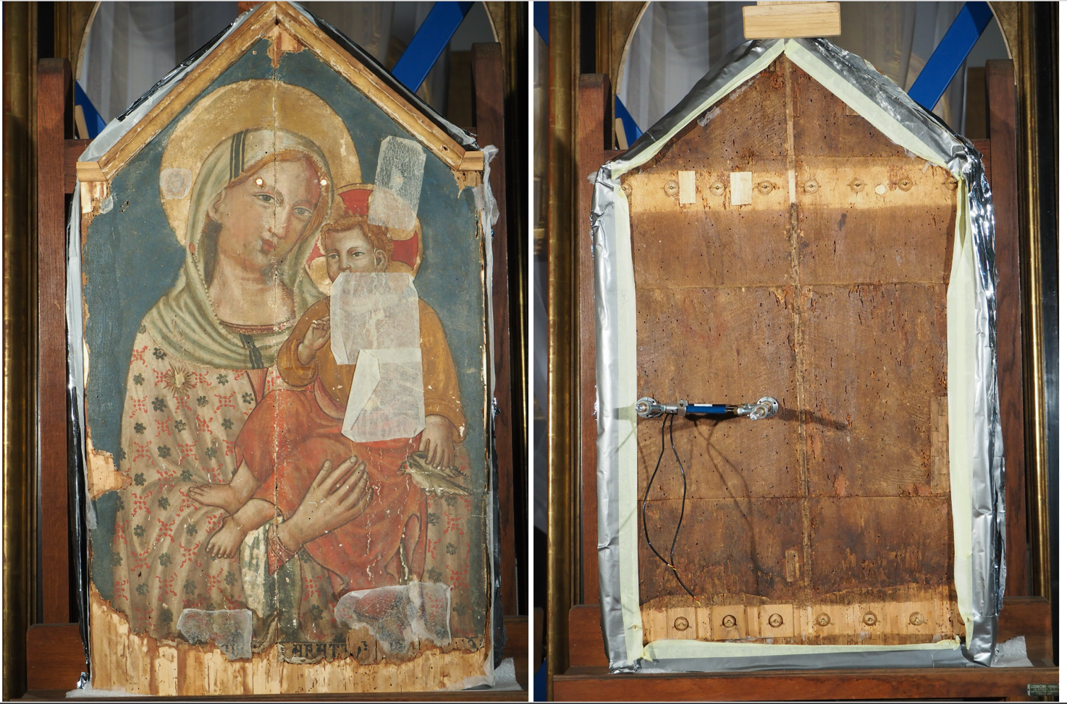
6,7,9
1, 2, 8
3,4,5
Figure S1. WPP1: front and back views, showing the DK position and numbered microscopy areas (stars).
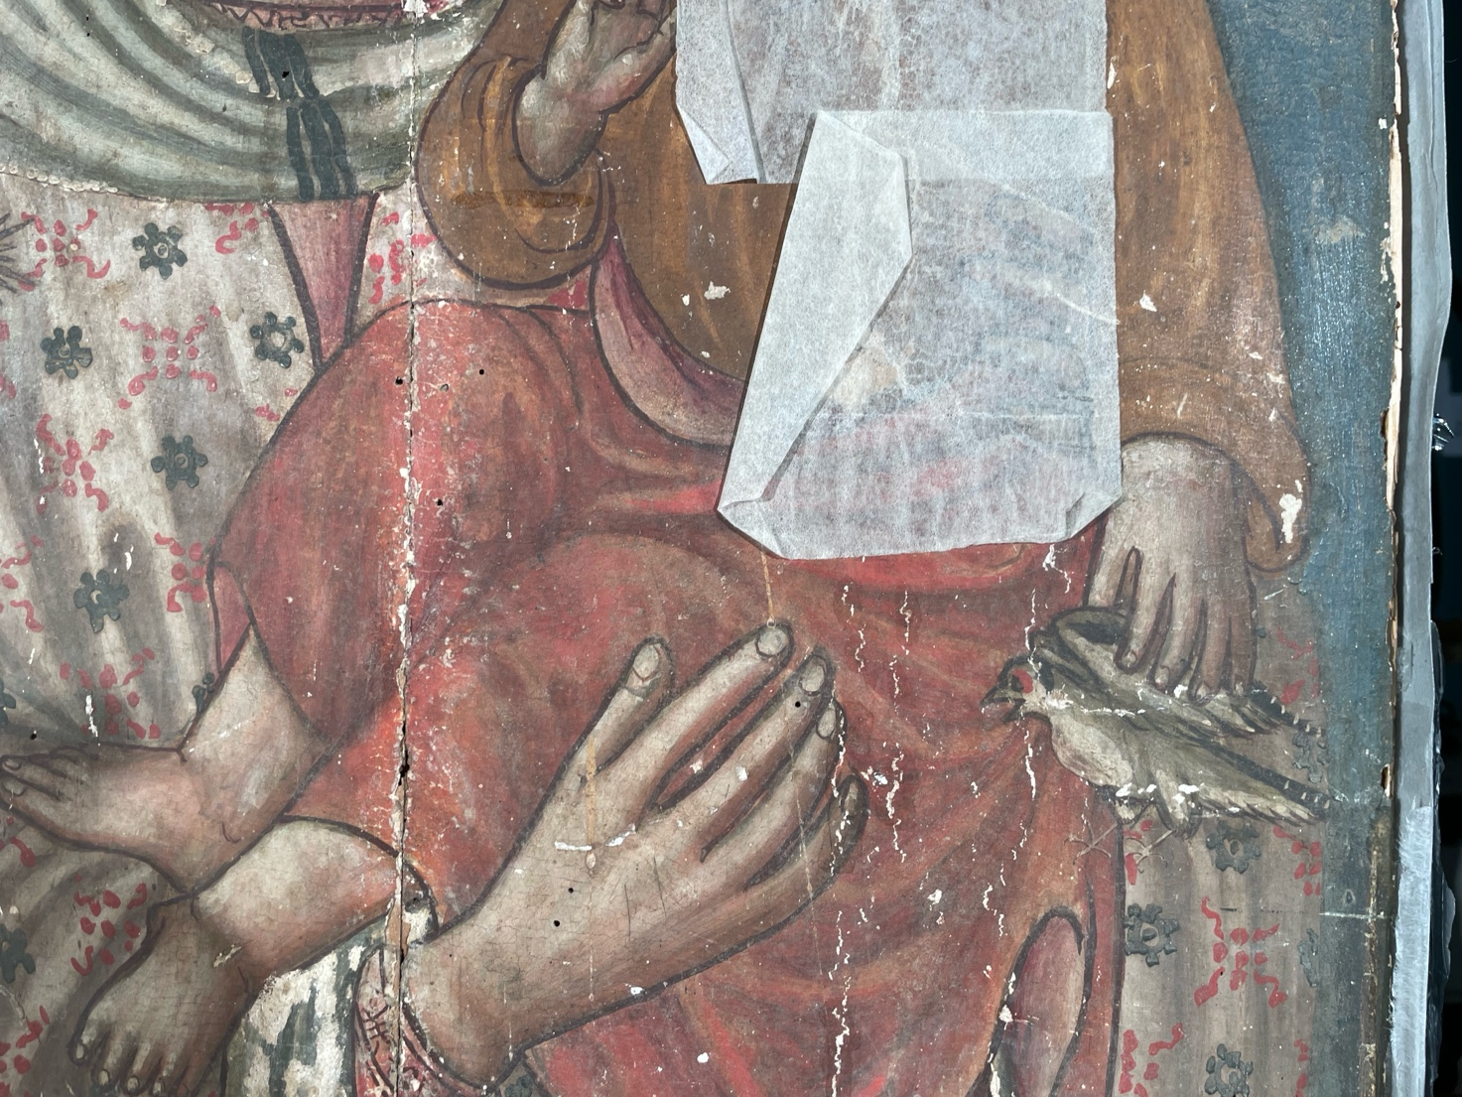
Figure S2. WPP1: raking-light detail of quadrangular craquelure and prominent vertical cracks along the wood grain.
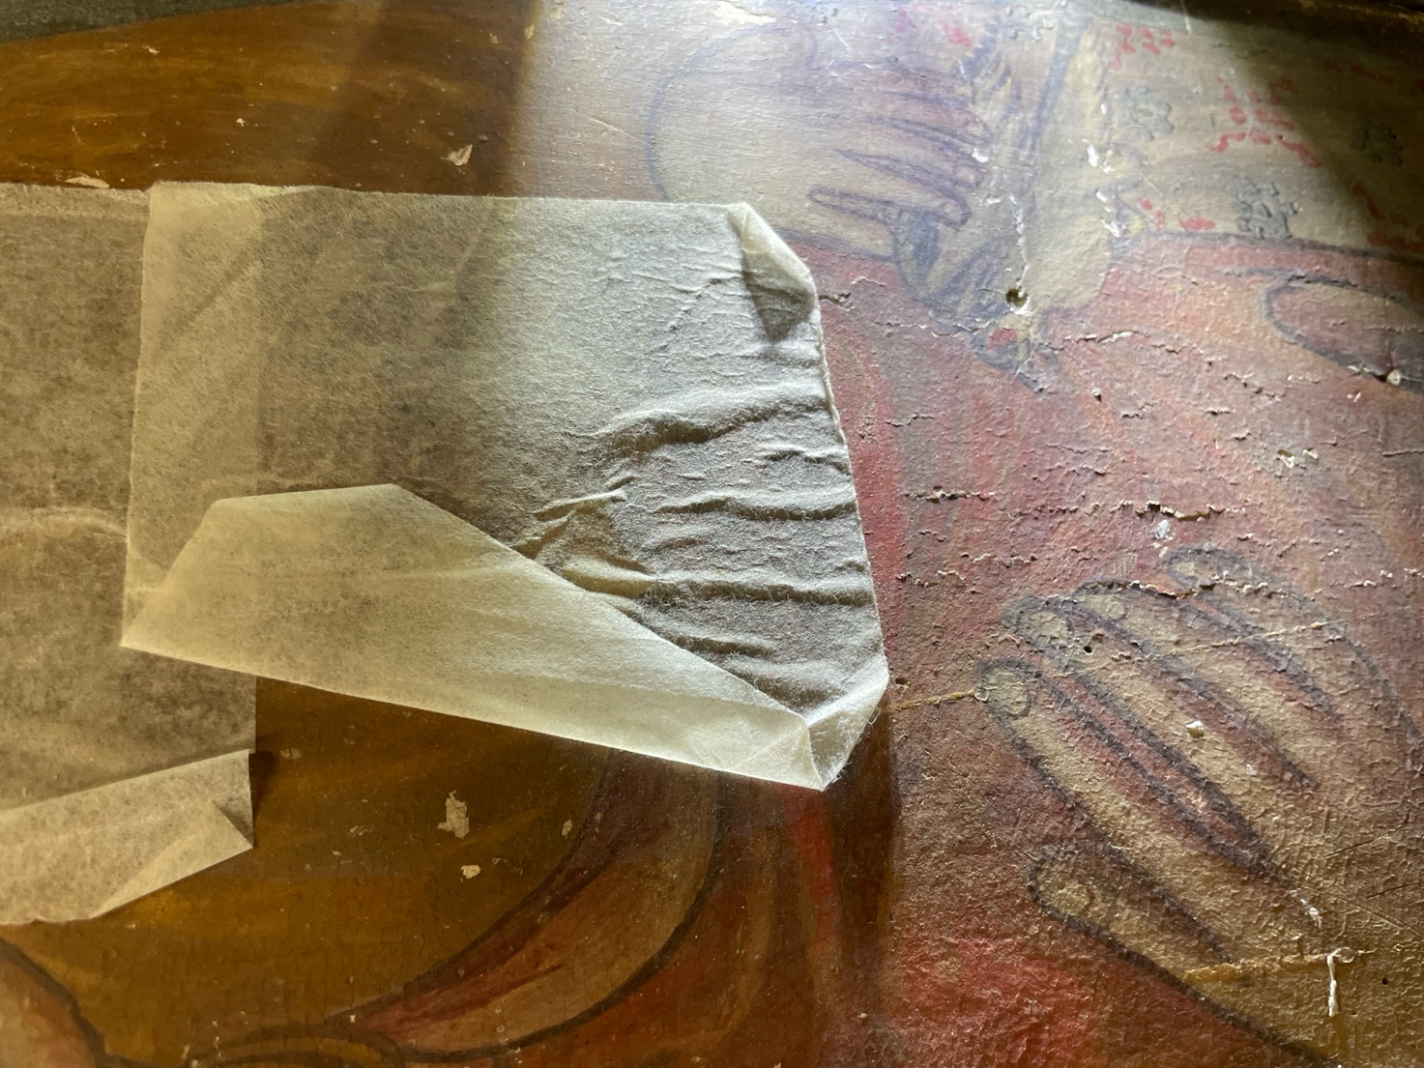
Figure S3. WPP1: raking-light detail of the paint surface, its texture and vertical cracks.
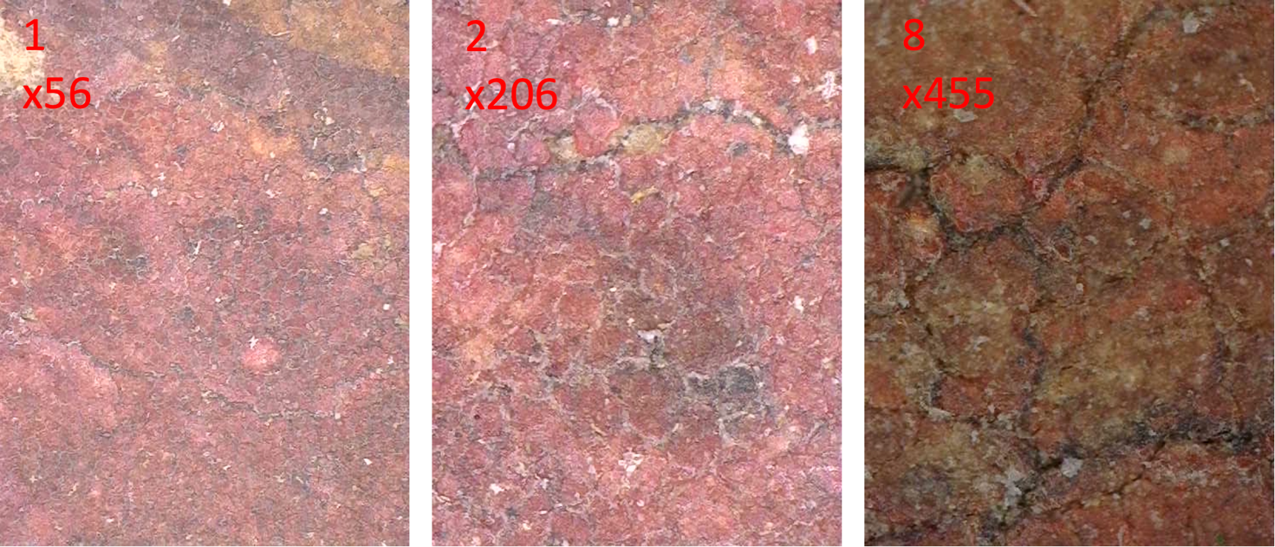
Figure S4. WPP1: micrographs 1, 2 and 8.
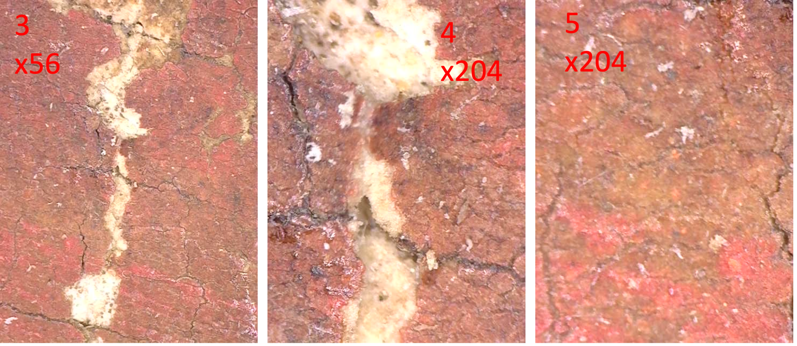
Figure S5. WPP1: paint layers and craquelure (micrographs 3, 4 and 5).
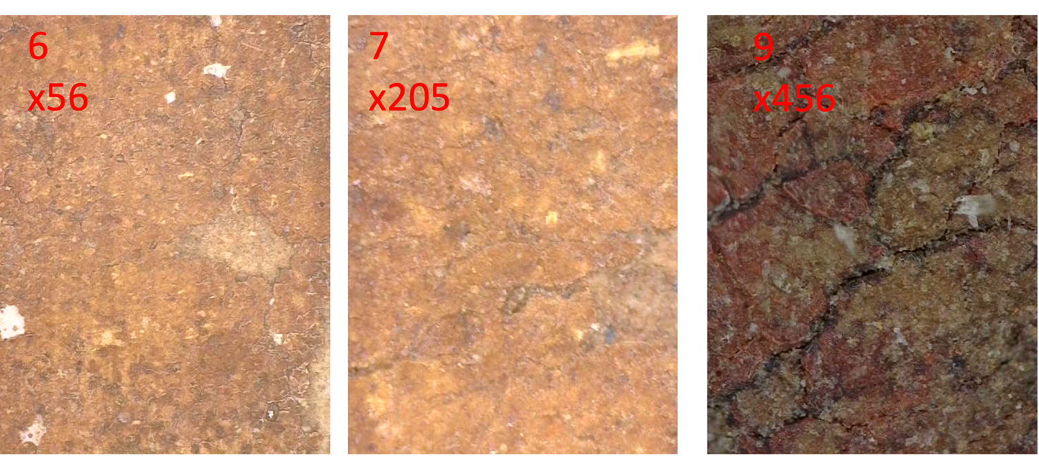
Figure S6. WPP1: surface condition and crack patterns (micrographs 6, 7 and 9).

WPP2
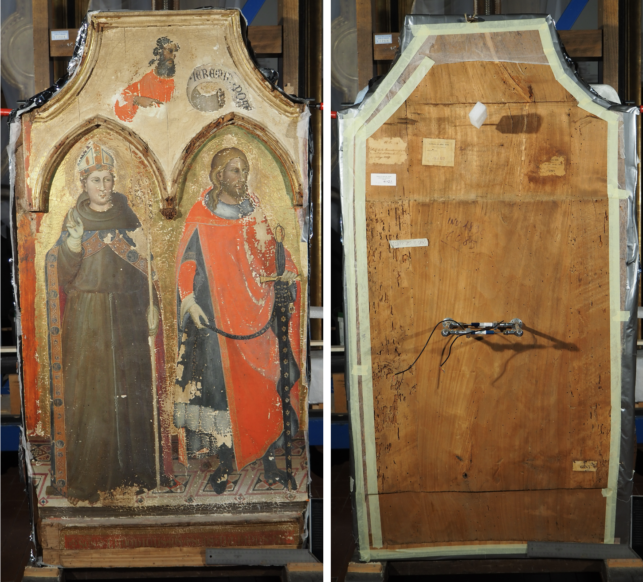
12,13,14
10,11
15,16
Figure S7. WPP2: front and back views, showing the DK position and numbered microscopy areas (stars).
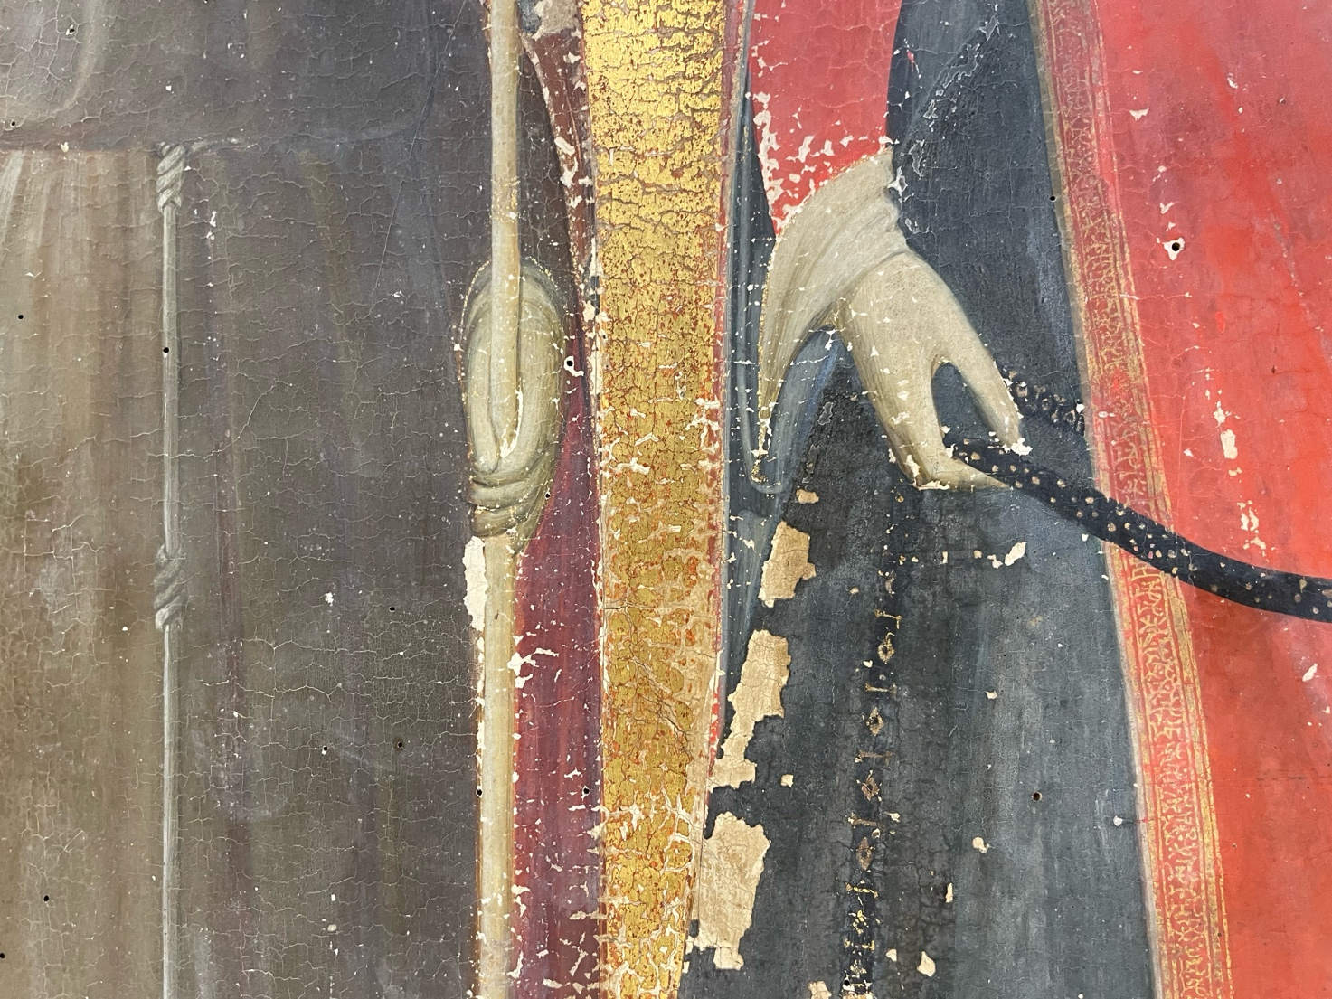
Figure S8. WPP2: quadrangular craquelure under raking light.
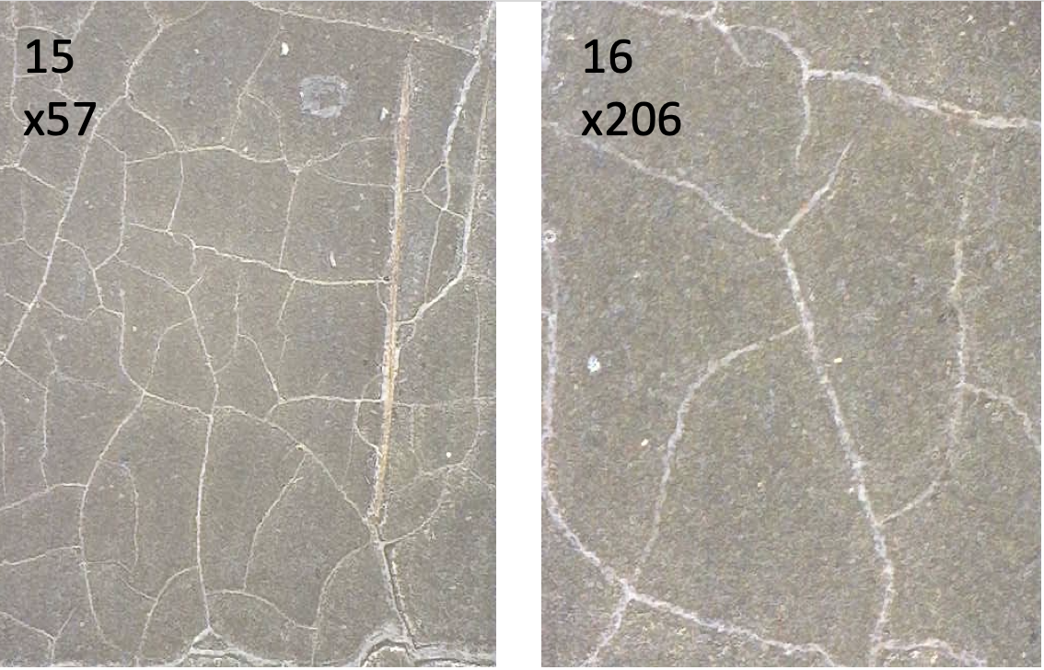
Figure S9. WPP2: paint surface (micrographs 15 and 16).
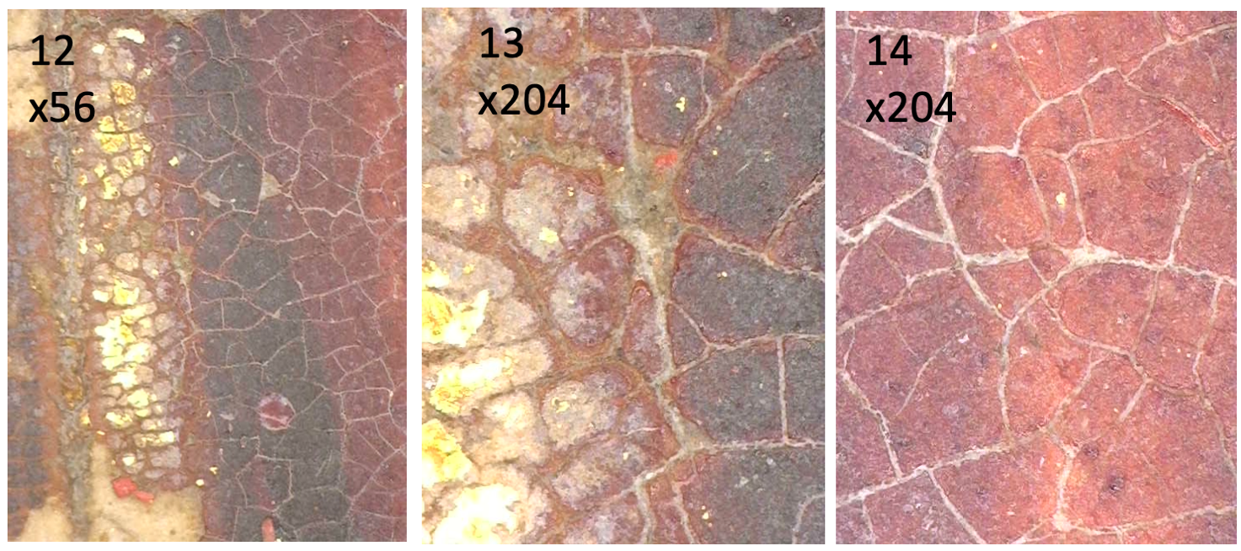
Figure S10. WPP2: surface details (micrographs 12, 13 and 14).
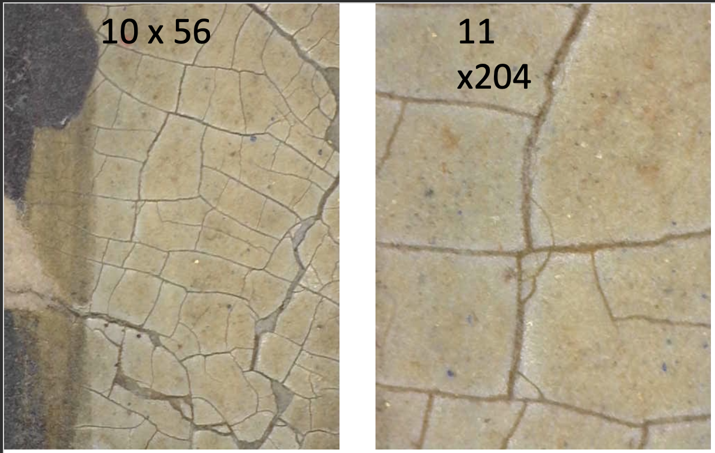Figure S11. WPP2: paint layer details (micrographs 10 and 11).

WPP3
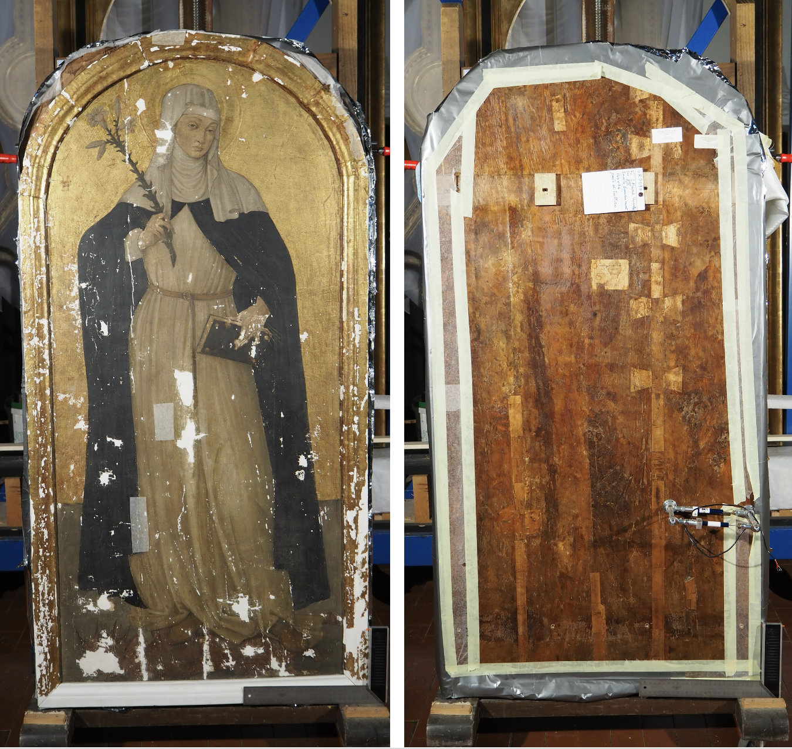
17,18,19,26
23,24,25,28
20,21,22,27
Figure S12. WPP3: front and back views, showing the DK position and numbered microscopy areas (stars).
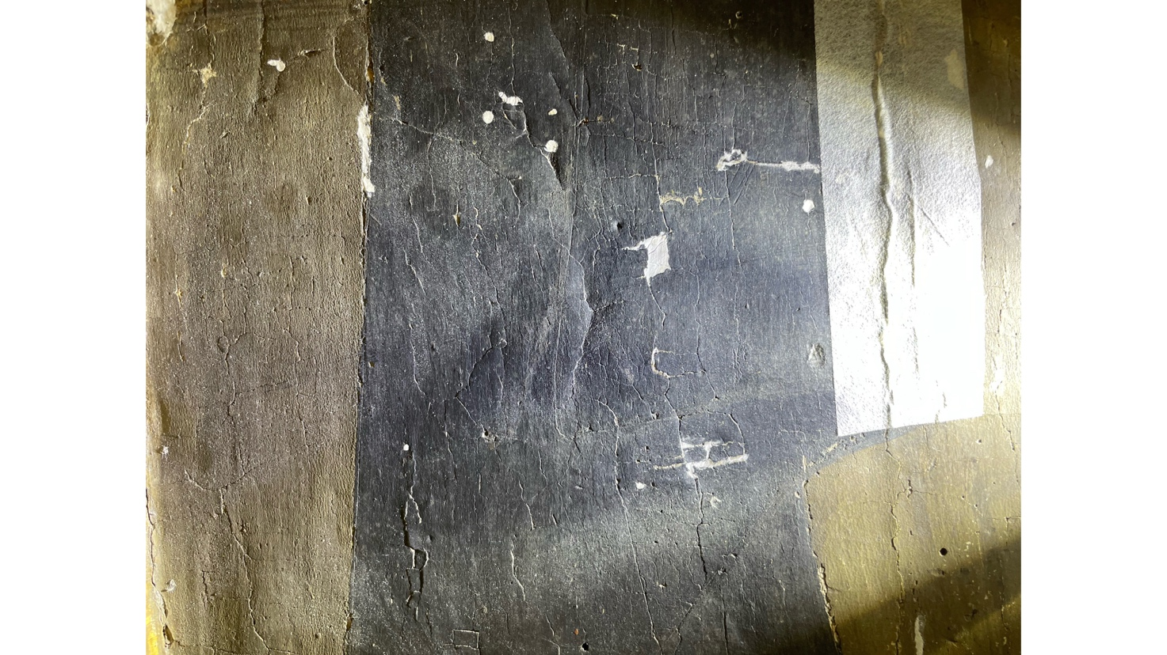
Figure S13. WPP3: raking-light detail of quadrangular craquelure and prominent vertical cracks along the wood grain.
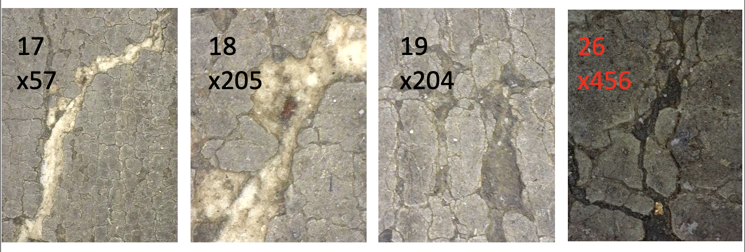
Figure S14. WPP3: deep cracks with fills and lifted flakes, with surrounding craquelure (micrographs 17, 18, 19 and 26).
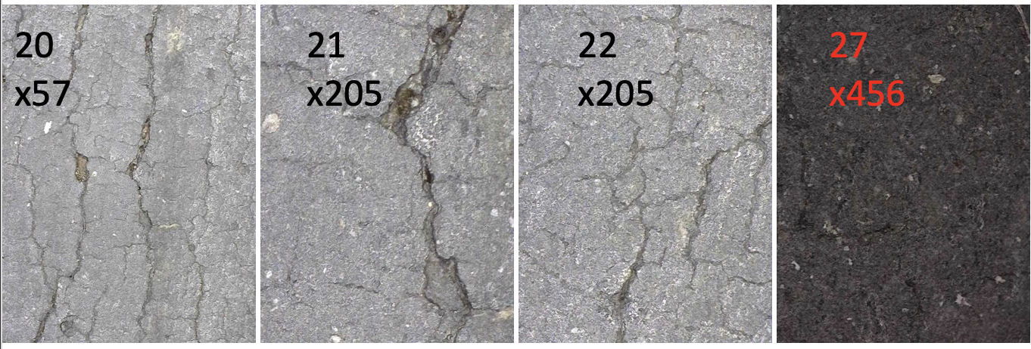
Figure S15. WPP3: surface condition and crack patterns (micrographs 20, 21, 22 and 27).
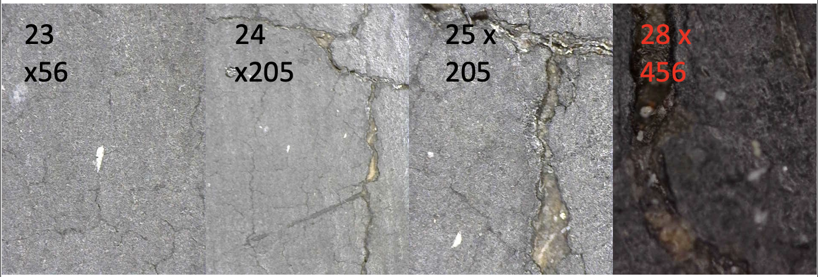
Figure S16. WPP3: micrographs 23, 24, 25 and 28.
Paint layers and craquelure.

WPP4
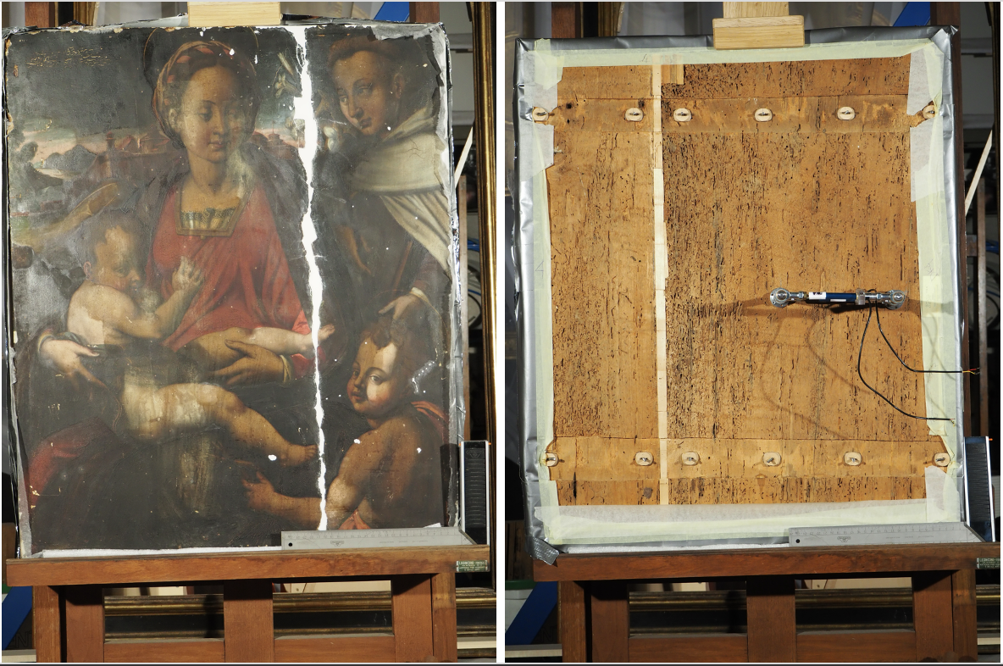
32,33
34,35
29,30,31
Figure S17. WPP4: front and back views, showing the DK position and numbered microscopy areas (stars).
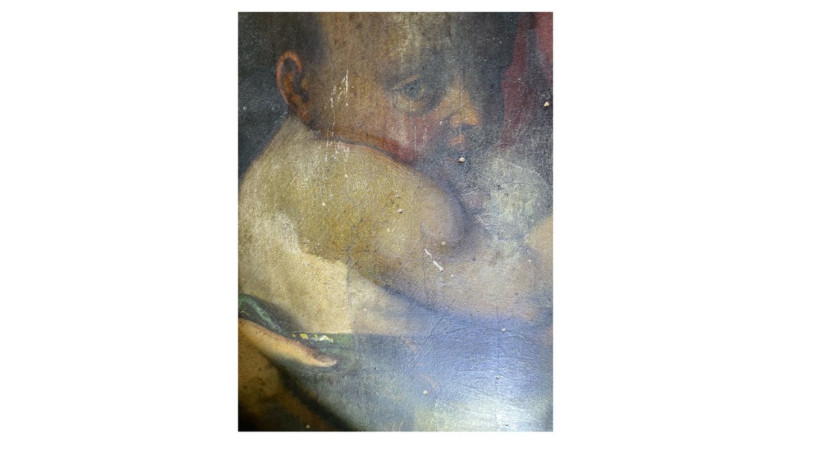
Figure S18. WPP4: quadrangular craquelure under raking light.
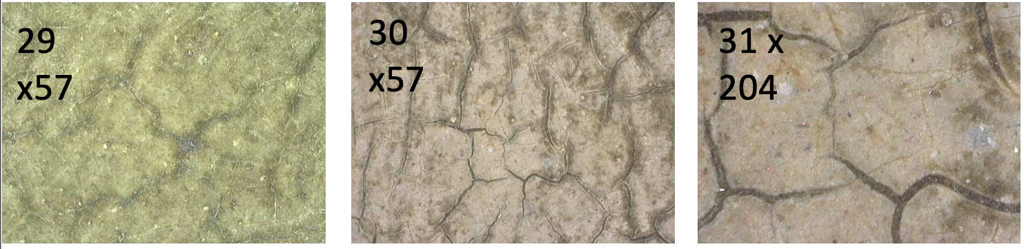
Figure S19. WPP4: surface details (micrographs 29, 30 and 31).
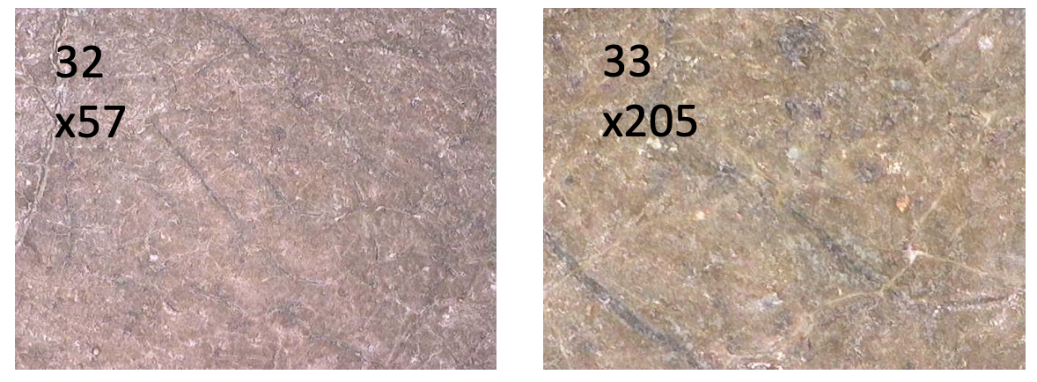
Figure S20. WPP4: paint layer details (micrographs 32 and 33).
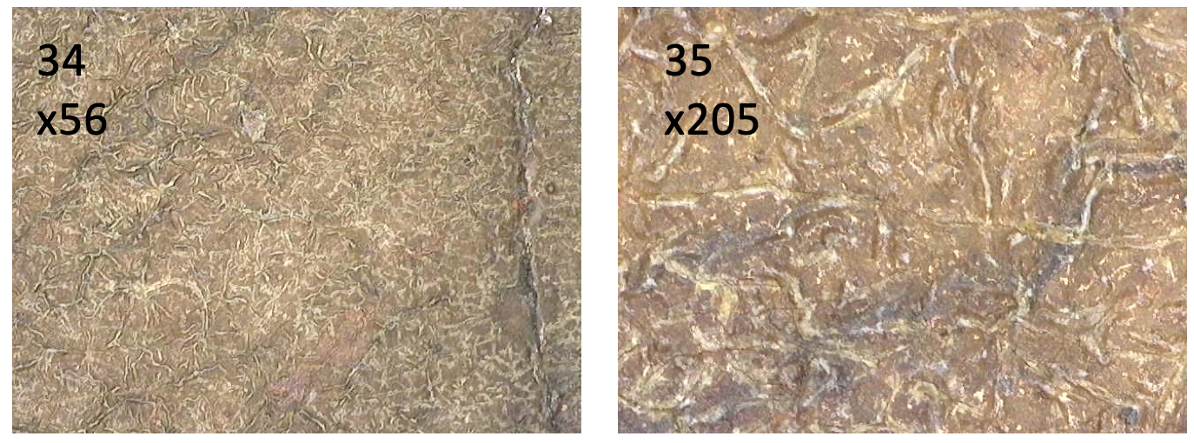
Figure S21. WPP4: paint surface (micrographs 34 and 35).

WPP5
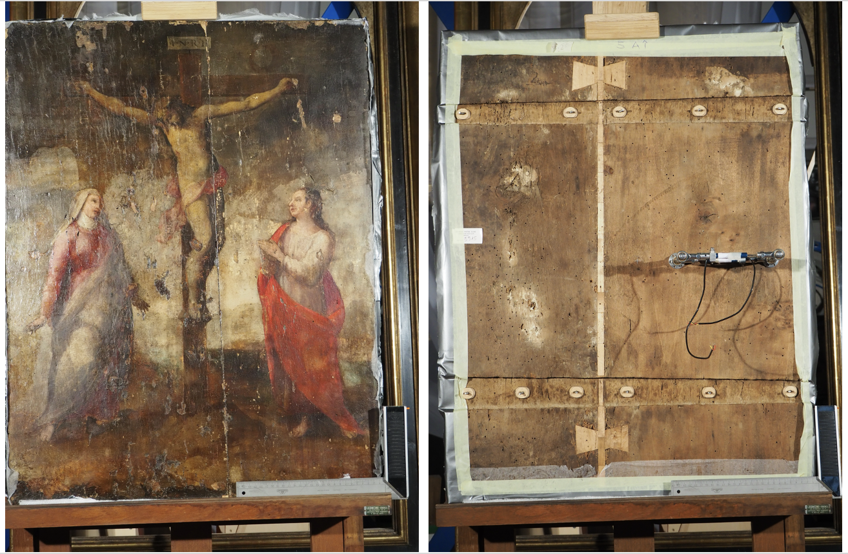
36,37
38,39
40,41
Figure S22. WPP5: front and back views, showing the DK position and numbered microscopy areas (stars).
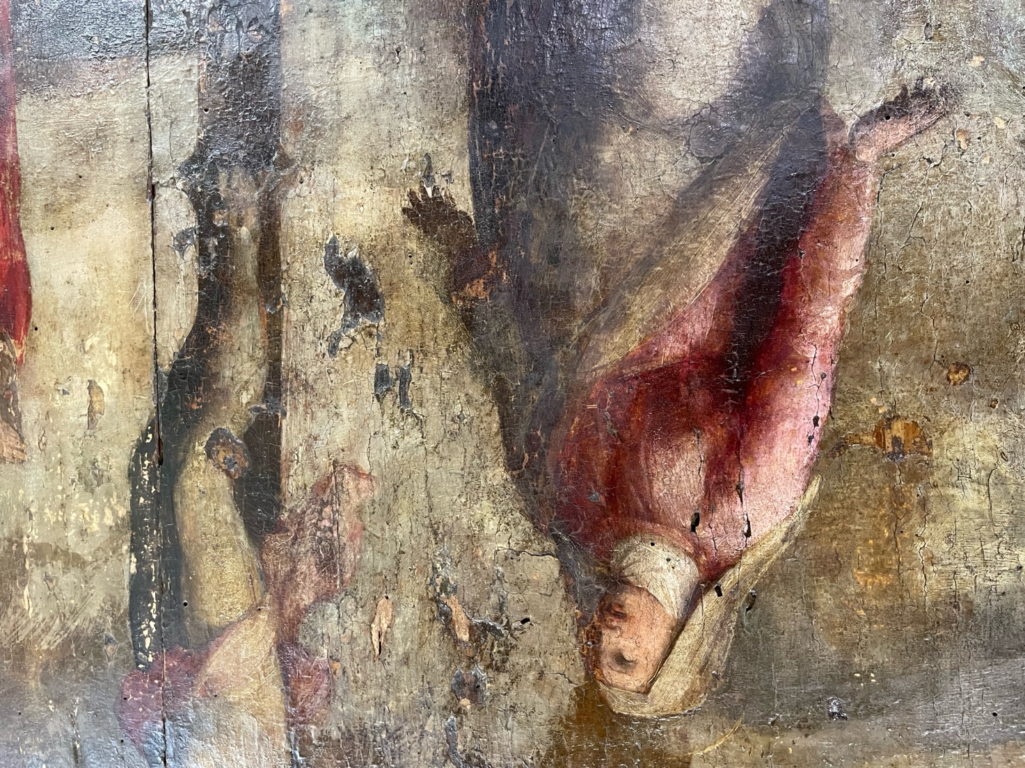
Figure S23. WPP5: quadrangular craquelure under raking light.
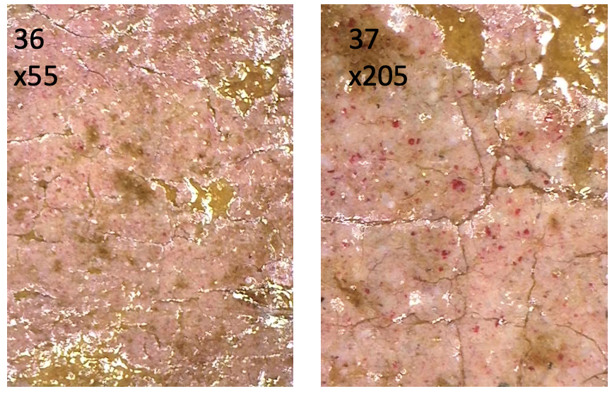
Figure S24. WPP5: paint layers and craquelure (micrographs 36 and 37).
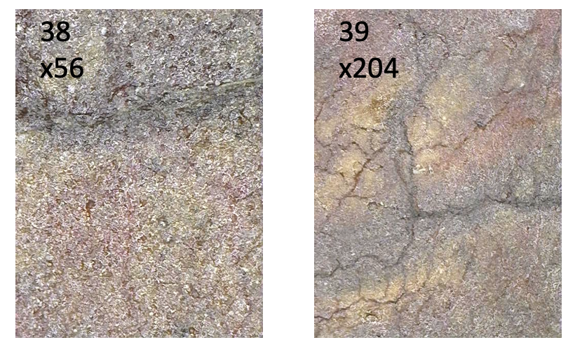
Figure S25. WPP5: paint layers and craquelure (micrographs 38 and 39).
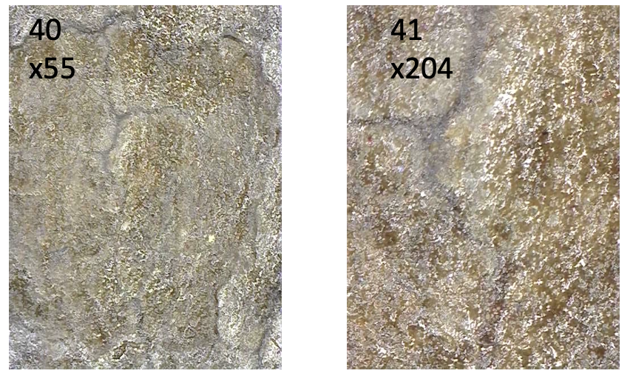
Figure S26. WPP5: paint layers and craquelure (micrographs 40 and 41).

WPP6
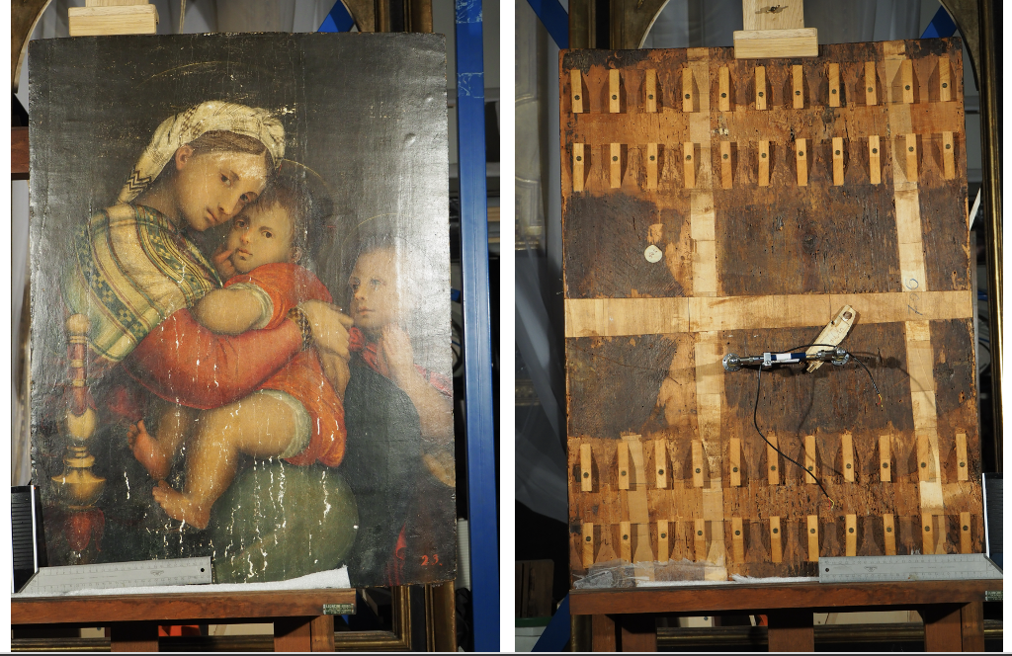
44,45,46,50
47,48,51
42,43,49
Figure S27. WPP6: front and back views, showing the DK position and numbered microscopy areas (stars).
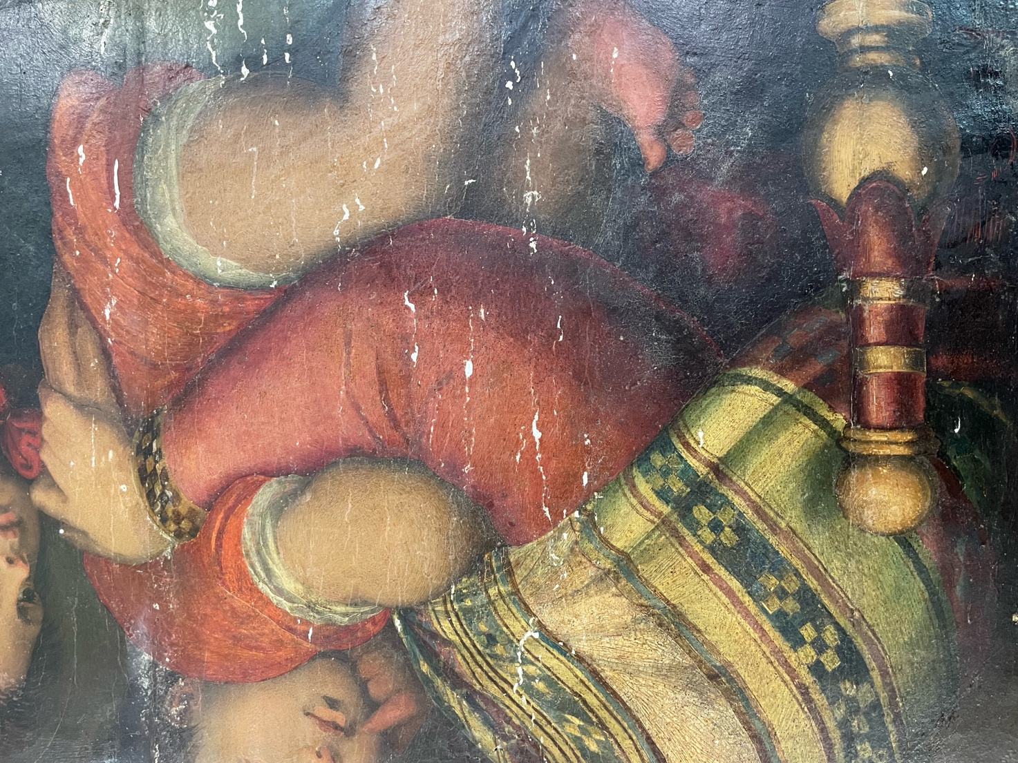
Figure S28. WPP6: raking-light detail of quadrangular craquelure and prominent vertical cracks along the wood grain.
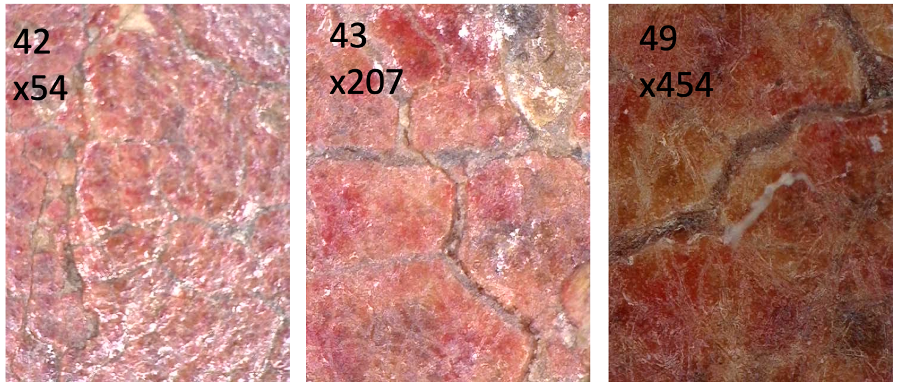
Figure S29. WPP6: deep cracks and surrounding craquelure (micrographs 42, 43 and 49).
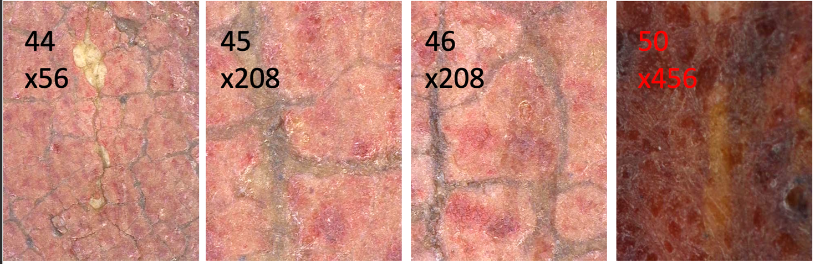
Figure S30. WPP6: surface condition and crack patterns (micrographs 44, 45, 46 and 50).
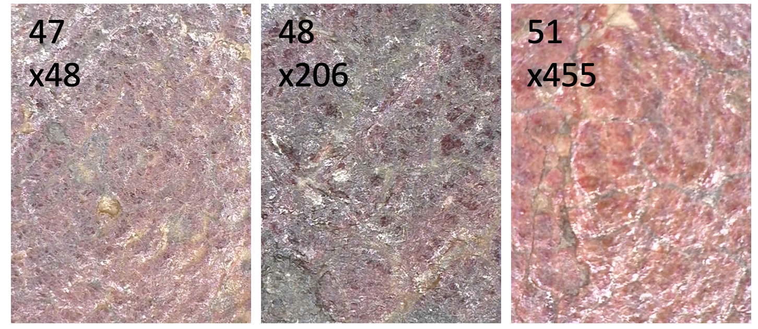
Figure S31. WPP6: paint layers and craquelure (micrographs 47, 48 and 51).

