HMGCR Inhibition Impairs Mitochondrial Fatty Acid Oxidation in Clinical and Preclinical Models: Therapeutic Targeting of Long-Chain Acylcarnitines
Maija Dambrova^{1,2}*, Liga Zvejniece¹, Melita Ozola¹, Arturs Petersons^{2,4}, Anna Miteniece¹, Baiba Svalbe¹, Helena Cirule¹, Stanislava Korzh¹, Baiba Gukalova^{1,2}, Kristaps Krims-Davis^{1,2}, Eva Bolsteina^{5,6}, Gustavs Latkovskis^{5,6}, Ilze Konrade^{2,4}, Helgi B Schiöth^{1,3}, Edgars Liepinsh¹

¹ National Institute of Research and Innovation, Aizkraukles Str. 21, LV-1006, Riga, Latvia
² Riga Stradins University, Dzirciema Str. 16, LV-1007, Riga, Latvia
³ Uppsala University, BMC Box 593, Husargatan 3, 75124, Uppsala, Sweden
⁴ Riga East University Hospital, LV-1038, Riga, Latvia
⁵ University of Latvia, LV-1004, Riga, Latvia
⁶ Pauls Stradins Clinical University Hospital, LV-1002, Riga, Latvia

* Maija Dambrova, corresponding author
Email: maija.dambrova@niri.lv

Supplementary material 1
Inclusion and exclusion criteria for clinical study groups:
Inclusion Criteria:
- Age at least 18 years.
- A representative of the Caucasian race.
- The patient agrees to participate in the study by signing an informed consent form for participation in the study. (The patient may only be included in the muscle biopsy sub-study if the relevant additional informed consent form has also been signed.)
- Specific inclusion criteria for each of the study subgroups:
    - Group A: patients have elevated creatine kinase levels >1.5x above the upper limit of normal (women >325 U/L and men >504 U/L) with or without muscle symptoms that have no other obvious explanation (including intense physical activity in the last 7 days).
    - Group B: atorvastatin 40-80 mg or rosuvastatin 20-40 mg monotherapy for at least 8 weeks at a constant dose and no muscle symptoms (pain, weakness, fatigue, cramps) during this period, CK <200 U/L.
    - Group C: no lipid-lowering agents have been used during the last year and there have been no muscle symptoms (pain, weakness, fatigue, cramps) of unknown origin lasting >1 week during this period, CK <200 U/L.
Exclusion Criteria:
- Any disease that, in the opinion of the investigator, could also cause a significant increase in CK or muscle symptoms.
- Use of other cholesterol-lowering agents specific to each of the study groups:
    - Group A: use of red yeast rice extract, fibrates, or bempedoic acid within the last 8 weeks.
    - Group B: use of other non-statin cholesterol-lowering agents (red yeast rice extract, ezetimibe, fibrates, PCSK9 inhibitors, inclisiran, bempedoic acid) in the last 8 weeks.
    - Group C: use of any cholesterol-lowering agents (statins, red yeast rice extract, ezetimibe, fibrates, PCSK9 inhibitors, inclisiran, bempedoic acid) in the last 12 weeks.
- Intense physical activity in the last 7 days.
- Acute myocardial infarction or stroke in the last 4 weeks.
- Major surgery within the last 4 weeks (invasive cardiac procedures are not an exclusion criterion).
- Patients with severe illness that, in the investigator's opinion, may significantly affect the patient's overall metabolism (e.g., active malignancy, terminal heart failure, etc.).
- Excessive alcohol consumption (binge drinking or >7 units of alcohol per day) within the last year.
- Use of other substances or medications known to have direct myotoxic effects (e.g., fibrates, cyclosporins, labetalol, propofol, procainamide, interferon-alpha, hydroxyurea, zidovudine, colchicine, vincristine, amiodarone, corticosteroids) or that may affect CK elevation.
- Use of meldonium within the last 2 months.

Supplementary Table 1. Primers for the identification of transgenic mice
Primer | Forward primer sequence (5’-3’) | Reverse primer sequence (5’-3’)
Hmgcr | GGTGTTTCAGTGCGTGTTCATTTAC | AAGCCTCATGAAACCCAGATTGAC
Mutant  (Rosa26Cre) | CGTGATCTGCAACTCCAGTC | AGGCAAATTTTGGTGTACGG
Wild type  (Rosa26Cre) | CTGGCTTCTGAGGACCG | CCGAAAATCTGTGGGAAGTC

Supplementary Table 2. Primer sequences of the genes used in this study.
Gene symbol | Full name | Forward primer sequence  (5'->3') | Reverse primer sequence  (5'->3')
β-actin | Actin, beta | CCTCTATGCCAACACAGTGC | CATCGTACTCCTGCTTGCTG
Hmgcr N-terminal | HMG- Coenzyme A reductase N-terminal | GATCCGGAGGATCCAAGGAC | AGGATGATGATGTCGCTGCT
Hmgcr C-terminal | HMG- Coenzyme A reductase C-terminal | GATCGAAGGACGAGGAAAGACT | CCGTAGTTGTCTTTAACACCTCTC
Acox1 | Acyl-Coenzyme A oxidase 1 | TAACTTCCTCACTCGAAGCCA | AGTTCCATGACCCATCTCTGTC
Cpt1 | Carnitine palmitoyltransferase 1 | CTCCGCCTGAGCCATGAAG | CACCAGTGATGATGCCATTCT
Fabp1 | Fatty Acid-Binding Protein 1 | TGAAGGCAATAGGTCTGCCC | CACCTTCCAGCTTGACGACT
Ehhadh | Enoyl-Coenzyme A hydratase and 3-hydroxyacyl Coenzyme A dehydrogenase | GGCGCAGGATACCTTGAGAA | TGGCTCTAACCGTATGGTCC
Acaa1b | Acetyl- Coenzyme A acyltransferase 1B | GATGCATCGGCTGCAGGTAGT | CGACAGAAGCTCGTCGGGG
Hadh | Hydroxyacyl-Coenzyme A dehydrogenase | GAGGCGATGCGTCTAAGGAA | ATTTCATGCCACCCGTCCAA
Cpt2 | Carnitine palmitoyltransferase 2 | CAGCACAGCATCGTACCCA | TCCCAATGCCGTTCTCAAAAT
Hsd17b6 | Hydroxysteroid 17-beta dehydrogenase 6 | AGGTTCAAGAATTCGGGGTGA | GTGGTGCTGCAAAAGTCGTC
Acot3 | Acyl-Coenzyme A thioesterase 3 | CTGCTCAGTCACCCTCAGGTAA | AGTTTCCGCCGATGTTGGA

Supplementary Table 3. Optimized UPLC–MS/MS parameters for quantification of carnitine and acylcarnitines
Compound | Abbreviation | MRM transition (Q1→Q3, m/z) | Cone (V) | Collision energy (eV) | Calibration range (nM)
L-Carnitine | C0 | 162 → 103 | 30 | 16 | 2–1200
Acetylcarnitine | C2 | 204 → 85 | 32 | 18 | 0.3–200
Propionylcarnitine | C3 | 218 → 85 | 30 | 18 | 0.07–40
Butyrylcarnitine | C4 | 232 → 85 | 30 | 20 | 0.03–16
Valerylcarnitine | C5 | 246 → 85 | 30 | 20 | 0.01–8
Hexanoylcarnitine | C6 | 260 → 85 | 30 | 20 | 0.01–6
Octanoylcarnitine | C8 | 288 → 85 | 30 | 20 | 0.01–6
Decanoylcarnitine | C10 | 316 → 85 | 30 | 20 | 0.01–6
Lauroylcarnitine | C12 | 344 → 85 | 30 | 20 | 0.01–6
Tetradecenoylcarnitine | C14 | 372 → 85 | 30 | 22 | 0.01–6
3-Hydroxytetradecanoyl-L-carnitine | C14:0-OH | 388 → 85 | 30 | 30 | 0.01–6
Palmitoylcarnitine | C16 | 400 → 85 | 30 | 26 | 0.01–8
3-Hydroxyhexadecanoyl-L-carnitine | C16:0-OH | 416 → 85 | 30 | 28 | 0.01–8
Oleoylcarnitine | C18:1 | 426 → 85 | 30 | 26 | 0.01–8
Linoleoylcarnitine | C18:2 | 424 → 85 | 30 | 26 | 0.009–5.4
Stearoylcarnitine | C18:0 | 428 → 85 | 30 | 26 | 0.01–8
3-Hydroxyoctadecanoyl-L-carnitine | C18:0-OH | 444 → 85 | 30 | 30 | 0.01–8
Hydroxyoleoyl-L-carnitine* | C18:1-OH | 442 → 85 | 30 | 26 | 0.01–8
Hydroxylinoleylcarnitine* | C18:2-OH | 440 → 85 | 30 | 26 | 0.01–8
* Quantified using the calibration curve of C18:0-OH.

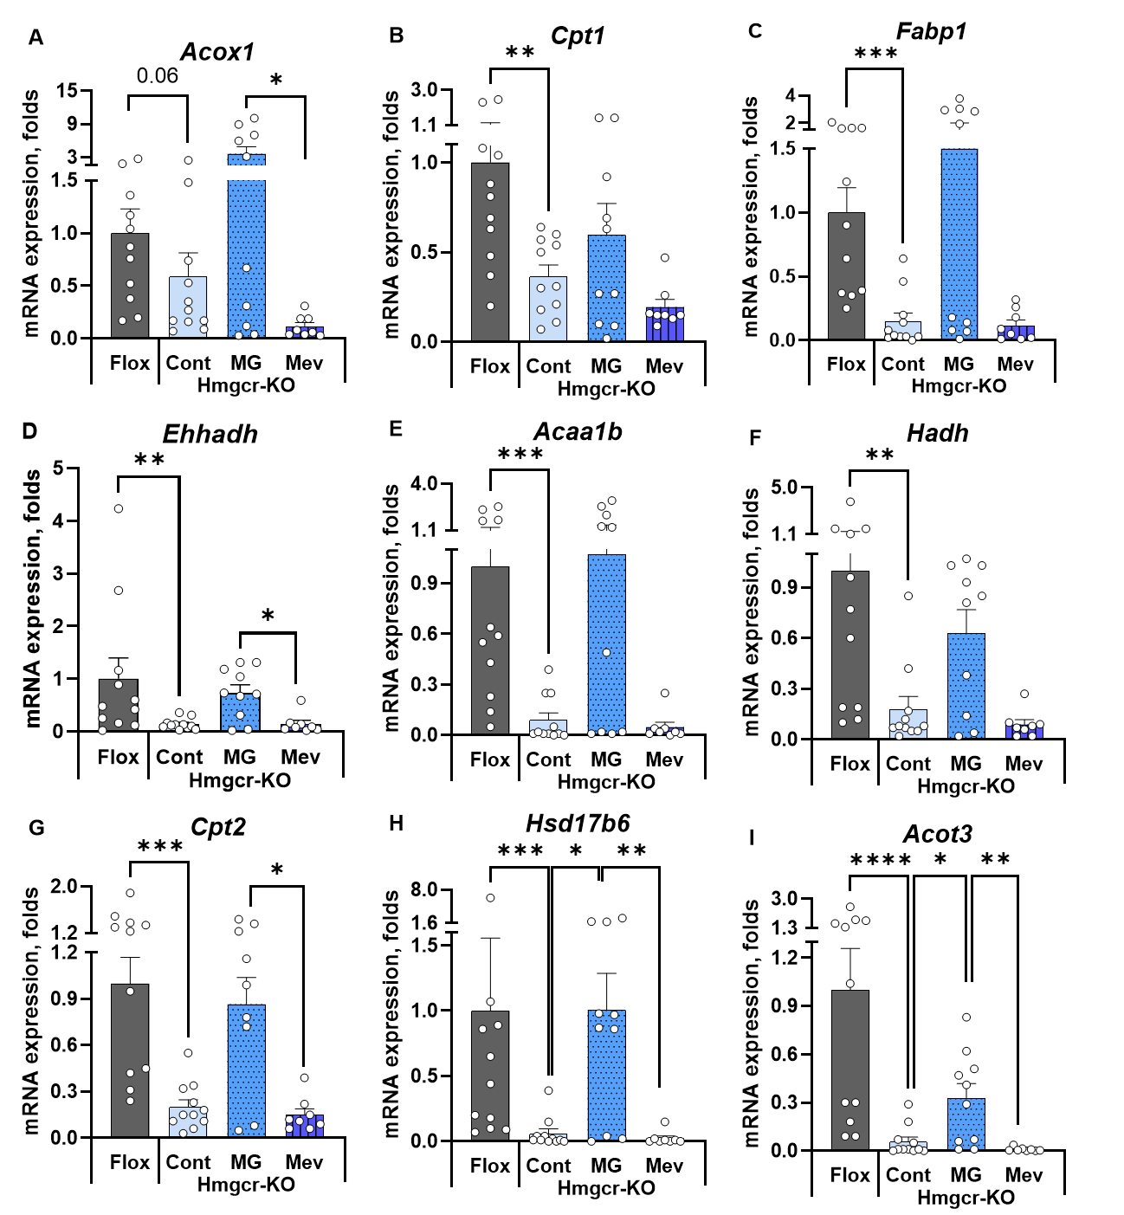
Supplementary Figure 1. Decreased expression of PPARα target genes in Hmgcr-KO mice is partially rescued by methyl-GBB treatment. Relative mRNA expression levels of (A) Acox1, (B) Cpt1, (C) Fapb1, (D), Ehhadh, (E) Acaa1b, (F) Hadh, (G) Cpt2, (H) Hsd17b6, and (I) Acot3 normalized against the ẞ-actin housekeeping gene. Data are shown as the mean ± SEM (n = 8–11 mice per group). *P < 0.05, **P<0.01, ***P<0.001, ****P<0.0001 floxed vs KO control: nonparametric Mann-Whitney test; KO + treatment vs KO control, nonparametric Kruskal-Wallis test. Abbreviations: Hmgcr-KO, Hmgcr knockout mice; Flox, floxed mice; Cont, control mice; MG, Methyl-GBB; Mev, Mevalonate; Acox1, Acyl-CoA oxidase 1; Cpt1, Carnitine palmitoyltransferase 1; Fabp1, Fatty Acid-Binding Protein 1; Ehhadh, Enoyl-Coenzyme A hydratase and 3-hydroxyacyl Coenzyme A dehydrogenase; Acaa1b, Acetyl-CoA acyltransferase 1B; Hadh, Hydroxyacyl-Coenzyme A dehydrogenase; Cpt2, Carnitine palmitoyltransferase 2; Hsd17b6, Hydroxysteroid 17-beta dehydrogenase 6; Acot3, Acyl-Coenzyme A thioesterase 3.
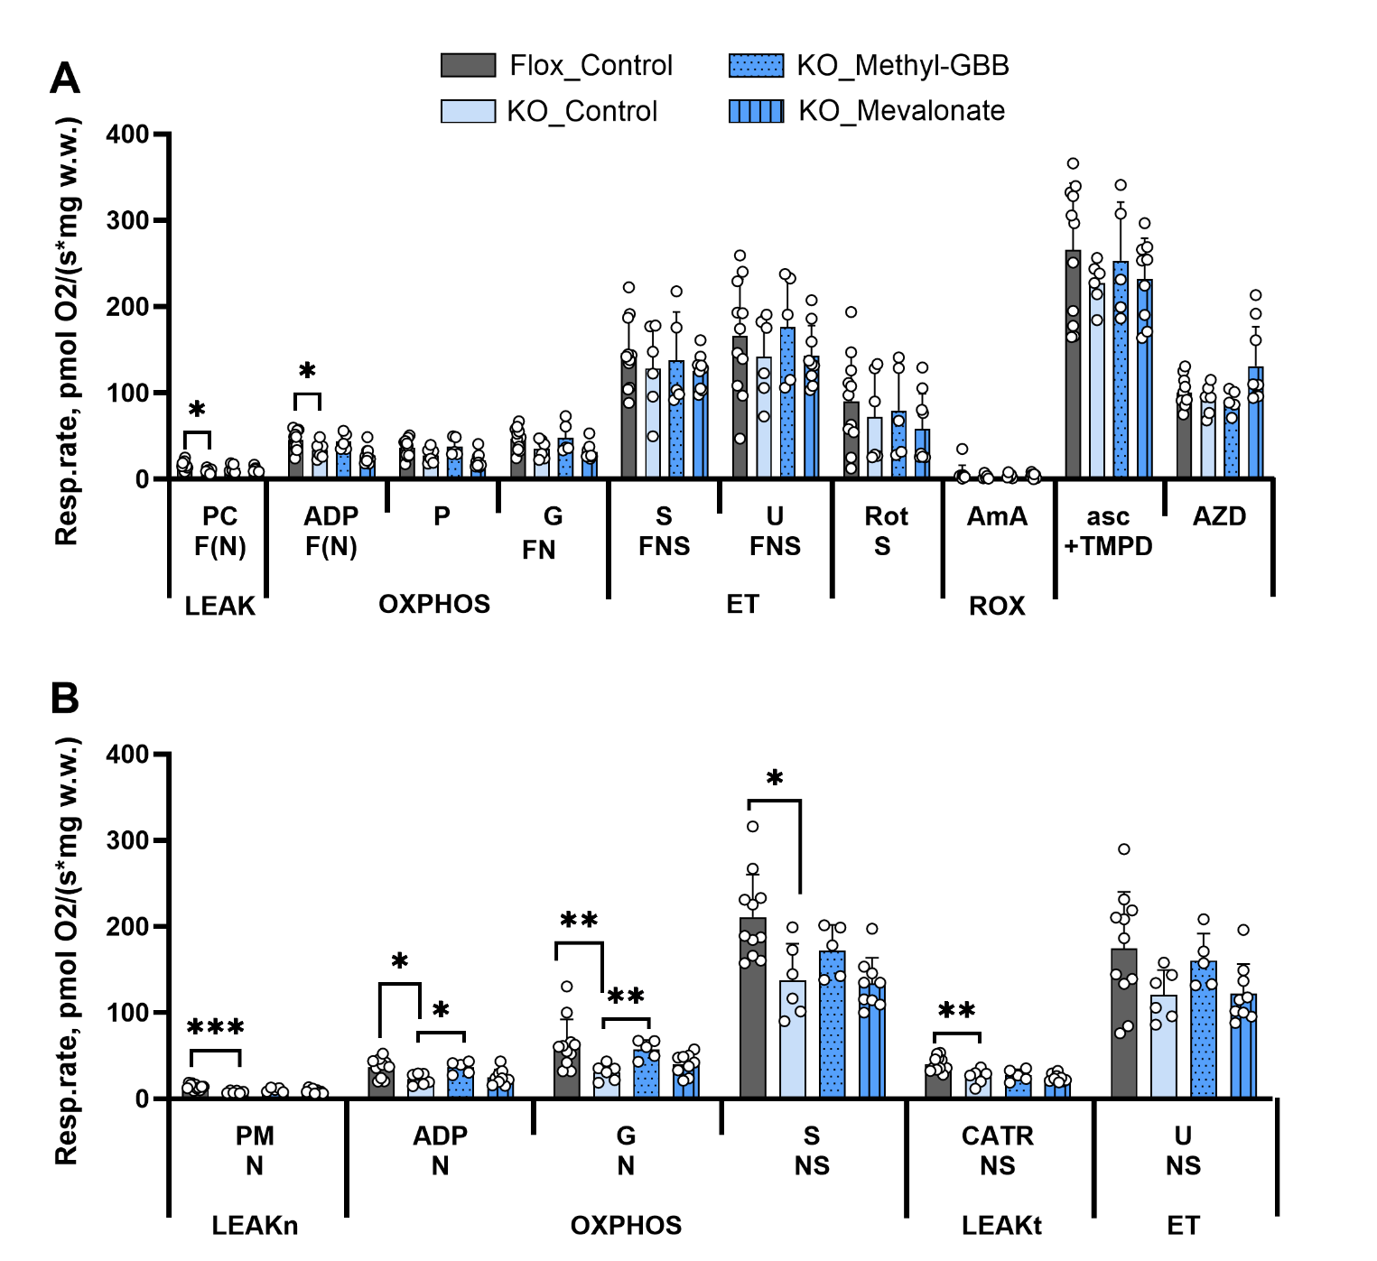
Supplementary Figure 2. High-resolution respirometry measurements from full substrate-uncoupler-inhibitor titration (SUIT) protocols. Mitochondrial respiration was measured using a combination of substrates supporting fatty acid oxidation (F)-, NADH (N)- and succinate (S)-linked electron transfer pathways (A), and N- and S-linked electron transfer pathways alone (B). Data are shown as the mean ± SEM (n = 5–11 mice per group). *P < 0.05, **P<0.01, ***P<0.001, Mann-Whitney test. Abbreviations: ADP, adenosine diphosphate; AmA, antimycin A; asc, ascorbate; AZD, sodium azide; CATR, carboxyatractyloside; F, FAO-dependent pathway; G, glutamate; KO, Hmgcr knockout mice; LEAKn, substrate metabolism-dependent state without adenylates; LEAKt, substrate metabolism-dependent state with adenylates present, after pharmacological inhibition of the phosphorylation system; N, NADH pathway; OXPHOS, oxidative phosphorylation-dependent state; P, pyruvate; PC, palmitoylcarnitine; Rot, rotenone; ROX, residual oxygen consumption; S, succinate; TMPD, N,N,N’, N’-tetramethyl-p-phenylenediamine dihydrochloride; U, uncoupler- carbonyl cyanide 3-chlorophenylhydrazone.

