Supplementary Materials
Title: Multi-scale effects of single-dose psilocybin in the macaque brain

Catalog
Figure S1. Psilocybin induces sustained alterations in sleep architecture, social behavior, and consummatory behavior in cynomolgus macaques. 3
Figure S2. Changes in behavioral measures pre- and post-psilocybin administration. 5
Figure S3. Exploratory association analyses between psilocybin-induced network reorganization and behavioral changes. 6
Figure S4. Longitudinal changes in MRS metabolites before and after psilocybin administration. 7
Figure S5. Psilocybin Reshapes Metabolic Programs in Cortical Neurons. 8
Figure S6. Reconfiguration of Neuronal Co-expression Networks and HTR2A Expression Dynamics after Psilocybin Administration. 10
Figure S7. Drug intervention remodels neuronal synaptic function and drives microglial polarization toward an M2 anti-inflammatory phenotype. 12
Figure S8. Psilocybin remodels astrocyte-mediated neuro-immune communication networks. 14
Figure S9. Psilocybin-induced transition of astrocytes toward a highly differentiated state with up-regulation of CD44. 16

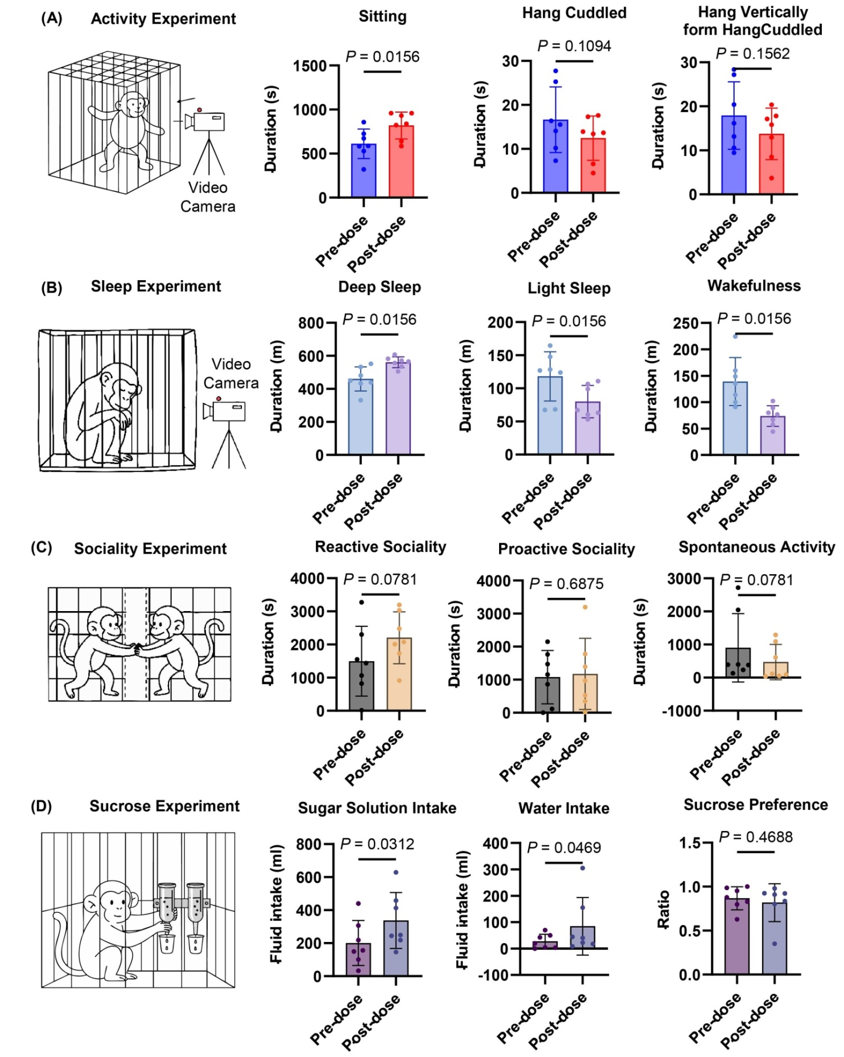
Figure S1. Psilocybin induces sustained alterations in sleep architecture, social behavior, and consummatory behavior in cynomolgus macaques.
(A) Activity experiment. Schematic of the behavioral recording setup and quantification of activity-related behaviors under pre- and after post-dose conditions (n = 7). Psilocybin significantly altered sitting behavior, while Hang Cuddled and Hang Vertically remained unchanged. (B) Sleep experiment. Schematic of sleep monitoring and comparison of sleep-wake states (n = 7). Significant differences were observed in deep sleep, light sleep, and wakefulness following psilocybin administration. (C) Social interaction experiment. Schematic of the dyadic social interaction paradigm and quantification of reactive sociality, proactive sociality, and spontaneous activity (n = 7). No significant difference was observed. (D) Sucrose preference experiment. Schematic of the two-bottle choice task and measurements of water intake, sugar solution intake, and sucrose preference (n = 7). Significant differences were observed in sucrose solution intake and water intake following psilocybin administration. Data are presented as mean ± SEM with individual animals shown as dots. Statistical comparisons between conditions with and without Psilocybin administration were performed using Wilcoxon signed-rank test, with exact P-values indicated above each comparison. Statistical significance was defined as P < 0.05.
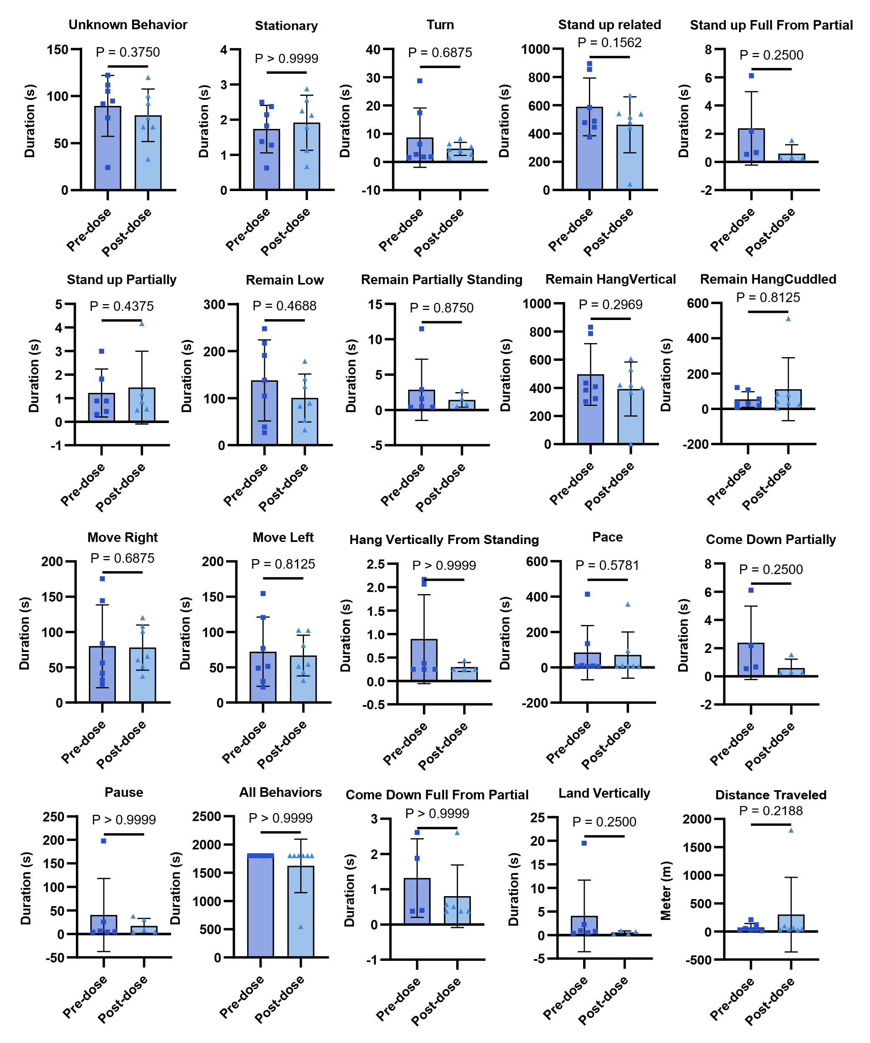
Figure S2. Changes in behavioral measures pre- and post-psilocybin administration.
Quantitative comparison of behavioral measures pre- and post-psilocybin administration. Data are presented as mean ± SEM with individual animals shown as dots (n = 7). Statistical comparisons between Pre- and Post-dose conditions were performed using Wilcoxon signed-rank test, with exact P values indicated above each comparison.

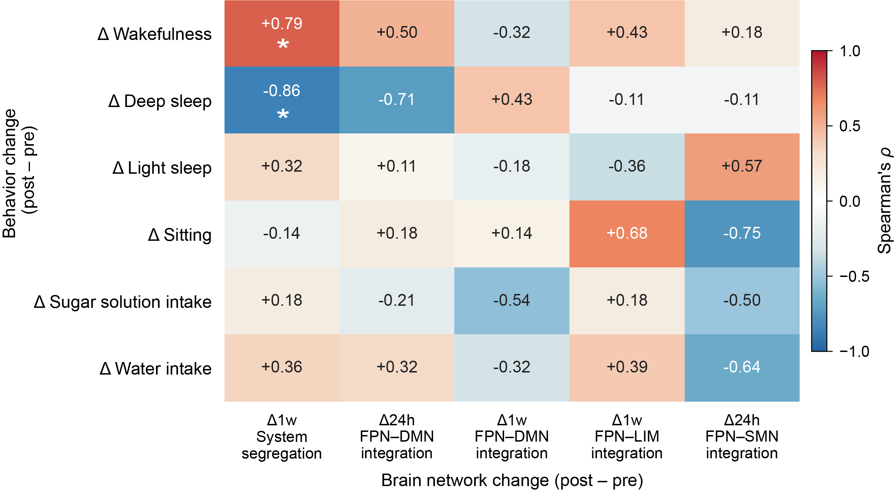
Figure S3. Exploratory association analyses between psilocybin-induced network reorganization and behavioral changes.
Heatmap shows Spearman's rank correlation coefficients (ρ) between psilocybin-induced changes in global brain network metrics (columns; 24 hours and 1 week post-dose) and changes in behavior (rows) in cynomolgus macaques (n = 7). Δ denotes post-dose minus pre-dose (baseline) values; Δ24h and Δ1w correspond to the 24-hour and 1-week post-dose time points, respectively. Only those network metrics that showed significant psilocybin-induced changes in the primary analyses were retained, namely Δ1w system segregation, Δ24h and Δ1w frontoparietal–default-mode network (FPN–DMN) integration, Δ1w FPN–limbic (FPN–LIM) integration, and Δ24h FPN–somatomotor (FPN–SMN) integration, yielding 6 × 5 = 30 brain–behavior pairs. Statistical significance was assessed by 10,000 permutations of behavioral labels. Asterisks denote significance (*P < 0.05). In the present analysis, two associations reached nominal significance but none survived FDR correction. DMN, default-mode network; FPN, frontoparietal network; LIM, limbic network; SMN, somatomotor network.
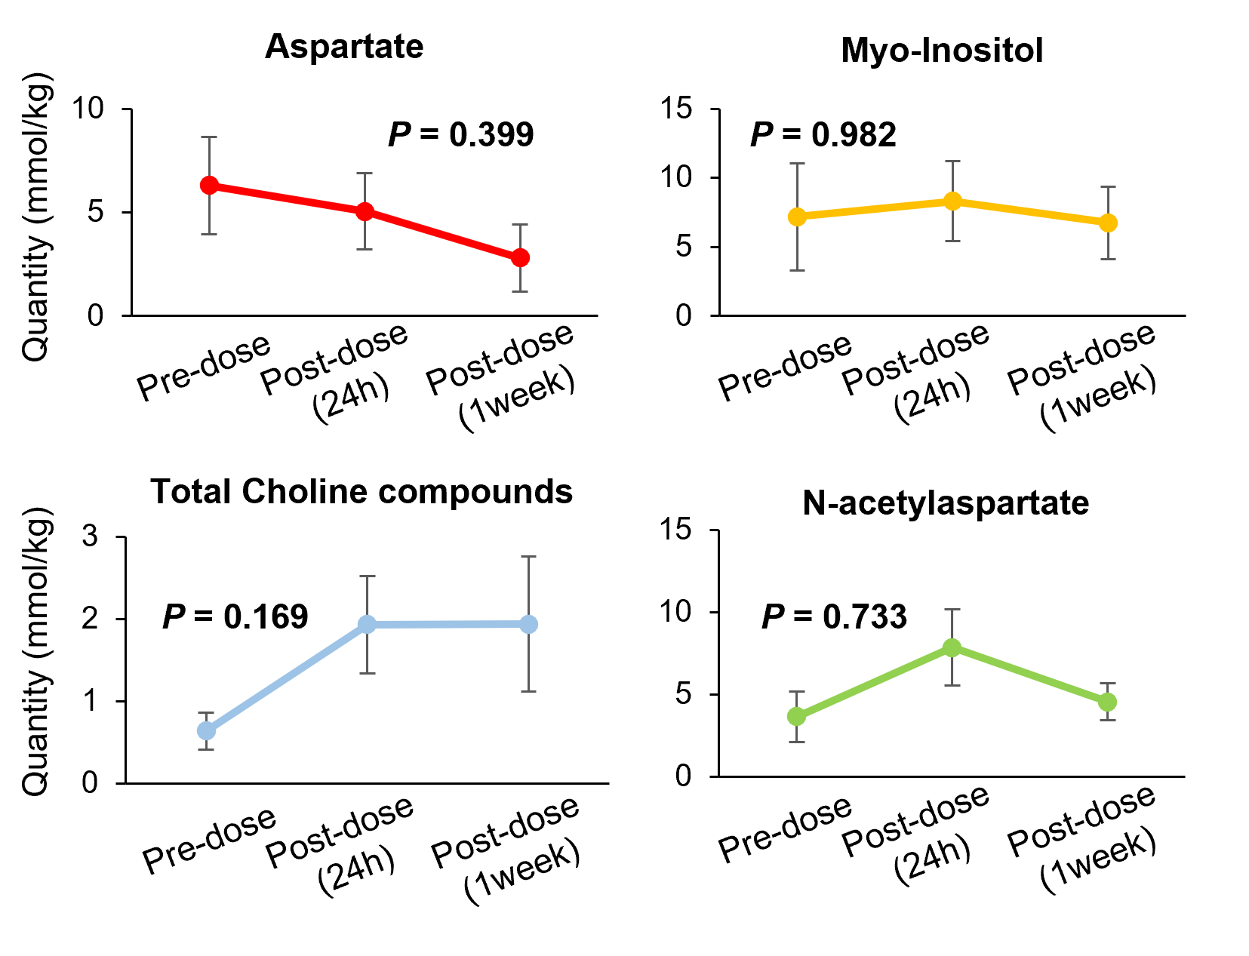
Figure S4. Longitudinal changes in MRS metabolites before and after psilocybin administration.
Magnetic resonance spectroscopy (MRS) measurements in the dorsolateral prefrontal cortex (dlPFC). Longitudinal changes in aspartate, myo-inositol, total choline compounds, and N-acetylaspartate at baseline (pre-dose), 24 hours after psilocybin administration, and 1-week post- psilocybin. Data are presented as mean ± standard deviation. P values were determined using linear mixed-effects models and are indicated within each panel.
Figure S5. Psilocybin Reshapes Metabolic Programs in Cortical Neurons.
(A) Quality-control metrics for each sample (C, control; E, psilocybin): number of genes detected, total RNA counts, and proportion of mitochondrial genes. (B) GO pathway enrichment of genes up-regulated across cell types with psilocybin intervention. (C) Gene Ontology (GO) Biological Process enrichment analysis of up-regulated genes in neuronal subclusters in the control group. (D) Overlap of downregulated genes following psilocybin treatment across excitatory neuron subtypes. HMGN3 and ENSMFAG00000034226 were the only genes commonly downregulated across L2–3, L3–5, L5/6 IT, L5–6 NP, L6 CT, and L6B excitatory neuron subtypes. (E) HMGN3 expression changes by cell type with- versus without-psilocybin (Wilcoxon test: ****P < 0.0001; ***P < 0.001; **P < 0.01; *P < 0.05; ns, not significant).Ctrl control, Psi psilocybin. (F) Overlap of up-regulated genes among cell types; central violin plot shows ND3 expression levels across cell types. (G) ND3 expression changes by cell type with- versus without-psilocybin (Wilcoxon test: ****P < 0.0001; ***P < 0.001; **P < 0.01; *P < 0.05; ns, not significant).Ctrl control, Psi psilocybin.

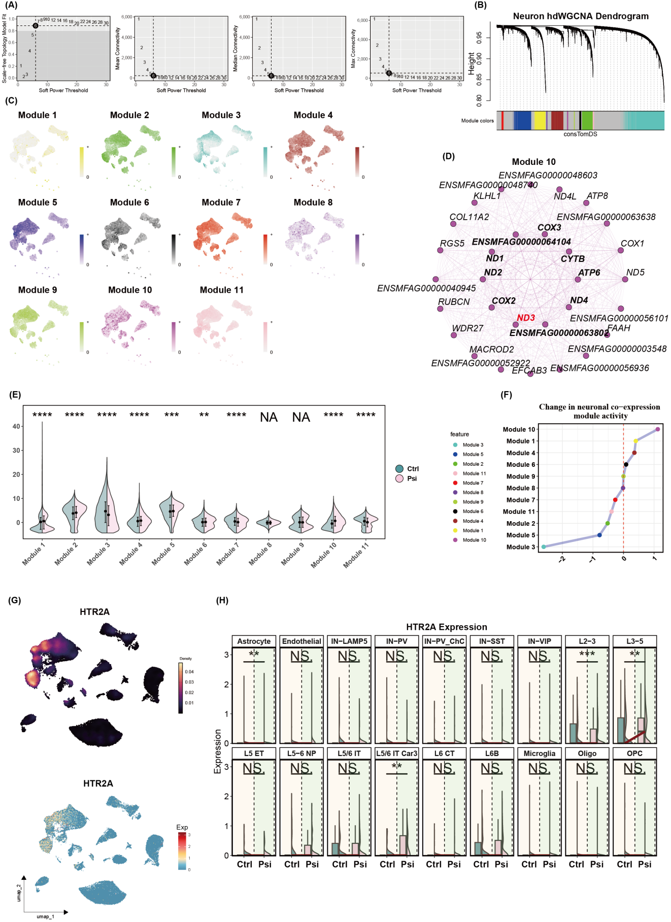

Figure S6. Reconfiguration of Neuronal Co-expression Networks and HTR2A Expression Dynamics after Psilocybin Administration.
(A) WGCNA soft-threshold assessment: scale-free topology fit and mean connectivity. (B) Hierarchical clustering dendrogram of neurons based on gene expression; color bar below indicates module assignment. (C) Distribution of each co-expression module across UMAP space. (D) Top 25 hub genes of Module 10. (E) Differential module activity between with- and without-psilocybin conditions. (Wilcoxon test: ****P < 0.0001; ***P < 0.001; **P < 0.01; *P < 0.05; ns, not significant). (F) Change in neuronal co-expression module activity (with minus without). (G) Top: HTR2A density distribution on UMAP; bottom: HTR2A expression mapped onto UMAP. (H) HTR2A expression changes across cell types with- versus without-psilocybin (Wilcoxon test: ****P < 0.0001; ***P < 0.001; **P < 0.01; *P < 0.05; ns, not significant).Ctrl control, Psi psilocybin.

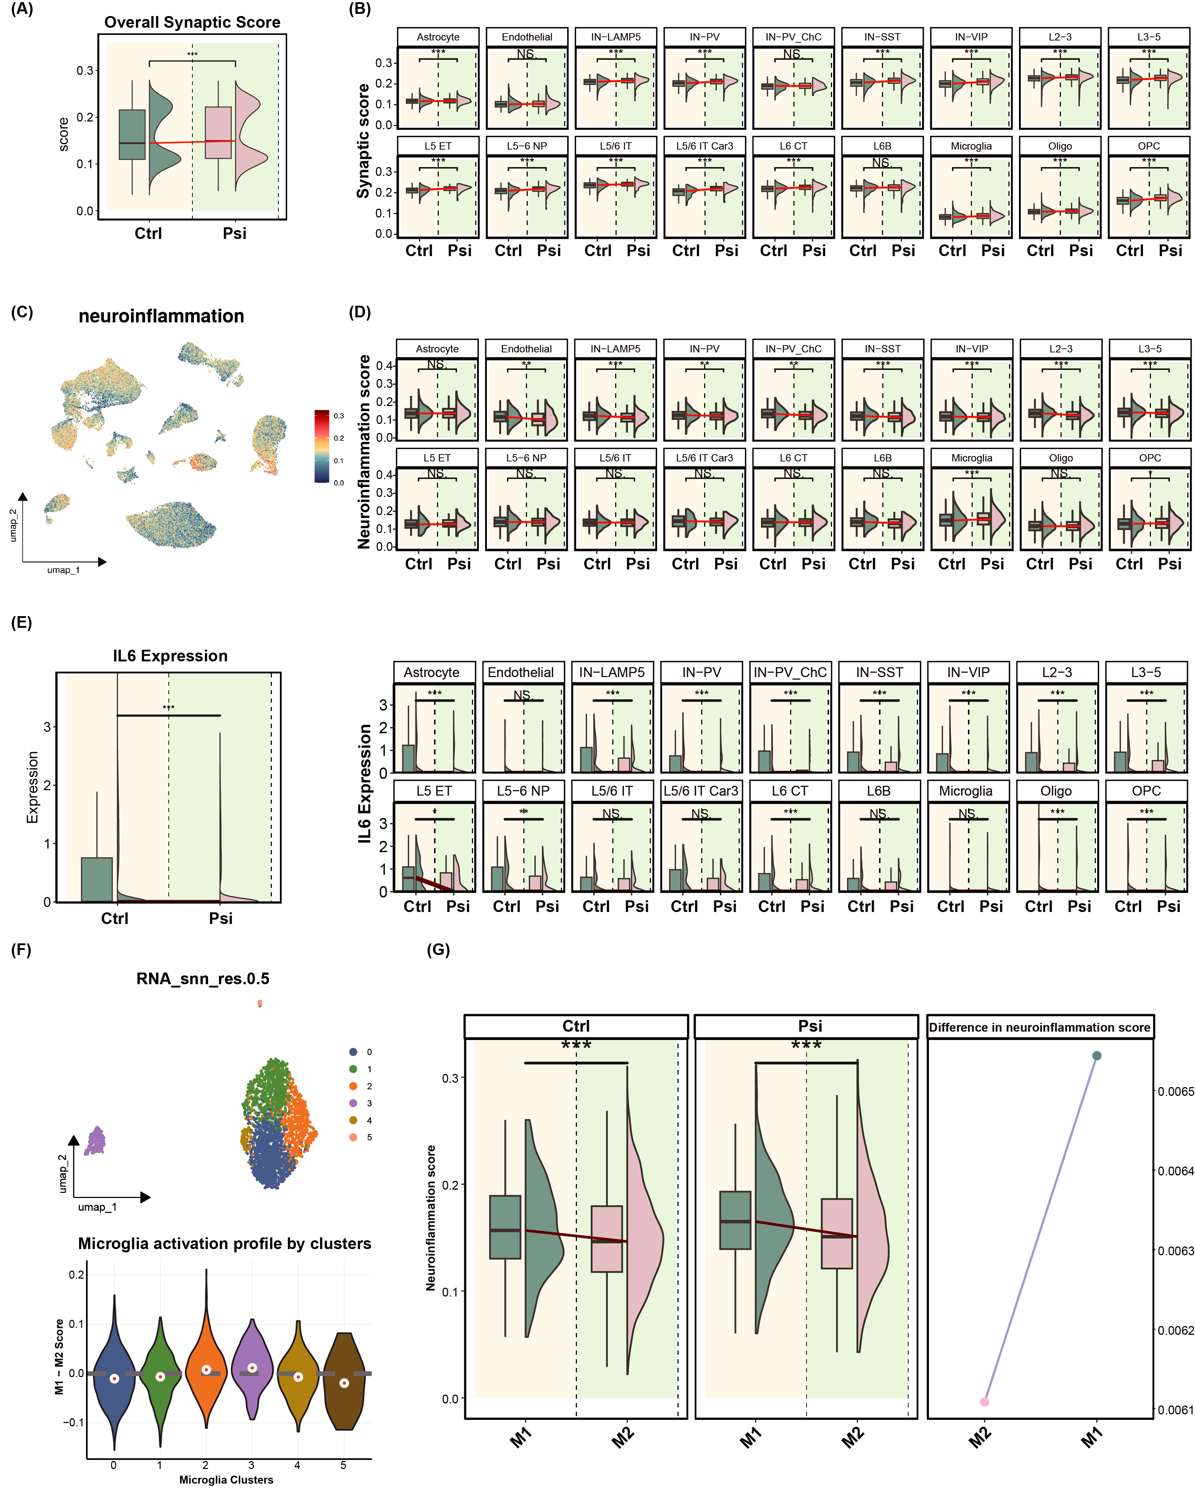

Figure S7. Drug intervention remodels neuronal synaptic function and drives microglial polarization toward an M2 anti-inflammatory phenotype.
(A) Overall change in synaptic-function score (Wilcoxon test, *** P < 0.001). Ctrl control, Psi psilocybin.
(B) Synaptic-function score changes by cell type with- versus without-psilocybin (Wilcoxon test: ****P < 0.0001; ***P < 0.001; **P < 0.01; *P < 0.05; ns, not significant). (C) Neuro-inflammation score distribution on UMAP embedding. (D) Neuro-inflammation score changes by cell type with- versus without-psilocybin (Wilcoxon test: ****P < 0.0001; ***P < 0.001; **P < 0.01; *P < 0.05; ns, not significant). (E) Left: global IL6 expression with- versus without-psilocybin; right: IL6 distribution across cell types (Wilcoxon test: ****P < 0.0001; ***P < 0.001; **P < 0.01; *P < 0.05; ns, not significant). (F) Top: UMAP projection of microglial subclusters; bottom: M1–M2 score distribution per cluster. (G) Left: M1 and M2 score changes with- versus without-psilocybin; right: trajectories of M1 and M2 inflammation scores with- versus without-psilocybin (Wilcoxon test, ***P < 0.001).

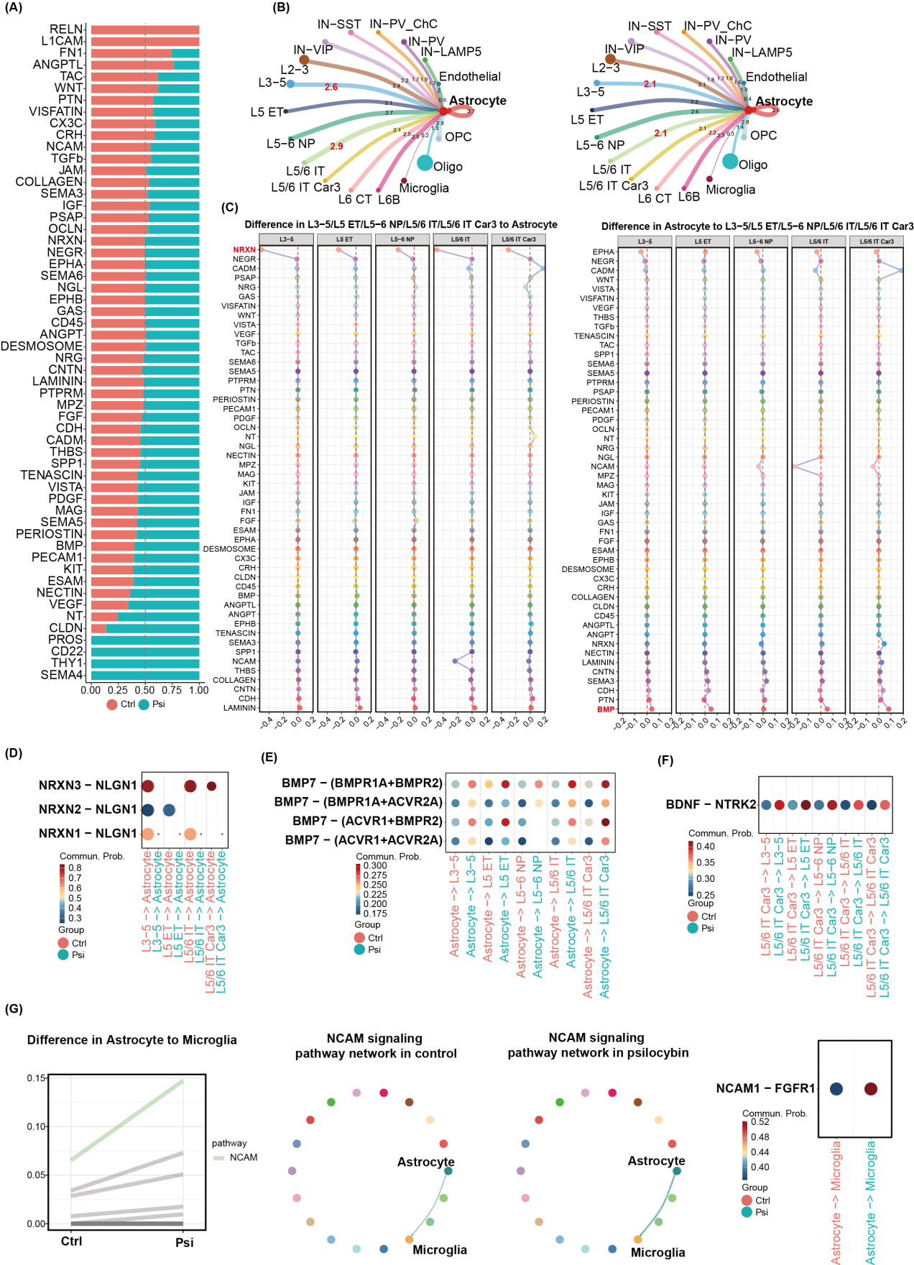

Figure S8. Psilocybin remodels astrocyte-mediated neuro-immune communication networks.
(A) Relative contribution of each ligand class before (red) and after (cyan) psilocybin administration. Ctrl control, Psi psilocybin. (B) Astrocyte–other-cell communication networks with- and without-psilocybin; node size reflects cellular proportion. (C) Left: differential communication strength (with vs without) for ligands transmitted from L3–5/L5 ET, L5–6 NP, L5/6 IT, and L5/6 IT Car3 neurons to astrocytes; right: corresponding reverse-signaling changes. (D–E) Bubble heat maps of NRXN (D) and BMP (E) subclass communication strength between L5 deep-layer neurons and astrocytes (with vs without). (F) Bubble heat map of NT (BDNF–NTRK2) subclass communication strength among neuronal subtypes originating from L5/6 IT Car3 neurons (with vs without). (G) Far left: overall pathway strength difference from astrocytes → microglia with- and without-psilocybin; middle panels: NCAM signaling network changes from astrocytes to microglia; far right: NCAM subclass intensity.

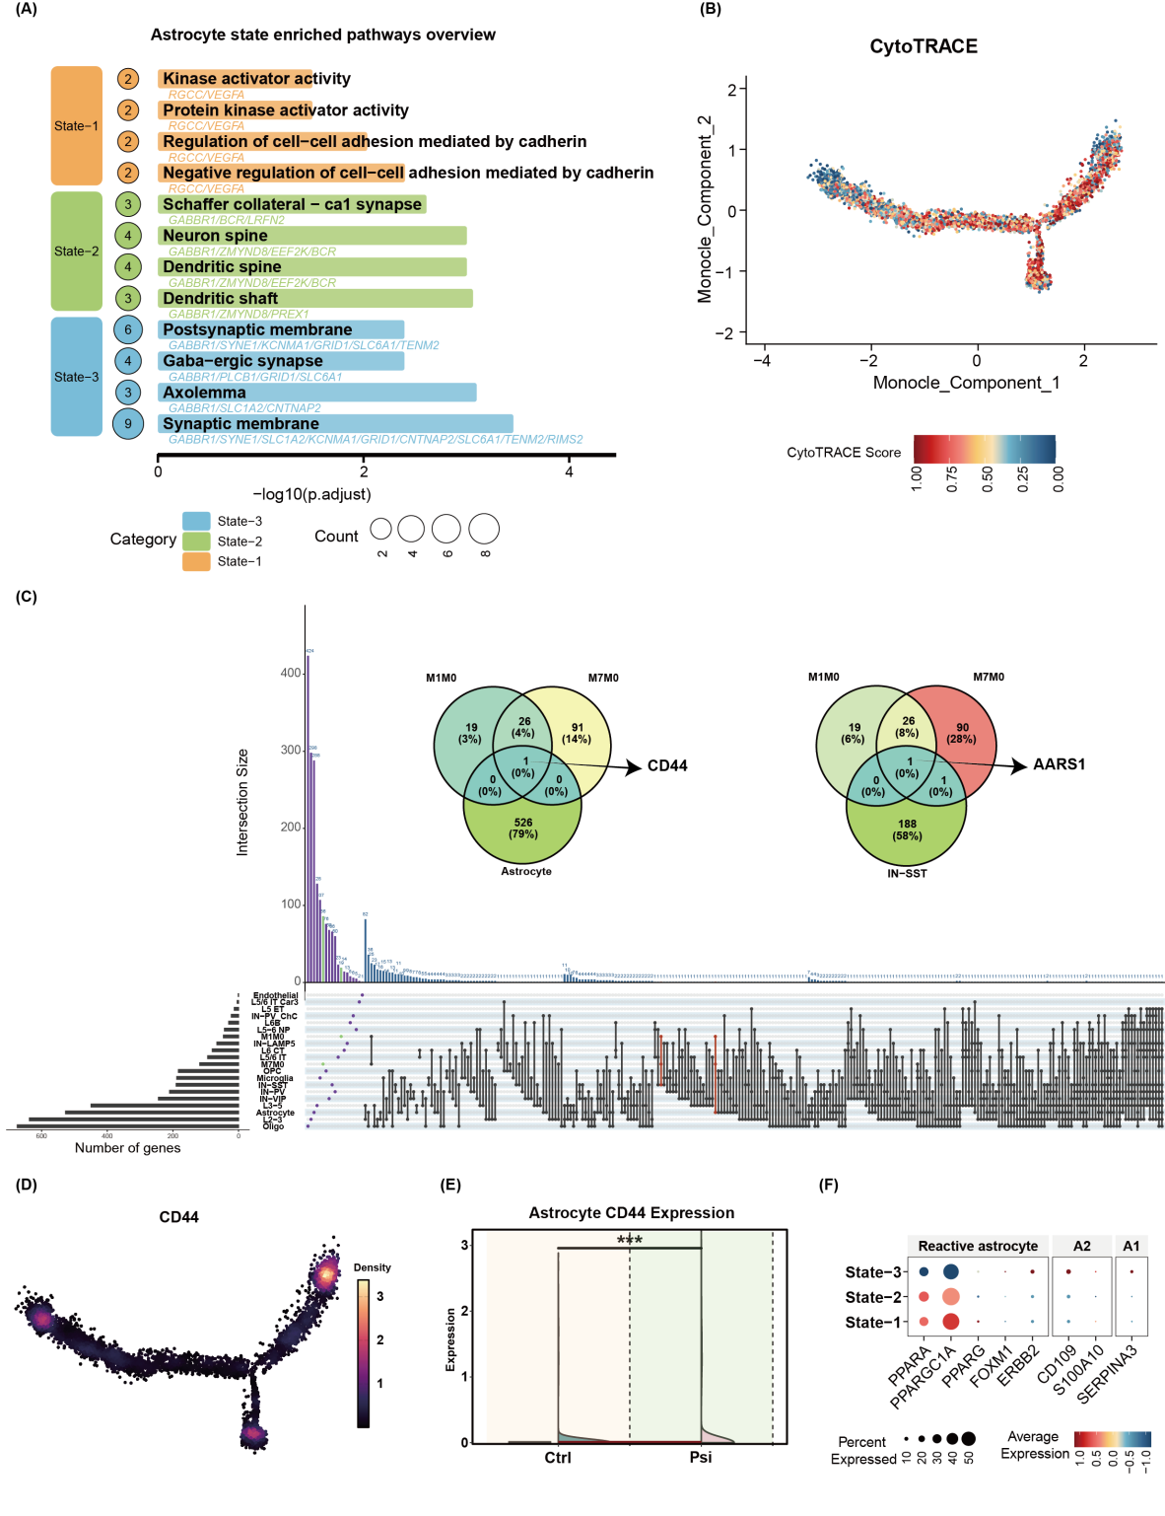

Figure S9. Psilocybin-induced transition of astrocytes toward a highly differentiated state with up-regulation of CD44.
(A) GO enrichment of up-regulated genes in the three pseudotime-resolved astrocyte clusters with-psilocybin. (B) Astrocyte differentiation trajectory in Monocle-embedded space; color gradient indicates CytoTRACE-based proliferative potential. (C) Intersection of genes up-regulated across all cell types with-psilocybin with genes up-regulated in cerebrospinal fluid at 24 h and 1-week post-infusion; upper Venn diagrams depict intersections between these temporal signatures and psilocybin-up-regulated genes specific to astrocytes or IN-SST neurons. (D) Density distribution of CD44 on the Monocle-embedded astrocyte trajectory. (E) with- versus without-psilocybin CD44 expression in astrocytes (***P < 0.001). Ctrl control, Psi psilocybin. (F) Dot plot of signature gene expression across astrocyte subclusters.

