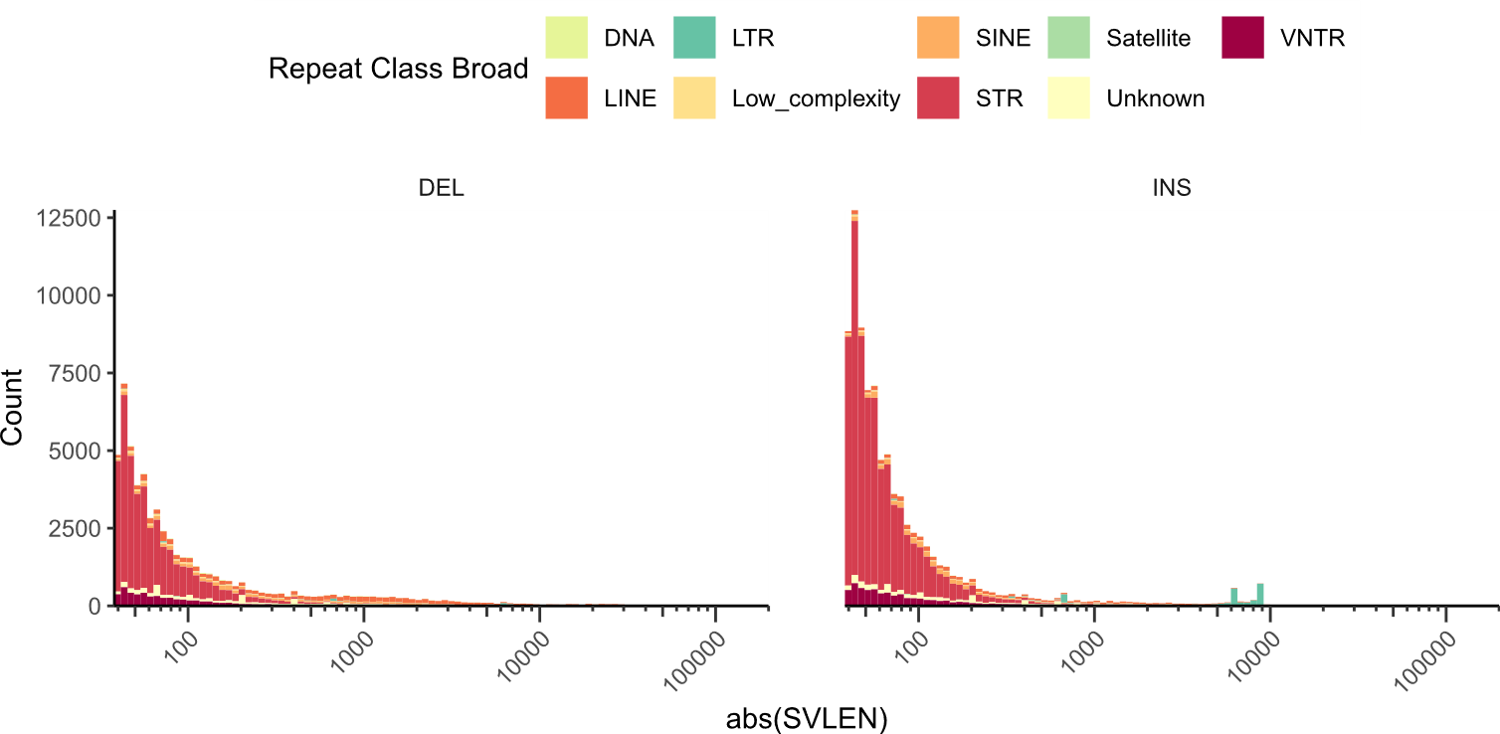
Extended Data Fig. 1: Full structural variant length distribution for SVIM-asm including simple tandem repeats (STRs) show they contribute significantly to the total number of SVs. INS, insertion; DEL, deletion; DNA, DNA, transposon; SINE, short interspersed nuclear elements; LTR, long terminal repeat; LINE, long interspersed nuclear elements; VNTR, variable number tandem repeats.
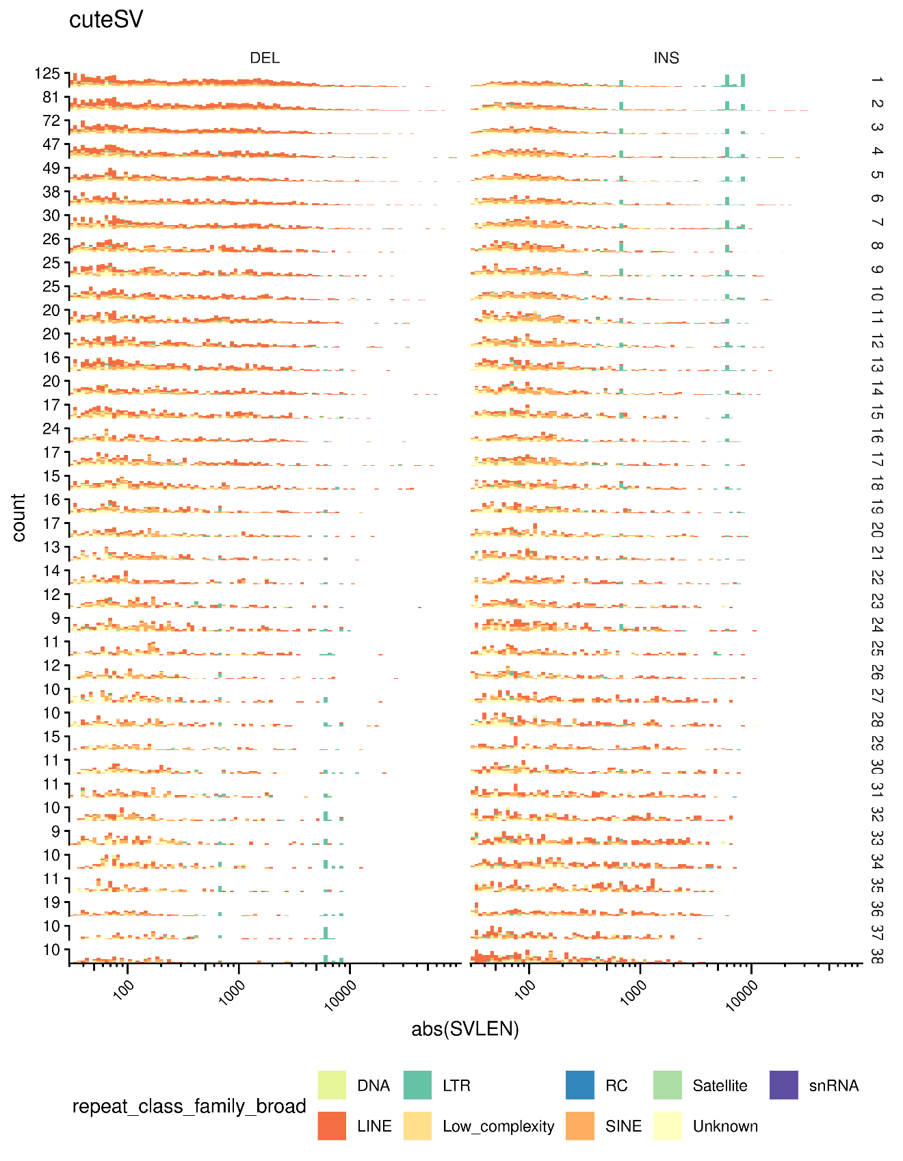
Extended Data Fig. 2: LTR-associated insertions increased as their population frequency decreased while LINE and DNA transposon deletions increased as population frequency decreased. INS, insertion; DEL, deletion; DNA, DNA, transposon; SINE, short interspersed nuclear elements; LTR, long terminal repeat; LINE, long interspersed nuclear elements; VNTR, variable number tandem repeats; RC, rolling circle.

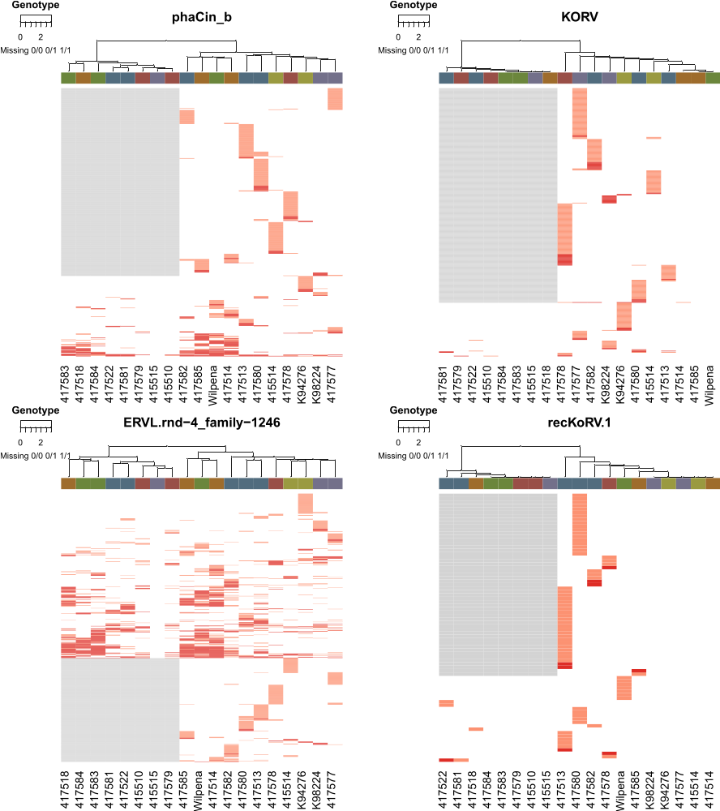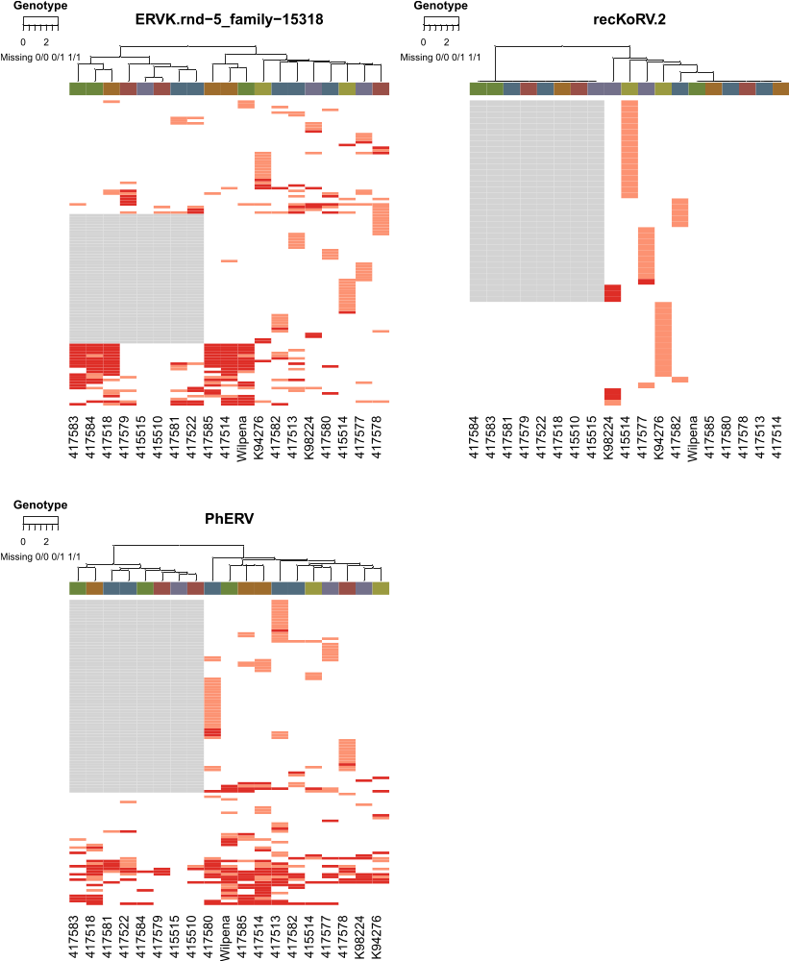
Extended Data Fig. 3: Genotyping for major ERV families shows assemblies extracted a substantial number of ERVs missed by long-read based SV callers. Rows containing missing genotyping (grey boxes) are SURVIVOR merged variants from SVIM-asm and are not fully genotyped in this plot. Remaining rows were detected with cuteSV and genotyped with cuteFC.
Extended Data Fig. 4: Multiple sequence alignment (MSA) of representative insertions of recKoRV.1, PhERV and the PhERV-like retrovirus shows these LTR insertions had high homology at both 5’ and 3’ ends. Rows 1 and 7 are the PhERV-like retrovirus, rows 2 and 3 are recKoRV.1 and rows 4,5 and 6 are PhERV. recKoRV.1 has LTRs from KoRV which do not align well to the LTRs of the PhERV-like retrovirus. Sequence homology between the PhERV-like retrovirus may be allowing PhERV to reintegrate at a higher rate and could be contributing to the formation of recKoRV.1. This MSA included all recKoRV.1 and PhERV sequences and was subset to representative

sequences.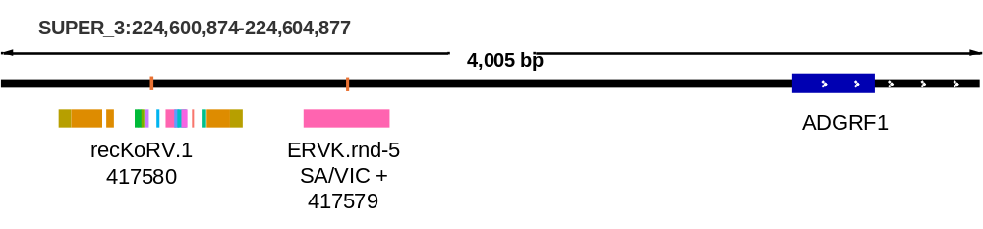
Extended Data Fig. 5: ERVK.rnd5 insertion upstream of ADGRF1’s TSS that was misgenotyped by read-based SV callers.

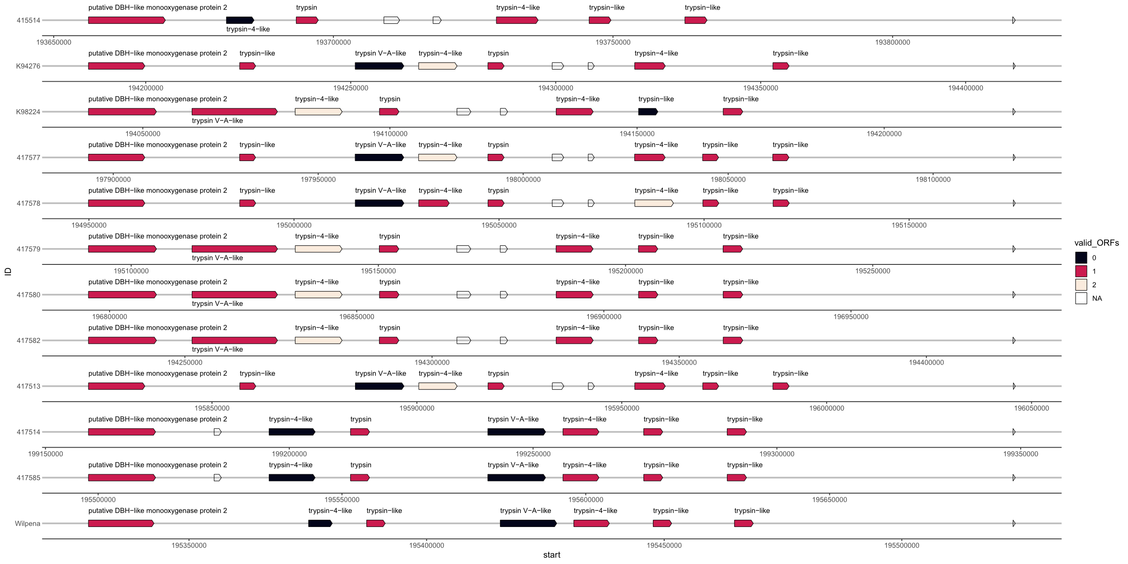
Extended Data Fig. 6: Structure of Trypsin family locus in 12 primary assemblies, ordered by cluster north to south, show high variability and distinct haplotypes resulting in variation of trypsin family genes. This example also highlights the limitations of different assembly methods and lower coverage. Missing genes in 415514’s primary assembly (AmpliFi ~19X coverage) may be induced by haplotype switching rather than a true deletion as a gap occurs in one haplotype at this location (not shown). K94276 has a gap overlapping the trypsin-like gene missing in its assembly, and Wilpena had a gap inserted where tryspin V-A-like was in mPhaCin1.pri. Despite these limitations we can clearly see all southern koalas possessed a distinct gene order and loss of open reading frames (ORFs). One copy of a trypsin-4-like and tryspin V-A-like gene no longer have valid ORFs while the upstream region of the second trypsin-4-like gene has been rearranged which may alter gene regulation.

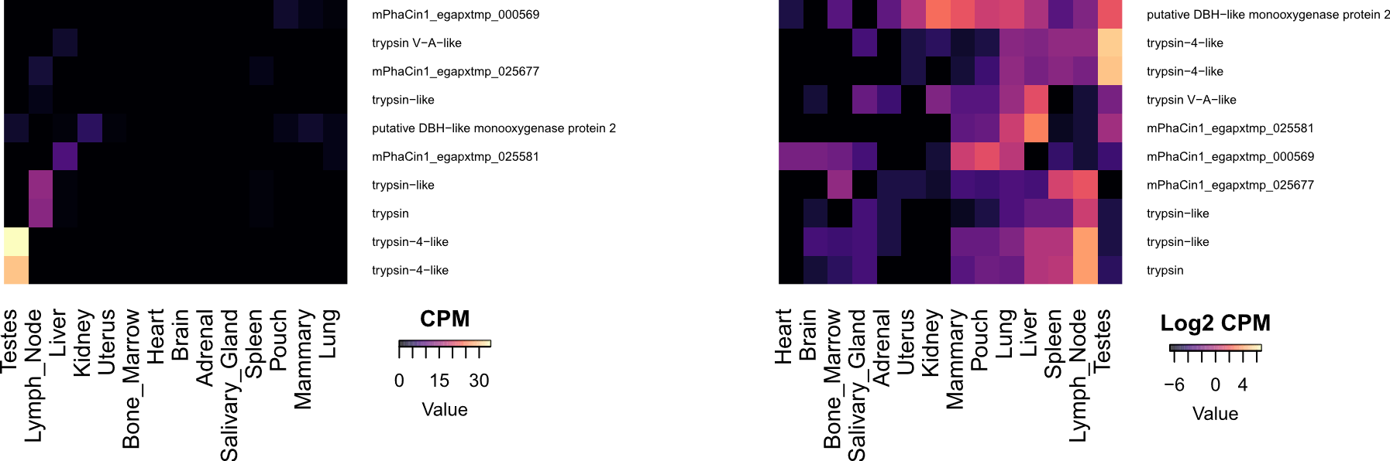
Extended Data Fig. 7: A) CPM B) log2 CPM; of all genes in the rearranged trypsin family locus. Shows all Trypsin-4-like genes are highly specific to the testes, while trypsin and trypsin-like are confined to the lymph nodes. Trypsin-V-A-like is very lowly expressed and most strongly in the liver. CPM, counts per million.

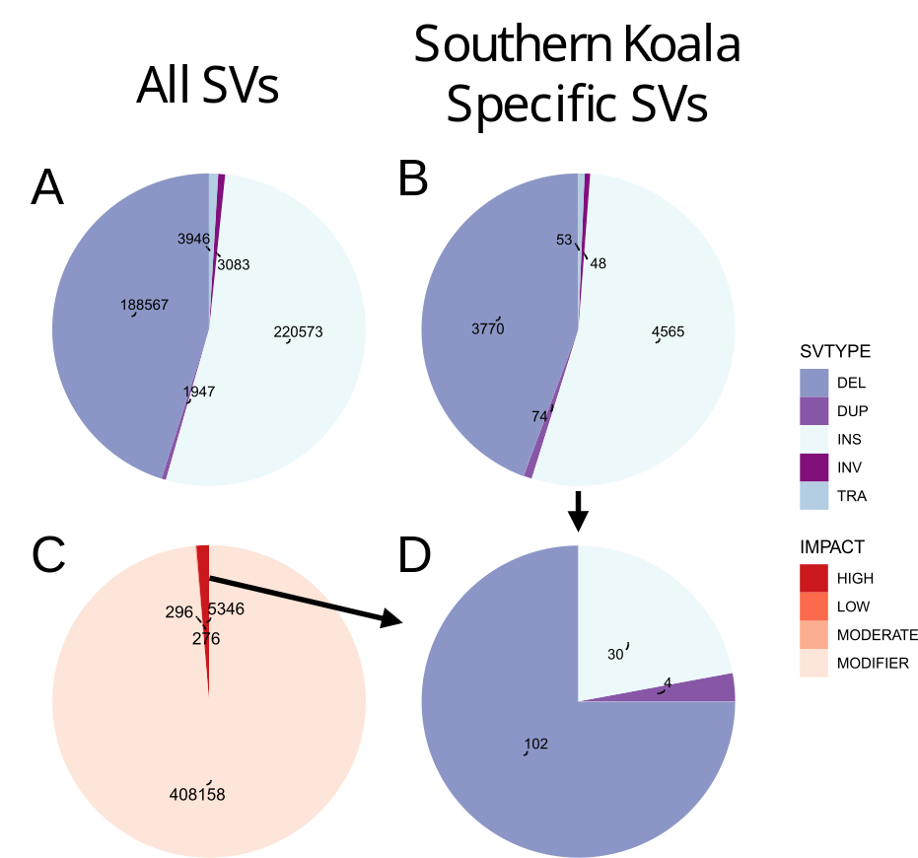
Extended Data Fig. 8: Variant prioritization for kidney disease variant discovery. Pie chart descriptions from top to bottom and left to right: A) SV type for all VEP predictions in SVIM-asm and cuteSV. B) SV types of VEP predictions for southern koala specific SVs. C) Predicted SV impact for all SVs in SVIM-asm or cuteSV (bottom left). D) Final set of southern koala specific SVs where impact was not MODIFIER were investigated for possible links to kidney disease. SV impact was determined with variant effect predictor (VEP). Note, a single variant will be counted multiple times if it has more than one predicted effect and the numbers in this plot are not representative of the total number of variants. Unique SVs from cuteSV or SVIM-asm from the final merged SURVIVOR VCF were used. cuteSV variants were used preferentially as it was fully genotyped. VCF, variant call format.

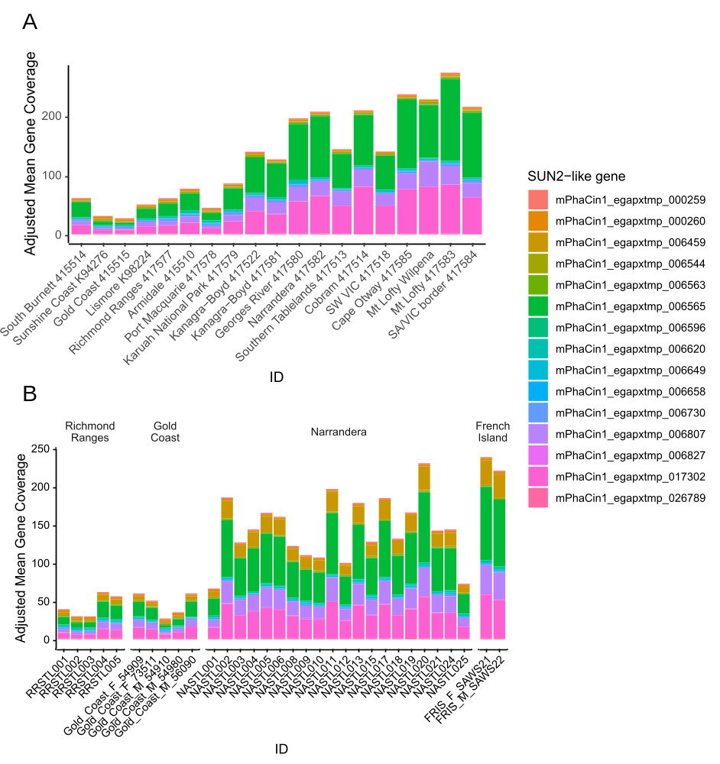
Extended Data Fig. 9: SUN2-like gene coverage-based copy number estimates. A) SUN2-like gene copy number estimates in both long-read organised from north to south B) Short read samples facetted by sampling region highlighting Admixture Narrandera samples are a key region for understanding how copy number variation in SUN2-like genes affect centromere drive and for associating variation in SUN2-like gene copy number with phenotype.
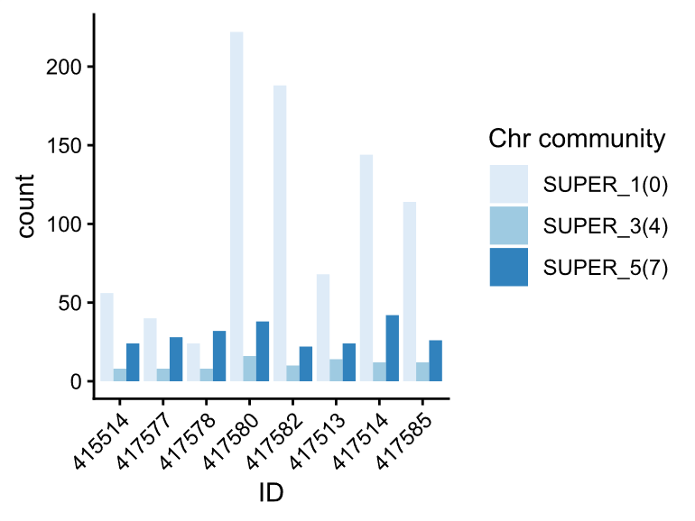
Extended Data Fig. 10: Counts of SUN2-like genes mostly occurred on Chromosome 1 during PGGB clustering. Community number is in brackets.

