Supplementary information for
A koala pangenome reveals hidden structural variation with implications for disease and fertility
Samuel Bagot¹, Elspeth A. McLennan¹, Andrea L. Schraven¹, Angus, Li², Luke W. Silver^{1,3}, Katherine Belov^{1,3} and Carolyn J. Hogg^{1,3}
¹ School of Life & Environmental Sciences, The University of Sydney, Sydney, NSW
² Australian Genome Research Facility, St Lucia, QLD
³ ARC Centre of Excellence in Peptide and Protein Science, The University of Sydney, Sydney, NSW
Contents
Supplementary Figures 4
1 Genomes 7
1.1 Sampling and DNA extraction 7
1.2 Sequencing 7
1.3 Read processing 7
1.3.1 PacBio HiFi read processing 7
1.3.2 ONT and associated short read processing 8
1.3.3 Meryl kmer libraries 8
1.3.4 Alignment of long-reads to mPhaCin1.pri 9
1.4 Genome assembly 9
1.4.1 HiFi Assemblies 9
1.4.2 ONT assemblies 9
1.4.3 Correcting interchromosomal joins and gaps 10
1.4.4 Reference based scaffolding and Y contig identification 11
1.4.5 Mitogenome assemblies 11
1.4.6 Assembly QC 12
1.4.7 GC content analysis 13
1.4.8 Low coverage and unassembled regions 13
1.5 Assembly annotation 13
1.5.1 Repeat Identification 13
1.5.2 EGAPx gene annotation 14
1.5.3 Telomeres 14
1.5.4 Centromeres 14
2 Structural variant call set generation 17
2.1 Liftoff & Pangene 18
2.2 Pangenome Graph Builder (PGGB) 19
2.2.1 Divergence estimation 19
2.2.2 PGGB community identification and assembly 19
2.2.3 PGGB pangenome growth curves and stats 20
2.2.4 PGGB presence absence variants (PAVs) 20
2.3 Minigraph-cactus (MC) 20
2.3.1 Minigraph Cactus Generation 20
2.3.2 Minigraph-cactus VCF stats 21
2.3.3 Read mapping and SV genotyping with Minigraph-cactus 22
2.4 Structural variant calling – assembly based 25
2.4.1 SVIM-asm 25
2.4.2 Assembly based Inversions 26
2.5 Structural variant calling – read to reference based 27
2.6 Merging SV calls from different methods 27
3 XY homology and Y satellite analysis 28
4 Repeats and ERV analysis 30
4.1 Variant Annotation 30
4.1.1 Variant effect prediction 30
4.1.2 Variant repeat annotation 30
4.2 LTR clustering 31
4.3 LTR structural annotation and dating and the PhERV-like retrovirus 32
4.4 Uncalled ERVs, long-read callers are not optimized for shorter AmpliFi reads. 34
5 Population specific SVs 35
5.1 Definition of population specific SVs 35
5.2 Transcriptomics 35
5.3 Kidney disease gene identification 36
5.4 Visualisation of OBSCN and Phci-Cath5 38
5.5 OBSCN protein domains Interproscan 38
5.6 Characterisation of MHC loss 38
5.7 Possibly variants involved in southern coat variation 39
6 SUN2-like genes 41
6.1 Synthesis of SUN2-like results 41
6.2 Coverage based copy number estimation of SUN2-like genes. 41
6.3 SUN2-like function and subtypes 41
References 45

Supplementary Figures
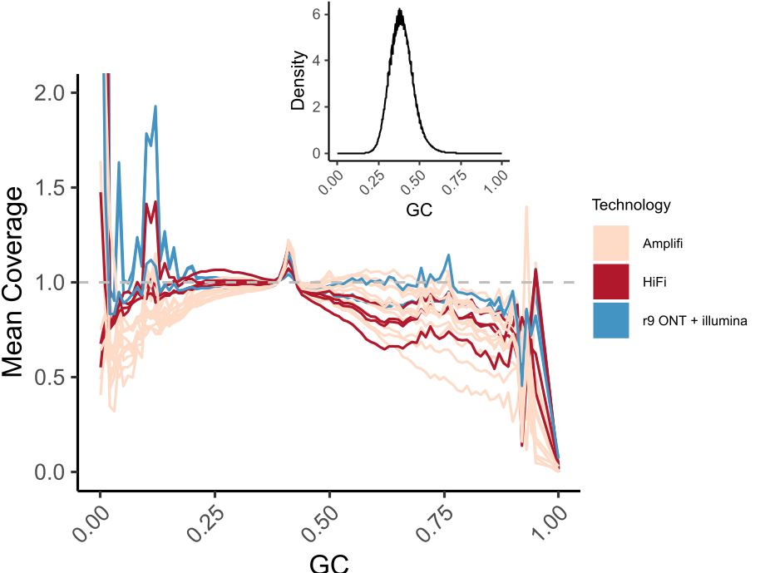
Supplementary Figure 1: AmpliFi reads have relatively minor GC bias when compared to HiFi/ONT. Mean coverage of 200bp sliding windows of mPhaCin1.pri. Window plot – for reference - density plot of GC content in 200bp regions of mPhaCin1.pri shows only tiny fraction of genome is less than 25% or more than 50% GC content.

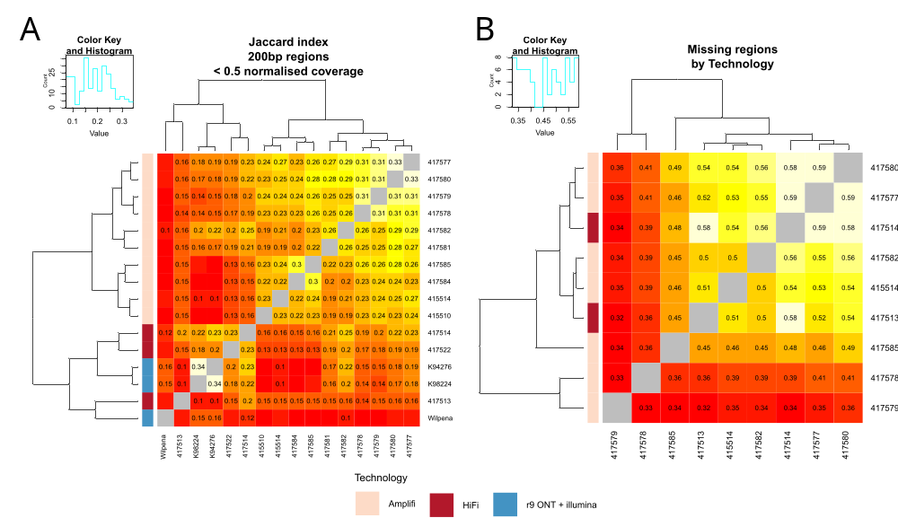
Supplementary Figure 2: Missing and low coverage regions indicate some technology bias exists, but coverage was the major driver of shared missingness in the final assemblies. A) Jaccard indexes of low read depth coverage regions. B) Jaccard indexes of missing regions in assemblies relative to mPhaCin1.pri post purging.

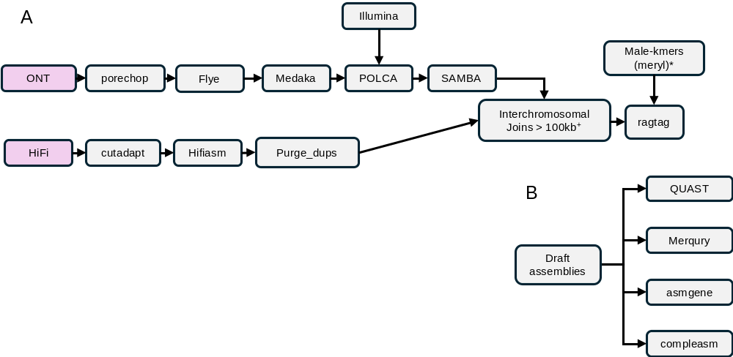
Supplementary Figure 3: A) Overview of genome assembly pipeline for ONT or HiFi reads. Simple overview of methods used to assemble genomes in this paper. ONT R9 assemblies follow methods described by Blanchard et al. ¹. +Manually break joins >100kb. *Male samples contigs containing high male (>40%) were excluded from scaffolding. B) QC methods used to validate and iteratively check genome quality.

Genomes

Sampling and DNA extraction
We obtained whole blood samples in EDTA (N = 2) that were stored at -80ºC, and ear biopsies collected in 80% ethanol and stored at -20ºC (N = 15) from wild koalas (N = 17) sampled between 2/07/2017 and 29/10/2024 (Fig 1A). High molecular weight DNA was extracted from both blood and tissue samples using the Nanobind PanDNA extraction kit (Pacific Biosciences) following the whole blood and animal tissue protocols, respectively. DNA concentration was quantified using a Qubit fluorometer 4.0 with the Qubit dsDNA BR assay kit (Thermo Fisher Scientific). All samples were held under NSW Scientific Licence (SL101204) at the University of Sydney. All samples used in this paper were assigned to a broad genetic ‘cluster’ based on known population differentiation and geographical barriers to gene flow, namely the Brisbane River, Clarence Valley, and the Hunter Valley ². Sampling locations were visualised with R v4.4.2 ³ using ggplot2 v4.0.3 ⁴ and ozmaps v0.4.5 ⁵.

Sequencing
Pacific Biosciences (PacBio) high fidelity (HiFi) Circular Consensus Sequencing (CCS) reads were generated from all koala DNA samples (N = 17). All the following processing and sequencing steps were carried out at the Australian Genomics Research Facility (AGRF). Partially degraded koala DNA samples were subjected to a modified AmpliFi protocol (N = 12). For AmpliFi sequencing, gDNA was first sheared by the Megaruptor 3 system to achieve fragment size of approximately 11kb. Eight to ten cycles of PCR were performed with TWIST Universal adaptor (TWIST - 101308) and KOD Xtreme™ Hot Start DNA polymerase (Sigma - 71975-M). Samples then underwent size selection of 8.5kb via Pippin HT to eliminate short DNA fragments. Standard PacBio Hi-Fi protocol was then carried out for all samples (N = 17), consisting of end repair, adaptor ligation, nuclease treatment, along with annealing, binding, and cleanup (ABC). Samples were then sequenced with two samples per SPRQ SMRT Cell. One HiFi sample (417521) achieved 0.43X sequencing coverage and was not used in downstream variant calling due to low coverage.

Read processing

PacBio HiFi read processing
HiFi and AmpliFi reads were processed to remove residual adapters. If a sample was sequenced across multiple runs, the resulting BAM files were merged using samtools v1.22 sort and samtools v1.22 merge ⁶. HiFi and AmpliFi BAM files were converted to FASTQ files using samtools v1.22 ⁶. As AmpliFi libraries contained reads with Illumina TruSeq Sequencing Primers libraries were first trimmed using cutadapt v5.1 ⁷ (parameters: -e 4 -O 8 --times 10). TruSeq Sequencing Primers were found in 0.2%-24% of reads per library (Supplementary Table 11). For all trimmed AmpliFi and HiFi libraries, cutadapt v5.1 was used to remove any remaining reads containing PacBio SMRTbell adapters or TruSeq Sequencing Primers (parameters: -b AAAAAAAAAAAAAAAAAATTAACGGAGGAGGAGGA;min_overlap=34 -b " ATCTCTCTCTTTTCCTCCTCCTCCGTTGTTGTTGTTGAGAGAGAT;min_overlap=44" , -b Tru-seq;min_overlap=30 --discard-trimmed --revcomp). Between 0%-0.5% of reads still contained TruSeq Sequencing Primers or PacBio SMRTbell adapters and were discarded (Supplementary Table 12). Final read QC was run with FastQC v0.12.1 ⁸ to ensure no overrepresented sequence remained.

ONT and associated short read processing
Oxford Nanopore Technologies (ONT) fast5 files were obtained from the authors of Yu, et al. ⁹ (N = 2). These ONT data were previously generated with the Ligation PromethION Kit (Oxford Nanopore Technologies; SQK-LSK109). To generate FASTQ files, fast5 files were first were converted to pod5 format using the pod5 v0.3.28 package ¹⁰ in python v3.12 ¹¹ and base-called using dorado v0.9.5 basecaller ¹² (parameters: sup@v3.3,5mCG_5hmCG). ONT R9 FASTQ reads were also obtained from Blanchard, et al. ¹ (NCBI accession: SRR21496350) (N = 1). ONT R9 FASTQ files were adapter trimmed, filtered and split with porechop v0.2.4 ¹³. ONT adapters were trimmed from 82%-87% of reads with porechop (Supplementary Table 13).
To polish ONT assemblies, we obtained Illumina or Beijing Genomics Institute (BGI-seq) paired end short reads for each of these three samples from NCBI accessions: K94276 (SRR30590027), K98224 (SRR30590019, SRR30590020, SRR30590021), Wilpena (SRR21496351). Paired end short reads were processed with fastp v1.0.1 ¹⁴ using prespecified adapter sequences for each technology (parameters: -q30).

Meryl kmer libraries
Kmers were used to evaluate completeness of all assemblies and generate male-specific kmer profiles. Kmers were generated for each sample using meryl v1.4.1 ¹⁵ (parameters: k=31). Trimmed and filtered reads were used for HiFi and AmpliFi sequenced samples, whereas trimmed and filtered Illumina or BGI-seq data were used for ONT assemblies due to higher Phred Quality Scores. Kmer profiles were generated for each sex by using intersect-sum of all samples with >10X genome coverage (N = 16). Male specific kmers were identified as those present in the male-intersect set (N = 10) but absent from the female-intersect set (N = 6). The proportion of male-specific kmers in each contig of all primary and haplotype-phased assemblies was then determined using meryl-lookup v1.4.1.

Alignment of long-reads to mPhaCin1.pri
Filtered long-reads were aligned to mPhaCin1.pri using winnowmap2 v2.03 ¹⁶ with repetitive kmers (parameters: -W and -ax map-ont (ONT) or -ax map-pb (HiFi/AmpliFi)). Repetitive kmers were generated with meryl v1.0 count (parameters: k=15) and meryl v1.0 print (parameters: greater-than distinct=0.9998). The output BAM files were sorted and indexed with samtools v1.22. To estimate genome coverage and quantify mean and maximum read length, we used samtools v1.22 stat and flagstat. Genome depth of coverage was estimated as total length from samtools v1.22 stats divided by 3.5Gb based on previous maximum genome size estimates ¹⁷(Supplementary Table 14). Maximum read length ranged from 312kb to 691kb for ONT, 45kb to 63kb for HiFi, and 15kb to 45kb for AmpliFi libraries (Fig 1B). Mean read length for each library ranged from 10kb to 24kb (mean = 15kb) for ONT, 10kb to 17kb for HiFi (mean = 14kb), and 2.5kb to 10kb for AmpliFi libraries (mean = 8.6kb).

Genome assembly

HiFi Assemblies
For samples sequenced with PacBio HiFi reads and >13x coverage (N = 9), we used hifiasm v0.25.0-r726 ¹⁸ (parameters: --telo-m CCCTAA) to generate primary assemblies and partially phased haplotype assemblies.
Assembly QC (see section 1.4.5) found high levels of duplication in both primary and diploid assemblies. Genes marked as duplicated in haplotype one were significantly enriched for being missing genes in haplotype two, suggesting incomplete phasing (Supplementary Table 16). Assemblies were purged using purge_dups v1.2.5 ¹⁹ with a slight modification to the default pipeline. Firstly, reads were aligned with minimap2 v2.28²⁰ with automated read depth thresholds generated by purge_dups used for mid and high cutoffs but with low (JUNK) thresholds reduced to two. Diploid assemblies were purged iteratively as follows. Haplotype one was purged with the purged contigs marked ‘HAPLOTIG’ added to haplotype two. Haplotype two was then subsequently purged and contigs marked ‘HAPLOTIG’ originating from haplotype two (excluding purged sequence from haplotype one) and then added back to haplotype one. Haplotype one was then purged again and all other purged contigs from both assemblies were discarded. After purging, all assemblies had minimal overlap between the homozygous and repeat peaks in merqury plots and less than 1% of single copy orthrogroups were identified as duplicated by compleasm.

ONT assemblies
We generated primary assemblies for ONT samples K94276 and K98224 with similar methods to those described in Blanchard, et al. ¹ to allow for technology dependent comparisons of structural variants. Wilpena ¹ was also reassembled using recalled fast5 files obtained from the authors, but we found it did not improve the existing assembly and elected to use the existing assembly for backwards compatibility. For K94276 and K98224, we used flye v2.9.6 ²¹ to assemble a draft primary assembly from filtered ONT reads (parameters: --nano-hq , --genome-size 3.5g, --keep-haplotypes, --read-error 0.05, and one iteration of polishing). Assemblies were then polished with medaka_concensus from medaka v 2.1.1²², autodetecting the appropriate polishing model. Medaka polished assemblies were then polished and scaffolded using the MaSuRCA v4.1.4 ²³ package as follows: POLCA ²⁴ was used to polish the assemblies with filtered Illumina reads as input, and SAMBA ²⁵ was used to scaffold these assemblies with filtered ONT reads as input.

Correcting interchromosomal joins and gaps
We investigated potential interchromosomal misjoins (>100kb) in our primary and haplotype-phased assembles. We first generated assembly to mPhaCin1.pri alignments in paf format using minigraph v0.21-r606 ²⁶ (parameters: -cxasm). We then identified potential interchromosomal misjoins using paftools.js misjoin (parameters: -l 100k) from minimap2 v2.29-r1283 ²⁷. Potential misjoins were then further investigated using a custom Rscript.
We converted misjoin output to a GRanges object from GenomicRanges v1.58.0 ²⁸, and then retained only joins between reference chromosomes. We identified a total of 71 potential interchromosomal joins. All AmpliFi assemblies, K94276, and one >13X coverage HiFi sample (417513), contained at least one interchromosomal join >100kb that were not found in any other assembly. We did not observe any private interchromosomal joins in the highest coverage HiFi (19X) or ONT flye assemblies prior to SAMBA indicating most of these joins were likely to be erroneous (Supplementary Table 2). For each contig, we extracted the gap regions between chromosomal alignments and found 32 contained gaps between 6,000bp and 9,000bp corresponding to known ERV sized insertions. To detect if these gaps were associated with actively inserting ERVs ²⁹, we used blast hits against a database of KoRV, PhERV, and Phac-B sequences and found either KoRV (N = 29), or Phac-β (N = 3) matched to all 32 gaps. The majority of ERV induced joins were in lower coverage midcoastal AmpliFi samples 417578 (N = 13) and 417579 (N = 9). All interchromosomal joins with retrovirus-associated insertions were split to include the unaligned region (containing the retrovirus-associated insertion) at the end of both contigs. We did not definitively rule out if these are real joins and further investigation may determine active retroviruses are truly causing interchromosomal joins.
For the remaining joins (N = 39), if a reference breakpoint (chromosome and start or end) was present in multiple samples the join was considered real (N = 19). This left 20 joins that were not present in multiple samples. One interchromosomal misjoin was introduced by SAMBA in K94276, this scaffold was discarded and replaced with the corresponding pre-SAMBA contigs. For the remaining 19 interchromosomal joins, if the reference chromosome alignments overlapped at the interchromosomal join, the misjoin was likely due to sequence similarity between chromosomes and the contigs were broken at the alignment ends, keeping overlaps. If there was a gap between the alignments to the reference chromosomes, reads were manually inspected in the hifiasm assembly GFA file to check if any reads spanned the gaps. When reads did not span a gap the interchromosomal join was broken with the ambiguous region retained at the ends of both contigs. All remaining 19 interchromosomal joins were broken.

Reference based scaffolding and Y contig identification
To orient and order contigs, haplotype and primary assemblies were scaffolded using ragtag v2.1.0--pyhb7b1952_0 ³⁰ against the koala reference genome (mPhaCin1.pri)¹⁷. As the reference genome was generated with CCL PacBio reads and may contain errors (approximately 15% read error rate) and some regions in the newly generated genomes are more accurately assembled, we used stricter than default settings for ragtag, including a minimum grouping confidence score (-i) of 0.9, a minimum mapq of 30, and scaffolding was restricted to chromosomal scaffolds in mPhaCin1.pri. To limit spurious scaffolding due to the missing Y chr in mPhaCin1.pri, contigs with >40% male-specific kmers in male assemblies, were considered putative Y contigs and not considered for scaffolding. Scaffolding improved the completeness and contiguity of assemblies, allowing for improved interpretability in pangenome software and reducing the number of walks in the final graph (Supplementary Table 3).
We found read depth was generally misleading when identifying potential Y contigs (data not shown) because the marsupial Y chromosome is extremely small and repetitive. The marsupial Y chromosome was previously estimated to be 10Mb in dunnarts ^{31,32} and is 14Mb in the tammar wallaby (Notamacropus eugenii) assembly (GCF_028372415.2)³³. We found that scaffolds with more than 40% of male-specific kmers totalled between 7-8.5Mb of sequence in ONT R9 male assemblies and 10-16Mb in HiFi/AmpliFi partially-phased haplotype assemblies, with 417580 having the greatest putative Y contig length. To validate potential Y contigs, we used blastn v2.16.0 ³⁴ to search for known marsupial Y chromosome genes in our assemblies (SRY (Genbank accession: S69429.1)³⁵, Ube1y (Genbank accession: X68940.1, Z29668.1)³⁶, KDM5D (NCBI accession: GATO01000006.1) and opossum/wallaby Y chromosome sequences ³⁷. We filtered to retain blast matches with higher quality in males than females (max bitscore male > (max bitscore female + 50)), to confirm that Y contigs were selected by the male specific kmer threshold.

Mitogenome assemblies
We assembled mitogenomes for all samples using mitoHiFi v3.2.1 ³⁸, using the koala reference mitogenome (NC_008133.1). For samples sequenced with PacBio HiFi, we used adapter filtered reads as input. For samples K94276 and K98224 sequenced with ONT, we used contigs from the flye assemblies polished with POLCA, prior to SAMBA scaffolding. Finally, for Wilpena we used contigs from the NCBI genome as input. We found mitogenomes frequently had a circular consensus length of 18kb, approximately 1.6kb larger than the reference mitogenome. We set the max-read-len parameter to 1.1X to ensure the reads identified by mitoHiFi were no longer than the estimated circular mitogenome size of 18kb. Mitogenomes were annotated using the Vertebrate Mitochondrial Code.
Two mitogenomes (417513 and 415510) were 35kb and appeared to be duplicated around an extended tandem repeat of (TTTATAATAA)n and (TAAAGTAT)n. This repeat occurred at the end and in the middle of both assemblies. The sequence was manually split in half based on flanking sequences starting with “GTTAATGTAGCTTATTTATAAAG” and ending with “AAAAAATCTATTTATCCCT”. The first copy of each was discarded as the mitoHiFi annotation more accurately annotated the second copy of the mitogenome. Sample 417521 was excluded here due to low sequencing depth and poor mitogenome assembly.

Assembly QC
Assemblies were quality checked for completeness and accuracy using QUAST v5.3.0 ³⁹, asmgene from minimap2 v2.29-r1283 ²⁷, compleasm v0.2.7 ⁴⁰ and MERQURY v1.3 ¹⁵ as described below. Contiguity completeness and correctness were evaluated using QUAST with flags for large, eukaryote, fragmented, and reference mode with gff features from mPhaCin1.pri. Assembly Nx contiguity plots for pre-ragtag scaffolded assemblies were generated by first indexing assemblies with samtools v1.22 faidx and then visualized in R with ggplot2 v4.0.3 ⁴.Primary genome size appeared relatively stable for all technologies, prior to RagTag size genome size ranged from 3.2-3.3Gb. Asmgene was used to assess correctness and completeness by quantifying the number the number of known koala cDNAs and any duplications in each assembly. Asmgene compares splice-aware mapping of cDNAs between a reference and a target assembly. Paf mappings of cDNAs were generated with minimap2 v2.28 (parameters: -cx splice.hq) using transcripts from mPhaCin1.pri’s gene annotation. Finally paftools.js asmgene from minimap2 v2.29-r1283 was run using k8 v0.2.4 ²⁷. Compleasm was run to assess completeness of single copy othrogroups using the odb12 mammalian lineage. Scaffolded primary assemblies had between 97.35-98.22% single copy orthogroups (compleasm) (Supplementary Table 3). QVs and completeness metrics were calculated with MERQURY in diploid mode using the previously generated meryl database. AmpliFi and HiFi partially phased haplotype assemblies had merqury kmer completeness ranging 88.9-96.4% with combined haplotype completeness ranging from 99.2-99.7%. ONT primary assemblies kmer completenesss was slightly lower and ranged from 95.1-97.5%. HiFi and AmpliFi assembly QVs ranged from 58.1-62.0, ONT assembly QVs ranged from 41.3-43.5. Detailed QC from QUAST³⁹, compleasm⁴⁰, and MERQURY¹⁵ are available for all assemblies, scaffolded and unscaffolded (Supplementary Table 3-6).

GC content analysis
We assessed GC bias of reads mapped to mPhaCin1.pri with winnowmap2 v2.03 ¹⁶ (see section 1.3.4). Bedtools makewindows v2.31.0⁴¹ was used to generate 200bp windows sliding by 100bp and bedtools nuc was used to calculate GC percent in these windows. Mosdepth v0.3.9 ⁴² was run to calculate the mean read depth in each 200bp window. GC bias and read depth bias show there is some minor GC bias attributable to AmpliFi when compared to HiFi/ONT (Supplementary Figure 1).

Low coverage and unassembled regions
To detect sequencing bias, Jaccard indexes were calculated between regions of low sequencing coverage as well as missing regions in each purged AmpliFi/HiFi primary assembly, relative to mPhaCin1.pri. We defined low coverage regions as 200bp regions with coverage < 50% of the mean coverage for that sample. To identify assembled regions for each assembly we used paf alignments between each assembly and mPhaCin1.pri and processed as per GitHub (lh3/minimap2 Issue #1046), removing short and low-quality alignments with `awk '/tp:A:[PI]/&&$11>=10000'. The resulting BED files contained alignments to mPhaCin1.pri which we then inverted with bedtools v2.31.0 subtract to obtain regions of mPhaCin1.pri missing from each assembly. heatmap.2 from the R package gplots v3.2.0 ⁴³ was then used to visualize and cluster each set of Jaccard indexes.
Low coverage (>50% mean coverage) regions in samples >10X coverage make up a small percentage of the genome (2-10%) but clearly segregated by technology (Supplementary Figure 2A). Coverage is the strongest indicator of shared missingness between assemblies (Supplementary Figure 2B). Mapping bias may be due to the minor PCR bias introduced by AmpliFi or shorter read length, its likely these factors lower the contiguity of AmpliFi assemblies.

Assembly annotation

Repeat Identification
To identify newly resolved repeats in the HiFi assemblies we generated a de novo repeat library using the primary assembly of 417514, the male HiFi individual with the highest contiguity, with RepeatModeller v2.0.4 ⁴⁴. As this individual is from Victoria (VIC), and did not contain full length KoRV insertions, we also added the KoRV LTR and protein coding regions from the curated mammalian repeat database, RepBase v28.01 ⁴⁵ to the RepeatModeller FASTA.
To estimate background genomic levels of each repeat type and mask 417514’s scaffolded primary assembly we ran RepeatMasker v4.1.5 ⁴⁶, with NCBI/RMBLAST v2.13.0 and the de novo repeat library from 417514 (without KoRV annotations). Of 417514’s 3.3Gb of DNA sequence, 52.51% was masked as repetitive DNA by RepeatMasker.
We identified segmental duplications in 417514’s primary with biser v1.4 ⁴⁷ using (parameters: --max-chromosome-size 757892679 --keep-contigs).

EGAPx gene annotation
We annotated genes in 417514.p with the publicly accessible version of the updated National Center for Biotechnology Information (NCBI) Eukaryotic Genome Annotation Pipeline, EGAPx v0.5.2 ⁴⁸, using short RNA-seq data from four studies ^{9,17,49,50}. NCBI accessions: ERR2014780.1, SRR30589449.1, SRX501344.1, SRR1106690.1, SRR1121764.1, SRR1122141.1, SRR1207973.1, SRR1207974.1, SRR1207975.1, SRR1205222.1, SRX501342.2, SRX501320.1, SRX1881580.1, SRX501302.1. The EGAPx pipeline annotated a total of 26,416 genes with 97.9% (N = 9226) BUSCO completeness v5.7.1⁵¹ indicating a highly complete annotation.

Telomeres
Contigs from haplotype assemblies and ONT-flye assembly primaries were checked for internal telomeres before and after scaffolding using tandem repeat finder (trf) v4.09.1 ⁵² (parameters: 2 7 7 80 10 500 6 -l 10 -d -h) using scripts from ausargs Patel et al. ⁵³ find_telomeres.sh and processtrftelo.py.
Internal telomeres were not present in haplotype-phased assemblies or ONT primary assemblies prior to scaffolding (Supplementary Table 17). However, ragtag scaffolding introduced a substantial number of internal telomeres within 2Mb of the chromosome ends, which is likely the result of mis scaffolding due to real inversions. Interestingly, one telomere was scaffolded 218Mb from the start of Chromosome 1 of 417578’s (from Port Macquarie) haplotype one assembly, 100kb from SUN1 and proximal to the proposed neocentromere (see main text). We yet to determine if this is misidentified interstitial telomeric DNA, a misjoin with a telomere, or a real chromosomal breakage. Thus, further exploration and cytogenetic validation is required.

Centromeres

CENP-A and CREST alignments
To identify active centromere regions, we aligned CREST and CENP-A (NCBI accession: SRX3327279) from Johnson et al. 2018 ¹⁷ to 417514’s scaffolded primary assembly. CENP-A was a custom Meu anti-CenpA (rabbit) and CREST was human anti-centromere protein IgG (Antibodies incorporated). Input DNA from this accession was used as the control for peak calling. CREST, CENP-A and DNA control reads were first trimmed with fastp v0.20 in paired mode. We then aligned each chromatin immunoprecipitation (ChIP)-seq data set to 417514’s scaffolded primary assembly using bwa-mem2 mem v2.2.1⁵⁴ with minimum seed length 50 (-k) and increased the number of maximal exact matches (MEMs) to 1000000 (-c), following methods to align CENP-A to highly complete reference genomes described in Altemose et al. ⁵⁵. Alignments were then sorted and indexed with samtools v1.22 before being filtered with samtools v1.22 view -b -F 2308 to exclude unmapped, supplementary and secondary alignments. MACS3 v3.0.3⁵⁶ was used to call broad and gapped peaks for CREST and CENP-A, with broad cutoff set to 0.01 and FDR (-q) set to 0.01 (Supplementary Table 7 and 8).

TRASH
Centromeric repeat units were identified using TRASH ⁵⁷ following methods from Patel et al.⁵³, (parameters: --N.max.div set to 5). The initial centromere repeat identification was done using the primary assembly of 417514. This identified a peak of tandemly repeating DNA at length 200bp and a smaller peak at 186bp. We extracted two repeat units at 200bp and named them CEN200_1, CEN200_2, as well as a single repeat at 186bp which we initially named CEN186. TRASH was then run on all scaffolded primary assemblies, and 417580’s haplotype assemblies using these repeats and the telomere repeat (TTAGGG) through the --seqtk parameter. Additionally, to identify higher order arrays (HORs), TRASH’s HOR module was run on 417514 using the more common CEN200, CEN200_1. CEN186 was almost exclusively located on putative Y contigs 417514#p#ptg000682l_1 and 417514#p#ptg000124l_1 (Supplementary Table 9) and CEN186 was further investigated as a Y specific macrosatellite in section 3. More than half of all CENP-A peaks (667/1070) overlapped with CEN200_1 or CEN200_2. To test the enrichment of CENP-A peaks within the CEN200 satellites we first generated a null distribution by randomly shuffling CENP-A gapped peaks 10,000 times with bedtools v2.31.0 shuffle ⁴¹ and intersected them with a BED file of CEN200 regions from TRASH using bedtools v2.31.0 intersect. Overlaps between non-permutated CENP-A gapped peaks and CEN200 regions had a 27.7-fold enrichment over the mean of the null distribution (mean observed intersects = 24, standard deviation (SD) = 4.8, one-sided empirical p-value ≤ 0.0001) confirming that CEN200 is the koala’s main centromere satellite.
We determined that koala centromere satellites are significantly larger than previous reported ¹⁷ and may be the largest mammalian centromeres reported to date. CEN200 accounted for 74Mb of 417514’s primary assembly and found three separate CEN200 repeat regions spanning at least 11Mb that were colocalised with CENP-A and CREST ChIP-seq peaks (Supplementary Table 9). Higher order arrays (HORs) were also found within the koala’s centromeres contrary to prior reports. We examined the HOR blocks in 417514#p#ptg000361l_1 which contained more than 6Mb of CEN200 repeats over 10Mb of sequence. Zones of recent HOR expansion and high identity HOR blocks can (but do not always) indicate the active centromere region ⁵⁵. All but one (86/87) identical HOR block on contig 417514#p#ptg000361l_1 occurred in a 365kb region between 9502622 and 9867589bp and had a block size of four units that had lower identity to the remaining CEN200 block (Supplementary Figure 4). This may indicate an alternate centromere variant is becoming dominate in this centromere region. Further work is required to understand the periodicity of all centromere blocks. Accurately identifying the active subregion will likely require CENP-A from a matched, or more closely related, individual.
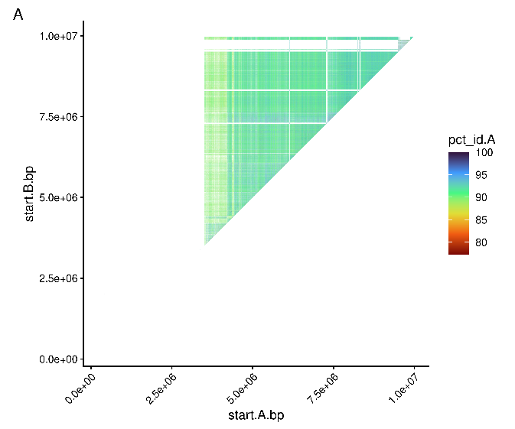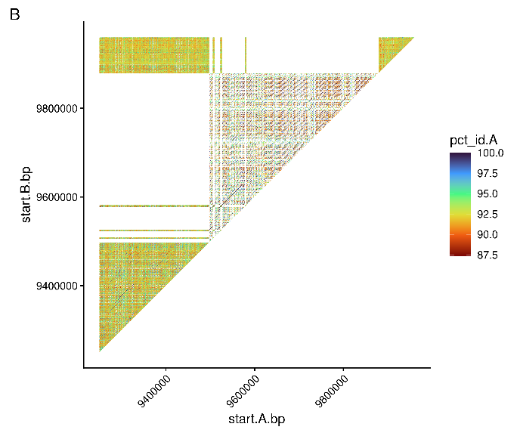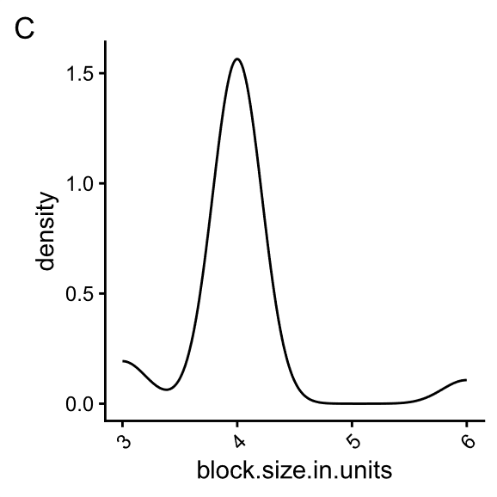

Supplementary Figure 4: Recent HOR expansion in centromere satellite in contig 417514#p#ptg000361l_1 A) Identity of blocks in 417514's primary contig ptg000361l_1. B) Restricted region of identical blocks in ptg000361l_1 had low identity to the remaining CEN200 sequences. C) Density distribution of identical repeat units of CEN200_1 (N = 87) have a peak at four units in ptg000361l_1.
Two centromere satellites (12.7Mb and 11.6Mb wide) containing active regions (CENP-A peaks) were assigned to 417514’s primary assembly during ragtag scaffolding, we suspected the centromere at the end of chromosome one to be erroneous scaffolding (Supplementary Figure 5). To test this, we ran the Vertebrate Genome Project (VGP) workflow for Hi-C scaffolding with YAHS v1.2a.2 ^{58,59} on 417514’s primary assembly using 2x150 bp paired-end Dovetail High-throughput chromosome conformation capture (Hi-C) reads from the reference individual Bilbo (mPhaCin1.pri ) ⁶⁰ NCBI accession: SRX9630632. We then ran minigraph v0.21-r606 ²⁶ (parameters: -cxasm) to align these two assemblies and found this region was no longer scaffolded to a chromosome. Until a T2T genome is available we consider it likely this is a centromere from another chromosome.
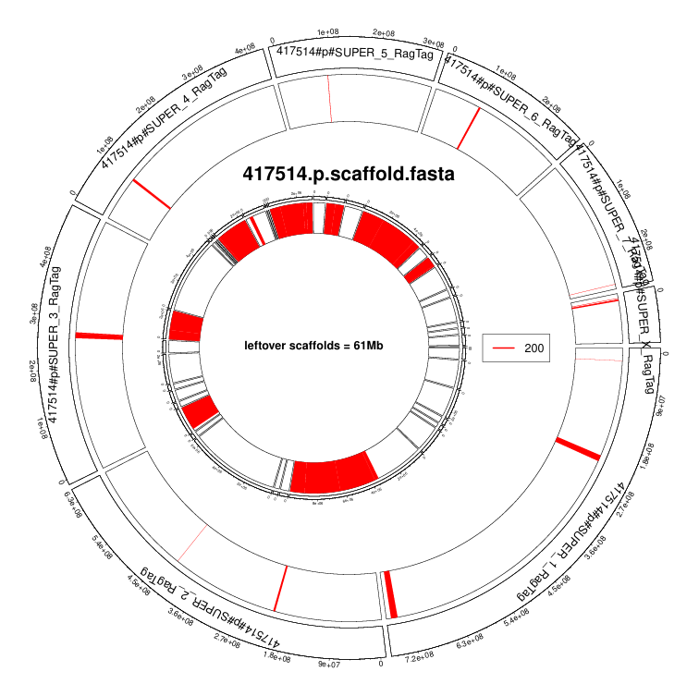
Supplementary Figure 5: CEN200 location in 417514’s primary assembly including a second, likely erroneous, centromere at end of Chromosome 1

Structural variant call set generation
The below describes in detail the methods used to identify SVs across long read assemblies. We annotated all assemblies using liftoff and pangene to identify gene-level copy number variation (CNV) and presence absence variants (PAV). We use reference free Pangenome Graph Builder (PGGB) to allow reference free analysis of genome-to-genome alignments, presence absence variants (PAV), and visualise complex loci. Reference backbone method Minigraph-Cactus (MC) was used to genotype SVs. To understand the composition of newly integrated sequence, we used assembly-to-assembly SV caller SVIM-asm as our main assembly-based SV caller. Inversion calling remains unreliable, particularly with fragmented genome assemblies, so we also used minigraph and SyRI, to generate a set of non-redundant high-quality inversions and detect more inversions as per previous research^{61,62}. We utilised read to reference variant calling method cuteSV to call and genotyping additional variants from the unassembled individuals, SVIM and sniffles2 were also employed to generate a non-redundant high-quality set of SVs detected by multiple methods as per previous research ⁶³⁻⁶⁵ and test if any of these methods could reliably detect ERVs for AmpliFi samples.

Liftoff & Pangene
We used liftoff v1.6.3 ⁶⁶ to liftover genes annotated in mPhaCin1.pri and 417514.p to all other HiFi/AmpliFi assemblies (N = 12 individuals), and evaluate gene-level copy number variations (CNV) and presence absence variants (PAV). Liftoff transfers GFF annotations from a reference assembly to a target genome assembly by aligning gene sequences with minimap2. Liftoff was run on all primary (N = 12 haplotypes) and haplotype (N = 16 haplotypes) assemblies using the GFF generated by EGAPx for mPhaCin1.pri and 417514.p (parameters: -polish -copies -sc 0.90). 652|810 (mPhaCin1.pri|417514.p) discrete gene locus tags were missing or duplicated in at least one primary assembly, noting liftoff annotated additional copies of some genes that were missed in the original assembly by EGAPx (i.e. in mPhaCin1.pri or 417514.p). These variable genes had 402|424 unique descriptions. 109|139 of the variable genes (non-unique) were annotated as olfactory receptors, a gene family known to contain high CNV. The gene with the highest total copy number summed across the 12 primary assemblies mPhaCin1.pri was a SUN2-like gene mPhaCin1_egapxtmp_006459 with 220 copies. This also confirmed the duplication of the chlamydia-inhibiting cathelicidin gene Phci-Cath5 in koalas south of the Hunter Valley ^{67,68} (Fig. 3C).
We used orthofinder v2.5.5 ⁶⁹ to group genes annotated in primary assemblies (N = 13 haplotypes) into orthogroups. To first generate a set of proteins as input for orthofinder, we took the longest isoform for each using agat_sp_keep_longest_isoform.pl from AGAT v1.4 ⁷⁰ and extracted protein FASTA files with gffread v0.12.7 ⁷¹. We identified a total of 18965 and 19245 orthogroups using liftoff generated relative to mPhaCin1.pri and 417514.p.
We also analysed gene level CNVs, and PAVs with pangene v1.1 ⁷² which utilises protein sequences for mapping rather than genomic DNA sequence. The protein FASTA files generated by EGAPx for mPhaCin1.pri and 417514.p were aligned to the primary and haplotype ragtag scaffolded assemblies using miniprot v0.12-r237 ⁷³ (parameters: --outs=0.97 --no-cs -Iu). We then used pangene to generate a GFA file containing scaffolded primaries (N = 13 haplotypes) or scaffolded primaries and haplotype phased assemblies (N = 20 haplotypes) where available. A copy number matrix was extracted from the pangene GFAs with gfa2matrix (parameters: -c). GFA gene bubbles were called with pangene call.

Pangenome Graph Builder (PGGB)
PGGB is an unbiased reference free method of generating pangenome graphs using an all-to-all alignment approach to generate clusters of sequence.

Divergence estimation
PGGB requires an estimate of nucleotide divergence to generate a pangenome graph. Nucleotide divergence between all koala populations is estimated to be <1% ⁷⁴. To estimate an upper bound for nucleotide divergence among koala genomes we ran mash v2.3 ⁷⁵ triangle on all assembled mitogenomes (all samples excluding 417521). All distance estimates between mitogenomes were <1% apart from the reference (NC_008133.1) which had divergence estimates between 1-1.5%. This increased divergence was likely explained by the improved quality of modern assemblies and about 1.5kb of new sequence added in the ne mitogenome assemblies, not true nucleotide divergence.

PGGB community identification and assembly
Ragtag scaffolded HiFi/AmpliFi haplotype assemblies and remaining primary assemblies (excl. 417579 due to low be scaffolding contiguity) were clustered into chromosomal communities using wfmash v0.13.1-0-g042386f0 ⁷⁶ and the PGGB v0.7.2 ⁷⁷ community identification scripts. First, ragtag assemblies were converted to Pangenome Sequence Naming (PanSN) format and merged into a single FASTA file containing all assemblies. To identify communities, we ran wfmash v0.13.1-0-g042386f0 (parameters: -p 99 -m -s 10kb -Y “#” -n 19) followed by paf2net.py, and net2communities.py with --accurate-detection. This resulted in 99% of sequence being placed in communities with chromosomal scaffolds.
Communities containing autosomal chromosomes were partitioned into separate FASTA files using samtools v1.19 faidx and PGGB v0.7.2 was subsequently run on each community with -Y ‘#’-p 99 -s 10000. As 97.3% (by total base pairs) of the 78Mb of putative Y contigs clustered with the X chromosome, we assembled them together as a single sex chromosome community to analyse X/Y homology. Only communities containing chromosomal scaffolds were assembled into the pangenome.
Mitogenomes for assemblies included in the PGGB graph (N = 12 haplotypes) were renamed to PanSN (Pangenome Sequence Naming) format and merged into one FASTA file before running PGGB v0.7.2 with -p 99 and -s 500.

PGGB pangenome growth curves and stats
To estimate the amount of non-reference sequence and total nodes added per sample we used odgi v0.9.0-0-g1895f496 ⁷⁸ and panacus v0.4.1 ⁷⁹. We used odgi squeeze to firstly merge multiple GFA files from assembled communities into a single merged GFA file and then ran odgi stats (parameters: -S) on the merged GFA file to obtain the pangenome graph statistics. To estimate the amount of sequence and nodes added to the PGGB graph, we also generated ordered histogram growth curves with panacus ordered-histgrowth (parameters: -c bp or -c node) with samples ordered by region/cluster placing HiFi/AmpliFi assemblies then ONT assemblies. A BED file of gaps in each haplotype was generated with seqtk gap v1.4 ⁸⁰ and used to exclude all gaps in assemblies from the growth calculation. On average 45.8Mb of sequence was added per assembly to the PGGB graph, adding a total of 504Mb relative to the northernmost individual 415514. ONT R9 assemblies added substantially less sequence than average 31Mb (K94276), 15.4Mb (K98224), and 8.5Mb (Wilpena).

PGGB presence absence variants (PAVs)
We generated PAVs using the PGGB graphs with respect to 417580, the sample with most high confidence Y contig length, and the reference mPhaCin1.pri. We first partitioned all contigs in both 417580 hap1 and hap2 and the mPhaCin1.pri into 1kb windows using bedtools v2.31 ⁴¹ makewindows. Windows for 417580 haplotypes were combined into a single file for the following steps. For each assembled PGGB chromosomal community we extracted all paths in the og graph file with odgi paths -L and grouped them by sample ID. odgi PAV v0.9.0-0-g1895f496 was then run for each PGGB chromosomal community, to output PAVs in matrix format for every sample with respect to the 1kb windows generated for either 417580 or mPhaCin1.pri. We identified 1kb PAVs ranging from 9,154 to 18,250 per individual relative to mPhaCin1.pri and 125,009 and 189,441 compared to 417580’s haplotype assemblies. Compared to mPhaCin1.pri, there was 1Mb of 1kb long PAVs found exclusively in southern koalas. The largest continuous region of southern specific PAVs was a 60kb deletion adjacent to the Immunoglobulin Heavy Chain Variable Region (IGHV) on Chromosome 7. We noted a total of 164kb of PAVs across five continuous regions longer than 10kb in surrounding region. region was poorly scaffolded in mPhaCin1.pri. We also confirmed the loss of a 42kb region overlapping class I MHC UB.

Minigraph-cactus (MC)

Minigraph Cactus Generation
To genotype SVs in short-read genomes, we generated a Minigraph-Cactus (MC) v2.9.7 ⁸¹ pangenome, which relies on a reference assembly to use as a backbone to which all other assemblies are then aligned. We used mPhaCin1.pri as the backbone, and then iteratively added scaffolded partially phased haplotype HiFi and ONT primary assemblies (N = 20 haplotypes) (parameters: --chrom-og --vcf --giraffe --gfa --gbz --viz). Addition order - 417577.1,417577.2,K98224.p,K94276.p,415514.1,415514.2,417578.1,417578.2,417580.1,417580.2,417513.1,417513.2,Wilpena.p,417582.1,417582.2,417514.1,417514.2,417585.1,417585.2. The unfiltered, clipped GBZ graph was indexed with vg v1.72.0 ⁸²⁻⁸⁴ autoindex (parameters: --workflow giraffe --no-guessing). We also generated a primary only MC v3.1.4 graph (N = 13 haplotypes) with mPhaCin1.pri as the backbone (parameters: --chrom-og --vcf --giraffe --gfa --gbz --viz --lrGiraffe). Addition order – reference, 417577.p, K98224.p, 415514.p, K94276.p, 417578.p, 417579.p, 417580.p, 417513.p, 417514.p, Wilpena.p, 417585.p, 417582.p.
The Chromosome X in the MC graphs is likely to be poorly assembled. 1D visualisation of the indicates there are many gaps in haplotype paths that are probably due to poor assembly and scaffolding of mPhaCin1.pri as well as homology with the putative Y chromosome contigs (Supplementary Figure 6). Similarly, when analysing interchromosomal joins we noted a substantial number of intrachromosomal gaps on the X chromosome relative to the reference.
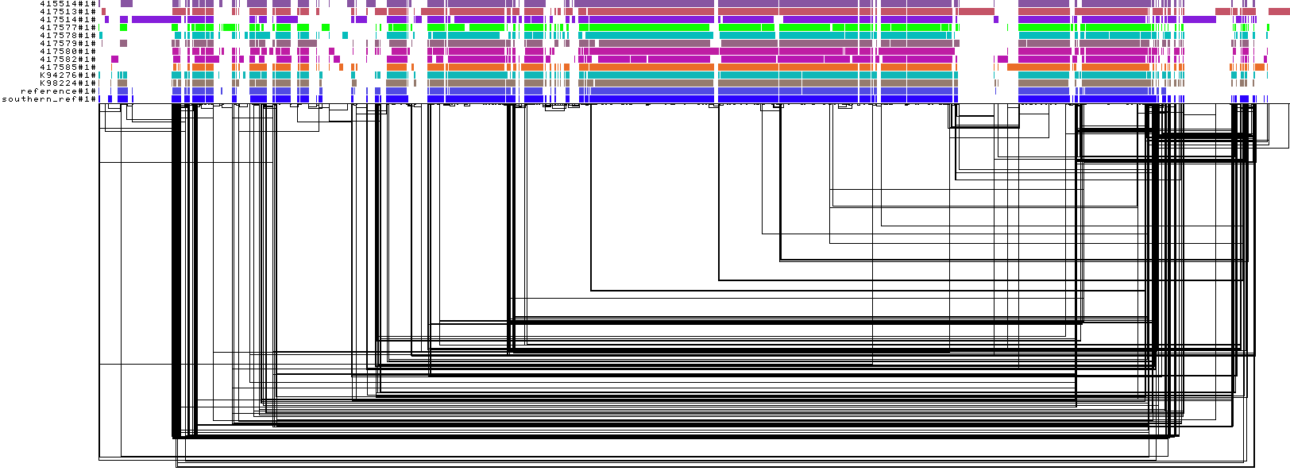
Supplementary Figure 6: 1D visualisation of paths through the X chromosome of the primary only MC graph contain a substantial number of gaps, which may indicate poor quality. Gaps are expected in the lower coverage male samples, but gaps were found across all primary assemblie

Minigraph-cactus VCF stats
VCF statistics were generated with bcftools v1.21⁸⁵ stats on the MC VCF that has gone through vcfbub to remove nested sites, as well as those greater than 100kb and left normalised with bcftools norm. Prior to running bcftools stat the VCF was also normalised to decompose multiallele sites with bcftools norm (parameters: -m -any). The decomposed VCF from the MC graph containing partially-phased haplotypes (N = 20) contained 192,883 SVs (INDELS > 50bp), 8,675,720 INDELS < 50bp, and 18,328,490 SNPs. The decomposed VCF from the MC graph containing only primary assemblies (N = 13) contained 180,014 SVs, 8,251,893 INDELS, and 17,294,956 SNPs.

Read mapping and SV genotyping with Minigraph-cactus
To test graph genotyping, AmpliFi, HiFi and Illumina short reads from two French Island from the koala genome survey McLennan, et al. ² (SAWS21 and SAWS22), were downloaded from “https://koalagenomes.s3.ap-southeast-2.amazonaws.com/index.html” with aws cli v 2.13.9. Paired end reads were aligned to the unfiltered, clipped GBZ file from the MC graph containing haplotype-phased assemblies using vg giraffe v1.72.0 ⁸²⁻⁸⁴. To compare mapping quality between primary only and haplotype containing MC graphs, a subset of samples (415510, 415514, 415515, and 417513) were aligned to the D2 filtered graph of both MC graphs. HiFi reads (N = 17) were aligned with parameters: -b hifi and Illumina short reads (N = 2) were mapped with default parameters. To generate mapping quality statistics, vg stats was run on each GAM alignment file. Variants were called for each sample using the GAM alignment file, vg pack (parameters: -Q 5) and vg call with the precalculated snarls (parameters: -a -z). Individual VCFs were merged with bcftools v1.21 merge (parameters: -m all). The genotyped variant calls from giraffe were also checked for concordance with the calls output by the normalised VCF generated by MC based on assembled genomes with bcftools gtcheck -g.
We found MC graphs generated using haplotype assemblies did not impact the mapping quality of HiFi /AmpliFi reads (N = 4), increased the number of gapless alignments, and decreased total soft clipping bps (Supplementary Figure 7). However, the lower contiguity of haplotype assemblies may impact the variant calling at larger insertion sites. It remains unclear which graph will more accurately genotype variants without further testing of pangenome variant callers and a truth set. Mean mapping quality of HiFi/AmpliFi reads aligned to the MC graph was directly correlated with read length (Spearman's rho (ρ) = 0.93) (Supplementary Figure 8). Mean read length also appears to reduce the total number MAPQ60 reads when vg giraffe mapping is compared to winnowmap.2 mapping from section 1.3.4 (Supplementary Figure 9). It is unclear if this is due to erroneous mapping quality calculation or if the reads shorter are leading to poorer mapping quality with vg giraffe. Illumina short reads from French Island aligned to the MC graph had fewer MAPQ 60 reads when compared to reads mapped to mPhaCin1.pri. For short read French Island samples (SAWS21 & SAWS22) MAPQ 60 reads decreased from 756512031 to 725743678, and 745327367 to 715314235 when aligned to the MC graph compared to mapping against mPhaCin1.pri with bwa-mem2 (alignment methods in section 6.2).
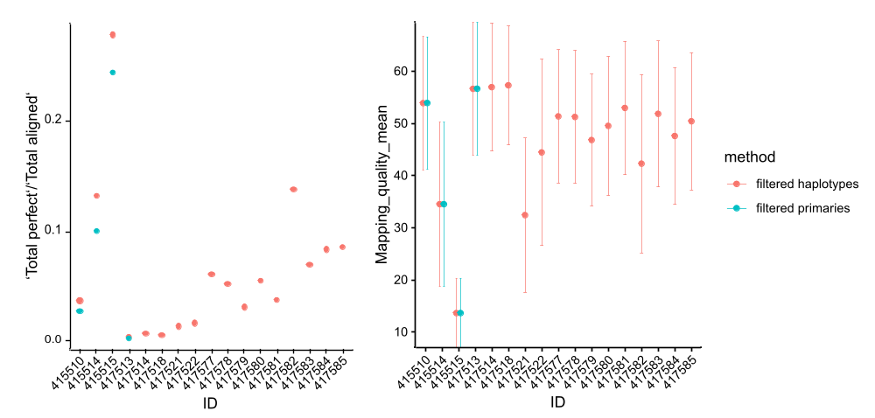
Supplementary Figure 7: A) Minigraph-cactus (MC) graph constructed with haplotype assemblies increase the number of perfect HiFi read alignments in both incorporated and unincorporated samples. Only the first four samples were mapped with both methods. B) Primary vs haplotype MC graphs show no meaningful difference in mean mapping quality (N = 4). Error bars represent one standard deviation.
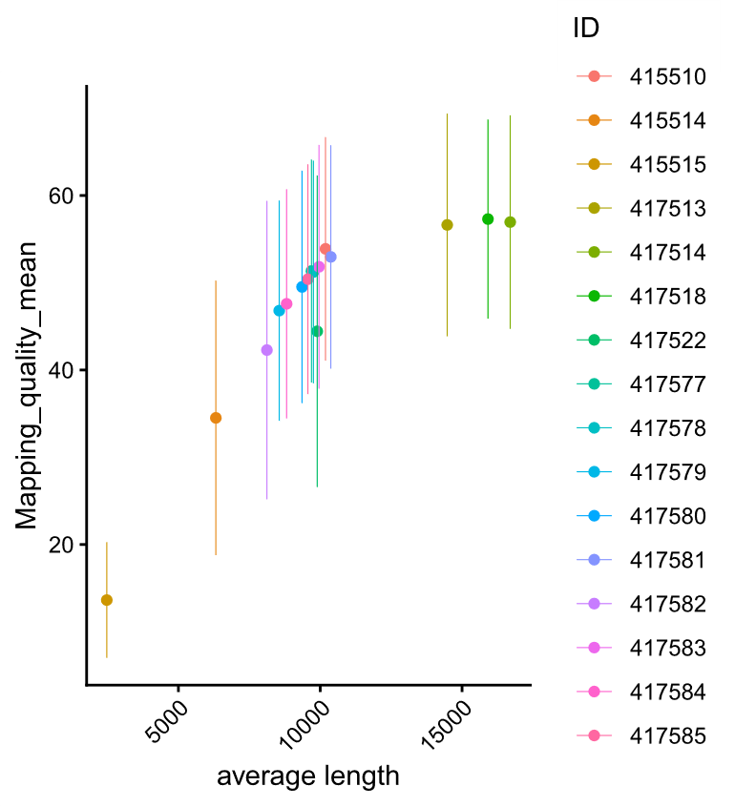
Supplementary Figure 8: Average read length vs mapping quality of HiFi and AmpliFi reads in the filtered haplotypes MC graph shows clear correlation (Spearman's rho (ρ) = 0.93). Error bars represent one standard deviation.
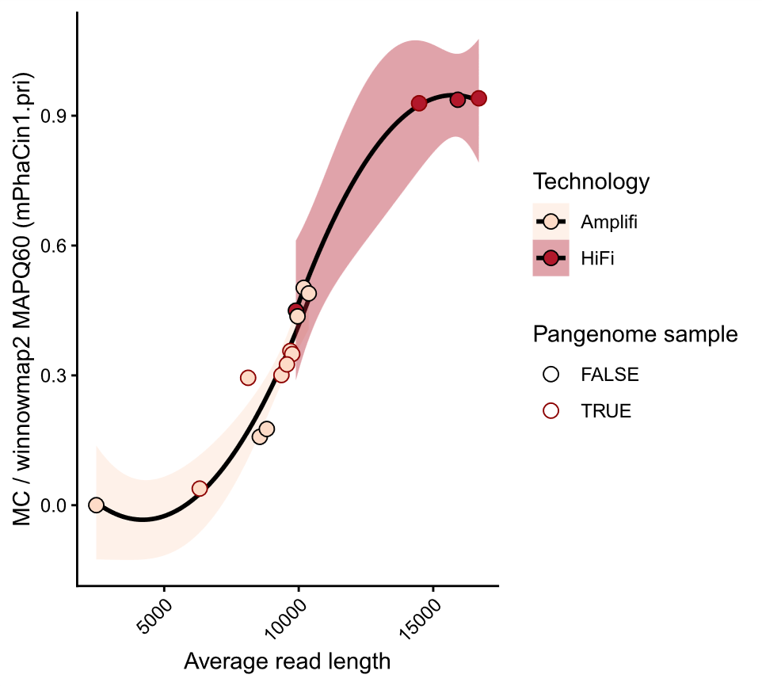
Supplementary Figure 9: The ratio of MAPQ60 reads from vg giraffe and MAPQ60 reads from winnowmap2 appears to follow a sigmoidal relationship with read length, centred around 10kb. It is unclear if mapping quality from vg giraffe is unreliable for shorter long-reads or if vg giraffe cannot reliably align shorter long-reads. Quadratic models were fitted separately for AmpliFi and HiFi with geom_smooth “lm”. Ribbons represent a 95% confidence interval standard error.
Unsurprisingly we found VCFs generated by read mapping to the MC graph had highly concordant genotyping when compared to the VCF generated during the construction of the MC graph for those same samples (Supplementary Figure 10). As expected, the proportion of matching sites decreased with geographical distance for samples not included in the pangenome graph. SA and VIC samples had the highest proportion of matching genotypes for non-pangenome samples, likely due to recent bottlenecks ⁸⁶. These concordance results suggest the relationship we observed between vg giraffe’s mapping quality and read length may be the result of how mapping quality is calculated, rather than truly low-quality mapping. However, further validation of genotyped variants is warranted given the underlying assembly contiguity is lower than most previously generated pangenome graphs.
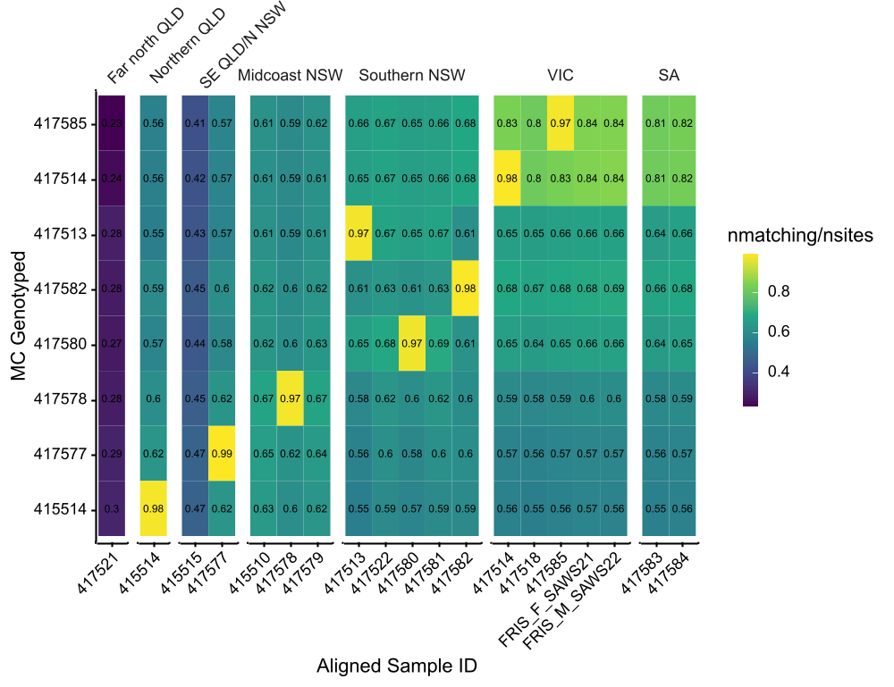
Supplementary Figure 10: Proportion of matching genotypes for reads mapped to the MC graphs compared to the VCF produced by MC during graph construction. FRIS_M_SAWS21 and FRIS_F_SAWS22 are Illumina short read samples.

Structural variant calling – assembly based

SVIM-asm
SVs were identified from the pre-ragtag haplotype-phased HiFi and AmpliFi genomes (N = 8), as well as the primary ONT assemblies (N = 3), with SVIM-asm v1.0.3⁸⁷. Each assembly was aligned to mPhaCin1.pri using minimap2 (parameters: -a -x asm5 --cs -r2k). The resulting SAM files were sorted and converted to BAM format using samtools v1.22. For diploid assemblies (N = 7) we ran SVIM-asm diploid and for primary assemblies (N = 3) we ran SVIM-asm haploid to generate VCF files for each sample. The VCF files from different samples were then merged to produce a non-redundant set of SVs with SURVIVOR v1.0.7 merge (parameters: 1000 1 1 1 0 30). SVIM-asm identified 166,403 unique SVs across these assemblies (N = 11), 70,066 deletions, 466 duplications, 96,877 insertions, 709 inversions, and 468 translocations excluding unplaced scaffolds for translocations. We plotted the genomic distribution of insertions, deletions, duplications and inversions that were not called in all samples (N < 11) with R v4.4.2 package circlize v0.4.17 ^{88,89}. For insertions and deletions, we used a density plot with 10Mb windows, for inversions we replaced SVIM-asm with inversions detected with two or more methods described in the following section 2.4.2 (Supplementary Figure 11).
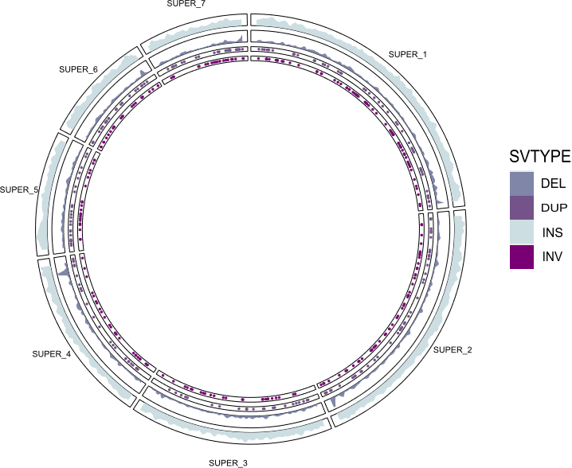
Supplementary Figure 11: Distribution of insertions (INS), deletions (DEL), and duplications (DEL) against mPhaCin1.pri obtained from SVIM-asm. Inversions (INV) are those called detected by more than one assembly-based caller. Outer two rings containing INSs and DELs are density plots with window size 10Mb.

Assembly based Inversions
To detect inversions in the assemblies we used SyRI v1.7.1⁹⁰. As SyRI requires assemblies to contain full length chromosomes, RagTag scaffolded assemblies were used as input. Reference chromosomes with a length greater than 250Mb were split into even length segments prior to mapping as CIGAR strings have a maximum length of (268435456 bases), we split chr 1 and 2 into N = 3, chr 3,4,5,6,7 to N = 2 and chrX N = 1. For all assemblies, each split chromosome was aligned to each other using minimap2 (parameters: -ax asm5 –eqx). SyRI was run between all assemblies and mPhaCin1.pri. SyRI VCF files were merged into one non-redundant file with SURVIVOR v1.0.7 merge (parameters:1000 1 1 1 0 30). SyRI VCF co-ordinates were converted from split chromosome back to full length chromosome co-ordinates in mPhaCin1.pri. We also used minigraph v0.21-r606 ²⁶ to detected inversions in the unscaffolded assemblies. Assembly-based inversion calling against the reference assembly mPhaCin1.pri had little consistency between methods. Many breakpoints were not conserved between methods or individuals and occurred near assembly gaps (Ns) or regions that appeared to be collapsed in mPhac.pri1. Ragtag scaffolding clearly induced inversion errors during our analysis of telomeres in section 1.5.3, further complicating inversion identification. To account for this, we also generated a mPhaCin1.pri backboned pangenome graph using minigraph (parameters: -cxggs) and the unscaffolded curated assemblies as input.
We then called variants using gfatools v0.5-r292-dirty bubble and retained inversions. We generated a non-redundant set of inversions identified through svim-asm, SyRI, and minigraph and retained only high confidence inversions identified by at least two methods with SURVIVOR v1.0.7 merge 1000 2 1 1 0 30. We identified 276 inversions which were present across two methods. The largest region-specific variant (see section 5.1) was a 139kb inversion (SVIM-asm) towards the end of Chromosome 7 (256315982) which was homozygous in SEQLD/NNSW (417577, K98224) and Port Macquarie (417579) and heterozygous in Narrandera (417582) and may affect recombination or gene flow. This variant was not reproduced by minigraph or SyRI. Large inversions are commonly flanked by segmental duplications, the hardest regions of the genome to assemble, meaning higher contiguity assemblies are likely necessary to detect breakpoints. Future studies should investigate inversions relative to 417514 or a T2T reference, while SNP based inversion detection may help confirm putative inversions that were not reproducible between methods ^{62,91}.

Structural variant calling – read to reference based
SVs were called for all samples relative to mPhaCin1.pri using reads mapped with winnowmap.2 (see section 1.3.4) using cuteSV v2.1.3 ⁹², sniffles2 v2.6.1 ⁹³, and SVIM v2.0.0--pyhdfd78af ⁹⁴. cuteSV variants were called using the recommended settings for ONT and HiFi and filtered to retain variants on chromosome scaffolds, with a minimum coverage of 4 reads, and -q 40 for HiFi samples. To genotype variants called by cuteSV we first compressed VCF files with bgzip from htslib v1.16 ⁹⁵ and then indexed with bcftools v1.21 index. Sample IDs were then added to cuteSV variants IDs, filtered to chromosome scaffolds and to variants labelled FILTER = “PASS” and INFO/RE >= 5. cuteSV VCFs for all samples were then merged into a single non-redundant VCF file with SURVIVOR v1.0.7 merge (parameters: 1000 1 1 1 0 30). We then force called genotyping using cuteFC v1.0.0 ⁹⁶ and the merged VCF with the same settings to call the variants in each technology. Sniffles2 was run using tandem repeats annotated on the reference using TRF-mod v4.10.0 ⁹⁷. All snf files were merged with sniffles2 into a final genotyped VCF file. Variants were called using SVIM alignment with the goal of detecting additional ERV insertions by retaining most SV calls. ONT VCFs were samples to QUAL >= 5 and HiFi/AmpliFi VCF were filtered to QUAL >= 2 and merged with SURVIVOR v 1.0.7 merge (parameters: 1000 1 1 1 0 30).

Merging SV calls from different methods
We generated a non-redundant set of variants identified through SVIM-asm, cuteSV, sniffles2, and SVIM with SURVIVOR v1.0.7 merge (parameters: 1000 1 1 1 0 30). This resulted in 291,727 unique SVs with 194,066 reproduced by more than one method.

XY homology and Y satellite analysis
A reference Y chromosome for the koala was not available during pangenome construction. During PGGB clustering we determined 97.3% (out of 78Mb) of putative Y contigs clustered with the X community. To identify conserved regions of the Y chromosome with X chromosome homology we used PAVs in the PGGB graph with 417580’s assembly as a reference (see section 2.2.4) as it had the largest total Y contig length. We first removed 417580’s X chromosome sequences from the PAV matrix and visualised PAV matrixes to search for contigs with broad coverage in male assemblies but only partial matches in female samples. We identified six contigs fitting this criteria h1tg000999l_1_1, h1tg002234l_1_1, h2tg001648l_1, h1tg004580l_1_1,h1tg005871l_1_1,h2tg005005l_1 (Supplementary Figure 12). All contigs had >40% male kmers excluding h1tg004580l which had 38.9% male kmers. These contigs contained 517, 1kb regions with greater than 0% alignment to 415514, the highest coverage female sample. This totalled to a weighted sum of 500384.3bp of total alignment between these six contigs, and 415514. Using the weighted sum formula: sum(region width * PAV proportion). The largest of these regions were 226kb, 100kb, 70kb and 60kb. This corresponded to 3.2% of the 16Mb of putative Y contigs in 417580’s assembly, nearly proportional to the PAR region on the human Y chromosome (3.8%) ⁹⁸. In paf alignments obtained during PGGB clustering, alignments between putative Y contig 417514#2#ht2g000294l (male) contained two separate alignments of 200kb to a single region of Wilpena’s X chromosome (female). Further study of these regions will be vital for understanding the dynamics of a minimal Y chromosome in mammals.
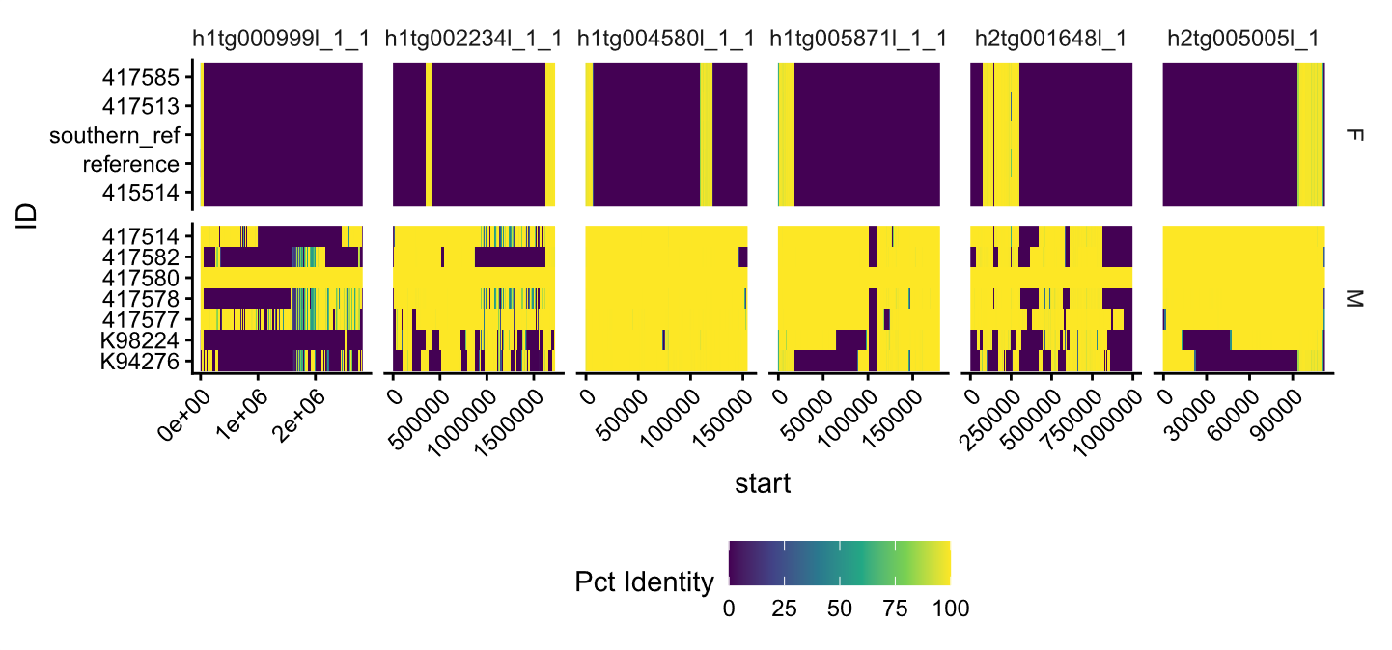
Supplementary Figure 12: Y contigs in 417580’s assembly with restricted regions of high homology to female samples. F, female; M, male.
To analyse the repeat composition of Y contigs with X homology in 417580’s haplotype assemblies, we masked these contigs with RepeatMasker v4.2.0 (de novo 417514.p library + KoRV) and combined them with TRASH annotations (from section 1.5.4). Macrosatellites dominated the koala’s Y chromosome and CEN186 was highly Y specific. In total we identified 5.2Mb of CEN186 in 417580’s haplotype-phased assembly. Of the total 16Mb of putative Y contigs in 417580’s assembly, 5.1Mb of these contigs were CEN186. 82kb of CEN186 repeats were found on Chromosome X, the most of any other chromosome which may promote chromosomal pairing or be the result of recombination with the Y chromosome. Two of the largest XY homologous regions were directly adjacent to CEN186 in 417580#1#h1tg000999l_l_l and 417580#1#h1tg00234l_1_1 (Supplementary Figure 13). The structure of the CEN186 satellite in 417580 appears to be substantially different to male AmpliFi samples from north of the hunter valley (417582, 417578, 417577) given the consistent gaps in 417580#1#h1tg000999l_l_l’s PAV matrix (Supplementary Figure 12), but a scaffolded y chromosome should be generated before asserting this. In 417514’s primary assembly, 7Mb of putative Y contigs (>40% male) were identified and 3.6Mb (2Mb of CEN200_1 and 1.6Mb of CEN186) were macrosatellite/centromeric DNA sequence residing on three contigs, ptg000524l_1, ptg000124l_1, ptg000682l_1. These results suggest, CEN186 is a Y chromosome specific macrosatellite located proximally to CEN200_1, that may play a role in maintaining the homology between the X and Y chromosomes. Without CENP-A ChIP-seq from a male, we could not determine if CEN186 has any centromere function.
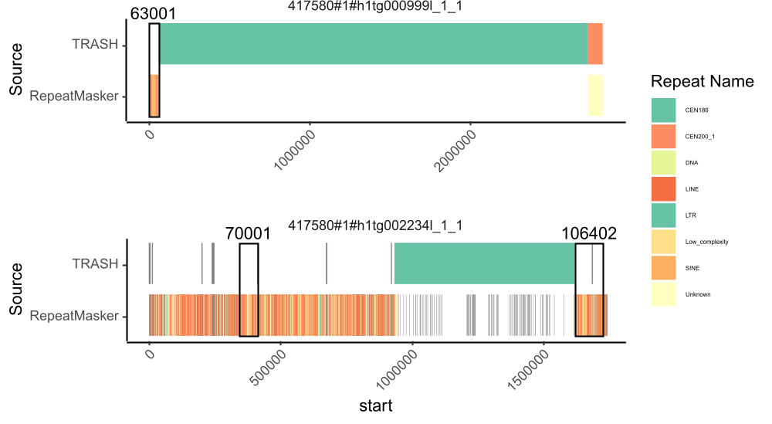
Supplementary Figure 13: CEN186 occurs directly adjacent to regions of very high homology between the XY and Y chromosomes. Black box represents the high homology regions directly adjacent to CEN186.

Repeats and ERV analysis

Variant Annotation

Variant effect prediction
To predict the impact of structural variants, we ran Variant Effect Predictor (VEP) v115.2 ⁹⁹ on VCF files produced by cuteSV, SVIM-asm, and MC respectively. We used the EGAPx annotation generated from PhaCin1.pri as input (parameters: --everything --vcf -offline --species "phascolarctos_cinereus"). We found that VEP annotated some intronic insertions as HIGH impact ‘transcript elongation’ that did not overlap exons. VEP appeared to predict transcript elongation if the start +- SVLEN overlapped an exon rather than the insertion site, but we did not formally test this. Setting SVLEN = 0 for insertions downgraded intronic insertions while leaving exonic insertions as HIGH, so SVLEN was set to 0 prior to running VEP.

Variant repeat annotation
To investigate the repeat content of SVs in koalas we extracted INDELs and DUPs from cuteSV (all), sniffles2 (all), svim-asm (all), and the MC graph (ALT >50bp). We generated a FASTA file for each SV calling method containing the alternate allele for INSs and the REF allele for DELs/DUPs. Each FASTA was then annotated with RepeatMasker v4.2.0 ⁴⁶ using the previously generated repeat library with KoRV ENV/LTR. Additionally, we annotated the FASTA files with TRF-mod v4.10.0 ⁹⁷. For each INDEL/DUP, we assigned the SV the repeat class with the highest Smith-Waterman (SW) score that was above default masking threshold and output by RepeatMasker v4.2.0. If the highest SW score was a simple repeat, we discarded the annotation and reannotated the region with the longest annotation from TRF-mod v4.10.0 and then the highest percent matches to break ties. Simple repeats were then classified into variable-number tandem repeat (VNTR), a tandem repeat with the unit motif length ≥7bp; short tandem repeat (STR), a tandem repeat with the unit motif length ≤6bp.
We used SVIM-asm to analyse the composition of inserted bases relative to mPhaCin1.pri. INDELs/DUPs were masked by repeat masker at a higher rate than background DNA in 417514 primary assembly (62.12% vs 52.51%). Simple repeats are over-represented in SVs, accounting for 2.01% of individual 417514’s assembly but 10.09% of the total masked bases in SVIM-asm SVs. LTR-associated SVs less than 10kb accounted for 30.5% of uniquely inserted bases, compared to just 0.6% of 417514’s primary assembly being masked as LTR elements. We used pairwise two-sided Fisher's Exact Tests in R v4.4.2 ³ to assess the enrichment of each broad repeat class (Simple repeat, LTR, SINE, LINE, DNA, Unknown, Low complexity, or Satellite) among insertions (N = 96,877) compared to deletions (N = 70,066). After bonferroni correction, we found that insertions were significantly more likely than deletions to be associated with LTRs (2,397 insertions vs. 566 deletions, OR=3.1, p-value < 2.2e-16) or simple repeats (72455 insertions vs. 41650 deletions, OR = 2.0, p-value < 2.2e-16). In contrast, deletions were more likely to be associated with LINEs (4,852 INS vs 8,549 DEL, OR=0.35, p-value < 2.2e-16) and DNA transposons (328 INS vs 636 DEL, OR=0.35, p-value < 2.2e-16). The number of LTR insertions also increased with decreasing support indicating they are key driver of recent koala evolution. SV deletion density increased towards the ends of several autosomal chromosomes, while insertion density did not appear to follow this trend (SVIM-asm) (Supplementary Figure 11).

LTR clustering
To assess the sequence variation of full length long tandem repeats (LTRs) across the koalas’ range, we aligned and clustered all LTRs detected in our variant calls from SVIM-asm and cuteSV. Non-redundant SV insertions from cuteSV and SVIM-asm that were previously annotated as LTRs with RepeatMasker v4.2.0 between 5kb and 10kb were added to a single FASTA file. We preferentially selected cuteSV variants over svim-asm as they were fully genotyped and less likely to be the result of misjoins. LTRs of length between 5kb and 10kb were aligned with mafft v7.525 ¹⁰⁰ (parameters: --adjustdirectionaccurately --auto along) with Bovine Foamy Virus as an outgroup (GenBank accession: NC001831). A phylogenetic tree of all LTRs between 5kb – 10kb was generated using FastTree -nt v2.1.11 ¹⁰¹. To identify clusters, we took the reorientated sequences from mafft and removed gaps before running mmseqs easy-cluster v18-8cc5c ¹⁰² (parameters: -s 7 -c 0.80 --cov-mode 0), adding a PhERV from Hobbs, et al. ¹⁰³ (PhERV_phaCin_unsw_v4.1.) and KoRV-A (GCF_002888855.1). We also obtained full length and partial LTR sequences from Lillie, et al. ¹⁰⁴ to aid in cluster annotation. Sequence alignment and clustering was done with mafft and mmseqs using the same methods as above but mmseqs was run with --cov-mode 1 to allow for clustering of partial sequences. Subclusters were grouped into larger families of LTRs based on the Repeatmasker v4.2.0 annotation identity, the tree structure, and any co-clustered sequences from Lille et al. ¹⁰⁴.
Range-wide there appeared to be five main lineages of recently active ERVs, Phac-β, KoRV/recKoRV, ERVL.rnd-4_family-1246 (ERVL.rnd4), ERVK.rnd-5_family-15318 (ERVK.rnd5) and PhERV sequences (Fig 2B). All recently active lineages of LTRs have previously been identified ^{9,104,105}, ERVK.rnd5, ERVL.rnd4, and Phac-β are the same as ERVK.14, ERVL.1, and ERV.1, respectively, in Yu, et al. ⁹. Phac-β-like sequences identified by Lillie, et al. ¹⁰⁴ were not extracted during this analysis. ERVL.rnd4, KoRV and Phac-β made up most full-length LTR-associated insertions that we investigated here (1,476/1,870). ERVL.rnd4, KoRV and Phac-β made up most unique full-length insertions that we investigated (1476/1870). recKoRV.2 was only found in koalas north of Richmond Ranges (northern NSW). Whilst recKoRV.1 identified in southern koalas ¹⁰⁶ was seen as far north as Port Macquire (mid-coast NSW, individual 417578) reflecting finding based on short-read data by Yu et al. ¹⁰⁷.
We then investigated sub clusters of full-length ERV insertions that fell under these branches in the phylogenetic tree, ERVK.rnd5 (N = 13), ERVL.rnd4 (N = 59), KORV (N = 13), PhERV (N = 20), phaCin_b (N = 16), recKoRV.1 (N = 9), recKoRV.2 (N = 12), NA (N = 31). Some of these subclusters were induced by the lower quality consensus sequences extracted from cuteSV ONT R9 samples and these numbers are an overestimation of subtyping. To investigate these sequences, we looked for distinct subclusters with regional bounding and annotated the functional protein domains of all full length LTR insertions.

LTR structural annotation and dating and the PhERV-like retrovirus
To predict functional protein domains in each endogenous retrovirus (ERV) we ran LTRdigest from GenomeTools (gt) v1.6.5 ¹⁰⁸ on all inserted LTRs. A FASTA file containing all unique LTR-associated insertions from cuteSV and svim-asm was indexed with suffixerator (from GenomeTools). To identify LTR boundaries in the insertions LTRharvest (from GenomeTools) was run on the indexed FASTA file with -overlaps all to capture all annotations for nested LTRs. The GFF3 output file from LTRharvest was then sorted with gt gff3. To identify protein domains, the sorted gff3 file was used as the input to LTRdigest with hmms from pfam (v [3.3 | Nov 2019]) and hmmer v3.4 ¹⁰⁹.
One subcluster in the PhERV branch of the phylogenetic tree, referred to as the PhERV-like retrovirus, contained a complete set of retroviral genes that may contribute to the clear geographic structure of recombinant koala retrovirus variants. In the three assembled genomes containing this PhERV-like retrovirus, we saw a high number of private PhERV and recKoRV.1 insertions in individuals from Upper Nepean (south of Sydney), Port Macquarie, and Monaro (south of Sydney, individuals 417580, 417578, 417513) (Fig 2D) (cluster-417580:svim_asm.INS.19792). All four PhERV-like retrovirus insertions had >99.9% identity. All other PhERVs insertions had no gag, RT or integrase genes and are unlikely to have autonomously integrated. To visualise regions of homology between PhERV, PhERV-like retrovirus, and recKoRV.1, a multiple sequence alignment containing all PhERV and recKoRV.1 sequences was generated with mafft v7.525 (parameters: --adjustdirectionaccurately --auto along). The MSA was uploaded to NCBI MSA Viewer v1.26.0 ¹¹⁰ and anchored on the PhERV-like retrovirus (417580:svim_asm.INS.5539). PhERV, recKoRV.1, and PhERV-like retroviruses retain high homology at the 3’ and 5’ end (Extended Data Fig. 4). The 5′ region of retroviral RNA generally contains the ψ (psi) packaging signal which is recognised by gag genes to ensure the correct viral mRNAs are packaged into the virus ¹¹¹. Interestingly, recKoRV.1 insertions had higher percent identity with PhERV than PhERV-like approximately 61% vs 46%, indicating it had not directly recombined with the PhERV-like retrovirus. The LTRs of PhERV and the PhERV-like retrovirus are slightly divergent which may allow the identification of this retrovirus directly from short reads. MC genotyping of the four insertions of the PhERV-like retrovirus showed at least seven, possibly eight, AmpliFi or HiFi individuals contain the PhERV-like retrovirus (Supplementary Table 7). Variant >41635867>41635877 had a genotyping quality of 0 and no evidence of an insertion in the BAM files from read alignments to mPhaCin1.pri for Gold Coast individual 415515 and may be the result of misgenotyping. The current confirmed integration range of the PhERV-like retrovirus appears to be from Mt Lofty to as far north as Armidale.
As some ERV insertions may have occurred in previously unassembled regions of the reference genome, they would be missed through reference-based methods by the strict 5-10kb size used to extract LTRs in section 4.2. We used blastn v2.16.0 with representative, PhERV, PhERV-like retrovirus, and recKoRV.1 sequences to confirm if they were present or absent from the assemblies. This identified recKoRV.1 was also present in the assembly of 417514 (Cobram, Victoria) while it was not detected using SVIM-asm or cuteSV. We cannot exclude the possibility these ERVs are present in other individuals without aligning reads directly to these representative ERVs. The 8642bp PhERV-like retrovirus was not found in any additional assemblies but aligned with 83% identity (qstart 1437 qend 8205bp) to a highly conserved ERV insertion (NCBI accession: XM_078147977.1) found on Chromosome 1 found in all assemblies (mPhaCin1.pri - SUPER_1:599435957-599442636). Future studies should search the deletions in the reference for a PhERV-like ERV that may explain the formation of recKoRV.2.
To date LTR insertions, LTRharvest was run again on the indexed FASTA file with -similar 70 -overlaps best to identify the most similar LTRs. For each unique insertion the 3’ and 5’ LTRs identified by LTRharvest were extracted in FASTA format using bedtools. Each insertion of the LTR pair was aligned with mafft --auto and LTR evolutionary distance was then calculated using EMBOSS v6.6 ¹¹² and the Kimura two-parameter (K2P) model (-nucmethod 2). Insertions dates were estimated using the T=K/2r formula ¹¹³.
$$T=\frac{K}{2r}$$
T = Estimated time since insertion date
K = Evolutionary distance between LTRs calculated with Kimura two-parameter model
r = Koala mutation rate (6.12 * 10^-9)⁷⁴ estimate the insertion date and
We identified private and recent ERVL.rnd4 insertions in southern koalas that do not have endogenous KoRV. Most ERVL.rnd4 insertions consisted of a minimal set of retroviral genes, reverse transcriptase, RNAse-H, (RT_RNASE_H) and integrase (rve) (SUP FIGURE), none had a gag gene, indicating they have reinserted using non-autonomous replication. We found just one private ERVK.rnd5 in southern koalas, despite ERVK.rnd5s having a more complete set of retroviral genes (Sup Fig X). ERVK.rnd5 was also found to be less active in northern animals in a previous analysis ⁹ and this could be due to the higher number of ERVL.rnd4 insertions present in all koalas ¹⁰⁷. Given southern koalas were bottlenecked <100 years ago, these results suggest ERVL.rnd4 is likely active in the absence of KoRV and reintegrating using gag genes from a different ERV. A higher total number of ERVL.rnd4 integrations were also predicted in southern animals using range-wide short read ¹⁰⁷ alongside an increased number of PhaCin-β insertions. 1547/1870 of LTR-associated insertions had a pair of LTRs detected by LTRharvest. LTR divergence was 0 for most of these insertions (N = 1162/1547) indicating they occurred in the last approximately 114kya, the youngest non-zero estimate, which is unsurprising considering we are exclusively looking at non-conserved insertions and koalas only diverged into modern populations 30kya.

Uncalled ERVs, long-read callers are not optimized for shorter AmpliFi reads.
When comparing SVs called between HiFi/ONT and AmpliFi samples we noticed a systematic undercalling of longer SVs in AmpliFi samples when using standard long-read to reference calling methods, sniffles2, cuteSV, and svim. From 11 assemblies, SVIM-asm identified 1,713 ERV-like insertions, (LTR-associated insertions between 5kb-10kb). Conversely long-read callers, cuteSV, sniffles2, and SVIM identified just 775, 788, 346 ERV-like insertions respectively despite having 8 additional samples. SVIM-asm identified 1,001 ERV-like insertions that were not detected by any long-read to assembly SV calling method. Long ERVs were the most clearly impacted in AmpliFi samples where even in samples with >20X coverage, most private full length ERV insertions were only detected in the assemblies using SVIM-asm (i.e. 417580, 417577, 415514) (Extended Data Fig. 3). Relying on the long-read callers alone would have substantially impacted the interpretation of ERV activity, completely missing the PhERV-like retrovirus that was only called with SVIM-asm. Sniffles2 did not genotype the key ERV5.rnd5 (6kb) insertion 1.8kb upstream of ADGRF1 (Sniffles2.INS.1AM56A) in AmpliFi samples but did in HiFi (N = 2) and ONT (N = 1) samples from SA/VIC. In cuteSV, the ADGRF1 insertion was merged with an adjacent recKoRV.1 (7.2kb) insertion 800bp away by SURVIVOR, resulting in cuteFC subsequently mis genotyping the insertion as a single recKoRV site (Extended Data Fig. 5) (417580:cuteSV.INS.22186). A more aggressive calling method with lower minimum reads or a combination of methods designed for short reads may be required to extract all longer insertions, including ERVs, from these AmpliFi data.

Population specific SVs

Definition of population specific SVs
Using range-wide long-read data we identified genetic cluster specific variants from variant callsets. Our long-read samples covered 5 previously identified genomic clusters, VIC and SA koalas (also referred to as southern koalas) were grouped together as koalas at these individuals originate from on genetic cluster of recently bottlenecked French Island koalas. Narrandera is an admixture site between French Island decedents and Northern NSW koalas and therefore 417582 was excluded during identification of region-specific variants. We excluded samples 415515 and 417521 due to low coverage. We determined SVs to be region specific if they occurred in ≥75% of individuals from a genetic cluster (minimum 2 individuals) and no more than one individual from another region. We identified 16,572 putative-regionally fixed or high frequency SVs that may contribute to differing phenotypes seen between regions. We defined a regional SV as being called in a minimum of 2 individuals and >75% of samples from a ‘region’, in either SVIM-asm or cuteSV. The most variants for a region came from the bottlenecked SA/VIC region (N = 5944 SVs; 6 samples), and the least from the Midcoastal NSW cluster (N=778 SVs; 3 samples).

Transcriptomics
To determine the tissue specificity of genes affected by population specific SVs, RNA-seq data from koala tissue was obtained from three studies ^{50,114,115} were utilised to generate counts per million (CPM) and tissue specific differentially expressed (DEGs) genes. These bulk RNA-seq tissue samples were obtained from tissue samples of adrenal gland, bone marrow, brain, buffy coat, heart, kidney, liver, lung, lymph nodes, mammary gland, pouch, salivary gland, spleen, testes, and uterus. NCBI accessions: SRR3724381, SRR1106690, SRR1106707, SRR1122141, SRR1121764 SRR1207973, SRR1207974, SRR1207975, SRR1205224, SRR1205223, SRR1205998, SRR1205138, SRR1205218, SRR1203868, SRR1205176, SRR1205222, SRR1799592, SRR1799850, SRR1799715 and previously unpublished mammary and pouch samples deposited at NCBI under BioProject accession PRJNA1525783. Reads from Abts, et al. ¹¹⁵ were had been pre-processed to remove adapters and were not trimmed further. All other paired end reads were trimmed with Trimmomatic v0.39 ¹¹⁶ (parameters: TruSeq3-PE.fa:2:30:10 SLIDINGWINDOW:4:5 LEADING:5 TRAILING:5 MINLEN:25, -phred33). An index was built for mPhaCin1.pri with hisat2-build v 2.2.1 ¹¹⁷. Paired reads were mapped to the mPhaCin1.pri assembly with hisat2 v2.2.1 -phred33 --rna-strandness RF. Transcripts were then quantified using multimapping featurecounts from subread v2.1.1 ¹¹⁸ (parameters: -p --countReadPairs -M -t "exon" -g "locus_tag"). To quantify CPM and differentially expressed genes (DEGs) in each tissue we followed the Quasi-Likelihood (QL) model from edgeR v4.4.2 ^{119,120}. Samples were grouped by tissue, and normalised library sizes before calculating CPMs. We also called for each tissue vs all other tissues, filtering lowly expressed genes, using the normalised libraries and the quasi-likelihood negative binomial generalized log-linear model. There was an overrepresentation of immune tissues that may lower the specificity of co-expressed genes from these tissues.

Kidney disease gene identification
Southern koalas are prone to oxalate nephrosis, a fatal kidney disease resulting from oxalate crystal build up ¹²¹⁻¹²³. Genome-wise association studies (GWAS) are not currently available or suitable for this disease as the underlying variants may have become fixed or very high frequency in this subpopulation leading to low statistical variance along with variants that were also fixed during the previous bottlenecks. To identify candidate kidney disease related genes from the putative southern koala specific SVs, or variants only found in Wilpena, who died from oxalate nephrosis ^{1,106}, we used the following methods (Extended Data Fig. 8). First, we used VEP annotations from section 4.1.1 to subset putative region-specific variants from section 5 to those with MEDIUM or HIGH predicted impacts or non-intergenic LTR-associated insertions greater than 5kb in length. Human gene to trait associations were obtained from National Human Genome Research Institute Catalog human GWAS databases using gwasrapidd v0.99.18 ¹²⁴. We retained potential kidney disease genes that contained HIGH or MEDIUM impact southern specific SVs in genes with human homologs associated with urate measurement, urinary system trait, chronic kidney disease, serum creatinine amount, glomerular filtration rate, diabetic kidney disease, creatine kinase measurement, or urinary albumin to creatinine ratio. We also used DEGs and tissue expression from section 5.2 to identify genes with specificity to the kidney. Additionally, we obtained CPMs for RNA single cell clusters from the human protein atlas ¹²⁵, to identify what cell types potential genes with human homologs were associated with. For genes with human homologs, we examined raw CPMs in kidney specific cell types and confirmed tissue or cell-type specificity using protein staining, or single cell type specificity scores manually on the web version of the human protein atlas ¹²⁵. High impact variants in any of these genes were considered candidates for koala regional kidney disease and their function was further investigated.
Southern koalas had high impact SVs in genes associated with glomerular filtration rate, SH3BP4, OBSCN, and GAB2, serum creatinine kinase RSBN1L, urate measurement associated gene URI1, as well as chronic kidney disease associated gene CACNA1A. We found a fixed 216bp 3’ UTR deletion in PTGER3, a gene involved in uterine contraction and kidney function. Additionally, we found high impact variants in proximal tubule cell folate transporter SLC19A1, and two genes highly expressed in podocytes, AKT3 implicated in acute kidney disease ¹²⁶, and BGN implicated in chronic renal inflammation ¹²⁷. Wilpena, the only sample with confirmed oxalate nephrosis ^{1,106}, has a complete deletion of exon 2 in NRIP2 not detected in any other sample. NRIP2 is highly specific to myocytes and podocytes, modulating the response of podocytes to diabetic kidney disease and is upregulated in focal segmental glomerulosclerosis ¹²⁸. Interestingly, BGN and OBSCN are both implicated in muscle growth and muscle cytoskeleton signalling ¹²⁹⁻¹³¹ which could suggest a link between the abnormally large size of southern koala’s and their kidney disease. NRIP2 ¹²⁸, AKT3 ¹²⁶, BGN ¹³², and OBSCN ¹³³ all interact with the WNT/β-catenin signalling pathway that controls apoptosis which has also been implicated in a variety of kidney diseases ¹³⁴.
We found 12 non-intergenic full-length fixed or regionally enriched LTRs in southern koalas, including an insertion upstream of ADGRF1 that was misgenotyped by cuteSV (see section 4.4). These 12 full-length LTRs were in non-intergenic regions of 14 genes, six of these genes had annotated gene symbols CNTNAP2, CHRNA6, GABRG3, GRPEL2, CACNA1E, and ADGRF1, which were uploaded to human PANTHER v19.0 ¹³⁵ through gene ontology (GO) ¹³⁶. All six genes play roles in the nervous system, four of these genes were involved in transmembrane transport and three are monoatomic ion channels. This included an intronic LTR insertion (ERVL.rnd-4_family-1246) in a second CACNA family calcium channel gene CACNA1E. CACNA genes are generally associated with brain function, and CACNA1A and CACNA1E are both lowly expressed in koala kidneys but share functional links to OBSCN through calcium ions signalling. We found an ERVK.rnd5 insertion 1.8kb upstream of ADGRF1’s TSS. ADGRF1 was predominately expressed in the koalas’ kidneys (LogFC 10.63515 vs all other tissues) but was not significantly differentially expressed, although ADGRF1 is highly specific to medullary principal cells in mice and humans. Medullary principal cells are a major cell-type in collecting ducts, critical for adjusting urine volume and composition ¹³⁷. ADGRF1’s function in the kidney is still unclear but it has been shown to interact with occludin (OCLN) to control membrane permeability in the brain ¹³⁸. OCLN are co-expressed with ADGRF1 in several kidney cell-types humans ¹²⁵, and these genes may play a similar role controlling membrane permeability in the kidney.
Functionally, we found high impact southern specific SVs in genes involved in calcium signalling and WNT/β-catenin signalling. OBSCN is linked to both calcium signalling and WNT/β-catenin signalling and is one of several genes identified here to have high specificity to both myocytes and an association with kidney disease ^{130,131}. It was difficult to interpret predicted frameshift mutations, stop codons, and inframe insertions for OBSCN as both 417514.p’s and mPhaCin1.pri’s OBSCN proteins were annotated by EGAPx as LOW QUALITY PROTEINs which can indicate stop codons or frame shifts in protein coding genes ⁴⁸. Further work, including southern koala-specific tissue analysis, such as RNA-seq or protein staining is required to determine how and if this extensive list high impact SVs have permanently impacted southern koala’s kidney function.

Visualisation of OBSCN and Phci-Cath5
We used the PGGB graph to visualise OBSCN and Phci-Cath5 identified with liftoff in section 2.1. Odgi was used to extract subgraphs, project and reposition gene or exon bed files within the subgraph and untangle gene or exon paths to generate csv files for Bandage-NG v2025.6.1 ¹³⁹. Subgraphs were visualised interactively using Bandage-NG and odgi viz was used to generate 1D representations of subgraphs. We then visualised exon paths for OBSCN and gene paths for Phci-Cath5 with gggenes v0.6.0 ¹⁴⁰ in R v4.4.2 ³.
To visualise the copy number variation of near identical OBSCN exons, path depths were obtained from the OBSCN subgraph GFA for each haplotype in the admixture individual 417582, that contained a representative allele from both southern (Victorian (VIC) and South Australian (SA)) and northern regions. Nodes overlapping the complex variant loop were obtained using Bandage-NG ¹³⁹ and path depth in the OBSCN GFA subgraph was calculated as the number of times each node was crossed by each haplotype path. A Bandage-NG annotation csv file was generated using R to visualise the depth of coverage of the graph within the variable region.

OBSCN protein domains Interproscan
To identify protein domains underlying the variant in OBSCN, OBSCN’s protein FASTA sequence from assembly mPhaCin1.pri was uploaded to the web version of interProScan 5.77-108.0 ¹⁴¹. The interProScan GFF file was then imported into R v4.4.2 with rtracklayer v1.66.0 ¹⁴² and overlapped with the affected exons (exons 49 to 59). Relative positions for each exon in the final protein were determined using CDS annotations in OBSCN’s GFF file. All exons overlapped with predicted immunoglobulin-like domains.

Characterisation of MHC loss
We identified the loss of class I MHC genes in southern koalas with liftoff, pangene and orthofinder from section 2.1 and confirmed its loss by inspecting PGGB PAVs from section 2.2.4. To determine the relationship between class I MHC genes, manual MHC bed file annotations¹⁴³ were lifted over from koala genome version GCA_002099425 to mPhaCin1.pri with a MC graph and halLiftover using cactus v3.1.4⁸¹. FASTA files for each MHC were then extracted with bedtools v 2.31 getfasta and uploaded to CLUSTAL v2.1¹⁴⁴ to obtain a percent identify matrix. Class I MHC UB (geneID_MHCI-19) occurs just 568bp from the start of Chromosome 6 and has 85% identity to a class I MHC just 12kb from the start of Chromosome 5 (geneID_MHCI-11), indicating they share recent evolutionary history. The class I MHCI I at the start of Chromosome 5 are 120kb from a vomeronasal and olfactory receptor cluster indicating these MHCI’s may be evolutionarily linked to olfaction. Another class I MHC (UA from Silver, et al. ¹⁴³) from the same orthogroup (OG0000043) was duplicated on Chromosome 3 in at least three koalas but not in southern koalas in line with short-read based copy number estimates¹⁴³. UA was distinct from UB (37% identity) suggesting a broad degradation of immunorecognition pathways in southern koalas. The UA gene was located 130kb from an aryl hydrocarbon receptor-like (AhR-like) gene, AhR is a transcription factor involved in mediating ligand response, for chemical breakdown and environmental sensing.

Possibly variants involved in southern coat variation
We detected a fixed 36bp deletion in the 3’ UTR of GAB2 that is fixed in all samples with French Island heritage (N = 8; 2 short read and 6 long-read samples). GAB2 variants are strongly associated with hair colour (p = 2 × 10⁻⁸⁵) in humans¹⁴⁵ and may contribute to southern koalas darker coat colour. Future GWAS using admixture individuals from Narrandera should be utilised to confirm the genetic basis of southern koala phenotypes.
Variation in keratin-associated protein 20-2-like and keratin-associated protein 20-1-like may explain the distinctly “fluffy” coat of southern koalas. In the orthofinder results for mPhaCin1.pri from section 2.1, the resolved gene tree for orthogroup (OG0000084) contained a subbranch exclusively populated by proteins from southern koalas and the admixture Narrandera individual (417514, 417585, Wilpena, and 417582) (Supplementary Figure 14). The reference protein (mPhaCin1_egapxtmp_014966-P1) was uncharacterized by the EGAPx pipeline so we uploaded the protein to the online NCBI blastp v2.17.0¹⁴⁶ and found it had 98.39% identity to keratin-associated protein 20-2-like (Vombatus ursinus) (NCBI accession: XP_027699438.1). Keratin-associated protein 20-2 (KAP20-2) is associated with variation in the cashmere traits in goats¹⁴⁷. Conversely pangene results, using 417514’s protein annotation as input, indicated southern koalas 417585, 417514 and Narrandera sample 417582 had two copies of keratin-associated protein 20-1-like isoform 1-T1 (egapxtmp_006199−P1) while all southern koalas, 417585, 417514, and Wilpena had no copies of isoform 4-T4 (egapxtmp_006199−P4) (Supplementary Figure 15). AmpliFi and HiFi samples 417585, 417582, and 417514 also had no copies of keratin-associated protein-20-2-like (egapxtmp_006201−P1). Liftoff annotations indicated that egapxtmp_006199 isoforms 1,2, and 4 only had valid ORFs and matched the reference protein in French Island descendants (417585, 417514, Wilpena and 417582). The inconsistent isoform and gene annotation may be due to the missing or poor gene annotations, and further research is warranted into the impact of variation in keratin-associated proteins on koala coat phenotype.
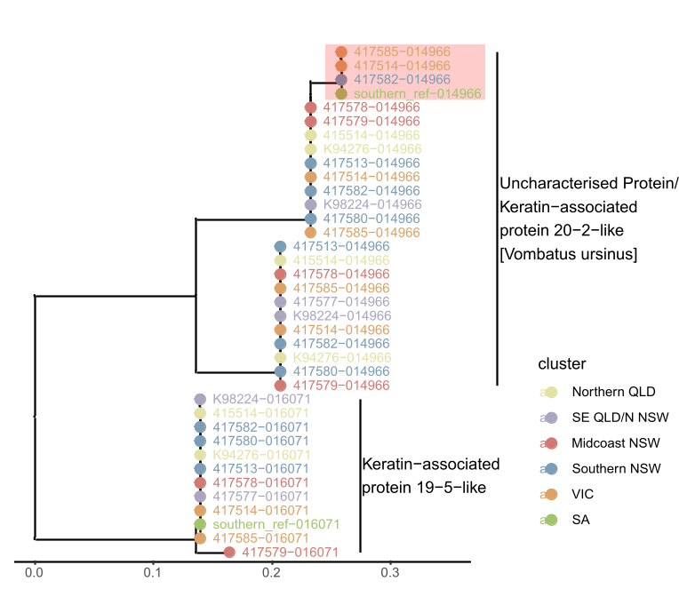
Supplementary Figure 14: Resolved orthogroup gene tree (OG0000084) from orthofinder indicates there is a subbranch of keratin-associated proteins only identified in individuals of French Island decent highlighted in red. Proteins are annotated by assembly-protein number from EGAPx of mPhaCin1.pri. QLD, Queensland; NSW, New South Wales; VIC, Victoria; SA, South Australia.
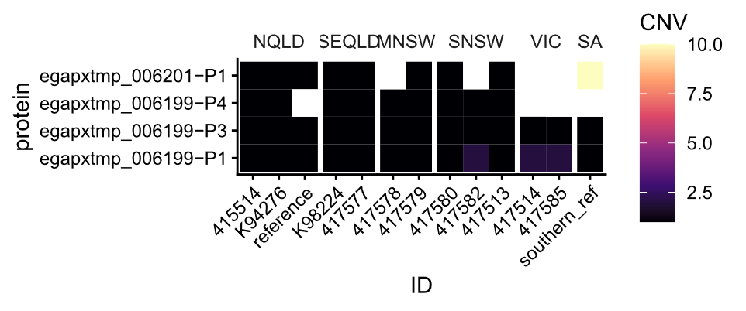
Supplementary Figure 15: Pangene copy number variation (CNV) for keratin-associated protein 20-1-like (egapxtmp_006199) and keratin-associated protein 20-2-like (egapxtmp_006201) indicates French Island descendants possess a distinct composition of keratin-associated protein 20 genes. Proteins are from the primary annotation of 417514 with EGAPx. NQLD, northern Queensland; SEQLD, southeast Queensland; MNSW, midcoast New South Wales; SNSW, southern New South Wales; VIC, Victoria; SA, South Australia.

SUN2-like genes

Synthesis of SUN2-like results
SUN2-like gene variation was first noted as being highly variable when inspecting results from liftoff and pangene annotations from section 2.1. Colocalization with segmental duplications and adjacency to centromeres and interstitial telomeric DNA was observed in R v4.4.2 with ggplot2 v4.0.3 by plotting the position of SUN2-like genes from liftoff relative to annotations produced for 417514’s primary assembly from section 1.5. During our analysis of telomeres in section 1.5.3, we detected a possible chromosomal breakage at this location in Port Macquarie individual 417578 highlighting extreme genomic volatility at this locus.

Coverage based copy number estimation of SUN2-like genes.
We found the CNV of SUN2-like genes were highly variable in assembly-based analysis, using both liftoff and pangene from section 2.1. To generate SUN2-like gene copy number estimates for unassembled long-reads and a selection of short read samples we used read-depth based CNV estimation. For long-read samples, we used the BAM file from section 1.3.4. We also calculated the estimated copy number of SUN2-like genes using Illumina short reads from individuals across three genetic clusters, French Island (N = 2), NNSW/SQLD (Gold coast[N = 5] and Richmond Ranges[N = 5]), and Narrandera (N = 20) (Supplementary Table 12) ^{2,148}. Raw FASTQ files for each short-read sample was download from AWS servers “https://koalagenomes.s3.ap-southeast-2.amazonaws.com/index.html” using aws cli v 2.13.9 and trimmed with fastp v0.20. Trimmed reads were then aligned to mPhaCin1.pri with bwa-mem2 mem v2.2.1^{54,149}. Alignments were sorted and indexed with samtools v1.22. To estimate total sequencing depth for both long and short-read samples, we used samtools v1.22 stat to obtain the total sequencing length / 3.5Gb. To estimate the depth of coverage of SUN2-like genes in each sample, we used samtools v1.22 depth -b, with a bed file of all gene features labelled as “SUN domain-containing protein 2-like” from the EGAPx annotation of mPhaCin1.pri. Copy number estimates were obtained by dividing the SUN2-like depth of coverage by total sequencing depth.

SUN2-like function and subtypes
SUN2 and all SUN2-like genes were extracted from protein FASTA file generated for orthogroup clustering in section 2.1 with seqkit grep v2.9.0 ¹⁵⁰. FASTAs were then aligned with mafft v7.525 (Katoh & Standley, 2013) (parameters: --adjustdirectionaccurately --auto along). This was then uploaded to NCBI MSA Viewer v1.26 ¹¹⁰ and anchored on SUN2. This showed substantial loss of protein structure compared to SUN2 (Supplementary Figure 16).

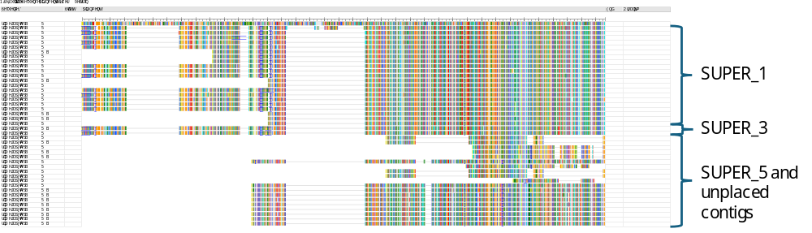
Supplementary Figure 16: MSA of SUN2 and SUN2-like genes anchored on SUN2 (top) show the structure of SUN2-like genes vary substantially from SUN2.

Protein FASTAs for SUN2 (egapxtmp_022329) and Chromosome 1 SUN2-like (egapxtmp_004755 & egapxtmp_004743) gene from EGAPx of 417514’s primary assembly were uploaded to interProScan 5.77-108.0 ¹⁴¹ to compare their protein coding domains to SUN2 (Supplementary Figure 17). SUN2-like gene egapxtmp_004755 does not appear to have a cytoplasmic domain and has partially lost its transmembrane domain while retaining the SUN domains (Supplementary Figure 18). Conversely, SUN2-like gene egapxtmp_004743 retains both its cytoplasmic and transmembrane regions (Supplementary Figure 19) indicating SUN2-like genes are likely to divergent functions from SUN2 and should be investigated separately.
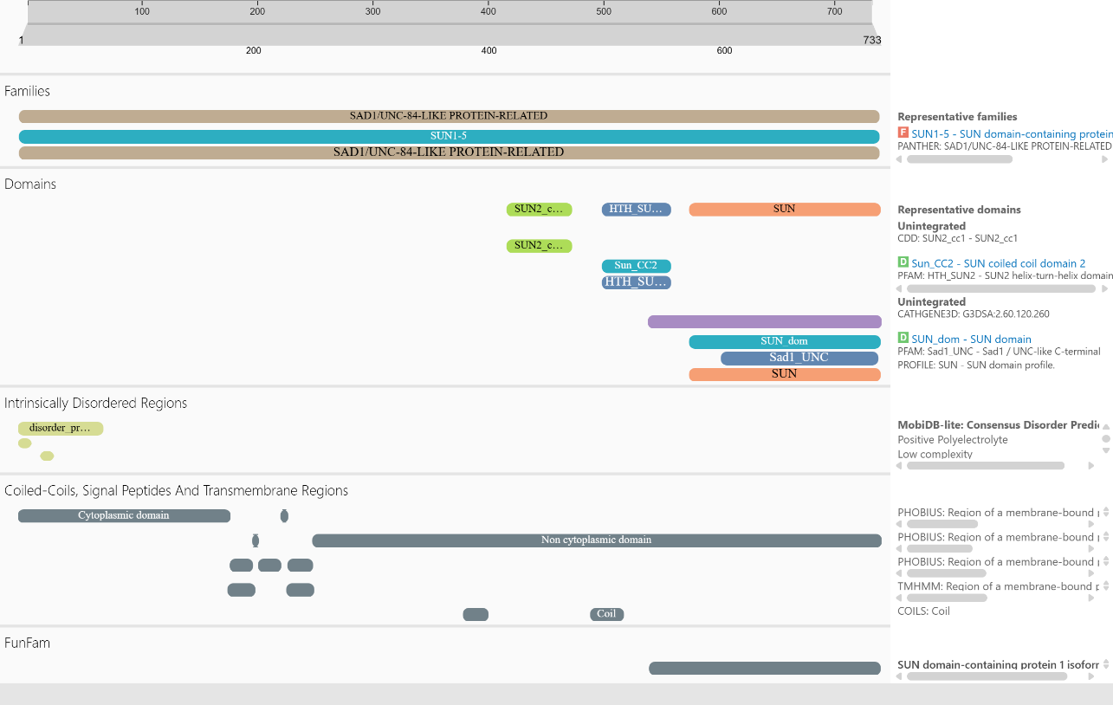
Supplementary Figure 17: Protein domains from interProScan of SUN2
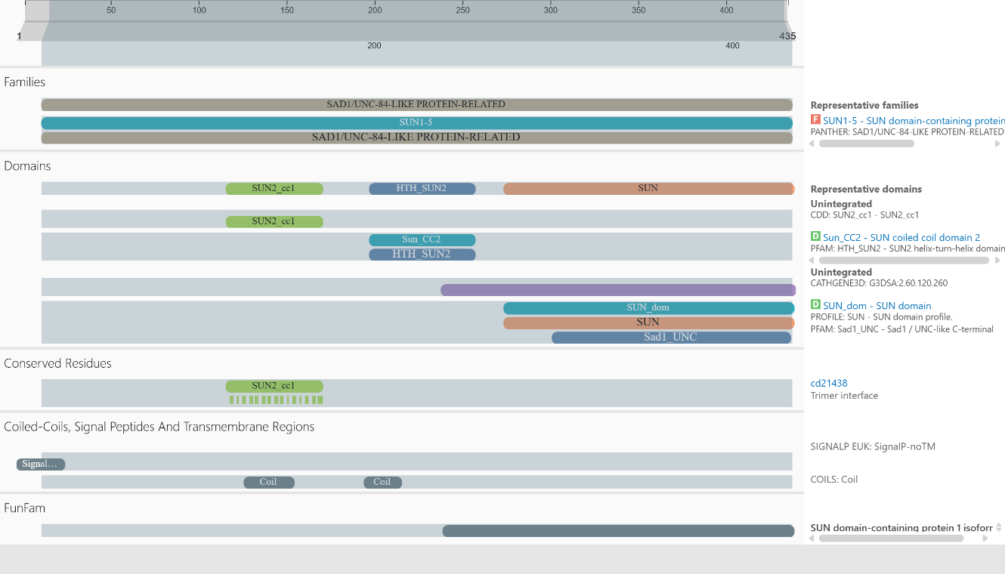
Supplementary Figure 18: Protein domains from interProScan of a SUN2-like gene (egapxtmp_004755) from Chromosome 1 indicates a loss of membrane and cytoplasmic domains when compared to SUN2 (Supplementary Figure 17).
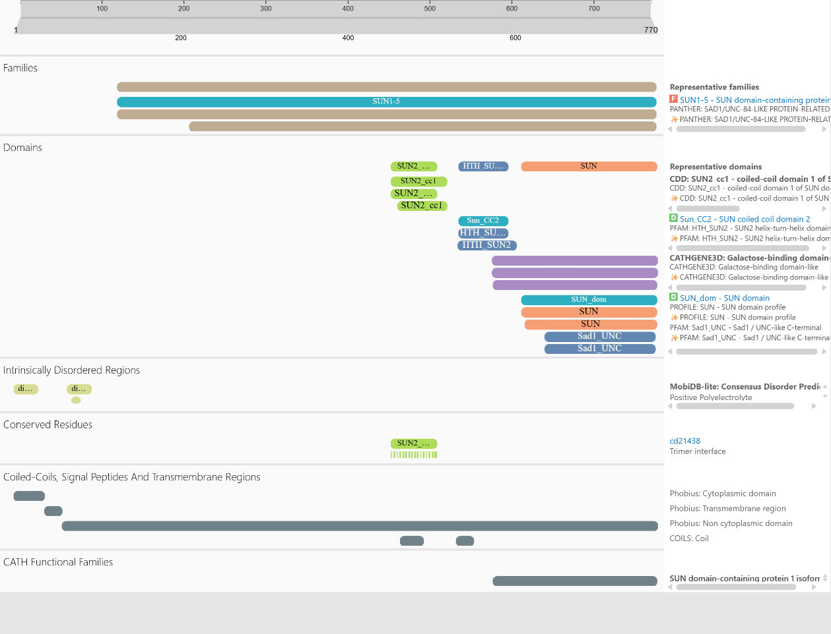
Supplementary Figure 19: Protein domains from interProScan of a SUN2-like gene (egapxtmp_004755) from Chromosome 1 indicates a loss of membrane and cytoplasmic domains when compared to SUN2 (Supplementary Figure 17).

References
1 Blanchard, A. M. et al. Genome reference assembly for bottlenecked southern Australian koalas. Genome Biology and Evolution 15, evac176 (2022). https://doi.org/10.1093/gbe/evac176
2 McLennan, E. A. et al. Genomics identifies koala populations at risk across eastern Australia. Ecological Applications 35, e3062 (2025). https://doi.org/10.1002/eap.3062
3 R Core Team. R: A language and environment for statistical computing. (R Foundation for Statistical Computing, 2024).
4 Wickham, H. ggplot2: elegant graphics for data analysis. (Springer-Verlag New York, 2016).
5 Sumner, M. ozmaps: Australia Maps, https://mdsumner.github.io/ozmaps/ (2021).
6 Li, H. et al. The Sequence Alignment/Map format and SAMtools. Bioinformatics 25, 2078-2079 (2009). https://doi.org/10.1093/bioinformatics/btp352
7 Martin, M. Cutadapt removes adapter sequences from high-throughput sequencing reads. EMBnet.journal 17, 10-12 (2011). https://doi.org/10.14806/ej.17.1.200
8 Andrews, S. FastQC: a quality control tool for high throughput sequence data, https://www.bioinformatics.babraham.ac.uk/projects/fastqc/ (2010).
9 Yu, T. et al. Evolution of KoRV-A transcriptional silencing in wild koalas. Cell 188, 2081-2093.e2016 (2025). https://doi.org/10.1016/j.cell.2025.02.006
10 Technologies, O. N. pod5: A high performance file format for nanopore reads, https://github.com/nanoporetech/pod5-file-format (2023).
11 Python Software Foundation. Python language reference, https://www.python.org/ (2026).
12 Technologies, O. N. Dorado, https://github.com/nanoporetech/dorado (2023).
13 Wick, R. R., Judd, L. M., Gorrie, C. L. & Holt, K. E. Completing bacterial genome assemblies with multiplex MinION sequencing. Microbial Genomics 3, e000132 (2017). https://doi.org/10.1099/mgen.0.000132
14 Chen, S., Zhou, Y., Chen, Y. & Gu, J. fastp: an ultra-fast all-in-one FASTQ preprocessor. Bioinformatics 34, i884-i890 (2018). https://doi.org/10.1093/bioinformatics/bty560
15 Rhie, A., Walenz, B. P., Koren, S. & Phillippy, A. M. Merqury: reference-free quality, completeness, and phasing assessment for genome assemblies. Genome Biology 21, 245 (2020). https://doi.org/10.1186/s13059-020-02134-9
16 Jain, C., Rhie, A., Hansen, N. F., Koren, S. & Phillippy, A. M. Long-read mapping to repetitive reference sequences using Winnowmap2. Nature Methods 19, 705-710 (2022). https://doi.org/10.1038/s41592-022-01457-8
17 Johnson, R. N. et al. Adaptation and conservation insights from the koala genome. Nature Genetics 50, 1102-1111 (2018). https://doi.org/10.1038/s41588-018-0153-5
18 Cheng, H., Concepcion, G. T., Feng, X., Zhang, H. & Li, H. Haplotype-resolved de novo assembly using phased assembly graphs with hifiasm. Nature Methods 18, 170-175 (2021). https://doi.org/10.1038/s41592-020-01056-5
19 Guan, D. et al. Identifying and removing haplotypic duplication in primary genome assemblies. Bioinformatics 36, 2896-2898 (2020). https://doi.org/10.1093/bioinformatics/btaa025
20 Li, H. New strategies to improve minimap2 alignment accuracy. Bioinformatics 37, 4572-4574 (2021). https://doi.org/10.1093/bioinformatics/btab705
21 Kolmogorov, M., Yuan, J., Lin, Y. & Pevzner, P. A. Assembly of long, error-prone reads using repeat graphs. Nature Biotechnology 37, 540-546 (2019). https://doi.org/10.1038/s41587-019-0072-8
22 Technologies, O. N. Medaka: Sequence correction provided by ONT Research, https://github.com/nanoporetech/medaka (2018).
23 Zimin, A. V. et al. The MaSuRCA genome assembler. Bioinformatics 29, 2669-2677 (2013). https://doi.org/10.1093/bioinformatics/btt476
24 Zimin, A. V. & Salzberg, S. L. The genome polishing tool POLCA makes fast and accurate corrections in genome assemblies. PLOS Computational Biology 16, e1007981 (2020). https://doi.org/10.1371/journal.pcbi.1007981
25 Zimin, A. V. & Salzberg, S. L. The SAMBA tool uses long reads to improve the contiguity of genome assemblies. PLOS Computational Biology 18, e1009860 (2022). https://doi.org/10.1371/journal.pcbi.1009860
26 Li, H., Feng, X. & Chu, C. The design and construction of reference pangenome graphs with minigraph. Genome Biology 21, 265 (2020). https://doi.org/10.1186/s13059-020-02168-z
27 Li, H. Minimap2: pairwise alignment for nucleotide sequences. Bioinformatics 34, 3094-3100 (2018). https://doi.org/10.1093/bioinformatics/bty191
28 Lawrence, M. et al. Software for computing and annotating Genomic Ranges. PLOS Computational Biology 9, e1003118 (2013). https://doi.org/10.1371/journal.pcbi.1003118
29 Neumann, G. B. et al. Multi-generational koala pedigree analysis reveals rapid changes in heritable provirus load associated with life history traits. Nature Communications 17, 345 (2026). https://doi.org/10.1038/s41467-025-66312-8
30 Alonge, M. et al. Automated assembly scaffolding using RagTag elevates a new tomato system for high-throughput genome editing. Genome Biology 23, 258 (2022). https://doi.org/10.1186/s13059-022-02823-7
31 Deakin, J. E. Chromosome evolution in marsupials. Genes 9, 72 (2018). https://doi.org/10.3390/genes9020072
32 Toder, R., Wakefield, M. J. & Graves, J. A. M. The minimal mammalian Y chromosome – the marsupial Y as a model system. Cytogenetics and Cell Genetics 91, 285-292 (2001). https://doi.org/10.1159/000056858
33 National Center for Biotechnology Information (NCBI). Notamacropus eugenii (tammar wallaby) Genome Assembly, mMacEug1.pri_v2. NCBI RefSeq (2023).
34 Camacho, C. et al. BLAST+: architecture and applications. BMC Bioinformatics 10, 421 (2009). https://doi.org/10.1186/1471-2105-10-421
35 Foster, J. W. & Graves, J. A. An SRY-related sequence on the marsupial X chromosome: implications for the evolution of the mammalian testis-determining gene. Proc Natl Acad Sci U S A 91, 1927-1931 (1994). https://doi.org/10.1073/pnas.91.5.1927
36 Mitchell, M. J., Woods, D. R., Wilcox, S. A., Marshall Graves, J. A. & Bishop, C. E. Marsupial Y chromosome encodes a homologue of the mouse Y-linked candidate spermatogenesis gene Ube1y. Nature 359, 528-531 (1992). https://doi.org/10.1038/359528a0
37 Cortez, D. et al. Origins and functional evolution of Y chromosomes across mammals. Nature 508, 488-493 (2014). https://doi.org/10.1038/nature13151
38 Uliano-Silva, M. et al. MitoHiFi: a python pipeline for mitochondrial genome assembly from PacBio high fidelity reads. BMC Bioinformatics 24, 288 (2023). https://doi.org/10.1186/s12859-023-05385-y
39 Gurevich, A., Saveliev, V., Vyahhi, N. & Tesler, G. QUAST: quality assessment tool for genome assemblies. Bioinformatics 29, 1072-1075 (2013). https://doi.org/10.1093/bioinformatics/btt086
40 Huang, N. & Li, H. compleasm: a faster and more accurate reimplementation of BUSCO. Bioinformatics 39, btad595 (2023). https://doi.org/10.1093/bioinformatics/btad595
41 Quinlan, A. R. & Hall, I. M. BEDTools: a flexible suite of utilities for comparing genomic features. Bioinformatics 26, 841-842 (2010). https://doi.org/10.1093/bioinformatics/btq033
42 Pedersen, B. S. & Quinlan, A. R. Mosdepth: quick coverage calculation for genomes and exomes. Bioinformatics 34, 867-868 (2018). https://doi.org/10.1093/bioinformatics/btx699
43 gplots: Various R Programming Tools for Plotting Data (2025).
44 Flynn, J. M. et al. RepeatModeler2 for automated genomic discovery of transposable element families. Proceedings of the National Academy of Sciences 117, 9451-9457 (2020). https://doi.org/10.1073/pnas.1921046117
45 Jurka, J. et al. Repbase update, a database of eukaryotic repetitive elements. Cytogenetic and Genome Research 110, 462-467 (2005). https://doi.org/10.1159/000084979
46 Smit, A., Hubley, R. & Green, P. RepeatMasker Open-4.0, https://www.repeatmasker.org/ (2013-2015).
47 Išerić, H., Alkan, C., Hach, F. & Numanagić, I. Fast characterization of segmental duplication structure in multiple genome assemblies. Algorithms for Molecular Biology 17, 4 (2022). https://doi.org/10.1186/s13015-022-00210-2
48 National Center for Biotechnology Information (NCBI). EGAPx: Eukaryotic Genome Annotation Pipeline, https://github.com/ncbi/egapx (2024).
49 Tarlinton, R. E. et al. Transcriptomic and genomic variants between koala populations reveals underlying genetic components to disorders in a bottlenecked population. Conservation Genetics 22, 329-340 (2021). https://doi.org/10.1007/s10592-021-01340-7
50 Hobbs, M. et al. A transcriptome resource for the koala (Phascolarctos cinereus): insights into koala retrovirus transcription and sequence diversity. BMC Genomics 15, 786 (2014). https://doi.org/10.1186/1471-2164-15-786
51 Tegenfeldt, F. et al. OrthoDB and BUSCO update: annotation of orthologs with wider sampling of genomes. Nucleic Acids Research 53, D516-D522 (2024). https://doi.org/10.1093/nar/gkae987
52 Benson, G. Tandem repeats finder: a program to analyze DNA sequences. Nucleic Acids Res 27, 573-580 (1999). https://doi.org/10.1093/nar/27.2.573
53 Patel, H. R. et al. A near telomere-to-telomere phased genome assembly and annotation for the Australian central bearded dragon Pogona vitticeps. GigaScience 14, giaf085 (2025). https://doi.org/10.1093/gigascience/giaf085
54 Vasimuddin, M., Misra, S., Li, H. & Aluru, S. Efficient architecture-aware acceleration of BWA-MEM for multicore systems. 2019 IEEE International Parallel and Distributed Processing Symposium (IPDPS), 314-324 (2019). https://doi.org/10.1109/IPDPS.2019.00041
55 Altemose, N. et al. Complete genomic and epigenetic maps of human centromeres. Science 376, eabl4178 (2022). https://doi.org/10.1126/science.abl4178
56 Zhang, Y. et al. Model-based Analysis of ChIP-Seq (MACS). Genome Biology 9, R137 (2008). https://doi.org/10.1186/gb-2008-9-9-r137
57 Wlodzimierz, P., Hong, M. & Henderson, I. R. TRASH: Tandem Repeat Annotation and Structural Hierarchy. Bioinformatics 39, btad308 (2023). https://doi.org/10.1093/bioinformatics/btad308
58 Zhou, C., McCarthy, S. A. & Durbin, R. YaHS: yet another Hi-C scaffolding tool. Bioinformatics 39, btac808 (2023). https://doi.org/10.1093/bioinformatics/btac808
59 TSI-Scaffolding-with-HiC (based on VGP-HiC-scaffolding) (WorkflowHub, 2024).
60 Damas, J. et al. Evolution of the ancestral mammalian karyotype and syntenic regions. Proceedings of the National Academy of Sciences 119, e2209139119 (2022). https://doi.org/10.1073/pnas.2209139119
61 Edwards, S. V. et al. Multispecies pangenomes reveal a pervasive influence of population size on structural variation. Science 390, eadw1931 (2025). https://doi.org/10.1126/science.adw1931
62 Fang, B. & Edwards, S. V. Fitness consequences of structural variation inferred from a House Finch pangenome. Proceedings of the National Academy of Sciences 121, e2409943121 (2024). https://doi.org/10.1073/pnas.2409943121
63 Guan, J. et al. Pangenome-resolved structural variation drives adaptation and trait evolution in cucumber. Nature Genetics 58, 2040-2052 (2026). https://doi.org/10.1038/s41588-026-02682-z
64 Bian, P. et al. A graph-based goat pangenome reveals structural variations involved in domestication and adaptation. Molecular Biology and Evolution 41, msae251 (2024). https://doi.org/10.1093/molbev/msae251
65 Liao, W.-W. et al. A draft human pangenome reference. Nature 617, 312-324 (2023). https://doi.org/10.1038/s41586-023-05896-x
66 Shumate, A. & Salzberg, S. L. Liftoff: accurate mapping of gene annotations. Bioinformatics 37, 1639-1643 (2021). https://doi.org/10.1093/bioinformatics/btaa1016
67 Peel, E. et al. Koala cathelicidin PhciCath5 has antimicrobial activity, including against Chlamydia pecorum. PLOS ONE 16, e0249658 (2021). https://doi.org/10.1371/journal.pone.0249658
68 Petrohilos, C., Peel, E., Silver, L. W., Belov, K. & Hogg, C. J. AMPed up immunity: 418 whole genomes reveal intraspecific diversity of koala antimicrobial peptides. Immunogenetics 77, 11 (2025). https://doi.org/10.1007/s00251-024-01368-2
69 Emms, D. M., Liu, Y., Belcher, L., Holmes, J. & Kelly, S. OrthoFinder: scalable phylogenetic orthology inference for comparative genomics. bioRxiv, 2025.2007.2015.664860 (2025). https://doi.org/10.1101/2025.07.15.664860
70 NBISweden/AGAT: AGAT v1.7.0 (Zenodo, 2026).
71 Pertea, G. & Pertea, M. GFF Utilities: GffRead and GffCompare. F1000Res 9 (2020). https://doi.org/10.12688/f1000research.23297.2
72 Li, H., Marin, M. & Farhat, M. R. Exploring gene content with pangene graphs. Bioinformatics 40, btae456 (2024). https://doi.org/10.1093/bioinformatics/btae456
73 Li, H. Protein-to-genome alignment with miniprot. Bioinformatics 39, btad014 (2023). https://doi.org/10.1093/bioinformatics/btad014
74 Kovacs, T. G. L. et al. Mutation rate estimate and population genomic analysis reveals decline of koalas prior to human arrival. Molecular Biology and Evolution 43, msag108 (2026). https://doi.org/10.1093/molbev/msag108
75 Ondov, B. D. et al. Mash: fast genome and metagenome distance estimation using MinHash. Genome Biology 17, 132 (2016). https://doi.org/10.1186/s13059-016-0997-x
76 Guarracino, A., Mwaniki, N., Marco-Sola, S. & Garrison, E. wfmash: whole-chromosome pairwise alignment using the hierarchical wavefront algorithm, https://github.com/ekg/wfmash (2021).
77 Garrison, E. et al. Building pangenome graphs. Nature Methods 21, 2008-2012 (2024). https://doi.org/10.1038/s41592-024-02430-3
78 Guarracino, A., Heumos, S., Nahnsen, S., Prins, P. & Garrison, E. ODGI: understanding pangenome graphs. Bioinformatics 38, 3319-3326 (2022). https://doi.org/10.1093/bioinformatics/btac308
79 Parmigiani, L., Garrison, E., Stoye, J., Marschall, T. & Doerr, D. Panacus: fast and exact pangenome growth and core size estimation. Bioinformatics 40, btae720 (2024). https://doi.org/10.1093/bioinformatics/btae720
80 Li, H. seqtk: Toolkit for processing sequences in FASTA/Q formats, https://github.com/lh3/seqtk (2013).
81 Hickey, G. et al. Pangenome graph construction from genome alignments with Minigraph-Cactus. Nature Biotechnology 42, 663-673 (2024). https://doi.org/10.1038/s41587-023-01793-w
82 Garrison, E. et al. Variation graph toolkit improves read mapping by representing genetic variation in the reference. Nature Biotechnology 36, 875-879 (2018). https://doi.org/10.1038/nbt.4227
83 Sirén, J. et al. Pangenomics enables genotyping of known structural variants in 5202 diverse genomes. Science 374, abg8871 (2021). https://doi.org/10.1126/science.abg8871
84 Chang, X. et al. Rapid, accurate long- and short-read mapping to large pangenome graphs with vg Giraffe. bioRxiv, 2025.2009.2029.678807 (2025). https://doi.org/10.1101/2025.09.29.678807
85 Danecek, P. et al. Twelve years of SAMtools and BCFtools. Gigascience 10, giab008 (2021). https://doi.org/10.1093/gigascience/giab008
86 Whisson, D. A. & Ashman, K. R. When an iconic native animal is overabundant: the koala in southern Australia. Conservation Science and Practice 2, e188 (2020). https://doi.org/10.1111/csp2.188
87 Heller, D. & Vingron, M. SVIM-asm: structural variant detection from haploid and diploid genome assemblies. Bioinformatics 36, 5519-5521 (2020). https://doi.org/10.1093/bioinformatics/btaa1034
88 Krzywinski, M. et al. Circos: An information aesthetic for comparative genomics. Genome Research 19, 1639-1645 (2009). https://doi.org/10.1101/gr.092759.109
89 Gu, Z., Gu, L., Eils, R., Schlesner, M. & Brors, B. circlize implements and enhances circular visualization in R. Bioinformatics 30, 2811-2812 (2014). https://doi.org/10.1093/bioinformatics/btu393
90 Goel, M., Sun, H., Jiao, W.-B. & Schneeberger, K. SyRI: finding genomic rearrangements and local sequence differences from whole-genome assemblies. Genome Biology 20, 277 (2019). https://doi.org/10.1186/s13059-019-1911-0
91 Zheng, X. et al. A high-performance computing toolset for relatedness and principal component analysis of SNP data. Bioinformatics 28, 3326-3328 (2012). https://doi.org/10.1093/bioinformatics/bts606
92 Jiang, T. et al. Long-read-based human genomic structural variation detection with cuteSV. Genome Biology 21, 189 (2020). https://doi.org/10.1186/s13059-020-02107-y
93 Smolka, M. et al. Detection of mosaic and population-level structural variants with Sniffles2. Nature Biotechnology 42, 1571-1580 (2024). https://doi.org/10.1038/s41587-023-02024-y
94 Heller, D. & Vingron, M. SVIM: structural variant identification using mapped long reads. Bioinformatics 35, 2907-2915 (2019). https://doi.org/10.1093/bioinformatics/btz041
95 Bonfield, J. K. et al. HTSlib: C library for reading/writing high-throughput sequencing data. GigaScience 10, giab007 (2021). https://doi.org/10.1093/gigascience/giab007
96 Jiang, T. et al. cuteFC: regenotyping structural variants through an accurate and efficient force-calling method. Genome Biology 26, 166 (2025). https://doi.org/10.1186/s13059-025-03642-2
97 Zhang, Y., Chu, J., Cheng, H. & Li, H. De novo reconstruction of satellite repeat units from sequence data. Genome Research 33, 1994-2001 (2023). https://doi.org/10.1101/gr.278005.123
98 Rhie, A. et al. The complete sequence of a human Y chromosome. Nature 621, 344-354 (2023). https://doi.org/10.1038/s41586-023-06457-y
99 McLaren, W. et al. The Ensembl Variant Effect Predictor. Genome Biology 17, 122 (2016). https://doi.org/10.1186/s13059-016-0974-4
100 Katoh, K. & Standley, D. M. MAFFT multiple sequence alignment software version 7: improvements in performance and usability. Molecular Biology and Evolution 30, 772-780 (2013). https://doi.org/10.1093/molbev/mst010
101 Price, M. N., Dehal, P. S. & Arkin, A. P. FastTree 2 – Approximately maximum-likelihood trees for large alignments. PLOS ONE 5, e9490 (2010). https://doi.org/10.1371/journal.pone.0009490
102 Hauser, M., Steinegger, M. & Söding, J. MMseqs software suite for fast and deep clustering and searching of large protein sequence sets. Bioinformatics 32, 1323-1330 (2016). https://doi.org/10.1093/bioinformatics/btw006
103 Hobbs, M. et al. Long-read genome sequence assembly provides insight into ongoing retroviral invasion of the koala germline. Scientific Reports 7, 15838 (2017). https://doi.org/10.1038/s41598-017-16171-1
104 Lillie, M., Hill, J., Pettersson, M. E. & Jern, P. Expansion of a retrovirus lineage in the koala genome. Proceedings of the National Academy of Sciences 119, e2201844119 (2022). https://doi.org/10.1073/pnas.2201844119
105 Lillie, M., Pettersson, M. & Jern, P. Contrasting segregation patterns among endogenous retroviruses across the koala population. Communications Biology 7, 350 (2024). https://doi.org/10.1038/s42003-024-06049-0
106 Tarlinton, R. E. et al. Differential and defective transcription of koala retrovirus indicates the complexity of host and virus evolution. Journal of General Virology 103 (2022). https://doi.org/10.1099/jgv.0.001749
107 Yu, T. et al. The trajectory of KoRV-A evolution indicates initial integration into the koala germline genome near coffs harbour. Research Square (2024). https://doi.org/10.21203/rs.3.rs-5671983/v1
108 Gremme, G., Steinbiss, S. & Kurtz, S. GenomeTools: a comprehensive software library for efficient processing of structured genome annotations. IEEE/ACM Transactions on Computational Biology and Bioinformatics 10, 645-656 (2013). https://doi.org/10.1109/TCBB.2013.68
109 Rajković, A. et al. HMMER web server: 2026 update. Nucleic Acids Research 54, W272-W278 (2026). https://doi.org/10.1093/nar/gkag373
110 Yachdav, G. et al. MSAViewer: interactive JavaScript visualization of multiple sequence alignments. Bioinformatics 32, 3501-3503 (2016). https://doi.org/10.1093/bioinformatics/btw474
111 Coffin JM, Hughes SH & Varmus HE. Retroviruses. Viral RNA Packaging (Cold Spring Harbor Laboratory Press, 1997).
112 Rice, P., Longden, I. & Bleasby, A. EMBOSS: The European Molecular Biology Open Software Suite. Trends in Genetics 16, 276-277 (2000). https://doi.org/10.1016/S0168-9525(00)02024-2
113 SanMiguel, P., Gaut, B. S., Tikhonov, A., Nakajima, Y. & Bennetzen, J. L. The paleontology of intergene retrotransposons of maize. Nature Genetics 20, 43-45 (1998). https://doi.org/10.1038/1695
114 Morris, K. M. et al. Characterisation of the immune compounds in koala milk using a combined transcriptomic and proteomic approach. Scientific Reports 6, 35011 (2016). https://doi.org/10.1038/srep35011
115 Abts, K. C., Ivy, J. A. & DeWoody, J. A. Immunomics of the koala (Phascolarctos cinereus). Immunogenetics 67, 305-321 (2015). https://doi.org/10.1007/s00251-015-0833-6
116 Bolger, A. M., Lohse, M. & Usadel, B. Trimmomatic: a flexible trimmer for Illumina sequence data. Bioinformatics 30, 2114-2120 (2014). https://doi.org/10.1093/bioinformatics/btu170
117 Kim, D., Paggi, J. M., Park, C., Bennett, C. & Salzberg, S. L. Graph-based genome alignment and genotyping with HISAT2 and HISAT-genotype. Nature Biotechnology 37, 907-915 (2019). https://doi.org/10.1038/s41587-019-0201-4
118 Liao, Y., Smyth, G. K. & Shi, W. featureCounts: an efficient general purpose program for assigning sequence reads to genomic features. Bioinformatics 30, 923-930 (2014). https://doi.org/10.1093/bioinformatics/btt656
119 Chen, Y., Chen, L., Lun, Aaron T. L., Baldoni, Pedro L. & Smyth, Gordon K. edgeR v4: powerful differential analysis of sequencing data with expanded functionality and improved support for small counts and larger datasets. Nucleic Acids Research 53 (2025). https://doi.org/10.1093/nar/gkaf018
120 Robinson, M. D., McCarthy, D. J. & Smyth, G. K. edgeR: a Bioconductor package for differential expression analysis of digital gene expression data. Bioinformatics 26, 139-140 (2010). https://doi.org/10.1093/bioinformatics/btp616
121 Speight, N., Bacci, B., Stent, A. & Whiteley, P. Histological survey for oxalate nephrosis in Victorian koalas (Phascolarctos cinereus). Australian Veterinary Journal 98, 467-470 (2020). https://doi.org/10.1111/avj.12986
122 Speight, K. N. et al. Pathological features of oxalate nephrosis in a population of koalas (Phascolarctos cinereus) in South Australia. Veterinary Pathology 50, 299-307 (2013). https://doi.org/10.1177/0300985812456215
123 Speight, N. et al. Leaf oxalate content of Eucalyptus spp. and its implications for koalas (Phascolarctos cinereus) with oxalate nephrosis. Australian Journal of Zoology 61, 366-371 (2013). https://doi.org/10.1071/ZO13049
124 Magno, R. & Maia, A.-T. gwasrapidd: an R package to query, download and wrangle GWAS catalog data. Bioinformatics 36, 649-650 (2020). https://doi.org/10.1093/bioinformatics/btz605
125 Thul, P. J. & Lindskog, C. The human protein atlas: A spatial map of the human proteome. Protein Science 27, 233-244 (2018). https://doi.org/10.1002/pro.3307
126 Xu, Y. et al. circ-AKT3 aggravates renal ischaemia-reperfusion injury via regulating miR-144-5p /Wnt/β-catenin pathway and oxidative stress. Journal of Cellular and Molecular Medicine 26, 1766-1775 (2022). https://doi.org/10.1111/jcmm.16072
127 Hsieh, L. T., Nastase, M. V., Zeng-Brouwers, J., Iozzo, R. V. & Schaefer, L. Soluble biglycan as a biomarker of inflammatory renal diseases. The International Journal of Biochemistry & Cell Biology 54, 223-235 (2014). https://doi.org/10.1016/j.biocel.2014.07.020
128 Hou, Q. et al. Nuclear receptor interacting protein-2 mediates the stabilization and activation of β-catenin during podocyte injury. Frontiers in Cell and Developmental Biology 9 (2021). https://doi.org/10.3389/fcell.2021.781792
129 Kanehisa, M., Furumichi, M., Sato, Y., Matsuura, Y. & Ishiguro-Watanabe, M. KEGG: biological systems database as a model of the real world. Nucleic Acids Research 53, D672-D677 (2025). https://doi.org/10.1093/nar/gkae909
130 Krämer-Best, H. H. et al. Myopathy with exercise-induced intolerance due to novel biallelic variants in OBSCN - a clinical, morphological and molecular analysis. Neuropathology and Applied Neurobiology 52, e70065 (2026). https://doi.org/10.1111/nan.70065
131 Liu, Q., Zhu, W., Wen, X. & Da, Y. Rhabdomyolysis associated with OBSCN mutations: case report and mechanistic review. Neuromuscular Disorders 53, 105451 (2025). https://doi.org/10.1016/j.nmd.2025.105451
132 Berendsen, A. D. et al. Modulation of canonical Wnt signaling by the extracellular matrix component biglycan. Proceedings of the National Academy of Sciences 108, 17022-17027 (2011). https://doi.org/10.1073/pnas.1110629108
133 Rajendran, B. K. & Deng, C. X. A comprehensive genomic meta-analysis identifies confirmatory role of OBSCN gene in breast tumorigenesis. Oncotarget 8, 102263-102276 (2017). https://doi.org/10.18632/oncotarget.20404
134 Schunk, S. J., Floege, J., Fliser, D. & Speer, T. WNT–β-catenin signalling — a versatile player in kidney injury and repair. Nature Reviews Nephrology 17, 172-184 (2021). https://doi.org/10.1038/s41581-020-00343-w
135 Thomas, P. D. et al. PANTHER: Making genome-scale phylogenetics accessible to all. Protein Science 31, 8-22 (2022). https://doi.org/10.1002/pro.4218
136 Consortium, T. G. O. The Gene Ontology knowledgebase in 2026. Nucleic Acids Research 54, D1779-D1792 (2026). https://doi.org/10.1093/nar/gkaf1292
137 McMahon, R. S., Penfold, D. & Bashir, K. in StatPearls [Internet] (StatPearls publishing, 2024).
138 Huang, B. X. et al. Interaction between GPR110 (ADGRF1) and tight junction protein occludin implicated in blood-brain barrier permeability. iScience 26, 106550 (2023). https://doi.org/10.1016/j.isci.2023.106550
139 Wick, R. R., Schultz, M. B., Zobel, J. & Holt, K. E. Bandage: interactive visualization of de novo genome assemblies. Bioinformatics 31, 3350-3352 (2015). https://doi.org/10.1093/bioinformatics/btv383
140 Wilkins, D. gggenes: draw gene arrow maps in 'ggplot2'. (2025).
141 Blum, M. et al. InterPro: the protein sequence classification resource in 2025. Nucleic Acids Research 53, D444-D456 (2025). https://doi.org/10.1093/nar/gkae1082
142 Lawrence, M., Gentleman, R. & Carey, V. rtracklayer: an R package for interfacing with genome browsers. Bioinformatics 25, 1841-1842 (2009). https://doi.org/10.1093/bioinformatics/btp328
143 Silver, L. W. et al. Using bioinformatics to investigate functional diversity: a case study of MHC diversity in koalas. Immunogenetics 76, 381-395 (2024). https://doi.org/10.1007/s00251-024-01356-6
144 Sievers, F. et al. Fast, scalable generation of high-quality protein multiple sequence alignments using Clustal Omega. Molecular Systems Biology 7, 539 (2011). https://doi.org/10.1038/msb.2011.75
145 Kichaev, G. et al. Leveraging polygenic functional enrichment to improve GWAS power. The American Journal of Human Genetics 104, 65-75 (2019). https://doi.org/10.1016/j.ajhg.2018.11.008
146 Altschul, S. F. et al. Gapped BLAST and PSI-BLAST: a new generation of protein database search programs. Nucleic Acids Research 25, 3389-3402 (1997). https://doi.org/10.1093/nar/25.17.3389
147 Wang, J. et al. Identification of the caprine keratin-associated protein 20-2 (KAP20-2) gene and its effect on cashmere traits. Genes (Basel) 8 (2017). https://doi.org/10.3390/genes8110328
148 Hogg, C. J., Silver, L., McLennan, E. A. & Belov, K. Koala genome survey: an open data resource to improve conservation planning. Genes 14, 546 (2023). https://doi.org/10.3390/genes14030546
149 Li, H. & Durbin, R. Fast and accurate short read alignment with Burrows–Wheeler transform. Bioinformatics 25, 1754-1760 (2009). https://doi.org/10.1093/bioinformatics/btp324
150 Shen, W., Le, S., Li, Y. & Hu, F. SeqKit: a cross-platform and ultrafast toolkit for FASTA/Q file manipulation. PLOS ONE 11, e0163962 (2016). https://doi.org/10.1371/journal.pone.0163962

