Biological Properties of Small Molecule-modified I-Protonectin Antimicrobial Peptides
Yuan Fang¹, Lige Liu², Lei Lei² and Libo Yuan^{2*}
¹ Pharmacy Department, Henan Provincial People's Hospital, 450003, P.R.China.
²College of Chemistry and Chemical Engineering, Henan University of Technology, Zhengzhou 450001, P.R.China.
Corresponding authors:
Libo Yuan, lbyuan@haut.edu.cn

Materials
Rink MHBA amine resin and amino acids were purchased from GL Biochem (Shanghai, China) Ltd. Ninhydrin, N,N-diisopropylethylamine (DIEA), mercaptoethanol, cefazolin, cefoperazone, and 9-oxo-10(9H)-acridineacetic acid were purchased from Aladdin Biochemical Technology Co. Ltd. (Shanghai, China). N,N-Dimethylformamide (DMF), anhydrous methanol, anhydrous ethanol, methyl tert-butyl ether, and dimethyl sulfoxide (DMSO) were purchased from Kemiou Chemical Reagent Co. Ltd. (Tianjin, China). 1-Hydroxybenzotriazole (HOBT), 2-(7-Azabenzotriazol-1-yl)-N,N,N',N'-tetramethyluronium hexafluorophosphate (HATU), methyl phenyl sulfide, trifluoroacetic acid (TFA), and acetonitrile were purchased from Macklin Biochemical Technology Co. Ltd. (Shanghai, China). Phenol was purchased from Fengchuan Chemical Reagent Co. Ltd. (Tianjin, China). Yeast extract, calf thymus DNA (ct-DNA), and pancreatic peptone were purchased from Bioengineering (Shanghai, China) Co. Ltd.
Bacterial strains B.subtilis (ATCC 3366), B. licheniformis (CGMCC 2875), E. coli (ATCC 25922), S. enteritidis (CVCC 3375), S. flexneri (CGCC 51572), S. sonnei (ATCC 25931), S. aureus (ATCC 25923), L. monocytogenes (ATCC 19115) and HEK-293T cells were all obtained from commercial strain banks.

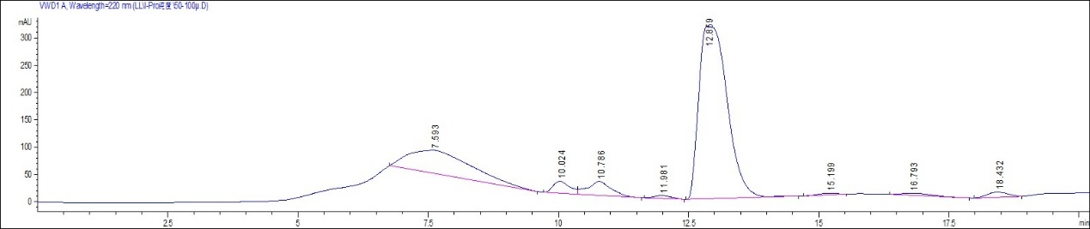
Figure S1. RP-HPLC chromatogram of I-Pro.

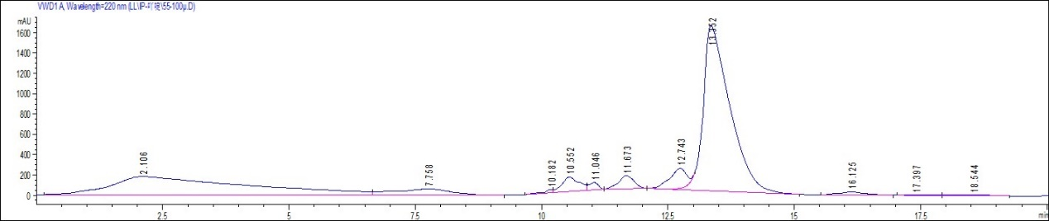
Figure S2. RP-HPLC chromatogram of I-Pro1.

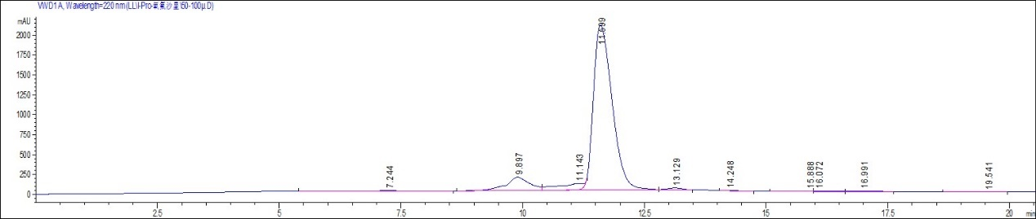
Figure S3. RP-HPLC chromatogram of I-Pro2.

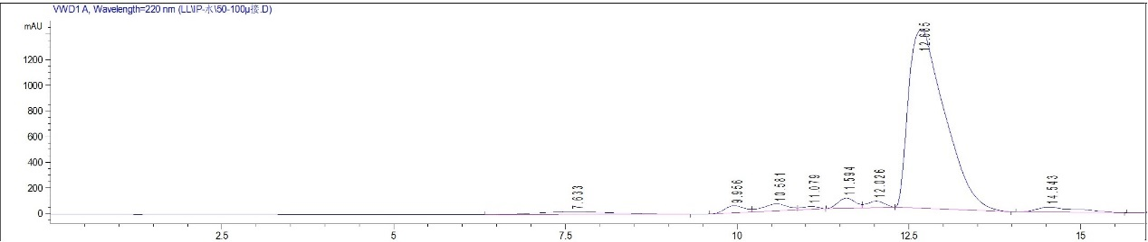
Figure S4. RP-HPLC chromatogram of I-Pro3.

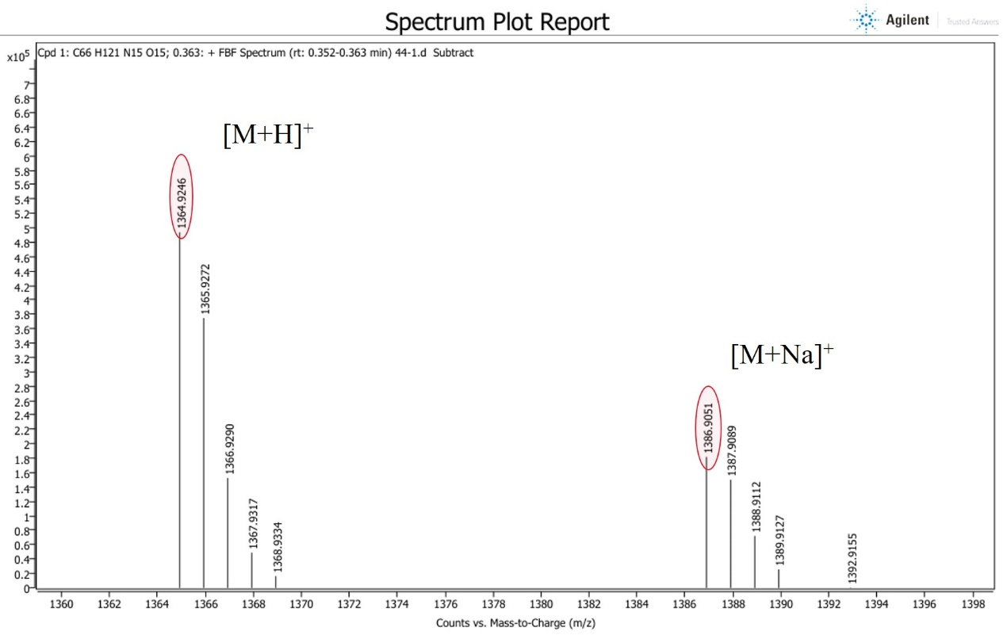 Figure S5. MS spectrum of I-Pro.

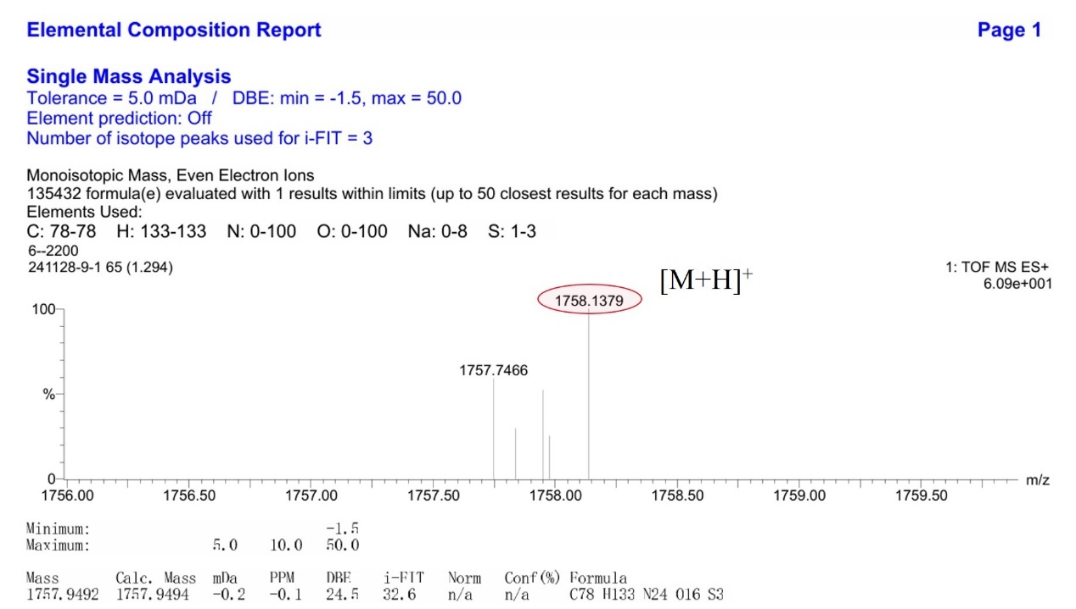
Figure S6. MS spectrum of I-Pro1.
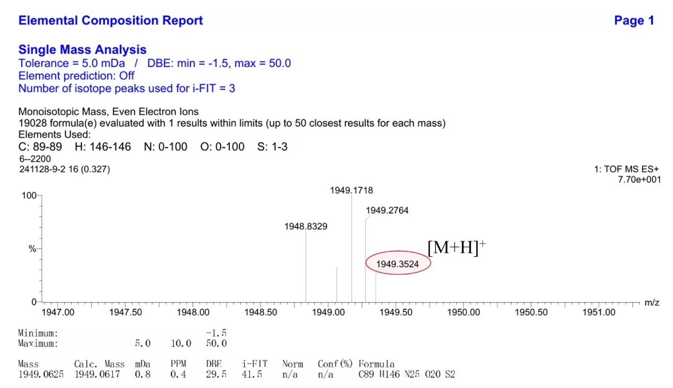
Figure S7. MS spectrum of I-Pro2.
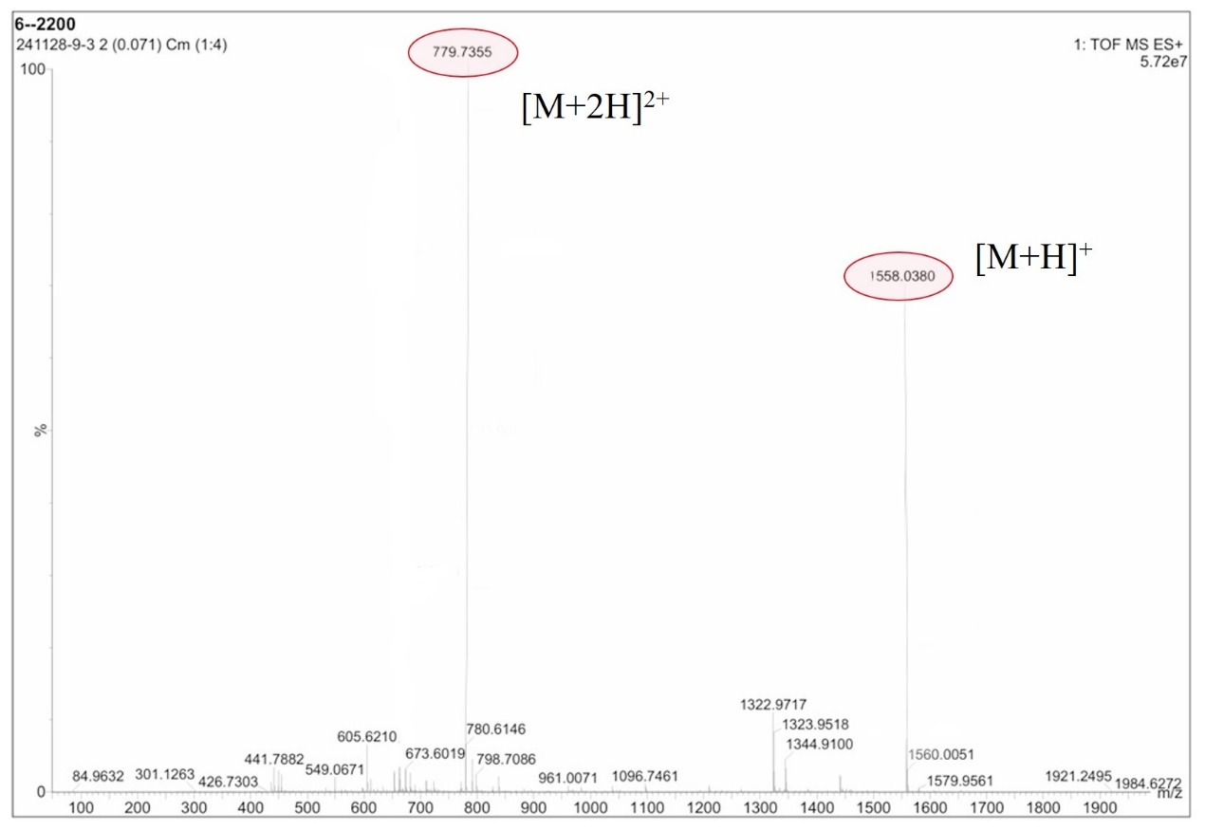
Figure S8. MS spectrum of I-Pro3.

