Supporting Information

Influence of Graphite on Lithiation-Induced Strain in Crystalline Silicon Anodes
Minsu Kim, Bumjoon Seo*
Department of Chemical and Biomolecular Engineering, Seoul National University of Science and Technology, 01811 Seoul, Korea
Email: bseo@seoultech.ac.kr

Computational Details and Data Analysis

In this study, two atomistic models were constructed to compare the lithiation behavior of crystalline Si with and without graphite. Group A represents a Li–graphite–Si composite system, whereas Group B is the control system obtained by removing the graphite layer from Group A, thereby placing Li and Si in direct contact. Group A contains 1,424 atoms, including 336 Si, 672 C, and 416 Li atoms, while Group B contains 752 atoms, including 336 Si and 416 Li atoms.
Non-periodic boundary conditions were applied along the x direction, while periodic boundary conditions were applied along the y and z directions. The Si region at x = 0–2 Å was fixed to prevent atomic motion during the simulations. The initial simulation box dimensions of Group A and Group B were 55.5 × 20.1 × 17.2 Å³ and 42.2 × 20.1 × 17.2 Å³, respectively.
Interatomic interactions were described using the MACE-OMAT-SMALL machine-learning potential,[1-2] and all molecular dynamics simulations were performed using LAMMPS.[3] The timestep was set to 1 fs. After energy minimization of the initial structures, the temperature was increased from 300 K to 600 K over 30 ps during a warm-up stage. During the warm-up stage, reflecting walls tailored to each system were applied to prevent premature interactions between the initial Li and Si or graphite regions. After the warm-up stage, the reflecting walls were removed and production simulations were performed at 600 K for 1 ns. During the production stage, the x direction was maintained as a free surface, while periodic boundary conditions were applied along the y and z directions, and trajectories were saved at 5 ps intervals. Five independent trajectories were generated for each system to ensure statistical reproducibility, and all analysis results were summarized using ensemble averages and standard deviations across the independent trajectories.
Post-processing of the simulation trajectories was performed using Python. Spatial number-density profiles of Si and Li and Si–Si and Si–Li coordination numbers were calculated using MDAnalysis and SciPy,[4-5] and the coordination numbers were evaluated using cutoff distances determined from the corresponding radial distribution functions. The Si–Si and Si–Li radial distribution functions were calculated using the RDF analysis functionality of MDAnalysis.[4] The tetrahedral order parameter was calculated using freud based on the four nearest Si neighbors of each Si atom,[6-7] and the Si region was divided into Inner, Middle, and Surface regions according to the initial atomic positions to compare their temporal evolution. The local Green–Lagrangian strain tensor was calculated using the Atomic Strain modifier in OVITO,[8] and the $E_{xx}$, $E_{yy}$ and $E_{zz}$ components were extracted for each Si atom to characterize local structural rearrangement and deformation.
Additionally, stress analysis was performed to examine the spatial distribution of the mechanical response during lithiation.[Figs. S1 and S2] Per-atom virial stress obtained from LAMMPS was used to calculate the stress within the Si domain over x = 2–18 Å,[3,9] and the stress change was determined relative to the initial state at 0 ns for each trajectory. The same analysis procedure was then applied to the five independent trajectories to obtain an ensemble-averaged stress distribution. The stress analysis showed that, in Group A, negative stress changes developed over a relatively broad Si region at approximately x = 10–15 Å as lithiation proceeded, whereas in Group B, positive stress changes were more pronounced in the surface-adjacent region at approximately x = 12–17 Å.
These results indicate that the mechanical response in Group A was distributed over a broader Si region, whereas Group B exhibited a more localized stress response near the surface in direct contact with Li. The stress analysis was performed as an additional analysis to examine these spatial differences and to provide supplementary support for the structural changes and Green–Lagrangian strain results presented in the main text.
The density, CN, RDF, tetrahedral order, and strain analyses used in this study were performed using individual Python scripts based on the same simulation trajectories. The final results were reported as averages and standard deviations across the independent simulations. These procedures enable the atomistic analyses presented in this study to be reproduced using the same initial structures, simulation conditions, and post-processing procedures.

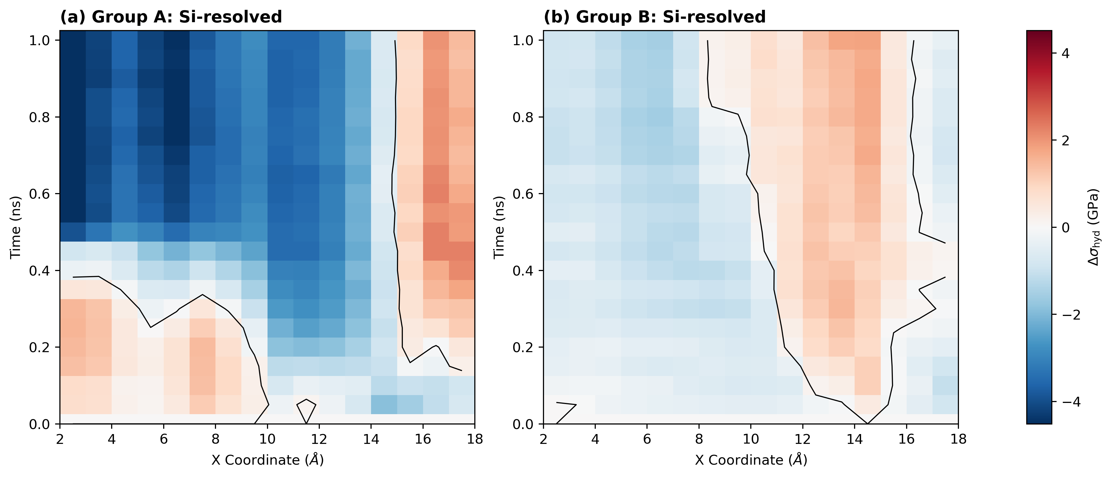
Fig. S1. Spatial and temporal evolution of Si-resolved hydrostatic stress change during lithiation in (a) Group A and (b) Group B.

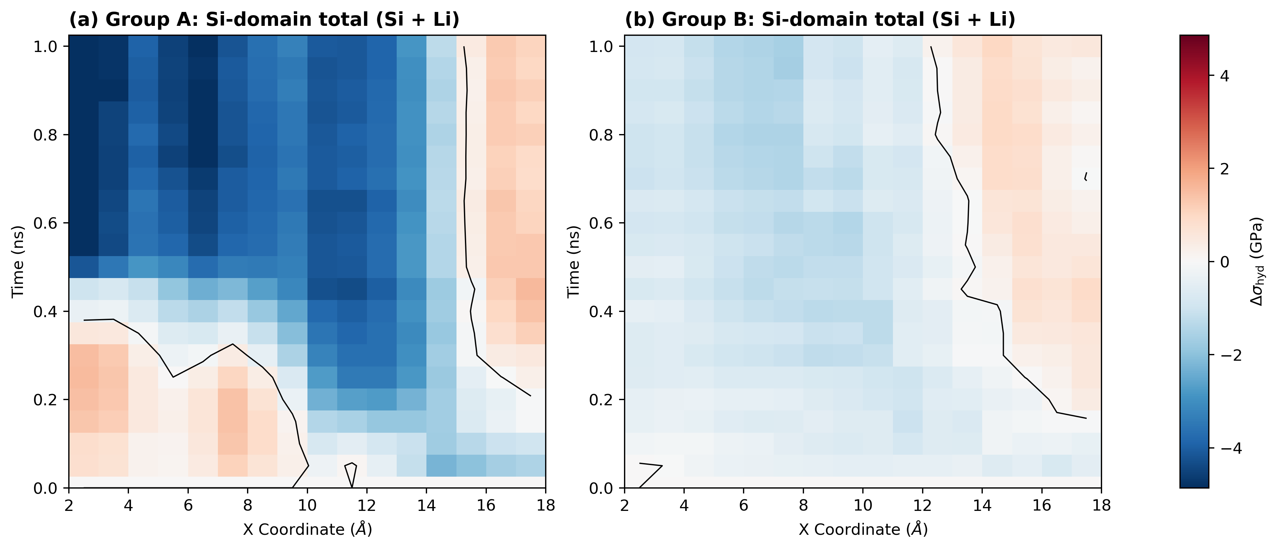
Fig. S2. Spatial and temporal evolution of hydrostatic stress change for the combined Si–Li domain during lithiation in (a) Group A and (b) Group B.

REFERENCES

1. Batatia, I., Kovács, D. P., Simm, G. N. C., Ortner, C. and Csányi, G., MACE: Higher Order Equivariant Message Passing Neural Networks for Fast and Accurate Force Fields, Adv. Neural Inf. Process. Syst., 35, 19715–19727(2022).

2. Barros-Luque, L., Shuaibi, M., Fu, X., Wood, B. M., Dzamba, M., Gao, M., Rizvi, A., Uyttendaele, M., Zitnick, C. L. and Ulissi, Z. W., The Open Materials 2024 (OMat24) inorganic materials dataset and models, Nat. Comput. Sci., 6, 642–652(2026).

3. Thompson, A. P., Aktulga, H. M., Berger, R., Bolintineanu, D. S., Brown, W. M., Crozier, P. S., in ’t Veld, P. J., Kohlmeyer, A., Moore, S. G., Nguyen, T. D., Shan, R., Stevens, M. J., Tranchida, J., Trott, C. and Plimpton, S. J., LAMMPS – a flexible simulation tool for particle-based materials modeling at the atomic, meso, and continuum scales, Comput. Phys. Commun., 271, 108171(2022).

4. Michaud-Agrawal, N., Denning, E. J., Woolf, T. B. and Beckstein, O., MDAnalysis: A Toolkit for the Analysis of Molecular Dynamics Simulations, J. Comput. Chem., 32(10), 2319–2327(2011).

5. Virtanen, P., Gommers, R., Oliphant, T. E., Haberland, M., Reddy, T., Cournapeau, D., Burovski, E., Peterson, P., Weckesser, W., Bright, J., van der Walt, S. J., Brett, M., Wilson, J., Jarrod Millman, K., Mayorov, N., Nelson, A. R. J., Jones, E., Kern, R., Larson, E., Carey, C. J., Polat, İ., Feng, Y., Moore, E. W., VanderPlas, J., Laxalde, D., Perktold, D., Cimrman, R., Henriksen, I., Quintero, E. A., Harris, C. R., Archibald, A. M., Ribeiro, A. H., Pedregosa, F. and van Mulbregt, P., SciPy 1.0: Fundamental Algorithms for Scientific Computing in Python, Nat. Methods, 17, 261–272(2020).

6. Ramasubramani, V., Dice, B. D., Harper, E. S., Hensley, H. E., Hernandez, A. D., Merna, A. and Sherman, Z. M., freud: A software suite for high throughput analysis of particle simulation data, Comput. Phys. Commun., 254, 107275(2020).

7. Chau, P.-L. and Hardwick, A. J., A new order parameter for tetrahedral configurations, Mol. Phys., 93(3), 511–518(1998).

8. Stukowski, A., Visualization and analysis of atomistic simulation data with OVITO–the Open Visualization Tool, Model. Simul. Mater. Sci. Eng., 18(1), 015012(2010).

9. Thompson, A. P., Plimpton, S. J. and Mattson, W., General formulation of pressure and stress tensor for arbitrary many-body interaction potentials under periodic boundary conditions, J. Chem. Phys., 131(15), 154107(2009).

