Mitochondria-associated endoplasmic reticulum membranes mediate heat stress-induced blood-testis barrier damage via ERS-driven paraptosis in goat Sertoli cells

Qiang Li^{1#}, Yaowen Liu^{1#}, Yinghuan Xu¹, Qian Liu¹, Yawen Han², Xin Shi¹, Jiawei Yang¹, Jiaxin Huang¹, Tengfei Liu^{1*}

¹College of Veterinary Medicine, Northwest A&F University, Yangling 712100, Shaanxi, P.R. China
²Shangzhou District Animal Husbandry and Veterinary Center, Shangluo ‌726000, Shaanxi, P.R. China

#Qiang Li and Yaowen Liu contributed equally to the work.

*Correspondence: Tengfei Liu, liutf@nwafu.edu.cn.

Author E-mail: Qiang Li, 2025060420@nwafu.edu.cn; Yaowen Liu, 1360503798@nwafu.edu.cn; Yinghuan Xu, x1648594086@163.com; Qian Liu, liuqian2025@nwafu.edu.cn; Yawen Han, hanyawen185@163.com; Xin Shi, 2023011292@nwafu.edu.cn; Jiawei Yang, 2024015725@nwafu.edu.cn; Jiaxin Huang, 770507247@nwafu.edu.cn; Tengfei Liu, liutf@nwafu.edu.cn
Full uncropped Gels and Blots image(s): The full-length gels and blots used in western blot analysis for Figure 1I.
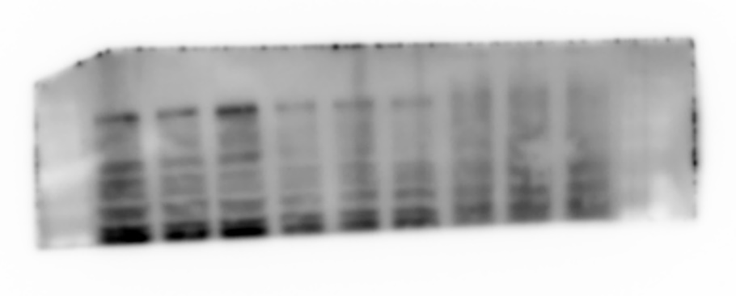

ZO-1

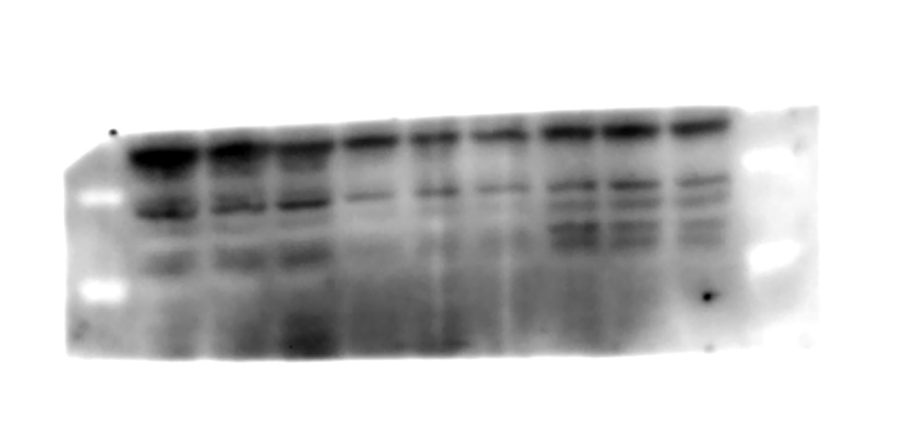

Occludin

Claudin-11

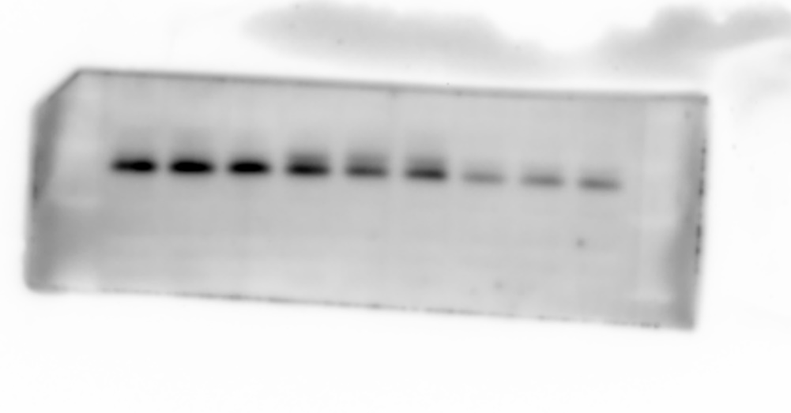

Connexin-43

N-cadherin

β-Actin

Full uncropped Gels and Blots image(s): The full-length gels and blots used in western blot analysis for Figure 2G.

ZO-1

Occludin

Claudin-11

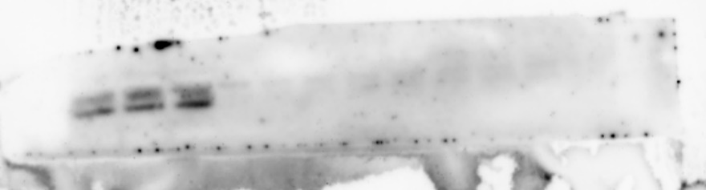

Connexin-43

N-cadherin

β-Actin

Full uncropped Gels and Blots image(s): The full-length gels and blots used in western blot analysis for Figure 3J.

Alix

β-Actin

Full uncropped Gels and Blots image(s): The full-length gels and blots used in western blot analysis for Figure 4F.

p-PERK

PERK

p-eIF2α

eIF2α

ATF4

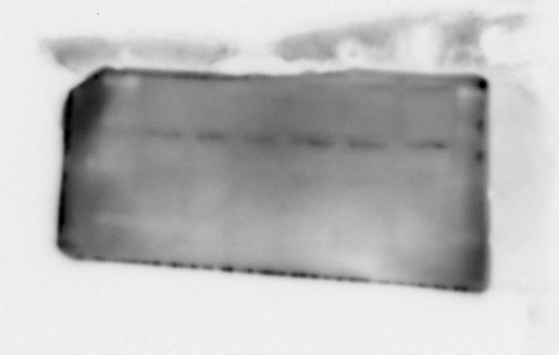

p-IRE1

IRE1

XBP1s

ATF6

GRP78

CHOP

β-Actin

Full uncropped Gels and Blots image(s): The full-length gels and blots used in western blot analysis for Figure 4K.

Alix

β-Actin

Full uncropped Gels and Blots image(s): The full-length gels and blots used in western blot analysis for Figure 4M.

Alix

β-Actin

Full uncropped Gels and Blots image(s): The full-length gels and blots used in western blot analysis for Figure 5F.

IP: IP3R

IP: GRP75

IP: VDAC1

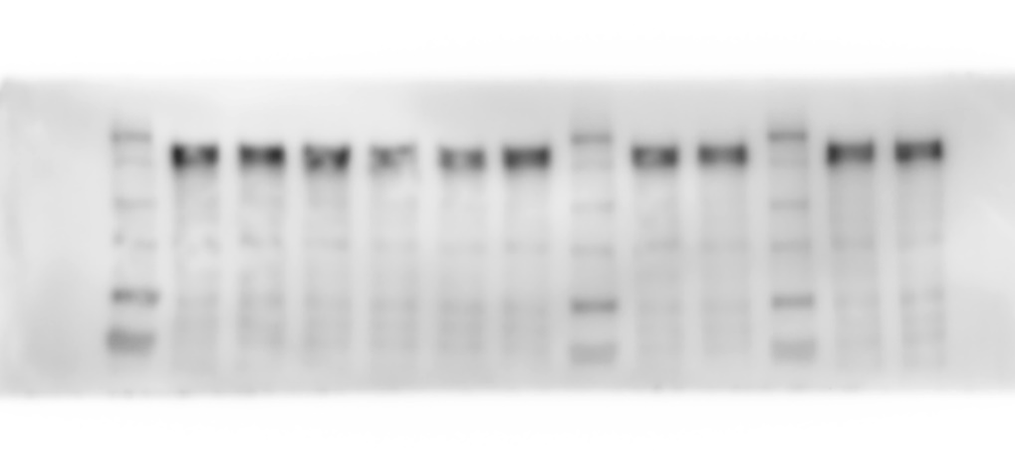

Input: IP3R

Input: GRP75

Input: VDAC1

β-Actin

IG: IP3R

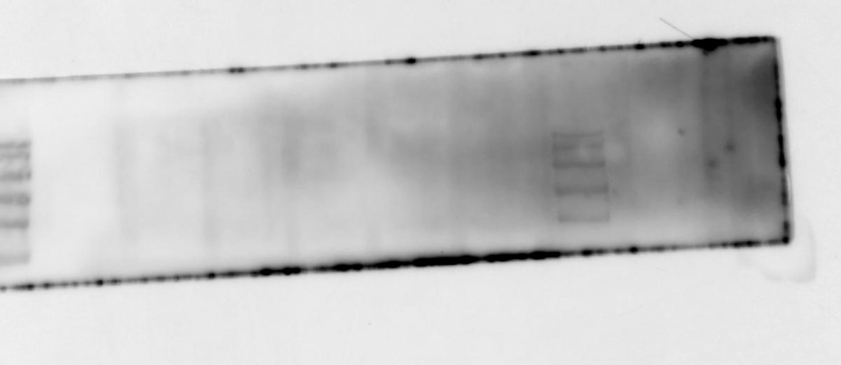

IG: GRP75

IG: VDAC1

Full uncropped Gels and Blots image(s): The full-length gels and blots used in western blot analysis for Figure 6H.

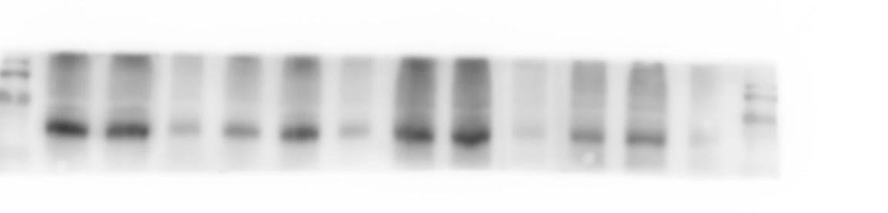

p-PERK

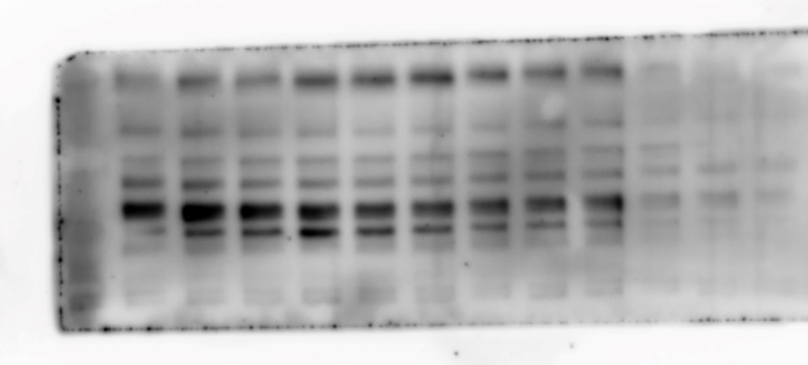

PERK

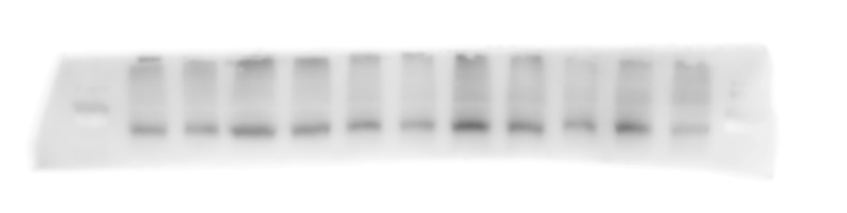

p-eIF2α

eIF2α

ATF4

GRP78

CHOP

β-Actin

Full uncropped Gels and Blots image(s): The full-length gels and blots used in western blot analysis for Figure 6L.

Alix

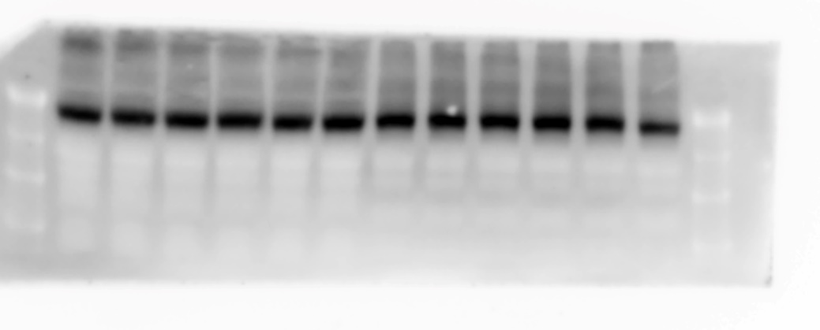

β-Actin

Full uncropped Gels and Blots image(s): The full-length gels and blots used in western blot analysis for Figure 7E.

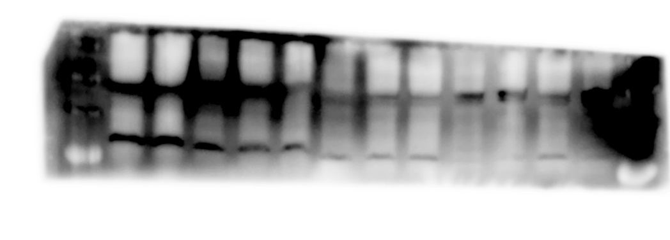

IP: IP3R

IP: GRP75

IP: VDAC1

Input: IP3R

Input: GRP75

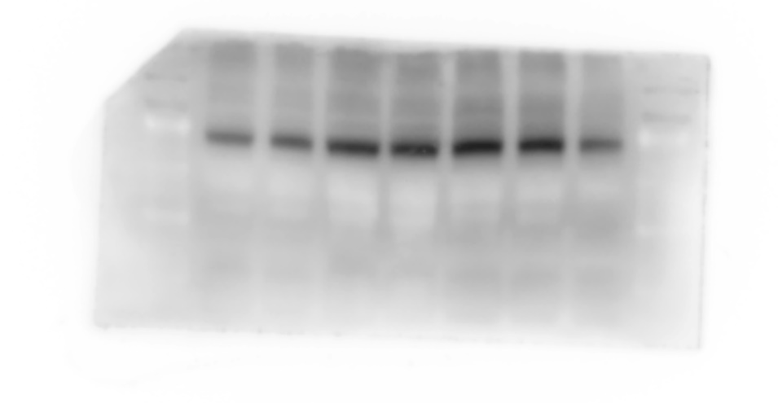

Input: VDAC1

β-Actin

IG: IP3R

IG: GRP75

IG: VDAC1

Full uncropped Gels and Blots image(s): The full-length gels and blots used in western blot analysis for Figure 7G.

p-PERK

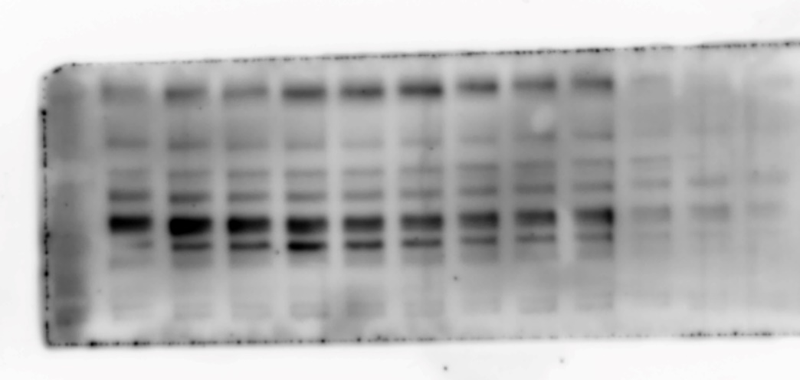

PERK

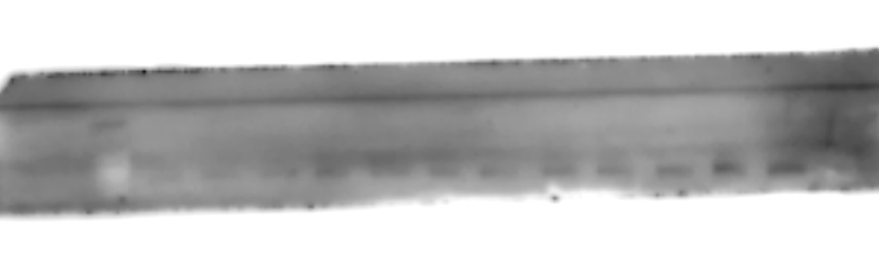

p-eIF2α

eIF2α

ATF4

GRP78

CHOP

Alix

β-Actin

Full uncropped Gels and Blots image(s): The full-length gels and blots used in western blot analysis for Figure S1A.

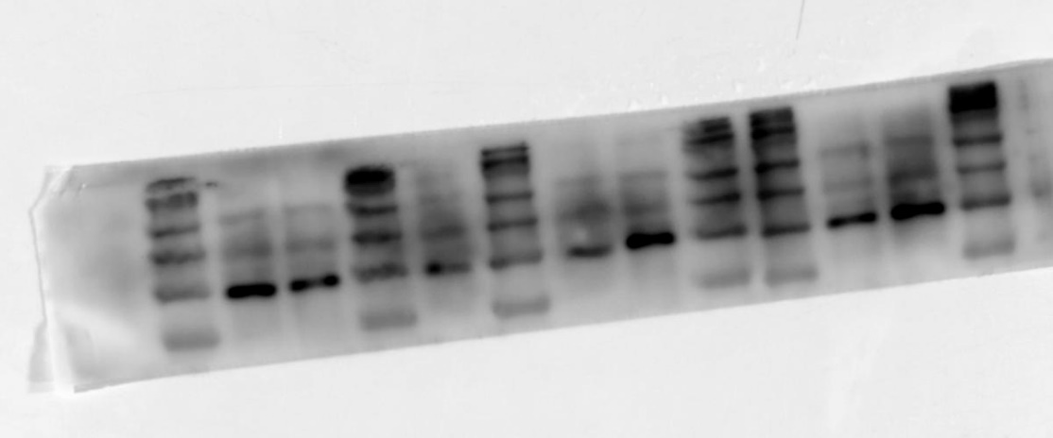

Alix

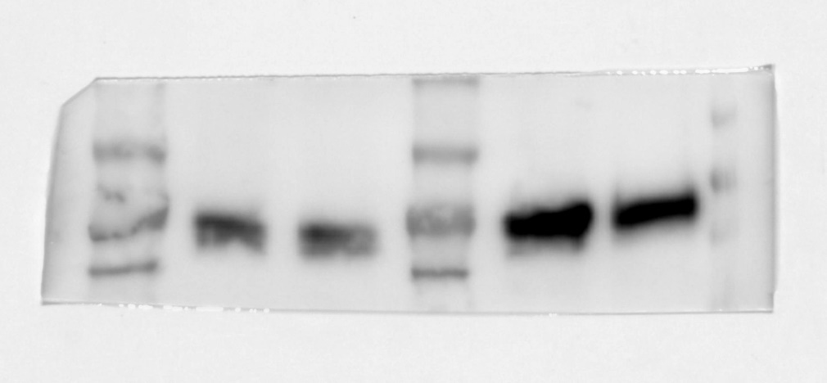

β-Actin

Full uncropped Gels and Blots image(s): The full-length gels and blots used in western blot analysis for Figure S2A.

GRP75

β-Actin

Full uncropped Gels and Blots image(s): The full-length gels and blots used in western blot analysis for Figure S4C.

PARP

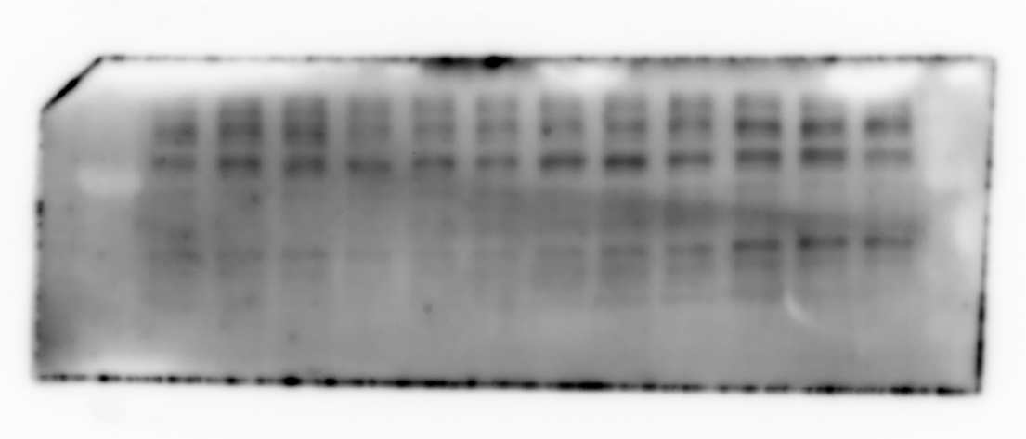

Caspase-3

β-Actin

Full uncropped Gels and Blots image(s): The full-length gels and blots used in western blot analysis for Figure S5B.

ATG5

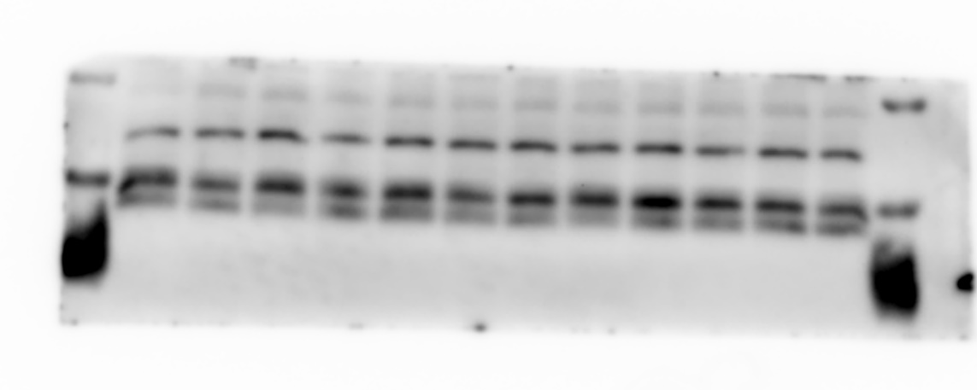

LC3

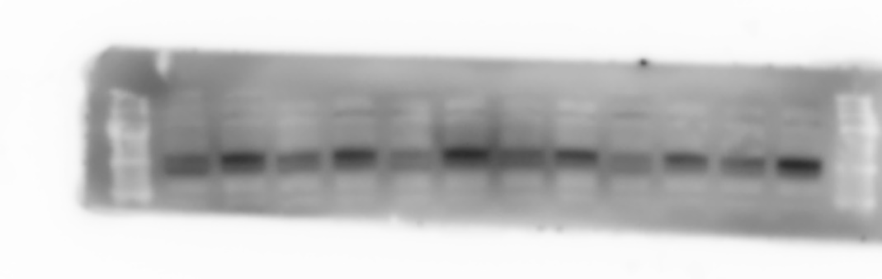

SQSTM1

β-Actin

