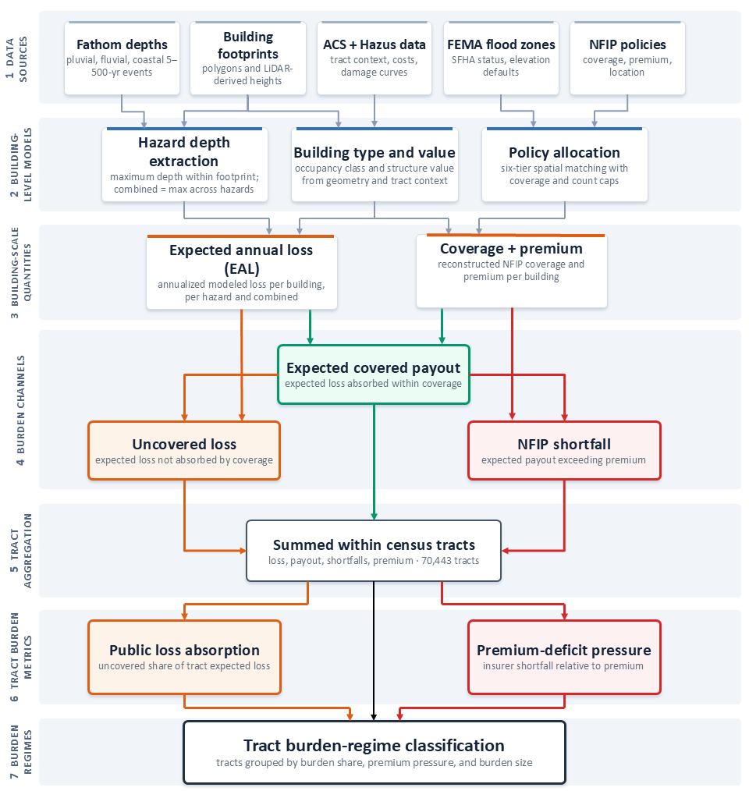
Extended Data Fig. 1 | Analytical workflow for reconstructing hazard-specific flood loss, insurance coverage and burden channels. The workflow proceeds from hazard, building, census, flood-zone and NFIP policy inputs through building-scale depth extraction, occupancy and valuation, policy allocation, loss estimation and annualization. Expected annual loss is divided into public shortfall and expected covered payout; covered payout is divided into premium-funded payout and NFIP shortfall. Building-level quantities are aggregated to census tracts for the burden-regime analysis.

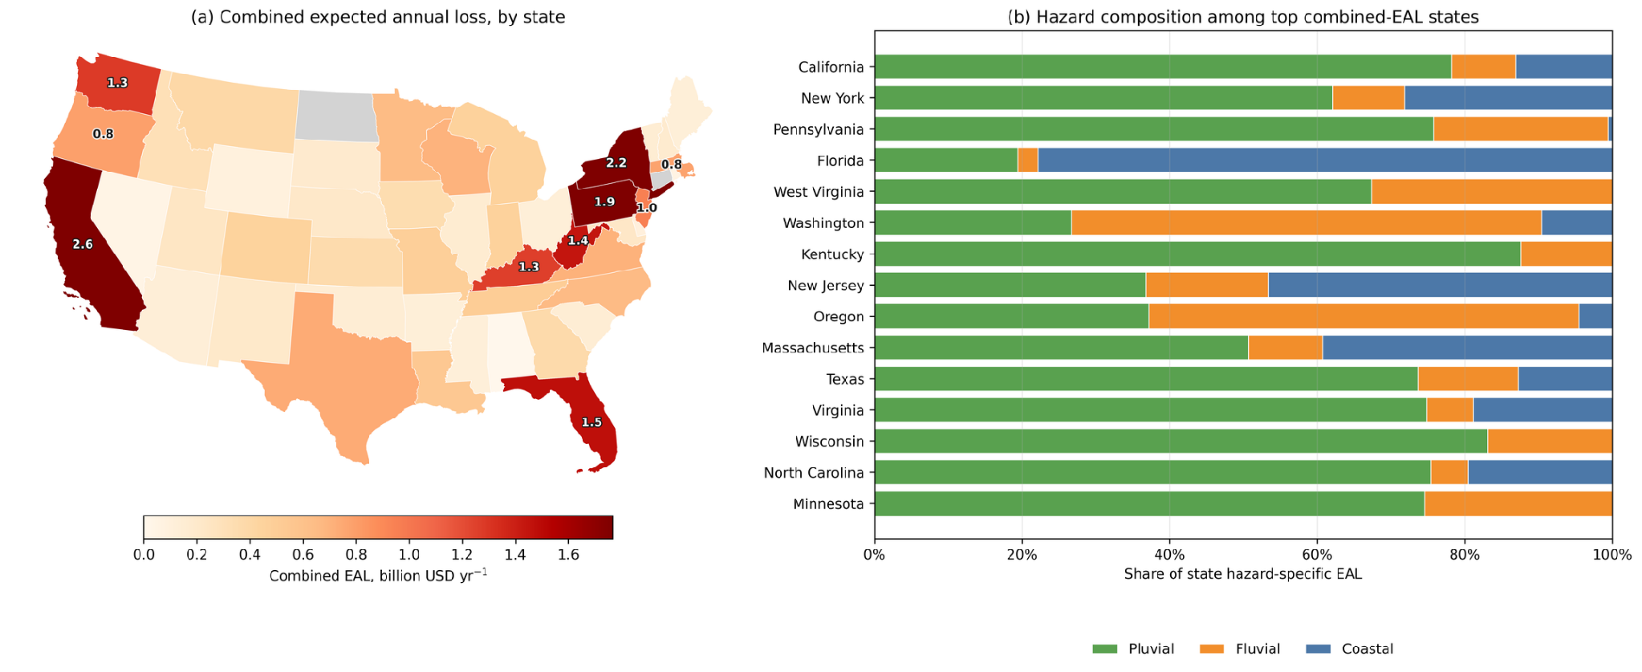
Extended Data Fig. 2 | State-level concentration and hazard composition of expected annual loss. Panel (a) maps combined-hazard EAL by state, in billion USD yr⁻¹, with the ten highest-loss states labelled. Panel (b) shows hazard-specific composition for the fifteen highest-loss states. Similar combined totals can arise from different hazard structures: Florida is coastal-dominant, Washington and Oregon are fluvial-dominant, and California and Texas have large pluvial components.

Extended Data Table 1 | Flood burden, exposure and insurance by hazard. The table reports exposed and insured buildings, expected annual loss, expected covered payout, public shortfall, NFIP shortfall and the location of public shortfall relative to FEMA Special Flood Hazard Area (SFHA) zones. Combined values use the maximum hazard-specific depth at each return period and are not the sum of the hazard rows. Channel percentages are shares of hazard-specific EAL; NFIP shortfall is the sum of positive building-level gaps between expected covered payout and the allocated building-coverage risk premium.
Metric | Pluvial | Fluvial | Coastal | Combined
Exposed buildings (positive EAL) | 4,890,253 | 1,472,944 | 1,624,810 | 7,506,151
Insured exposed buildings | 767,661 | 294,086 | 958,021 | 1,866,757
Insured share of exposed buildings | 15.7% | 20.0% | 59.0% | 24.9%
Expected annual loss ($B yr-1) | 17.11 | 5.32 | 3.88 | 25.67
Expected covered payout ($B yr⁻¹) | 2.26 | 0.78 | 1.94 | 4.8
Public shortfall ($B yr-1) | 14.84 | 4.53 | 1.94 | 20.87
NFIP shortfall ($B yr-1) | 1.87 | 0.60 | 1.24 | 3.59
Public shortfall (% of EAL) | 86.8% | 85.3% | 50.0% | 81.3%
NFIP shortfall (% of EAL) | 10.9% | 11.3% | 32.1% | 14.0%
Uncovered-loss share among insured | 17.6% | 33.4% | 22.1% | 22.5%
Public shortfall outside SFHA zones | 78.4% | 59.0% | 35.8% | 70.9%

Extended Data Table 2 | Input data and analytical scope. Processed inventory, spatial units, and the data sources and key parameters used in the building-to-tract reconstruction. The complete processing audit, including all thresholds and allocation rules, is reported in Supplementary Methods A1–A8 and Supplementary Table S10. Buildings with reconstructed NFIP coverage (3,300,588, or 25.5% of processed records) count every processed building carrying at least one allocated policy, including buildings whose combined-hazard expected annual loss is zero; the 1,866,757 insured exposed buildings in Extended Data Table 1 are the subset with positive combined-hazard expected annual loss.
Item | Value
Building records processed (CONUS, modeled inundation) | 12,932,146
Buildings with positive combined-hazard EAL | 7,506,151
Buildings with reconstructed NFIP coverage | 3,300,588 (25.5% of processed)
Census tracts (building-level dataset) | 76,659
Census tracts (tract-level layer) | 83,954
Census tracts classified into burden regimes | 74,240
Hazard model | Combined Fathom-type model⁷, ~30 m
Return periods used for annualization | 5, 10, 100, and 500 yr; depths interpolated in log-return-period space on a 33-point grid spanning 5 to 500 years, with trapezoidal integration over annual exceedance probability
First-floor elevation model | Surveyed Elevation-Certificate first-floor heights; county x occupancy x zone-family stratum medians with state and national fallbacks; central scenario (stratum quartiles define the low and high scenarios)
Exposure and vulnerability | Building footprints and heights; Hazus occupancy prototypes and replacement values; ACS priors (Tables S2504 and B25034)
Insurance coverage | OpenFEMA NFIP policy records; tiered spatial allocation; coverage cap of 1.10 times estimated replacement value
SFHA definition | FEMA flood zones beginning with A or V
Burden regimes | Four empirical regimes classified by burden level and insurance state (minor burden, uninsured; minor burden, some coverage; major burden, mostly uncovered; major burden, substantially insured); Gaussian mixture model on public loss absorption, log premium-deficit pressure, and log total burden, with composition-based label assignment
Full processing audit | Supplementary Methods A1–A8; Supplementary Table S10

Extended Data Table 3 | Empirical burden regimes and burden concentration. Summary of tract counts, regime-defining metrics, burden totals and concentration ratios under the combined hazard layer.
Regime | Tracts (share) | Median PLA / PDP | Median burden | Public / NFIP shortfall | Conc. public / NFIP
Minor burden, uninsured | 17,882 (24.1%) | 1.000 / 0.000 | $23.95K | $1.96B / $511 | 0.39 / 0.00
Minor burden, some coverage | 5,747 (7.7%) | 0.916 / 0.000 | $5.16K | $126.73M / $192.41K | 0.08 / 0.00
Major burden, mostly uncovered | 21,197 (28.6%) | 0.927 / 0.926 | $214.77K | $12.89B / $684.57M | 2.16 / 0.67
Major burden, substantially insured | 29,414 (39.6%) | 0.457 / 1.266 | $54.31K | $5.89B / $2.91B | 0.71 / 2.04
Notes: Paired entries are ordered PLA / PDP, public / NFIP shortfall and public / NFIP concentration. PLA is public loss absorption; PDP is premium-deficit pressure. Higher PLA indicates that a larger share of tract-level expected annual loss remains uncovered, while higher PDP indicates greater NFIP shortfall relative to allocated written policy cost. Concentration is each regime’s share of burden among classified tracts divided by its tract share; values above one indicate disproportionate concentration. Concentration ratios do not use the national building-level totals in Extended Data Table 1.

