Supplementary Information
Hazard-specific pathways shape the flood protection gap in the USA

Part A. Supplementary Methods: building-scale reconstruction of flood burden and tract-level burden regimes

A1. Analytical overview
The analysis reconstructs hazard-specific flood loss, observed National Flood Insurance Program (NFIP) coverage, and the resulting burden channels for individual buildings across the contiguous United States, and then aggregates the building-level quantities to census tracts. The workflow proceeds in seven stages: assembly of building-scale hazard depths from a multi-hazard flood model; assignment of occupancy prototypes and replacement values from building geometry, Hazus inventory data and American Community Survey priors; reconstruction of building-level NFIP coverage and written policy cost through a tiered spatial allocator applied to observed policy records; assignment of first-floor heights from surveyed Elevation Certificate records; estimation of hazard-specific event losses on a structure replacement-cost basis, including explicit below-grade and elevated-enclosure pathways; annualization of event losses by integration of the exceedance-loss curve; and aggregation to census tracts followed by an empirical burden-regime classification.
The processed building-level dataset contains 12,932,146 records within the modeled hazard domain. Exposed buildings are the subset with positive expected annual loss for the hazard layer under analysis, 7,506,151 under the combined layer. Buildings that lie within the modeled hazard domain but return zero expected loss once first-floor heights are applied remain in the dataset and can carry allocated policies, but they do not enter exposure-based shares. This distinction accounts for the difference between the 3,300,588 buildings holding reconstructed coverage and the 1,866,757 insured exposed buildings reported in the main text, and it is quantified in Section D5.
Buildings in Alabama, Connecticut and North Dakota were not carried through the upstream building-to-tract assignment and are absent from the processed inventory: across the 740 processed hazard tiles, three buildings are attributed to Alabama and none to Connecticut or North Dakota. National totals therefore exclude these three states and are conservative to that extent. The omission is noted wherever state-level results are reported, and the affected states appear as no-data areas in the national maps.

A2. Data foundations

A2.1. Flood-hazard fields
Hazard depths were taken from the Fathom United States flood model, which produces high-resolution pluvial, fluvial and coastal inundation layers at 30 m grid resolution and has been described and evaluated in prior peer-reviewed United States applications. The defended layers were used throughout, so the depth fields incorporate the model's representation of known flood defences. Depths are provided at the 5-, 10-, 100- and 500-year return periods, in feet, and all four layers enter the loss integration.
Building-scale flood depth is the maximum modeled depth within each building footprint rather than a centroid or footprint-average value, which preserves localized high-depth cells that averaging would remove. For integrated multi-hazard loss estimation, a combined depth is defined at each return period as the maximum across the three hazard-specific depths. The combined layer is a non-additive measure of integrated exposure that counts each building once where the pluvial, fluvial and coastal layers overlap; it is not a compound-event simulation.
Two properties of the hazard input bear directly on how the results should be read. The pluvial layers embed design-standard drainage assumptions through an effective-rainfall formulation, so urban drainage is represented implicitly rather than omitted; Section D7 reports a bound in which the first 0.2 m of pluvial depth is removed to represent localized departures from those assumptions. Separately, rainfall-driven flooding in small headwater channels is carried partly within the pluvial layer, because separating surface-water from fluvial inundation in headwater valley bottoms is not well posed at this resolution. The pluvial–fluvial division reported here is therefore model-defined: the pluvial total includes some small-channel fluvial loss, and the fluvial total is correspondingly a lower bound on riverine processes. Comparisons of the hazard-specific totals with estimates produced under other national models should be made with this convention in mind, because vendors differ in where they place that boundary.

A2.2. Building footprints, heights and census geography
Building exposure was represented using footprint polygons with associated maximum building heights from a national building-footprint and height dataset. Each building was assigned a planimetric footprint area from its polygon geometry and a maximum height, from which a story count and gross floor area were inferred. This geometry supports occupancy-prototype assignment, provides the floor-area basis for replacement-value estimation and for the policy-count constraint in the allocator, and supplies the ceiling used to cap above-floor inundation depth. Buildings were assigned to census tracts by spatial location, and tracts are used throughout as the standardized aggregation unit. The National Structure Inventory and related United States Army Corps of Engineers documentation were used as national inventory support for structure classification and harmonization.
Aggregation to census tracts is an analytical choice with a specific statistical purpose. High-resolution flood models carry appreciable local error at the scale of an individual 30 m cell, but local over- and under-prediction are largely uncorrelated at short range and therefore cancel substantially when summed over an area. Published evaluations of models in this family report mean absolute errors in flooded fraction falling to the order of a few per cent once predictions are aggregated to cells of about one square kilometer. Census tracts are considerably larger than this across almost all of the country; their area distribution is reported in Table S13. The tract-level quantities that carry the analysis are therefore expected to be substantially more reliable than any individual building-scale prediction, and the comparisons drawn in the main text are between tracts rather than between buildings.

A2.3. Hazus inventory and depth-damage relationships
Prototype-specific unit replacement costs were taken from the Hazus inventory, using the structure value that excludes contents, with missing tract-prototype values imputed from state-level medians for the same prototype. Above-floor depth-damage relationships are Hazus-family piecewise-linear functions by occupancy prototype. Below-grade relationships are the United States Army Corps of Engineers generic structure functions published in Economic Guidance Memorandum 04-01, estimated from post-flood damage records. The complete above-floor and below-grade curve tables as implemented are reproduced in Tables S27 and S28, and the prototype mapping and multipliers in Table S29, so that the damage model can be reproduced exactly.

A2.4. American Community Survey priors
Tract-level occupancy priors and housing-age information were taken from the American Community Survey, specifically Tables S2504 and B25034. The occupancy prior regularizes the geometry-based prototype assignment, and the age cohort informs the housing-value and depreciation adjustments applied to unit replacement cost.

A2.5. Flood-zone information and the treatment of unmapped areas
Flood-zone status was taken from FEMA's National Flood Hazard Layer. Designations beginning with V define the V family and designations beginning with A define the A family; together these constitute the Special Flood Hazard Area (SFHA)-like zones used throughout. All other designations, including mapped X zones, Zone D, and records with missing or absent designations in areas without digitized coverage, are grouped with the X family and treated as outside the mapped SFHA.
This convention has a consequence that must be stated plainly, because it bears on the outside-SFHA shares reported in the main text. The National Flood Hazard Layer is assembled from community-level studies and is not a seamless national coverage: it contains gaps, overlapping panels and areas that have never been digitized, and obtaining and cleaning it requires substantial manual effort. Its topology was not manually corrected here, and buildings in areas without digitized coverage are counted as outside the SFHA by construction rather than by evidence. Table S22 therefore decomposes outside-SFHA public shortfall into the portion falling in mapped non-SFHA zones and the portion falling in areas with missing or absent designations, so that readers can judge how much of the result rests on mapped evidence. All SFHA-related quantities in this study inherit the coverage limitations of the underlying layer.

A3. Occupancy prototype assignment
Each building was assigned to a Hazus occupancy prototype through a Bayesian fusion of geometry-based likelihoods and tract-level prior information. For each candidate prototype, a geometry likelihood was computed from reference intervals for footprint area, story count and gross floor area, and combined with the tract-level occupancy prior derived from American Community Survey Table S2504. Each building was assigned the maximum a posteriori prototype, so that local tract context regularizes the assignment while building-scale geometric evidence is preserved. The procedure follows established machine-learning approaches to estimating building occupancy from open-source data. Prototype assignment is an inference rather than an observation, and misassignment propagates into replacement value, into the depth-damage family applied and into the policy-count constraint. It is carried as a limitation in Part F rather than as a quantified uncertainty, because no national ground-truth occupancy dataset exists against which it could be scored.

A4. Replacement value estimation
The Hazus unit replacement cost for each building's tract and prototype was adjusted in four bounded steps. A local housing-value correction scaled the unit cost by the ratio of tract- to state-level median values for the building's age cohort. A vertical adjustment was applied for buildings taller than the canonical storey count of their prototype. An age factor, bounded between 0.05 and 1, approximated depreciated structural value. Tile-level winsorization of the resulting value basis limited the influence of sparse prototype assignments and extreme geometry, following standard robust-estimation practice.
Because the loss model is applied to full, undepreciated structure replacement cost — consistent with Hazus practice and with NFIP replacement-cost settlement for primary residences — the depreciation applied upstream is reversed before loss estimation by dividing the adjusted value by the bounded age factor. The resulting value excludes land, which is not insurable, and excludes contents throughout. The national structure replacement-value basis is $6.14 trillion, against which the central combined-hazard expected annual loss corresponds to an annual damage rate of 0.418% of structure value. As an external plausibility check, relative spatial patterns in selected Austin, Texas tracts were compared with the publicly available Zillow Home Value Index; the comparison was used only to assess whether the reconstructed value surface reproduces sensible relative patterns across neighborhoods, and was not used to calibrate, rescale or validate individual building values.

A5. NFIP policy filtering and building-level allocation
The OpenFEMA NFIP redacted policy files provide policy-level coverage, written policy cost, surveyed elevation and geocoded location information, but they do not identify an insured building footprint directly. Building-level coverage and written policy cost were therefore reconstructed by assigning observed policy records to physical buildings through a tiered spatial allocator. Because the NFIP is the dominant observed public flood-insurance portfolio, these records capture the main public flood-insurance structure; privately underwritten and surplus-lines flood policies are not observed in these files and are treated as a limitation rather than as evidence of zero private coverage.

A5.1. Policy filtering and capacity constraints
Policy records were retained where building coverage was positive, and duplicates were removed on the policy identifier. Allocation was applied only to buildings within the processed inundation inventory. Each candidate assignment had to satisfy two capacity constraints. The first is a coverage cap set at 1.10 times the building's estimated replacement value. The second is a prototype-specific policy-count cap, computed as gross floor area divided by a prototype-specific floor area per policy and then capped at a prototype maximum: 2,200 ft² per policy and a maximum of one policy for single-family prototypes, 1,800 ft² and up to six to eight policies for multi-family prototypes, and 4,800 ft² and up to eight to twenty policies for commercial prototypes, with a global fallback of 2,000 ft² per policy and fifty policies for unmatched prototypes. An assignment was admissible only if it violated neither constraint.
These constraints govern where an observed policy may be placed; they do not create coverage. The coverage amounts carried into the loss calculation are the observed policy values, so the statutory NFIP building-coverage limits of $250,000 for residential and $500,000 for non-residential structures are embedded in the reconstruction rather than imposed by it. Section D8 reports how strongly those statutory limits bind in the reconstructed portfolio.

A5.2. Tiered allocation procedure
Policies were assigned in six tiers, ordered from strongest to weakest spatial evidence, with residential-status consistency enforced where indicated and the capacity constraints enforced throughout. Tier 0 performs a buffered footprint match, joining policy points to a 10 m buffer around each footprint. Tier 1 performs strict footprint containment with residential-status consistency required. Tier 2 matches remaining policies to the nearest eligible building centroid within a 200 m upper bound. Tier 3 assigns remaining policies within the same census tract and rated flood zone through three deterministic sub-passes, requiring first matching building type and storey class, then matching building type alone, and finally neither. Tier 4 assigns remaining policies by stochastic selection among open buildings, considering up to 512 nearby candidates per policy with weights proportional to the product of inverse distance and a risk term equal to one plus the building's 100-year fluvial depth normalized by the tile maximum; a first sub-pass requires the building type implied by the policy's building-description code and a second relaxes it. Tier 5 is a within-tract highest-risk fallback used after the stronger tiers are exhausted, first requiring type consistency and then relaxing it. The stochastic tiers use a fixed random seed of 42.
Tier-level assignment counts are reported in Table S11, and their distribution is itself a result worth stating. Fewer than one policy in a thousand could be matched by direct or buffered footprint containment, because coordinates in the redacted policy files are spatially generalized rather than precise. Deterministic within-tract and flood-zone passes placed 69.2% of policies, and the two stochastic tiers placed the remaining 30.7%. The reconstruction is therefore well constrained at tract scale, where each policy is placed within its observed tract and rated zone, and correspondingly weak at the scale of any individual building. This is the principal reason the main text reports tract-level geography and channel shares rather than building-level attributions, and it should be read alongside the aggregation argument in Section A2.2.

A5.3. Reconstructed coverage and written policy cost
After allocation, each building accumulated reconstructed coverage as the sum of assigned building-coverage amounts and reconstructed written policy cost as the sum of assigned annual policy costs. Across the processed dataset, 3,300,588 buildings received reconstructed coverage, corresponding to 25.5% of processed records, holding $740.7 billion of building coverage and $4.53 billion of annual written policy cost across 3,412,456 assigned policy records. These are reconstructed building-level assignments derived from observed policy records; they are neither observed parcel-level contracts nor optimal-coverage allocations.

A6. First-floor height from surveyed Elevation Certificates
First-floor height determines how much floodwater reaches the occupied part of a building and is the single most consequential exposure parameter in the loss chain. It was derived from surveyed measurements rather than assumed. NFIP policy records include two Elevation Certificate quantities, the elevation of the lowest floor and the elevation of the lowest adjacent grade; their difference is the height of the reported lowest floor above local grade.
Strata were formed by county, occupancy class (residential or non-residential) and A/V/X flood-zone family. A stratum was used when it contained at least 100 measurements; assignment otherwise fell back to state by occupancy and zone family, then to state by occupancy, and finally to the national distribution. Under this hierarchy 37.1% of study buildings received a county-level estimate, 37.9% a state-by-zone-family estimate, 25.0% a state-level estimate and fewer than 0.1% a national estimate. The stratum median provides the central specification and the first and third quartiles define the low and high scenarios reported in Part D. The resulting assignment reproduces known construction patterns, with a mean first-floor height of 8.76 ft in V zones, where pile elevation above base flood elevation is required, against 2.17 ft in A zones and 1.37 ft in X zones. Representative strata are reported in Table S26.
Elevation Certificates are held disproportionately by insured, post-FIRM properties in mapped flood zones, so the X-zone strata are thinner than the A- and V-zone strata and the surveyed population is not a random sample of the building stock. This selection is not corrected; it is declared, and its consequence is bounded by carrying the stratum quartiles through the sensitivity analysis, where they generate the widest range of any single specification choice.

A7. Event-loss estimation
Direct event loss was estimated separately for the pluvial, fluvial, coastal and combined hazard layers. Effective depth above the first floor is the modeled depth minus the assigned first-floor height, truncated below at zero and truncated above so that depth above the first floor does not exceed the available building height above that floor. Above-floor damage applies the Hazus-family piecewise-linear curve associated with the building's prototype family, scaled by a prototype multiplier. Three curve families are used—for single-family residential, multi-family residential and commercial prototypes, with all non-residential prototypes mapped to the commercial family—and the multipliers range from 1.10 for single-family prototypes to 0.90 for industrial and warehouse prototypes. The curves are published in Table S27 and the prototype mapping and multipliers in Table S29. No global rescaling was applied to any damage function and no parameter was calibrated to reproduce an external loss total; the prototype multipliers are fixed structural constants of the damage model, not fitted quantities.
Damage below the first floor is represented explicitly. The below-grade increment at a given water level is the difference between the Economic Guidance Memorandum 04-01 with-basement and without-basement structure functions evaluated at the same depth relative to the first floor, selected by story class, and is active only when the building is inundated. Because no national inventory records which individual buildings have basements, basement presence was assigned by a Bernoulli draw with a fixed seed of 12345 against a local prevalence: the observed share of basement-type foundation codes among NFIP records in the building's county-by-occupancy stratum where at least 100 records exist, falling back to the state stratum where at least 50 records exist, and then to the Census Survey of Construction basement share for the building's census division for residential buildings or a national non-residential share of 16.7%. Divisional prevalence ranges from 2% in the West South Central division to 64% in the West North Central division and is reported in Table S30. Under the central seed, 3,110,951 buildings (24.1%) carry a basement.
Two properties of this pathway should be read together. It is quantitatively important: removing it entirely lowers combined expected annual loss from $25.67B to $15.22B, so it accounts for roughly two fifths of the national total, concentrated in the colder inland divisions where basements are prevalent and where exposed buildings are least often insured. It is also the pathway with the weakest observational support, because prevalence is inferred from the same Elevation Certificate population that is selected toward insured properties in mapped zones. Re-drawing the assignment under an alternative seed changes national expected annual loss by $0.006B and is reported in Part D for completeness, but that test bounds only the sampling variability of the draw and not the accuracy of the underlying prevalence. The exclusion row in Table S14 is the honest bound on this pathway.
Buildings with assigned first-floor heights of four feet or more additionally accrue damage to the enclosure, foundation and service equipment beneath the elevated floor. This component is set at one tenth of structure value and increases in proportion to the fraction of the grade-to-floor space filled by water. The total damage ratio is the sum of the above-floor, below-grade and enclosure components, bounded between zero and one, and direct event loss is that ratio multiplied by structure replacement value.

A8. Annualization, burden channels and tract-level metrics
Expected annual loss was obtained by integrating the exceedance-loss curve. Because only four return periods are modeled, the depth sequence for each building and hazard was first constrained to be non-decreasing with event severity, then interpolated between the available layers in log-return-period space onto a 33-point grid spanning 5 to 500 years. Event losses were evaluated at each grid point and integrated over annual exceedance probability by the trapezoidal rule, with events rarer than the 500-year layer carried at the 500-year loss. The logarithmic transformation applies to the interpolation of depths between layers; the integration itself is trapezoidal in annual exceedance probability. Events more frequent than the 5-year layer are not represented in the hazard fields, which is conservative for regions whose losses concentrate in frequent, low-severity flooding.
Expected covered payout applies a representative per-event deductible of $1,500 to each event loss and caps the remainder at reconstructed building coverage, annualized on the same grid and by the same rule. The deductible is a single global constant: NFIP minimum deductibles range from approximately $1,000 to $2,000 and optional deductibles reach $10,000, so the value used is at the low end of the observed range and the resulting payout estimate is correspondingly generous to the insured channel. Section D3 reports the sensitivity of every channel to this choice across the full observed range.
Building-level public shortfall is expected annual loss minus expected covered payout, and therefore contains three distinct components: loss on buildings holding no coverage at all, the portion of an insured loss absorbed by the deductible, and the portion of an insured loss exceeding available coverage. These are separated in Section D4, which addresses coverage adequacy directly rather than through a premium comparison.
The premium base was adjusted toward the building-only scope of the modeled payouts. Because the modeled payouts are building-coverage payouts, while written policy cost contains components associated with both building and contents coverage as well as federal fees and surcharges, the allocated policy cost of each building was multiplied by two state-level ratios: the share of written policy cost constituting insurance premium, 0.8174 nationally, and the building share of combined building-and-contents coverage, 0.8100 nationally. Their product places the building-coverage risk-premium base at 66.2% of written policy cost, or $2.99 billion per year against $4.53 billion of allocated policy cost. State-level ratios are reported in Table S32. Two features of this construction should be stated. The building share is a coverage-weighted ratio applied to premium, which assumes that building and contents premium are proportional to their respective coverage amounts within a state; the policy files do not report the split directly. The resulting base is not a pure actuarial risk premium because expense, underwriting and increased-cost-of-compliance components cannot be separated from the available fields. To the extent that such components remain in the base, the NFIP shortfall estimated against it is conservative.
Building-level NFIP shortfall is the positive part of expected covered payout minus this allocated risk-premium base. Because it takes only positive gaps, it does not net premium surpluses on one building against deficits on another; the corresponding net quantity, aggregate expected payout minus the aggregate risk-premium base, is reported alongside it in Part C. Expected annual loss decomposes exactly into public shortfall, NFIP shortfall and premium-funded payout, and the identity was verified numerically at building scale.
Building-level quantities were then summed within census tracts. Tract-level public loss absorption is tract public shortfall divided by tract expected annual loss. Tract-level premium-deficit pressure is tract NFIP shortfall divided by the tract's allocated written policy cost, and total shortfall burden is the sum of the two shortfall channels. The premium-deficit denominator is allocated written policy cost rather than the building-coverage risk-premium base, so the ratio expresses NFIP shortfall against the premium volume actually collected locally. It should be read as a relative indicator of pressure across tracts, not as a break-even threshold, an actuarial loss ratio or a measure of program liability, and it is not on the same basis as the building-level shortfall numerator. The denominator includes premium allocated to buildings with zero combined-hazard expected annual loss, which remain part of the local premium base even though they contribute no modeled payout.
Tract-level burden regimes were identified with a four-component Gaussian mixture model on three variables: public loss absorption, the logarithm of one plus premium-deficit pressure, and the logarithm of one plus total shortfall burden. Premium-deficit pressure and total shortfall burden were capped at their 99th percentiles before transformation, and the three variables were centered on their medians and scaled by the difference between their 90th and 10th percentiles. The model used full covariance matrices, three initializations, a maximum of 150 iterations, covariance regularization of 10⁻⁶ and a random seed of 42, and was fitted to a random sample of 20,000 valid tracts before predicting membership for all 74,240 classified tracts. Components were labelled from their empirical composition rather than by assumption, and neither hazard type nor geographic location entered the classification, so the hazard composition and spatial distribution of each regime are independent properties of the fitted components. Model-selection diagnostics across two to six components are reported in Table S31 and Figure S8.

A9. Quality control and implementation checks
Four checks were run on every execution of the workflow. The depth-unit assertion confirms that the maximum modeled 500-year depth across the three hazard layers equals 32.808 ft, guarding against a unit substitution that would change losses by roughly an order of magnitude. The accounting-identity check confirms that expected annual loss equals expected covered payout plus public shortfall at building scale, with a maximum residual of $0.000000 per building. The aggregation check confirms that tract-level expected annual loss summed over all tracts reproduces the building-level national total to the reported precision. The allocation-capacity check confirms that no building holds coverage exceeding 1.10 times its replacement value and that no building holds more policies than its prototype-specific cap permits. The processing audit in Table S10 records the resulting counts and the column provenance used at each stage.

Part B. Supplementary Results

B1. National burden accounting
Table S1 reports the national accounting by hazard layer and Table S2 the corresponding insurance-pathway metrics. The two should be read together. Pluvial flooding accounts for the largest share of national expected annual loss but the smallest share of participation, so its loss resolves overwhelmingly into public shortfall. The coastal layer inverts this: it carries the highest participation of any hazard and by far the highest ratio of NFIP shortfall to expected annual loss. Fluvial flooding sits between the two on participation but resembles pluvial flooding in its channel split.
Supplementary Table S1 | Aggregate national burden by hazard layer, in USD billions per year. Percentages in parentheses express each shortfall channel as a share of expected annual loss for the same hazard. The combined layer uses the maximum hazard-specific depth at each return period and is not the sum of the hazard-specific rows. NFIP shortfall is the sum of positive building-level gaps between expected covered payout and the allocated building-coverage risk premium and is therefore not equal to aggregate payout minus aggregate premium; the corresponding net quantity is reported in Section C2.
Hazard | EAL ($B yr-1) | Expected insurer payout ($B yr-1) | Public shortfall ($B yr-1; % of EAL) | NFIP shortfall ($B yr-1; % of EAL)
Pluvial | 17.11 | 2.26 | 14.84 (86.8%) | 1.87 (10.9%)
Fluvial | 5.32 | 0.78 | 4.53 (85.3%) | 0.60 (11.3%)
Coastal | 3.88 | 1.94 | 1.94 (50.0%) | 1.24 (32.1%)
Combined | 25.67 | 4.8 | 20.87 (81.3%) | 3.59 (14.0%)

Supplementary Table S2 | Hazard-specific insurance-pathway metrics. Exposed buildings are those with positive expected annual loss for the given hazard layer; insured exposed buildings are exposed buildings carrying at least one reconstructed NFIP policy. The uncovered-loss share among insured buildings is computed over insured exposed buildings only and measures residual loss beyond available reconstructed coverage; it is decomposed into its deductible and coverage-limit components in Section D4. The outside-SFHA share reports the portion of public shortfall located outside SFHA-like zones, separated into mapped and unmapped components in Tables S22 and S21.
Hazard | Exposed buildings | Insured exposed buildings | Insured share of exposed | Uncovered-loss share among insured | Outside-SFHA share of public shortfall
Pluvial | 4,890,253 | 767,661 | 15.7% | 17.6% | 78.4%
Fluvial | 1,472,944 | 294,086 | 20.0% | 33.4% | 59.0%
Coastal | 1,624,810 | 958,021 | 59.0% | 22.1% | 35.8%
Combined | 7,506,151 | 1,866,757 | 24.9% | 22.5% | 70.9%

B2. State-level concentration and hazard composition
Expected annual loss is spatially concentrated, and the states carrying the largest totals are not those a coastal-centred view of flood risk would predict. California carries the largest state total, followed by New York, Pennsylvania, Florida and West Virginia. Because the reconstruction is structure-only and uses a four-layer return-period set, state rankings are not directly comparable with all-property assessments built on denser return-period sets; the comparison in Part C should be read with those scope differences in mind. Alabama, Connecticut and North Dakota are absent from the processed inventory and appear as no-data areas.
Supplementary Table S3 | State-level expected annual loss and burden summary under the central specification, ordered by combined-hazard expected annual loss. Hazard-specific columns are additive across hazards and therefore sum to slightly more than the combined column, which uses the maximum hazard-specific depth at each return period. Alabama appears with zero modeled exposure, and Connecticut and North Dakota are absent, because the upstream building-to-tract assignment did not carry buildings in these states into the processed dataset; national totals exclude them.
State | Pluvial EAL ($M yr⁻¹) | Fluvial EAL ($M yr⁻¹) | Coastal EAL ($M yr⁻¹) | Combined EAL ($M yr⁻¹) | Public shortfall ($M yr⁻¹) | NFIP shortfall ($M yr⁻¹) | Exposed buildings
California | 2,039.7 | 227.6 | 342.1 | 2,566.6 | 2,175.0 | 333.5 | 715,324
New York | 1,433.7 | 226.4 | 648.9 | 2,231.3 | 1,667.8 | 467.9 | 490,692
Pennsylvania | 1,448.4 | 452.9 | 10.0 | 1,862.9 | 1,656.2 | 173.1 | 319,782
Florida | 292.3 | 40.7 | 1,171.4 | 1,474.9 | 686.8 | 388.7 | 954,850
West Virginia | 992.3 | 479.6 | 0.0 | 1,448.4 | 1,398.0 | 41.2 | 233,958
Washington | 350.3 | 836.8 | 125.4 | 1,281.1 | 1,133.1 | 129.1 | 175,500
Kentucky | 1,108.2 | 156.5 | 0.0 | 1,258.9 | 1,199.5 | 49.5 | 206,406
New Jersey | 369.6 | 166.0 | 468.3 | 955.4 | 516.3 | 324.5 | 283,345
Oregon | 301.3 | 471.5 | 36.7 | 786.4 | 670.2 | 101.0 | 167,498
Massachusetts | 402.8 | 80.4 | 311.8 | 778.1 | 588.3 | 154.6 | 134,612
Texas | 581.4 | 107.0 | 100.9 | 744.7 | 481.6 | 180.0 | 596,398
Virginia | 536.6 | 45.3 | 134.8 | 704.7 | 587.3 | 97.0 | 186,660
Wisconsin | 593.3 | 120.3 | 0.0 | 696.8 | 652.0 | 38.1 | 163,222
North Carolina | 505.9 | 33.7 | 131.4 | 660.3 | 492.4 | 126.2 | 217,099
Minnesota | 500.0 | 170.2 | 0.0 | 653.8 | 614.6 | 34.4 | 145,793
Louisiana | 92.6 | 329.2 | 141.3 | 551.4 | 319.2 | 148.5 | 294,228
Tennessee | 410.8 | 100.3 | 0.0 | 505.2 | 449.5 | 47.0 | 133,241
Missouri | 416.5 | 83.1 | 0.0 | 489.4 | 441.3 | 39.9 | 104,841
Indiana | 328.2 | 138.2 | 0.0 | 459.1 | 423.2 | 29.0 | 170,131
Michigan | 381.9 | 79.5 | 0.0 | 455.8 | 427.1 | 23.3 | 210,356
Colorado | 402.5 | 62.6 | 0.0 | 453.4 | 400.0 | 46.1 | 142,288
Montana | 209.2 | 200.7 | 0.0 | 394.6 | 372.2 | 19.5 | 98,022
Georgia | 346.7 | 19.5 | 10.0 | 373.3 | 275.1 | 84.5 | 87,557
Kansas | 354.2 | 19.8 | 0.0 | 365.2 | 336.5 | 24.6 | 115,758
Iowa | 318.3 | 42.1 | 0.0 | 346.7 | 323.4 | 19.4 | 104,727
Idaho | 161.1 | 163.7 | 0.0 | 313.0 | 289.9 | 20.1 | 88,138
Utah | 231.9 | 18.6 | 0.0 | 244.8 | 232.2 | 11.1 | 82,625
Maryland | 140.4 | 13.4 | 80.4 | 229.7 | 153.8 | 63.7 | 72,464
Nebraska | 198.8 | 32.8 | 0.0 | 217.5 | 196.8 | 17.1 | 78,964
New Mexico | 199.0 | 11.8 | 0.0 | 209.4 | 180.2 | 25.2 | 59,919
South Dakota | 183.1 | 13.7 | 0.0 | 190.1 | 176.3 | 11.9 | 41,963
New Hampshire | 95.7 | 78.3 | 16.7 | 185.6 | 159.9 | 20.7 | 32,203
Illinois | 145.8 | 35.2 | 0.0 | 172.3 | 121.2 | 40.8 | 57,011
Vermont | 136.2 | 23.3 | 0.0 | 156.3 | 132.2 | 20.5 | 23,759
Oklahoma | 138.8 | 16.7 | 0.0 | 151.6 | 139.1 | 10.0 | 71,622
South Carolina | 102.5 | 16.1 | 32.9 | 148.8 | 77.5 | 51.2 | 91,350
Arizona | 127.9 | 9.4 | 0.0 | 136.6 | 119.1 | 13.8 | 86,210
Ohio | 84.2 | 46.7 | 0.0 | 127.4 | 77.7 | 41.4 | 32,856
Maine | 33.7 | 56.7 | 39.5 | 127.0 | 96.6 | 25.5 | 19,540
Arkansas | 112.7 | 14.1 | 0.0 | 125.0 | 108.3 | 13.9 | 31,275
Mississippi | 95.3 | 15.0 | 17.8 | 122.6 | 87.4 | 24.4 | 69,730
Delaware | 47.5 | 7.2 | 48.1 | 97.6 | 56.2 | 32.1 | 32,490
Wyoming | 62.2 | 37.4 | 0.0 | 95.5 | 89.4 | 5.2 | 28,761
Rhode Island | 46.6 | 1.8 | 8.8 | 56.2 | 38.6 | 12.6 | 21,514
Nevada | 39.0 | 8.8 | 0.0 | 47.2 | 38.7 | 6.8 | 29,078
District of Columbia | 8.8 | 5.9 | 0.8 | 14.4 | 8.4 | 5.5 | 2,391
Alabama | 0.0 | 0.0 | 0.0 | 0.0 | 0.0 | 0.0 | 0

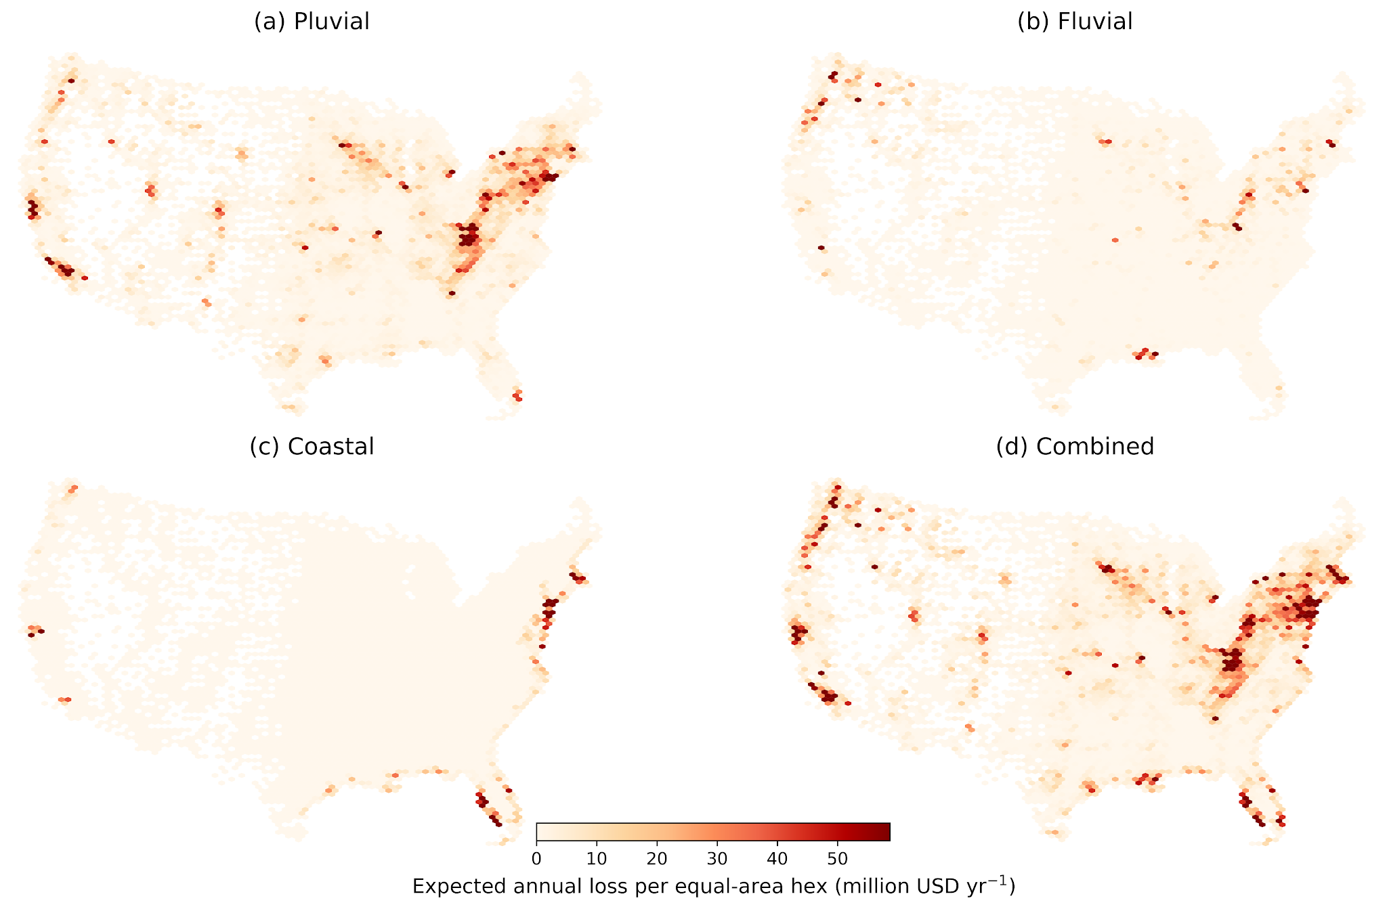
Supplementary Figure S1 | Combined-hazard expected annual loss on an equal-area hexagonal grid. Census tracts are population-based units, so a tract choropleth gives visual weight to large, sparsely populated interior tracts and compresses dense urban areas where much of the loss sits. Aggregating the same building-level losses onto equal-area cells removes that distortion and is the appropriate view for judging where loss is concentrated geographically.
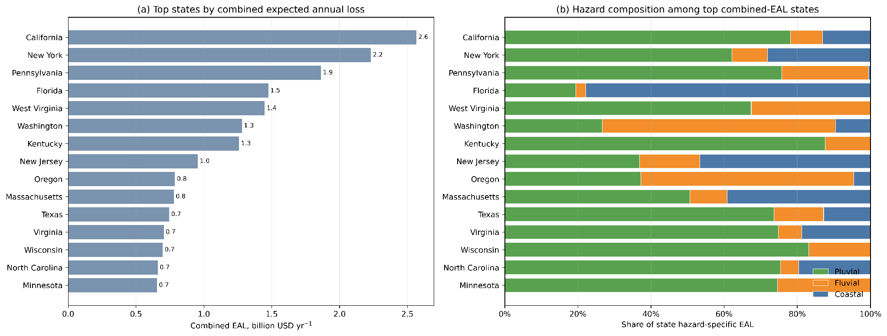
Supplementary Figure S2 | State-level concentration and hazard composition of expected annual loss. States with similar combined-hazard totals can have markedly different hazard structures: Florida is coastal-dominant, Washington and Oregon are fluvial-dominant, and California, Texas and the Appalachian states are pluvial-dominant.

B3. Hazard-specific pathways into and around the insurance structure
Table S4 reports participation, residual loss among insured buildings and the outside-SFHA share across the full expected-loss distribution using fourteen fixed logarithmic bins from $100 to $1,000,000, without truncation or a minimum bin count. Three patterns are visible. Participation rises only weakly with expected loss for the inland hazards and remains near or below one fifth across almost the entire distribution, so nonparticipation persists even among the highest-loss inland buildings. The uncovered-loss share among insured buildings is U-shaped: elevated at the lowest expected losses, where the per-event deductible absorbs small losses before coverage responds; lowest through the middle of the distribution, where reconstructed coverage absorbs the large majority of modeled loss; and rising again toward the upper tail as coverage limits bind. The outside-SFHA share of uncovered loss declines with expected loss for every hazard but remains above two thirds for pluvial flooding throughout.
Two binning conventions are used, and the distinction is important. Main-text Figure 3 uses twelve quantile-based bins constructed from the pooled logarithm of positive EAL across the four hazard layers, caps the distribution at its 99.5th percentile and retains hazard-specific bins containing at least 2,000 exposed buildings. This keeps each plotted point well populated but removes the extreme upper tail. Table S4 and Figure S3 use fourteen fixed logarithmic bins spanning $100 to $1,000,000, with no truncation or minimum bin count, and therefore retain that tail. The two approaches agree closely over their shared range and diverge only above roughly $20,000 of expected annual loss, where the untruncated version shows the uncovered-loss share among insured buildings continuing to climb toward 85% as statutory coverage limits bind. Neither is a correction of the other: the main-text version provides the more stable summary, while the supplementary version shows where the insured pool stops absorbing additional loss.
Supplementary Table S4 | Insurance-pathway metrics across the expected-annual-loss distribution, by hazard layer. Buildings are grouped into fourteen fixed logarithmic bins spanning $100 to $1,000,000 of building-level expected annual loss, of which thirteen are populated; no minimum bin population is imposed and the upper tail is not truncated. This differs from main-text Figure 3, which uses twelve pooled quantile-based bins capped at the 99.5th percentile and retains hazard-specific bins containing at least 2,000 exposed buildings. The insured share is computed over exposed buildings in each bin; the uncovered share among insured buildings is summed uncovered loss divided by summed expected annual loss over insured buildings in the bin.
Hazard | Bin midpoint EAL ($ yr⁻¹) | Buildings | Insured share | Uncovered share among insured | Outside-SFHA share of uncovered loss
Pluvial | 147 | 357,920 | 15.6% | 12.2% | 78.6%
Pluvial | 283 | 483,120 | 14.8% | 9.5% | 80.5%
Pluvial | 546 | 661,739 | 16.6% | 6.4% | 82.9%
Pluvial | 1,055 | 631,880 | 18.0% | 6.2% | 82.7%
Pluvial | 2,036 | 439,914 | 13.3% | 10.1% | 78.4%
Pluvial | 3,931 | 484,507 | 11.6% | 10.1% | 79.5%
Pluvial | 7,590 | 567,147 | 15.9% | 7.9% | 82.1%
Pluvial | 14,653 | 320,196 | 17.2% | 11.5% | 80.0%
Pluvial | 28,291 | 97,878 | 15.1% | 25.5% | 74.1%
Pluvial | 54,622 | 32,522 | 15.5% | 36.7% | 72.6%
Pluvial | 105,459 | 6,190 | 23.7% | 55.1% | 67.8%
Pluvial | 203,610 | 637 | 36.4% | 71.4% | 63.0%
Pluvial | 393,109 | 44 | 36.4% | 85.1% | 60.8%
Fluvial | 147 | 103,786 | 17.6% | 7.2% | 67.3%
Fluvial | 283 | 153,142 | 18.0% | 6.8% | 68.0%
Fluvial | 546 | 211,572 | 19.6% | 7.7% | 69.4%
Fluvial | 1,055 | 232,004 | 21.4% | 13.9% | 69.9%
Fluvial | 2,036 | 188,954 | 23.8% | 28.4% | 64.3%
Fluvial | 3,931 | 133,711 | 19.0% | 26.6% | 56.9%
Fluvial | 7,590 | 121,570 | 19.2% | 20.3% | 56.6%
Fluvial | 14,653 | 83,565 | 22.1% | 27.2% | 56.7%
Fluvial | 28,291 | 36,750 | 21.9% | 39.0% | 57.0%
Fluvial | 54,622 | 13,022 | 24.0% | 46.7% | 60.5%
Fluvial | 105,459 | 3,394 | 29.3% | 58.4% | 60.1%
Fluvial | 203,610 | 513 | 29.4% | 72.8% | 60.3%
Fluvial | 393,109 | 24 | 20.8% | 85.3% | 75.6%
Coastal | 147 | 127,401 | 50.5% | 9.2% | 42.1%
Coastal | 283 | 172,773 | 51.5% | 8.8% | 43.2%
Coastal | 546 | 248,277 | 58.4% | 7.9% | 44.0%
Coastal | 1,055 | 292,996 | 66.2% | 11.3% | 42.1%
Coastal | 2,036 | 232,452 | 65.4% | 22.5% | 34.7%
Coastal | 3,931 | 149,991 | 64.4% | 24.9% | 26.9%
Coastal | 7,590 | 113,509 | 69.1% | 18.0% | 27.1%
Coastal | 14,653 | 62,163 | 65.9% | 20.2% | 39.3%
Coastal | 28,291 | 15,696 | 55.9% | 30.1% | 49.4%
Coastal | 54,622 | 4,444 | 63.1% | 39.1% | 36.6%
Coastal | 105,459 | 881 | 55.6% | 53.7% | 28.4%
Coastal | 203,610 | 91 | 49.5% | 71.5% | 39.4%
Coastal | 393,109 | 7 | 28.6% | 86.3% | 52.1%
Combined | 147 | 537,620 | 22.8% | 9.0% | 73.5%
Combined | 283 | 743,367 | 22.7% | 8.3% | 74.5%
Combined | 546 | 1,041,224 | 26.0% | 7.2% | 76.3%
Combined | 1,055 | 1,084,528 | 30.7% | 10.1% | 74.8%
Combined | 2,036 | 825,221 | 29.6% | 20.8% | 68.4%
Combined | 3,931 | 743,636 | 23.0% | 20.6% | 69.9%
Combined | 7,590 | 779,860 | 23.6% | 13.7% | 74.4%
Combined | 14,653 | 456,682 | 24.4% | 17.3% | 72.7%
Combined | 28,291 | 148,797 | 20.9% | 30.2% | 68.3%
Combined | 54,622 | 49,648 | 21.8% | 40.1% | 67.4%
Combined | 105,459 | 10,503 | 28.2% | 55.9% | 62.2%
Combined | 203,610 | 1,253 | 34.2% | 71.9% | 59.5%
Combined | 393,109 | 75 | 30.7% | 85.3% | 64.5%

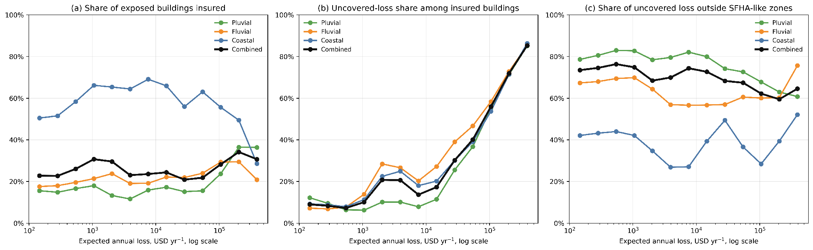
Supplementary Figure S3 | Hazard-specific pathways into and around the reconstructed insurance structure across the full expected-annual-loss distribution. Panels show, from left to right, the insured share of exposed buildings, the uncovered-loss share among insured buildings and the share of uncovered loss located outside SFHA-like zones. This figure uses the untruncated fixed logarithmic bins of Table S4 and is therefore the extended companion to main-text Figure 3, which uses twelve pooled quantile-based bins capped at the 99.5th percentile and retains hazard-specific bins containing at least 2,000 exposed buildings. The two are computed from the same building-level quantities and agree closely wherever their ranges overlap; they diverge only in the sparse upper tail excluded from the main-text figure. That divergence is informative: in panel (b), the uncovered-loss share among insured buildings continues rising to roughly 85% in the highest bins, where expected losses exceed what the statutory building-coverage limits can absorb. The tail bins contain relatively few buildings and are correspondingly noisy, which is why the main text reports the truncated version.

B4. Burden across the expected-loss spectrum
Table S5 aggregates the two shortfall channels into fixed expected-loss bands. Public shortfall dominates in every band, but its share of total shortfall burden falls from essentially all of it below $100 per year to about 84% in the $1,000–$100,000 range, before rising again in the highest band. The non-monotonicity in the highest band is the aggregate signature of coverage-limit censoring: once expected loss exceeds what available coverage can absorb, additional loss accrues to the uncovered channel by construction. The finer bin structure underlying this reversal is shown in Figure S13.
Supplementary Table S5 | Combined-hazard burden by expected-annual-loss band. Shares are computed over the sum of the two shortfall channels within each band and therefore exclude premium-funded payout.
Expected annual loss band | Buildings | Public shortfall ($M yr⁻¹) | NFIP shortfall ($M yr⁻¹) | Public share of shortfall burden | NFIP share of shortfall burden
$0-100 | 1,083,737 | 34.8 | 0.0 | 100.0% | 0.0%
$100-1K | 2,895,424 | 997.6 | 33.2 | 96.8% | 3.2%
$1K-10K | 2,860,032 | 8,494.2 | 1,501.1 | 85.0% | 15.0%
$10K-100K | 662,715 | 10,826.4 | 1,996.6 | 84.4% | 15.6%
$100K-1M | 4,243 | 513.1 | 63.5 | 89.0% | 11.0%

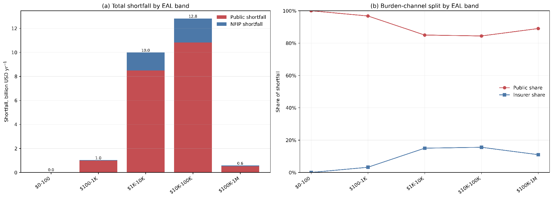
Supplementary Figure S4 | Combined-hazard shortfall burden across fixed expected-loss bands, showing the absolute magnitude of each channel and the split between them.
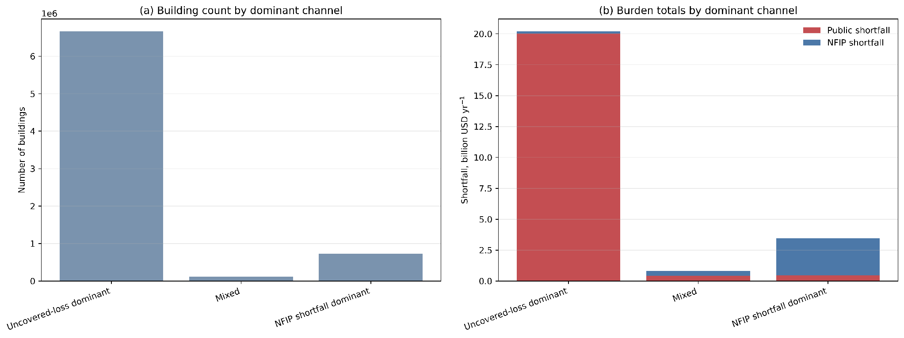
Supplementary Figure S5 | Dominant burden-channel classification. Buildings are labelled by which shortfall channel carries the larger share of their expected annual loss. Uncovered loss dominates for 6,659,790 buildings, NFIP shortfall for 726,656, with 119,705 in a mixed class; the counts are reported in the Supplementary Data.

B5. Empirical burden regimes at the tract scale
Table S6 summarizes the four fitted regimes and Table S7 their assignment uncertainty. The regimes organize along two interpretable axes, the amount of shortfall burden a tract carries and how far its losses sit inside the insurance structure, without hazard or geography entering the classification. Because expected annual loss decomposes into covered payout and uncovered loss, the two defining metrics are not independent: a tract that leaves most of its loss uncovered generates little NFIP shortfall by construction, so the classification organizes a constrained space rather than two free axes.
Supplementary Table S6 | Empirical burden-regime summary. Public loss absorption is tract public shortfall divided by tract expected annual loss. Premium-deficit pressure is tract NFIP shortfall divided by tract allocated written policy cost. Concentration is each regime's share of burden among classified tracts divided by its share of classified tracts; values above one indicate disproportionate concentration.
Burden regime | Tracts | Tract share | Median public loss absorption | Median premium-deficit pressure | Public shortfall ($M yr⁻¹) | NFIP shortfall ($M yr⁻¹) | Public concentration | NFIP concentration
Minor burden, uninsured | 17,882 | 24.1% | 1.000 | 0.000 | 1,958.6 | 0.0 | 0.39 | 0.00
Minor burden, some coverage | 5,747 | 7.7% | 0.916 | 0.000 | 126.7 | 0.2 | 0.08 | 0.00
Major burden, mostly uncovered | 21,197 | 28.6% | 0.927 | 0.926 | 12,890.9 | 684.6 | 2.16 | 0.67
Major burden, substantially insured | 29,414 | 39.6% | 0.457 | 1.266 | 5,889.8 | 2,909.5 | 0.71 | 2.04

Supplementary Table S7 | Regime-assignment uncertainty. Component membership is probabilistic; the table reports the median and mean maximum posterior probability, the median assignment entropy, and the share of tracts whose maximum posterior probability falls below the 0.70 threshold used in the main text. Assignment is least certain in the major burden, mostly uncovered regime, which borders both minor-burden components in the classification space.
Burden regime | Tracts | Median posterior probability | Mean posterior probability | Median assignment entropy | Share below 0.70 posterior
Minor burden, uninsured | 17,882 | 0.999 | 0.997 | 0.004 | 0.3%
Minor burden, some coverage | 5,747 | 0.994 | 0.965 | 0.025 | 2.4%
Major burden, mostly uncovered | 21,197 | 0.942 | 0.89 | 0.16 | 10.1%
Major burden, substantially insured | 29,414 | 1.0 | 0.958 | 0.0 | 5.8%

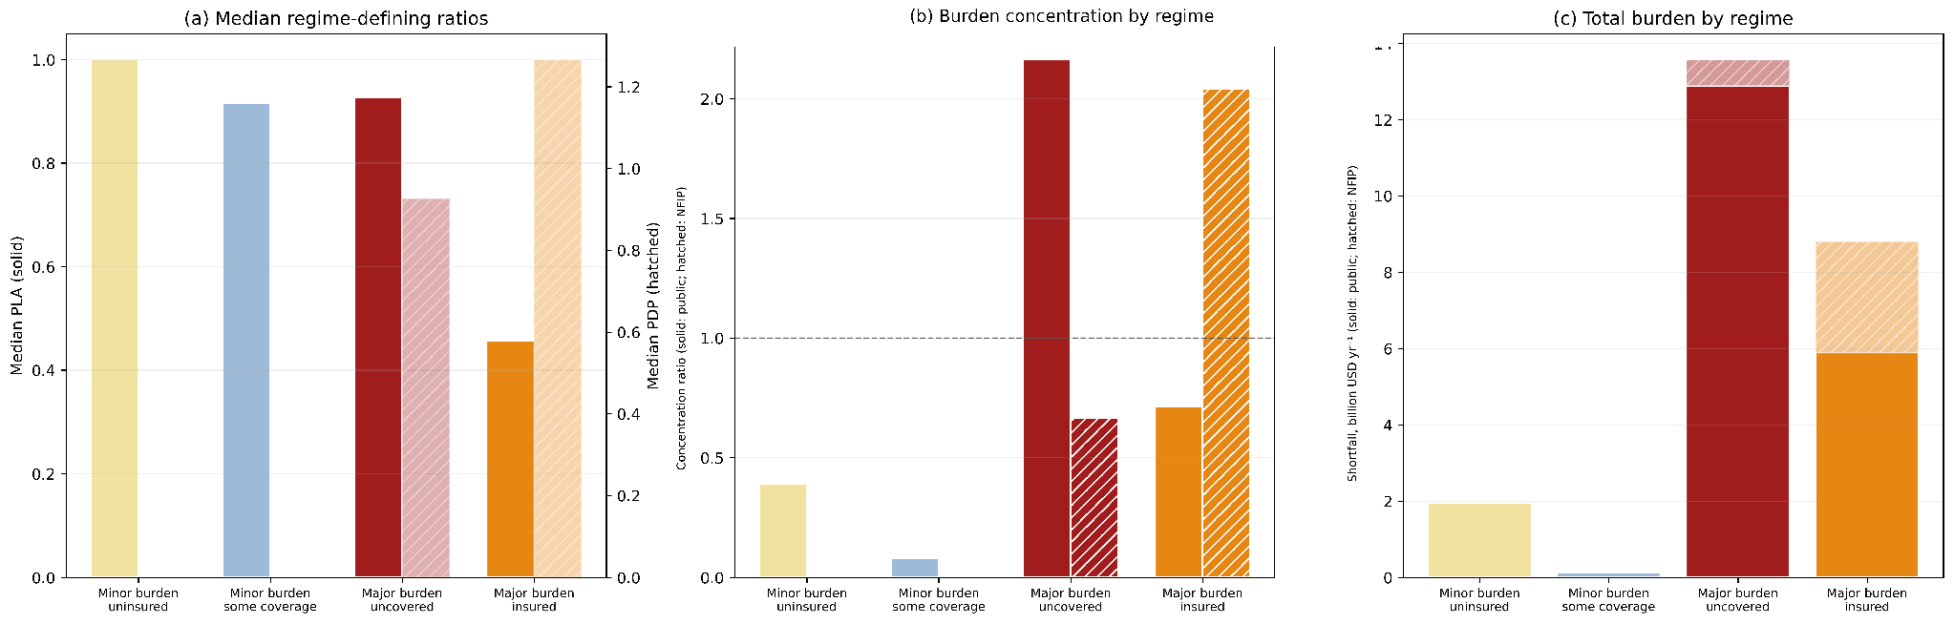
Supplementary Figure S6 | Regime-defining metrics and burden concentration by regime, showing median public loss absorption and premium-deficit pressure alongside each regime's share of burden among classified tracts relative to its share of classified tracts.
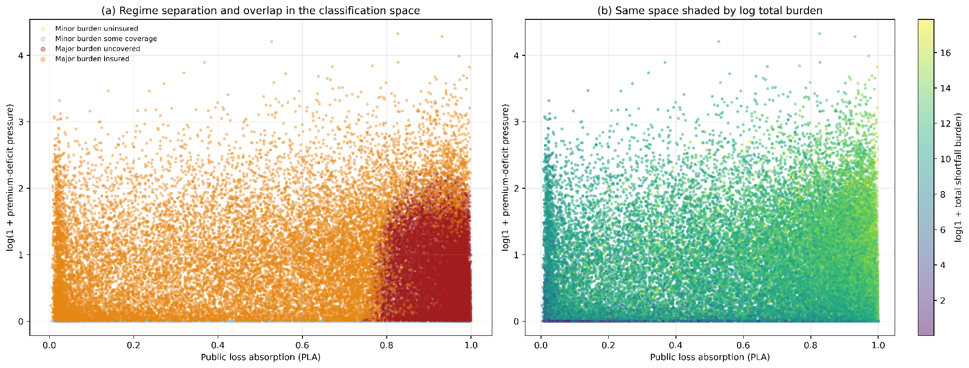
Supplementary Figure S7 | Regime feature space. Tracts are plotted in the space of the three clustering variables, coloured by assigned regime. The components are statistically distinguishable but overlap substantially, which is why assignment is treated as probabilistic throughout and why the regimes are described as empirical typologies rather than as fixed classes.
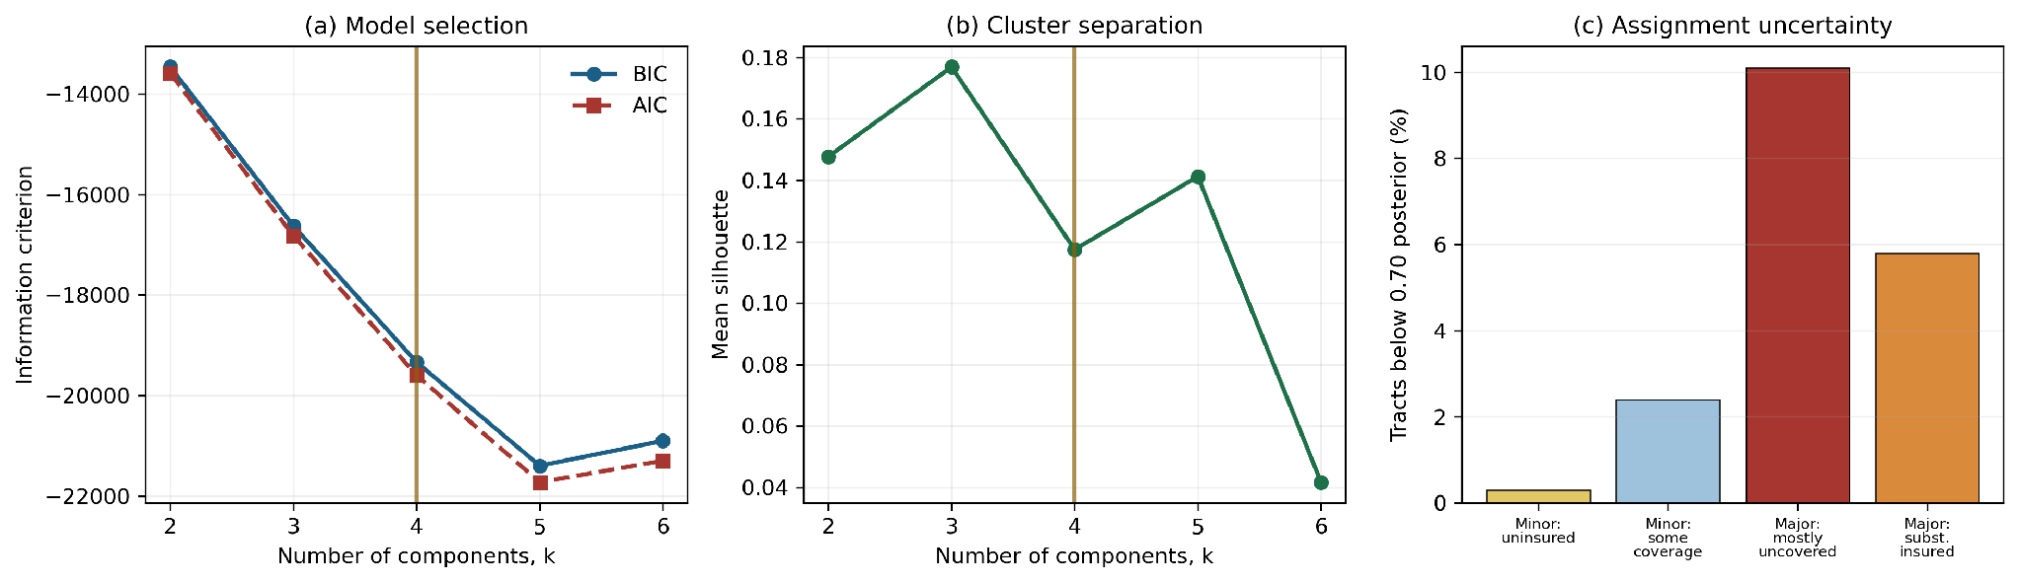
Supplementary Figure S8 | Gaussian mixture model selection and posterior assignment uncertainty. Panel (a) shows the Bayesian and Akaike information criteria across two to six components, evaluated on a random diagnostic sample of 6,000 valid tracts. Panel (b) shows mean silhouette width over the same range. Panel (c) shows the share of tracts in each fitted regime whose maximum posterior probability falls below 0.70. Neither criterion selects the four-component solution: the Bayesian information criterion continues to improve through five components before deteriorating at six, and mean silhouette width is highest at three. This is the expected behavior for a continuous burden space that does not contain a small number of well-separated modes. The four-component solution was retained because it yields an interpretable separation of burden magnitude and insurance state, not because it optimizes a model-selection criterion, and the regimes are therefore presented throughout as empirical typologies rather than as evidence of discrete underlying classes. This is also why assignment is treated as probabilistic and why the uncertainty in panel (c) is reported alongside every regime result.

B6. Hazard composition within burden regimes
Within a given regime the hazard mix driving public shortfall often differs from the mix driving NFIP shortfall, and Table S8 reports both. Inland hazards dominate public shortfall in every regime. The NFIP-side composition is more balanced: within the major burden, substantially insured regime, pluvial and coastal flooding contribute comparable shares of premium-deficit pressure, so the coastal geographic concentration of that regime should not be read as evidence that coastal flooding alone produces the pressure.
Supplementary Table S8 | Hazard composition of public and NFIP shortfall by burden regime. Hazard-specific shortfalls are additive across hazards and therefore sum to slightly more than the non-additive combined-layer totals; within-regime shares are unaffected. Where a channel total falls below $10 million the percentage composition is not interpretable and is flagged accordingly; for the minor burden, uninsured regime this is definitional, because tracts without an insured pool cannot generate NFIP shortfall.
Burden regime | Channel | Tracts | Channel total ($M yr⁻¹) | Pluvial share | Fluvial share | Coastal share | Composition interpretable
Minor burden, uninsured | Public shortfall | 17,882 | 1,983.49 | 86.6% | 13.1% | 0.4% | Yes
Minor burden, uninsured | NFIP shortfall | 17,882 | 0.00 | 95.5% | 4.5% | 0.0% | No (total below $10M)
Minor burden, some coverage | Public shortfall | 5,747 | 128.64 | 87.8% | 8.1% | 4.2% | Yes
Minor burden, some coverage | NFIP shortfall | 5,747 | 0.19 | 72.8% | 6.6% | 20.6% | No (total below $10M)
Major burden, mostly uncovered | Public shortfall | 21,197 | 13,177.61 | 75.8% | 22.1% | 2.1% | Yes
Major burden, mostly uncovered | NFIP shortfall | 21,197 | 707.08 | 72.0% | 25.2% | 2.8% | Yes
Major burden, substantially insured | Public shortfall | 29,414 | 6,025.33 | 50.1% | 22.5% | 27.4% | Yes
Major burden, substantially insured | NFIP shortfall | 29,414 | 3,004.02 | 45.3% | 14.0% | 40.8% | Yes

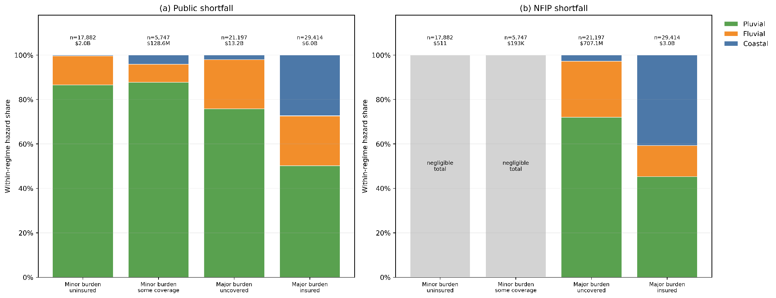
Supplementary Figure S9 | Hazard composition of public and NFIP shortfall within burden regimes. Bar segments represent within-regime burden composition, not the prevalence of hazards across tracts.

B7. Spatial diagnostic maps
Figures S10 to S12 provide the hazard-specific and combined-layer map panels underlying the national geography reported in the main text. Two cautions apply to all of them. Census tracts are population-based units, so visual area is not proportional to loss contribution and sparsely populated interior tracts occupy far more of the map than their burden warrants; the magnitude maps and the share maps should therefore be read together, because a tract can combine a high uncovered share with a small absolute burden. Alabama, Connecticut and North Dakota appear as no-data areas throughout.
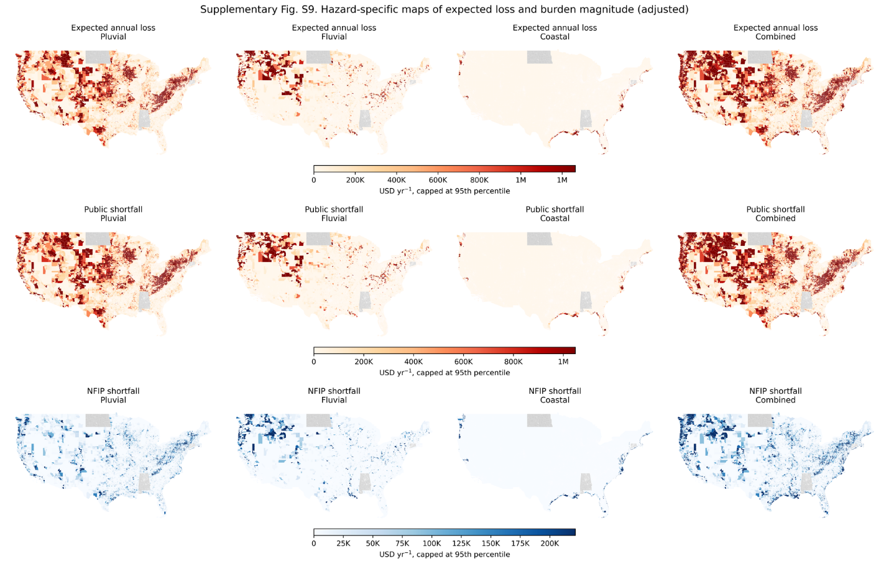
Supplementary Figure S10 | Hazard-specific maps of expected annual loss and burden magnitude across the contiguous United States.
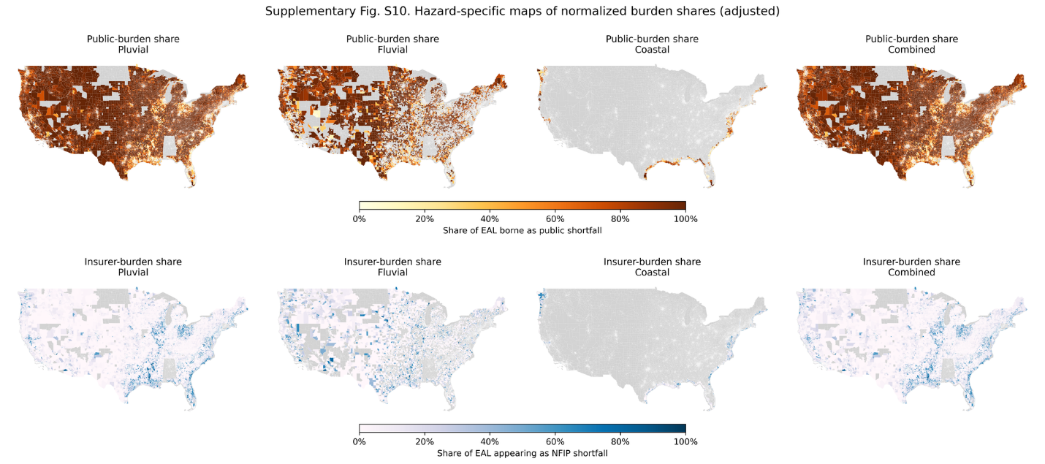
Supplementary Figure S11 | Hazard-specific maps of normalized burden shares. Shares are bounded between zero and one and should be interpreted alongside the magnitude maps in Figure S10.
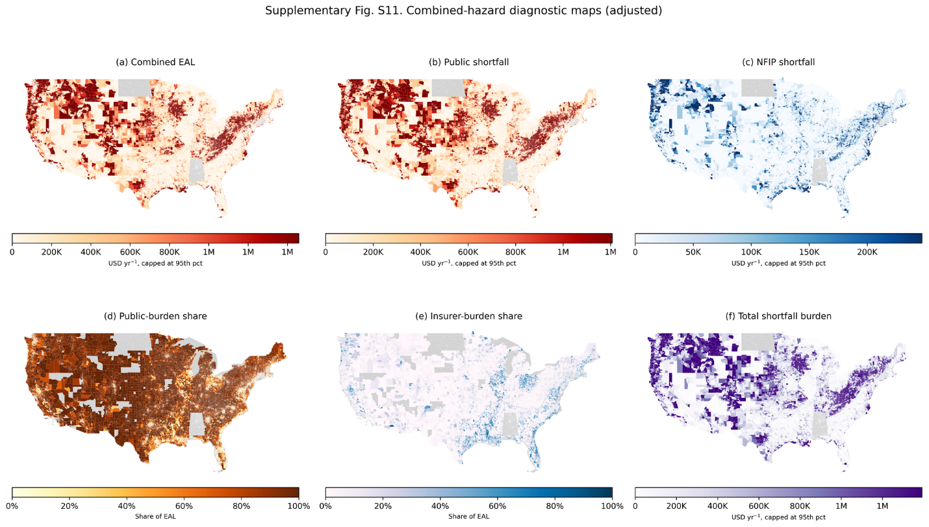
Supplementary Figure S12 | Combined-hazard diagnostic maps used to interpret the tract-level burden regimes.

B8. Variable definitions
Table S9 defines every burden metric used in the analysis and records the interpretive cautions that attach to each. Two are load-bearing. Public shortfall names a channel and not a payer of last resort: it falls first on property owners and their communities and reaches public recovery systems only through subsequent demand for assistance. NFIP shortfall is a diagnostic of premium-deficit pressure within the reconstructed portfolio and is not a solvency measure, because administrative costs, reserves, capital requirements and reinsurance lie outside its scope.
Supplementary Table S9 | Variable definitions and interpretation notes for the quantities used throughout the main text and this Supplementary Information.
Variable | Definition and interpretation
Expected annual loss (EAL) | Annualized modeled structure loss from trapezoidal integration of the exceedance-loss curve over the 5- to 500-year range. Structure only; excludes contents, vehicles, business interruption and land.
Expected covered payout | Annualized portion of modeled loss absorbed within reconstructed coverage after a $1,500 per-event deductible and the building-coverage limit.
Public shortfall | EAL minus expected covered payout. Contains loss on uninsured buildings, loss absorbed by the deductible, and loss above the coverage limit. Falls first on property owners and communities; not a measure of government expenditure.
NFIP shortfall | Sum of positive building-level gaps between expected covered payout and the allocated building-coverage risk premium. A premium-deficit diagnostic, not a solvency estimate; positive gaps are not netted against surpluses.
Premium-funded payout | The portion of expected covered payout supported by the allocated risk-premium base. EAL decomposes exactly into this quantity plus the two shortfall channels.
Allocated written policy cost | Sum of the annual policy cost of all policy records assigned to a building. $4.53B nationally.
Building-coverage risk-premium base | Allocated written policy cost multiplied by the state-level premium share of policy cost (0.8174 nationally) and the building share of combined coverage (0.8100 nationally). $2.99B nationally.
Public loss absorption (PLA) | Tract public shortfall divided by tract EAL. Bounded between zero and one.
Premium-deficit pressure (PDP) | Tract NFIP shortfall divided by tract allocated written policy cost. A continuous relative indicator; not a break-even threshold or an actuarial loss ratio, and not on the same premium basis as the building-level shortfall numerator.
Total shortfall burden (TBA) | Public shortfall plus NFIP shortfall for a tract.
Concentration ratio | A regime's share of national burden among classified tracts divided by its share of classified tracts. One denotes proportional burden.
Combined hazard layer | Maximum hazard-specific depth at each return period. Non-additive: not the sum of the pluvial, fluvial and coastal layers, and not a compound-event simulation.
Exposed buildings | Buildings with positive EAL for the hazard layer under analysis. Buildings inside the hazard domain with zero modeled loss remain in the dataset and may carry policies.
SFHA-like zones | FEMA flood zones whose designation begins with A or V. All other and missing designations, including areas without digitized coverage, are treated as outside the SFHA.

B9. Processing audit
Table S10 records the complete processing audit: the record counts carried through each stage of the workflow, the spatial units, the column provenance used for coverage, premium and flood-zone status, and the parameters and thresholds that define the central specification. Table S11 reports the tier-level outcome of the policy allocator.
Supplementary Table S10 | Input data, processing audit and central-specification parameters. Every threshold and rule required to reproduce the reported quantities from the processed building inventory is listed here or in the referenced reference tables.
Item | Value
Building records processed (CONUS, modeled inundation) | 12,932,146
Buildings with positive combined-hazard EAL | 7,506,151
Buildings with positive pluvial EAL | 4,890,253
Buildings with positive fluvial EAL | 1,472,944
Buildings with positive coastal EAL | 1,624,810
Buildings with reconstructed NFIP coverage | 3,300,588 (25.5% of processed)
Insured exposed buildings (coverage and positive combined EAL) | 1,866,757
Policy records allocated | 3,412,456
Reconstructed building coverage in force | $740.7 billion
Allocated written policy cost | $4.53 billion yr⁻¹
Building-coverage risk-premium base | $2.99 billion yr⁻¹
Census tracts, building-level dataset | 76,659
Census tracts, spatial layer | 83,954
Census tracts classified into burden regimes | 74,240
States absent from the processed inventory | Alabama, Connecticut, North Dakota
Hazard model | Fathom U.S. flood model, defended layers, 30 m resolution
Return periods | 5, 10, 100 and 500 years; depths in feet; maximum 32.808 ft
Annualization | Depths interpolated in log-return-period space onto a 33-point grid spanning 5–500 yr; trapezoidal integration over annual exceedance probability; 500-yr loss carried in the tail
First-floor height | Surveyed Elevation Certificates; county × occupancy × zone-family stratum medians (min 100 obs) with state and national fallbacks; 2,378,132 distinct records
Below-grade pathway | USACE EGM 04-01 with-basement minus without-basement, by storey class; Bernoulli assignment, seed 12345; 3,110,951 buildings (24.1%)
Elevated-enclosure pathway | 0.10 of structure value, active at first-floor height ≥ 4 ft, filling progressively
Deductible | $1,500 per event, applied before the coverage limit
Coverage amounts | Observed policy values; statutory $250k/$500k limits embedded
Allocation caps | Coverage ≤ 1.10 × replacement value; prototype-specific policy-count cap scaled by gross floor area
SFHA definition | Flood zones beginning with A or V; all else and missing treated as X
Burden regimes | Four-component Gaussian mixture, full covariance, RobustScaler(10–90), seed 42, fitted on 20,000 tracts, predicted for 74,240
Column provenance | coverage_total (coverage); premium_act (written policy cost); flood_zone (zone status)
Accounting-identity residual | $0.000000 per building (maximum)
Structure replacement-value basis | $6.138 trillion
Implied annual damage rate | 0.418% of structure replacement value

Supplementary Table S11 | Policy-allocation outcome by tier, aggregated over the 738 processed tiles that recorded tier diagnostics; the total of 3,412,441 assignments corresponds to the 3,412,456 policy records carried into the analysis. Fewer than one policy in a thousand could be matched by footprint containment, because coordinates in the redacted policy files are spatially generalized. Deterministic within-tract and rated-zone passes placed 69.2% of policies and the stochastic tiers the remaining 30.7%, which is why the reconstruction is treated as reliable at tract scale and weak at the scale of an individual building.
Tier | Assignment rule | Policies assigned | Share of allocated policies
Tier 0 | Buffered footprint match, 10 m buffer | 155 | 0.0%
Tier 1 | Strict footprint containment, residential status consistent | 0 | 0.0%
Tier 2 | Nearest eligible building centroid within 200 m | 1,462 | 0.0%
Tier 3a | Within tract and rated zone; type and storey class required | 1,642,100 | 48.1%
Tier 3b | Within tract and rated zone; building type required | 26,904 | 0.8%
Tier 3c | Within tract and rated zone; no type requirement | 693,099 | 20.3%
Tier 4a | Stochastic risk-distance, up to 512 candidates; type required | 258,714 | 7.6%
Tier 4b | Stochastic risk-distance, up to 512 candidates; type relaxed | 302,730 | 8.9%
Tier 5a | Within-tract highest-risk fallback; type required | 260,166 | 7.6%
Tier 5b | Within-tract highest-risk fallback; type relaxed | 227,111 | 6.7%

Part C. Validation and benchmarking
No parameter in the loss model is fitted to an external loss total, so every comparison in this Part is an out-of-sample check rather than a validation of a calibrated quantity. The comparisons are grouped by what they test: the level of modeled loss, the insured slice, and the hazard composition.

C1. Benchmarking the national loss level
Table S12 places the central combined-hazard estimate alongside published national estimates. The comparison that matters most is scope. Our $25.67B is a structure-only quantity covering all building types; it excludes contents, vehicles, business interruption and land. The closest scope match in the literature is the First Street residential estimate of $20.0–20.3 billion, which is explicitly building-only and covers one-to-four-unit residential structures alone; our all-building total sitting modestly above that residential-only figure is the expected ordering. A single-family, structure-focused Federal Reserve analysis places residential average annual loss at $24.4 billion, and an all-property estimate under a closely related hazard framework reports $32.1 billion. Our estimate falls between the residential-only and all-property figures, which is where a structure-only all-building estimate should fall.
Two comparisons run the other way and are reported for completeness. Catastrophe models calibrated to NFIP claims experience produce lower figures, with a single-family building-only estimate above $7 billion; the difference reflects the known gap between the academic high-resolution modelling family used here and models tuned to realized insured experience. FEMA's National Risk Index, following its December 2025 revision that renamed the riverine category to inland flooding and folded pluvial flooding into it, reports a substantially higher inland building-value expected annual loss than any academic estimate including ours. Both bounds are stated rather than reconciled, because reconciling them would require access to the proprietary vulnerability functions behind each.
Supplementary Table S12 | Published national estimates of average annual flood loss alongside the central estimate of this study. Estimates differ in the building population covered, in whether contents are included, in dollar year, and in hazard-model lineage; the scope column records the differences that matter for the comparison. None of these estimates was used to calibrate any parameter in this study.
Source | Average annual loss ($B yr⁻¹) | Scope | Note
This study, central specification | 25.67 | All buildings, CONUS, structure only | Surveyed first-floor heights; no fitted parameters
Wing et al. 2022, Nature Climate Change | 32.1 (30.5–33.8) | All buildings, CONUS | Same hazard-model lineage; broader valuation basis
Amornsiripanitch et al. 2025, Nature Climate Change | 24.4 | Single-family residences, 2023 USD | 70% of expected loss uninsured
First Street Foundation 2021 | 20.0–20.3 | Residential 1–4 units, structure only | Closest scope match to this study
Society of Actuaries / Milliman 2020 | > 7 | Single-family residences, building only | KatRisk model calibrated to NFIP experience
FEMA National Risk Index v1.20, Dec 2025 | 63.0 inland; 0.9 coastal | All buildings, building-value EAL | Riverine renamed inland flooding and now includes pluvial
NOAA billion-dollar disasters, 1980–2024 | ≈ 4.5 | Realized losses, billion-dollar events only | Excludes tropical-cyclone flooding; a floor, not a ceiling

C2. Benchmarking the insured slice
The insured portion of the reconstruction admits a more direct comparison, because an independent federal measurement of the same portfolio exists. Expected covered payout on the reconstructed portfolio is $4.80 billion per year. The Congressional Budget Office, analyzing the actual NFIP book, estimated approximately $3.7 billion in expected annual claims covering both building and contents coverage in 2016–2017 dollars; adjusting that figure for inflation alone brings it close to our building-only estimate, and the two are of the same order on different accounting bases. The aggregate net gap between expected payout and the risk-premium base is $1.81 billion per year, against the Congressional Budget Office's estimate of a $1.4 billion national one-year shortfall under a different program-accounting framework; that estimate rises to approximately $1.8 billion when expressed in 2024 dollars. The geography also agrees: the federal analysis found its shortfall concentrated in coastal counties, and NFIP shortfall in our reconstruction concentrates along the Gulf and Atlantic coasts.
Participation is consistent with the survey literature once the denominator is matched. Our combined-hazard insured share of 24.9% is computed over buildings with positive modeled expected loss, a substantially riskier population than the national building stock. Published take-up estimates of roughly 30% inside Special Flood Hazard Areas, of the order of 1–4% outside them or across all homeowners nationally, and of roughly 50–60% in high-participation coastal counties, bracket our hazard-specific shares of 59.0% coastal, 20.0% fluvial and 15.7% pluvial. The share of the coverage gap that lies outside mapped Special Flood Hazard Areas provides the closest external agreement available: an independent national analysis of single-family residences places 69% of the coverage gap outside those zones, against 70.9% in our broader building-scale reconstruction, from an entirely different modelling chain.

C3. The hazard composition of loss
The aggregate benchmarks above do not provide a like-for-like comparison of pluvial, fluvial and coastal loss components. The claims literature nonetheless supports pluvial dominance from an independent direction. Analyses of NFIP claims outside Special Flood Hazard Areas attribute 87.1% of analysable claims to pluvial flooding, and a separate claims analysis attributes 74% of tropical-cyclone-related and 60% of non-tropical-cyclone flood claims to pluvial processes. Federal practice is converging on the same conclusion: the December 2025 revision of the National Risk Index folded pluvial flooding into a broader inland-flooding hazard precisely because the previous riverine-only category did not represent it. This classification change provides context for interpreting inland risk, rather than an additional finding of the present reconstruction.
Two qualifications attach to the composition. The pluvial–fluvial boundary is model-defined, as set out in Section A2.1, so the pluvial total includes some small-channel fluvial loss. And the below-grade pathway, which contributes roughly two fifths of national expected annual loss, is concentrated in inland divisions where basements are prevalent, so it amplifies the inland share; Table S14 bounds that contribution by exclusion.

C4. Aggregation scale and hazard-model error
The reliability of the tract-level comparisons rests on the aggregation argument set out in Section A2.2. Table S13 reports the area distribution of the census tracts used, which establishes that the aggregation units are large relative to the scale at which published evaluations of models in this family report that flooded-fraction errors fall to a few per cent. This does not eliminate hazard uncertainty; it means that the tract-scale quantities carrying the analysis are far better constrained than any individual building-scale prediction, and it is the reason results are presented as tract-level geography and channel shares rather than as building-level attributions.
Supplementary Table S13 | Area distribution of the census tracts used as the aggregation unit, computed on an equal-area projection. Tract areas are strongly right-skewed because tracts are population-based units: dense urban tracts are small while rural tracts are very large.
Statistic | Value
Census tracts in the spatial layer | 83,954
Mean tract area (km²) | 117.0
Median tract area (km²) | 4.90
5th percentile (km²) | 0.42
25th percentile (km²) | 1.81
75th percentile (km²) | 32.1
95th percentile (km²) | 378.6
Share of tracts larger than 1 km² | 87.3%

Part D. Sensitivity and robustness
Every quantity in this Part varies one element of the central specification at a time and recomputes the full loss chain. The resulting range is a specification envelope, not a confidence interval: it describes how far the national estimate moves under defensible alternative choices, and it makes no probabilistic statement about which choice is correct. The consistent finding across the whole Part is that absolute loss levels are sensitive to several choices while the allocation between burden channels is not.

D1. Robustness of the reallocation profile
The reallocation profile in the main text is a smooth fit to binned means. Figure S13 reports the underlying bin means with 95% confidence intervals, so that the rise and the upper-tail reversal can be judged against the sampling variability of the bins rather than against the smoothed curve alone. The rise through the middle of the distribution is well resolved. The reversal in the upper tail rests on comparatively few buildings, so the precise position of the threshold is less certain than the existence of the reversal; the mechanism behind it is quantified directly in Section D8 and Table S23.
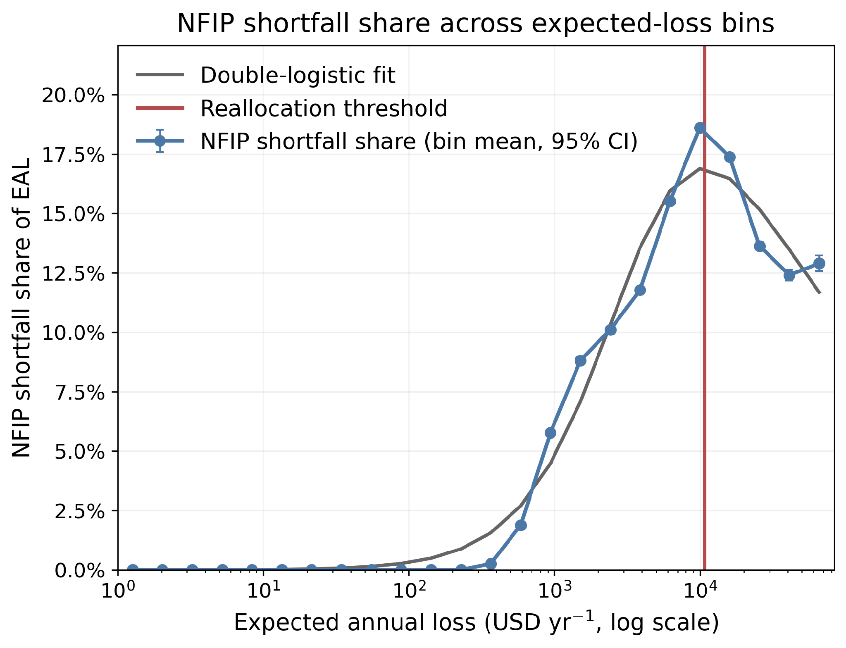
Supplementary Figure S13 | Mean building-level NFIP-shortfall share within logarithmically spaced expected-annual-loss bins, with 95% confidence intervals and the reallocation threshold marked. This is the unsmoothed companion to the reallocation panel of main-text Figure 4. The decline beyond the threshold is the aggregate signature of statutory-limit censoring quantified in Table S23, while Table S25 decomposes the corresponding residual loss across expected-loss bins.

D2. Specification grid
Supplementary Table S14 | Specification grid for the combined hazard layer. Each row varies one element of the central specification and recomputes the full loss chain: the first-floor height scenario (stratum quartiles), the return-period floor, the below-grade and enclosure pathways, the integration rule, the premium-base definition, the basement-assignment seed, and a pluvial drainage bound that removes the first 0.2 m of pluvial depth.
Specification | EAL ($B yr⁻¹) | Expected payout ($B yr⁻¹) | Public shortfall ($B yr⁻¹) | NFIP shortfall ($B yr⁻¹) | Public share of EAL
central | 25.67 | 4.80 | 20.87 | 3.59 | 81.3%
first-floor low scenario (stratum q25) | 38.93 | 7.22 | 31.71 | 5.66 | 81.4%
first-floor high scenario (stratum q75) | 15.35 | 2.84 | 12.52 | 1.92 | 81.5%
RP floor T>=10 | 21.86 | 4.28 | 17.57 | 3.08 | 80.4%
below-grade pathway off | 15.22 | 2.82 | 12.40 | 1.84 | 81.5%
enclosure pathway off | 25.21 | 4.54 | 20.67 | 3.43 | 82.0%
integration: left-step (lower bound) | 10.55 | 1.70 | 8.85 | 0.92 | 83.9%
integration: upper-Riemann (upper bound) | 47.07 | 9.35 | 37.72 | 7.80 | 80.1%
premium base: total policy cost | 25.67 | 4.80 | 20.87 | 3.26 | 81.3%
basement assignment: alternative seed | 25.67 | 4.81 | 20.87 | 3.60 | 81.3%
pluvial drainage bound (-0.2 m PD) | 19.76 | 3.95 | 15.81 | 2.88 | 80.0%

Across the eleven specifications the national expected annual loss spans $10.55B to $47.07B, a range of more than a factor of four, while the public share of expected annual loss spans only 80.0% to 83.9%. The two integration rows are deliberate bounds rather than plausible alternatives: left-step integration over the raw layers bounds the estimate from below and upper-Riemann integration from above, and the central trapezoidal rule sits between them. The first-floor quartile rows generate the widest range among the substantive choices, which is why the surveyed Elevation Certificate evidence in Section A6 carries so much of the analysis. The below-grade exclusion row is the bound on the pathway discussed in Section A7.
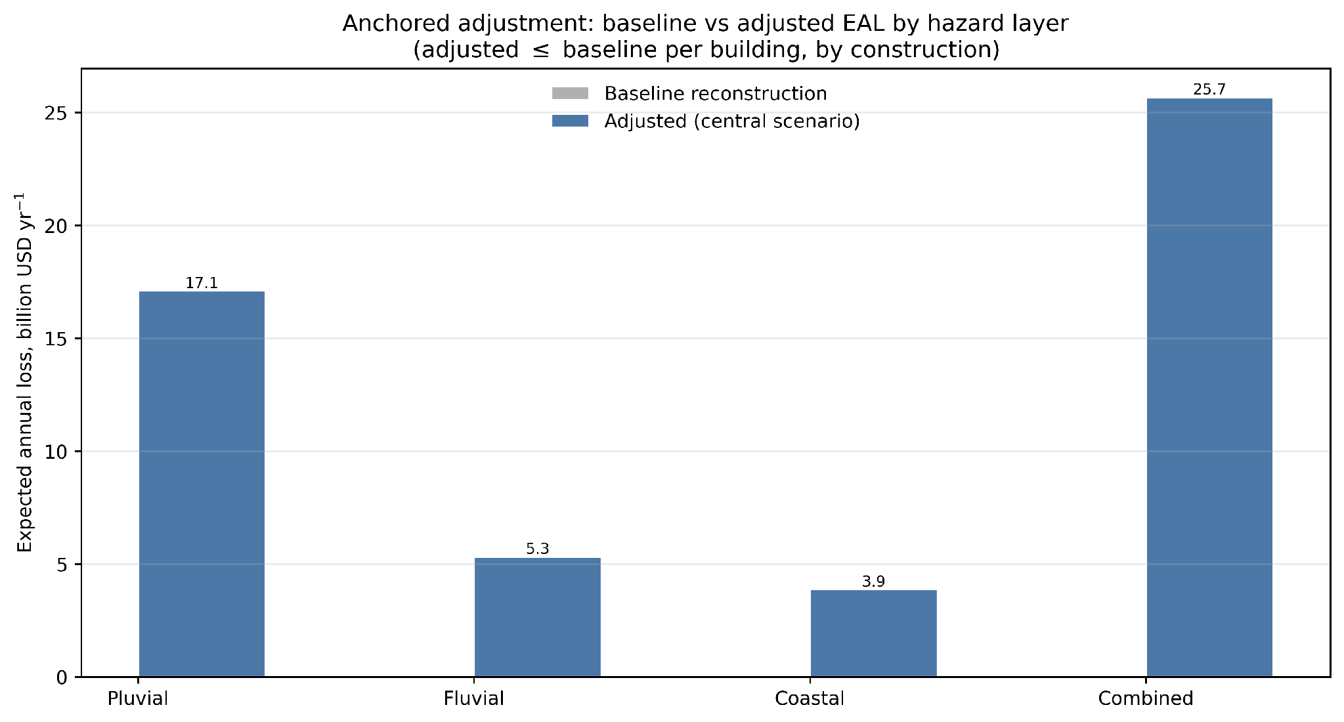
Supplementary Figure S14 | Integration-rule sensitivity of the annualized burden estimates, showing how the choice of quadrature over the four modeled return periods bounds the national totals.
Supplementary Table S15 | Per-hazard resolution of the principal specification choices. Because the paper's central claims are hazard-specific, the sensitivity analysis is resolved by hazard layer as well as in aggregate. The hazard ordering of expected annual loss and the contrast in channel shares between the inland layers and the coastal layer persist under every specification tested.
Specification | Hazard layer | EAL ($B yr⁻¹) | Expected payout ($B yr⁻¹) | Public shortfall ($B yr⁻¹) | NFIP shortfall ($B yr⁻¹) | Public share of EAL
Central specification | Pluvial | 17.11 | 2.26 | 14.84 | 1.87 | 86.8%
Central specification | Fluvial | 5.32 | 0.78 | 4.53 | 0.60 | 85.3%
Central specification | Coastal | 3.88 | 1.94 | 1.94 | 1.24 | 50.0%
Central specification | Combined | 25.67 | 4.80 | 20.87 | 3.59 | 81.3%
First-floor q25 (low) | Pluvial | 25.69 | 3.29 | 22.40 | 2.72 | 87.2%
First-floor q25 (low) | Fluvial | 7.79 | 1.10 | 6.69 | 0.87 | 85.9%
First-floor q25 (low) | Coastal | 6.42 | 3.12 | 3.31 | 2.25 | 51.5%
First-floor q25 (low) | Combined | 38.93 | 7.22 | 31.71 | 5.66 | 81.4%
First-floor q75 (high) | Pluvial | 10.28 | 1.39 | 8.89 | 1.07 | 86.5%
First-floor q75 (high) | Fluvial | 3.37 | 0.51 | 2.87 | 0.36 | 85.0%
First-floor q75 (high) | Coastal | 2.06 | 1.04 | 1.02 | 0.54 | 49.3%
First-floor q75 (high) | Combined | 15.35 | 2.84 | 12.52 | 1.92 | 81.5%
Below-grade pathway off | Pluvial | 8.70 | 1.00 | 7.70 | 0.76 | 88.5%
Below-grade pathway off | Fluvial | 3.94 | 0.58 | 3.36 | 0.42 | 85.4%
Below-grade pathway off | Coastal | 2.83 | 1.32 | 1.51 | 0.69 | 53.3%
Below-grade pathway off | Combined | 15.22 | 2.82 | 12.40 | 1.84 | 81.5%
Return-period floor T>=10 | Pluvial | 13.93 | 1.92 | 12.01 | 1.53 | 86.2%
Return-period floor T>=10 | Fluvial | 4.85 | 0.71 | 4.14 | 0.52 | 85.4%
Return-period floor T>=10 | Coastal | 3.68 | 1.83 | 1.84 | 1.14 | 50.2%
Return-period floor T>=10 | Combined | 21.86 | 4.28 | 17.57 | 3.08 | 80.4%

Supplementary Table S16 | Tract-level rank stability of the two burden metrics under alternative specifications. Spearman rank correlations are computed across all tracts common to both the central and the alternative specification.
Specification | Tracts compared | National EAL ($B yr⁻¹) | Spearman ρ, public loss absorption | Spearman ρ, total shortfall burden
First-floor q25 (low) | 76,659 | 38.93 | 0.9720 | 0.9878
First-floor q75 (high) | 76,659 | 15.35 | 0.9634 | 0.9807
Return-period floor T>=10 | 76,659 | 21.86 | 0.9994 | 0.9985
Left-step integration (lower bound) | 76,659 | 10.55 | 0.9875 | 0.9592
Upper-Riemann integration (upper bound) | 76,659 | 47.07 | 0.9923 | 0.9791
Below-grade pathway off | 76,659 | 15.22 | 0.8570 | 0.8215
Pluvial drainage bound (-0.2 m) | 76,659 | 19.60 | 0.9147 | 0.9487

Rank correlations against the central specification remain at or above 0.821 for both tract-level metrics under every alternative tested, including the two integration bounds that move the national total by more than a factor of four. The spatial pattern that the regime classification rests on is therefore substantially more stable than the dollar level of the estimate, which is the basis for treating channel shares, hazard contrasts and regime geography as the primary findings.

D3. Sensitivity to the per-event deductible
The central specification applies a flat $1,500 per-event deductible. NFIP minimum deductibles range from approximately $1,000 to $2,000 and optional deductibles reach $10,000, and a residential private flood program reports an average deductible of $4,374 across approximately 60,000 risks. Table S17 recomputes the full chain across this range, including a zero-deductible reference.
Supplementary Table S17 | Sensitivity of the burden channels to the per-event deductible, combined hazard layer. Expected annual loss is invariant to the deductible by construction; the deductible shifts loss between expected covered payout and public shortfall.
Per-event deductible | EAL ($B yr⁻¹) | Expected payout ($B yr⁻¹) | Public shortfall ($B yr⁻¹) | NFIP shortfall ($B yr⁻¹) | Public share of EAL
$0 | 25.667 | 4.888 | 20.779 | 3.664 | 80.96%
$1,000 | 25.667 | 4.829 | 20.838 | 3.617 | 81.19%
$1,500 | 25.667 | 4.801 | 20.866 | 3.594 | 81.30%
$2,000 | 25.667 | 4.773 | 20.894 | 3.572 | 81.40%
$4,374 | 25.667 | 4.647 | 21.020 | 3.467 | 81.90%
$10,000 | 25.667 | 4.369 | 21.298 | 3.234 | 82.98%

The deductible is not a material driver of the national result. Raising it from $1,500 to $4,374 lowers expected covered payout from $4.801B to $4.647B, a reduction of 3.2%, and raising it to $10,000 lowers payout to $4.369B, a reduction of 9.0%. Expected annual loss is unaffected by construction, and the public share of expected annual loss moves by well under one percentage point across the entire range. The insensitivity arises because annualized payout is dominated by moderate and rare events whose losses greatly exceed any deductible in this range; the deductible matters for the frequent, shallow events that contribute the low-expected-loss end of the distribution, which is where its signature appears in Figure S15 and in the U-shaped residual reported in Table S4.

D4. Losses below the deductible and above the coverage limit
The residual uncovered loss carried by insured buildings is often summarized as a single underinsurance figure, but it has two mechanically distinct sources: the portion of each event loss absorbed by the deductible, and the portion exceeding the building-coverage limit. Separating them provides a measure of coverage adequacy that does not depend on the reconstructed premium base at all, and it tests directly the mechanism the main text invokes to explain the shape of the burden-share curves.
Supplementary Table S18 | Decomposition of combined-hazard expected annual loss into expected covered payout and the components of public shortfall, separating loss on uninsured buildings from the deductible-absorbed and limit-exceeding components on insured buildings. The residual row absorbs the interaction between the deductible and the coverage limit within the annualization.
Quantity | Value ($B yr⁻¹) | Share of combined EAL
Combined-hazard EAL, all buildings | 25.667 | 100.00%
EAL on insured buildings | 6.196 | 24.14%
Expected covered payout | 4.801 | 18.70%
Public shortfall, total | 20.866 | 81.30%
of which: on uninsured buildings | 19.471 | 75.86%
of which: on insured buildings | 1.395 | 5.44%
absorbed by the per-event deductible | 0.100 | 0.39%
in excess of the coverage limit | 1.295 | 5.05%
residual (rounding / interaction) | 0.000 | 0.00%

Supplementary Table S19 | The same decomposition across expected-loss bands, over insured buildings only. The deductible dominates residual loss at low expected loss and the coverage limit dominates in the upper bands, which is the mechanism underlying the U-shaped uncovered-loss share reported in Table S4 and the upper-tail reversal in Figure S13.
Expected annual loss band | Insured buildings | EAL ($M yr⁻¹) | Payout ($M yr⁻¹) | Deductible-absorbed ($M yr⁻¹) | Above coverage limit ($M yr⁻¹) | Deductible share of EAL | Above-limit share of EAL
$0-100 | 215,969 | 9.5 | 8.0 | 1.4 | 0.0 | 15.2% | 0.3%
$100-1K | 736,051 | 359.7 | 332.1 | 16.6 | 11.0 | 4.6% | 3.1%
$1K-10K | 758,210 | 2,649.4 | 2,212.1 | 55.4 | 381.8 | 2.1% | 14.4%
$10K-100K | 155,134 | 2,985.9 | 2,183.6 | 26.6 | 775.8 | 0.9% | 26.0%
$100K+ | 1,393 | 191.9 | 65.2 | 0.4 | 126.3 | 0.2% | 65.8%

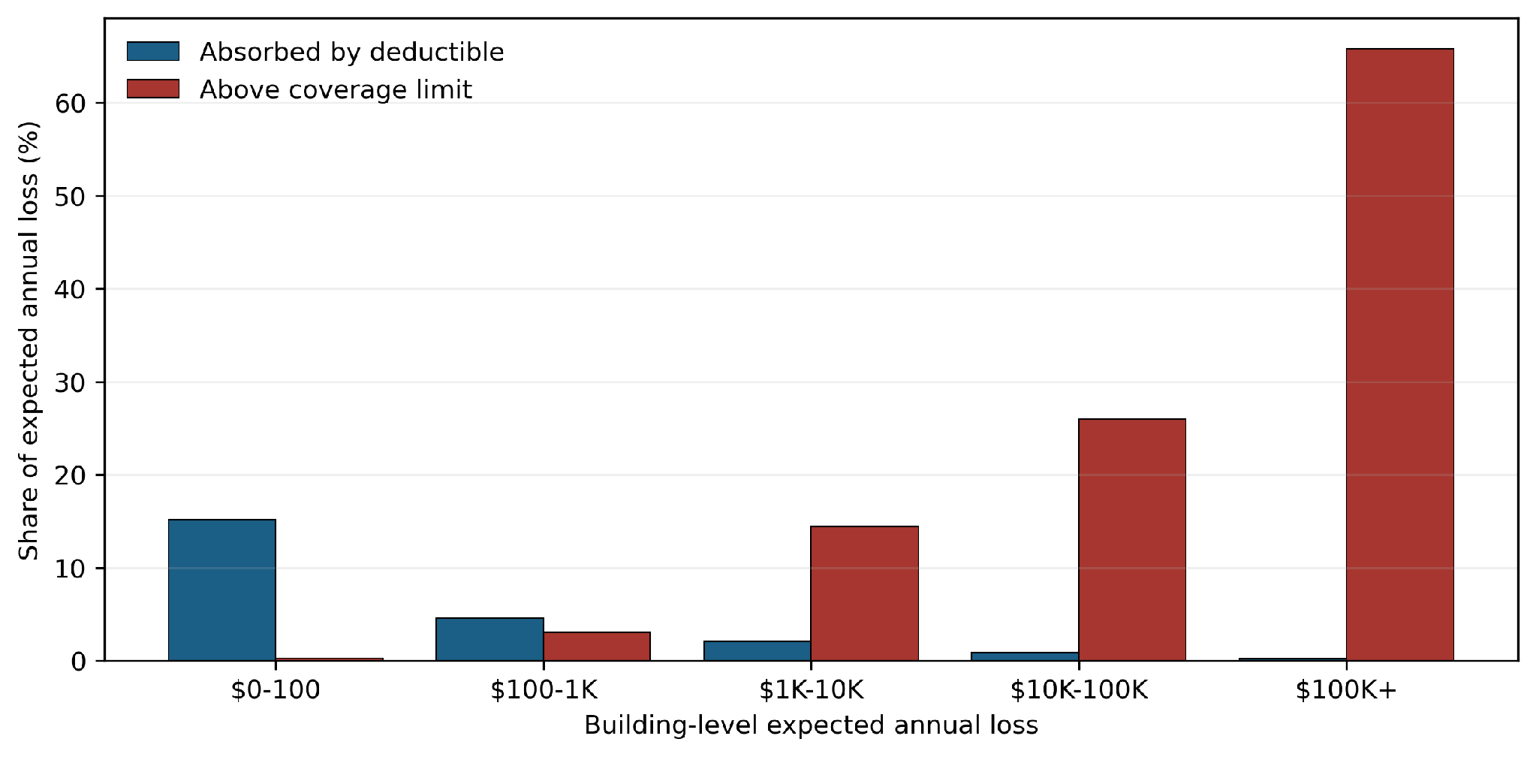
Supplementary Figure S15 | Deductible-absorbed and above-limit components of residual uncovered loss among insured buildings, as shares of expected annual loss, by expected-loss band.

D5. Premium reconciliation and unexposed structures
Premium from processed structures with zero modeled loss enters the aggregate net gap and tract-level premium denominator, but does not offset positive building-level NFIP shortfalls. Allocated premium is retained for every processed building carrying a policy, including the substantial population of covered buildings whose combined-hazard expected annual loss is zero, and that premium enters both the aggregate net gap reported in Section C2 and the tract-level premium-deficit denominator. Table S20 reconciles the allocated portfolio.
Supplementary Table S20 | Reconciliation of the allocated NFIP portfolio, separating buildings with and without positive combined-hazard expected annual loss. The difference between the 3,300,588 covered buildings and the 1,866,757 insured exposed buildings reported in the main text is the population of covered buildings whose modeled expected loss is zero.
Building group | Buildings | Allocated policy cost ($B yr⁻¹) | Building-coverage risk premium ($B yr⁻¹)
All processed buildings | 12,932,146 | 4.533 | 2.989
With reconstructed NFIP coverage | 3,300,588 | 4.533 | 2.989
Covered and positive combined-hazard EAL | 1,866,757 | 2.968 | 1.979
Covered but zero combined-hazard EAL | 1,433,831 | 1.565 | 1.011

Of the 3,300,588 buildings holding reconstructed coverage, 1,433,831 (43.4%) have zero combined-hazard expected annual loss and therefore contribute no expected payout, while carrying $1.565B of allocated policy cost. Because building-level NFIP shortfall takes only positive gaps, this premium does not offset deficits elsewhere in the building-level metric; it does enter the aggregate net gap, which is why that quantity ($1.81B) is roughly half the sum of positive gaps ($3.59B). Both are reported, and they answer different questions: the sum of positive gaps locates where pressure arises, while the net gap is the quantity comparable to program-level accounting.

D6. Flood-zone coverage and the outside-SFHA result
Because unmapped areas are treated as outside the Special Flood Hazard Area by construction (Section A2.5), the outside-SFHA shares reported in the main text require decomposition before they can be interpreted. Tables S22 and S21 provide it.
Supplementary Table S21 | Distribution of buildings, expected annual loss and public shortfall across National Flood Hazard Layer designation classes, separating mapped X zones from records with missing or absent designations. The A and V classes constitute the SFHA-like zones used throughout.
Flood-zone class | Buildings | Share of buildings | Insured share | EAL ($B yr⁻¹) | Public shortfall ($B yr⁻¹) | Share of public shortfall
X zone (mapped, outside SFHA) | 8,401,921 | 65.0% | 18.3% | 14.687 | 12.934 | 62.0%
A zones (SFHA) | 3,473,522 | 26.9% | 46.2% | 8.835 | 6.026 | 28.9%
Missing / not digitized | 889,453 | 6.9% | 12.8% | 1.798 | 1.621 | 7.8%
Zone D (undetermined) | 102,540 | 0.8% | 5.0% | 0.249 | 0.231 | 1.1%
V zones (SFHA) | 64,598 | 0.5% | 62.3% | 0.098 | 0.053 | 0.3%
Other mapped designation | 112 | 0.0% | 23.2% | 0.001 | 0.001 | 0.0%

Supplementary Table S22 | Composition of public shortfall relative to mapped Special Flood Hazard Areas, separating the portion in mapped non-SFHA zones from the portion in areas with missing or absent National Flood Hazard Layer designations. The distinction matters because the latter is classified as outside the SFHA by the absence of mapping rather than by mapped evidence.
Hazard layer | Public shortfall ($B yr⁻¹) | Inside SFHA-like zones | Outside SFHA-like zones | of which in mapped non-SFHA zones | of which in unmapped or missing areas
Pluvial | 14.844 | 21.6% | 78.4% | 72.0% | 6.4%
Fluvial | 4.533 | 41.0% | 59.0% | 44.9% | 14.0%
Coastal | 1.938 | 64.2% | 35.8% | 32.5% | 3.3%
Combined | 20.866 | 29.1% | 70.9% | 63.1% | 7.8%

D7. The pluvial drainage bound
The pluvial hazard layers embed design-standard drainage assumptions through an effective-rainfall formulation, so urban drainage is represented implicitly rather than omitted. Local drainage systems nonetheless depart from design standards, in both directions, and the sensitivity reported in the specification grid bounds the consequence: removing the first 0.2 m of pluvial depth everywhere lowers combined expected annual loss from $25.67B to $19.76B, a reduction of 23.0%, with the reduction concentrated in the inland public-shortfall channel. This is a bound rather than an alternative estimate. It represents the effect of assuming that shallow pluvial inundation is entirely removed by drainage everywhere, which is not a physical claim about any particular location.

D8. Statutory coverage limits in the reconstructed portfolio
The coverage amounts used in this analysis are observed policy values, so the statutory NFIP building-coverage limits are embedded in the reconstruction. Table S23 reports how strongly they bind, and the answer bears directly on the interpretation of the upper-tail reversal in the main text.
Supplementary Table S23 | Statutory coverage-limit censoring in the reconstructed portfolio. Coverage amounts are observed policy values; the statutory maxima are $250,000 for residential and $500,000 for non-residential building coverage.
Segment | Statutory building limit | Insured buildings | At the statutory limit | Share at the limit | Coverage in force ($B) | Share of coverage at the limit | Median coverage
Residential | $250,000 | 3,176,768 | 2,049,368 | 64.5% | 689.5 | 77.3% | $250,000
Non-residential | $500,000 | 123,820 | 58,879 | 47.6% | 51.2 | 66.1% | $470,000

2,049,368 insured residential buildings, 64.5% of the reconstructed residential portfolio, carry building coverage at exactly the $250,000 statutory maximum, and those buildings hold 77.3% of all reconstructed residential coverage. The statutory limit is therefore not a remote constraint affecting a handful of high-value properties; it is the modal coverage amount in the insured population. This is consistent with federal audit evidence that the share of residential policies purchased at the maximum rose from 11% to 42% over the decade to 2012, and it supplies the direct mechanism for the reversal documented in Figure S13: once expected loss exceeds what the statutory limit can absorb, every additional dollar of expected loss accrues to the uncovered channel by construction.
Supplementary Table S24 | The ten most frequent reconstructed building-coverage amounts. The concentration at round figures and at the statutory maximum reflects the observed structure of the policy population rather than any feature of the allocator.
Reconstructed building coverage | Buildings | Share of covered buildings
$250,000 | 1,978,894 | 60.0%
$500,000 | 99,172 | 3.0%
$200,000 | 77,461 | 2.3%
$150,000 | 58,299 | 1.8%
$100,000 | 49,147 | 1.5%
$220,000 | 35,393 | 1.1%
$125,000 | 31,380 | 1.0%
$165,000 | 28,277 | 0.9%
$50,000 | 24,615 | 0.7%
$182,000 | 22,662 | 0.7%

D9. The profile of residual loss among insured buildings
The uncovered-loss share among insured buildings, plotted in panel (b) of main-text Figure 3 and in Figure S3, is not monotonic: it falls to a trough near $550 of expected annual loss, rises to a local maximum near $2,000–4,000, falls again near $7,000, and then climbs steeply. Because that profile carries an interpretive claim in the main text, Table S25 decomposes it bin by bin into its two mechanical components and reports the composition of the buildings in each bin.
Three things follow. The deductible component declines monotonically across the whole distribution, from 8.3% of expected annual loss in the lowest bin to 0.09% in the highest, and accounts for 92% of the residual in the lowest bin but under 1% in the highest. The above-coverage-limit component rises from 0.7% to 85% and dominates everywhere above roughly $1,000. The local minimum near $7,000 therefore sits entirely in the above-limit component, and its cause is visible in the two composition columns: median 500-year loss relative to expected annual loss falls from about 85 in the preceding bin to about 31, and the share of buildings whose 500-year loss exceeds their available coverage falls from 68% to 55%. Buildings reach that level of expected annual loss through frequent moderate flooding rather than through rare severe flooding, so a smaller part of their loss escapes above the coverage limit. The feature is therefore a compositional signature of how buildings arrive at a given expected annual loss, not an artifact of binning: it appears under both binning schemes and in all four hazard layers independently.
Supplementary Table S25 | Decomposition of the uncovered-loss share among insured buildings across the expected-annual-loss distribution, combined hazard layer, with the composition of each bin. The deductible and above-limit columns are expressed as shares of expected annual loss and sum to the uncovered share. The two right-hand composition columns explain the local minimum: where the median ratio of 500-year loss to expected annual loss falls, fewer events exceed the coverage limit and less loss escapes it. Bins use the same fixed logarithmic scheme as Table S4 and Figure S3.
Bin midpoint EAL ($ yr⁻¹) | Insured buildings | Uncovered share | of which deductible | of which above limit | Median coverage / EAL | Median 500-yr loss / EAL | Share with 500-yr loss above coverage | Share at $250k limit
139 | 122,350 | 8.99% | 8.25% | 0.74% | 1,543.9 | 324.1 | 2.8% | 55.6%
268 | 168,635 | 8.31% | 6.72% | 1.59% | 781.9 | 290.4 | 6.2% | 53.3%
518 | 271,228 | 7.25% | 4.72% | 2.53% | 409.5 | 215.6 | 10.6% | 58.1%
1,000 | 332,865 | 10.08% | 3.10% | 6.98% | 237.1 | 172.7 | 37.4% | 67.2%
1,931 | 244,064 | 20.78% | 2.39% | 18.39% | 125.2 | 179.3 | 66.1% | 65.8%
3,728 | 171,235 | 20.64% | 2.26% | 18.38% | 60.3 | 85.2 | 67.5% | 59.4%
7,197 | 183,884 | 13.67% | 1.80% | 11.86% | 31.2 | 31.0 | 55.0% | 63.0%
13,895 | 111,237 | 17.29% | 1.17% | 16.12% | 18.3 | 29.7 | 71.6% | 67.5%
26,827 | 31,046 | 30.22% | 0.75% | 29.47% | 9.4 | 24.0 | 90.5% | 61.4%
51,795 | 10,830 | 40.13% | 0.49% | 39.65% | 4.7 | 12.0 | 97.7% | 62.0%
100,000 | 2,963 | 55.95% | 0.30% | 55.65% | 2.6 | 7.6 | 99.6% | 66.1%
193,070 | 428 | 71.91% | 0.17% | 71.75% | 1.5 | 6.0 | 100.0% | 75.7%
372,759 | 23 | 85.27% | 0.09% | 85.18% | 0.8 | 5.4 | 100.0% | 78.3%

Part E. Model parameters and reference tables
This Part reproduces the fixed constants of the loss model so that the reconstruction can be implemented independently from the processed building inventory. None of these values is fitted; all are either published functions or observed distributions.

E1. First-floor-height strata
Supplementary Table S26 | Representative first-floor-height strata derived from surveyed Elevation Certificate records, showing the largest strata by number of surveyed buildings. The stratum median defines the central specification and the quartiles the low and high sensitivity scenarios. The complete stratum table is provided in the Supplementary Data.
State | Occupancy | Zone family | postfirm | Surveyed records | q25 (ft) | q75 (ft)
US | RES | A | -9 | 1,768,874 | 0.80 | 3.70
FL | RES | ALL | -9 | 790,583 | 0.80 | 2.50
FL | RES | A | -9 | 753,949 | 0.80 | 2.40
FL | RES | A | 1 | 498,974 | 0.80 | 2.80
FL | RES | A | 0 | 254,975 | 0.70 | 1.90
LA | RES | ALL | -9 | 229,567 | 0.90 | 3.60
US | NONRES | A | -9 | 225,791 | 0.50 | 2.90
LA | RES | A | -9 | 222,349 | 0.90 | 3.50
TX | RES | ALL | -9 | 188,986 | 0.90 | 3.30
TX | RES | A | -9 | 176,305 | 0.90 | 2.90
LA | RES | A | 1 | 141,051 | 0.90 | 3.80
TX | RES | A | 1 | 114,723 | 0.90 | 3.50
SC | RES | ALL | -9 | 105,368 | 1.60 | 9.80
SC | RES | A | -9 | 95,095 | 1.70 | 9.80
LA | RES | A | 0 | 81,298 | 0.80 | 3.10
NJ | RES | ALL | -9 | 77,376 | 1.30 | 7.90
SC | RES | A | 1 | 77,128 | 1.90 | 10.00
NC | RES | ALL | -9 | 75,182 | 1.90 | 9.50

E2. Depth-damage functions
Supplementary Table S27 | Above-floor depth-damage functions as implemented, expressed as the fraction of structure replacement value damaged at a given depth above the first floor. Values are linearly interpolated between the tabulated depths and held constant beyond the tabulated range. Every occupancy prototype is mapped to one of these three families; the mapping and the prototype multipliers are given in Table S29.
Depth above first floor (ft) | Commercial and other non-residential | Single-family residential | Multi-family residential
-1 | 0.00 | 0.00 | 0.00
0 | 0.00 | 0.00 | 0.00
1 | 0.15 | 0.20 | 0.10
2 | 0.25 | 0.35 | 0.20
3 | 0.35 | 0.45 | 0.30
4 | 0.45 | 0.55 | 0.40
5 | 0.55 | 0.60 | 0.50
6 | 0.60 | 0.65 | 0.55
7 | 0.65 | 0.70 | 0.60
8 | 0.70 | 0.75 | 0.65
9 | 0.75 | 0.80 | 0.70
10 | 0.80 | 0.85 | 0.75

Supplementary Table S28 | United States Army Corps of Engineers Economic Guidance Memorandum 04-01 generic structure depth-damage functions, abridged to two-foot increments, expressed as the fraction of structure value damaged. The below-grade increment used in this study is the with-basement column minus the without-basement column at the same depth, by story class, and is applied only to buildings assigned a basement and only when the building is inundated. Without-basement functions are undefined below two feet beneath the first floor, where the with-basement functions carry the whole of the increment.
Depth relative to first floor (ft) | 1 story, with basement | 2+ stories, with basement | 1 story, no basement | 2+ stories, no basement
-8 | 0.000 | 0.017
-6 | 0.008 | 0.019
-4 | 0.052 | 0.047
-2 | 0.138 | 0.102 | 0.000 | 0.000
0 | 0.255 | 0.179 | 0.134 | 0.093
2 | 0.387 | 0.270 | 0.321 | 0.209
4 | 0.522 | 0.369 | 0.471 | 0.314
6 | 0.645 | 0.469 | 0.586 | 0.407
8 | 0.742 | 0.564 | 0.672 | 0.488
10 | 0.801 | 0.648 | 0.732 | 0.557
12 | 0.811 | 0.714 | 0.772 | 0.614
14 | 0.811 | 0.754 | 0.795 | 0.659
16 | 0.811 | 0.764 | 0.807 | 0.692

Supplementary Table S29 | Mapping of Hazus occupancy prototypes to depth-damage families and the prototype multipliers applied to the above-floor damage ratio. These multipliers are fixed structural constants of the damage model. They are not fitted, and no global rescaling is applied to any function.
Hazus occupancy prototype | Depth-damage family | Multiplier
RES1I | Single-family residential | 1.10
RES2I | Single-family residential | 1.10
RES3AI | Multi-family residential | 0.95
RES3BI | Multi-family residential | 0.95
RES3CI | Multi-family residential | 0.95
RES3DI | Multi-family residential | 0.95
RES3EI | Multi-family residential | 0.95
RES3FI | Multi-family residential | 0.95
COM1I | Commercial and other non-residential | 0.95
COM2I | Commercial and other non-residential | 0.90
COM3I | Commercial and other non-residential | 0.95
COM4I | Commercial and other non-residential | 0.95
COM5I | Commercial and other non-residential | 0.95
COM6I | Commercial and other non-residential | 0.90
COM7I | Commercial and other non-residential | 0.90
COM8I | Commercial and other non-residential | 0.90
COM9I | Commercial and other non-residential | 0.90
COM10I | Commercial and other non-residential | 0.90
IND1I | Commercial and other non-residential | 0.90
IND2I | Commercial and other non-residential | 0.90
IND3I | Commercial and other non-residential | 0.90
IND4I | Commercial and other non-residential | 0.90
IND5I | Commercial and other non-residential | 0.90
IND6I | Commercial and other non-residential | 0.90
MFG1I | Commercial and other non-residential | 0.90
AGR1I | Commercial and other non-residential | 0.90
REL1I | Commercial and other non-residential | 0.95
GOV1I | Commercial and other non-residential | 0.95
GOV2I | Commercial and other non-residential | 0.95
EDU1I | Commercial and other non-residential | 0.95
EDU2I | Commercial and other non-residential | 0.95

Supplementary Table S30 | Census Survey of Construction basement prevalence by census division, used as the terminal fallback for residential basement assignment where county and state strata from the NFIP records contain too few observations. A national share of 16.7% is used for non-residential buildings. Under the central seed the resulting assignment gives 3,110,951 buildings (24.1% of the processed inventory) a basement.
Census division | Basement share of new construction
New England | 0.62
Middle Atlantic | 0.48
East North Central | 0.48
West North Central | 0.64
South Atlantic | 0.08
East South Central | 0.12
West South Central | 0.02
Mountain | 0.30
Pacific | 0.10

Supplementary Table S31 | Gaussian mixture model selection across two to six components, evaluated on a random diagnostic sample of 6,000 valid tracts with a fixed seed. Lower information criteria indicate better penalized fit and higher silhouette width indicates better-separated clusters. Neither criterion selects four components; the four-component solution is an interpretability choice, as stated in the main text and in the caption to Figure S8.
Number of components, k | Bayesian information criterion | Akaike information criterion | Mean silhouette width | Converged
2 | -13,460.1 | -13,587.3 | 0.148 | Yes
3 | -16,623.6 | -16,817.9 | 0.177 | Yes
4 | -19,335.8 | -19,597.1 | 0.117 | Yes
5 | -21,396.0 | -21,724.3 | 0.141 | Yes
6 | -20,901.1 | -21,296.4 | 0.042 | Yes

Supplementary Table S32 | State-level composition of written policy cost and coverage, showing the two ratios that convert allocated written policy cost into the building-coverage risk-premium base. The first 25 states are shown; the complete table is provided in the Supplementary Data.
State | Written policy cost ($M) | Insurance premium ($M) | Building coverage ($B) | Contents coverage ($B) | Premium share of policy cost | Building share of coverage
AK | 42.8 | 35.0 | 10.11 | 1.97 | 0.8176 | 0.8370
AL | 723.6 | 588.2 | 175.36 | 34.79 | 0.8129 | 0.8344
AR | 253.3 | 203.4 | 40.57 | 8.35 | 0.8032 | 0.8292
AZ | 407.2 | 326.1 | 108.36 | 20.34 | 0.8009 | 0.8420
CA | 3,728.4 | 3,074.3 | 900.09 | 203.08 | 0.8246 | 0.8159
CO | 332.5 | 272.7 | 70.20 | 16.16 | 0.8202 | 0.8128
CT | 914.9 | 777.2 | 133.19 | 23.14 | 0.8495 | 0.8520
DC | 24.5 | 19.8 | 6.10 | 1.78 | 0.8073 | 0.7736
DE | 376.4 | 297.3 | 96.20 | 18.70 | 0.7899 | 0.8372
FL | 20,768.7 | 16,876.3 | 6,391.06 | 1,284.91 | 0.8126 | 0.8326
GA | 1,213.3 | 991.8 | 301.66 | 83.48 | 0.8174 | 0.7832
GU | 7.1 | 6.1 | 0.68 | 0.03 | 0.8592 | 0.9562
HI | 721.5 | 608.1 | 215.51 | 13.34 | 0.8428 | 0.9417
IA | 252.7 | 209.7 | 35.30 | 10.18 | 0.8300 | 0.7761
ID | 93.3 | 75.7 | 21.85 | 4.96 | 0.8116 | 0.8149
IL | 751.3 | 633.2 | 113.66 | 21.32 | 0.8428 | 0.8421
IN | 425.3 | 357.3 | 63.60 | 13.70 | 0.8400 | 0.8228
KS | 166.8 | 137.7 | 25.17 | 6.96 | 0.8257 | 0.7833
KY | 389.2 | 319.7 | 50.08 | 9.74 | 0.8214 | 0.8372
LA | 6,884.5 | 5,605.8 | 1,576.50 | 484.79 | 0.8143 | 0.7648
MA | 1,342.6 | 1,124.1 | 211.26 | 36.64 | 0.8372 | 0.8522
MD | 743.2 | 598.4 | 227.85 | 40.29 | 0.8053 | 0.8497
ME | 176.9 | 143.5 | 27.63 | 6.28 | 0.8113 | 0.8149
MI | 397.1 | 331.4 | 61.81 | 10.67 | 0.8345 | 0.8528
MN | 166.3 | 138.9 | 32.08 | 9.35 | 0.8354 | 0.7743

Part F. Limitations
The limitations below are grouped by where they arise in the workflow. They are stated as constraints on interpretation rather than as caveats, because several of them bound the conclusions in specific and quantified ways.

F1. Scope of the loss estimate
The reconstruction is structure-only. It excludes contents, vehicles, business interruption, public infrastructure, agricultural loss and land, and it therefore cannot be compared directly with all-property or total-economic-loss assessments without the scope adjustments set out in Part C. Losses are expected annual quantities under a single present-day hazard epoch; no climate trend, exposure growth or adaptation response is modeled, so the estimates describe the current allocation of expected loss rather than its future trajectory.

F2. Hazard representation
The hazard fields come from a single national model. Other national models delineate the pluvial and fluvial domains differently, and in this framework rainfall-driven flooding in small headwater channels is carried partly within the pluvial layer, so the pluvial–fluvial division is model-defined rather than physical. Only four return periods are available, so the annualization interpolates the frequent-to-moderate range coarsely and does not represent events more frequent than the 5-year layer at all; this is conservative for regions whose losses concentrate in frequent, shallow flooding. The combined layer avoids double counting by taking the maximum hazard-specific depth at each return period, but it does not simulate compound or sequential flooding, so genuinely compound events are represented by their most severe single component rather than by their joint effect.

F3. Exposure and vulnerability
Occupancy prototype, replacement value, story count and gross floor area are all inferred rather than observed, and no national ground-truth dataset exists against which the inference could be scored. The below-grade pathway contributes roughly two fifths of national expected annual loss while resting on basement prevalence inferred from a policy population selected toward insured properties in mapped zones; the exclusion row of Table S14 is the honest bound on it, and the alternative-seed row bounds only the sampling variability of the assignment, not the accuracy of the underlying prevalence. First-floor heights come from surveyed Elevation Certificates that are likewise held disproportionately by insured, post-FIRM properties in mapped flood zones, and the quartile scenarios in Table S14 are the bound on that selection.

F4. Insurance reconstruction
Building-level coverage and premium are reconstructed by allocating spatially generalized policy records to likely buildings; they are not observed parcel-level contracts. As Table S11 shows, fewer than one policy in a thousand could be placed by footprint containment and roughly three in ten were placed stochastically, so the reconstruction is well constrained at tract scale and weak at the scale of any individual building. Building-level attributions should not be read as statements about identifiable properties.
Privately underwritten and surplus-lines flood coverage is not observed in the policy files and is therefore absent from the reconstruction. Its omission overstates public shortfall in regions and market segments where private penetration is meaningful. The private flood market differs from the NFIP structurally as well as in size: private carriers exercise risk selection and underwriting discretion, price closer to modeled risk, offer higher and more flexible limits, cede risk through reinsurance, and in the surplus-lines segment operate outside admitted-market rate and form regulation with capacity supplied in part by London and other specialty markets. The NFIP is therefore not a proxy for the private market, and the reconstruction should be read as describing the NFIP-observed insurance pathway rather than the full flood-insurance marketplace. Incorporating state surplus-lines premium data, regulatory filings, lender data and carrier or managing-general-agent portfolio samples is the natural extension.
The premium base carries two further caveats. The building share applied to premium is a coverage-weighted ratio, which assumes building and contents premium are proportional to their respective coverage amounts within a state; the policy files do not report the split directly. Further, expense, underwriting and increased-cost-of-compliance components cannot be separated from the available fields, so the base retains loadings that a pure risk premium would exclude, which makes the NFIP shortfall measured against it conservative.

F5. Scope of the burden channels
Public shortfall is the loss remaining outside expected NFIP payout. It is not a measure of government expenditure, and the analysis does not represent the wider set of resources through which households and communities actually recover, including federal individual assistance, Small Business Administration lending, household savings, charitable assistance, private credit and state or local recovery programs. NFIP shortfall is a diagnostic of premium-deficit pressure within the reconstructed portfolio and excludes administrative costs, reserves, capital requirements and reinsurance; it is not a solvency estimate and the implied ratio of expected payout to premium base should not be read as an actuarial loss ratio for the actual program book. The tract-level premium-deficit pressure metric uses allocated written policy cost as its denominator rather than the risk-premium base, so it is a relative indicator across tracts and is not on the same basis as the building-level shortfall numerator.

F6. Geographic completeness
Alabama, Connecticut and North Dakota are absent from the processed building inventory because the upstream building-to-tract assignment did not carry buildings in these states through. National totals exclude them and are conservative to that extent; the affected states appear as no-data areas in every national map, and state-level results should be read with the omission in mind. Separately, the National Flood Hazard Layer is not a seamless national coverage, and buildings in areas without digitized coverage are classified as outside the Special Flood Hazard Area by construction; Tables S22 and S21 report how much of the outside-SFHA result rests on mapped evidence rather than on the absence of mapping.

F7. Statistical status of the burden regimes
The four regimes are empirical typologies, not discrete classes recovered from a mixture that the data support uniquely. As Table S31 and Figure S8 show, neither the information criteria nor the silhouette statistic selects four components: the burden space is continuous and the components overlap materially, with assignment uncertainty highest in the major burden, mostly uncovered regime. The regimes should be used as an organizing description of a continuous gradient, and the classification should not be treated as an actuarial or regulatory categorization.

F8. Validation status
The reconstruction has not been validated against observed NFIP claims. Only the policy files were used, so the comparisons in Part C are against published aggregates rather than against realized loss records, and the closest available anchor is the federal expected-claims and net-shortfall estimate for the same program. Comparing the reconstructed channels against event-level claims, which would test both the loss model and the allocation directly, is the single most valuable extension of this work and requires claims data that were not used here.

