Supplementary Figure S1 Sensitivity of natural effects to frailty-index composition
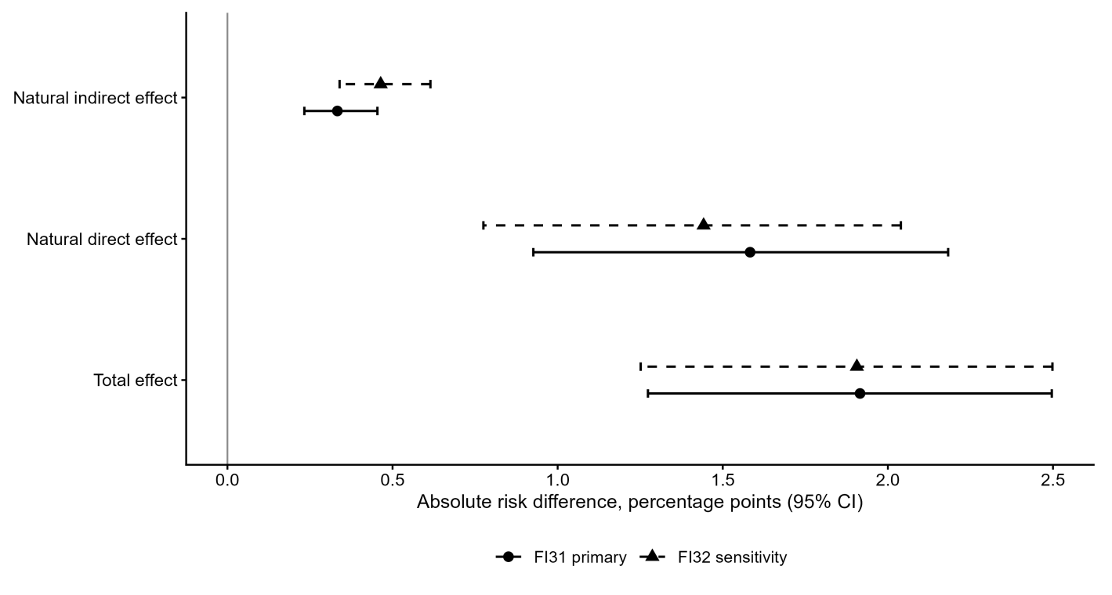
Points and bars show Model 2 natural effects and percentile 95% CIs for an ACE score of 1 versus 0. FI31 excludes arthritis/rheumatism; FI32 includes it. Each index uses its eligible sample. The FI32 indirect estimate was larger, but the analyses were not formally compared.
Supplementary Figure S2 FI31 distribution and age–sex gradient
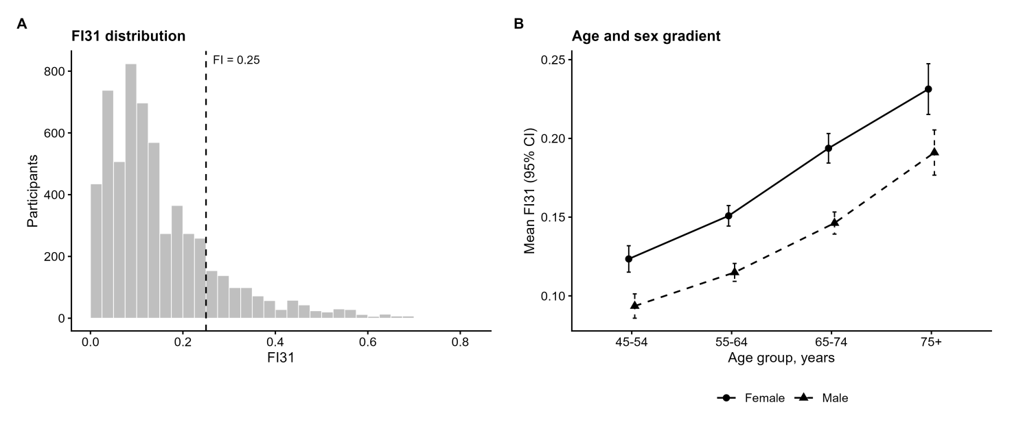
Panel A shows the FI31 distribution in the primary sample; the dashed line marks the descriptive frailty threshold of 0.25. Panel B shows mean FI31 and 95% CIs by age group and sex. These plots were used as reasonableness checks after correction of questionnaire-routing skips.

