Supplementary Information – Tables and Figures
Title: Now you see it: evidence of object permanence in wild Western Australian magpies
Authors: Candice Peters (ORCID 0009-0002-8536-6724), Prof. Mandy Ridley (ORCID 000-0001-5886-0992, and Dr. Lizzie Speechley (ORCID 0000-0003-0690-955X)
The University of Western Australia, Western Australia, Australia
Corresponding author: 23379707@student.uwa.edu.au, candice.herinckx@gmail.com

Table S1. Sidedness bias based on OP2 scores with pass probability on left and right side. Significance is highlighted in bold. Individuals (ID) in red highlighted in grey, with significance (holm-adjusted p) < 0.01, were removed from further analysis.
ID | Pass probability left | Pass probability right | p (raw) | p (holm)
1 | 0.833 | 1 | 1 | 1
2 | 0.6 | 0.552 | 0.935 | 1
3 | 0.714 | 0.833 | 1 | 1
4 | 0.833 | 1 | 1 | 1
5 | 0.6 | 0.48 | 0.616 | 1
6 | 1 | 1 | 1 | 1
7 | 0.915 | 0.038 | <0.001 | <0.001
8 | 0.833 | 0.833 | 1 | 1
9 | 0.8 | 0.857 | 1 | 1
10 | 0.667 | 1 | 0.455 | 1
11 | 0.667 | 0.706 | 1 | 1
12 | 0.75 | 0.588 | 0.285 | 1
13 | 0.898 | 0.137 | <0.001 | <0.001
14 | 0.8 | 1 | 0.417 | 1
15 | 0.833 | 0.833 | 1 | 1
16 | 0.833 | 1 | 1 | 1
17 | 1 | 0.625 | 0.2 | 1
18 | 0.913 | 0.148 | <0.001 | <0.001
19 | 0.833 | 0.75 | 1 | 1
20 | 1 | 1 | 1 | 1
21 | 0.833 | 0.833 | 1 | 1
22 | 1 | 0.833 | 1 | 1
23 | 0.5 | 0.818 | 0.183 | 1
24 | 1 | 0.667 | 0.455 | 1
25 | 0.538 | 0.923 | 0.073 | 1
26 | 0.778 | 0.875 | 1 | 1
27 | 1 | 1 | 1 | 1
28 | 0.833 | 0.833 | 1 | 1
29 | 0.389 | 0.743 | 0.00565 | 0.187
30 | 0.8 | 1 | 0.417 | 1
31 | 0.833 | 0.833 | 1 | 1
32 | 0.536 | 0.667 | 0.499 | 1
34 | 0.5 | 1 | 0.0325 | 1
35 | 1 | 0.556 | 0.0325 | 1
36 | 0.455 | 0.667 | 0.414 | 1
37 | 0.925 | 0.238 | <0.001 | <0.001
38 | 1 | 1 | 1 | 1

Table S2. Model selection (AICc) for potential predictors of object permanence performance for first attempts. Binomial GLMM (logit) with individual and group ID included as random terms. N =103 task scores from 38 birds across 15 groups. Top model is highlighted in bold.
Model | AICc | ∆AICc
Phase | 347.57 | 0.00
Phase + Latency | 349.70 | 2.13
Phase + Latency + Latency² | 350.01 | 2.44
Latency | 404.80 | 57.23
Body mass | 409.01 | 61.44
Average neophobia | 409.98 | 62.41
Temperature | 411.19 | 63.62
Base model | 411.53 | 63.96
Group size on day | 412.81 | 65.24
Age | 412.90 | 65.33
Sex ratio | 413.49 | 65.92
Group size | 413.58 | 66.01
Sex | 415.51 | 67.94
Latency and Latency² (quadratic) were scaled. Lower AICc indicates better fit.

Table S3. Model selection (AICc) for potential predictors of object permanence performance for overall attempts (trial-to-criterion). Gaussian GLMM of log-transformed trials-to-criterion with individual and group ID included as random terms. N =103 task scores from 38 birds across 15 groups. Top model is highlighted in bold.
Model | AICc | ∆AICc
Phase + Latency + Latency² | 120.13 | 0.00
Phase + Latency + Latency² + Temperature | 123.19 | 3.06
Phase + Latency | 124.76 | 4.63
Phase | 132.30 | 12.17
Temperature | 171.55 | 51.42
Latency | 174.28 | 54.15
Base model | 178.10 | 57.97
Average neophobia | 179.60 | 59.47
Body mass | 179.78 | 59.65
Age | 180.86 | 60.73
Group size on day | 180.86 | 60.73
Sex ratio | 180.89 | 60.76
Group size | 180.91 | 60.78
Sex | 183.78 | 63.65
Latency and Latency² (quadratic) were scaled. Lower AICc indicates better fit.

Table S4. Pairwise phase contrasts in first-attempts accuracy (task difficulty). Estimates are from a binomial GLMM (logit) of first-attempts accuracy with random intercepts for group and individual ID. β (SE) is the log-odds difference; OR (95% CI) is the exponentiated contrast. p values are Holm-adjusted across three contrasts; N = birds contributing to each phase in the contrast (A vs B).
Contrast | N | β (SE) | z | OR (95% CI) | P (raw) | p (Holm)
OP1 vs OP2 | 38 vs 33 | 2.023 (0.286) | 7.08 | 7.56 (3.82-14.99) | <0.001 | <0.001
OP1 vs OP3 | 38 vs 32 | 1.624 (0.324) | 5.01 | 5.07 (2.34-11.02) | <0.001 | <0.001
OP2 vs OP3 | 33 vs 32 | -0.399 (0.243) | -1.64 | 0.67 (0.67-1.20) | 0.100 | 0.100

Table S5. Top AICc model set of terms affecting object permanence performance in trials to criterion for all phases (OP1-3), as a subset with attempts capped at 50 trials. The model was specified using a Gaussian GLMM on log-transformed trials. Individual and group ID were included as random terms. Coefficient estimates ± S.E. and 95% CIs are included. N =93 task scores from 36 birds across 15 groups.
Top model | AICc | ∆AICc
Phase + Latency + Latency² | 42.63 | 0.00
Base model | 108.39 | 65.77
Parameter | Estimate | S.E | CI
Phase
OP1 | 0 | - | -
OP2 | 0.21 | 0.03 | 0.15, 0.28
OP3 | -0.35 | 0.04 | -0.42, -0.28
Latency | 0.07 | 0.04 | -0.02, 0.15
Latency² (quadratic) | -0.03 | 0.01 | -0.05, -0.01
Latency and Latency² were scaled.

Table S6. Model selection (AICc) for potential predictors of object permanence performance for overall attempts (trial-to-criterion), as a subset with attempts capped at 50 trials. Gaussian GLMM of log-transformed trials-to-criterion with individual and group ID included as random terms. N =93 task scores from 36 birds across 15 groups. Top model is highlighted in bold.
Model | AICc | ∆AICc
Phase + Latency + Latency² | 42.63 | 0.00
Phase + Latency | 46.96 | 4.33
Phase | 47.51 | 4.88
Latency | 106.03 | 63.40
Temperature | 106.67 | 64.04
Body mass | 108.16 | 65.53
Base model | 108.39 | 65.77
Sex ratio | 110.45 | 67.83
Group size | 110.84 | 68.22
Group size on day | 111.10 | 68.47
Age | 111.24 | 68.62
Neophobia | 109.35 | 66.72
Sex | 113.89 | 71.26
Latency and Latency² (quadratic) were scaled. Lower AICc indicates better fit.

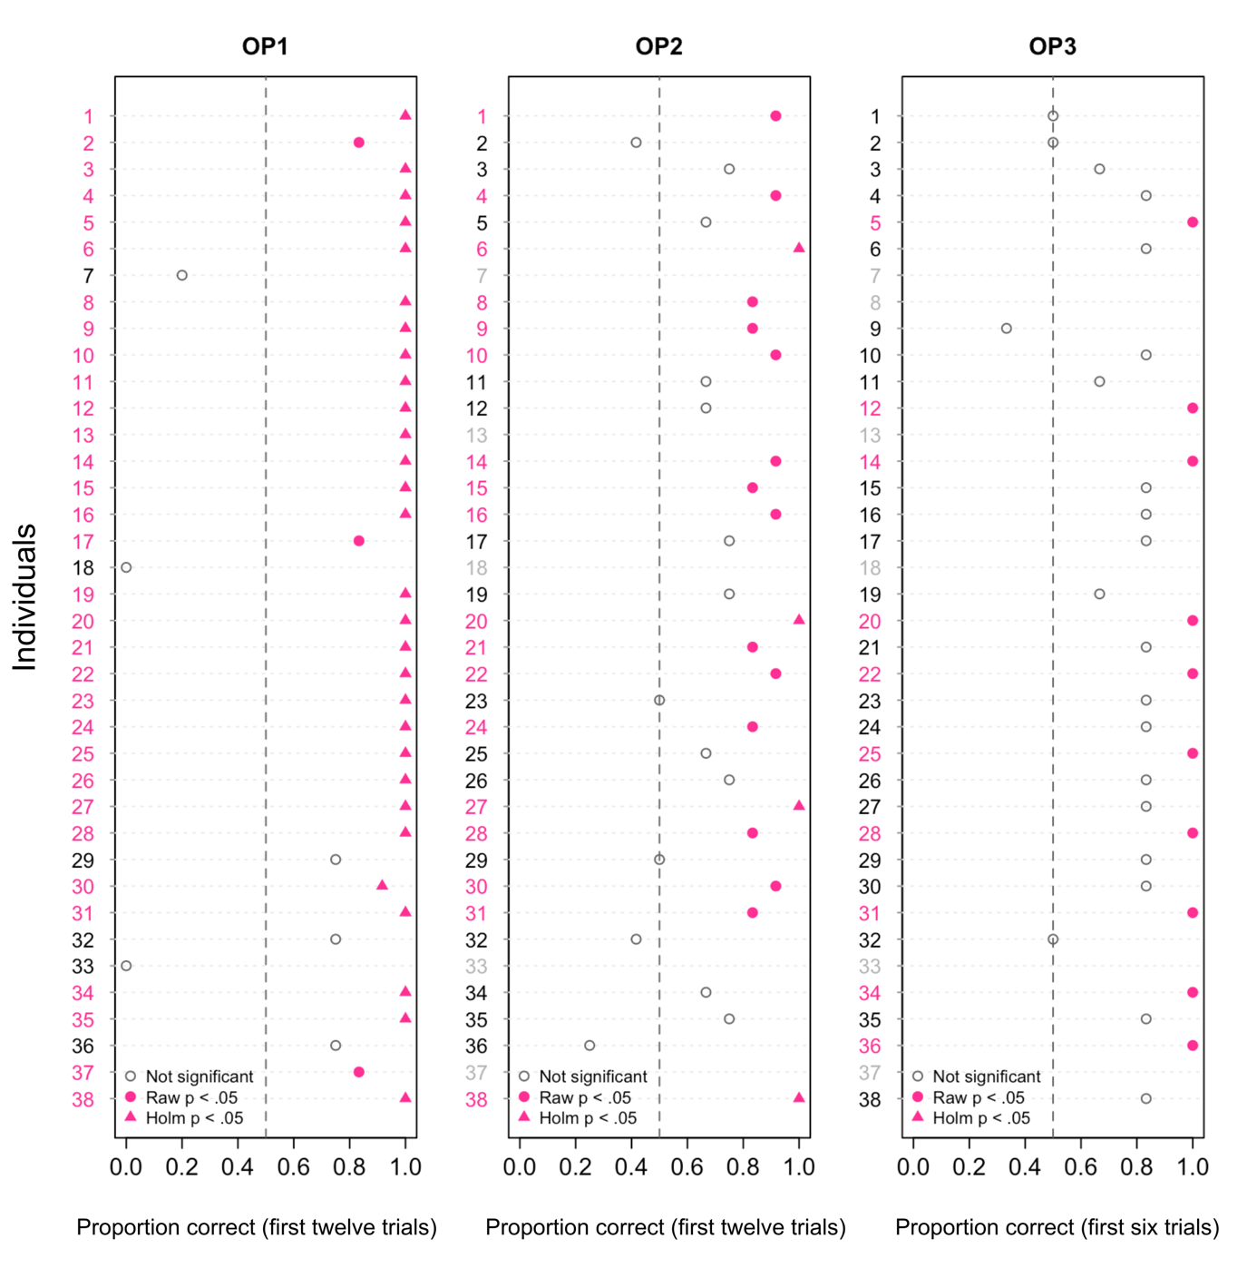
Fig S1. Proportion of correct choices in first attempts per individual in OP1, OP2 (first twelve trials), OP3 (first six trials), with not significant values (hollow grey circles), raw values (pink full circles), and Holm-adjusted values (pink triangles). Individuals in light grey represent those who have not progressed to later stages through failing previous phases or through demonstrating sidedness bias.

