Supplementary Methods S1. Computational and analytical specifications
Software environment. Analyses were performed in Python 3.14.6 using NumPy 2.4.6, pandas 3.0.3, SciPy 1.18.0, scikit-learn 1.9.0, XGBoost 3.3.0, LightGBM 4.6.0, statsmodels 0.14.6, SHAP 0.52.0, and Matplotlib 3.11.0.
Preprocessing and class imbalance. All preprocessing parameters requiring estimation were fitted using the 2019–2022 derivation cohort and applied unchanged to the 2023 temporal model-comparison cohort. Continuous and binary predictors were imputed using derivation-cohort medians and standardised using derivation-cohort parameters. Multicategory predictors underwent mode imputation and one-hot encoding. Class imbalance was addressed using algorithm-specific inverse-frequency weighting. XGBoost used scale_pos_weight=75.0689; logistic regression, random forest, and LightGBM used class_weight='balanced'. Synthetic minority oversampling was not used.
Primary model configurations. The primary XGBoost model used n_estimators=400, max_depth=6, learning_rate=0.05, subsample=0.8, colsample_bytree=0.8, scale_pos_weight=75.0689, eval_metric='logloss', and random_state=42. Random forest used n_estimators=200, min_samples_leaf=50, class_weight='balanced', and random_state=42. LightGBM used n_estimators=400, num_leaves=63, learning_rate=0.05, subsample=0.8, colsample_bytree=0.8, class_weight='balanced', and random_state=42. Logistic regression used max_iter=2000 and class_weight='balanced'. Parameters not explicitly specified used package-version defaults.
Probability calibration and resampling. Stratified five-fold cross-validation within the derivation cohort (shuffle=True, random_state=42) generated out-of-fold XGBoost predictions used to fit an isotonic regression mapping; the fitted mapping was applied unchanged to 2023 predictions. Principal confidence intervals were obtained using 1,000 percentile bootstrap resamples. The random seed was 42 where a seed was specified.
Random-search robustness analysis. Randomised hyperparameter search was used only as a robustness analysis and did not define the primary model. The search used 15 iterations of three-fold cross-validation on a random subsample of 150,000 derivation patients, AUROC as the optimisation objective, random_state=42, and no early stopping. The predefined search space was n_estimators {200, 400, 600}, max_depth {4, 6, 8}, learning_rate {0.03, 0.05, 0.10}, subsample {0.7, 0.8, 0.9}, colsample_bytree {0.7, 0.8, 0.9}, and min_child_weight {1, 5, 10}. The best-performing searched configuration was n_estimators=200, max_depth=4, learning_rate=0.05, subsample=0.7, colsample_bytree=0.8, and min_child_weight=10; it was not adopted for the primary analysis.

Supplementary Table S1. Operational definitions and analytical representations of the 15 candidate predictors
Category / predictor | Operational definition | Measurement / ascertainment | Analytical representation
I. Demographic and temporal characteristics
Age | Age at ED presentation | Recorded in EDIIS at ED presentation | Continuous, years
Sex | Sex recorded in EDIIS | Recorded at ED presentation | Categorical (male / female)
Nighttime ED presentation | ED presentation classified according to the predefined nighttime-arrival criterion | Derived from recorded ED arrival time | Binary (yes / no)
II. Prehospital and injury characteristics
Injury mechanism | Mechanism responsible for the traumatic injury, classified according to the EDIIS coding system | Recorded from injury-related information available at ED presentation | Binary (ambulance transportation: yes / no)
Injury intentionality | Intent associated with the injury event, classified according to the EDIIS coding system | Recorded from injury-event information | Binary (ambulance transportation: yes / no)
Time from injury to ED arrival | Elapsed time between the recorded injury time and ED arrival | Derived from recorded injury and ED-arrival times | Continuous, minutes for model development; converted to hours for descriptive presentation and regression-effect reporting.
Mode of transportation to the ED | Mode by which the patient arrived at the ED, classified according to the EDIIS coding system | Recorded at ED presentation | Binary (ambulance transportation: yes / no)
Alcohol-related status | Alcohol involvement at the time of injury according to the EDIIS source-data definition | Recorded from injury-context information | Binary (ambulance transportation: yes / no)
III. Initial physiological and neurological characteristics
Systolic blood pressure (SBP) | Initial systolic blood pressure recorded at ED presentation | First measurement recorded at ED presentation | Continuous, mmHg
Diastolic blood pressure (DBP) | Initial diastolic blood pressure recorded at ED presentation | First measurement recorded at ED presentation | Continuous, mmHg
Heart rate (HR) | Initial heart rate recorded at ED presentation | First measurement recorded at ED presentation | Continuous, beats/min
Respiratory rate (RR) | Initial respiratory rate recorded at ED presentation | First measurement recorded at ED presentation | Continuous, breaths/min
Body temperature | Initial body temperature recorded at ED presentation | First measurement recorded at ED presentation | Continuous, °C
Glasgow Coma Scale (GCS) | Total GCS score calculated from eye, verbal, and motor response components; possible total score 3–15 | Initial neurological assessment recorded at ED presentation | Continuous, total score 3–15
AVPU level of consciousness | Level of consciousness categorised as Alert, responsive to Voice, responsive to Pain, or Unresponsive | Initial consciousness assessment recorded at ED presentation | Categorical (Alert / Voice / Pain / Unresponsive)
Note. AVPU, Alert, Voice, Pain, Unresponsive; DBP, diastolic blood pressure; ED, emergency department; EDIIS, Emergency Department-based Injury In-depth Surveillance; GCS, Glasgow Coma Scale; HR, heart rate; RR, respiratory rate; SBP, systolic blood pressure. Missingness was assessed after application of the prespecified data-quality rules. Special physiological codes representing unmeasurable or unknown values were distinguished from valid observations and treated as missing where applicable. Missing continuous predictors in the primary analysis were imputed using median values estimated exclusively from the derivation cohort and subsequently applied unchanged to the 2023 temporal model-comparison cohort. No candidate predictor was excluded solely on the basis of missingness.
Supplementary Table S2. Missingness and data-quality handling of candidate predictors and conventional trauma scores (N = 626,233)
Variable / score | Missing (%) | Data-quality assessment and validation criteria | Primary handling / imputation strategy
Candidate predictors
Age | 0.00 | No missing values identified | No imputation
Sex | 0.00 | No missing values identified | No imputation
Injury mechanism | 0.00 | Coded according to the standard EDIIS classification | No imputation
Injury intentionality | 0.00 | Coded according to the standard EDIIS classification | No imputation
Time from injury to ED arrival | 0.00 | Derived from recorded injury time and ED-arrival time | No imputation
Systolic blood pressure (SBP) | 0.94 | Special codes indicating unmeasurable or unknown values and physiologically implausible values were treated as missing | Median imputation
Diastolic blood pressure (DBP) | 1.01 | Special codes, physiologically implausible values, and internally inconsistent measurements (DBP ≥ SBP) were treated as missing | Median imputation
Heart rate (HR) | 0.77 | Special codes and physiologically implausible values, including HR <20 beats/min, were treated as missing | Median imputation
Respiratory rate (RR) | 0.90 | Special codes and physiologically implausible values were treated as missing | Median imputation
Body temperature | 0.60 | Special codes and physiologically implausible values were treated as missing | Median imputation
Glasgow Coma Scale (GCS) | 1.92 | Component values were restricted to valid ranges: eye (1–4), verbal (1–5), and motor (1–6); total GCS was calculated only from valid component values | Median imputation of the derived total GCS score
AVPU level of consciousness | 0.00 | Coded according to the standard EDIIS classification | No imputation
Mode of transportation to the ED | 0.00 | Coded according to the standard EDIIS classification | No imputation
Nighttime ED presentation | 0.00 | Derived from recorded ED-arrival time | No imputation
Alcohol-related status | 6.22 | Unknown or unavailable information was distinguished according to the source-data coding structure | Missing alcohol-related status was handled using the same derivation-fitted categorical preprocessing procedure as other multicategory predictors, including mode imputation and subsequent one-hot encoding.
Conventional trauma scores
rSIG | 2.82 | Derived from GCS, SBP, and HR after data-quality assessment | Calculated when all required component values were available
RTS | 2.91 | Derived from GCS, SBP, and RR; recalculated values were cross-checked against the RTS values provided in the source data | Calculated when all required component values were available
Note. AVPU, Alert, Voice, Pain, Unresponsive; DBP, diastolic blood pressure; ED, emergency department; EDIIS, Emergency Department-based Injury In-depth Surveillance; GCS, Glasgow Coma Scale; HR, heart rate; rSIG, reverse Shock Index multiplied by Glasgow Coma Scale; RR, respiratory rate; RTS, Revised Trauma Score; SBP, systolic blood pressure.
Supplementary Table S3. Application of the algorithm-selection criterion in the 2023 temporal model-comparison cohort
Model | AUROC | Brier score | Calibration slope | Calibration intercept | Calibration-slope eligibility criterion (0.90–1.10)
Logistic regression | 0.9768 | 0.0580 | 0.785 | -4.271 | Not met
Random forest | 0.9796 | 0.0458 | 1.117 | -3.976 | Not met
XGBoost | 0.9783 | 0.0367 | 0.919 | -3.682 | Met
LightGBM | 0.9781 | 0.0295 | 0.875 | -3.413 | Not met
Note. Candidate algorithms were compared in the 2023 temporal model-comparison cohort. Eligibility for detailed characterisation required an unrecalibrated calibration-slope point estimate between 0.90 and 1.10; among eligible algorithms, the algorithm with the highest AUROC was to be selected. The calibration-slope criterion was finalised before model-specific calibration slopes were calculated, although preliminary discrimination results had previously been examined. XGBoost was the only algorithm satisfying the calibration-slope criterion. Because the 2023 cohort contributed to algorithm selection, these estimates should not be interpreted as independent external-validation performance of the selected algorithm. AUROC, area under the receiver operating characteristic curve; LightGBM, Light Gradient Boosting Machine; XGBoost, Extreme Gradient Boosting.
Supplementary Table S4. Dependence of calibration slope on derivation sample size and evaluation of alternative model-selection strategies
Panel A. Cumulative derivation period, evaluated in the 2023 temporal model-comparison cohort
Derivation period | N | Events | AUROC | Calibration slope
2019 | 158,179 | 1,636 | 0.9734 | 0.786
2019–2020 | 283,028 | 3,232 | 0.9761 | 0.837
2019–2021 | 395,064 | 4,917 | 0.9776 | 0.884
2019–2022 | 506,999 | 6,665 | 0.9783 | 0.919
Panel B. Random subsampling of the 2019–2022 derivation cohort, evaluated in the 2023 temporal model-comparison cohort
Proportion of derivation cohort | N | Events | AUROC | Calibration slope
25% | 126,750 | 1,621 | 0.9725 | 0.798
50% | 253,500 | 3,306 | 0.9763 | 0.853
75% | 380,249 | 4,960 | 0.9771 | 0.891
100% | 506,999 | 6,665 | 0.9783 | 0.919

Panel C. Alternative model-selection strategies excluding the 2023 cohort
Selection strategy | Model | AUROC | Calibration slope | Calibration-slope eligibility criterion (0.90–1.10)
Internal temporal split (2019–2021 to 2022) | Logistic regression | 0.9749 | 0.757 | Not met
Internal temporal split (2019–2021 to 2022) | Random forest | 0.9773 | 1.108 | Not met
Internal temporal split (2019–2021 to 2022) | XGBoost | 0.9752 | 0.859 | Not met
Internal temporal split (2019–2021 to 2022) | LightGBM | 0.9748 | 0.800 | Not met
Internal 5-fold cross-validation (2019–2022) | Logistic regression | 0.9791 | 0.783 | Not met
Internal 5-fold cross-validation (2019–2022) | Random forest | 0.9811 | 1.127 | Not met
Internal 5-fold cross-validation (2019–2022) | XGBoost | 0.9797 | 0.896 | Not met
Internal 5-fold cross-validation (2019–2022) | LightGBM | 0.9790 | 0.845 | Not met
Note. Calibration slope increased with increasing derivation sample size in both the cumulative-period and random-subsampling analyses, whereas AUROC varied by less than 0.006 across the examined sample sizes. When algorithm-selection strategies were restricted entirely to the 2019–2022 data, none of the candidate algorithms satisfied the specified calibration-slope criterion. These analyses were exploratory and were conducted to examine the sensitivity of calibration and algorithm selection to derivation-sample specification. AUROC, area under the receiver operating characteristic curve.
Supplementary Table S5. Sensitivity and robustness analyses for in-hospital mortality
Analysis | Model / metric | Primary or reference specification | AUROC | Alternative specification | AUROC | Difference in AUROC
Acute-trauma time window | XGBoost | ≤24 h (N = 626,233) | 0.978 | ≤12 h (N = 572,145) | 0.980 | +0.002
Acute-trauma time window | XGBoost | ≤24 h (N = 626,233) | 0.978 | ≤6 h (N = 526,990) | 0.981 | +0.003
Post-admission transfer exclusion | XGBoost | Full analytic cohort | 0.978 | Excluding post-admission transfers (n = 29,561) | 0.983 | +0.005
Alternative rSIG formulation | rSIG | SBP-based rSIG | 0.805 | MAP-based rSIG | 0.827 | +0.022
Missing-data method | XGBoost | Median imputation | 0.9783 | Iterative multivariable imputation | 0.9787 | +0.0003
Hyperparameter specification | XGBoost | Primary/default settings | 0.9783 | Random-search tuning | 0.9802 | +0.0019
Predictor ablation | XGBoost | Full model | 0.978 | Removal of neurological and physiological predictors | 0.898 | -0.081
Note. All machine-learning sensitivity analyses were performed with the primary XGBoost model. Iterative multivariable imputation was fitted exclusively within the derivation cohort (2019–2022) inside the modelling pipeline; the 2023 temporal model-comparison cohort was not used for imputation-model fitting. Differences in AUROC were calculated from unrounded values. MAP, mean arterial pressure. AUROC, area under the receiver operating characteristic curve; rSIG, reverse Shock Index multiplied by Glasgow Coma Scale; SBP, systolic blood pressure; XGBoost, Extreme Gradient Boosting.
Supplementary Table S6. Multivariable associations between candidate predictors and in-hospital mortality in the derivation cohort
Predictor | Unit / reference category | Adjusted OR | 95% CI | P value
Level of consciousness (AVPU) | Reference: Alert
Responsive to voice | vs. Alert | 4.84 | 4.30–5.45 | <0.001
Responsive to pain | vs. Alert | 13.69 | 11.97–15.67 | <0.001
Unresponsive | vs. Alert | 160.58 | 136.92–188.32 | <0.001
Injury mechanism | Reference: Blunt injury
Fall or slip | vs. Blunt injury | 2.00 | 1.68–2.37 | <0.001
Transportation-related injury | vs. Blunt injury | 2.03 | 1.70–2.41 | <0.001
Penetrating injury | vs. Blunt injury | 0.48 | 0.37–0.62 | <0.001
Overexertion | vs. Blunt injury | 0.81 | 0.50–1.33 | 0.408
Machinery | vs. Blunt injury | 0.63 | 0.39–1.04 | 0.069
Other | vs. Blunt injury | 0.58 | 0.43–0.79 | <0.001
Injury intentionality | Reference: Unintentional
Self-harm or suicide | vs. Unintentional | 3.69 | 3.07–4.43 | <0.001
Assault or violence | vs. Unintentional | 1.23 | 0.92–1.64 | 0.156
Unknown | vs. Unintentional | 4.93 | 3.74–6.50 | <0.001
Sex | Male vs. female | 1.58 | 1.47–1.71 | <0.001
Age | Per 10-year increase | 1.52 | 1.48–1.56 | <0.001
Systolic blood pressure | Per 10-mmHg decrease | 1.05 | 1.03–1.06 | <0.001
Diastolic blood pressure | Per 10-mmHg decrease | 1.05 | 1.02–1.08 | 0.002
Heart rate | Per 10-beats/min increase | 1.06 | 1.05–1.08 | <0.001
Respiratory rate | Per 5-breaths/min increase | 1.30 | 1.24–1.36 | <0.001
Body temperature | Per 1 °C decrease | 1.34 | 1.28–1.40 | <0.001
Glasgow Coma Scale | Per 1-point decrease | 1.15 | 1.13–1.16 | <0.001
Time from injury to ED arrival | Per 1-hour increase | 0.99 | 0.98–1.00 | 0.118
Ambulance transportation | Yes vs. No | 4.08 | 3.60–4.61 | <0.001
Nighttime ED presentation | Yes vs. No | 0.85 | 0.78–0.93 | <0.001
Alcohol-related status | Yes vs. No | 0.28 | 0.24–0.32 | <0.001
Note. Odds ratios were estimated in the entire derivation cohort (2019–2022, n = 506,999) using a multivariable logistic regression model including all 15 candidate predictors. Rare categories (<1% of the cohort) were merged according to the prespecified rule. The model converged (pseudo R² = 0.613). All variance inflation factors were below 5; the maximum was 4.47 for the Glasgow Coma Scale, followed by AVPU unresponsive (3.35) and AVPU responsive to pain (2.13), indicating acceptable collinearity between the two consciousness measures. OR, odds ratio; CI, confidence interval. This supplementary analysis was conducted to characterise adjusted associations and assess multicollinearity. Regression coefficients were not used for predictor selection or development of the primary prediction models. Odds ratios should not be interpreted as causal effects. AVPU, Alert, Voice, Pain, Unresponsive; ED, emergency department.
Supplementary Table S7. Comparison of characteristics and predictor missingness between the 2019–2022 derivation cohort and the 2023 temporal model-comparison cohort
Panel A. Cohort characteristics
Characteristic | 2019–2022 derivation cohort (n = 506,999) | 2023 temporal model-comparison cohort (n = 119,234) | SMD
In-hospital mortality, n (%) | 6,665/506,999 (1.31%) | 1,653/119,234 (1.39%) | —
Age, years | 49 (32–63) | 52 (33–66) | -0.100
Systolic blood pressure, mmHg | 139 (122–155) | 140 (124–157) | -0.045
Heart rate, beats/min | 83 (74–94) | 83 (74–94) | -0.011
Respiratory rate, breaths/min | 20 (18–20) | 20 (18–20) | +0.001
Body temperature, °C | 37 (36–37) | 37 (36–37) | +0.013
Glasgow Coma Scale | 15 (15–15) | 15 (15–15) | -0.003
Sex
Male | 293,325 (57.86) | 66,882 (56.09) | +0.036
Female | 213,674 (42.14) | 52,352 (43.91) | -0.036
Injury mechanism
Fall or slip | 172,668 (34.06) | 46,069 (38.64) | -0.095
Transportation-related | 97,877 (19.31) | 20,666 (17.33) | +0.051
Blunt injury | 91,445 (18.04) | 20,656 (17.32) | +0.019
Penetrating injury | 75,401 (14.87) | 16,405 (13.76) | +0.032
Other | 42,551 (8.39) | 9,304 (7.80) | +0.022
Overexertion | 19,774 (3.90) | 4,659 (3.91) | -0.000
Machinery | 7,258 (1.43) | 1,468 (1.23) | +0.017
Natural disaster | 25 (0.00) | 7 (0.01) | -0.001
AVPU
Alert | 487,076 (96.07) | 114,222 (95.80) | +0.014
Responsive to voice | 9,878 (1.95) | 2,520 (2.11) | -0.012
Responsive to pain | 5,372 (1.06) | 1,304 (1.09) | -0.003
Unresponsive | 4,673 (0.92) | 1,188 (1.00) | -0.008
Ambulance transport, n (%) | 194,778 (38.42) | 46,245 (38.79) | -0.008

Panel B. Predictor missingness
Predictor | 2019–2022 derivation cohort,  missing (%) | 2023 temporal model-comparison cohort,  missing (%)
SBP | 0.93 | 0.98
DBP | 1.00 | 1.06
HR | 0.75 | 0.85
RR | 0.89 | 0.93
BT | 0.58 | 0.69
GCS | 2.31 | 0.27
Alcohol-related status | 6.37 | 5.58
Note. Continuous variables are presented as median (IQR), and categorical variables as n (%). Standardised mean differences (SMDs) were used to describe between-cohort differences. For continuous variables, SMDs were calculated using means and pooled standard deviations although median (IQR) values are presented; for categorical variables, SMDs were calculated using the binary variance approximation. Missingness was assessed after application of the prespecified data-quality rules. SMDs are descriptive measures and were not used for hypothesis testing. AVPU, Alert, Voice, Pain, Unresponsive; BT, body temperature; DBP, diastolic blood pressure; GCS, Glasgow Coma Scale; HR, heart rate; IQR, interquartile range; RR, respiratory rate; SBP, systolic blood pressure; SMD, standardised mean difference.
Supplementary Table S8. Operating-threshold performance in the derivation and 2023 temporal model-comparison cohorts
Operating threshold | Cohort | Model-output threshold | Sensitivity, % | Specificity, % | PPV, % | NPV, % | F1
Youden-index threshold | 2019–2022 derivation | 0.516 | 97.18 | 96.22 | 25.53 | 99.96 | 0.404
Youden-index threshold | 2023 model-comparison | 0.516 | 86.57 | 95.49 | 21.26 | 99.80 | 0.341
≥90%-sensitivity threshold | 2019–2022 derivation | 0.744 | 90.01 | 98.51 | 44.64 | 99.87 | 0.597
≥90%-sensitivity threshold | 2023 model-comparison | 0.744 | 79.49 | 98.26 | 39.05 | 99.71 | 0.524
Note. Both operating thresholds were determined exclusively from class-weighted, uncalibrated XGBoost model outputs in the 2019–2022 derivation cohort and subsequently applied unchanged to the 2023 temporal model-comparison cohort. The Youden-index threshold was defined as the model-output threshold that maximised the Youden index in the derivation cohort. The ≥90%-sensitivity threshold was defined as the highest model-output threshold retaining at least 90% sensitivity in the derivation cohort. No threshold was re-optimised using 2023 outcomes. Because both thresholds were derived from class-weighted, uncalibrated model outputs, they represent model-specific operating cut-points and should not be interpreted as absolute mortality probabilities. NPV, negative predictive value; PPV, positive predictive value. Metrics were calculated using the unrounded thresholds (Youden, 0.515979; ≥90%-sensitivity, 0.7435389); the table displays thresholds rounded to three decimals. Sensitivity, specificity, PPV and NPV are presented as percentages, whereas F1 is presented on the 0–1 scale. XGBoost, Extreme Gradient Boosting.
Supplementary Table S9. Injury-mechanism–specific performance of the primary XGBoost model for in-hospital mortality in the 2023 temporal model-comparison cohort
Injury mechanism | N | In-hospital deaths, n | Mortality prevalence, % | AUROC (95% CI)
Fall or slip | 46,069 | 870 | 1.89 | 0.953 (0.946–0.960)
Transportation-related | 20,666 | 650 | 3.15 | 0.980 (0.975–0.984)
Blunt injury | 20,656 | 54 | 0.26 | 0.986 (0.968–0.997)
Penetrating injury | 16,405 | 33 | 0.20 | 0.999 (0.998–0.999)
Other | 9,304 | 29 | 0.31 | 0.998 (0.994–1.000)
Note. The XGBoost model fitted using the complete 2019–2022 derivation cohort was applied unchanged to each subgroup without subgroup-specific refitting or recalibration. 95% confidence intervals were obtained from 1,000 percentile bootstrap resamples within each subgroup. Estimates for penetrating injury and other mechanisms should be interpreted cautiously because these subgroups contained only 33 and 29 deaths, respectively. Fatal cases in these groups were concentrated among patients with severe neurological impairment. Subgroups with fewer than 20 events (overexertion, machinery and natural disaster; n = 6,134 with 17 deaths) were not analysed separately. AUROC, area under the receiver operating characteristic curve; CI, confidence interval; XGBoost, Extreme Gradient Boosting.
Supplementary Figure S1. Nomogram for prediction of in-hospital mortality using the five-variable parsimonious logistic regression model.
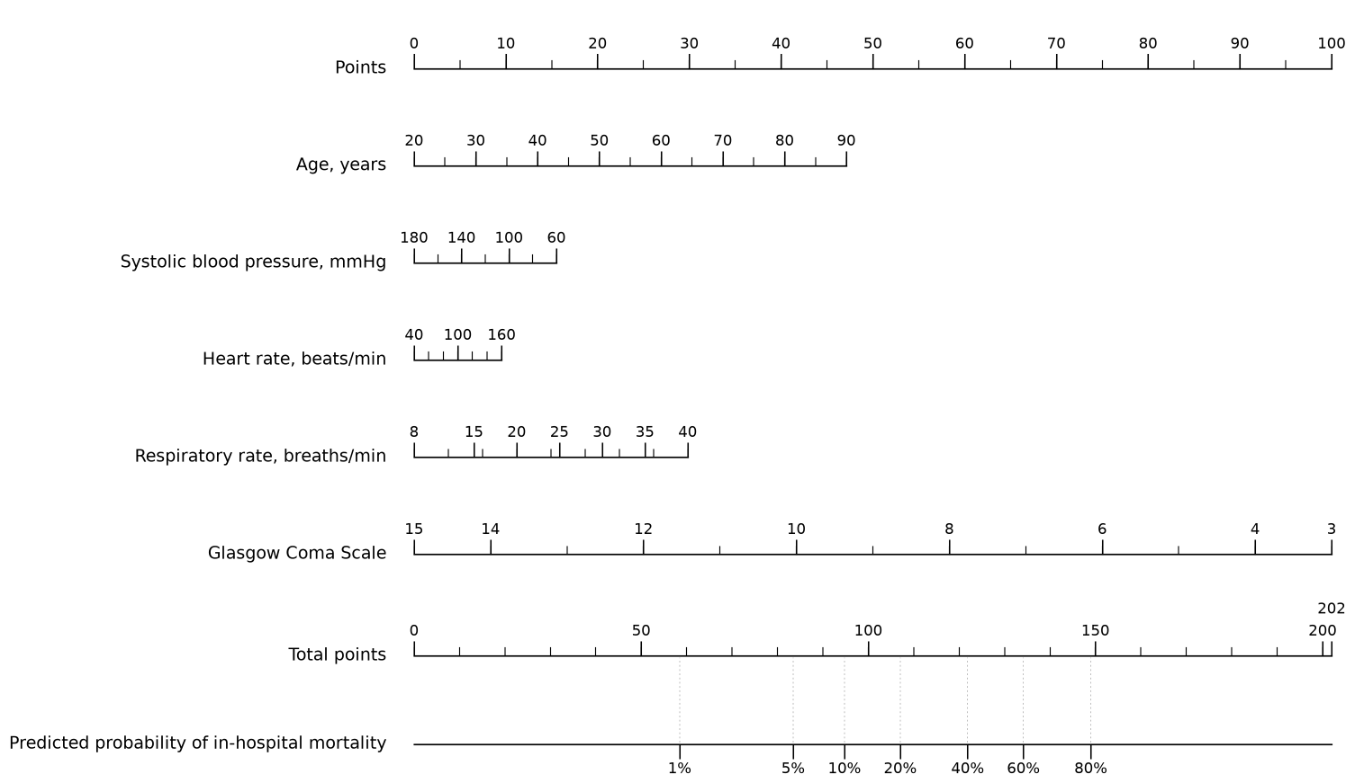
The nomogram incorporates age, systolic blood pressure, heart rate, respiratory rate, and Glasgow Coma Scale. Points assigned to each predictor are summed to obtain the total points, which are then mapped to the predicted probability of in-hospital mortality. The model was fitted without class weighting using unpenalised maximum likelihood. SBP, systolic blood pressure; HR, heart rate; RR, respiratory rate; GCS, Glasgow Coma Scale.
Supplementary Figure S2. Age-stratified SHAP-based characterisation of XGBoost model behaviour.
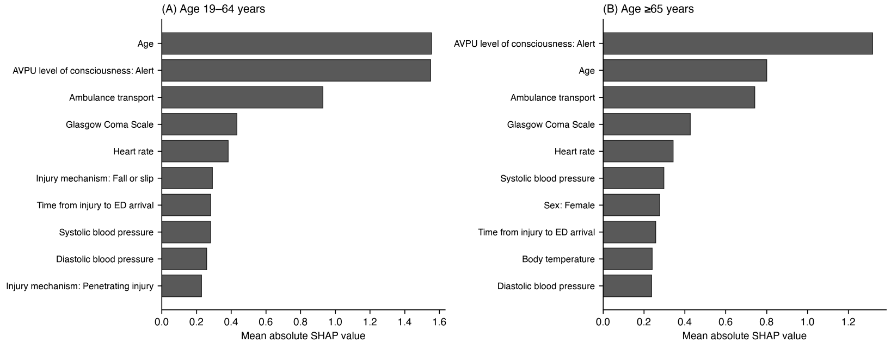
Mean absolute SHapley Additive exPlanations (SHAP) values are shown for the leading predictors among (A) adults aged 19–64 years and (B) adults aged ≥65 years. Higher mean absolute SHAP values indicate greater contributions to model output within the corresponding age group. The same XGBoost model fitted using the complete 2019–2022 derivation cohort was applied to both age groups without subgroup-specific refitting. These analyses characterise differences in model behaviour and should not be interpreted as causal explanations for age-related differences in mortality or predictive performance.

