Supplementary Information

Technoeconomic Framework for Evaluating Desalination and Brine Management Pathways in the United States

Walter P. Parker Jr.¹, Jordan D. Kocher¹, and Akanksha K. Menon^{1*}
¹ George W. Woodruff School of Mechanical Engineering, Georgia Institute of Technology, Atlanta, GA 30332, USA
* Corresponding author: akanksha.menon@me.gatech.edu

Supplementary Note 1 – Feed Sources and Brine Management Approaches
Description of Brine Management Approaches:
In this techno-economic analysis, three water sources were examined for desalination and to evaluate strategies for managing brine generated by desalination. The feed sources considered were seawater (SW), brackish groundwater (BGW), and produced water (PW). Data for BGW and PW were obtained from the United States Geological Survey^{1,2}. For SW, the brine management approaches considered were: (i) ocean discharge (OD) with inland transport of freshwater and (ii) zero liquid discharge (ZLD) with inland transport of freshwater. BGW and PW were evaluated using three brine management approaches: (i) ocean discharge (OD) to the nearest coastline for brine transport, (ii) deep well injection (DWI) at the local site, and (iii) zero liquid discharge (ZLD) on site with salt recovery and revenue. The primary differences between these two feed sources are the initial feed salinity and the corresponding type of reverse osmosis (RO) system required.
For the SW feed source, two brine management strategies were evaluated. In both cases, the feed stream was first treated using a seawater reverse osmosis (SWRO) system operating at a feed salinity of 3.5 wt.% and a water recovery of 50%, producing a brine stream with a salinity of 7 wt.%. For the OD scenario, the generated brine was discharged to the ocean. Since desalination facilities utilizing SW are assumed to be located near the coast, the cost associated with brine disposal was considered negligible. The freshwater produced by the desalination facility was then transported inland to the specified location (latitude and longitude coordinates), with the associated transport costs (includes vertical and horizontal cost). For the ZLD scenario, the SWRO brine was treated further —the 7 wt.% brine was first processed using a mechanical vapor compression (MVC) system, where additional freshwater was recovered and the brine salinity was increased to 20 wt.%, which was used in this study as the minimal liquid discharge (MLD) endpoint³⁻⁶. The concentrated brine was subsequently sent to an evaporation pond (EP), where the remaining water was extracted to reach saturation (26 wt.%) with salt precipitation. The recovered salt was assumed to be sold to offset the capital and operating costs associated with the ZLD process. A baseline salt selling price of 30 $/ton was used and was varied parametrically, as discussed in Supplementary Note 6.
Unlike SW, BGW and PW are inland feed sources distributed throughout the United States and span a wide range of salinities. Fig. S1 shows a histogram of the salinity distribution for BGW and PW sources. In this analysis, feed salinities between 0.05 and 4.8 wt.% were considered, representing practical operating ranges for commercially available RO systems^{7,8}. For BGW and PW feed sources, three brine management strategies were evaluated: ocean discharge (OD), deep well injection (DWI), and zero liquid discharge (ZLD). For the OD and DWI scenarios, desalination was performed using either brackish water reverse osmosis (BWRO) or SWRO, depending on the feed salinity. Feed streams with salinities between 0.05 and 1.2 wt.% were treated using BWRO at a fixed water recovery of 75%⁸⁻¹². Feed streams with salinities between 1.2 and 4.8 wt.% were treated using SWRO at a fixed water recovery of 50%¹²⁻¹⁶. If the 50% recovery resulted in an outlet salinity greater than 7 wt.%, the outlet salinity was fixed at 7 wt.% and the corresponding recovery was recalculated. These constraints were implemented to maintain realistic RO operating conditions and water recovery ratios.
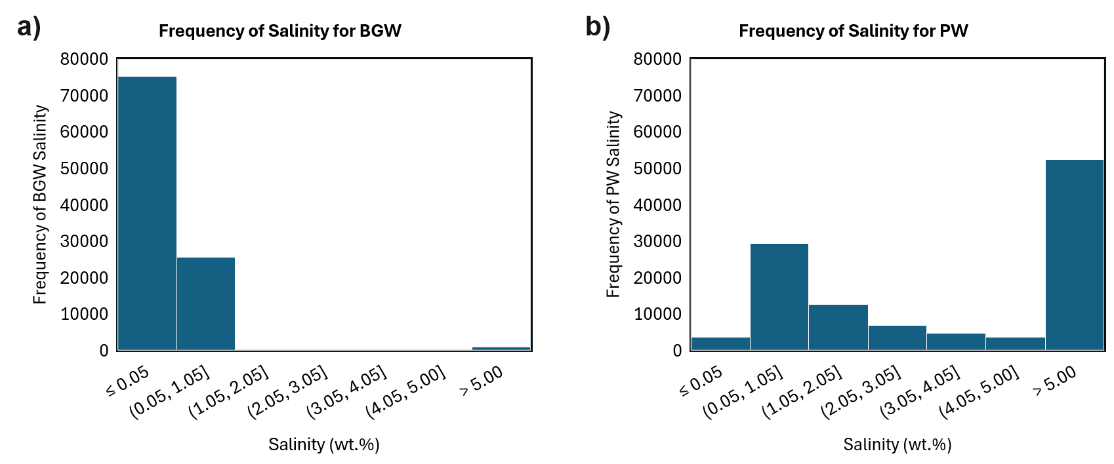
Fig. S1: Histogram showing the salinity frequency distribution for (a) brackish groundwater (BGW) and (b) produced water (PW) across the United States.
After RO, the brine was managed according to the selected strategy. For OD, the brine was transported to the nearest coastline for discharge. For DWI, the brine was injected underground at the location of interest. These two approaches required only a single RO stage prior to disposal. The ZLD configuration required additional concentration stages to increase the brine salinity up to saturation. Depending on the feed salinity, one or more BWRO stages were used to pre-concentrate the feed stream to approximately 3 - 3.5 wt.% before entering an SWRO unit. Each BWRO stage operated at a recovery of 75%, with successive stages applied until the target salinity was achieved. The concentrated stream was then processed using SWRO at a nominal recovery of 50%, with recovery adjusted as necessary to maintain a maximum outlet salinity of 7 wt.%. The resulting brine was subsequently treated using MVC, where the salinity was increased to 20 wt.% with additional recovery of freshwater. Finally, the concentrated brine was sent to an EP, where salt precipitation occurred and the recovered salt was assumed to be valorized to offset ZLD-related costs. The energy consumption and capital costs associated with all BWRO, SWRO, MVC, and EP stages were included in the technoeconomic analysis. These brine management pathways were evaluated at each location across the United States to determine their impact on the levelized cost of water (LCOW), and to identify the most economically favorable brine management strategy for each feed type.
Coastline Analysis:
For the OD brine disposal approach, the distance from each location to the nearest coastline was required. This was determined by first identifying the latitude and longitude coordinates corresponding to the coastline outline of North America (dataset is supplied by MATLAB). To ensure accurate distance calculations, inland water bodies, including lakes and other internal surface water bodies, were removed from the continental outline to prevent these features from being incorrectly identified as coastal locations. The resulting set of coastal coordinates served as reference points for determining the nearest coastline to each latitude and longitude evaluated in the analysis. For each location, the distance to all coastal points was calculated, and the minimum distance was selected as the distance to the nearest coastline. The North American coastline outline used in this analysis is shown in Fig. S2.
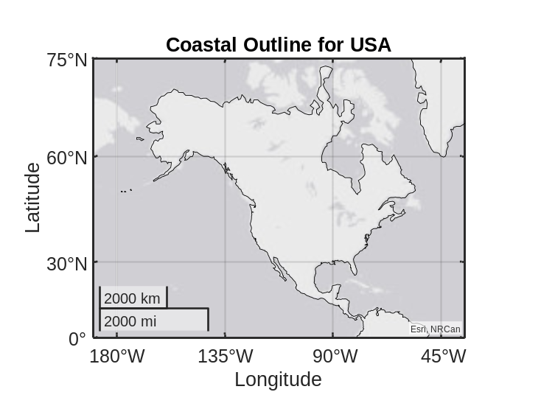
Fig. S2: Coastal Outline for the North American Continent
Population Analysis:
Population data was obtained from the United States Census Bureau¹⁷⁻²⁰. The dataset provided population information at the county level for each state, including the total population and county area in square miles. To enable a spatially resolved analysis, the population within each county was assumed to be uniformly distributed across the county area. This approach allowed a population value to be assigned to each latitude and longitude considered in the technoeconomic assessment. The resulting population distribution was applied to evaluate which brine management strategies and feed sources would serve the largest fraction of the population based on cost.

Supplementary Note 2 – Assumptions and Input Variables
For the LCOW analysis of the desalination systems and associated brine management strategies, several key assumptions were made. The capital expenditures, operating expenditures, exergetic efficiencies, and parameters for each subsystem are summarized in Table S1. All cost and performance data were obtained from values reported in peer-reviewed literature for comparable desalination and brine management systems. The LCOW formulation was further simplified by expressing system performance in terms of overall water recovery, stage-wise recovery, and unit cost parameters, without explicitly resolving system sizing effects (see Supplementary Note S3 and S4). The cost data adopted from the literature primarily correspond to desalination facilities with a nominal capacity of approximately 1000 m³/day, which was used as the representative, distributed-scale system in this study^{21,22}. Although economies of scale are expected to reduce unit costs for larger facilities, this effect was not included to maintain model consistency and reduce additional complexity across the nationwide analysis. Accordingly, a fixed system size was assumed across all scenarios. One main assumption for the ZLD configuration is that salts recovered from SW, BGW, and PW feeds are fully marketable and can generate revenue.
Table S1: Assumptions for system cost and parameters
 | Input Parameters | Symbol | Value | Units | References and Notes
Reverse Osmosis | CAPEX for BWRO | $$CAPEX_{BWRO}$$ | 600 | $$\frac{\text{\$}}{m^{3}/day}$$ | ²³⁻²⁵
Reverse Osmosis | BWRO SEC | $$SEC_{BWRO}$$ | 0.38 – 2.5 |  | ²⁶⁻²⁹
Reverse Osmosis | BWRO Exergetic Efficiency | $$η_{ex,BWRO}$$ | 4.5 | % | ^{10,23,30-35}
Reverse Osmosis | BWRO Water Recovery | $$RR_{BWRO}$$ | 75 | % | ⁸⁻¹¹
Reverse Osmosis | CAPEX for SWRO | $$CAPEX_{SWRO}$$ | 2500 | $$\frac{\text{\$}}{m^{3}/day}$$ | ^{22,36,37}
Reverse Osmosis | SWRO SEC | $$SEC_{SWRO}$$ | 2.7 - 5 | $$\frac{\text{kWh}}{{\text{m}}^{\text{3}}}$$ | ^{22,27,29,38,39}
Reverse Osmosis | SWRO Exergetic Efficiency | $$η_{ex,SWRO}$$ | 31 | % | ⁴⁰⁻⁴⁶
Reverse Osmosis | SWRO Water Recovery | $$RR_{SWRO}$$ | 50 | % | ^{12,13,22}
Reverse Osmosis | Reference SWRO Inlet Salinity | $$S_{in,swro}$$ | 3.5 | wt.%
Reverse Osmosis | Membrane Lifetime | $$n_{RO,mem}$$ | 5 | yr | ²²
Reverse Osmosis | RO Lifetime | $$n_{RO}$$ | 30 | yr | ²²
Financial Parameters | Levelized Cost of Electricity | LCOE | 0.06 | $$\frac{\text{\$}}{\text{kW}\text{h}}$$ | ²²
Financial Parameters | Discount Rate | i | 7 | % | ²²
Financial Parameters | Fixed Operations and Maintenance Cost | $$OPEX_{fix}$$ | 2 | $$\frac{\% CAPEX}{Year}$$ | ²²
Financial Parameters | Membrane Replacement Cost | $$OPEX_{repl}$$ | 10 | $$\frac{\% CAPEX}{Replacement}$$ | ²²
Ocean Discharge (OD) | Horizontal Transport Cost | $$C_{Horiz}$$ | 13.58×${\text{10}}^{\text{-4}}$ | $$\frac{\text{\$}}{m^{3}/km}$$ | ⁴⁷
Ocean Discharge (OD) | Vertical Transport Cost | $$C_{Vert}$$ | 5×${\text{10}}^{\text{-4}}$ | $$\frac{\text{\$}}{m^{3}/m}$$ | ⁴⁷
Ocean Discharge (OD) | Horizontal Transport Energy Consumption | $$SEC_{Horiz}$$ | 11.30×${\text{10}}^{\text{-3}}$ | $$\frac{kWh}{m^{3}/km}$$ | ⁴⁷
Ocean Discharge (OD) | Vertical Transport Energy Consumption | $$SEC_{Vert}$$ | 4.30×${\text{10}}^{\text{-3}}$ | $$\frac{kWh}{m^{3}/m}$$ | ⁴⁷
Deep Well Injection (DWI) | Levelized Cost of DWI | $$C_{DWI}$$ | 1.5 | $$\frac{\text{\$}}{{\text{m}}^{\text{3}}\text{,brine}}$$ | ^{22,48-53}
Deep Well Injection (DWI) | Energy Consumption for DWI | $$SEC_{DWI}$$ | 3.39 | $$\frac{kWh}{{\text{m}}^{\text{3}}\text{,brine}}$$ | ^{3,22}
Zero Liquid Discharge (ZLD) | CAPEX for MVC | $$CAPEX_{MVC}$$ | 8430 | $$\frac{\text{\$}}{m^{3}/day}$$ | ²²
Zero Liquid Discharge (ZLD) | MVC Lifetime | $$n_{MVC}$$ | 30 | yr | ²²
Zero Liquid Discharge (ZLD) | MVC SEC | $$SEC_{MVC}$$ | 27 | $$\frac{\text{kWh}}{{\text{m}}^{\text{3}}}$$ | Inlet and exit salinity are 7 and 20 wt.%^{22,54-56}
Zero Liquid Discharge (ZLD) | MVC Exergetic Efficiency | $$η_{ex,MVC}$$ | 16 | % | ⁵⁷⁻⁶²
Zero Liquid Discharge (ZLD) | MVC Outlet Salinity | $$S_{out,MVC}$$ | 20 | wt.%
Zero Liquid Discharge (ZLD) | Levelized Cost of EP | $$C_{EP}$$ | 5.375 | $$\frac{\text{\$}}{{\text{m}}^{\text{3}}\text{,brine}}$$ | ^{3,63}
Zero Liquid Discharge (ZLD) | Salt Selling Price (Revenue) | $$C_{SS}$$ | 30 (0.03) | $$\frac{\text{\$}}{\text{ton}}\left(\frac{\text{\$}}{\text{kg}}\right)$$ | ^{5,64-66}

A baseline salt selling price of 30 $/ton was used throughout the techno-economic analysis presented in the main text. This conservative value was selected to avoid overstating the economic benefits of salt recovery while remaining within the range of reported commercial prices. The selected price is based on a compilation of market values for salts that can potentially be recovered from desalination brines, including sodium chloride (NaCl), mixed salts, calcium chloride (CaCl₂), calcium carbonate (CaCO₃), magnesium chloride (MgCl₂), magnesium hydroxide (Mg(OH)₂), and magnesium sulfate heptahydrate (MgSO₄·7H₂O), as summarized in Table S2. Since the present analysis assumes that the recovered solid product is predominantly composed of NaCl, the baseline value was chosen primarily from the reported market prices of NaCl and mixed-salt products. A sensitivity analysis examining the effect of salt selling price on the levelized cost of water (LCOW) is presented in Supplementary Note S7.

Table S2: Price of different types of salt found in brine
Type of Salts | Price | Units | Reference/Notes
NaCl Salts | 30 – 200 | $$\frac{\text{\$}}{\text{ton}}$$ | ^{5,64-73}
Mixed Salts | 5 – 111 | $$\frac{\text{\$}}{\text{ton}}$$ | ^{54,65,72,}Survey and National Minerals Information ^{73,74,75}
CaCl₂ | 210 – 325 | $$\frac{\text{\$}}{\text{ton}}$$ | ^{5,64}
CaCO₃ | 62 – 225 | $$\frac{\text{\$}}{\text{ton}}$$ | ^{5,64,66}
Mg(OH)₂ | 240 – 390 | $$\frac{\text{\$}}{\text{ton}}$$ | ⁵
MgCl₂ | 175 – 210 | $$\frac{\text{\$}}{\text{ton}}$$ | ^{5,64}
MgSO₄*7H₂0 | 570 | $$\frac{\text{\$}}{\text{ton}}$$ | ⁶⁶

Supplementary Note 3 – Specific Energy Consumption Calculation
For SW feed, the inlet and outlet salinities are fixed throughout the analysis at 3.5 wt.% and 7 wt.%, respectively, allowing for a constant SEC of 5 kWh/m³ to be used²². The energy consumption of the MVC unit is assumed to be 27 kWh/m³, while the evaporation pond (EP) is assumed to have negligible energy consumption because it relies on natural evaporation²². Unlike the SW feed source, BGW and PW exhibit substantial variation in salinity across the United States. As a result, the energy required for desalination varies, and a single fixed value for energy consumption cannot be used. Instead, the specific energy consumption (SEC) must be evaluated based on the inlet and outlet salinities, or equivalently the water recovery, associated with each desalination stage. For this, two quantities are required: (i) the minimum reversible work of separation for a finite recovery, and (ii) the exergetic efficiency of the desalination technology. The minimum reversible work establishes the thermodynamic lower bound for separation, while the exergetic efficiency accounts for irreversibilities and practical operating limitations observed in real systems. The relationship between the minimum reversible work of separation and the actual work of separation to obtain exergetic efficiency is shown in Eq. (S1):
$η_{ex}=\frac{W_{rev}}{W_{act}}$ | (S1)

$η_{ex}$ is the exergetic efficiency, $W_{rev}$ is the minimum reversible work of separation for a finite recovery, and $W_{act}$ is the actual work of separation required by the desalination system. By combining the calculated minimum work of separation with exergetic efficiencies for BWRO, SWRO, and MVC systems reported in the literature, the actual energy consumption for each desalination stage can be determined.
Minimum Work of Separation for Ideal Solution:
The minimum work of separation has been extensively investigated in the desalination literature. Wang et al. derived an analytical expression for the minimum work of separation under ideal solution assumptions and complete salt rejection⁷⁶. The resulting expression for the minimum SEC at finite water recovery is given by Eq. (S2):
${SEC}_{min,ID}=-\frac{2×R×T×S_{in}}{M_{NaCl}×\frac{1}{ρ}×RR}×\frac{1}{3.6×{10}^{6}}×ln⁡(1-RR)$ | (S2)
$m_{f}=m_{p}+m_{b}$ | (S3)
$S=\frac{m_{salt}}{m_{solution}}$ | (S4)
$RR=\frac{m_{p}}{m_{f}}=1- \frac{S_{in}}{S_{out}}$ | (S5)

In this equation, R is the universal gas constant, T is the absolute temperature, $S_{in}$(g/kg) is the feed salinity, $M_{NaCl}$ is the molecular weight of sodium chloride, $ρ$ is the density of liquid water, and $RR$ is the water recovery. The factor of 3.6×10⁶ is used to convert the units from J/m³ to kWh/m³. The water recovery, $RR$, is defined as the ratio of permeate mass produced to the feed mass entering the desalination system, as shown in Eq. (S5). This relationship can be further expressed in terms of feed and brine salinity using an overall mass balance as shown in Eq. (S3), where $m_{f}$, $m_{p}$, and $m_{b}$ represent the feed, permeate, and brine mass flowrates, respectively. Salinity is defined in Eq. (S4) as the mass fraction of dissolved salt relative to the total solution. For the desalination processes considered in this study, the inlet and outlet salinities are known or can be determined from the operating conditions of each stage. Consequently, Eq. (S2) – (S5) can be used to calculate the corresponding minimum reversible work of separation for each location considered in the technoeconomic analysis. Once the minimum reversible work of separation has been calculated, the next step is to estimate the actual energy consumption of the desalination technologies.
Exergetic Efficiency of Desalination systems:
To estimate the actual energy consumption of the desalination technologies in this study, literature values were used for representative exergetic efficiencies for BWRO, SWRO, and MVC systems. Exergetic efficiency provides a measure of how closely a real desalination process approaches its thermodynamic minimum energy requirement and can therefore be used to relate the minimum reversible work of separation to the actual energy consumption of a desalination system. Based on literature, exergetic efficiencies for BWRO systems ranged from 1.2–7.6%^{10,23,30-35}, while SWRO systems exhibited higher exergetic efficiencies ranging from 4–32%⁴⁰⁻⁴⁶. For MVC systems, reported exergetic efficiencies ranged from 10–16%⁵⁷⁻⁶². These values are summarized in Table S3. The range in reported values reflects differences in plant design, operating conditions, feed composition, system size, and energy recovery configurations. For the present analysis, representative exergetic efficiencies of 4.5%, 31%, and 16% were selected for BWRO, SWRO, and MVC systems, respectively to reflect the performance of modern commercial desalination systems equipped with contemporary energy recovery and process optimization technologies. To maintain consistency throughout the nationwide technoeconomic assessment, the exergetic efficiency of each technology was assumed to be constant across the range of operating salinities (Table S3). Although exergetic efficiency will vary with operating conditions, this assumption is reasonable to estimate system performance while avoiding the need for technology-specific performance models at each location.
Table S3: Exergetic efficiency of desalination technologies reported in the literature.
Desalination Technology | Exergetic Efficiency (%) | References
Brackish Water Reverse Osmosis (BWRO) | 1.2 – 7.6 | ^{10,23,30-35}
Seawater Reverse Osmosis (SWRO) | 4 – 32 | ⁴⁰⁻⁴⁶
Mechanical Vapor Compression (MVC) | 10 – 16 | ⁵⁷⁻⁶²

By combining the reversible work of separation calculated in the previous section with the representative exergetic efficiencies presented here, the actual SEC of each desalination stage can be obtained using Eq. (S1). This approach enables the energy requirements of BWRO, SWRO, and MVC systems to be evaluated as a function of feed salinity and recovery, allowing the technoeconomic analysis to account for the substantial spatial variability in BGW and PW salinities across the United States. Consequently, location-specific energy consumption and LCOW values can be calculated without requiring detailed process simulations for each desalination facility considered in the study.

Supplementary Note 4 – LCOW Analysis for Desalination and Brine Management Approaches
Sizing the Desalination System:
To evaluate the levelized cost of water (LCOW) in $/m³ of freshwater produced for the combined desalination and brine management configurations, it is convenient to express the capacity (size) of each desalination stage in terms of the overall system’s water production and recovery. This formulation allows the LCOW equations to be written independently of the total plant size and instead in terms of recovery ratios and unit costs. The feed flowrate entering the desalination system can be expressed as $\frac{Size_{total}}{RR_{total}}$ where $Size_{total}$ (m³/day) is the total freshwater production capacity of the system and $RR_{total}$ (-) is the water recovery of the full treatment train. Some configurations consist of a single desalination stage (i.e., RO) that produces all the freshwater, such as the ocean discharge (OD) and deep well injection (DWI) cases. Consequently, the freshwater production (size) of the desalination unit is equal to that of the total system as shown in Eq. (S6), as is the recovery ratio shown in Eq. (S7):
$Size_{desal}=Size_{total}$ | (S6)
${RR}_{desal}={RR}_{total}$ | (S7)
$Size_{desal}=$ $m_{f}×RR_{total}×\frac{RR_{desal}}{RR_{total}}$ | (S8)
$Size_{total}=m_{f}×RR_{total}$ | (S9)

The total freshwater production can also be related to the feed flowrate entering the desalination system, $m_{f}$ (m³/day) and the recovery of the desalination system as seen with Eq. (S8). For the ZLD configuration comprising multiple treatment steps, individual desalination units produce only a fraction of the total freshwater generated by the overall system, as shown in Eq. (S10). In these cases, the freshwater production of each desalination stage must account for the brine from the previous (upstream) stages and the recovery of the current stage. The freshwater production of the $j^{th}$ desalination stage can therefore be expressed in Eq. (S10) as:
$Size_{desal,j}=m_{f}×\left(\prod_{k=1}^{j-1}{\left(1-RR_{k}\right)}\right)×RR_{j}$ | (S10)

where $RR_{k}$ represents the recovery of each upstream desalination stage, and $RR_{j}$ is the recovery of the current stage. For example, consider a coastal SW desalination system with ZLD consisting of RO, MVC, and EP. To determine the freshwater production of the MVC unit, the recovery of all preceding desalination stages must be considered. In this case, the only preceding stage is RO, which has an inlet salinity of 3.5 wt.% and an outlet salinity of 7 wt.%, corresponding to a water recovery of 50%. The MVC unit then concentrates the brine from 7 wt.% to 20 wt.%, corresponding to a recovery of 65%. Therefore, the freshwater production of the MVC unit, calculated using Eq. (S10), is equal to the feed mass flow rate multiplied by the fraction of flow remaining after RO $\left(1-RR_{RO}\right)$, and then multiplied by the MVC recovery ($RR_{MVC}$). The same approach can be extended to desalination trains with additional upstream desalination stages by accounting for the cumulative recoveries of all preceding units. Within this analysis, all capital, operating, and replacement costs can be expressed on a common basis of $/m³ of total freshwater produced, regardless of the number of desalination stages present in the treatment train.
Operating Cost – Desalination and Brine Management:
Each desalination technology considered in this study includes three operating cost components: fixed operating and maintenance costs, replacement costs, and variable operating costs. These costs are initially calculated based on individual desalination technology and are subsequently converted to a $/m³ of total freshwater produced. The fixed operating and maintenance cost ($OPEX_{fix,i}$) is assumed to be 2 percent $\left[\frac{\%}{year}\right]$ of the desalination plant capital expenditure ($CAPEX_{i}\left[\frac{\$}{\left[\frac{m^{3}}{day}\right]}\right]$) per year, consistent with values reported in literature^{22,47,77}. Since the LCOW analysis is performed on a daily production basis, the annual operating cost must be converted to an equivalent daily cost by dividing by 365 days per year. The resulting expression is shown in Eq. (S11):
$OPEX_{fix,i}=0.02 ×\frac{CAPEX_{i} }{365 }$ | (S11)

The replacement cost ($OPEX_{repl,i}$) accounts for periodic membrane replacement over the lifetime of the RO system. For BWRO and SWRO systems, the membrane replacement cost is assumed to be 10% of the plant capital cost for each replacement cycle. This cost is distributed over the membrane lifetime ($n_{RO,mem}[year]$) and converted to a daily basis according to Eq. (S12):
$OPEX_{repl,i}=\frac{\frac{1}{n_{RO,mem }}× 0.10 × CAPEX_{i }}{365 }$ | (S12)

The variable operating cost ($OPEX_{var,i}$) is assumed to be dominated by energy consumption. It is therefore calculated as the product of the levelized cost of electricity (LCOE$\left[\frac{\$}{kWh}\right]$) and the specific energy consumption ($SEC_{i}\left[\frac{kWh}{m^{3}}\right]$) of the desalination process (see Supplementary Note S3 for more detail on SEC calculations) as shown in Eq. (S13):
$OPEX_{var,i}=LCOE×SEC_{i}$ | (S13)

These three operating costs are defined per unit volume of water produced by the individual desalination technology. However, the LCOW is based on the total freshwater production of the overall treatment train. Consequently, each cost contribution must be weighted by the fraction of total freshwater produced (i.e., recovery ratios). Substituting Eq. (S9) and (S10) into Eq. (S11) – (S13) yields the final versions of the operating costs:
$OPEX_{fix,i}=\frac{0.02 × CAPEX_{i }× \left(\prod_{k=1}^{j-1}{\left(1-RR_{k}\right)}\right) × RR_{j}}{365 × RR_{total}}$ | (S14)
$OPEX_{repl,i}=\frac{\frac{1}{n_{RO,mem}} × 0.1 × CAPEX_{i} × \left(\prod_{k=1}^{j-1}{\left(1-RR_{k}\right)}\right) × RR_{j}}{365 × RR_{total}}$ | (S15)
$OPEX_{var,i}=LCOE×SEC_{i}×\frac{\left(\prod_{k=1}^{j-1}{\left(1-RR_{k}\right)}\right) × RR_{j}}{RR_{total}}$ | (S16)

Operating Cost - Transportation Cost:
Another operating cost in this analysis is associated with transporting feed/brine/freshwater, which includes both horizontal and vertical transport components multiplied by their respective distances (transportation costs are found in Table S1). For the SW cases with OD and ZLD as brine management approaches, freshwater is transported from the coast to the desired location inland, with the associated cost ($OPEX_{trans,water }$) shown in Eq. (S17). For the BGW and PW cases with OD, DWI, and ZLD as brine management approaches, feed is first transported from a well to the desalination facility, with the associated cost ($OPEX_{trans,feed}$) shown in Eq. (S18). For the DWI and ZLD configurations, brine management occurs on-site. However, for the OD configuration, brine is transported from the desalination facility to the coast for disposal with an associated cost ($OPEX_{trans, brine}$) shown in Eq. (S19). Each transport cost is expressed in terms of the specific stream (freshwater/feed/brine) being moved. All transport costs are normalized to units of $/m³ of freshwater produced using the total recovery ratio, $RR_{\text{total}}$, to enable a direct comparison.
$OPEX_{trans,water}={(C}_{Horiz}×X_{dist}+C_{Vert}×Y_{dist})$ | (S17)
$OPEX_{trans,feed}={(C}_{Horiz}×X_{dist}+C_{Vert}×Y_{dist})×\frac{1}{RR_{total}}$ | (S18)
$OPEX_{trans, brine}={(C}_{Horiz}×X_{dist}+C_{Vert}×Y_{dist})×\frac{1 - RR_{total}}{RR_{total}}$ | (S19)

All cost components in the LCOW formulation must be expressed in units of $/m³ of total freshwater produced. In Eq. (S17), the transportation cost is based on the total freshwater generated by the desalination train and is therefore already expressed in the correct units. As a result, no recovery ratio correction is required. In contrast, without the recovery ratio correction, Eq. (S18) represents the transportation cost in units of $/m³ of feedwater transported. To express this cost per unit volume of freshwater produced, Eq. (S18) is multiplied by the ratio of the feed mass flow rate, ($m_{f}$), to the freshwater production rate, ($m_{f}×RR_{total}$). Simplifying this ratio yields the correction factor ($\frac{1}{RR_{total}}$), resulting in the expression shown in Eq. (S18). A similar approach is applied to Eq. (S19). Without the recovery ratio correction, the expression represents the transportation cost in units of $/m³ of brine transported. To convert it to $/m³ of total freshwater produced, Eq. (S19) is multiplied by the ratio of the brine production rate, ($m_{f}×(1 - RR_{total})$), to the freshwater production rate, ($m_{f}×RR_{total}$). Simplifying this ratio yields the final expression presented in Eq. (S19).
Salt Selling (Revenue):
Salt selling is considered only for ZLD cases, where dissolved salts in the feed are crystallized and recovered as a solid byproduct. Revenue from salt sales ($OPEX_{ss}$) is used to offset the additional capital and operating costs associated with achieving ZLD. The salt selling contribution is modeled as:
$OPEX_{ss}=\frac{C_{ss} × \left(\frac{S_{in}}{1000}\right) × ρ_{w}}{RR_{total}}$ | (S20)

where $C_{\text{ss}}$is the salt selling price ($/kg), $ρ_{w}$is the density of water, and $S_{in}$ (g/kg) is the feed inlet salinity as described in Supplementary Note S3. In this analysis, $C_{\text{ss}}$ is parametrized to determine the threshold value at which it makes ZLD economically competitive relative to other brine management strategies. This allows identification of the minimum viable salt market value required to offset the cost of crystallization and mineral recovery. The baseline salt selling price, along with additional details on the selling prices of other salts, is provided in Supplementary Note 2.
Methodology for Calculating LCOW for Seawater Feed:
This section outlines the full LCOW equation used for each feed and brine management configuration in this analysis. For SW feed, two brine management pathways are considered. For a coastal SWRO system with OD and freshwater transport inland, the total LCOW is:
$LCOW_{SW,OD}=LCOW_{SWRO}+OPEX_{trans,water}$ | (S21)
$LCOW_{SWRO}=\frac{{\left|CAPEX × \frac{r×{\left(1+r\right)}^{n}}{{\left(1+r\right)}^{n}-1} × RR\right|}_{SWRO}}{365 × RR_{total}}+OPEX_{fix,SWRO}+OPEX_{repl,SWRO}+OPEX_{var,SWRO}$ | (S22)

For a coastal SWRO system with ZLD, the total LCOW also includes brine concentration ($LCOW_{MVC}$) and crystallization ($LCOW_{EP}$) stages, as well as revenue from salt recovery ($OPEX_{ss}$):
$LCOW_{SW,ZLD}L=LCOW_{SWRO}+LCOW_{MVC}+LCOW_{EP}+OPEX_{trans,water}-OPEX_{ss}$ | (S23)
$LCOW_{SWRO}=\frac{{\left|CAPEX × \frac{r×{\left(1+r\right)}^{n}}{{\left(1+r\right)}^{n}-1} × RR\right|}_{SWRO}}{365 × RR_{total}}+OPEX_{fix,SWRO}+OPEX_{repl,SWRO}+OPEX_{var,SWRO}$ | (S24)
$LCOW_{MVC}=\frac{{\left|CAPEX × \frac{r×{\left(1+r\right)}^{n}}{{\left(1+r\right)}^{n}-1} × \left(\prod_{k=1}^{j-1}{\left(1-RR_{k}\right)}\right) × RR\right|}_{MVC}}{365 × RR_{total}}+OPEX_{fix,MVC}+OPEX_{var,MVC}$ | (S25)
$LCOW_{EP}=C_{EP}×\frac{\left(\prod_{k=1}^{j-1}{\left(1-RR_{k}\right)}\right)}{RR_{total}}$ | (S26)

The MVC cost is formulated analogously to the SWRO cost shown in Eq. (S25); however, it is applied to the residual brine stream exiting RO rather than the full feed stream entering RO. As a result, the effective feed into MVC is reduced by the recovery of upstream processes, represented by the term $\prod_{k=1}^{j-1}{(1-R}R_{k})$. The EP cost is obtained from literature, where it is reported on a per unit brine volume basis (i.e., $/m³, brine)³. Therefore, a recovery-based normalization is required to convert this value into the consistent units of $/m³ of freshwater produced. Details on the values for CAPEX, energy consumption, and recovery for SWRO, MVC, and EP can be found in Table S1 in Supplementary Note S2.
Methodology for Calculating LCOW for Brackish Groundwater and Produced Water Feed:
The LCOW calculations for BGW and PW feed sources follow a similar approach to that described for the SW case. The main differences arise from (i) the inclusion of feed transport from a well site to the desalination plant, (ii) the inclusion of a brackish water reverse osmosis (BWRO) stage as the first desalination process for lower salinity feed, and (iii) the addition of deep well injection (DWI) as an inland brine management strategy in addition to OD and ZLD. The selection of the first RO stage depends on the feed salinity – BWRO is used for feed salinities below 1.2 wt.%, beyond which SWRO is used. Details on the salinity range and recovery used for BWRO and SWRO are in Supplementary Note S1. For the OD configuration, the LCOW is composed of the RO desalination with feed transport, and brine transport to the coast for disposal:
$LCOW_{BGW/ PW,OD}=LCOW_{RO}+OPEX_{trans,brine}+OPEX_{trans,feed}$ | (S27)
$LCOW_{BWRO}=\frac{{\left|CAPEX × \frac{r×{\left(1+r\right)}^{n}}{{\left(1+r\right)}^{n}-1} × RR\right|}_{BWRO}}{365 × RR_{total}}+OPEX_{fix,BWRO}+OPEX_{repl,BWRO}+OPEX_{var,BWRO}$ | (S28)
For the DWI configuration, the LCOW includes RO desalination with feed transport, as well as a brine disposal cost associated with DWI:
$LCOW_{BGW / PW,DWI}=LCOW_{BWRO}+OPEX_{trans,feed} +OPEX_{DWI}$ | (S29)
$OPEX_{DWI}=C_{DWI}×\frac{\left(\prod_{k=1}^{j-1}{\left(1-RR_{k}\right)}\right)}{RR_{total}}$ | (S30)

Since $C_{DWI}$ is expressed as a levelized cost per unit volume of brine ($/m³,brine), it is converted to a freshwater basis ($/m³,product water) using the cumulative recovery ratio. For the ZLD configuration, the total LCOW includes BWRO (when required) and SWRO, MVC, and EP, along with feed transport and salt recovery revenue:
$LCOW_{BGW/ PW,ZLD}=LCOW_{BWRO}+LCOW_{SWRO}+ LCOW_{MVC}+LCOW_{EP}+OPEX_{trans,feed}-OPEX_{ss}$ | (S31)

The individual component costs are defined as:
$LCOW_{BWRO}=\frac{{\left|CAPEX × \frac{r×{\left(1+r\right)}^{n}}{{\left(1+r\right)}^{n}-1} × RR\right|}_{BWRO}}{365 × RR_{total}}+OPEX_{fix,BWRO}+OPEX_{repl,BWRO}+OPEX_{var,BWRO}$ | (S32)
$LCOW_{SWRO}=\frac{{\left|CAPEX × \frac{r×{\left(1+r\right)}^{n}}{{\left(1+r\right)}^{n}-1} × \left(\prod_{k=1}^{j-1}{\left(1-RR_{k}\right)}\right) × RR\right|}_{SWRO}}{365 × RR_{total}}+OPEX_{fix,SWRO}+OPEX_{repl,SWRO}+OPEX_{var,SWRO}$ | (S33)
$LCOW_{MVC}=\frac{{\left|CAPEX × \frac{r×{\left(1+r\right)}^{n}}{{\left(1+r\right)}^{n}-1} × \left(\prod_{k=1}^{j-1}{\left(1-RR_{k}\right)}\right) × RR\right|}_{MVC}}{365 × RR_{total}}+OPEX_{fix,MVC}+OPEX_{var,MVC}$ | (S34)
$LCOW_{EP}=C_{EP}×\frac{\left(\prod_{k=1}^{j-1}{\left(1-RR_{k}\right)}\right)}{RR_{total}}$ | (S35)

This is a multi-step treatment train in which each subsequent process treats progressively smaller flowrates due to upstream recovery. This is captured through the cumulative recovery term $\prod_{k=1}^{j-1}{(1-R}R_{k})$, which reduces the effective flowrate entering each treatment unit. If the feed salinity is sufficiently high (>1.2 wt.%), the BWRO stage is bypassed, and the system begins directly with SWRO followed by downstream concentration processes. Conversely, for lower salinity feeds (<1.2 wt.%), BWRO is required and may be implemented in multiple stages prior to SWRO. For multi-stage BWRO configurations, the capital cost is scaled to reflect the additional installed capacity required to achieve the necessary intermediate salinity for downstream SWRO operation. For example, in the ZLD configuration, if the feed salinity is 0.7 wt.%, a BWRO stage is required before SWRO. The purpose of the BWRO train is to increase the feed salinity into the typical SWRO operating range. With a fixed recovery of 75%, the first BWRO stage increases the salinity from 0.7 wt.% to 2.8 wt.%, which falls within the SWRO operating range but is below the nominal SWRO feed salinity between 3 - 3.5 wt.% used in this study. Therefore, a second BWRO stage is included. Rather than operating this stage at the nominal 75% recovery, the recovery is reduced so that the outlet salinity reaches 3.5 wt.%, corresponding to a recovery of approximately 20%. Although BWRO systems can produce higher outlet salinities, 3.5 wt.% was selected as the transition point because it represents a typical SWRO feed salinity reported in the literature and provides a consistent design condition for the downstream SWRO stage throughout the analysis¹²⁻¹⁶. After the BWRO train, the brine enters the SWRO stage, where it is concentrated from 3.5 wt.% to 7 wt.%. The concentrate is then treated by the MVC unit, which further increases the salinity to 20 wt.%, followed by the EP, where the remaining brine is concentrated to saturation. This example illustrates how multiple BWRO stages may be required for low-salinity BGW and PW feed sources before transitioning to the downstream ZLD process. Details on the values for CAPEX, energy consumption, and recovery for BWRO can be found in Table S1 in Supplementary Note S2.

Supplementary Note 5 –SEC Analysis for Desalination and Brine Disposal Approaches
Energy Consumption - Transport:
The specific energy consumption (SEC) associated with feed/brine/freshwater transport includes both horizontal and vertical components multiplied by the transport distance. For SW feed, freshwater is transported from the coast to the desired inland location. This is considered for both the OD and ZLD brine management scenarios, as shown in Eq. (S36). For BGW and PW sources, feed is transported from a well (based on the locations shown in Fig. 1 of the main text) to the desired location. This is considered for all three brine management strategies (OD, DWI, and ZLD), as shown in Eq. (S37). Additionally, for the OD pathway for BGW and PW desalination, the brine is transported from the inland desalination facility to the coast for disposal, as shown in Eq. (S38). Like the LCOW equations, the transport-specific energy consumption equations are normalized by the total volume of freshwater produced by including the recovery ratio, as shown below:
${SEC}_{trans,water }={(SEC}_{Horiz}×X_{dist}+{SEC}_{Vert}×Y_{dist})$ | (S36)
${SEC}_{trans,feed }={(SEC}_{Horiz}×X_{dist}+{SEC}_{Vert}×Y_{dist})×\frac{1}{RR_{total}}$ | (S37)
${SEC}_{trans, brine }={(SEC}_{Horiz}×X_{dist}+{SEC}_{Vert}×Y_{dist})×\frac{1-RR_{total}}{RR_{total}}$ | (S38)

The expressions presented in Eq. (S36) - (S38) follow the same recovery-based formulation as the LCOW expressions in Eq. (S17) - (S18). In Eq. (S36), no recovery ratio term is required because the SEC is already expressed in units of kWh/m³ of freshwater produced. In Eq. (S37), the SEC without the recovery ratio is expressed in units of kWh/m³ of feed transported. Therefore, multiplying by$\frac{1}{RR_{total}}$ converts the expression to units of kWh/m³ of freshwater produced. Similarly, in Eq. (S38), the SEC is expressed in units of kWh/m³ of brine processed. As a result, the same recovery ($\frac{1-RR_{total}}{RR_{total}}$) ratio used in Eq. (S18) is applied to convert the expression to kWh/m³ of freshwater produced.

Methodology for Calculating Total SEC for Seawater:
Two brine management methods were evaluated for SW feed: (i) coastal seawater reverse osmosis (SWRO) with OD and (ii) coastal SWRO system with ZLD. For the OD scenario, the total SEC consists of the energy required for SWRO treatment ($SEC_{SWRO}$) and the energy required to transport freshwater inland as shown in Eq. (S39). The SWRO system operates at a fixed feed salinity of 3.5 wt.% and a fixed brine salinity of 7 wt.%, resulting in a constant energy consumption of 5 kWh/m³. Energy consumption associated with freshwater transport is calculated using the horizontal and vertical components ($SEC_{Horiz}$ and $SEC_{Vert}$) provided in Table S1 and Eq. (S36).
$SEC_{SW,OD}=SEC_{SWRO}+{SEC}_{trans,water }$ | (S39)

Since SWRO is the only desalination system producing freshwater in the OD configuration, RR_{SWRO} = RR_{total} = 50% and the expression already accounts for the total freshwater production. However, for the ZLD pathway, the total energy consumption includes contributions from the SWRO unit, MVC unit, and freshwater transport inland. The energy consumption of each desalination unit is first expressed per unit volume of freshwater produced by that subsystem. To express it in terms of the total amount of freshwater produced, the energy consumption of each desalination unit must be multiplied by the ratio of its water recovery to the total recovery from the overall system. This approach is consistent with the methodology presented in Supplementary Note 4 for LCOW. The total specific energy consumption for the ZLD configuration is thus given by:
$SEC_{SW,ZLD}=\left(SEC_{SWRO}×\frac{RR_{SWRO}}{RR_{total}}\right)+\left(SEC_{MVC}×\frac{\left(\prod_{k=1}^{j-1}{\left(1-RR_{k}\right)}\right)×RR_{MVC}}{RR_{total}}\right)+{SEC}_{trans,water }$ | (S40)

Table S1 has the input parameters for $SEC_{MVC}$ and $RR_{MVC}$.
Methodology for Calculating SEC for Brackish Groundwater and Produced Water:
For BGW and PW feed sources, Supplementary Note 4 describes the additional considerations for LCOW which are also used for SEC calculations here. For brevity, it is assumed that the feed salinity is sufficiently low such that BWRO serves as the initial desalination technology. For the OD and DWI scenarios, the equations can be modified by replacing BWRO with SWRO based on the feed salinity. For the OD scenario, the SEC consists of the energy required for BWRO desalination, feed transport from the well to the desalination facility, and brine transport to the coast for disposal as shown in Eq. (S41):
${SEC}_{BGW/PW,OD}=\left(SEC_{BWRO}×\frac{RR_{BWRO}}{RR_{total}}\right)+SEC_{trans,brine}+SEC_{trans,feed}$ | (S41)

As noted previously, if the feed salinity exceeds the applicable range for BWRO, the $SEC_{BWRO}$ term can be replaced with $SEC_{SWRO}$ without modifying the overall SEC framework. For the DWI scenario, the SEC includes the energy required for BWRO desalination, feed transport, and brine disposal through underground injection ($SEC_{DWI}$) as shown in Eq. (S42):
${SEC}_{BGW/PW,DWI}=\left(SEC_{BWRO}×\frac{RR_{BWRO}}{RR_{total}}\right)+\left(SEC_{DWI}×\frac{1-RR_{BWRO}}{RR_{total}}\right) +SEC_{trans,feed}$ | (S42)

The DWI energy consumption is expressed per unit volume of brine treated (kWh/m³-brine). To express this based on total freshwater produced, $SEC_{DWI}$ is multiplied by the appropriate recovery ratio. In Eq. (S41) and Eq. (S42), the recovery associated with BWRO cancels out because the BWRO recovery is equal to the total system recovery, as BWRO is the only desalination technology in these configurations. For the ZLD configuration on the other hand, the treatment train consists of BWRO (when required), SWRO, MVC, and EP, in addition to the energy required for feed transport as shown in Eq. (S43):
$SEC_{BGW/PW,ZLD}=\left(SEC_{BWRO}×\frac{RR_{BWRO}}{RR_{total}}\right)+\left({SEC}_{SWRO}×\frac{\left(\prod_{k=1}^{j-1}{\left(1-RR_{k}\right)}\right)×RR_{SWRO}}{RR_{total}}\right)+ \left({SEC}_{MVC}×\frac{\left(\prod_{k=1}^{j-1}{\left(1-RR_{k}\right)}\right)×RR_{MVC}}{RR_{total}}\right)+SEC_{trans,feed}$ | (S43)

All the equations presented here for SEC follow a similar methodology to that presented in Supplementary Note 4 for LCOW.

Supplementary Note 6 – Spatial Analysis of Total SEC
Using the equations in Supplementary Note 5, a spatial analysis of the total SEC is obtained across the United States for every feed source and brine management approach. For brevity, only the LCOW results were shown in the main manuscript, and this section shows the corresponding SEC values
Total SEC for Seawater:
For SW feed, OD was identified as the economically preferred brine management strategy across the United States when a salt selling price of $30/ton was assumed, as discussed in the main manuscript. The primary factor contributing to this result is the higher energy consumption associated with ZLD, as illustrated in Fig. S3.
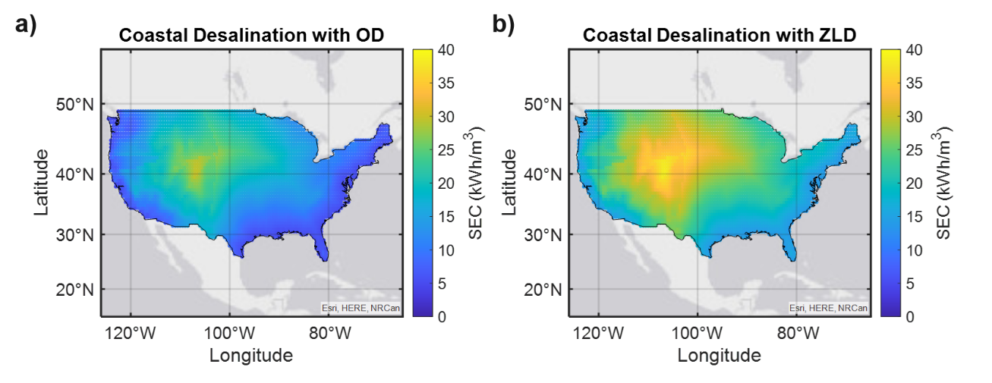
Fig. S3: Spatial distribution of specific energy consumption (SEC) for seawater (SW) desalination across the United States using two disposal strategies: (a) ocean discharge (OD) and (b) zero liquid discharge (ZLD).
For the OD configuration, the maximum SEC is approximately 30 kWh/m³, whereas the ZLD configuration exhibited values as high as 40 kWh/m³. The higher energy demand associated with ZLD is attributed to the additional treatment stages to concentrate the brine up to saturation. The highest SEC values for both brine management strategies were observed in inland regions with higher elevations. This is because a substantial fraction of the total energy is associated with freshwater transport over large vertical distances. Although horizontal transport distances can also be significant, on a per-unit-distance basis, vertical transport requires nearly 1000× more energy. Consequently, elevation change has a larger influence on the total transport energy consumption.
A breakdown of the SEC is shown in Fig. S4 for the four representative cities discussed in the main manuscript.
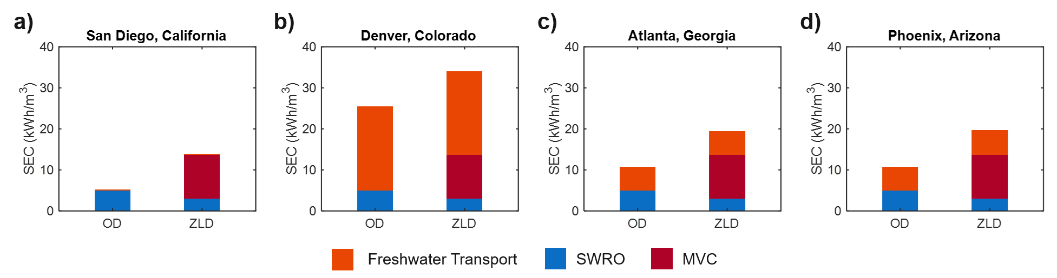
Fig. S4: Specific Energy Consumption (SEC) breakdown for SW desalination systems utilizing ocean discharge (OD) and zero liquid discharge (ZLD) brine management strategies for four U.S. cities: (a) San Diego, California; (b) Denver, Colorado; (c) Atlanta, Georgia; and (d) Phoenix, Arizona.
Variations in the total SEC for both the OD and ZLD scenarios are driven primarily by the energy requirements associated with freshwater transport to each location. For coastal locations such as San Diego with minimal elevation change between the desalination facility and the point of use, the energy required for freshwater transport is negligible. Consequently, the SEC of the ZLD configuration is dominated by the additional energy associated with the MVC unit. In contrast, for inland, high-elevation cities such as Denver, freshwater transport dominates energy consumption. Under these conditions, the total SEC of the OD configuration approaches 25 kWh/m³, while the ZLD configuration exceeds 30 kWh/m³. For inland cities such as Atlanta and Phoenix with intermediate elevation, transport energy requirements are comparable, resulting in similar total SEC values. In these cases, the addition of the ZLD treatment train approximately doubles the SEC relative to the OD configuration because of the increased energy demand associated with brine concentration. Overall, these regional comparisons demonstrate that transitioning from OD to ZLD consistently introduces an energy penalty due to the additional treatment processes needed for salt recovery. The magnitude of this penalty depends strongly on geographic factors, particularly elevation and distance from the coast. These findings highlight the importance of considering both desalination energy requirements and transport energy demand when evaluating the feasibility of alternative brine management strategies.
Total SEC for Brackish Groundwater:
Next, the brackish groundwater (BGW) scenario was evaluated to examine the spatial distribution of specific energy consumption (SEC) across the United States and to assess the energy requirements for the representative cities discussed in the main manuscript. A nationwide breakdown of the SEC for BGW under the different brine management strategies is presented in Fig. S5.
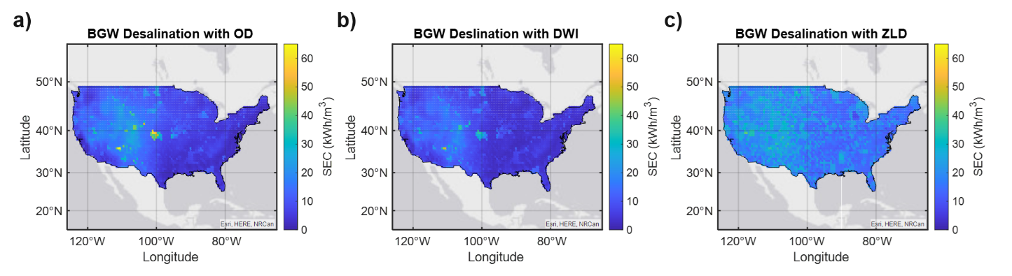
Fig. S5: Spatial distribution of specific energy consumption (SEC) for brackish groundwater (BGW) desalination across the United States using three disposal strategies: (a) ocean discharge (OD), (b) deep well injection (DWI), and (c) zero liquid discharge (ZLD).
The results presented in Fig. S5 demonstrate that the SEC for BGW exhibits strong spatial variability that depends on the selected brine management strategy. For the OD scenario (Fig. S5a), the SEC remains relatively low across most regions of the United States, typically below 15 kWh/m³. However, pronounced increases in SEC, reaching approximately 40–60 kWh/m³, are observed in inland mountainous and high-elevation regions. In these locations, the energy demand is dominated by the transportation of brine over long horizontal distances and substantial elevation gradients to reach the nearest coastal discharge point. A similar spatial trend is observed for the DWI scenario (Fig. S5b). Although most regions exhibit SEC values comparable to those of the OD configuration, localized hotspots are evident in portions of the central United States, where SEC values increase to approximately 30–40 kWh/m³. These elevated energy requirements are primarily associated with regions where significant pumping energy is required for brine injection and freshwater transportation. In contrast, the ZLD configuration (Fig. S5c) exhibits a markedly different energy profile characterized by relatively high SEC values and limited spatial variability. Under the ZLD scenario, SEC values generally range from 25–45 kWh/m³ across nearly all locations, regardless of proximity to the coast or regional topography. This elevated and spatially uniform energy demand reflects the substantial energy requirements associated with the need to concentrate the brine. Overall, these results indicate that transportation energy dominates the SEC of the OD and DWI configurations, resulting in strong geographic dependencies, whereas the energy demand of the ZLD pathway is governed primarily by the desalination processes themselves.
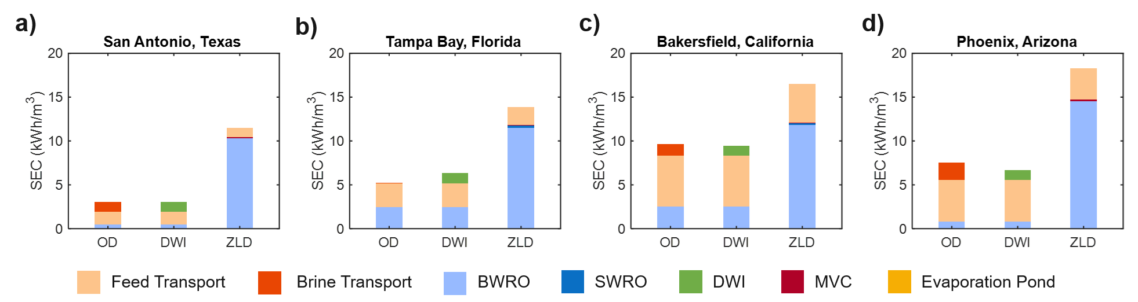
Fig. S6: Specific Energy Consumption (SEC) breakdown for BGW desalination systems utilizing ocean discharge (OD), deep well injection (DWI), and zero liquid discharge (ZLD) brine management strategies for four U.S. cities: (a) San Antonio, Texas; (b) Tampa Bay, Florida; (c) Bakersfield, California; and (d) Phoenix, Arizona.
To further examine the spatial distribution of energy consumption across the United States, the representative cities discussed in the main manuscript were evaluated based on their SEC. This city-level analysis provides additional insight into the relative contributions of desalination, transportation, and brine management processes to the total energy demand. As shown in Fig. S6, the OD and DWI scenarios exhibit similar SEC values across all four cities. This similarity is expected because both configurations share identical feedwater transportation and BWRO energy requirements. Consequently, the primary difference between the two approaches arises from the energy associated with brine disposal. For DWI, the disposal energy requirement remains constant at approximately 1.13 kWh/m³ of product water. In contrast, the energy required for OD depends on the distance and elevation between the desalination facility and the nearest coastal discharge location. Therefore, OD becomes the more energy-efficient option when the energy required to transport brine to the coast is less than the fixed energy demand associated with DWI. As expected, the ZLD configuration exhibits the highest SEC among all brine management strategies because of the additional energy required for downstream brine concentration and crystallization processes. However, considering the relatively low-salinity BGW feedwaters in this study, the BWRO system accounts for most of both freshwater production and energy consumption. As a result, only a small fraction of the feed stream is processed by the downstream ZLD units, leading to a relatively modest increase in SEC when expressed per unit volume of total freshwater produced. These findings highlight the importance of feed salinity in determining the overall energy demand of ZLD systems. For low-salinity feedwaters, the primary desalination burden remains with the BWRO stage, while the downstream ZLD units process progressively smaller brine volumes because of the high recovery achieved in upstream stages.
Total SEC for Produced Water:
The results presented in Fig. S7 illustrate the spatial distribution of SEC for PW desalination across the USA under three distinct brine management strategies. Because PW resources are inherently associated with localized oil and gas production sites, the resulting energy profiles reflect the combined effects of geographic location, transportation requirements, and feedwater salinity. For the OD configuration shown in Fig. S7a, the SEC remains relatively low across most regions of the country but exhibits localized hotspots with SEC values exceeding 50–60 kWh/m³. These elevated values are concentrated in inland regions, where transporting large brine volumes over long horizontal distances and substantial elevation gradients to reach coastal discharge locations results in significant transportation energy demands. In contrast, the DWI scenario shown in Fig. S7b substantially reduces these transportation penalties by utilizing localized subsurface disposal. Consequently, SEC values remain relatively low across most PW locations, generally below 20 kWh/m³. The ZLD configuration shown in Fig. S7c exhibits a more spatially uniform energy profile characterized by consistently elevated SEC values ranging from 20–35 kWh/m³, largely independent of geographic location or proximity to the coast. Overall, these results demonstrate that transportation energy is the primary driver of SEC variability for the OD and DWI configurations, whereas the energy demand of the ZLD pathway is governed predominantly by the desalination processes required to achieve salt recovery.
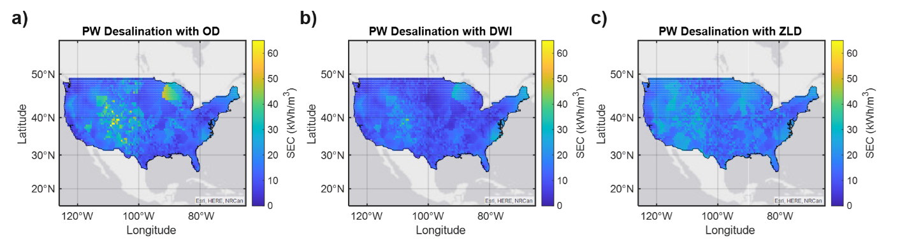
Fig. S7: Spatial distribution of specific energy consumption (SEC) for produced water (PW) desalination across the United States using three disposal strategies: (a) ocean discharge (OD), (b) deep well injection (DWI), and (c) zero liquid discharge (ZLD).
The results presented in Fig. S8 provide a detailed breakdown of the SEC for the representative cities analyzed in this study, highlighting the relative contributions from feed transportation, desalination, and brine management processes. For San Antonio, Tampa Bay, and Bakersfield, the total SEC for the OD and DWI scenarios remain at or below approximately 10 kWh/m³, indicating that these disposal strategies can achieve relatively low energy requirements when favorable geographic conditions exist. In contrast, Phoenix exhibits SEC values exceeding 10 kWh/m³ due to the larger contributions associated with feed transportation and BWRO operation. Across all cities, OD and DWI exhibit similar SEC values because both configurations share identical feed transportation and BWRO energy requirements; the primary difference arises from the energy associated with brine management. When the energy required to transport brine to the coast is lower than the fixed DWI energy requirement, OD becomes the more energy-efficient option. As expected, the ZLD configuration consistently exhibits the highest SEC owing to the additional energy demands associated with downstream desalination processes. However, the results indicate that BWRO remains the dominant contributor to total energy consumption even under ZLD conditions, as discussed in the previous section for BGW. Consequently, while ZLD eliminates dependence on local disposal infrastructure and surface topography, it introduces a significant process energy penalty that increases the overall SEC across all locations.
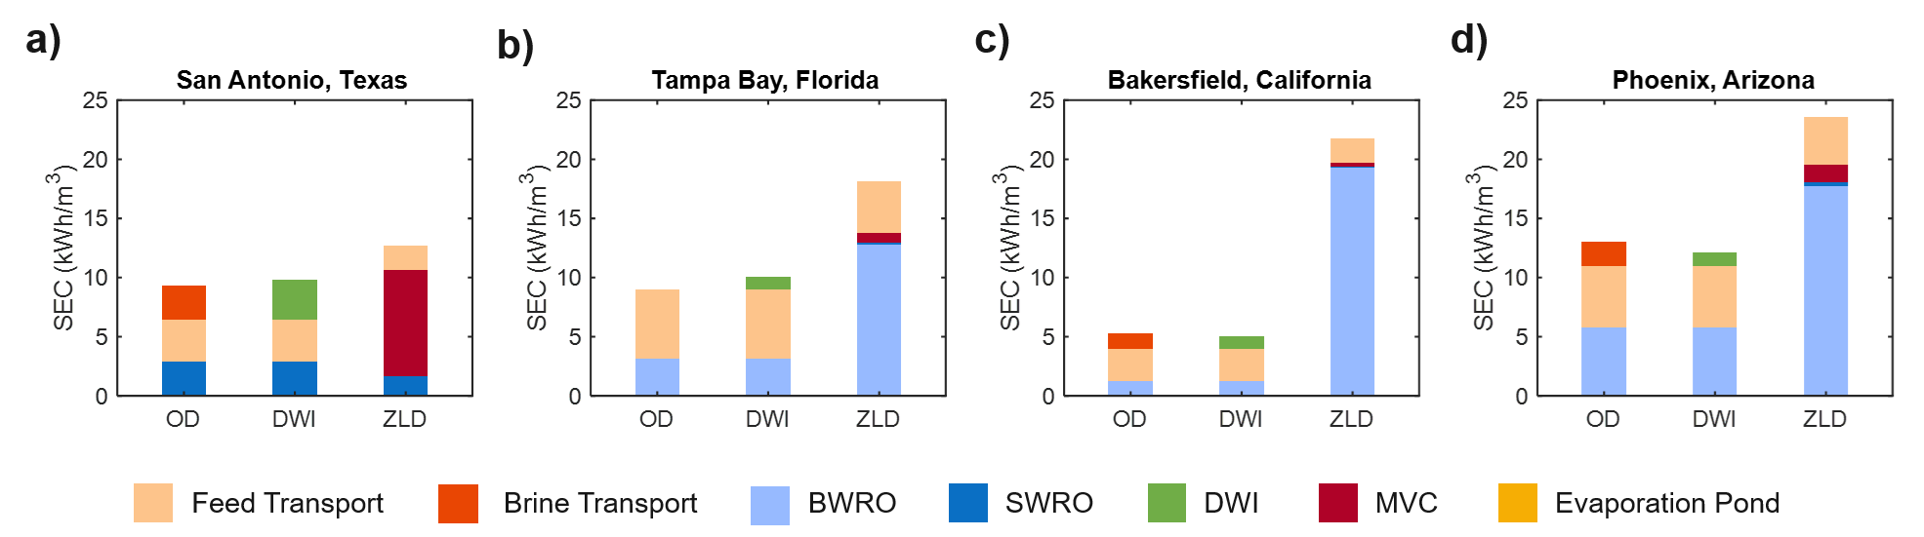
Fig. S8: Specific Energy Consumption (SEC) breakdown for PW desalination systems utilizing ocean discharge (OD), deep well injection (DWI), and zero liquid discharge (ZLD) brine management strategies for four U.S. cities: (a) San Antonio, Texas; (b) Tampa Bay, Florida; (c) Bakersfield, California; and (d) Phoenix, Arizona.

Supplementary Note 7 – LCOW Sensitivity Analysis
Impact of Salt Selling Price:
The LCOW results presented in the main manuscript are based on the input parameter assumptions shown in Table S1. For the ZLD scenarios, a salt selling price (revenue) of $30/ton was assumed, which resulted in OD being the more economically favorable brine management approach as shown in Fig. S9a. As discussed in the main manuscript, for SW desalination with ZLD, a salt selling price of approximately 49 $/ton represents the economic threshold at which the revenue generated from salt recovery offsets the additional costs associated with the MVC and EP units. Above this threshold, the revenue generated from salt sales reduces the overall LCOW by offsetting other system costs. Given the uncertainty in salt price, Fig. S9 shows the impact of salt revenue on LCOW. The results presented in Fig. S9 consider salt selling prices of $30/ton, $60/ton, and $180/ton. The additional values of $60/ton and $180/ton were chosen to span a broader range of commercially relevant salt values while remaining within the price ranges reported for NaCl, mixed salts, and several higher-value salts (Table S2). These values provide a reasonable range for evaluating the sensitivity of the techno-economic analysis to salt selling price without considering unrealistically high market values.
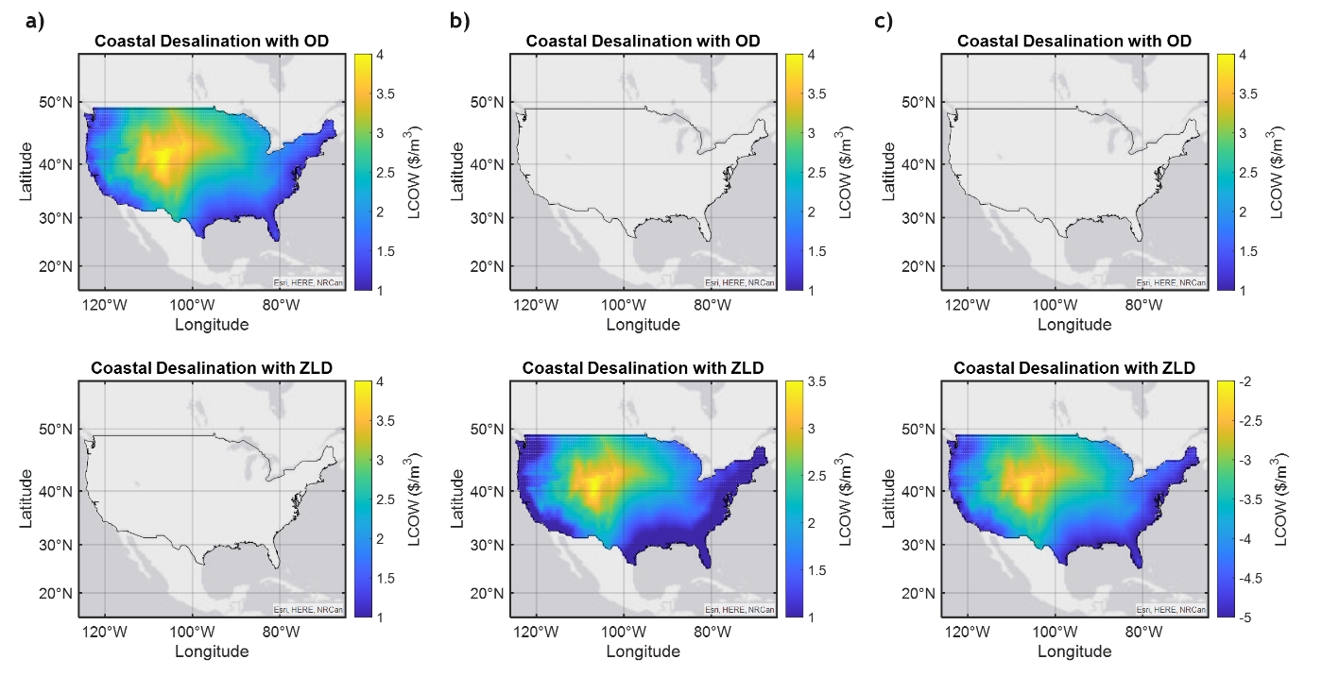
Fig. S9: Spatial distribution of the levelized cost of water (LCOW) for seawater (SW) desalination across the United States for ocean discharge (OD) and zero liquid discharge (ZLD) configurations at salt selling prices of (a) $30/ton, (b) $60/ton, and (c) $180/ton.

This analysis demonstrates that increasing the salt selling price to 60 $/ton shifts the economically preferred brine management strategy from OD to ZLD as shown in Fig. S9b. At a salt selling price of 180 $/ton, the maximum LCOW decreases from approximately 4.0 $/m³ in the base case to approximately -3.5 $/m³, as shown in Fig. S9c. The negative LCOW means that the revenue generated from salt recovery is sufficient to completely offset the capital and operating costs associated with the entire desalination and brine management system, and the facility generates a net economic benefit (profit). However, achieving a salt selling price of 180 $/ton is highly dependent on the composition and purity of the recovered salts, market demand, and long-term price stability. In many cases, the recovered product is likely to consist of mixed salts with lower market value. Additional separation and purification steps may be required to recover higher-value minerals, which would introduce other capital and operating costs that are not considered in the present analysis.
A breakdown of the LCOW contributions under varying salt selling prices is shown in Fig. S10 for the specific cities evaluated in this work. As the salt price increases, the revenue generated from salt recovery offsets an increasing fraction of the costs associated with the RO, MVC, and EP units. At sufficiently high salt prices, the revenue generated from salt sales exceeds the combined costs of these desalination processes, as shown in Fig. S10c.
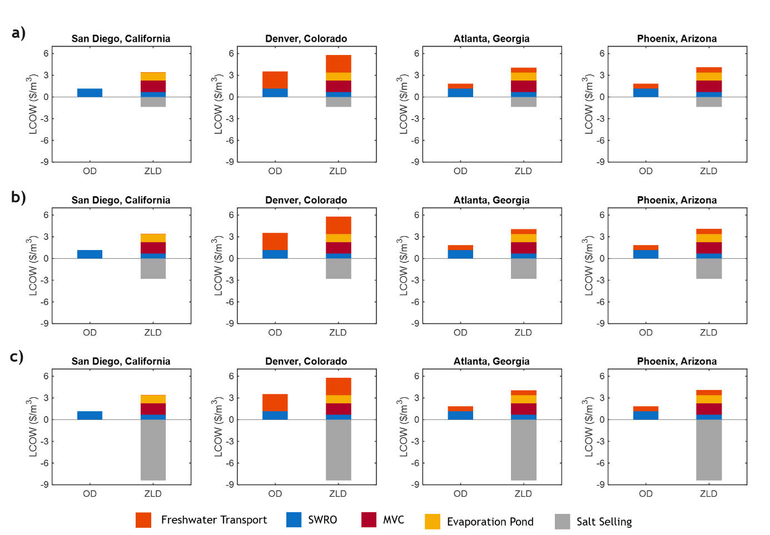
Fig. S10: Breakdown of the levelized cost of water (LCOW) for seawater (SW) desalination systems employing ocean discharge (OD) and zero liquid discharge (ZLD) brine management strategies in four representative U.S. cities: San Diego, California; Denver, Colorado; Atlanta, Georgia; and Phoenix, Arizona. Results are presented for salt selling prices of (a) $30/ton, (b) $60/ton, and (c) $180/ton.

A similar analysis was conducted for BGW feed. Results in Fig. S11 show limited sensitivity of LCOW to salt revenue due to the low salinity of BGW and consequently small amount of salt recovered. At 60 $/ton, Fig. S11a shows that ZLD becomes favorable for 8% of locations, with a corresponding decrease in DWI to 33%, while OD remains unchanged at approximately 59% compared to the base case. At 180 $/ton, Fig. S11b shows that ZLD increases to 17%, while OD and DWI decrease to 53% and 30%, respectively. Overall, OD and DWI remain the dominant disposal options for BGW.
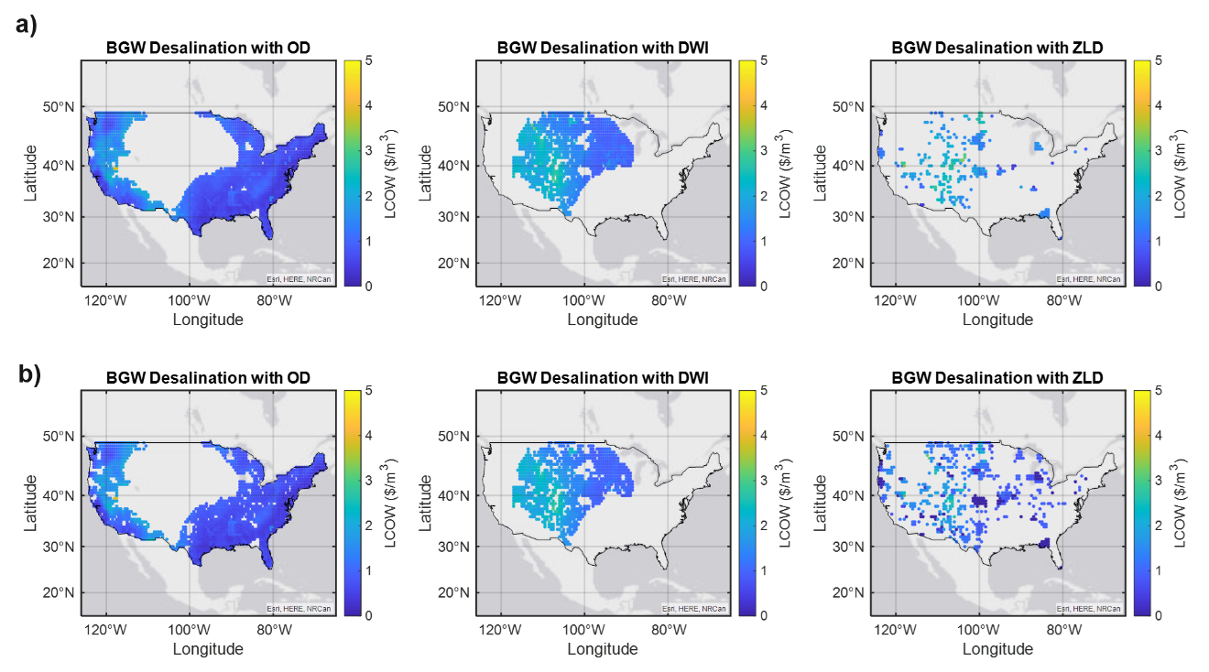
Fig. S11: Spatial distribution of the levelized cost of water (LCOW) for brackish groundwater (BGW) desalination across the United States for ocean discharge (OD), deep well injection (DWI) and zero liquid discharge (ZLD) configurations at salt selling prices of (a) $60/ton and (b) $180/ton.
A city-level breakdown is provided in Fig. S12. Across all cities, increasing the salt selling price primarily affects the magnitude of the LCOW offset rather than changing the preferred brine management pathway. At 180 $/ton, LCOW reductions are most notable in Tampa Bay and Bakersfield due to increased salt revenue (grey region). In Bakersfield, LCOW decreases to 1.16 $/m³ for ZLD, compared to 1.18 $/m³ (OD) and 1.30 $/m³ (DWI), indicating near parity. Overall, BGW shows limited responsiveness to salt selling price, and ZLD becomes competitive only in select cases with sufficiently high salt values that may not be practically achievable.
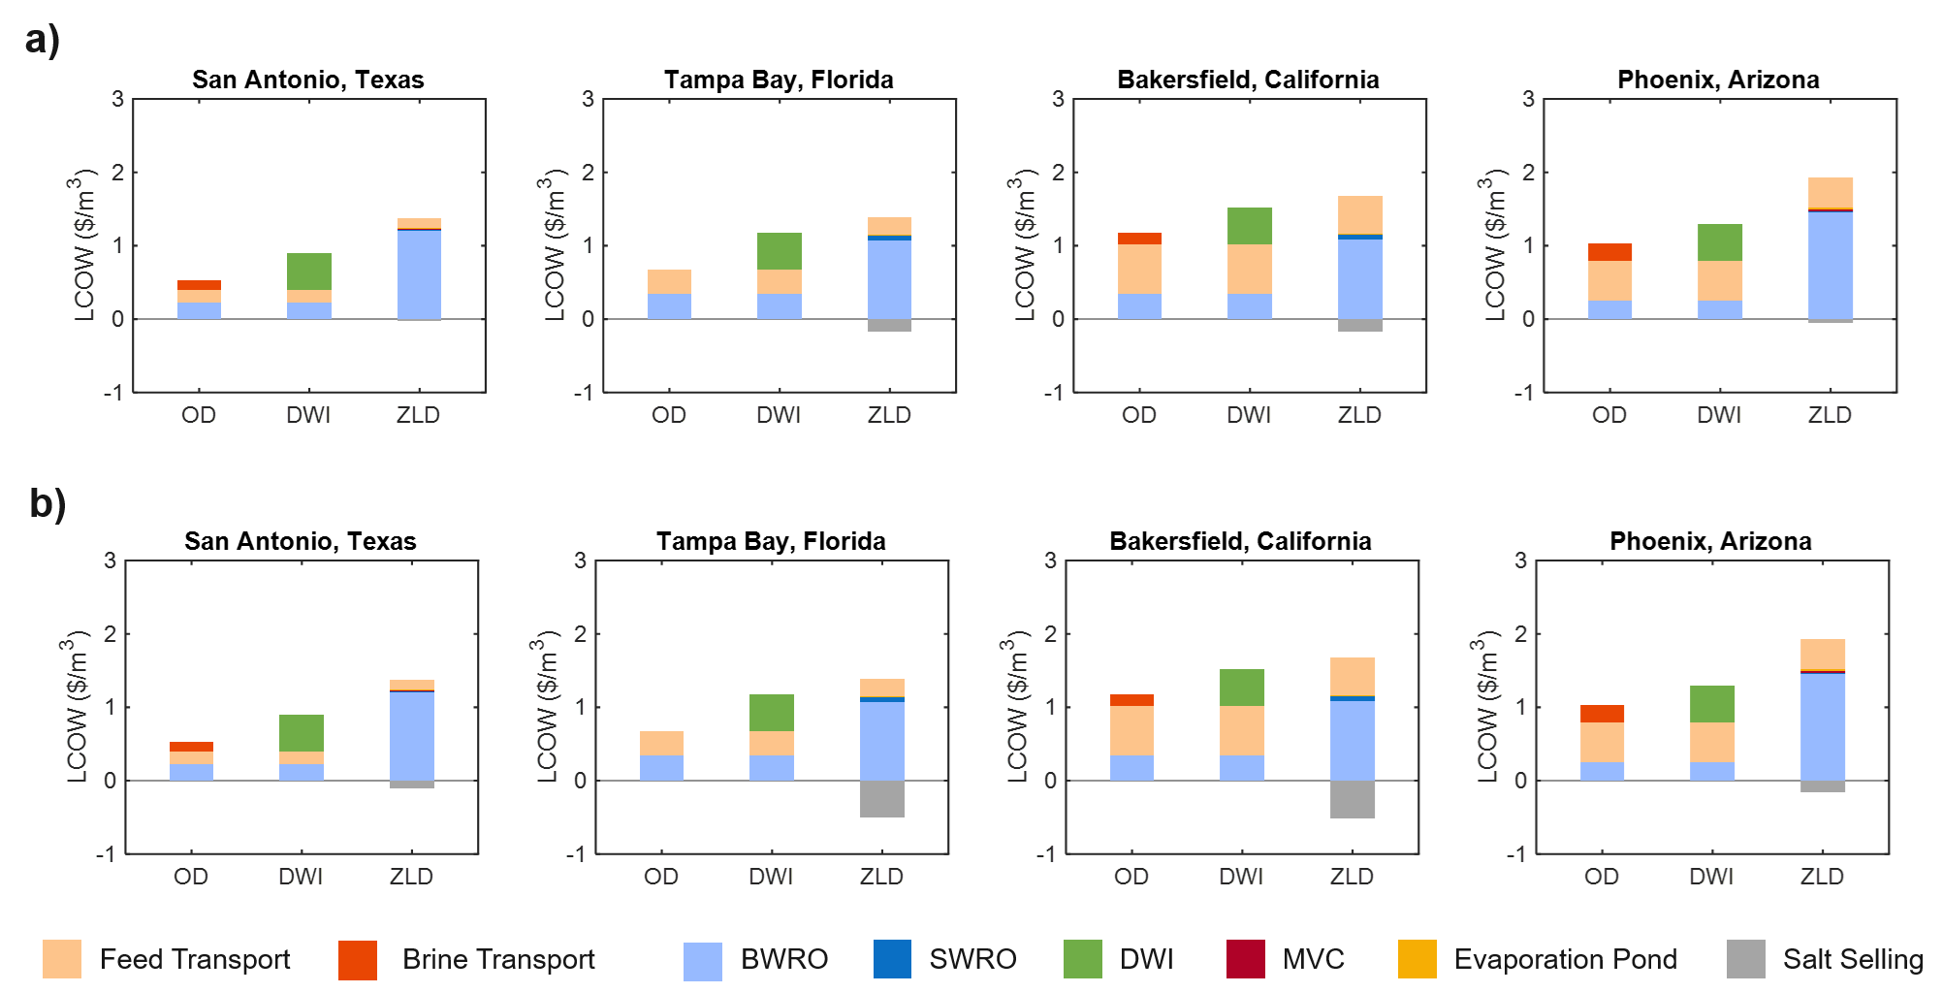
Fig. S12: Breakdown of the levelized cost of water (LCOW) for brackish groundwater (BGW) desalination systems employing ocean discharge (OD), deep well injection (DWI), and zero liquid discharge (ZLD) brine management strategies in four representative U.S. cities: San Antonio, Texas; Tampa Bay, Florida; Bakersfield, California; and Phoenix, Arizona. Results are presented for salt selling prices of (a) $60/ton, and (b) $180/ton.

Lastly, the effect of salt selling price was evaluated for PW feed sources. Results show a strong shift in brine management strategy with increasing salt value. At 60 $/ton, Fig. S13a shows that ZLD becomes dominant, increasing to 58%, while OD and DWI decrease to 22% and 20%, respectively. At 180 $/ton, Fig. S13b shows that ZLD becomes strongly favored, accounting for 86% of cases, while OD and DWI decrease to 9% and 5%. Compared to BGW, PW is more sensitive to salt price due to its higher salinity distribution, which increases the amount of recoverable salt and the associated revenue.
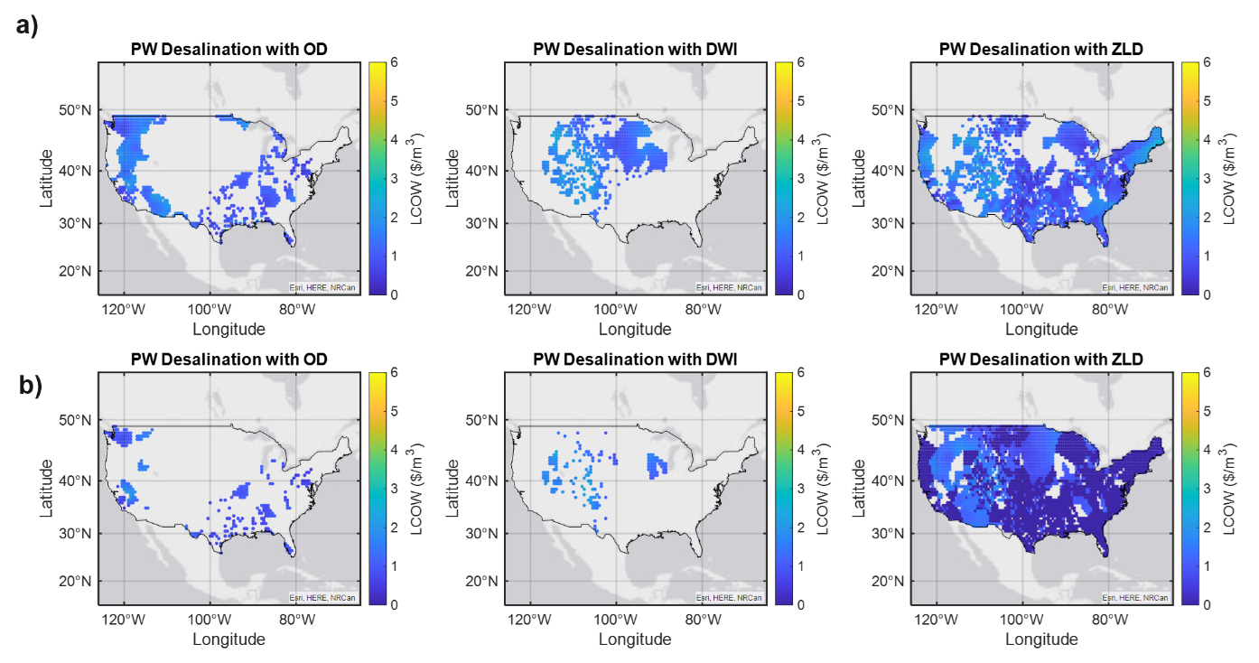
Fig. S13: Spatial distribution of the levelized cost of water (LCOW) for produced water (PW) desalination across the United States for ocean discharge (OD), deep well injection (DWI) and zero liquid discharge (ZLD) configurations at salt selling prices of (a) $60/ton and (b) $180/ton.
A city-level LCOW breakdown is provided in Fig. S14. In low-salinity cities such as Tampa Bay, Bakersfield, and Phoenix, the price of salt has minimal impact on LCOW due to limited recoverable salt. This reinforces that salinities below ~1 wt.% provide insufficient revenue to influence ZLD economics. In contrast, San Antonio (2.7 wt.% salinity) shows a significant reduction in LCOW with increasing salt price due to higher salt recovery potential. Overall, these results indicate that ZLD with PW feed becomes increasingly favorable under high salt selling prices, particularly in regions with salinities exceeding ~1 wt.% which represent most locations.
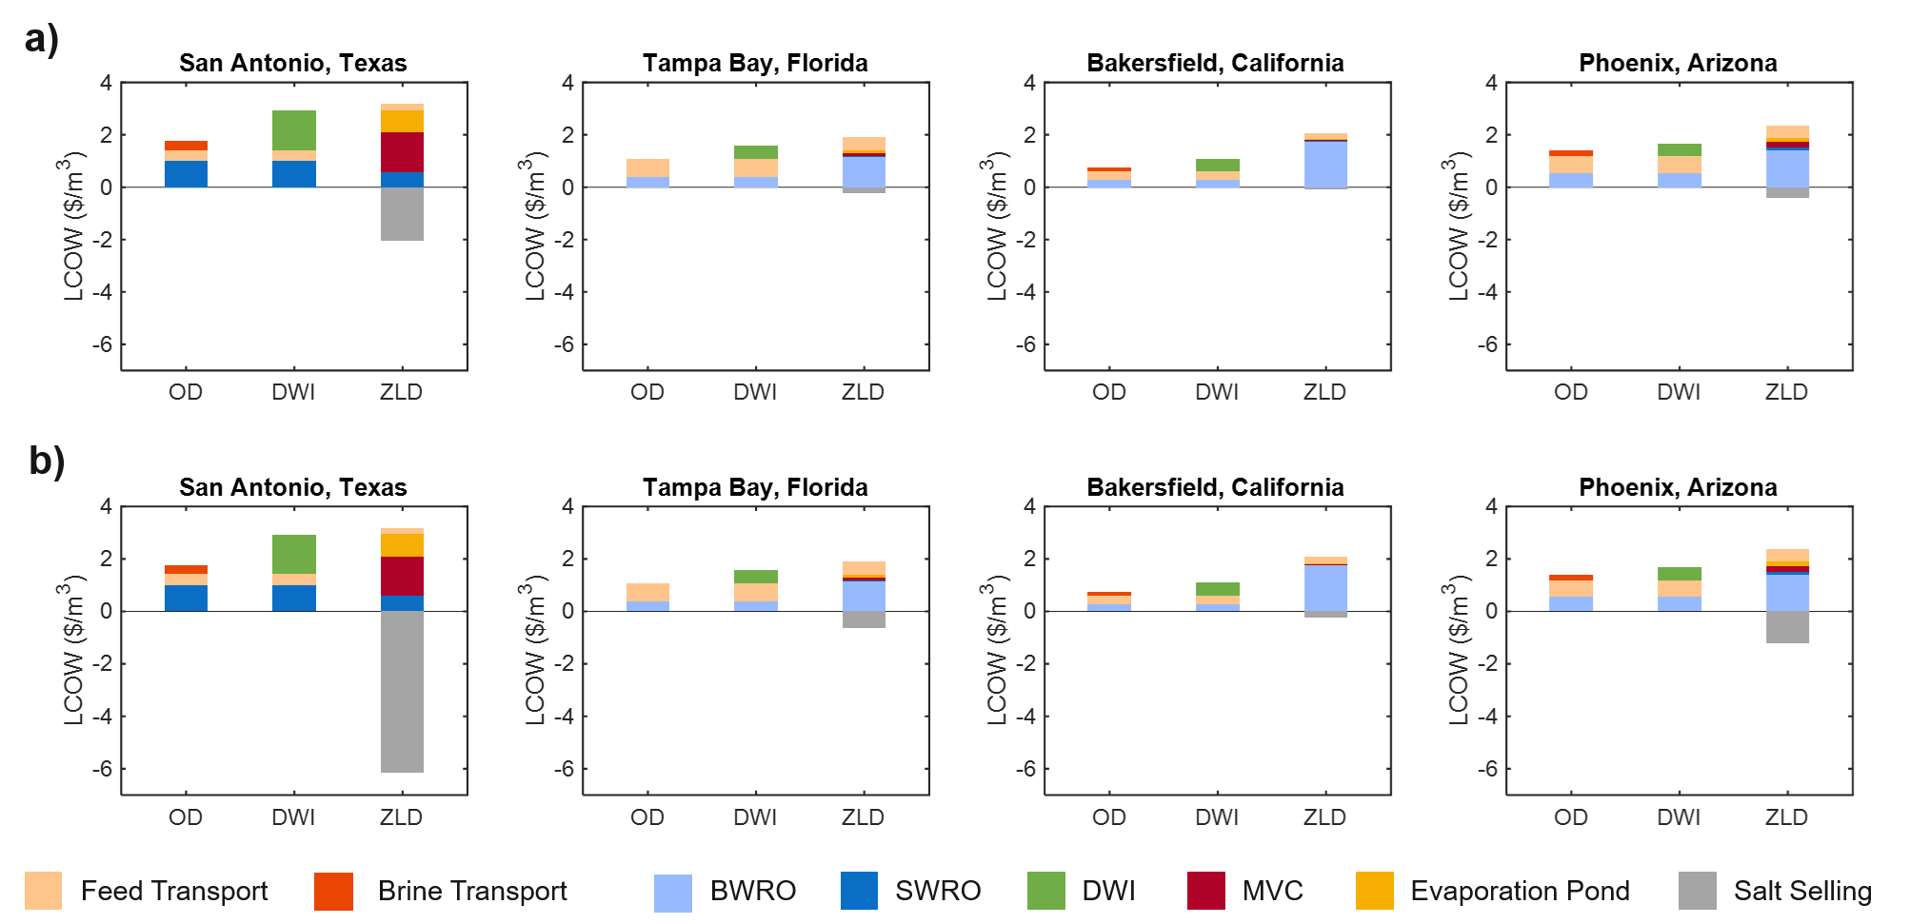
Fig. S14: Breakdown of the levelized cost of water (LCOW) for produced water (PW) desalination systems employing ocean discharge (OD), deep well injection (DWI), and zero liquid discharge (ZLD) brine management strategies in four representative U.S. cities: San Antonio, Texas; Tampa Bay, Florida; Bakersfield, California; and Phoenix, Arizona. Results are presented for salt selling prices of (a) $60/ton, and (b) $180/ton.
Sensitivity Analysis on Feed Sources:
The main manuscript provided a sensitivity analysis only for PW feed for brevity. A sensitivity analysis for SW is presented in Fig. S15. Transport cost is the dominant driver of LCOW variability across all cities. OD and ZLD exhibit similar transport cost sensitivities because freshwater must be transported inland under both configurations, while ocean disposal incurs negligible transport costs due to the assumption that all SW facilities are located along the coast. Denver exhibits the largest LCOW sensitivity because of its long transport distance from the coast, whereas San Diego shows the smallest sensitivity due to its coastal location. Atlanta and Phoenix display intermediate sensitivities consistent with their comparable inland distances. In contrast, salt selling price and ZLD equipment cost affect only the ZLD configuration and produce identical LCOW shifts across all cities. Increasing salt selling price decreases LCOW by approximately 7 $/m³, while changes in ZLD equipment cost result in LCOW variations of approximately −1.03 to +2.06 $/m³. Overall, the results demonstrate that transportation distance governs the spatial variability in LCOW, whereas salt revenue and ZLD capital cost influence the economic performance of ZLD systems.
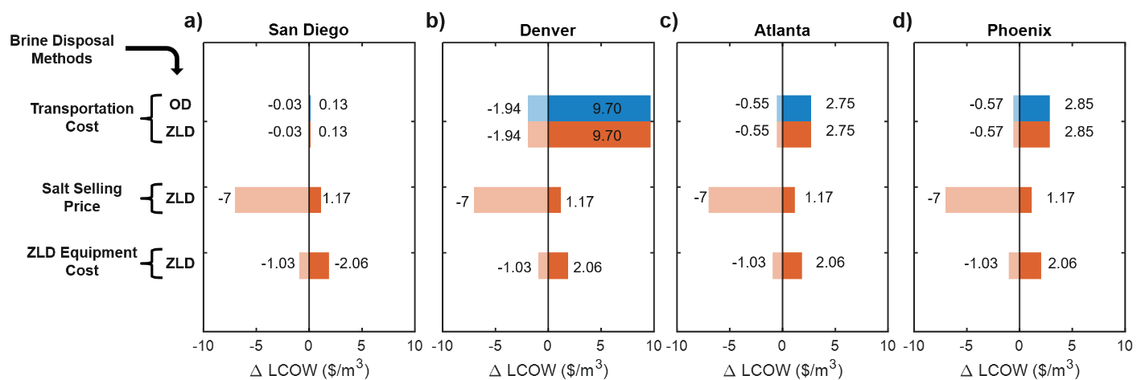
Fig. S15: Sensitivity analysis showing the change in levelized cost of water (ΔLCOW) resulting from variations in transportation cost, salt selling price, and ZLD equipment cost for the three brine management strategies: ocean discharge (OD) and zero liquid discharge (ZLD). Results are presented for four representative U.S. cities: (a) San Diego, California; (b) Denver, Colorado; (c) Atlanta, Georgia; and (d) Phoenix, Arizona. Positive values indicate an increase in LCOW, while negative values represent a reduction in LCOW relative to the baseline case.
A sensitivity analysis for BGW is presented in Fig. S16. Across all cities, transport cost is the dominant driver of LCOW variability. OD exhibits the largest sensitivity range, with the most pronounced variations observed in Bakersfield (−0.81 to 4.07 $/m³) and Phoenix (0.83 to 4.16 $/m³). This strong dependence reflects the central role of inland transport distances in determining overall cost for BGW systems. In contrast, variations in salt selling price and ZLD equipment cost have negligible effects on LCOW across all cities. Changes in equipment cost result in only marginal shifts of a few cents, as ZLD contributions are relatively minor for BGW due to its low salinity. Overall, the results demonstrate that BGW economics are primarily governed by location-dependent transportation costs, while equipment costs and salt market value have minimal influence on overall system performance.
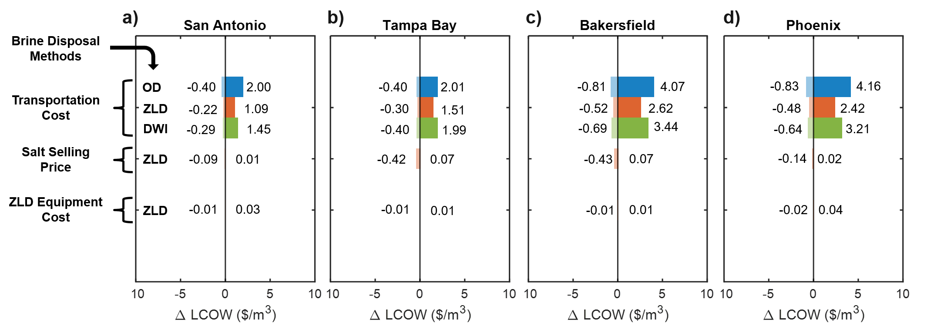
Fig. S16: Sensitivity analysis showing the change in levelized cost of water (ΔLCOW) resulting from variations in transportation cost, salt selling price, and ZLD equipment cost for the three brine management strategies: ocean discharge (OD), deep well injection (DWI), and zero liquid discharge (ZLD). Results are presented for four representative U.S. cities: (a) San Antonio, Texas; (b) Tampa Bay, Florida; (c) Bakersfield, California; and (d) Phoenix, Arizona. Positive values indicate an increase in LCOW, while negative values represent a reduction in LCOW relative to the baseline case.

Supplementary Note 8 – Brine Disposal Framework for Feed Sources
Framework for Brine Disposal Utilization Based on Feed Sources:
To better identify the conditions under which each brine disposal strategy is optimal, OD, DWI, and ZLD were mapped as a function of salinity (wt.%) and distance from the coast (km) for BGW and PW feed sources (Fig. S17). The analysis uses the base-case parameters defined in the main text, providing a spatial–salinity decision map for selecting the preferred disposal approach. Across both feed sources, OD is generally favored near the coastline (typically within ~500 km) due to low transportation costs. As distance from the coast increases, the optimal strategy becomes increasingly dependent on salinity. For inland locations, ZLD becomes dominant at higher salinities, while DWI is preferred for lower-salinity brines (generally less than ~1 wt.%). An intermediate region of overlap is observed between OD and DWI for low-salinity cases extending roughly 500–1000 km inland, along with a narrow transition region where ZLD begins to become competitive at salinities around ~0.25 wt.%. Finally, PW spans a broader and higher salinity range compared to BGW, resulting in a wider region of ZLD dominance, whereas BGW remains concentrated at lower salinity, where OD and DWI are more prevalent.
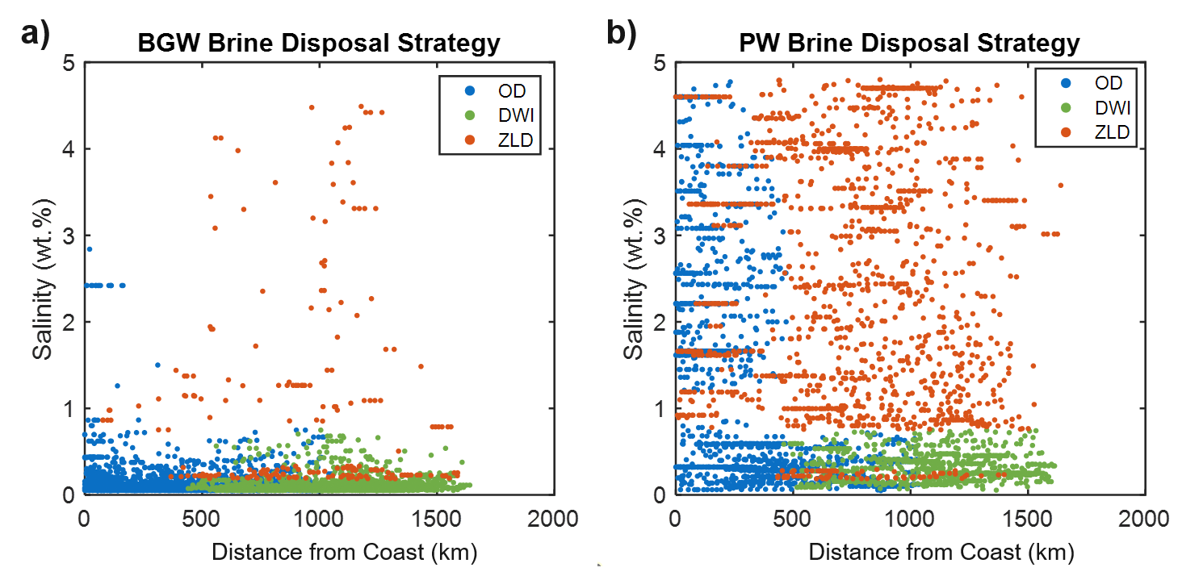
Fig. S17: Brine management strategy map illustrating the optimal disposal pathway: ocean discharge (OD), deep well injection (DWI), or zero liquid discharge (ZLD) as a function of feedwater salinity and geographic distance from the coast. The preferred brine management approach is shown as a function of feed salinity (wt.%) and distance from the coastline (km) for (a) brackish groundwater (BGW) and (b) produced water (PW).
A similar analysis to Fig. S17 is presented in Fig. S18, where the x-axis is replaced by the transportation cost to the ocean ($/m³), while maintaining salinity (wt.%) as the y-axis. The figure evaluates the optimal brine disposal strategy (OD, DWI, ZLD) for BGW and PW as a function of feed salinity and ocean transport cost. Across both feed sources, OD is the preferred option when transportation costs to the coast are low (typically <0.5 $/m³), independent of salinity, due to its strong cost advantage. As transportation costs increase beyond this threshold, the optimal strategy shifts depending on salinity. For low-salinity brines (generally <~1 wt.%), DWI becomes favorable within a narrow cost range (~0.5–1 $/m³). At higher transportation costs (>~1 $/m³) and salinities exceeding ~1 wt.%, ZLD becomes the dominant and most cost-effective option for both BGW and PW. This transition is more pronounced for PW (Fig. S18b), which spans a broader and higher salinity distribution, resulting in a larger region of ZLD dominance across elevated transport costs. Overall, Fig. S18 provides a clear decision map linking salinity and ocean transport cost, enabling rapid identification of the most economical brine disposal strategy for a given site.
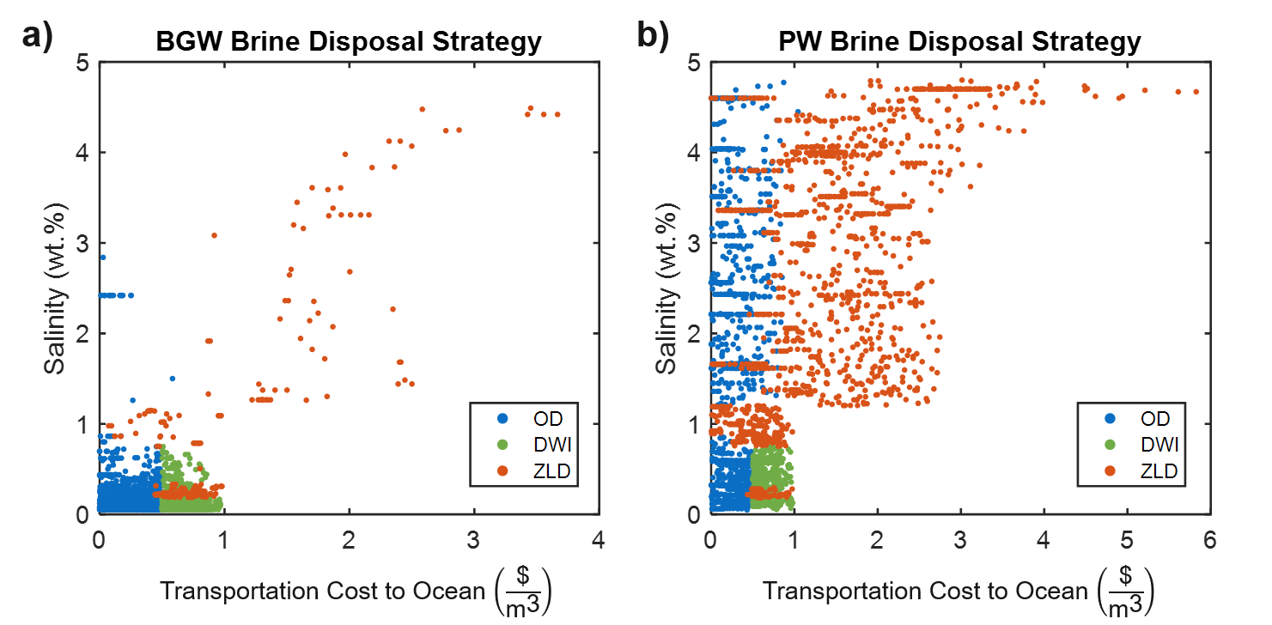
Fig. S18: Brine management strategy map illustrating the optimal disposal pathway: ocean discharge (OD), deep well injection (DWI), or zero liquid discharge (ZLD) as a function of feedwater salinity and transportation cost to the coast. The preferred brine management approach is shown as a function of feed salinity (wt.%) and transportation cost to the ocean ($/m³) for (a) brackish groundwater (BGW) and (b) produced water (PW).
The next analysis compares the dominant brine disposal strategy across SW, BGW, and PW feed sources under base-case input parameters, as shown in Fig. S19. The figure presents the spatial coverage of the optimal disposal method across the United States for each feed type. For SW, OD dominates 100% of the study area, reflecting consistently favorable coastal discharge conditions. For BGW, OD remains the most prevalent strategy at approximately 60% coverage, followed by DWI at ~35%, while ZLD accounts for a minor fraction (~5%). This distribution reflects the relatively low salinity of BGW and the continued feasibility of non-ZLD options. In contrast, PW exhibits a more diversified and ZLD-dominant distribution. ZLD becomes the largest single category, covering approximately 40% of the USA. This shift is driven by the higher salinity and more inland distribution of PW sources, which reduces the viability of OD and increases reliance on more intensive treatment pathways. Overall, Fig. S19 highlights a clear transition from OD-dominated systems (SW and BGW) toward ZLD-relevant conditions in PW, governed primarily by salinity and geographic constraints.
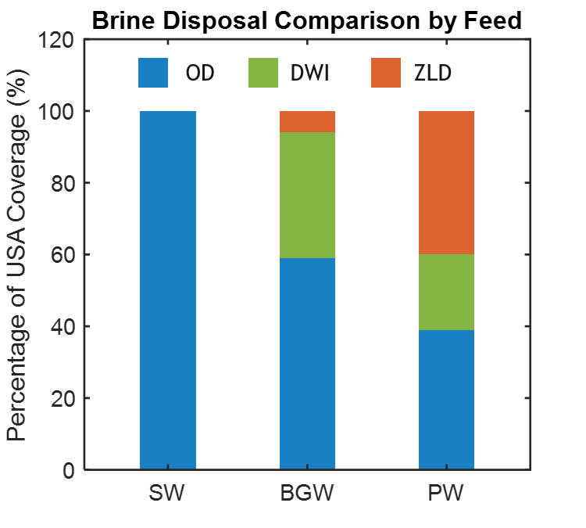
Fig. S19: United States geographical coverage breakdown of optimal brine disposal strategies by feed source. The stacked bar chart illustrates the percentage of USA coverage for Ocean Discharge (OD), Deep Well Injection (DWI), and Zero Liquid Discharge (ZLD) when treating Seawater (SW), Brackish Groundwater (BGW), and Produced Water (PW).
Comparison of Brine Disposal Approaches Across All Feed Sources:
To extend the comparison beyond individual feed sources, all feed–disposal combinations were evaluated simultaneously to identify the most suitable brine management strategy across the United States under base-case conditions, as shown in Fig. S20. The analysis maps LCOW for eight feed-and-disposal configurations (Fig. S20a – h), highlighting the coupled influence of feedwater source and brine management strategy on spatial cost distribution. For BGW, OD provides the lowest LCOW across the widest geographic extent, covering approximately 50% of the United States, particularly in regions with access to coastal discharge. DWI and ZLD (BGW feed source) are more limited, representing ~18% and ~2% of the domain, respectively, and are primarily concentrated in inland regions where ocean disposal is not feasible. For SW, viable deployment is largely restricted to coastal areas due to SW access requirements. Overall coverage is minimal (<1% of the U.S.), reflecting higher salinity and associated cost penalties. In this case, ZLD does not appear as a competitive option (0% coverage), as OD consistently provides lower LCOW under all evaluated conditions. PW exhibits a more spatially heterogeneous distribution that closely follows major production regions. OD remains the lowest-cost option where coastal access exists (~8% coverage), while DWI becomes a strong inland alternative (~14%) because it avoids the long-distance transport required for ocean discharge. ZLD accounts for ~8% coverage, reflecting regions where high salinity and inland constraints make more intensive treatment economically justified despite higher energy demand. Overall, Fig. S20 demonstrates that optimal brine management is strongly location dependent and governed by the combined effects of feedwater source, salinity, transport distance, and disposal infrastructure availability
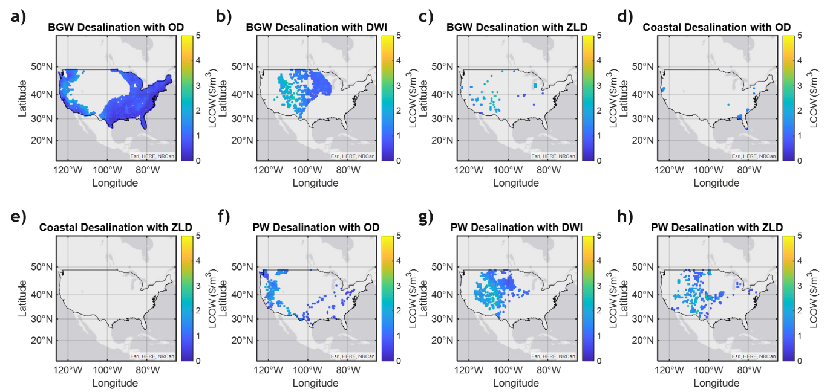
Fig. S20: Geospatial distribution of the levelized cost of water (LCOW) across the United States for different feedwater sources and brine management strategies. Panels (a) – (c) show LCOW results for brackish groundwater (BGW) with ocean discharge (OD), deep well injection (DWI), and zero liquid discharge (ZLD), respectively. Panels (d) and (e) show seawater (SW) results for OD and ZLD, respectively. Panels (f) – (h) show produced water (PW) results for OD, DWI, and ZLD, respectively.

Supplementary Note 9 – Alternate Approach for Calculating LCOW for Inland Feed Sources
All the results presented in the main manuscript and the SI thus far assume that the LCOW is calculated using the geographically closest available feed source to a given location of interest. In the main text, we mentioned an alternate approach for BGW and PW, in which the LCOW is based on selecting the feed source that provides the lowest cost possible. In this formulation, the analysis prioritizes the economically optimal feed source rather than the nearest one. This approach is motivated by the fact that the closest feed source does not necessarily correspond to the lowest LCOW, since nearby sources may have higher salinity or less favorable geographic characteristics compared to a more distant alternative. In such cases, transporting water from a farther but lower-salinity source can yield a lower overall LCOW. Therefore, this method identifies the minimum cost for a given location and feed source, providing a more comprehensive assessment of the economically optimal supply strategy. This analysis was not applied to SW, since all coastal locations are assumed to have the same salinity of 3.5 wt.%, making source selection redundant under this framework.
Analysis of Brackish Groundwater Feed:
The results in Fig. S21 demonstrate that selecting the lowest-cost feed source, rather than the geographically closest source, alters the preferred brine disposal strategy for BGW. As shown in Fig. S21a, OD and DWI remain the dominant disposal methods, while ZLD is not identified as the optimal option under any scenario. This indicates that the additional transportation costs associated with sourcing water from more distant locations are outweighed by the economic benefits of accessing lower-salinity feedwaters, which reduce treatment costs and favor less energy-intensive disposal pathways. Under this approach, OD is the preferred disposal strategy for approximately 61% of locations, while DWI accounts for approximately 39% of locations. The absence of ZLD highlights its limited economic viability for BGW under current assumptions and suggests that substantially higher salt selling prices, lower ZLD capital costs, improved energy efficiency, or a combination of these factors would be required for ZLD to become competitive. Compared with the baseline analysis presented in the main text, this alternative source-selection framework substantially reduces LCOW. Specifically, the maximum LCOW for both OD and DWI decrease to approximately 1.5 $/m³, compared with values approaching 5 $/m³ when only the nearest feed source is considered. These results demonstrate that allowing feedwater to be sourced from more distant, lower-salinity locations can significantly reduce overall treatment costs despite increased transportation requirements. Fig. S21(b) presents the corresponding SEC for each disposal strategy. OD and DWI exhibit relatively uniform energy consumption across the United States, with both approaches maintaining SEC values below approximately 10 kWh/m³. DWI generally exhibits the lowest energy consumption, followed by OD, contributing to their economic competitiveness. In contrast, ZLD exhibits substantially higher energy demands, with SEC values reaching approximately 25 kWh/m³. This elevated energy requirement is a primary factor limiting the feasibility of ZLD for BGW applications. Overall, these results demonstrate that optimizing feedwater selection based on minimum LCOW rather than geographic proximity can further reduce treatment costs and decrease the competitiveness of ZLD for BGW systems.
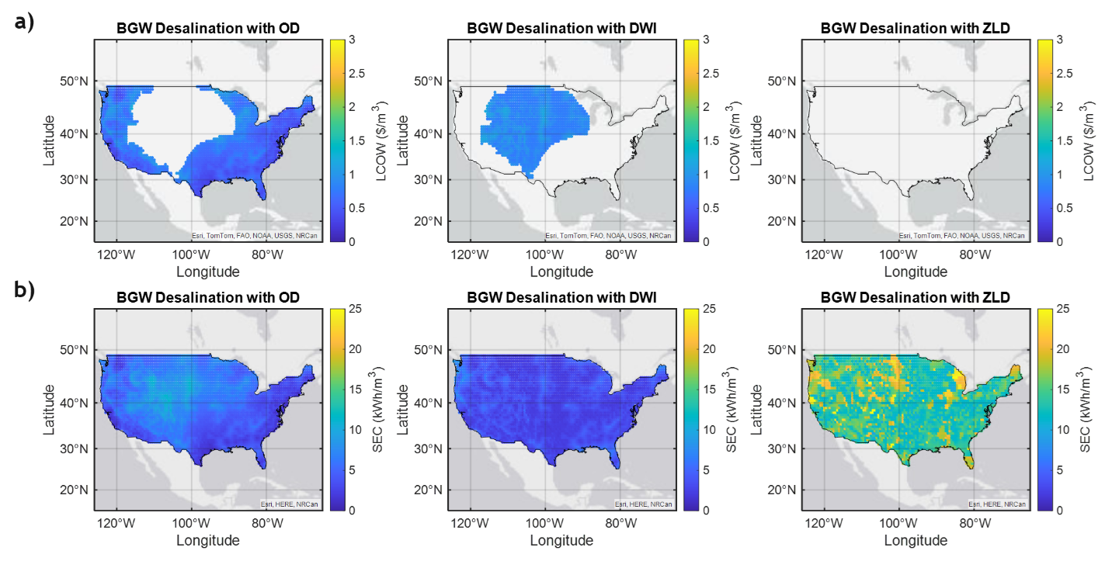
Fig. S21: (a) Geospatial distribution of the levelized cost of water (LCOW) and (b) specific energy consumption (SEC) for brackish groundwater (BGW) desalination across the United States for ocean discharge (OD), deep well injection (DWI) and zero liquid discharge (ZLD) configurations.
Analysis of Produced Water Feed:
A similar analysis was conducted for PW feed sources to evaluate the national cost and energy trade-offs associated with selecting the feed source that minimizes LCOW rather than the geographically closest source. As shown in Fig. S22, this optimization framework significantly alters the preferred brine disposal strategy across the United States. Fig. S22a shows that OD and DWI remain the dominant disposal methods, accounting for approximately 61% and 39% of the study area, respectively. ZLD is selected only in a small number of isolated cases effectively accounting for 0%, indicating that sourcing lower-salinity feedwaters or selecting locations with lower transportation energy requirements can offset the additional costs associated with longer transport distances. Consequently, the reduced desalination costs achieved through optimal source selection outweigh the economic benefits of salt recovery, rendering ZLD largely uncompetitive for PW under the base-case assumptions. Under this approach, the LCOW for both OD and DWI remain below approximately 1.5 $/m³ across all viable regions, representing a substantial reduction compared with the nearest-source framework shown in the main text. The corresponding SEC distributions are presented in Fig. S22b. Both OD and DWI exhibit relatively uniform energy consumption across the country, with SEC values consistently below 10 kWh/m³. DWI demonstrates the lowest overall energy demand, followed closely by OD. In contrast, ZLD exhibits substantially higher energy requirements, with SEC values frequently approaching 25 kWh/m³. This elevated energy intensity further explains the limited economic viability of ZLD for PW applications. Overall, these results demonstrate that optimizing feed source selection based on minimum LCOW rather than geographic proximity can significantly reduce desalination costs and energy consumption while further decreasing the competitiveness of ZLD.
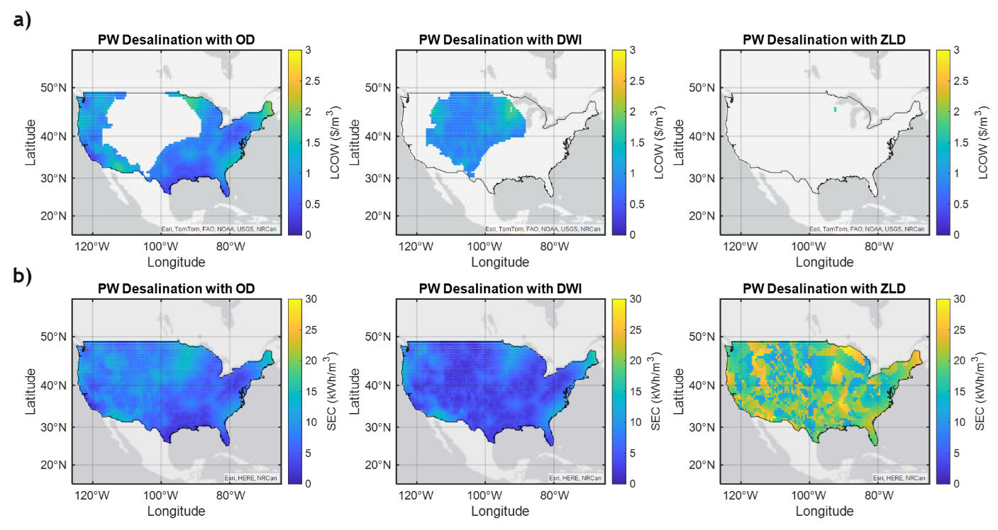
Fig. S22: (a) Geospatial distribution of the levelized cost of water (LCOW) and (b) specific energy consumption (SEC) for produced water (PW) desalination across the United States for ocean discharge (OD), deep well injection (DWI) and zero liquid discharge (ZLD) configurations.

References:
1 Stanton, J. S. et al. Desalination and Water Purification Research and Development Program Report No. 139. Report No. 2330-7102, (U.S. Geological Survey, Reston, VA, 2017).
2 Blondes, M. S. et al. (U.S. Geological Survey, 2023).
3 O’Connell, M. G., Rajendran, N., Elimelech, M., Gilron, J. & Dunn, J. B. Analysis of energy, water, land and cost implications of zero and minimal liquid discharge desalination technologies. Nature Water 2, 1116-1127, doi:10.1038/s44221-024-00327-1 (2024).
4 Panagopoulos, A. in Resource Recovery in Industrial Waste Waters (eds Mika Sillanpää, Ali Khadir, & Khum Gurung) 337-351 (Elsevier, 2023).
5 Panagopoulos, A. & Haralambous, K.-J. Minimal Liquid Discharge (MLD) and Zero Liquid Discharge (ZLD) strategies for wastewater management and resource recovery – Analysis, challenges and prospects. Journal of Environmental Chemical Engineering 8, 104418, doi:https://doi.org/10.1016/j.jece.2020.104418 (2020).
6 Tong, T. et al. Brine management with zero and minimal liquid discharge. Nature Reviews Clean Technology 1, 185-200, doi:10.1038/s44359-025-00036-2 (2025).
7 Futterlieb, M., ElSherbiny, I. M. A., Tuczinski, M., Lipnizki, J. & Panglisch, S. Limits of High Recovery Inland Desalination: Closed-Circuit Reverse Osmosis – a Viable Option? Chemie Ingenieur Technik 93, 1359-1368, doi:https://doi.org/10.1002/cite.202100042 (2021).
8 Alghoul, M. A., Poovanaesvaran, P., Sopian, K. & Sulaiman, M. Y. Review of brackish water reverse osmosis (BWRO) system designs. Renewable and Sustainable Energy Reviews 13, 2661-2667, doi:https://doi.org/10.1016/j.rser.2009.03.013 (2009).
9 Wilf, M. & Bartels, C. Optimization of seawater RO systems design. Desalination 173, 1-12, doi:https://doi.org/10.1016/j.desal.2004.06.206 (2005).
10 Martin, J. & Eisberg, D. Brackish Water Desalination: Energy and Cost Considerations. (Energy Recovery Inc., San Leandro, CA, 2014).
11 Zhang, Z., Lokare, O. R., Gusa, A. V. & Vidic, R. D. Pretreatment of brackish water reverse osmosis (BWRO) concentrate to enhance water recovery in inland desalination plants by direct contact membrane distillation (DCMD). Desalination 508, 115050, doi:https://doi.org/10.1016/j.desal.2021.115050 (2021).
12 Lim, Y. J. et al. Quantifying the potential of high-performance RO membranes for seawater and hypersaline brine desalination: from module-scale modelling to experimental evaluation. Desalination 616, 119394, doi:https://doi.org/10.1016/j.desal.2025.119394 (2025).
13 Saeed, M. O., Al-Nomazi, M. A. & Al-Amoudi, A. S. Evaluating suitability of source water for a proposed SWRO plant location. Heliyon 5, e01119, doi:10.1016/j.heliyon.2019.e01119 (2019).
14 Elimelech, M. & Phillip, W. A. The Future of Seawater Desalination: Energy, Technology, and the Environment. Science 333, 712-717, doi:doi:10.1126/science.1200488 (2011).
15 Qasim, M., Badrelzaman, M., Darwish, N. N., Darwish, N. A. & Hilal, N. Reverse osmosis desalination: A state-of-the-art review. Desalination 459, 59-104, doi:https://doi.org/10.1016/j.desal.2019.02.008 (2019).
16 Moon, J., Son, S., Kim, J. & Park, K. Critical challenges in high-salinity seawater reverse osmosis systems: Technical, energy, and environmental reviews. Desalination 607, 118811, doi:https://doi.org/10.1016/j.desal.2025.118811 (2025).
17 United States Census, B. (United States Census Bureau, 2024).
18 United States Census, B. (United States Census Bureau, 2024).
19 Krieger, N. (USpopcenters R package, 2023).
20 balsama. (2025).
21 Menon, A. K. Distributed desalination using renewable energy: A paradigm shift toward affordable and sustainable clean water. One Earth 7, 355-358, doi:https://doi.org/10.1016/j.oneear.2024.02.011 (2024).
22 Menon, A. K., Jia, M., Kaur, S., Dames, C. & Prasher, R. S. Distributed desalination using solar energy: A technoeconomic framework to decarbonize nontraditional water treatment. iScience 26, 105966, doi:https://doi.org/10.1016/j.isci.2023.105966 (2023).
23 Xu, X. et al. Analysis of Brackish Water Desalination for Municipal Uses: Case Studies on Challenges and Opportunities. ACS ES&T Engineering 2, 306-322, doi:10.1021/acsestengg.1c00326 (2022).
24 Pearson, J. L., Michael, P. R., Ghaffour, N. & Missimer, T. M. Economics and Energy Consumption of Brackish Water Reverse Osmosis Desalination: Innovations and Impacts of Feedwater Quality. Membranes 11, 616 (2021).
25 Arroyo, J. & Shirazi, S. Estimating the Cost of Brackish Groundwater Desalination in Texas. (Texas Water Development Board, Austin, Texas, 2012).
26 Karabelas, A. J., Koutsou, C. P., Kostoglou, M. & Sioutopoulos, D. C. Analysis of specific energy consumption in reverse osmosis desalination processes. Desalination 431, 15-21, doi:https://doi.org/10.1016/j.desal.2017.04.006 (2018).
27 Voutchkov, N. Energy use for membrane seawater desalination – current status and trends. Desalination 431, 2-14, doi:https://doi.org/10.1016/j.desal.2017.10.033 (2018).
28 Patel, S. K., Biesheuvel, P. M. & Elimelech, M. Energy Consumption of Brackish Water Desalination: Identifying the Sweet Spots for Electrodialysis and Reverse Osmosis. ACS ES&T Engineering 1, 851-864, doi:10.1021/acsestengg.0c00192 (2021).
29 Al-Karaghouli, A. & Kazmerski, L. L. Energy consumption and water production cost of conventional and renewable-energy-powered desalination processes. Renewable and Sustainable Energy Reviews 24, 343-356, doi:https://doi.org/10.1016/j.rser.2012.12.064 (2013).
30 Lugo, A. et al. Technical, Economic, Energetic, and Environmental Evaluation of Pretreatment Strategies for Scaling Control in Brackish Water Desalination Brine Treatment. Water 17, 708 (2025).
31 Alsarayreh, A. A., Al-Obaidi, M. A., Ruiz-García, A., Patel, R. & Mujtaba, I. M. Thermodynamic Limitations and Exergy Analysis of Brackish Water Reverse Osmosis Desalination Process. Membranes (Basel) 12, doi:10.3390/membranes12010011 (2021).
32 Cerci, Y. Exergy analysis of a reverse osmosis desalination plant in California. Desalination 142, 257-266, doi:https://doi.org/10.1016/S0011-9164(02)00207-2 (2002).
33 Fellaou, S., Ruiz-Garcia, A. & Gourich, B. Enhanced exergy analysis of a full-scale brackish water reverse osmosis desalination plant. Desalination 506, 114999, doi:https://doi.org/10.1016/j.desal.2021.114999 (2021).
34 Aljundi, I. H. Second-law analysis of a reverse osmosis plant in Jordan. Desalination 239, 207-215, doi:https://doi.org/10.1016/j.desal.2008.03.019 (2009).
35 Pearson, J. L., Michael, P. R., Ghaffour, N. & Missimer, T. M. Economics and Energy Consumption of Brackish Water Reverse Osmosis Desalination: Innovations and Impacts of Feedwater Quality. Membranes (Basel) 11, doi:10.3390/membranes11080616 (2021).
36 Caldera, U. & Breyer, C. Learning Curve for Seawater Reverse Osmosis Desalination Plants: Capital Cost Trend of the Past, Present, and Future. Water Resources Research 53, 10523-10538, doi:https://doi.org/10.1002/2017WR021402 (2017).
37 (Centre for Mediterranean Integration (CMI)).
38 Kim, J., Park, K., Yang, D. R. & Hong, S. A comprehensive review of energy consumption of seawater reverse osmosis desalination plants. Applied Energy 254, 113652, doi:https://doi.org/10.1016/j.apenergy.2019.113652 (2019).
39 Park, K., Kim, J., Yang, D. R. & Hong, S. Towards a low-energy seawater reverse osmosis desalination plant: A review and theoretical analysis for future directions. Journal of Membrane Science 595, 117607, doi:https://doi.org/10.1016/j.memsci.2019.117607 (2020).
40 Al Ghamdi, A. & Mustafa, I. Exergy analysis of a seawater reverse osmosis plant in Jeddah, Saudi Arabia. Desalination and Water Treatment 264, 1-11, doi:https://doi.org/10.5004/dwt.2022.28595 (2022).
41 Power Consumption and Energy Efficiency in the Water Industry. (WateReuse Association, Alexandria, VA, 2011).
42 Bandwidth Study on Energy Use and Potential Energy Savings Opportunities in U.S. Seawater Desalination Systems. (U.S. Department of Energy, Washington, DC, 2017).
43 Qureshi, B. A. & Zubair, S. M. Energy-exergy analysis of seawater reverse osmosis plants. Desalination 385, 138-147, doi:https://doi.org/10.1016/j.desal.2016.02.009 (2016).
44 Blanco-Marigorta, A. M., Lozano-Medina, A. & Marcos, J. D. The exergetic efficiency as a performance evaluation tool in reverse osmosis desalination plants in operation. Desalination 413, 19-28, doi:https://doi.org/10.1016/j.desal.2017.03.007 (2017).
45 Blanco-Marigorta, A. M., Lozano-Medina, A. & Marcos, J. D. A critical review of definitions for exergetic efficiency in reverse osmosis desalination plants. Energy 137, 752-760, doi:https://doi.org/10.1016/j.energy.2017.05.136 (2017).
46 Sutariya, B. & Amaliar, G. Thermodynamic performance assessment of a community-scale brackish water reverse osmosis plant using exergy analysis. AQUA - Water Infrastructure, Ecosystems and Society 72, 1867-1880, doi:10.2166/aqua.2023.105 (2023).
47 Kocher, J. D. & Menon, A. K. Addressing global water stress using desalination and atmospheric water harvesting: a thermodynamic and technoeconomic perspective. Energy & Environmental Science 16, 4983-4993, doi:10.1039/D3EE02916F (2023).
48 Soliman, M. N. et al. Energy consumption and environmental impact assessment of desalination plants and brine disposal strategies. Process Safety and Environmental Protection 147, 589-608, doi:https://doi.org/10.1016/j.psep.2020.12.038 (2021).
49 Panagopoulos, A. & Haralambous, K.-J. Environmental impacts of desalination and brine treatment - Challenges and mitigation measures. Marine Pollution Bulletin 161, 111773, doi:https://doi.org/10.1016/j.marpolbul.2020.111773 (2020).
50 Ziolkowska, J. R. & Reyes, R. in Competition for Water Resources (eds Jadwiga R. Ziolkowska & Jeffrey M. Peterson) 298-316 (Elsevier, 2017).
51 Greenlee, L. F., Lawler, D. F., Freeman, B. D., Marrot, B. & Moulin, P. Reverse osmosis desalination: Water sources, technology, and today's challenges. Water Research 43, 2317-2348, doi:https://doi.org/10.1016/j.watres.2009.03.010 (2009).
52 Mickley et al. Membrane Concentrate Disposal : Practices and Regulation. (U.S. Department of the Interior, Bureau of Reclamation, Technical Service Center, Water Treatment Engineering and Research Group, 2006).
53 Mickley, M. C., Mickley, Associates & Reclamation, U. S. B. o. Membrane Concentrate Disposal: Practices and Regulation, Final Report. (U.S. Department of the Interior, Bureau of Reclamation, 2001).
54 Panagopoulos, A. Techno-economic assessment and feasibility study of a zero liquid discharge (ZLD) desalination hybrid system in the Eastern Mediterranean. Chemical Engineering and Processing - Process Intensification 178, 109029, doi:https://doi.org/10.1016/j.cep.2022.109029 (2022).
55 Panagopoulos, A., Haralambous, K.-J. & Loizidou, M. Desalination brine disposal methods and treatment technologies - A review. Science of The Total Environment 693, 133545, doi:https://doi.org/10.1016/j.scitotenv.2019.07.351 (2019).
56 Panagopoulos, A. Energetic, economic and environmental assessment of zero liquid discharge (ZLD) brackish water and seawater desalination systems. Energy Conversion and Management 235, 113957, doi:https://doi.org/10.1016/j.enconman.2021.113957 (2021).
57 Lin, B. & Malmali, M. Energy and exergy analysis of multi-stage vacuum membrane distillation integrated with mechanical vapor compression. Separation and Purification Technology 306, 122568, doi:https://doi.org/10.1016/j.seppur.2022.122568 (2023).
58 Vane, L. M., Rock, K. & Jordan, D. Energy efficient vortex-enhanced water evaporation technology for concentrated brine management: Theory and process simulation evaluation. Desalination 522, 1-14, doi:10.1016/j.desal.2021.115427 (2022).
59 Tucker, C. I., Bartholomew, T. V., Dudchenko, A. V. & Mauter, M. S. Component innovations for lower cost mechanical vapor compression. Water Research 260, 121950, doi:https://doi.org/10.1016/j.watres.2024.121950 (2024).
60 Schwantes, R., Chavan, K., Winter, D., Felsmann, C. & Pfafferott, J. Techno-economic comparison of membrane distillation and MVC in a zero liquid discharge application. Desalination 428, 50-68, doi:https://doi.org/10.1016/j.desal.2017.11.026 (2018).
61 Farahat, M. A., Fath, H. E. S., El-Sharkawy, I. I., Ookawara, S. & Ahmed, M. Energy/exergy analysis of solar driven mechanical vapor compression desalination system with nano-filtration pretreatment. Desalination 509, 115078, doi:https://doi.org/10.1016/j.desal.2021.115078 (2021).
62 Ettouney, H. Design of single-effect mechanical vapor compression. Desalination 190, 1-15, doi:https://doi.org/10.1016/j.desal.2005.08.003 (2006).
63 Morgante, C. et al. A global outlook of the desalination industry and state-of-the-art technologies for brine valorisation. Desalination 621, 119718, doi:https://doi.org/10.1016/j.desal.2025.119718 (2026).
64 Panagopoulos, A. & Giannika, V. Decarbonized and circular brine management/valorization for water & valuable resource recovery via minimal/zero liquid discharge (MLD/ZLD) strategies. Journal of Environmental Management 324, 116239, doi:https://doi.org/10.1016/j.jenvman.2022.116239 (2022).
65 Nayar, K. G. et al. Cost and energy requirements of hybrid RO and ED brine concentration systems for salt production. Desalination 456, 97-120, doi:https://doi.org/10.1016/j.desal.2018.11.018 (2019).
66 Macedonio, F., Curcio, E. & Drioli, E. Integrated membrane systems for seawater desalination: energetic and exergetic analysis, economic evaluation, experimental study. Desalination 203, 260-276, doi:https://doi.org/10.1016/j.desal.2006.02.021 (2007).
67 Panagopoulos, A. Techno-economic evaluation of a solar multi‐effect distillation/thermal vapor compression hybrid system for brine treatment and salt recovery. Chemical Engineering and Processing - Process Intensification 152, 107934, doi:https://doi.org/10.1016/j.cep.2020.107934 (2020).
68 Panagopoulos, A. Beneficiation of saline effluents from seawater desalination plants: Fostering the zero liquid discharge (ZLD) approach - A techno-economic evaluation. Journal of Environmental Chemical Engineering 9, 105338, doi:https://doi.org/10.1016/j.jece.2021.105338 (2021).
69 in World Environmental and Water Resources Congress 2015 1219-1230.
70 van Wyk, S., van der Ham, A. G. J. & Kersten, S. R. A. Potential of supercritical water desalination (SCWD) as zero liquid discharge (ZLD) technology. Desalination 495, 114593, doi:https://doi.org/10.1016/j.desal.2020.114593 (2020).
71 Morillo, J. et al. Comparative study of brine management technologies for desalination plants. Desalination 336, 32-49, doi:https://doi.org/10.1016/j.desal.2013.12.038 (2014).
72 Mineral commodity summaries 2026. Report No. 2026, 222 (Reston, VA, 2026).
73 Survey, U. S. G. & National Minerals Information, C. Salt Statistics and Information. (2026).
74 Panagopoulos, A. Techno-economic assessment of zero liquid discharge (ZLD) systems for sustainable treatment, minimization and valorization of seawater brine. Journal of Environmental Management 306, 114488, doi:https://doi.org/10.1016/j.jenvman.2022.114488 (2022).
75 Shamet, O. et al. Multi-stage humidification–dehumidification system integrated with a crystallizer for zero liquid discharge of desalination brine. Energy Conversion and Management 307, 118340, doi:https://doi.org/10.1016/j.enconman.2024.118340 (2024).
76 Wang, L., Violet, C., DuChanois, R. M. & Elimelech, M. Derivation of the Theoretical Minimum Energy of Separation of Desalination Processes. Journal of Chemical Education 97, 4361-4369, doi:10.1021/acs.jchemed.0c01194 (2020).
77 Parker, W. P., Kocher, J. D. & Menon, A. K. Brine concentration using air gap diffusion distillation: A performance model and cost comparison with membrane distillation for high salinity desalination. Desalination 580, 117560, doi:https://doi.org/10.1016/j.desal.2024.117560 (2024).

